BETHLEHEM LUTHERAN CHURCH
A congregation of The Lutheran Church-Missouri Synod
902 Hitchcock Drive SW,
Aiken, South Carolina 29803
Church Phone: (803) 649-6417
blcaikensc@gmail.com
Pastor: Rev. John B. Engwall
Office Hours By Appointment
Note: The format of this bulletin has been modified for use in private devotion services.
Unable to join us in person? Please find us on Facebook live.
The service is also posted on our website; bethlehemlutheranaiken.org

+ + + + + + + + + + + + + + +
The Third Sunday in Lent
March 8, 2026
10:30 a.m.
+ + + + + + + + + + + + + + +

Our Policy and Practice Regarding Holy Communion
Hear the words of the Apostle Paul;
Anyone who eats and drinks without recognizing the body of the Lord eats and drinks judgment on himself. -1 Cor.11:29
Therefore, visitors are asked to please refrain from partaking of the Sacrament before speaking about this with the pastor; because we care about your spiritual well-being.
Also, because communing at this altar is a public confession that you agree with the doctrines of The Lutheran Church-Missouri Synod, and reject all contrary teachings.
Persons who are not communing today are always welcome to come forward during the distribution to receive an individual blessing; please cross your arms over your chest to indicate your desire for this. Thank you!
We commune in two alternating tables. The ushers will guide you. Non-alcoholic white wine is available in the center of the individual cup tray. Please leave empty individual cups at the altar rail.

+ SERVICE OF PREPARATION +
After the bell tolls, please observe a time of silence.

WELCOME AND ANNOUNCEMENTS

(Stand)

648 GLORIOUS THINGS OF YOU ARE SPOKEN
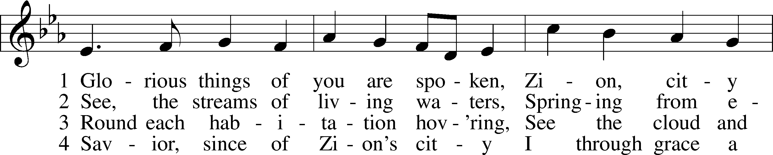
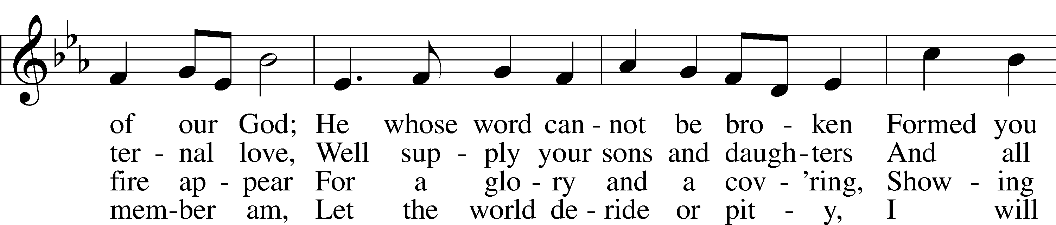
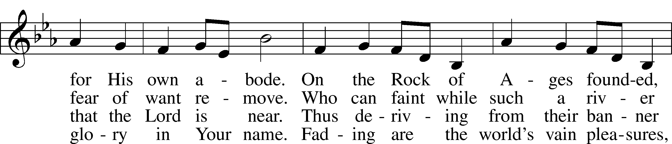
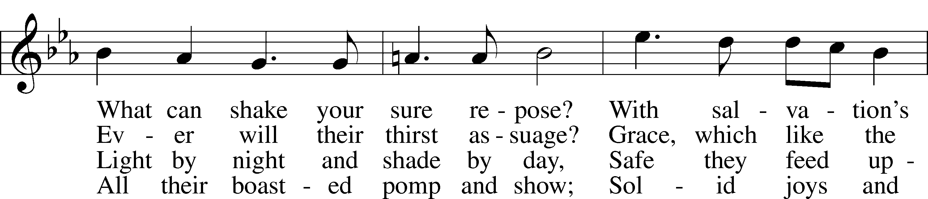
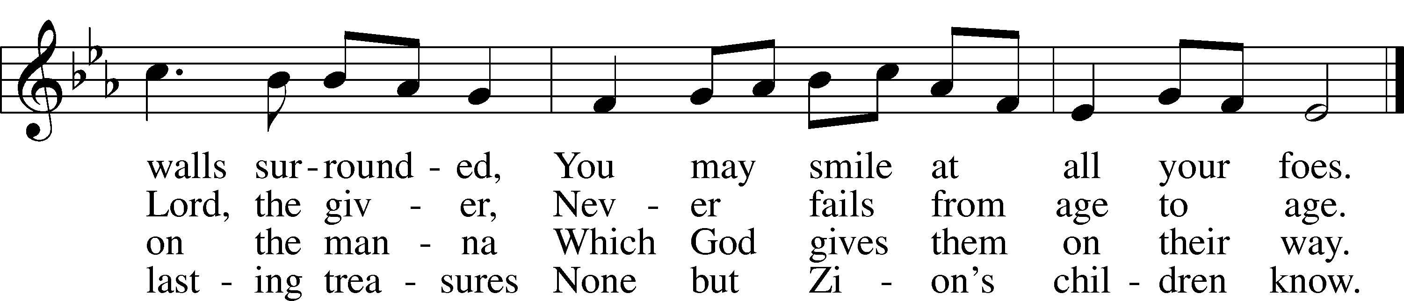
Text: John Newton, 1725–1807, alt.
Tune: Franz Joseph Haydn, 1732–1809
Text and tune: Public domain

+ CONFESSION AND ABSOLUTION +

(The sign of the cross may be made by all in remembrance of their Baptism.)

INVOCATION
L In the name of the Father and of the T Son and of the Holy Spirit.
C Amen.

EXHORTATION LSB 184
L Beloved in the Lord! Let us draw near with a true heart and confess our sins unto God our Father, beseeching Him in the name of our Lord Jesus Christ to grant us forgiveness.

L Our help is in the name of the Lord,
C who made heaven and earth.
L I said, I will confess my transgressions unto the Lord,
C and You forgave the iniquity of my sin.

(Silence for reflection on God’s Word and for self-examination.)

CONFESSION OF SINS LSB 184
L O almighty God, merciful Father,
C I, a poor, miserable sinner, confess unto You all my sins and iniquities with which I have ever offended You and justly deserved Your temporal and eternal punishment. But I am heartily sorry for them and sincerely repent of them, and I pray You of Your boundless mercy and for the sake of the holy, innocent, bitter sufferings and death of Your beloved Son, Jesus Christ, to be gracious and merciful to me, a poor, sinful being.

DECLARATION OF GRACE
L In the mercy of almighty God, Jesus Christ was given to die for us, and for His sake God forgives us all our sins. To those who believe in Jesus Christ He gives the power to become the children of God and bestows on them the Holy Spirit. May the Lord, who has begun this good work in us, bring it to completion in the day of our Lord Jesus Christ.
C Amen.

+ SERVICE OF THE WORD +

INTROIT
He remembers his covenant for- | ever,*
the word that he commanded, for a thousand gener- | ations.
Seek the Lord | and his strength;*
seek his presence con- | tinually!
Remember the wondrous works that | he has done,*
his miracles, and the judgments he | uttered,
O offspring of Abraham, his | servant,*
children of Jacob, his | chosen ones!
He is the | Lord our God;*
his judgments are in | all the earth.
He remembers his covenant for- | ever,*
the word that he commanded, for a thousand gener- | ations.

GLORIA PATRI LSB 186
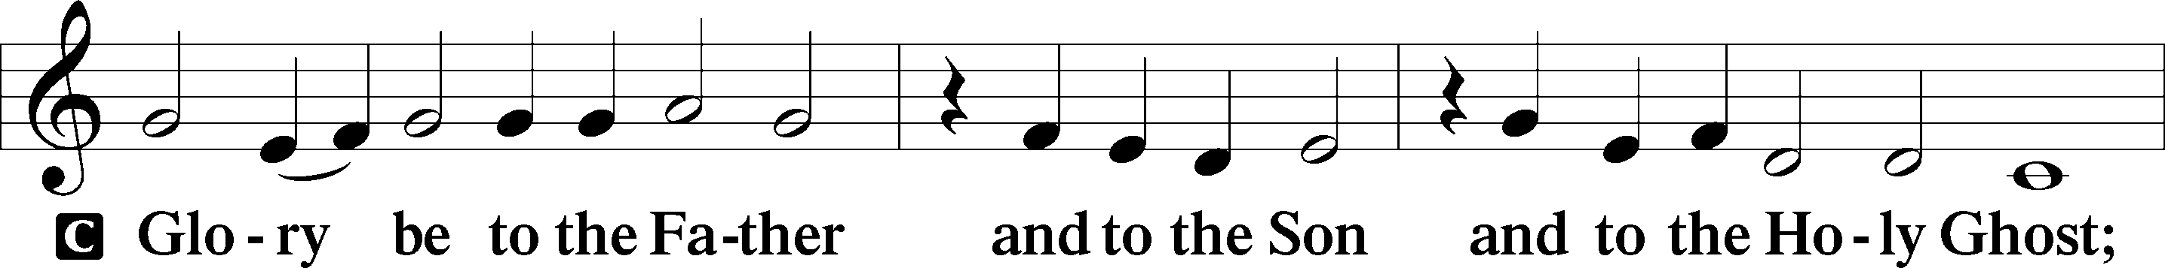
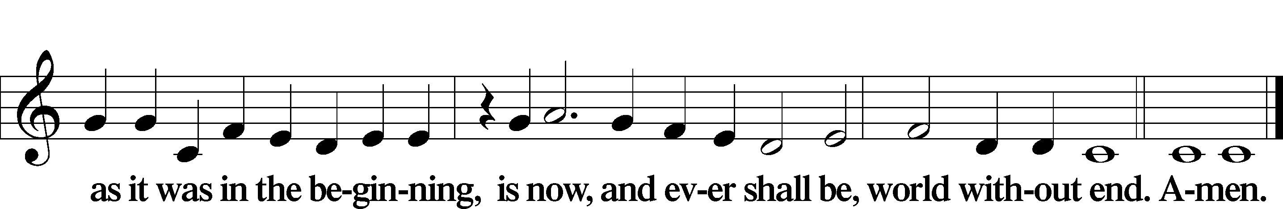

KYRIE LSB 186
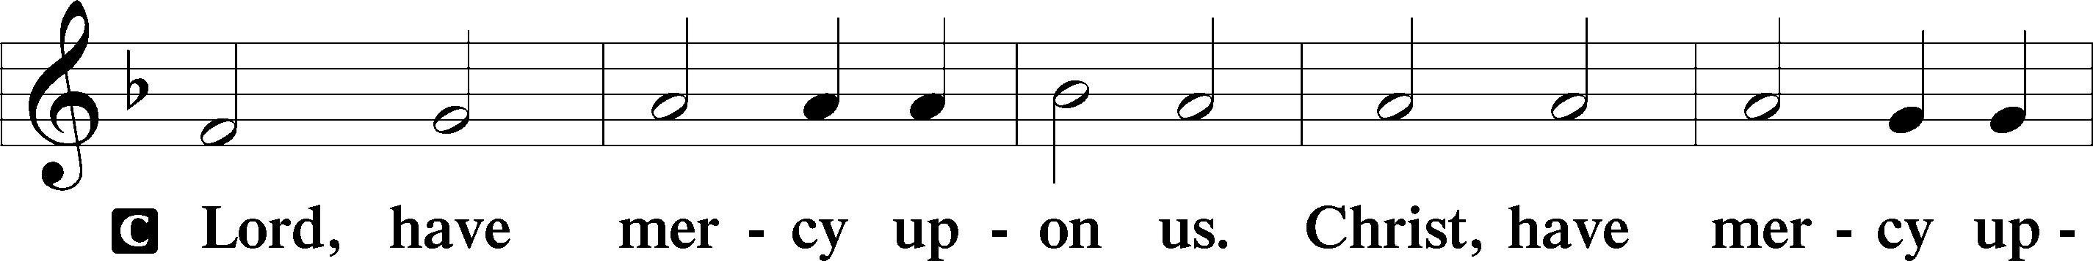
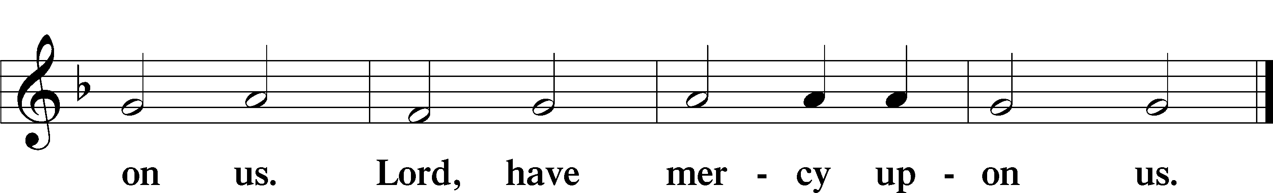

SALUTATION AND COLLECT OF THE DAY
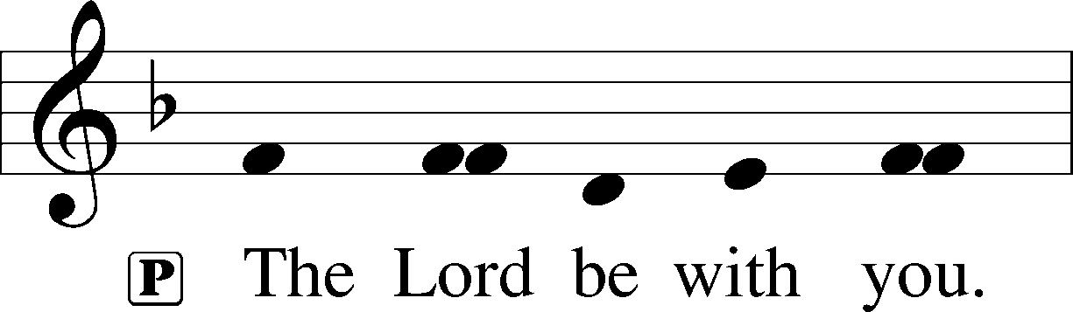
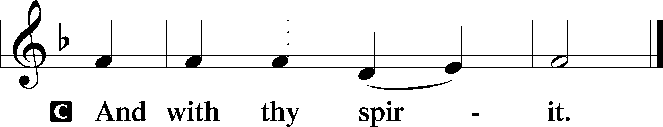

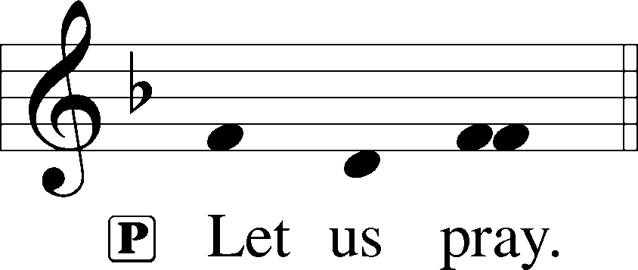

L O God, whose glory it is always to have mercy, be gracious to all who have gone astray from Your ways and bring them again with penitent hearts and steadfast faith to embrace and hold fast the unchangeable truth of Your Word; through Jesus Christ, Your Son, our Lord, who lives and reigns with You and the Holy Spirit, one God, now and forever.

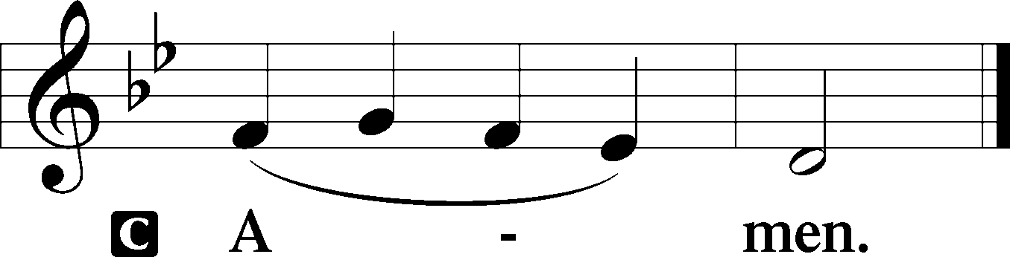

(Sit)

CHILDREN'S LESSON

OLD TESTAMENT READING Exodus 17:1–7
1All the congregation of the people of Israel moved on from the wilderness of Sin by stages, according to the commandment of the Lord, and camped at Rephidim, but there was no water for the people to drink. 2Therefore the people quarreled with Moses and said, “Give us water to drink.” And Moses said to them, “Why do you quarrel with me? Why do you test the Lord?” 3But the people thirsted there for water, and the people grumbled against Moses and said, “Why did you bring us up out of Egypt, to kill us and our children and our livestock with thirst?” 4So Moses cried to the Lord, “What shall I do with this people? They are almost ready to stone me.” 5And the Lord said to Moses, “Pass on before the people, taking with you some of the elders of Israel, and take in your hand the staff with which you struck the Nile, and go. 6Behold, I will stand before you there on the rock at Horeb, and you shall strike the rock, and water shall come out of it, and the people will drink.” And Moses did so, in the sight of the elders of Israel. 7And he called the name of the place Massah and Meribah, because of the quarreling of the people of Israel, and because they tested the Lord by saying, “Is the Lord among us or not?”

L This is the Word of the Lord.
C Thanks be to God.

GRADUAL Hebrews 12:2
[O come, let us fix our eyes on] | Jesus,*
the founder and perfecter | of our faith,
who for the joy that was set before him endured the cross, despis- | ing the shame,*
and is seated at the right hand of the | throne of God.

EPISTLE Romans 5:1–8
1Therefore, since we have been justified by faith, we have peace with God through our Lord Jesus Christ. 2Through him we have also obtained access by faith into this grace in which we stand, and we rejoice in hope of the glory of God. 3More than that, we rejoice in our sufferings, knowing that suffering produces endurance, 4and endurance produces character, and character produces hope, 5and hope does not put us to shame, because God’s love has been poured into our hearts through the Holy Spirit who has been given to us.
6For while we were still weak, at the right time Christ died for the ungodly. 7For one will scarcely die for a righteous person—though perhaps for a good person one would dare even to die— 8but God shows his love for us in that while we were still sinners, Christ died for us.
L This is the Word of the Lord.
C Thanks be to God.

(Stand)

HOLY GOSPEL John 4:5–26
L The Holy Gospel according to St. John, the fourth chapter.

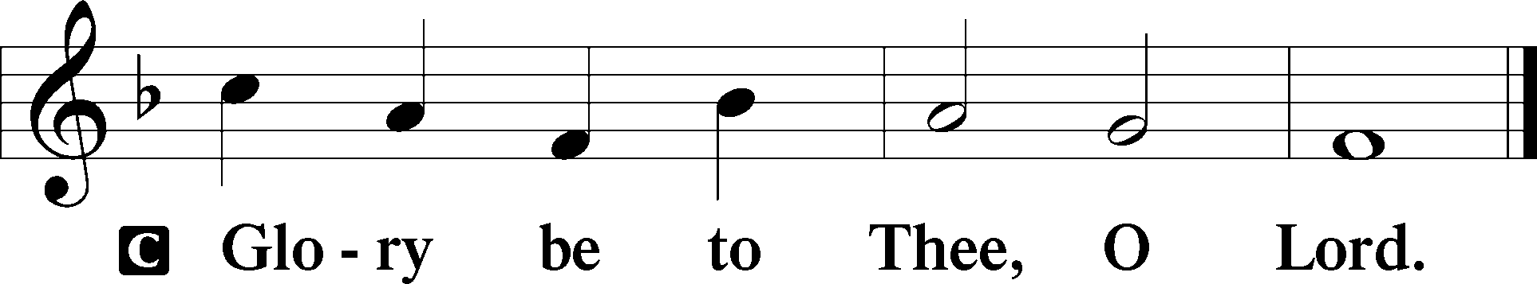

5[Jesus] came to a town of Samaria called Sychar, near the field that Jacob had given to his son Joseph. 6Jacob’s well was there; so Jesus, wearied as he was from his journey, was sitting beside the well. It was about the sixth hour.
7There came a woman of Samaria to draw water. Jesus said to her, “Give me a drink.” 8(For his disciples had gone away into the city to buy food.) 9The Samaritan woman said to him, “How is it that you, a Jew, ask for a drink from me, a woman of Samaria?” (For Jews have no dealings with Samaritans.) 10Jesus answered her, “If you knew the gift of God, and who it is that is saying to you, ‘Give me a drink,’ you would have asked him, and he would have given you living water.” 11The woman said to him, “Sir, you have nothing to draw water with, and the well is deep. Where do you get that living water? 12Are you greater than our father Jacob? He gave us the well and drank from it himself, as did his sons and his livestock.”

13Jesus said to her, “Everyone who drinks of this water will be thirsty again, 14but whoever drinks of the water that I will give him will never be thirsty forever. The water that I will give him will become in him a spring of water welling up to eternal life.” 15The woman said to him, “Sir, give me this water, so that I will not be thirsty or have to come here to draw water.”
16Jesus said to her, “Go, call your husband, and come here.” 17The woman answered him, “I have no husband.” Jesus said to her, “You are right in saying, ‘I have no husband’; 18for you have had five husbands, and the one you now have is not your husband. What you have said is true.” 19The woman said to him, “Sir, I perceive that you are a prophet. 20Our fathers worshiped on this mountain, but you say that in Jerusalem is the place where people ought to worship.” 21Jesus said to her, “Woman, believe me, the hour is coming when neither on this mountain nor in Jerusalem will you worship the Father. 22You worship what you do not know; we worship what we know, for salvation is from the Jews. 23But the hour is coming, and is now here, when the true worshipers will worship the Father in spirit and truth, for the Father is seeking such people to worship him. 24God is spirit, and those who worship him must worship in spirit and truth.” 25The woman said to him, “I know that Messiah is coming (he who is called Christ). When he comes, he will tell us all things.” 26Jesus said to her, “I who speak to you am he.”

L This is the Gospel of the Lord.

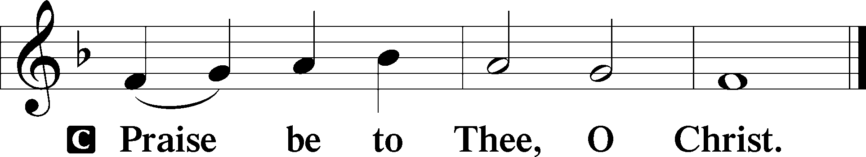

APOSTLES’ CREED
C I believe in God, the Father Almighty,
maker of heaven and earth.

And in Jesus Christ, His only Son, our Lord,
who was conceived by the Holy Spirit,
born of the virgin Mary,
suffered under Pontius Pilate,
was crucified, died and was buried.
He descended into hell.
The third day He rose again from the dead.
He ascended into heaven
and sits at the right hand of God the Father Almighty.
From thence He will come to judge the living and the dead.

I believe in the Holy Spirit,
the holy Christian Church,
the communion of saints,
the forgiveness of sins,
the resurrection of the body,
and the life T everlasting. Amen.

(Sit)

824 MAY GOD BESTOW ON US HIS GRACE
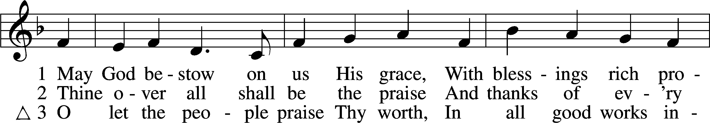
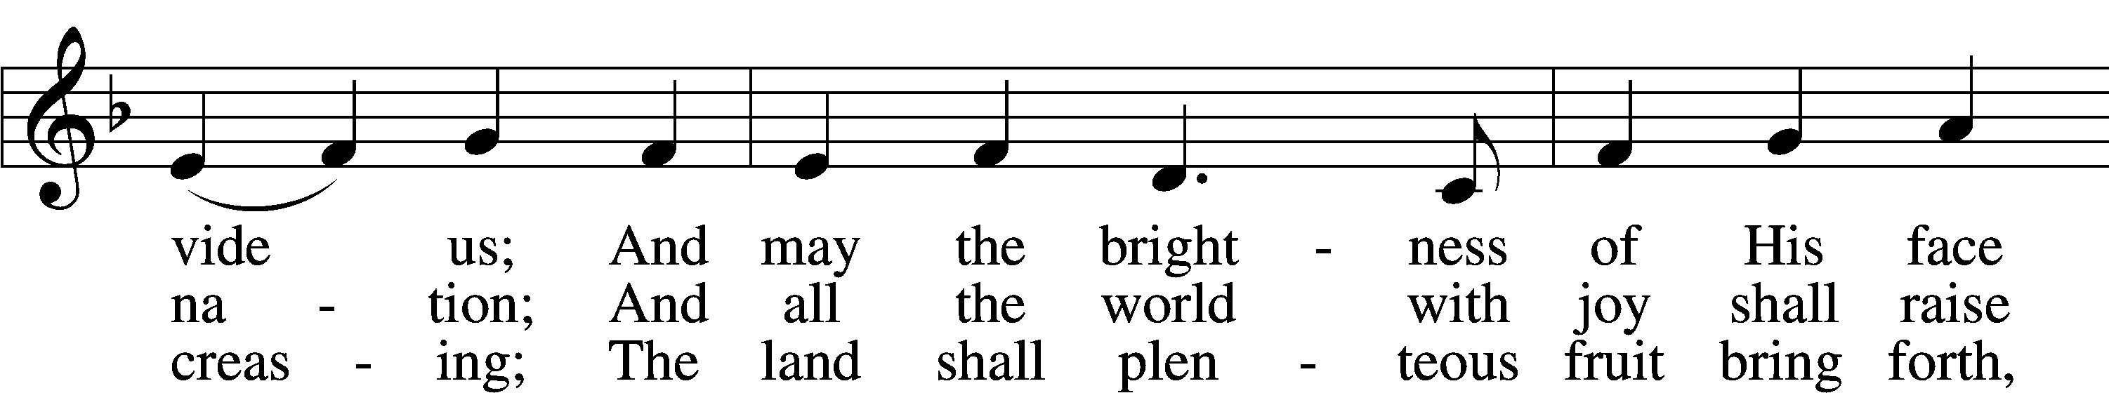
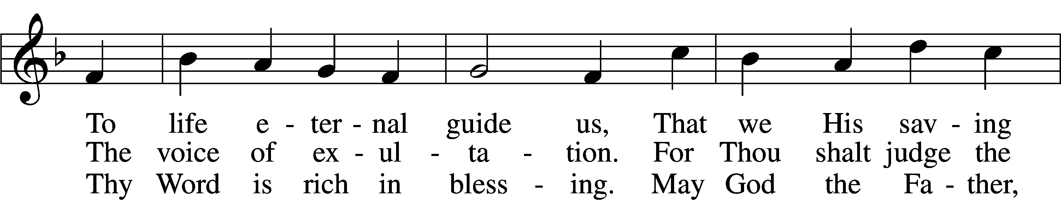
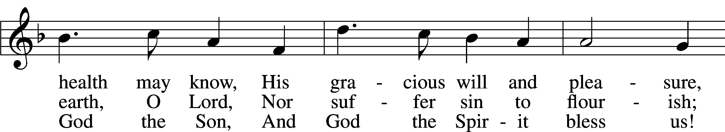
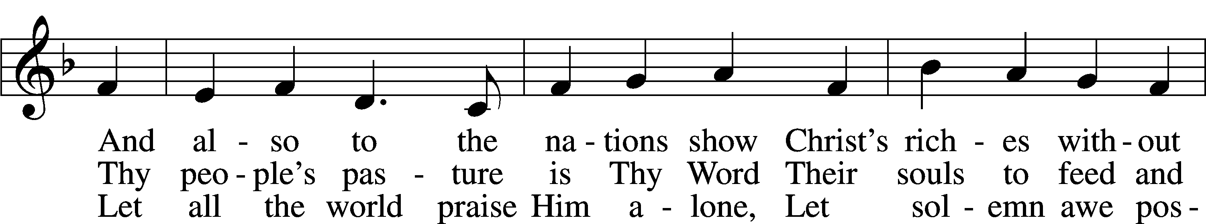
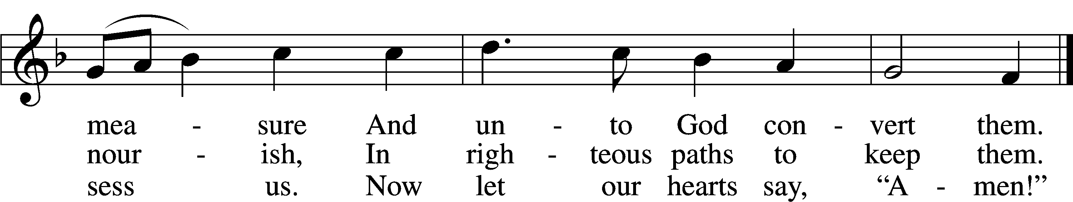
Text: Martin Luther, 1483–1546; tr. Richard Massie, 1800–87, alt.
Tune: David Lee, 1956
Text: Public domain
Tune: © 2004 David Lee. Used by permission: LSB Hymn License no. 110004798

SERMON OR MEDITATION ON THE READINGS

(Stand)

OFFERING
As a part of our expression of thanksgiving to God for the treasure of His salvation to us, we offer a portion of our treasure, according to what each has determined in their heart to give. Please place offerings in the collection plate at the back of the sanctuary before or after the service. Offerings can also be sent to Bethlehem Lutheran Church via U.S. Mail. Thank you!

OFFERTORY LSB 192
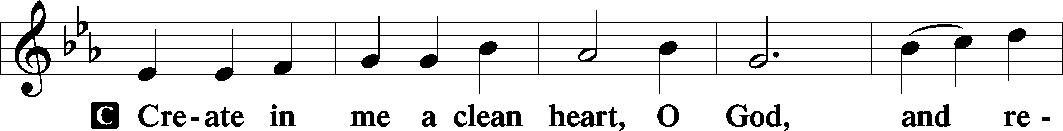
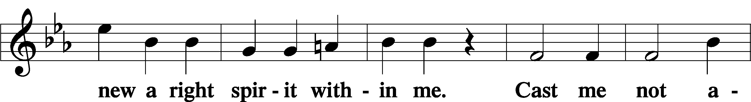
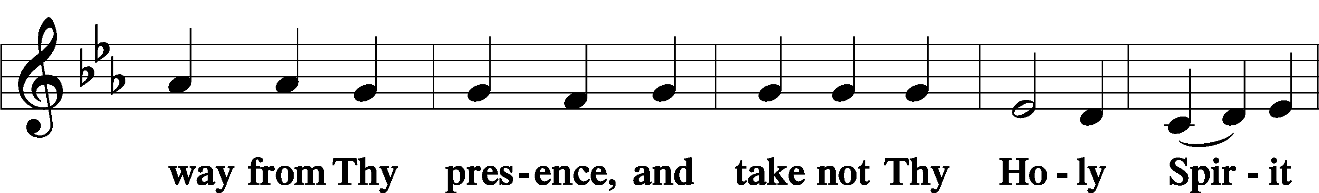
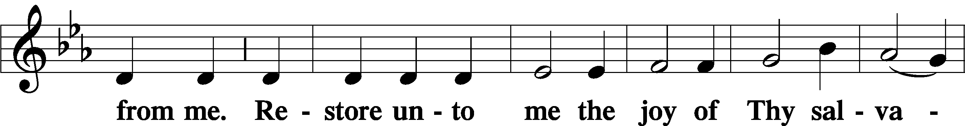
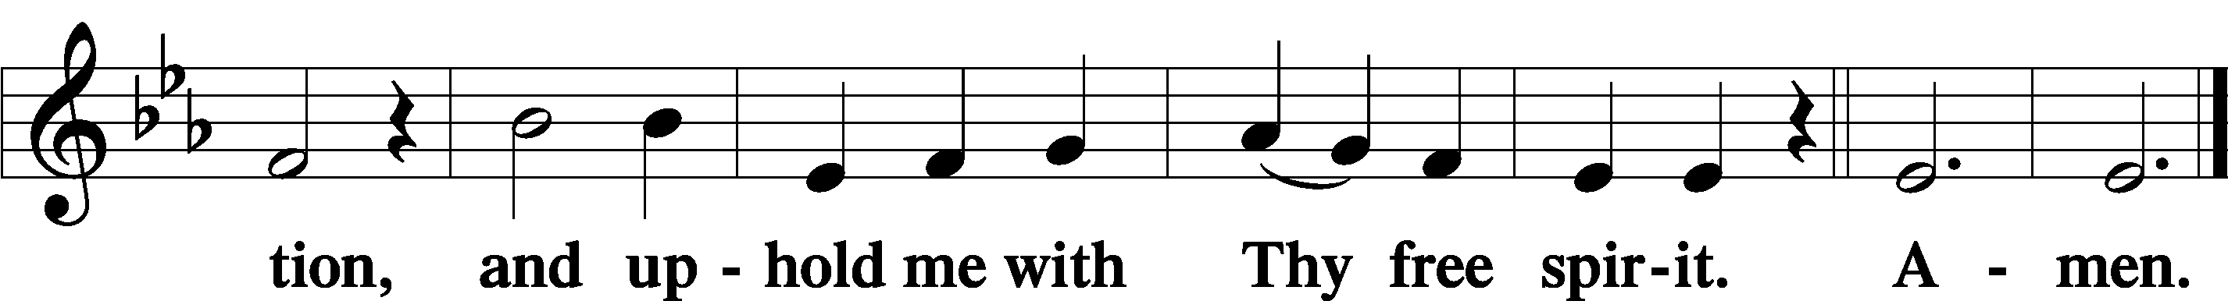

SHARING OF THE PEACE

(Sit)

PRAYER OF THE CHURCH

+ SERVICE OF THE SACRAMENT +
Note: The Service of The Sacrament is included in the lay bulletin solely as a viewers’ guide for those watching the livestream service; Communicant members who are unable to attend the Divine Service in person are encouraged to make arrangements with Pastor Engwall to receive the Lord’s Supper.

PREFACE LSB 194




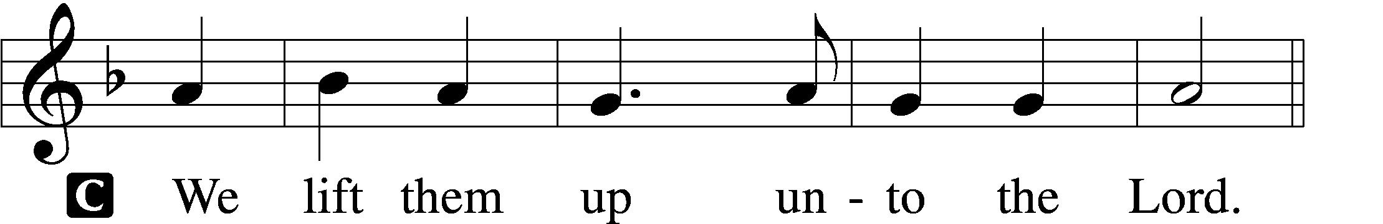

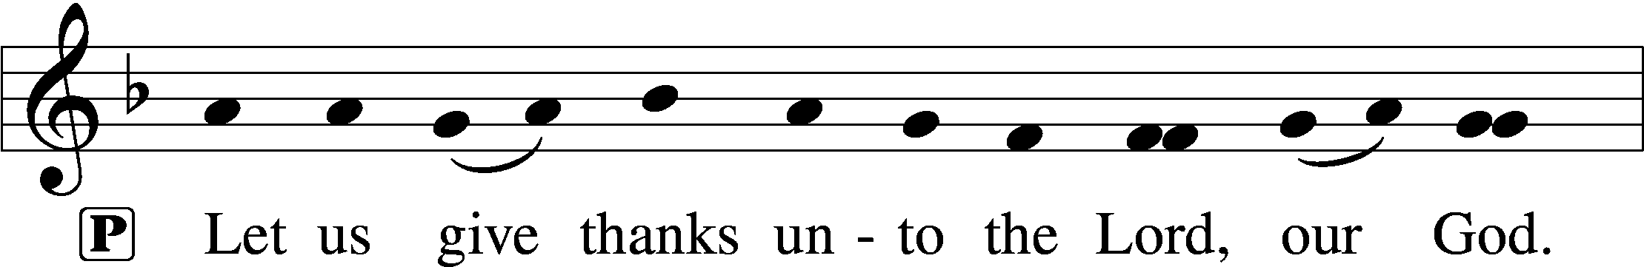
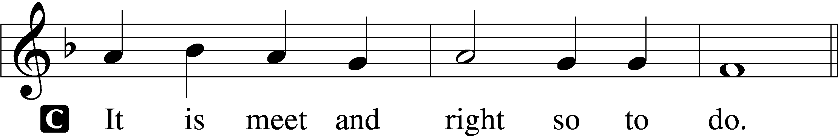

PROPER PREFACE (ABBREVIATED) LSB 194
L It is truly meet, right, and salutary . . . evermore praising You and saying:

SANCTUS LSB 195
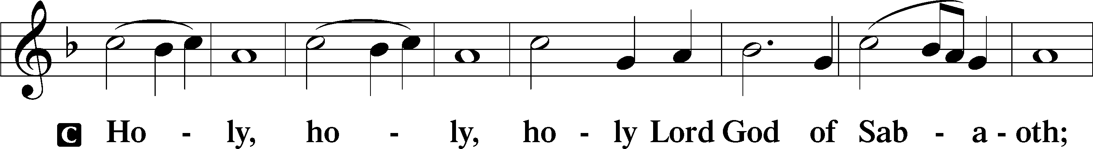
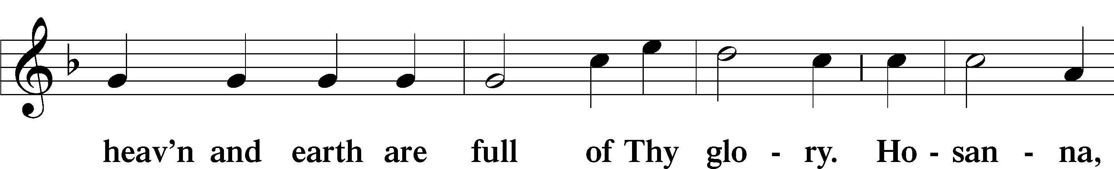
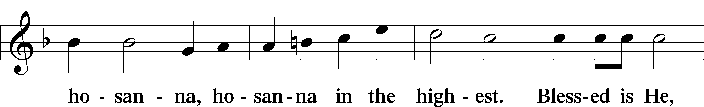
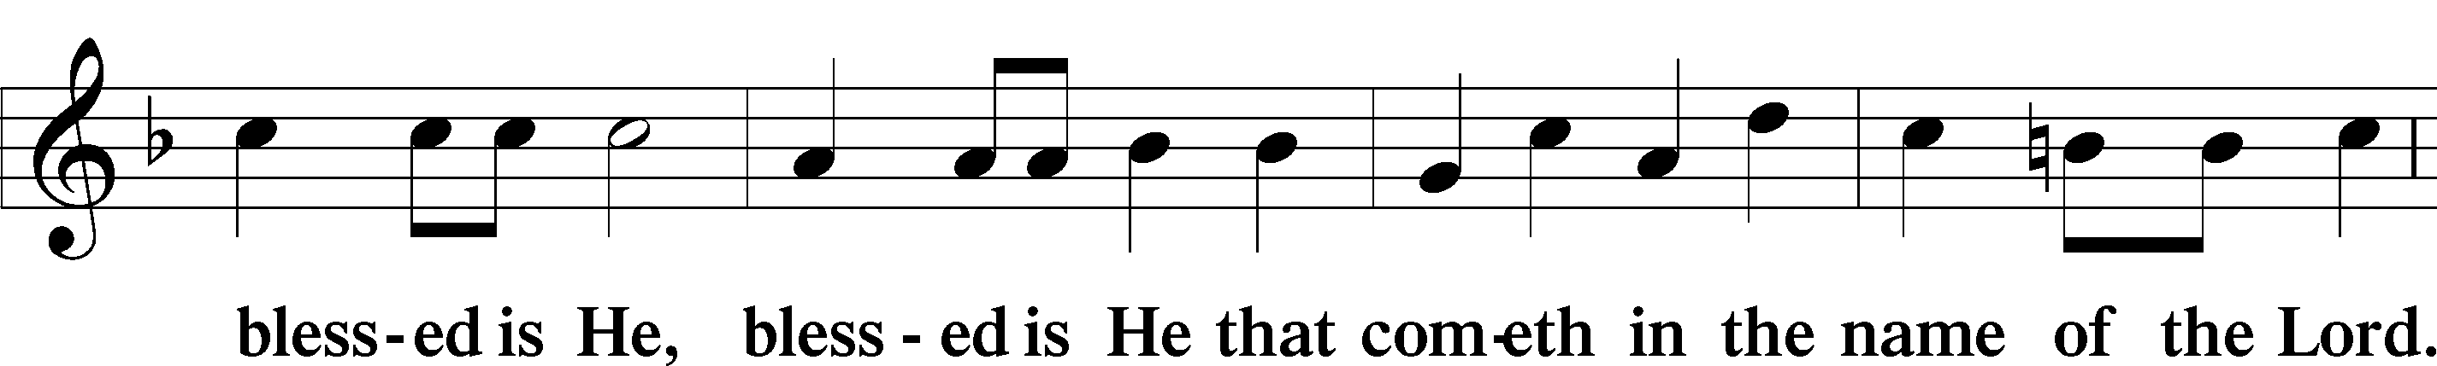
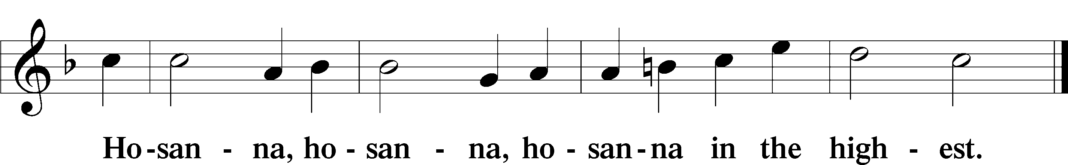

LORD’S PRAYER
C Our Father who art in heaven,
hallowed be Thy name,
Thy kingdom come,
Thy will be done on earth
as it is in heaven;
give us this day our daily bread;
and forgive us our trespasses
as we forgive those
who trespass against us;
and lead us not into temptation,
but deliver us from evil.
For Thine is the kingdom
and the power and the glory
forever and ever. Amen.

THE WORDS OF OUR LORD LSB 197

PAX DOMINI LSB 197
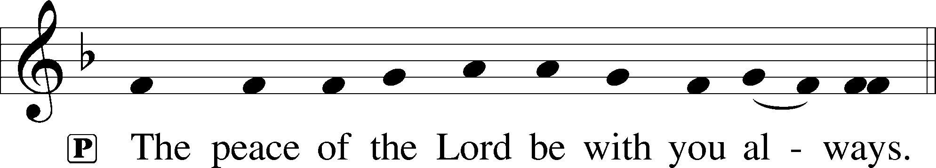

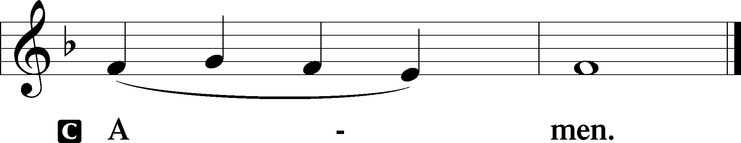

AGNUS DEI LSB 198
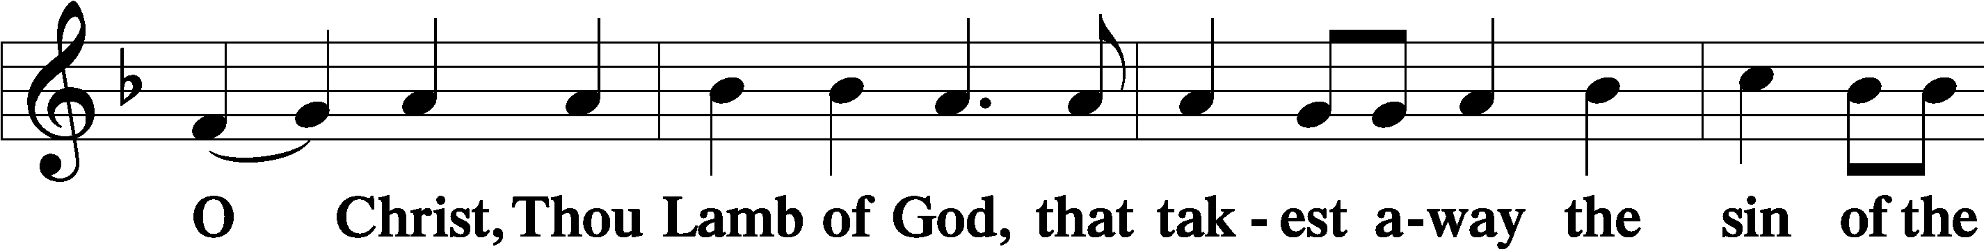
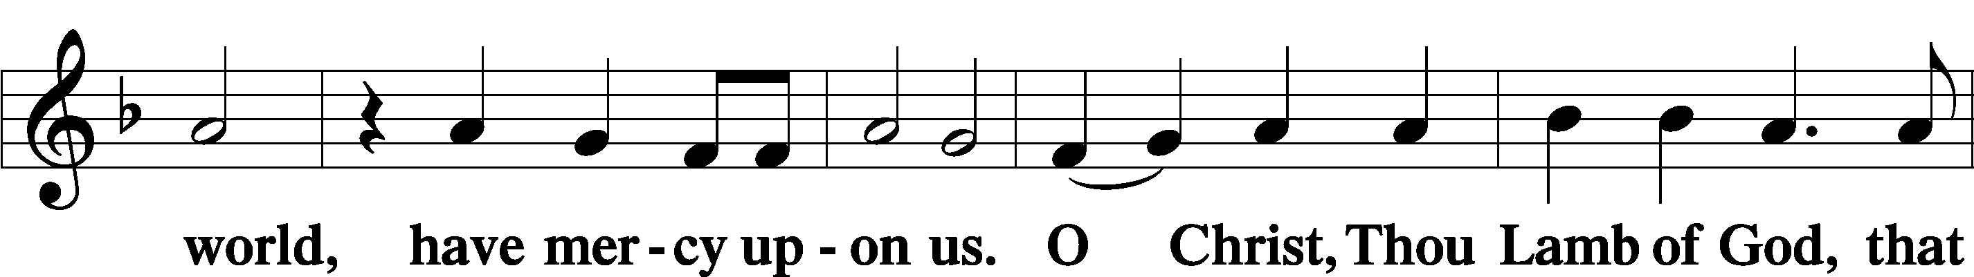
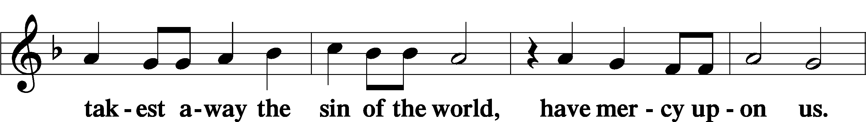
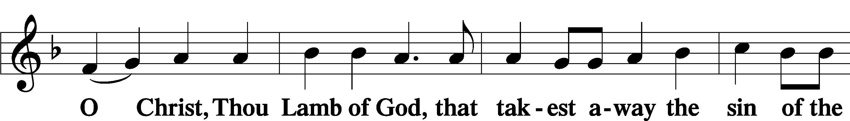
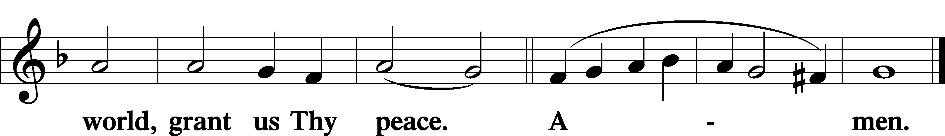

DISTRIBUTION
(The pastor and those who assist him receive the body and blood of Christ first, then commune those who are unable to come to the altar. The ushers will then direct all other communicants to the altar.)

597 WATER, BLOOD, AND SPIRIT CRYING
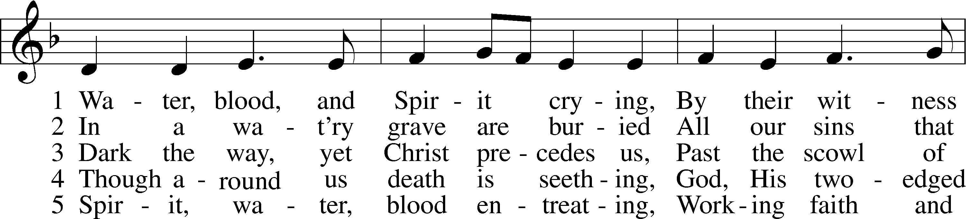
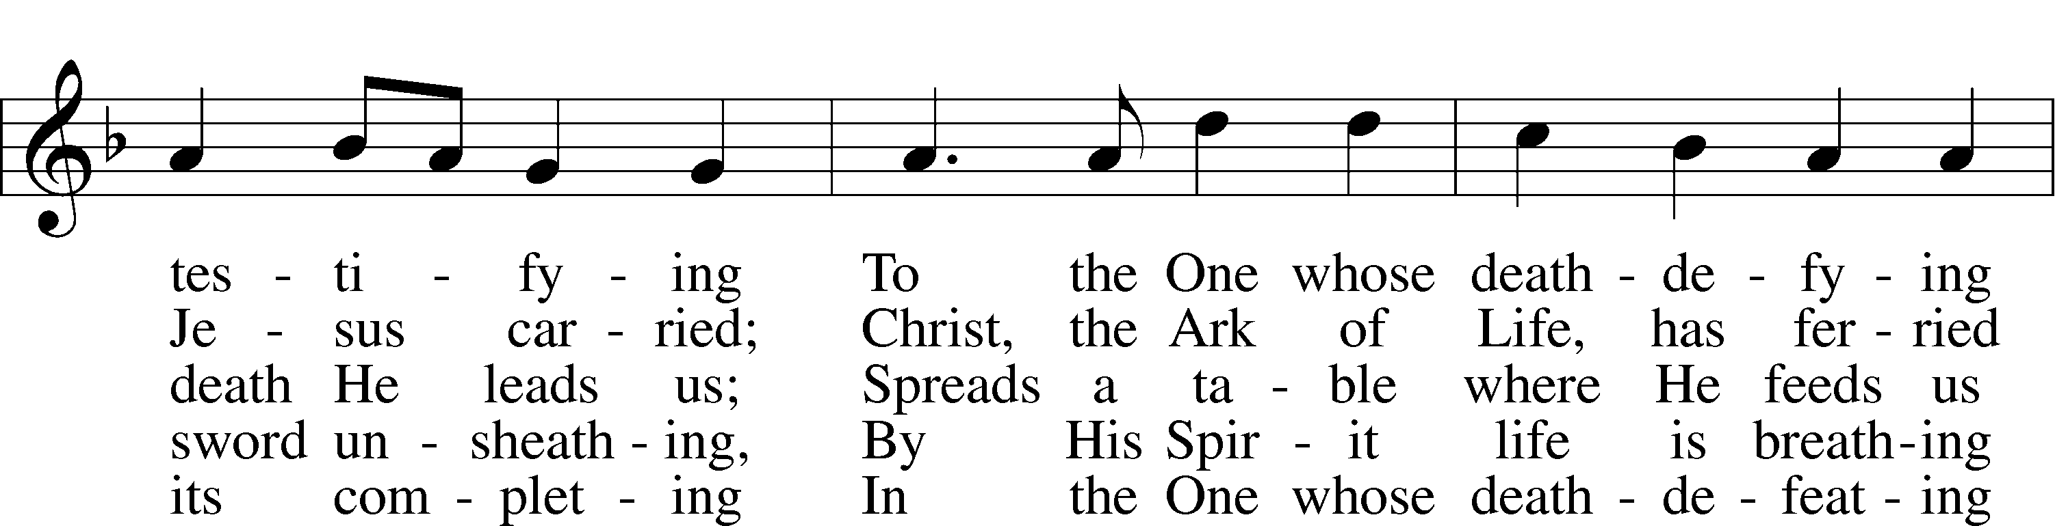
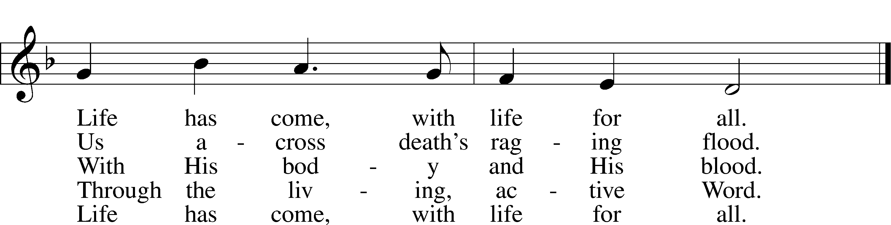
Text: Stephen P. Starke, 1955
Tune: Jeffrey N. Blersch, 1967
Text: © 1999 Stephen P. Starke, admin. Concordia Publishing House. Used by permission: LSB Hymn License no. 110004798
Tune: © 2003 Jeffrey N. Blersch. Used by permission: LSB Hymn License no. 110004798

INSTRUMENTAL

(Stand)

NUNC DIMITTIS LSB 199
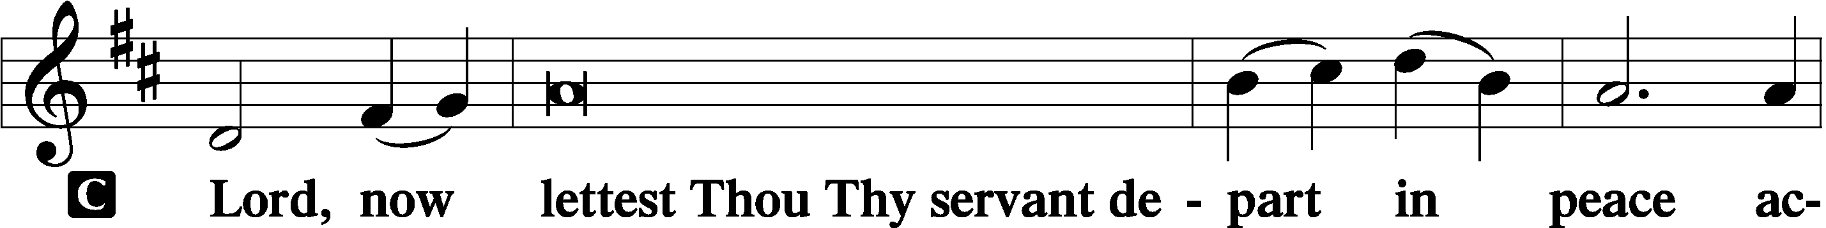

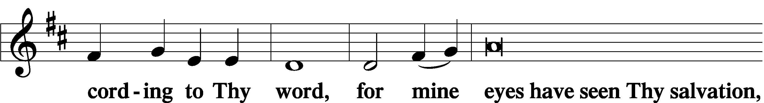

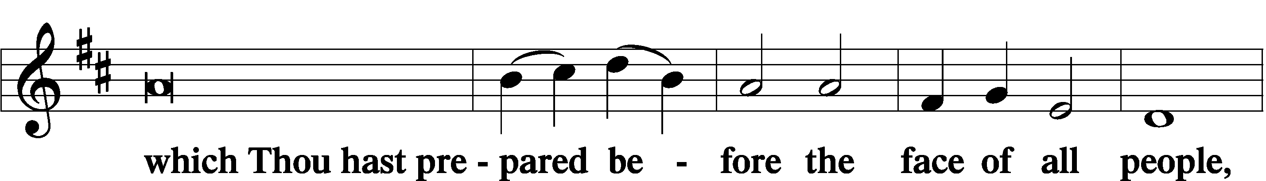

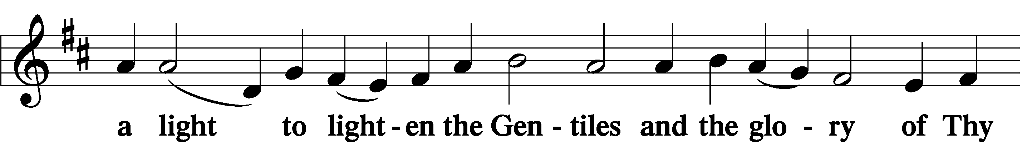

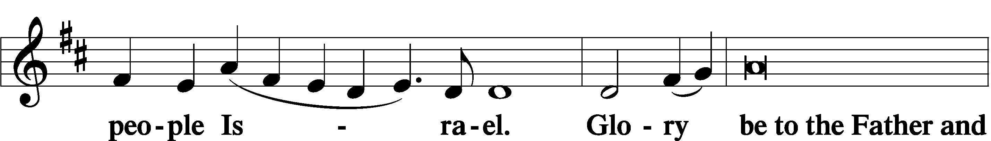

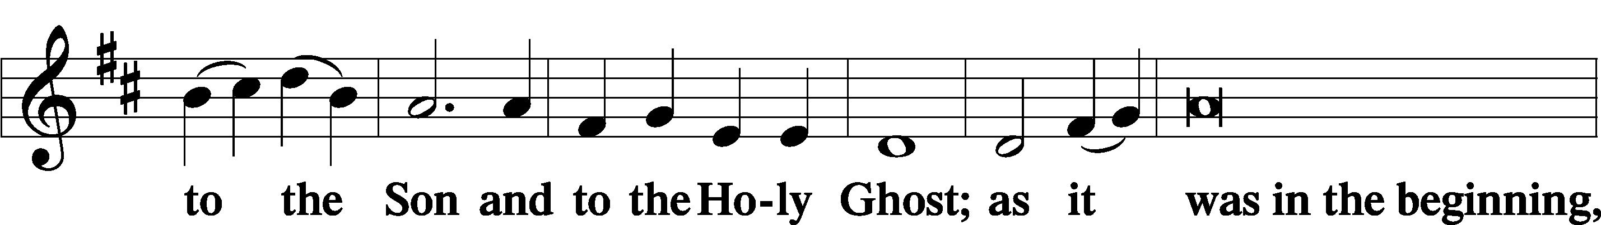

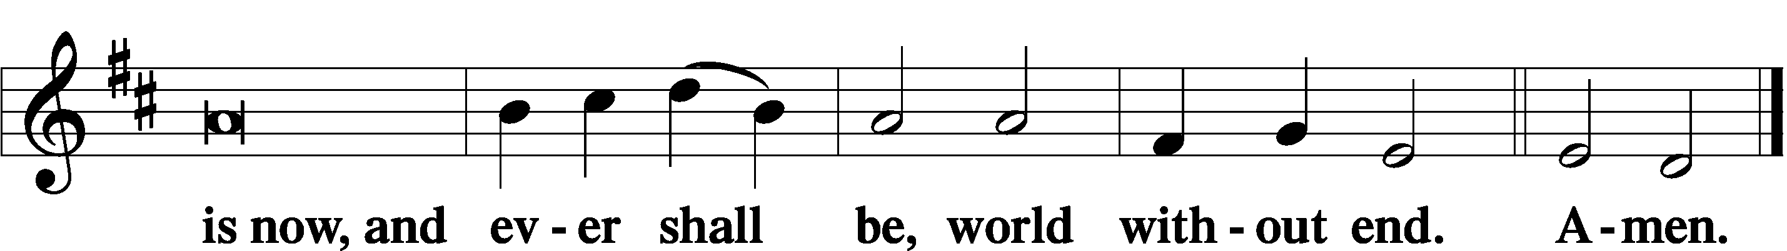

THANKSGIVING LSB 200
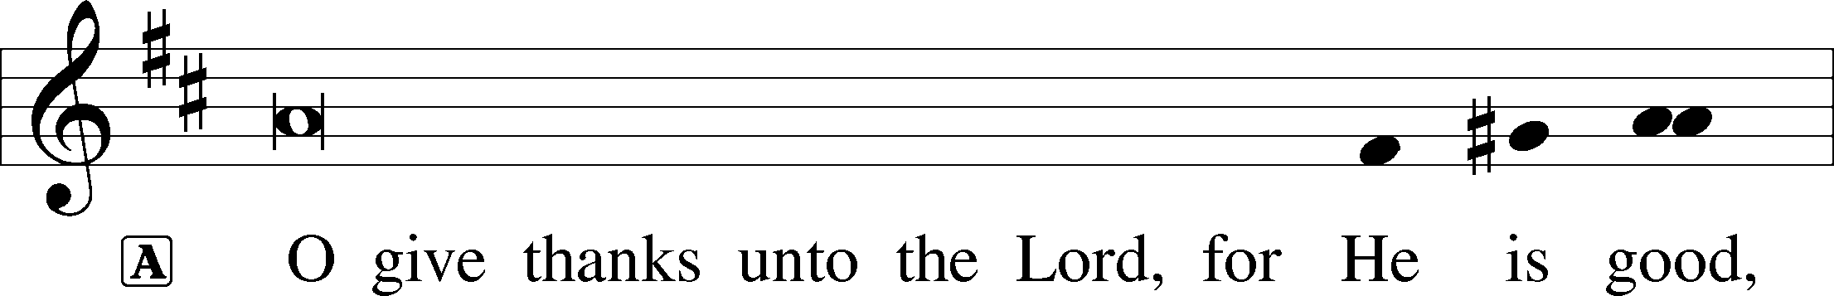

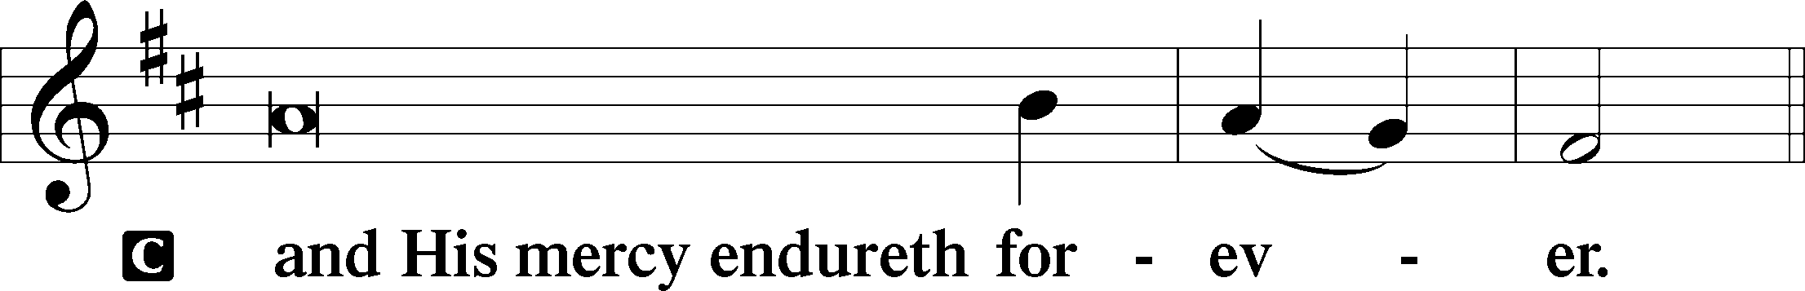

POST-COMMUNION COLLECT

SALUTATION LSB 201
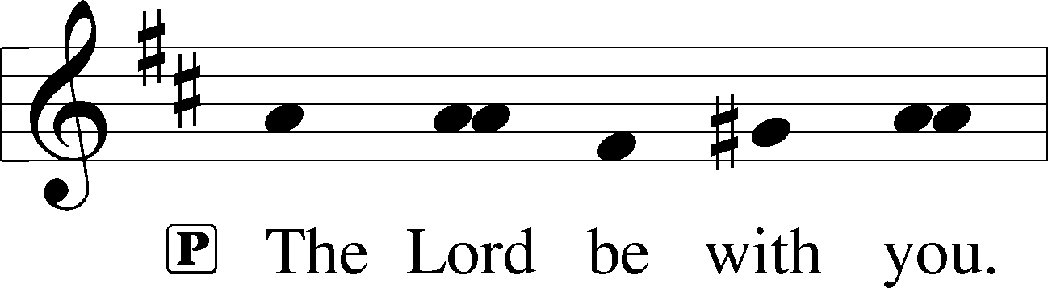

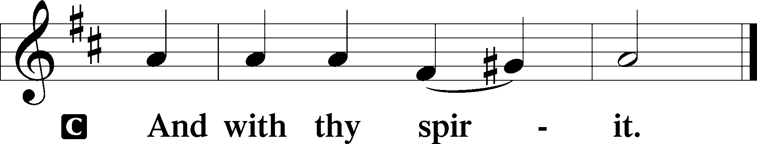

BENEDICAMUS LSB 202
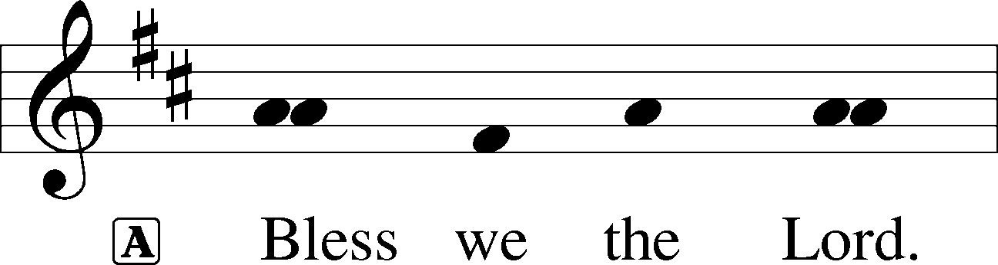

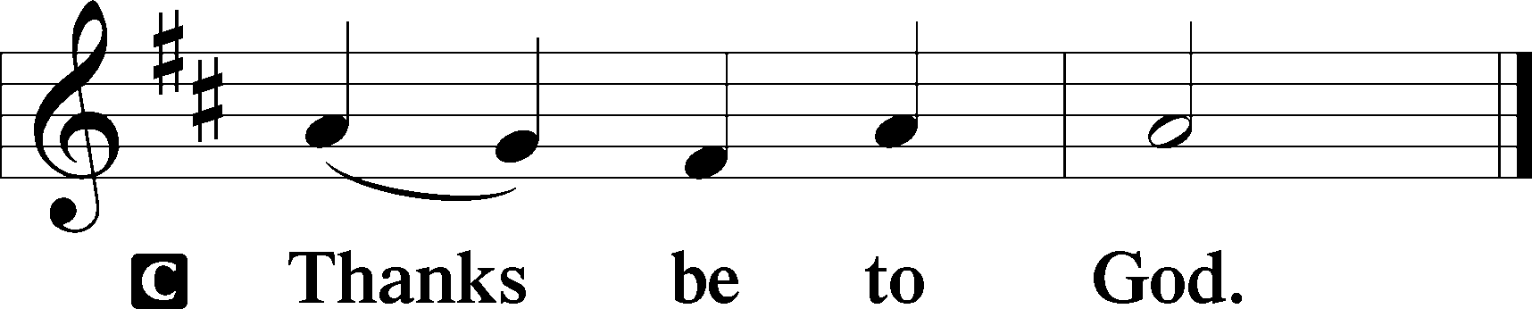

BENEDICTION
L:The grace of our Lord T Jesus Christ, and the love of God, and the fellowship of the Holy Spirit, be with us all.
C: Amen.

435 COME TO CALVARY’S HOLY MOUNTAIN
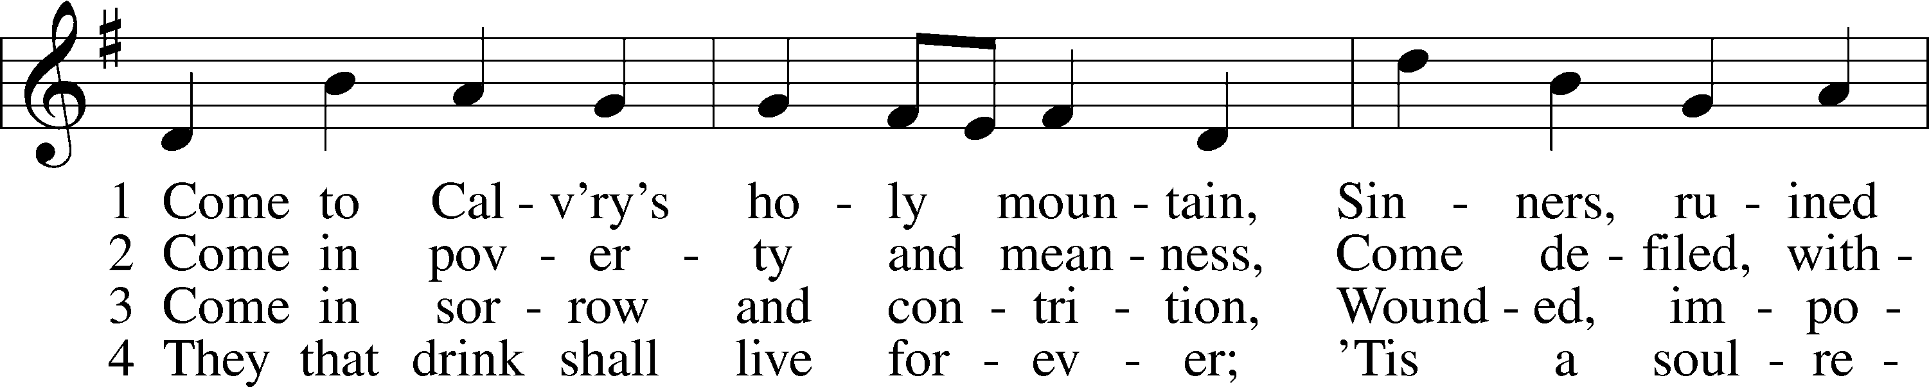
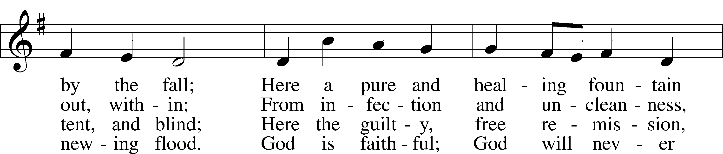
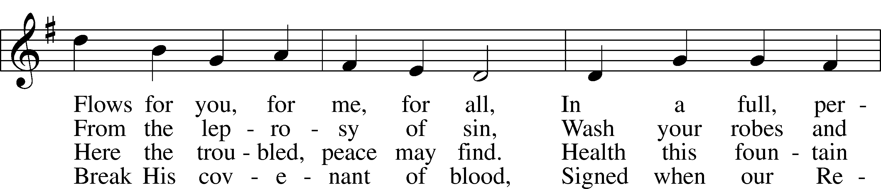
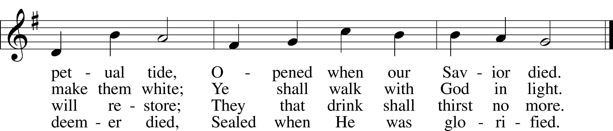
Text: James Montgomery, 1771–1854, alt.
Tune: Ludvig M. Lindeman, 1812–87
Text and tune: Public domain

ACKNOWLEDGMENTS
Unless otherwise indicated, Scripture quotations are from the ESV® Bible (The Holy Bible, English Standard Version®), copyright © 2001 by Crossway, a publishing ministry of Good News Publishers. Used by permission. All rights reserved.
Created by Lutheran Service Builder © 2026 Concordia Publishing House.

IN OUR PRAYERS:
Submitted petitions are included for two consecutive Sundays

For Those suffering afflictions of mind, body, or spirit:
Blake B., Carol R., Michele N., Dean S., Carl B., the family of Sandy A.

All of our Shut- Ins:
Betty A., Shirley F., Mary H., Patsy L., Herman L., Tommy M., Jerome M., Sharon B., Judy S., Anne H.

For missionaries
Deaconess Sandra R., Rev. Jonathan A.

ANNOUNCEMENTS
Please email announcements for Sunday bulletins by 8:00 a.m. Tuesday to pastorblcaiken@gmail.com
ALTAR FLOWERS:
Flowers are donated today by the W. family

EASTER LILY ORDER FORMS:
Time to order Easter lilies! They are $15.00 each. Order forms are in the East Narthex. The deadline to order is March 22nd.

BOARD OF ELDERS:
Meets today, after the service

PARISH COUNCIL:
Meets Sunday, March 15th after the service

ACTS DONATION FOR MARCH :
CANNED FRUIT

FELLOWSHIP COFFEE HOUR:
Every Sunday morning, during Bible Study and after the Divine Service, coffee, treats and good fellowship are waiting for you in our Fellowship Hall!

Attendance: Wednesday: 34 Sunday: 54

Offering: Wednesday: $2,185 Sunday: $3,548

Average weekly offering needed to make budget: $2,865

BE IN THE WORD!
SUNDAY MORNINGS AT 9 a.m.
Adult Bible Study
Sunday School for children and youth
TUESDAY MORNINGS AT 10:00 a.m.
Women’s Bible Study (resumes April 14)
WEDNESDAY EVENINGS AT 7 p.m.
Adult Bible Study (resumes April 15)
JUNIOR CONFIRMATION and ADULT INSTRUCTION
Always available by request:
Contact Pastor to schedule
OUR VALUE STATEMENT: Bethlehem Lutheran Church exists under God’s grace to save the lost and to strengthen the saved so that they may live bold and courageous lives of Christian witness before a non-believing world.
Therefore, our purpose is:
- to glorify God in Word and deed,
- to nurture each other in Christian love,
- to reach out to others with our Savior’s Gospel of life and salvation.
(Rom 5:8, Matt. 28:18-20).

OUR VISION: By the Grace of God, Bethlehem Lutheran Church, is a loving family united in Christ, learning, living, and spreading His Word.

OUR MISSION: Learn the Word. Live the Word. Spread the Word.

Lent, Holy Week, and Easter Schedule of services
Lenten Wednesdays: Feb. 25th; Mar. 4th,11th,18th, 25th
-Meals at 11:30 a.m. and 6:00 p.m.; services at 11:00 a.m. and 7:00 p.m.
Palm/ Passion Sunday: March 29th
Maundy Thursday: April 2nd; 7:00 p.m. Communion service
Good Friday: April 3rd; 7:00 p.m. Tenebrae service
Easter Sunday: April 5th; 9:00 a.m. breakfast, (no Bible study)
- 10:30 a.m. Divine Service (outside, weather permitting)

