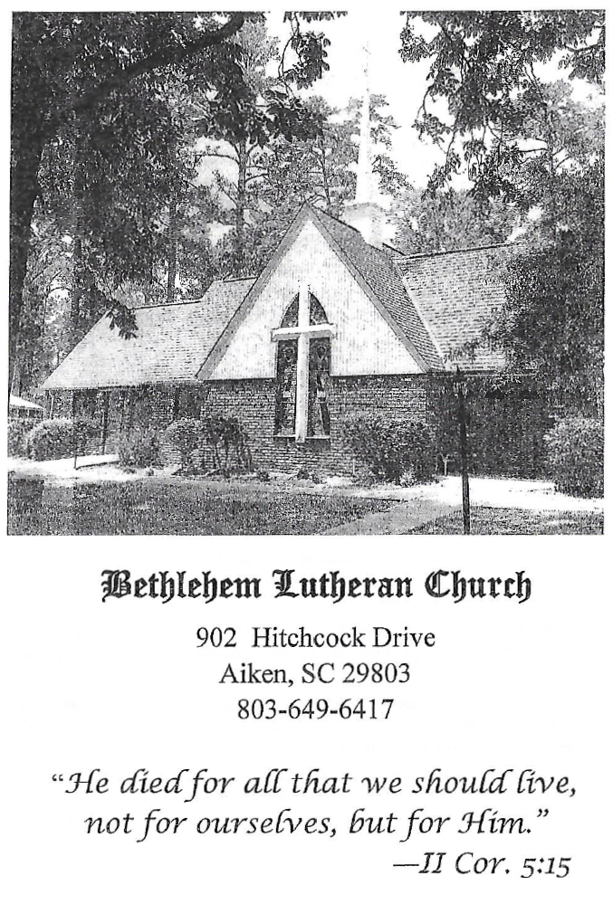

BETHLEHEM LUTHERAN CHURCH
A congregation of The Lutheran Church-Missouri Synod
902 Hitchcock Drive SW,
Aiken, South Carolina 29803
Church Phone: (803) 649-6417
blcaikensc@gmail.com

Bethlehem Lutheran welcomes our members and guests to our worship service! Unable to join us in person? Please find us on Facebook live. The service is also posted on our website; bethlehemlutheranaiken.org.

+ + + + + + + + + + + + + + +
All Saints’ Day
November 1, 2026
10:30 a.m.
+ + + + + + + + + + + + + + +

+ SERVICE OF PREPARATION +

(After the bell tolls, please observe a time of silence.)

WELCOME AND ANNOUNCEMENTS

(Stand)

671 SING WITH ALL THE SAINTS IN GLORY
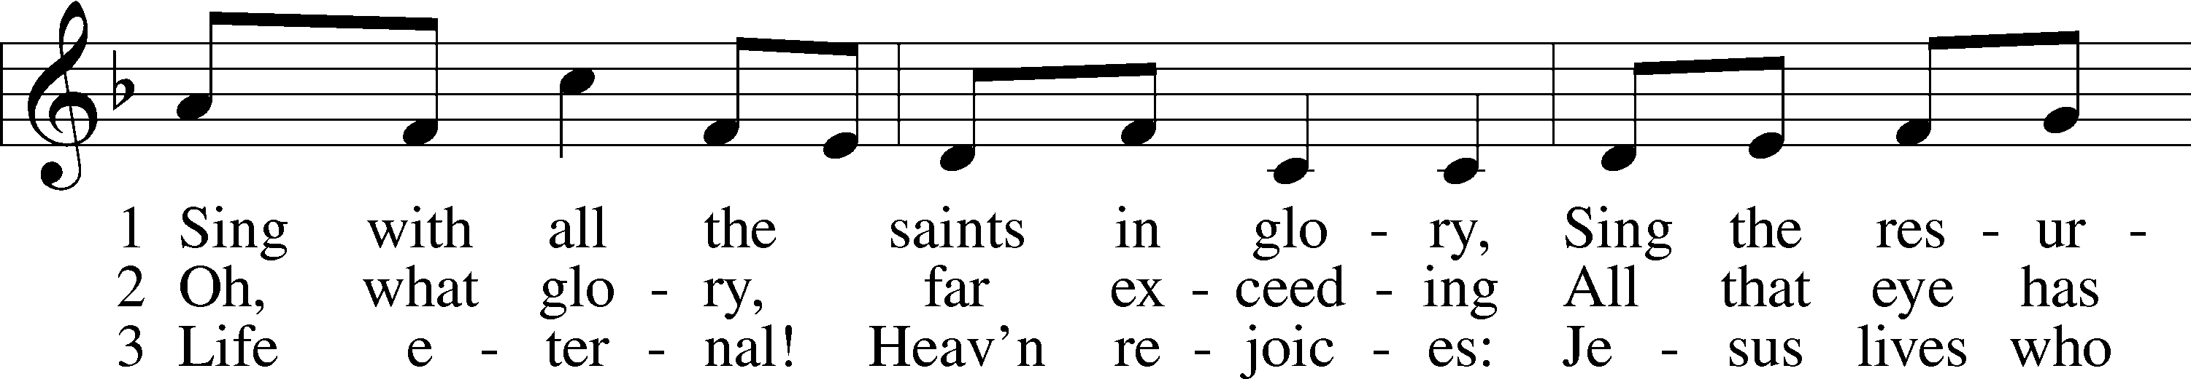
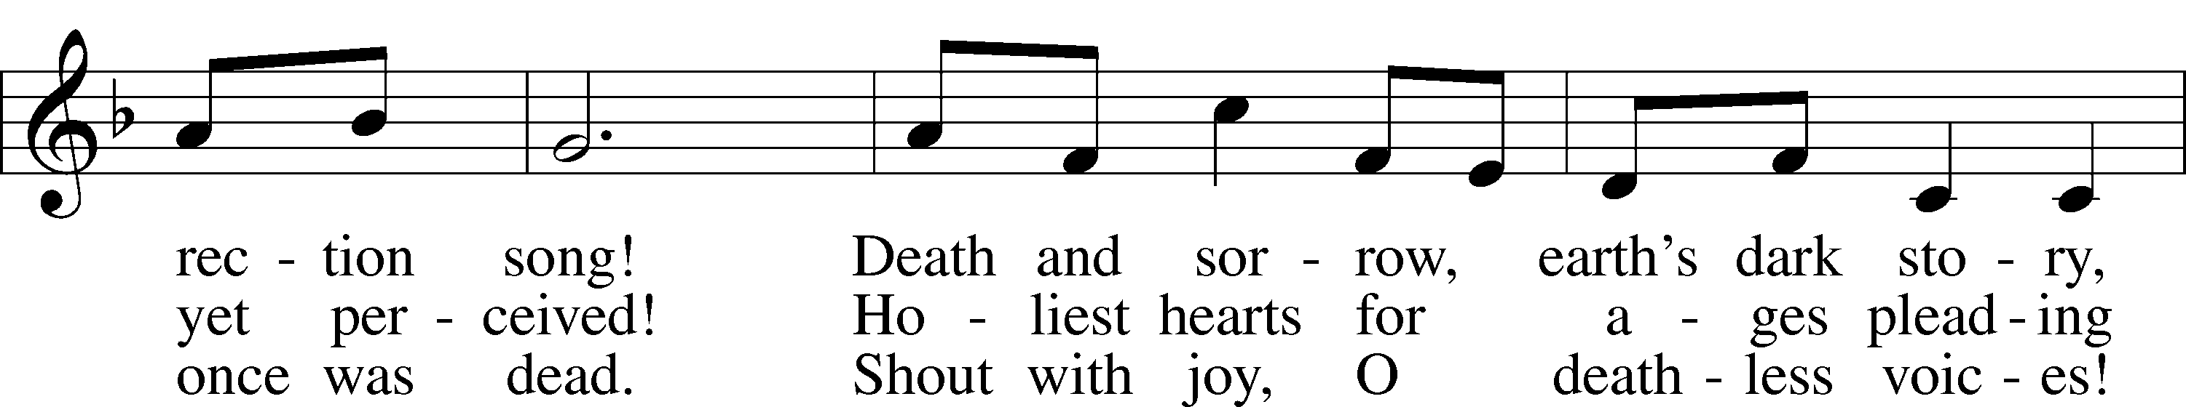
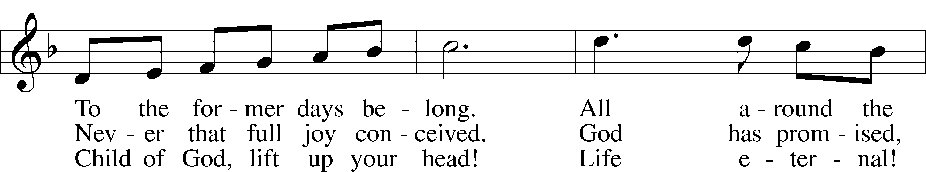
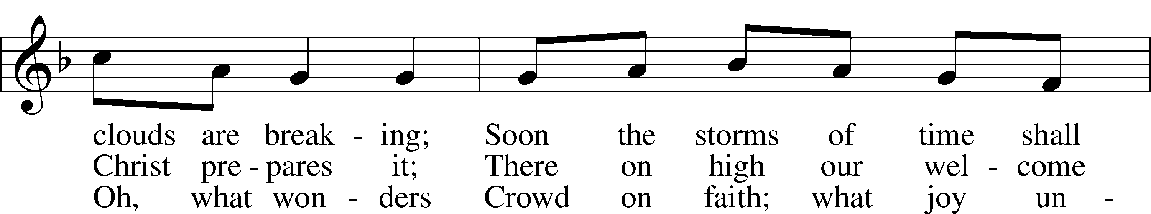
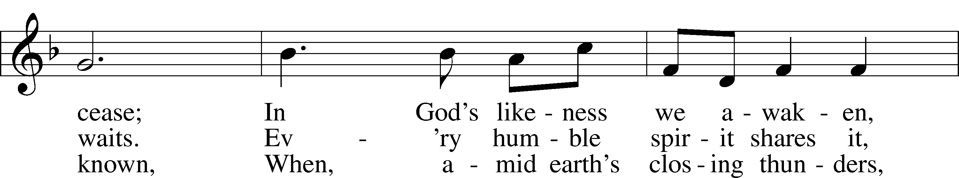
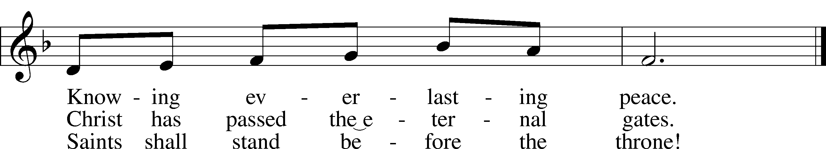
Text: William J. Irons, 1812–83, alt.
Tune: William B. Roberts, 1947
Text: Public domain
Tune: © 1995 Augsburg Fortress. Used by permission: LSB Hymn License no. 110004798

+ CONFESSION AND ABSOLUTION +

(The sign of the cross may be made by all in remembrance of their Baptism.)

INVOCATION LSB 151
L In the name of the Father and of the T Son and of the Holy Spirit.
C Amen.

EXHORTATION LSB 151
L If we say we have no sin, we deceive ourselves, and the truth is not in us.
C But if we confess our sins, God, who is faithful and just, will forgive our sins and cleanse us from all unrighteousness.

(Silence for reflection on God’s Word and for self-examination.)

CONFESSION OF SINS LSB 151
L Let us then confess our sins to God our Father.
C Most merciful God, we confess that we are by nature sinful and unclean. We have sinned against You in thought, word, and deed, by what we have done and by what we have left undone. We have not loved You with our whole heart; we have not loved our neighbors as ourselves. We justly deserve Your present and eternal punishment. For the sake of Your Son, Jesus Christ, have mercy on us. Forgive us, renew us, and lead us, so that we may delight in Your will and walk in Your ways to the glory of Your holy name. Amen.

DECLARATION OF GRACE LSB 151
L In the mercy of almighty God, Jesus Christ was given to die for us, and for His sake God forgives us all our sins. To those who believe in Jesus Christ He gives the power to become the children of God and bestows on them the Holy Spirit. May the Lord, who has begun this good work in us, bring it to completion in the day of our Lord Jesus Christ.
C Amen.

+ SERVICE OF THE WORD +

INTROIT Psalm 31:1, 3, 5; antiphon: Revelation 7:14b

These are the ones coming out of the great tribu- | lation.*
They have washed their robes and made them white in the blood | of the Lamb.
In you, O Lord, do I take refuge; let me never be | put to shame;*
in your righteousness de- | liver me.
For you are my rock and my | fortress;*
and for your name’s sake you lead me and | guide me.
Into your hand I commit my | spirit;*
you have redeemed me, O Lord, | faithful God.
Glory be to the Father and | to the Son*
and to the Holy | Spirit;
as it was in the be- | ginning,*
is now, and will be forever. | Amen.
These are the ones coming out of the great tribu- | lation.*
They have washed their robes and made them white in the blood | of the Lamb.

KYRIE LSB 152

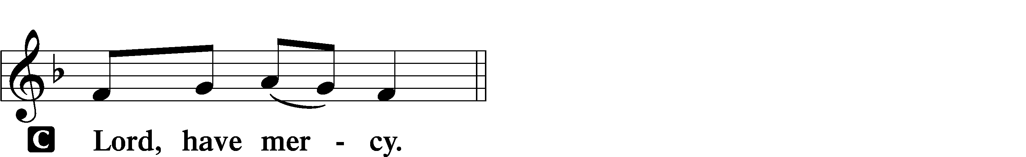

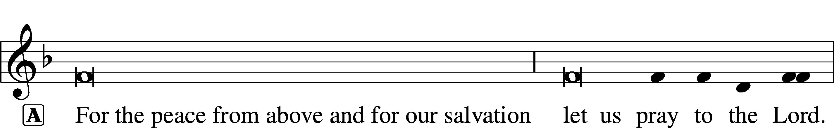
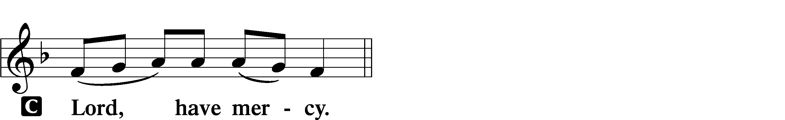

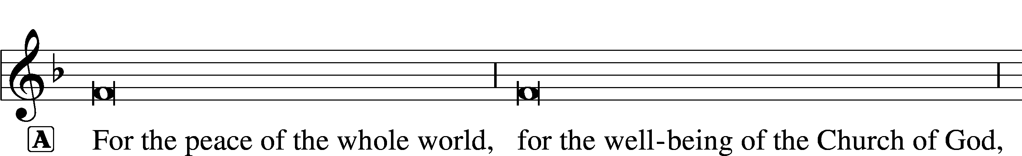

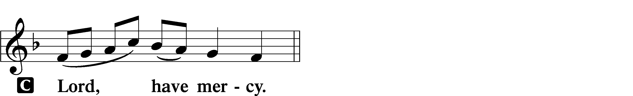

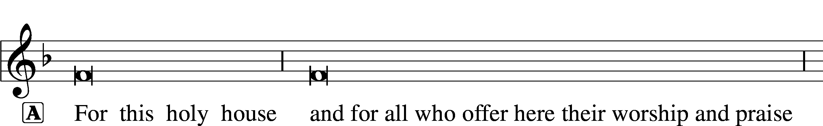

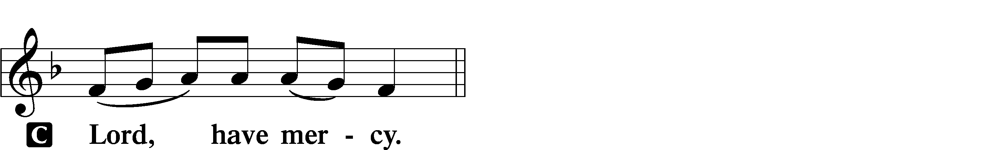




GLORIA IN EXCELSIS LSB 154
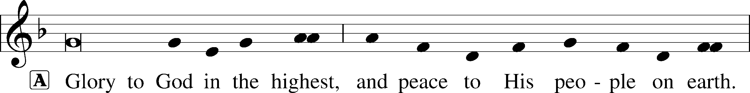
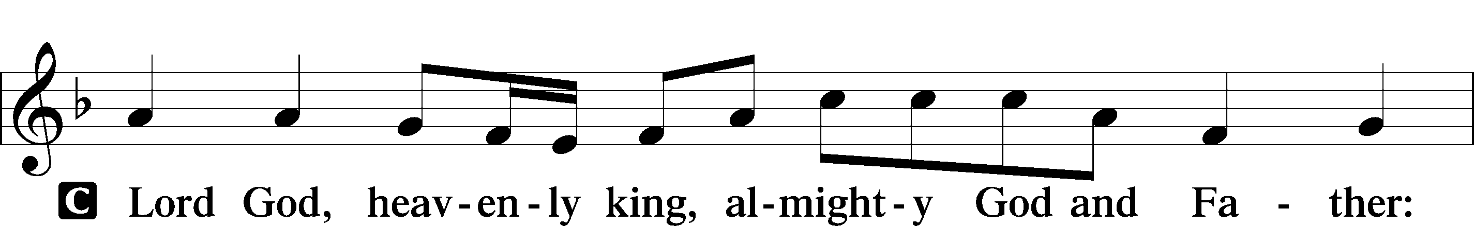
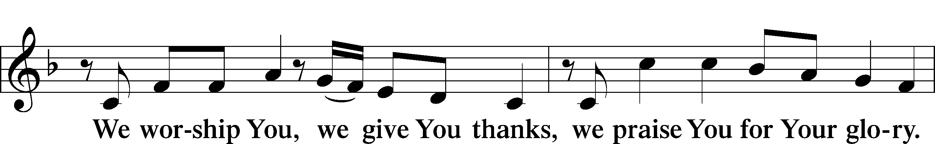
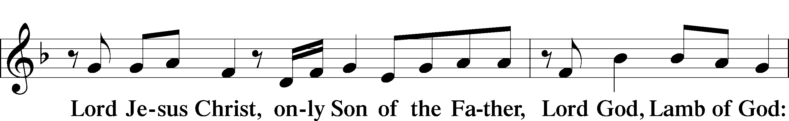
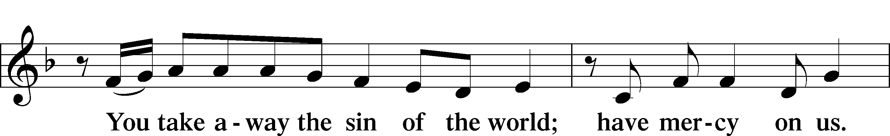
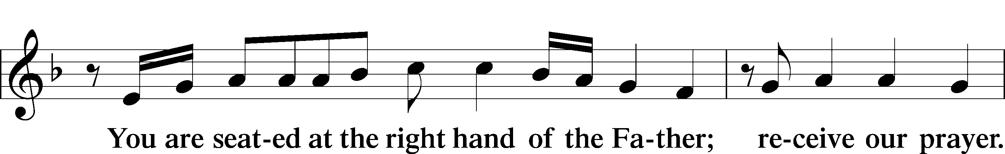
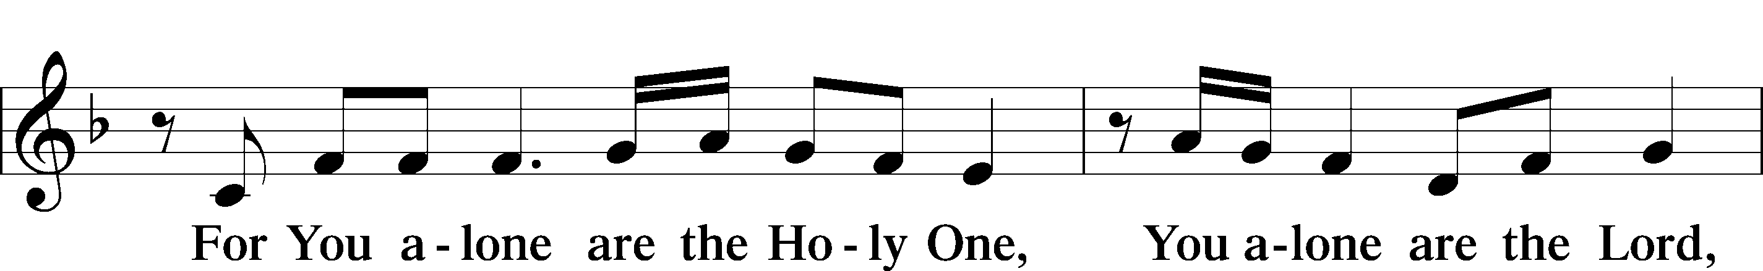
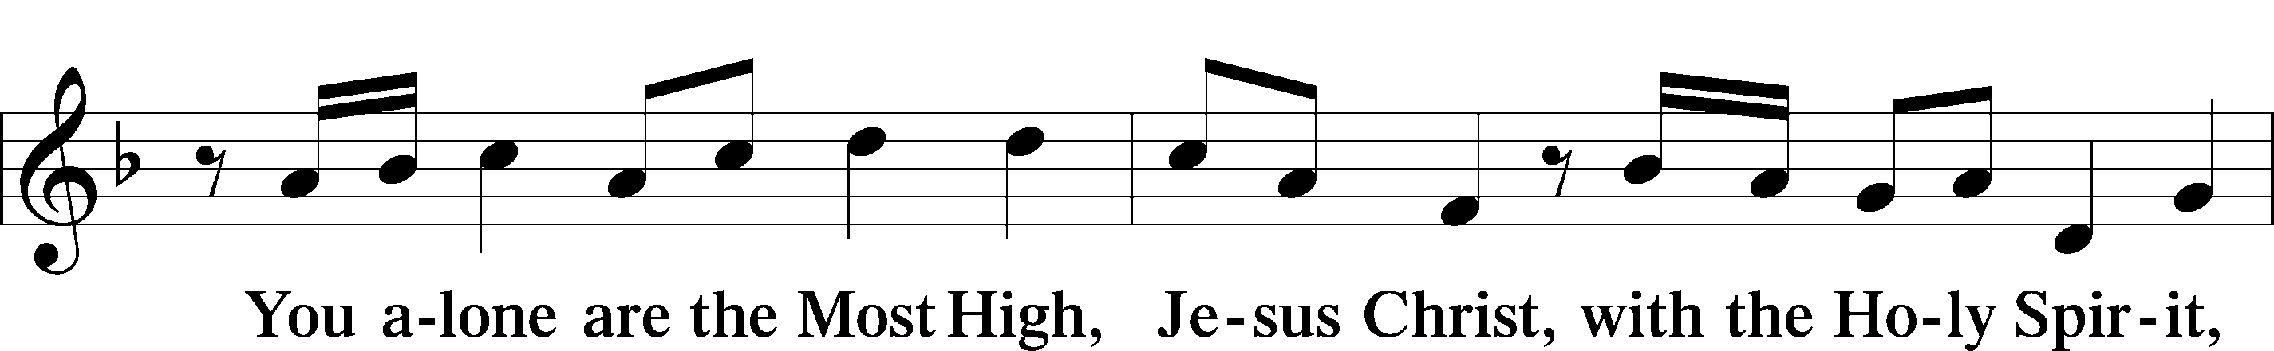
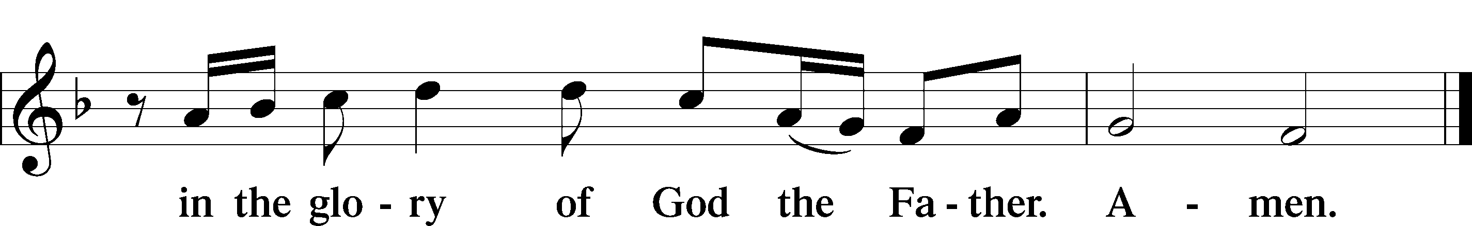

SALUTATION AND COLLECT OF THE DAY LSB 156
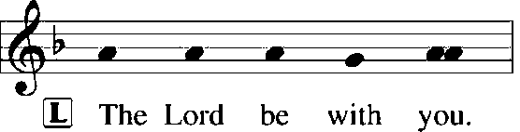
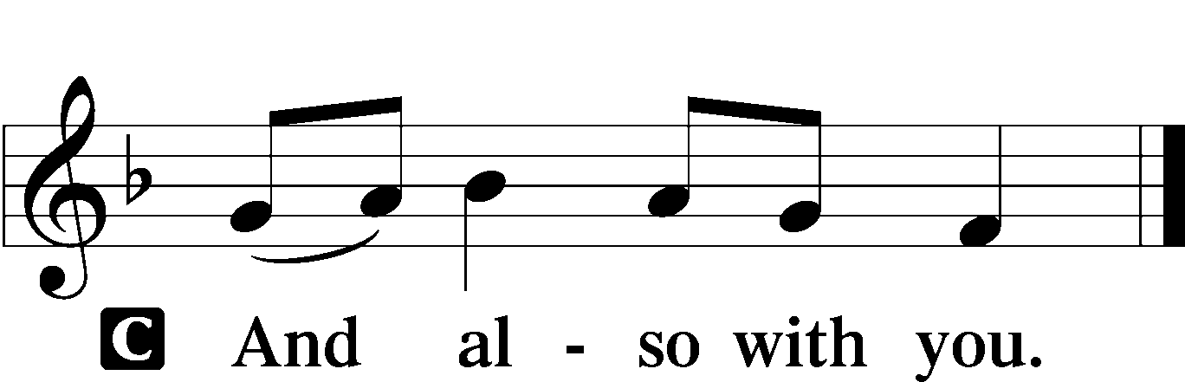

L Let us pray.
Almighty and everlasting God, You knit together Your faithful people of all times and places into one holy communion, the mystical body of Your Son, Jesus Christ. Grant us so to follow Your blessed saints in all virtuous and godly living that, together with them, we may come to the unspeakable joys You have prepared for those who love You; through Jesus Christ, our Lord, who lives and reigns with You and the Holy Spirit, one God, now and forever.

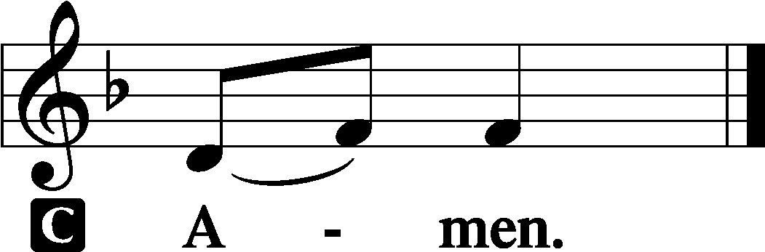

(Sit)

FIRST READING Revelation 7:2–17
2Then I saw another angel ascending from the rising of the sun, with the seal of the living God, and he called with a loud voice to the four angels who had been given power to harm earth and sea, 3saying, “Do not harm the earth or the sea or the trees, until we have sealed the servants of our God on their foreheads.” 4And I heard the number of the sealed, 144,000, sealed from every tribe of the sons of Israel:

(next page)

512,000 from the tribe of Judah were sealed,
12,000 from the tribe of Reuben,
12,000 from the tribe of Gad,
612,000 from the tribe of Asher,
12,000 from the tribe of Naphtali,
12,000 from the tribe of Manasseh,
712,000 from the tribe of Simeon,
12,000 from the tribe of Levi,
12,000 from the tribe of Issachar,
812,000 from the tribe of Zebulun,
12,000 from the tribe of Joseph,
12,000 from the tribe of Benjamin were sealed.
9After this I looked, and behold, a great multitude that no one could number, from every nation, from all tribes and peoples and languages, standing before the throne and before the Lamb, clothed in white robes, with palm branches in their hands, 10and crying out with a loud voice, “Salvation belongs to our God who sits on the throne, and to the Lamb!” 11And all the angels were standing around the throne and around the elders and the four living creatures, and they fell on their faces before the throne and worshiped God, 12saying, “Amen! Blessing and glory and wisdom and thanksgiving and honor and power and might be to our God forever and ever! Amen.”
13Then one of the elders addressed me, saying, “Who are these, clothed in white robes, and from where have they come?” 14I said to him, “Sir, you know.” And he said to me, “These are the ones coming out of the great tribulation. They have washed their robes and made them white in the blood of the Lamb.
15“Therefore they are before the throne of God,
and serve him day and night in his temple;
and he who sits on the throne will shelter them with his presence.
16They shall hunger no more, neither thirst anymore;
the sun shall not strike them,
nor any scorching heat.
17For the Lamb in the midst of the throne will be their shepherd,
and he will guide them to springs of living water,
and God will wipe away every tear from their eyes.”

L This is the Word of the Lord.
C Thanks be to God.

GRADUAL Revelation 7:14b; Psalm 84:5
These are the ones coming out of the great tribu- | lation.*
They have washed their robes and made them white in the blood | of the Lamb.
Blessèd are those whose strength is | in you,*
in whose heart are the highways to | Zion.

EPISTLE 1 John 3:1–3
1See what kind of love the Father has given to us, that we should be called children of God; and so we are. The reason why the world does not know us is that it did not know him. 2Beloved, we are God’s children now, and what we will be has not yet appeared; but we know that when he appears we shall be like him, because we shall see him as he is. 3And everyone who thus hopes in him purifies himself as he is pure.

L This is the Word of the Lord.
C Thanks be to God.

(Stand)

ALLELUIA AND VERSE LSB 156
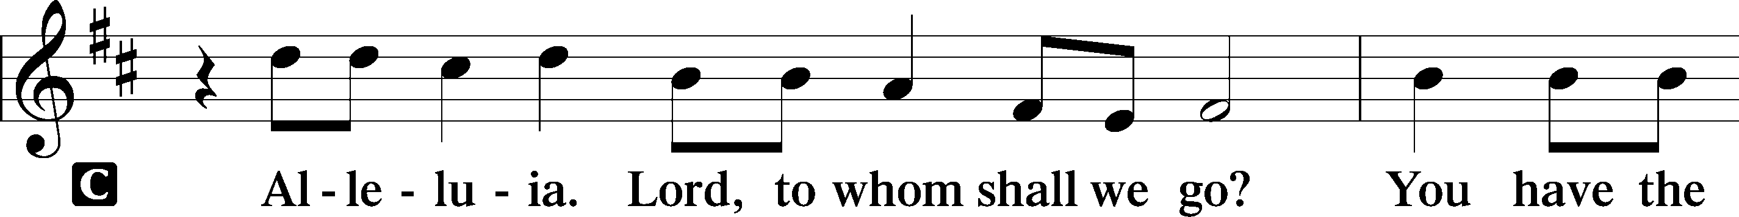
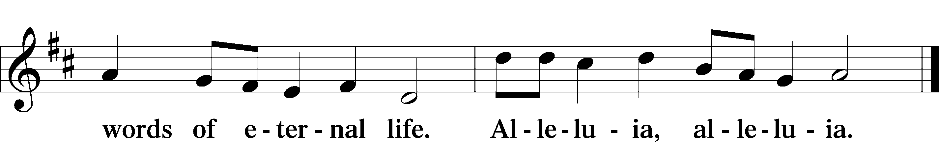

HOLY GOSPEL Matthew 5:1–12
L The Holy Gospel according to St. Matthew, the fifth chapter.

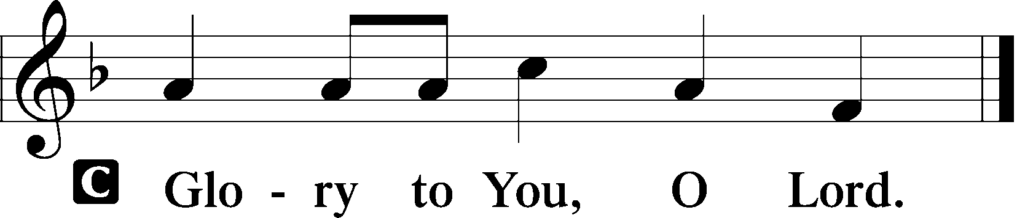

1Seeing the crowds, [Jesus] went up on the mountain, and when he sat down, his disciples came to him.
2And he opened his mouth and taught them, saying:
3“Blessed are the poor in spirit, for theirs is the kingdom of heaven.
4“Blessed are those who mourn, for they shall be comforted.
5“Blessed are the meek, for they shall inherit the earth.
6“Blessed are those who hunger and thirst for righteousness, for they shall be satisfied.
7“Blessed are the merciful, for they shall receive mercy.
8“Blessed are the pure in heart, for they shall see God.
9“Blessed are the peacemakers, for they shall be called sons of God.
10“Blessed are those who are persecuted for righteousness’ sake, for theirs is the kingdom of heaven.
11“Blessed are you when others revile you and persecute you and utter all kinds of evil against you falsely on my account. 12Rejoice and be glad, for your reward is great in heaven, for so they persecuted the prophets who were before you.”

L This is the Gospel of the Lord.

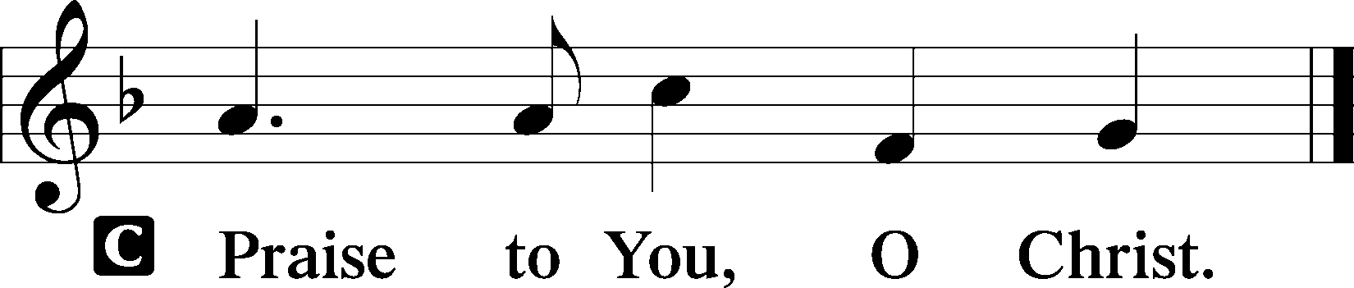

(Sit)

950 SPLENDOR AND HONOR
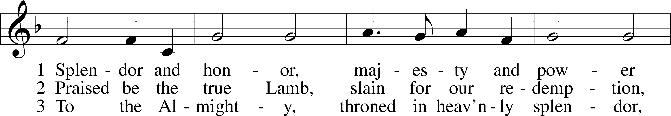
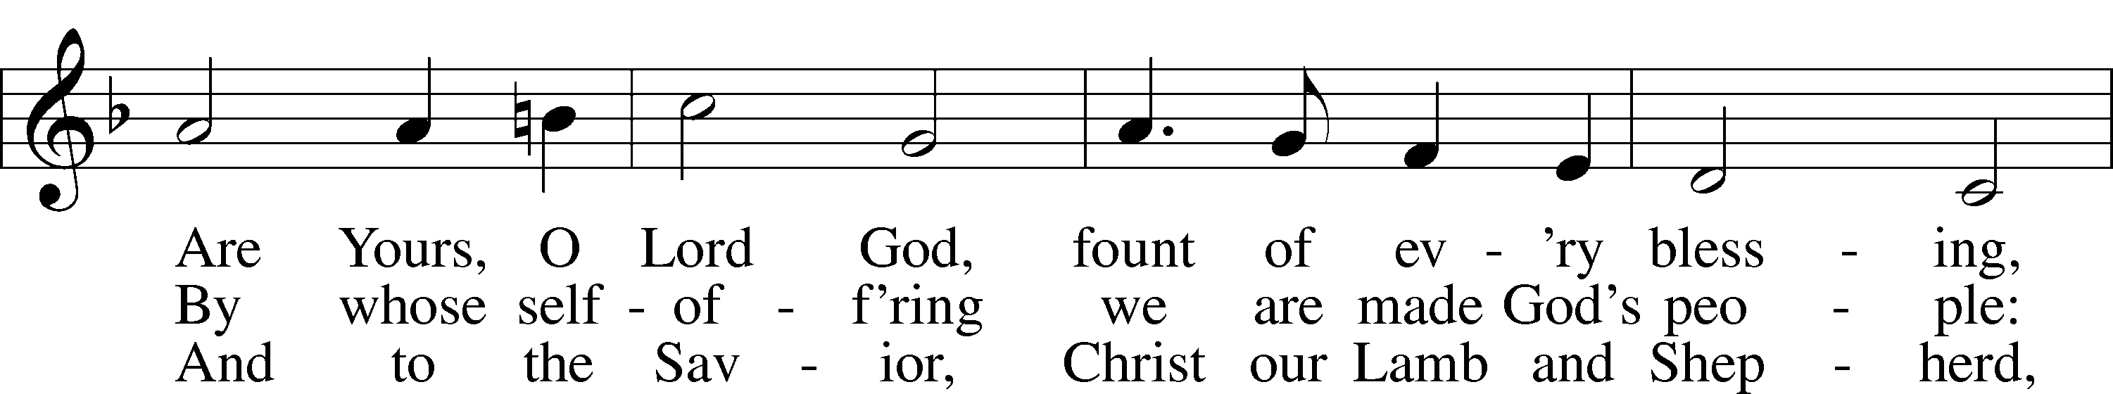
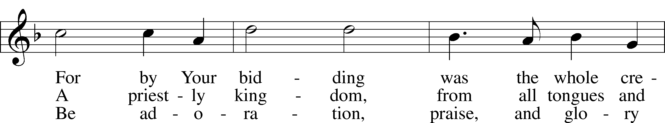
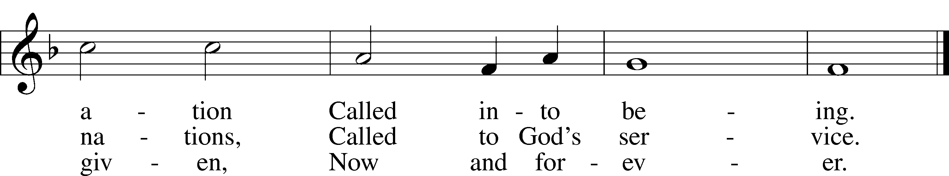
Text: Carl P. Daw, Jr., 1944
Tune: K. Lee Scott, 1950
Text: © 1990 Hope Publishing Co. Used by permission: LSB Hymn License no. 110004798
Tune: © 1987 K. Lee Scott, admin. MorningStar Music Publishers. Used by permission: LSB Hymn License no. 110004798

SERMON

(Sermons for Elder led services are provided courtesy of the Lutheran Church - Canada (https://www.lutheranchurchcanada.ca/resources/written-sermons/), a member of the International Lutheran Council (https://ilcouncil.org/) with whom the Lutheran Church - Missouri Synod (https://www.lcms.org/) is in altar and pulpit fellowship.)

822 ALLELUIA! LET PRAISES RING
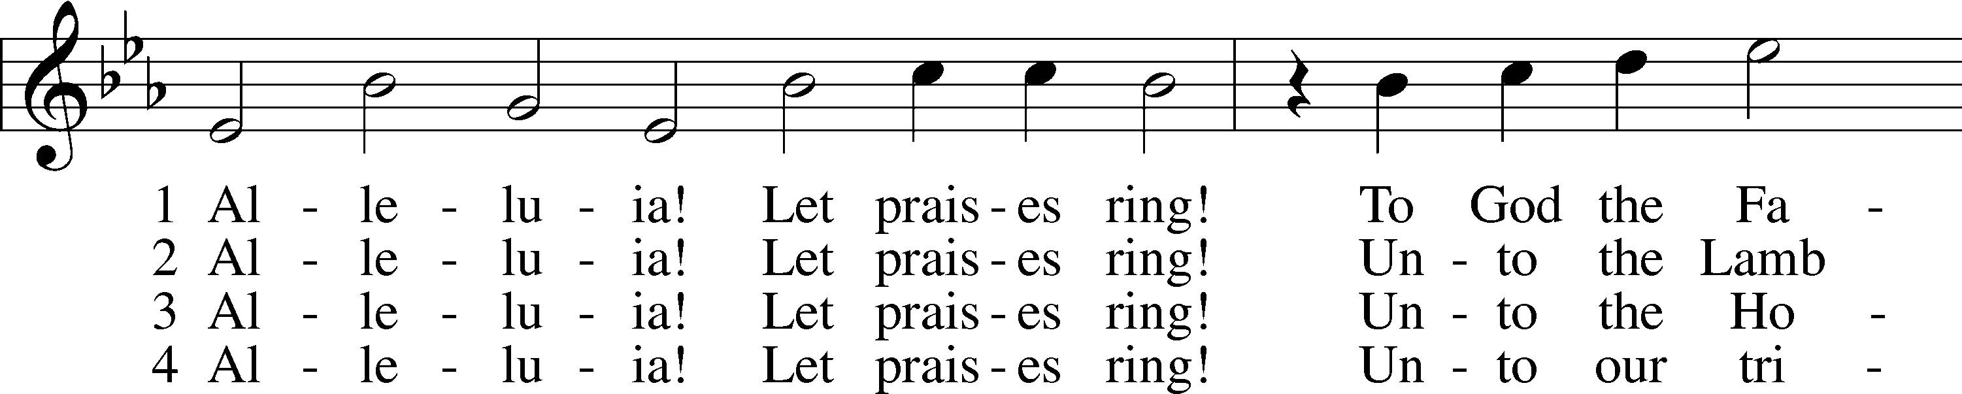
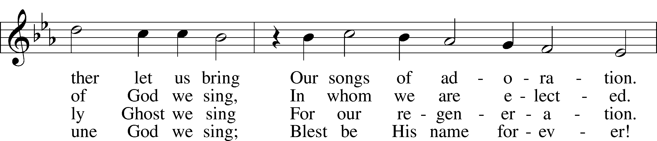
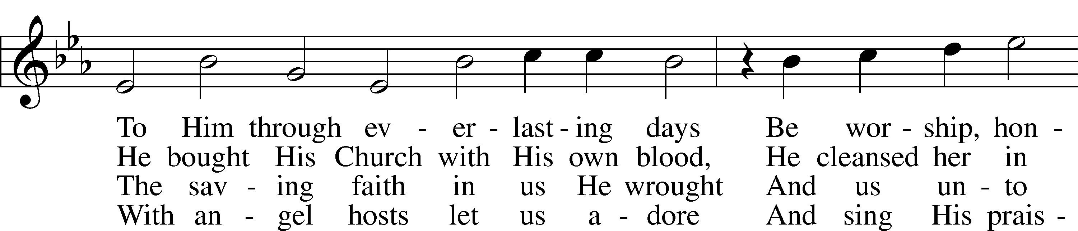
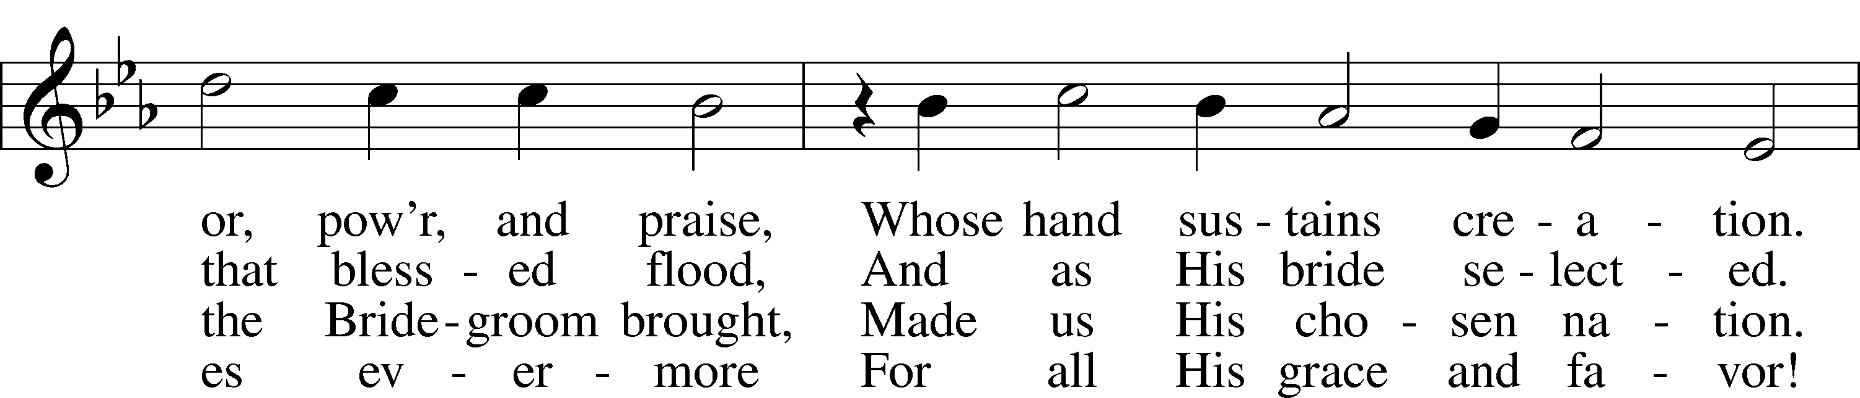
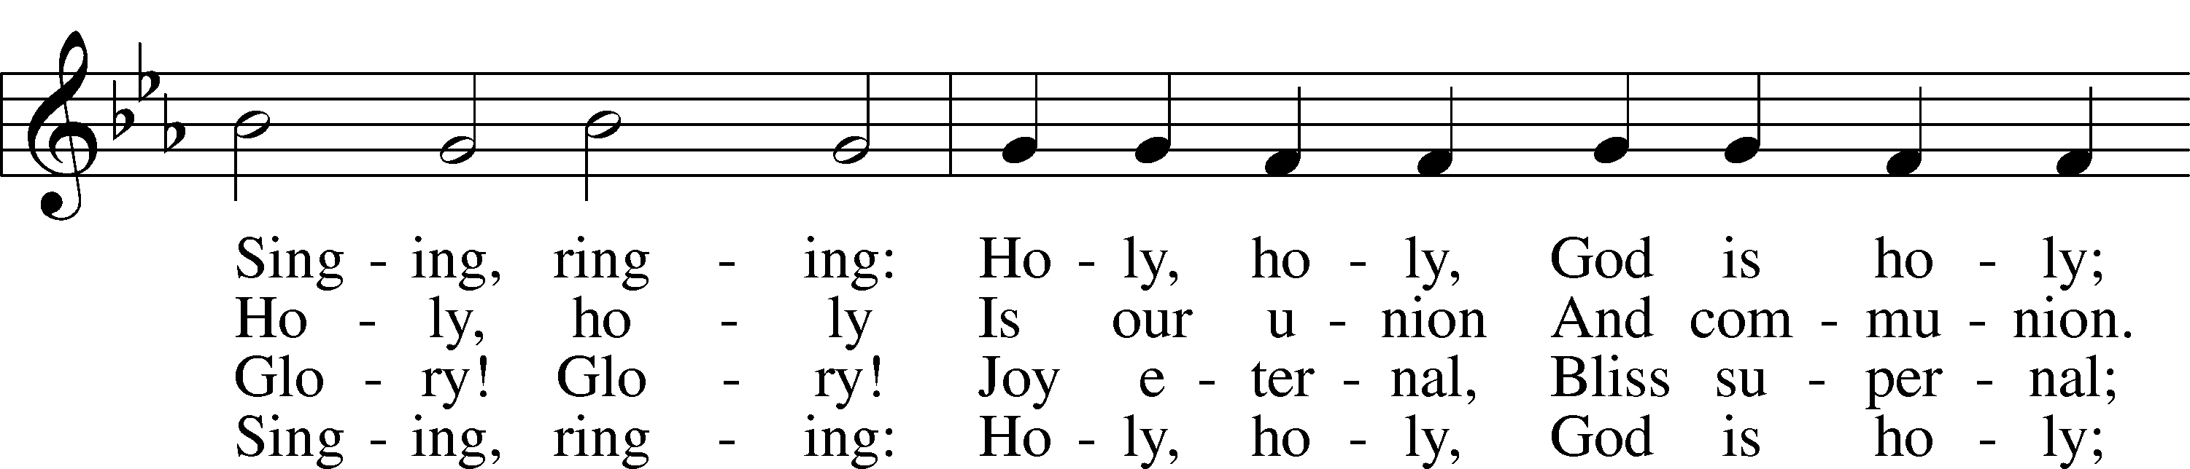
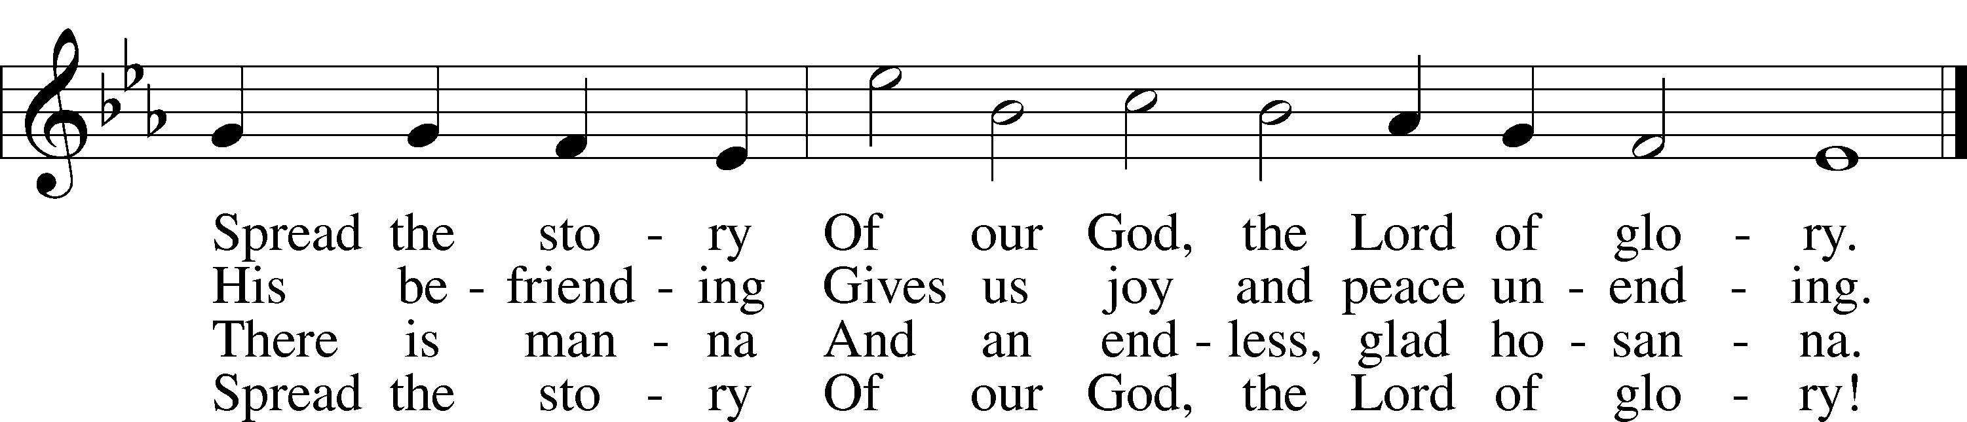
Text: Geistreiches Gesang-Buch, 1698, Darmstadt; tr. The Lutheran Hymnal, 1941, alt.
Tune: Philipp Nicolai, 1556–1608
Text and tune: Public domain

(Stand)

APOSTLES’ CREED LSB 159
C I believe in God, the Father Almighty,
maker of heaven and earth.

And in Jesus Christ, His only Son, our Lord,
who was conceived by the Holy Spirit,
born of the virgin Mary,
suffered under Pontius Pilate,
was crucified, died and was buried.
He descended into hell.
The third day He rose again from the dead.
He ascended into heaven
and sits at the right hand of God the Father Almighty.
From thence He will come to judge the living and the dead.

I believe in the Holy Spirit,
the holy Christian Church,
the communion of saints,
the forgiveness of sins,
the resurrection of the body,
and the life T everlasting. Amen.

SHARING OF THE PEACE

(The people may greet one another in the name of the Lord, saying, “Peace be with you,” as a sign of reconciliation and of the unity of the Spirit in the bond of peace (Matt. 5:22–24; Eph. 4:1–3).)

(Sit)

PRAYER OF THE CHURCH

OFFERING

(As a part of our expression of thanksgiving to God for the treasure of His salvation to us, we offer a portion of our treasure, according to what each has determined in their heart to give. Please place offerings in the collection plate at the back of the sanctuary before or after the service. Offerings can also be sent to Bethlehem Lutheran Church via U.S. Mail. Thank you!)

(Stand)

OFFERTORY LSB 159
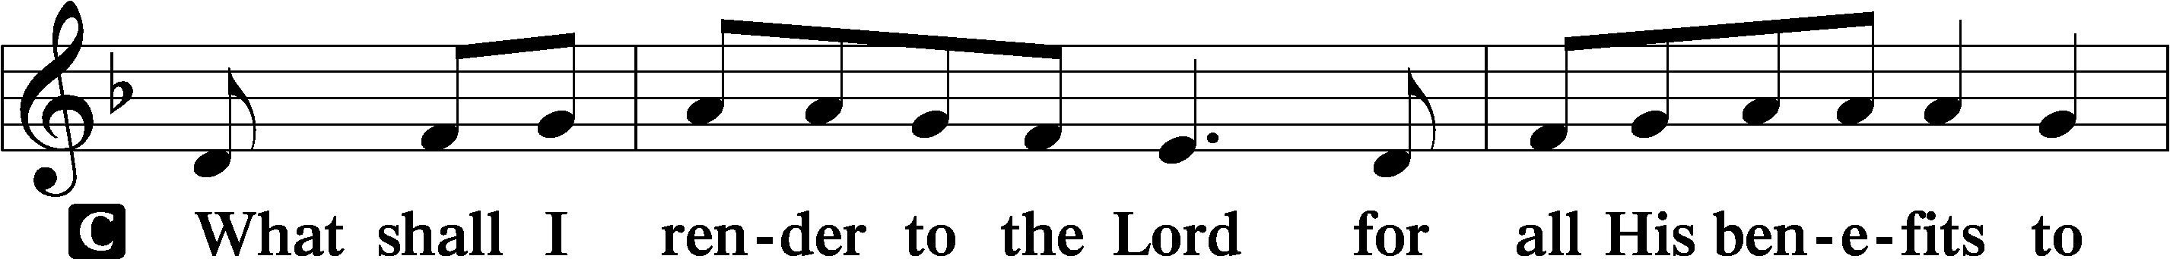
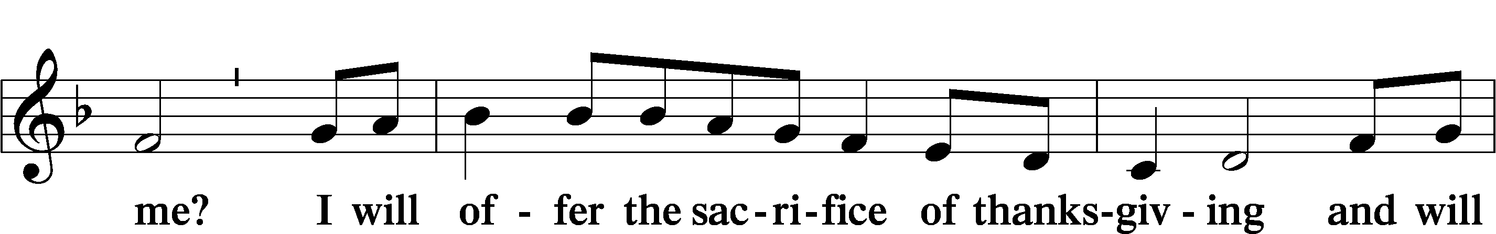
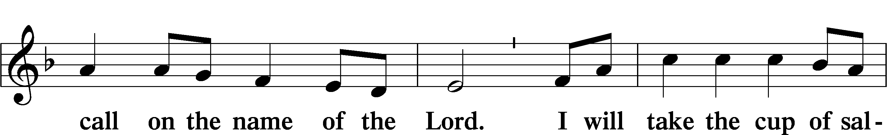
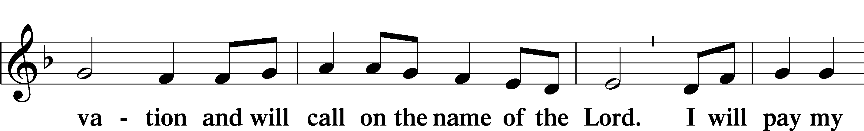
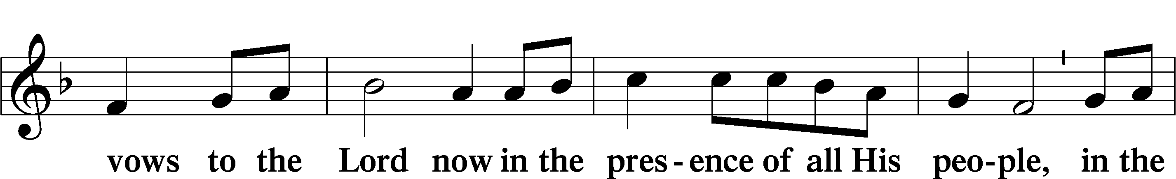
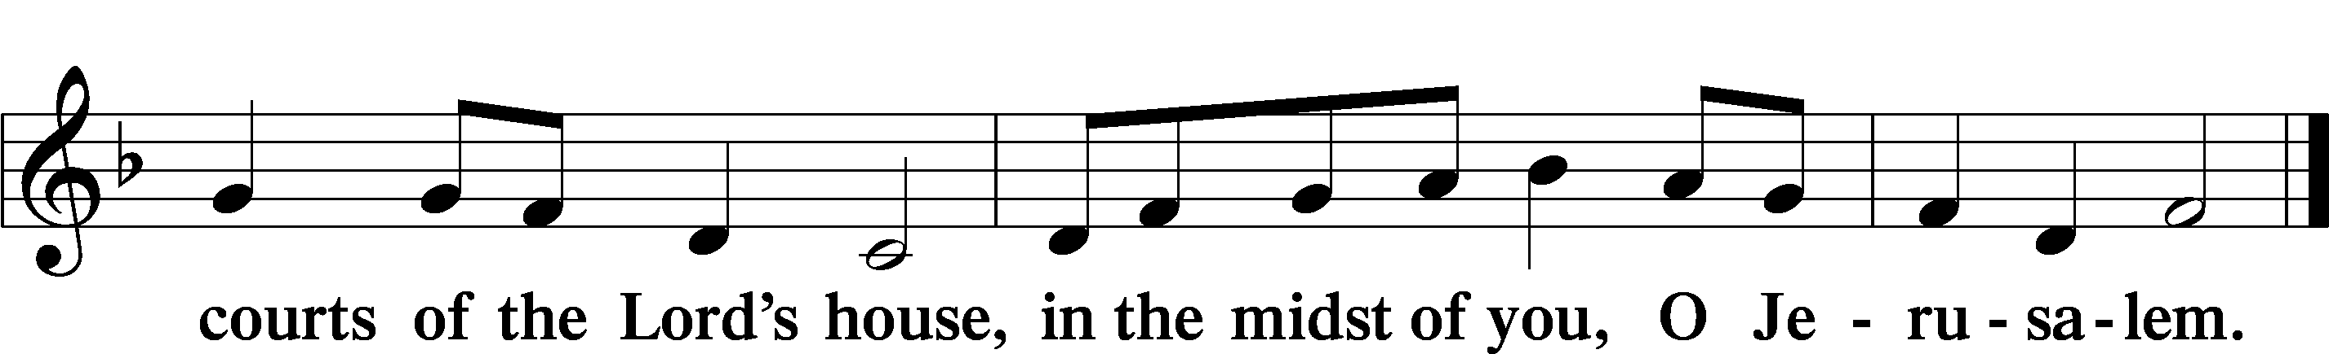

LORD’S PRAYER LSB 162
L Lord, remember us in Your kingdom and teach us to pray:
C Our Father who art in heaven,
hallowed be Thy name,
Thy kingdom come,
Thy will be done on earth
as it is in heaven;
give us this day our daily bread;
and forgive us our trespasses
as we forgive those
who trespass against us;
and lead us not into temptation,
but deliver us from evil.
For Thine is the kingdom
and the power and the glory
forever and ever. Amen.

CONCLUDING COLLECT

BENEDICTION LSB 166
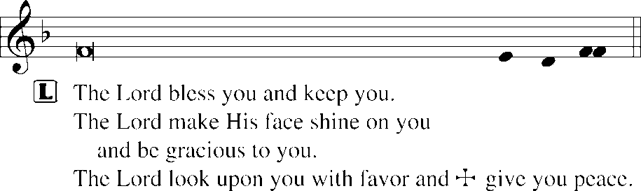


HYMN TO DEPART Vs 1 All; Vs 2, 4, 6 Men; Vs 3, 5, 7 Women; Vs 8 All
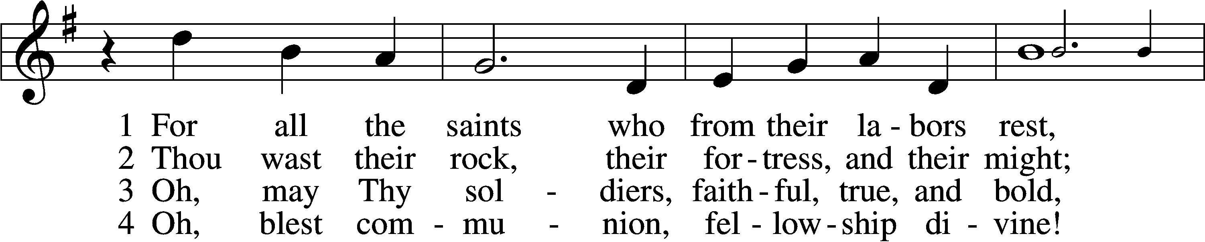
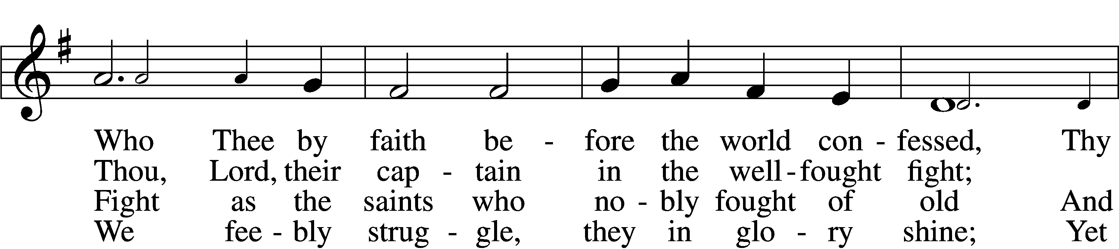
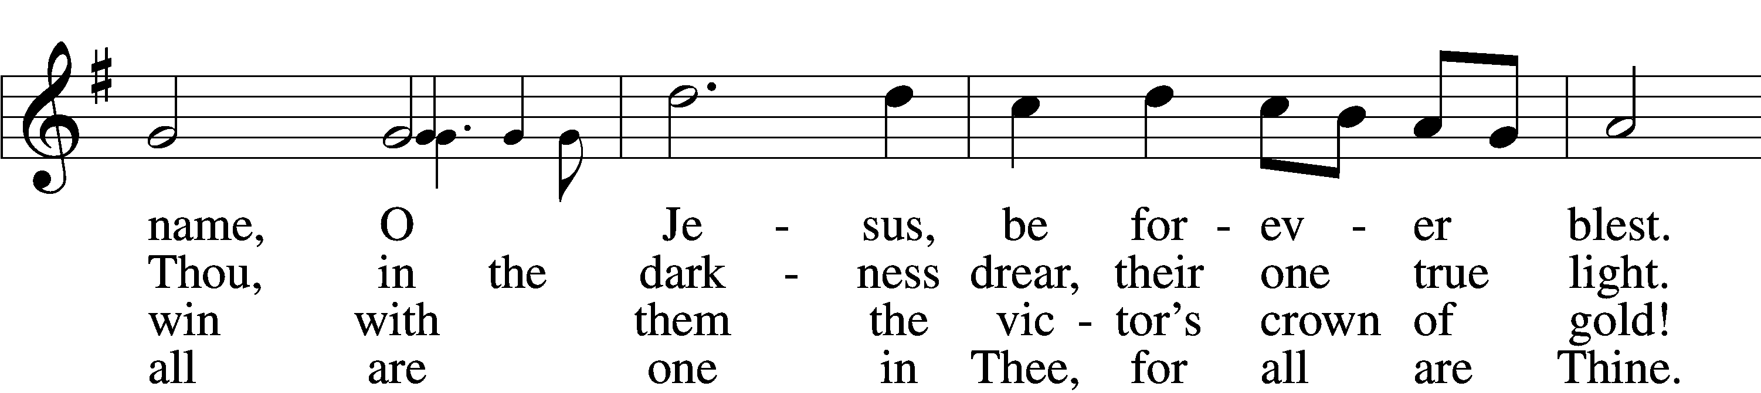
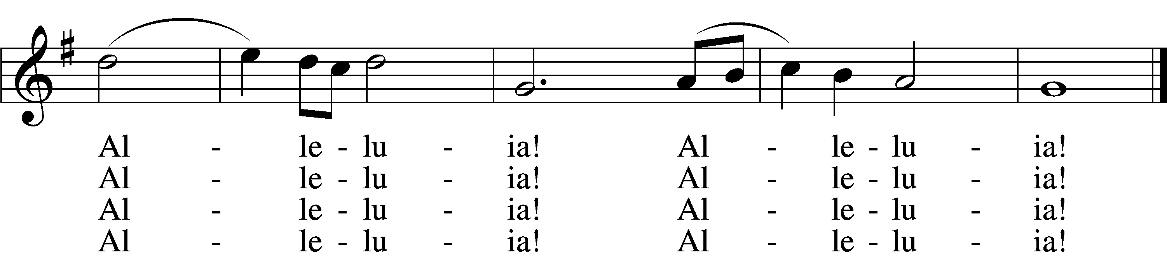

(next page)

5 And when the fight is fierce, the warfare long,
Steals on the ear the distant triumph song,
And hearts are brave again, and arms are strong.
Alleluia! Alleluia!

6 The golden evening brightens in the west;
Soon, soon to faithful warriors cometh rest;
Sweet is the calm of paradise the blest.
Alleluia! Alleluia!

7 But, lo, there breaks a yet more glorious day:
The saints triumphant rise in bright array;
The King of Glory passes on His way.
Alleluia! Alleluia!

D 8 From earth’s wide bounds, from ocean’s farthest coast,
Through gates of pearl streams in the countless host,
Singing to Father, Son, and Holy Ghost:
Alleluia! Alleluia!
Text: William W. How, 1823–97, alt.
Tune: Ralph Vaughan Williams, 1872–1958
Text and tune: Public domain
ACKNOWLEDGMENTS
Unless otherwise indicated, Scripture quotations are from the ESV® Bible (The Holy Bible, English Standard Version®), copyright © 2001 by Crossway, a publishing ministry of Good News Publishers. Used by permission. All rights reserved.
Created by Lutheran Service Builder © 2026 Concordia Publishing House.

