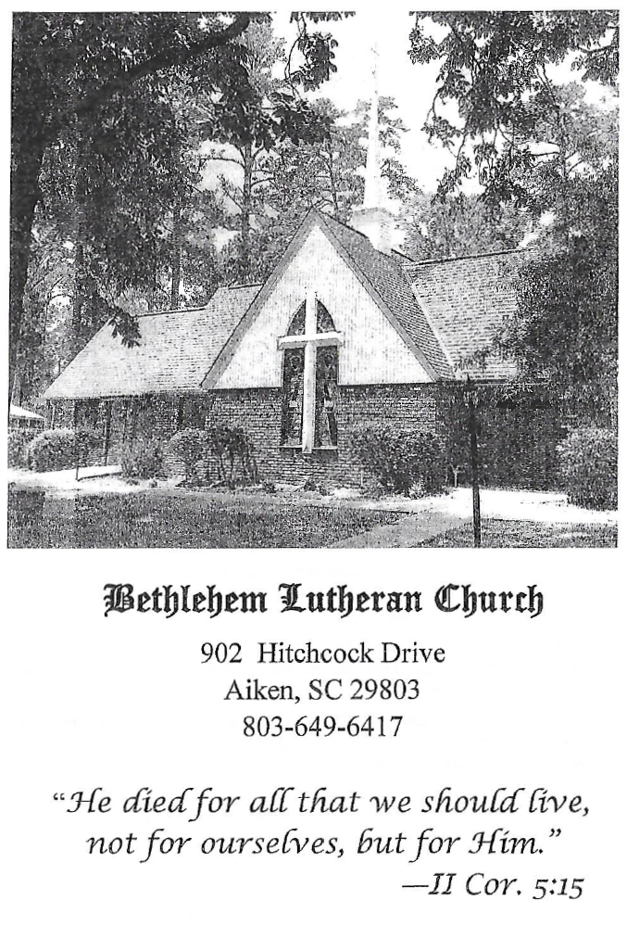

BETHLEHEM LUTHERAN CHURCH
A congregation of The Lutheran Church-Missouri Synod
902 Hitchcock Drive SW,
Aiken, South Carolina 29803
Church Phone: (803) 649-6417
blcaikensc@gmail.com

Bethlehem Lutheran welcomes our members and guests to our worship service! Unable to join us in person? Please find us on Facebook live. The service is also posted on our website; bethlehemlutheranaiken.org.

+ + + + + + + + + + + + + + +
Seventeenth Sunday after Pentecost
September 20, 2026
10:30 a.m.
+ + + + + + + + + + + + + + +

+ SERVICE OF PREPARATION +

(After the bell tolls, please observe a time of silence.)

WELCOME AND ANNOUNCEMENTS

(Stand)

789 PRAISE AND THANKSGIVING
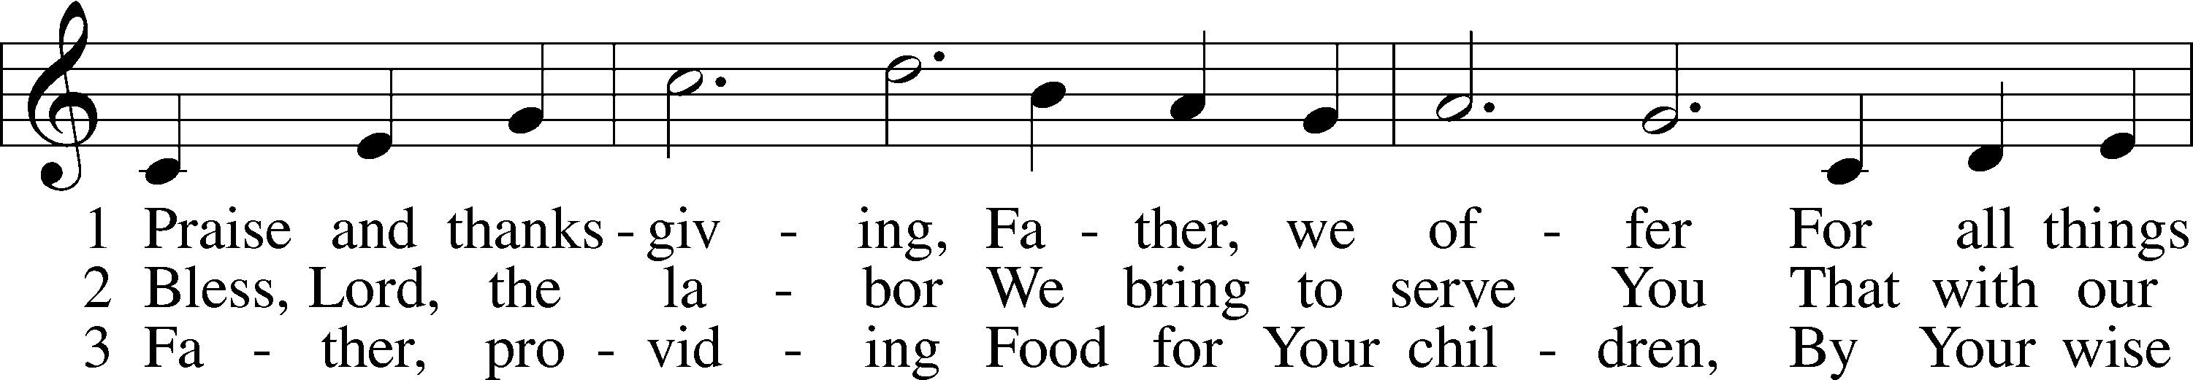
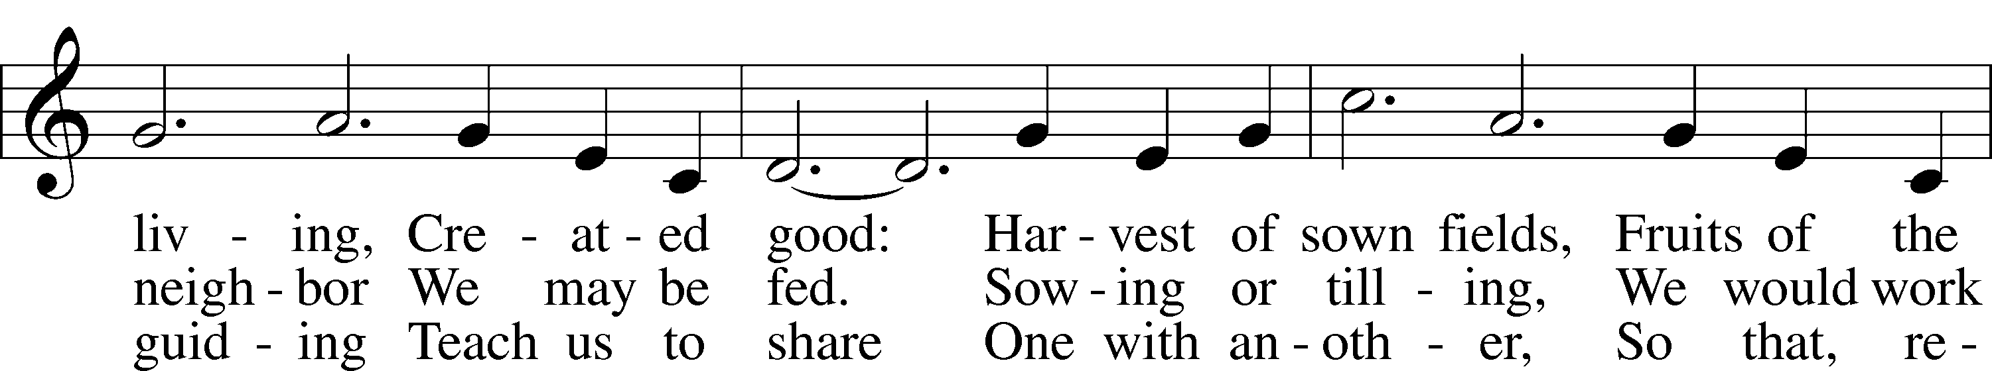
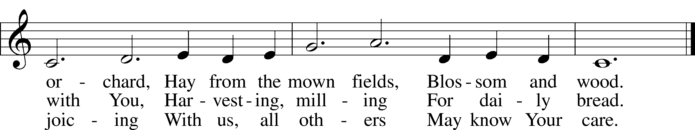
Text: Albert F. Bayly, 1901–84
Tune: Gaelic, 19th cent.
Text: © 1987 Oxford University Press. Used by permission: LSB Hymn License no. 110004798
Tune: Public domain

+ CONFESSION AND ABSOLUTION +

(The sign of the cross may be made by all in remembrance of their Baptism.)

INVOCATION LSB 151
L In the name of the Father and of the T Son and of the Holy Spirit.
C Amen.

EXHORTATION LSB 151
L If we say we have no sin, we deceive ourselves, and the truth is not in us.
C But if we confess our sins, God, who is faithful and just, will forgive our sins and cleanse us from all unrighteousness.

(Silence for reflection on God’s Word and for self-examination.)

CONFESSION OF SINS LSB 151
L Let us then confess our sins to God our Father.
C Most merciful God, we confess that we are by nature sinful and unclean. We have sinned against You in thought, word, and deed, by what we have done and by what we have left undone. We have not loved You with our whole heart; we have not loved our neighbors as ourselves. We justly deserve Your present and eternal punishment. For the sake of Your Son, Jesus Christ, have mercy on us. Forgive us, renew us, and lead us, so that we may delight in Your will and walk in Your ways to the glory of Your holy name. Amen.

DECLARATION OF GRACE LSB 151
L In the mercy of almighty God, Jesus Christ was given to die for us, and for His sake God forgives us all our sins. To those who believe in Jesus Christ He gives the power to become the children of God and bestows on them the Holy Spirit. May the Lord, who has begun this good work in us, bring it to completion in the day of our Lord Jesus Christ.
C Amen.

+ SERVICE OF THE WORD +

INTROIT Psalm 116:12–13, 15–16; antiphon: v. 17

I will offer to you the sacrifice of thanks- | giving*
and call on the name | of the Lord.
What shall I render | to the Lord*
for all his bene- | fits to me?
I will lift up the cup of sal- | vation*
and call on the name | of the Lord.
Precious in the sight | of the Lord*
is the death | of his saints.
O Lord, I am your | servant;*
I am your servant, the son of your maidservant. You have | loosed my bonds.
Glory be to the Father and | to the Son*
and to the Holy | Spirit;
as it was in the be- | ginning,*
is now, and will be forever. | Amen.
I will offer to you the sacrifice of thanks- | giving*
and call on the name | of the Lord.

KYRIE LSB 152

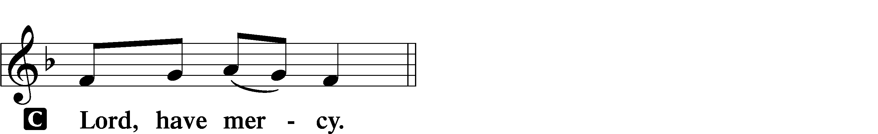

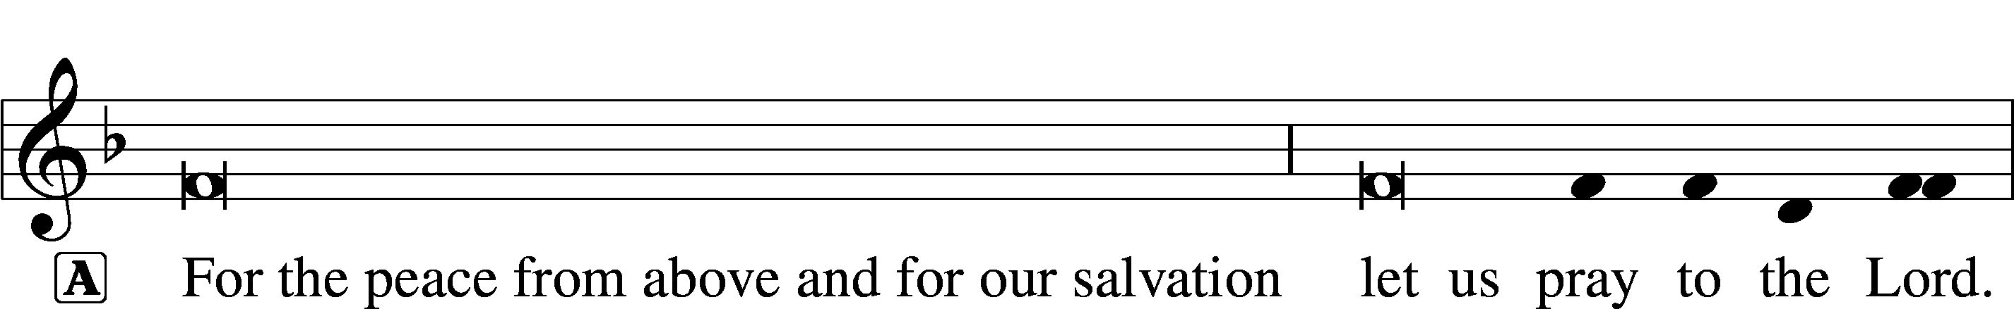

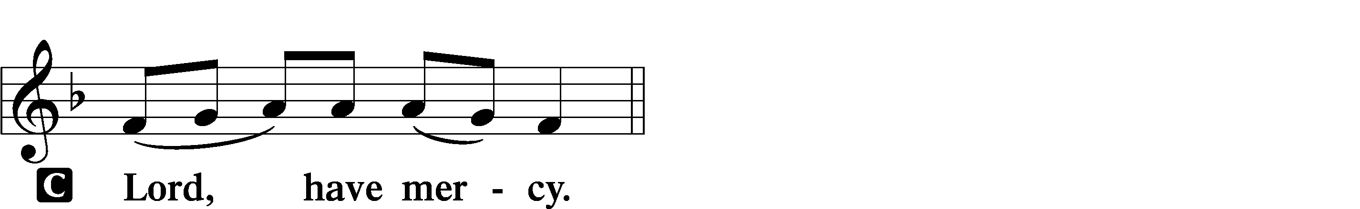

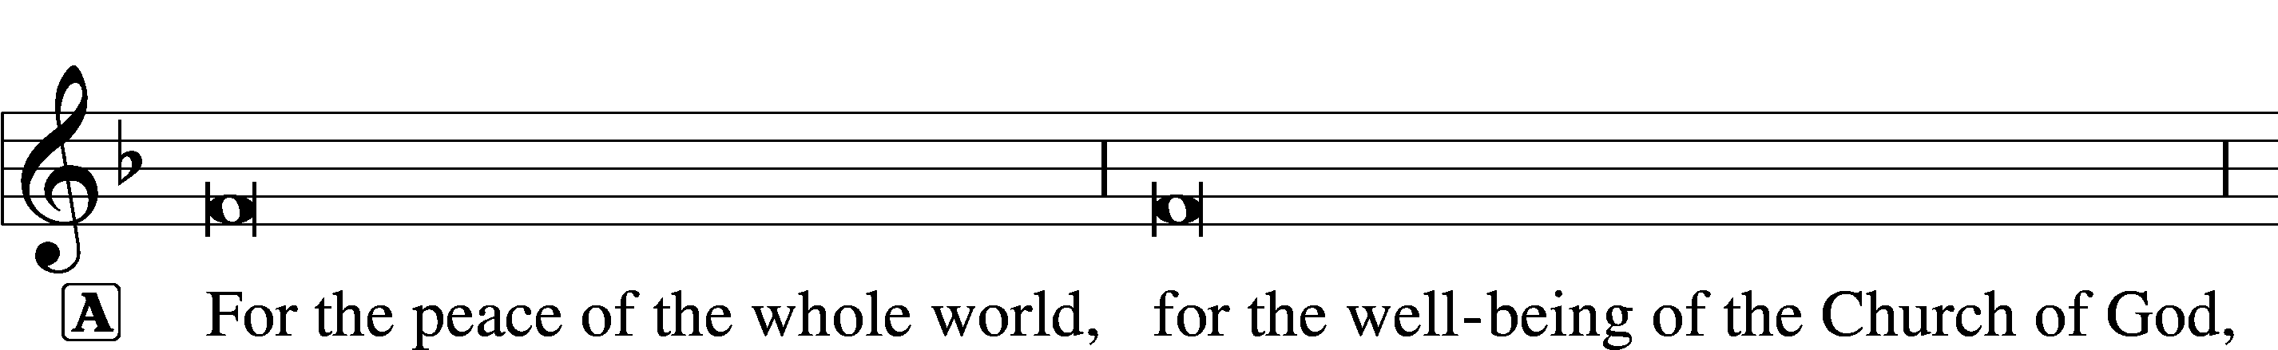
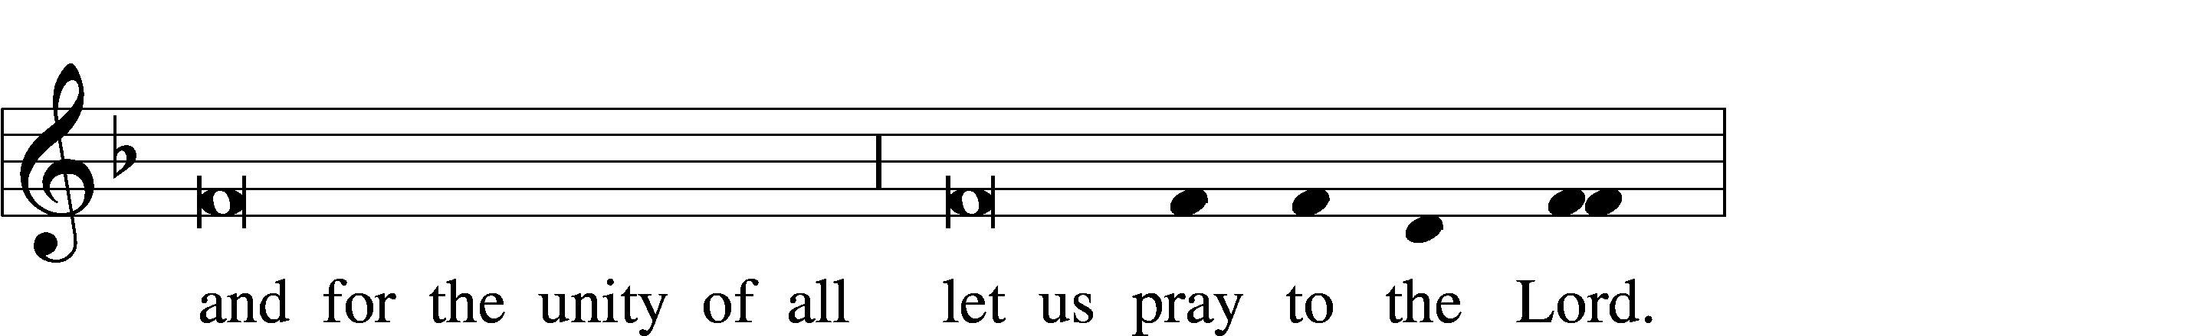
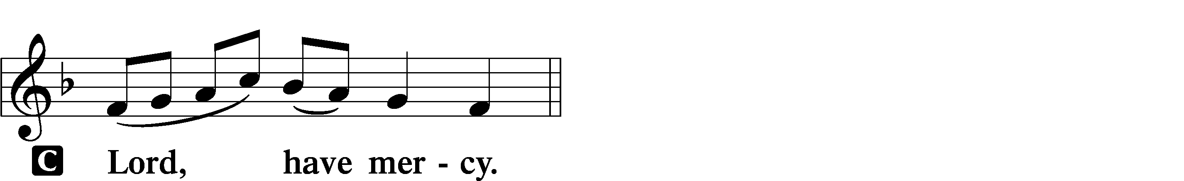

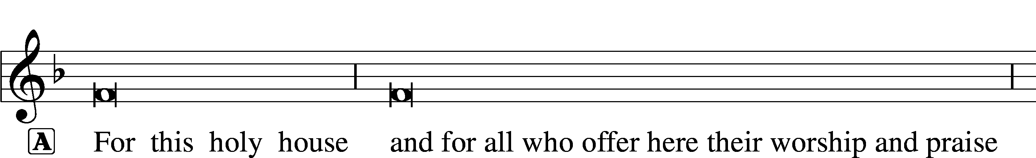
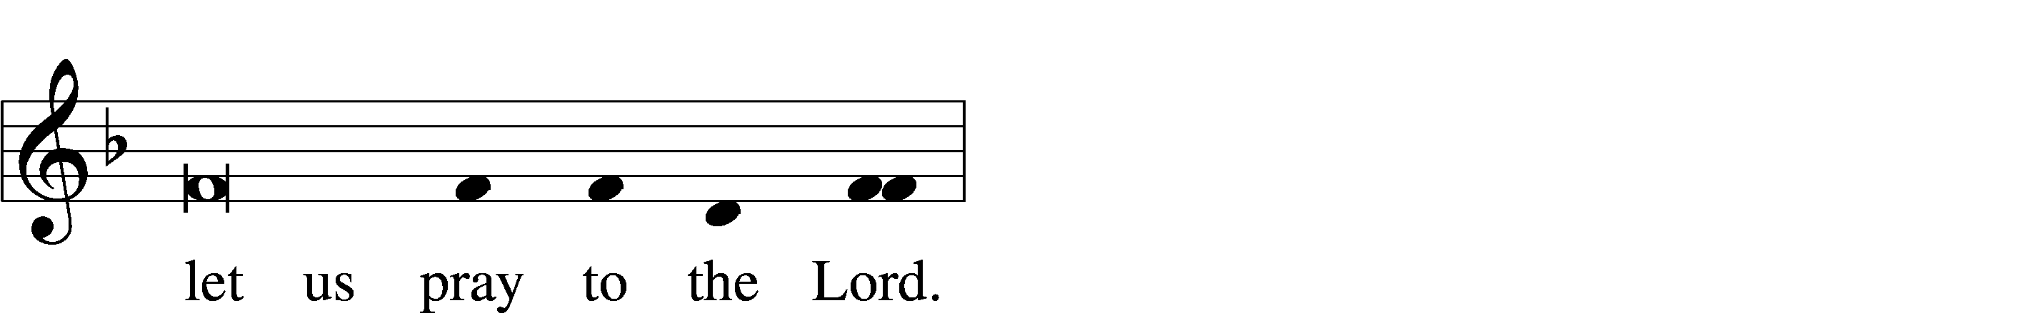
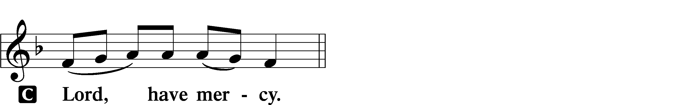

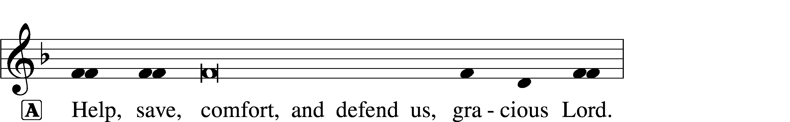


GLORIA IN EXCELSIS LSB 154
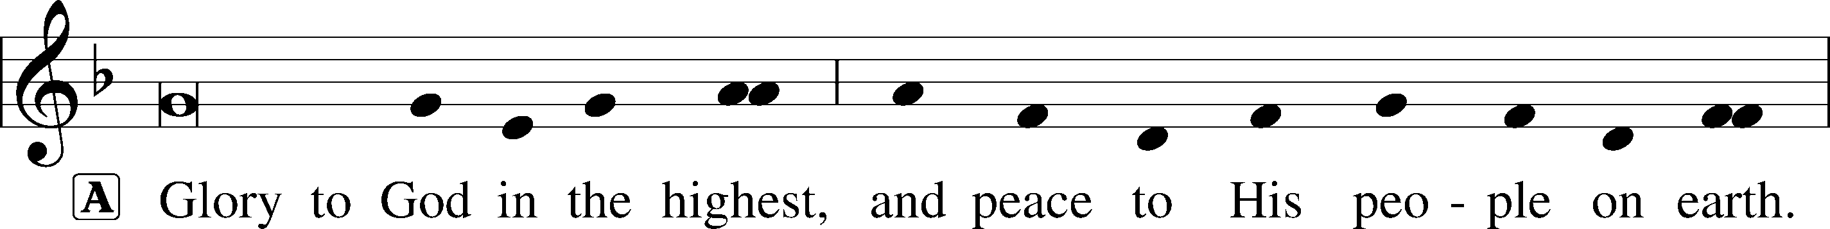
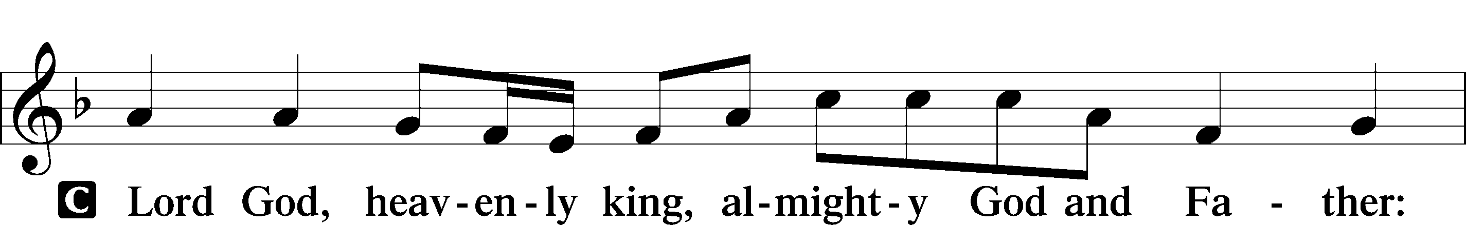
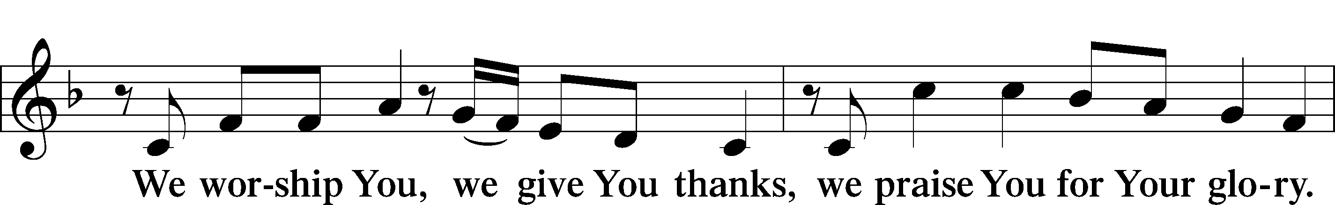
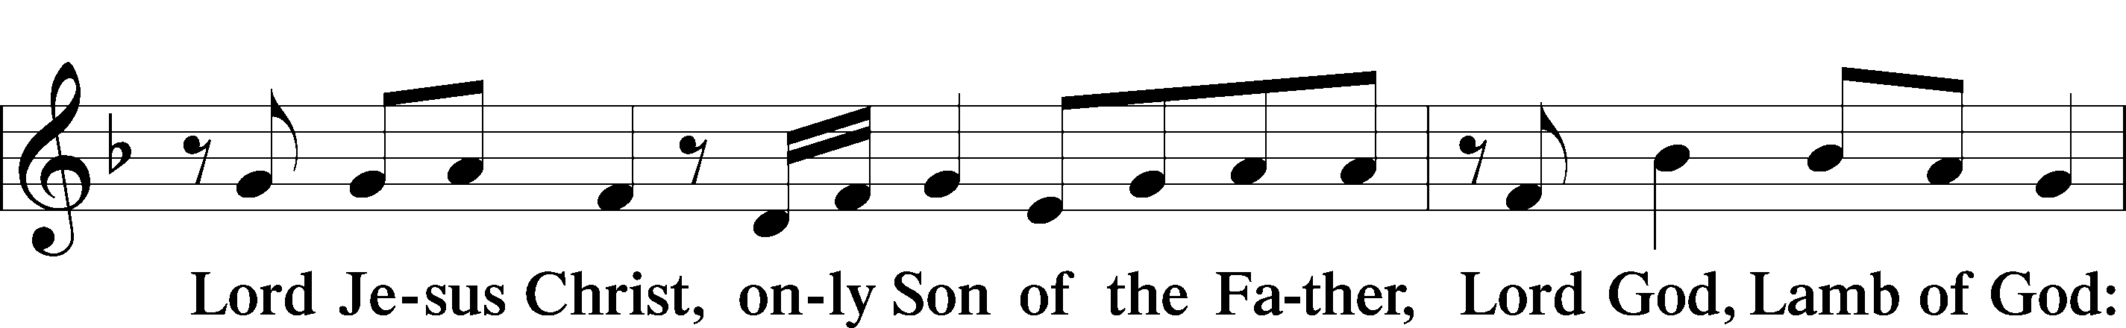
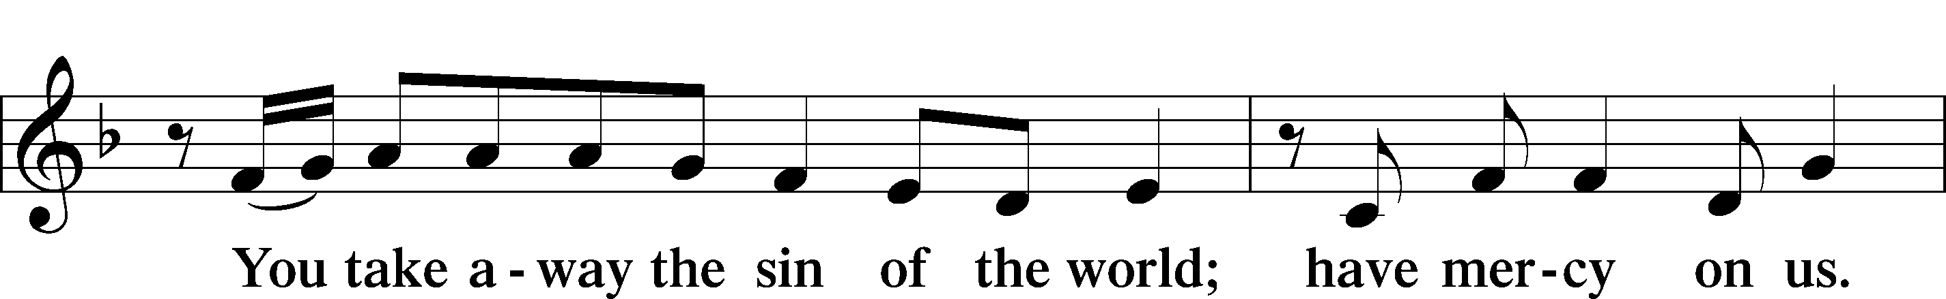
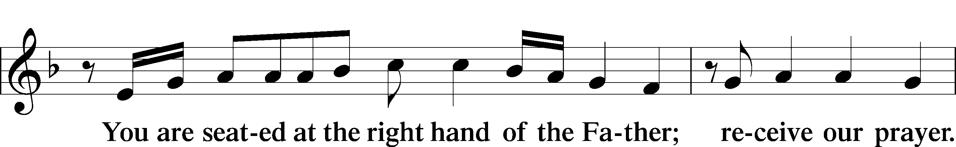
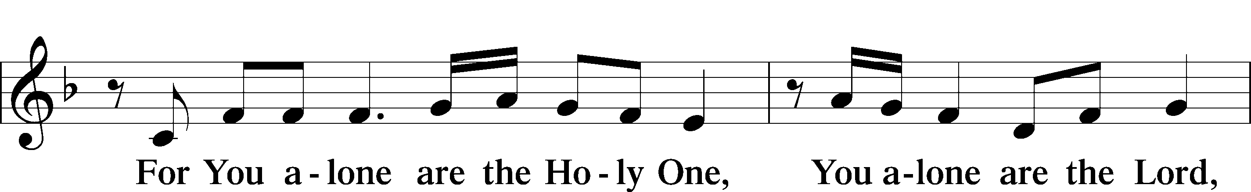
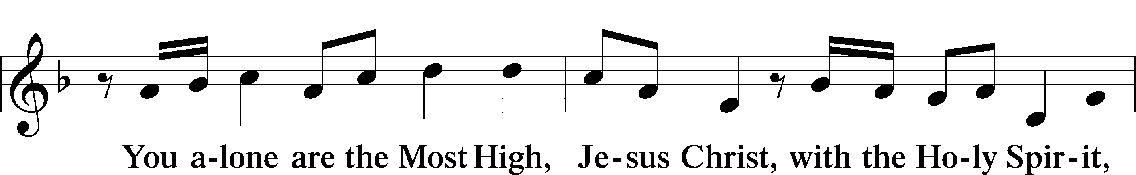
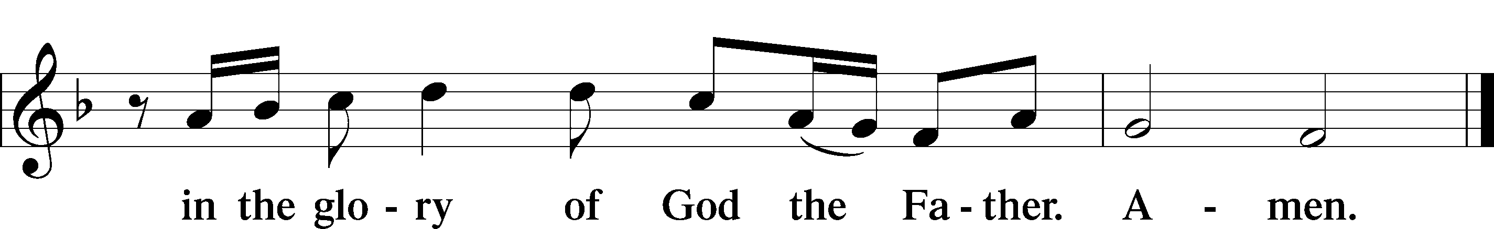

SALUTATION AND COLLECT OF THE DAY LSB 156
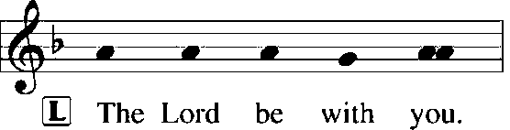
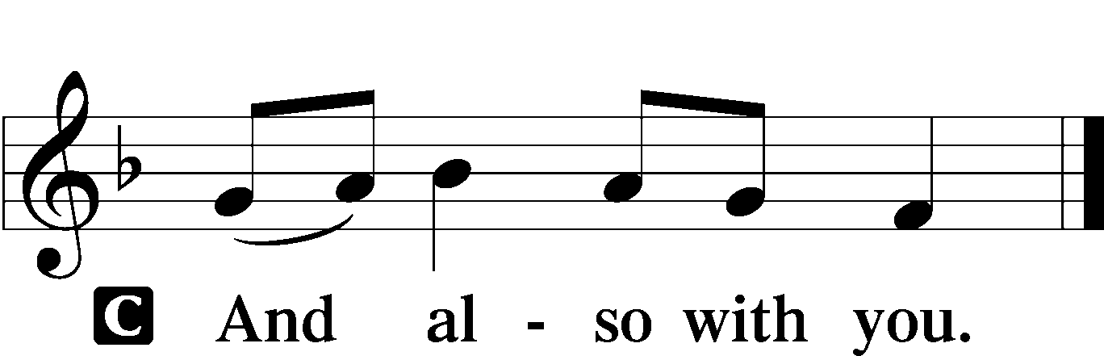

L Let us pray.
Lord God, heavenly Father, since we cannot stand before You relying on anything we have done, help us trust in Your abiding grace and live according to Your Word; through Jesus Christ, Your Son, our Lord, who lives and reigns with You and the Holy Spirit, one God, now and forever.

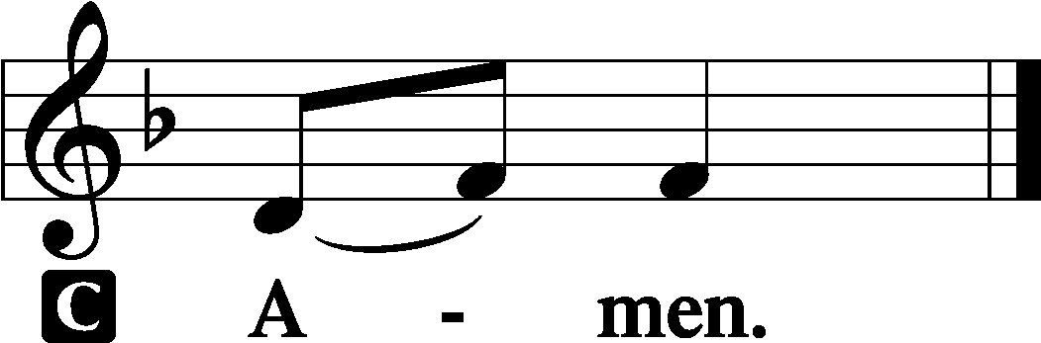

(Sit)

OLD TESTAMENT READING Isaiah 55:6–9
6“Seek the Lord while he may be found;
call upon him while he is near;
7let the wicked forsake his way,
and the unrighteous man his thoughts;
let him return to the Lord, that he may have compassion on him,
and to our God, for he will abundantly pardon.
8For my thoughts are not your thoughts,
neither are your ways my ways, declares the Lord.
9For as the heavens are higher than the earth,
so are my ways higher than your ways
and my thoughts than your thoughts.”

L This is the Word of the Lord.
C Thanks be to God.

GRADUAL Psalm 34:9, 19, alt.
Fear the Lord, | you his saints,*
for those who fear him lack | nothing!
Many are the afflictions of the | righteous,*
but the Lord delivers him out | of them all.

EPISTLE Philippians 1:12–14, 19–30
12I want you to know, brothers, that what has happened to me has really served to advance the gospel, 13so that it has become known throughout the whole imperial guard and to all the rest that my imprisonment is for Christ. 14And most of the brothers, having become confident in the Lord by my imprisonment, are much more bold to speak the word without fear. . . .
19for I know that through your prayers and the help of the Spirit of Jesus Christ this will turn out for my deliverance, 20as it is my eager expectation and hope that I will not be at all ashamed, but that with full courage now as always Christ will be honored in my body, whether by life or by death. 21For to me to live is Christ, and to die is gain. 22If I am to live in the flesh, that means fruitful labor for me. Yet which I shall choose I cannot tell. 23I am hard pressed between the two. My desire is to depart and be with Christ, for that is far better. 24But to remain in the flesh is more necessary on your account. 25Convinced of this, I know that I will remain and continue with you all, for your progress and joy in the faith, 26so that in me you may have ample cause to glory in Christ Jesus, because of my coming to you again.
27Only let your manner of life be worthy of the gospel of Christ, so that whether I come and see you or am absent, I may hear of you that you are standing firm in one spirit, with one mind striving side by side for the faith of the gospel, 28and not frightened in anything by your opponents. This is a clear sign to them of their destruction, but of your salvation, and that from God. 29For it has been granted to you that for the sake of Christ you should not only believe in him but also suffer for his sake, 30engaged in the same conflict that you saw I had and now hear that I still have.

L This is the Word of the Lord.
C Thanks be to God.

(Stand)

ALLELUIA AND VERSE LSB 156
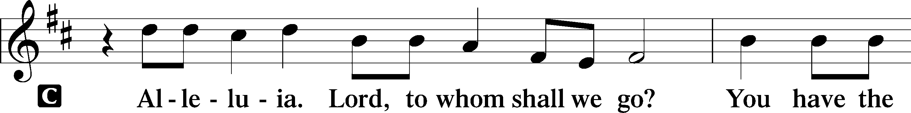
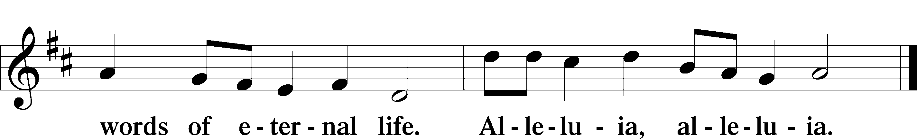

HOLY GOSPEL Matthew 20:1–16
L The Holy Gospel according to St. Matthew, the twentieth chapter.

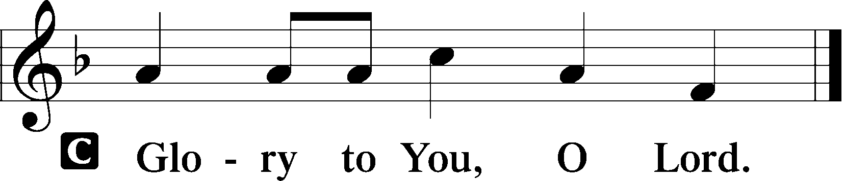

1[Jesus said:] “The kingdom of heaven is like a master of a house who went out early in the morning to hire laborers for his vineyard. 2After agreeing with the laborers for a denarius a day, he sent them into his vineyard. 3And going out about the third hour he saw others standing idle in the marketplace, 4and to them he said, ‘You go into the vineyard too, and whatever is right I will give you.’ 5So they went. Going out again about the sixth hour and the ninth hour, he did the same. 6And about the eleventh hour he went out and found others standing. And he said to them, ‘Why do you stand here idle all day?’ 7They said to him, ‘Because no one has hired us.’ He said to them, ‘You go into the vineyard too.’ 8And when evening came, the owner of the vineyard said to his foreman, ‘Call the laborers and pay them their wages, beginning with the last, up to the first.’ 9And when those hired about the eleventh hour came, each of them received a denarius. 10Now when those hired first came, they thought they would receive more, but each of them also received a denarius. 11And on receiving it they grumbled at the master of the house, 12saying, ‘These last worked only one hour, and you have made them equal to us who have borne the burden of the day and the scorching heat.’ 13But he replied to one of them, ‘Friend, I am doing you no wrong. Did you not agree with me for a denarius? 14Take what belongs to you and go. I choose to give to this last worker as I give to you. 15Am I not allowed to do what I choose with what belongs to me? Or do you begrudge my generosity?’ 16So the last will be first, and the first last.”

L This is the Gospel of the Lord.

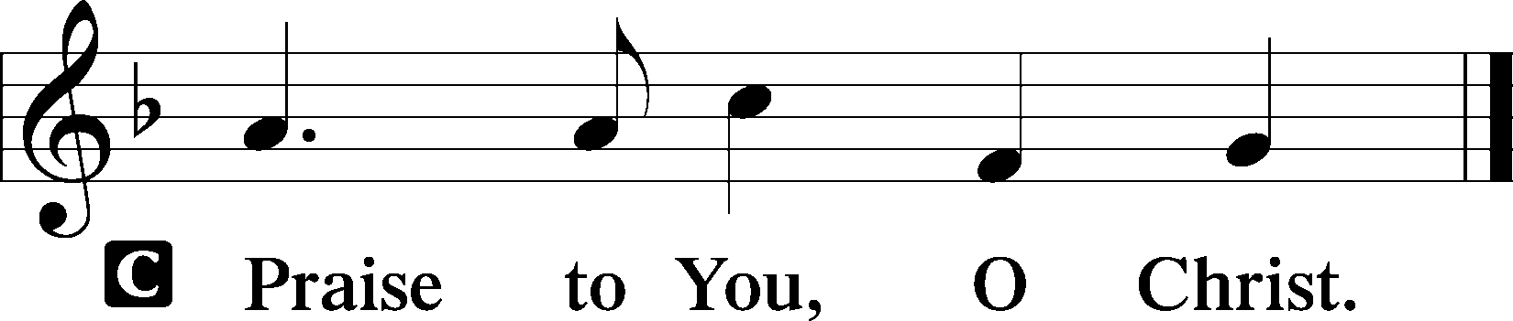

(Sit)

555 SALVATION UNTO US HAS COME
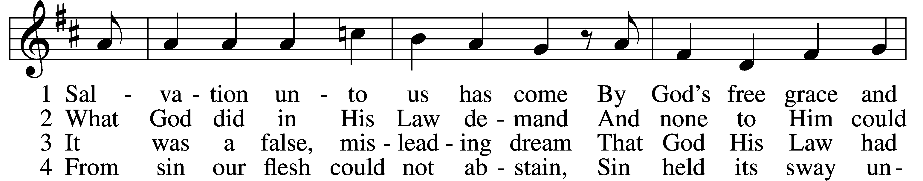
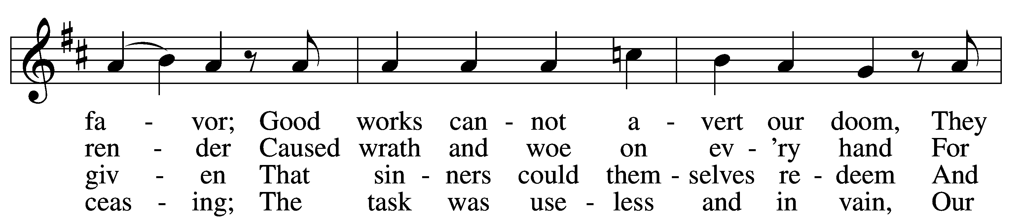
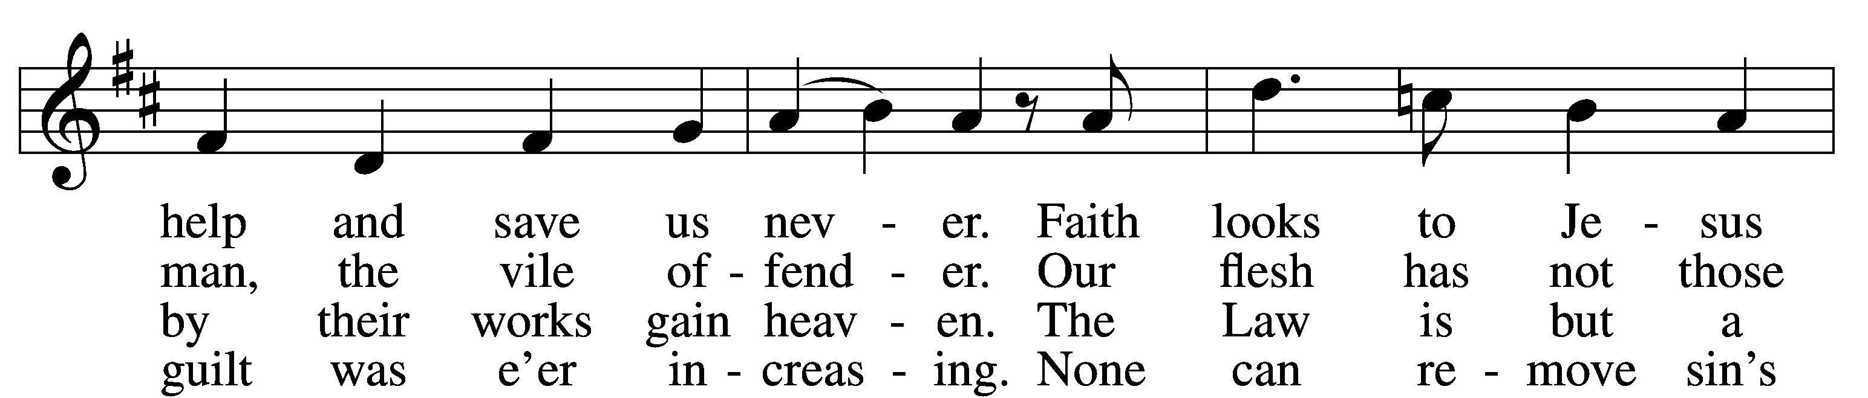
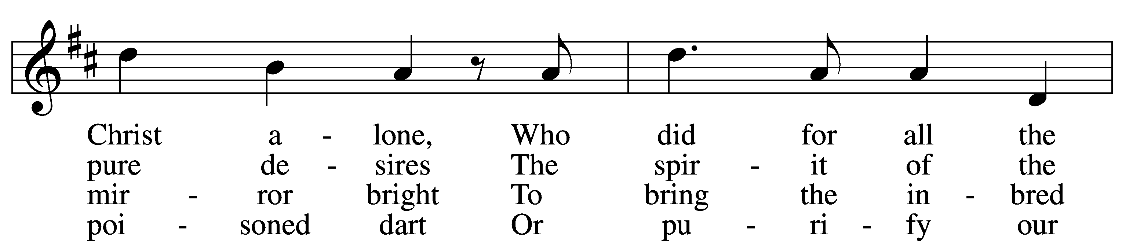
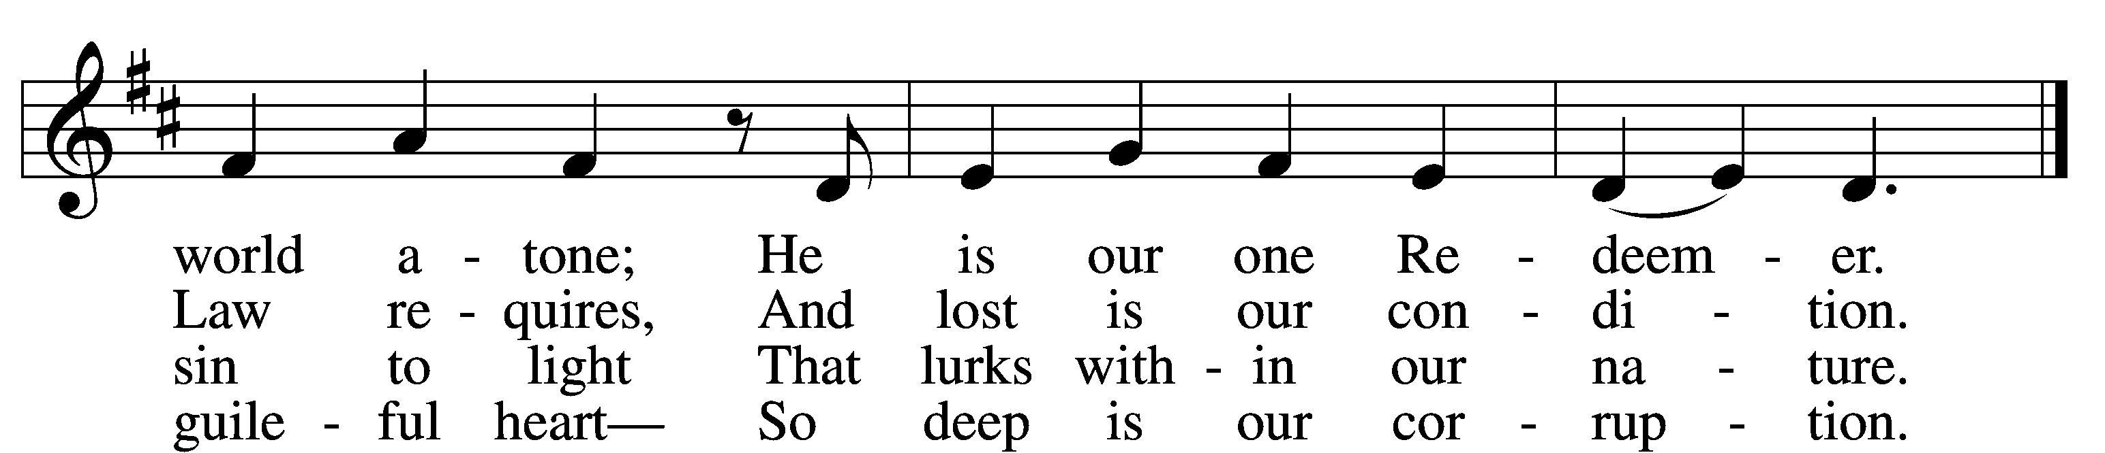

5 Yet as the Law must be fulfilled
Or we must die despairing,
Christ came and has God’s anger stilled,
Our human nature sharing.
He has for us the Law obeyed
And thus the Father’s vengeance stayed
Which over us impended.

(next page)

6 Since Christ has full atonement made
And brought to us salvation,
Each Christian therefore may be glad
And build on this foundation.
Your grace alone, dear Lord, I plead,
Your death is now my life indeed,
For You have paid my ransom.

7 Let me not doubt, but truly see
Your Word cannot be broken;
Your call rings out, “Come unto Me!”
No falsehood have You spoken.
Baptized into Your precious name,
My faith cannot be put to shame,
And I shall never perish.

8 The Law reveals the guilt of sin
And makes us conscience-stricken;
But then the Gospel enters in
The sinful soul to quicken.
Come to the cross, trust Christ, and live;
The Law no peace can ever give,
No comfort and no blessing.

9 Faith clings to Jesus’ cross alone
And rests in Him unceasing;
And by its fruits true faith is known,
With love and hope increasing.
For faith alone can justify;
Works serve our neighbor and supply
The proof that faith is living.

D 10 All blessing, honor, thanks, and praise
To Father, Son, and Spirit,
The God who saved us by His grace;
All glory to His merit.
O triune God in heav’n above,
You have revealed Your saving love;
Your blessèd name we hallow.
Text: Paul Speratus, 1484–1551; tr. The Lutheran Hymnal, 1941, alt.
Tune: Etlich Cristlich lider, 1524, Wittenberg
Text and tune: Public domain

SERMON

(Sermons for Elder led services are provided courtesy of the Lutheran Church - Canada (https://www.lutheranchurchcanada.ca/resources/written-sermons/), a member of the International Lutheran Council (https://ilcouncil.org/) with whom the Lutheran Church - Missouri Synod (https://www.lcms.org/) is in altar and pulpit fellowship.)

838 THE SAINTS IN CHRIST ARE ONE IN EVERY PLACE
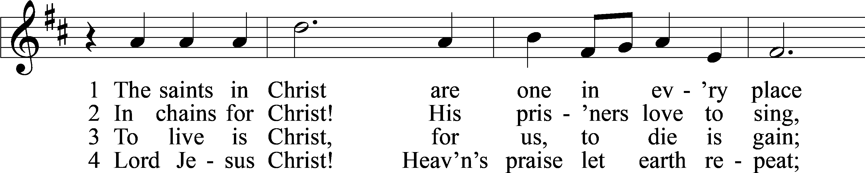
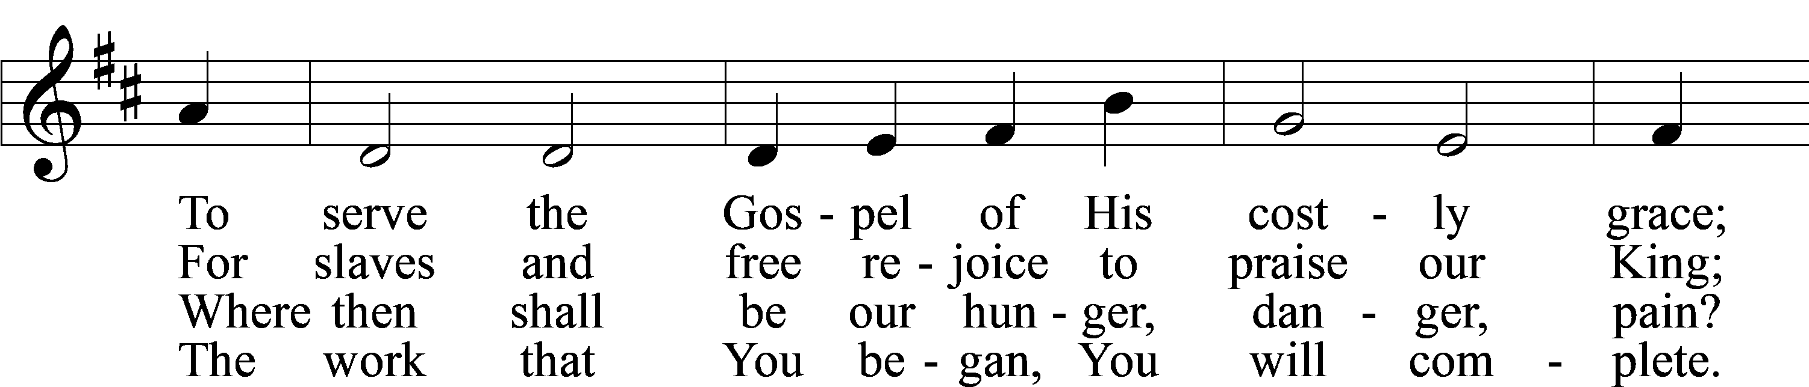
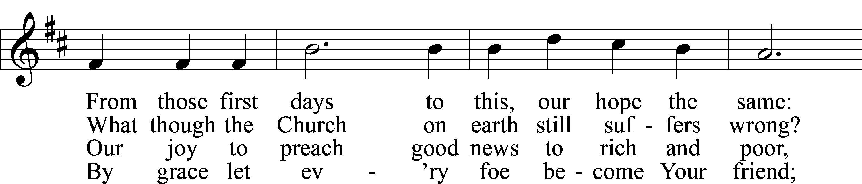
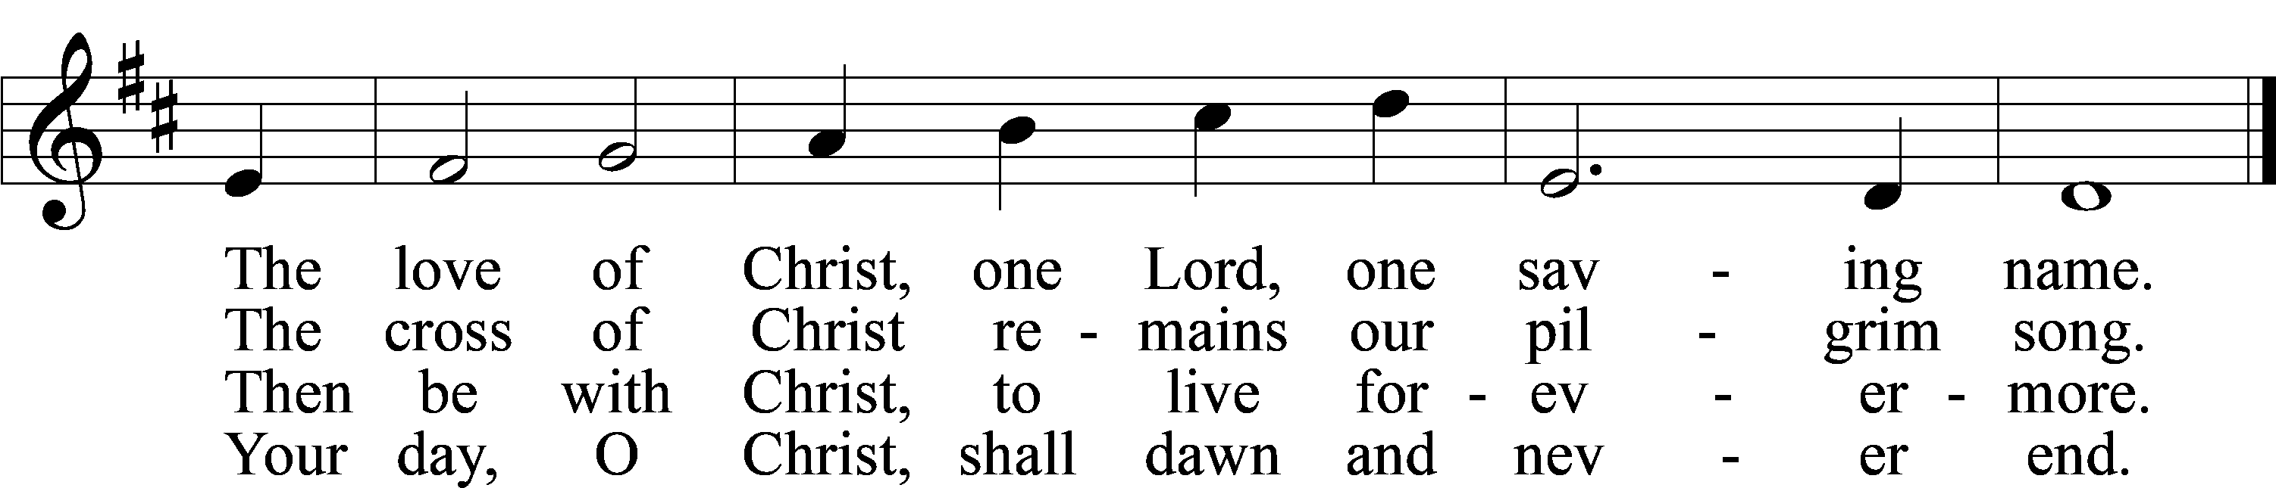
Text: Christopher M. Idle, 1938, alt.
Tune: Walter Greatorex, 1877–1949
Text: © 1996 The Jubilate Group, admin. Hope Publishing Co. Used by permission: LSB Hymn License no. 110004798
Tune: © Oxford University Press. Used by permission: LSB Hymn License no. 110004798

(Stand)

APOSTLES’ CREED LSB 159
C I believe in God, the Father Almighty,
maker of heaven and earth.

And in Jesus Christ, His only Son, our Lord,
who was conceived by the Holy Spirit,
born of the virgin Mary,
suffered under Pontius Pilate,
was crucified, died and was buried.
He descended into hell.
The third day He rose again from the dead.
He ascended into heaven
and sits at the right hand of God the Father Almighty.
From thence He will come to judge the living and the dead.

I believe in the Holy Spirit,
the holy Christian Church,
the communion of saints,
the forgiveness of sins,
the resurrection of the body,
and the life T everlasting. Amen.

SHARING OF THE PEACE

(The people may greet one another in the name of the Lord, saying, “Peace be with you,” as a sign of reconciliation and of the unity of the Spirit in the bond of peace (Matt. 5:22–24; Eph. 4:1–3).)

(Sit)

PRAYER OF THE CHURCH

OFFERING

(As a part of our expression of thanksgiving to God for the treasure of His salvation to us, we offer a portion of our treasure, according to what each has determined in their heart to give. Please place offerings in the collection plate at the back of the sanctuary before or after the service. Offerings can also be sent to Bethlehem Lutheran Church via U.S. Mail. Thank you!)

(Stand)

OFFERTORY LSB 159
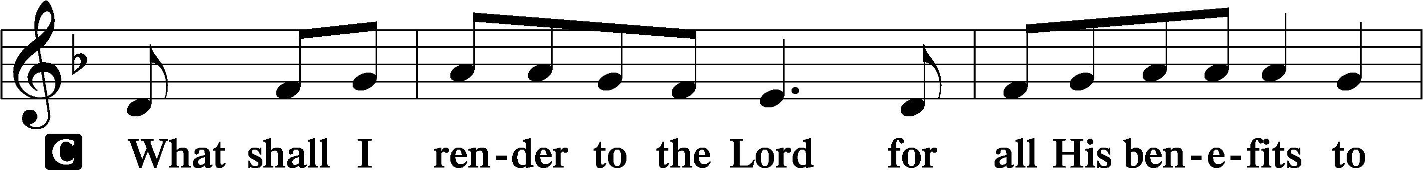
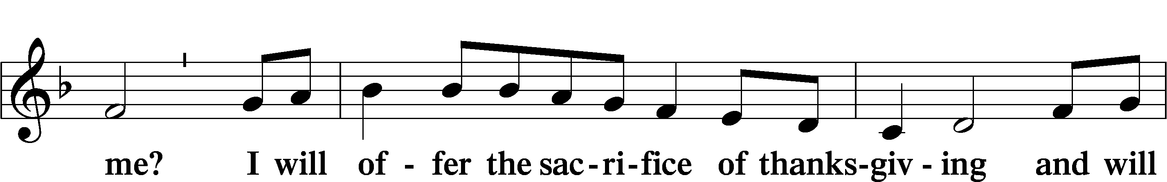
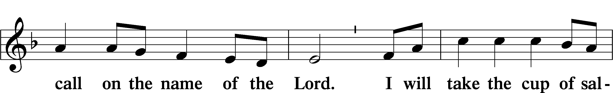
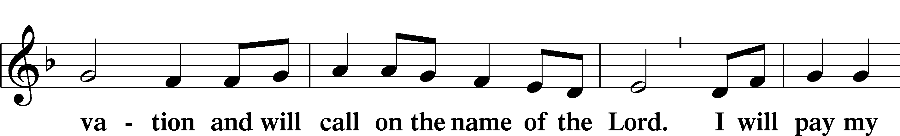
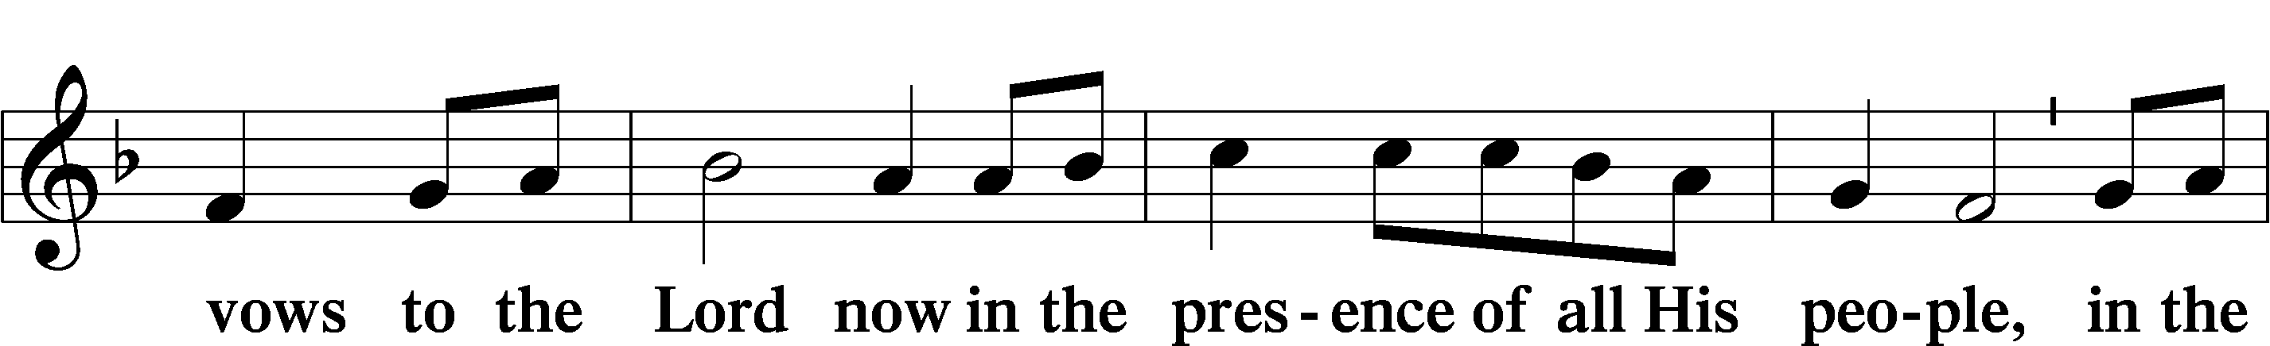
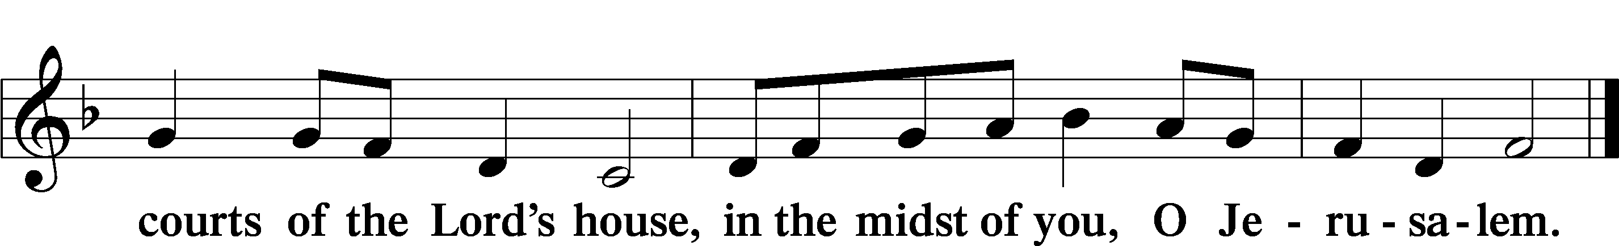

LORD’S PRAYER LSB 162
L Lord, remember us in Your kingdom and teach us to pray:
C Our Father who art in heaven,
hallowed be Thy name,
Thy kingdom come,
Thy will be done on earth
as it is in heaven;
give us this day our daily bread;
and forgive us our trespasses
as we forgive those
who trespass against us;
and lead us not into temptation,
but deliver us from evil.
For Thine is the kingdom
and the power and the glory
forever and ever. Amen.

CONCLUDING COLLECT

BENEDICTION LSB 166
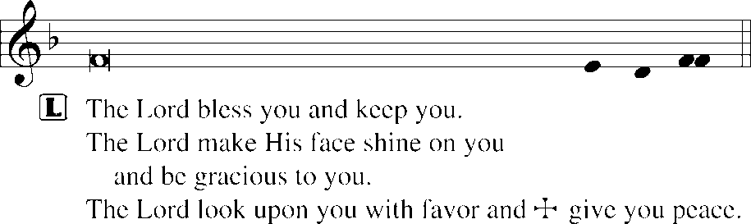


784 TAKE MY LIFE AND LET IT BE
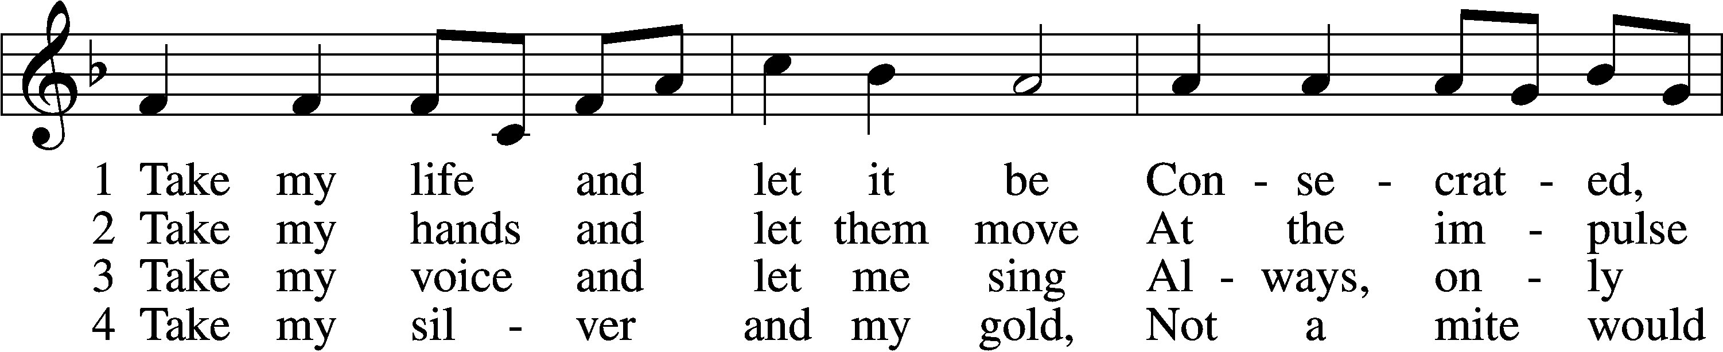
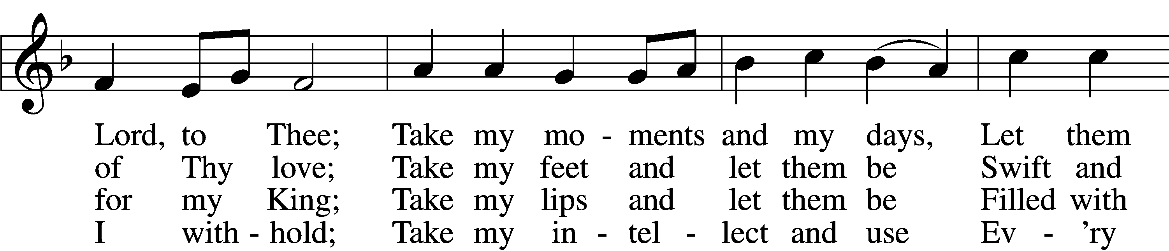
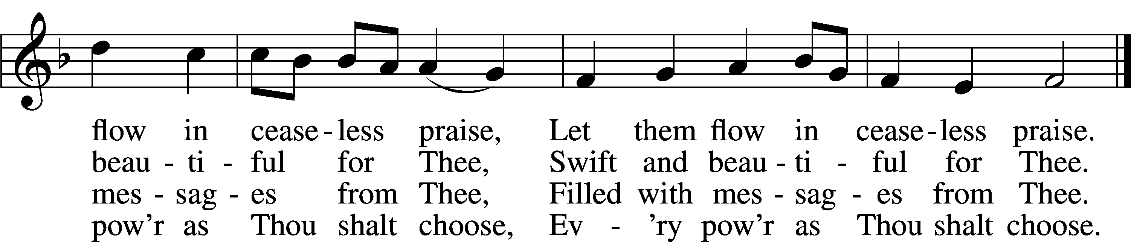

5 Take my will and make it Thine,
It shall be no longer mine;
Take my heart, it is Thine own,
It shall be Thy royal throne,
It shall be Thy royal throne.

6 Take my love, my Lord, I pour
At Thy feet its treasure store;
Take myself, and I will be
Ever, only, all for Thee,
Ever, only, all for Thee.
Text: Frances R. Havergal, 1836–79
Tune: Henri A. C. Malan, 1787–1864
Text and tune: Public domain
ACKNOWLEDGMENTS
Unless otherwise indicated, Scripture quotations are from the ESV® Bible (The Holy Bible, English Standard Version®), copyright © 2001 by Crossway, a publishing ministry of Good News Publishers. Used by permission. All rights reserved.
Created by Lutheran Service Builder © 2026 Concordia Publishing House.

