BETHLEHEM LUTHERAN CHURCH
A congregation of The Lutheran Church-Missouri Synod
902 Hitchcock Drive SW,
Aiken, South Carolina 29803
Church Phone: (803) 649-6417
blcaikensc@gmail.com

Note: The format of this bulletin has been modified for use in private devotion services. Unable to join us in person? Please find us on Facebook live. The service is also posted on our website: bethlehemlutheranaiken.org

+ + + + + + + + + + + + + + +
Fourth Sunday of Easter
April 26, 2026
10:30 a.m.
+ + + + + + + + + + + + + + +

+ SERVICE OF PREPARATION +
After the bell tolls, please observe a time of silence.

WELCOME AND ANNOUNCEMENTS

(Stand)

864 SHEPHERD OF TENDER YOUTH
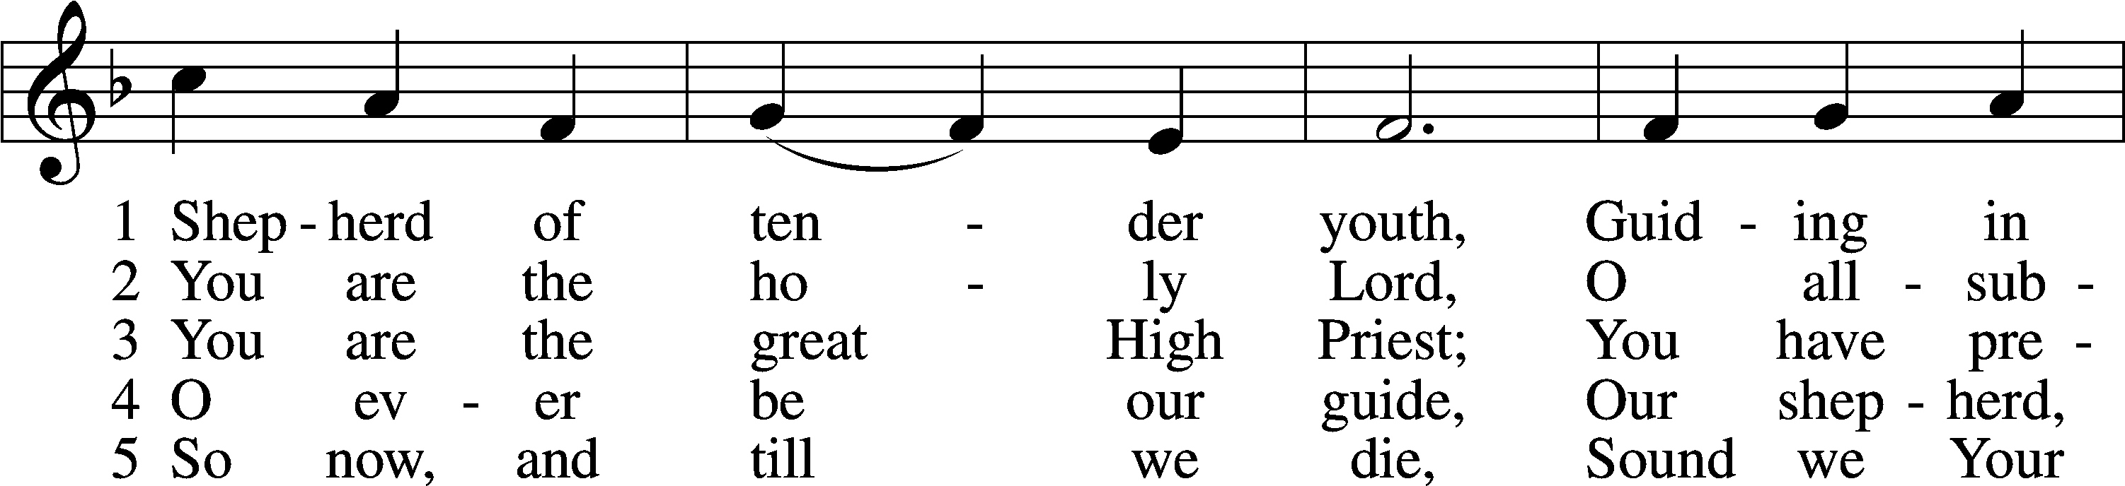
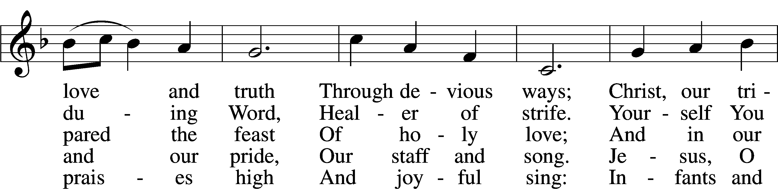
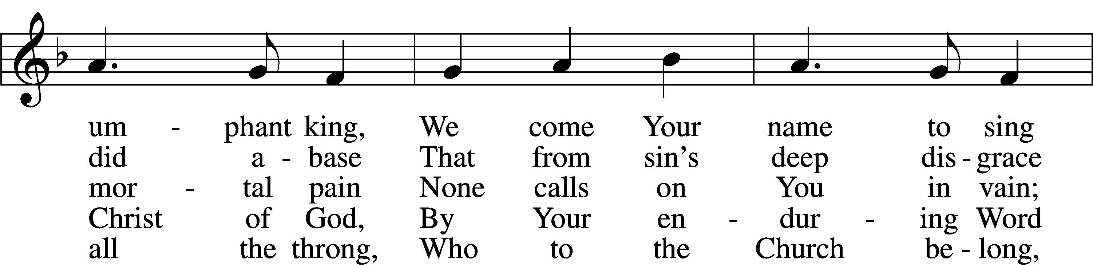
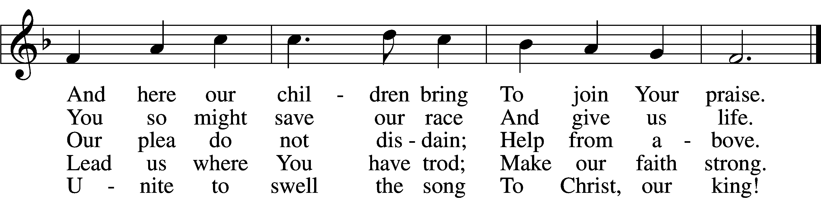
Text: attr. Clement of Alexandria, c. 170–c. 220; tr. Henry M. Dexter, 1821–90, alt.
Tune: Felice de Giardini, 1716–96
Text and tune: Public domain

+ CONFESSION AND ABSOLUTION +

(The sign of the cross may be made by all in remembrance of their Baptism.)

INVOCATION
L In the name of the Father and of the T Son and of the Holy Spirit.
C Amen.

EXHORTATION LSB 151
L If we say we have no sin, we deceive ourselves, and the truth is not in us.
C But if we confess our sins, God, who is faithful and just, will forgive our sins and cleanse us from all unrighteousness.

(Silence for reflection on God’s Word and for self-examination.)

CONFESSION OF SINS LSB 151
L Let us then confess our sins to God our Father.
C Most merciful God, we confess that we are by nature sinful and unclean. We have sinned against You in thought, word, and deed, by what we have done and by what we have left undone. We have not loved You with our whole heart; we have not loved our neighbors as ourselves. We justly deserve Your present and eternal punishment. For the sake of Your Son, Jesus Christ, have mercy on us. Forgive us, renew us, and lead us, so that we may delight in Your will and walk in Your ways to the glory of Your holy name. Amen.

DECLARATION OF GRACE LSB 151
L In the mercy of almighty God, Jesus Christ was given to die for us, and for His sake God forgives us all our sins. To those who believe in Jesus Christ He gives the power to become the children of God and bestows on them the Holy Spirit. May the Lord, who has begun this good work in us, bring it to completion in the day of our Lord Jesus Christ.
C Amen.

+ SERVICE OF THE WORD +

INTROIT Psalm 95:1–3, 6–7a; antiphon: John 10:14, 15b
I am the good | shepherd.*
I know my own and my own know me, and I lay down my life | for the sheep.
Oh come, let us sing | to the Lord;*
let us make a joyful noise to the rock of our sal- | vation!
Let us come into his presence with thanks- | giving;*
let us make a joyful noise to him with | songs of praise!
For the Lord is a | great God,*
and a great King a- | bove all gods.
Oh come, let us worship and | bow down;*
let us kneel before the Lord, our | Maker!
For he | is our God,*
and we are the people of his pasture, and the sheep | of his hand.
Glory be to the Father and | to the Son*
and to the Holy | Spirit;
as it was in the be- | ginning,*
is now, and will be forever. | Amen.
I am the good | shepherd.*
I know my own and my own know me, and I lay down my life | for the sheep.

KYRIE LSB 152

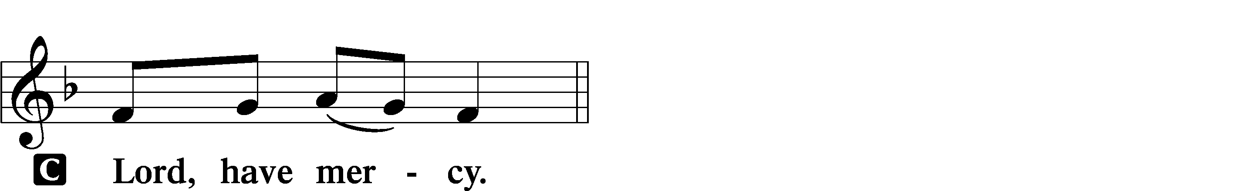

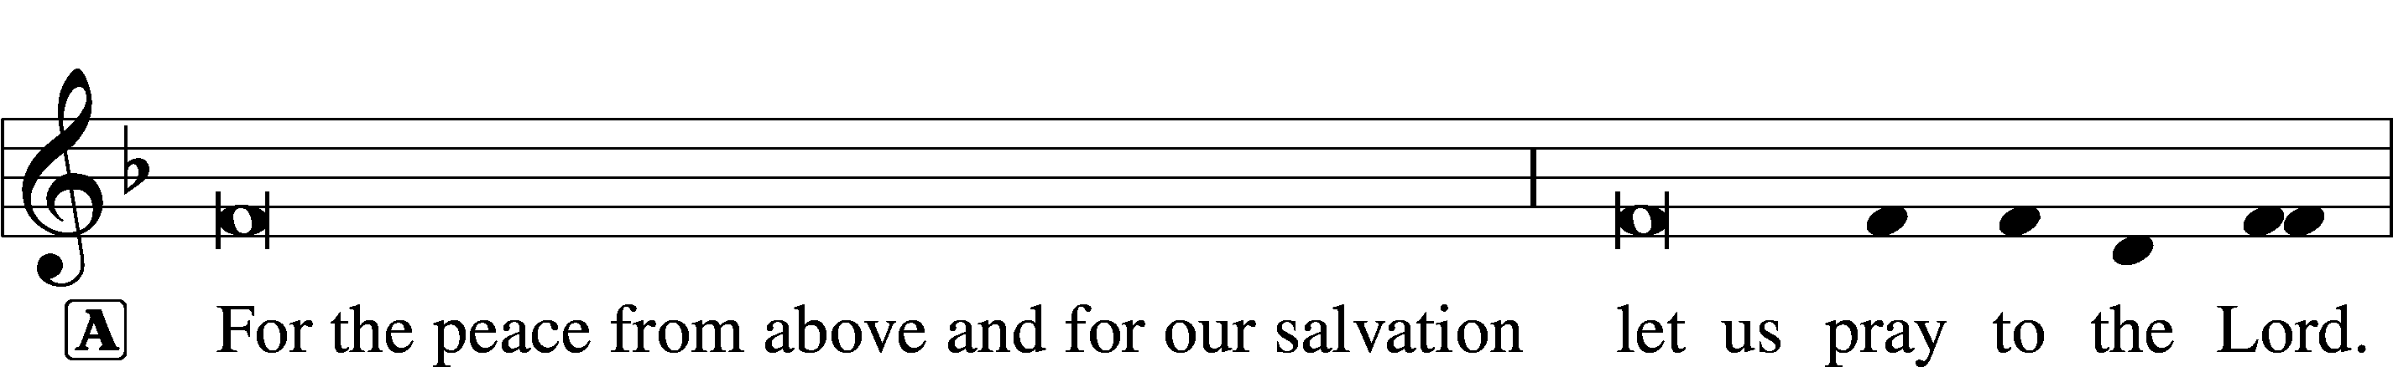
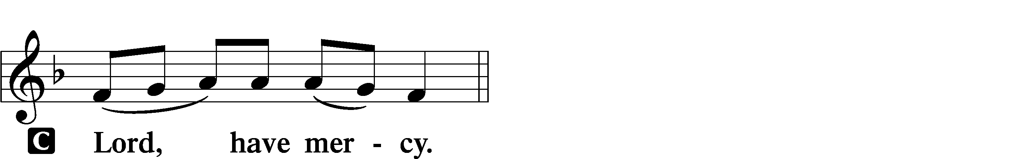
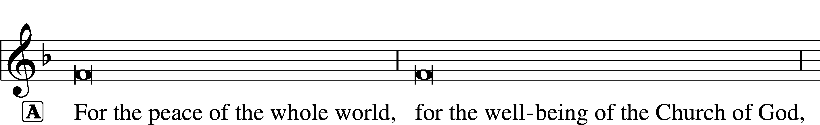

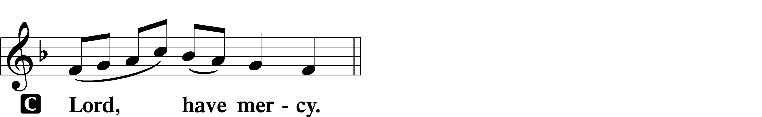

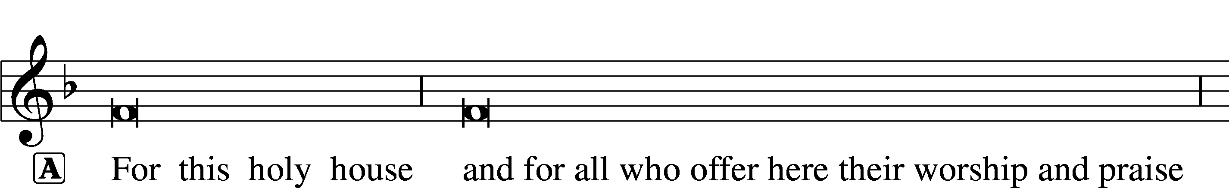

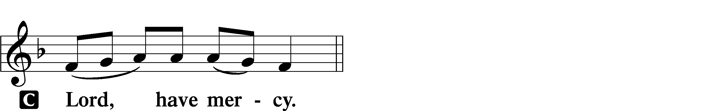




GLORIA IN EXCELSIS 154
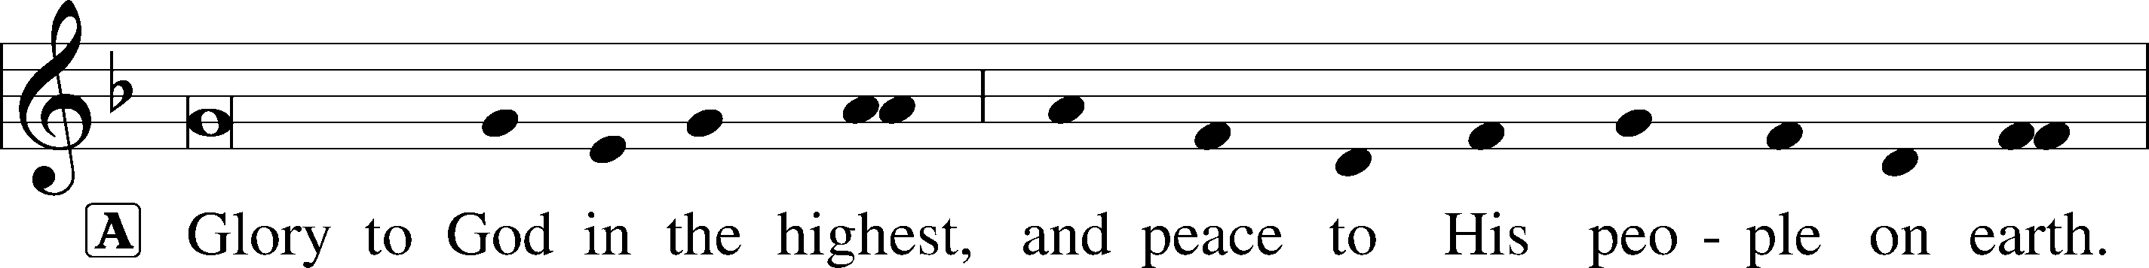
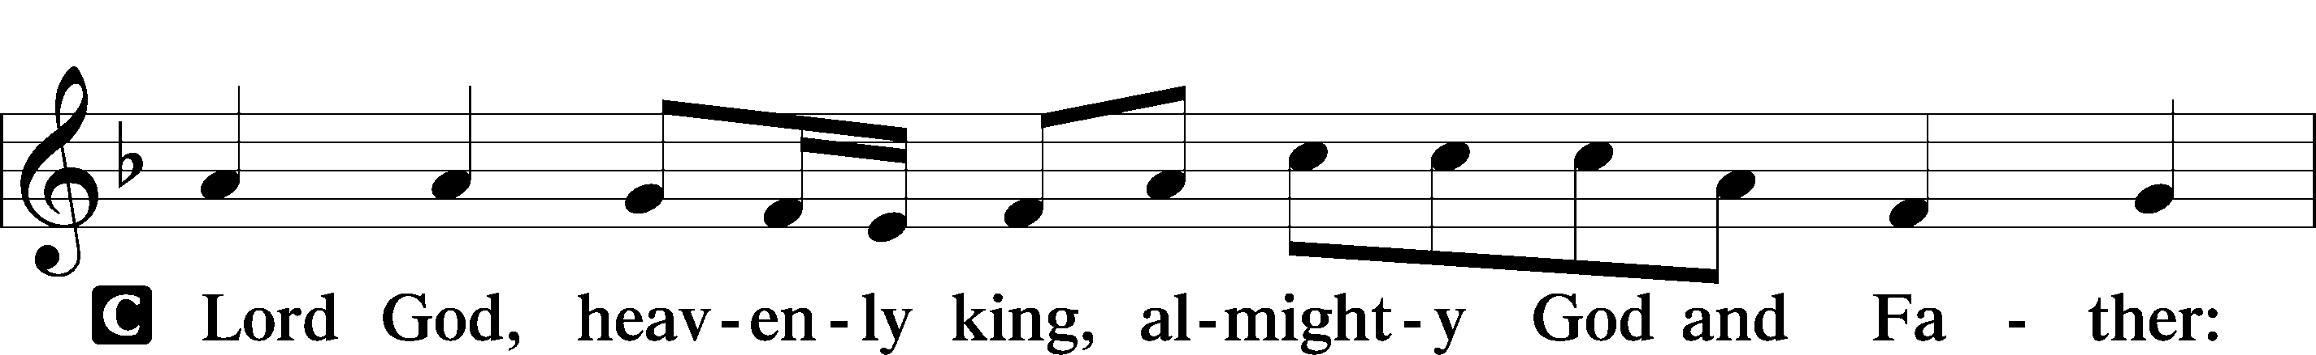
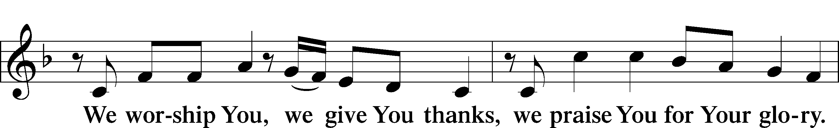
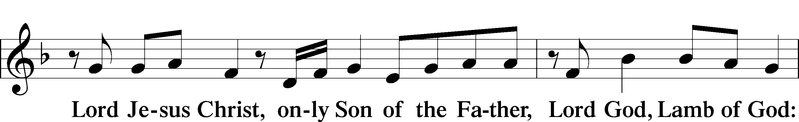
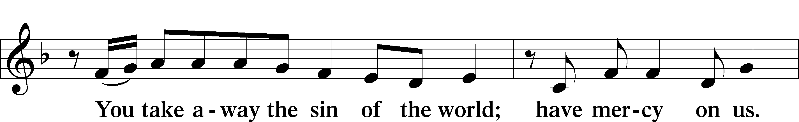
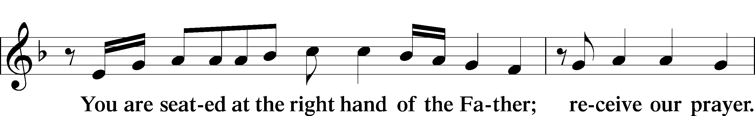
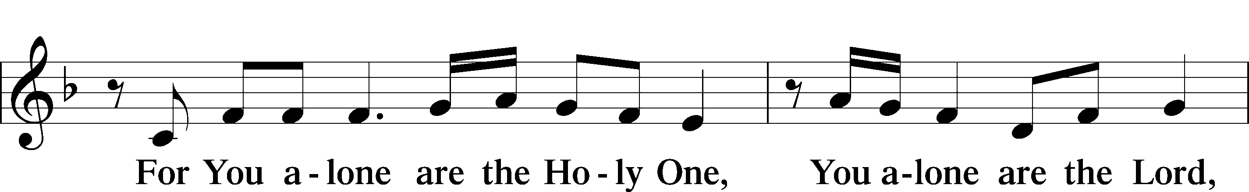
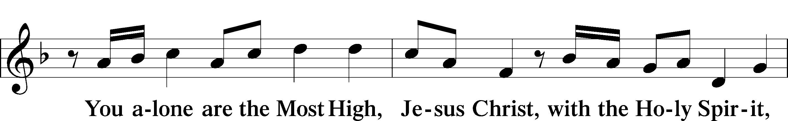
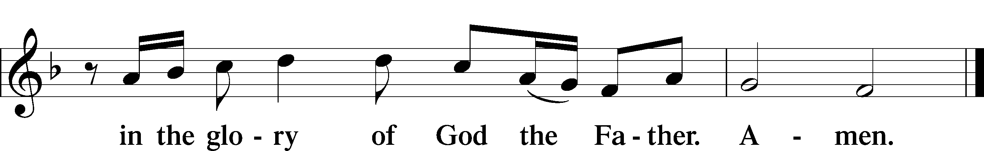

SALUTATION AND COLLECT OF THE DAY
L The Lord be with you.
C And also with you.

L Let us pray.
Almighty God, merciful Father, since You have wakened from death the Shepherd of Your sheep, grant us Your Holy Spirit that when we hear the voice of our Shepherd we may know Him who calls us each by name and follow where He leads; through the same Jesus Christ, Your Son, our Lord, who lives and reigns with You and the Holy Spirit, one God, now and forever.
C Amen.

(Sit)

FIRST READING Acts 2:42–47
42They devoted themselves to the apostles’ teaching and fellowship, to the breaking of bread and the prayers. 43And awe came upon every soul, and many wonders and signs were being done through the apostles. 44And all who believed were together and had all things in common. 45And they were selling their possessions and belongings and distributing the proceeds to all, as any had need. 46And day by day, attending the temple together and breaking bread in their homes, they received their food with glad and generous hearts, 47praising God and having favor with all the people. And the Lord added to their number day by day those who were being saved.

A This is the Word of the Lord.
C Thanks be to God.

GRADUAL adapt. from Matthew 28:7; Hebrews 2:7; Psalm 8:6
Christ has risen | from the dead.*
[God the Father] has crowned him with glory and | honor.
He has given him dominion over the works | of his hands;*
he has put all things un- | der his feet.

EPISTLE 1 Peter 2:19–25
19This is a gracious thing, when, mindful of God, one endures sorrows while suffering unjustly. 20For what credit is it if, when you sin and are beaten for it, you endure? But if when you do good and suffer for it you endure, this is a gracious thing in the sight of God. 21For to this you have been called, because Christ also suffered for you, leaving you an example, so that you might follow in his steps. 22He committed no sin, neither was deceit found in his mouth. 23When he was reviled, he did not revile in return; when he suffered, he did not threaten, but continued entrusting himself to him who judges justly. 24He himself bore our sins in his body on the tree, that we might die to sin and live to righteousness. By his wounds you have been healed. 25For you were straying like sheep, but have now returned to the Shepherd and Overseer of your souls.

A This is the Word of the Lord.
C Thanks be to God.

(Stand)

ALLELUIA AND VERSE LSB 156
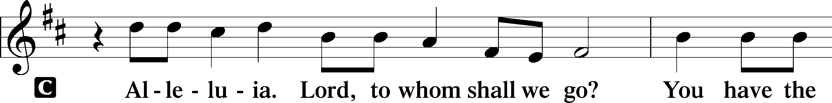
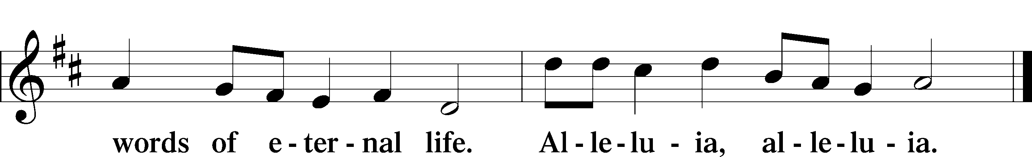

HOLY GOSPEL John 10:1–10
L The Holy Gospel according to St. John, the tenth chapter.

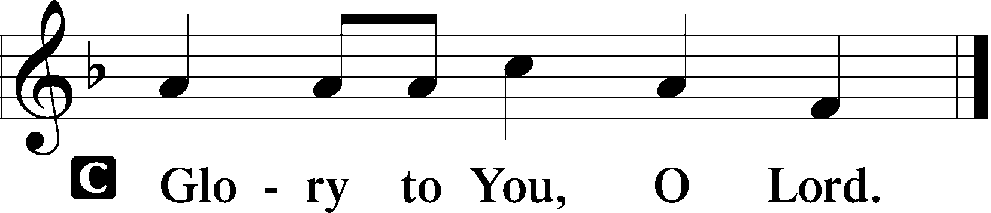

1[Jesus said:] “Truly, truly, I say to you, he who does not enter the sheepfold by the door but climbs in by another way, that man is a thief and a robber. 2But he who enters by the door is the shepherd of the sheep. 3To him the gatekeeper opens. The sheep hear his voice, and he calls his own sheep by name and leads them out. 4When he has brought out all his own, he goes before them, and the sheep follow him, for they know his voice. 5A stranger they will not follow, but they will flee from him, for they do not know the voice of strangers.” 6This figure of speech Jesus used with them, but they did not understand what he was saying to them.
7So Jesus again said to them, “Truly, truly, I say to you, I am the door of the sheep. 8All who came before me are thieves and robbers, but the sheep did not listen to them. 9I am the door. If anyone enters by me, he will be saved and will go in and out and find pasture. 10The thief comes only to steal and kill and destroy. I came that they may have life and have it abundantly.”

L This is the Gospel of the Lord.

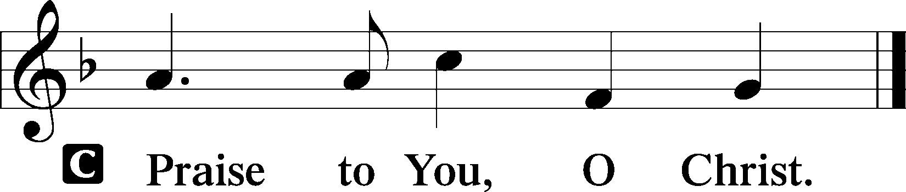

(Sit)

709 THE KING OF LOVE MY SHEPHERD IS
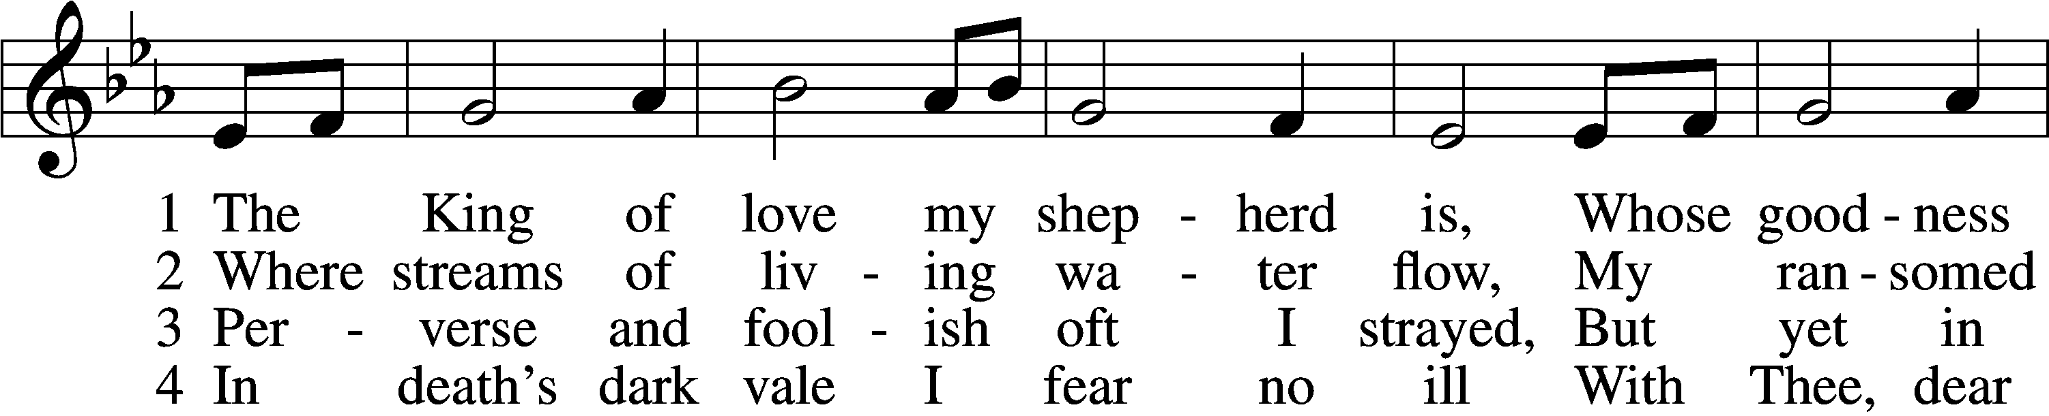
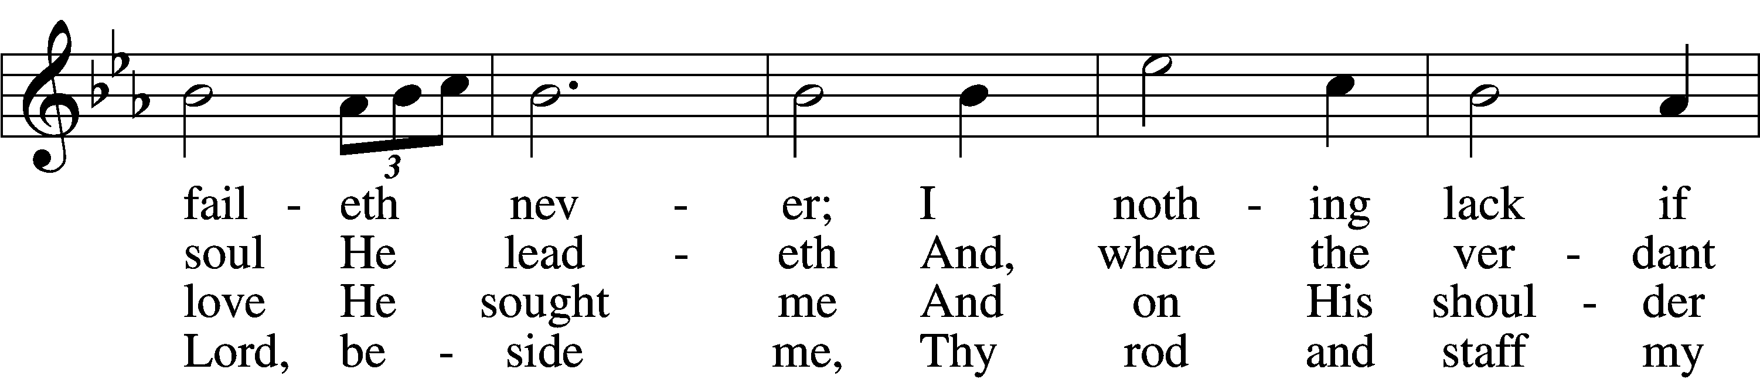
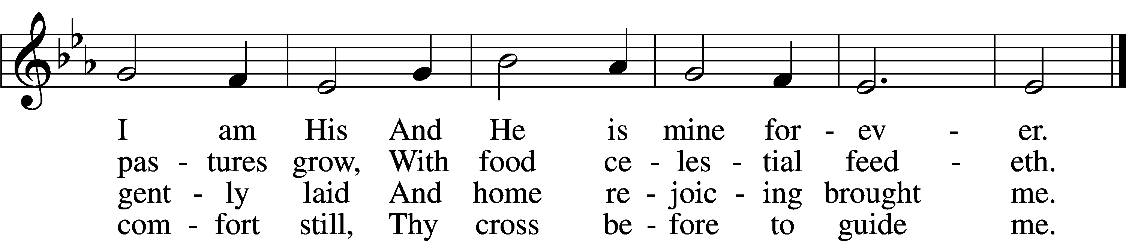

5 Thou spreadst a table in my sight;
Thine unction grace bestoweth;
And, oh, what transport of delight
From Thy pure chalice floweth!

6 And so through all the length of days
Thy goodness faileth never;
Good Shepherd, may I sing Thy praise
Within Thy house forever!
Text: Henry W. Baker, 1821–77
Tune: Irish, c. 18th cent.
Text and tune: Public domain

SERMON OR MEDITATION ON THE READINGS

(Stand)

NICENE CREED
C I believe in one God,
the Father Almighty,
maker of heaven and earth
and of all things visible and invisible.

And in one Lord Jesus Christ,
the only-begotten Son of God,
begotten of His Father before all worlds,
God of God, Light of Light,
very God of very God,
begotten, not made,
being of one substance with the Father,
by whom all things were made;
who for us men and for our salvation came down from heaven
and was incarnate by the Holy Spirit of the virgin Mary
and was made man;
and was crucified also for us under Pontius Pilate.
He suffered and was buried.
And the third day He rose again according to the Scriptures
and ascended into heaven
and sits at the right hand of the Father.
And He will come again with glory to judge both the living and the dead,
whose kingdom will have no end.

And I believe in the Holy Spirit,
the Lord and giver of life,
who proceeds from the Father and the Son,
who with the Father and the Son together is worshiped and glorified,
who spoke by the prophets.
And I believe in one holy Christian and apostolic Church,
I acknowledge one Baptism for the remission of sins,
and I look for the resurrection of the dead
and the life T of the world to come. Amen.

SHARING OF THE PEACE

(Sit)

PRAYER OF THE CHURCH

OFFERING
As a part of our expression of thanksgiving to God for the treasure of His salvation to us, we offer a portion of our treasure, according to what each has determined in their heart to give. Please place offerings in the collection plate at the back of the sanctuary before or after the service. Offerings can also be sent to Bethlehem Lutheran Church via U.S. Mail. Thank you!

(Stand)

OFFERTORY 159
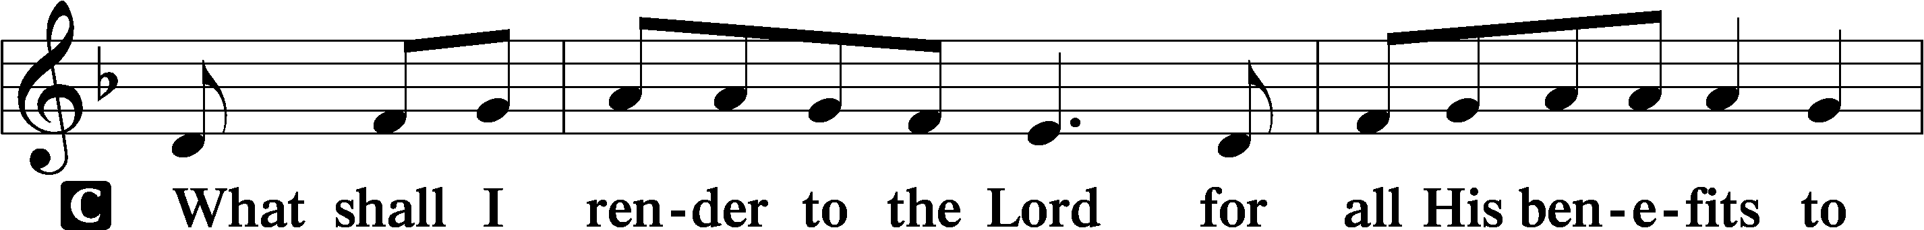
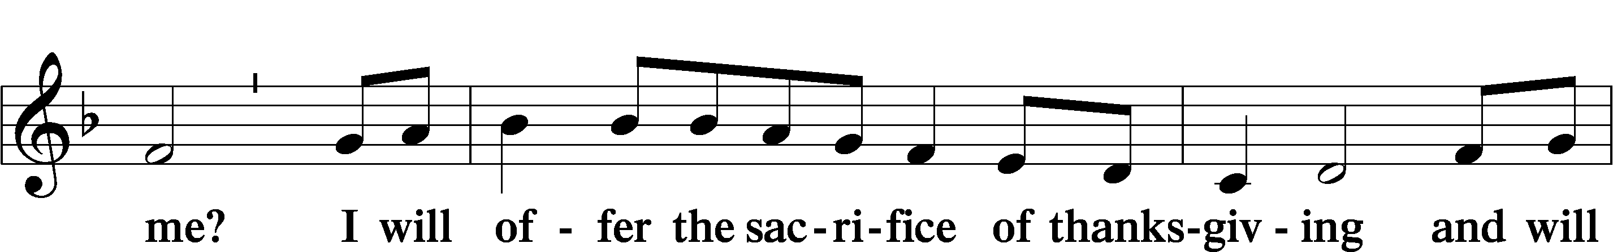
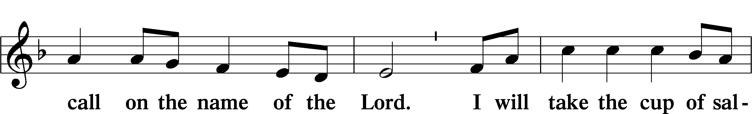
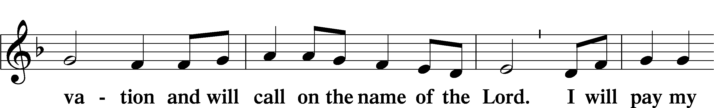
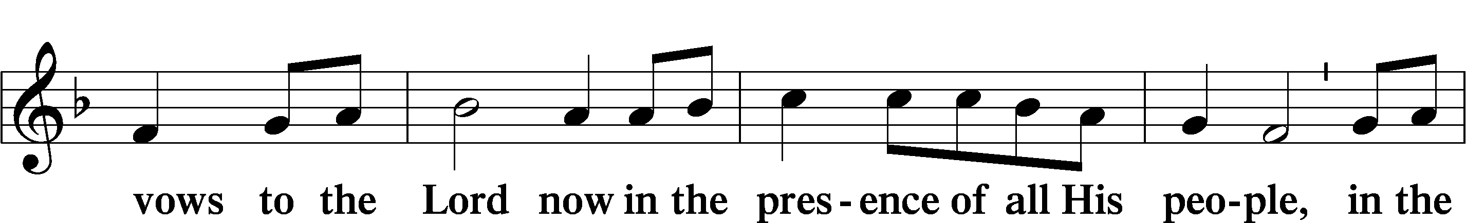
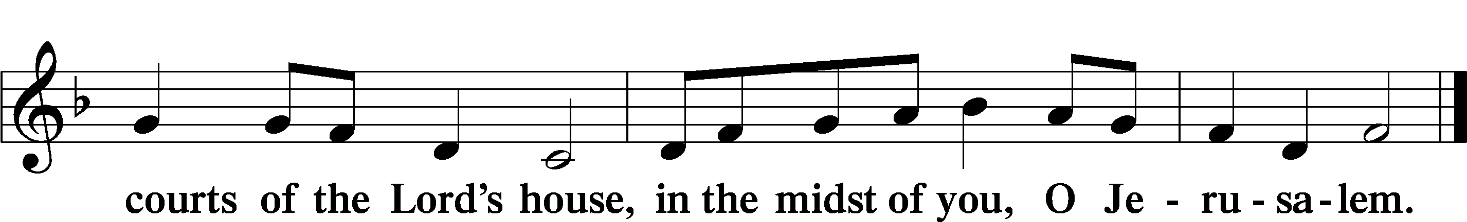

LORD’S PRAYER
C Our Father who art in heaven,
hallowed be Thy name,
Thy kingdom come,
Thy will be done on earth
as it is in heaven;
give us this day our daily bread;
and forgive us our trespasses
as we forgive those
who trespass against us;
and lead us not into temptation,
but deliver us from evil.
For Thine is the kingdom
and the power and the glory
forever and ever. Amen.

CONCLUDING COLLECT

BENEDICTION LSB 166
L The grace of our Lord T Jesus Christ, and the love of God, and the fellowship of the Holy Spirit, be with us all.


918 GUIDE ME, O THOU GREAT REDEEMER
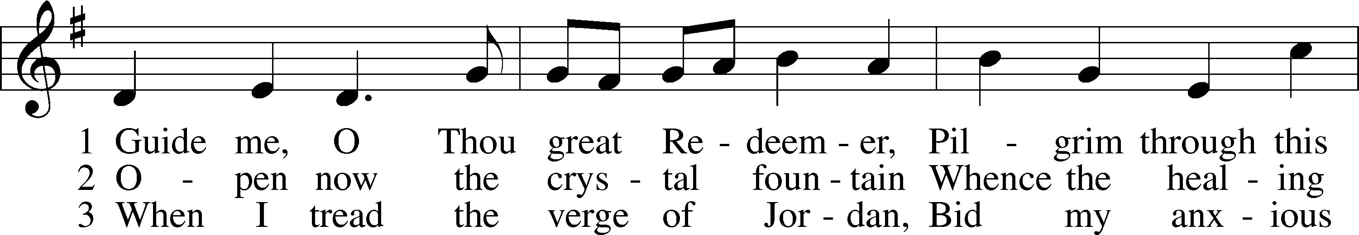
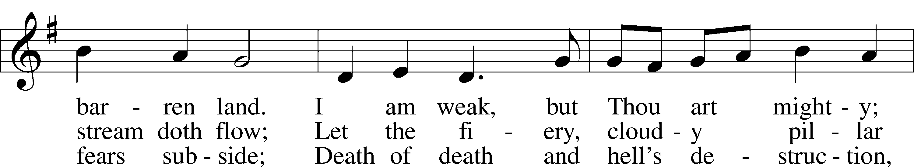
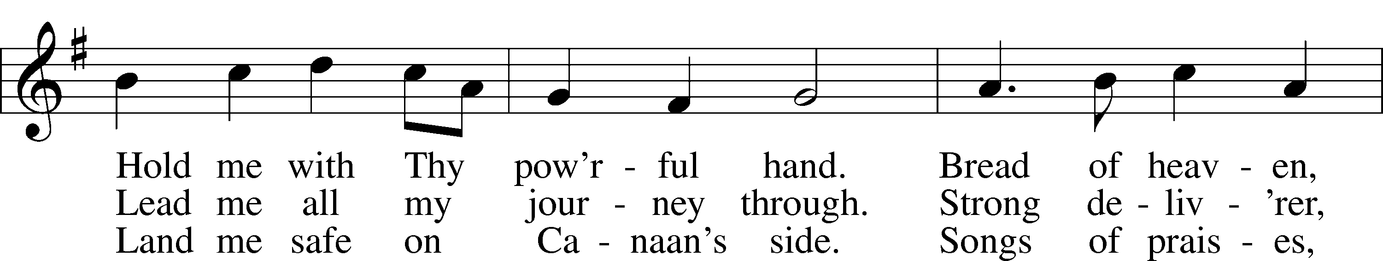
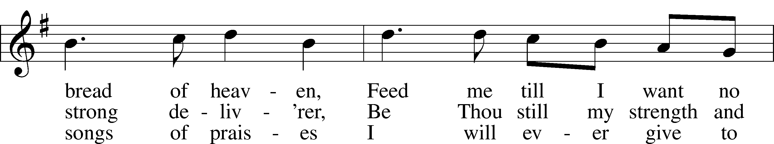
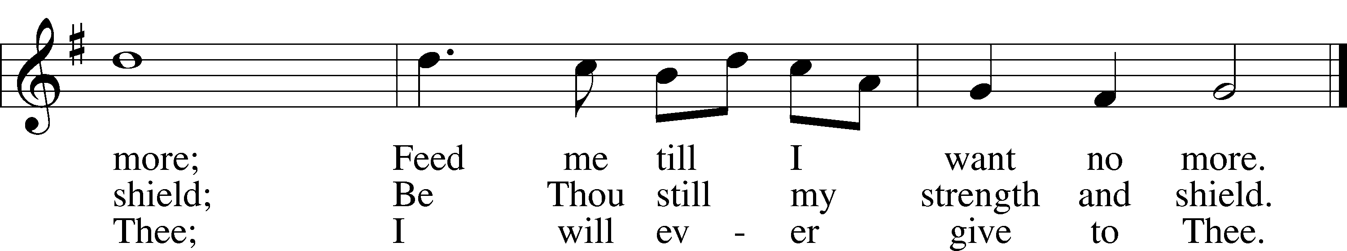
Text: William Williams, 1717–91, abr.; (st. 1): tr. Peter Williams, 1722–96, alt.; (sts. 2–3): tr. William Williams, 1717–91
Tune: John Hughes, 1873–1932
Text and tune: Public domain
ACKNOWLEDGMENTS
Unless otherwise indicated, Scripture quotations are from the ESV® Bible (The Holy Bible, English Standard Version®), copyright © 2001 by Crossway, a publishing ministry of Good News Publishers. Used by permission. All rights reserved.
Created by Lutheran Service Builder © 2026 Concordia Publishing House.

OUR VALUE STATEMENT: Bethlehem Lutheran Church exists under God’s grace to save the lost and to strengthen the saved so that they may live bold and courageous lives of Christian witness before a non-believing world.
Therefore, our purpose is:
- to glorify God in Word and deed,
- to nurture each other in Christian love,
- to reach out to others with our Savior’s Gospel of life and salvation.
(Rom 5:8, Matt. 28:18-20).

OUR VISION: By the Grace of God, Bethlehem Lutheran Church, is a loving family united in Christ, learning, living, and spreading His Word.

OUR MISSION: Learn the Word. Live the Word. Spread the Word.

