BETHLEHEM LUTHERAN CHURCH
A congregation of The Lutheran Church-Missouri Synod
902 Hitchcock Drive SW,
Aiken, South Carolina 29803
Church Phone: (803) 649-6417
blcaikensc@gmail.com
Pastor: Rev. John B. Engwall
Office Hours By Appointment
Note: The format of this bulletin has been modified for use in private devotion services.
Unable to join us in person? Please find us on Facebook live.
The service is also posted on our website; bethlehemlutheranaiken.org

+ + + + + + + + + + + + + + +
The Second Sunday in Lent
March 1, 2026
10:30 a.m.
+ + + + + + + + + + + + + + +

Our Policy and Practice Regarding Holy Communion
Hear the words of the Apostle Paul;
Anyone who eats and drinks without recognizing the body of the Lord eats and drinks judgment on himself. -1 Cor.11:29
Therefore, visitors are asked to please refrain from partaking of the Sacrament before speaking about this with the pastor; because we care about your spiritual well-being.
Also, because communing at this altar is a public confession that you agree with the doctrines of The Lutheran Church-Missouri Synod, and reject all contrary teachings.
Persons who are not communing today are always welcome to come forward during the distribution to receive an individual blessing; please cross your arms over your chest to indicate your desire for this. Thank you!
We commune in two alternating tables. The ushers will guide you. Non-alcoholic white wine is available in the center of the individual cup tray. Please leave empty individual cups at the altar rail.

+ SERVICE OF PREPARATION +
After the bell tolls, please observe a time of silence.

WELCOME AND ANNOUNCEMENTS

(Stand)

798 THE GOD OF ABRAHAM PRAISE sts. 1–4
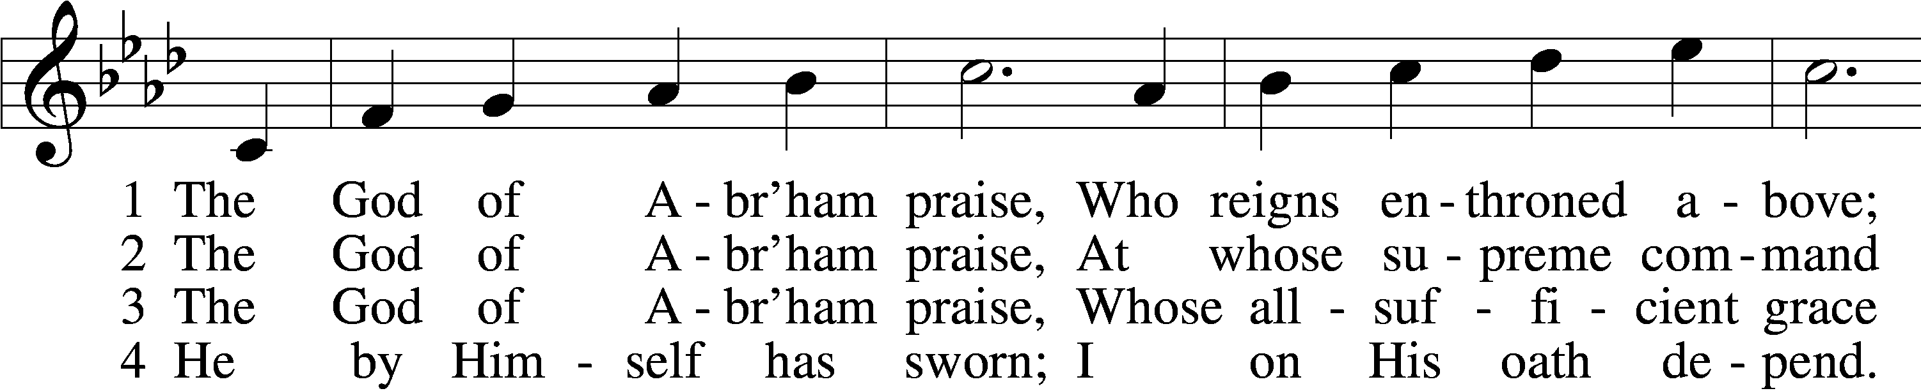
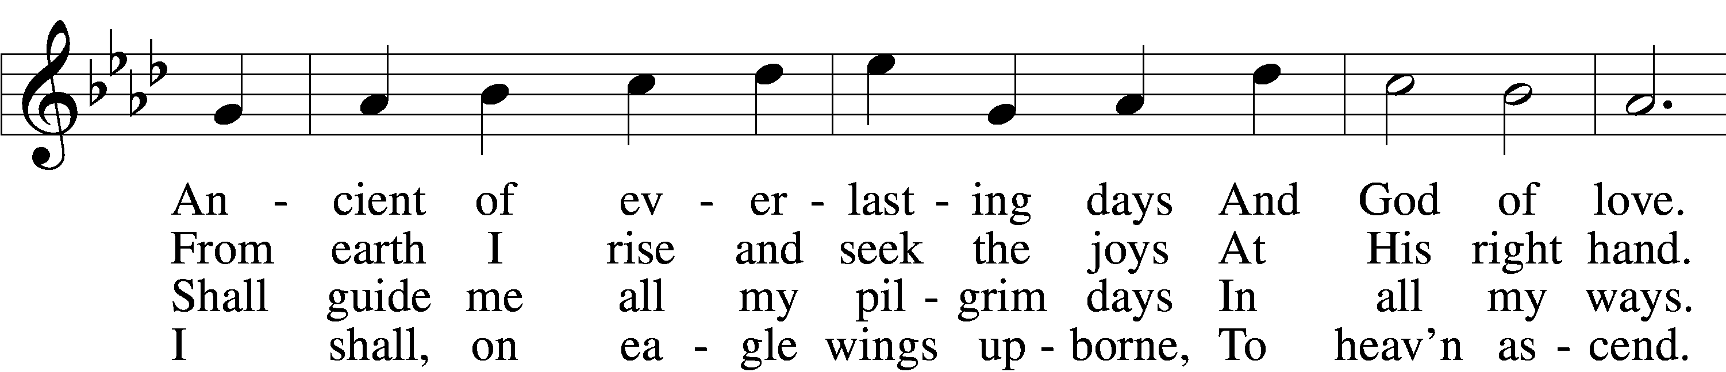
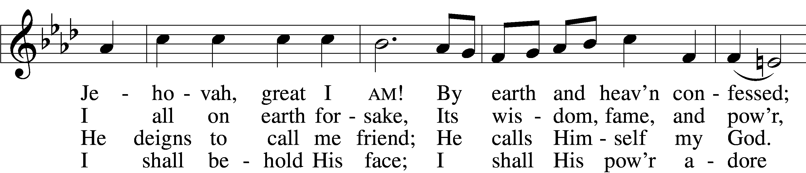
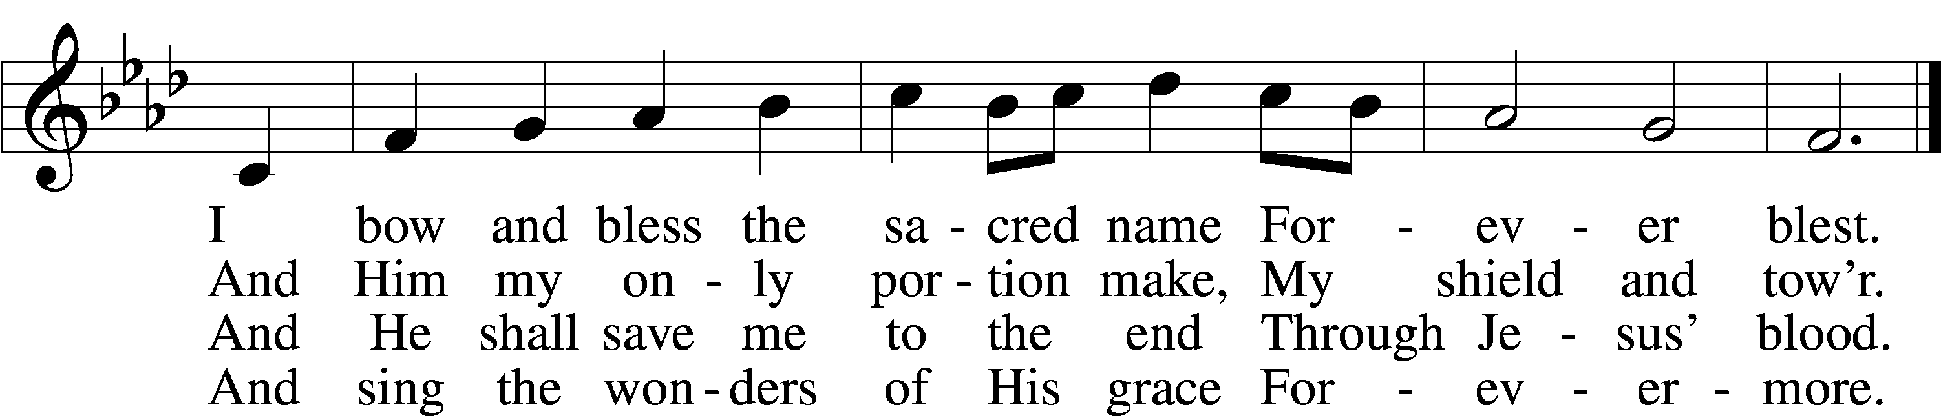
Text: Thomas Olivers, 1725–99, alt.
Tune: Hebrew
Text and tune: Public domain

+ CONFESSION AND ABSOLUTION +

(The sign of the cross may be made by all in remembrance of their Baptism.)

INVOCATION
L In the name of the Father and of the T Son and of the Holy Spirit.
C Amen.

EXHORTATION LSB 184
L Beloved in the Lord! Let us draw near with a true heart and confess our sins unto God our Father, beseeching Him in the name of our Lord Jesus Christ to grant us forgiveness.

L Our help is in the name of the Lord,
C who made heaven and earth.
L I said, I will confess my transgressions unto the Lord,
C and You forgave the iniquity of my sin.

(Silence for reflection on God’s Word and for self-examination.)

CONFESSION OF SINS LSB 184
L O almighty God, merciful Father,
C I, a poor, miserable sinner, confess unto You all my sins and iniquities with which I have ever offended You and justly deserved Your temporal and eternal punishment. But I am heartily sorry for them and sincerely repent of them, and I pray You of Your boundless mercy and for the sake of the holy, innocent, bitter sufferings and death of Your beloved Son, Jesus Christ, to be gracious and merciful to me, a poor, sinful being.

DECLARATION OF GRACE
L In the mercy of almighty God, Jesus Christ was given to die for us, and for His sake God forgives us all our sins. To those who believe in Jesus Christ He gives the power to become the children of God and bestows on them the Holy Spirit. May the Lord, who has begun this good work in us, bring it to completion in the day of our Lord Jesus Christ.
C Amen.

+ SERVICE OF THE WORD +

INTROIT
He remembers his covenant for- | ever,*
the word that he commanded, for a thousand gener- | ations.
Seek the Lord | and his strength;*
seek his presence con- | tinually!
Remember the wondrous works that | he has done,*
his miracles, and the judgments he | uttered,
O offspring of Abraham, his | servant,*
children of Jacob, his | chosen ones!
He is the | Lord our God;*
his judgments are in | all the earth.
He remembers his covenant for- | ever,*
the word that he commanded, for a thousand gener- | ations.

GLORIA PATRI LSB 186
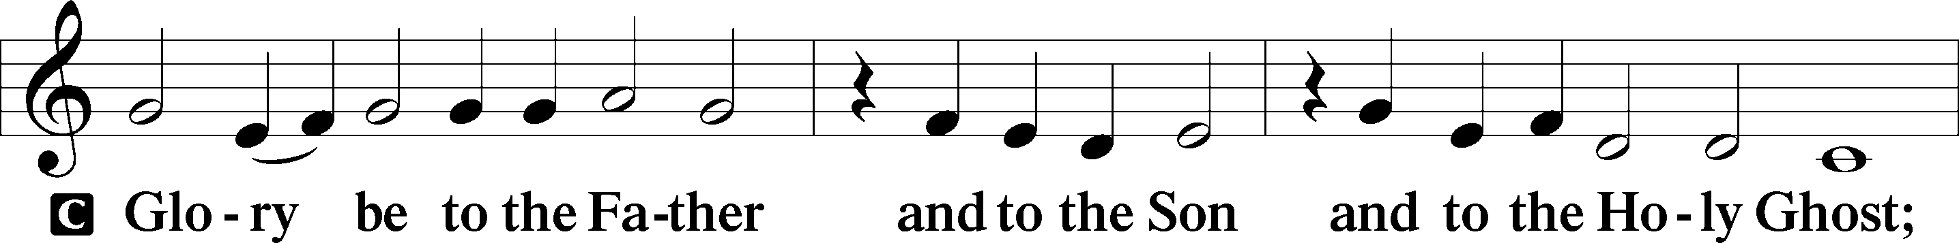
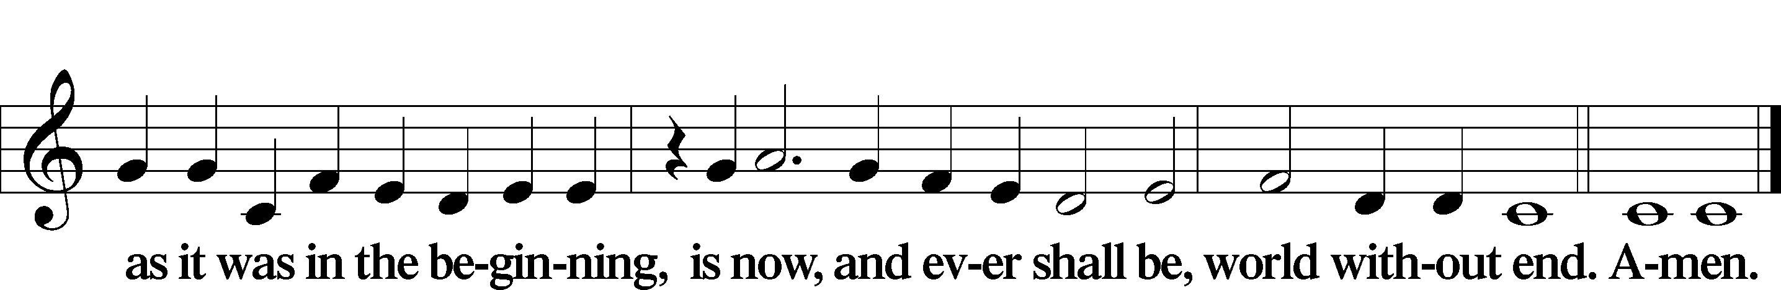

KYRIE LSB 186
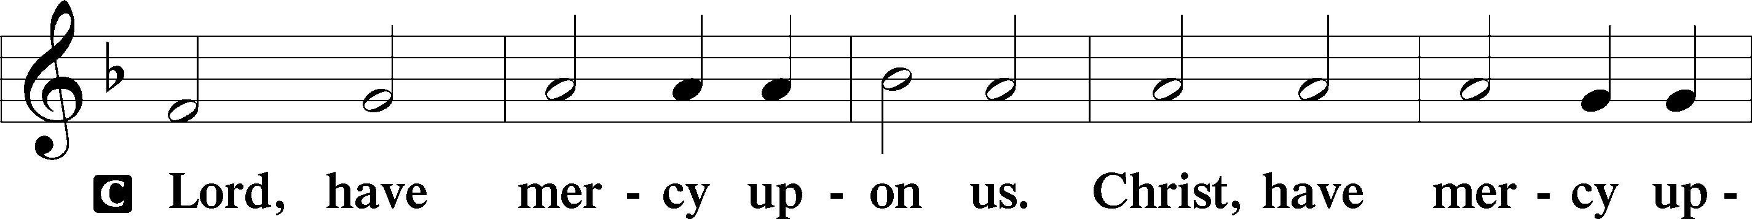
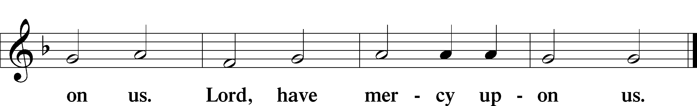

SALUTATION AND COLLECT OF THE DAY
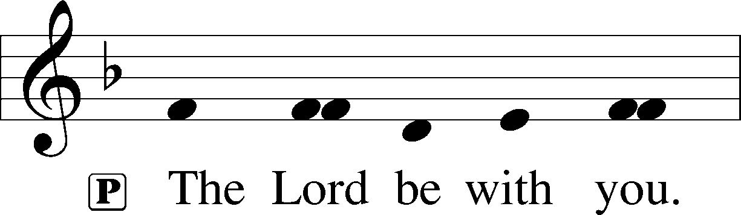
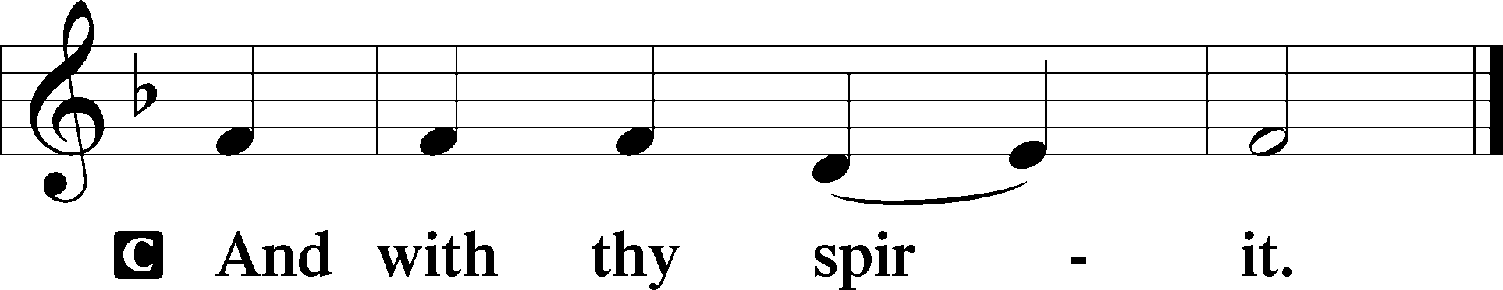

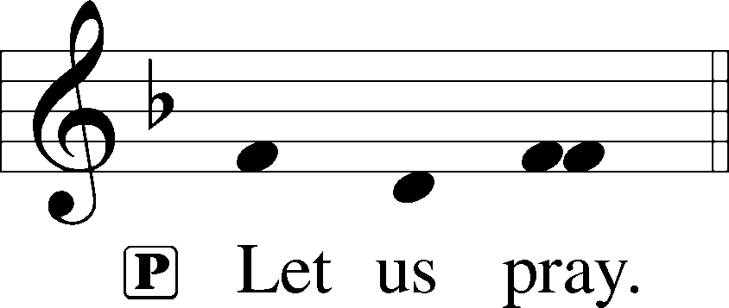

L O God, You see that of ourselves we have no strength. By Your mighty power defend us from all adversities that may happen to the body and from all evil thoughts that may assault and hurt the soul; through Jesus Christ, Your Son, our Lord, who lives and reigns with You and the Holy Spirit, one God, now and forever.

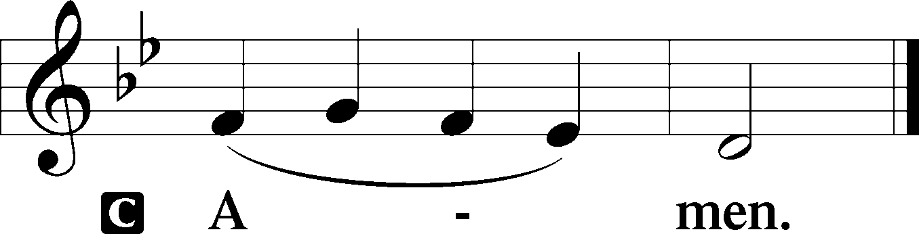

(Sit)

CHILDREN'S LESSON

OLD TESTAMENT READING Genesis 12:1–9
1The Lord said to Abram, “Go from your country and your kindred and your father’s house to the land that I will show you. 2And I will make of you a great nation, and I will bless you and make your name great, so that you will be a blessing. 3I will bless those who bless you, and him who dishonors you I will curse, and in you all the families of the earth shall be blessed.”
4So Abram went, as the Lord had told him, and Lot went with him. Abram was seventy-five years old when he departed from Haran. 5And Abram took Sarai his wife, and Lot his brother’s son, and all their possessions that they had gathered, and the people that they had acquired in Haran, and they set out to go to the land of Canaan. When they came to the land of Canaan, 6Abram passed through the land to the place at Shechem, to the oak of Moreh. At that time the Canaanites were in the land. 7Then the Lord appeared to Abram and said, “To your offspring I will give this land.” So he built there an altar to the Lord, who had appeared to him. 8From there he moved to the hill country on the east of Bethel and pitched his tent, with Bethel on the west and Ai on the east. And there he built an altar to the Lord and called upon the name of the Lord. 9And Abram journeyed on, still going toward the Negeb.

L This is the Word of the Lord.
C Thanks be to God.

GRADUAL Hebrews 12:2
[O come, let us fix our eyes on] | Jesus,*
the founder and perfecter | of our faith,
who for the joy that was set before him endured the cross, despis- | ing the shame,*
and is seated at the right hand of the | throne of God.

EPISTLE Romans 4:1–8, 13–17
1What then shall we say was gained by Abraham, our forefather according to the flesh? 2For if Abraham was justified by works, he has something to boast about, but not before God. 3For what does the Scripture say? “Abraham believed God, and it was counted to him as righteousness.” 4Now to the one who works, his wages are not counted as a gift but as his due. 5And to the one who does not work but trusts him who justifies the ungodly, his faith is counted as righteousness, 6just as David also speaks of the blessing of the one to whom God counts righteousness apart from works:
7“Blessed are those whose lawless deeds are forgiven,
and whose sins are covered;
8blessed is the man against whom the Lord will not count his sin.” . . .
13For the promise to Abraham and his offspring that he would be heir of the world did not come through the law but through the righteousness of faith. 14For if it is the adherents of the law who are to be the heirs, faith is null and the promise is void. 15For the law brings wrath, but where there is no law there is no transgression.
16That is why it depends on faith, in order that the promise may rest on grace and be guaranteed to all his offspring—not only to the adherent of the law but also to the one who shares the faith of Abraham, who is the father of us all, 17as it is written, “I have made you the father of many nations”—in the presence of the God in whom he believed, who gives life to the dead and calls into existence the things that do not exist.

L This is the Word of the Lord.
C Thanks be to God.

(Stand)

HOLY GOSPEL John 3:1–17
L The Holy Gospel according to St. John, the third chapter.

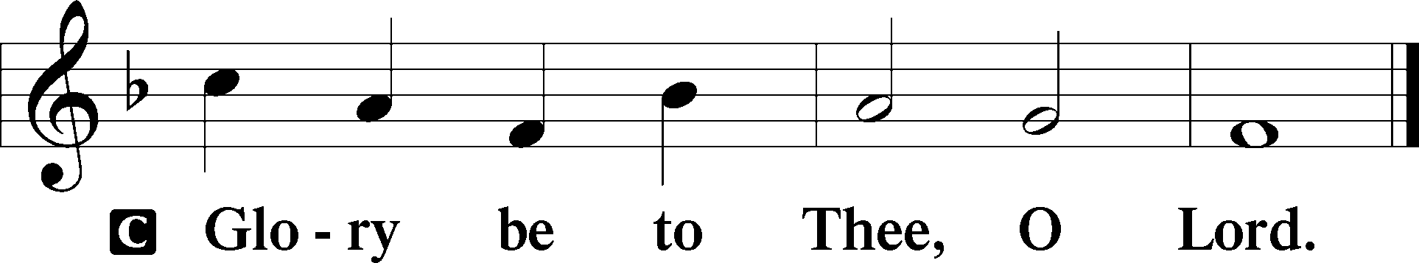

1Now there was a man of the Pharisees named Nicodemus, a ruler of the Jews. 2This man came to Jesus by night and said to him, “Rabbi, we know that you are a teacher come from God, for no one can do these signs that you do unless God is with him.” 3Jesus answered him, “Truly, truly, I say to you, unless one is born again he cannot see the kingdom of God.” 4Nicodemus said to him, “How can a man be born when he is old? Can he enter a second time into his mother’s womb and be born?” 5Jesus answered, “Truly, truly, I say to you, unless one is born of water and the Spirit, he cannot enter the kingdom of God. 6That which is born of the flesh is flesh, and that which is born of the Spirit is spirit. 7Do not marvel that I said to you, ‘You must be born again.’ 8The wind blows where it wishes, and you hear its sound, but you do not know where it comes from or where it goes. So it is with everyone who is born of the Spirit.”
9Nicodemus said to him, “How can these things be?” 10Jesus answered him, “Are you the teacher of Israel and yet you do not understand these things? 11Truly, truly, I say to you, we speak of what we know, and bear witness to what we have seen, but you do not receive our testimony. 12If I have told you earthly things and you do not believe, how can you believe if I tell you heavenly things? 13No one has ascended into heaven except he who descended from heaven, the Son of Man. 14And as Moses lifted up the serpent in the wilderness, so must the Son of Man be lifted up, 15that whoever believes in him may have eternal life.
16“For God so loved the world, that he gave his only Son, that whoever believes in him should not perish but have eternal life. 17For God did not send his Son into the world to condemn the world, but in order that the world might be saved through him.”

L This is the Gospel of the Lord.

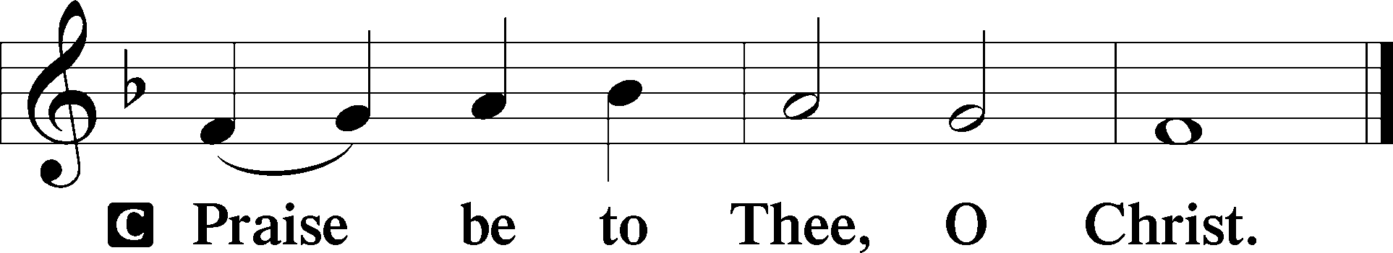

APOSTLES’ CREED
C I believe in God, the Father Almighty,
maker of heaven and earth.

And in Jesus Christ, His only Son, our Lord,
who was conceived by the Holy Spirit,
born of the virgin Mary,
suffered under Pontius Pilate,
was crucified, died and was buried.
He descended into hell.
The third day He rose again from the dead.
He ascended into heaven
and sits at the right hand of God the Father Almighty.
From thence He will come to judge the living and the dead.

I believe in the Holy Spirit,
the holy Christian Church,
the communion of saints,
the forgiveness of sins,
the resurrection of the body,
and the life T everlasting. Amen.

(Sit)

708 LORD, THEE I LOVE WITH ALL MY HEART
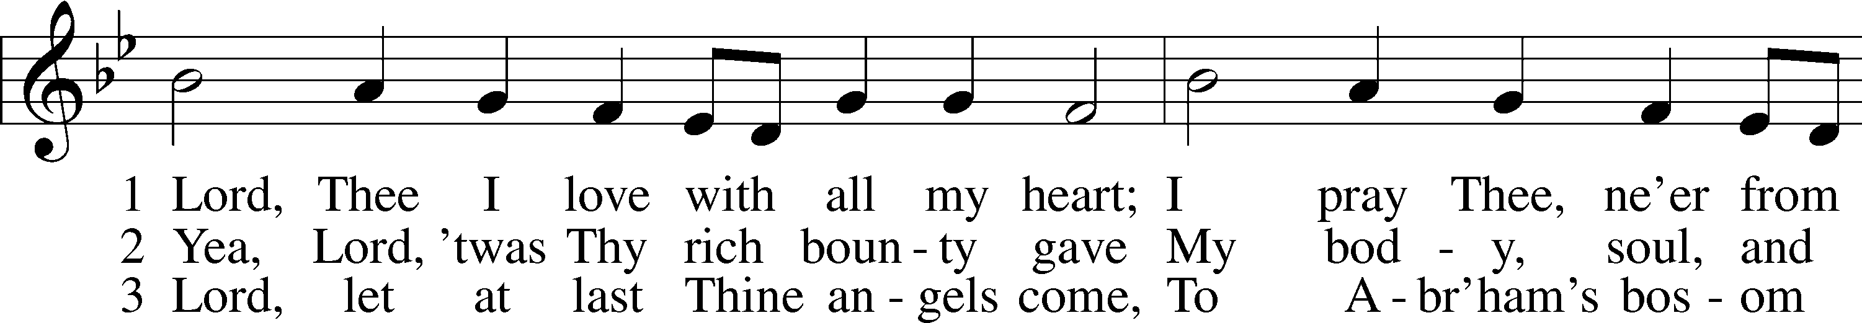
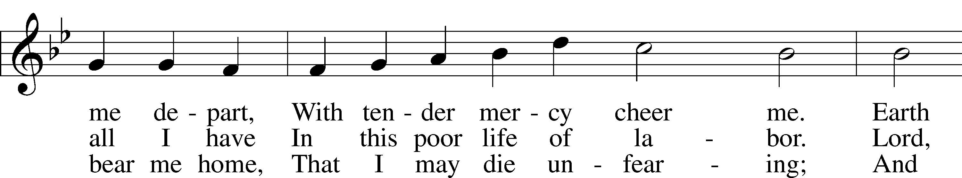
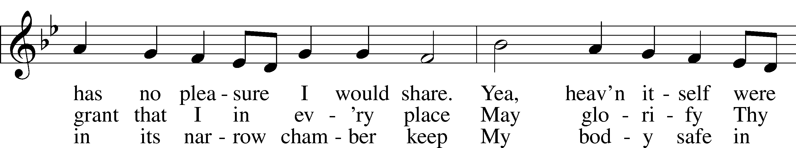
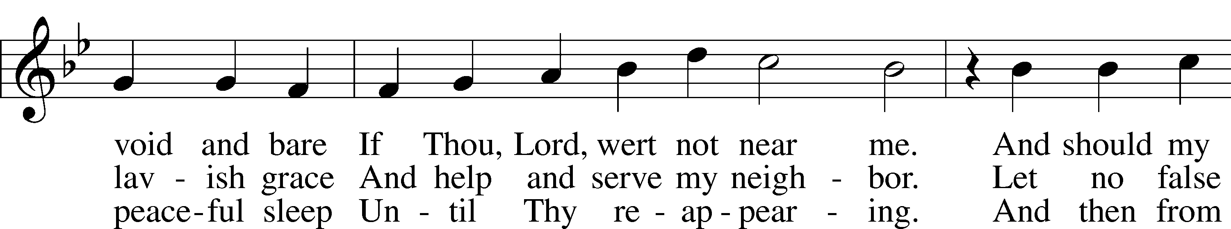
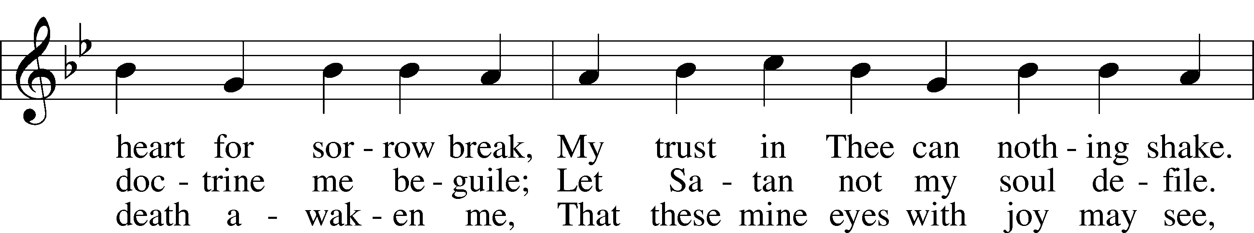
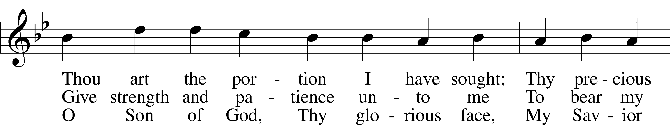
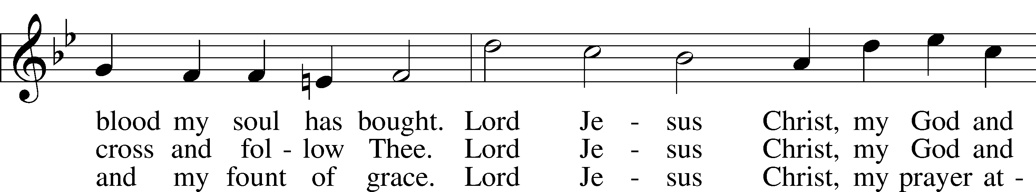
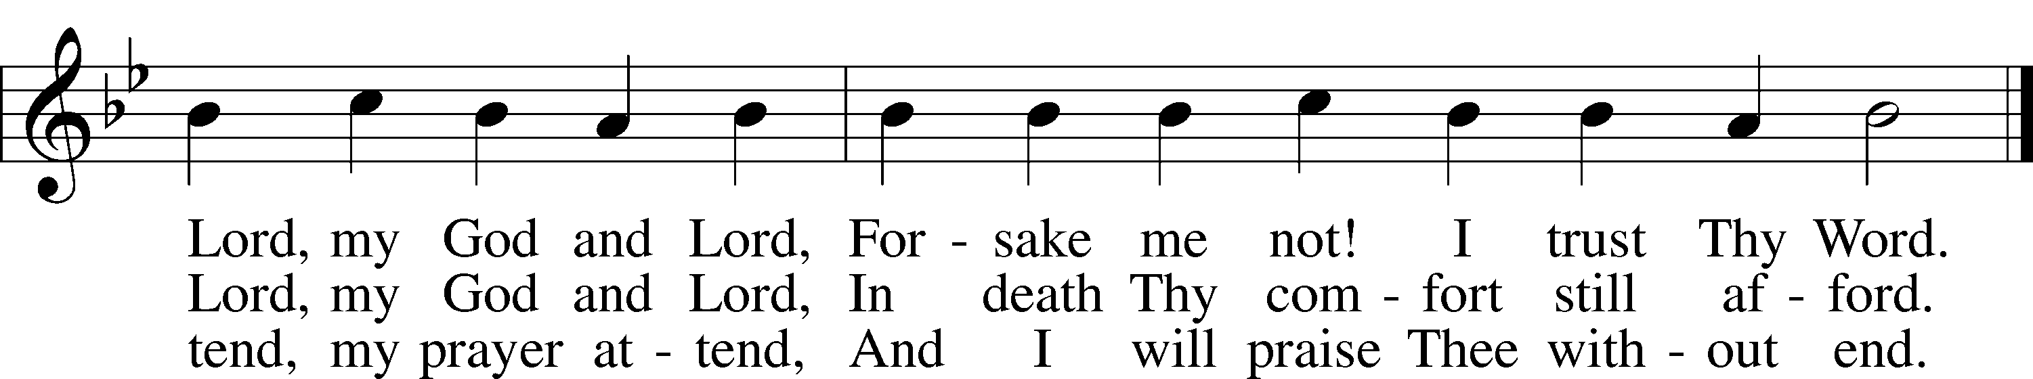
Text: Martin Schalling, 1532–1608; tr. Catherine Winkworth, 1827–78, alt.
Tune: Zwey Bücher . . . Tabulatur, 1577, Strassburg
Text and tune: Public domain

SERMON OR MEDITATION ON THE READINGS

(Stand)
OFFERING
As a part of our expression of thanksgiving to God for the treasure of His salvation to us, we offer a portion of our treasure, according to what each has determined in their heart to give. Please place offerings in the collection plate at the back of the sanctuary before or after the service. Offerings can also be sent to Bethlehem Lutheran Church via U.S. Mail. Thank you!

OFFERTORY LSB 192
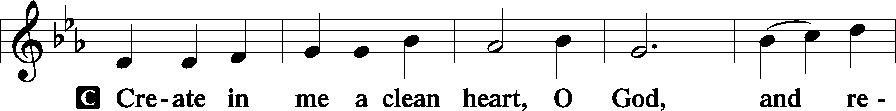
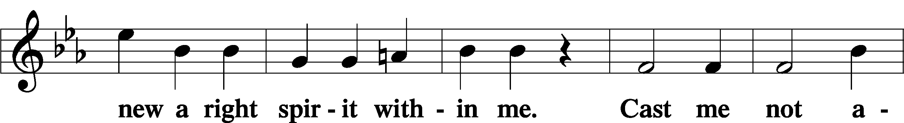
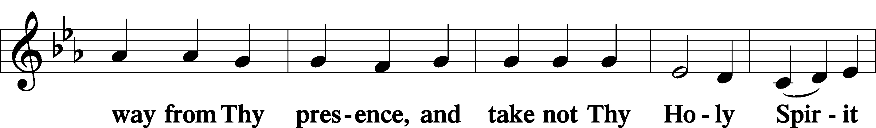
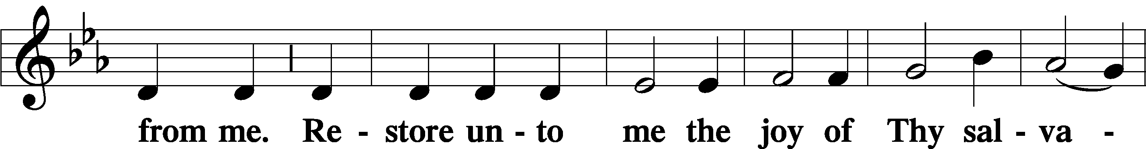
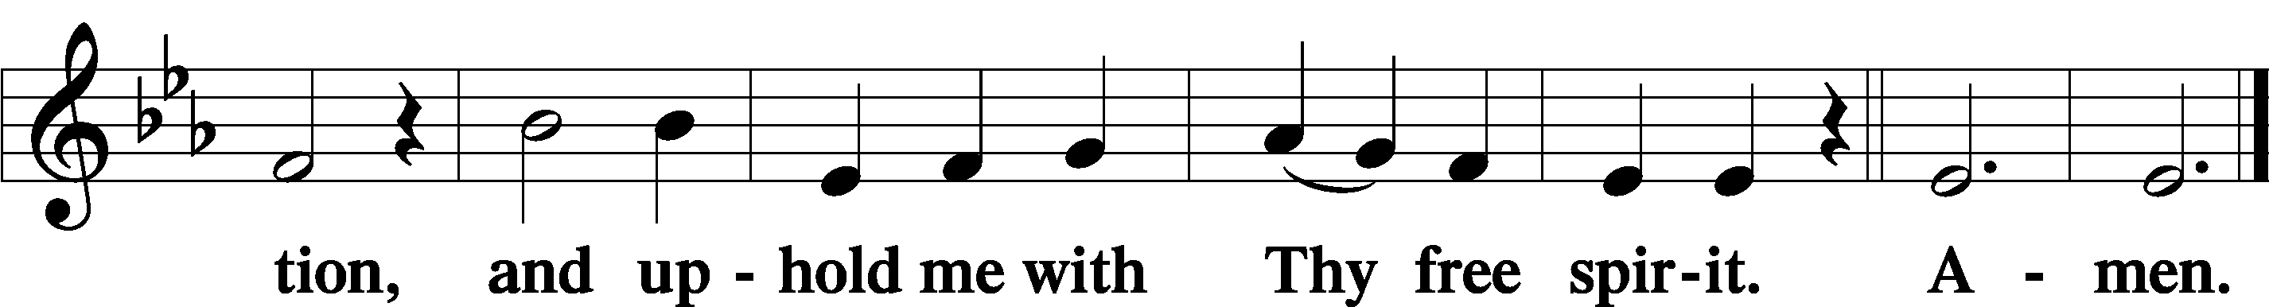

SHARING OF THE PEACE

(Sit)

PRAYER OF THE CHURCH

+ SERVICE OF THE SACRAMENT +
Note: The Service of The Sacrament is included in the lay bulletin solely as a viewers’ guide for those watching the livestream service; Communicant members who are unable to attend the Divine Service in person are encouraged to make arrangements with Pastor Engwall to receive the Lord’s Supper.

PREFACE LSB 194

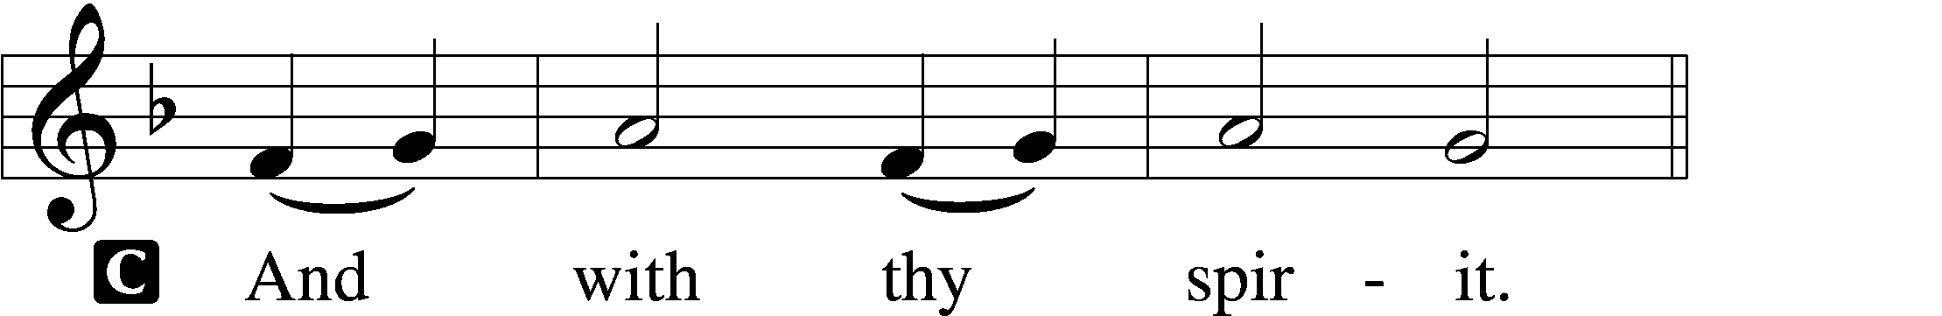


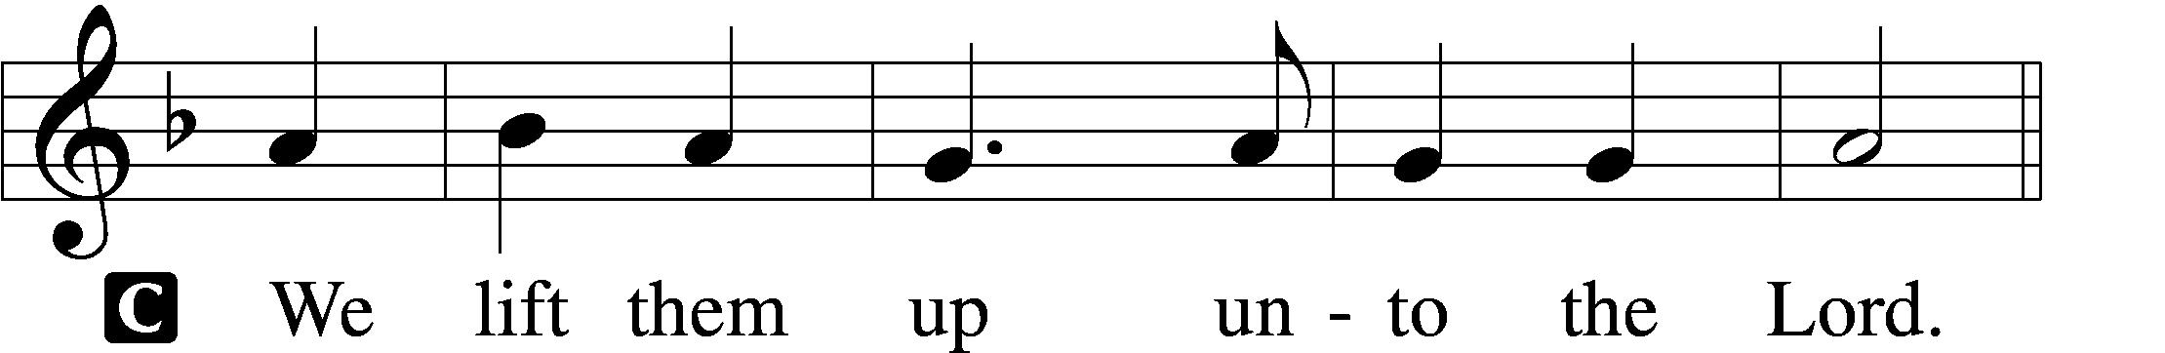

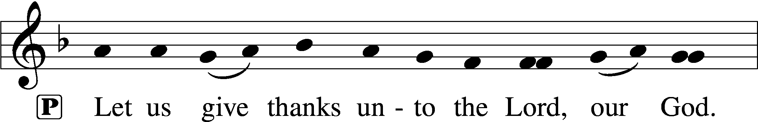
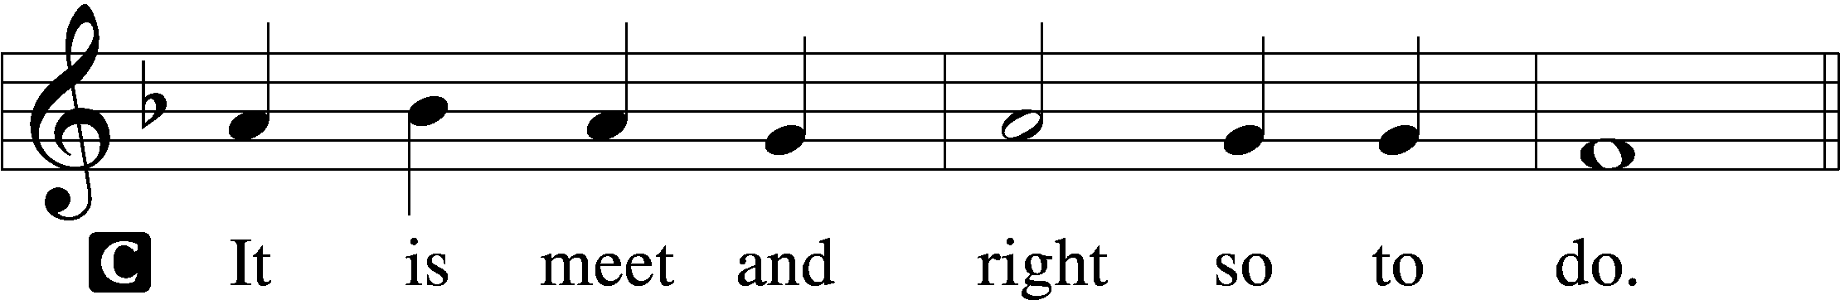

PROPER PREFACE (ABBREVIATED) LSB 194
P It is truly meet, right, and salutary . . . evermore praising You and saying:

SANCTUS LSB 195
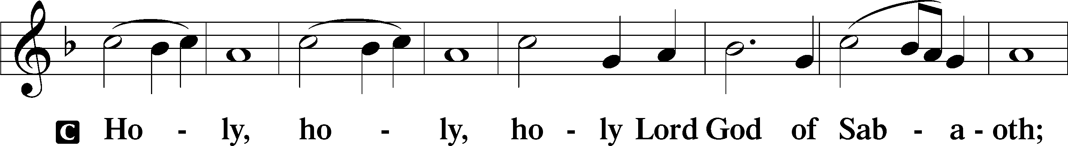
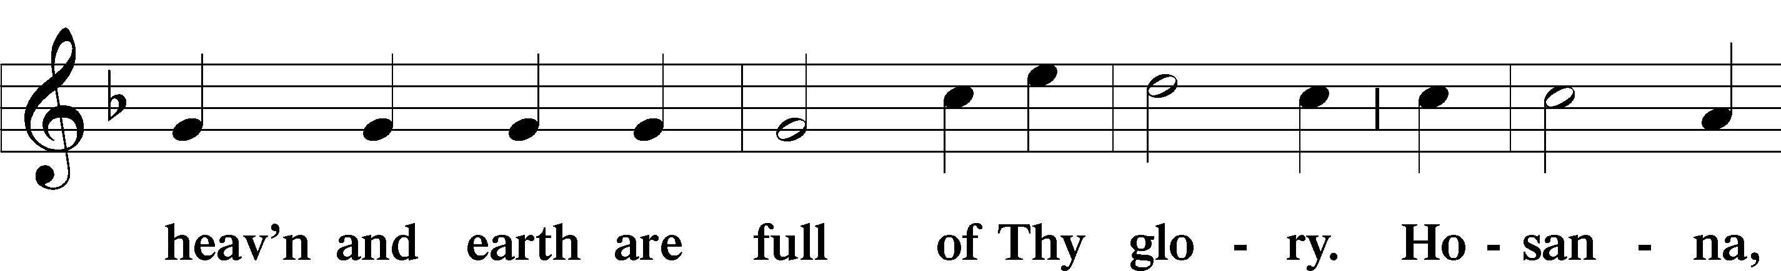
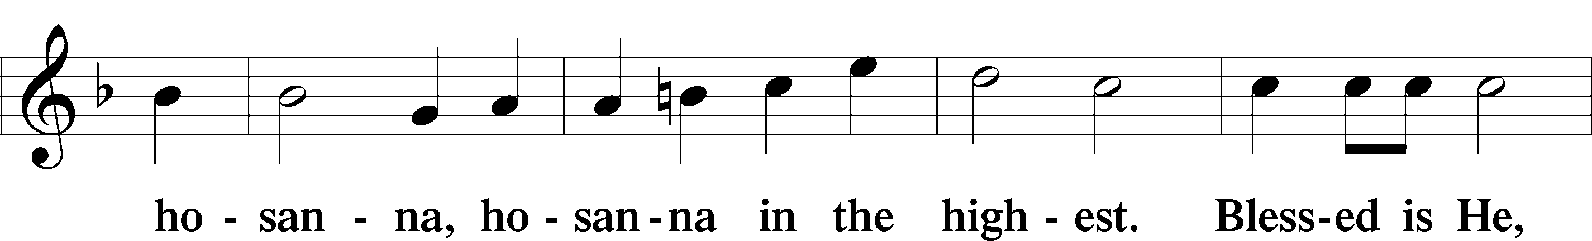
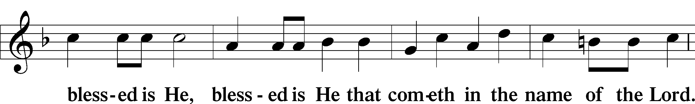
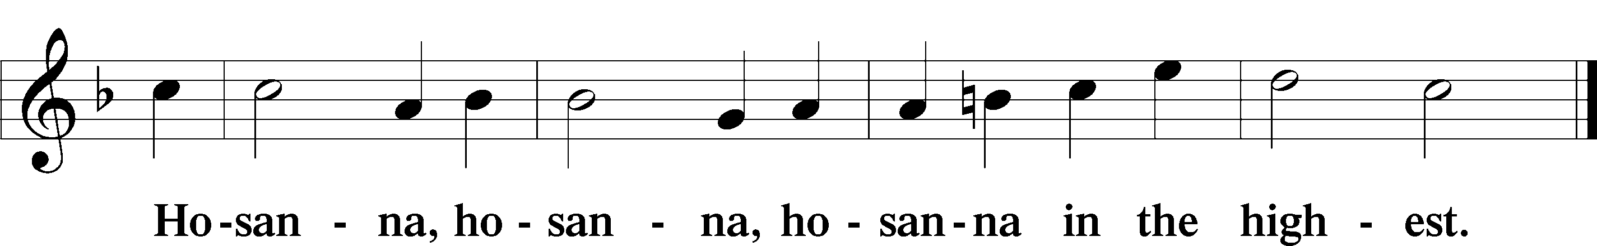

LORD’S PRAYER LSB 196
C Our Father who art in heaven,
hallowed be Thy name,
Thy kingdom come,
Thy will be done on earth as it is in heaven;
give us this day our daily bread;
and forgive us our trespasses as we forgive those who trespass against us;
and lead us not into temptation,
but deliver us from evil.
C For Thine is the kingdom and the power and the glory forever and ever. Amen.

THE WORDS OF OUR LORD LSB 197

PAX DOMINI LSB 197
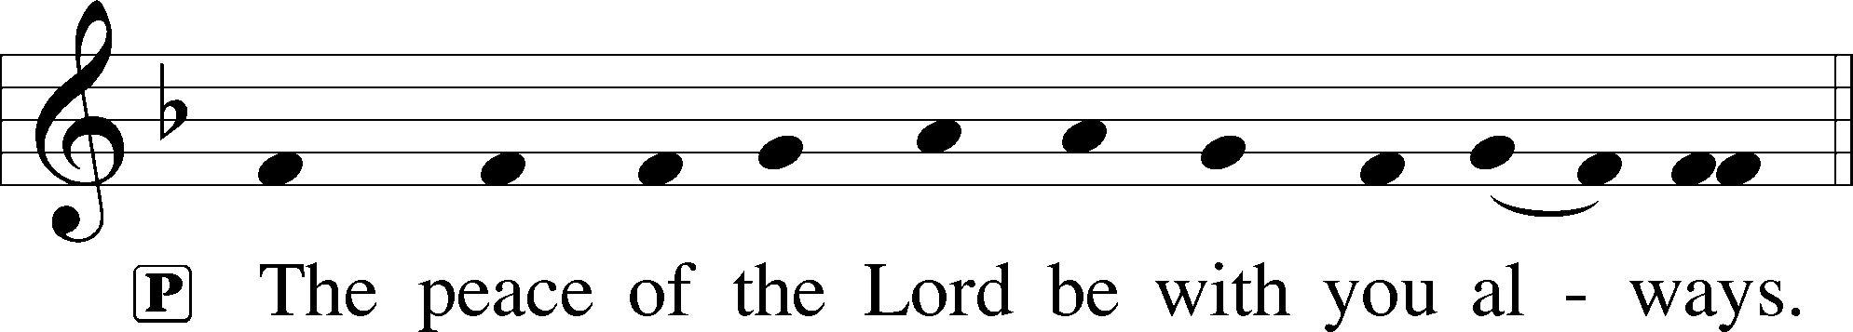

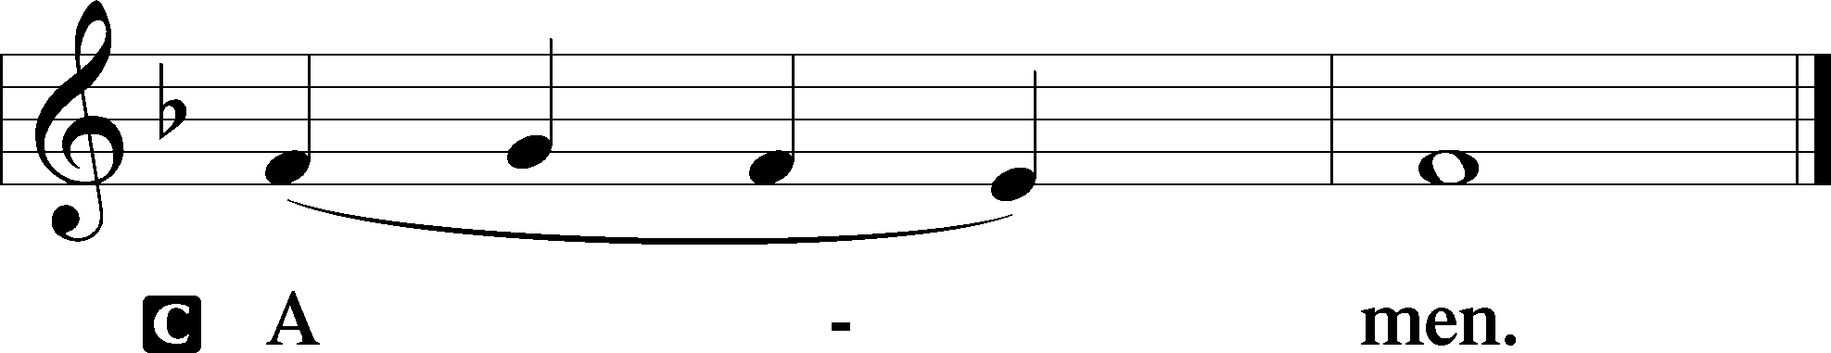

AGNUS DEI LSB 198
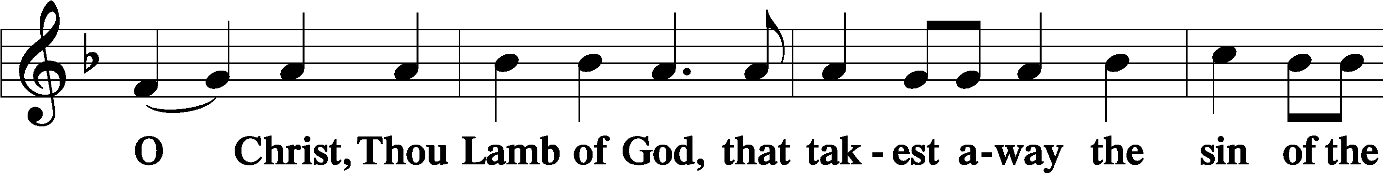
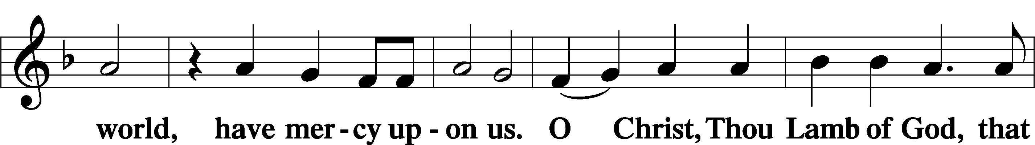
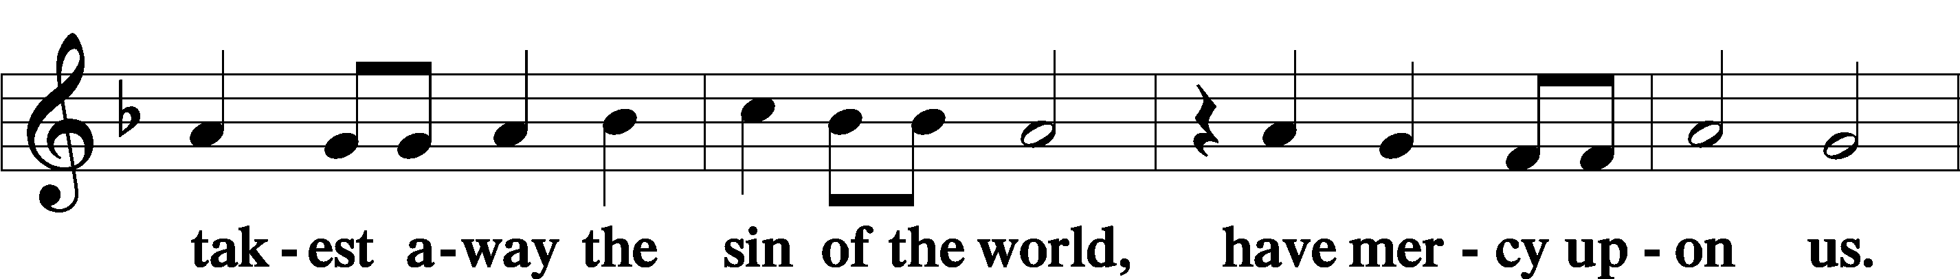
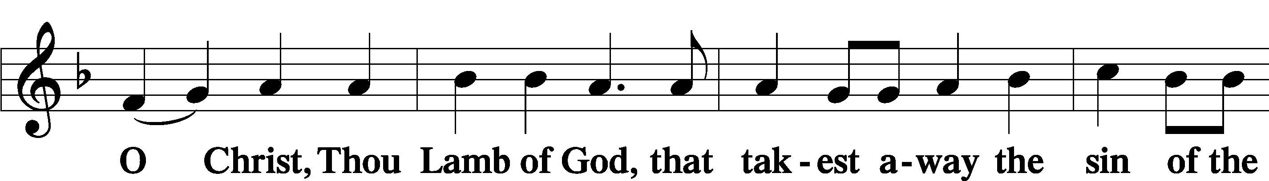
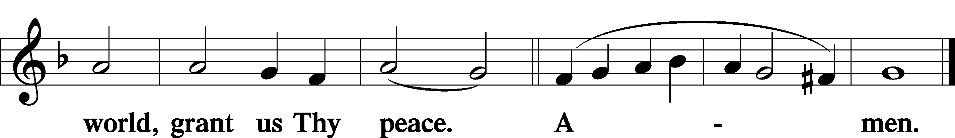

DISTRIBUTION
(The pastor and those who assist him receive the body and blood of Christ first, then commune those who are unable to come to the altar. The ushers will then direct all other communicants to the altar.)

571 GOD LOVED THE WORLD SO THAT HE GAVE
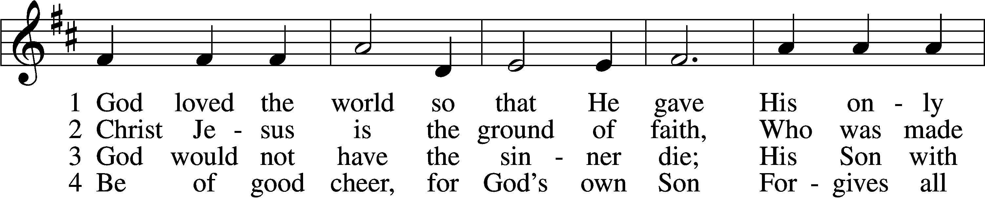
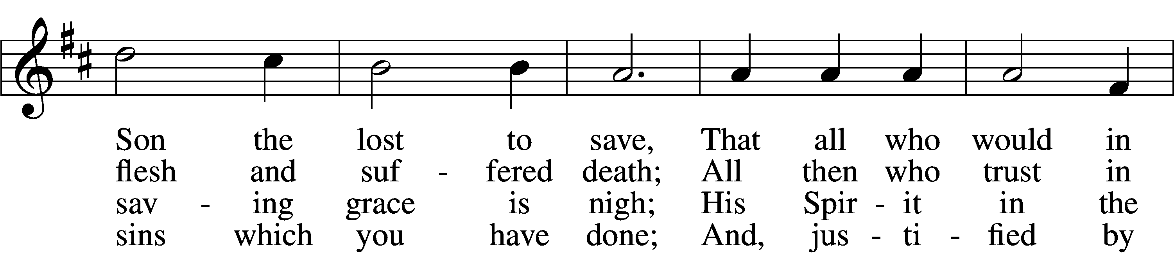
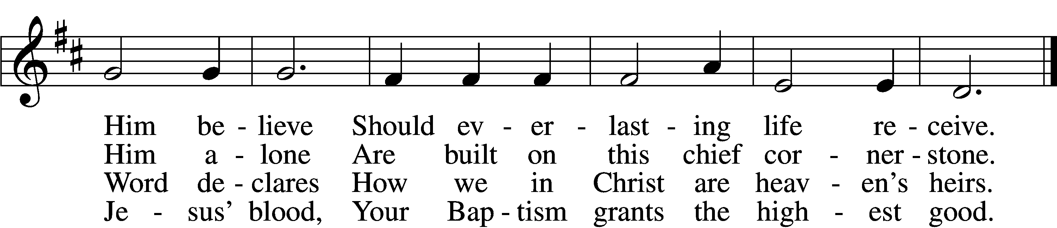

5 If you are sick, if death is near,
This truth your troubled heart can cheer:
Christ Jesus saves your soul from death;
That is the firmest ground of faith.

D 6 Glory to God the Father, Son,
And Holy Spirit, Three in One!
To You, O blessèd Trinity,
Be praise now and eternally!
Text: Heiliges Lippen- und Hertzens-Opffer, c. 1778, Stettin; tr. August Crull, 1845–1923, alt.
Tune: George J. Elvey, 1816–93
Text and tune: Public domain

INSTRUMENTAL

(Stand)

NUNC DIMITTIS LSB 199
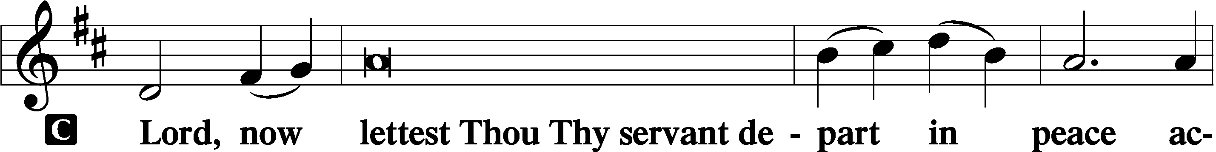

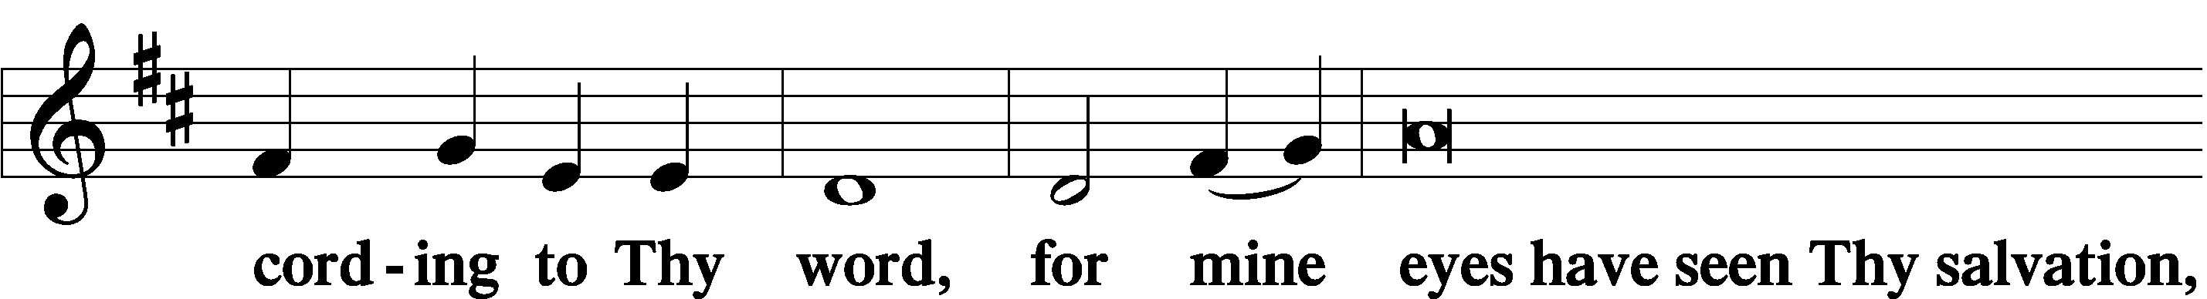

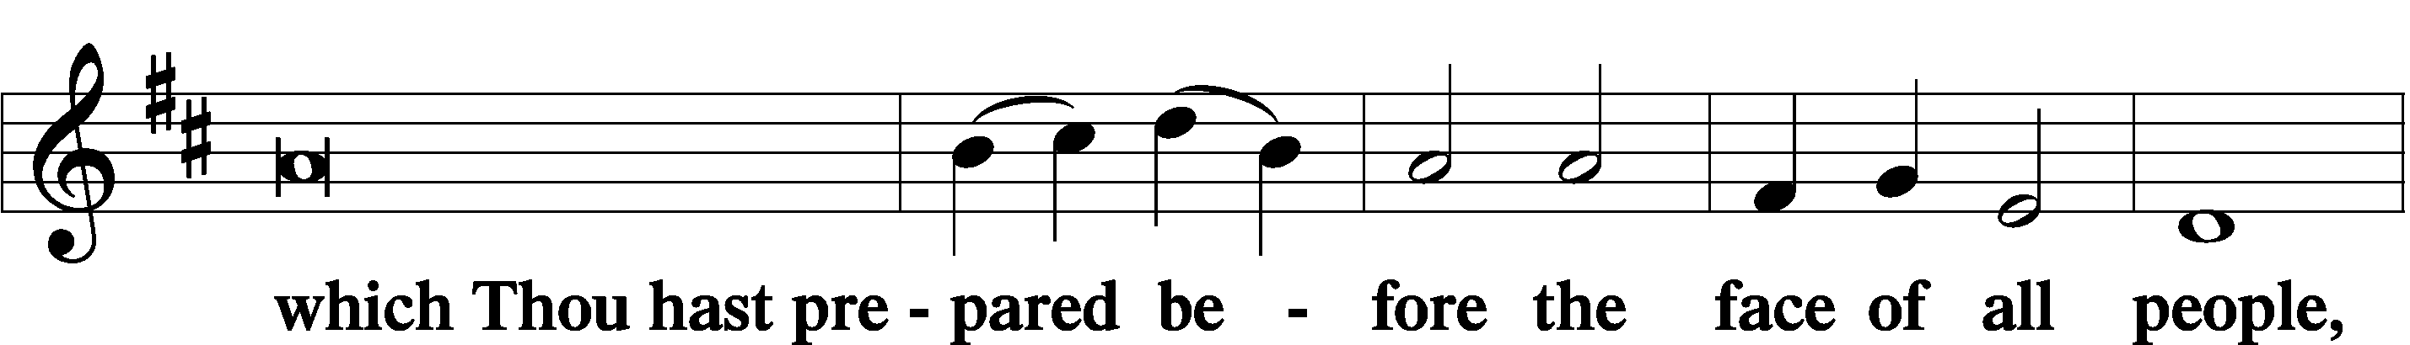

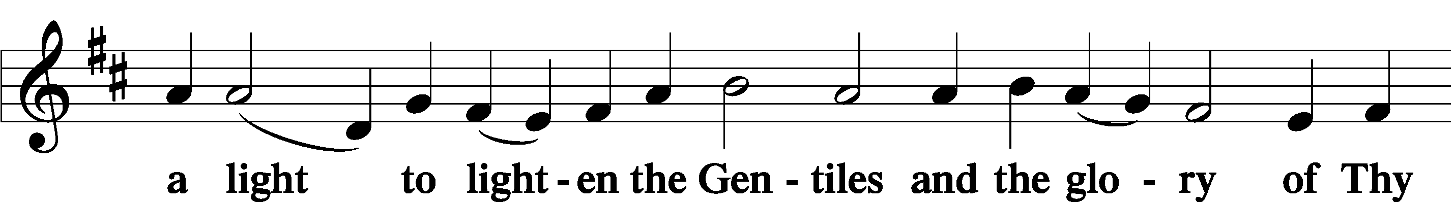

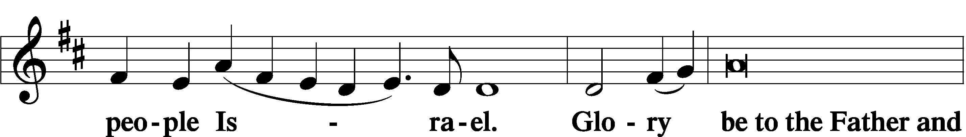

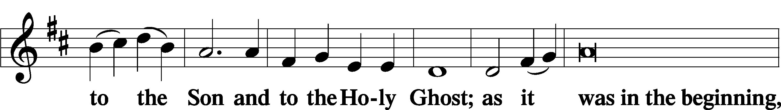

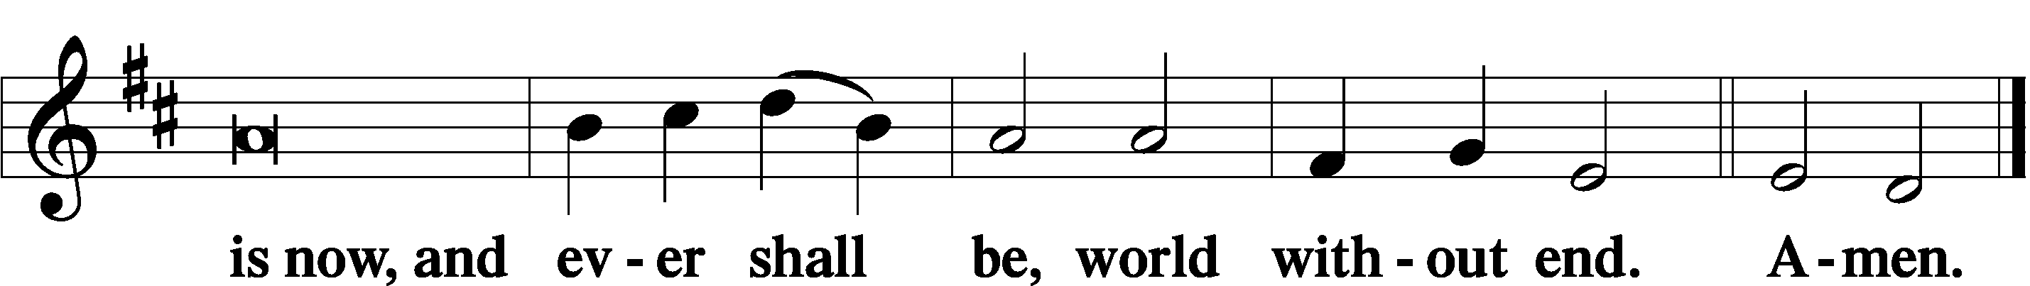

THANKSGIVING LSB 200
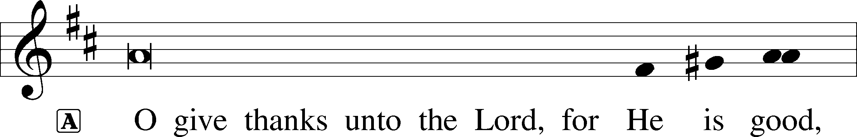

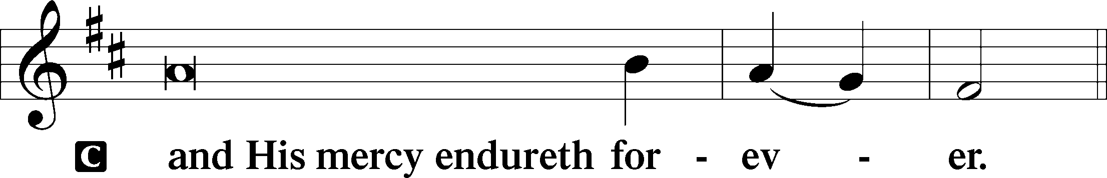

POST-COMMUNION COLLECT

SALUTATION LSB 201
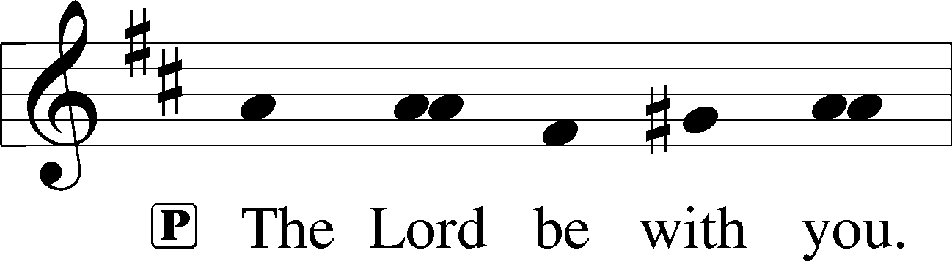

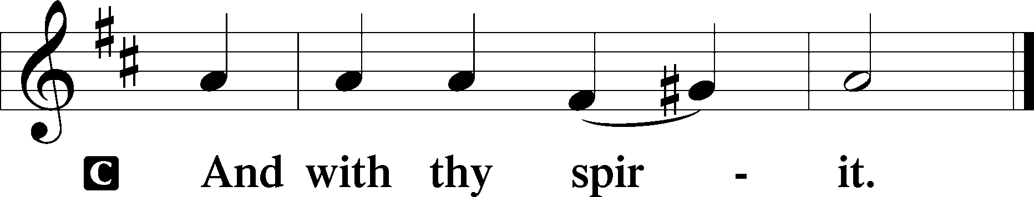

BENEDICAMUS LSB 202
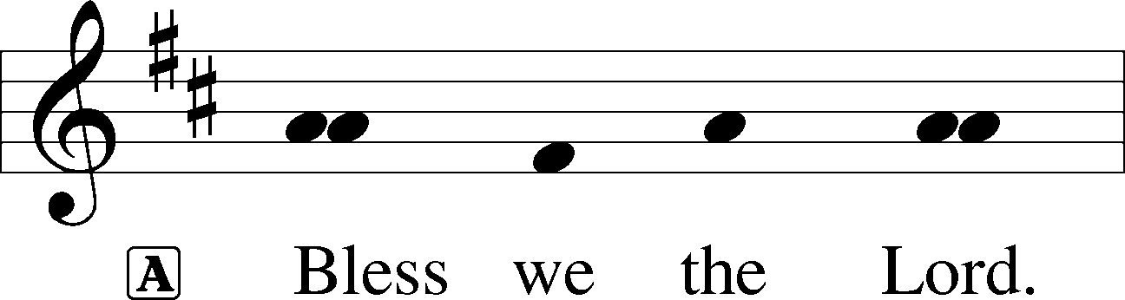

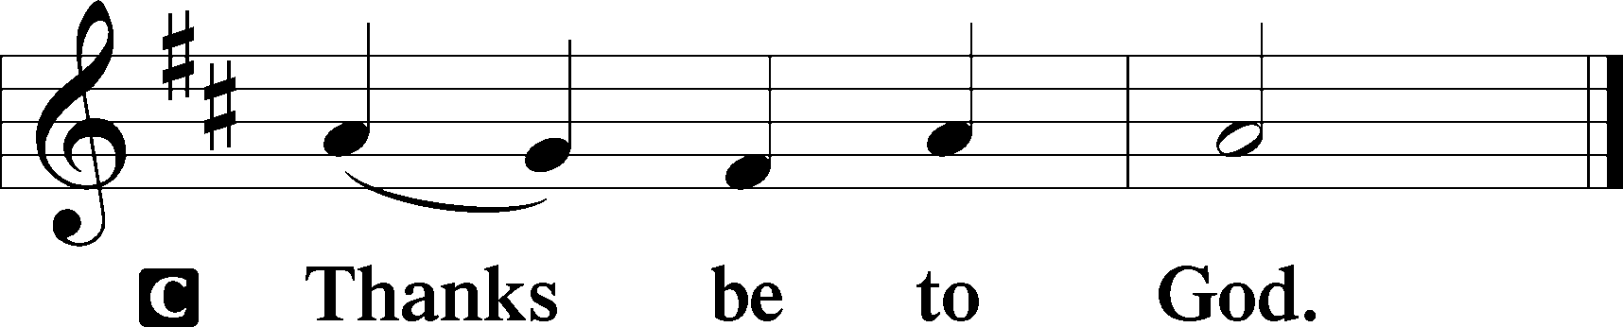

BENEDICTION
L:The grace of our Lord T Jesus Christ, and the love of God, and the fellowship of the Holy Spirit, be with us all.
C: Amen.

798 THE GOD OF ABRAHAM PRAISE sts. 5–9
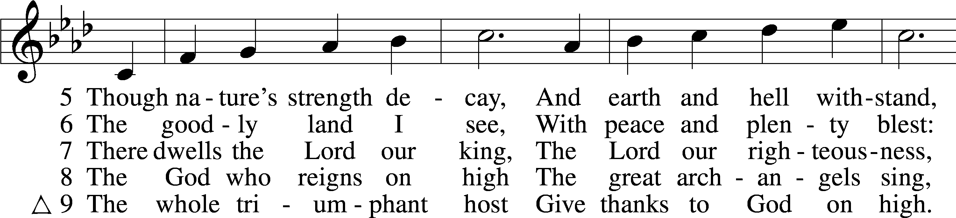
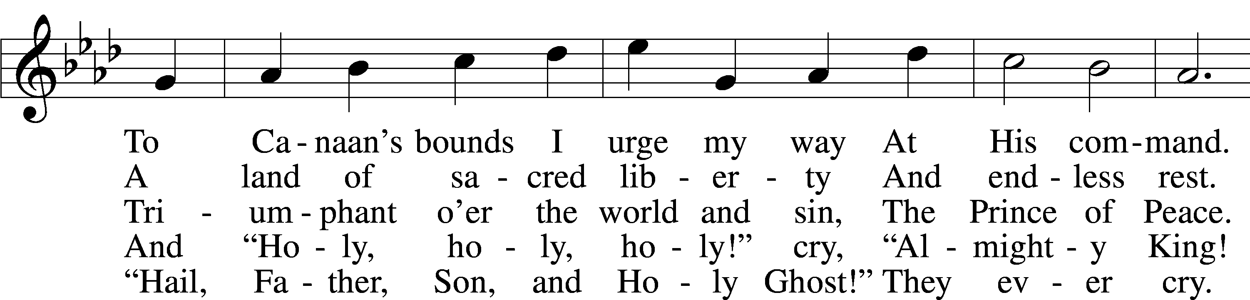
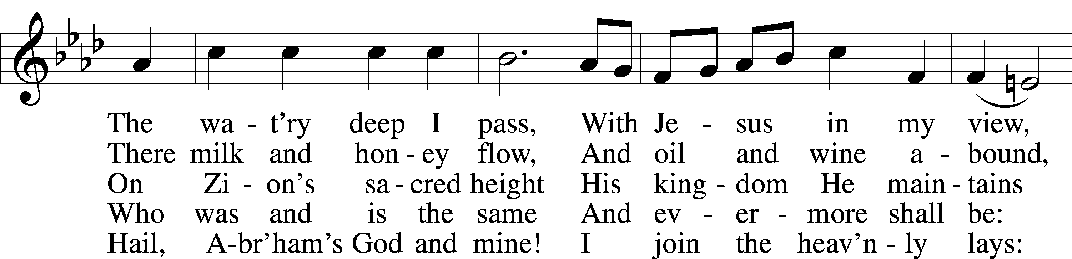
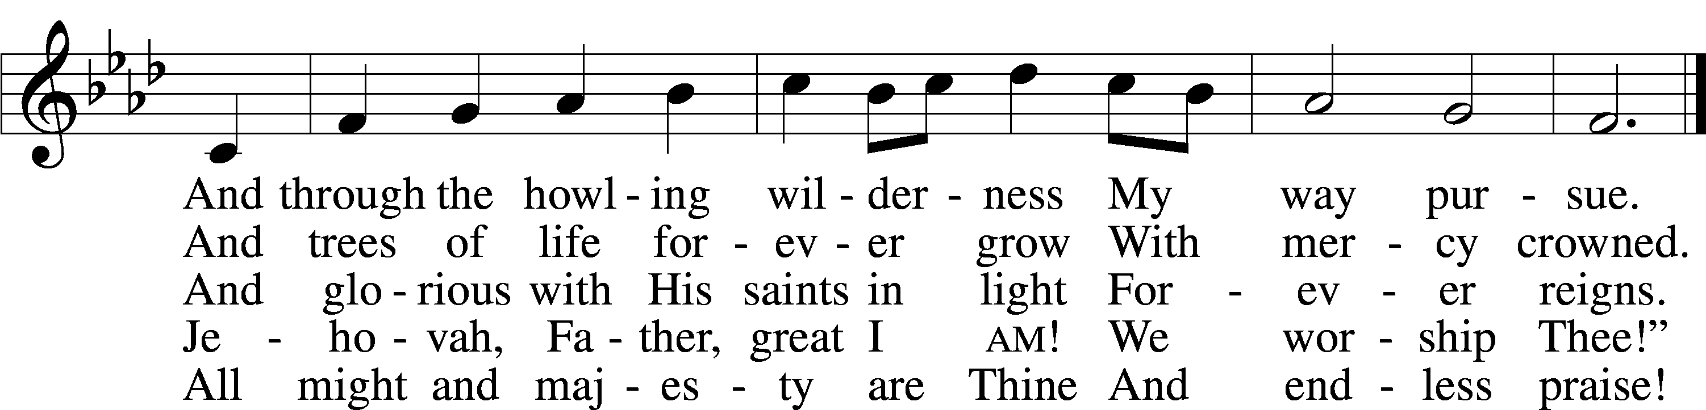
Text: Thomas Olivers, 1725–99, alt.
Tune: Hebrew
Text and tune: Public domain

ACKNOWLEDGMENTS
Unless otherwise indicated, Scripture quotations are from the ESV® Bible (The Holy Bible, English Standard Version®), copyright © 2001 by Crossway, a publishing ministry of Good News Publishers. Used by permission. All rights reserved.
Created by Lutheran Service Builder © 2026 Concordia Publishing House.

IN OUR PRAYERS:
Submitted petitions are included for two consecutive Sundays
For Those suffering afflictions of mind, body, or spirit:
Blake B., Carol R., Michele N., Dean S., Carl B., Sandy A.

All of our Shut- Ins:
Betty A., Shirley F., Mary H., Patsy L., Herman L., Tommy M., Jerome M., Sharon B., Judy S., Anne H.

For missionaries
Deaconess Sandra R., Rev. Jonathan A.

ANNOUNCEMENTS
Please email announcements for Sunday bulletins by 8:00 a.m. Tuesday to pastorblcaiken@gmail.com
ALTAR FLOWERS:
Flowers are donated today by Liz S.

EASTER LILY ORDER FORMS:
Time to order Easter lilies! They are $15.00 each. Order forms are in the East Narthex. The deadline to order is March 22nd.

BOARD OF ELDERS:
Meets next Sunday, March 8th after the service

PARISH COUNCIL:
Meets Sunday, March 15th after the service

ACTS DONATION FOR FEBRUARY:
Mac & cheese

FELLOWSHIP COFFEE HOUR:
Every Sunday morning, during Bible Study and after the Divine Service, coffee, treats and good fellowship are waiting for you in our Fellowship Hall!

Attendance: Ash Wednesday: 43 Sunday: 41

Offering: Ash Wednesday: $505 Sunday: $2,185

Average weekly offering needed to make budget: $2,865

BE IN THE WORD!
SUNDAY MORNINGS AT 9 a.m.
Adult Bible Study
Sunday School for children and youth
TUESDAY MORNINGS AT 10:00 a.m.
Women’s Bible Study
WEDNESDAY EVENINGS AT 7 p.m.
Adult Bible Study
JUNIOR CONFIRMATION and ADULT INSTRUCTION
Always available by request:
Contact Pastor to schedule

OUR VALUE STATEMENT: Bethlehem Lutheran Church exists under God’s grace to save the lost and to strengthen the saved so that they may live bold and courageous lives of Christian witness before a non-believing world.
Therefore, our purpose is:
- to glorify God in Word and deed,
- to nurture each other in Christian love,
- to reach out to others with our Savior’s Gospel of life and salvation.
(Rom 5:8, Matt. 28:18-20).

OUR VISION: By the Grace of God, Bethlehem Lutheran Church, is a loving family united in Christ, learning, living, and spreading His Word.

OUR MISSION: Learn the Word. Live the Word. Spread the Word.

Lent, Holy Week, and Easter Schedule of services
Lenten Wednesdays: Feb. 25th; Mar. 4th,11th,18th, 25th
Meals at 11:30 a.m. and 6:00 p.m.;
Services at 11:00 a.m. and 7:00 p.m.
Palm/ Passion Sunday: March 29th
Maundy Thursday: April 2nd; 7:00 p.m. Communion service
Good Friday: April 3rd; 7:00 p.m. Tenebrae service
Easter Sunday: April 5th;
9:00 a.m. breakfast
10:30 a.m. Divine Service (outside, weather permitting)

