BETHLEHEM LUTHERAN CHURCH
A congregation of The Lutheran Church-Missouri Synod
902 Hitchcock Drive SW,
Aiken, South Carolina 29803
Church Phone: (803) 649-6417
blcaikensc@gmail.com
Pastor: Rev. John B. Engwall
Office Hours By Appointment
Bethlehem Lutheran welcomes our members and guests to our worship service! Unable to join us in person? Please find us on Facebook live. The service is also posted on our website; bethlehemlutheranaiken.org.

+ + + + + + + + + + + + + + +
New Year’s Eve
December 31st, 2025
7:00 p.m.
+ + + + + + + + + + + + + + +

(Stand)
766 OUR FATHER, WHO FROM HEAVEN ABOVE sts. 1–3
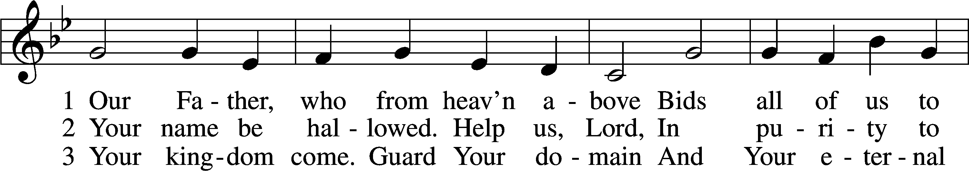
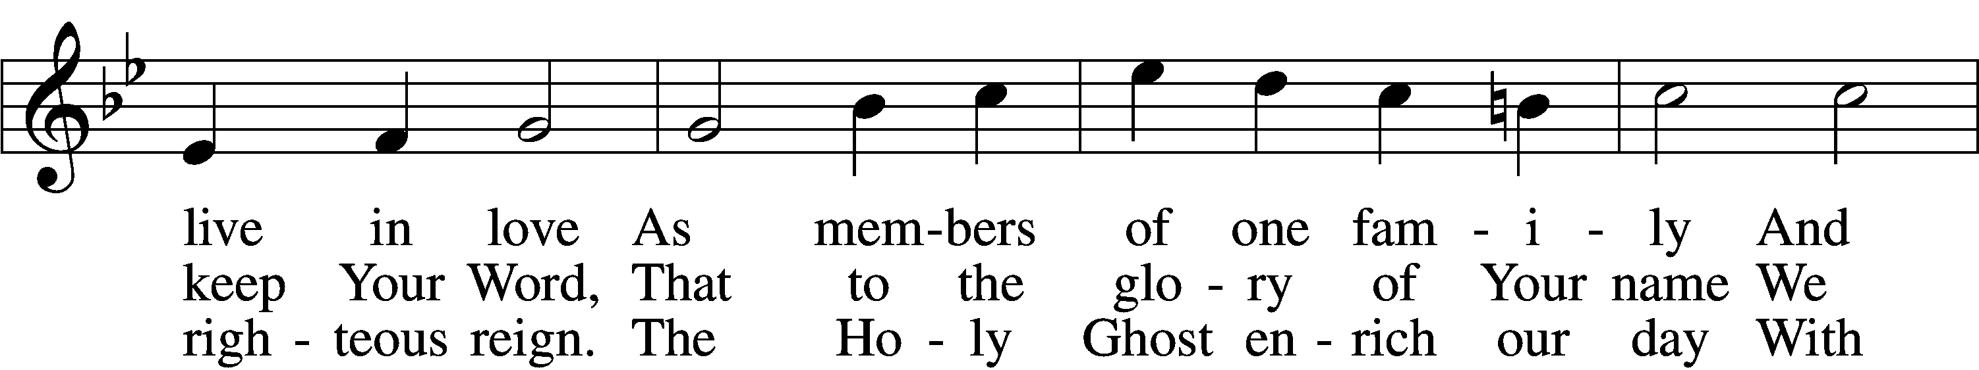
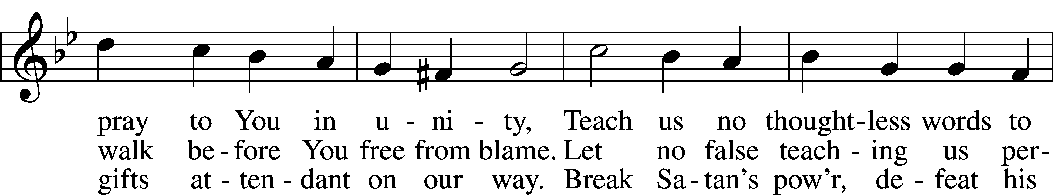
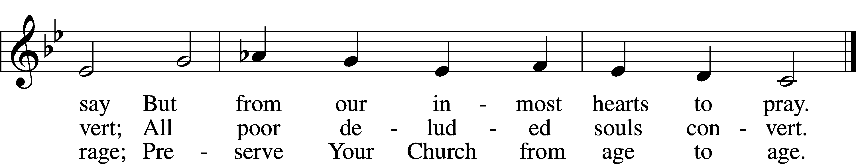
Text: Martin Luther, 1483–1546; (st. 1): tr. The Lutheran Hymnal, 1941, alt.; (sts. 2–3): tr. F. Samuel Janzow, 1913–2001, alt.
Tune: attr. Martin Luther, 1483–1546
Text (st. 1): Public domain
Text (sts. 2–3): © 1980 Concordia Publishing House. Used by permission: LSB Hymn License no. 110004798
Tune: Public domain

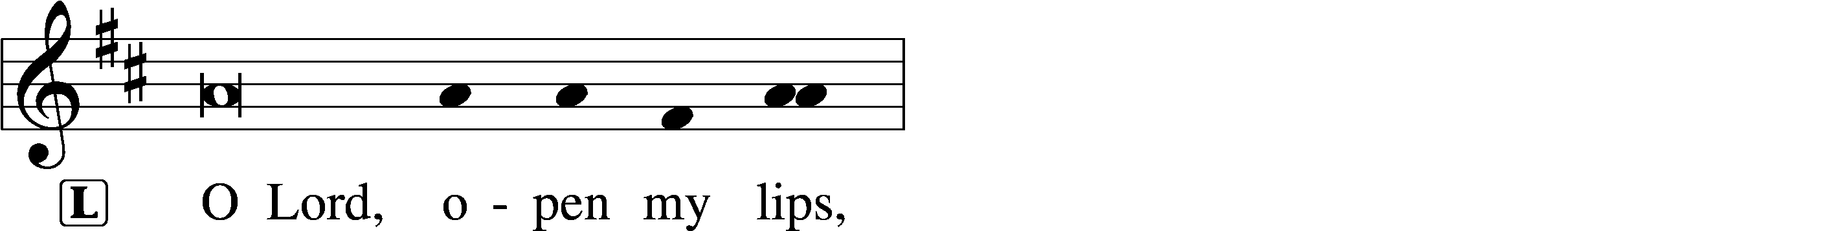
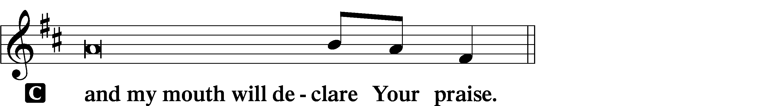

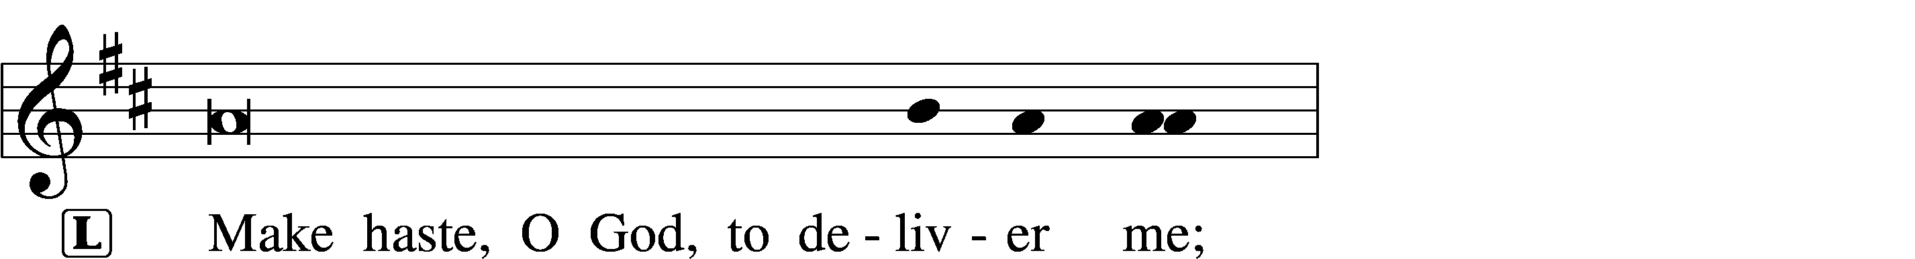
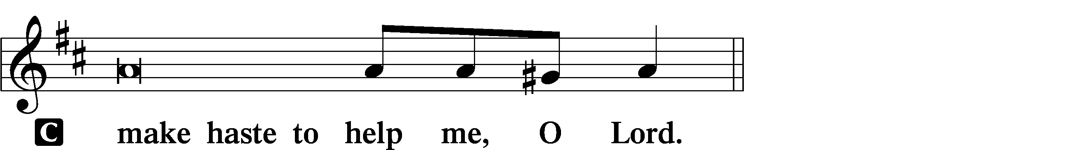

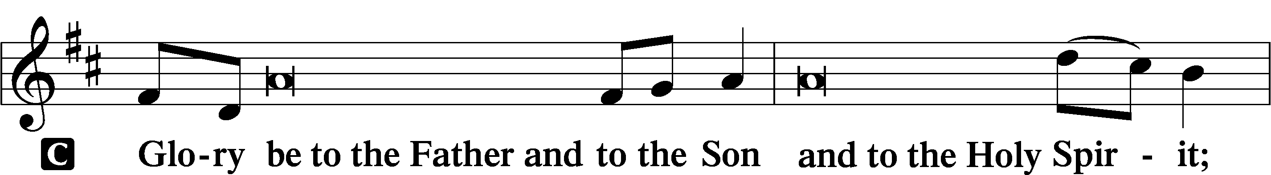
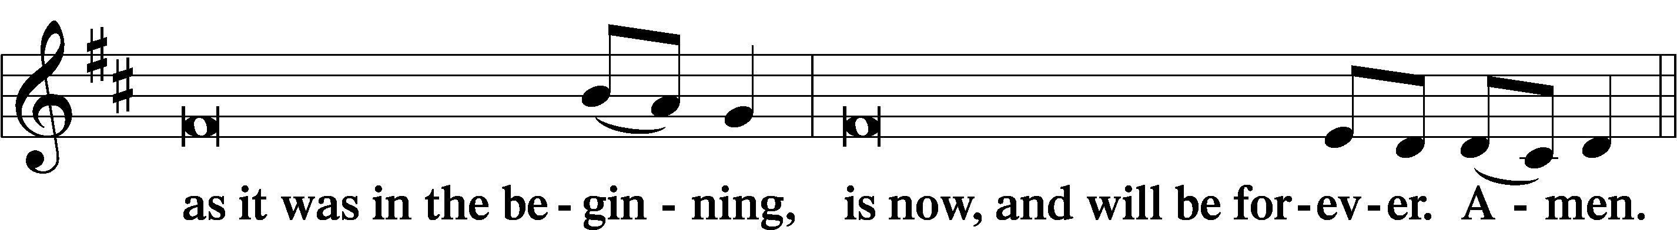
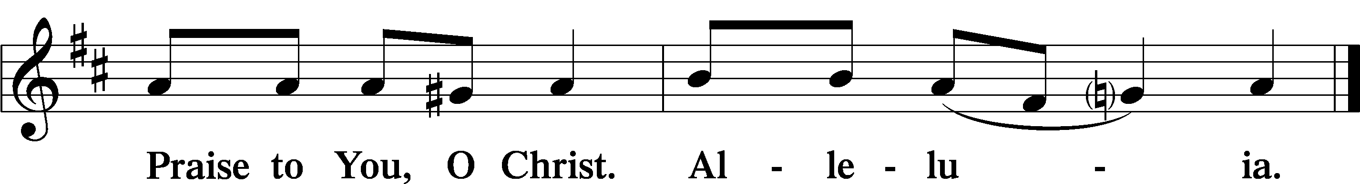

COLLECT OF THE DAY
L Eternal God, we commit to Your mercy and forgiveness the year now ending and commend to Your blessing and love the times yet to come. In the new year, abide among us with Your Holy Spirit that we may always trust in the saving name of our Lord Jesus Christ, who lives and reigns with You and the Holy Spirit, one God, now and forever.

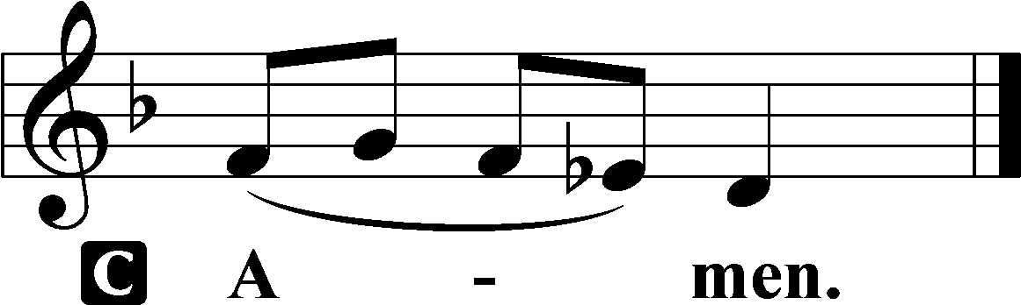

+ PSALMODY +

PSALM Psalm 90:1–12
L 1Lord, you have been our | dwelling place*
in all gener- | ations.
C 2Before the mountains were brought forth,
or ever you had formed the earth | and the world,*
from everlasting to everlasting | you are God.
L 3You return | man to dust*
and say, “Return, O chil- | dren of man!”
C 4For a thousand years in your sight
are but as yesterday when | it is past,*
or as a watch | in the night.
L 5You sweep them away as | with a flood;*
they are like a dream,
like grass that is renewed in the | morning:
C 6in the morning it flourishes and | is renewed;*
in the evening it fades and | withers.
L 7For we are brought to an end by your | anger;*
by your wrath we | are dismayed.
C 8You have set our iniquities be- | fore you,*
our secret sins in the light of your | presence.
L 9For all our days pass away un- | der your wrath;*
we bring our years to an end | like a sigh.
C 10The years of our life are seventy,
or even by reason of strength | eighty;*
yet their span is but toil and trouble;
they are soon gone, and we | fly away.
L 11Who considers the power of your | anger,*
and your wrath according to the | fear of you?
C 12So teach us to number | our days*
that we may get a heart of | wisdom.

(Sit)

+ READINGS +

READING Isaiah 30:15–17
L A reading from Isaiah, chapter 30.

15For thus said the Lord God, the Holy One of Israel,
“In returning and rest you shall be saved;
in quietness and in trust shall be your strength.”
But you were unwilling, 16and you said,
“No! We will flee upon horses”;
therefore you shall flee away;
and, “We will ride upon swift steeds”;
therefore your pursuers shall be swift.
17A thousand shall flee at the threat of one;
at the threat of five you shall flee,
till you are left
like a flagstaff on the top of a mountain,
like a signal on a hill.

L O Lord, have mercy on us.
C Thanks be to God.
READING Romans 8:31b–39
L A reading from Romans, chapter 8.

If God is for us, who can be against us? 32He who did not spare his own Son but gave him up for us all, how will he not also with him graciously give us all things? 33Who shall bring any charge against God’s elect? It is God who justifies. 34Who is to condemn? Christ Jesus is the one who died—more than that, who was raised—who is at the right hand of God, who indeed is interceding for us. 35Who shall separate us from the love of Christ? Shall tribulation, or distress, or persecution, or famine, or nakedness, or danger, or sword? 36As it is written,
“For your sake we are being killed all the day long;
we are regarded as sheep to be slaughtered.”
37No, in all these things we are more than conquerors through him who loved us. 38For I am sure that neither death nor life, nor angels nor rulers, nor things present nor things to come, nor powers, 39nor height nor depth, nor anything else in all creation, will be able to separate us from the love of God in Christ Jesus our Lord.

L O Lord, have mercy on us.
C Thanks be to God.

READING Luke 12:35–40
L A reading from Luke, chapter 12.

35[Jesus said:] “Stay dressed for action and keep your lamps burning, 36and be like men who are waiting for their master to come home from the wedding feast, so that they may open the door to him at once when he comes and knocks. 37Blessed are those servants whom the master finds awake when he comes. Truly, I say to you, he will dress himself for service and have them recline at table, and he will come and serve them. 38If he comes in the second watch, or in the third, and finds them awake, blessed are those servants! 39But know this, that if the master of the house had known at what hour the thief was coming, he would not have left his house to be broken into. 40You also must be ready, for the Son of Man is coming at an hour you do not expect.”

L O Lord, have mercy on us.
C Thanks be to God.

RESPONSORY LSB 230
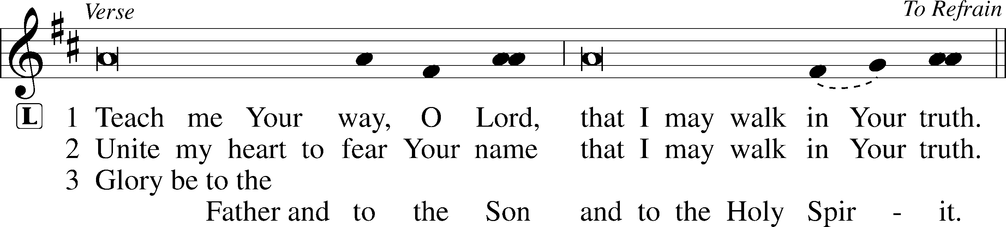
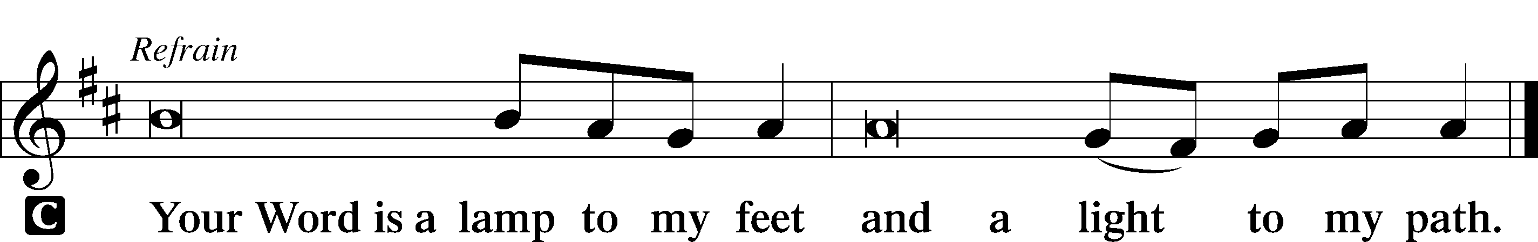

766 OUR FATHER, WHO FROM HEAVEN ABOVE sts. 4–6
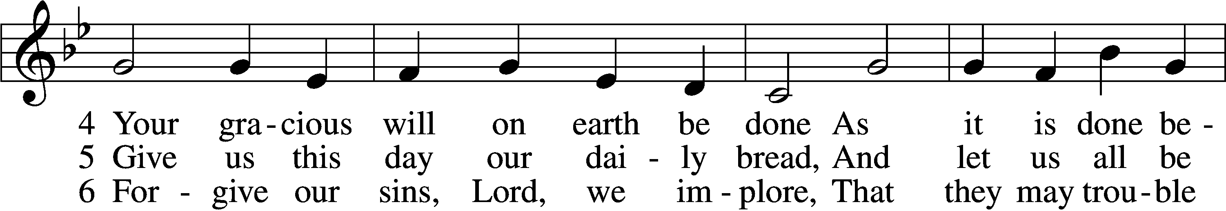
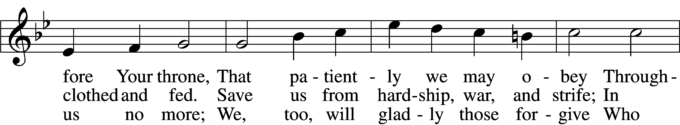
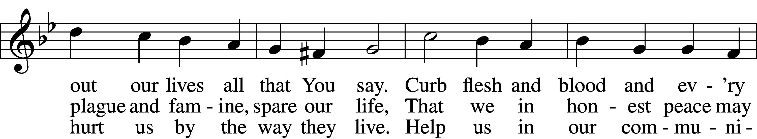
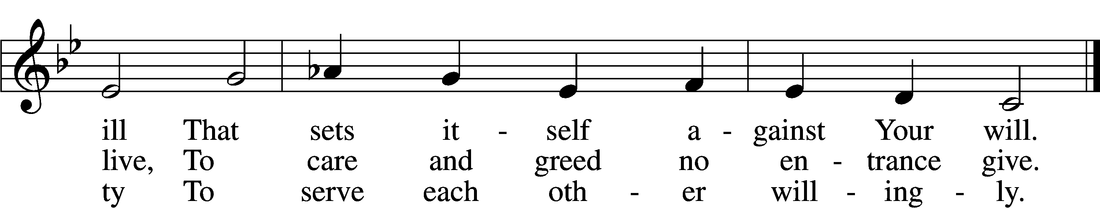
Text: Martin Luther, 1483–1546; (sts. 4–5): tr. F. Samuel Janzow, 1913–2001, alt.; (st. 6): tr. The Lutheran Hymnal, 1941, alt.
Tune: attr. Martin Luther, 1483–1546
Text (sts. 4–5): © 1980 Concordia Publishing House. Used by permission: LSB Hymn License no. 110004798
Text (st. 6): Public domain
Tune: Public domain

SERMON

(Stand)

+ PRAYER +
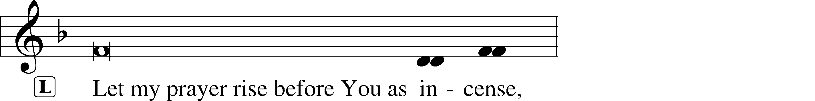
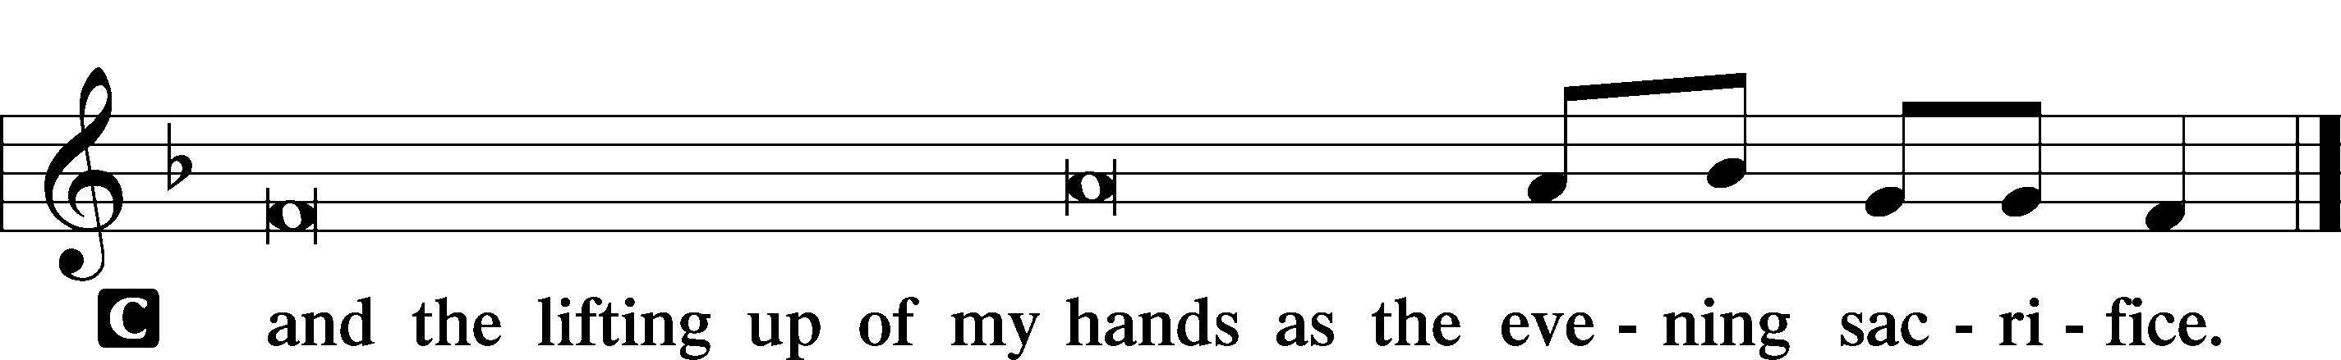
KYRIE LSB 233
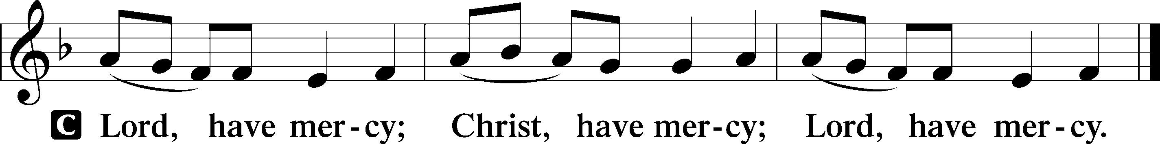

LORD’S PRAYER
C Our Father who art in heaven,
hallowed be Thy name,
Thy kingdom come,
Thy will be done on earth
as it is in heaven;
give us this day our daily bread;
and forgive us our trespasses
as we forgive those
who trespass against us;
and lead us not into temptation,
but deliver us from evil.
For Thine is the kingdom
and the power and the glory
forever and ever. Amen.

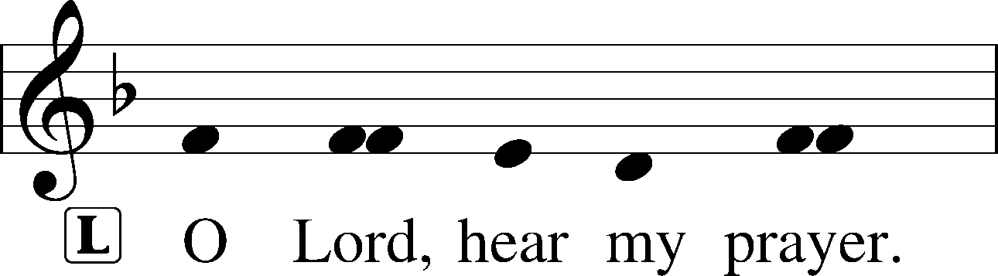
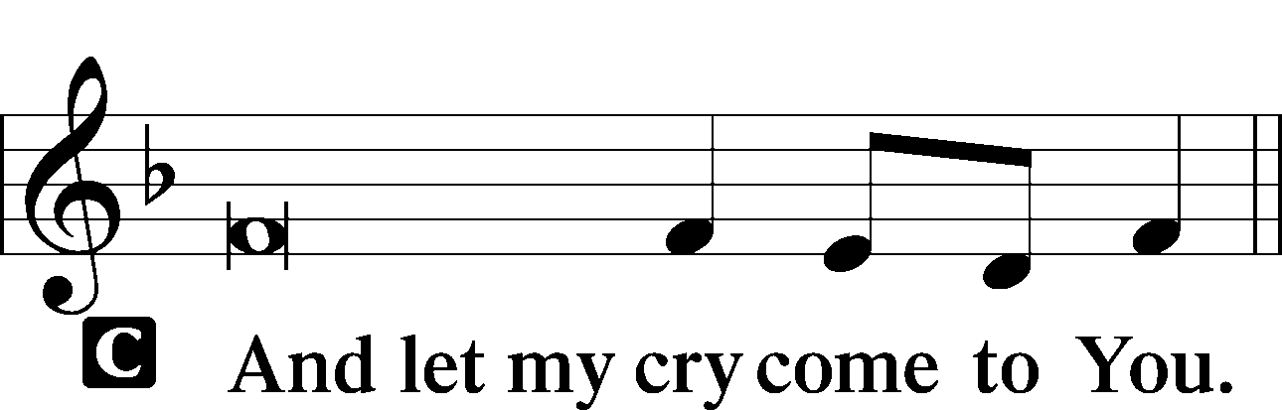

PRAYER OF THE CHURCH

BENEDICAMUS LSB 234
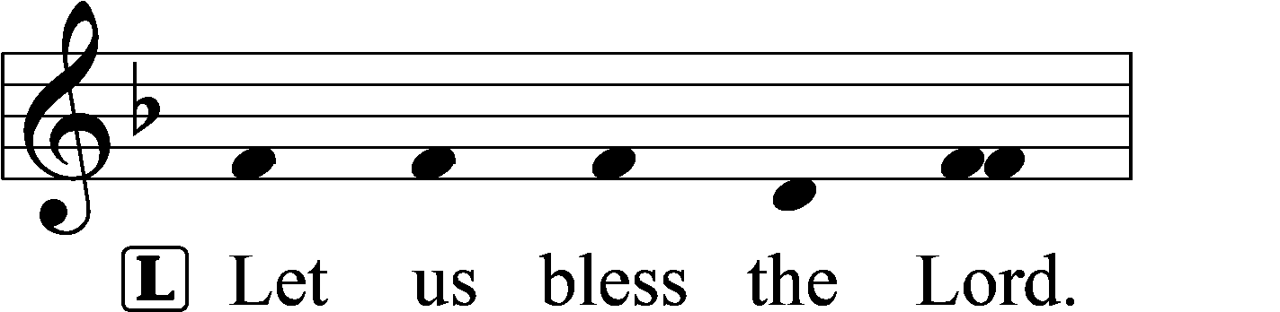
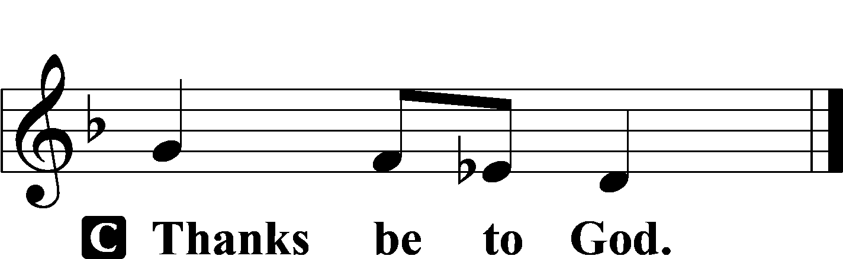

BENEDICTION LSB 234
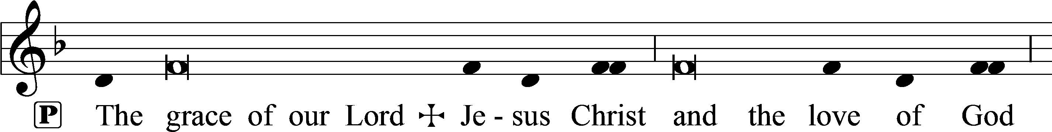
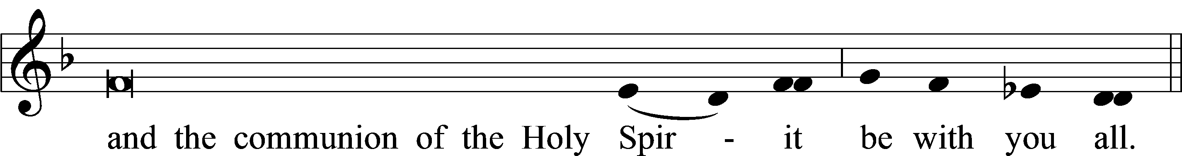
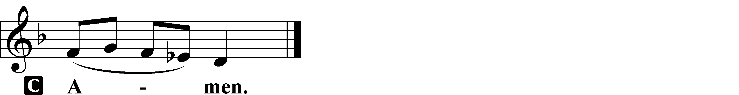

766 OUR FATHER, WHO FROM HEAVEN ABOVE sts. 7–9
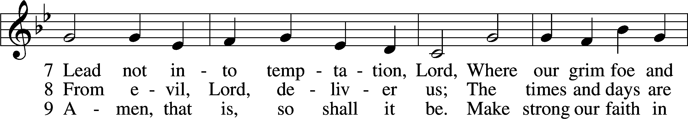
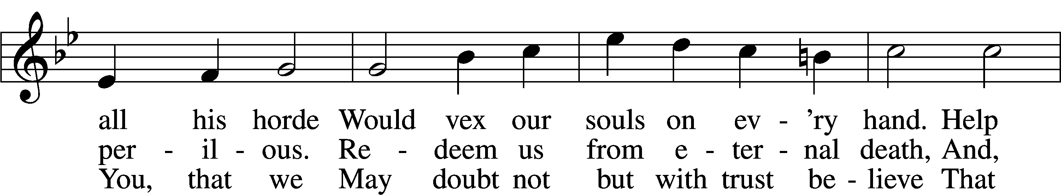
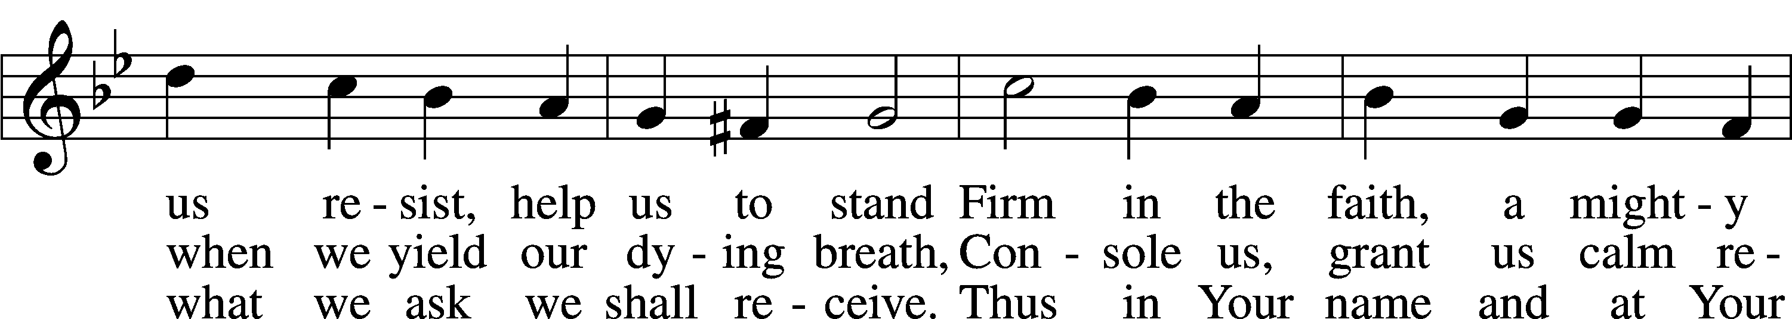
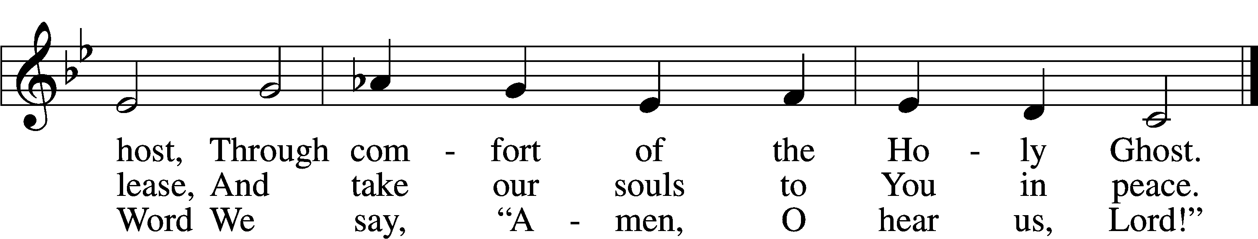
Text: Martin Luther, 1483–1546; (st. 7): tr. F. Samuel Janzow, 1913–2001, alt.; (sts. 8–9): tr. The Lutheran Hymnal, 1941, alt.
Tune: attr. Martin Luther, 1483–1546
Text (st. 7): © 1980 Concordia Publishing House. Used by permission: LSB Hymn License no. 110004798
Text (sts. 8–9): Public domain
Tune: Public domain

ACKNOWLEDGMENTS
Vespers from Lutheran Service Book
Unless otherwise indicated, Scripture quotations are from the ESV® Bible (The Holy Bible, English Standard Version®), copyright © 2001 by Crossway, a publishing ministry of Good News Publishers. Used by permission. All rights reserved.
Created by Lutheran Service Builder © 2025 Concordia Publishing House.

