BETHLEHEM LUTHERAN CHURCH
A congregation of The Lutheran Church-Missouri Synod
902 Hitchcock Drive SW,
Aiken, South Carolina 29803
Church Phone: (803) 649-6417
blcaikensc@gmail.com
Pastor: Rev. John B. Engwall
Office Hours By Appointment
Note: The format of this bulletin has been modified for use in private devotion services.
Unable to join us in person? Please find us on Facebook live.
The service is also posted on our website; bethlehemlutheranaiken.org

+ + + + + + + + + + + + + + +
The Eighteenth Sunday after Pentecost
October 12, 2025
10:30 a.m.
+ + + + + + + + + + + + + + +

Our Policy and Practice Regarding Holy Communion
Hear the words of the Apostle Paul;
Anyone who eats and drinks without recognizing the body of the Lord eats and drinks judgment on himself. -1 Cor.11:29
Therefore, visitors are asked to please refrain from partaking of the Sacrament before speaking about this with the pastor; because we care about your spiritual well-being.
Also, because communing at this altar is a public confession that you agree with the doctrines of The Lutheran Church-Missouri Synod, and reject all contrary teachings.
Persons who are not communing today are always welcome to come forward during the distribution to receive an individual blessing; please cross your arms over your chest to indicate your desire for this. Thank you!
We commune in two alternating tables. The ushers will guide you. Non-alcoholic white wine is available in the center of the individual cup tray. Please leave empty individual cups at the altar rail.

+ SERVICE OF PREPARATION +
After the bell tolls, please observe a time of silence.

WELCOME AND ANNOUNCEMENTS

(Stand)

846 YOUR HAND, O LORD, IN DAYS OF OLD
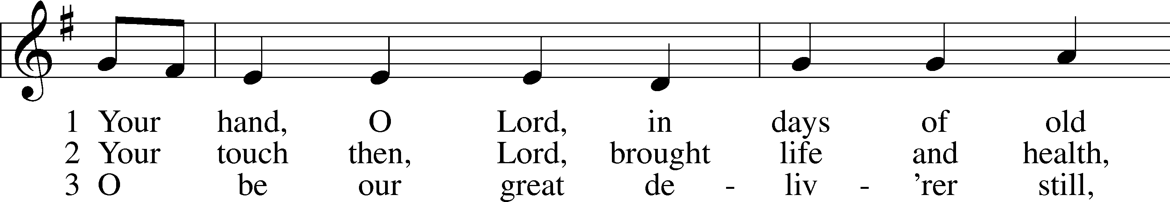
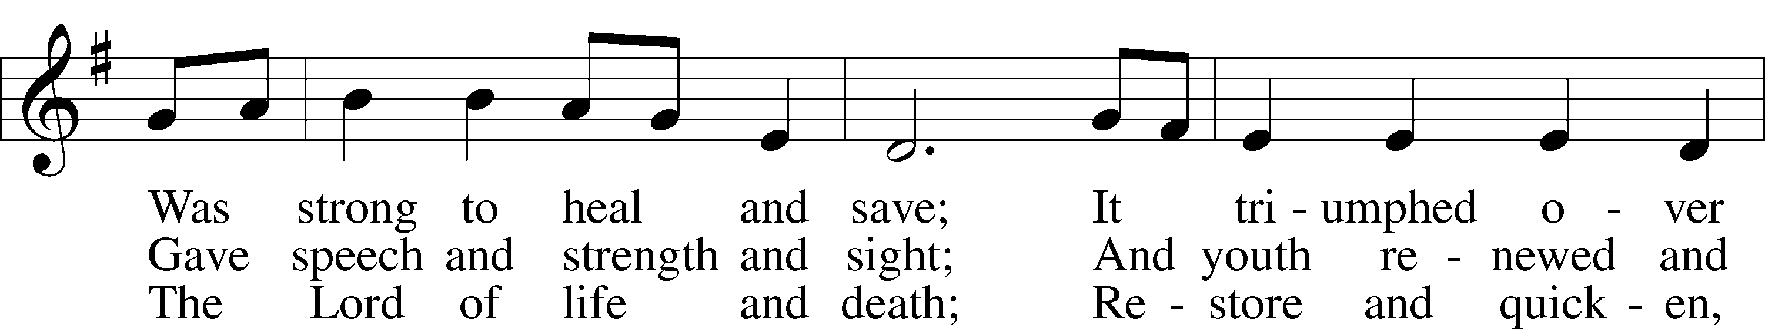
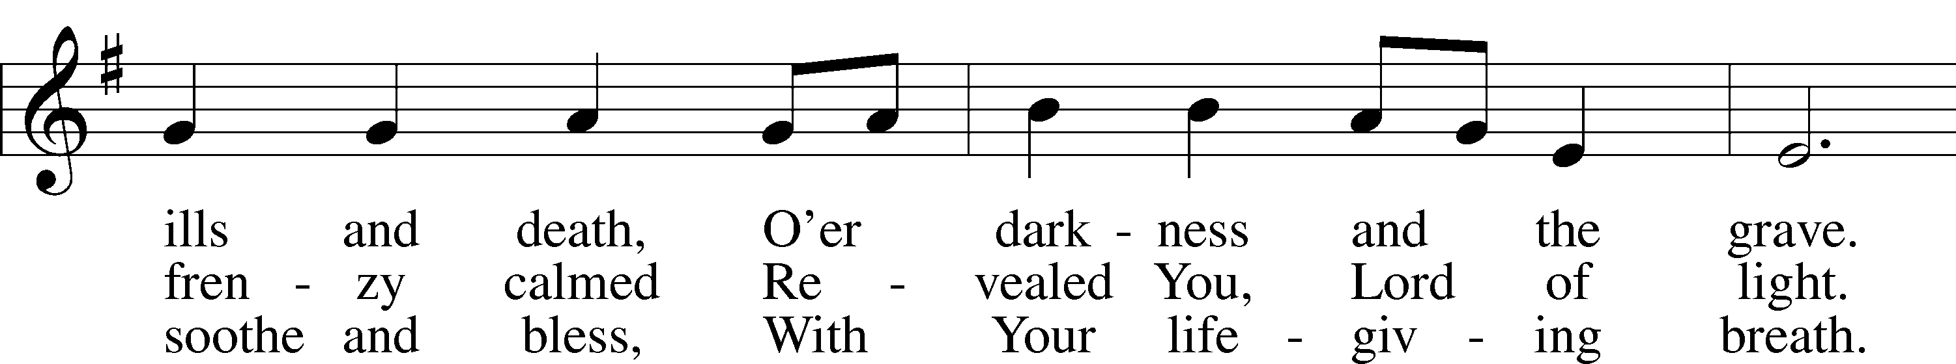
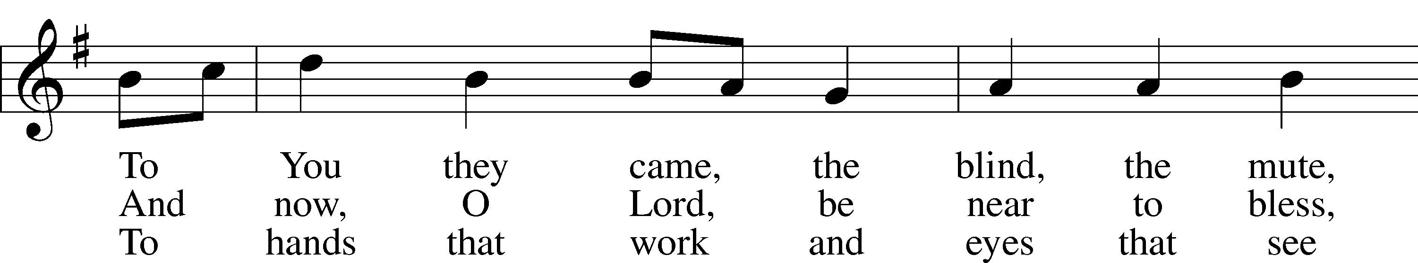
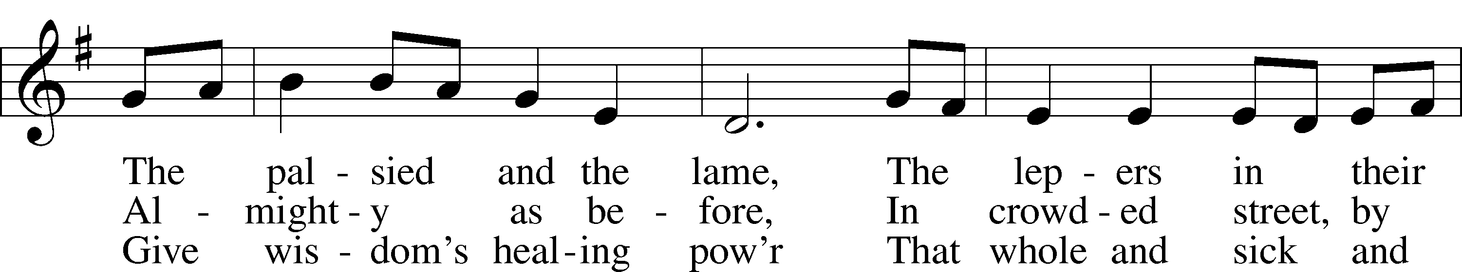
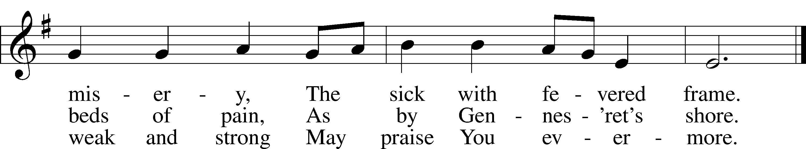
Text: Edward H. Plumptre, 1821–91, alt.
Tune: English; adapt. and harm. Ralph Vaughan Williams, 1872–1958, alt.
Text and tune: Public domain

+ CONFESSION AND ABSOLUTION +

(The sign of the cross may be made by all in remembrance of their Baptism.)

INVOCATION
L In the name of the Father and of the T Son and of the Holy Spirit.
C Amen.

EXHORTATION LSB 151
L If we say we have no sin, we deceive ourselves, and the truth is not in us.
C But if we confess our sins, God, who is faithful and just, will forgive our sins and cleanse us from all unrighteousness.

(Silence for reflection on God’s Word and for self-examination.)

CONFESSION OF SINS LSB 151
L Let us then confess our sins to God our Father.
C Most merciful God, we confess that we are by nature sinful and unclean. We have sinned against You in thought, word, and deed, by what we have done and by what we have left undone. We have not loved You with our whole heart; we have not loved our neighbors as ourselves. We justly deserve Your present and eternal punishment. For the sake of Your Son, Jesus Christ, have mercy on us. Forgive us, renew us, and lead us, so that we may delight in Your will and walk in Your ways to the glory of Your holy name. Amen.

DECLARATION OF GRACE
L In the mercy of almighty God, Jesus Christ was given to die for us, and for His sake God forgives us all our sins. To those who believe in Jesus Christ He gives the power to become the children of God and bestows on them the Holy Spirit. May the Lord, who has begun this good work in us, bring it to completion in the day of our Lord Jesus Christ.
C Amen.

+ SERVICE OF THE WORD +

INTROIT Psalm 34:2–4, 17; antiphon: Psalm 48:1a
Great is the Lord and greatly | to be praised*
in the city | of our God!
My soul makes its boast | in the Lord;*
let the humble hear | and be glad.
Oh, magnify the | Lord with me,*
and let us exalt his name to- | gether!
I sought the Lord, and he | answered me*
and delivered me from | all my fears.
When the righteous cry for help, the | Lord hears*
and delivers them out of all their | troubles.
Glory be to the Father and | to the Son*
and to the Holy | Spirit;
as it was in the be- | ginning,*
is now, and will be forever. | Amen.
Great is the Lord and greatly | to be praised*
in the city | of our God!

KYRIE LSB 152

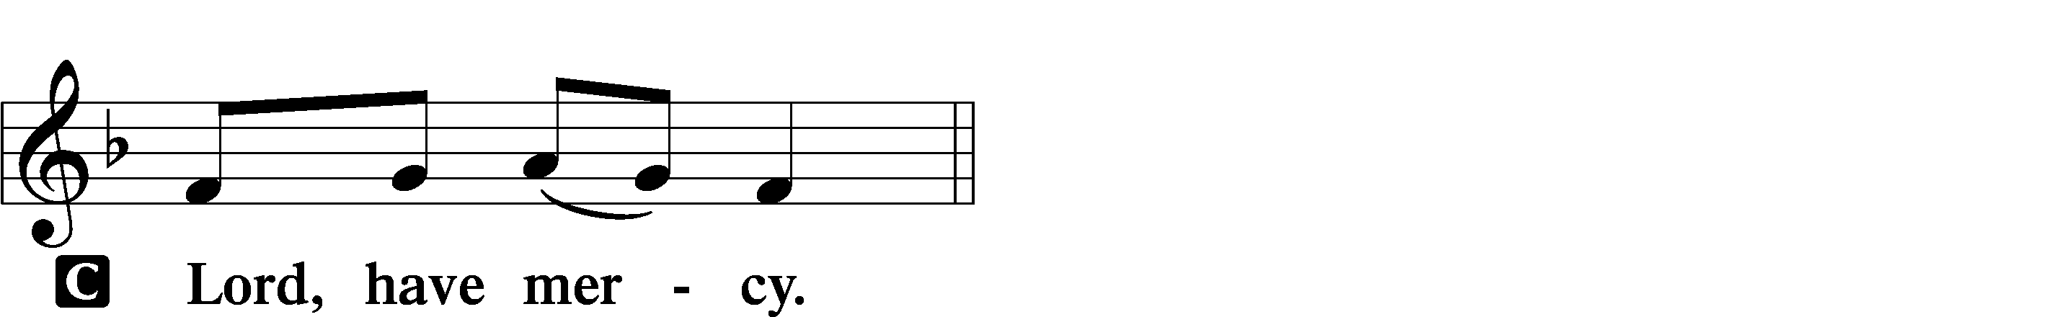

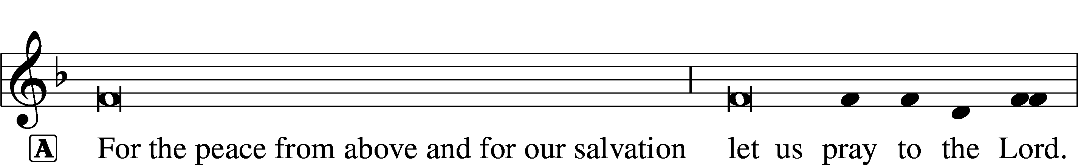
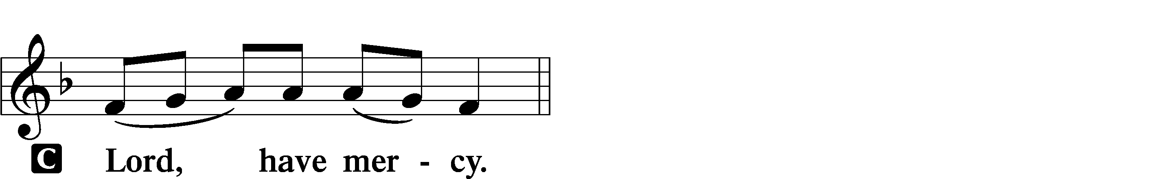

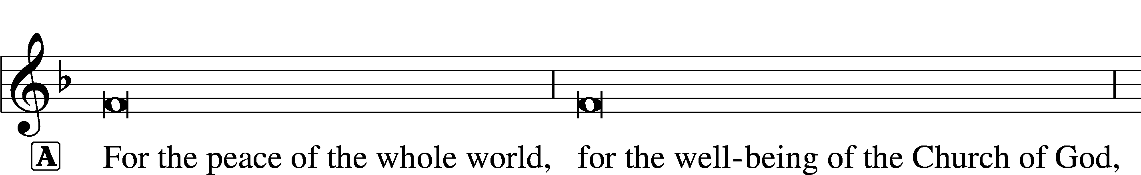

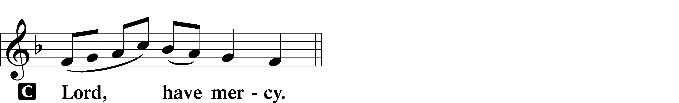

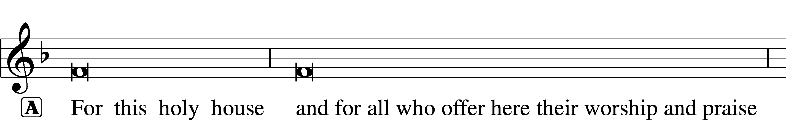

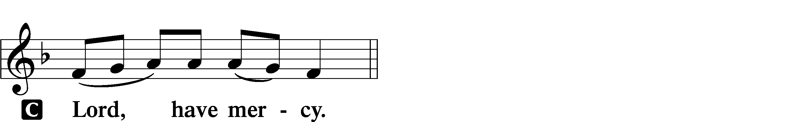




GLORIA IN EXCELSIS LSB 154
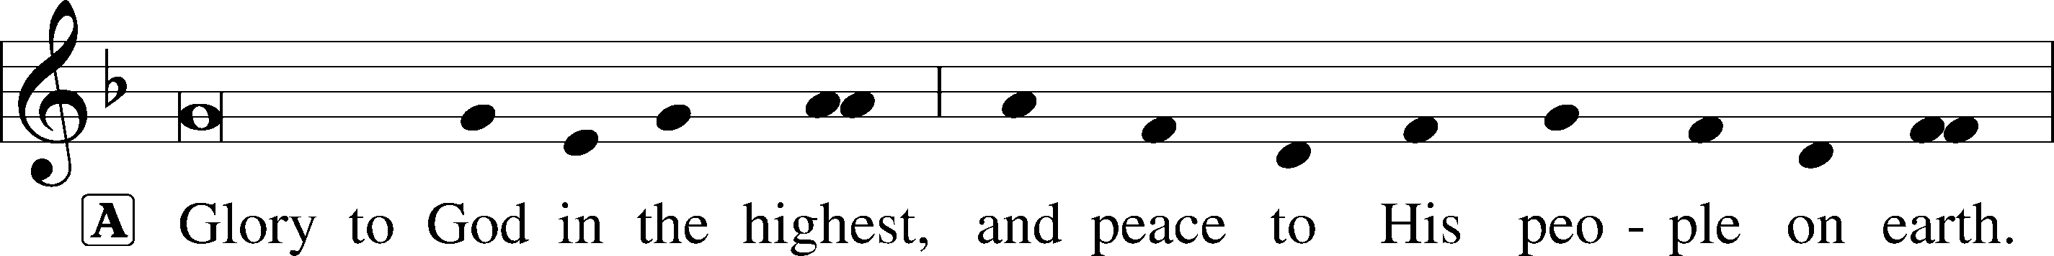
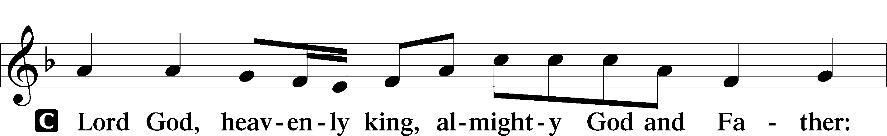
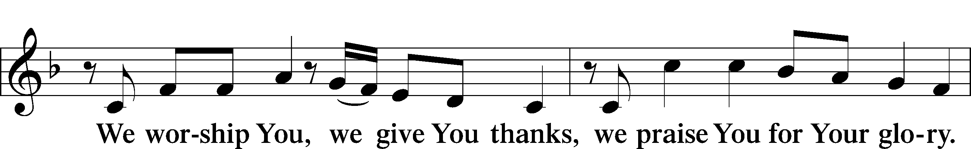
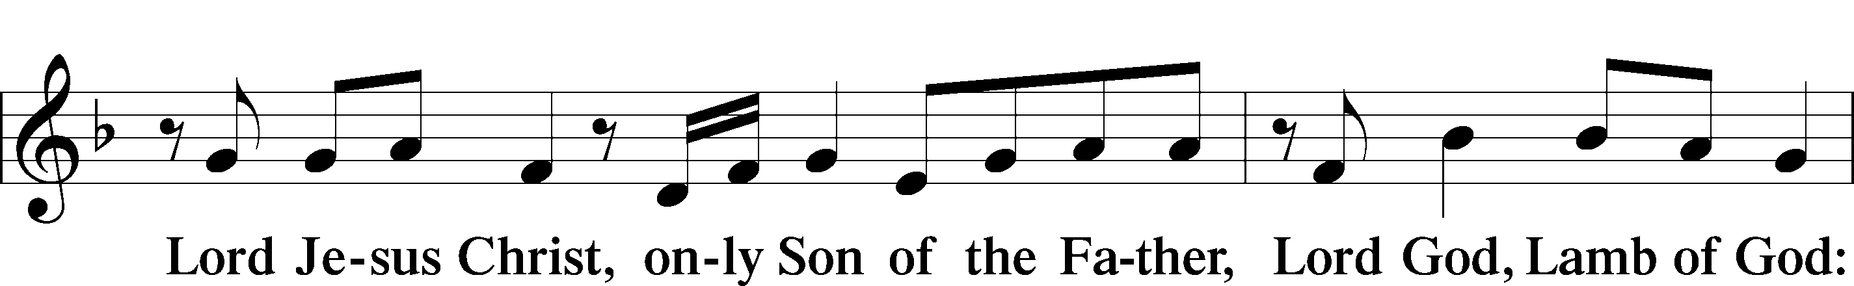
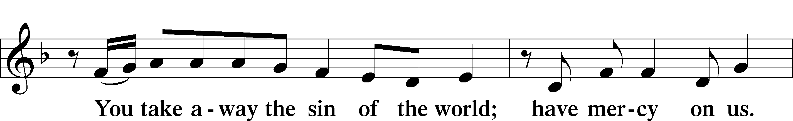
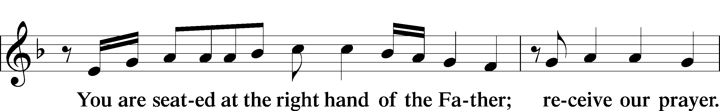
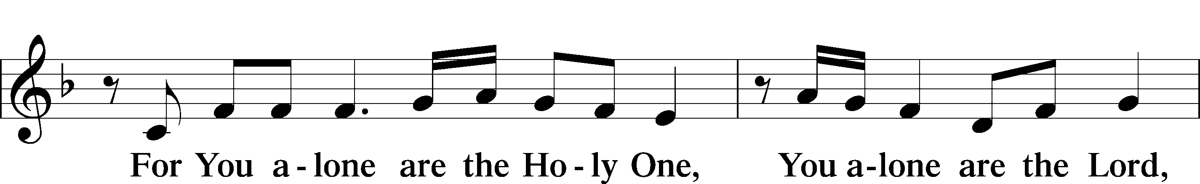
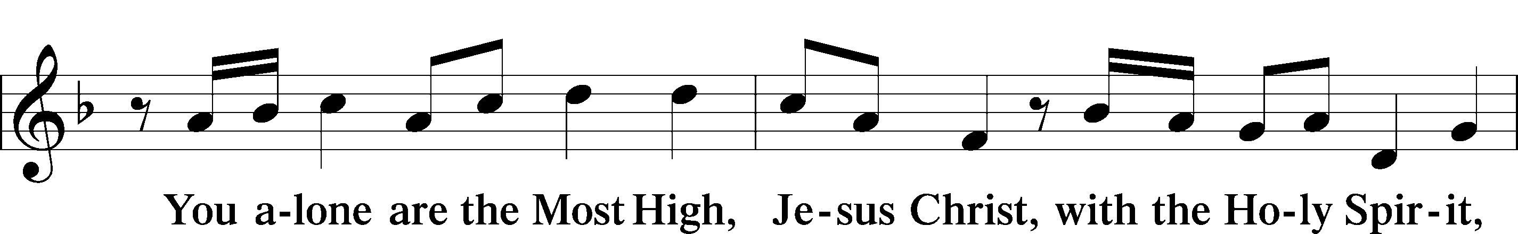
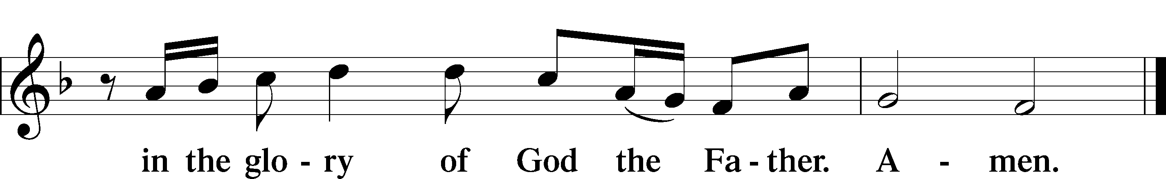

SALUTATION AND COLLECT OF THE DAY
L The Lord be with you.
C And also with you.

L Let us pray.
Almighty God, You show mercy to Your people in all their troubles. Grant us always to recognize Your goodness, give thanks for Your compassion, and praise Your holy name; through Jesus Christ, Your Son, our Lord, who lives and reigns with You and the Holy Spirit, one God, now and forever.
C Amen.

(Sit)

CHILDRENS LESSON

OLD TESTAMENT READING Ruth 1:1–19a
1In the days when the judges ruled there was a famine in the land, and a man of Bethlehem in Judah went to sojourn in the country of Moab, he and his wife and his two sons. 2The name of the man was Elimelech and the name of his wife Naomi, and the names of his two sons were Mahlon and Chilion. They were Ephrathites from Bethlehem in Judah. They went into the country of Moab and remained there. 3But Elimelech, the husband of Naomi, died, and she was left with her two sons. 4These took Moabite wives; the name of the one was Orpah and the name of the other Ruth. They lived there about ten years, 5and both Mahlon and Chilion died, so that the woman was left without her two sons and her husband.
6Then she arose with her daughters-in-law to return from the country of Moab, for she had heard in the fields of Moab that the Lord had visited his people and given them food. 7So she set out from the place where she was with her two daughters-in-law, and they went on the way to return to the land of Judah. 8But Naomi said to her two daughters-in-law, “Go, return each of you to her mother’s house. May the Lord deal kindly with you, as you have dealt with the dead and with me. 9The Lord grant that you may find rest, each of you in the house of her husband!” Then she kissed them, and they lifted up their voices and wept. 10And they said to her, “No, we will return with you to your people.” 11But Naomi said, “Turn back, my daughters; why will you go with me? Have I yet sons in my womb that they may become your husbands? 12Turn back, my daughters; go your way, for I am too old to have a husband. If I should say I have hope, even if I should have a husband this night and should bear sons, 13would you therefore wait till they were grown? Would you therefore refrain from marrying?
No, my daughters, for it is exceedingly bitter to me for your sake that the hand of the Lord has gone out against me.” 14Then they lifted up their voices and wept again. And Orpah kissed her mother-in-law, but Ruth clung to her.
15And she said, “See, your sister-in-law has gone back to her people and to her gods; return after your sister-in-law.” 16But Ruth said, “Do not urge me to leave you or to return from following you. For where you go I will go, and where you lodge I will lodge. Your people shall be my people, and your God my God. 17Where you die I will die, and there will I be buried. May the Lord do so to me and more also if anything but death parts me from you.” 18And when Naomi saw that she was determined to go with her, she said no more.
19So the two of them went on until they came to Bethlehem.

L This is the Word of the Lord.
C Thanks be to God.

GRADUAL Psalm 91:11; 103:1
He will command his angels con- | cerning you*
to guard you in | all your ways.
Bless the Lord, | O my soul,*
and all that is within me, bless his | holy name!

EPISTLE 2 Timothy 2:1–13
1You then, my child, be strengthened by the grace that is in Christ Jesus, 2and what you have heard from me in the presence of many witnesses entrust to faithful men who will be able to teach others also. 3Share in suffering as a good soldier of Christ Jesus. 4No soldier gets entangled in civilian pursuits, since his aim is to please the one who enlisted him. 5An athlete is not crowned unless he competes according to the rules. 6It is the hard-working farmer who ought to have the first share of the crops. 7Think over what I say, for the Lord will give you understanding in everything.
8Remember Jesus Christ, risen from the dead, the offspring of David, as preached in my gospel, 9for which I am suffering, bound with chains as a criminal. But the word of God is not bound! 10Therefore I endure everything for the sake of the elect, that they also may obtain the salvation that is in Christ Jesus with eternal glory. 11The saying is trustworthy, for:
If we have died with him, we will also live with him;
12if we endure, we will also reign with him;
if we deny him, he also will deny us;
13if we are faithless, he remains faithful—
for he cannot deny himself.

L This is the Word of the Lord.
C Thanks be to God.

(Stand)

ALLELUIA AND VERSE LSB 156
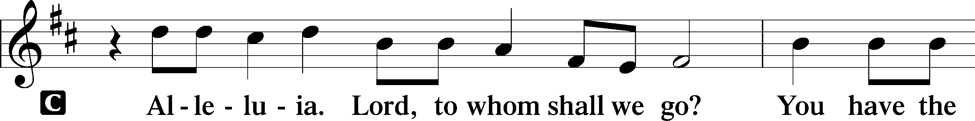
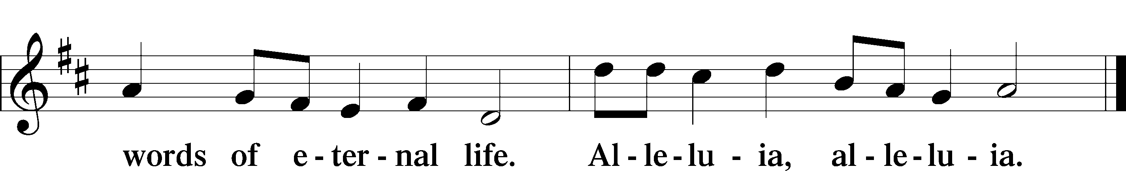

HOLY GOSPEL Luke 17:11–19
L The Holy Gospel according to St. Luke, the seventeenth chapter.

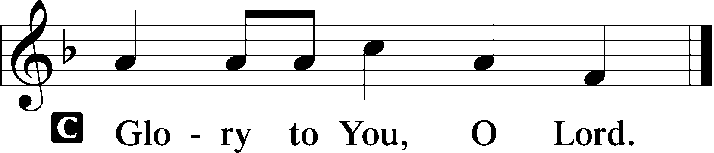

11On the way to Jerusalem [Jesus] was passing along between Samaria and Galilee. 12And as he entered a village, he was met by ten lepers, who stood at a distance 13and lifted up their voices, saying, “Jesus, Master, have mercy on us.” 14When he saw them he said to them, “Go and show yourselves to the priests.” And as they went they were cleansed. 15Then one of them, when he saw that he was healed, turned back, praising God with a loud voice; 16and he fell on his face at Jesus’ feet, giving him thanks. Now he was a Samaritan. 17Then Jesus answered, “Were not ten cleansed? Where are the nine? 18Was no one found to return and give praise to God except this foreigner?” 19And he said to him, “Rise and go your way; your faith has made you well.”

L This is the Gospel of the Lord.

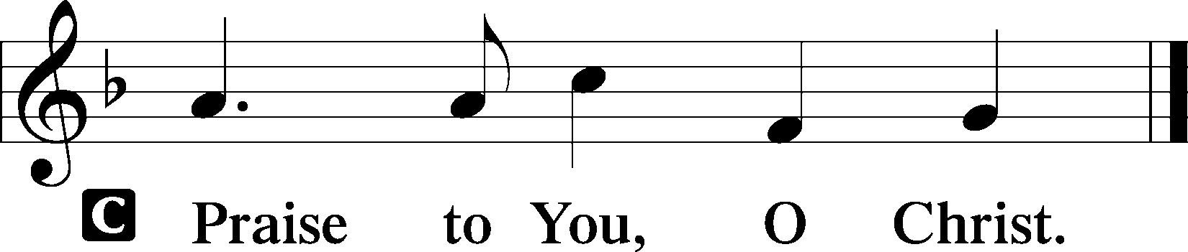

(Sit)

855 FOR ALL THE FAITHFUL WOMEN sts. 1–2, 7, 3–4
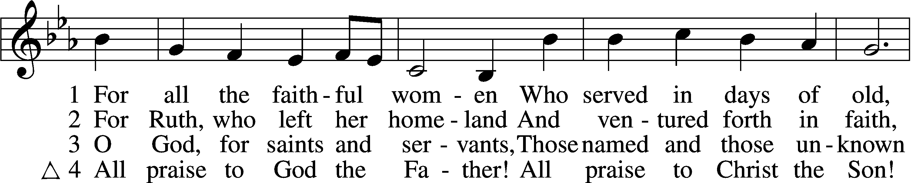
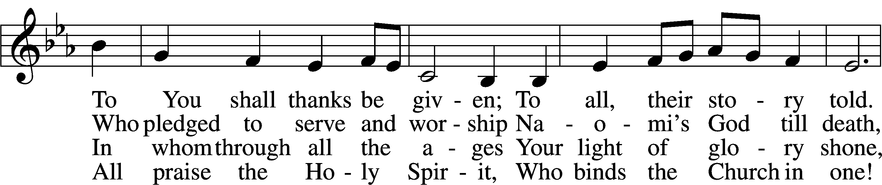
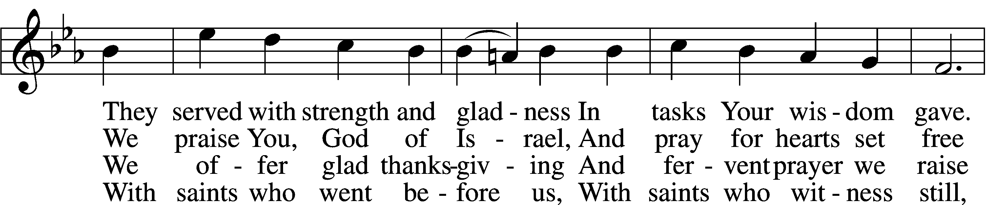
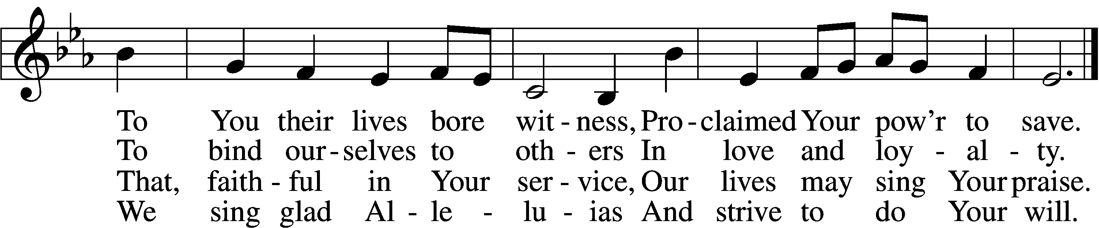

SERMON OR MEDITATION ON THE READINGS

(Stand)

NICENE CREED
C I believe in one God,
the Father Almighty,
maker of heaven and earth
and of all things visible and invisible.

And in one Lord Jesus Christ,
the only-begotten Son of God,
begotten of His Father before all worlds,
God of God, Light of Light,
very God of very God,
begotten, not made,
being of one substance with the Father,
by whom all things were made;
who for us men and for our salvation came down from heaven
and was incarnate by the Holy Spirit of the virgin Mary
and was made man;
and was crucified also for us under Pontius Pilate.
He suffered and was buried.
And the third day He rose again according to the Scriptures
and ascended into heaven
and sits at the right hand of the Father.
And He will come again with glory to judge both the living and the dead,
whose kingdom will have no end.

And I believe in the Holy Spirit,
the Lord and giver of life,
who proceeds from the Father and the Son,
who with the Father and the Son together is worshiped and glorified,
who spoke by the prophets.
And I believe in one holy Christian and apostolic Church,
I acknowledge one Baptism for the remission of sins,
and I look for the resurrection of the dead
and the life T of the world to come. Amen.

SHARING OF THE PEACE

(Sit)

PRAYER OF THE CHURCH

OFFERING

(Stand)

OFFERTORY LSB 159
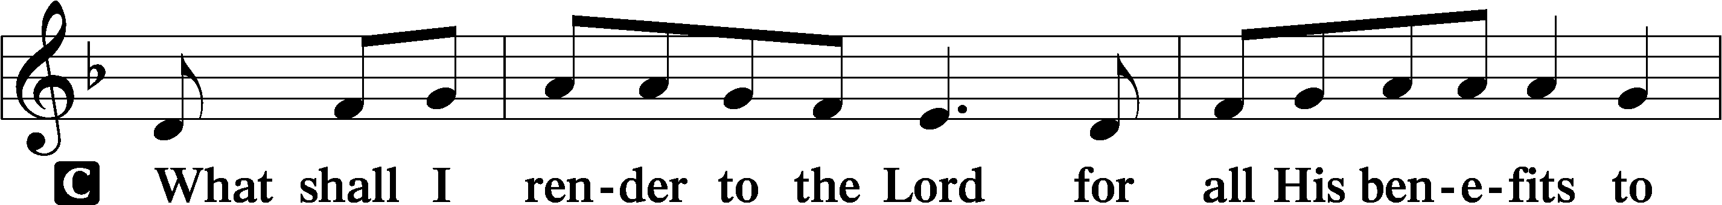
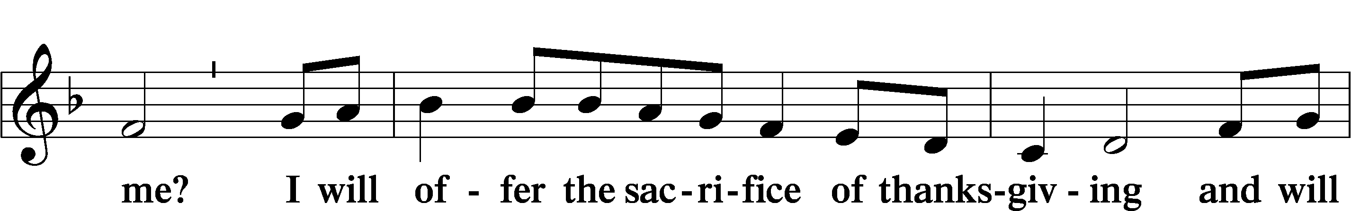
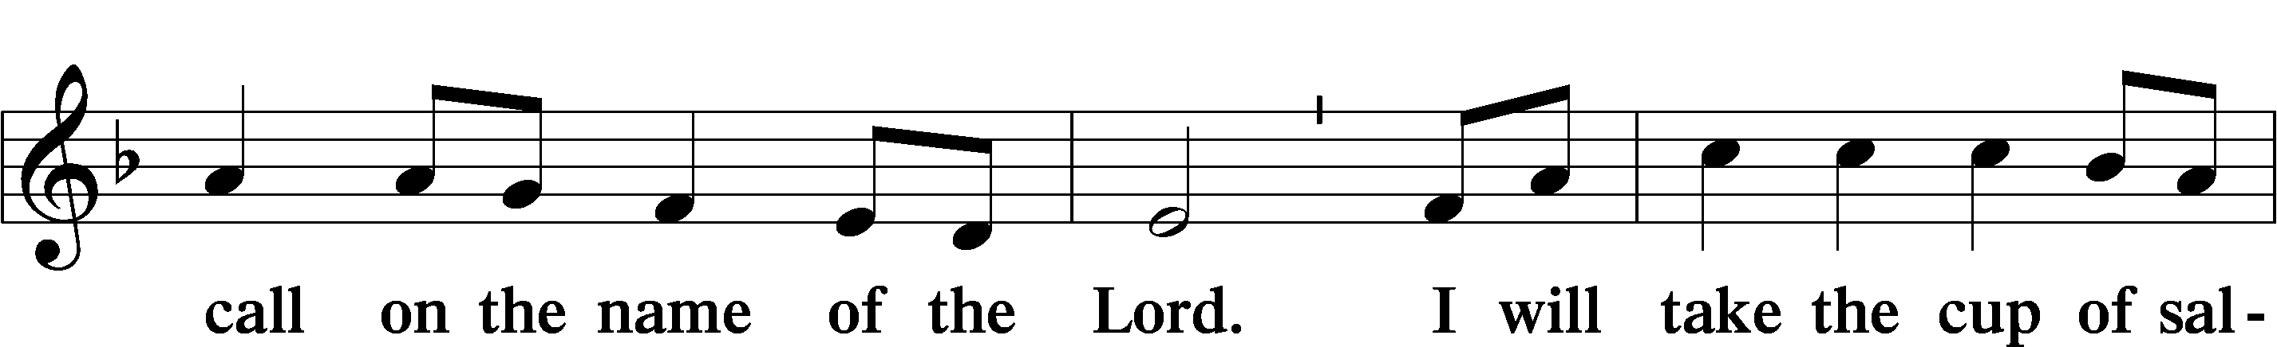
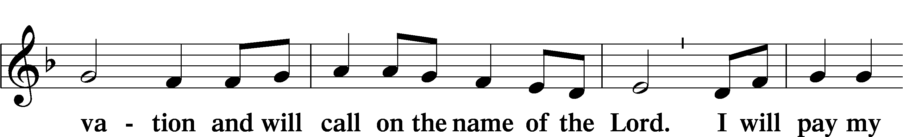
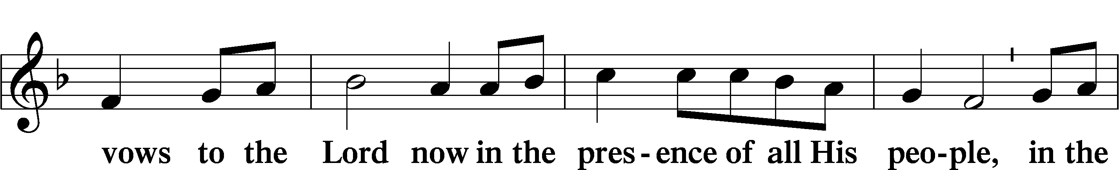
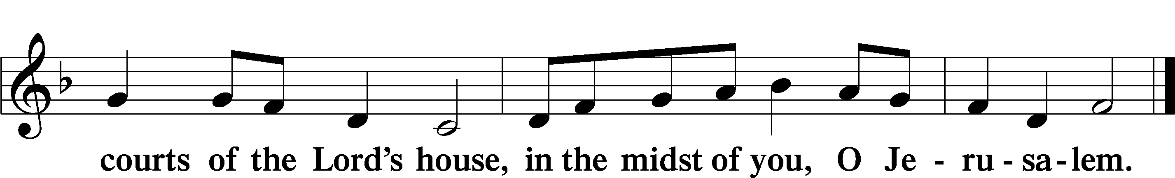

+ SERVICE OF THE SACRAMENT +
Note: The Service of The Sacrament is included in the lay bulletin solely as a viewers’ guide for those watching the livestream service; Communicant members who are unable to attend the Divine Service in person are encouraged to make arrangements with Pastor Engwall to receive the Lord’s Supper.

PREFACE LSB 160





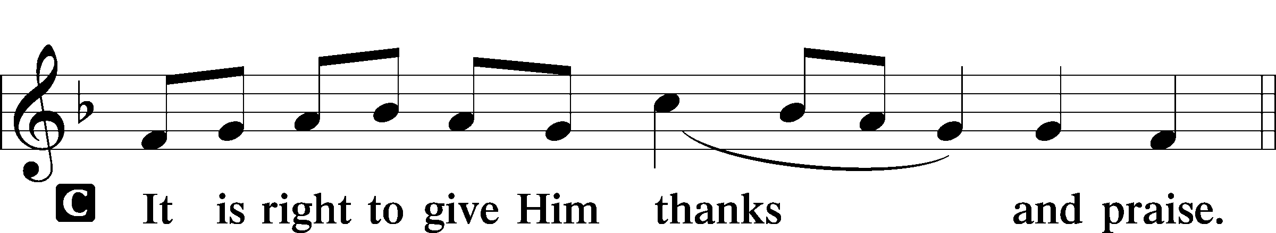

PROPER PREFACE (ABBREVIATED) LSB 161
P It is truly good, right, and salutary . . . evermore praising You and saying:

SANCTUS LSB 161
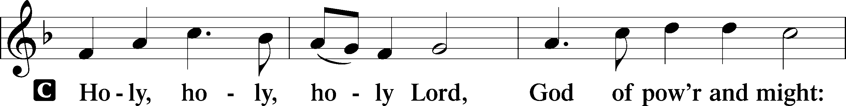
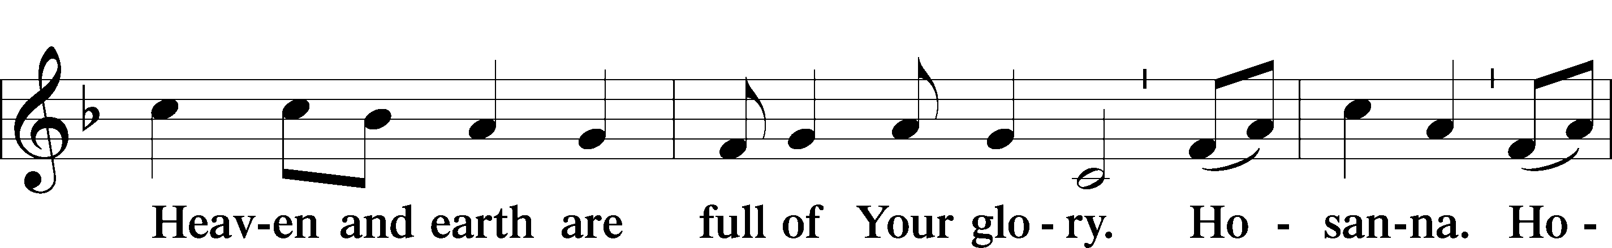
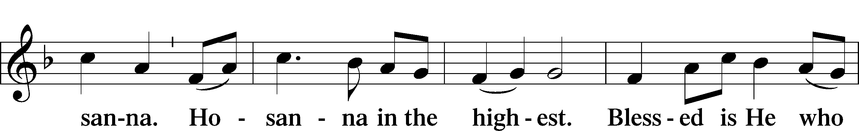
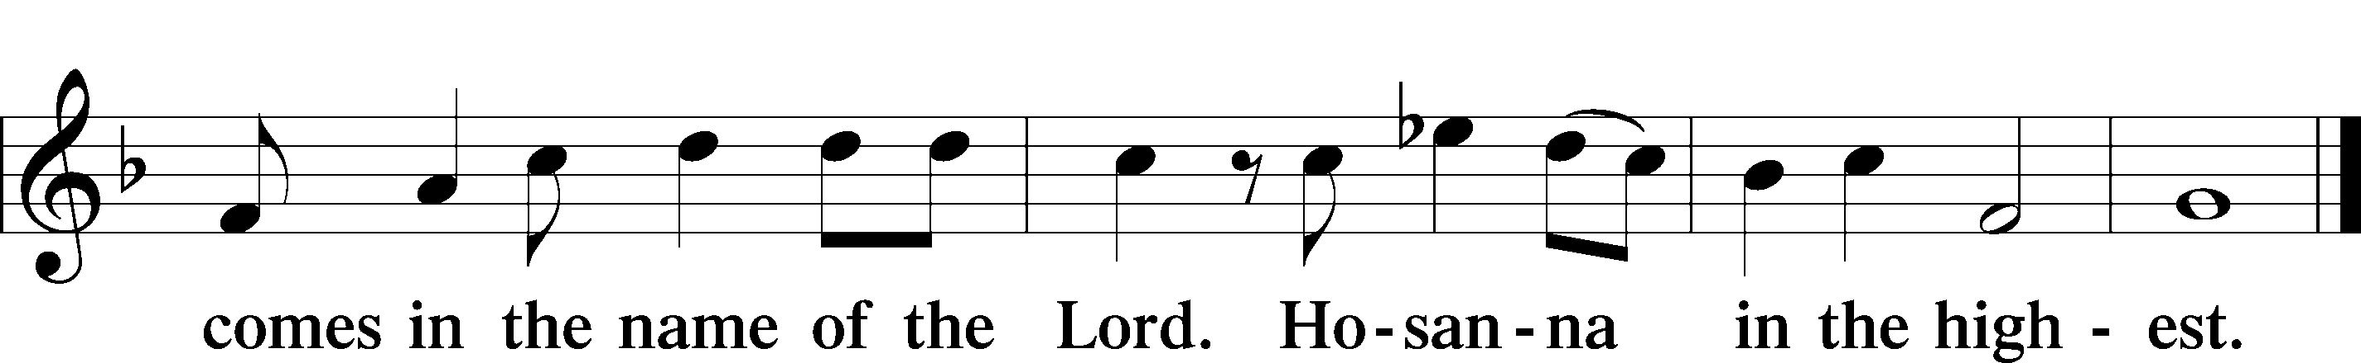

PRAYER OF THANKSGIVING LSB 161

LORD’S PRAYER
C Our Father who art in heaven,
hallowed be Thy name,
Thy kingdom come,
Thy will be done on earth
as it is in heaven;
give us this day our daily bread;
and forgive us our trespasses
as we forgive those
who trespass against us;
and lead us not into temptation,
but deliver us from evil.
For Thine is the kingdom
and the power and the glory
forever and ever. Amen.

THE WORDS OF OUR LORD

PAX DOMINI LSB 163
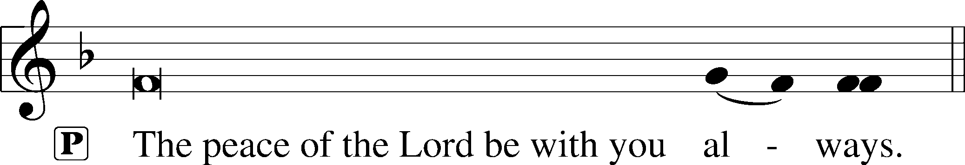


AGNUS DEI LSB 163
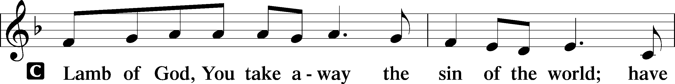
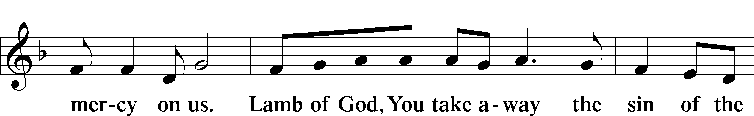
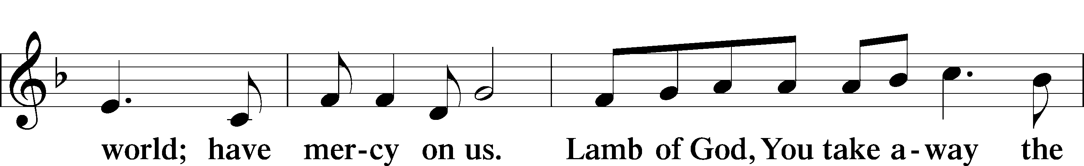
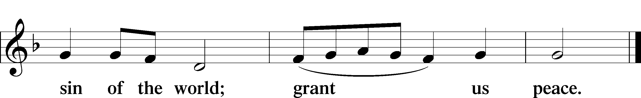

(Sit)

DISTRIBUTION

(The pastor and those who assist him receive the body and blood of Christ first and then distribute them to those who are unable to come to the altar. The ushers will then direct all other communicants to the altar..)

333 ONCE HE CAME IN BLESSING
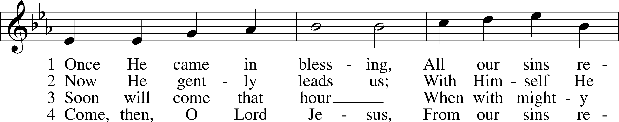
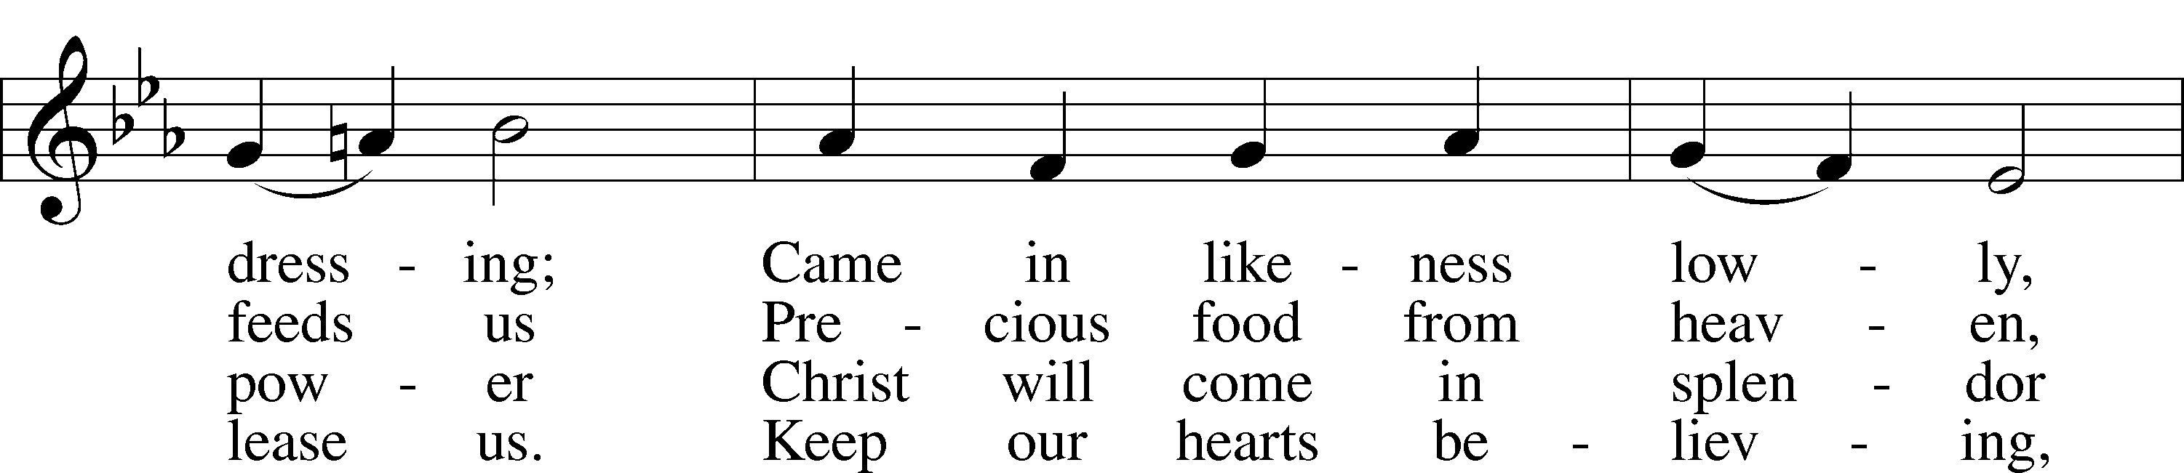
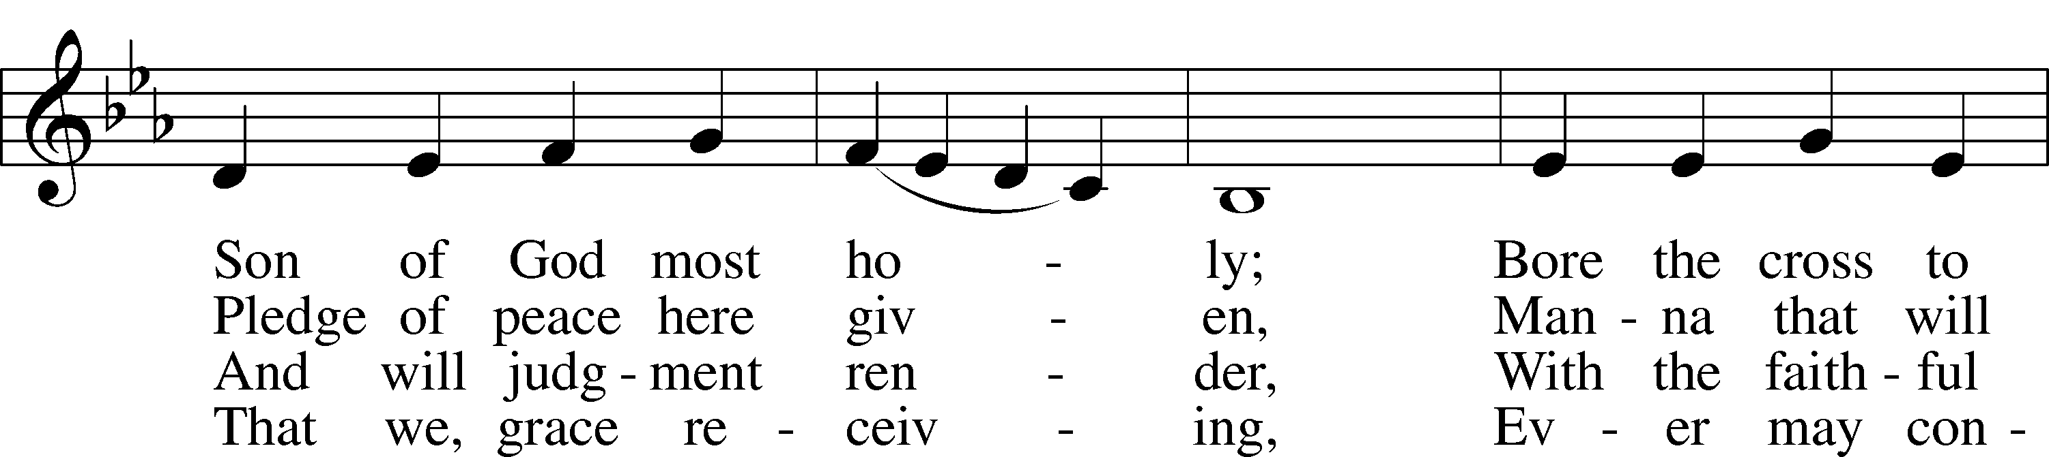
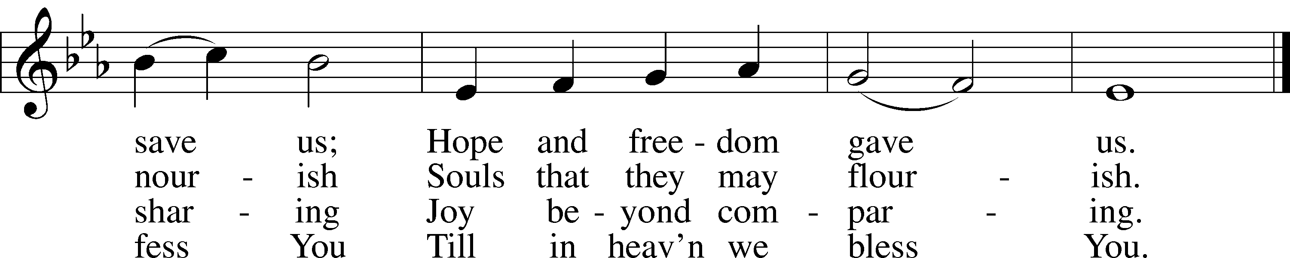
Text: Johann Horn, c. 1490–1547; (sts. 1, 4): tr. Catherine Winkworth, 1827–78, alt.; (sts. 2–3): tr. Lutheran Service Book, 2006
Tune: Michael Weisse, c. 1480–1534
Text (sts. 2–3): © 2006 Concordia Publishing House. Used by permission: LSB Hymn License no. 110004798
Text (sts. 1, 4) and tune: Public domain

INSTRUMENTAL

(Stand)

THANK THE LORD LSB 164
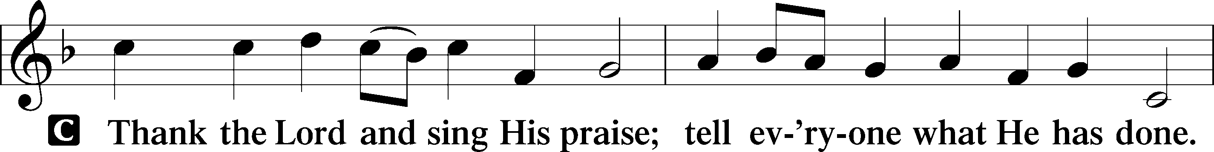
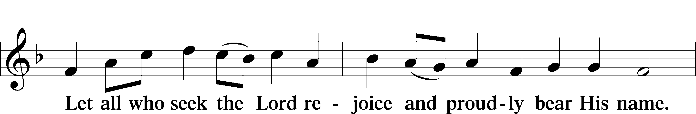
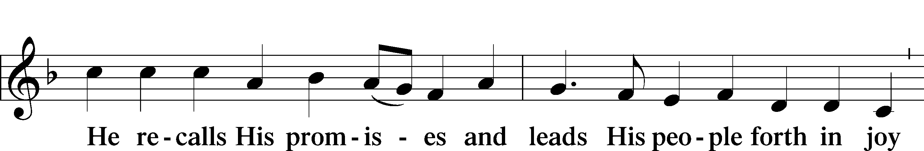
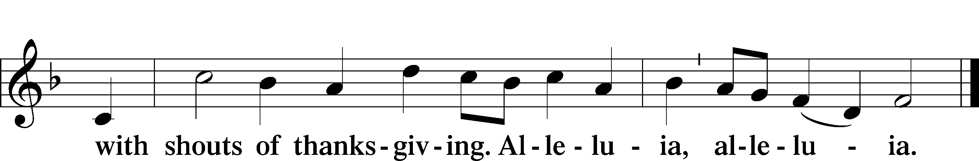

POST-COMMUNION COLLECT

BENEDICTION
L:The grace of our Lord T Jesus Christ, and the love of God, and the fellowship of the Holy Spirit, be with us all.
C: Amen.

662 ONWARD, CHRISTIAN SOLDIERS
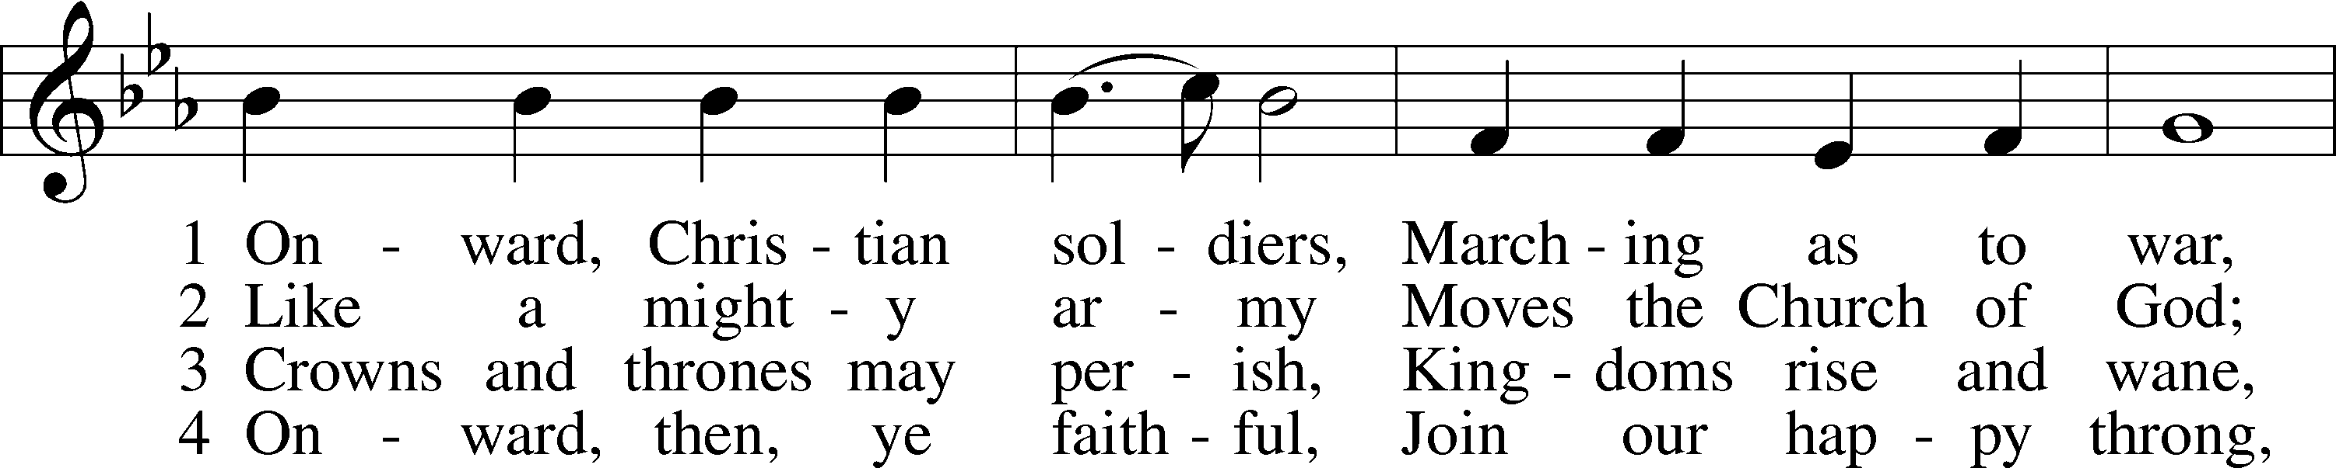
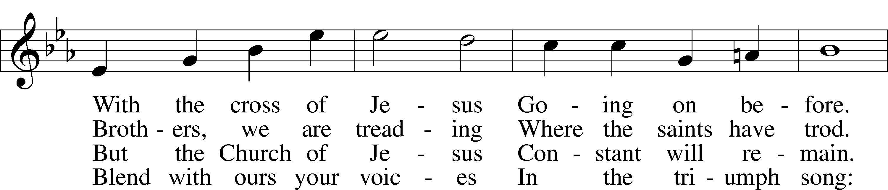
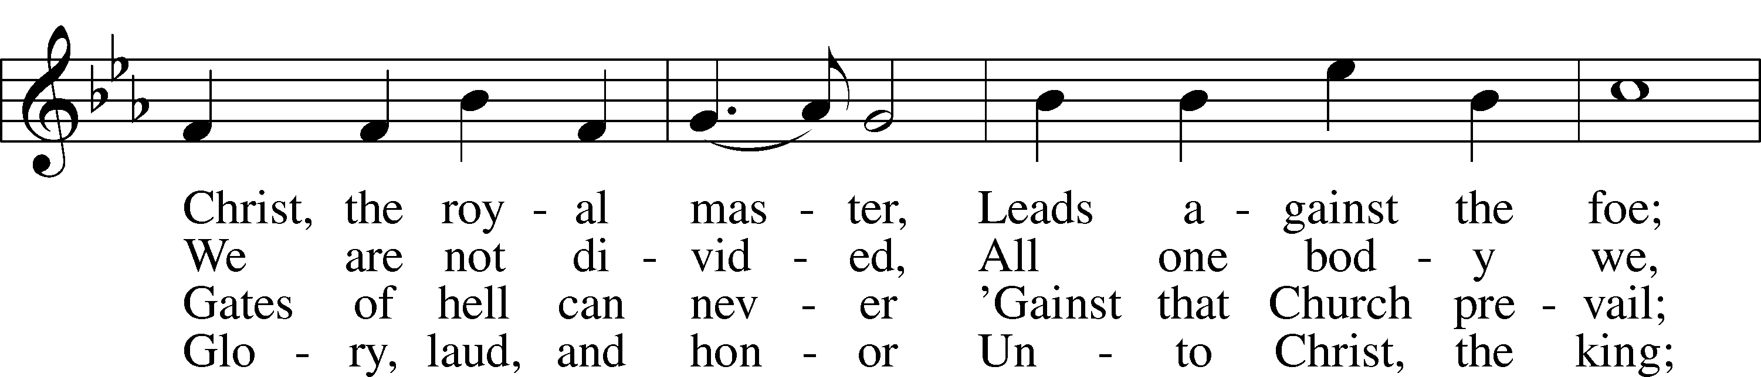
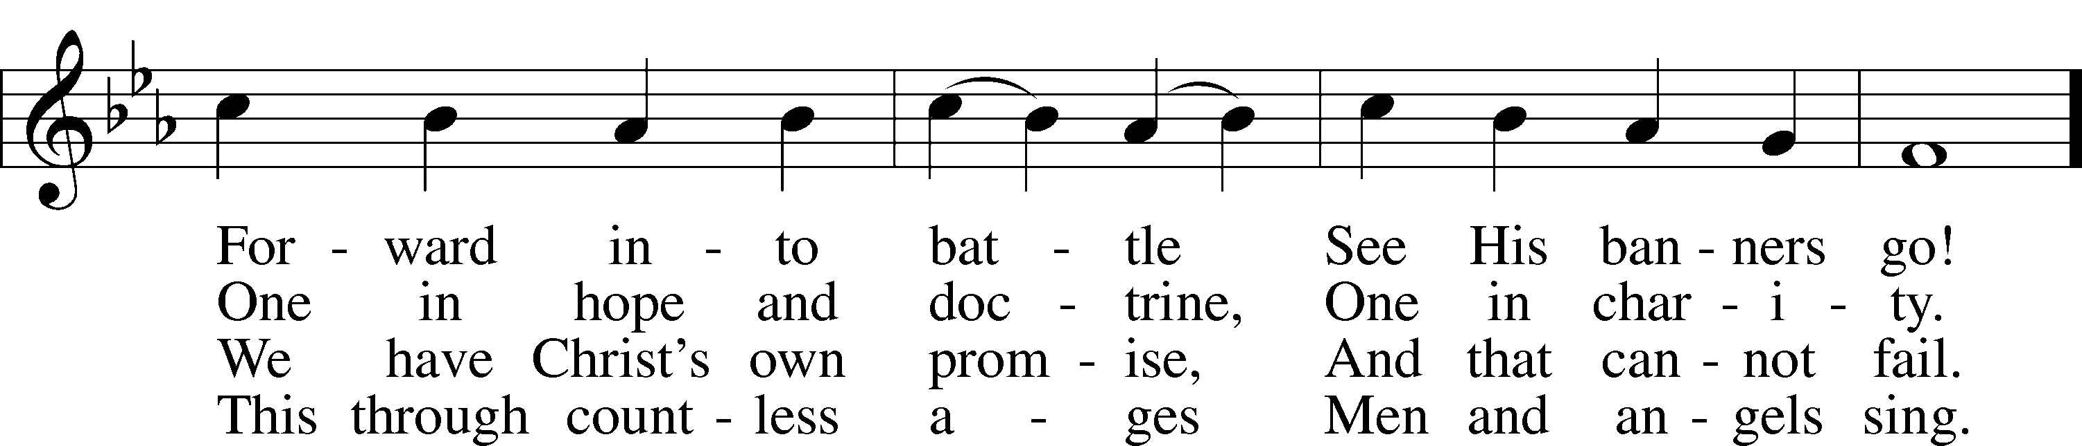
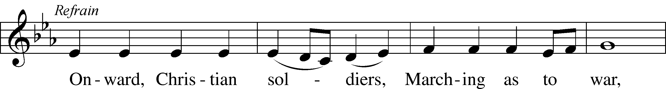
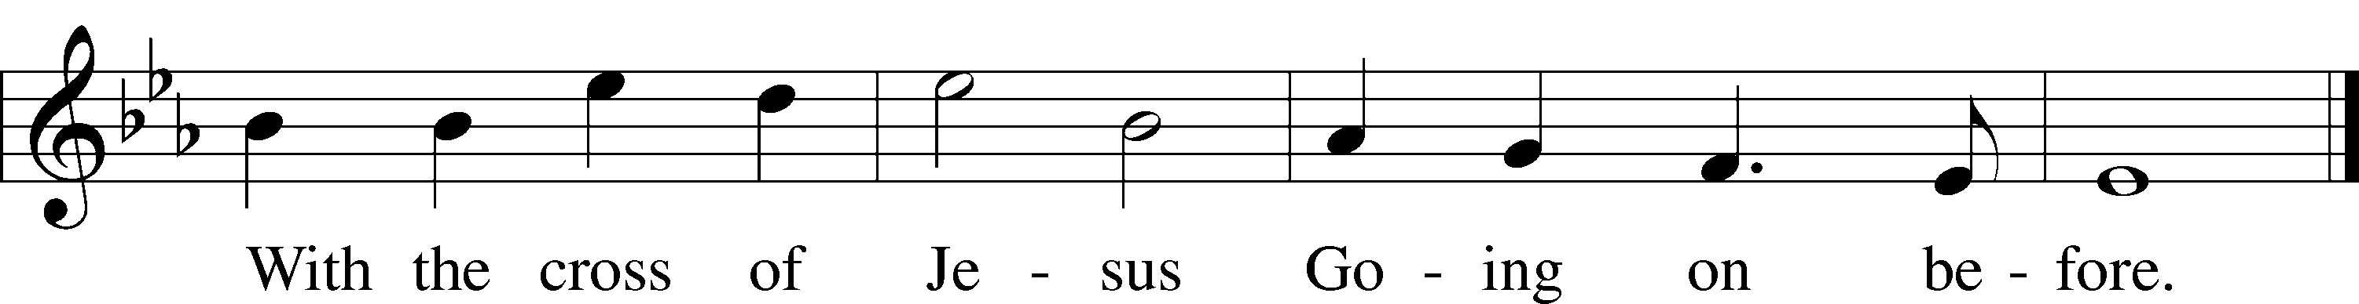
Text: Sabine Baring-Gould, 1834–1924, alt.
Tune: Arthur S. Sullivan, 1842–1900
Text and tune: Public domain

ACKNOWLEDGMENTS
Unless otherwise indicated, Scripture quotations are from the ESV® Bible (The Holy Bible, English Standard Version®), copyright © 2001 by Crossway, a publishing ministry of Good News Publishers. Used by permission. All rights reserved.
Created by Lutheran Service Builder © 2025 Concordia Publishing House.

IN OUR PRAYERS:
Submitted petitions are included for two consecutive Sundays
For Those suffering afflictions of mind, body,or spirit:
John M., Anne H., Jim S., Dennis S., Blake B., Carol R., Michele N., Mark K., Dean S.
For missionaries
Deaconess Sandra R., Rev. Jonathan A.
All of our Shut- Ins:
Betty A., Shirley F., Mary H., Patsy L., Herman L., Tommy, Pam and Jerome M., Sharon B.

ANNOUNCEMENTS
Please email announcements for Sunday bulletins by 8:00 a.m. Tuesday to pastorblcaiken@gmail.com

PASTOR ON THE ROAD:
Sept. 29 – 30; Richmond, VA; Circuit Visitors Conference
Oct. 6 – 8; Virginia Beach, VA; Church Workers Conference
Oct. 11; Irmo, SC; Circuit Forum
Oct. 12 – Oct. 25; Vacation

THANK YOU!!
Everyone who was able to come out for Church Work Day yesterday.

THANK YOU!!
Rev. Douglas J., for officiating today’s service.

BLC NIGHT OUT
Thursday, October 16th, Shane’s Rib Shack

REFORMATIONFEST:
Sunday, October 26th after the service. Attendees must provide their own German beverage of choice, if so desired. (bringen zein own bier)

ACTS DONATION FOR OCTOBER:
Canned meat; beef, chicken, salmon, tuna, etc.

FELLOWSHIP COFFEE HOUR:
Every Sunday morning, during Bible Study and after the Divine Service, coffee, treats and good fellowship are waiting for you in our Fellowship Hall!

CALENDAR, NEWSLETTER, AND CHURCH DIRECTORY:
Please provide any articles, calendar entries, announcements, photos, etc. for the Star of Bethlehem newsletter to Debbie C. no later than noon on the 23rd of each month. The Star calendar will also be used for the website. Updates to your church directory data may be provided at any time.

Average weekly offering needed to make budget: $2,508

BE IN THE WORD!
SUNDAY MORNINGS AT 9 a.m.
Adult Bible Study
Sunday School for children and youth
TUESDAY MORNINGS AT 10:00 a.m.
Women’s Bible Study
WEDNESDAY EVENINGS AT 7 p.m.
Adult Bible Study
JUNIOR CONFIRMATION and ADULT INSTRUCTION
Always available by request:
Contact Pastor to schedule

OUR VALUE STATEMENT: Bethlehem Lutheran Church exists under God’s grace to save the lost and to strengthen the saved so that they may live bold and courageous lives of Christian witness before a non-believing world.
Therefore, our purpose is:
- to glorify God in Word and deed,
- to nurture each other in Christian love,
- to reach out to others with our Savior’s Gospel of life and salvation.
(Rom 5:8, Matt. 28:18-20).

OUR VISION: By the Grace of God, Bethlehem Lutheran Church, is a loving family united in Christ, learning, living, and spreading His Word.

OUR MISSION: Learn the Word. Live the Word. Spread the Word.

