BETHLEHEM LUTHERAN CHURCH
A congregation of The Lutheran Church-Missouri Synod
902 Hitchcock Drive SW,
Aiken, South Carolina 29803
Church Phone: (803) 649-6417
blcaikensc@gmail.com
Pastor: Rev. John B. Engwall
Office Hours By Appointment

Note: The format of this bulletin has been modified for use in private devotion services. Unable to join us in person? Please find us on Facebook live. The service is also posted on our website: bethlehemlutheranaiken.org

+ + + + + + + + + + + + + + +
The 3rd Sunday of Easter
April 19, 2026
10:30 a.m.
+ + + + + + + + + + + + + + +

Our Policy and Practice Regarding Holy Communion
Hear the words of the Apostle Paul;
Anyone who eats and drinks without recognizing the body of the Lord eats and drinks judgment on himself. -1 Cor.11:29
Therefore, visitors are asked to please refrain from partaking of the Sacrament before speaking about this with the pastor; because we care about your spiritual well-being.
Also, because communing at this altar is a public confession that you agree with the doctrines of The Lutheran Church-Missouri Synod, and reject all contrary teachings.
Persons who are not communing today are always welcome to come forward during the distribution to receive an individual blessing; please cross your arms over your chest to indicate your desire for this. Thank you!
We commune in two alternating tables. The ushers will guide you. Non-alcoholic white wine is available in the center of the individual cup tray. Please leave empty individual cups at the altar rail.
+ SERVICE OF PREPARATION +
After the bell tolls, please observe a time of silence.

WELCOME AND ANNOUNCEMENTS

(Stand)

603 WE KNOW THAT CHRIST IS RAISED
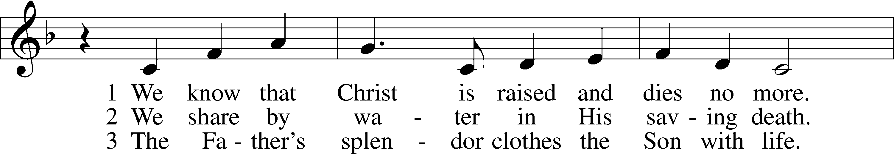
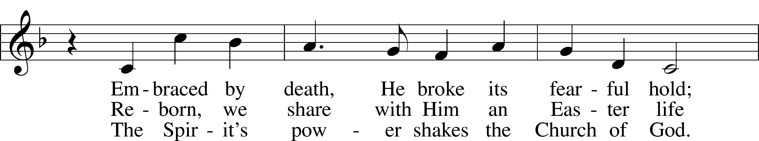
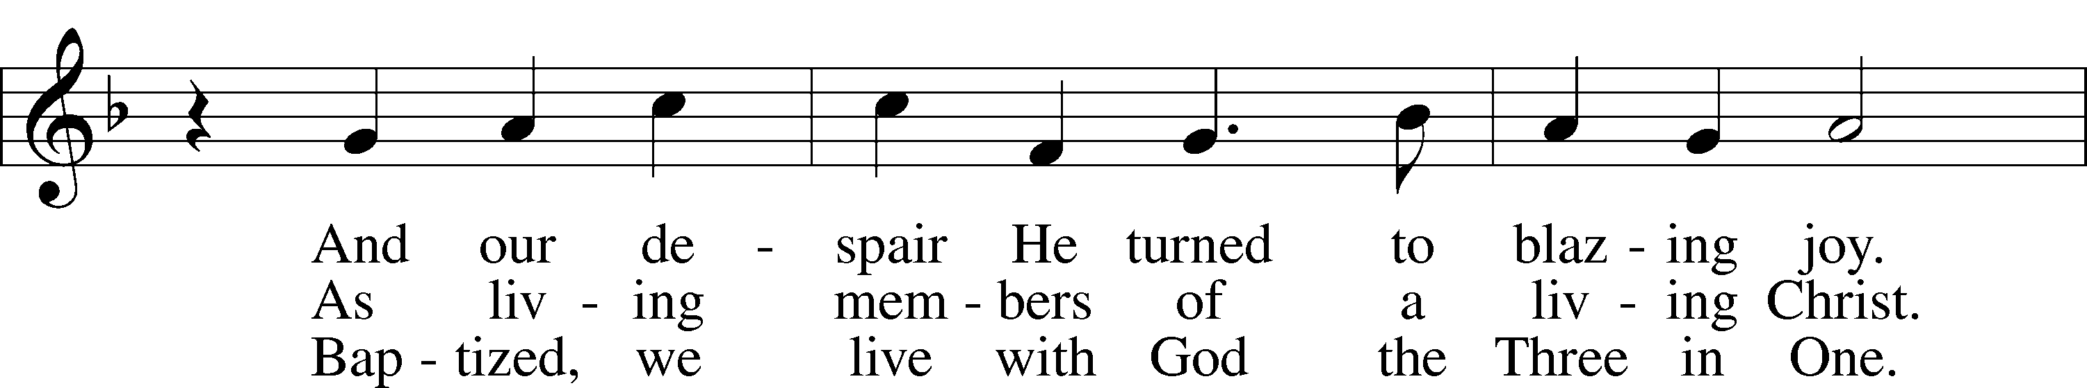
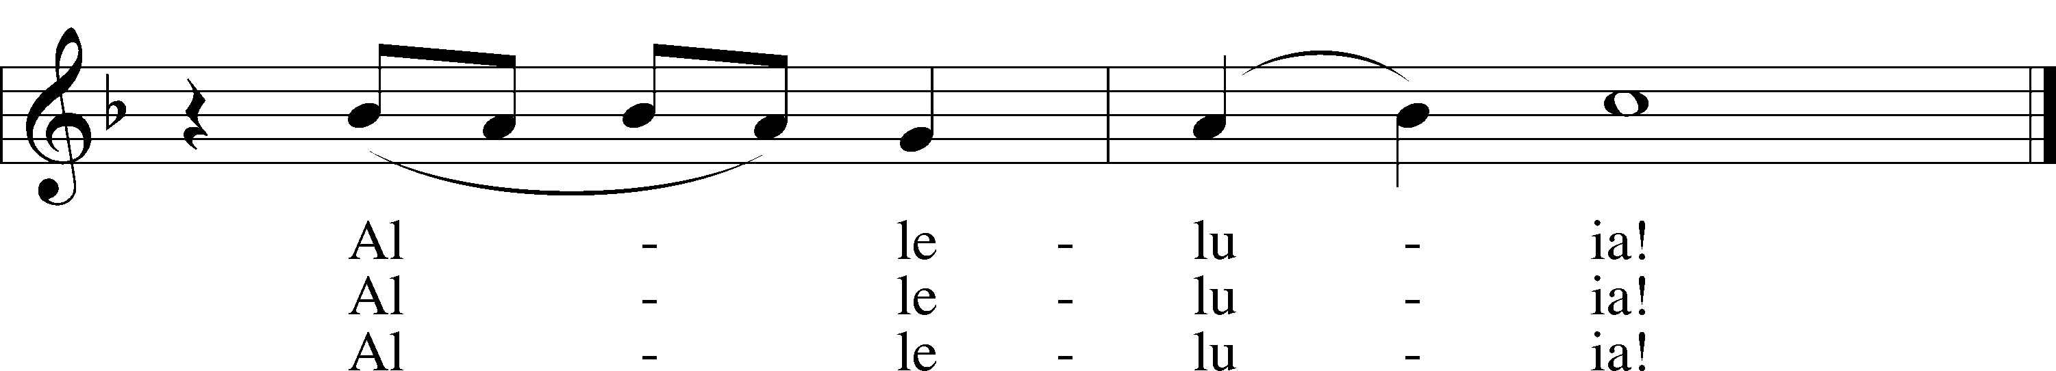
Text: John B. Geyer, 1932–2020, alt.
Tune: Charles V. Stanford, 1852–1924
Text: © John B. Geyer. Used by permission: LSB Hymn License no. 110004798
Tune: Public domain

+ CONFESSION AND ABSOLUTION +

(The sign of the cross may be made by all in remembrance of their Baptism.)

INVOCATION
L In the name of the Father and of the T Son and of the Holy Spirit.
C Amen.

EXHORTATION LSB 151
L If we say we have no sin, we deceive ourselves, and the truth is not in us.
C But if we confess our sins, God, who is faithful and just, will forgive our sins and cleanse us from all unrighteousness.

(Silence for reflection on God’s Word and for self-examination.)

CONFESSION OF SINS LSB 151
L Let us then confess our sins to God our Father.
C Most merciful God, we confess that we are by nature sinful and unclean. We have sinned against You in thought, word, and deed, by what we have done and by what we have left undone. We have not loved You with our whole heart; we have not loved our neighbors as ourselves. We justly deserve Your present and eternal punishment. For the sake of Your Son, Jesus Christ, have mercy on us. Forgive us, renew us, and lead us, so that we may delight in Your will and walk in Your ways to the glory of Your holy name. Amen.

DECLARATION OF GRACE
L In the mercy of almighty God, Jesus Christ was given to die for us, and for His sake God forgives us all our sins. To those who believe in Jesus Christ He gives the power to become the children of God and bestows on them the Holy Spirit. May the Lord, who has begun this good work in us, bring it to completion in the day of our Lord Jesus Christ.
C Amen.

+ SERVICE OF THE WORD +

INTROIT Psalm 133; antiphon: v. 1
Behold, how good and pleas- | ant it is*
when brothers dwell in | unity!
It is like the precious oil on the head, running down on the beard, on the beard of | Aaron,*
running down on the collar | of his robes!
It is like the dew of Hermon, which falls on the mountains of | Zion!*
For there the Lord has commanded the blessing, life for- | evermore.
Glory be to the Father and | to the Son*
and to the Holy | Spirit;
as it was in the be- | ginning,*
is now, and will be forever. | Amen.
Behold, how good and pleas- | ant it is*
when brothers dwell in | unity!

KYRIE LSB 152



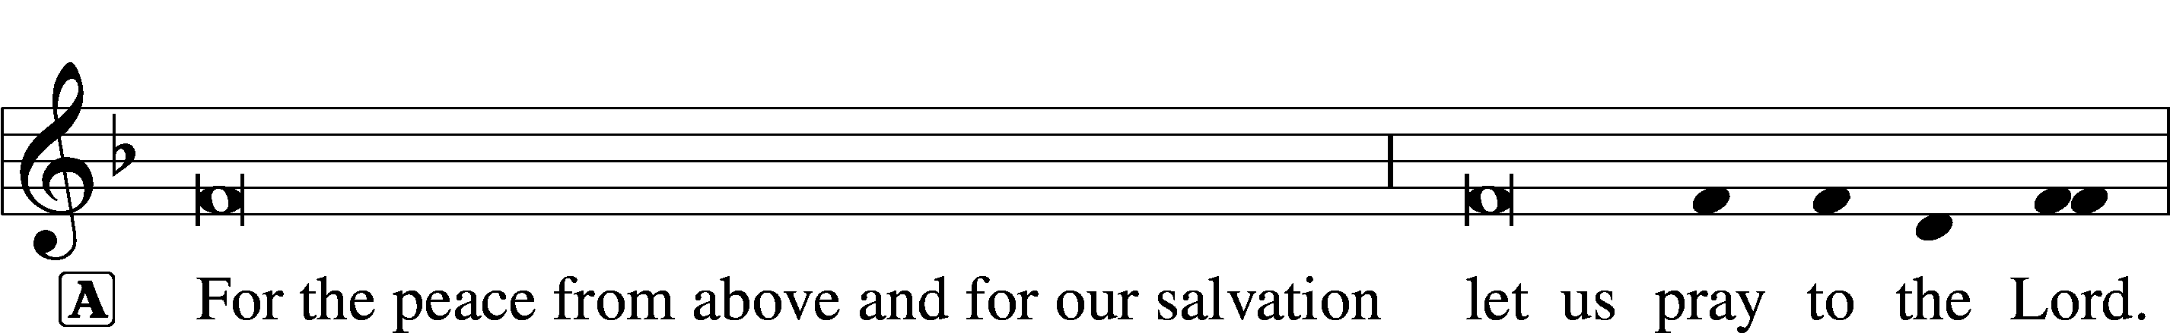


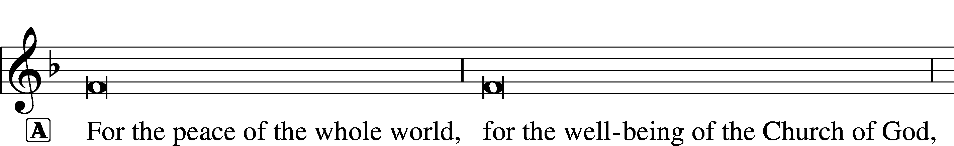



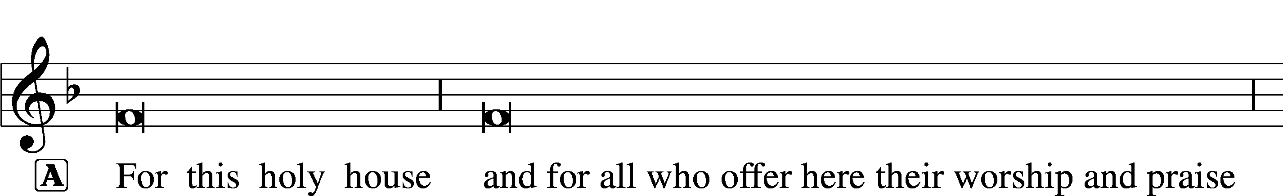






THIS IS THE FEAST LSB 155
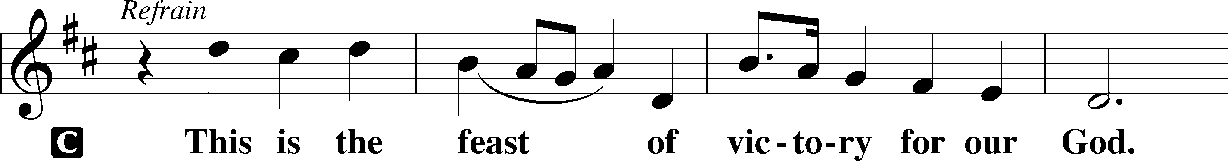
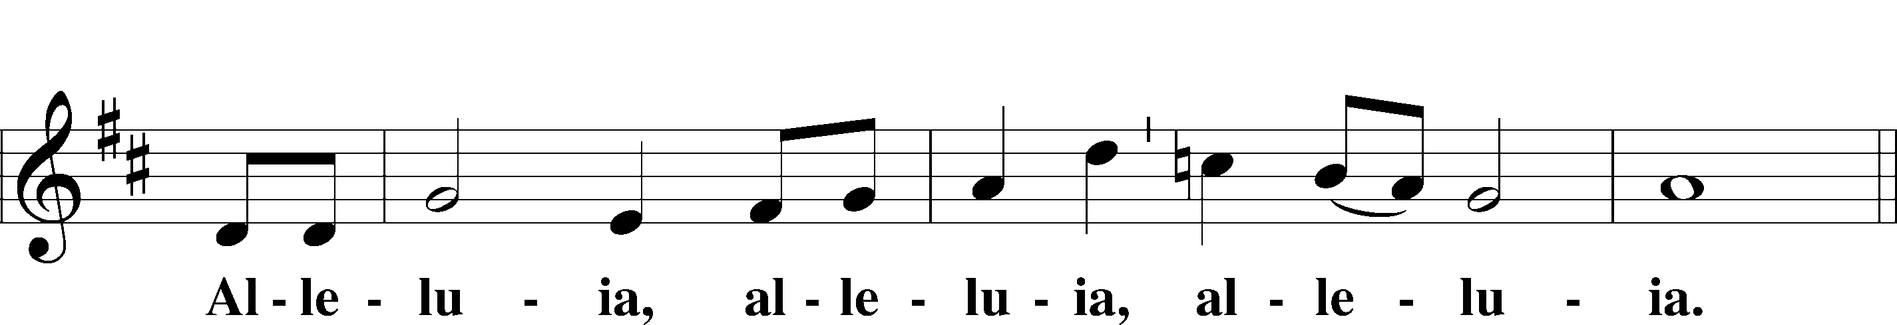
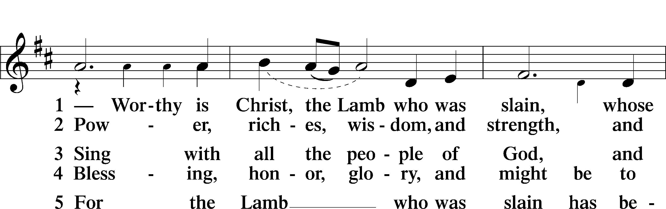
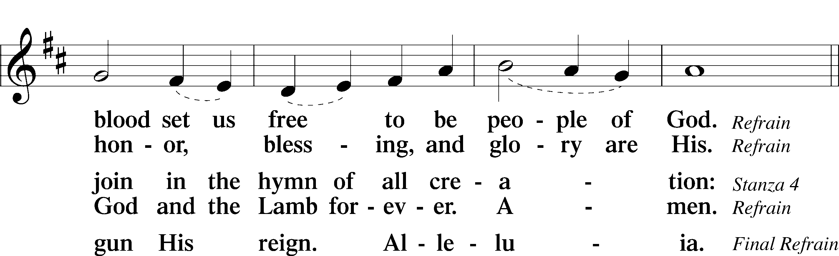
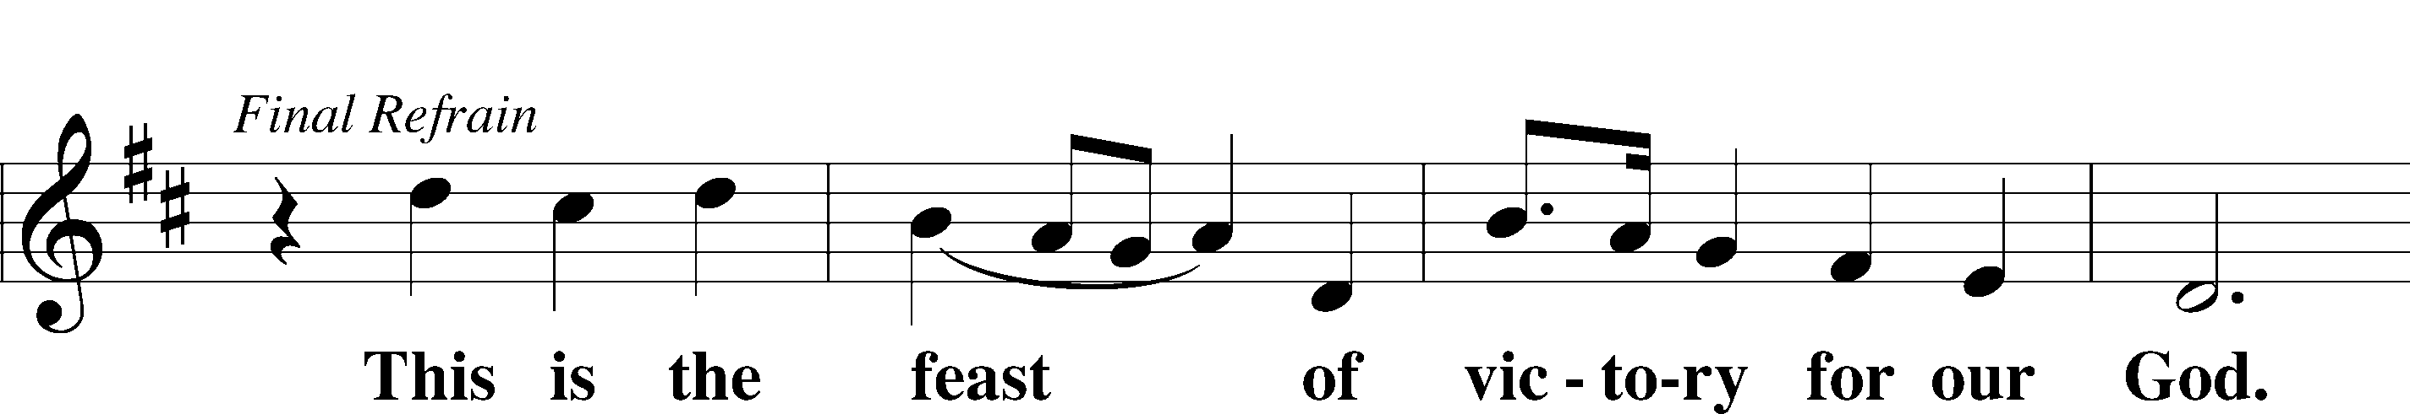
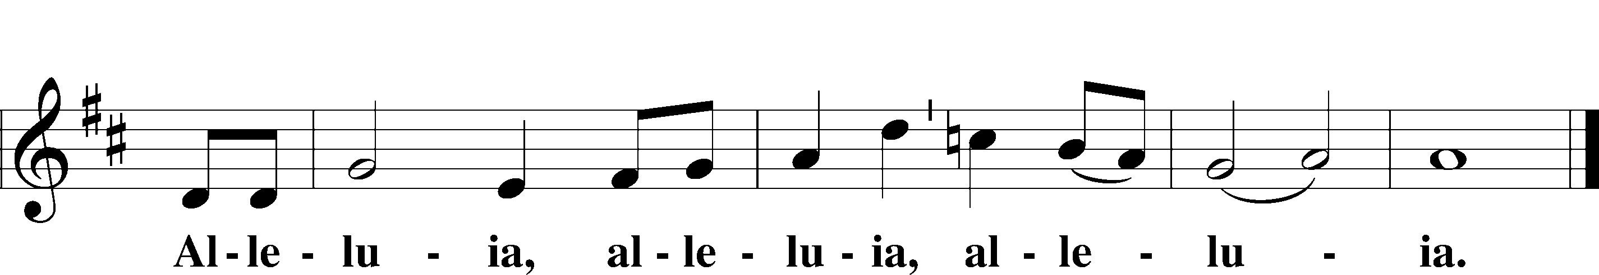

SALUTATION AND COLLECT OF THE DAY
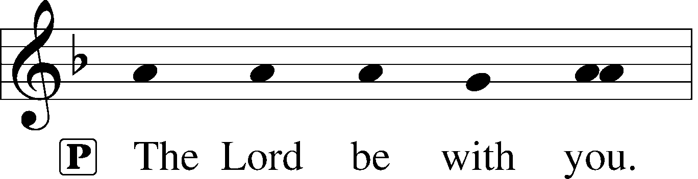
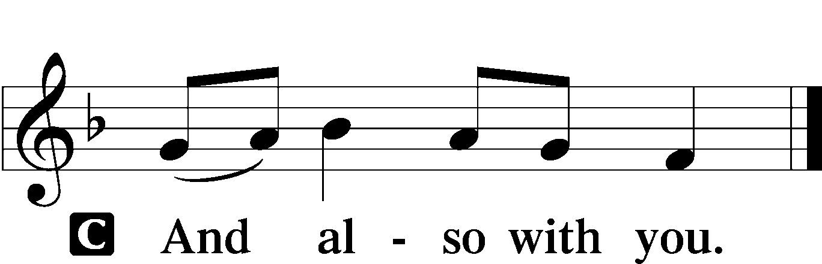

L Let us pray.
O God, through the humiliation of Your Son You raised up the fallen world. Grant to Your faithful people, rescued from the peril of everlasting death, perpetual gladness and eternal joys; through Jesus Christ, our Lord, who lives and reigns with You and the Holy Spirit, one God, now and forever.

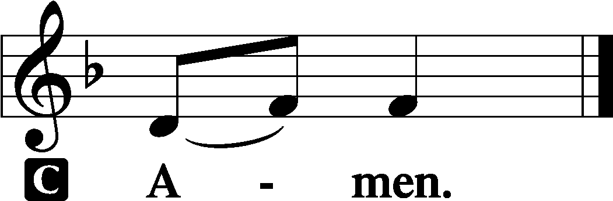

(Sit)

CHILDREN'S LESSON

FIRST READING Acts 2:14a, 36–41
14Peter, standing with the eleven, lifted up his voice and addressed them, . . .
36Let all the house of Israel therefore know for certain that God has made him both Lord and Christ, this Jesus whom you crucified.”
37Now when they heard this they were cut to the heart, and said to Peter and the rest of the apostles, “Brothers, what shall we do?” 38And Peter said to them, “Repent and be baptized every one of you in the name of Jesus Christ for the forgiveness of your sins, and you will receive the gift of the Holy Spirit. 39For the promise is for you and for your children and for all who are far off, everyone whom the Lord our God calls to himself.” 40And with many other words he bore witness and continued to exhort them, saying, “Save yourselves from this crooked generation.” 41So those who received his word were baptized, and there were added that day about three thousand souls.

L This is the Word of the Lord.
C Thanks be to God.

GRADUAL adapt. from Matthew 28:7; Hebrews 2:7; Psalm 8:6
Christ has risen | from the dead.*
[God the Father] has crowned him with glory and | honor.
He has given him dominion over the works | of his hands;*
he has put all things un- | der his feet.

EPISTLE 1 Peter 1:17–25
17If you call on him as Father who judges impartially according to each one’s deeds, conduct yourselves with fear throughout the time of your exile, 18knowing that you were ransomed from the futile ways inherited from your forefathers, not with perishable things such as silver or gold, 19but with the precious blood of Christ, like that of a lamb without blemish or spot. 20He was foreknown before the foundation of the world but was made manifest in the last times for your sake, 21who through him are believers in God, who raised him from the dead and gave him glory, so that your faith and hope are in God.
22Having purified your souls by your obedience to the truth for a sincere brotherly love, love one another earnestly from a pure heart, 23since you have been born again, not of perishable seed but of imperishable, through the living and abiding word of God; 24for
“All flesh is like grass
and all its glory like the flower of grass.
The grass withers,
and the flower falls,
25but the word of the Lord remains forever.”
And this word is the good news that was preached to you.

L This is the Word of the Lord.
C Thanks be to God.

(Stand)

ALLELUIA AND VERSE LSB 156
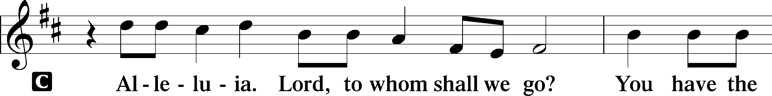
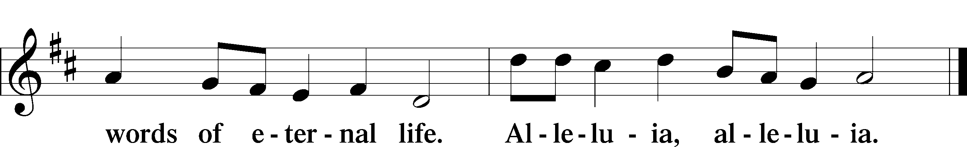

HOLY GOSPEL Luke 24:13–35
L The Holy Gospel according to St. Luke, the twenty-fourth chapter.

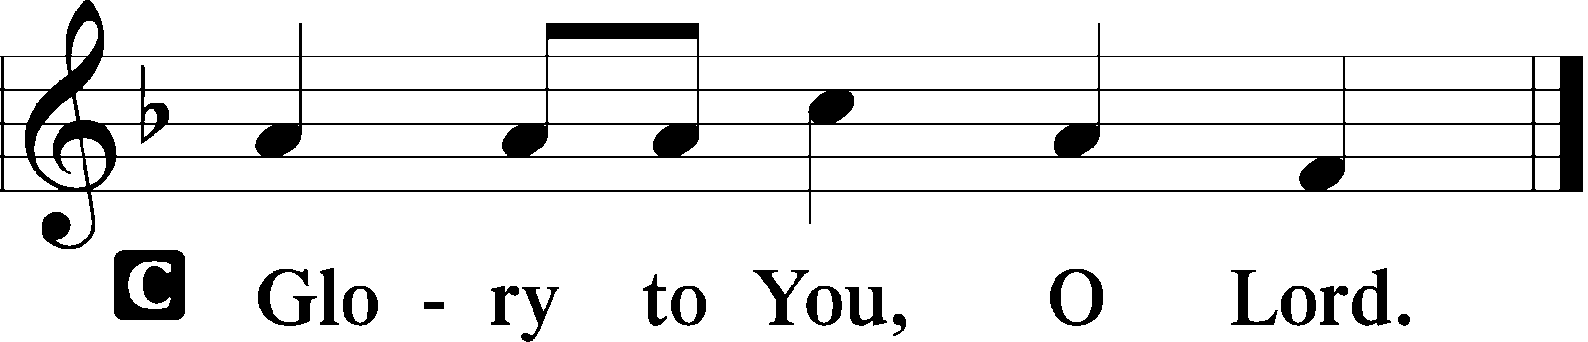

13That very day two of them were going to a village named Emmaus, about seven miles from Jerusalem, 14and they were talking with each other about all these things that had happened. 15While they were talking and discussing together, Jesus himself drew near and went with them. 16But their eyes were kept from recognizing him. 17And he said to them, “What is this conversation that you are holding with each other as you walk?” And they stood still, looking sad. 18Then one of them, named Cleopas, answered him, “Are you the only visitor to Jerusalem who does not know the things that have happened there in these days?” 19And he said to them, “What things?” And they said to him, “Concerning Jesus of Nazareth, a man who was a prophet mighty in deed and word before God and all the people, 20and how our chief priests and rulers delivered him up to be condemned to death, and crucified him. 21But we had hoped that he was the one to redeem Israel. Yes, and besides all this, it is now the third day since these things happened. 22Moreover, some women of our company amazed us. They were at the tomb early in the morning, 23and when they did not find his body, they came back saying that they had even seen a vision of angels, who said that he was alive. 24Some of those who were with us went to the tomb and found it just as the women had said, but him they did not see.” 25And he said to them, “O foolish ones, and slow of heart to believe all that the prophets have spoken! 26Was it not necessary that the Christ should suffer these things and enter into his glory?” 27And beginning with Moses and all the Prophets, he interpreted to them in all the Scriptures the things concerning himself.
28So they drew near to the village to which they were going. He acted as if he were going farther, 29but they urged him strongly, saying, “Stay with us, for it is toward evening and the day is now far spent.” So he went in to stay with them. 30When he was at table with them, he took the bread and blessed and broke it and gave it to them. 31And their eyes were opened, and they recognized him. And he vanished from their sight. 32They said to each other, “Did not our hearts burn within us while he talked to us on the road, while he opened to us the Scriptures?” 33And they rose that same hour and returned to Jerusalem. And they found the eleven and those who were with them gathered together, 34saying, “The Lord has risen indeed, and has appeared to Simon!” 35Then they told what had happened on the road, and how he was known to them in the breaking of the bread.

L This is the Gospel of the Lord.

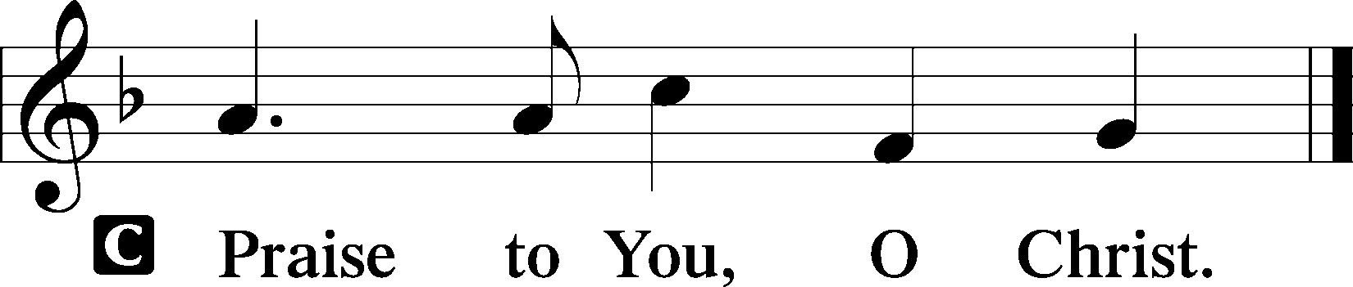

(Sit)

683 JESUS, THY BOUNDLESS LOVE TO ME
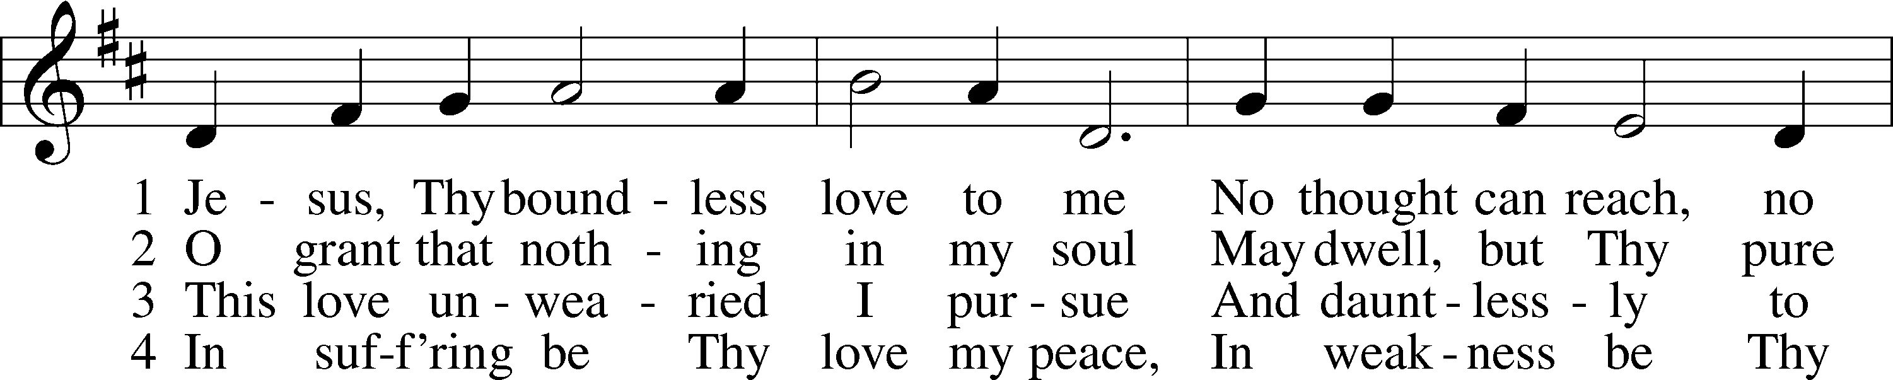
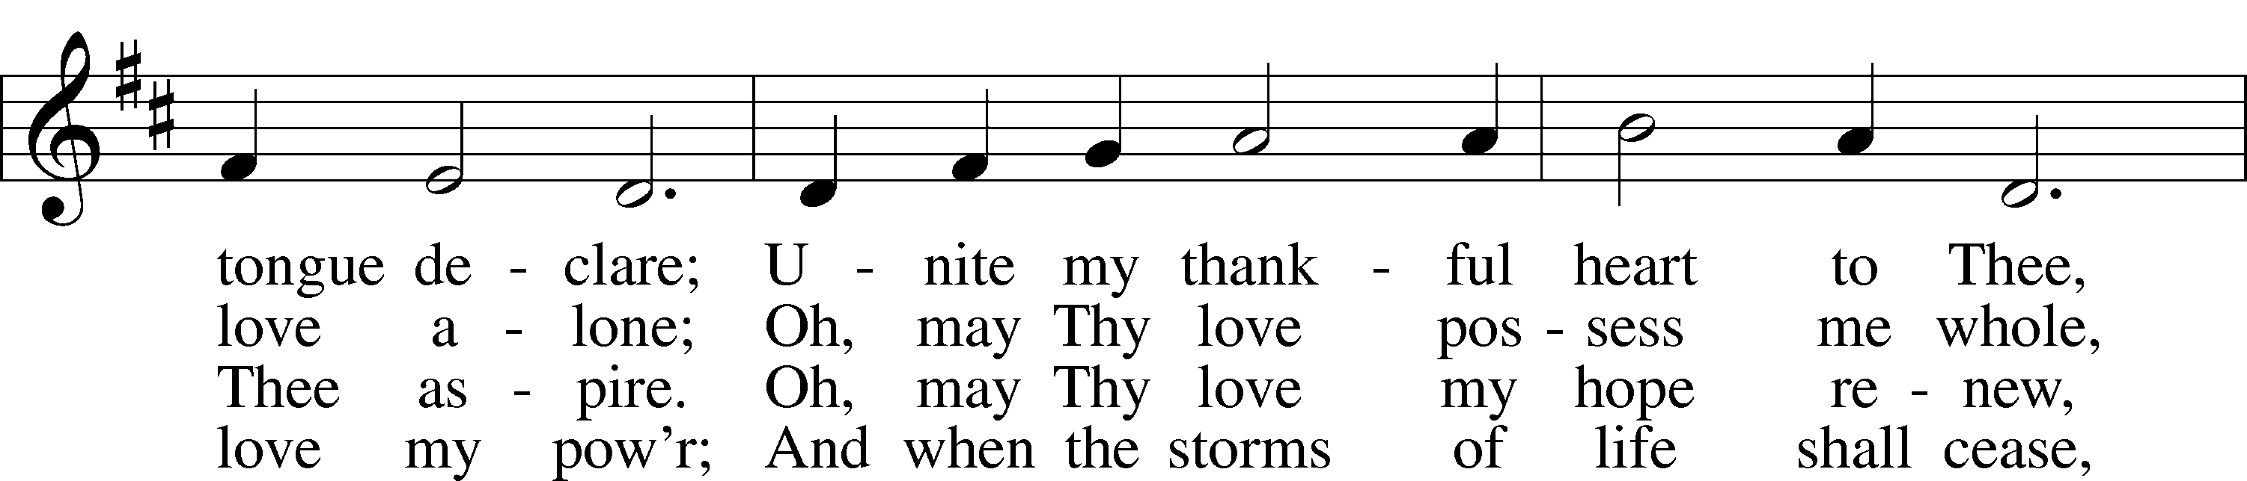
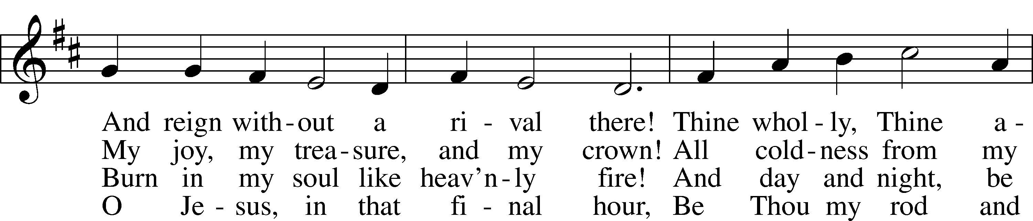
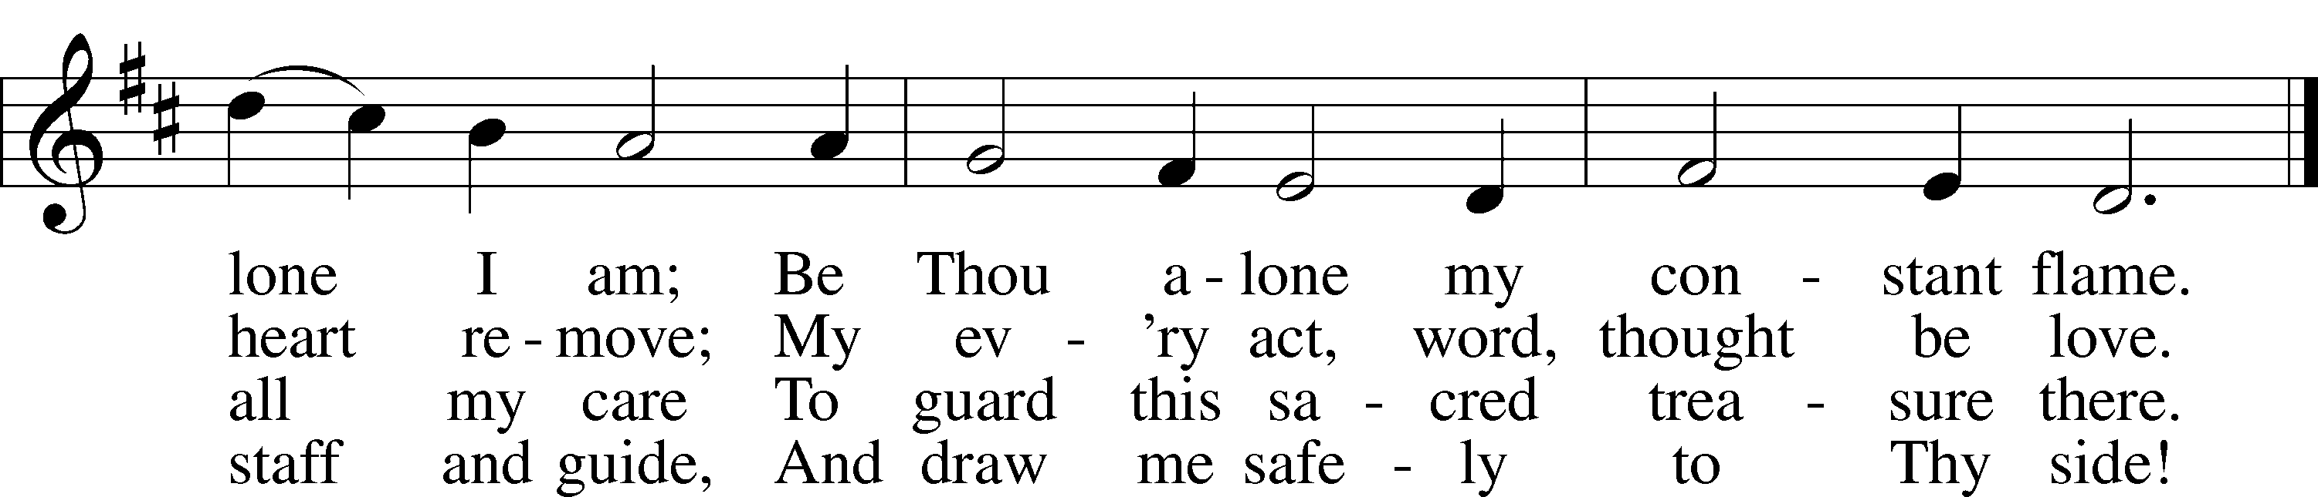
Text: Paul Gerhardt, 1607–76; tr. John B. Wesley, 1703–91, alt.
Tune: Norman Cocker, 1889–1953
Text: Public domain
Tune: © Oxford University Press. Used by permission: LSB Hymn License no. 110004798

SERMON OR MEDITATION ON THE READINGS

(Stand)

+ THE RITE OF HOLY BAPTISM +
Aidyn Bouknight

P Dearly beloved, Christ our Lord says in the last chapter of Matthew, “All authority in heaven and on earth has been given to Me. Therefore go and make disciples of all nations, baptizing them in the name of the Father and of the Son and of the Holy Spirit.” In the last chapter of Mark our Lord promises, “Whoever believes and is baptized will be saved.” And the apostle Peter has written, “Baptism now saves you.”

The Word of God also teaches that we are all conceived and born sinful and are under the power of the devil until Christ claims us as His own.

Therefore, depart, you unclean spirit, and make room for the Holy Spirit in the name of the Father and of the T Son and of the Holy Spirit.

(The pastor makes the sign of the holy cross upon the forehead and heart of the candidate while saying:)

P Receive the sign of the holy cross both upon your T forehead and upon your T heart to mark you as one redeemed by Christ the crucified.

P Almighty and eternal God, according to Your strict judgment You condemned the unbelieving world through the flood, yet according to Your great mercy You preserved believing Noah and his family, eight souls in all. You drowned hard-hearted Pharaoh and all his host in the Red Sea, yet led Your people Israel through the water on dry ground, foreshadowing this washing of Your Holy Baptism. Through the Baptism in the Jordan of Your beloved Son, our Lord Jesus Christ, You sanctified and instituted all waters to be a blessed flood and a lavish washing away of sin.

We pray that You would behold Aidyn according to Your boundless mercy and bless him with true faith by the Holy Spirit, that through this saving flood all sin in him, which has been inherited from Adam and which he himself has committed since, would be drowned and die. Grant that he be kept safe and secure in the holy ark of the Christian Church, being separated from the multitude of unbelievers and serving Your name at all times with a fervent spirit and a joyful hope, so that, with all believers in Your promise, he would be declared worthy of eternal life; through Jesus Christ, our Lord.
C Amen.

P Hear the Holy Gospel according to St. Mark.

They brought young children to [Jesus] that He might touch them; but the disciples rebuked those who brought them. But when Jesus saw it, He was greatly displeased and said to them, “Let the little children come to Me, and do not forbid them; for of such is the kingdom of God. Assuredly, I say to you, whoever does not receive the kingdom of God as a little child will by no means enter it.” And He took them up in His arms, put His hands on them, and blessed them.

(The pastor places his hands on the head of the candidate, and the congregation joins in praying:)

LORD’S PRAYER
C Our Father who art in heaven,
hallowed be Thy name,
Thy kingdom come,
Thy will be done on earth
as it is in heaven;
give us this day our daily bread;
and forgive us our trespasses
as we forgive those
who trespass against us;
and lead us not into temptation,
but deliver us from evil.
For Thine is the kingdom
and the power and the glory
forever and ever. Amen.

P The Lord preserve your coming in and your going out from this time forth and even T forevermore.
C Amen.

(Sit)

P Aidyn, do you renounce the devil?
R Yes, I renounce him.
P Do you renounce all his works?
R Yes, I renounce them.
P Do you renounce all his ways?
R Yes, I renounce them.

P Do you believe in God, the Father Almighty, maker of heaven and earth?
R Yes, I believe.

P Do you believe in Jesus Christ, His only Son, our Lord, who was conceived by the Holy Spirit, born of the virgin Mary, suffered under Pontius Pilate, was crucified, died and was buried; He descended into hell; the third day He rose again from the dead; He ascended into heaven and sits at the right hand of God the Father Almighty; from thence He will come to judge the living and the dead?
R Yes, I believe.

P Do you believe in the Holy Spirit, the holy Christian Church, the communion of saints, the forgiveness of sins, the resurrection of the body, and the life everlasting?
R Yes, I believe.

P Aidyn, do you desire to be baptized?
R Yes, I do.

(The pastor pours water three times on the head of each candidate while saying:)

P Aidyn, I baptize you in the name of the Father and of the Son and of the Holy Spirit.
C Amen.

(A white baptismal napkin is presented to the newly baptized.)

P Receive this white garment to show that you have been clothed with the robe of Christ’s righteousness that covers all your sin. So shall you stand without fear before the judgment seat of Christ to receive the inheritance prepared for you from the foundation of the world.

(The pastor lights a baptismal candle from the paschal candle and gives it to the newly baptized)

P Receive this burning light to show that you have received Christ who is the Light of the world. Live always in the light of Christ, and be ever watchful for His coming, that you may meet Him with joy and enter with Him into the marriage feast of the Lamb in His kingdom, which shall have no end.

(The pastor places his hands on the head of the newly baptized while saying:)

P The almighty God and Father of our Lord Jesus Christ, who has given you the new birth of water and of the Spirit and has forgiven you all your sins, strengthen you with His grace to life T everlasting.
C Amen.

P Peace T be with you.
C Amen.

(All return to their places.)

SHARING OF THE PEACE

(Sit)

PRAYER OF THE CHURCH

OFFERING
As a part of our expression of thanksgiving to God for the treasure of His salvation to us, we offer a portion of our treasure, according to what each has determined in their heart to give. Please place offerings in the collection plate at the back of the sanctuary before or after the service. Offerings can also be sent to Bethlehem Lutheran Church via U.S. Mail. Thank you!

(Stand)

OFFERTORY LSB 159
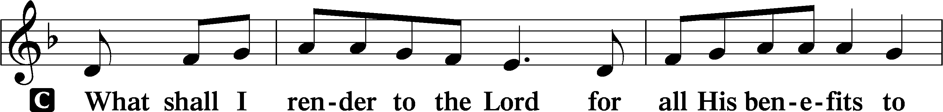
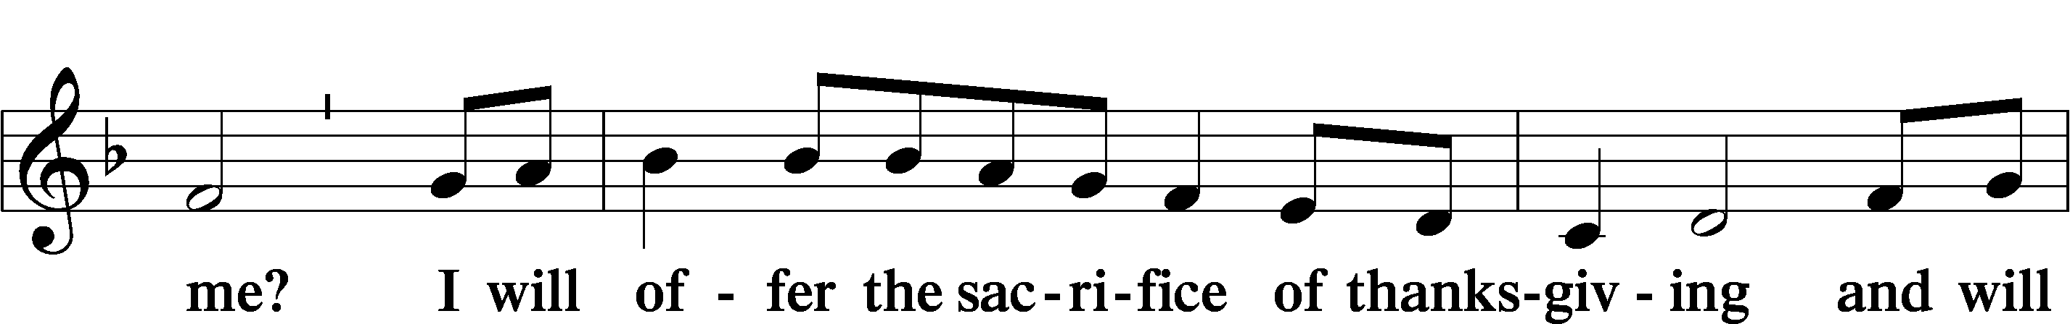
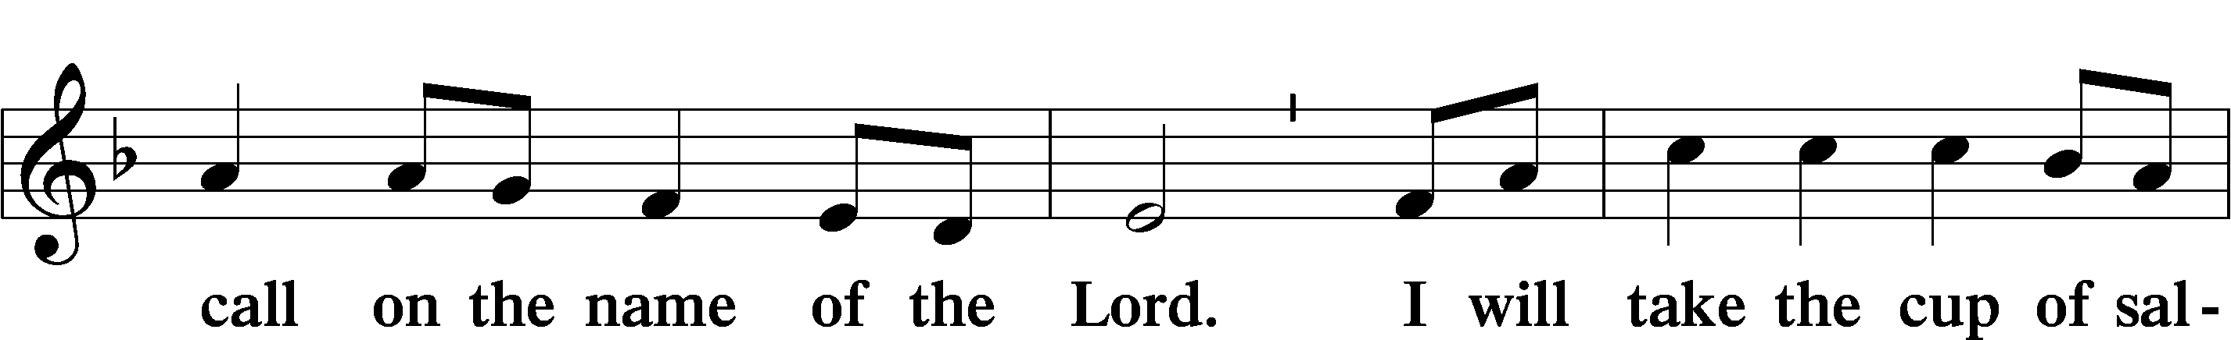
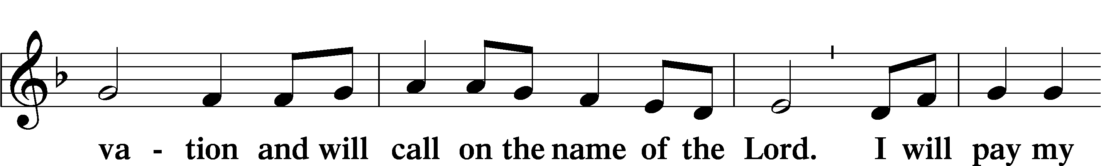
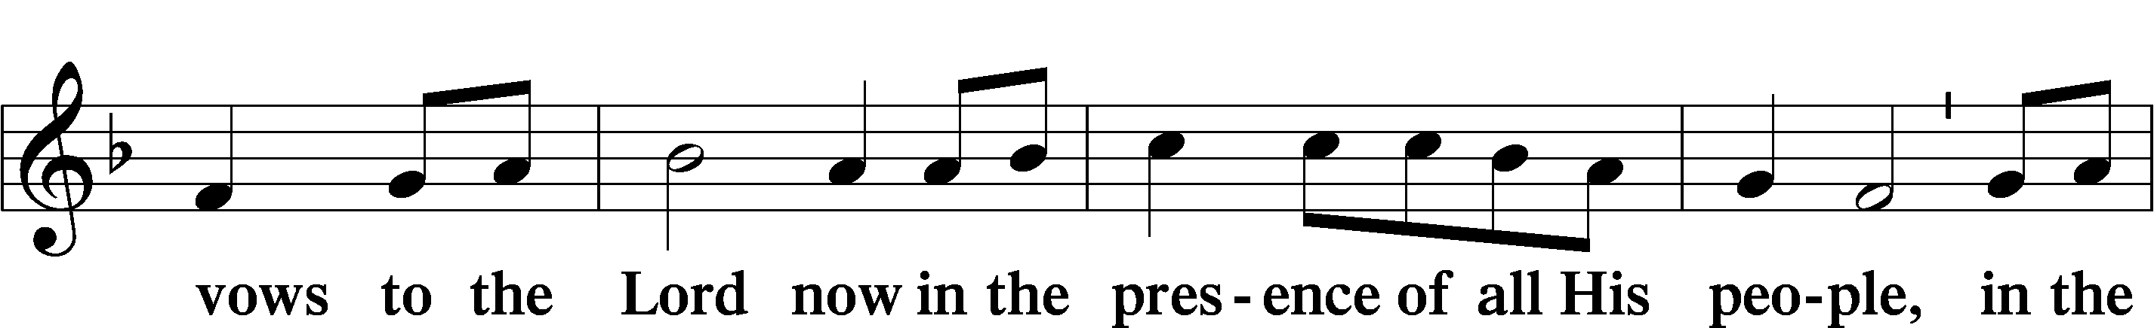
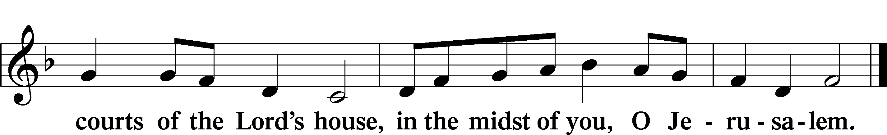

+ SERVICE OF THE SACRAMENT +
Note: The Service of The Sacrament is included in the lay bulletin solely as a viewers’ guide for those watching the livestream service; Communicant members who are unable to attend the Divine Service in person are encouraged to contact an Elder, who will make arrangements for you to receive the Lord’s Supper.

PREFACE LSB 160





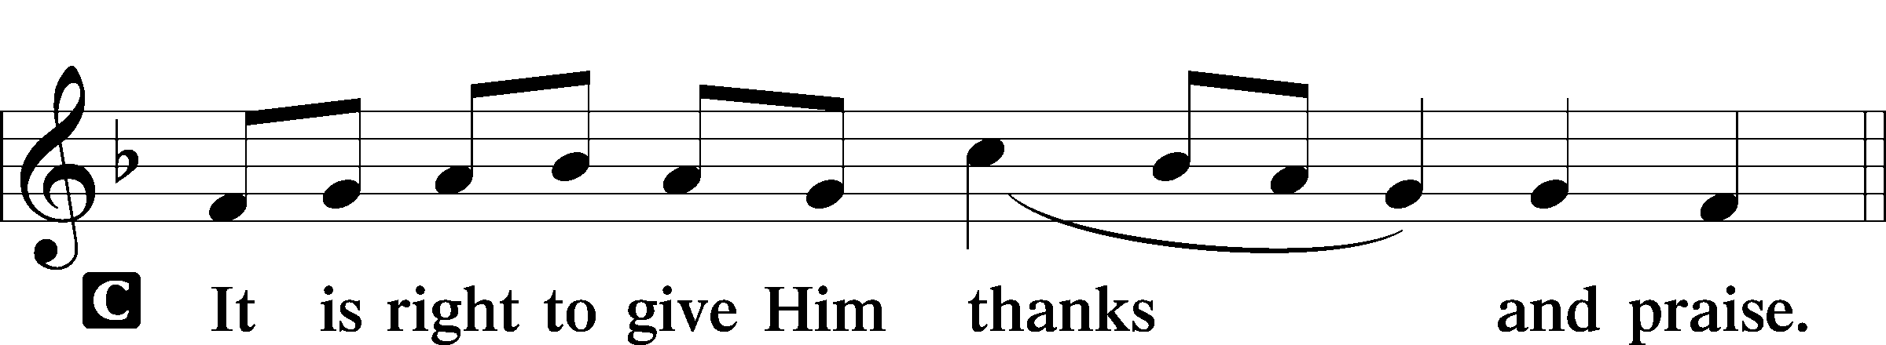

PROPER PREFACE (ABBREVIATED) LSB 161
P It is truly good, right, and salutary . . . evermore praising You and saying:

SANCTUS LSB 161
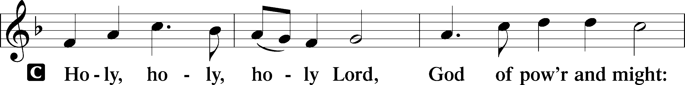
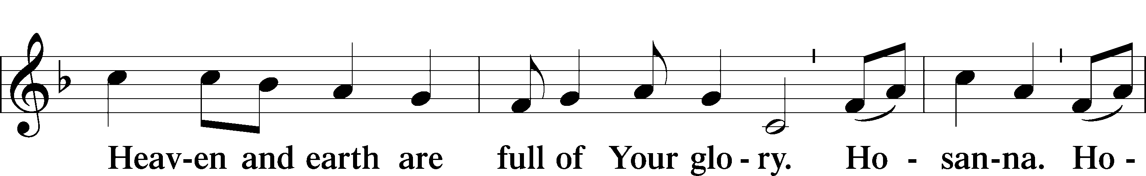
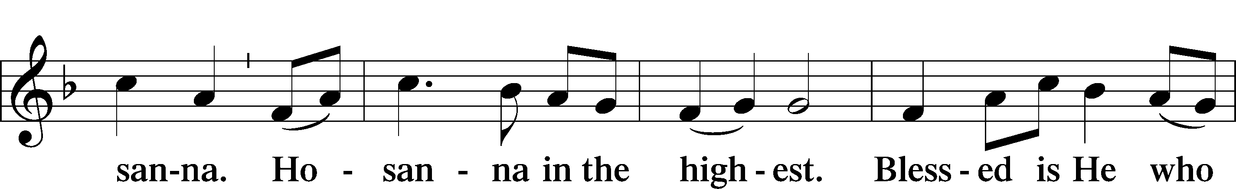
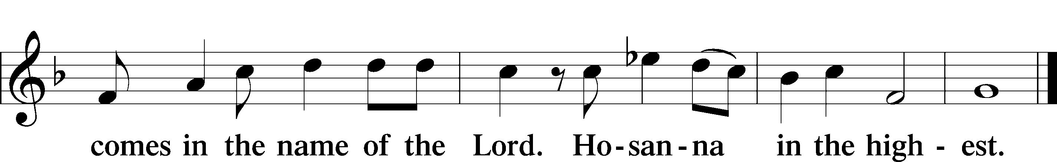

PRAYER OF THANKSGIVING LSB 161

LORD’S PRAYER 162
C Our Father who art in heaven,
hallowed be Thy name,
Thy kingdom come,
Thy will be done on earth
as it is in heaven;
give us this day our daily bread;
and forgive us our trespasses
as we forgive those
who trespass against us;
and lead us not into temptation,
but deliver us from evil.
For Thine is the kingdom
and the power and the glory
forever and ever. Amen.

THE WORDS OF OUR LORD

PAX DOMINI LSB 163
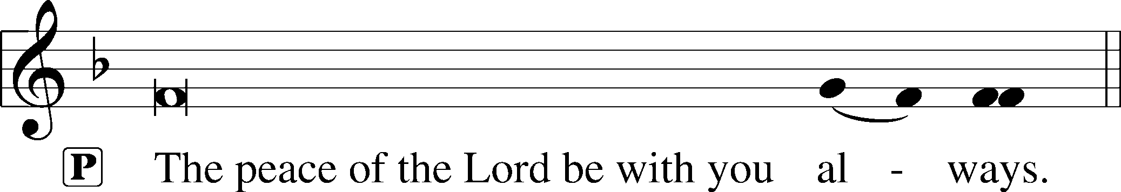


AGNUS DEI LSB 163
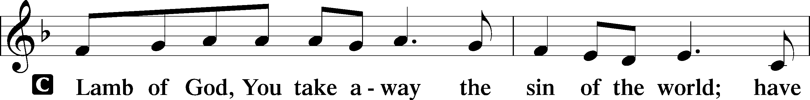
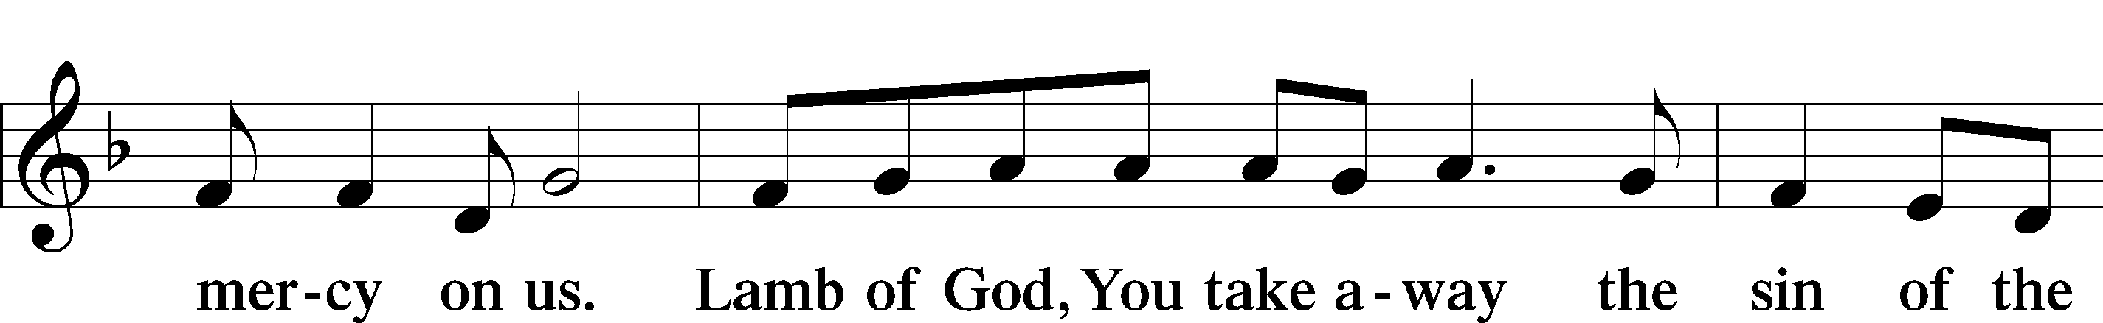
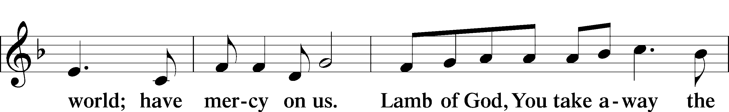
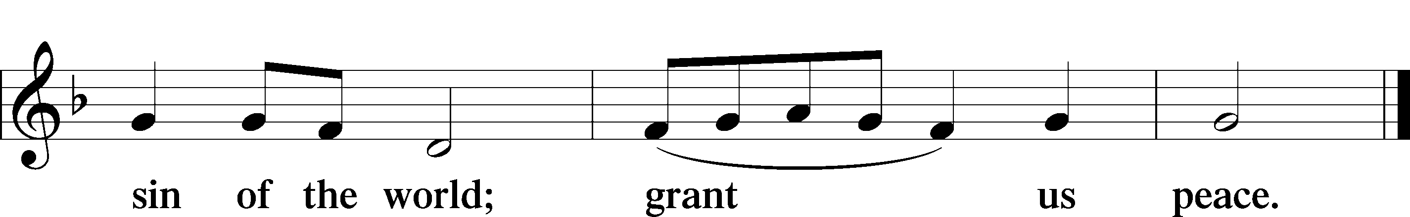

(Sit)

DISTRIBUTION
(The pastor and those who assist him receive the body and blood of Christ first and then distribute them to those who are unable to come to the altar. The ushers will then direct all other communicants to the altar.)

878 ABIDE WITH ME
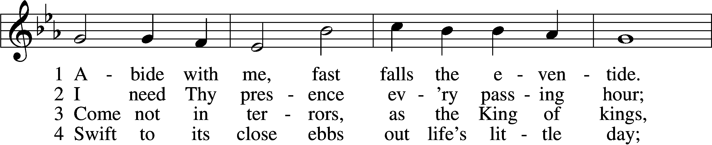
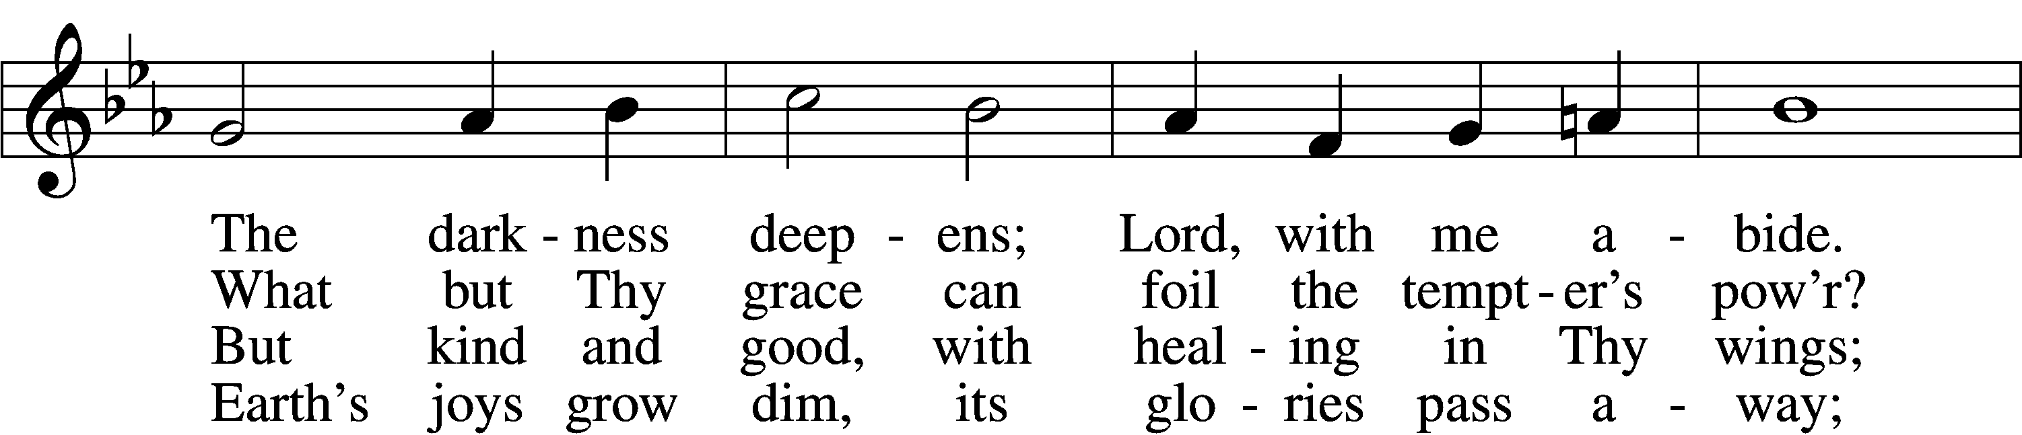
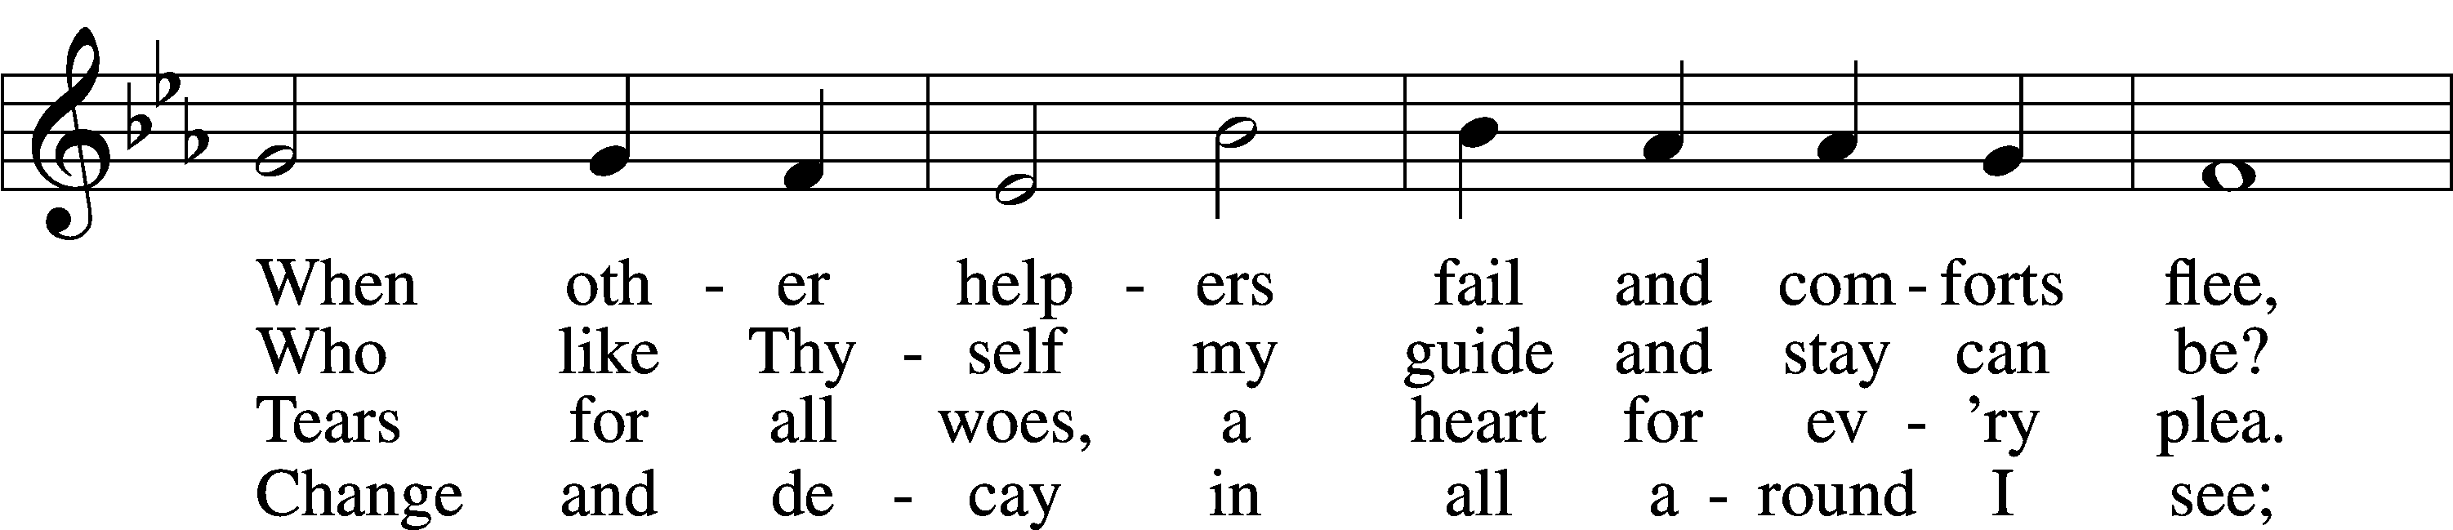
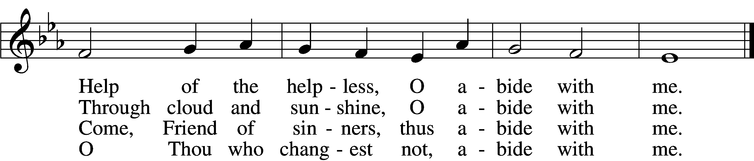

5 I fear no foe with Thee at hand to bless;
Ills have no weight and tears no bitterness.
Where is death’s sting? Where, grave, thy victory?
I triumph still if Thou abide with me!

6 Hold Thou Thy cross before my closing eyes;
Shine through the gloom, and point me to the skies.
Heav’n’s morning breaks, and earth’s vain shadows flee;
In life, in death, O Lord, abide with me.
Text: Henry F. Lyte, 1793–1847, alt.
Tune: William H. Monk, 1823–89
Text and tune: Public domain

INSTRUMENTAL

(Stand)

THANK THE LORD LSB 164
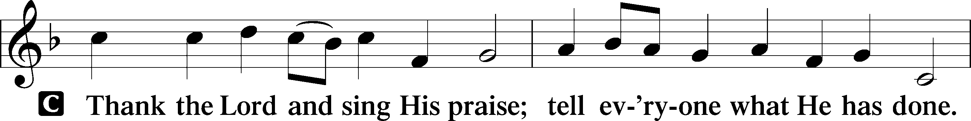
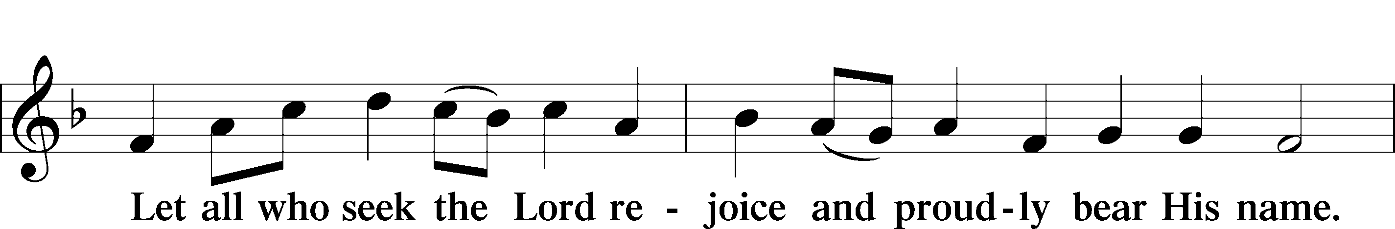
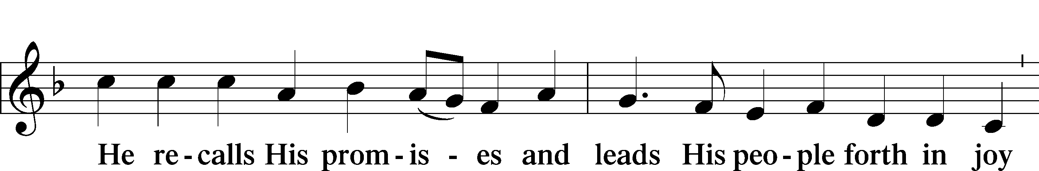
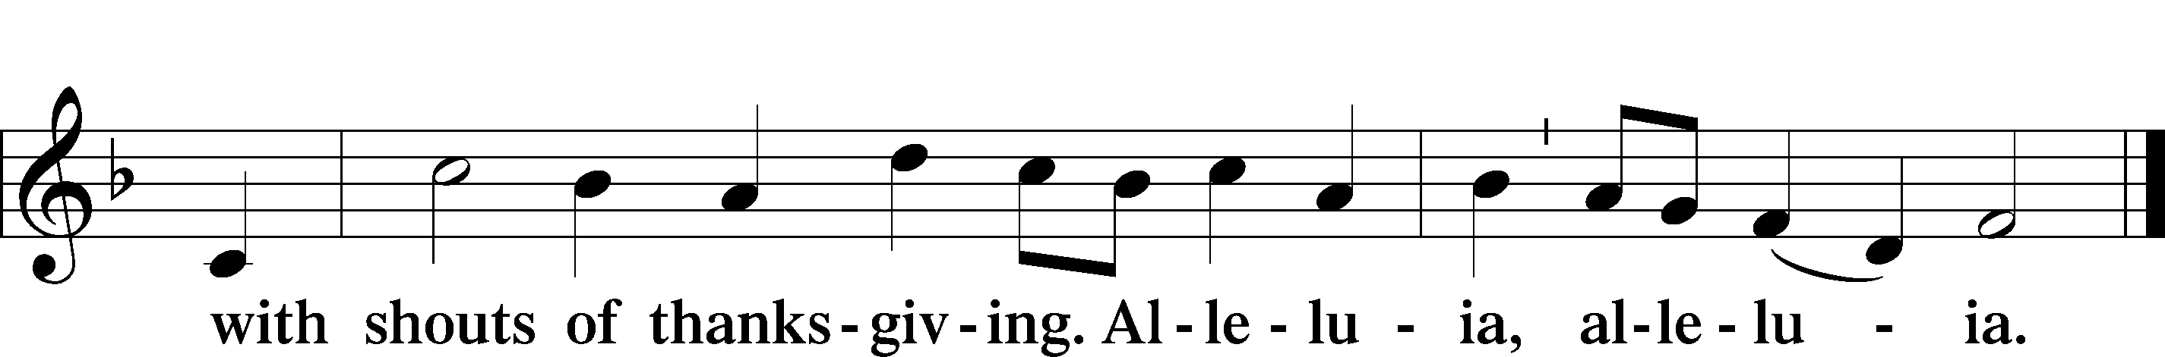

POST-COMMUNION COLLECT

+ FAREWELL AND GODSPEED TO A PASTOR +

(The departing pastor is presented before the altar.)

L Dear brothers and sisters in Christ, Pastor Engwall has accepted a call to a new field of service in the Church. At this time of farewell and Godspeed, let us hear the Word of the Lord.

A ³I thank my God in all my remembrance of you, ⁴always in every prayer of mine for you all making my prayer with joy, ⁵because of your partnership in the gospel from the first day until now. ⁶And I am sure of this, that he who began a good work in you will bring it to completion at the day of Jesus Christ. ⁷It is right for me to feel this way about you all, because I hold you in my heart, for you are all partakers with me of grace, both in my imprisonment and in the defense and confirmation of the gospel. ⁸For God is my witness, how I yearn for you all with the affection of Christ Jesus.

A ⁵⁸Therefore, my beloved brothers, be steadfast, immovable, always abounding in the work of the Lord, knowing that in the Lord your labor is not in vain.

C I lift up my eyes | to the hills.*
From where does my | help come?
My help comes | from the Lord,*
who made | heav’n and earth.
Lord, you have been our | dwelling place*
in all gener- | ations.
Before the mountains were brought forth,
or ever you had formed the earth | and the world,*
from everlasting to everlasting | you are God.
Blessèd shall you be in the | city,*
and blessèd shall you be | in the field.
Blessèd shall you be when | you come in,*
and blessèd shall you be when you | go out.
Satisfy us in the morning with your | steadfast love,*
that we may rejoice and be glad | all our days.
Let your work be shown to your | servants,*
and your glorious power to their | children.
Let the favor of the Lord our God be upon us,
and establish the work of our hands up- | on us;*
yes, establish the work | of our hands!
Glory be to the Father and | to the Son*
and to the Holy | Spirit;
as it was in the be- | ginning,*
is now, and will be forever. | Amen.
(Stand)

(The departing pastor may kneel.)

L Let us pray.
O Lord God, merciful and gracious Father, we give thanks for all the blessings You have bestowed on this congregation, its members, and the Church through the ministry of Your servant John Engwall. By Your Holy Spirit grant him grace in his new field of service, readiness, and steadfastness in his ministry, patience, understanding, a cheerful spirit, and great zeal. Support and strengthen him that by Your Word Your Church may be built and increased; through Your Son, our great High Priest, Jesus Christ, our Lord, who lives and reigns with You and the Holy Spirit, one God, now and forever.
C Amen.

L Let us also pray for our pastor’s family as they depart from us.
Lord God, heavenly Father, we give thanks that You have so faithfully nourished our pastor’s family with us in the communion of this congregation. Bless, protect, and defend them as they now depart from us. Preserve them in the confession of Your name and in loving service to others. Keep us in fellowship with all Your saints and bring us at last to the joys of Your heavenly kingdom; through Jesus Christ, Your Son, our Lord, who lives and reigns with You and the Holy Spirit, one God, now and forever.
C Amen.
L Go in peace and joy.
C Amen.

BENEDICTION
L: The grace of our Lord T Jesus Christ, and the love of God, and the fellowship of the Holy Spirit, be with us all.
C: Amen.

655 LORD, KEEP US STEADFAST IN YOUR WORD
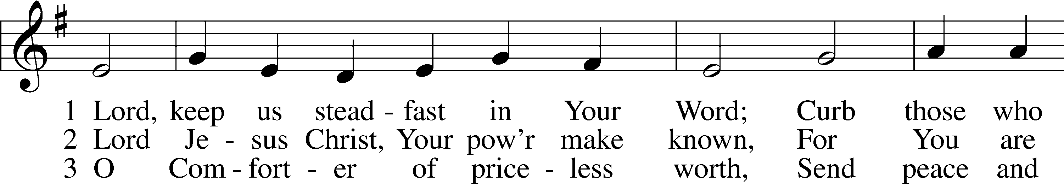
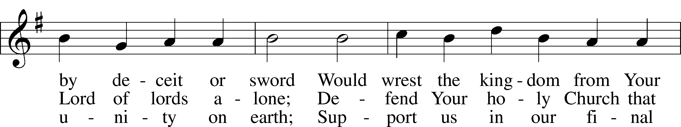
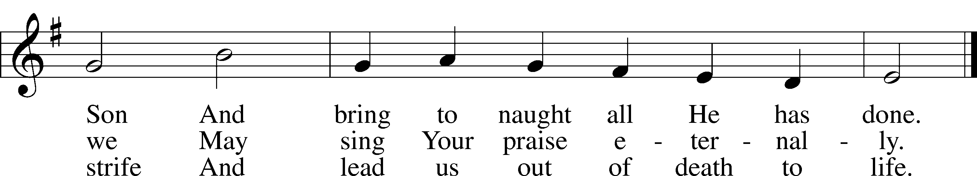
Text: Martin Luther, 1483–1546; tr. Catherine Winkworth, 1827–78, alt.
Tune: Geistliche Lieder auffs new gebessert, 1543, Wittenberg, ed. Joseph Klug
Text and tune: Public domain

ACKNOWLEDGMENTS
Unless otherwise indicated, Scripture quotations are from the ESV® Bible (The Holy Bible, English Standard Version®), copyright © 2001 by Crossway, a publishing ministry of Good News Publishers. Used by permission. All rights reserved.
Created by Lutheran Service Builder © 2026 Concordia Publishing House.

IN OUR PRAYERS:
Submitted petitions are included for two consecutive Sundays

For Those suffering afflictions of mind, body, or spirit:
Blake B., Carol R., Michele N., Dean S., Ruth M.
All of our Shut- Ins:
Betty A., Shirley F., Mary H., Patsy L., Tommy M., Jerome M., Sharon B., Judy S.
For missionaries
Deaconess Sandra R., Rev. Jonathan A.

ANNOUNCEMENTS
Please email announcements for Sunday bulletins by 8:00 a.m. Tuesday to pastorblcaiken@gmail.com

ALTAR FLOWERS:
Flowers are donated today in memory of Sharon N.

ACTS DONATION FOR APRIL:
CEREAL

FELLOWSHIP COFFEE HOUR:
Every Sunday morning, during Bible Study and after the Divine Service, coffee, treats and good fellowship are waiting for you in our Fellowship Hall!
PASTOR ENGWALL’S LAST DAY AT BETHLEHEM:
Today is Pastor Engwall’s final service here.
A farewell potluck for Pastor and Teffie will be held in the Fellowship Hall after the service.
Pastor Engwall will be installed at Immanuel Lutheran Church, Sweet Springs, Missouri
at 4:00p.m. Central time (5:00p.m. Eastern time) on Sunday, May 3rd.

Attendance:

Offerings:

Average weekly offering needed to make budget: $2,579

OUR VALUE STATEMENT: Bethlehem Lutheran Church exists under God’s grace to save the lost and to strengthen the saved so that they may live bold and courageous lives of Christian witness before a non-believing world.
Therefore, our purpose is:
- to glorify God in Word and deed,
- to nurture each other in Christian love,
- to reach out to others with our Savior’s Gospel of life and salvation.
(Rom 5:8, Matt. 28:18-20).

OUR VISION: By the Grace of God, Bethlehem Lutheran Church, is a loving family united in Christ, learning, living, and spreading His Word.

OUR MISSION: Learn the Word. Live the Word. Spread the Word.

2026 Easter Lilies
Bob and Eileen A. – 1 lily
Roger and Charlsie B. – 1 lily
Suzy E. – 3 lilies in memory of Sandy A. and Russell and Carole E.
Lana L. – 1 lily
Chuck and Joanne M. – 1 lily
John and Nancy M. – 1 lily for Blessings Received
Jack N. – 5 lilies in memory of Sharon
Juanita R. – 2 lilies in memory of her daughter, Shirley, and her son, John
Liz S. – 1 lily in memory of her mother, Pat C.
Angela S. – 1 lily in memory of Sam and Frances A. and Jennifer T.
Rebecca S. – 2 lilies in memory of her mother, Pat C., and her grandparents, Bigma & Papa
Kathy S. – 1 lily
Margie T. – 2 lilies in memory of Mike
Tom T. – 1 lily

