

+ + + + + + + + + + + + + + +
The 2nd Wednesday in Lent
March 4th , 2026
11: a.m. and 7:00 p.m.
+ + + + + + + + + + + + + + +

BETHLEHEM LUTHERAN CHURCH
A congregation of The Lutheran Church-Missouri Synod
902 Hitchcock Drive SW,
Aiken, South Carolina 29803
Church Phone: (803) 649-6417
blcaikensc@gmail.com
Pastor: Rev. John B. Engwall
Office Hours By Appointment
Bethlehem Lutheran welcomes our members and guests to our worship service! Unable to join us in person? Please find us on Facebook live. The service is also posted on our website; bethlehemlutheranaiken.org.

(STAND)

673 JERUSALEM, MY HAPPY HOME
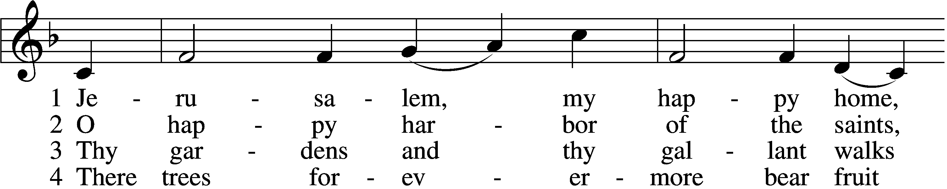
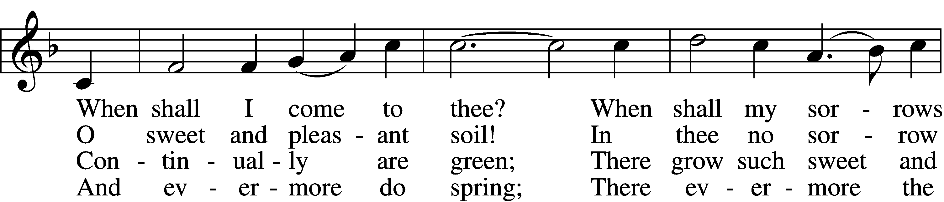
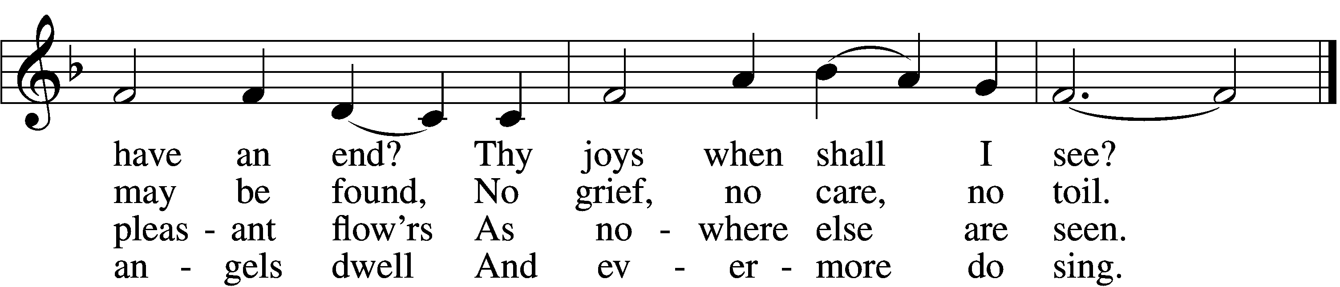

5 Apostles, martyrs, prophets, there
Around my Savior stand;
And soon my friends in Christ below
Will join the glorious band.

6 O Christ, do Thou my soul prepare
For that bright home of love
That I may see Thee and adore
With all Thy saints above.
Text: F. B. P., 16th cent., alt.
Tune: American
Text and tune: Public domain

PRAYER
O God, You resist the proud and give grace to the humble. Grant us true humility after the likeness of Your only Son that we may never be arrogant and prideful and thus provoke Your wrath, but in all lowliness be made partakers of the gifts of Your grace; through Jesus Christ, our Lord.
C Amen.

(sit)

READING Genesis 12:1–9
1The Lord said to Abram, “Go from your country and your kindred and your father’s house to the land that I will show you. 2And I will make of you a great nation, and I will bless you and make your name great, so that you will be a blessing. 3I will bless those who bless you, and him who dishonors you I will curse, and in you all the families of the earth shall be blessed.”
4So Abram went, as the Lord had told him, and Lot went with him. Abram was seventy-five years old when he departed from Haran. 5And Abram took Sarai his wife, and Lot his brother’s son, and all their possessions that they had gathered, and the people that they had acquired in Haran, and they set out to go to the land of Canaan. When they came to the land of Canaan, 6Abram passed through the land to the place at Shechem, to the oak of Moreh. At that time the Canaanites were in the land. 7Then the Lord appeared to Abram and said, “To your offspring I will give this land.” So he built there an altar to the Lord, who had appeared to him. 8From there he moved to the hill country on the east of Bethel and pitched his tent, with Bethel on the west and Ai on the east. And there he built an altar to the Lord and called upon the name of the Lord. 9And Abram journeyed on, still going toward the Negeb.

L O Lord, have mercy upon us.
C Thanks be to God.

SERMON

(stand)

APOSTLES’ CREED
C I believe in God, the Father Almighty,
maker of heaven and earth.

And in Jesus Christ, His only Son, our Lord,
who was conceived by the Holy Spirit,
born of the virgin Mary,
suffered under Pontius Pilate,
was crucified, died and was buried.
He descended into hell.
The third day He rose again from the dead.
He ascended into heaven
and sits at the right hand of God the Father Almighty.
From thence He will come to judge the living and the dead.

I believe in the Holy Spirit,
the holy Christian Church,
the communion of saints,
the forgiveness of sins,
the resurrection of the body,
and the life T everlasting. Amen.

LORD’S PRAYER
L Taught by our Lord and trusting His promises, we are bold to pray:
C Our Father who art in heaven,
hallowed be Thy name,
Thy kingdom come,
Thy will be done on earth
as it is in heaven;
give us this day our daily bread;
and forgive us our trespasses
as we forgive those
who trespass against us;
and lead us not into temptation,
but deliver us from evil.
For Thine is the kingdom
and the power and the glory
forever and ever. Amen.

BLESSING
P The grace of our Lord T Jesus Christ and the love of God and the communion of the Holy Spirit be with you all.
C Amen.

918 GUIDE ME, O THOU GREAT REDEEMER
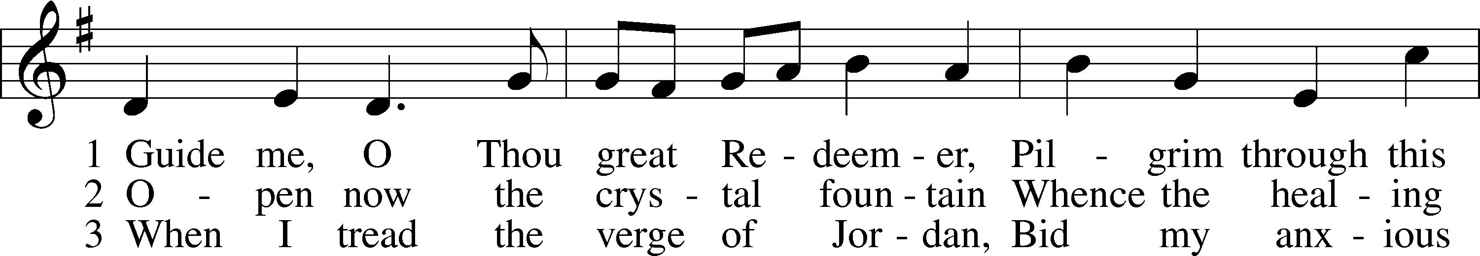
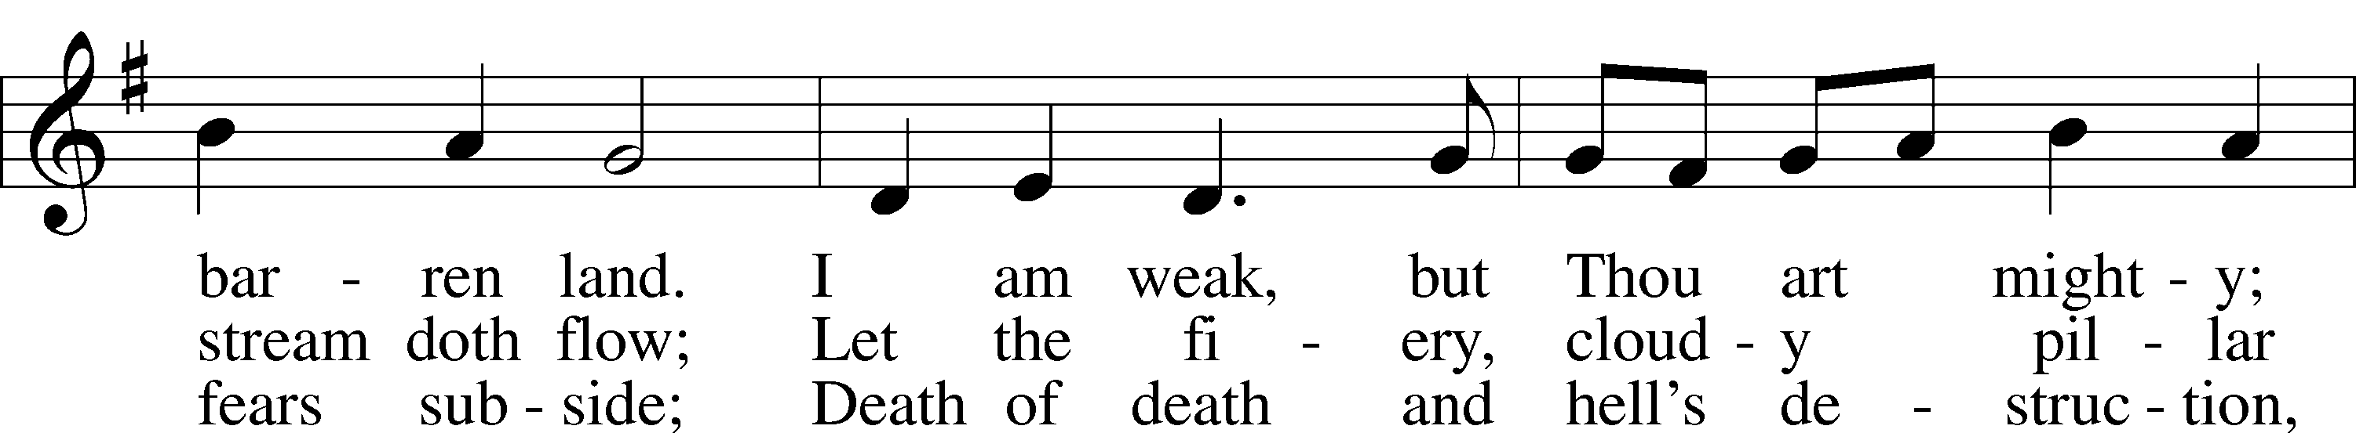
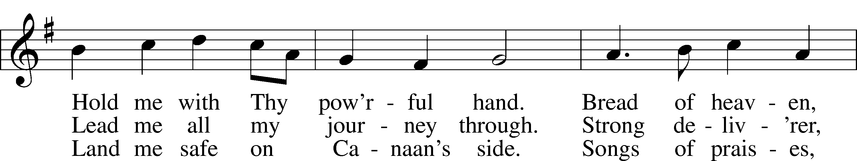
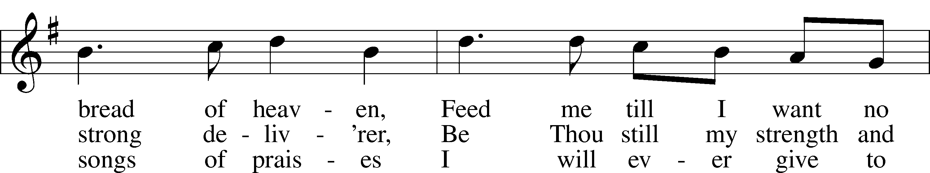
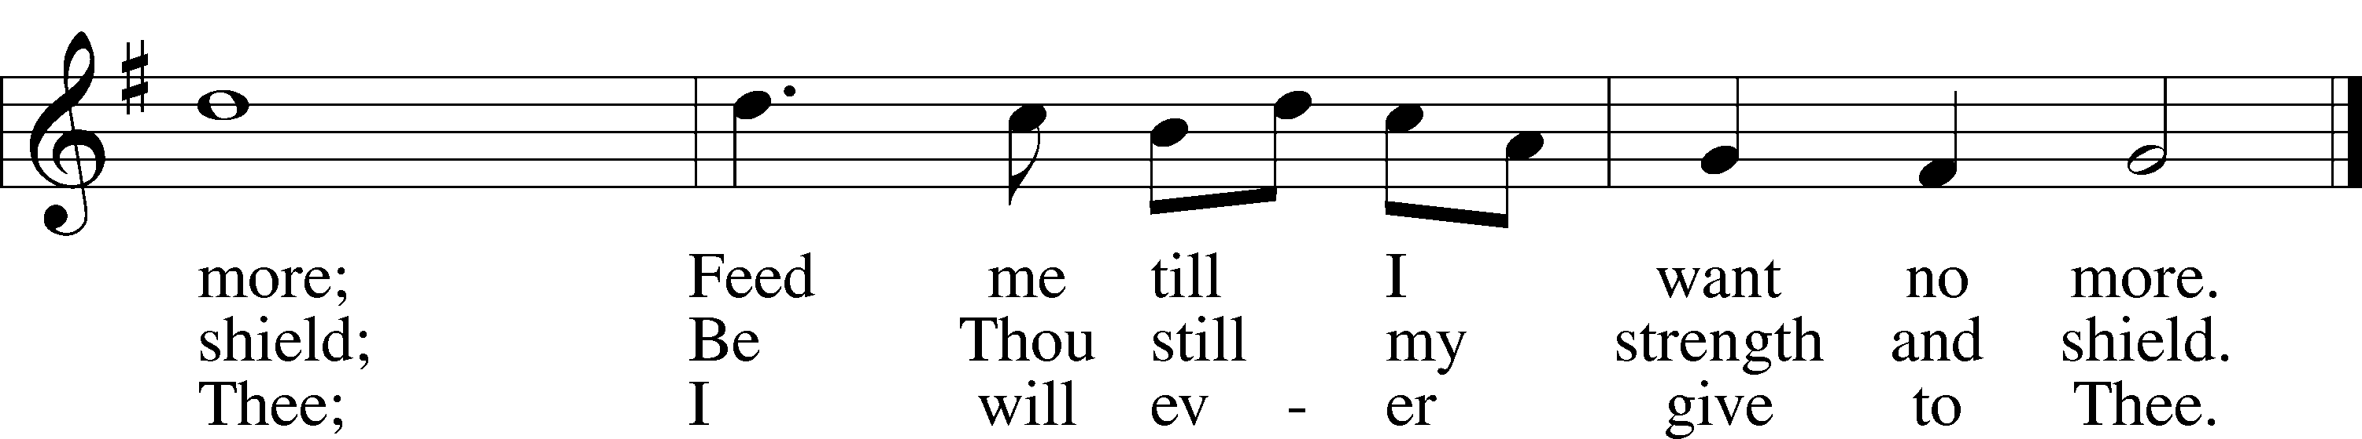
Text: William Williams, 1717–91, abr.; (st. 1): tr. Peter Williams, 1722–96, alt.; (sts. 2–3): tr. William Williams, 1717–91
Tune: John Hughes, 1873–1932
Text and tune: Public domain

ACKNOWLEDGMENTS
Unless otherwise indicated, Scripture quotations are from the ESV® Bible (The Holy Bible, English Standard Version®), copyright © 2001 by Crossway, a publishing ministry of Good News Publishers. Used by permission. All rights reserved.
Created by Lutheran Service Builder © 2026 Concordia Publishing House.

Lent, Holy Week, and Easter Schedule of services
Lenten Wednesdays: Feb. 25th; Mar. 4th,11th,18th, 25th
- services at 11:00 a.m. and 7:00 p.m.
-Meals at 11:30 a.m. and 6:00 p.m.;

Palm/ Passion Sunday: March 29th
Maundy Thursday: April 2nd; 7:00 p.m. Communion service
Good Friday: April 3rd; 7:00 p.m. Tenebrae service
Easter Sunday: April 5th; 9:00 a.m. breakfast, (no Bible study)
- 10:30 a.m. Divine Service
(outside, weather permitting)

