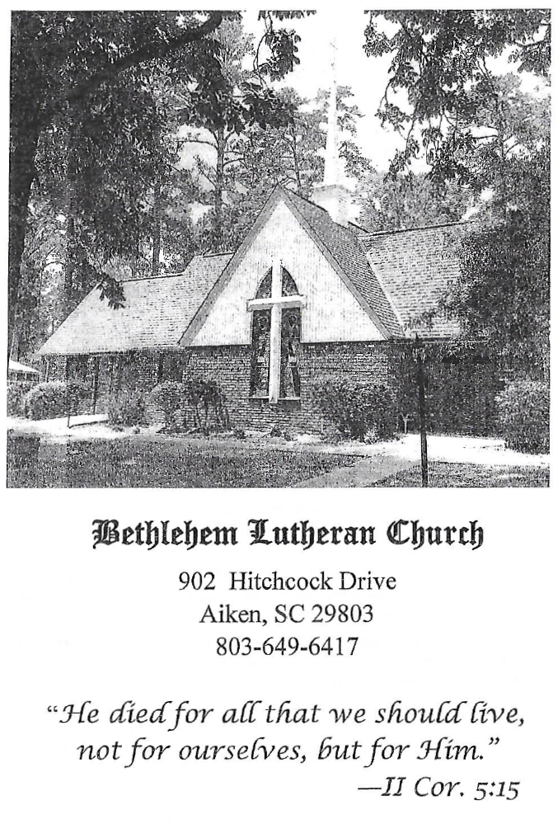

BETHLEHEM LUTHERAN CHURCH
A congregation of The Lutheran Church-Missouri Synod
902 Hitchcock Drive SW,
Aiken, South Carolina 29803
Church Phone: (803) 649-6417
blcaikensc@gmail.com

Bethlehem Lutheran welcomes our members and guests to our worship service! Unable to join us in person? Please find us on Facebook live. The service is also posted on our website; bethlehemlutheranaiken.org.

+ + + + + + + + + + + + + + +
Fourteenth Sunday after Pentecost
August 30, 2026
10:30 a.m.
+ + + + + + + + + + + + + + +

+ SERVICE OF PREPARATION +

(After the bell tolls, please observe a time of silence.)

WELCOME AND ANNOUNCEMENTS

(Stand)

851 LORD OF GLORY, YOU HAVE BOUGHT US
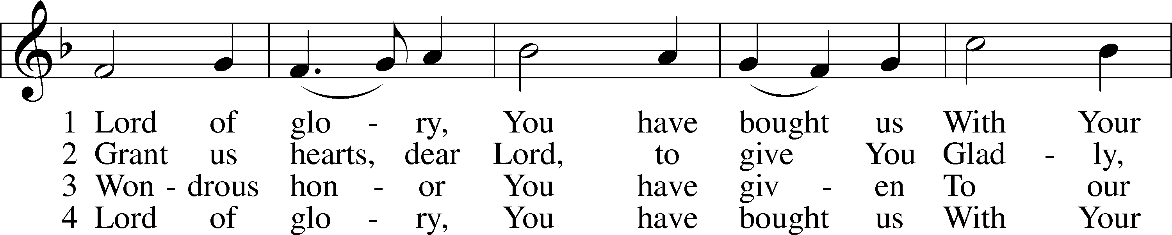
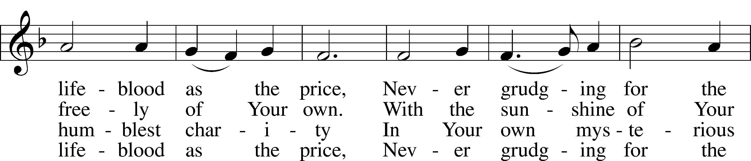
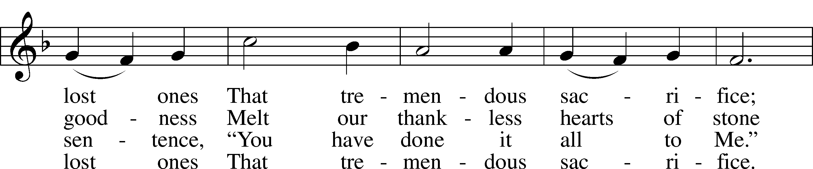
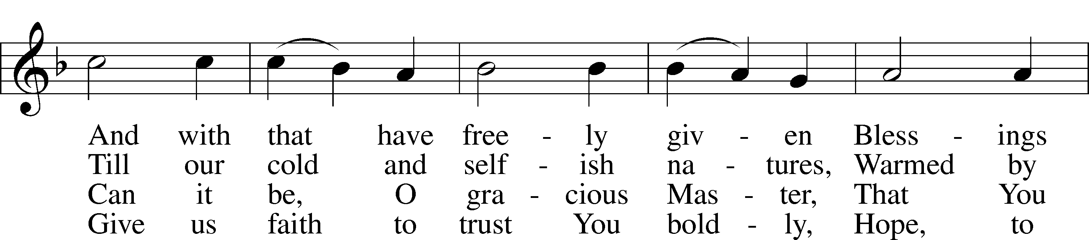
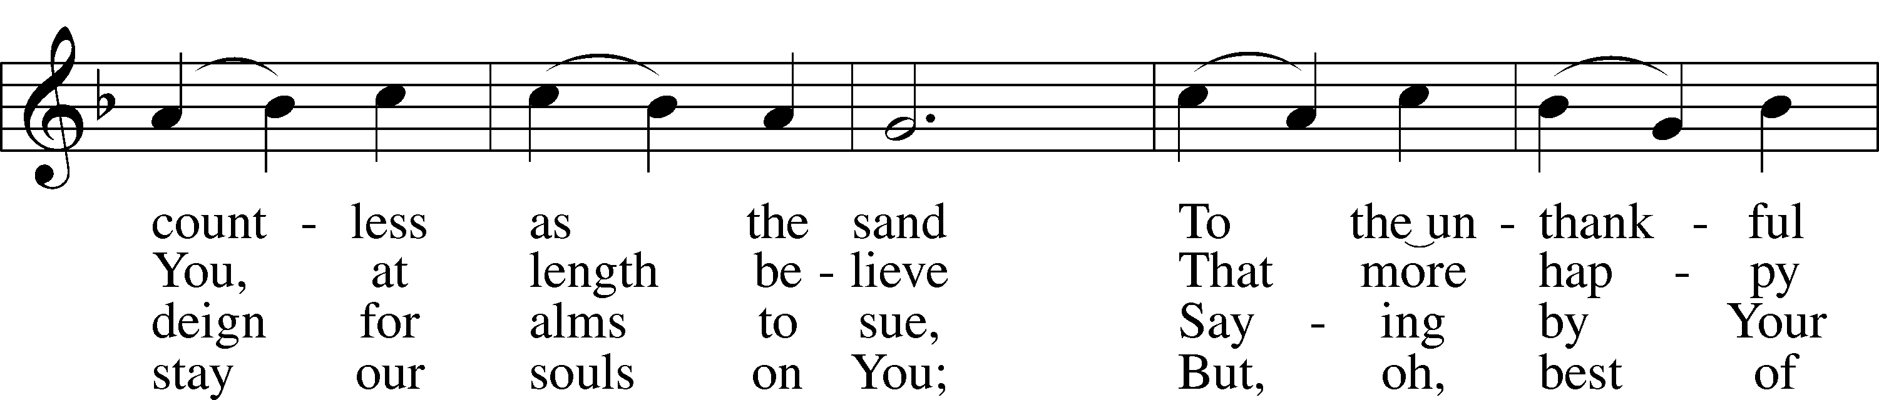
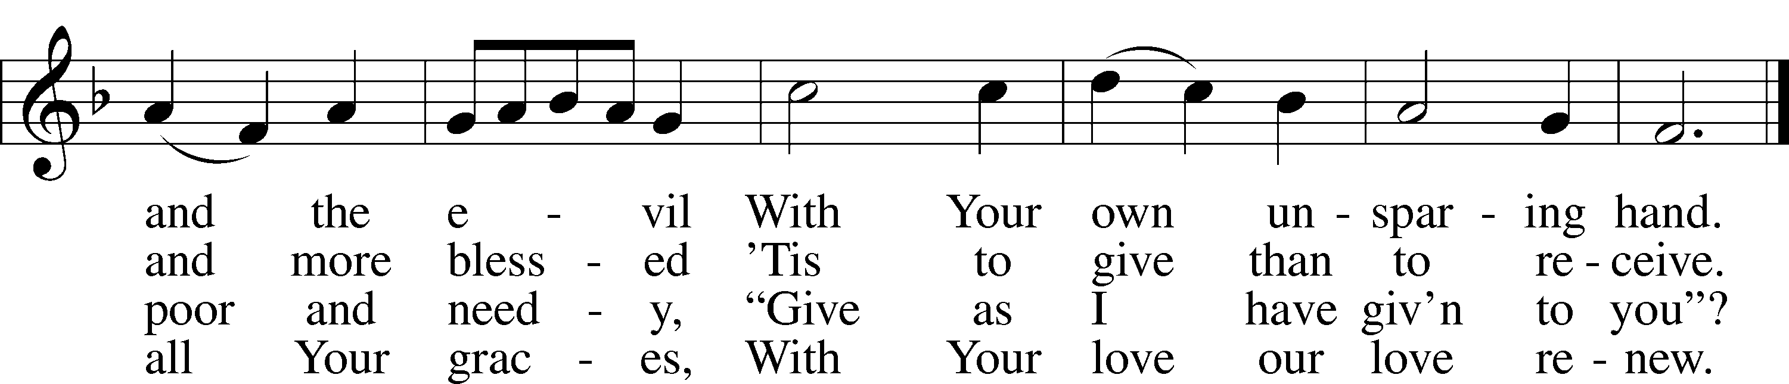
Text: Eliza S. Alderson, 1818–89, alt.
Tune: Rowland H. Prichard, 1811–87
Text and tune: Public domain

+ CONFESSION AND ABSOLUTION +

(The sign of the cross may be made by all in remembrance of their Baptism.)

INVOCATION LSB 151
L In the name of the Father and of the T Son and of the Holy Spirit.
C Amen.

EXHORTATION LSB 151
L If we say we have no sin, we deceive ourselves, and the truth is not in us.
C But if we confess our sins, God, who is faithful and just, will forgive our sins and cleanse us from all unrighteousness.

(Silence for reflection on God’s Word and for self-examination.)

CONFESSION OF SINS LSB 151
L Let us then confess our sins to God our Father.
C Most merciful God, we confess that we are by nature sinful and unclean. We have sinned against You in thought, word, and deed, by what we have done and by what we have left undone. We have not loved You with our whole heart; we have not loved our neighbors as ourselves. We justly deserve Your present and eternal punishment. For the sake of Your Son, Jesus Christ, have mercy on us. Forgive us, renew us, and lead us, so that we may delight in Your will and walk in Your ways to the glory of Your holy name. Amen.

DECLARATION OF GRACE LSB 151
L In the mercy of almighty God, Jesus Christ was given to die for us, and for His sake God forgives us all our sins. To those who believe in Jesus Christ He gives the power to become the children of God and bestows on them the Holy Spirit. May the Lord, who has begun this good work in us, bring it to completion in the day of our Lord Jesus Christ.
C Amen.

+ SERVICE OF THE WORD +

INTROIT Psalm 37:5–7; antiphon: v. 4

Delight yourself | in the Lord,*
and he will give you the desires | of your heart.
Commit your way | to the Lord;*
trust in him, and | he will act.
He will bring forth your righteousness | as the light,*
and your justice as the | noonday.
Be still before the Lord and wait patiently | for him;*
fret not yourself over the one who prospers in his way, over the man who carries out evil de- | vices!
Glory be to the Father and | to the Son*
and to the Holy | Spirit;
as it was in the be- | ginning,*
is now, and will be forever. | Amen.
Delight yourself | in the Lord,*
and he will give you the desires | of your heart.

KYRIE LSB 152

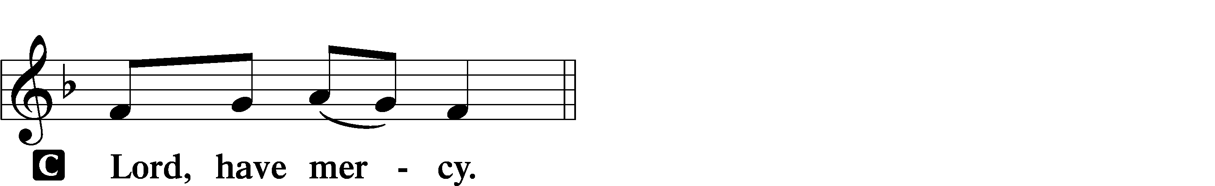

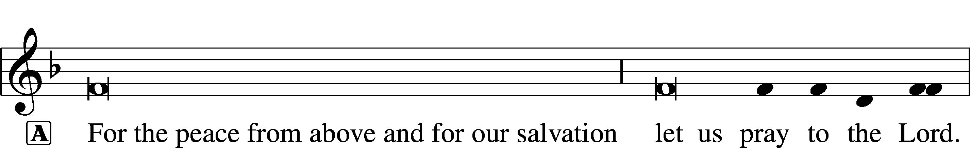
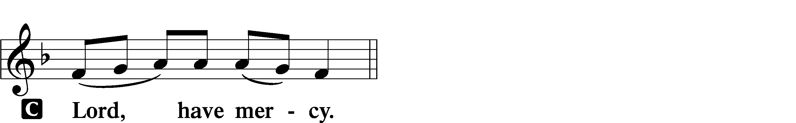

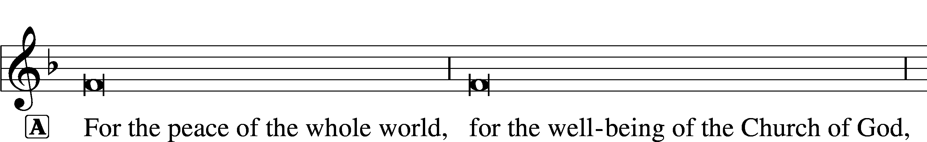

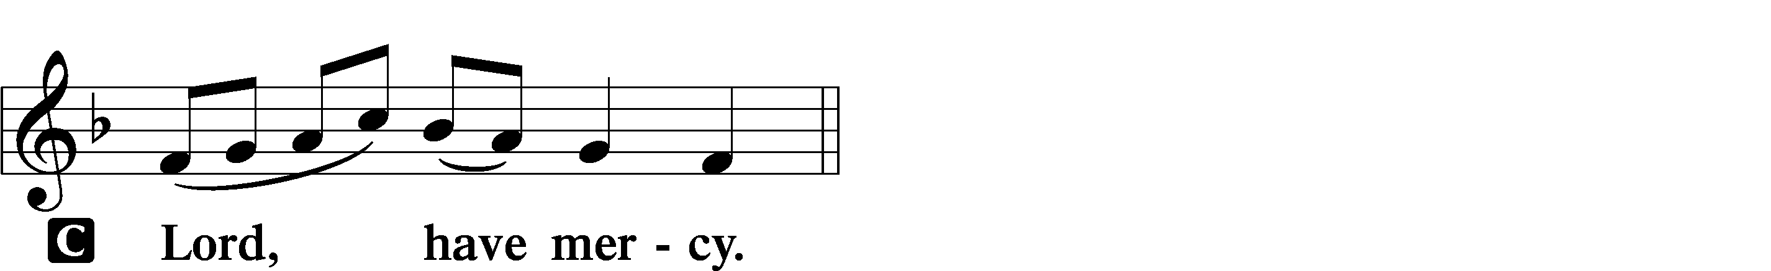

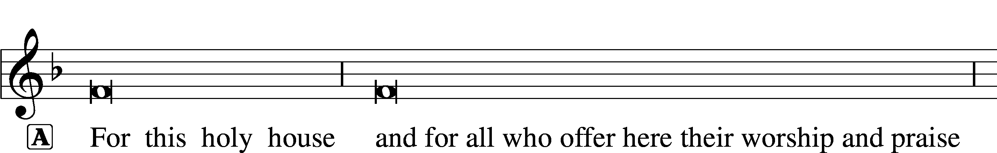

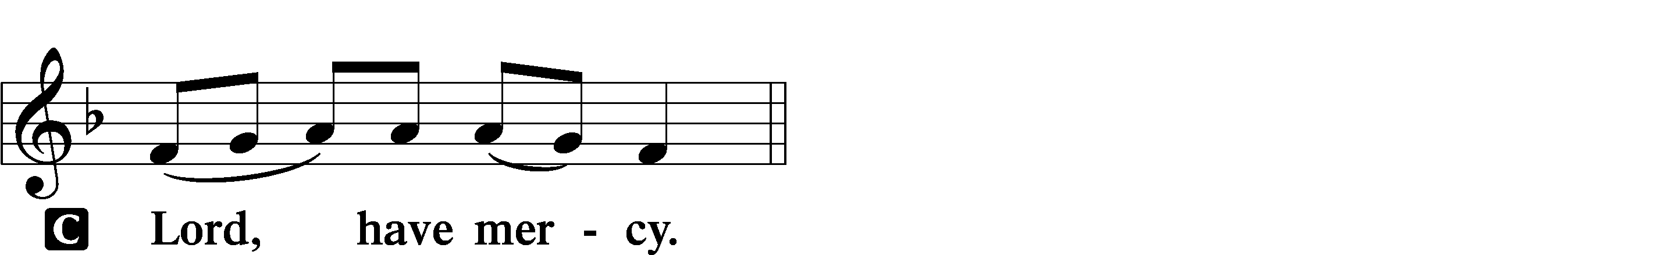

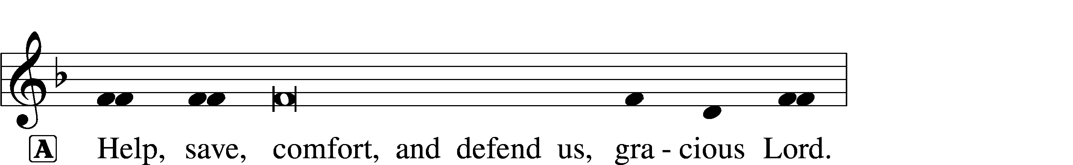


GLORIA IN EXCELSIS LSB 154
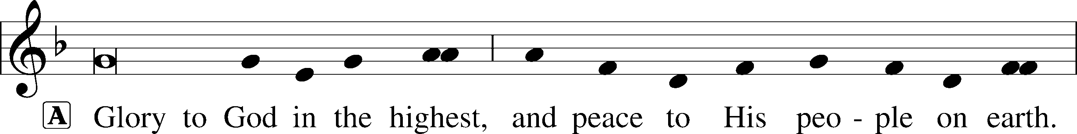
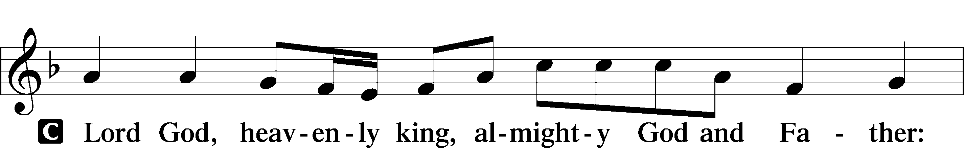
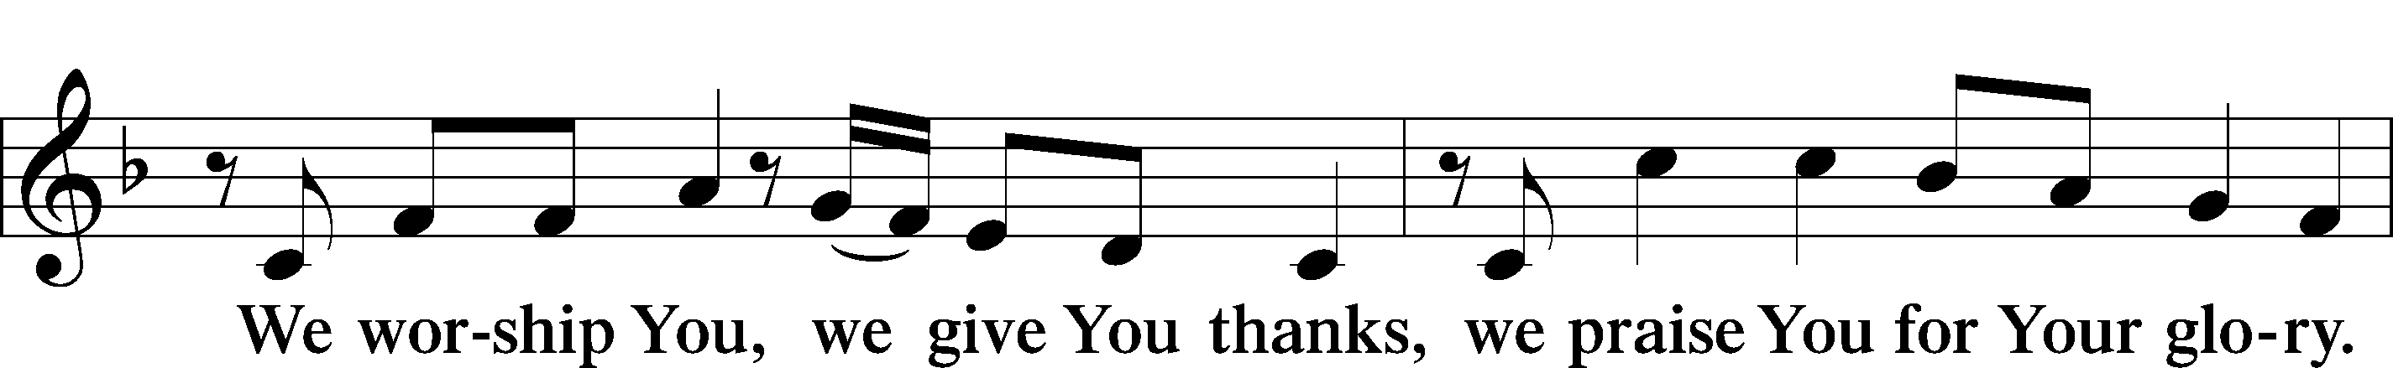
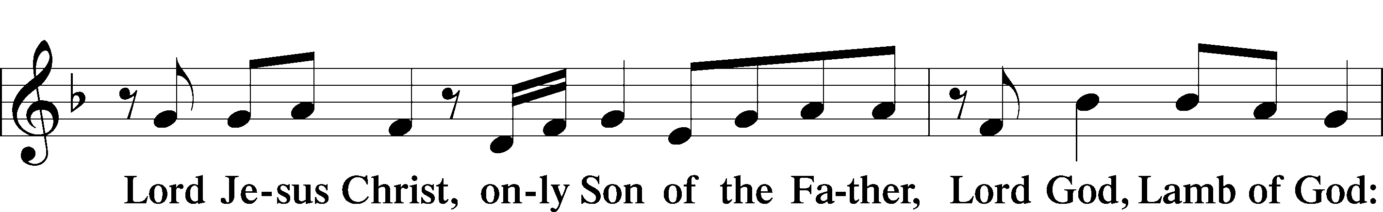
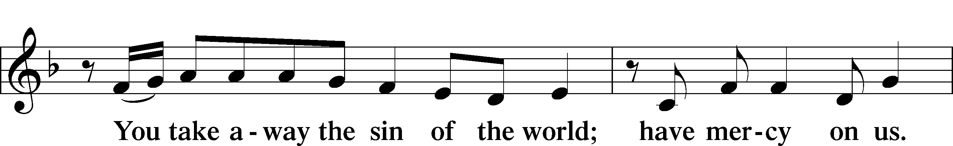
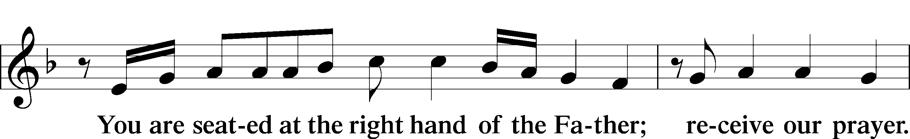
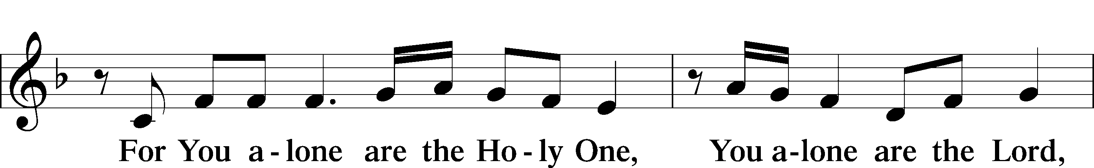
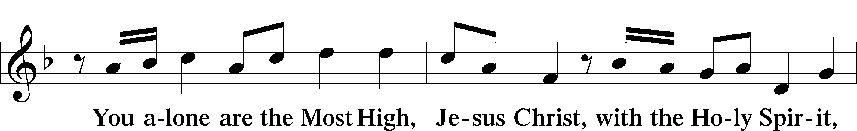
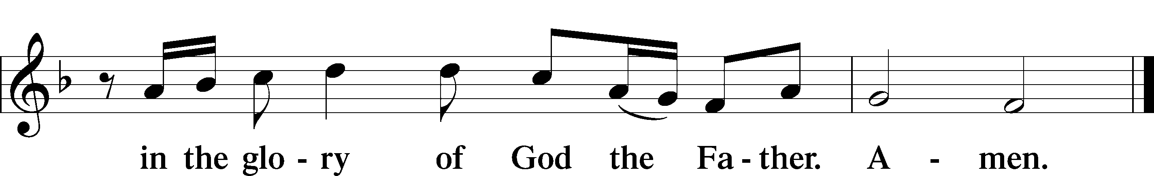

SALUTATION AND COLLECT OF THE DAY LSB 156
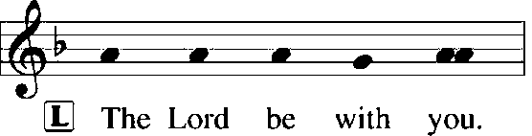
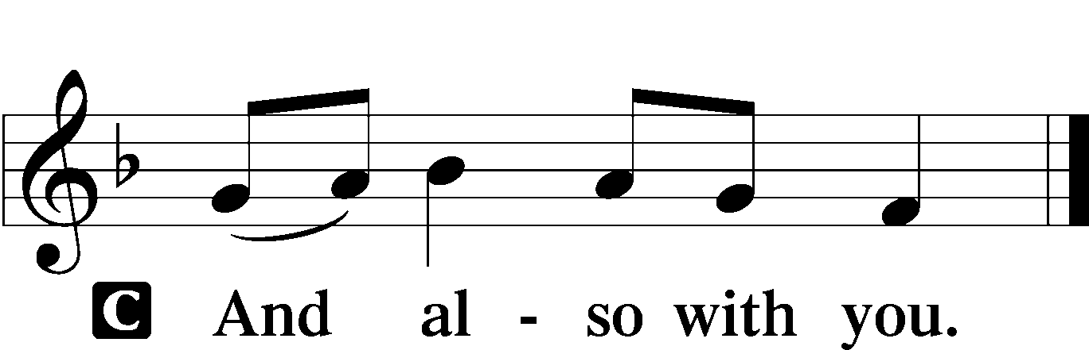

L Let us pray.
Almighty God, Your Son willingly endured the agony and shame of the cross for our redemption. Grant us courage to take up our cross daily and follow Him wherever He leads; through the same Jesus Christ, our Lord, who lives and reigns with You and the Holy Spirit, one God, now and forever.

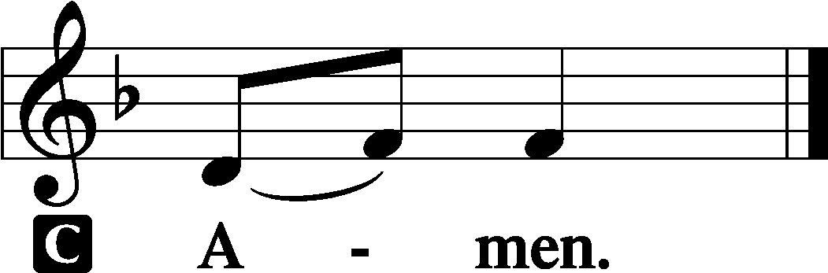

(Sit)

OLD TESTAMENT READING Jeremiah 15:15–21
15O Lord, you know;
remember me and visit me,
and take vengeance for me on my persecutors.
In your forbearance take me not away;
know that for your sake I bear reproach.
16Your words were found, and I ate them,
and your words became to me a joy
and the delight of my heart,
for I am called by your name,
O Lord, God of hosts.
17I did not sit in the company of revelers,
nor did I rejoice;
I sat alone, because your hand was upon me,
for you had filled me with indignation.
18Why is my pain unceasing,
my wound incurable,
refusing to be healed?
Will you be to me like a deceitful brook,
like waters that fail?
19Therefore thus says the Lord:
“If you return, I will restore you,
and you shall stand before me.
If you utter what is precious, and not what is worthless,
you shall be as my mouth.
They shall turn to you,
but you shall not turn to them.
20And I will make you to this people
a fortified wall of bronze;
they will fight against you,
but they shall not prevail over you,
for I am with you
to save you and deliver you,
declares the Lord.
21I will deliver you out of the hand of the wicked,
and redeem you from the grasp of the ruthless.”

L This is the Word of the Lord.
C Thanks be to God.

GRADUAL Psalm 34:9, 19, alt.
Fear the Lord, | you his saints,*
for those who fear him lack | nothing!
Many are the afflictions of the | righteous,*
but the Lord delivers him out | of them all.

EPISTLE Romans 12:9–21
9Let love be genuine. Abhor what is evil; hold fast to what is good. 10Love one another with brotherly affection. Outdo one another in showing honor. 11Do not be slothful in zeal, be fervent in spirit, serve the Lord. 12Rejoice in hope, be patient in tribulation, be constant in prayer. 13Contribute to the needs of the saints and seek to show hospitality.
14Bless those who persecute you; bless and do not curse them. 15Rejoice with those who rejoice, weep with those who weep. 16Live in harmony with one another. Do not be haughty, but associate with the lowly. Never be conceited. 17Repay no one evil for evil, but give thought to do what is honorable in the sight of all. 18If possible, so far as it depends on you, live peaceably with all. 19Beloved, never avenge yourselves, but leave it to the wrath of God, for it is written, “Vengeance is mine, I will repay, says the Lord.” 20To the contrary, “if your enemy is hungry, feed him; if he is thirsty, give him something to drink; for by so doing you will heap burning coals on his head.” 21Do not be overcome by evil, but overcome evil with good.

L This is the Word of the Lord.
C Thanks be to God.

(Stand)

ALLELUIA AND VERSE LSB 156
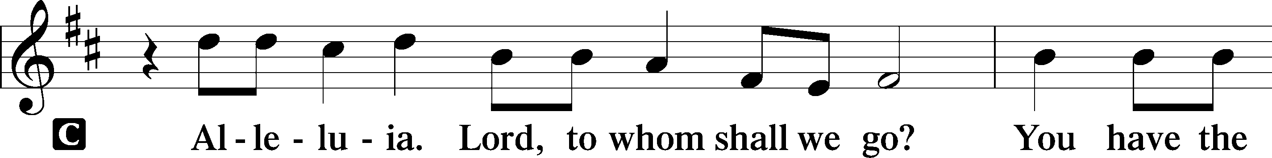
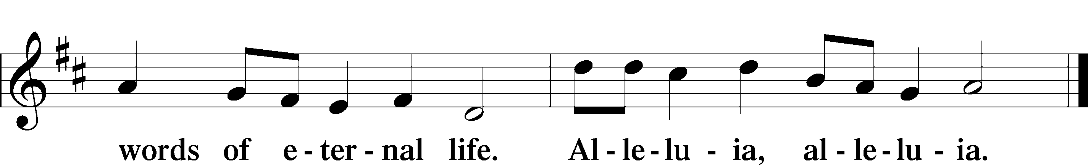

HOLY GOSPEL Matthew 16:21–28
L The Holy Gospel according to St. Matthew, the sixteenth chapter.

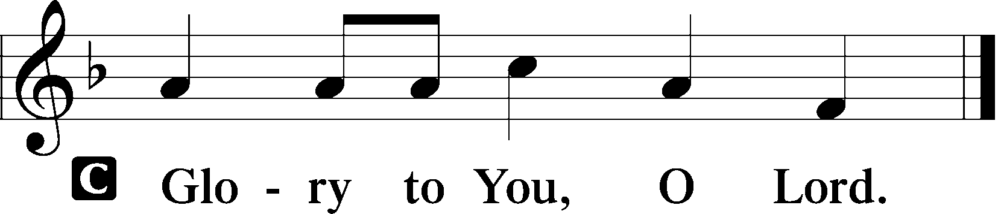

21From that time Jesus began to show his disciples that he must go to Jerusalem and suffer many things from the elders and chief priests and scribes, and be killed, and on the third day be raised. 22And Peter took him aside and began to rebuke him, saying, “Far be it from you, Lord! This shall never happen to you.” 23But he turned and said to Peter, “Get behind me, Satan! You are a hindrance to me. For you are not setting your mind on the things of God, but on the things of man.”
24Then Jesus told his disciples, “If anyone would come after me, let him deny himself and take up his cross and follow me. 25For whoever would save his life will lose it, but whoever loses his life for my sake will find it. 26For what will it profit a man if he gains the whole world and forfeits his life? Or what shall a man give in return for his life? 27For the Son of Man is going to come with his angels in the glory of his Father, and then he will repay each person according to what he has done. 28Truly, I say to you, there are some standing here who will not taste death until they see the Son of Man coming in his kingdom.”

L This is the Gospel of the Lord.

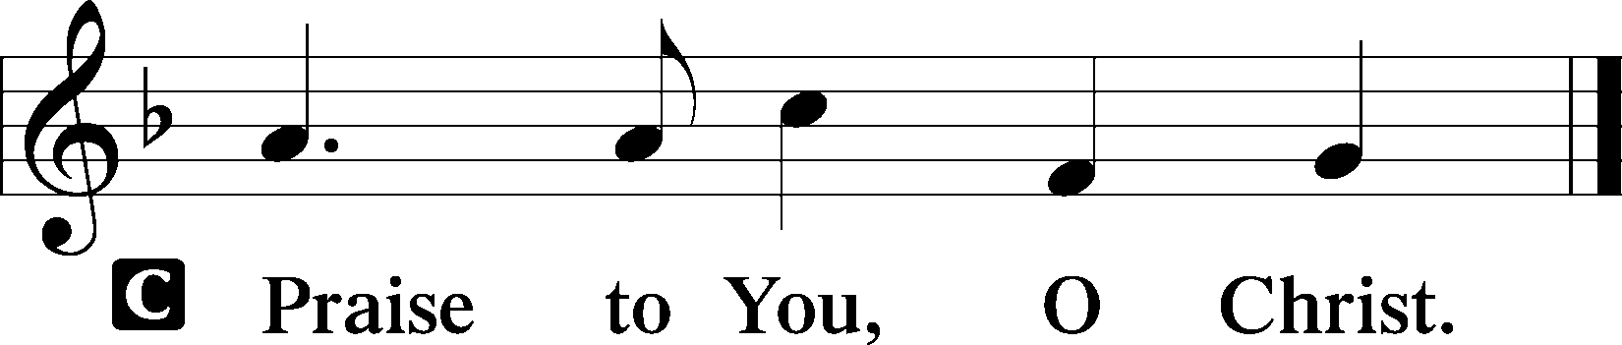

(Sit)

688 “COME, FOLLOW ME,” THE SAVIOR SPAKE
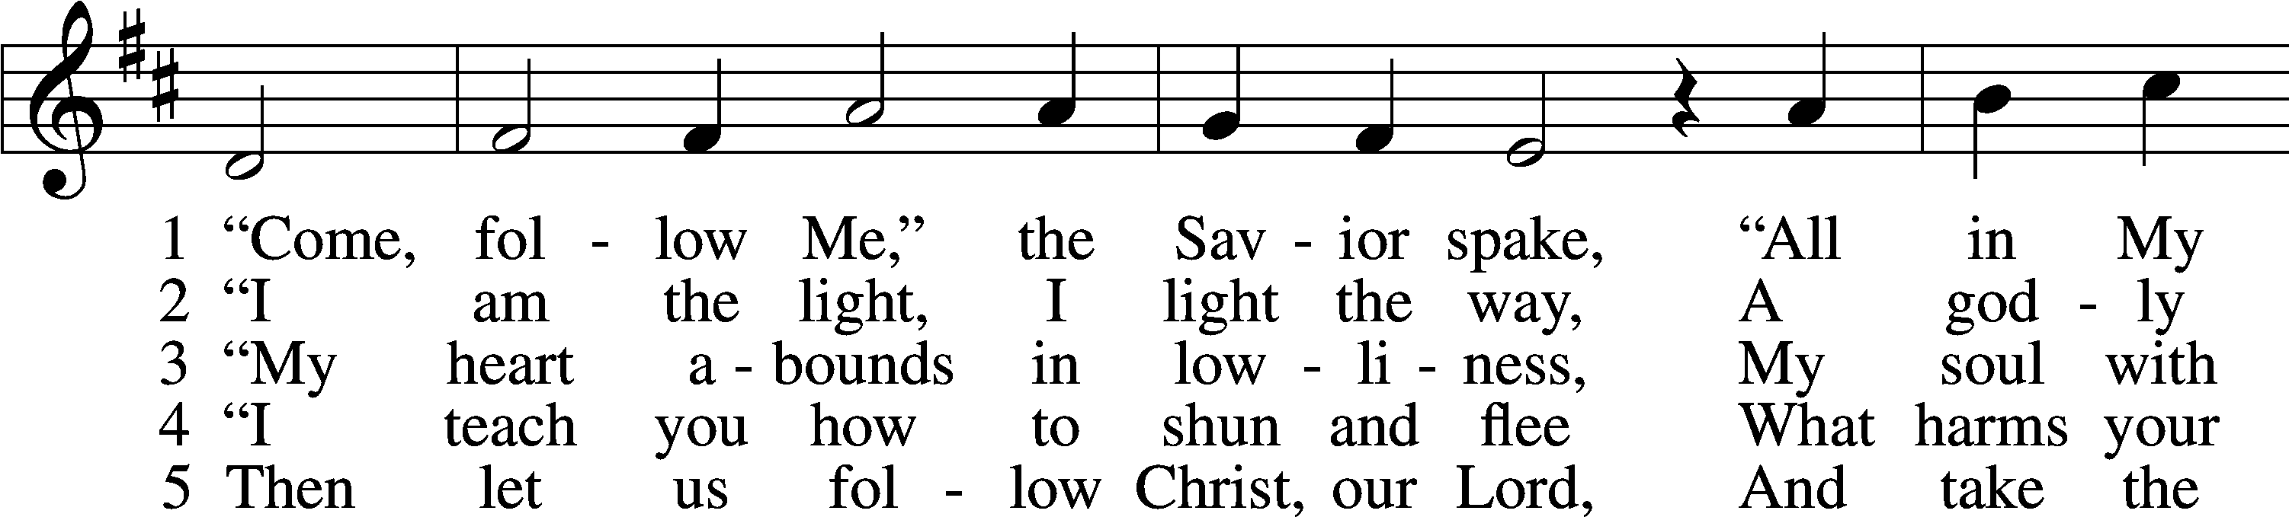
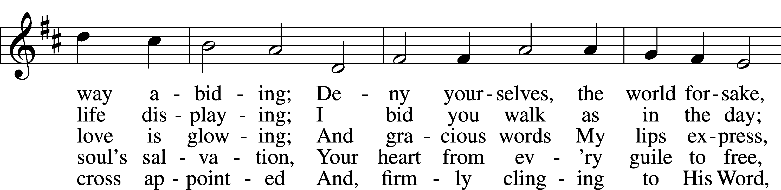
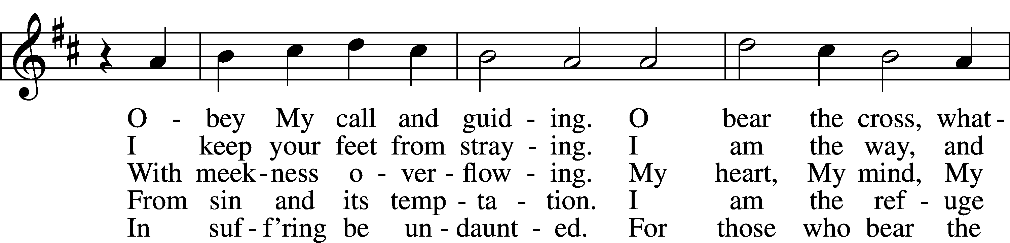
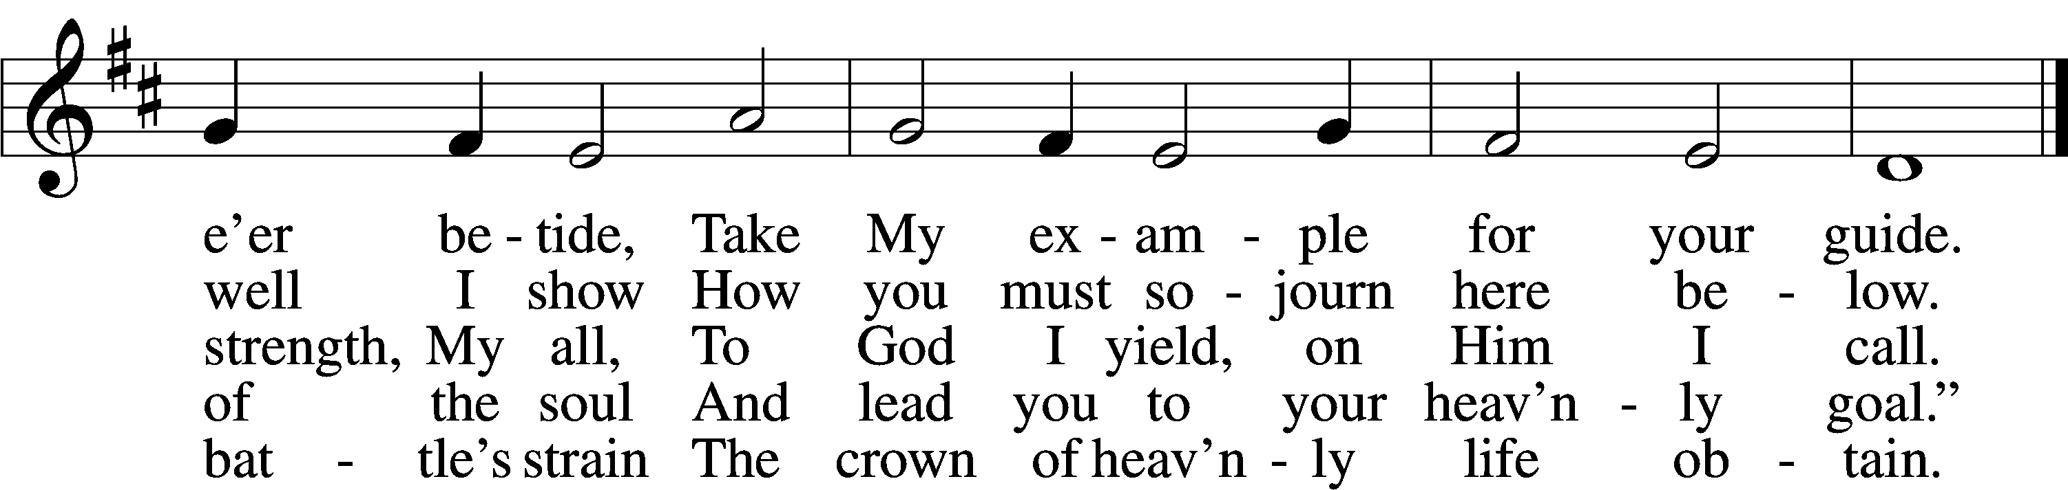
Text: tr. Charles W. Schaeffer, 1813–96; (sts. 1–3, 5): Johann Scheffler, 1624–77; (st. 4): Geistliche Lieder und Lobgesänge, 1695
Tune: Bartholomäus Gesius, c. 1555–1613, adapt.
Text and tune: Public domain

SERMON

(Sermons for Elder led services are provided courtesy of the Lutheran Church - Canada (https://www.lutheranchurchcanada.ca/resources/written-sermons/), a member of the International Lutheran Council (https://ilcouncil.org/) with whom the Lutheran Church - Missouri Synod (https://www.lcms.org/) is in altar and pulpit fellowship.)

980 JESU, JESU, FILL US WITH YOUR LOVE
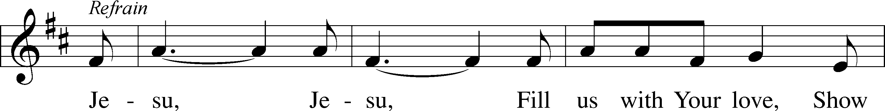
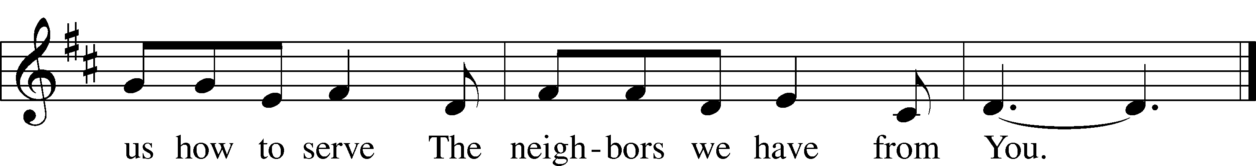
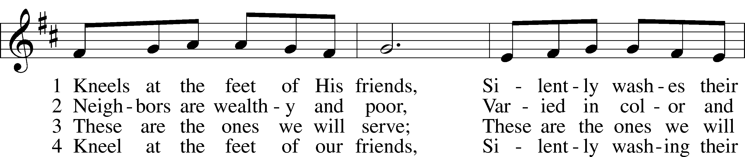
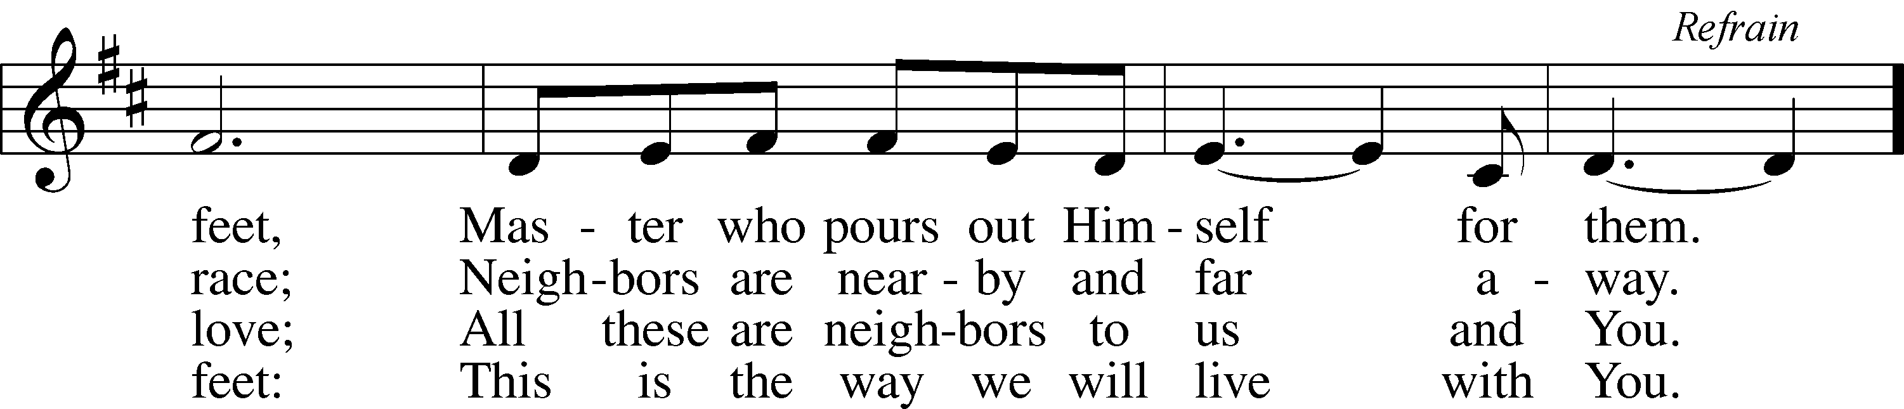
Text: Tom Colvin, 1925–2000, alt.
Tune: Ghanaian; adapt. Tom Colvin, 1925–2000
Text and tune: © 1969, revised 1997 Hope Publishing Co. Used by permission: LSB Hymn License no. 110004798

(Stand)

APOSTLES’ CREED LSB 159
C I believe in God, the Father Almighty,
maker of heaven and earth.

And in Jesus Christ, His only Son, our Lord,
who was conceived by the Holy Spirit,
born of the virgin Mary,
suffered under Pontius Pilate,
was crucified, died and was buried.
He descended into hell.
The third day He rose again from the dead.
He ascended into heaven
and sits at the right hand of God the Father Almighty.
From thence He will come to judge the living and the dead.

I believe in the Holy Spirit,
the holy Christian Church,
the communion of saints,
the forgiveness of sins,
the resurrection of the body,
and the life T everlasting. Amen.

SHARING OF THE PEACE

(The people may greet one another in the name of the Lord, saying, “Peace be with you,” as a sign of reconciliation and of the unity of the Spirit in the bond of peace (Matt. 5:22–24; Eph. 4:1–3).)

(Sit)

PRAYER OF THE CHURCH

OFFERING

(As a part of our expression of thanksgiving to God for the treasure of His salvation to us, we offer a portion of our treasure, according to what each has determined in their heart to give. Please place offerings in the collection plate at the back of the sanctuary before or after the service. Offerings can also be sent to Bethlehem Lutheran Church via U.S. Mail. Thank you!)

(Stand)

OFFERTORY LSB 159
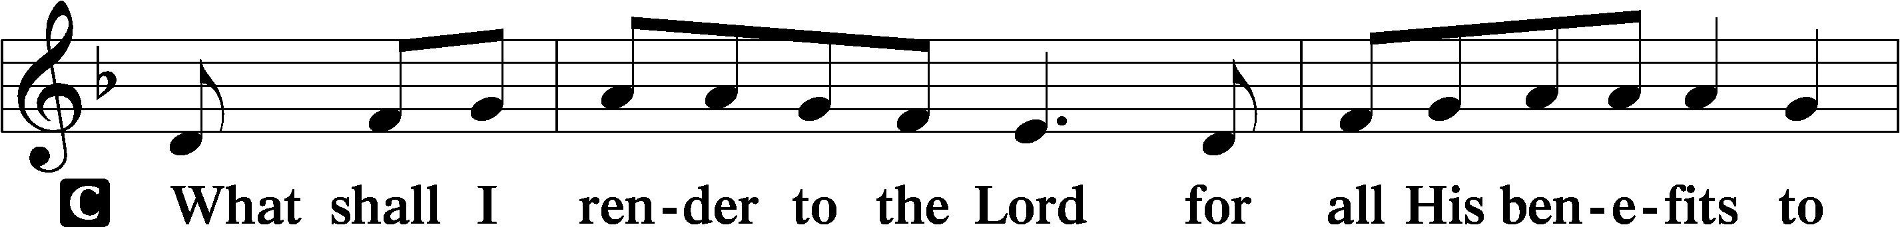
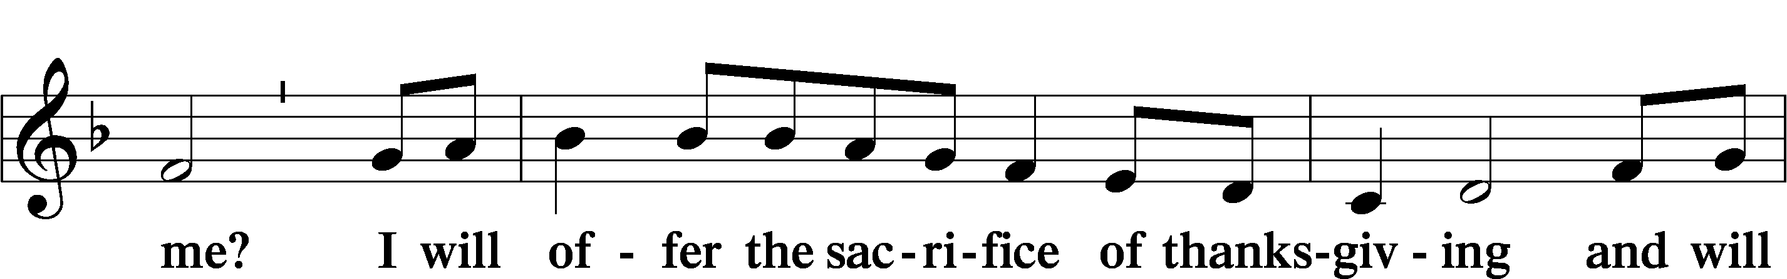
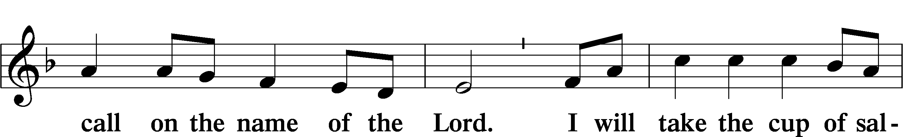
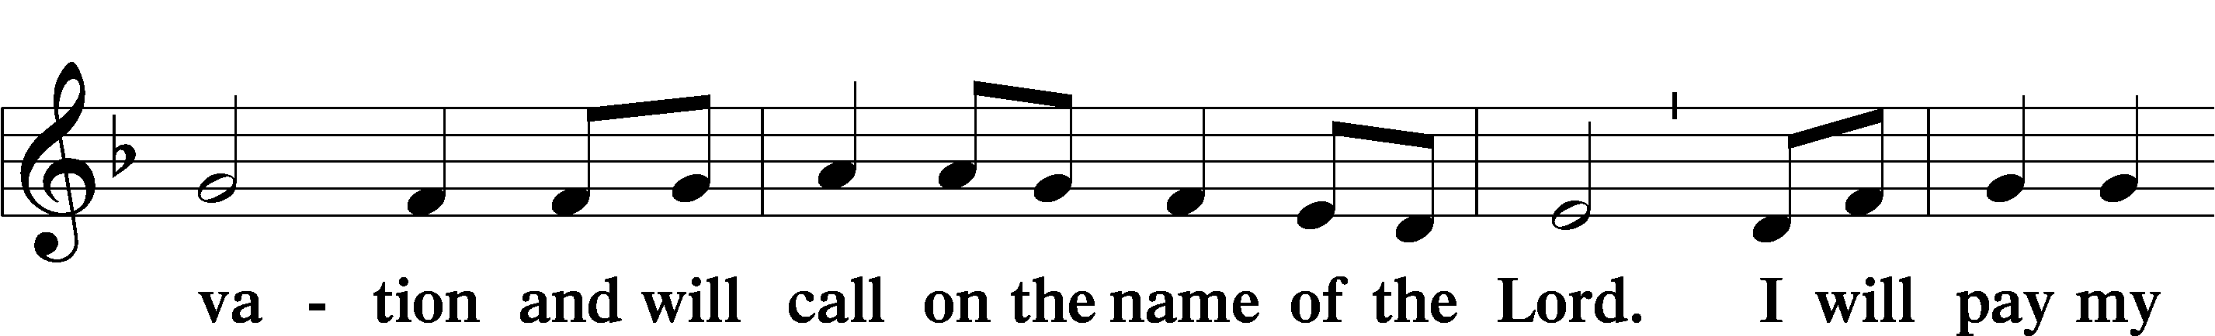
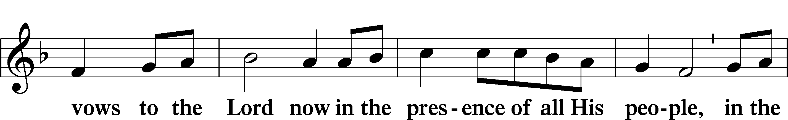
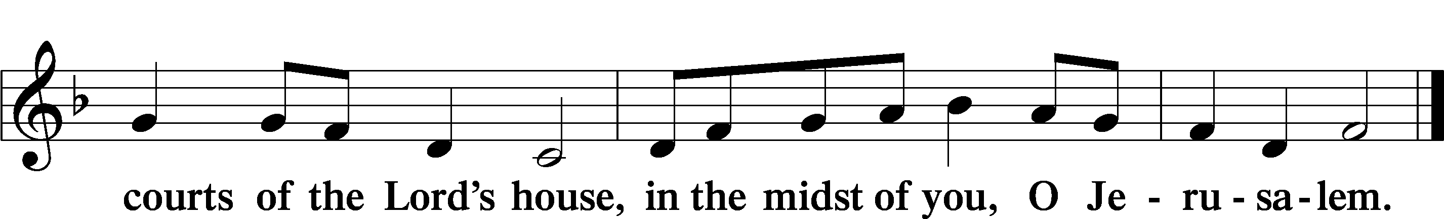

LORD’S PRAYER LSB 162
L Lord, remember us in Your kingdom and teach us to pray:
C Our Father who art in heaven,
hallowed be Thy name,
Thy kingdom come,
Thy will be done on earth
as it is in heaven;
give us this day our daily bread;
and forgive us our trespasses
as we forgive those
who trespass against us;
and lead us not into temptation,
but deliver us from evil.
For Thine is the kingdom
and the power and the glory
forever and ever. Amen.

CONCLUDING COLLECT

BENEDICTION LSB 166
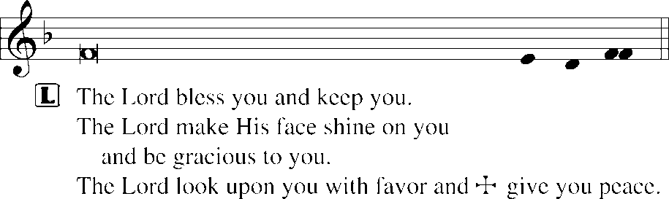


525 CROWN HIM WITH MANY CROWNS
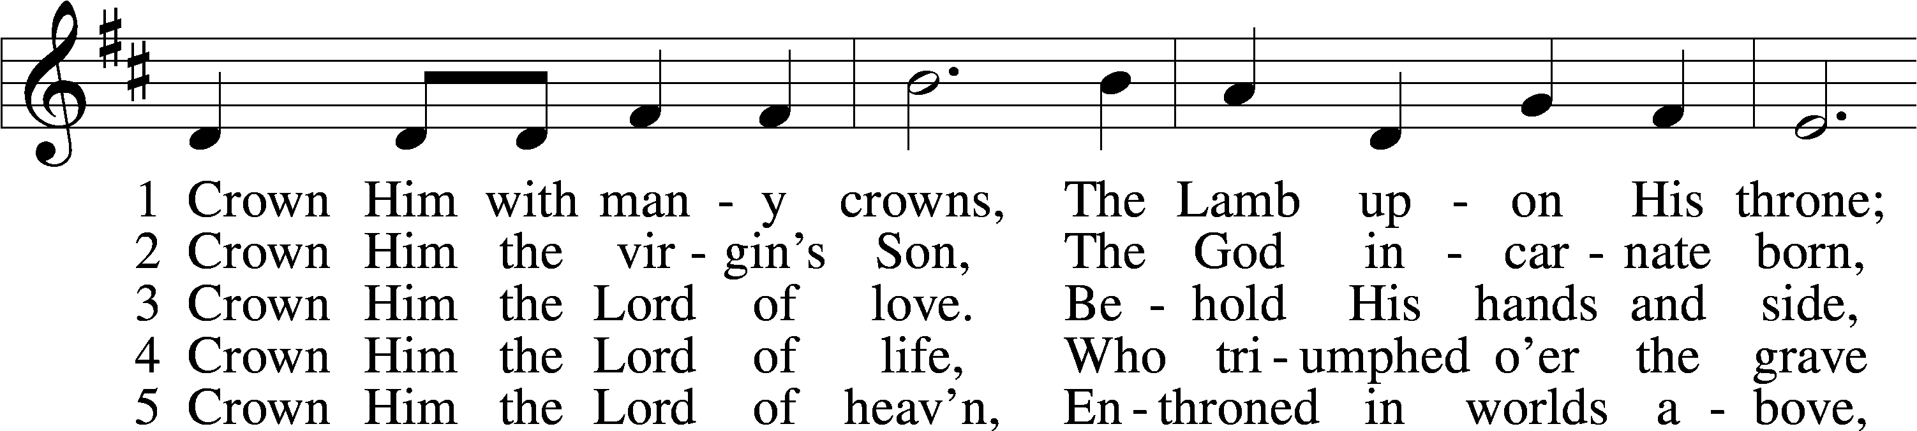
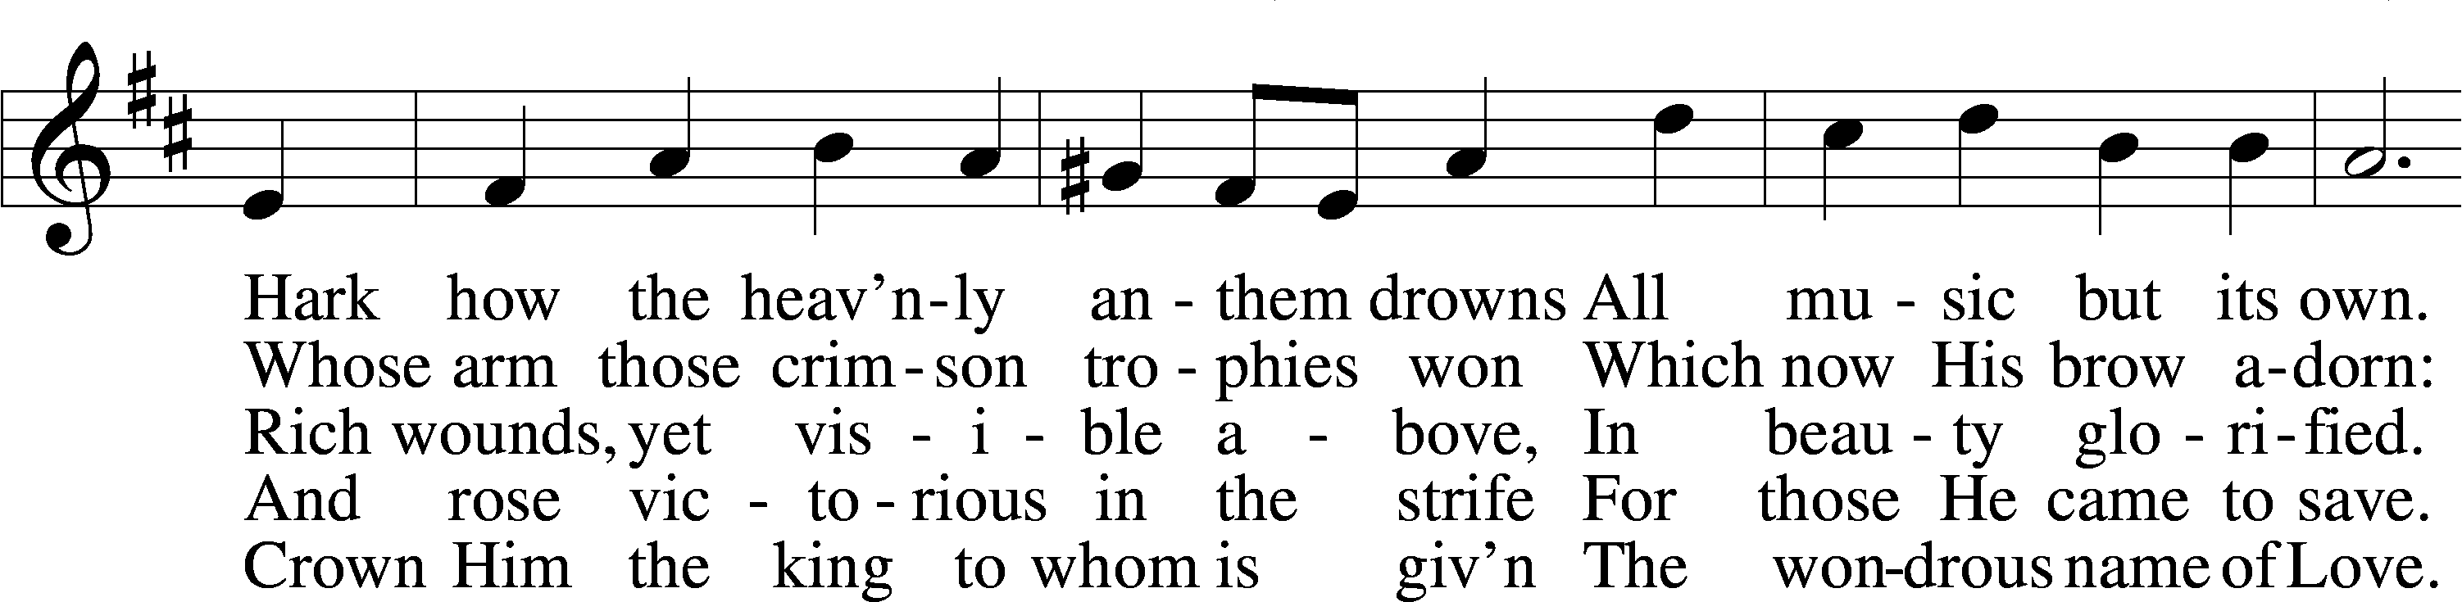
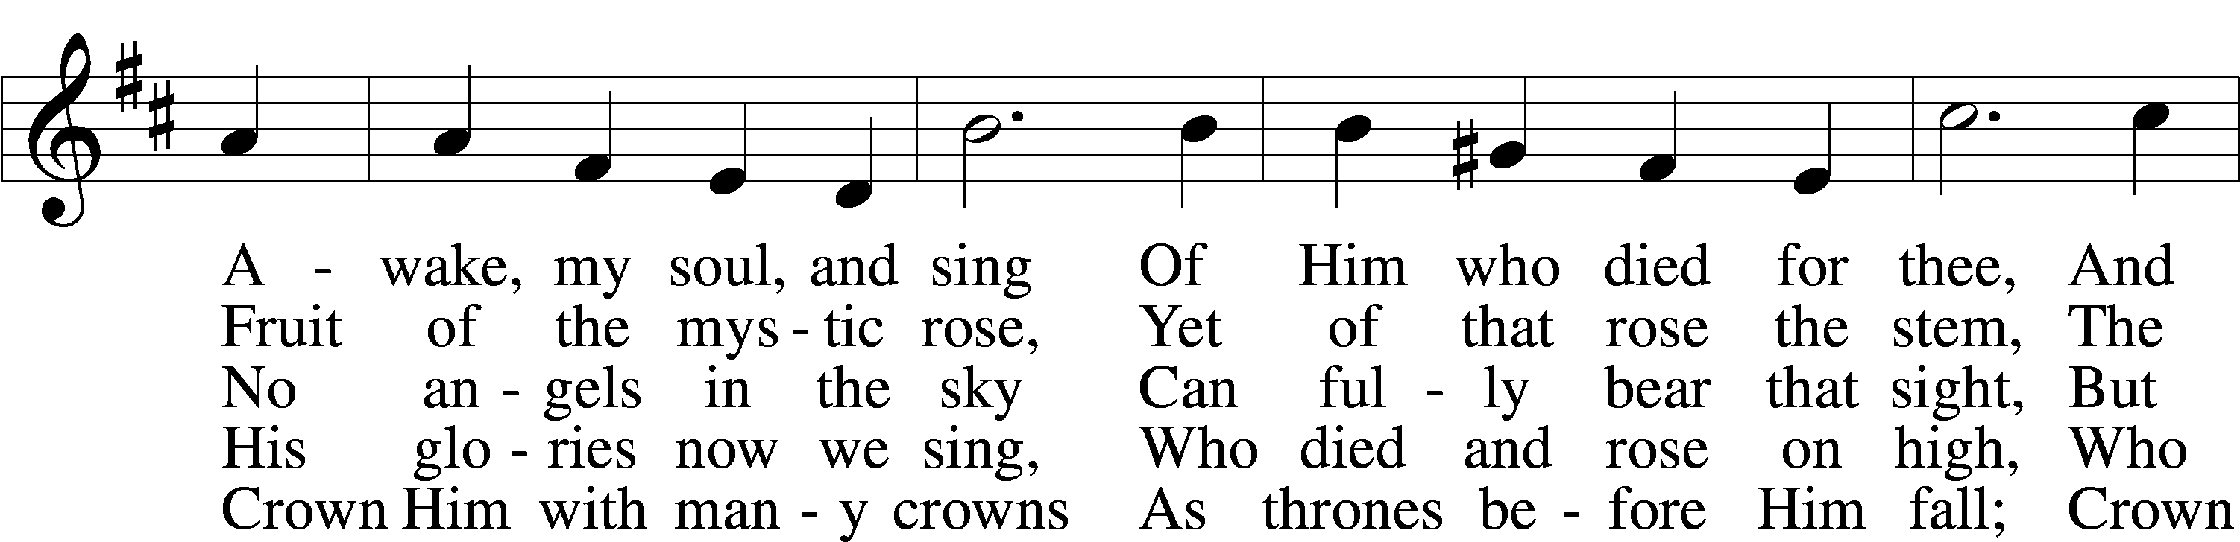
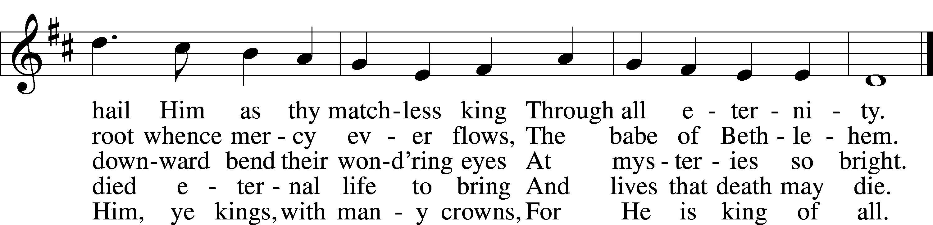
Text (sts. 1–3, 5): Matthew Bridges, 1800–94, alt.; (st. 4): Godfrey Thring, 1823–1903
Tune: George J. Elvey, 1816–93
Text and tune: Public domain

ACKNOWLEDGMENTS
Unless otherwise indicated, Scripture quotations are from the ESV® Bible (The Holy Bible, English Standard Version®), copyright © 2001 by Crossway, a publishing ministry of Good News Publishers. Used by permission. All rights reserved.
Created by Lutheran Service Builder © 2026 Concordia Publishing House.

