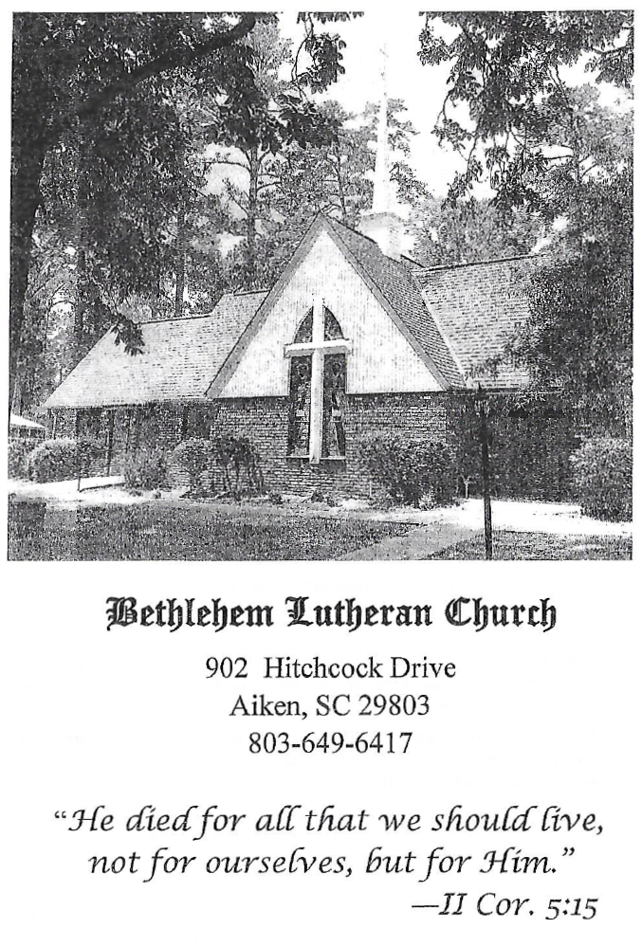

BETHLEHEM LUTHERAN CHURCH
A congregation of The Lutheran Church-Missouri Synod
902 Hitchcock Drive SW,
Aiken, South Carolina 29803
Church Phone: (803) 649-6417
blcaikensc@gmail.com

Bethlehem Lutheran welcomes our members and guests to our worship service! Unable to join us in person? Please find us on Facebook live. The service is also posted on our website; bethlehemlutheranaiken.org.

+ + + + + + + + + + + + + + +
Thirteenth Sunday after Pentecost
August 23, 2026
10:30 a.m.
+ + + + + + + + + + + + + + +

+ SERVICE OF PREPARATION +

(After the bell tolls, please observe a time of silence.)

WELCOME AND ANNOUNCEMENTS

(Stand)

818 IN THEE IS GLADNESS
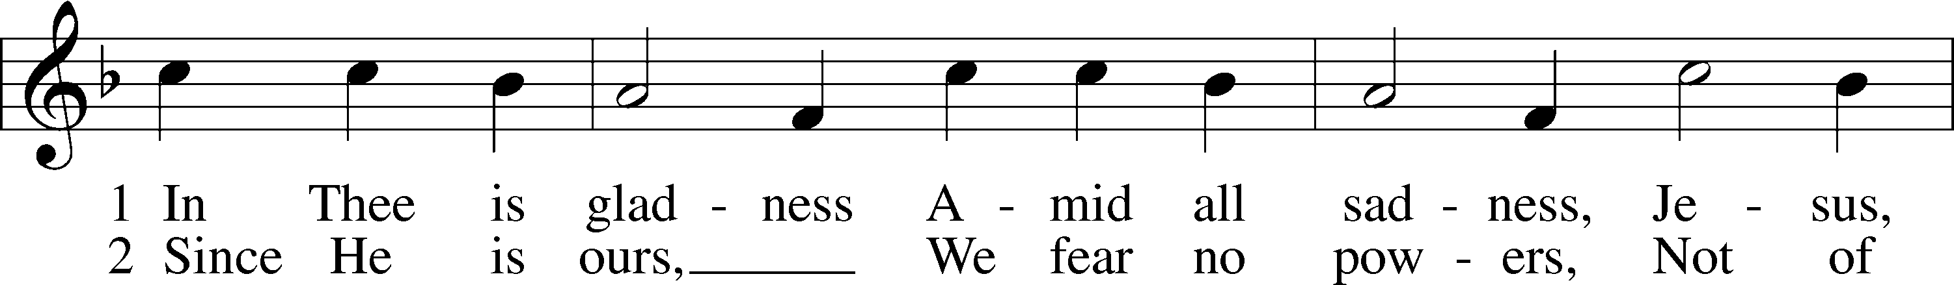
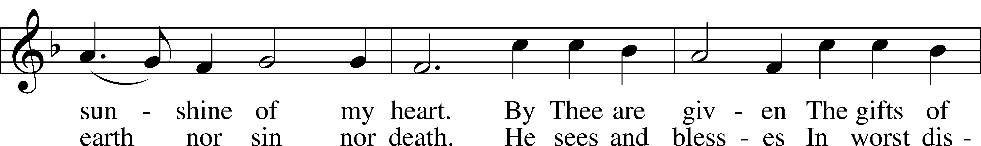
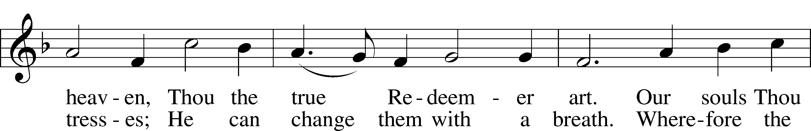
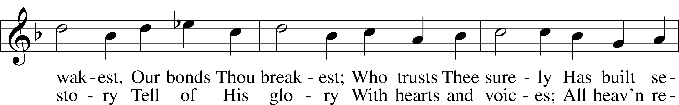
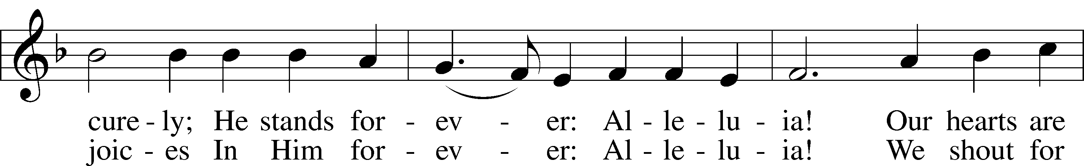
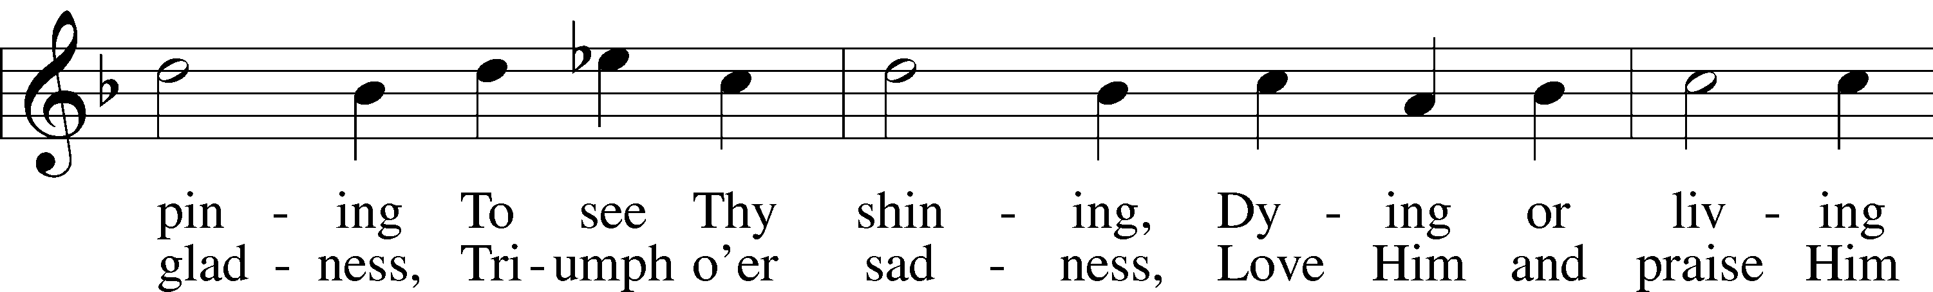
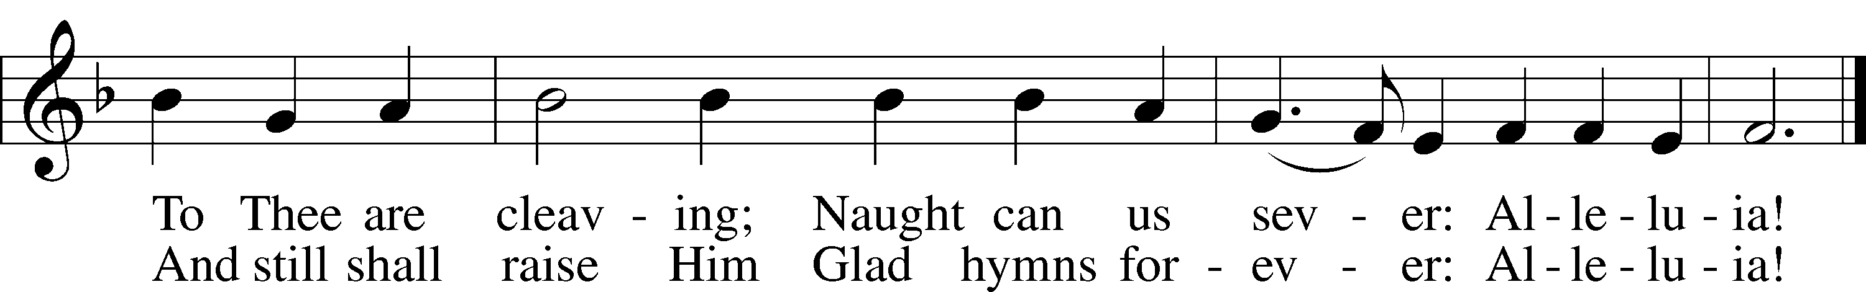
Text: Johann Lindemann, 1549–1631; tr. Catherine Winkworth, 1827–78, alt.
Tune: Giovanni Giacomo Gastoldi, c. 1556–c. 1622
Text and tune: Public domain

+ CONFESSION AND ABSOLUTION +

(The sign of the cross may be made by all in remembrance of their Baptism.)

INVOCATION LSB 151
L In the name of the Father and of the T Son and of the Holy Spirit.
C Amen.

EXHORTATION LSB 151
L If we say we have no sin, we deceive ourselves, and the truth is not in us.
C But if we confess our sins, God, who is faithful and just, will forgive our sins and cleanse us from all unrighteousness.

(Silence for reflection on God’s Word and for self-examination.)

CONFESSION OF SINS LSB 151
L Let us then confess our sins to God our Father.
C Most merciful God, we confess that we are by nature sinful and unclean. We have sinned against You in thought, word, and deed, by what we have done and by what we have left undone. We have not loved You with our whole heart; we have not loved our neighbors as ourselves. We justly deserve Your present and eternal punishment. For the sake of Your Son, Jesus Christ, have mercy on us. Forgive us, renew us, and lead us, so that we may delight in Your will and walk in Your ways to the glory of Your holy name. Amen.

DECLARATION OF GRACE LSB 151
L In the mercy of almighty God, Jesus Christ was given to die for us, and for His sake God forgives us all our sins. To those who believe in Jesus Christ He gives the power to become the children of God and bestows on them the Holy Spirit. May the Lord, who has begun this good work in us, bring it to completion in the day of our Lord Jesus Christ.
C Amen.

+ SERVICE OF THE WORD +

INTROIT Psalm 2:6–7; 117; antiphon: Psalm 115:18

But we will | bless the Lord*
from this time forth and forevermore. | Praise the Lord!
As for me, I have | set my King*
on Zion, my | holy hill.
I will tell of | the decree:*
The Lord said to me, “You are my Son; today I have be- | gotten you.”
Praise the Lord, all | nations!*
Extol him, all | peoples!
For great is his steadfast | love toward us,*
and the faithfulness of the Lord endures forever. | Praise the Lord!
Glory be to the Father and | to the Son*
and to the Holy | Spirit;
as it was in the be- | ginning,*
is now, and will be forever. | Amen.
But we will | bless the Lord*
from this time forth and forevermore. | Praise the Lord!

KYRIE LSB 152

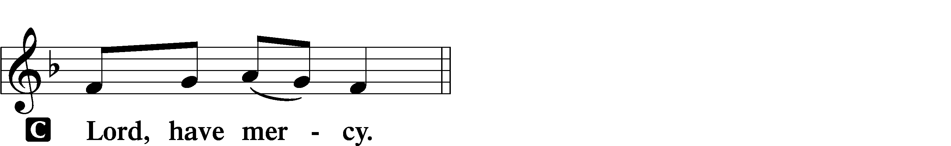

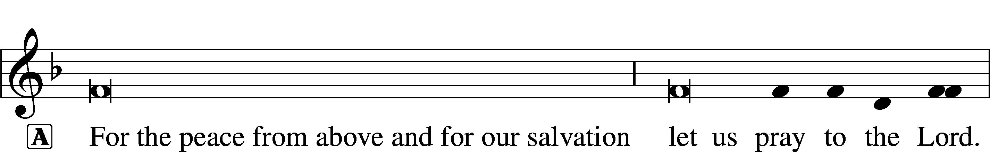
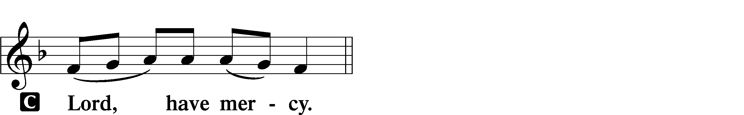
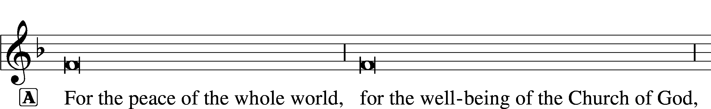
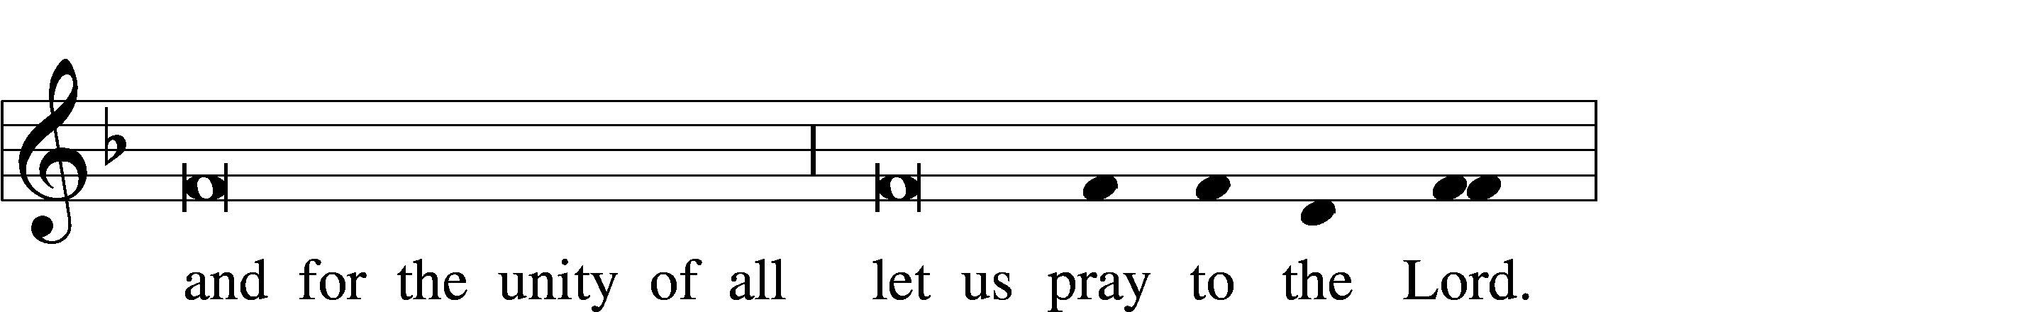
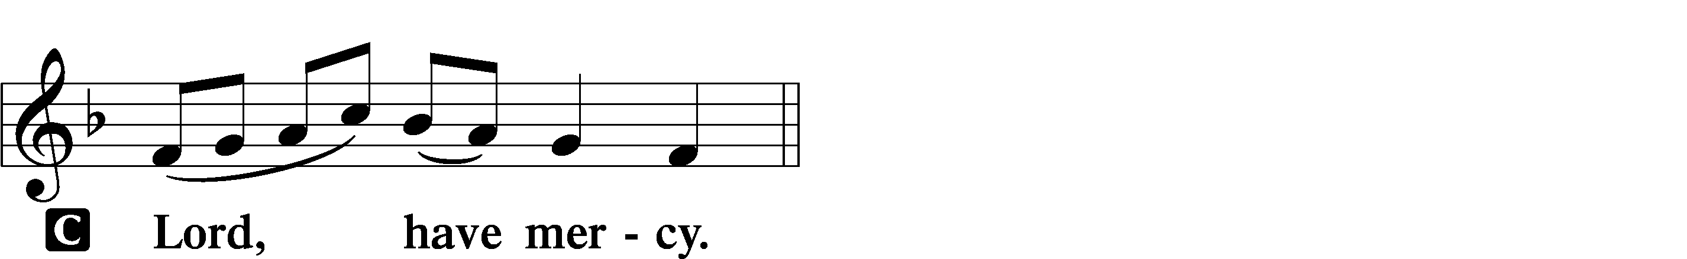

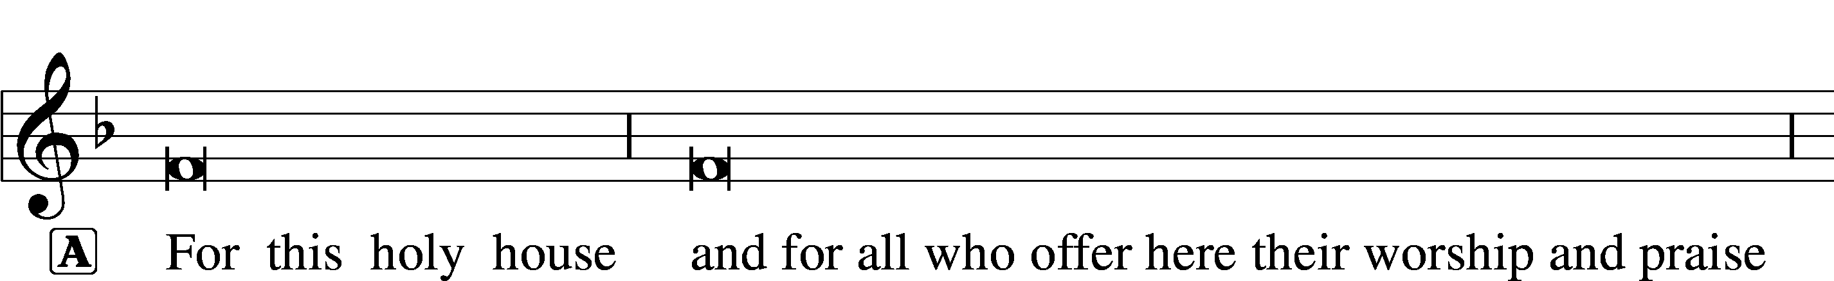

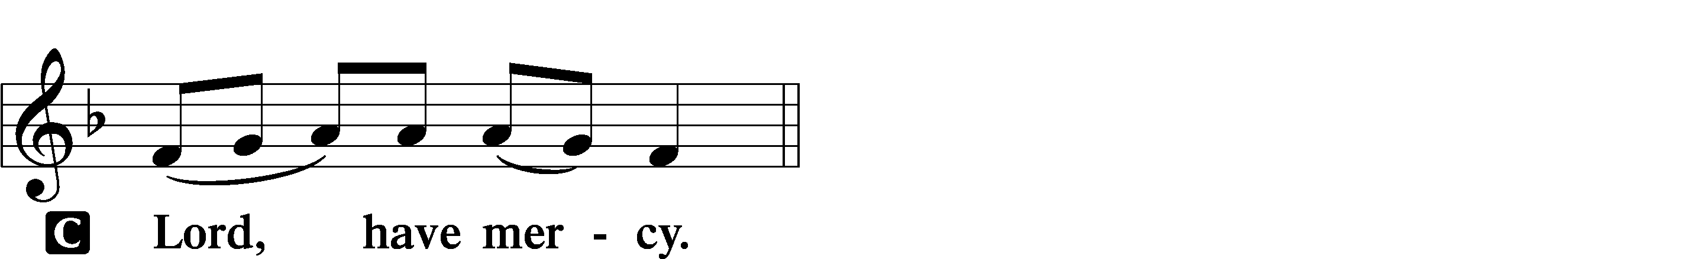

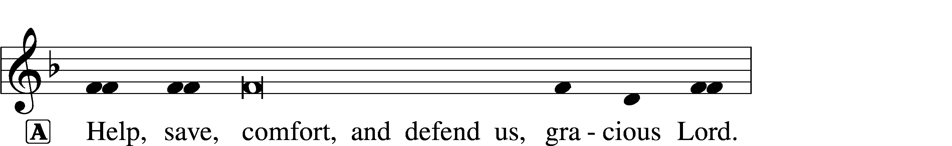


GLORIA IN EXCELSIS LSB 154
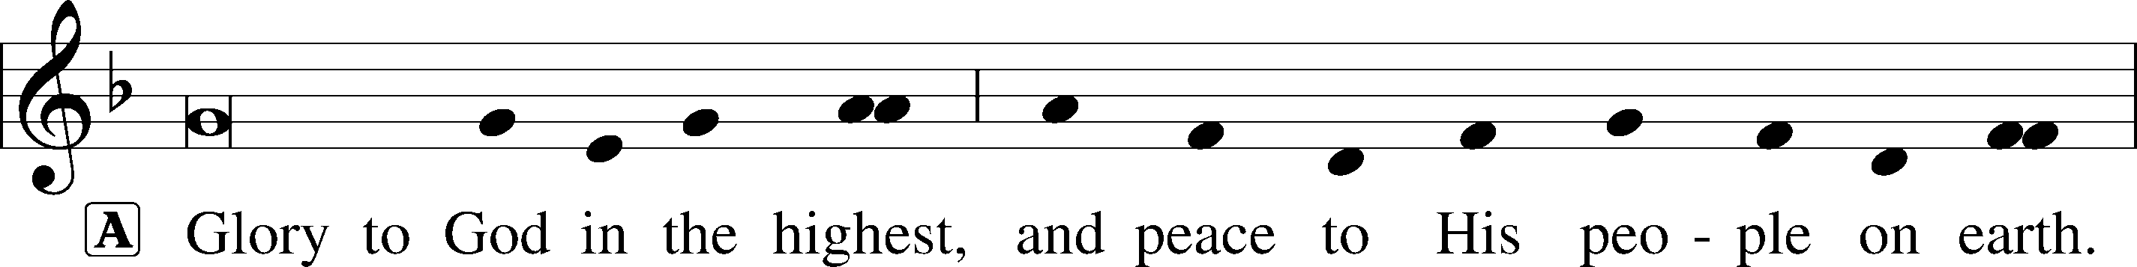
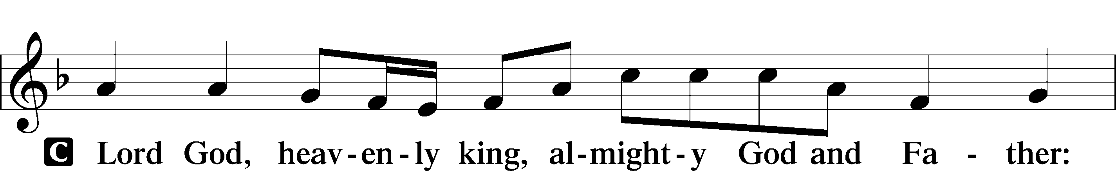
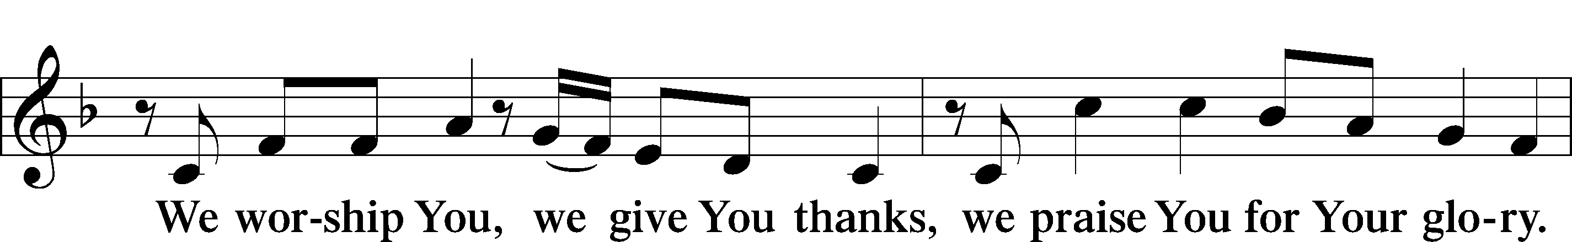
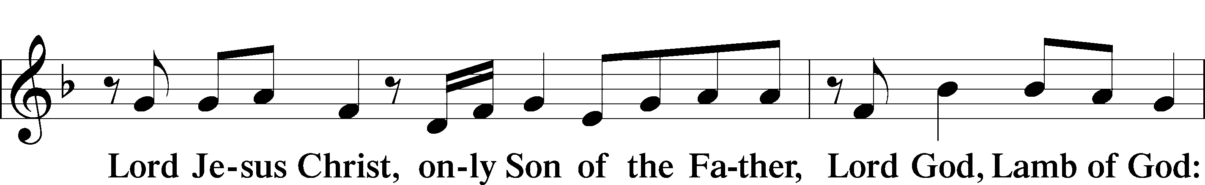
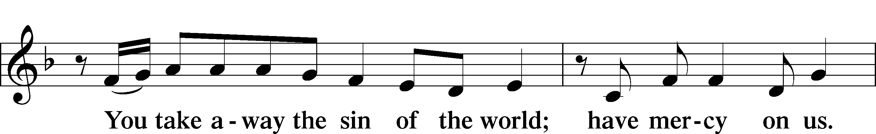
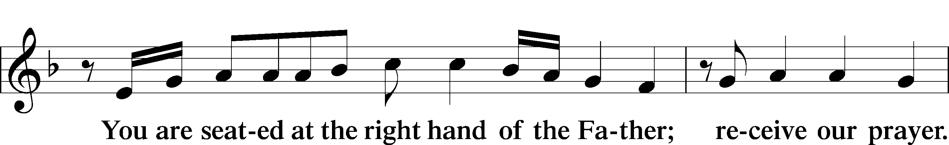
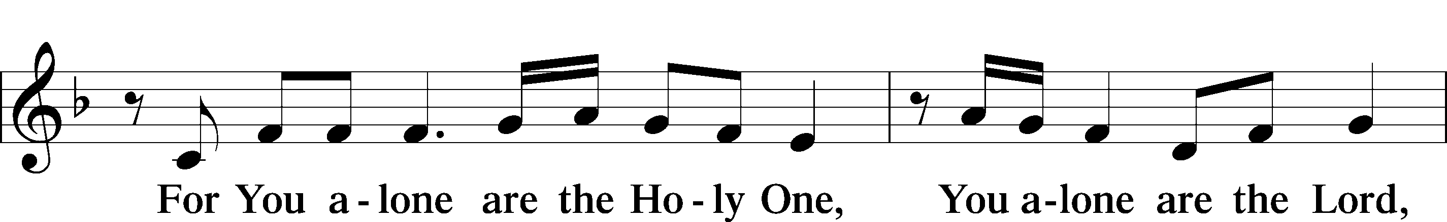
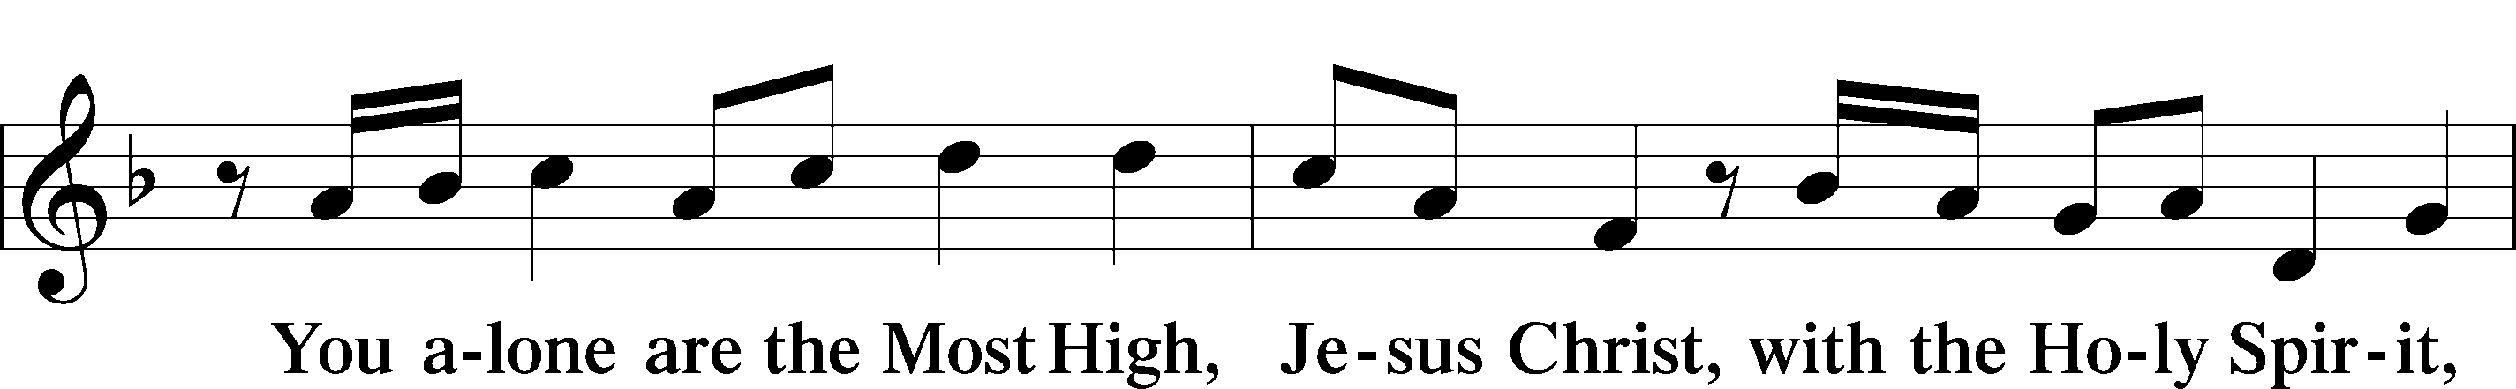
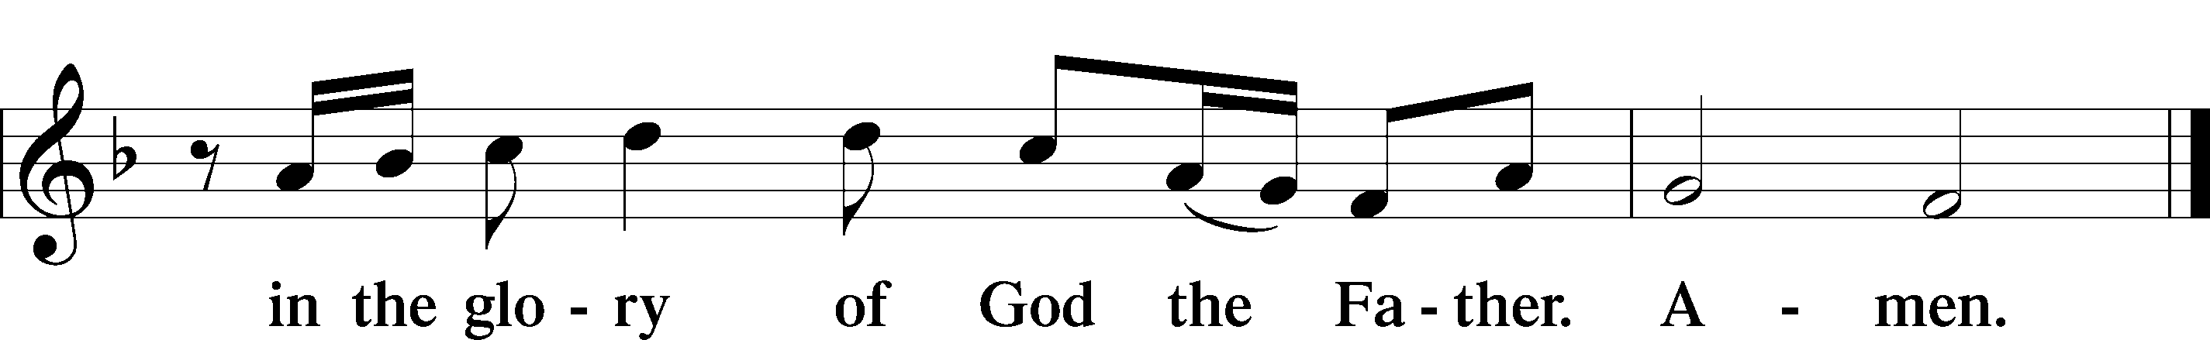

SALUTATION AND COLLECT OF THE DAY LSB 156
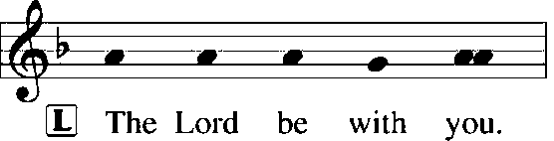
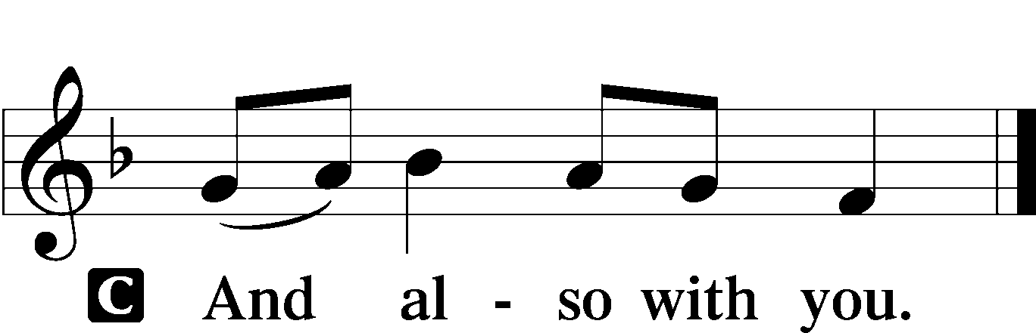

L Let us pray.
Almighty God, whom to know is everlasting life, grant us to know Your Son, Jesus, to be the way, the truth, and the life that we may boldly confess Him to be the Christ and steadfastly walk in the way that leads to life eternal; through the same Jesus Christ, our Lord, who lives and reigns with You and the Holy Spirit, one God, now and forever.

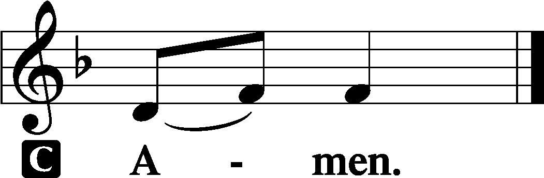

(Sit)

OLD TESTAMENT READING Isaiah 51:1–6
1“Listen to me, you who pursue righteousness,
you who seek the Lord:
look to the rock from which you were hewn,
and to the quarry from which you were dug.
2Look to Abraham your father
and to Sarah who bore you;
for he was but one when I called him,
that I might bless him and multiply him.
3For the Lord comforts Zion;
he comforts all her waste places
and makes her wilderness like Eden,
her desert like the garden of the Lord;
joy and gladness will be found in her,
thanksgiving and the voice of song.
4“Give attention to me, my people,
and give ear to me, my nation;
for a law will go out from me,
and I will set my justice for a light to the peoples.
5My righteousness draws near,
my salvation has gone out,
and my arms will judge the peoples;
the coastlands hope for me,
and for my arm they wait.
6Lift up your eyes to the heavens,
and look at the earth beneath;
for the heavens vanish like smoke,
the earth will wear out like a garment,
and they who dwell in it will die in like manner;
but my salvation will be forever,
and my righteousness will never be dismayed.”

L This is the Word of the Lord.
C Thanks be to God.

GRADUAL Psalm 34:9, 19, alt.
Fear the Lord, | you his saints,*
for those who fear him lack | nothing!
Many are the afflictions of the | righteous,*
but the Lord delivers him out | of them all.

EPISTLE Romans 11:33—12:8
33Oh, the depth of the riches and wisdom and knowledge of God! How unsearchable are his judgments and how inscrutable his ways!
34“For who has known the mind of the Lord,
or who has been his counselor?”
35“Or who has given a gift to him
that he might be repaid?”
36For from him and through him and to him are all things. To him be glory forever. Amen.
1I appeal to you therefore, brothers, by the mercies of God, to present your bodies as a living sacrifice, holy and acceptable to God, which is your spiritual worship. 2Do not be conformed to this world, but be transformed by the renewal of your mind, that by testing you may discern what is the will of God, what is good and acceptable and perfect.
3For by the grace given to me I say to everyone among you not to think of himself more highly than he ought to think, but to think with sober judgment, each according to the measure of faith that God has assigned. 4For as in one body we have many members, and the members do not all have the same function, 5so we, though many, are one body in Christ, and individually members one of another. 6Having gifts that differ according to the grace given to us, let us use them: if prophecy, in proportion to our faith; 7if service, in our serving; the one who teaches, in his teaching; 8the one who exhorts, in his exhortation; the one who contributes, in generosity; the one who leads, with zeal; the one who does acts of mercy, with cheerfulness.

L This is the Word of the Lord.
C Thanks be to God.

(Stand)

ALLELUIA AND VERSE LSB 156
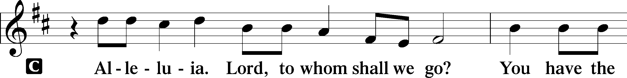
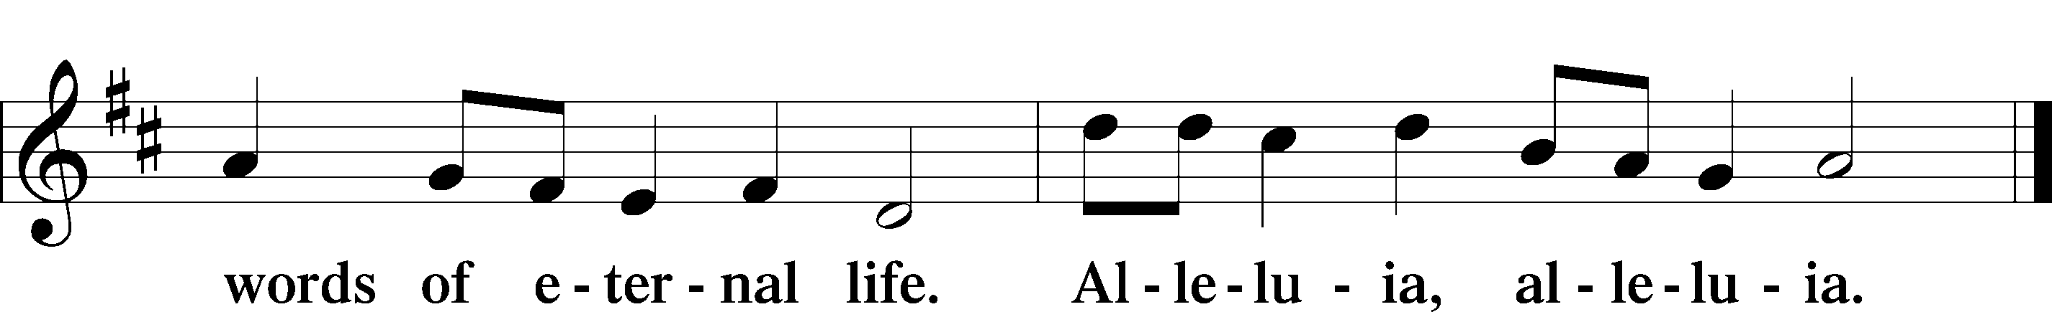

HOLY GOSPEL Matthew 16:13–20
L The Holy Gospel according to St. Matthew, the sixteenth chapter.

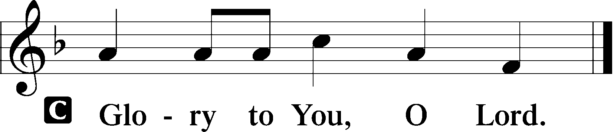

13Now when Jesus came into the district of Caesarea Philippi, he asked his disciples, “Who do people say that the Son of Man is?” 14And they said, “Some say John the Baptist, others say Elijah, and others Jeremiah or one of the prophets.” 15He said to them, “But who do you say that I am?” 16Simon Peter replied, “You are the Christ, the Son of the living God.” 17And Jesus answered him, “Blessed are you, Simon Bar-Jonah! For flesh and blood has not revealed this to you, but my Father who is in heaven. 18And I tell you, you are Peter, and on this rock I will build my church, and the gates of hell shall not prevail against it. 19I will give you the keys of the kingdom of heaven, and whatever you bind on earth shall be bound in heaven, and whatever you loose on earth shall be loosed in heaven.” 20Then he strictly charged the disciples to tell no one that he was the Christ.

L This is the Gospel of the Lord.

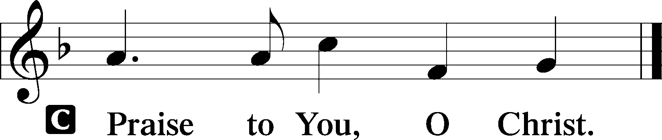

(Sit)

645 BUILT ON THE ROCK
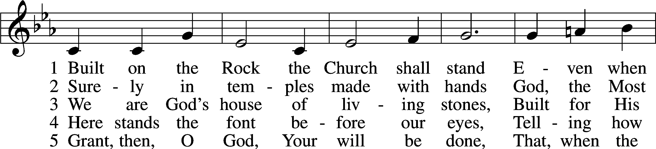
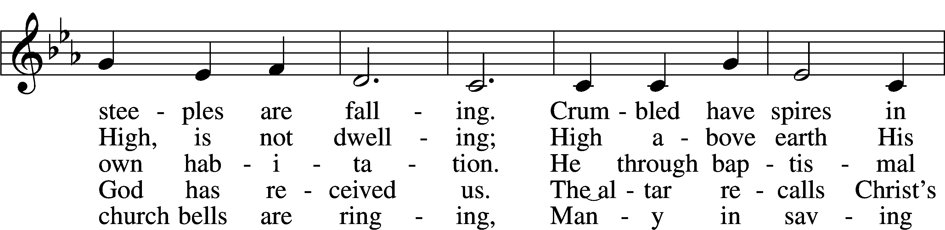
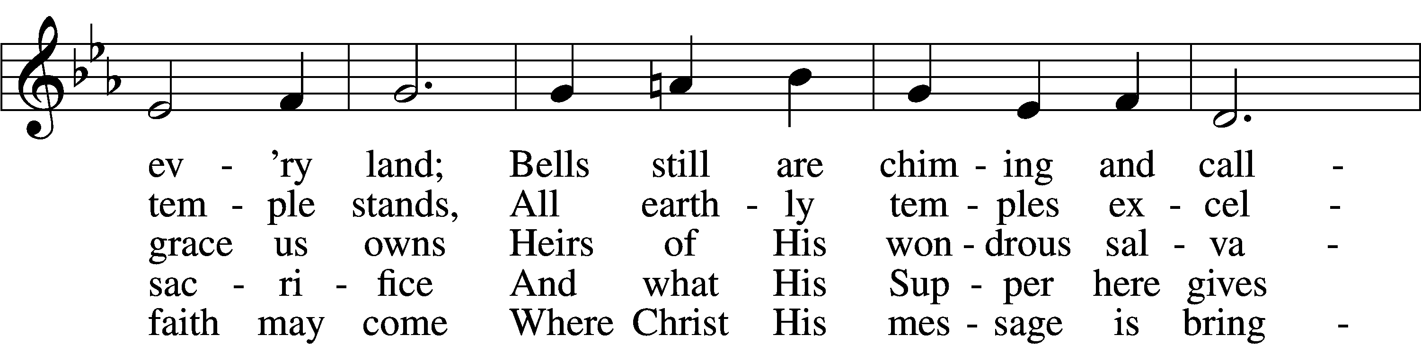
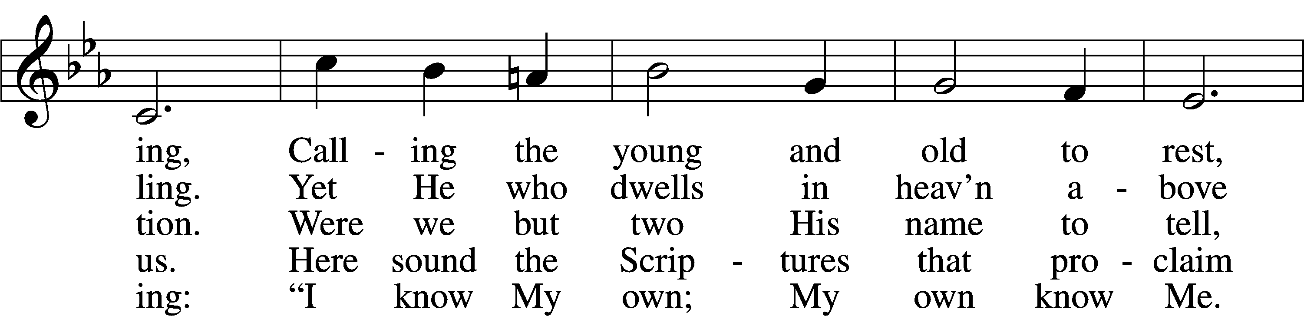
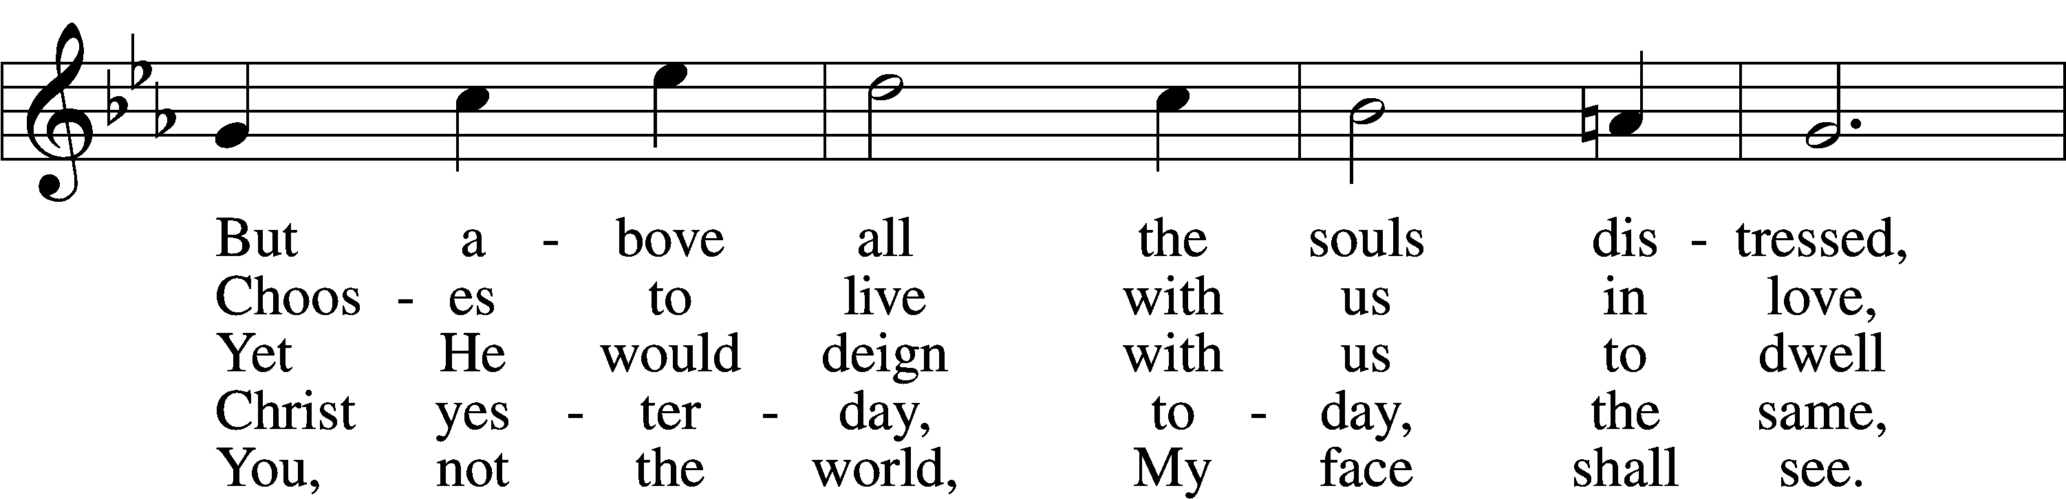
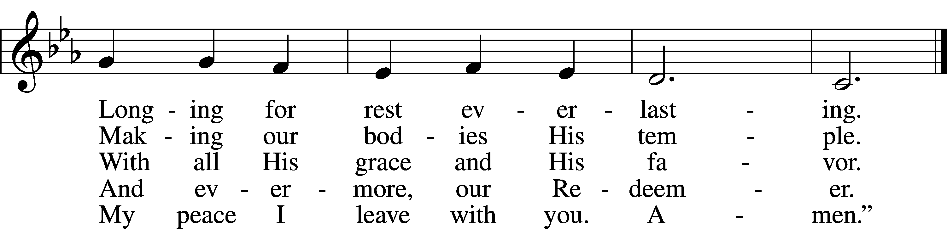
Text: Nikolai Fredrik Severin Grundtvig, 1783–1872, abr.; tr. Carl Döving, 1867–1937, alt.
Tune: Ludvig M. Lindeman, 1812–87
Text and tune: Public domain

SERMON

(Sermons for Elder led services are provided courtesy of the Lutheran Church - Canada (https://www.lutheranchurchcanada.ca/resources/written-sermons/), a member of the International Lutheran Council (https://ilcouncil.org/) with whom the Lutheran Church - Missouri Synod (https://www.lcms.org/) is in altar and pulpit fellowship.)

473 OUR PASCHAL LAMB, THAT SETS US FREE
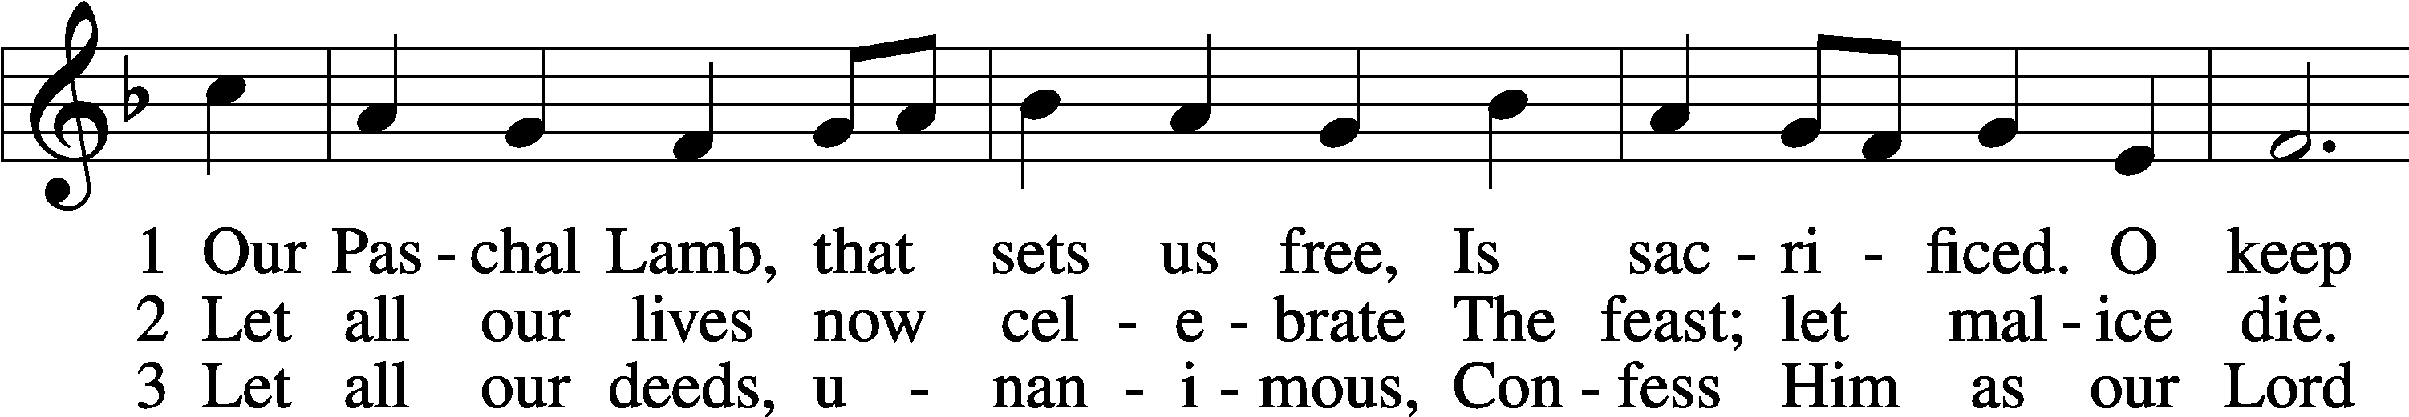
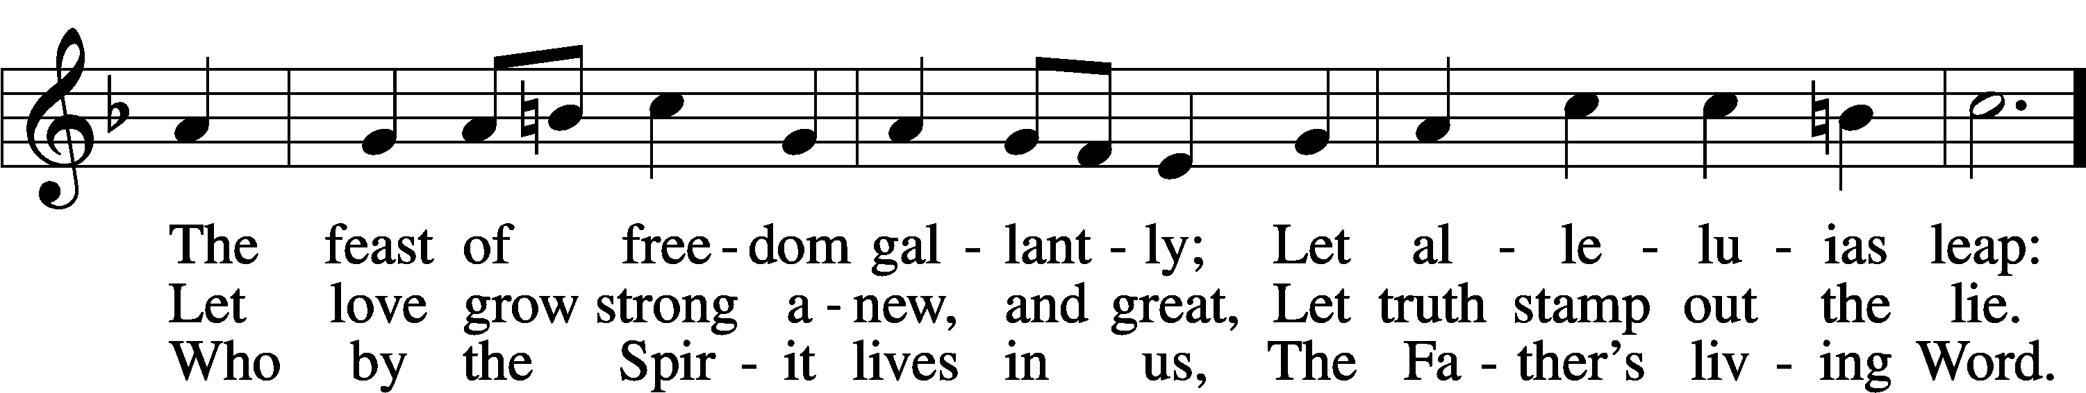
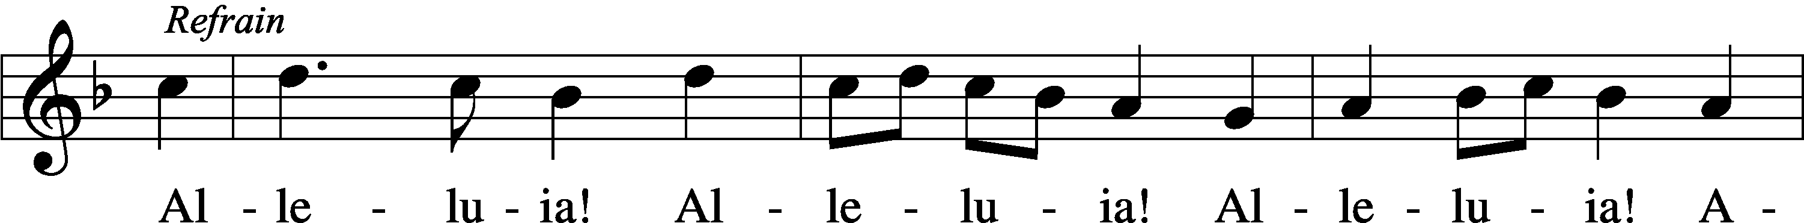
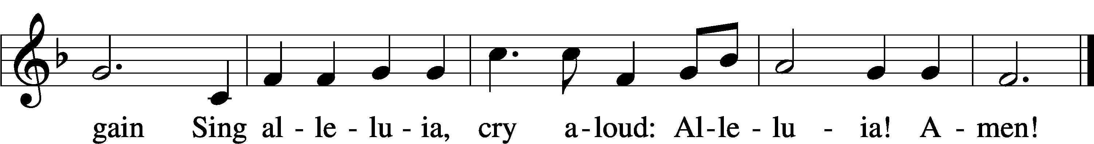
Text: Martin H. Franzmann, 1907–76
Tune: Walter L. Pelz, 1926
Text and tune: © 1974 Augsburg Publishing House. Used by permission: LSB Hymn License no. 110004798

(Stand)

APOSTLES’ CREED LSB 159
C I believe in God, the Father Almighty,
maker of heaven and earth.

And in Jesus Christ, His only Son, our Lord,
who was conceived by the Holy Spirit,
born of the virgin Mary,
suffered under Pontius Pilate,
was crucified, died and was buried.
He descended into hell.
The third day He rose again from the dead.
He ascended into heaven
and sits at the right hand of God the Father Almighty.
From thence He will come to judge the living and the dead.

I believe in the Holy Spirit,
the holy Christian Church,
the communion of saints,
the forgiveness of sins,
the resurrection of the body,
and the life T everlasting. Amen.

SHARING OF THE PEACE

(The people may greet one another in the name of the Lord, saying, “Peace be with you,” as a sign of reconciliation and of the unity of the Spirit in the bond of peace (Matt. 5:22–24; Eph. 4:1–3).)

(Sit)

PRAYER OF THE CHURCH

OFFERING

(As a part of our expression of thanksgiving to God for the treasure of His salvation to us, we offer a portion of our treasure, according to what each has determined in their heart to give. Please place offerings in the collection plate at the back of the sanctuary before or after the service. Offerings can also be sent to Bethlehem Lutheran Church via U.S. Mail. Thank you!)

(Stand)

OFFERTORY LSB 159
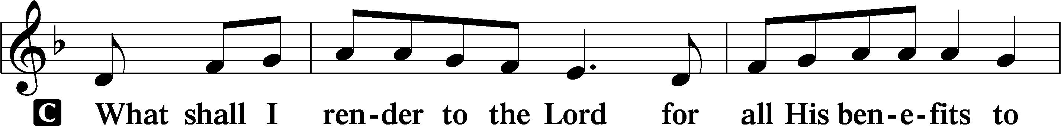
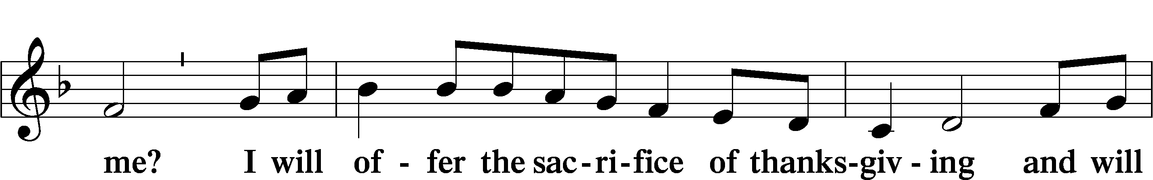
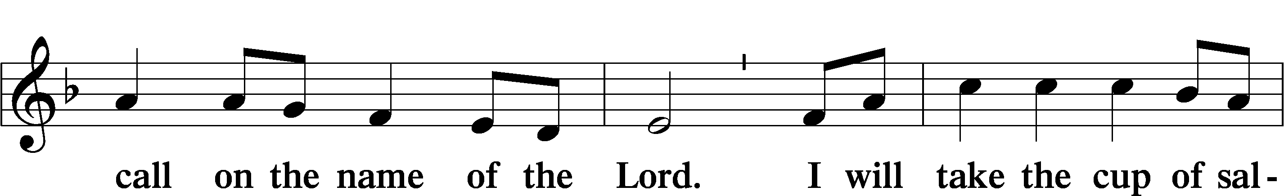
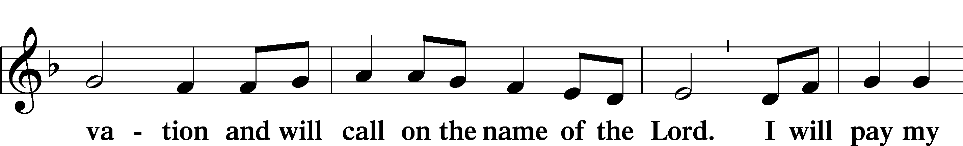
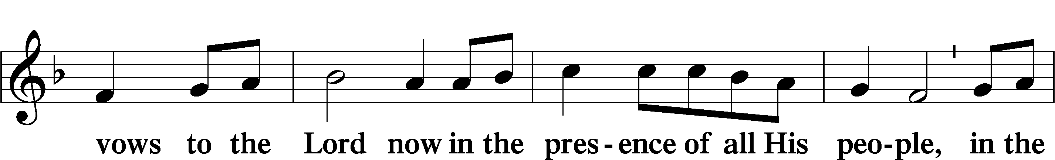
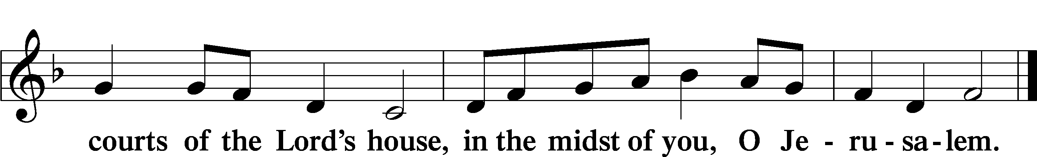

LORD’S PRAYER LSB 162
L Lord, remember us in Your kingdom and teach us to pray:
C Our Father who art in heaven,
hallowed be Thy name,
Thy kingdom come,
Thy will be done on earth
as it is in heaven;
give us this day our daily bread;
and forgive us our trespasses
as we forgive those
who trespass against us;
and lead us not into temptation,
but deliver us from evil.
For Thine is the kingdom
and the power and the glory
forever and ever. Amen.

CONCLUDING COLLECT

BENEDICTION LSB 166
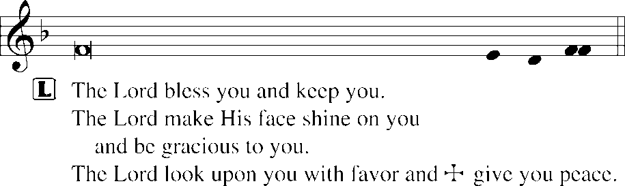


909 CHRIST IS MADE THE SURE FOUNDATION
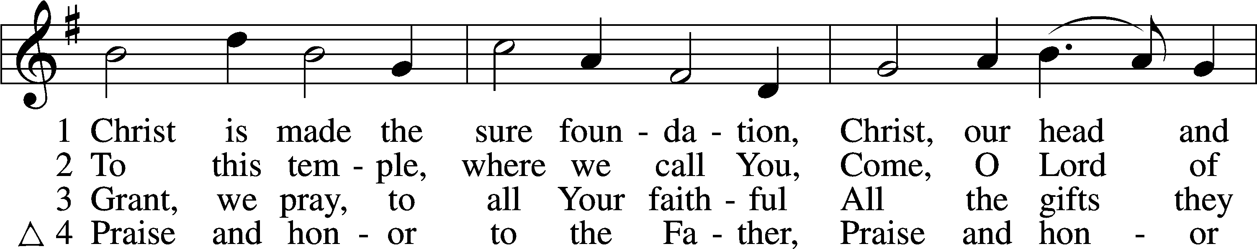
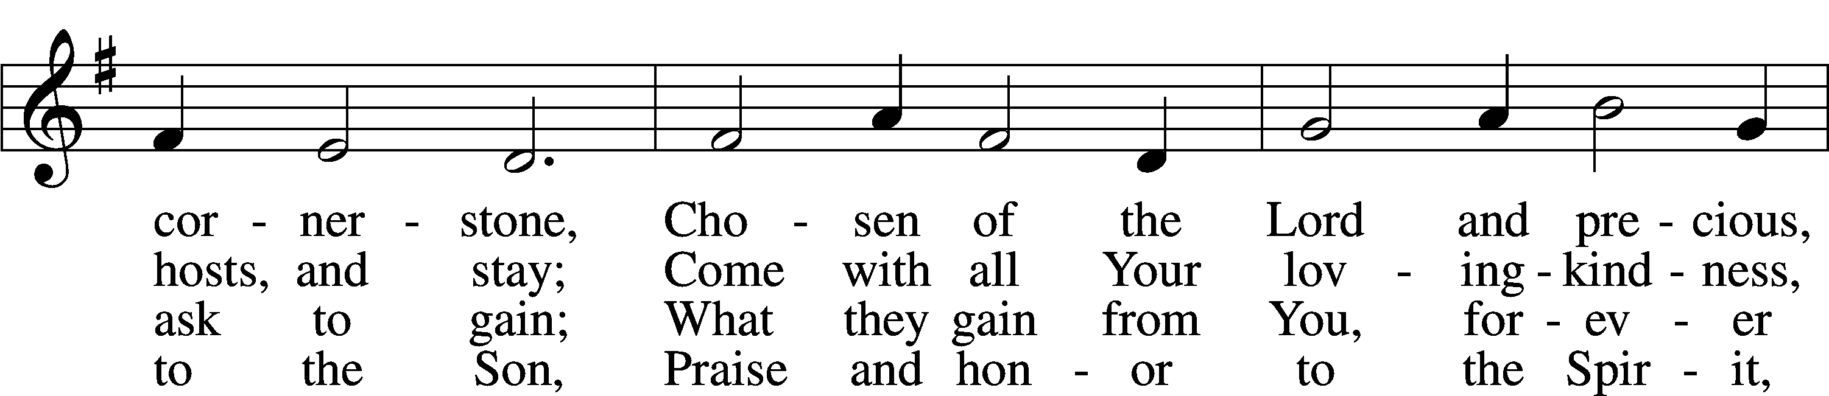
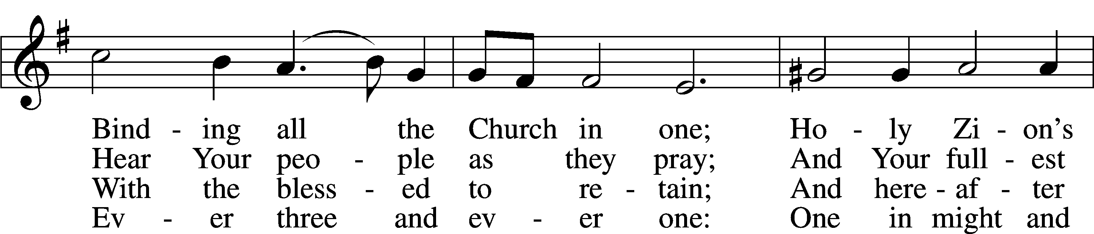
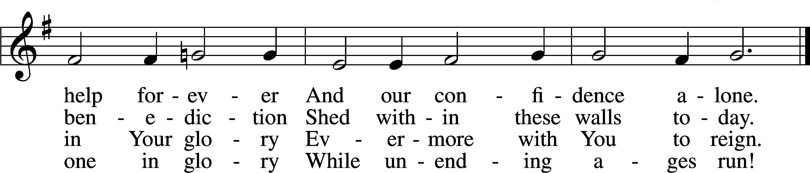
Text: Latin, c. 8th cent.; tr. John Mason Neale, 1818–66, alt.
Tune: Henry Purcell, 1659–95, adapt.
Text and tune: Public domain

ACKNOWLEDGMENTS
Unless otherwise indicated, Scripture quotations are from the ESV® Bible (The Holy Bible, English Standard Version®), copyright © 2001 by Crossway, a publishing ministry of Good News Publishers. Used by permission. All rights reserved.
Created by Lutheran Service Builder © 2026 Concordia Publishing House.

