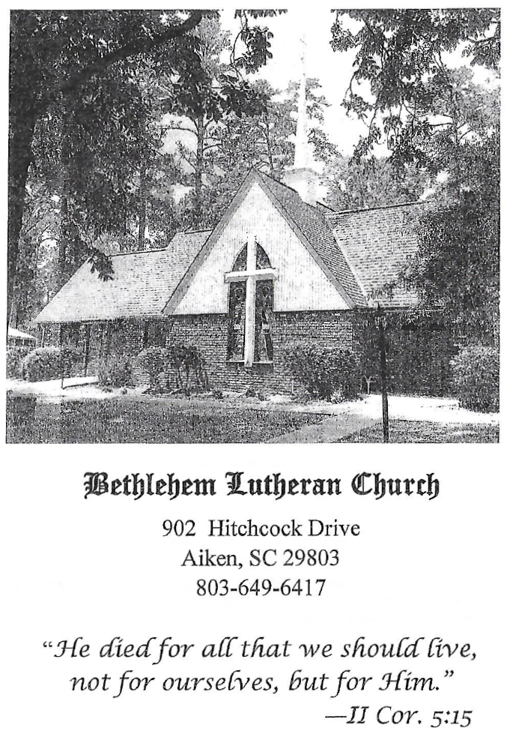

BETHLEHEM LUTHERAN CHURCH
A congregation of The Lutheran Church-Missouri Synod
902 Hitchcock Drive SW,
Aiken, South Carolina 29803
Church Phone: (803) 649-6417
blcaikensc@gmail.com

Bethlehem Lutheran welcomes our members and guests to our worship service! Unable to join us in person? Please find us on Facebook live. The service is also posted on our website; bethlehemlutheranaiken.org.

+ + + + + + + + + + + + + + +
Twenty-First Sunday after Pentecost
October 18, 2026
10:30 a.m.
+ + + + + + + + + + + + + + +

+ SERVICE OF PREPARATION +

(After the bell tolls, please observe a time of silence.)

WELCOME AND ANNOUNCEMENTS

(Stand)

726 EVENING AND MORNING
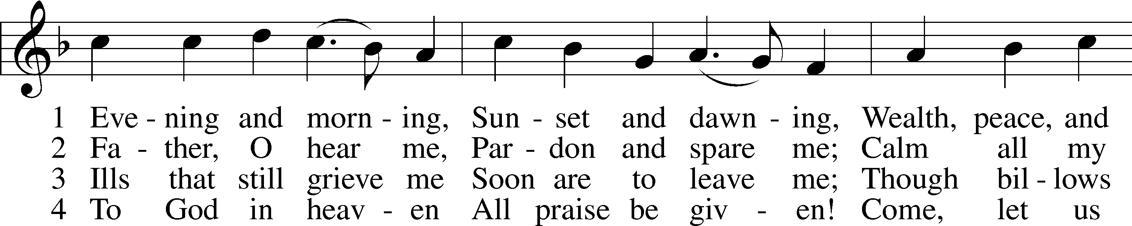
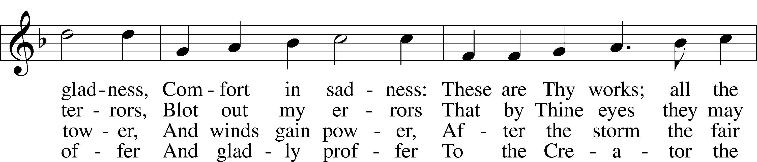
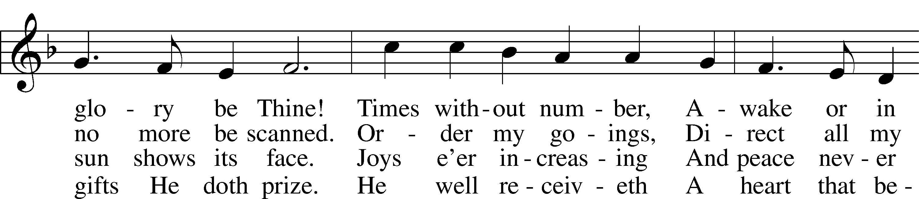
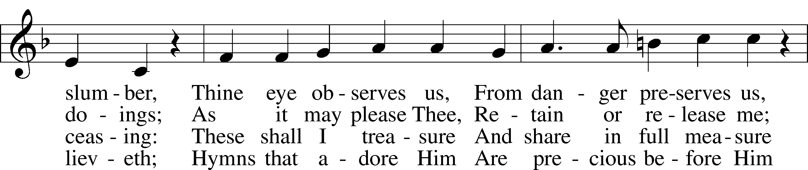
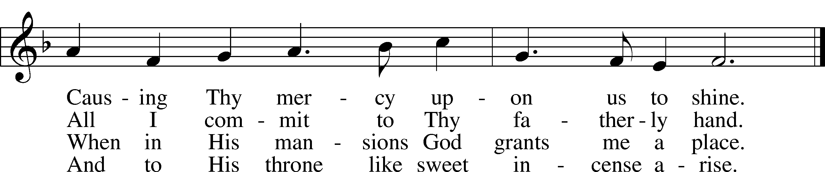
Text: Paul Gerhardt, 1607–76; (sts. 1–2): tr. Richard Massie, 1800–87, alt.; (sts. 3–4): tr. Hermann H. M. Brueckner, 1866–1942, alt.
Tune: Johann G. Ebeling, 1637–76
Text and tune: Public domain

+ CONFESSION AND ABSOLUTION +

(The sign of the cross may be made by all in remembrance of their Baptism.)

INVOCATION LSB 151
L In the name of the Father and of the T Son and of the Holy Spirit.
C Amen.

EXHORTATION LSB 151
L If we say we have no sin, we deceive ourselves, and the truth is not in us.
C But if we confess our sins, God, who is faithful and just, will forgive our sins and cleanse us from all unrighteousness.

(Silence for reflection on God’s Word and for self-examination.)

CONFESSION OF SINS LSB 151
L Let us then confess our sins to God our Father.
C Most merciful God, we confess that we are by nature sinful and unclean. We have sinned against You in thought, word, and deed, by what we have done and by what we have left undone. We have not loved You with our whole heart; we have not loved our neighbors as ourselves. We justly deserve Your present and eternal punishment. For the sake of Your Son, Jesus Christ, have mercy on us. Forgive us, renew us, and lead us, so that we may delight in Your will and walk in Your ways to the glory of Your holy name. Amen.

DECLARATION OF GRACE LSB 151
L In the mercy of almighty God, Jesus Christ was given to die for us, and for His sake God forgives us all our sins. To those who believe in Jesus Christ He gives the power to become the children of God and bestows on them the Holy Spirit. May the Lord, who has begun this good work in us, bring it to completion in the day of our Lord Jesus Christ.
C Amen.

+ SERVICE OF THE WORD +

INTROIT Psalm 121:1–4, 7–8; antiphon: v. 5
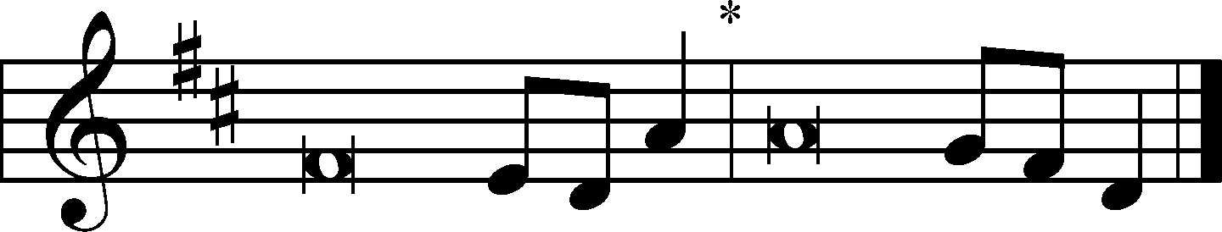
The Lord is your | keeper;*
the Lord is your shade on your | right hand.
I lift up my eyes | to the hills.*
From where does my | help come?
My help comes | from the Lord,*
who made | heaven and earth.
He will not let your | foot be moved;*
he who keeps you will not | slumber.
Behold, he who keeps | Israel*
will neither slum- | ber nor sleep.
The Lord will keep you from all | evil;*
he will | keep your life.
The Lord will keep your going out and your | coming in*
from this time forth and for- | evermore.
Glory be to the Father and | to the Son*
and to the Holy | Spirit;
as it was in the be- | ginning,*
is now, and will be forever. | Amen.
The Lord is your | keeper;*
the Lord is your shade on your | right hand.

KYRIE LSB 152
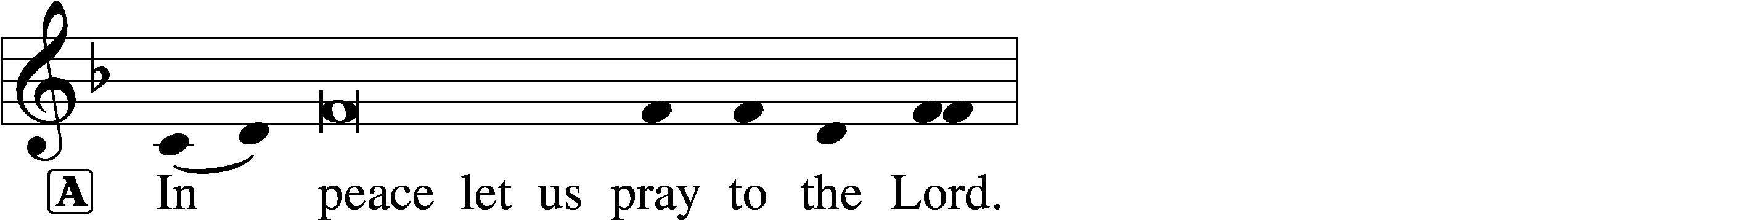
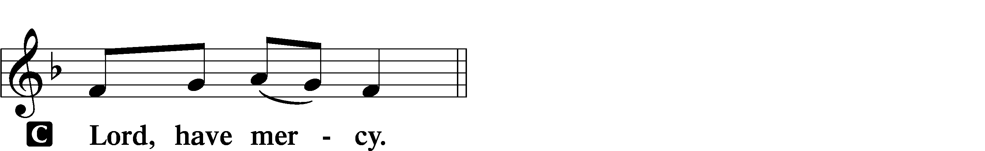

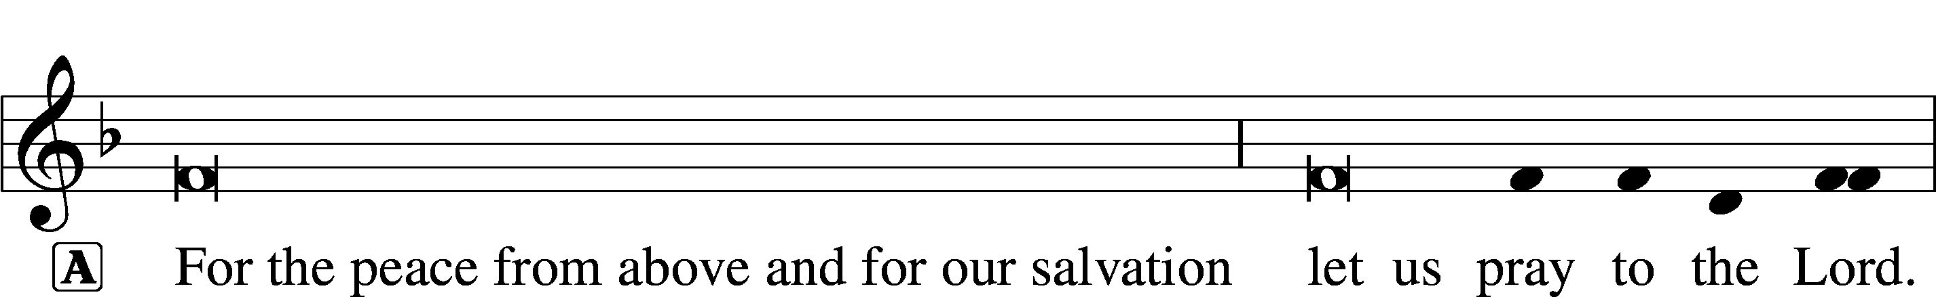

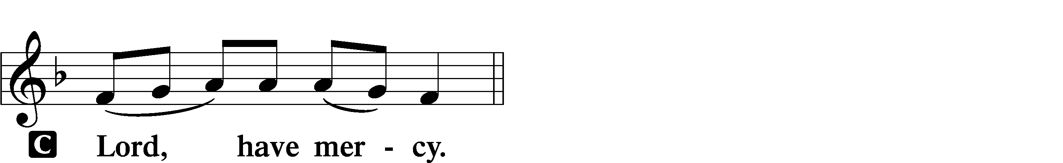

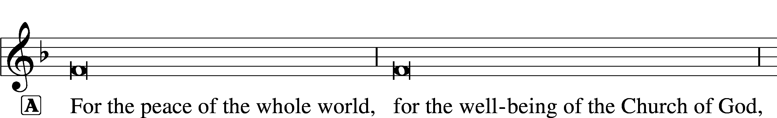
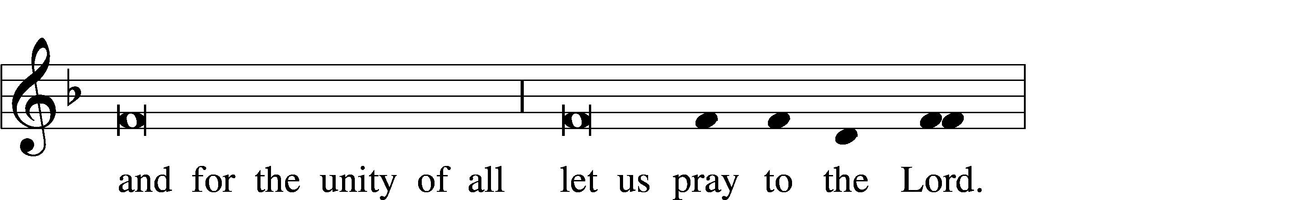
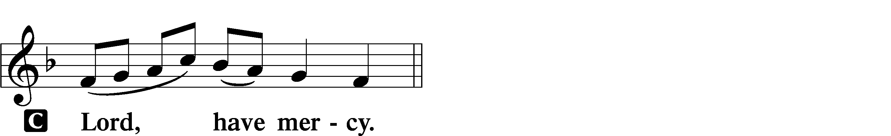

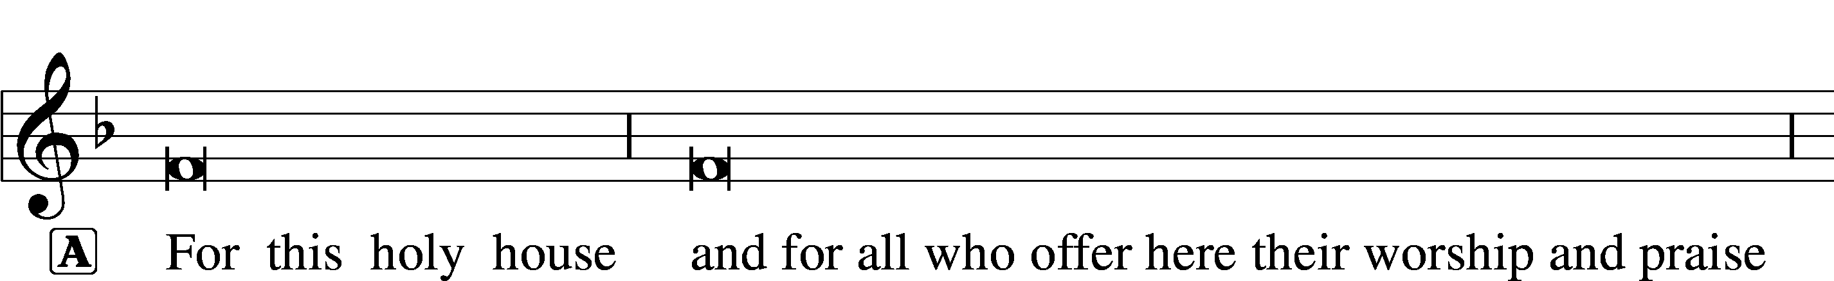
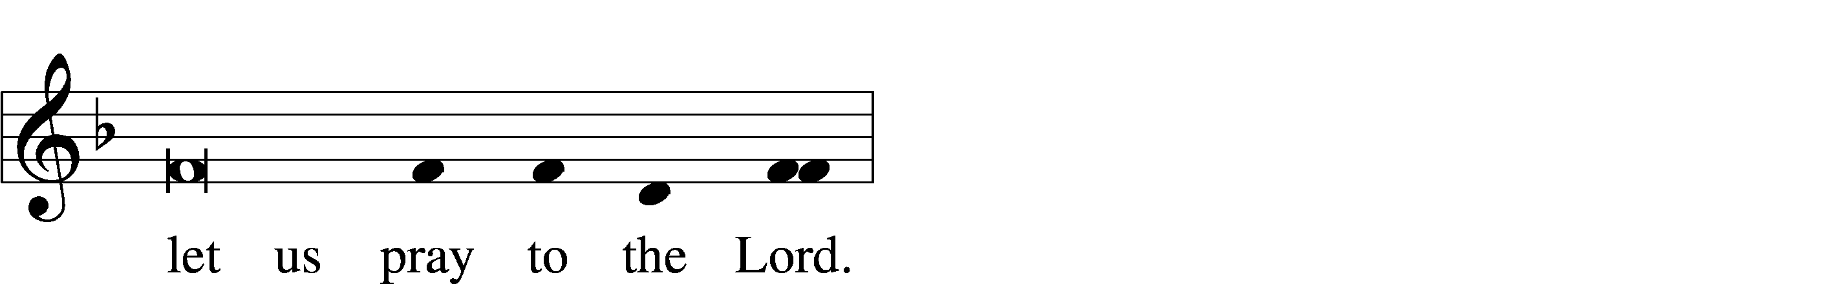
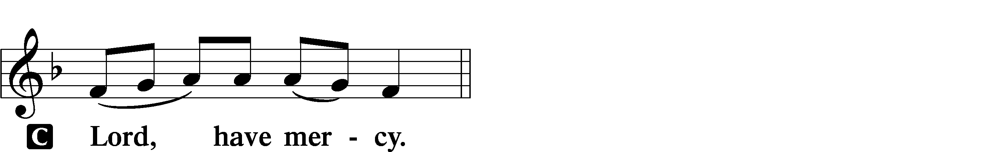

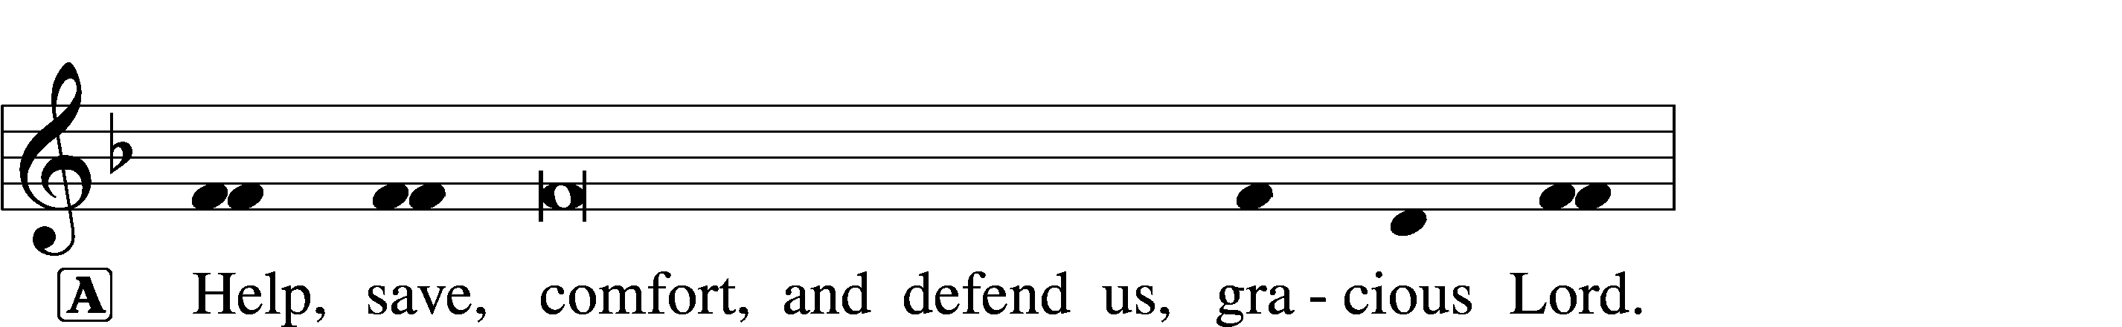
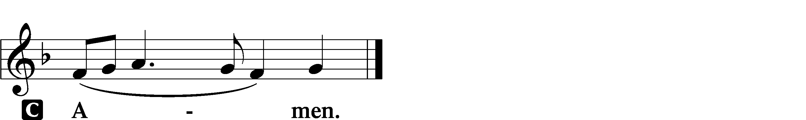

GLORIA IN EXCELSIS LSB 154
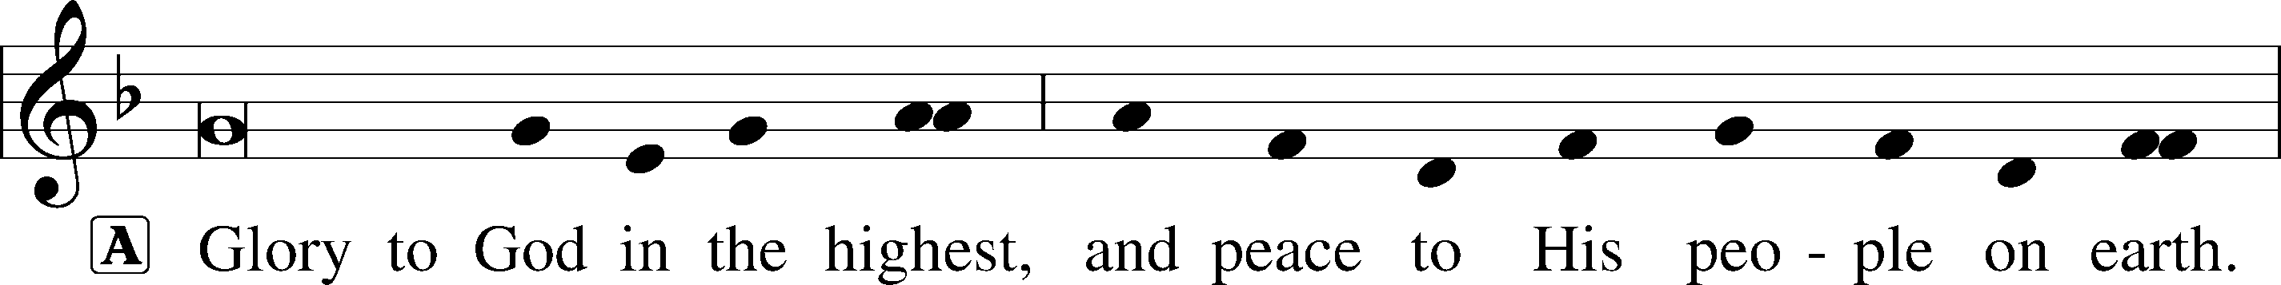
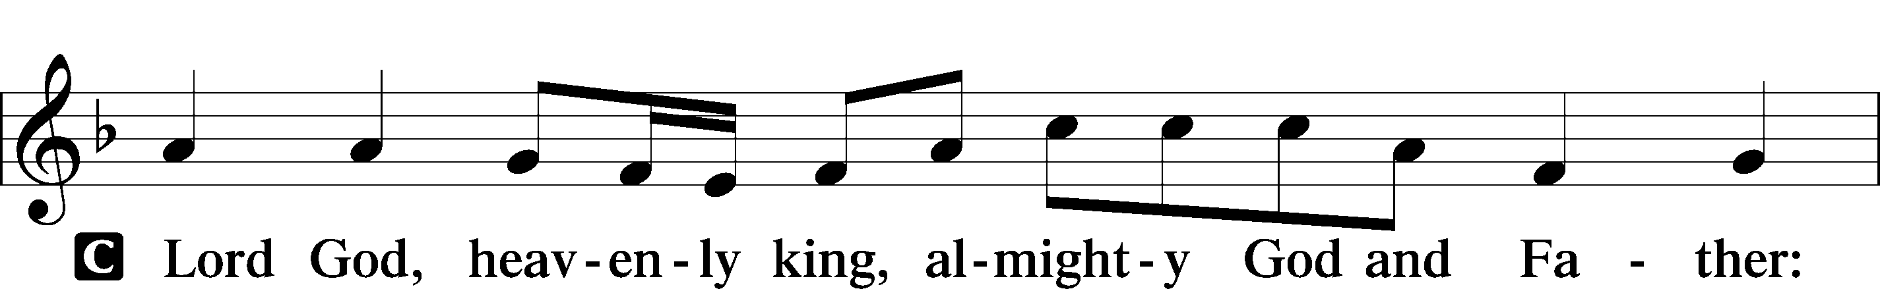
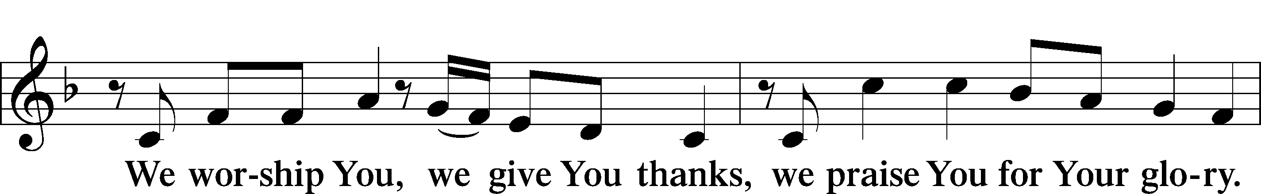
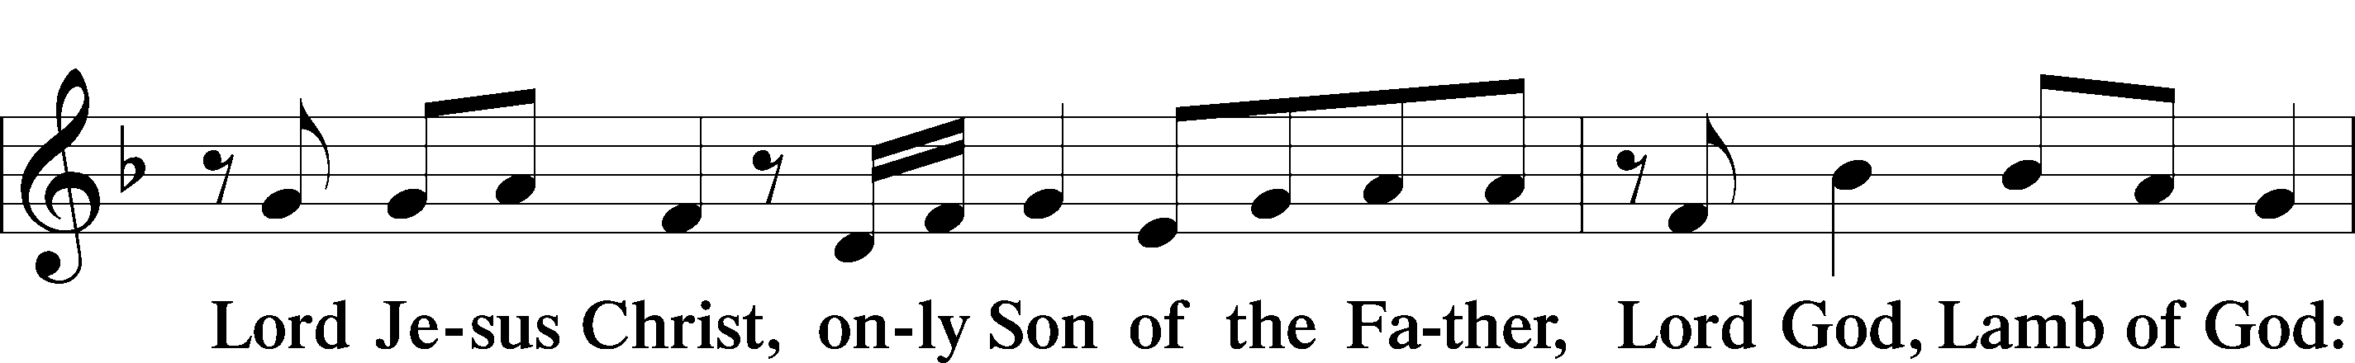
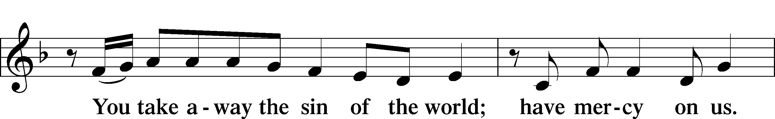
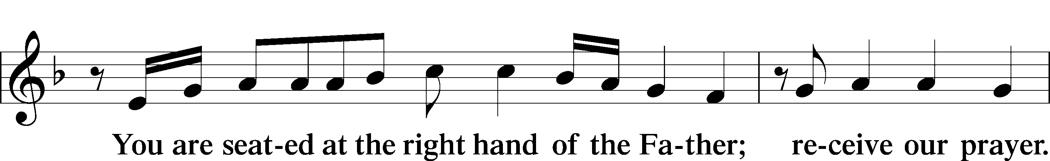
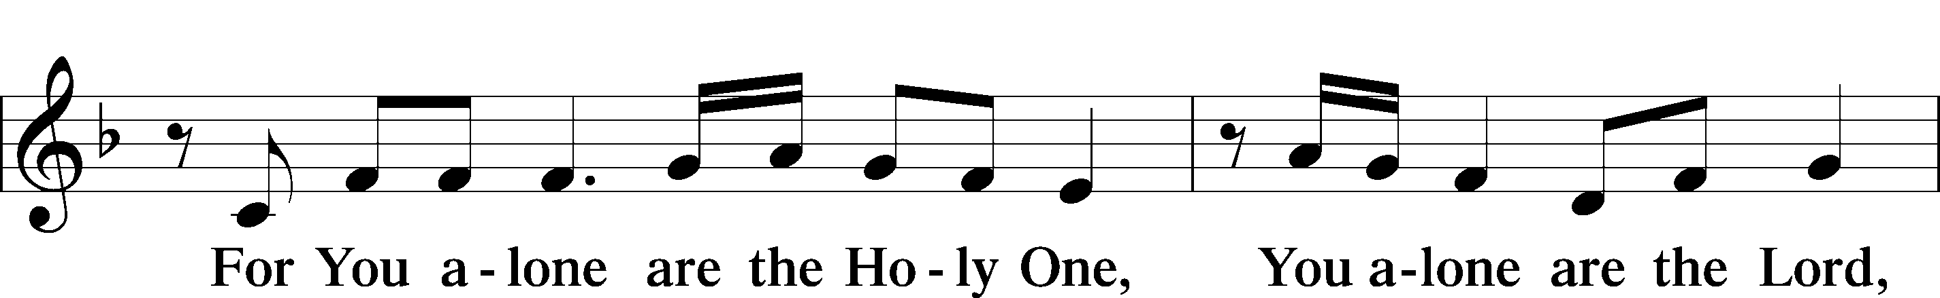
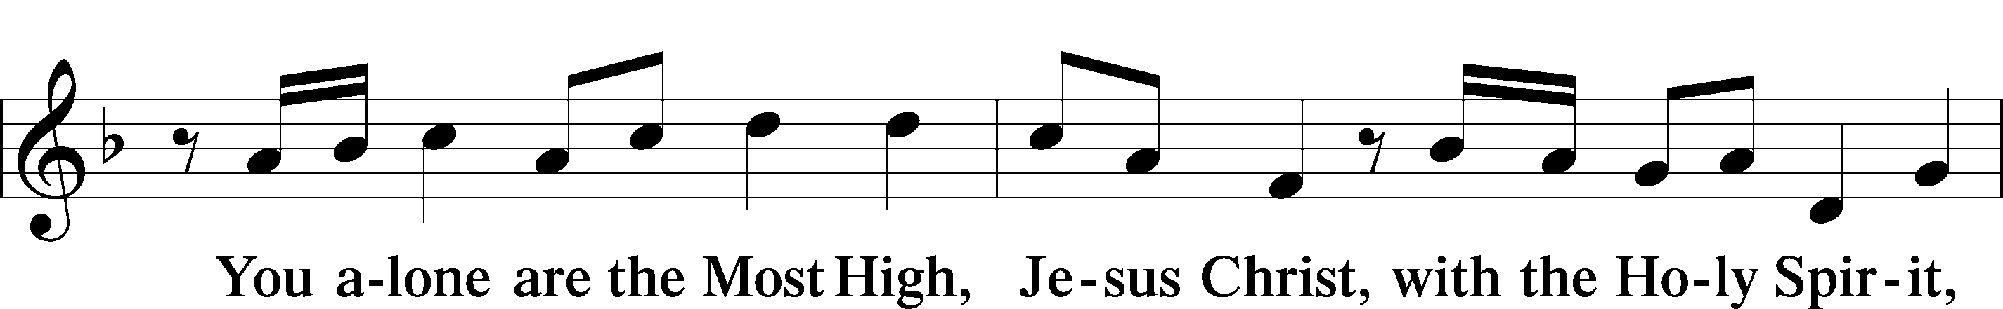
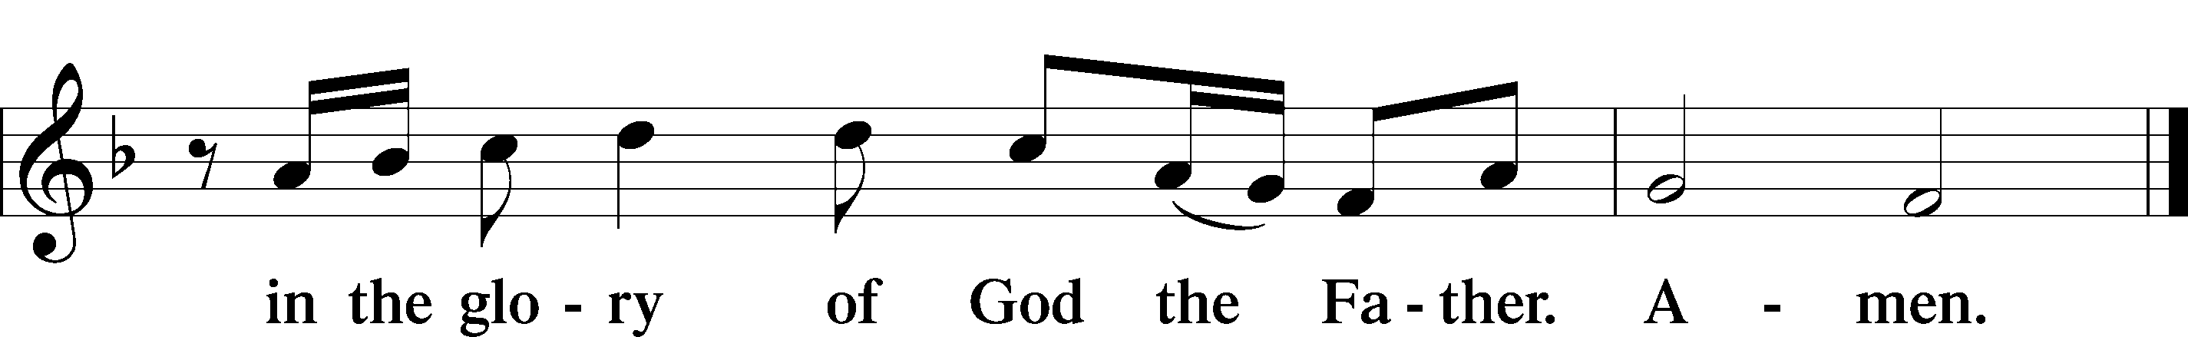

SALUTATION AND COLLECT OF THE DAY LSB 156
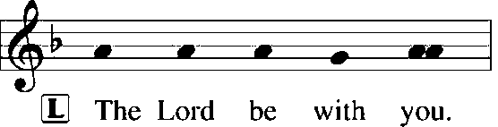
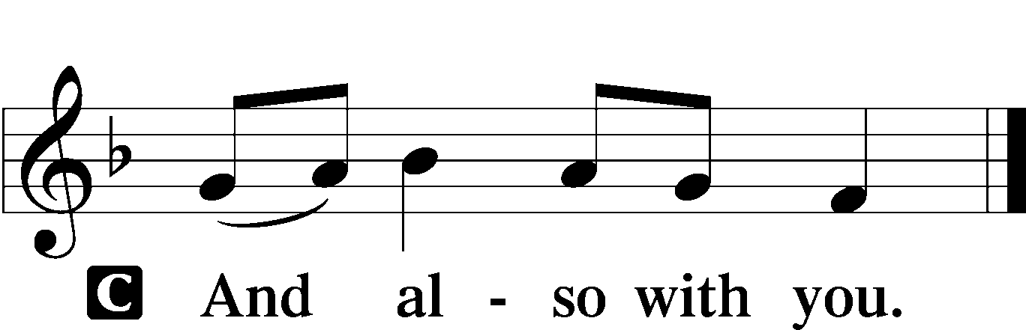

L Let us pray.
O God, the protector of all who trust in You, have mercy on us that with You as our ruler and guide we may so pass through things temporal that we lose not the things eternal; through Jesus Christ, Your Son, our Lord, who lives and reigns with You and the Holy Spirit, one God, now and forever.

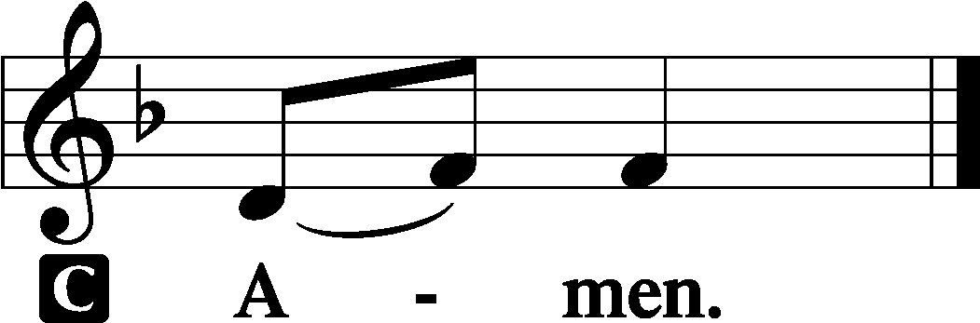

(Sit)

OLD TESTAMENT READING Isaiah 45:1–7
1Thus says the Lord to his anointed, to Cyrus,
whose right hand I have grasped,
to subdue nations before him
and to loose the belts of kings,
to open doors before him
that gates may not be closed:
2“I will go before you
and level the exalted places,
I will break in pieces the doors of bronze
and cut through the bars of iron,
3I will give you the treasures of darkness
and the hoards in secret places,
that you may know that it is I, the Lord,
the God of Israel, who call you by your name.
4For the sake of my servant Jacob,
and Israel my chosen,
I call you by your name,
I name you, though you do not know me.
5I am the Lord, and there is no other,
besides me there is no God;
I equip you, though you do not know me,
6that people may know, from the rising of the sun
and from the west, that there is none besides me;
I am the Lord, and there is no other.
7I form light and create darkness,
I make well-being and create calamity,
I am the Lord, who does all these things.”

L This is the Word of the Lord.
C Thanks be to God.

GRADUAL Psalm 91:11; 103:1
He will command his angels con- | cerning you*
to guard you in | all your ways.
Bless the Lord, | O my soul,*
and all that is within me, bless his | holy name!

EPISTLE 1 Thessalonians 1:1–10
1Paul, Silvanus, and Timothy,
To the church of the Thessalonians in God the Father and the Lord Jesus Christ:
Grace to you and peace.
2We give thanks to God always for all of you, constantly mentioning you in our prayers, 3remembering before our God and Father your work of faith and labor of love and steadfastness of hope in our Lord Jesus Christ. 4For we know, brothers loved by God, that he has chosen you, 5because our gospel came to you not only in word, but also in power and in the Holy Spirit and with full conviction. You know what kind of men we proved to be among you for your sake. 6And you became imitators of us and of the Lord, for you received the word in much affliction, with the joy of the Holy Spirit, 7so that you became an example to all the believers in Macedonia and in Achaia. 8For not only has the word of the Lord sounded forth from you in Macedonia and Achaia, but your faith in God has gone forth everywhere, so that we need not say anything. 9For they themselves report concerning us the kind of reception we had among you, and how you turned to God from idols to serve the living and true God, 10and to wait for his Son from heaven, whom he raised from the dead, Jesus who delivers us from the wrath to come.

L This is the Word of the Lord.
C Thanks be to God.

(Stand)

ALLELUIA AND VERSE LSB 156
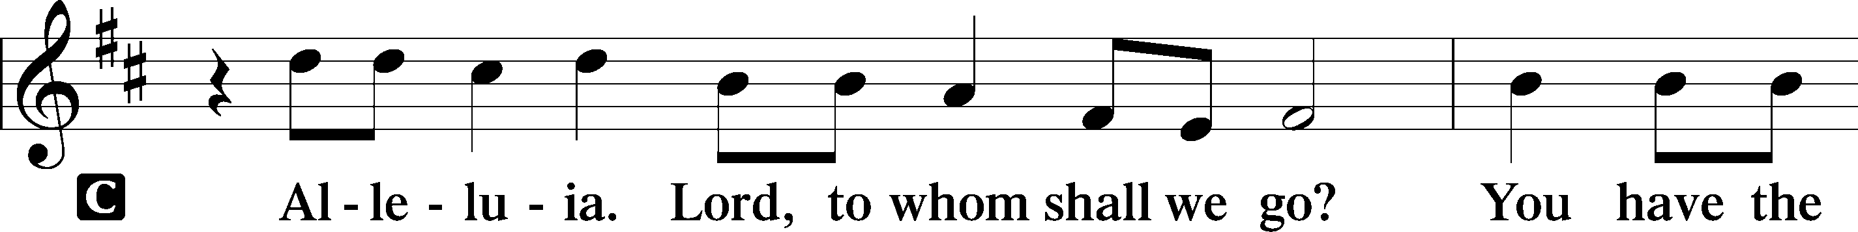
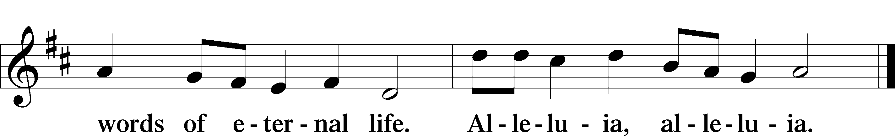

HOLY GOSPEL Matthew 22:15–22
L The Holy Gospel according to St. Matthew, the twenty-second chapter.

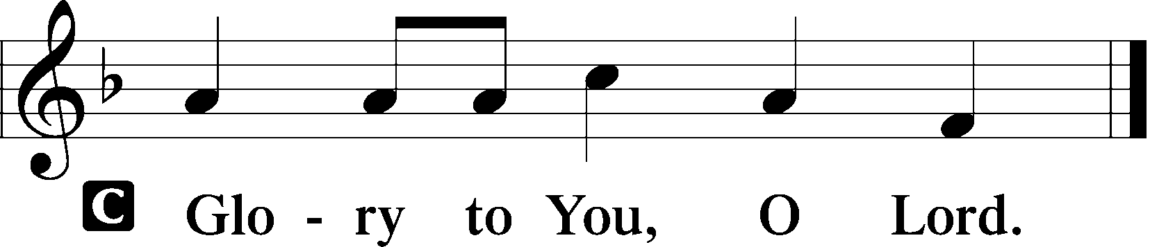

15Then the Pharisees went and plotted how to entangle [Jesus] in his talk. 16And they sent their disciples to him, along with the Herodians, saying, “Teacher, we know that you are true and teach the way of God truthfully, and you do not care about anyone’s opinion, for you are not swayed by appearances. 17Tell us, then, what you think. Is it lawful to pay taxes to Caesar, or not?” 18But Jesus, aware of their malice, said, “Why put me to the test, you hypocrites? 19Show me the coin for the tax.” And they brought him a denarius. 20And Jesus said to them, “Whose likeness and inscription is this?” 21They said, “Caesar’s.” Then he said to them, “Therefore render to Caesar the things that are Caesar’s, and to God the things that are God’s.” 22When they heard it, they marveled. And they left him and went away.

L This is the Gospel of the Lord.

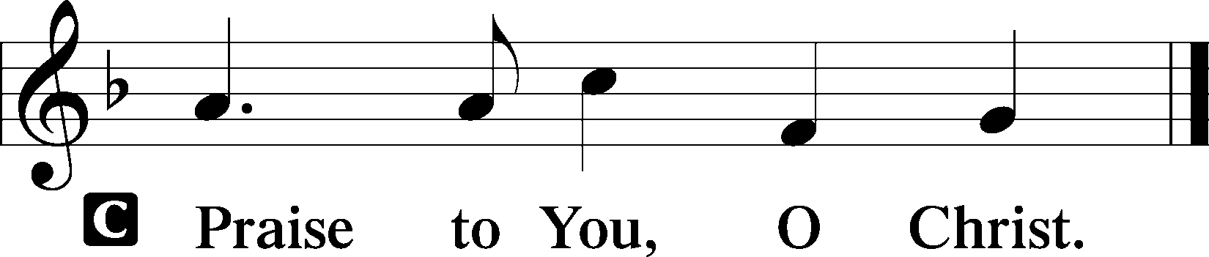

(Sit)

940 HOLY GOD, WE PRAISE THY NAME sts. 1–5
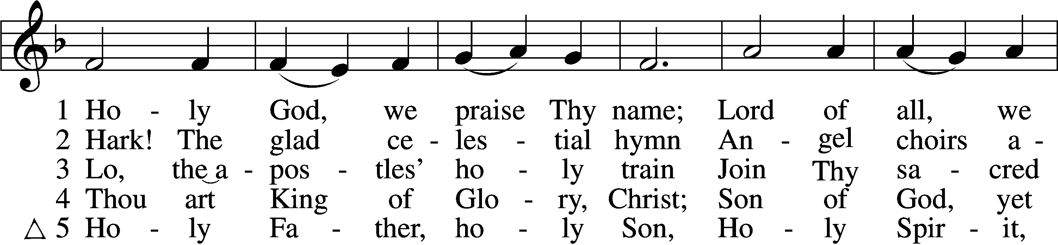
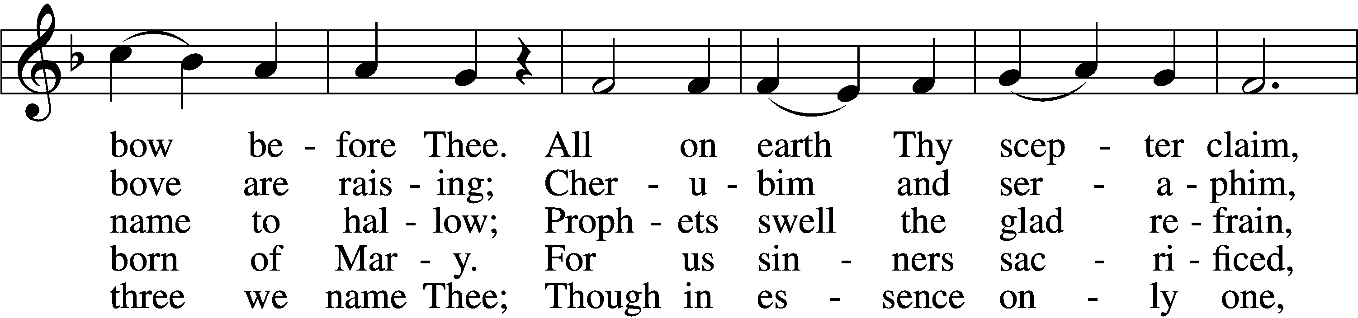
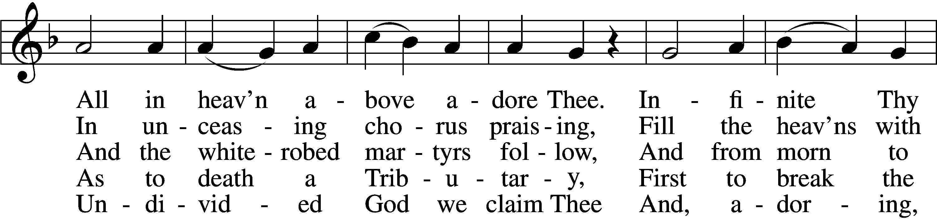
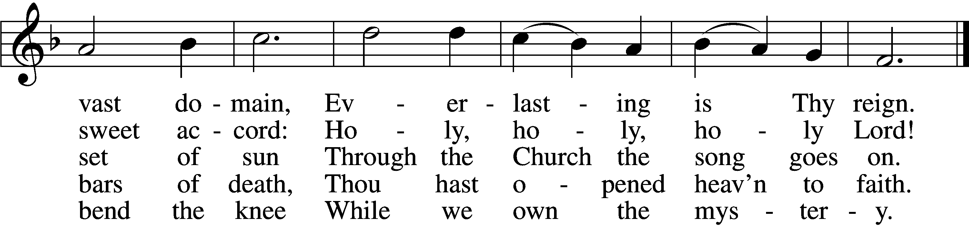
Text: Latin, c. 4th cent.; German version Katholisches Gesangbuch, 1774, Vienna; tr. Clarence A. Walworth, 1820–1900, alt.
Tune: Katholisches Gesangbuch, 1774, Vienna
Text and tune: Public domain

SERMON

(Sermons for Elder led services are provided courtesy of the Lutheran Church - Canada (https://www.lutheranchurchcanada.ca/resources/written-sermons/), a member of the International Lutheran Council (https://ilcouncil.org/) with whom the Lutheran Church - Missouri Synod (https://www.lcms.org/) is in altar and pulpit fellowship.)

886 THE DAY THOU GAVEST
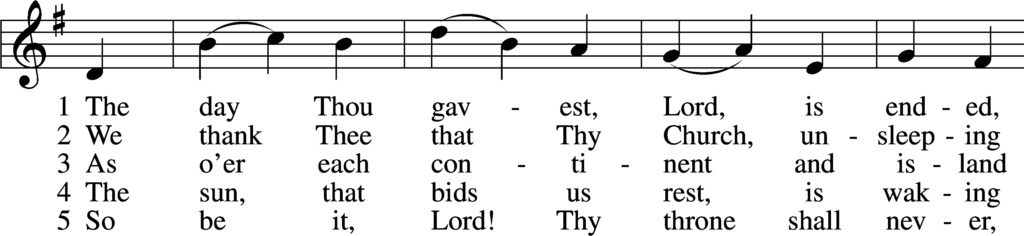
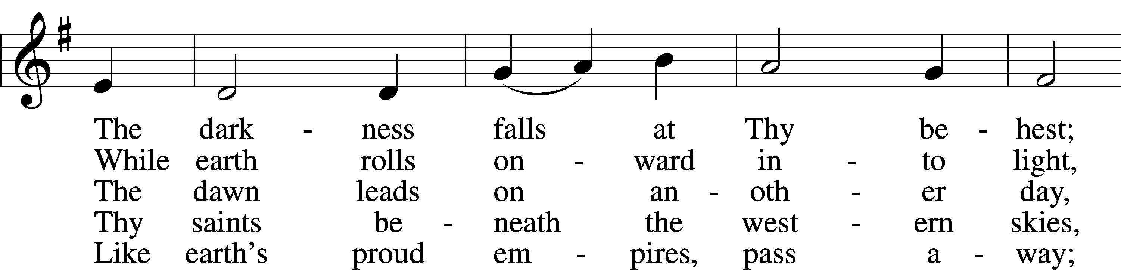
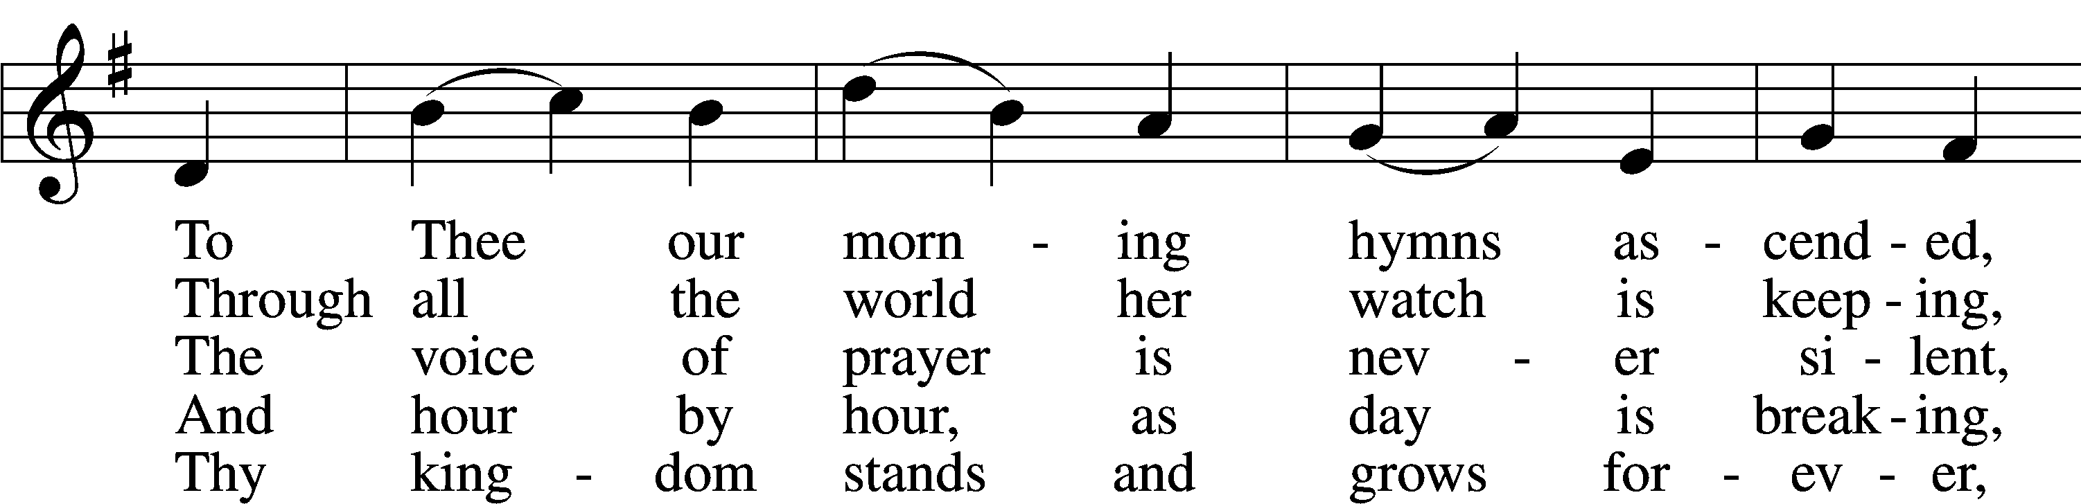
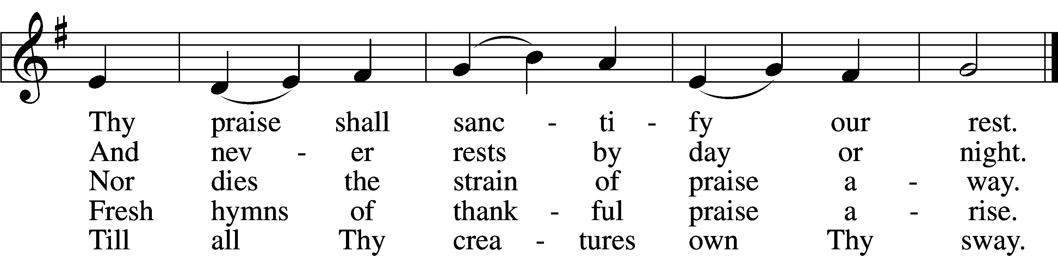
Text: John Ellerton, 1826–93, alt.
Tune: Clement C. Scholefield, 1839–1904
Text and tune: Public domain

(Stand)

APOSTLES’ CREED LSB 159
C I believe in God, the Father Almighty,
maker of heaven and earth.

And in Jesus Christ, His only Son, our Lord,
who was conceived by the Holy Spirit,
born of the virgin Mary,
suffered under Pontius Pilate,
was crucified, died and was buried.
He descended into hell.
The third day He rose again from the dead.
He ascended into heaven
and sits at the right hand of God the Father Almighty.
From thence He will come to judge the living and the dead.

I believe in the Holy Spirit,
the holy Christian Church,
the communion of saints,
the forgiveness of sins,
the resurrection of the body,
and the life T everlasting. Amen.

SHARING OF THE PEACE

(The people may greet one another in the name of the Lord, saying, “Peace be with you,” as a sign of reconciliation and of the unity of the Spirit in the bond of peace (Matt. 5:22–24; Eph. 4:1–3).)

(Sit)

PRAYER OF THE CHURCH

OFFERING

(As a part of our expression of thanksgiving to God for the treasure of His salvation to us, we offer a portion of our treasure, according to what each has determined in their heart to give. Please place offerings in the collection plate at the back of the sanctuary before or after the service. Offerings can also be sent to Bethlehem Lutheran Church via U.S. Mail. Thank you!)

(Stand)

OFFERTORY LSB 159
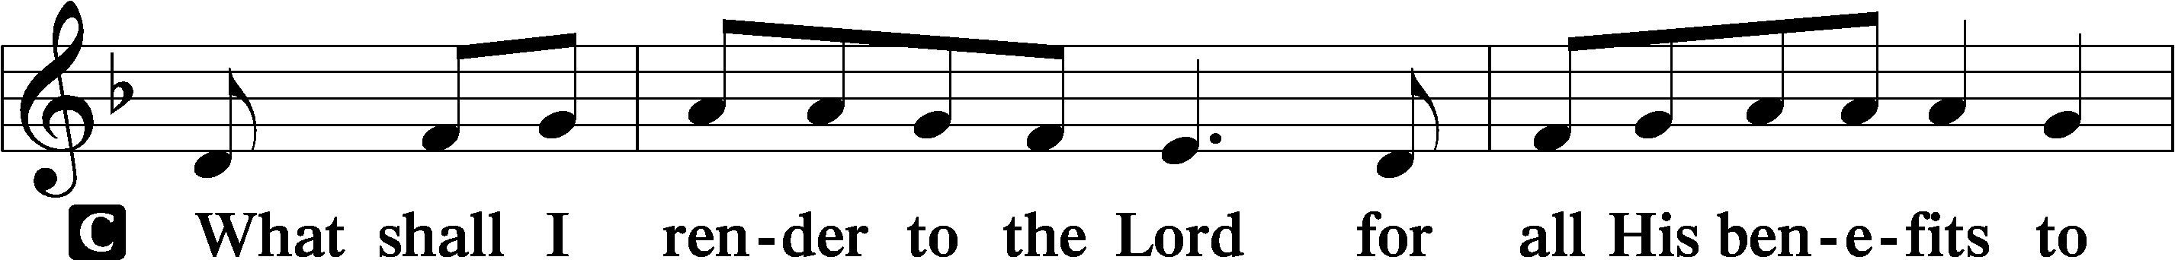
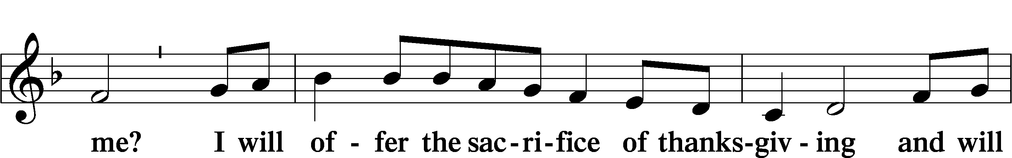
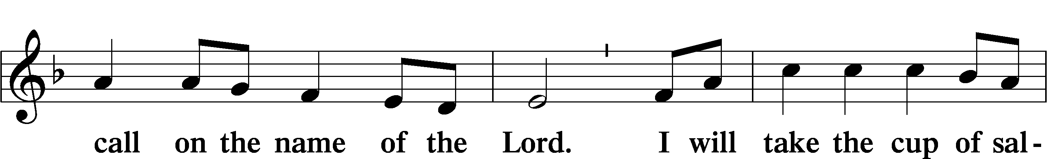
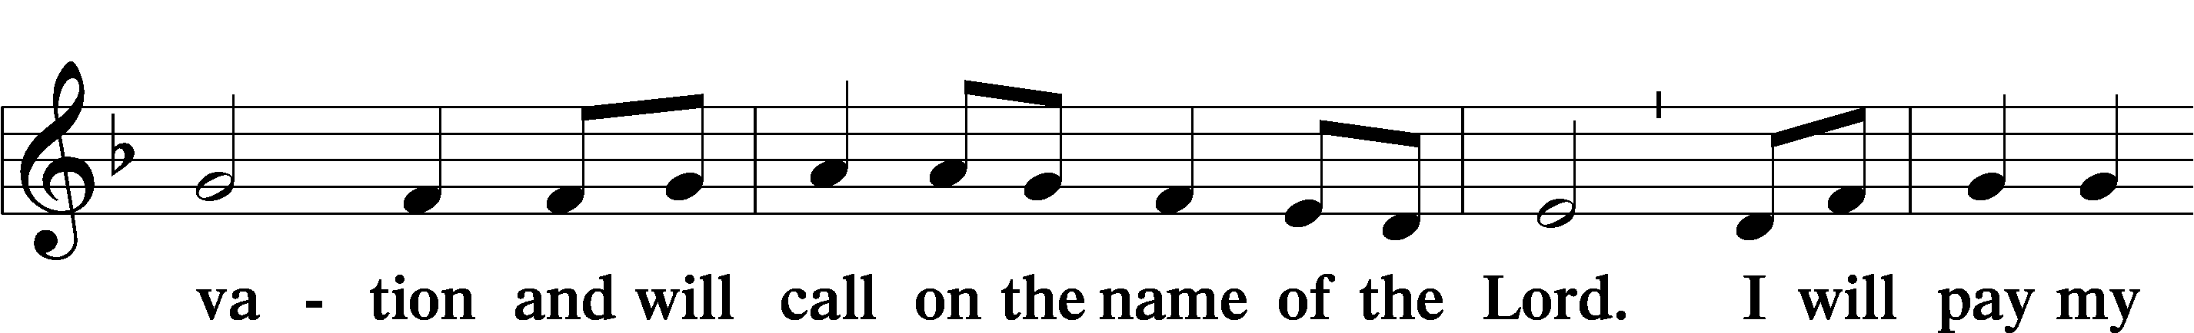
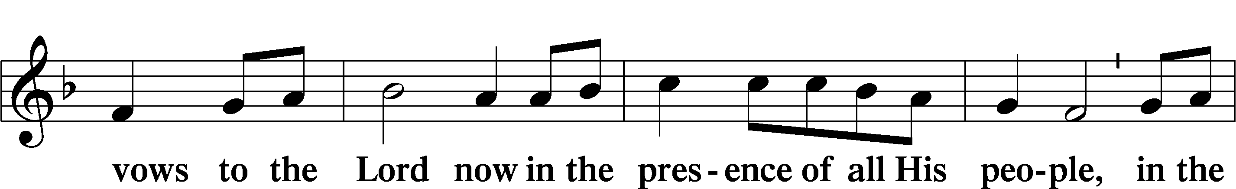
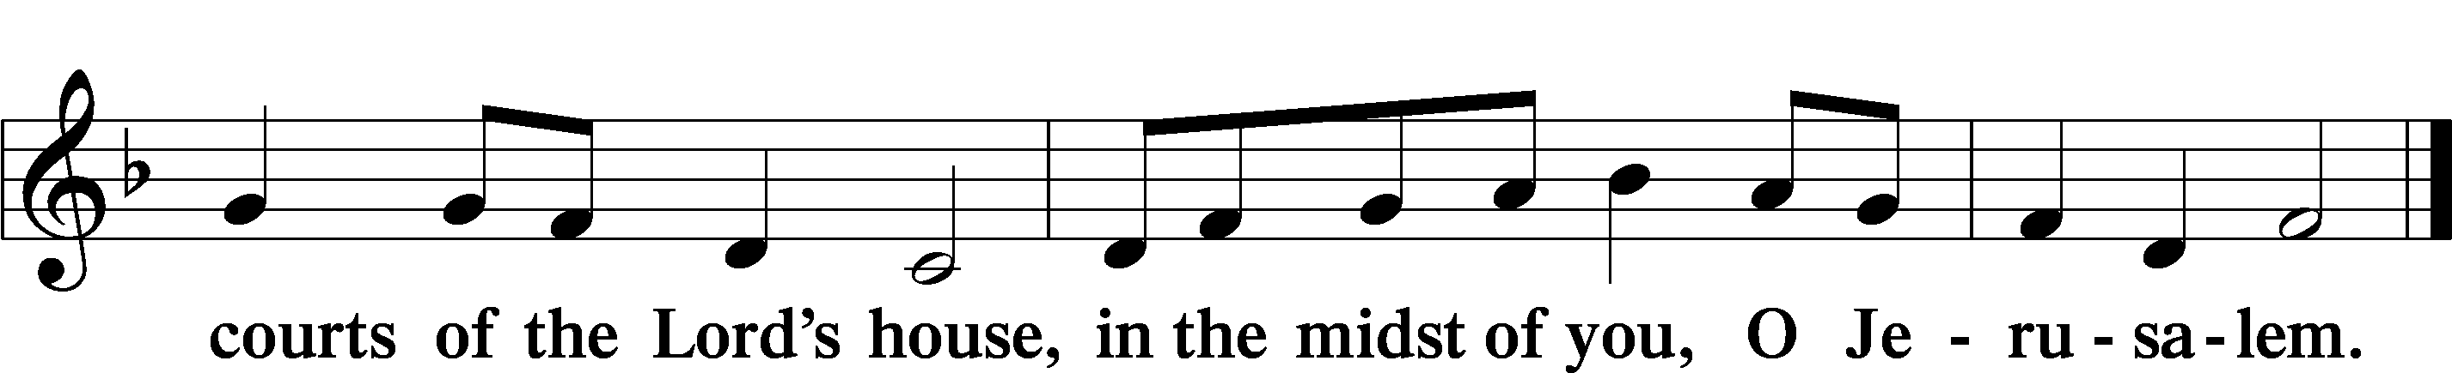

LORD’S PRAYER LSB 162
L Lord, remember us in Your kingdom and teach us to pray:
C Our Father who art in heaven,
hallowed be Thy name,
Thy kingdom come,
Thy will be done on earth
as it is in heaven;
give us this day our daily bread;
and forgive us our trespasses
as we forgive those
who trespass against us;
and lead us not into temptation,
but deliver us from evil.
For Thine is the kingdom
and the power and the glory
forever and ever. Amen.

CONCLUDING COLLECT

BENEDICTION LSB 166
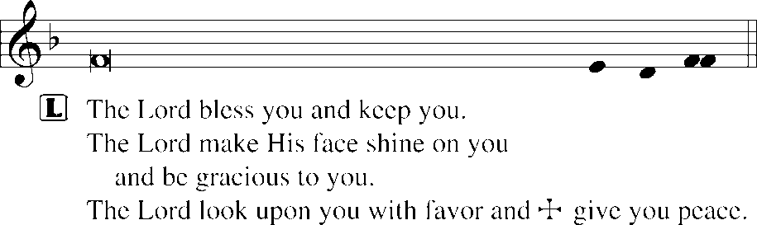
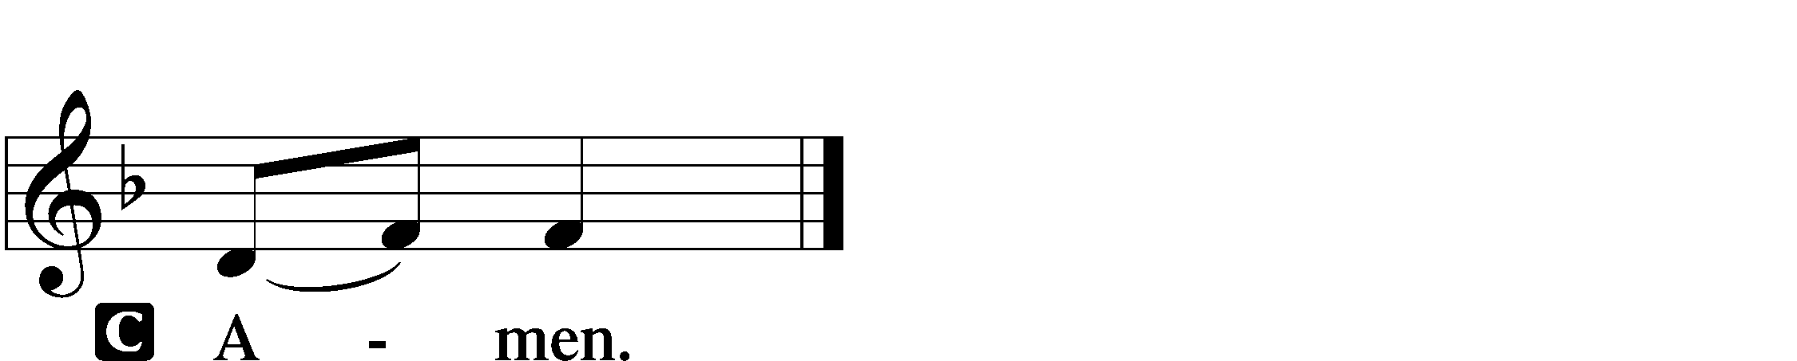

817 EARTH AND ALL STARS
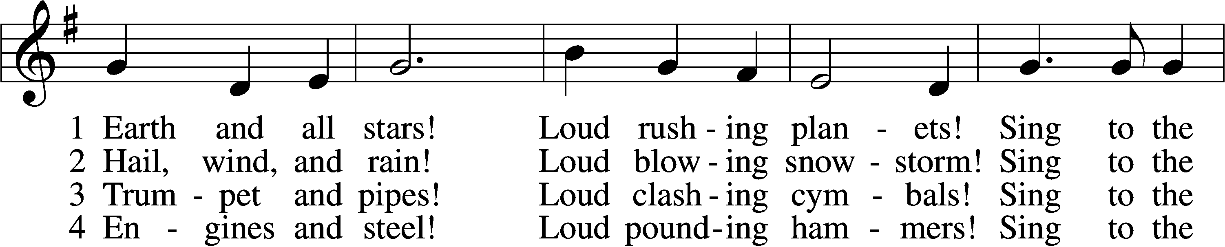
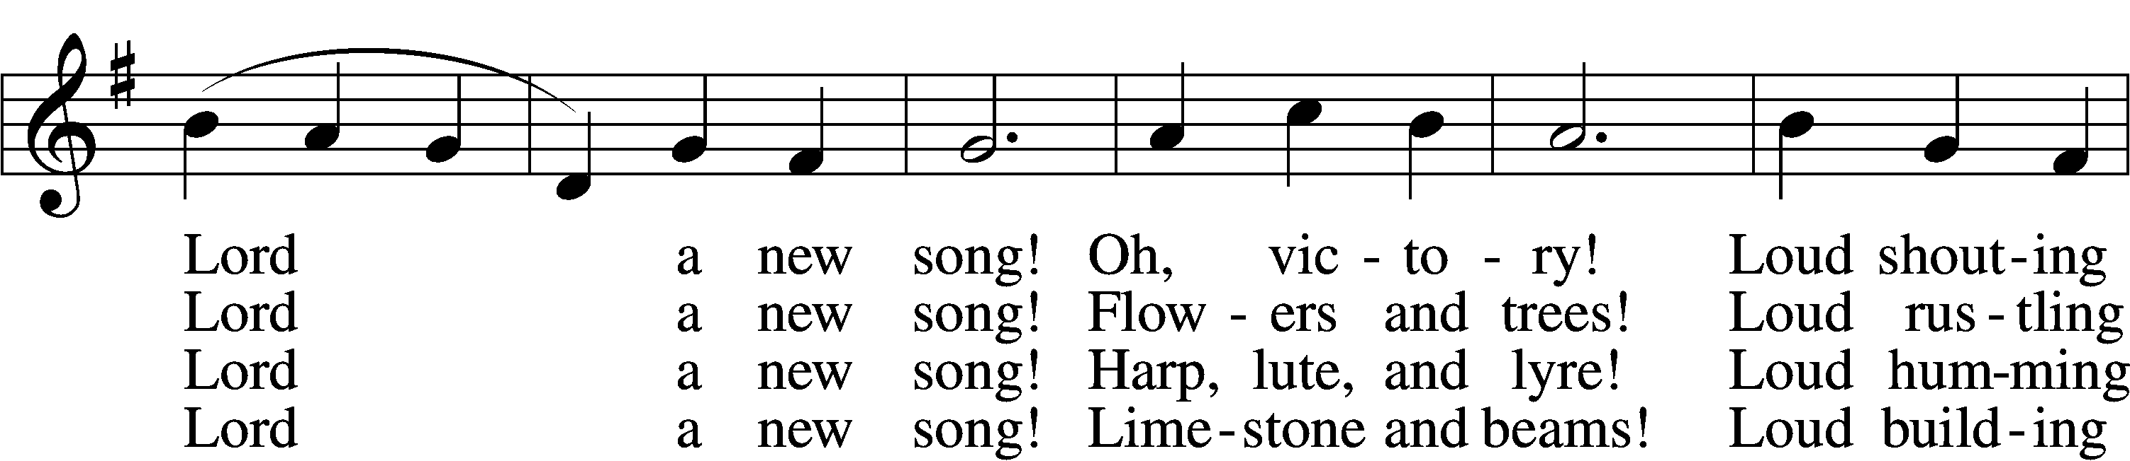
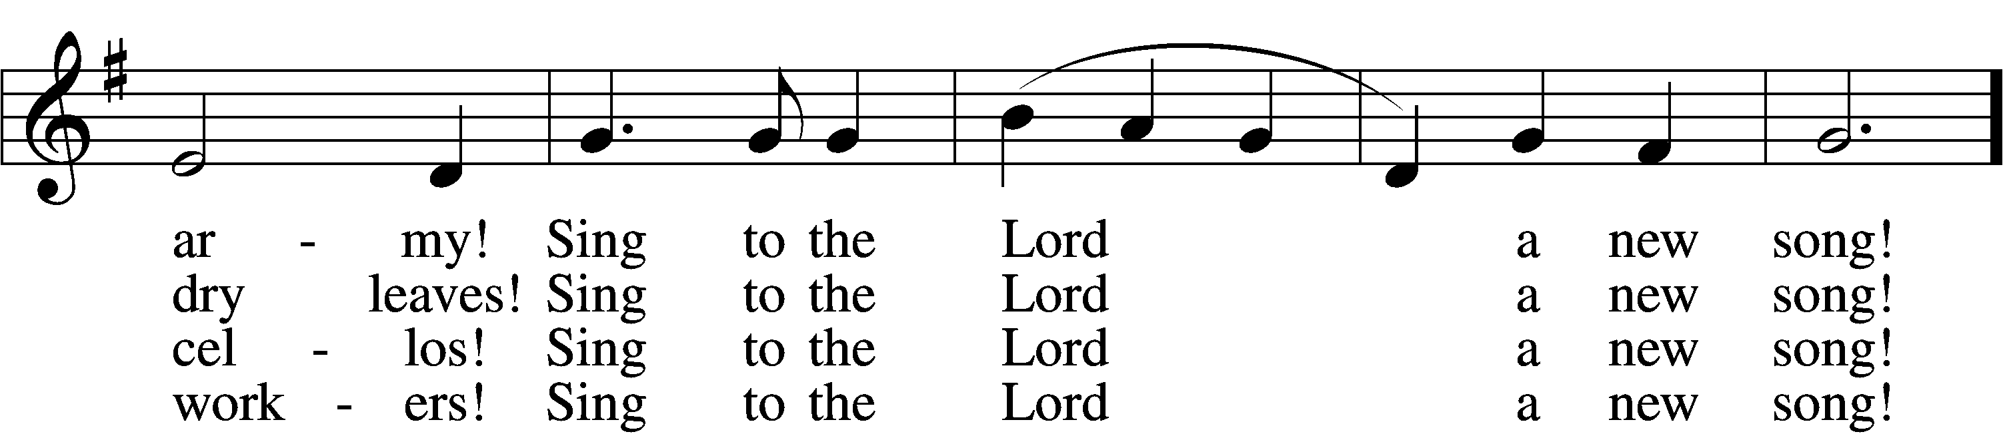
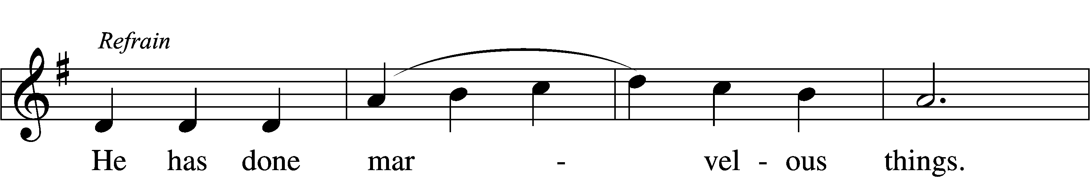
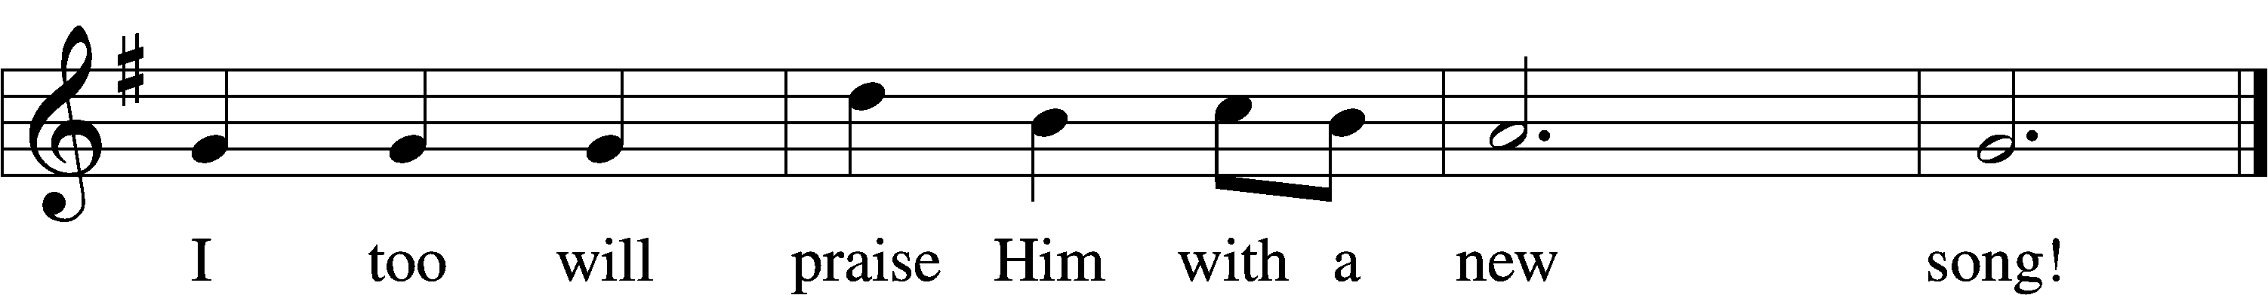

5 Classrooms and labs!
Loud boiling test tubes!
Sing to the Lord a new song!
Athlete and band!
Loud cheering people!
Sing to the Lord a new song! Refrain

6 Knowledge and truth!
Loud sounding wisdom!
Sing to the Lord a new song!
Daughter and son!
Loud praying members!
Sing to the Lord a new song! Refrain

(Next Page)

7 Children of God,
Dying and rising,
Sing to the Lord a new song!
Heaven and earth,
Hosts everlasting,
Sing to the Lord a new song! Refrain
Text: Herbert F. Brokering, 1926–2009
Tune: David N. Johnson, 1922–87
Text and tune: © 1968 Augsburg Publishing House. Used by permission: LSB Hymn License no. 110004798
ACKNOWLEDGMENTS
Unless otherwise indicated, Scripture quotations are from the ESV® Bible (The Holy Bible, English Standard Version®), copyright © 2001 by Crossway, a publishing ministry of Good News Publishers. Used by permission. All rights reserved.
Created by Lutheran Service Builder © 2026 Concordia Publishing House.

