BETHLEHEM LUTHERAN CHURCH
A congregation of The Lutheran Church-Missouri Synod
902 Hitchcock Drive SW,
Aiken, South Carolina 29803
Church Phone: (803) 649-6417
blcaikensc@gmail.com

Bethlehem Lutheran welcomes our members and guests to our worship service! Unable to join us in person? Please find us on Facebook live. The service is also posted on our website; bethlehemlutheranaiken.org.

+ + + + + + + + + + + + + + +
Third Sunday after Pentecost
June 14, 2026
10:30 a.m.
+ + + + + + + + + + + + + + +

+ SERVICE OF PREPARATION +

(After the bell tolls, please observe a time of silence.)

WELCOME AND ANNOUNCEMENTS

(Stand)

790 PRAISE TO THE LORD, THE ALMIGHTY
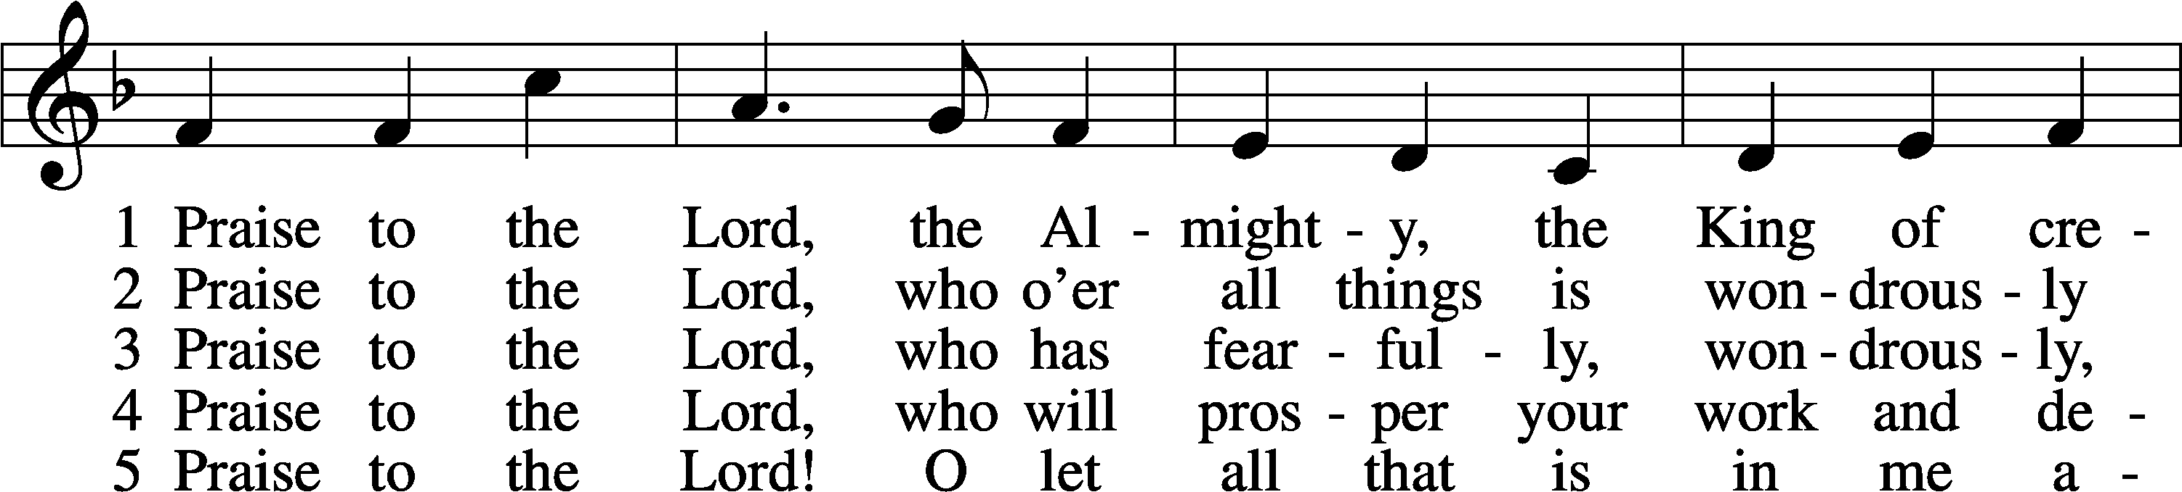
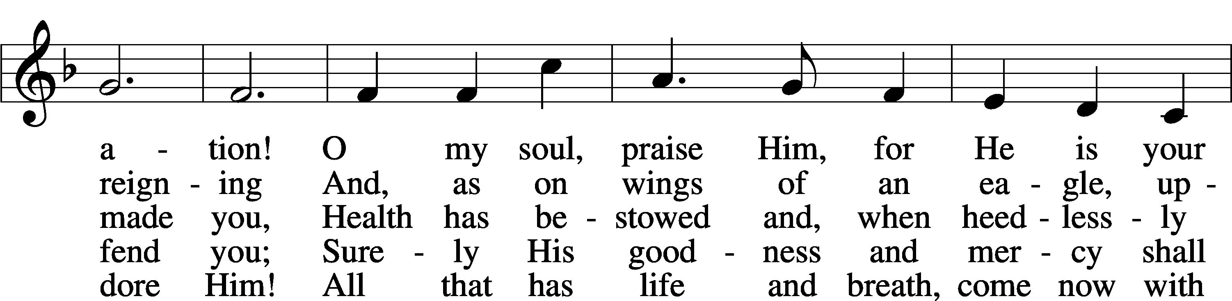
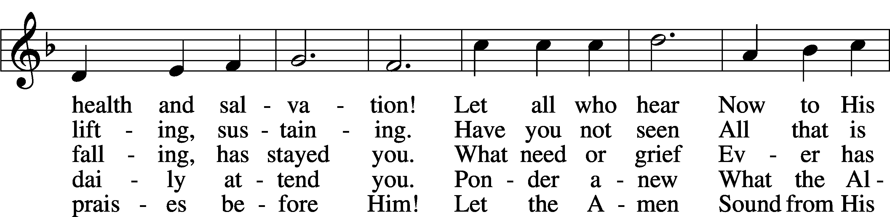
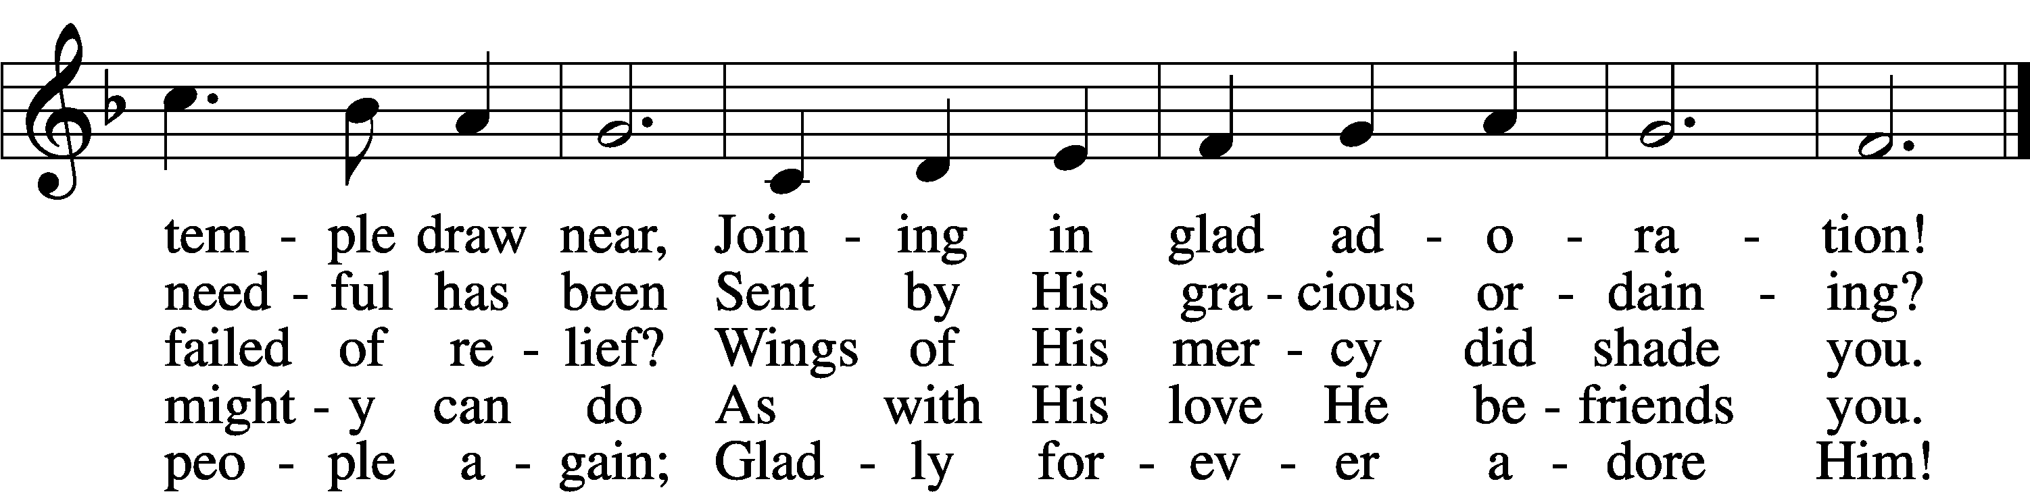
Text: Joachim Neander, 1650–80; tr. Catherine Winkworth, 1827–78, alt.
Tune: Ander Theil Des Erneuerten Gesang-Buchs, 1665, Stralsund
Text and tune: Public domain

+ CONFESSION AND ABSOLUTION +

(The sign of the cross may be made by all in remembrance of their Baptism.)

INVOCATION LSB 151
L In the name of the Father and of the T Son and of the Holy Spirit.
C Amen.

EXHORTATION LSB 151
L If we say we have no sin, we deceive ourselves, and the truth is not in us.
C But if we confess our sins, God, who is faithful and just, will forgive our sins and cleanse us from all unrighteousness.

(Silence for reflection on God’s Word and for self-examination.)

CONFESSION OF SINS LSB 151
L Let us then confess our sins to God our Father.
C Most merciful God, we confess that we are by nature sinful and unclean. We have sinned against You in thought, word, and deed, by what we have done and by what we have left undone. We have not loved You with our whole heart; we have not loved our neighbors as ourselves. We justly deserve Your present and eternal punishment. For the sake of Your Son, Jesus Christ, have mercy on us. Forgive us, renew us, and lead us, so that we may delight in Your will and walk in Your ways to the glory of Your holy name. Amen.

DECLARATION OF GRACE LSB 151
L In the mercy of almighty God, Jesus Christ was given to die for us, and for His sake God forgives us all our sins. To those who believe in Jesus Christ He gives the power to become the children of God and bestows on them the Holy Spirit. May the Lord, who has begun this good work in us, bring it to completion in the day of our Lord Jesus Christ.
C Amen.

+ SERVICE OF THE WORD +

INTROIT Psalm 67:4–7; antiphon: v. 3
Let the peoples praise you, | O God;*
let all the peoples | praise you!
Let the nations be glad and | sing for joy,*
for you judge the peoples with equity and guide the nations up- | on earth.
Let the peoples praise you, | O God;*
let all the peoples | praise you!
The earth has yielded its | increase;*
God, our God, shall | bless us.
God shall | bless us;*
let all the ends of the earth | fear him!
Glory be to the Father and | to the Son*
and to the Holy | Spirit;
as it was in the be- | ginning,*
is now, and will be forever. | Amen.
Let the peoples praise you, | O God;*
let all the peoples | praise you!

KYRIE LSB 152

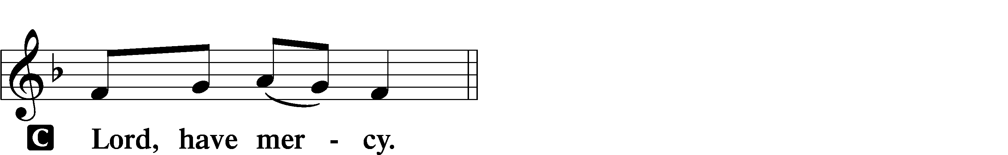

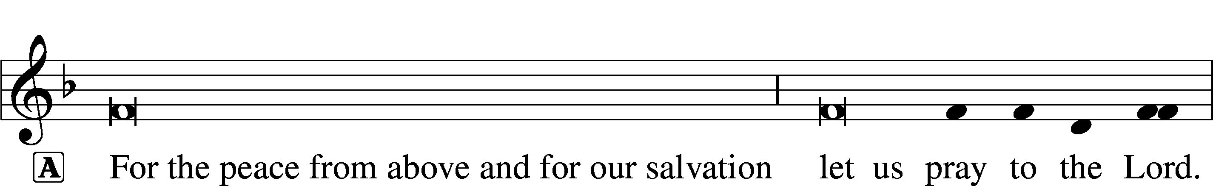
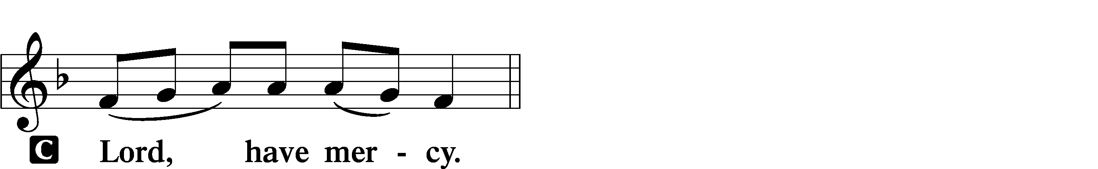

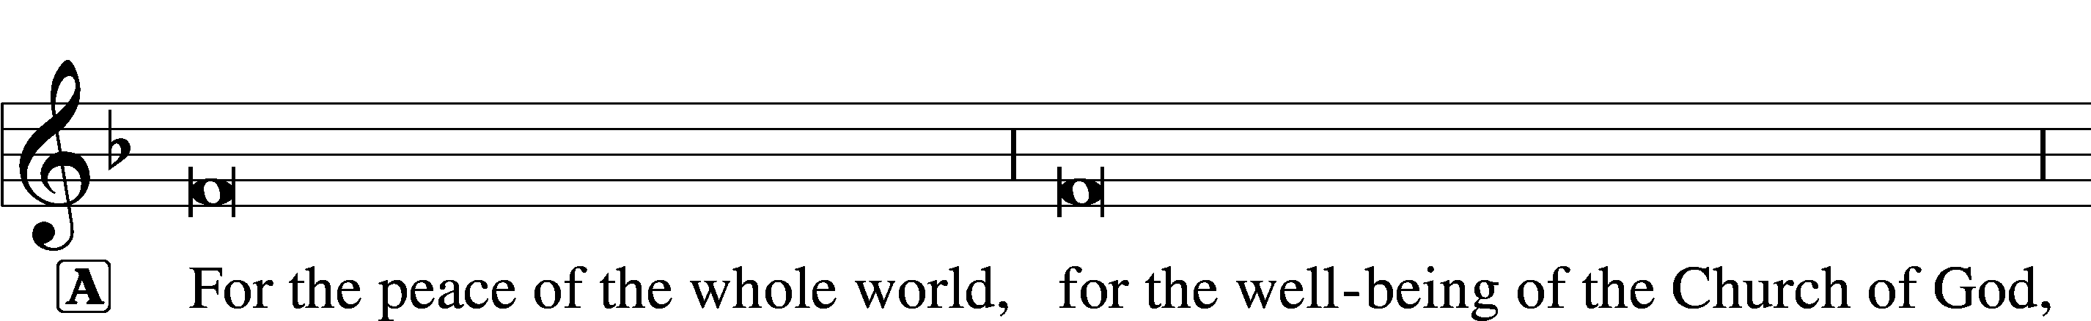
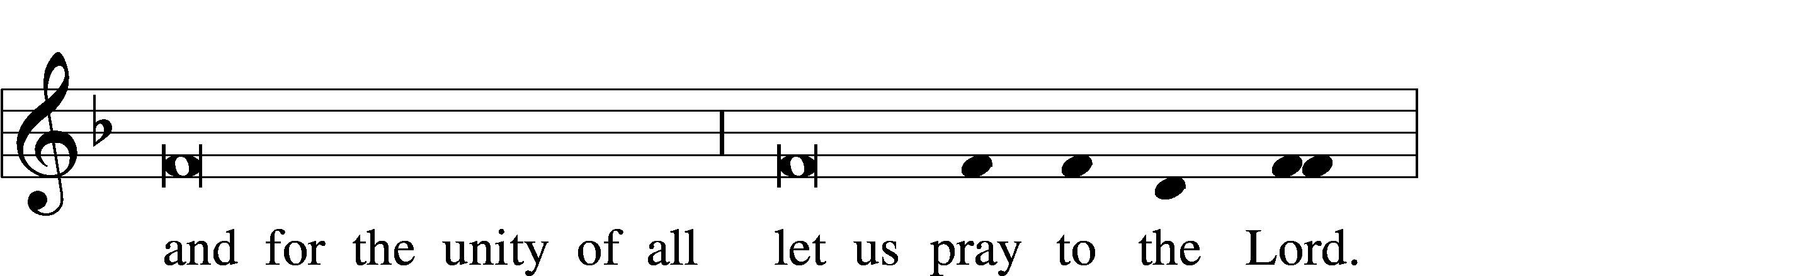
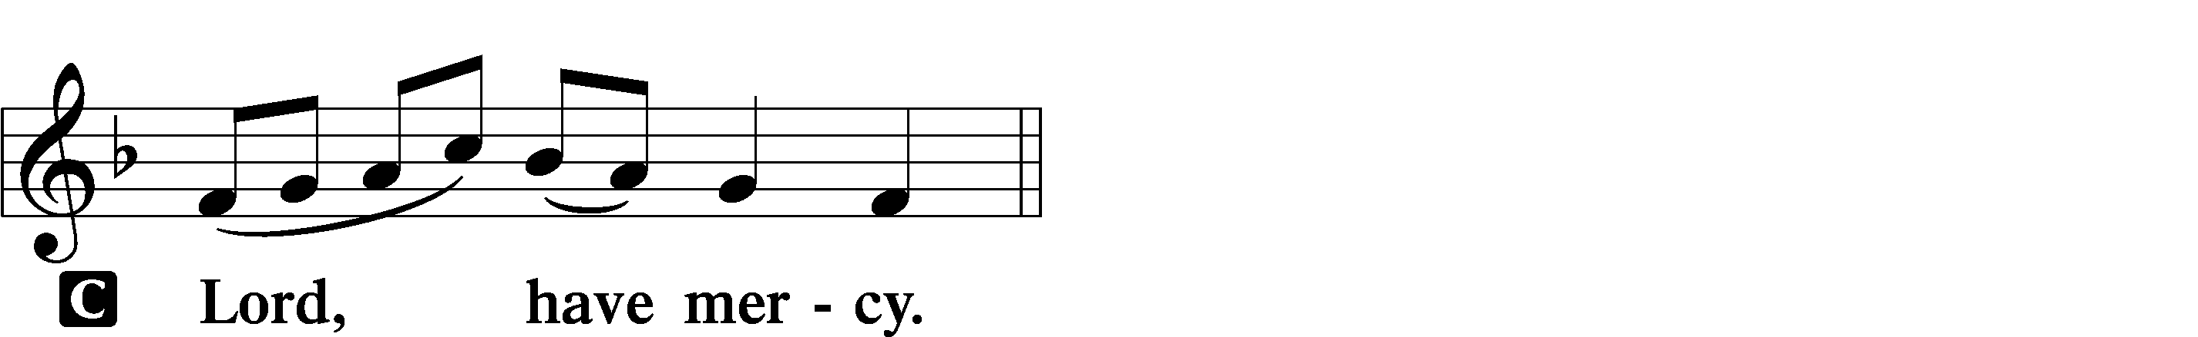

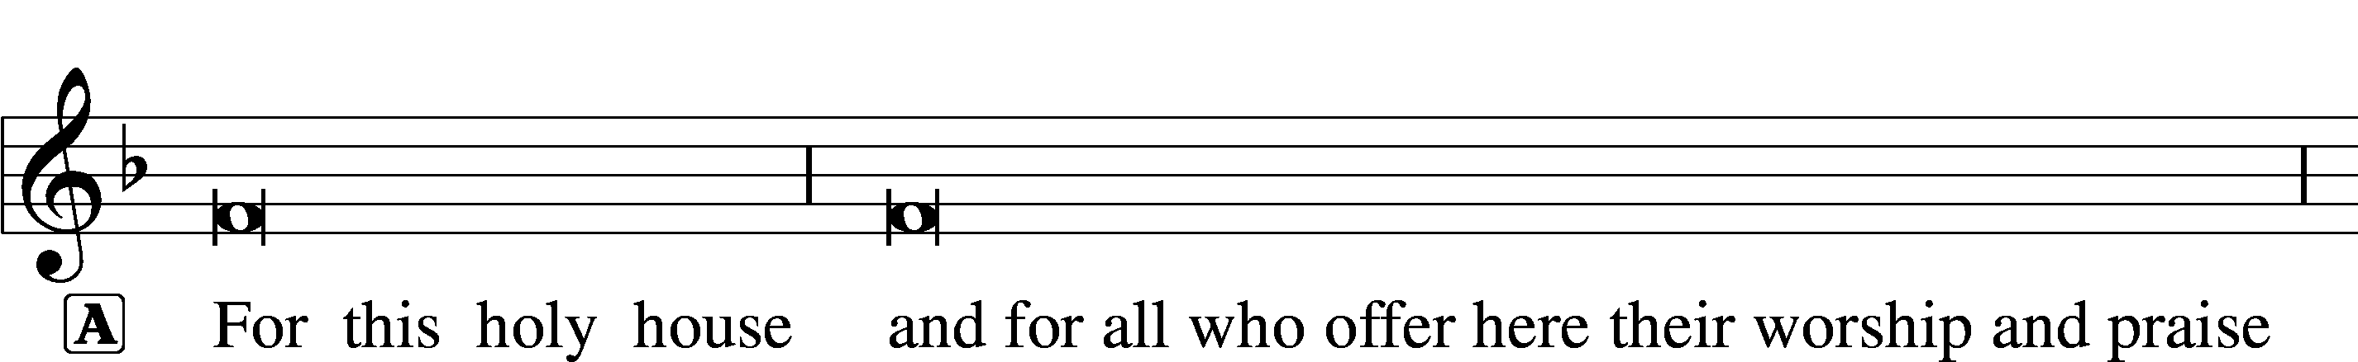

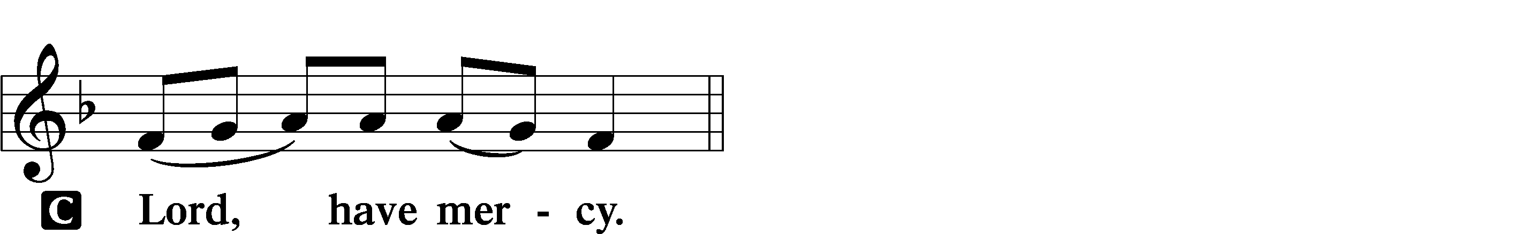




GLORIA IN EXCELSIS LSB 154
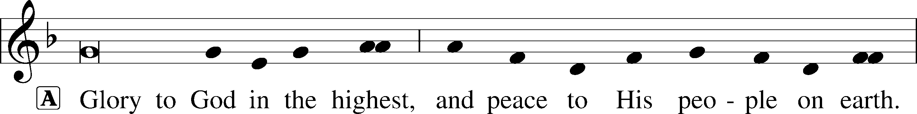
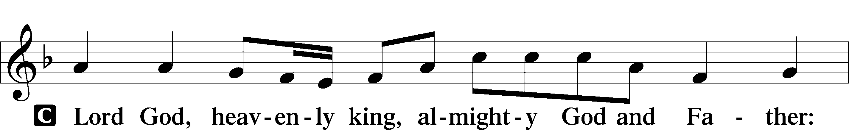
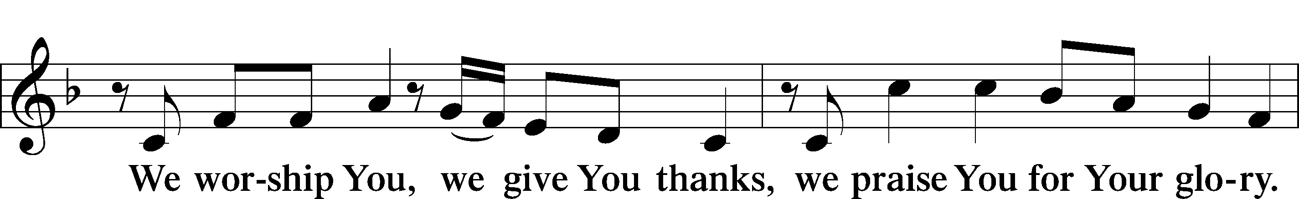
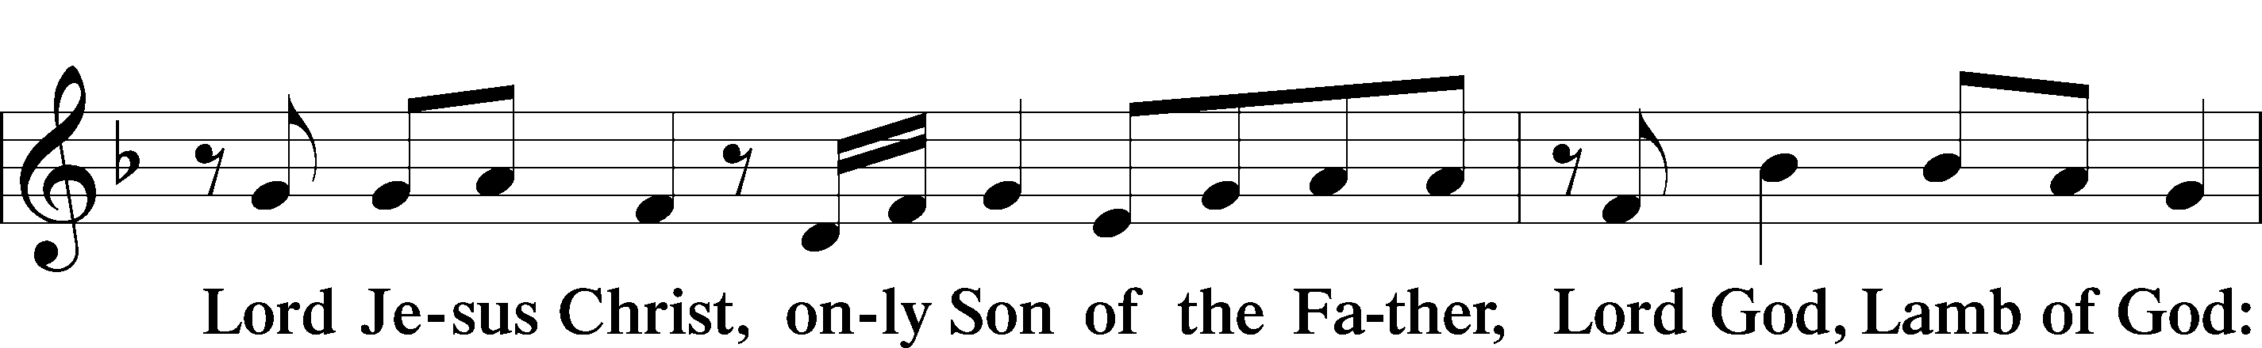
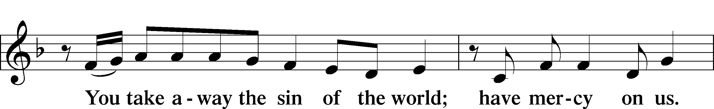
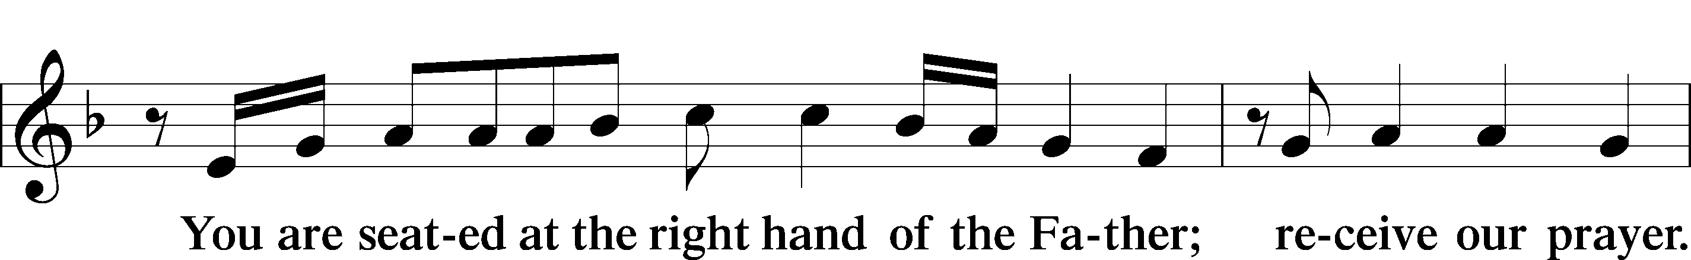
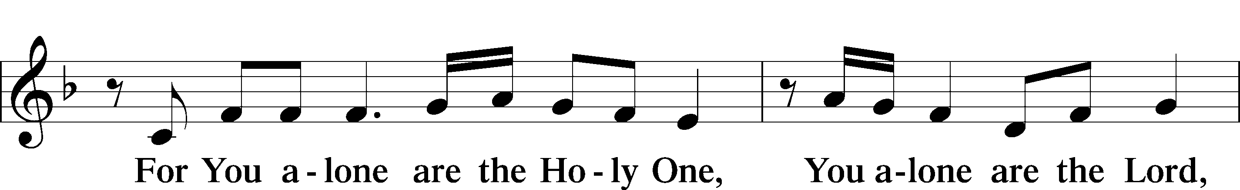
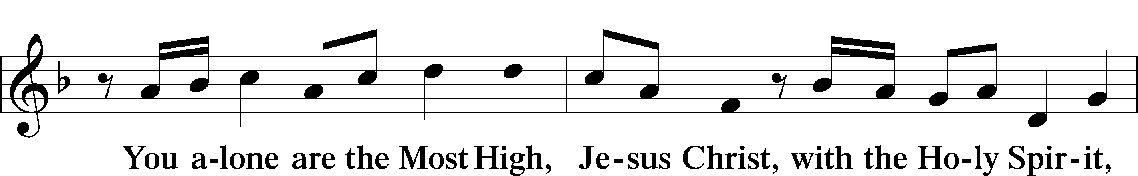
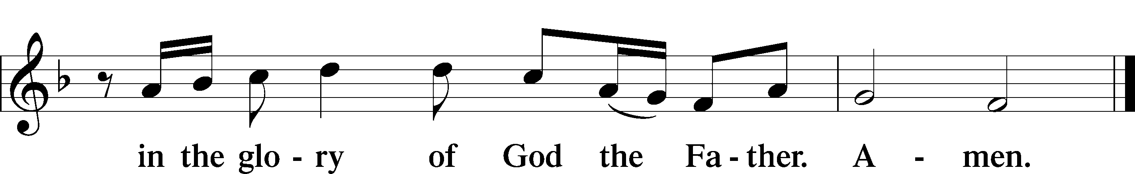

SALUTATION AND COLLECT OF THE DAY LSB 156
L The Lord be with you.
C And also with you.

L Let us pray.
Almighty, eternal God, in the Word of Your apostles and prophets You have proclaimed to us Your saving will. Grant us faith to believe Your promises that we may receive eternal salvation; through Jesus Christ, our Lord, who lives and reigns with You and the Holy Spirit, one God, now and forever.
C Amen.

(Sit)

OLD TESTAMENT READING Exodus 19:2–8
2[The people of Israel] set out from Rephidim and came into the wilderness of Sinai, and they encamped in the wilderness. There Israel encamped before the mountain, 3while Moses went up to God. The Lord called to him out of the mountain, saying, “Thus you shall say to the house of Jacob, and tell the people of Israel: 4You yourselves have seen what I did to the Egyptians, and how I bore you on eagles’ wings and brought you to myself. 5Now therefore, if you will indeed obey my voice and keep my covenant, you shall be my treasured possession among all peoples, for all the earth is mine; 6and you shall be to me a kingdom of priests and a holy nation. These are the words that you shall speak to the people of Israel.”
7So Moses came and called the elders of the people and set before them all these words that the Lord had commanded him. 8All the people answered together and said, “All that the Lord has spoken we will do.” And Moses reported the words of the people to the Lord.

L This is the Word of the Lord.
C Thanks be to God.

GRADUAL Psalm 145:3, 5b, 6b
Great is the Lord, and greatly | to be praised,*
and his greatness is un- | searchable.
On your wondrous works, I will | meditate,*
and I will declare your | greatness.

EPISTLE Romans 5:6–15
6For while we were still weak, at the right time Christ died for the ungodly. 7For one will scarcely die for a righteous person—though perhaps for a good person one would dare even to die— 8but God shows his love for us in that while we were still sinners, Christ died for us. 9Since, therefore, we have now been justified by his blood, much more shall we be saved by him from the wrath of God. 10For if while we were enemies we were reconciled to God by the death of his Son, much more, now that we are reconciled, shall we be saved by his life. 11More than that, we also rejoice in God through our Lord Jesus Christ, through whom we have now received reconciliation.
12Therefore, just as sin came into the world through one man, and death through sin, and so death spread to all men because all sinned— 13for sin indeed was in the world before the law was given, but sin is not counted where there is no law. 14Yet death reigned from Adam to Moses, even over those whose sinning was not like the transgression of Adam, who was a type of the one who was to come.
15But the free gift is not like the trespass. For if many died through one man’s trespass, much more have the grace of God and the free gift by the grace of that one man Jesus Christ abounded for many.

L This is the Word of the Lord.
C Thanks be to God.

(Stand)

ALLELUIA AND VERSE LSB 156
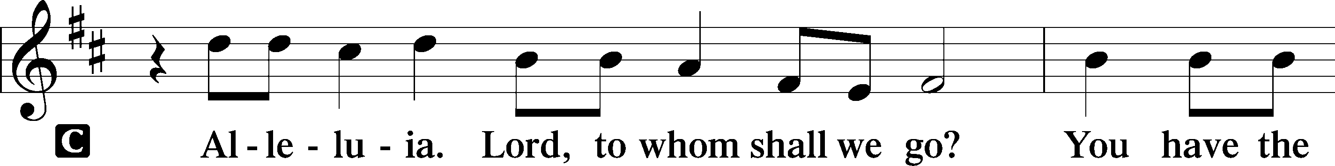
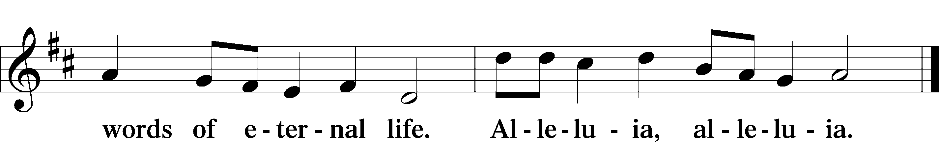

HOLY GOSPEL Matthew 9:35—10:20
L The Holy Gospel according to St. Matthew, the ninth chapter.

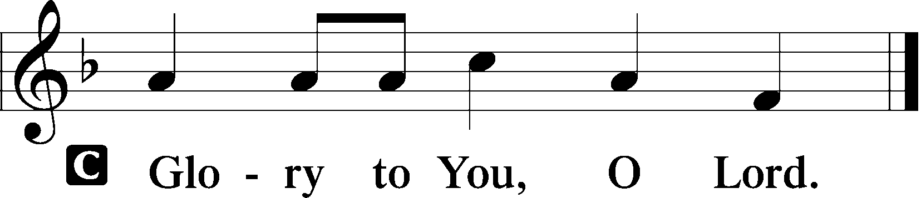

35Jesus went throughout all the cities and villages, teaching in their synagogues and proclaiming the gospel of the kingdom and healing every disease and every affliction. 36When he saw the crowds, he had compassion for them, because they were harassed and helpless, like sheep without a shepherd. 37Then he said to his disciples, “The harvest is plentiful, but the laborers are few; 38therefore pray earnestly to the Lord of the harvest to send out laborers into his harvest.”
1And he called to him his twelve disciples and gave them authority over unclean spirits, to cast them out, and to heal every disease and every affliction. 2The names of the twelve apostles are these: first, Simon, who is called Peter, and Andrew his brother; James the son of Zebedee, and John his brother; 3Philip and Bartholomew; Thomas and Matthew the tax collector; James the son of Alphaeus, and Thaddaeus; 4Simon the Cananaean, and Judas Iscariot, who betrayed him.
5These twelve Jesus sent out, instructing them, “Go nowhere among the Gentiles and enter no town of the Samaritans, 6but go rather to the lost sheep of the house of Israel. 7And proclaim as you go, saying, ‘The kingdom of heaven is at hand.’ 8Heal the sick, raise the dead, cleanse lepers, cast out demons. You received without paying; give without pay. 9Acquire no gold nor silver nor copper for your belts, 10no bag for your journey, nor two tunics nor sandals nor a staff, for the laborer deserves his food. 11And whatever town or village you enter, find out who is worthy in it and stay there until you depart. 12As you enter the house, greet it. 13And if the house is worthy, let your peace come upon it, but if it is not worthy, let your peace return to you. 14And if anyone will not receive you or listen to your words, shake off the dust from your feet when you leave that house or town. 15Truly, I say to you, it will be more bearable on the day of judgment for the land of Sodom and Gomorrah than for that town.

(next page)

16“Behold, I am sending you out as sheep in the midst of wolves, so be wise as serpents and innocent as doves. 17Beware of men, for they will deliver you over to courts and flog you in their synagogues, 18and you will be dragged before governors and kings for my sake, to bear witness before them and the Gentiles. 19When they deliver you over, do not be anxious how you are to speak or what you are to say, for what you are to say will be given to you in that hour. 20For it is not you who speak, but the Spirit of your Father speaking through you.”

L This is the Gospel of the Lord.

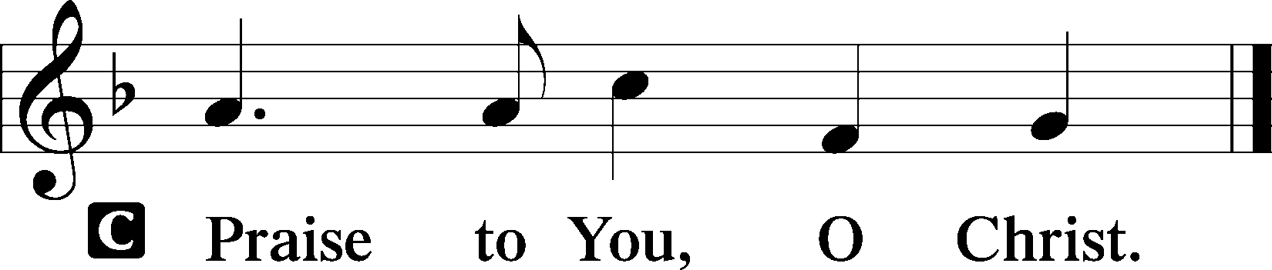

(Sit)

571 GOD LOVED THE WORLD SO THAT HE GAVE
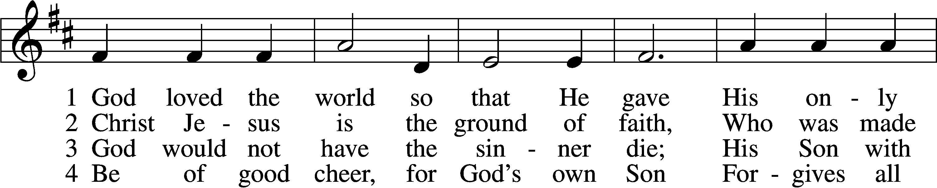
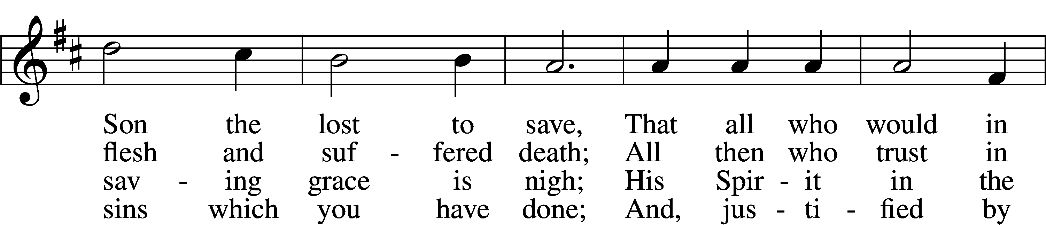
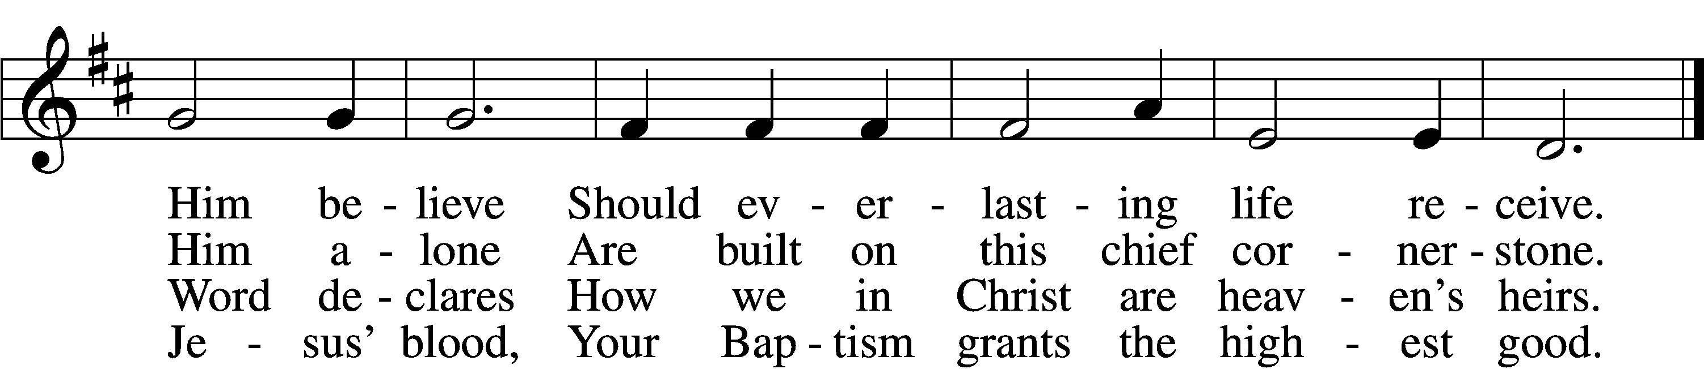

5 If you are sick, if death is near,
This truth your troubled heart can cheer:
Christ Jesus saves your soul from death;
That is the firmest ground of faith.

D 6 Glory to God the Father, Son,
And Holy Spirit, Three in One!
To You, O blessèd Trinity,
Be praise now and eternally!
Text: Heiliges Lippen- und Hertzens-Opffer, c. 1778, Stettin; tr. August Crull, 1845–1923, alt.
Tune: George J. Elvey, 1816–93
Text and tune: Public domain

SERMON

(Sermons for Elder led services are provided courtesy of the Lutheran Church - Canada (https://www.lutheranchurchcanada.ca/resources/written-sermons/), a member of the International Lutheran Council (https://ilcouncil.org/) with whom the Lutheran Church - Missouri Synod (https://www.lcms.org/) is in altar and pulpit fellowship.)

(Stand)

NICENE CREED LSB 158
C I believe in one God,
the Father Almighty,
maker of heaven and earth
and of all things visible and invisible.

And in one Lord Jesus Christ,
the only-begotten Son of God,
begotten of His Father before all worlds,
God of God, Light of Light,
very God of very God,
begotten, not made,
being of one substance with the Father,
by whom all things were made;
who for us men and for our salvation came down from heaven
and was incarnate by the Holy Spirit of the virgin Mary
and was made man;
and was crucified also for us under Pontius Pilate.
He suffered and was buried.
And the third day He rose again according to the Scriptures
and ascended into heaven
and sits at the right hand of the Father.
And He will come again with glory to judge both the living and the dead,
whose kingdom will have no end.

And I believe in the Holy Spirit,
the Lord and giver of life,
who proceeds from the Father and the Son,
who with the Father and the Son together is worshiped and glorified,
who spoke by the prophets.
And I believe in one holy Christian and apostolic Church,
I acknowledge one Baptism for the remission of sins,
and I look for the resurrection of the dead
and the life T of the world to come. Amen.

SHARING OF THE PEACE

(The people may greet one another in the name of the Lord, saying, “Peace be with you,” as a sign of reconciliation and of the unity of the Spirit in the bond of peace (Matt. 5:22–24; Eph. 4:1–3).)

(Sit)

PRAYER OF THE CHURCH

OFFERING

(As a part of our expression of thanksgiving to God for the treasure of His salvation to us, we offer a portion of our treasure, according to what each has determined in their heart to give. Please place offerings in the collection plate at the back of the sanctuary before or after the service. Offerings can also be sent to Bethlehem Lutheran Church via U.S. Mail. Thank you!)

(Stand)

OFFERTORY LSB 159
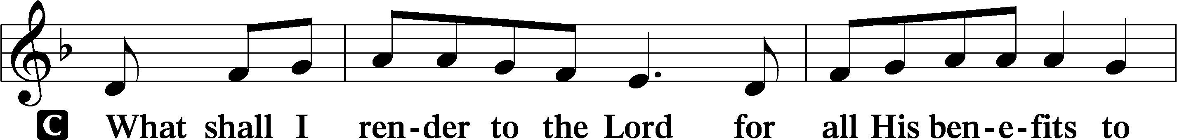
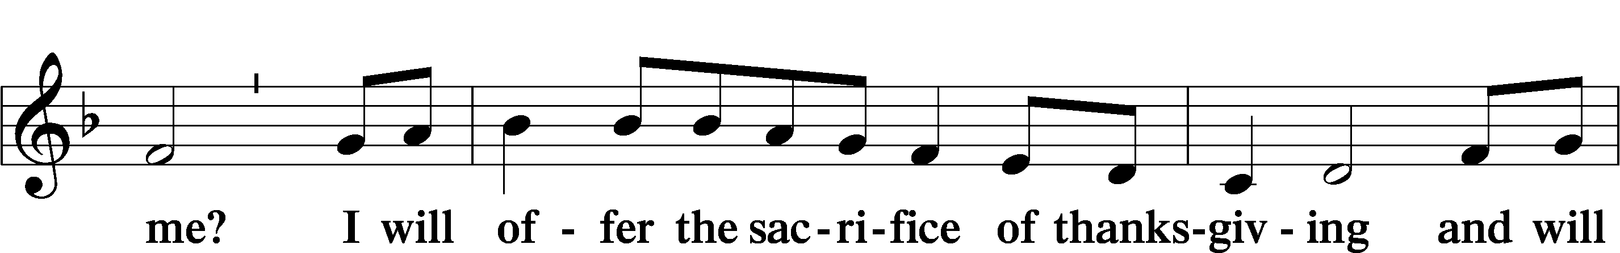
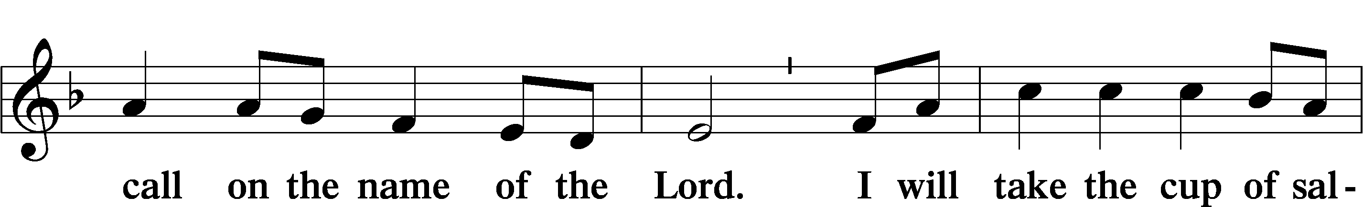
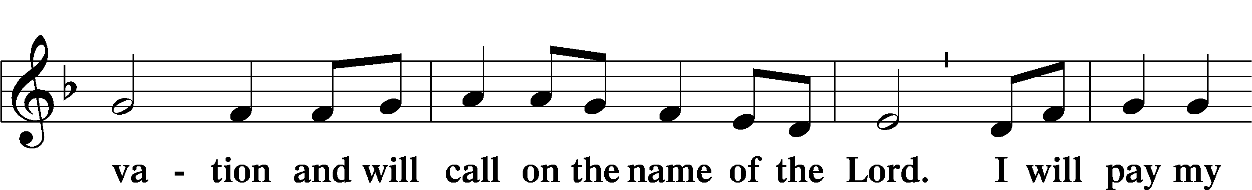
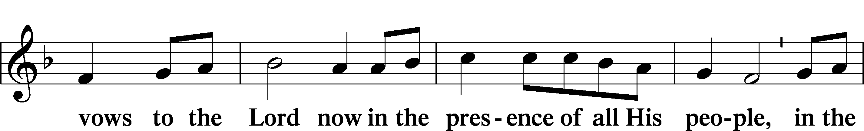
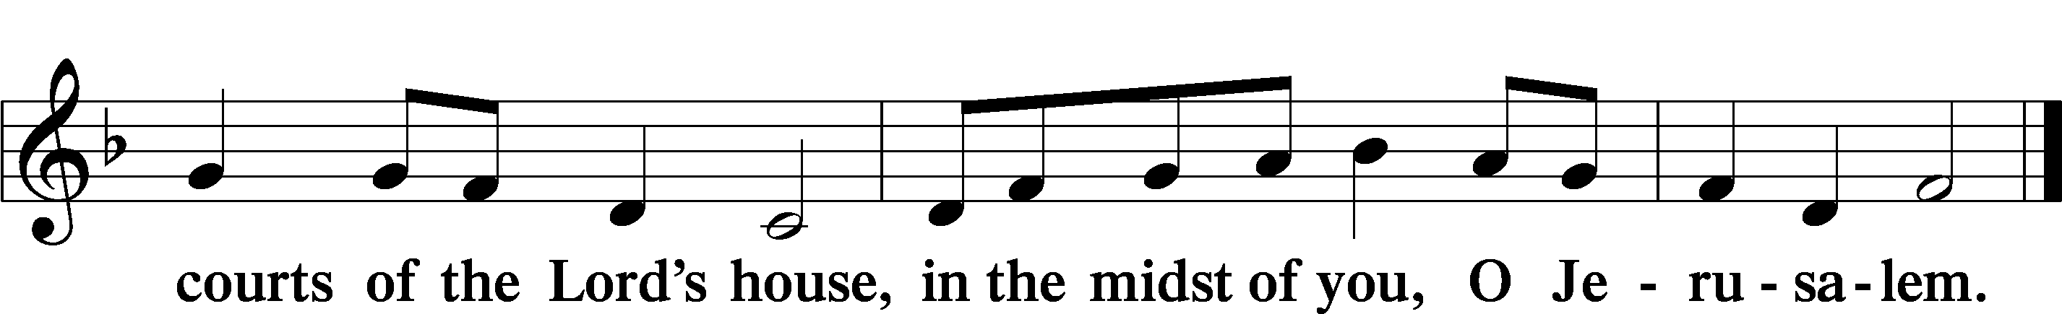

LORD’S PRAYER LSB 162
L Lord, remember us in Your kingdom and teach us to pray:
C Our Father who art in heaven,
hallowed be Thy name,
Thy kingdom come,
Thy will be done on earth
as it is in heaven;
give us this day our daily bread;
and forgive us our trespasses
as we forgive those
who trespass against us;
and lead us not into temptation,
but deliver us from evil.
For Thine is the kingdom
and the power and the glory
forever and ever. Amen.

CONCLUDING COLLECT

BENEDICTION
L The grace of our Lord T Jesus Christ and the love of God and the fellowship of the Holy Spirit be with us all.
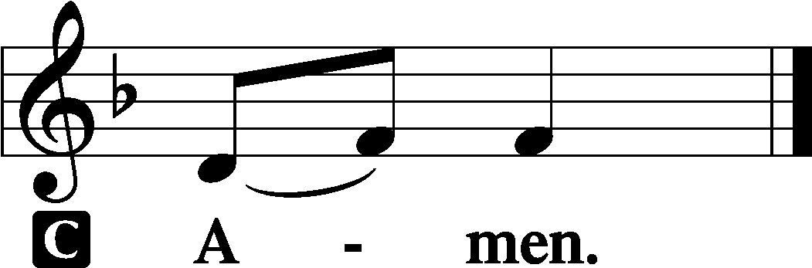

893 SING TO THE LORD OF HARVEST
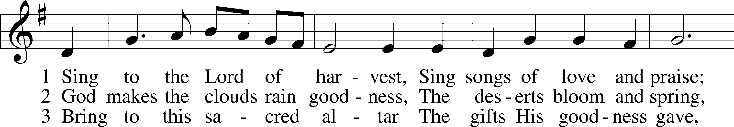
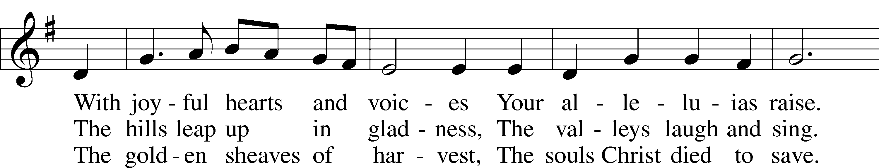
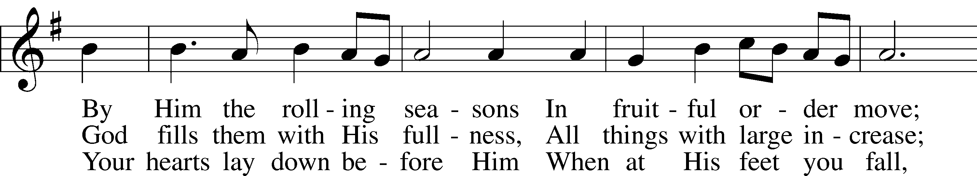
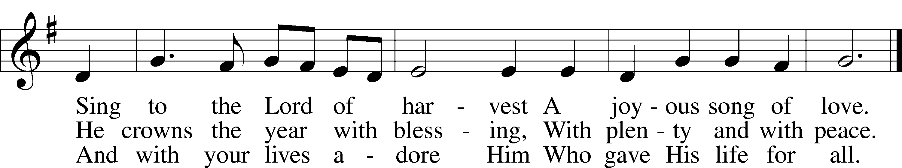
Text: John S. B. Monsell, 1811–75, alt.
Tune: Johann Steurlein, 1546–1613
Text and tune: Public domain
ACKNOWLEDGMENTS
Unless otherwise indicated, Scripture quotations are from the ESV® Bible (The Holy Bible, English Standard Version®), copyright © 2001 by Crossway, a publishing ministry of Good News Publishers. Used by permission. All rights reserved.
Created by Lutheran Service Builder © 2026 Concordia Publishing House.

