BETHLEHEM LUTHERAN CHURCH
A congregation of The Lutheran Church-Missouri Synod
902 Hitchcock Drive SW,
Aiken, South Carolina 29803
Church Phone: (803) 649-6417
blcaikensc@gmail.com
Pastor: Rev. John B. Engwall
Office Hours By Appointment
Note: The format of this bulletin has been modified for use in private devotion services.
Unable to join us in person? Please find us on Facebook live.
The service is also posted on our website; bethlehemlutheranaiken.org

+ + + + + + + + + + + + + + +
The Second Sunday after Christmas
January 4, 2026
10:30 a.m.
+ + + + + + + + + + + + + + +

Our Policy and Practice Regarding Holy Communion
Hear the words of the Apostle Paul;
Anyone who eats and drinks without recognizing the body of the Lord eats and drinks judgment on himself. -1 Cor.11:29
Therefore, visitors are asked to please refrain from partaking of the Sacrament before speaking about this with the pastor; because we care about your spiritual well-being.
Also, because communing at this altar is a public confession that you agree with the doctrines of The Lutheran Church-Missouri Synod, and reject all contrary teachings.
Persons who are not communing today are always welcome to come forward during the distribution to receive an individual blessing; please cross your arms over your chest to indicate your desire for this. Thank you!
We commune in two alternating tables. The ushers will guide you. Non-alcoholic white wine is available in the center of the individual cup tray. Please leave empty individual cups at the altar rail.

+ SERVICE OF PREPARATION +
After the bell tolls, please observe a time of silence.

WELCOME AND ANNOUNCEMENTS

(Stand)

523 O WORD OF GOD INCARNATE
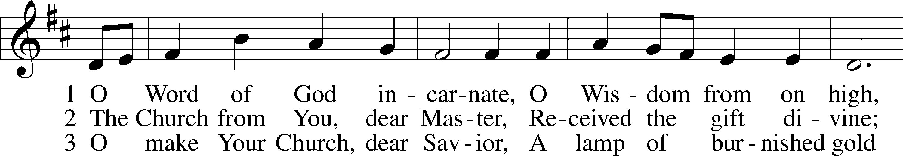
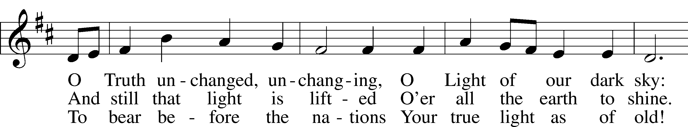
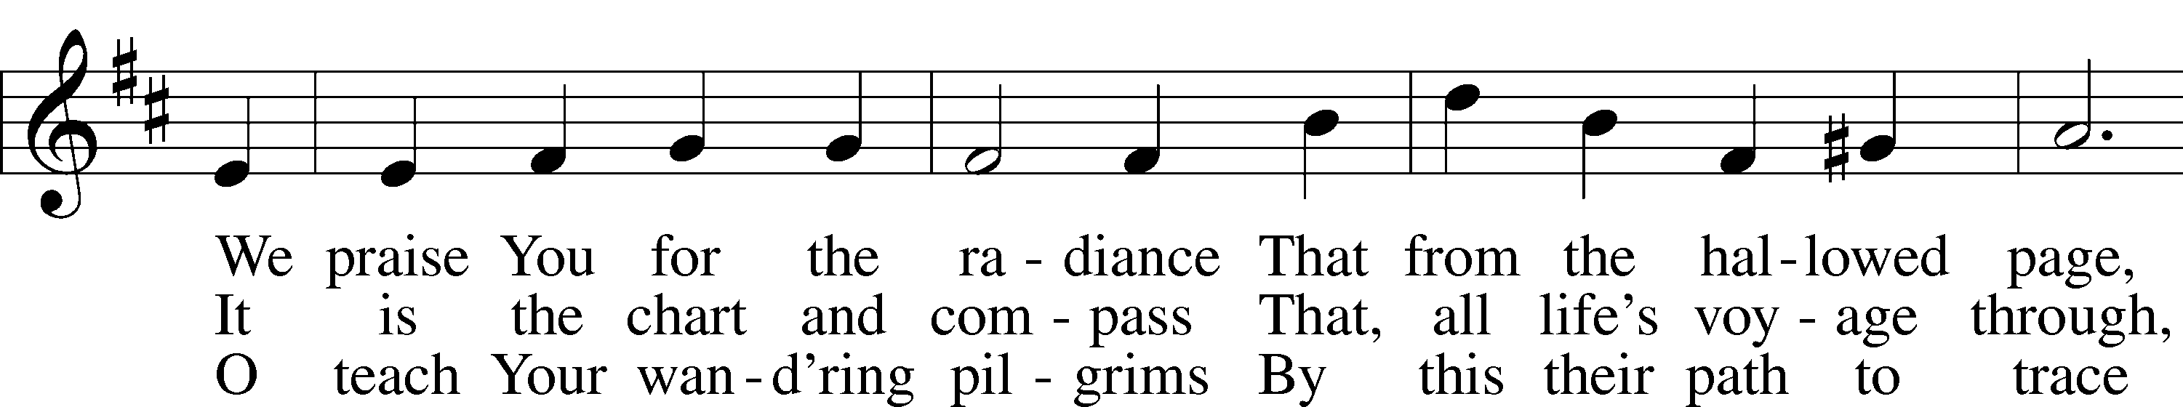
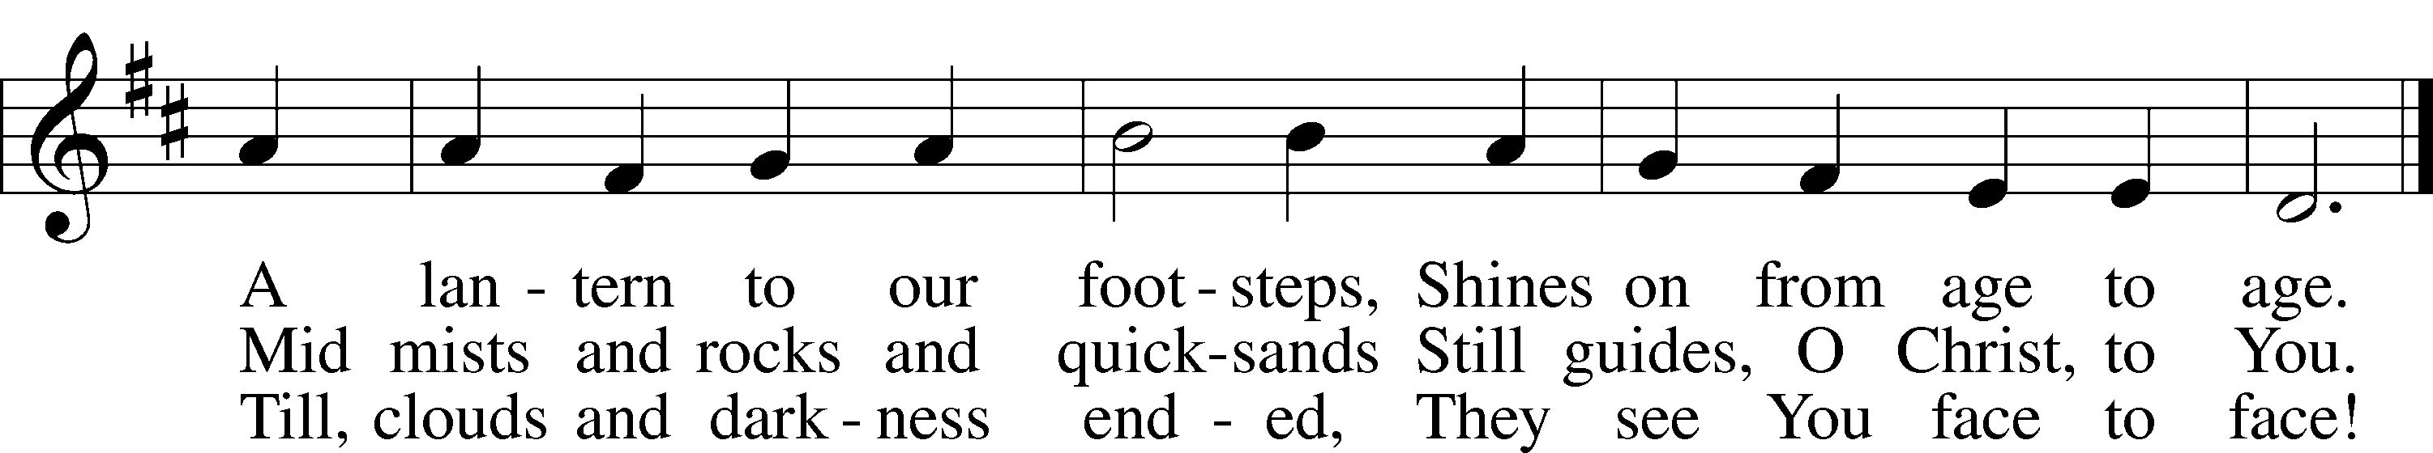
Text: William W. How, 1823–97, alt.
Tune: Neu-vermehrtes . . . Gesangbuch, 1693, 3rd ed., Meiningen
Text and tune: Public domain

+ CONFESSION AND ABSOLUTION +

(The sign of the cross may be made by all in remembrance of their Baptism.)

INVOCATION
L In the name of the Father and of the T Son and of the Holy Spirit.
C Amen.

EXHORTATION LSB 151
L If we say we have no sin, we deceive ourselves, and the truth is not in us.
C But if we confess our sins, God, who is faithful and just, will forgive our sins and cleanse us from all unrighteousness.

(Silence for reflection on God’s Word and for self-examination.)

CONFESSION OF SINS LSB 151
L Let us then confess our sins to God our Father.
C Most merciful God, we confess that we are by nature sinful and unclean. We have sinned against You in thought, word, and deed, by what we have done and by what we have left undone. We have not loved You with our whole heart; we have not loved our neighbors as ourselves. We justly deserve Your present and eternal punishment. For the sake of Your Son, Jesus Christ, have mercy on us. Forgive us, renew us, and lead us, so that we may delight in Your will and walk in Your ways to the glory of Your holy name. Amen.

DECLARATION OF GRACE
L In the mercy of almighty God, Jesus Christ was given to die for us, and for His sake God forgives us all our sins. To those who believe in Jesus Christ He gives the power to become the children of God and bestows on them the Holy Spirit. May the Lord, who has begun this good work in us, bring it to completion in the day of our Lord Jesus Christ.
C Amen.

(Stand)

+ SERVICE OF THE WORD +

INTROIT Psalm 147:1, 5, 11–12; antiphon: John 1:14
The Word became flesh and dwelt among us, and we have seen his | glory,*
glory as of the only Son from the Father, full of | grace and truth.
Praise the Lord! For it is good to sing praises | to our God;*
for it is pleasant, and a song of praise is | fitting.
Great is our Lord, and abun- | dant in power;*
his understanding is beyond | measure.
But the Lord takes pleasure in those who | fear him,*
in those who hope in his | steadfast love.
Praise the Lord, O Je- | rusalem!*
Praise your God, O | Zion!
Glory be to the Father and | to the Son*
and to the Holy | Spirit;
as it was in the be- | ginning,*
is now, and will be forever. | Amen.
The Word became flesh and dwelt among us, and we have seen his | glory,*
glory as of the only Son from the Father, full of | grace and truth.

KYRIE LSB 152
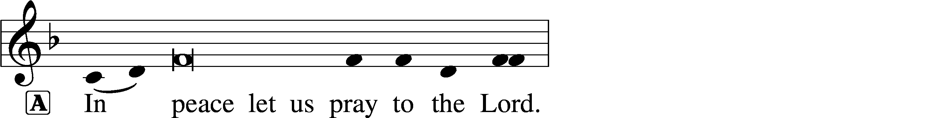
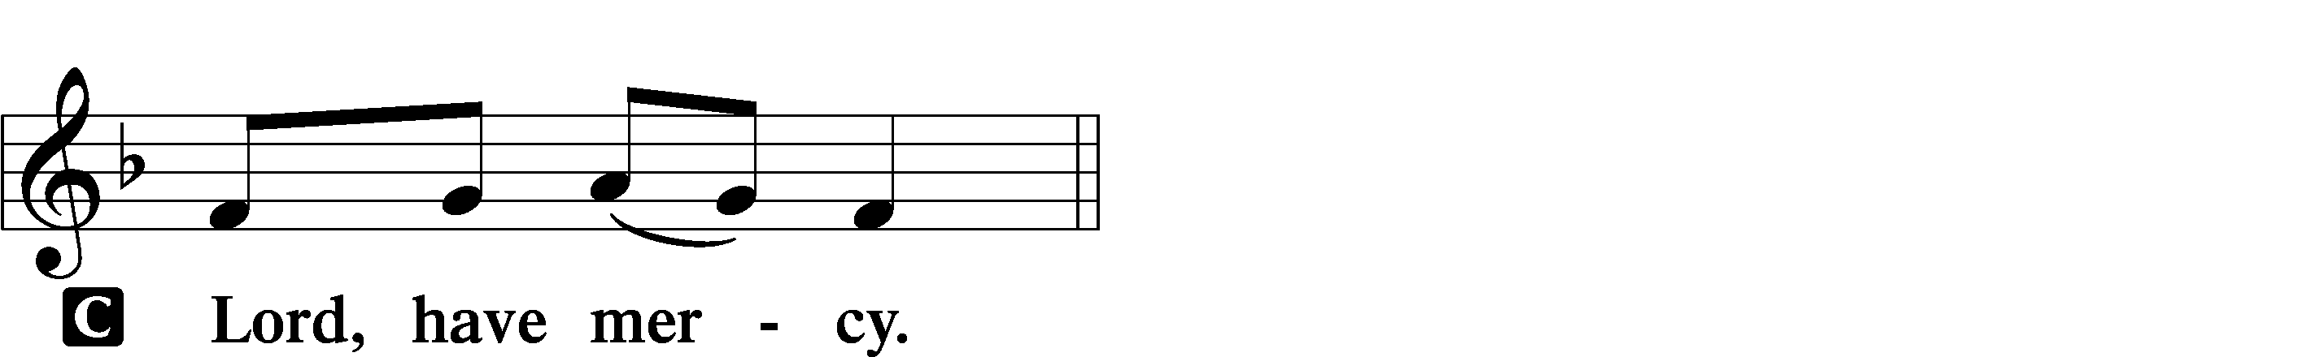

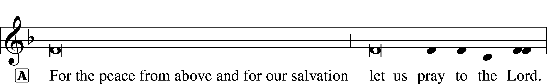
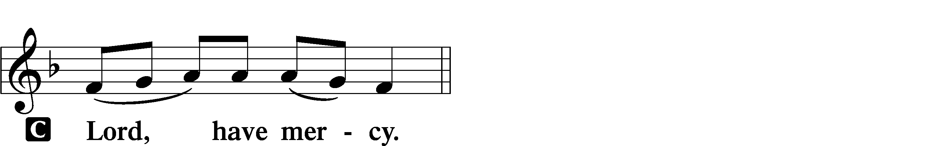

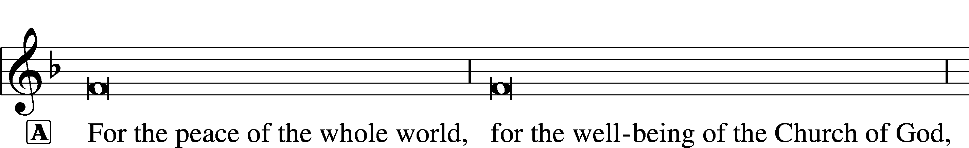
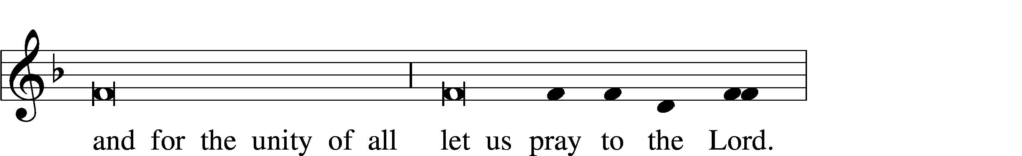
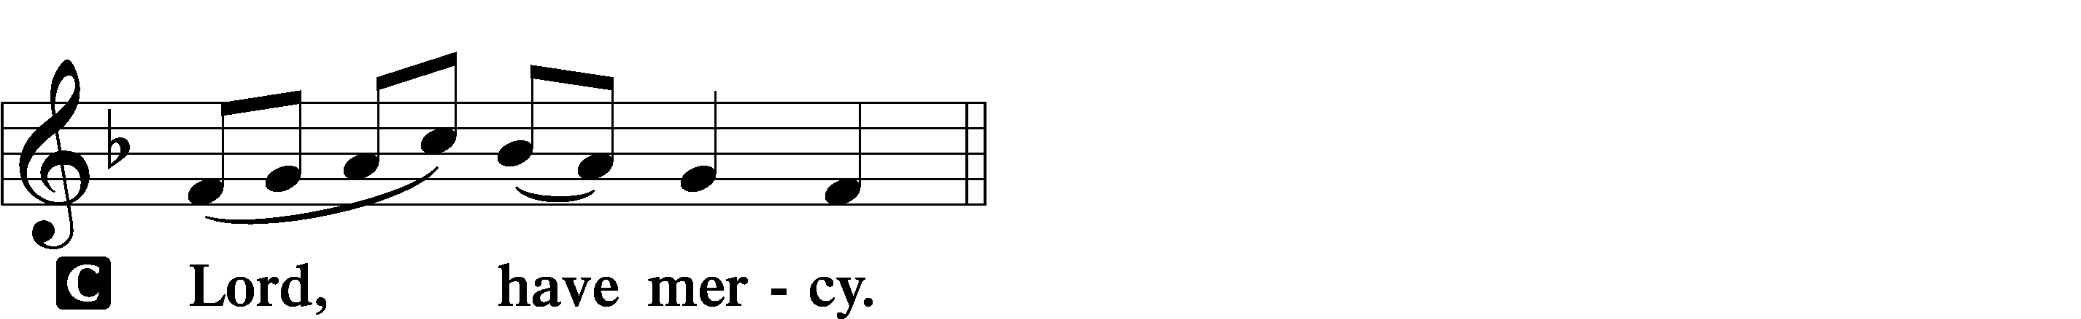
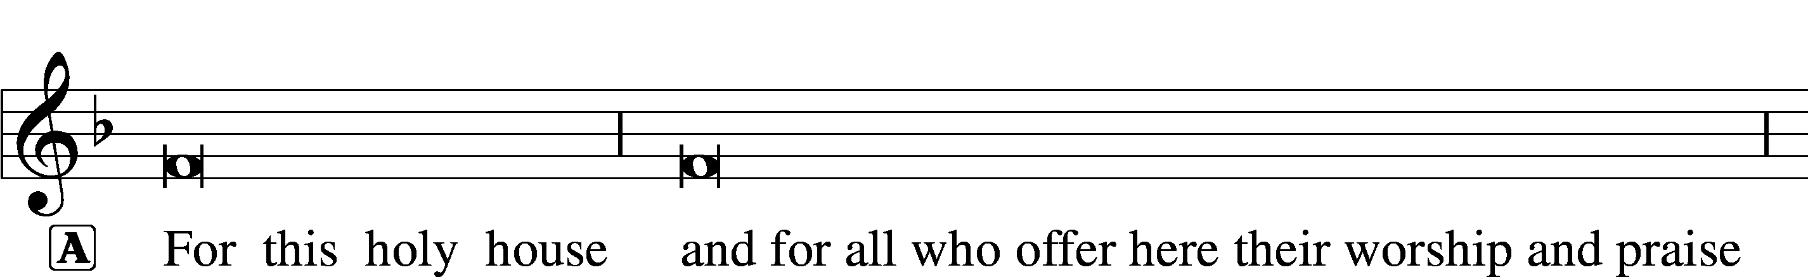
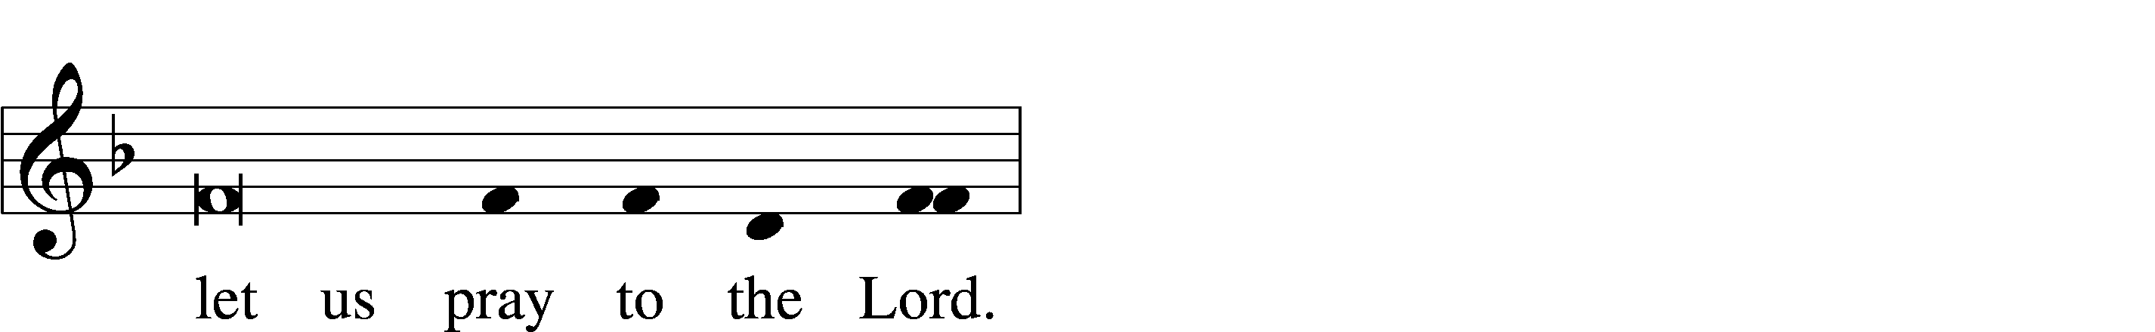
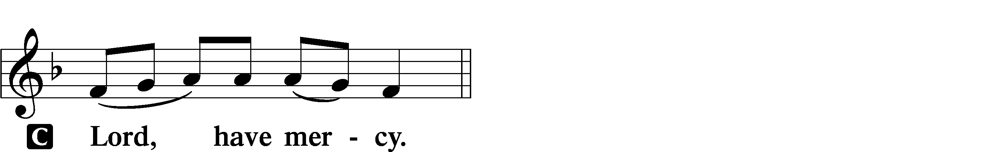

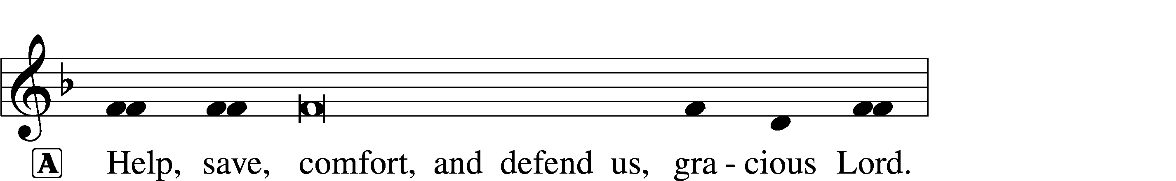


SALUTATION AND COLLECT OF THE DAY
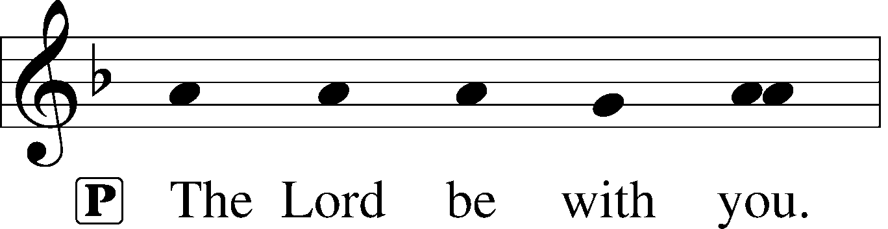
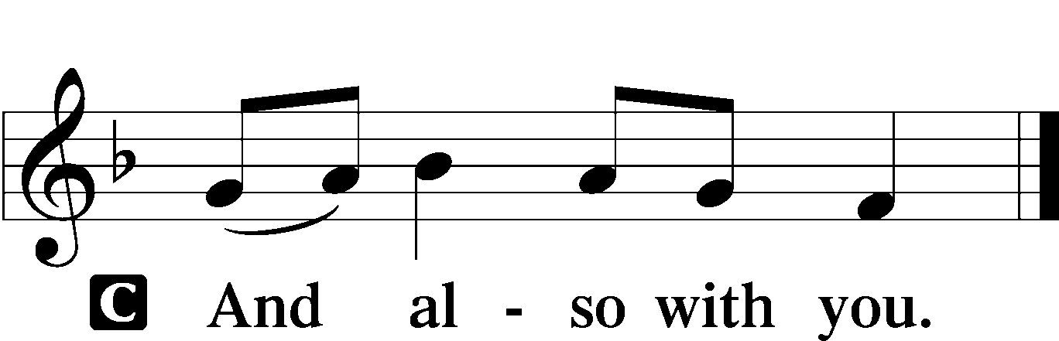

L Let us pray.
Almighty God, You have poured into our hearts the true Light of Your incarnate Word. Grant that this Light may shine forth in our lives; through the same Jesus Christ, Your Son, our Lord, who lives and reigns with You and the Holy Spirit, one God, now and forever.

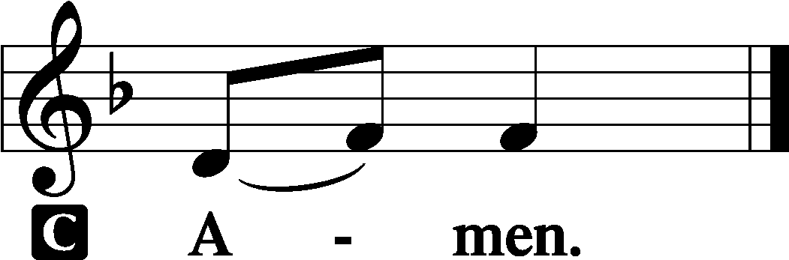

(Sit)

CHILDRENS LESSON

OLD TESTAMENT READING 1 Kings 3:4–15
4 The king went to Gibeon to sacrifice there, for that was the great high place. Solomon used to offer a thousand burnt offerings on that altar. 5At Gibeon the Lord appeared to Solomon in a dream by night, and God said, “Ask what I shall give you.” 6And Solomon said, “You have shown great and steadfast love to your servant David my father, because he walked before you in faithfulness, in righteousness, and in uprightness of heart toward you. And you have kept for him this great and steadfast love and have given him a son to sit on his throne this day. 7And now, O Lord my God, you have made your servant king in place of David my father, although I am but a little child. I do not know how to go out or come in. 8And your servant is in the midst of your people whom you have chosen, a great people, too many to be numbered or counted for multitude. 9Give your servant therefore an understanding mind to govern your people, that I may discern between good and evil, for who is able to govern this your great people?”
10It pleased the Lord that Solomon had asked this. 11And God said to him, “Because you have asked this, and have not asked for yourself long life or riches or the life of your enemies, but have asked for yourself understanding to discern what is right, 12behold, I now do according to your word. Behold, I give you a wise and discerning mind, so that none like you has been before you and none like you shall arise after you. 13I give you also what you have not asked, both riches and honor, so that no other king shall compare with you, all your days. 14And if you will walk in my ways, keeping my statutes and my commandments, as your father David walked, then I will lengthen your days.”
15And Solomon awoke, and behold, it was a dream. Then he came to Jerusalem and stood before the ark of the covenant of the Lord, and offered up burnt offerings and peace offerings, and made a feast for all his servants.

A This is the Word of the Lord.
C Thanks be to God.

GRADUAL Isaiah 9:6; Psalm 98:1a
To us a child is born, to us a son is | given;*
and the government shall be upon his | shoulder.
And his name shall be called Wonderful Counselor, | Mighty God,*
Everlasting Father, | Prince of Peace.
Sing to the Lord a | new song,*
for he has done | marvelous things!

EPISTLE Ephesians 1:3–14
3Blessed be the God and Father of our Lord Jesus Christ, who has blessed us in Christ with every spiritual blessing in the heavenly places, 4even as he chose us in him before the foundation of the world, that we should be holy and blameless before him. In love 5he predestined us for adoption as sons through Jesus Christ, according to the purpose of his will, 6to the praise of his glorious grace, with which he has blessed us in the Beloved. 7In him we have redemption through his blood, the forgiveness of our trespasses, according to the riches of his grace, 8which he lavished upon us, in all wisdom and insight 9making known to us the mystery of his will, according to his purpose, which he set forth in Christ 10as a plan for the fullness of time, to unite all things in him, things in heaven and things on earth.
11In him we have obtained an inheritance, having been predestined according to the purpose of him who works all things according to the counsel of his will, 12so that we who were the first to hope in Christ might be to the praise of his glory. 13In him you also, when you heard the word of truth, the gospel of your salvation, and believed in him, were sealed with the promised Holy Spirit, 14who is the guarantee of our inheritance until we acquire possession of it, to the praise of his glory.

A This is the Word of the Lord.
C Thanks be to God.

(Stand)

ALLELUIA AND VERSE LSB 156
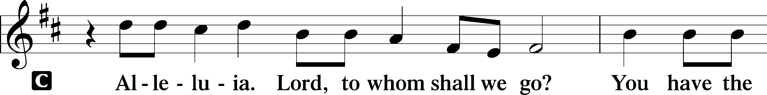
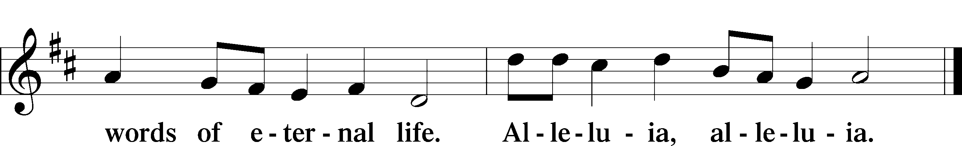

HOLY GOSPEL Luke 2:40–52
L The Holy Gospel according to St. Luke, the second chapter.

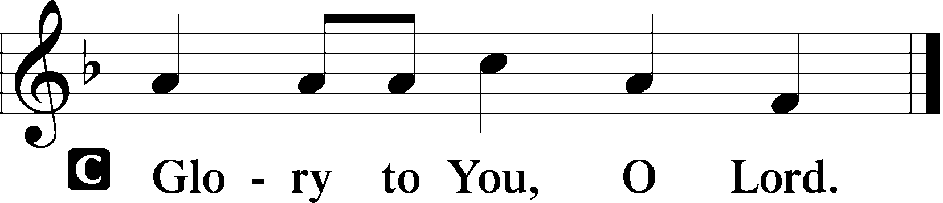

40The child [Jesus] grew and became strong, filled with wisdom. And the favor of God was upon him.
41Now his parents went to Jerusalem every year at the Feast of the Passover. 42And when he was twelve years old, they went up according to custom. 43And when the feast was ended, as they were returning, the boy Jesus stayed behind in Jerusalem. His parents did not know it, 44but supposing him to be in the group they went a day’s journey, but then they began to search for him among their relatives and acquaintances, 45and when they did not find him, they returned to Jerusalem, searching for him. 46After three days they found him in the temple, sitting among the teachers, listening to them and asking them questions. 47And all who heard him were amazed at his understanding and his answers. 48And when his parents saw him, they were astonished. And his mother said to him, “Son, why have you treated us so? Behold, your father and I have been searching for you in great distress.” 49And he said to them, “Why were you looking for me? Did you not know that I must be in my Father’s house?” 50And they did not understand the saying that he spoke to them. 51And he went down with them and came to Nazareth and was submissive to them. And his mother treasured up all these things in her heart.
52And Jesus increased in wisdom and in stature and in favor with God and man.

L This is the Gospel of the Lord.

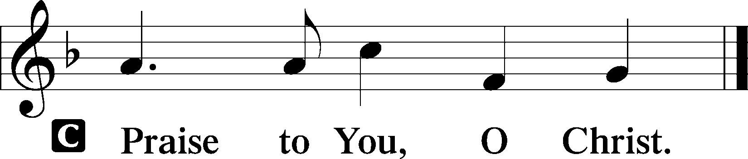

(Sit)

410 WITHIN THE FATHER’S HOUSE
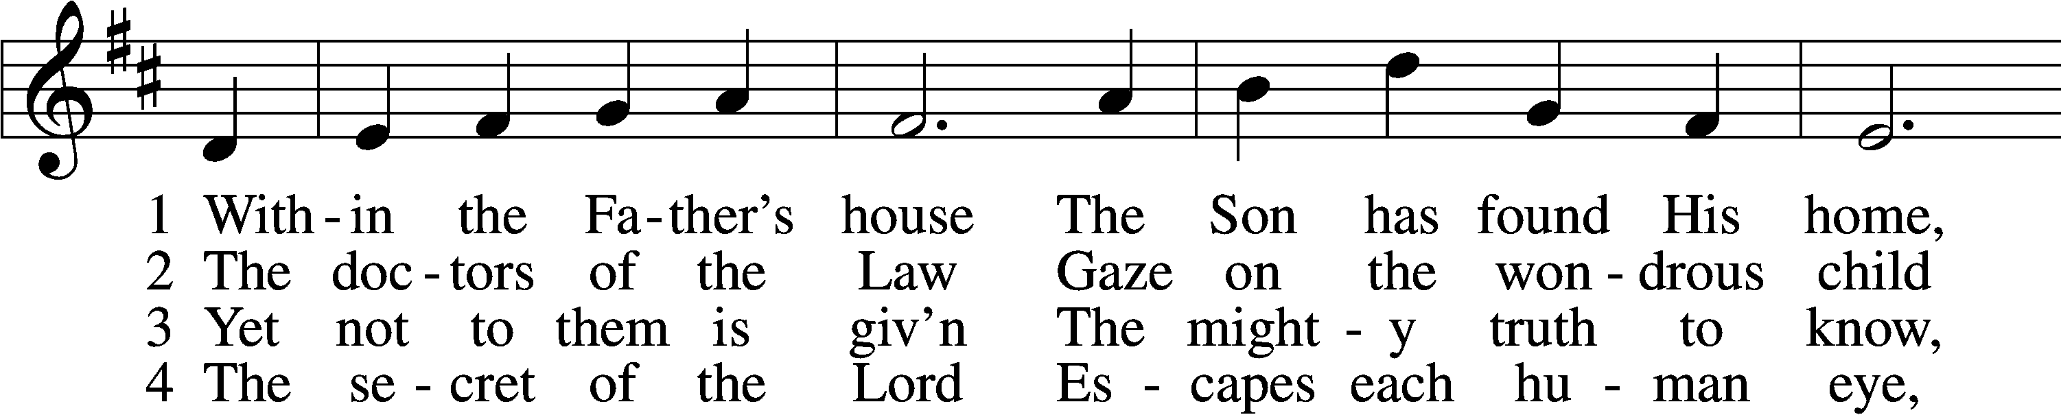
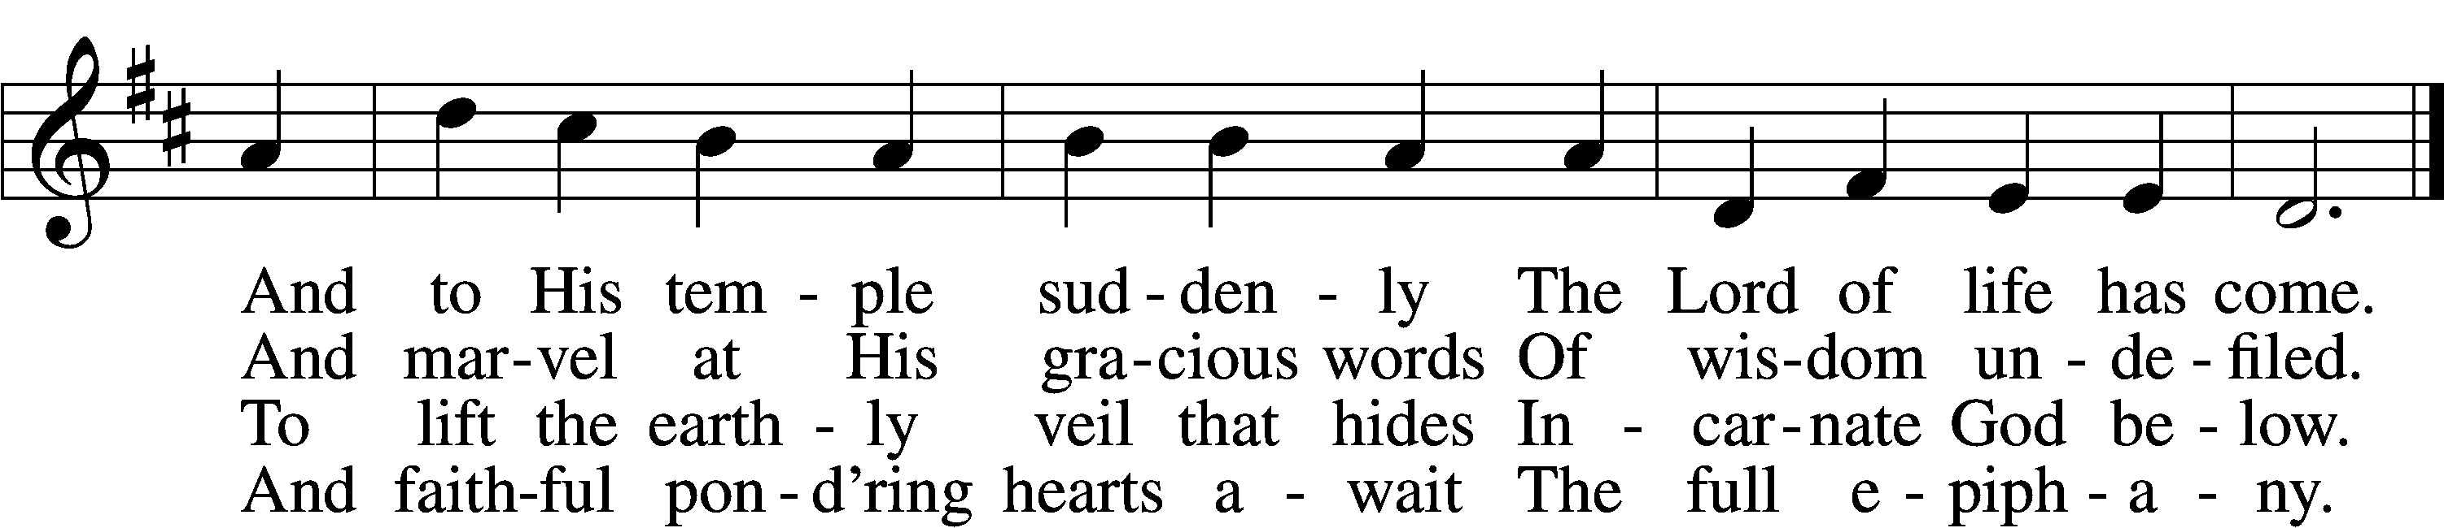

5 Lord, visit Thou our souls
And teach us by Thy grace
Each dim revealing of Thyself
With loving awe to trace

D 6 Till we behold Thy face
And know as we are known
Thee, Father, Son, and Holy Ghost,
Coequal Three in One.
Text: James R. Woodford, 1820–85, alt.
Tune: Johann Balthasar König, 1691–1758; adapt. William H. Havergal, 1793–1870
Text and tune: Public domain

SERMON OR MEDITATION ON THE READINGS

(Stand)

NICENE CREED
C I believe in one God,
the Father Almighty,
maker of heaven and earth
and of all things visible and invisible.

And in one Lord Jesus Christ,
the only-begotten Son of God,
begotten of His Father before all worlds,
God of God, Light of Light,
very God of very God,
begotten, not made,
being of one substance with the Father,
by whom all things were made;
who for us men and for our salvation came down from heaven
and was incarnate by the Holy Spirit of the virgin Mary
and was made man;
and was crucified also for us under Pontius Pilate.
He suffered and was buried.
And the third day He rose again according to the Scriptures
and ascended into heaven
and sits at the right hand of the Father.
And He will come again with glory to judge both the living and the dead,
whose kingdom will have no end.

And I believe in the Holy Spirit,
the Lord and giver of life,
who proceeds from the Father and the Son,
who with the Father and the Son together is worshiped and glorified,
who spoke by the prophets.
And I believe in one holy Christian and apostolic Church,
I acknowledge one Baptism for the remission of sins,
and I look for the resurrection of the dead
and the life T of the world to come. Amen.

SHARING OF THE PEACE

(Sit)

PRAYER OF THE CHURCH

OFFERING
As a part of our expression of thanksgiving to God for the treasure of His salvation to us, we offer a portion of our treasure, according to what each has determined in their heart to give. Please place offerings in the collection plate at the back of the sanctuary before or after the service. Offerings can also be sent to Bethlehem Lutheran Church via U.S. Mail. Thank you!

(Stand)

OFFERTORY LSB 159
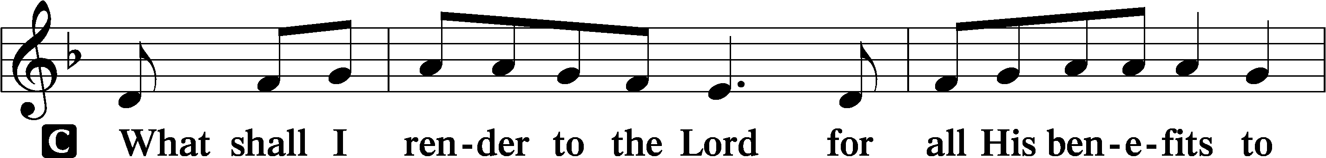
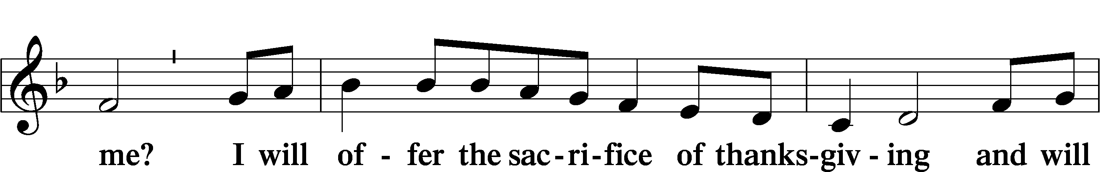
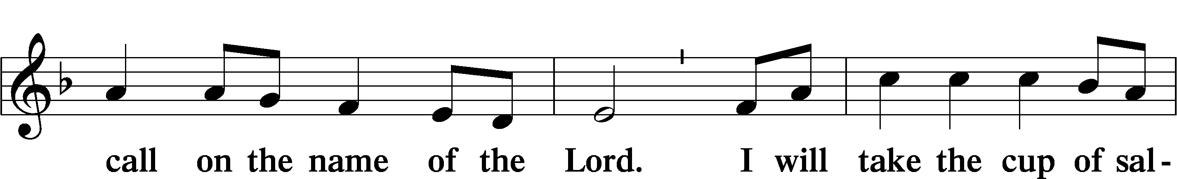
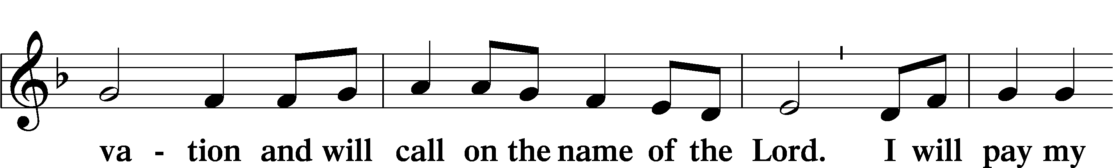
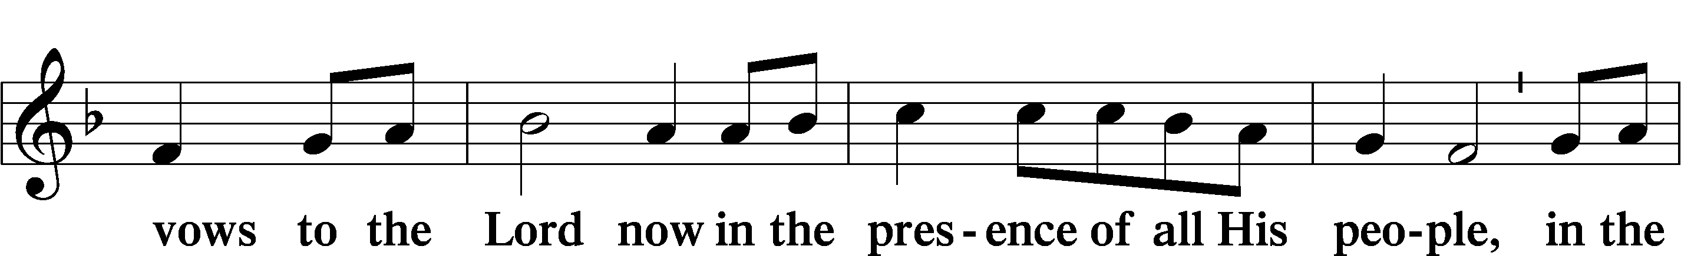
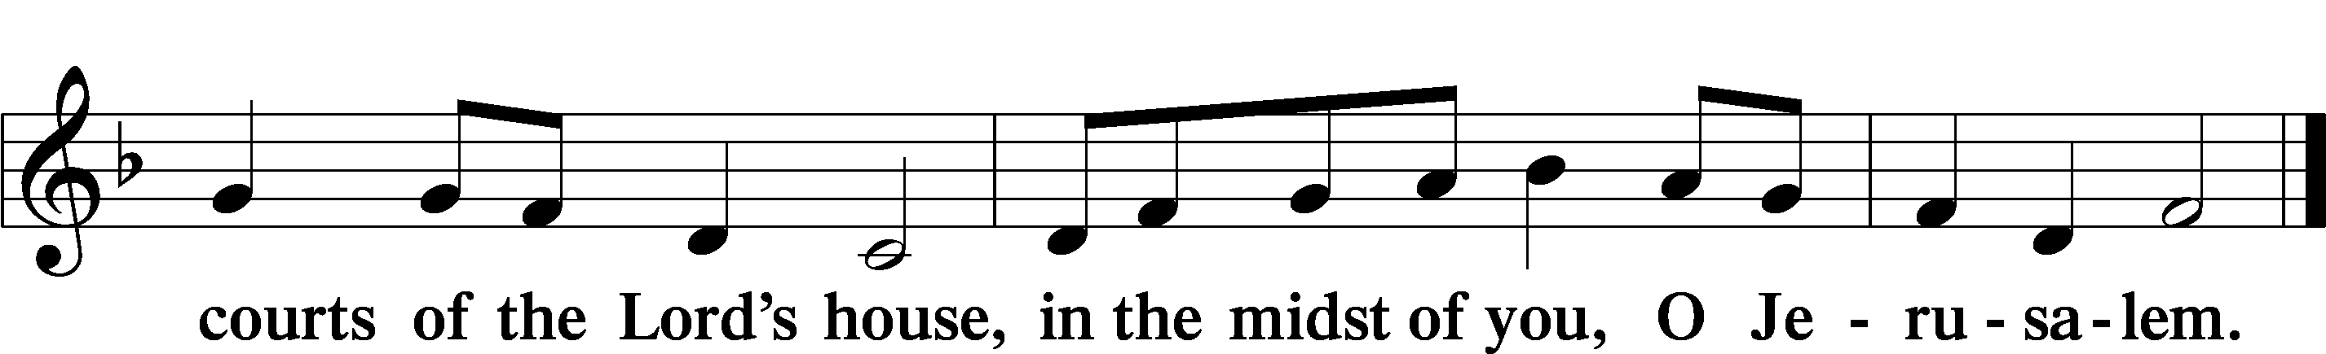

+ SERVICE OF THE SACRAMENT +
Note: The Service of The Sacrament is included in the lay bulletin solely as a viewers’ guide for those watching the livestream service; Communicant members who are unable to attend the Divine Service in person are encouraged to make arrangements with Pastor Engwall to receive the Lord’s Supper.

PREFACE LSB 160
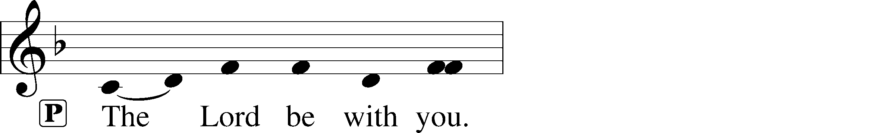
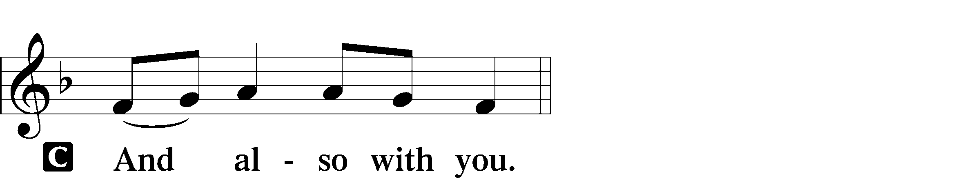
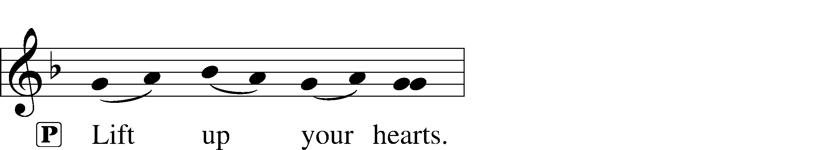

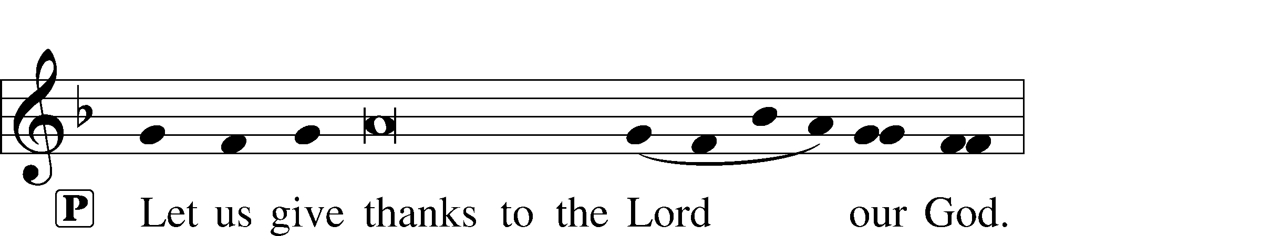
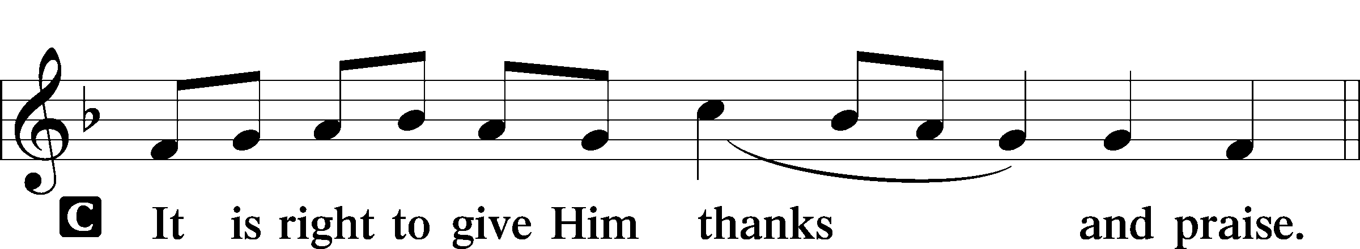

PROPER PREFACE (ABBREVIATED) LSB 161
L It is truly good, right, and salutary . . . evermore praising You and saying:

SANCTUS LSB 161
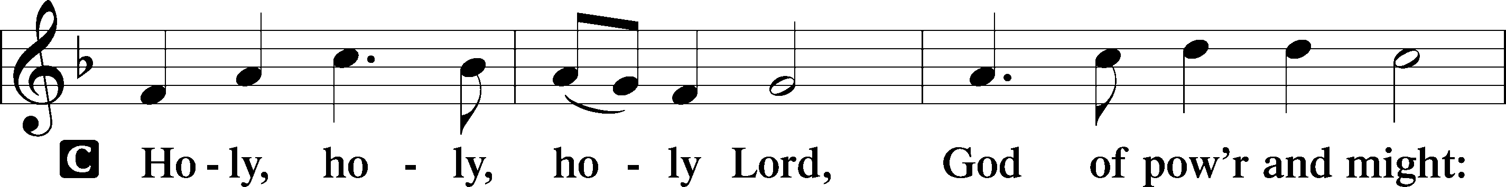
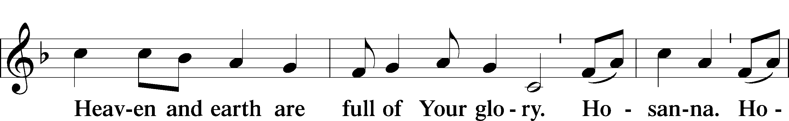
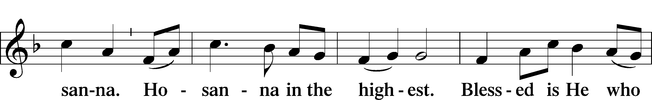
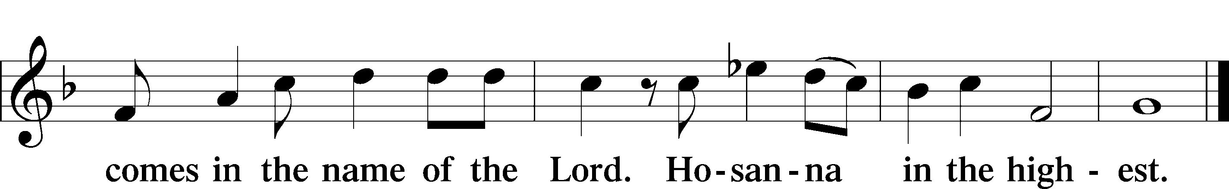

PRAYER OF THANKSGIVING LSB 161

LORD’S PRAYER LSB 162
L Lord, remember us in Your kingdom and teach us to pray:
C Our Father who art in heaven,
hallowed be Thy name,
Thy kingdom come,
Thy will be done on earth
as it is in heaven;
give us this day our daily bread;
and forgive us our trespasses
as we forgive those
who trespass against us;
and lead us not into temptation,
but deliver us from evil.
For Thine is the kingdom
and the power and the glory
forever and ever. Amen.

THE WORDS OF OUR LORD

PAX DOMINI LSB 163
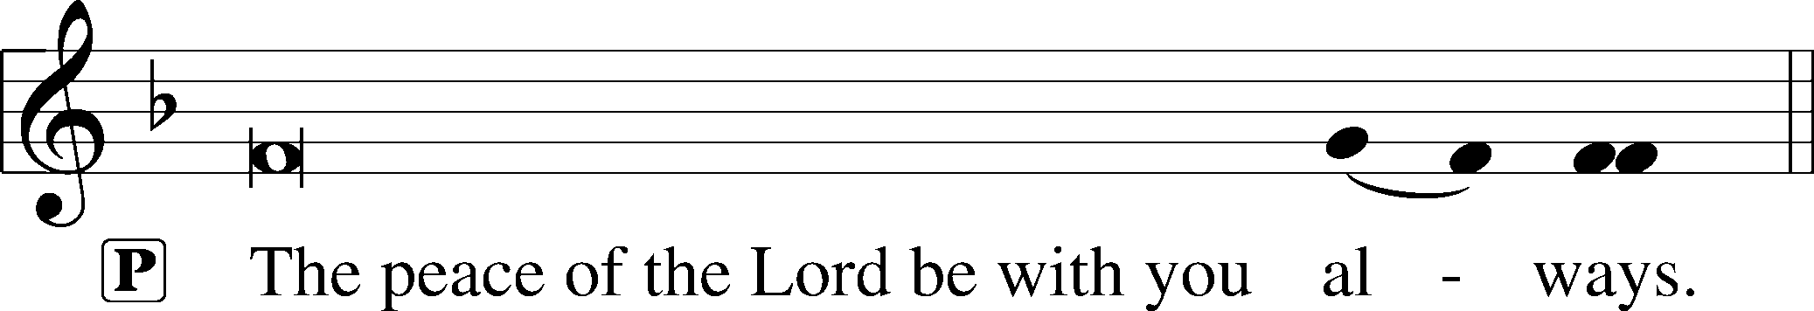


AGNUS DEI LSB 163
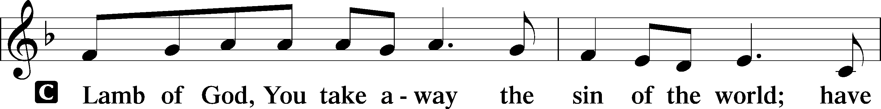
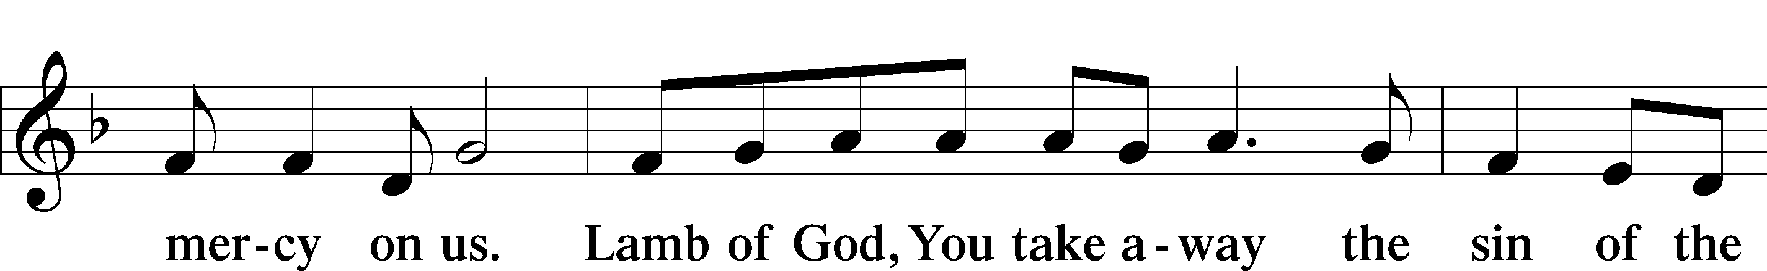
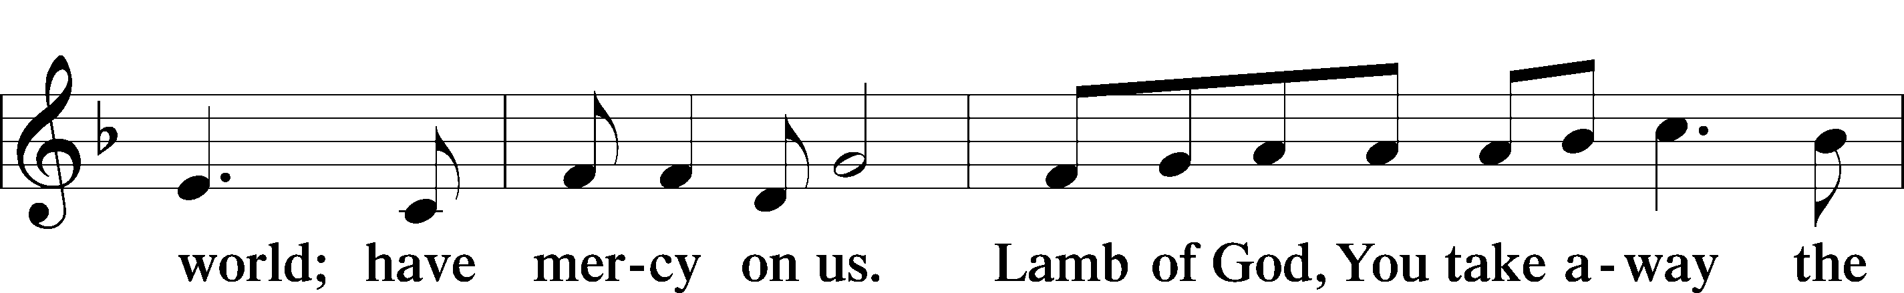
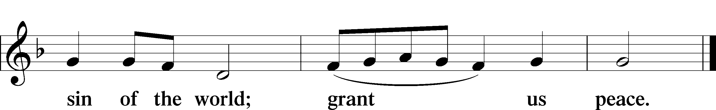

(Sit)

DISTRIBUTION
The pastor and those assisting him are communed first, then commune those who are unable to come to the altar.
The ushers will then direct all other communicants to the altar.

399 THE STAR PROCLAIMS THE KING IS HERE
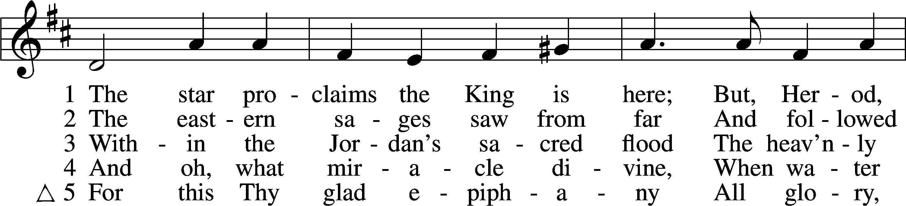
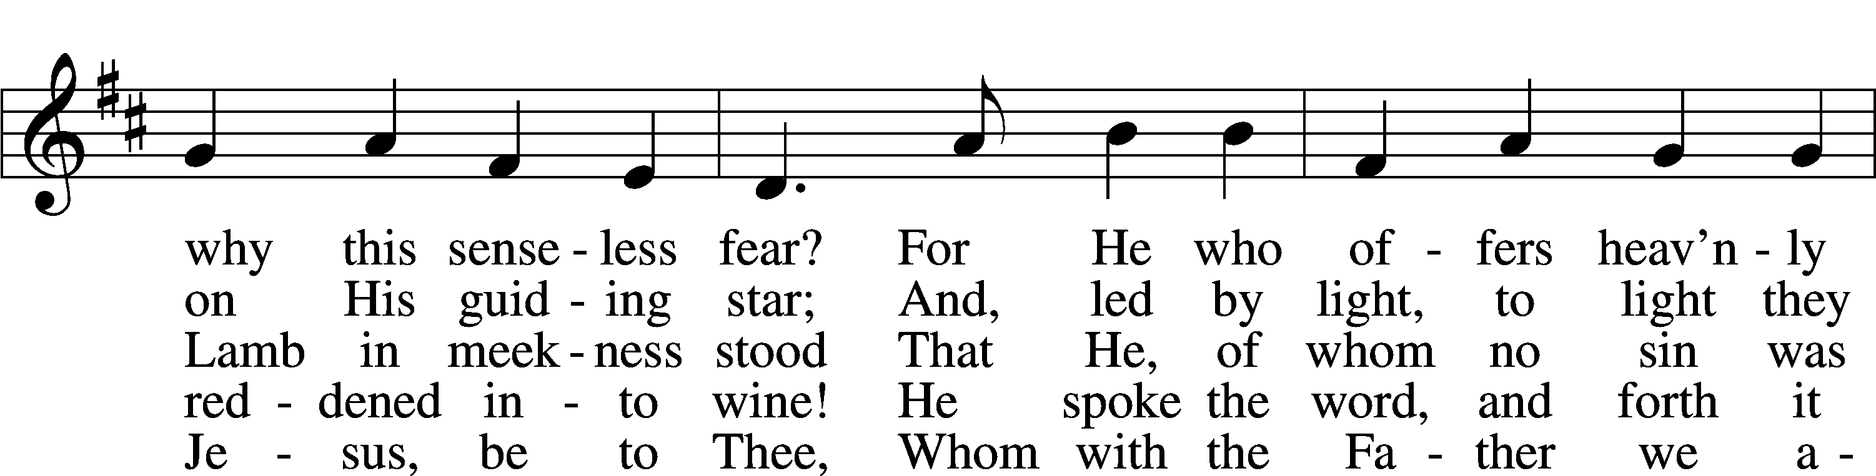
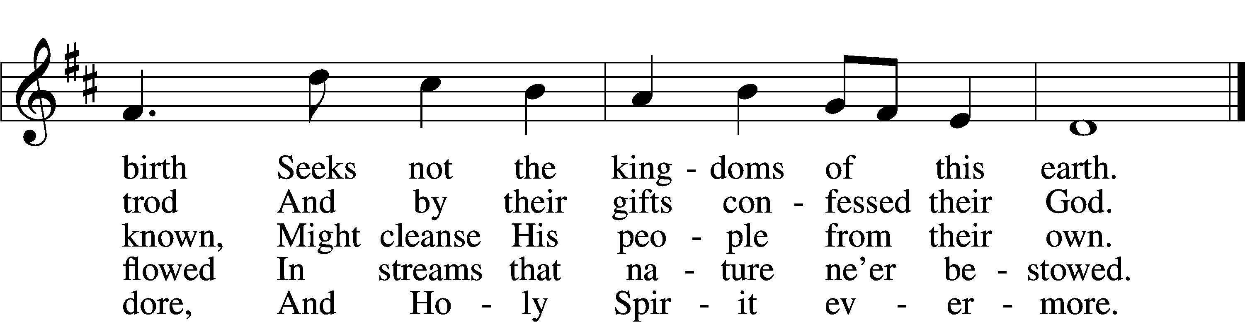
Text: Coelius Sedulius, 5th cent.; tr. John Mason Neale, 1818–66, alt.
Tune: Geistliche Lieder auffs new gebessert, 1535, Wittenberg, ed. Joseph Klug
Text and tune: Public domain

INSTRUMENTAL

(Stand)

THANK THE LORD LSB 164
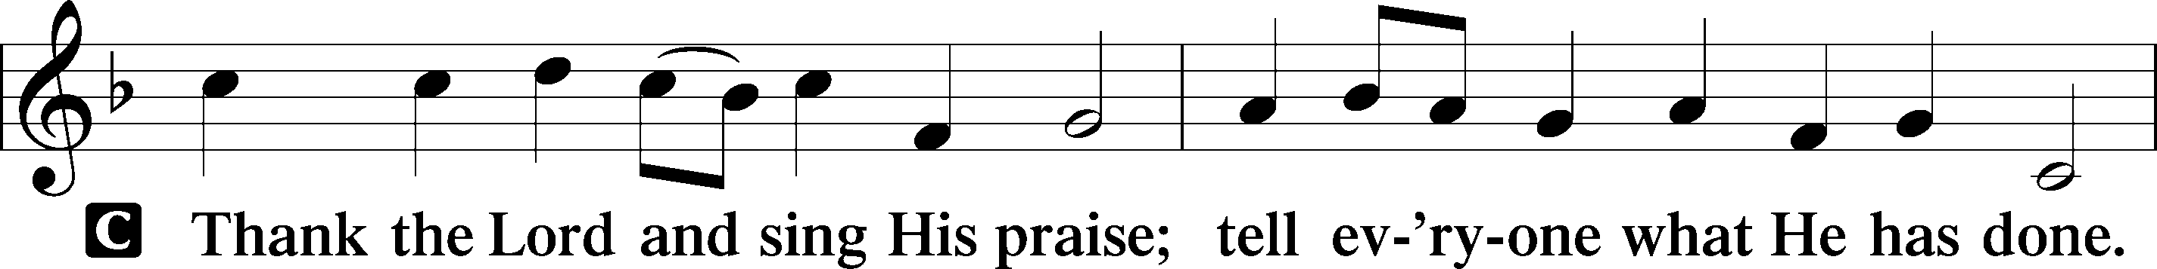
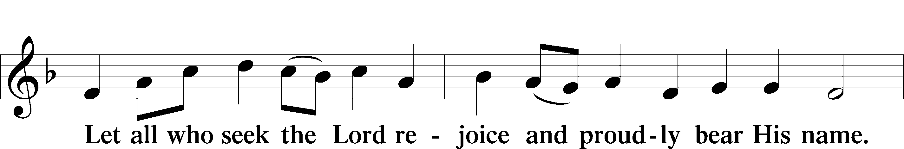
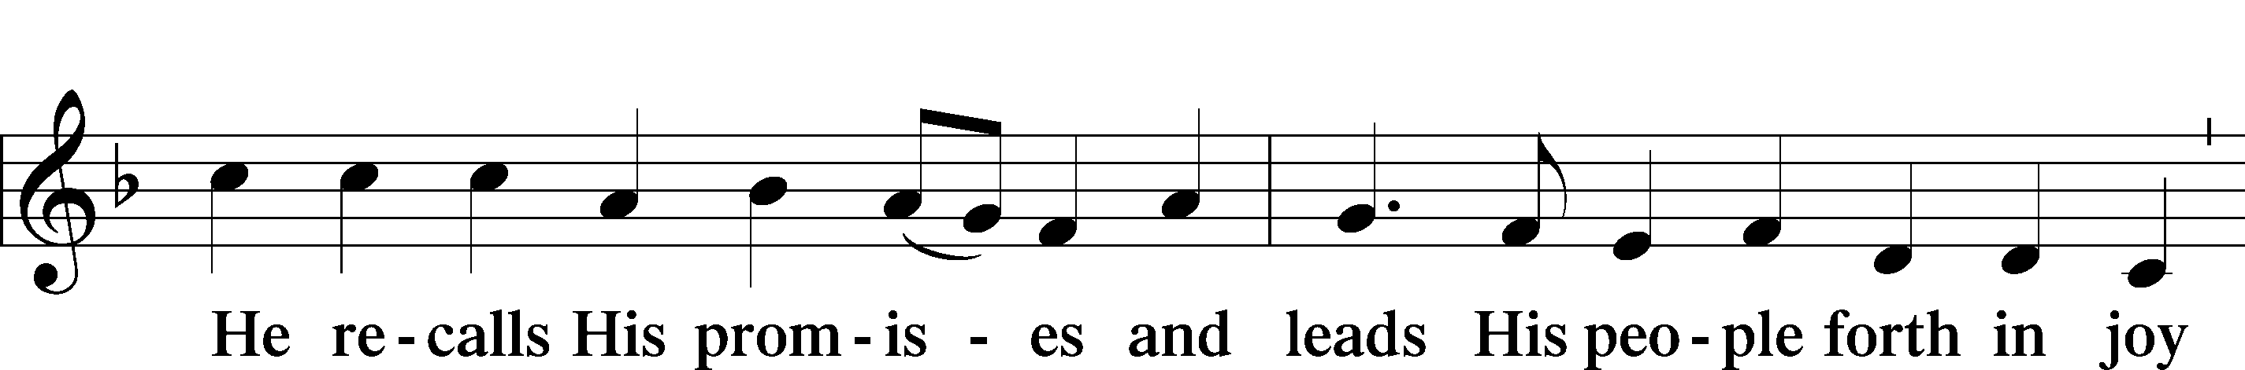
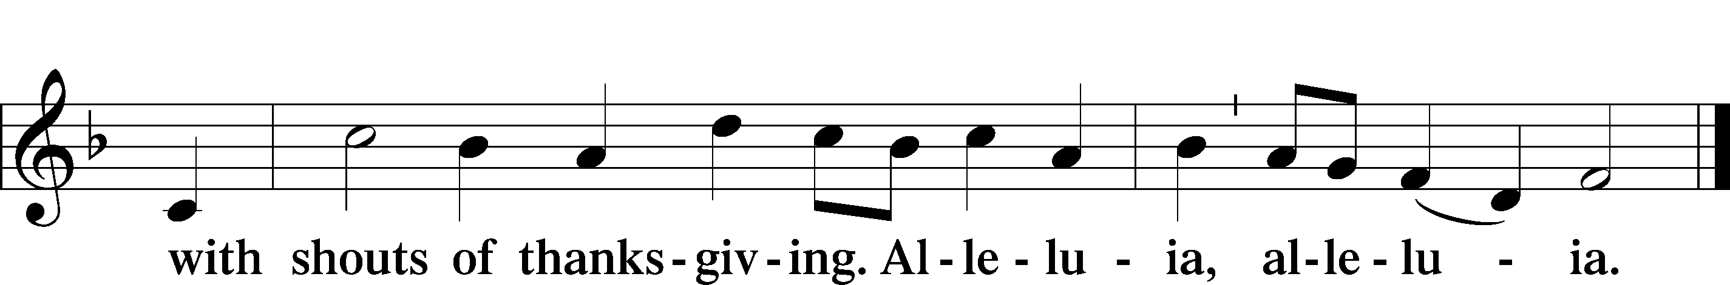

POST-COMMUNION COLLECT

BENEDICTION
L:The grace of our Lord T Jesus Christ, and the love of God, and the fellowship of the Holy Spirit, be with us all.
C: Amen.

376 ONCE IN ROYAL DAVID’S CITY
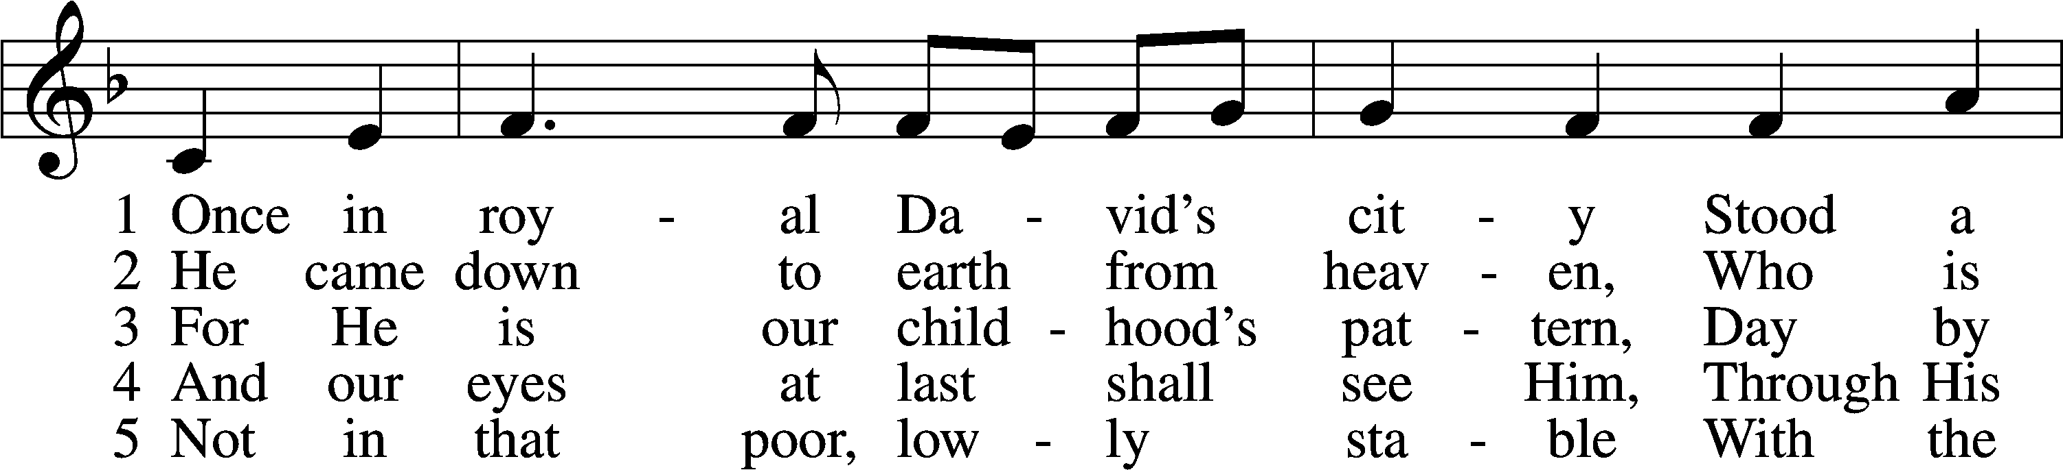
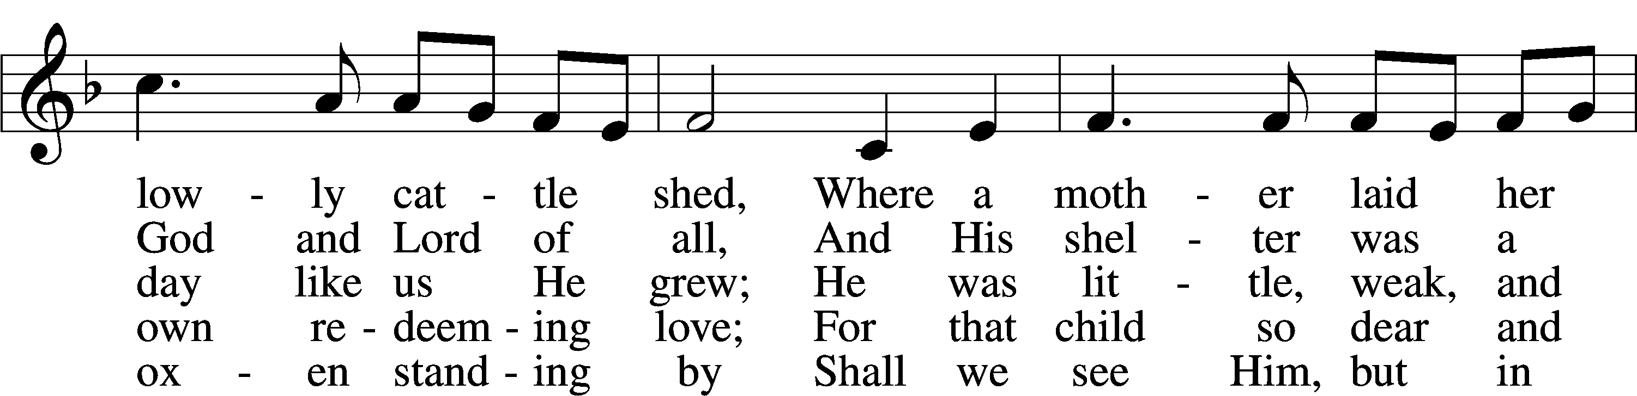
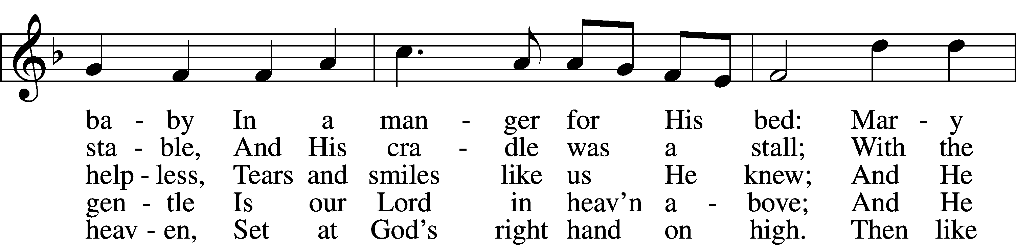
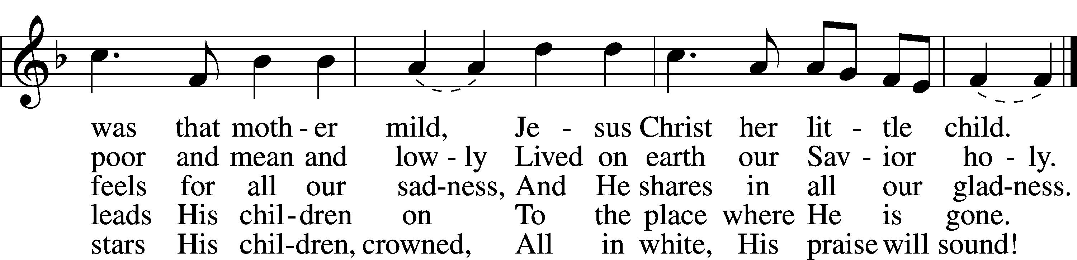
Text: Cecil F. Alexander, 1818–95, alt.
Tune: Henry J. Gauntlett, 1805–76
Text and tune: Public domain

ACKNOWLEDGMENTS
Unless otherwise indicated, Scripture quotations are from the ESV® Bible (The Holy Bible, English Standard Version®), copyright © 2001 by Crossway, a publishing ministry of Good News Publishers. Used by permission. All rights reserved.
Created by Lutheran Service Builder © 2025 Concordia Publishing House.

IN OUR PRAYERS:
Submitted petitions are included for two consecutive Sundays
For Those suffering afflictions of mind, body,or spirit:
Angela R., Blake B., Carol R., Michele N., Nancy O.

All of our Shut- Ins:
Betty A., Shirley F., Mary H., Patsy L., Herman L., Tommy, Pam and Jerome M., Sharon B., Dennis & Judy S., Anne H.

For missionaries
Deaconess Sandra R., Rev. Jonathan A.

ANNOUNCEMENTS
Please email announcements for Sunday bulletins by 8:00 a.m. Tuesday to pastorblcaiken@gmail.com
ALTAR FLOWERS:
The 2026 flower chart is now posted in the information center.

JANUARY 10th:
The Altar Guild needs volunteers for taking down Christmas decorations. 8:00 ‘til packed away.

JANUARY 28th
Potluck after church, meat will be provided.

ACTS DONATION FOR JANUARY:
1lbs. bag of rice
FELLOWSHIP COFFEE HOUR:
Every Sunday morning, during Bible Study and after the Divine Service, coffee, treats and good fellowship are waiting for you in our Fellowship Hall!
CALENDAR, NEWSLETTER, AND CHURCH DIRECTORY:
Please provide any articles, calendar entries, announcements, photos, etc. for the Star of Bethlehem newsletter to Debbie C. no later than noon on the 23rd of each month. The Star calendar will also be used for the website. Updates to your church directory data may be provided at any time.

Attendance: Christmas Eve: 38 Christmas Day: 28 Sunday: 31
Offering: Christmas Eve/Day: $485 Sunday: $ 2,135
Average weekly offering needed to make budget: $2,508

BE IN THE WORD!
SUNDAY MORNINGS AT 9 a.m.
Adult Bible Study
Sunday School for children and youth
TUESDAY MORNINGS AT 10:00 a.m.
Women’s Bible Study (Resumes Jan. 6th)
WEDNESDAY EVENINGS AT 7 p.m.
Adult Bible Study (Resumes Jan. 7th)
JUNIOR CONFIRMATION and ADULT INSTRUCTION
Always available by request:
Contact Pastor to schedule
OUR VALUE STATEMENT: Bethlehem Lutheran Church exists under God’s grace to save the lost and to strengthen the saved so that they may live bold and courageous lives of Christian witness before a non-believing world.
Therefore, our purpose is:
- to glorify God in Word and deed,
- to nurture each other in Christian love,
- to reach out to others with our Savior’s Gospel of life and salvation.
(Rom 5:8, Matt. 28:18-20).

OUR VISION: By the Grace of God, Bethlehem Lutheran Church, is a loving family united in Christ, learning, living, and spreading His Word.

OUR MISSION: Learn the Word. Live the Word. Spread the Word.

