BETHLEHEM LUTHERAN CHURCH
A congregation of The Lutheran Church-Missouri Synod
902 Hitchcock Drive SW,
Aiken, South Carolina 29803
Church Phone: (803) 649-6417
blcaikensc@gmail.com

Note: The format of this bulletin has been modified for use in private devotion services. Unable to join us in person? Please find us on Facebook live. The service is also posted on our website: bethlehemlutheranaiken.org

+ + + + + + + + + + + + + + +
Fifth Sunday of Easter
May 3, 2026
10:30 a.m.
+ + + + + + + + + + + + + + +

+ SERVICE OF PREPARATION +
After the bell tolls, please observe a time of silence.

WELCOME AND ANNOUNCEMENTS

(Stand)

667 SAINTS, SEE THE CLOUD OF WITNESSES
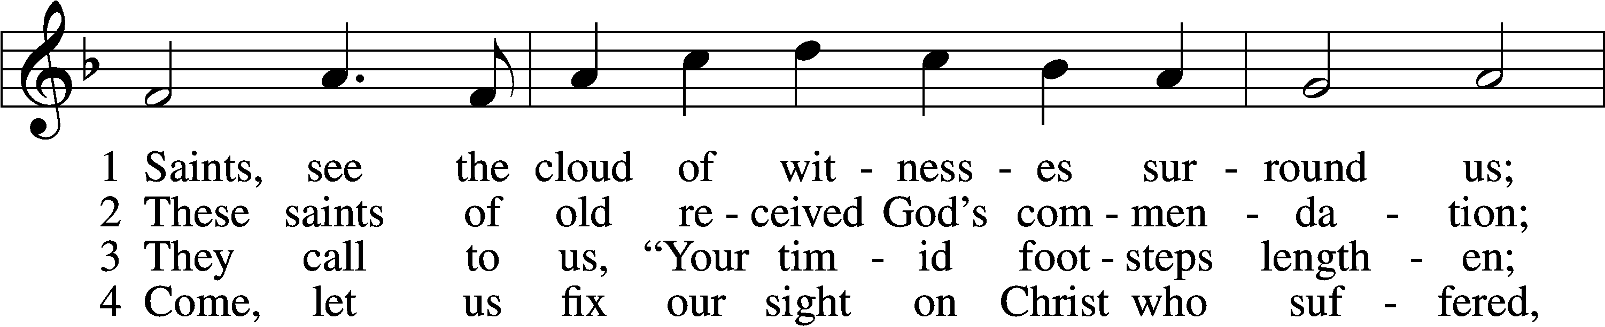
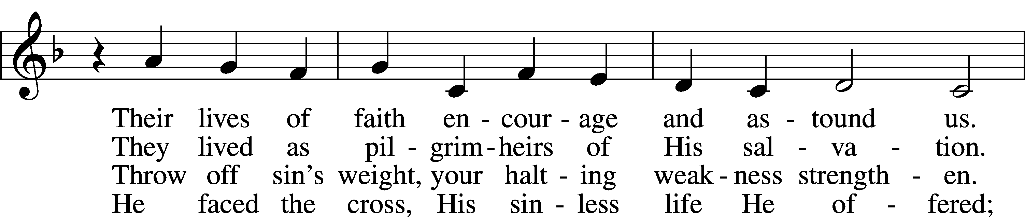
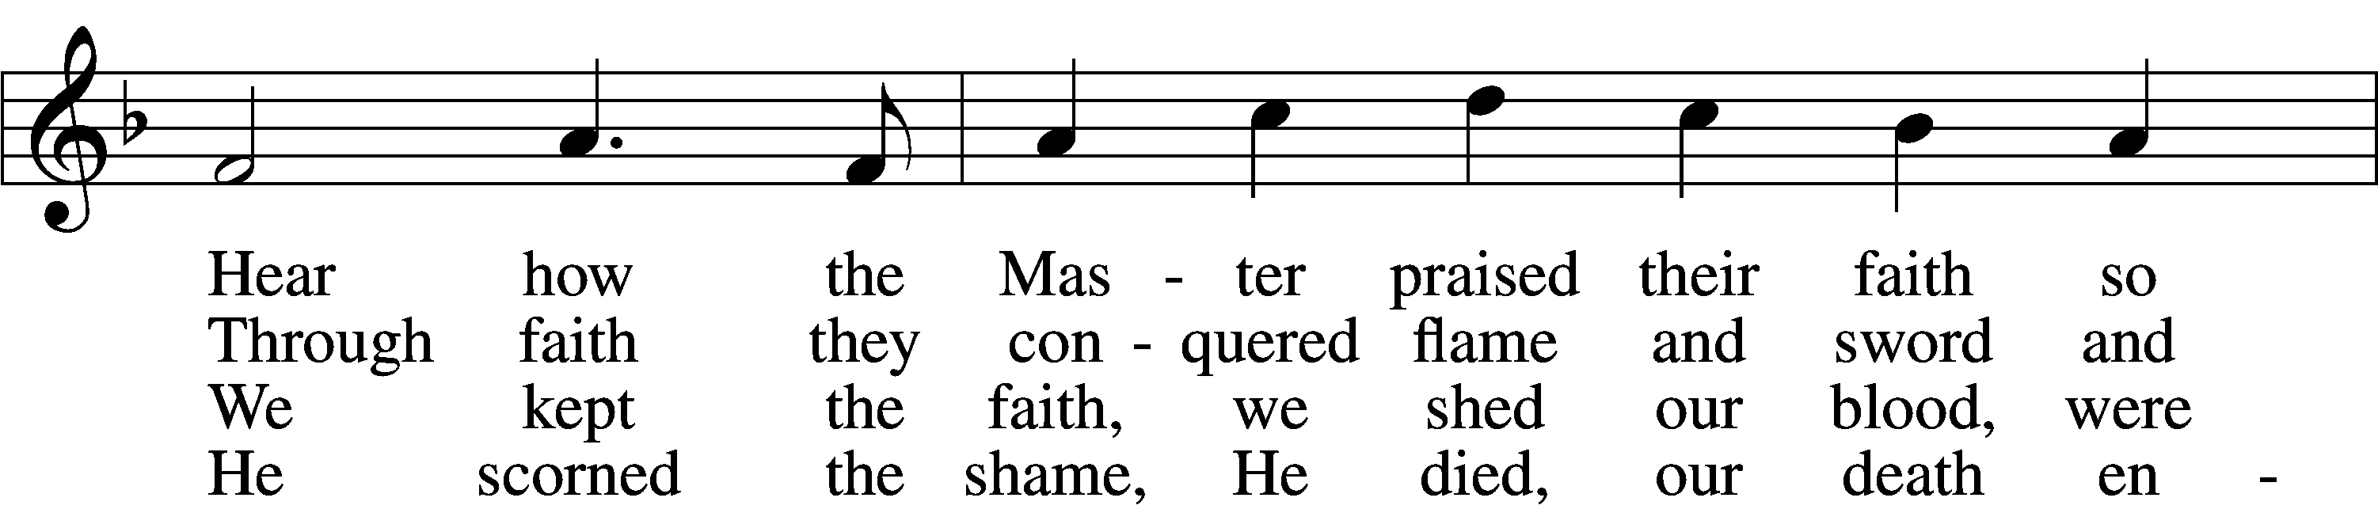
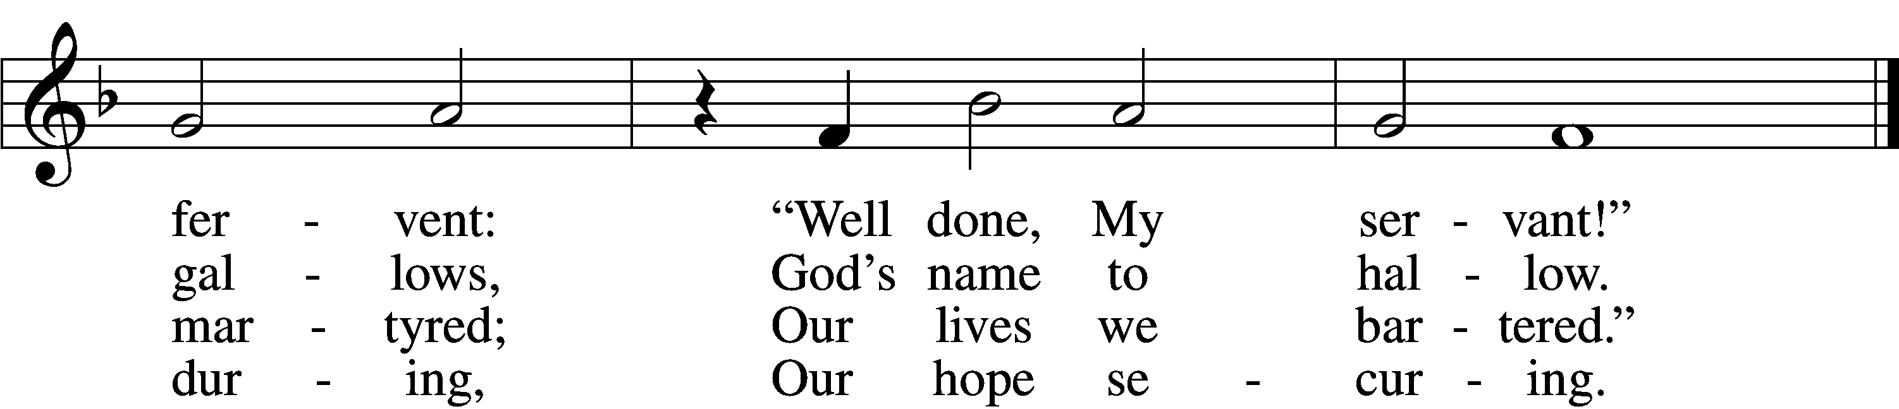

5 Lord, give us faith to walk where You are sending,
On paths unmarked, eyes blind as to their ending;
Not knowing where we go, but that You lead us—
With grace precede us.

6 You, Jesus, You alone deserve all glory!
Our lives unfold, embraced within Your story;
Past, present, future—You, the same forever—
You fail us never!
Text: Stephen P. Starke, 1955
Tune: Dale Wood, 1934–2003
Text: © 1997 Stephen P. Starke, admin. Concordia Publishing House. Used by permission: LSB Hymn License no. 110004798
Tune: © 1974 Augsburg Publishing House, admin. Augsburg Fortress. Used by permission: LSB Hymn License no. 110004798

+ CONFESSION AND ABSOLUTION +

(The sign of the cross may be made by all in remembrance of their Baptism.)

INVOCATION
L In the name of the Father and of the T Son and of the Holy Spirit.
C Amen.

EXHORTATION LSB 151
L If we say we have no sin, we deceive ourselves, and the truth is not in us.
C But if we confess our sins, God, who is faithful and just, will forgive our sins and cleanse us from all unrighteousness.

(Silence for reflection on God’s Word and for self-examination.)

CONFESSION OF SINS LSB 151
L Let us then confess our sins to God our Father.
C Most merciful God, we confess that we are by nature sinful and unclean. We have sinned against You in thought, word, and deed, by what we have done and by what we have left undone. We have not loved You with our whole heart; we have not loved our neighbors as ourselves. We justly deserve Your present and eternal punishment. For the sake of Your Son, Jesus Christ, have mercy on us. Forgive us, renew us, and lead us, so that we may delight in Your will and walk in Your ways to the glory of Your holy name. Amen.

DECLARATION OF GRACE LSB 151
L In the mercy of almighty God, Jesus Christ was given to die for us, and for His sake God forgives us all our sins. To those who believe in Jesus Christ He gives the power to become the children of God and bestows on them the Holy Spirit. May the Lord, who has begun this good work in us, bring it to completion in the day of our Lord Jesus Christ.
C Amen.

+ SERVICE OF THE WORD +

INTROIT Psalm 30:1–5; antiphon: Psalm 149:1
Praise the Lord! Sing to the Lord a | new song,*
his praise in the assembly of the | godly!
I will extol you, O Lord, for you have | drawn me up*
and have not let my foes rejoice | over me.
O Lord my God, I cried to | you for help,*
and you have | healed me.
O Lord, you have brought up my soul | from Sheol;*
you restored me to life from among those who go down | to the pit.
Sing praises to the Lord, O | you his saints,*
and give thanks to his | holy name.
For his anger is but for a moment, and his favor is for a | lifetime.*
Weeping may tarry for the night, but joy comes with the | morning.
Glory be to the Father and | to the Son*
and to the Holy | Spirit;
as it was in the be- | ginning,*
is now, and will be forever. | Amen.
Praise the Lord! Sing to the Lord a | new song,*
his praise in the assembly of the | godly!

KYRIE LSB 152

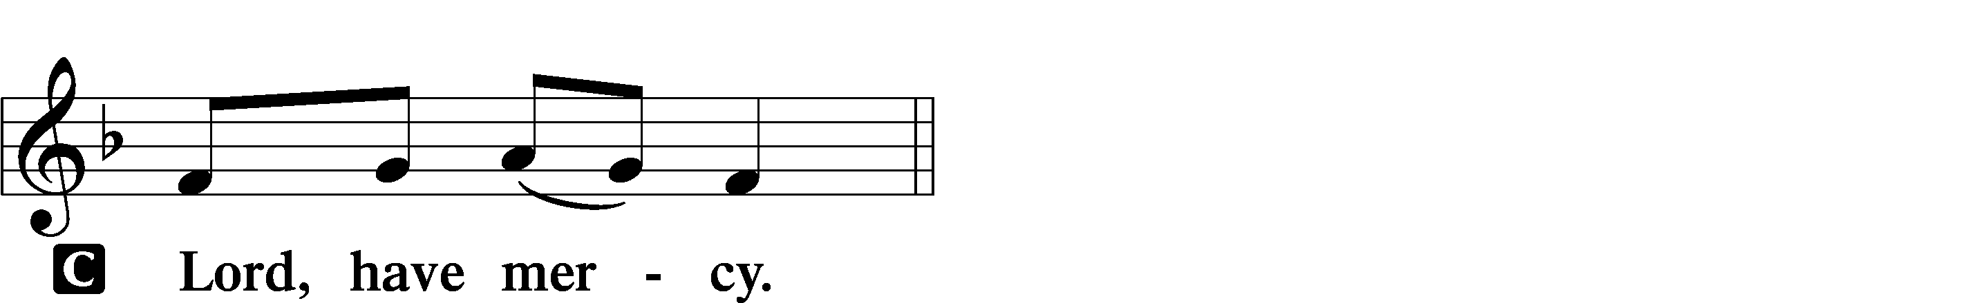

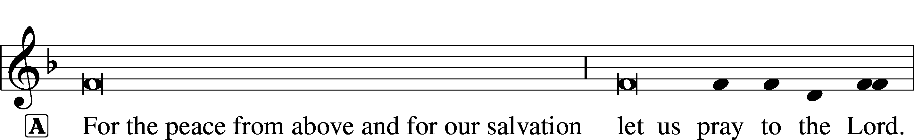
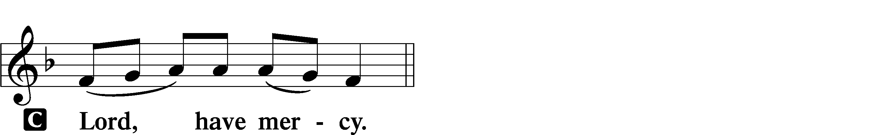

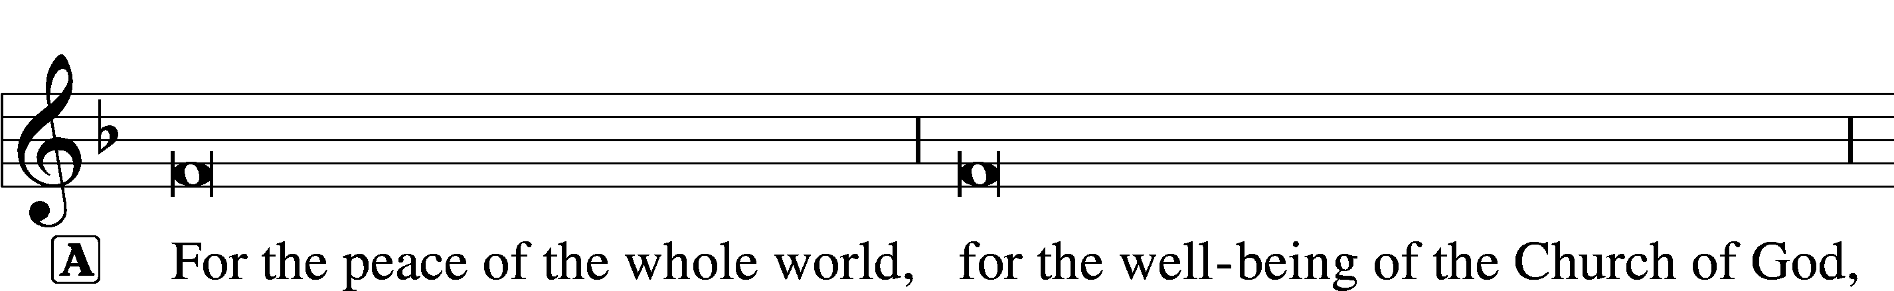
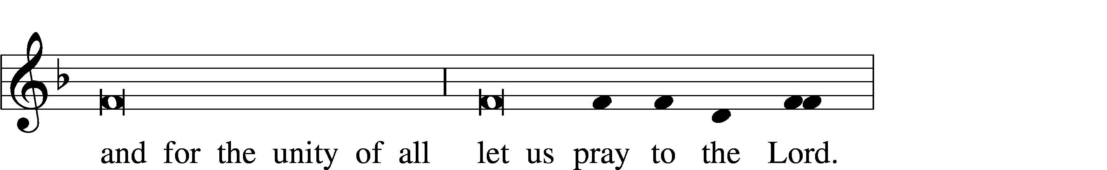
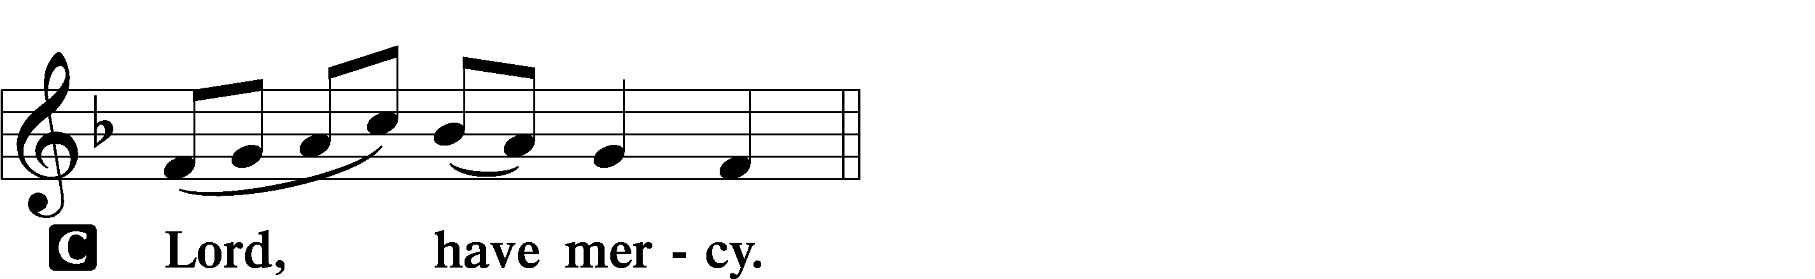

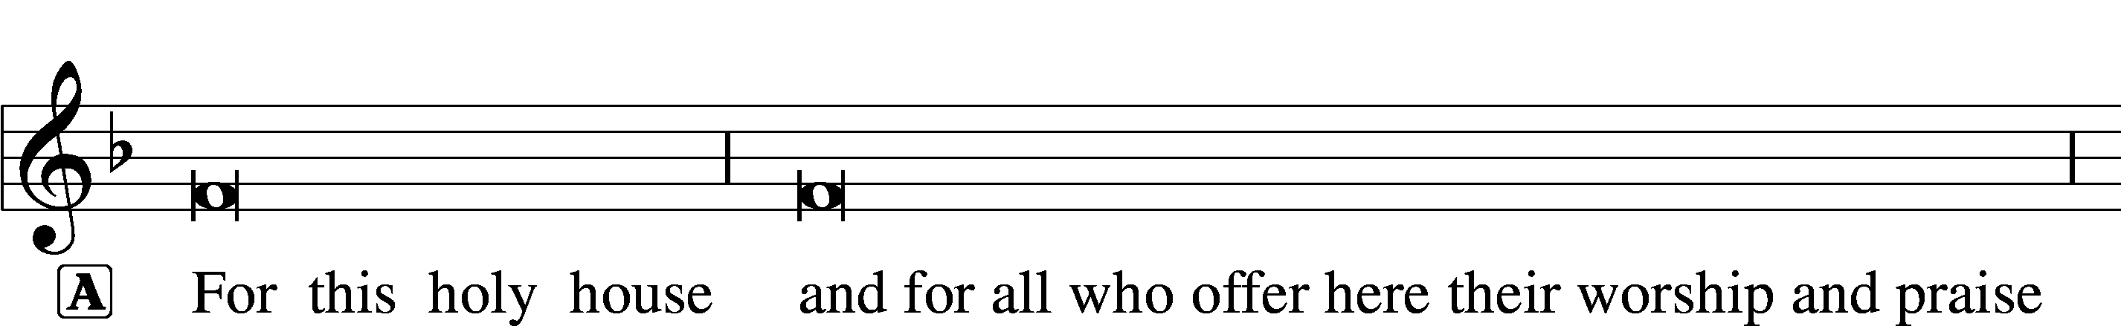

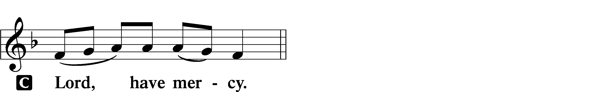

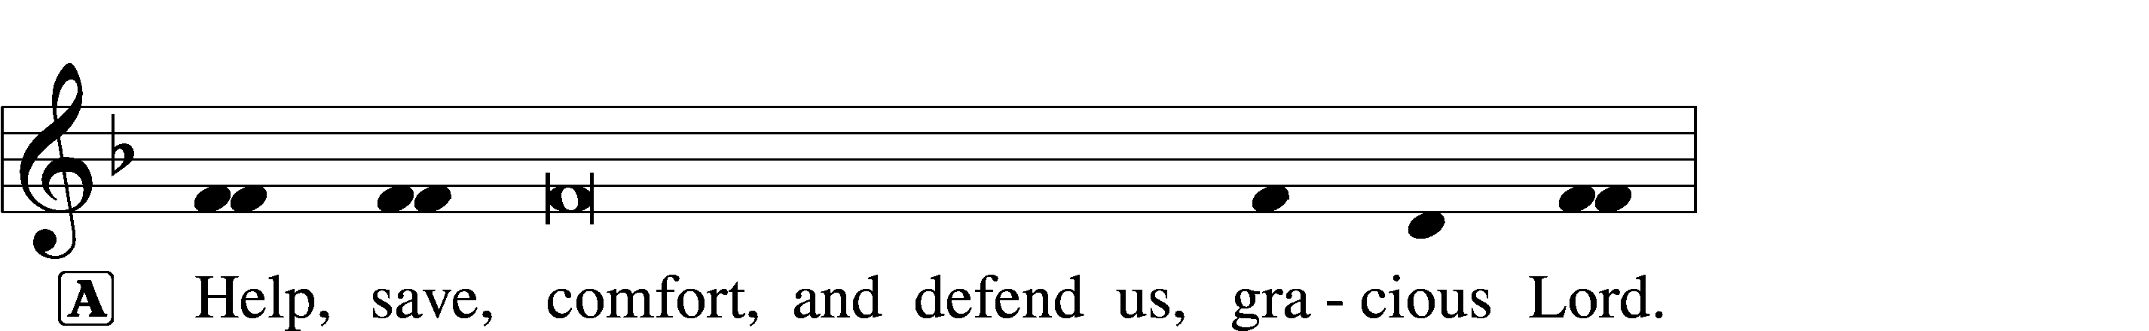


GLORIA IN EXCELSIS LSB 154
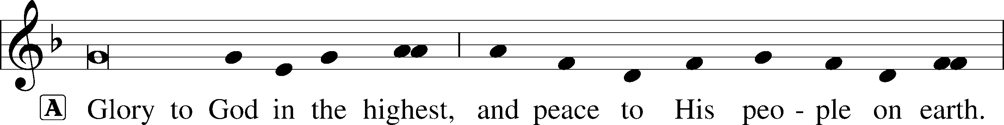
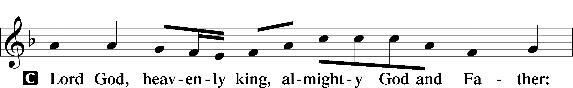
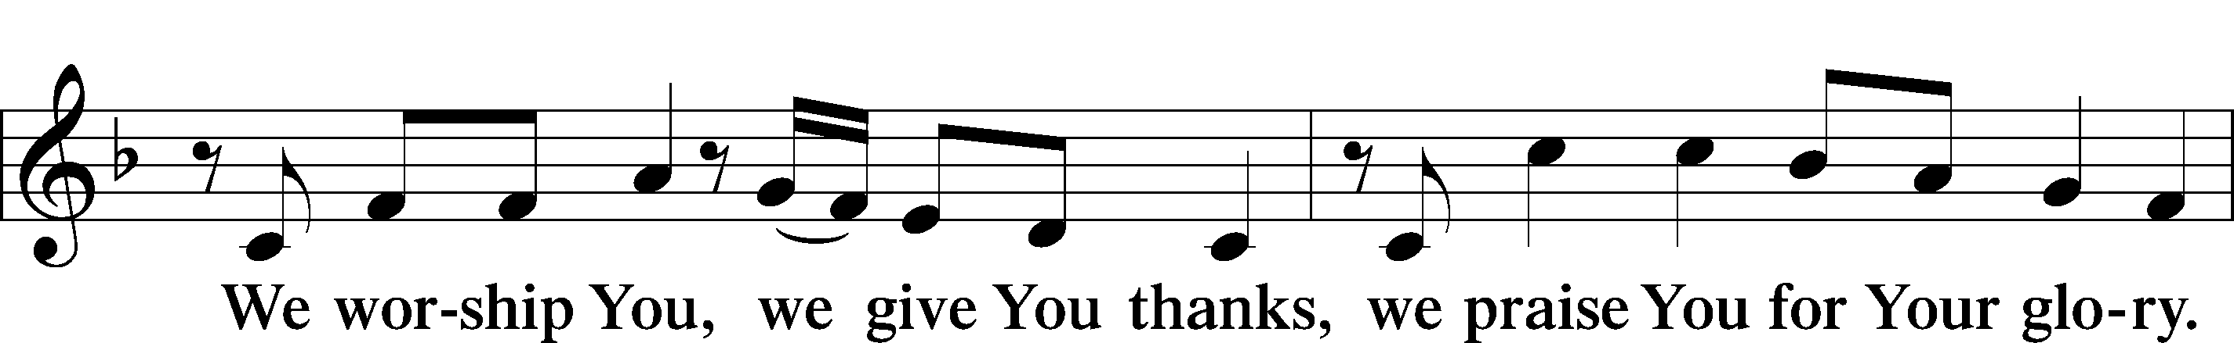
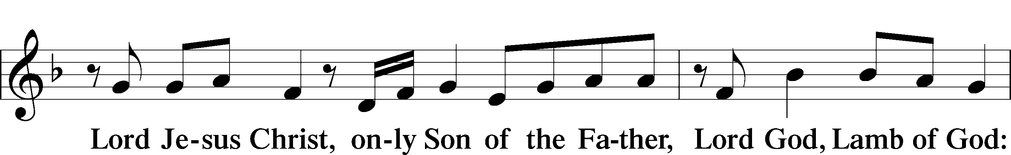
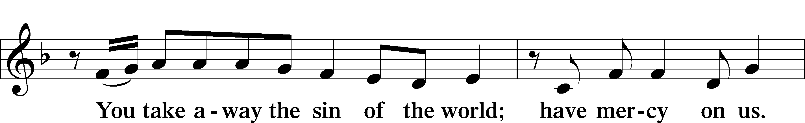
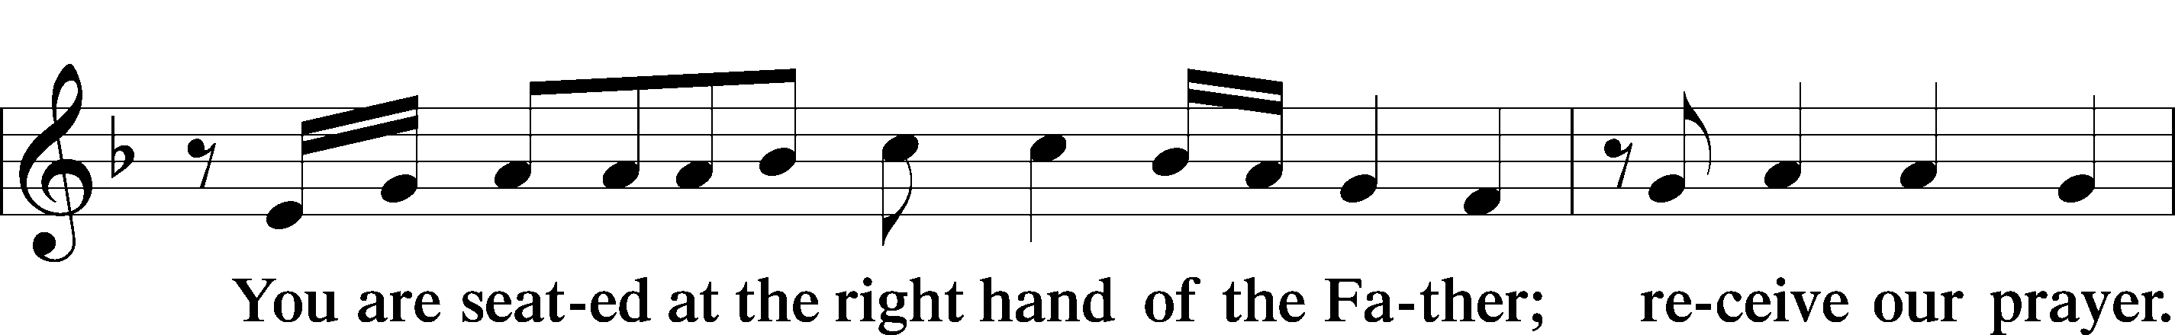
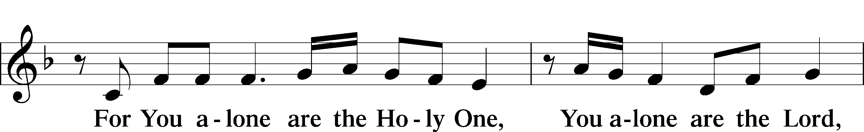
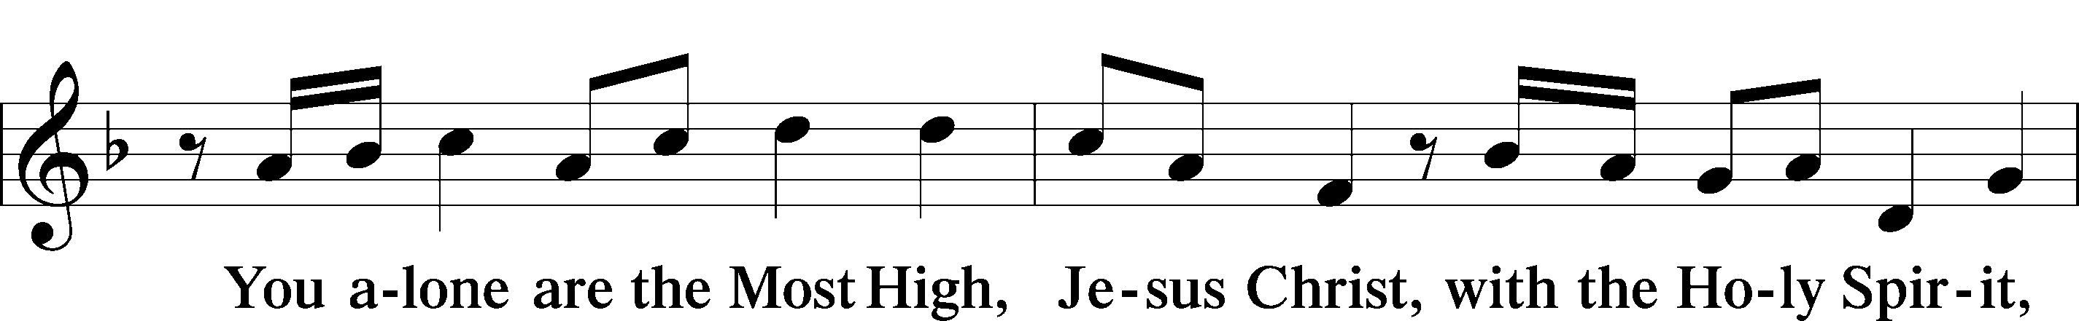
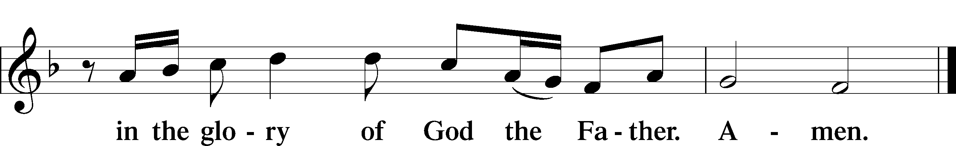

SALUTATION AND COLLECT OF THE DAY
L The Lord be with you.
C And also with you.

L Let us pray.
O God, You make the minds of Your faithful to be of one will. Grant that we may love what You have commanded and desire what You promise, that among the many changes of this world our hearts may be fixed where true joys are found; through Jesus Christ, Your Son, our Lord, who lives and reigns with You and the Holy Spirit, one God, now and forever.
C Amen.

(Sit)

FIRST READING Acts 6:1–9; 7:2a, 51–60
1Now in these days when the disciples were increasing in number, a complaint by the Hellenists arose against the Hebrews because their widows were being neglected in the daily distribution. 2And the twelve summoned the full number of the disciples and said, “It is not right that we should give up preaching the word of God to serve tables. 3Therefore, brothers, pick out from among you seven men of good repute, full of the Spirit and of wisdom, whom we will appoint to this duty. 4But we will devote ourselves to prayer and to the ministry of the word.” 5And what they said pleased the whole gathering, and they chose Stephen, a man full of faith and of the Holy Spirit, and Philip, and Prochorus, and Nicanor, and Timon, and Parmenas, and Nicolaus, a proselyte of Antioch. 6These they set before the apostles, and they prayed and laid their hands on them.
7And the word of God continued to increase, and the number of the disciples multiplied greatly in Jerusalem, and a great many of the priests became obedient to the faith.
8And Stephen, full of grace and power, was doing great wonders and signs among the people. 9Then some of those who belonged to the synagogue of the Freedmen (as it was called), and of the Cyrenians, and of the Alexandrians, and of those from Cilicia and Asia, rose up and disputed with Stephen. . . .
2And Stephen said:
“Brothers and fathers, hear me. . . .

(Next Page)

51You stiff-necked people, uncircumcised in heart and ears, you always resist the Holy Spirit. As your fathers did, so do you. 52Which of the prophets did not your fathers persecute? And they killed those who announced beforehand the coming of the Righteous One, whom you have now betrayed and murdered, 53you who received the law as delivered by angels and did not keep it.”
54Now when they heard these things they were enraged, and they ground their teeth at him. 55But he, full of the Holy Spirit, gazed into heaven and saw the glory of God, and Jesus standing at the right hand of God. 56And he said, “Behold, I see the heavens opened, and the Son of Man standing at the right hand of God.” 57But they cried out with a loud voice and stopped their ears and rushed together at him. 58Then they cast him out of the city and stoned him. And the witnesses laid down their garments at the feet of a young man named Saul. 59And as they were stoning Stephen, he called out, “Lord Jesus, receive my spirit.” 60And falling to his knees he cried out with a loud voice, “Lord, do not hold this sin against them.” And when he had said this, he fell asleep.

A This is the Word of the Lord.
C Thanks be to God.

GRADUAL adapt. from Matthew 28:7; Hebrews 2:7; Psalm 8:6
Christ has risen | from the dead.*
[God the Father] has crowned him with glory and | honor.
He has given him dominion over the works | of his hands;*
he has put all things un- | der his feet.

EPISTLE 1 Peter 2:2–10
2Like newborn infants, long for the pure spiritual milk, that by it you may grow up to salvation— 3if indeed you have tasted that the Lord is good.
4As you come to him, a living stone rejected by men but in the sight of God chosen and precious, 5you yourselves like living stones are being built up as a spiritual house, to be a holy priesthood, to offer spiritual sacrifices acceptable to God through Jesus Christ. 6For it stands in Scripture:
“Behold, I am laying in Zion a stone,
a cornerstone chosen and precious,
and whoever believes in him will not be put to shame.”
(Next Page)
7So the honor is for you who believe, but for those who do not believe,
“The stone that the builders rejected
has become the cornerstone,”
8and
“A stone of stumbling,
and a rock of offense.”
They stumble because they disobey the word, as they were destined to do.
9But you are a chosen race, a royal priesthood, a holy nation, a people for his own possession, that you may proclaim the excellencies of him who called you out of darkness into his marvelous light. 10Once you were not a people, but now you are God’s people; once you had not received mercy, but now you have received mercy.

A This is the Word of the Lord.
C Thanks be to God.

(Stand)

ALLELUIA AND VERSE LSB 156
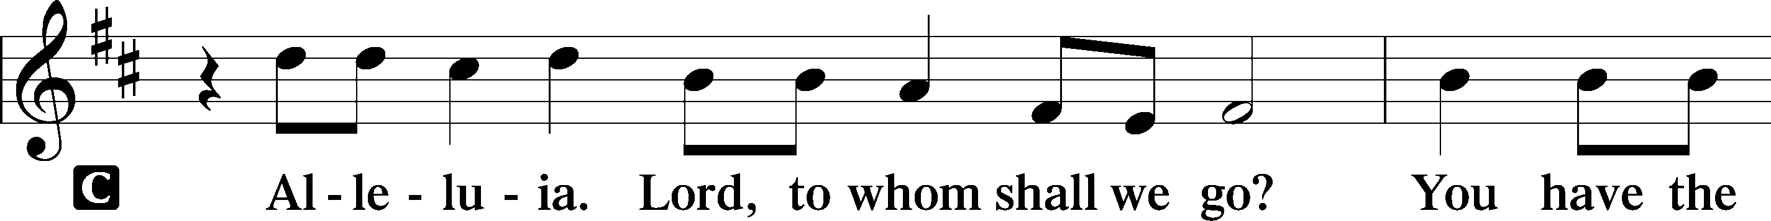
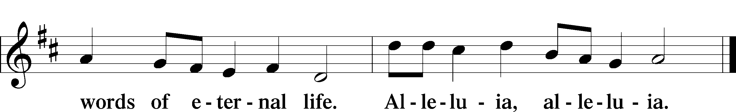

HOLY GOSPEL John 14:1–14
L The Holy Gospel according to St. John, the fourteenth chapter.

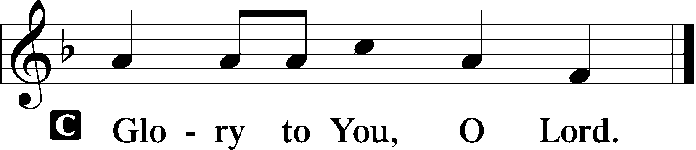

1[Jesus said:] “Let not your hearts be troubled. Believe in God; believe also in me. 2In my Father’s house are many rooms. If it were not so, would I have told you that I go to prepare a place for you? 3And if I go and prepare a place for you, I will come again and will take you to myself, that where I am you may be also. 4And you know the way to where I am going.” 5Thomas said to him, “Lord, we do not know where you are going. How can we know the way?” 6Jesus said to him, “I am the way, and the truth, and the life. No one comes to the Father except through me. 7If you had known me, you would have known my Father also. From now on you do know him and have seen him.”
8Philip said to him, “Lord, show us the Father, and it is enough for us.” 9Jesus said to him, “Have I been with you so long, and you still do not know me, Philip? Whoever has seen me has seen the Father. How can you say, ‘Show us the Father’? 10Do you not believe that I am in the Father and the Father is in me? The words that I say to you I do not speak on my own authority, but the Father who dwells in me does his works. 11Believe me that I am in the Father and the Father is in me, or else believe on account of the works themselves.
12“Truly, truly, I say to you, whoever believes in me will also do the works that I do; and greater works than these will he do, because I am going to the Father. 13Whatever you ask in my name, this I will do, that the Father may be glorified in the Son. 14If you ask me anything in my name, I will do it.”

L This is the Gospel of the Lord.

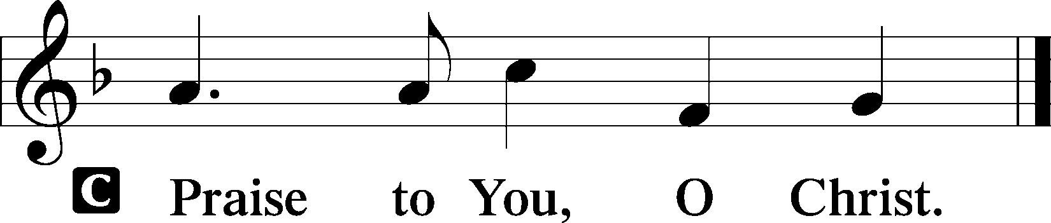

(Sit)

633 AT THE LAMB’S HIGH FEAST WE SING
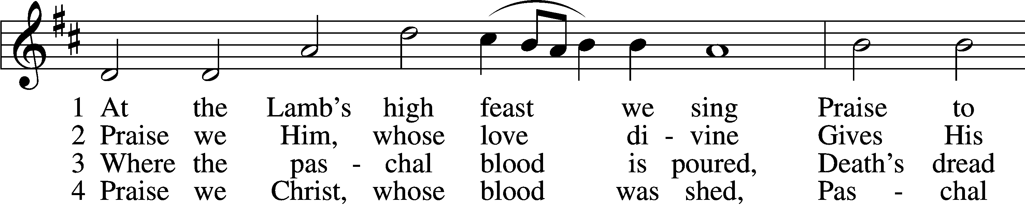
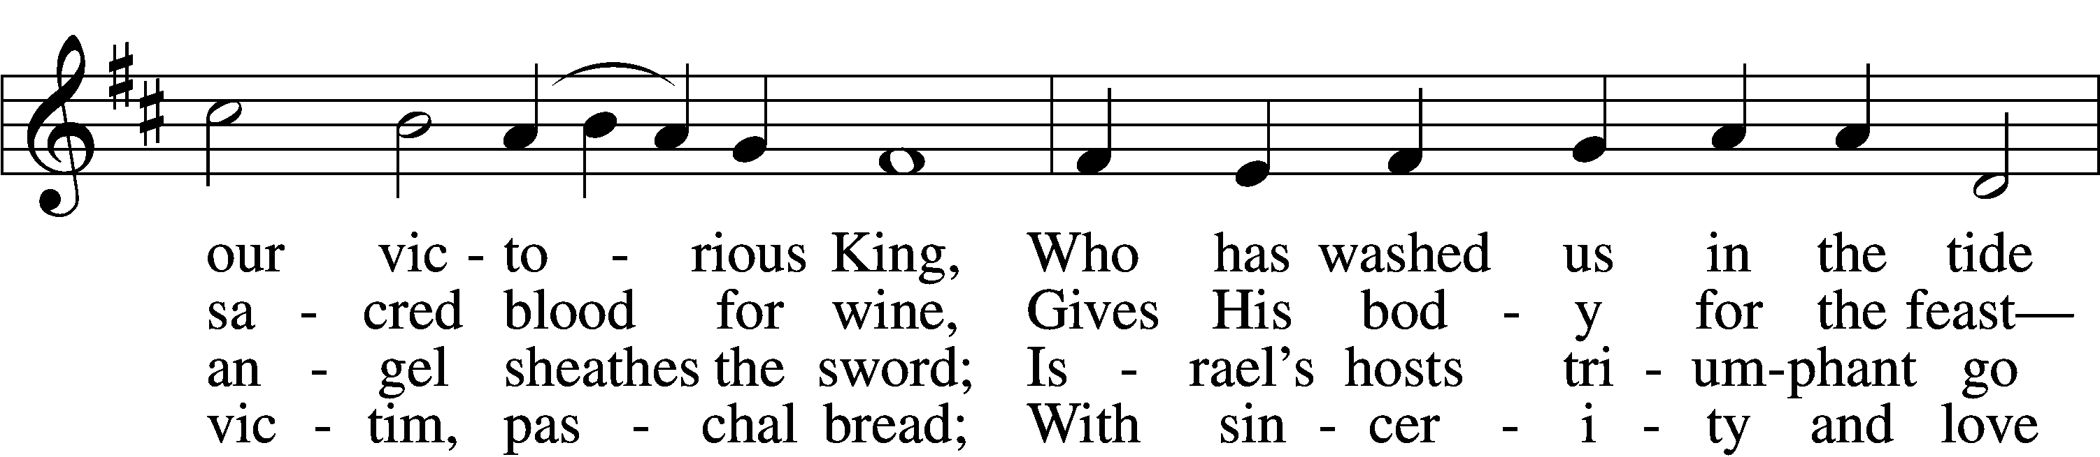
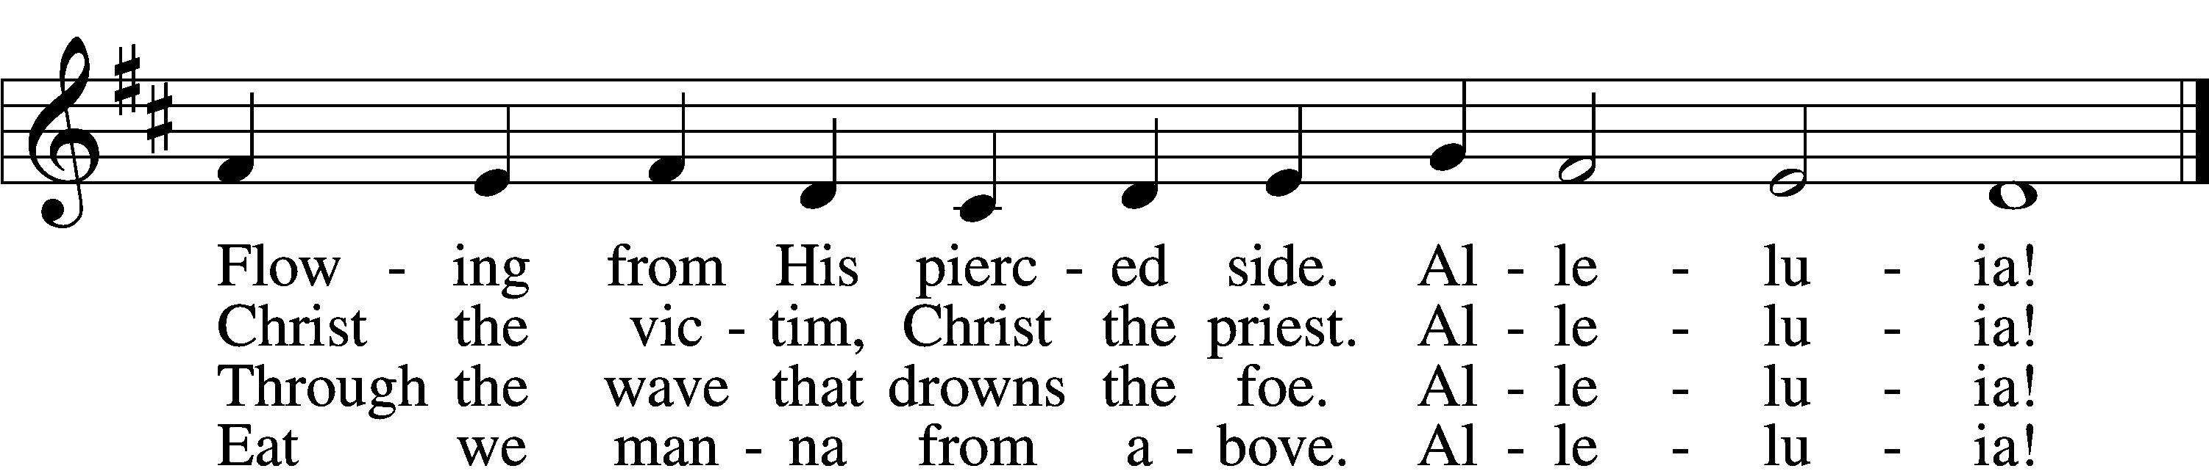

5 Mighty Victim from the sky,
Hell’s fierce pow’rs beneath You lie;
You have conquered in the fight,
You have brought us life and light.
Alleluia!

6 Now no more can death appall,
Now no more the grave enthrall;
You have opened paradise,
And Your saints in You shall rise.
Alleluia!

7 Easter triumph, Easter joy!
This alone can sin destroy;
From sin’s pow’r, Lord, set us free,
Newborn souls in You to be.
Alleluia!

D 8 Father, who the crown shall give,
Savior, by whose death we live,
Spirit, guide through all our days:
Three in One, Your name we praise.
Alleluia!
Text: Latin, c. 5th–10th cent.; tr. Robert Campbell, 1814–68, alt.
Tune: Kirchengeseng, 1566, Ivancice
Text and tune: Public domain

SERMON OR MEDITATION ON THE READINGS

(Stand)

NICENE CREED
C I believe in one God,
the Father Almighty,
maker of heaven and earth
and of all things visible and invisible.

And in one Lord Jesus Christ,
the only-begotten Son of God,
begotten of His Father before all worlds,
God of God, Light of Light,
very God of very God,
begotten, not made,
being of one substance with the Father,
by whom all things were made;
who for us men and for our salvation came down from heaven
and was incarnate by the Holy Spirit of the virgin Mary
and was made man;
and was crucified also for us under Pontius Pilate.
He suffered and was buried.
And the third day He rose again according to the Scriptures
and ascended into heaven
and sits at the right hand of the Father.
And He will come again with glory to judge both the living and the dead,
whose kingdom will have no end.

And I believe in the Holy Spirit,
the Lord and giver of life,
who proceeds from the Father and the Son,
who with the Father and the Son together is worshiped and glorified,
who spoke by the prophets.
And I believe in one holy Christian and apostolic Church,
I acknowledge one Baptism for the remission of sins,
and I look for the resurrection of the dead
and the life T of the world to come. Amen.

SHARING OF THE PEACE

(Sit)

PRAYER OF THE CHURCH

OFFERING
As a part of our expression of thanksgiving to God for the treasure of His salvation to us, we offer a portion of our treasure, according to what each has determined in their heart to give. Please place offerings in the collection plate at the back of the sanctuary before or after the service. Offerings can also be sent to Bethlehem Lutheran Church via U.S. Mail. Thank you!

(Stand)

OFFERTORY 159
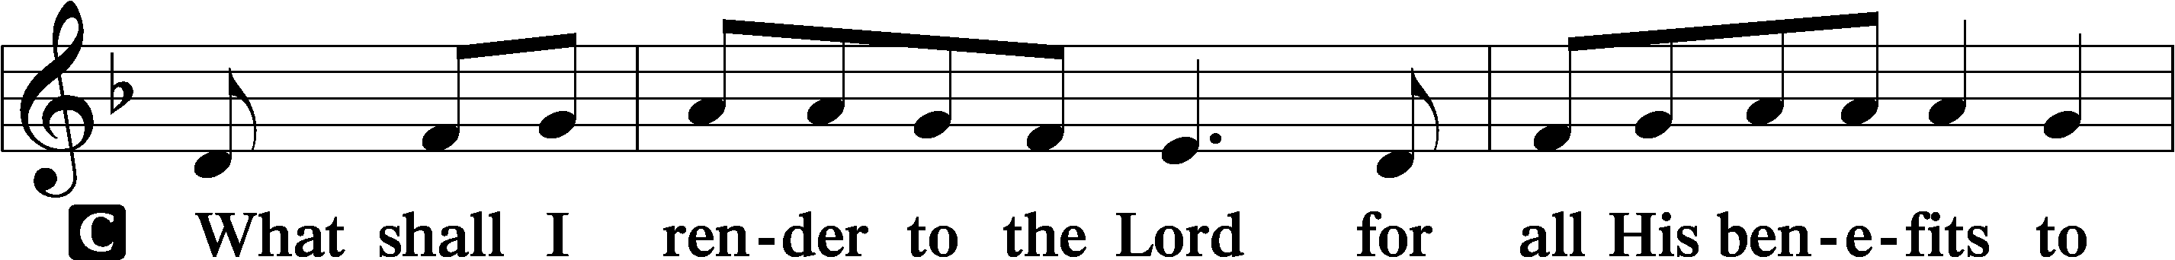
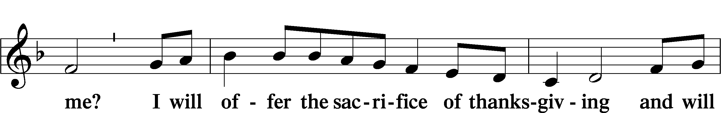
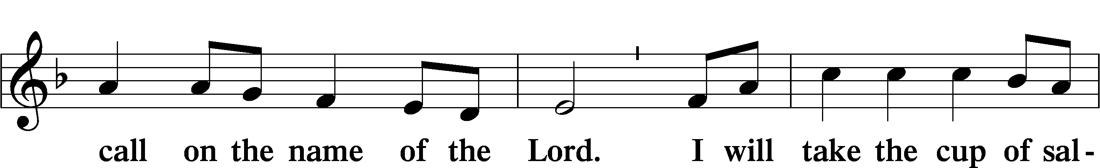
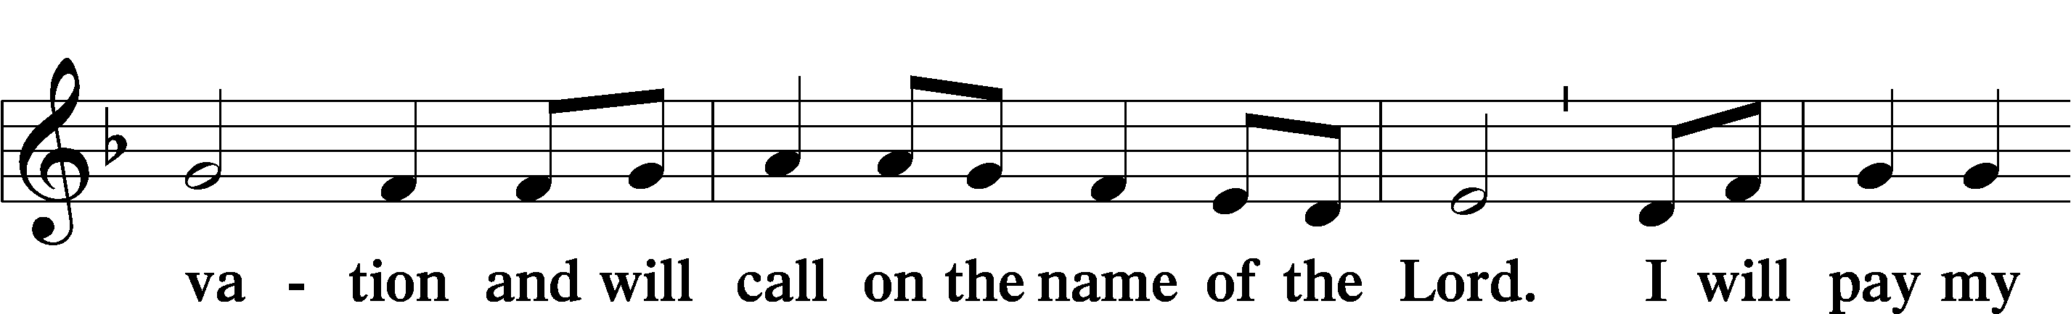
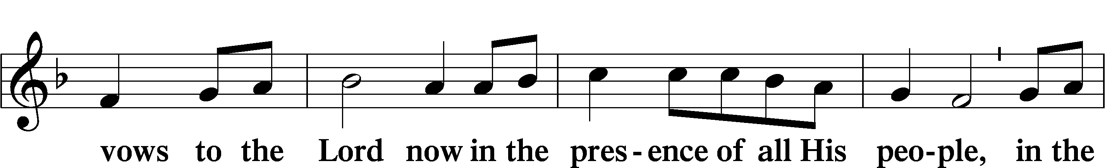
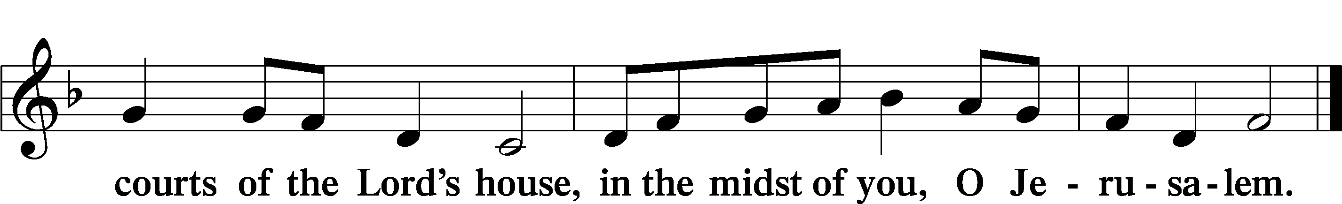

LORD’S PRAYER
C Our Father who art in heaven,
hallowed be Thy name,
Thy kingdom come,
Thy will be done on earth
as it is in heaven;
give us this day our daily bread;
and forgive us our trespasses
as we forgive those
who trespass against us;
and lead us not into temptation,
but deliver us from evil.
For Thine is the kingdom
and the power and the glory
forever and ever. Amen.

CONCLUDING COLLECT

BENEDICTION
L The grace of our Lord T Jesus Christ, and the love of God, and the fellowship of the Holy Spirit, be with us all.


846 YOUR HAND, O LORD, IN DAYS OF OLD
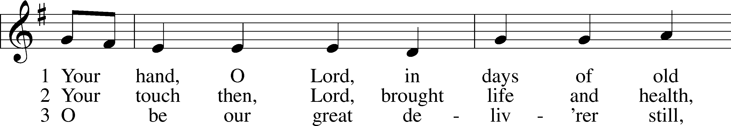
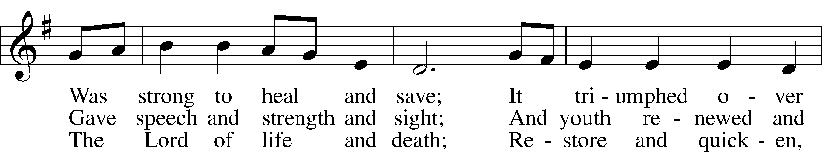
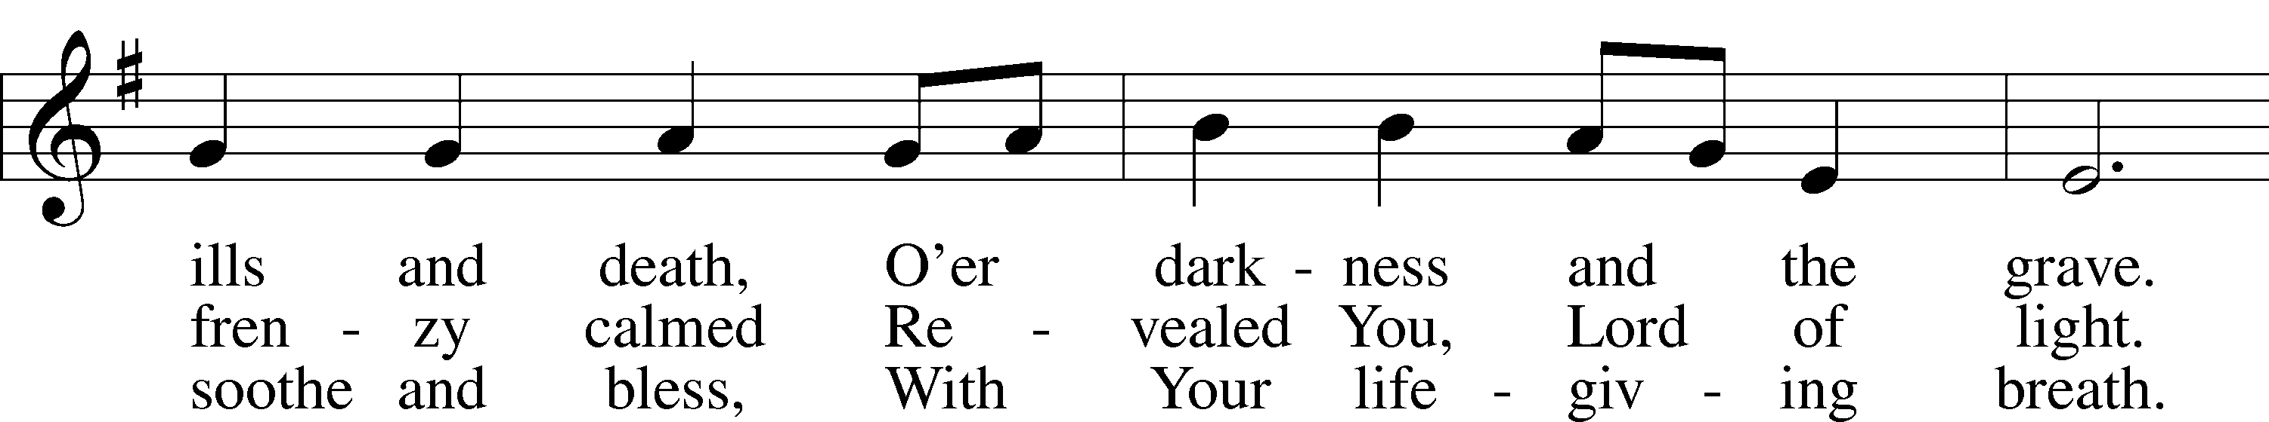
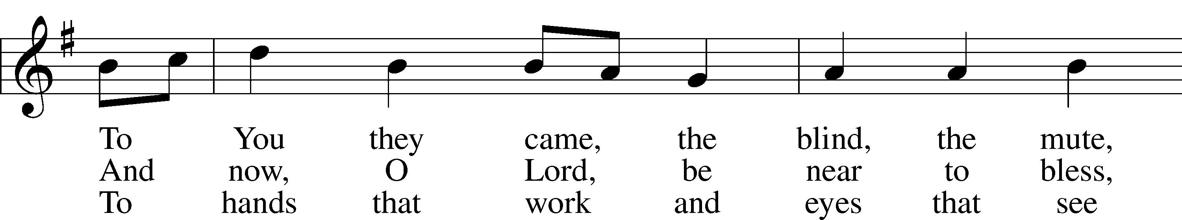
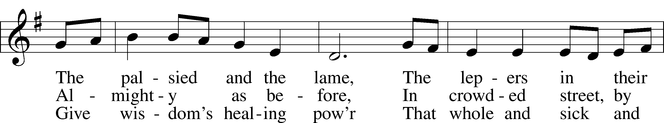
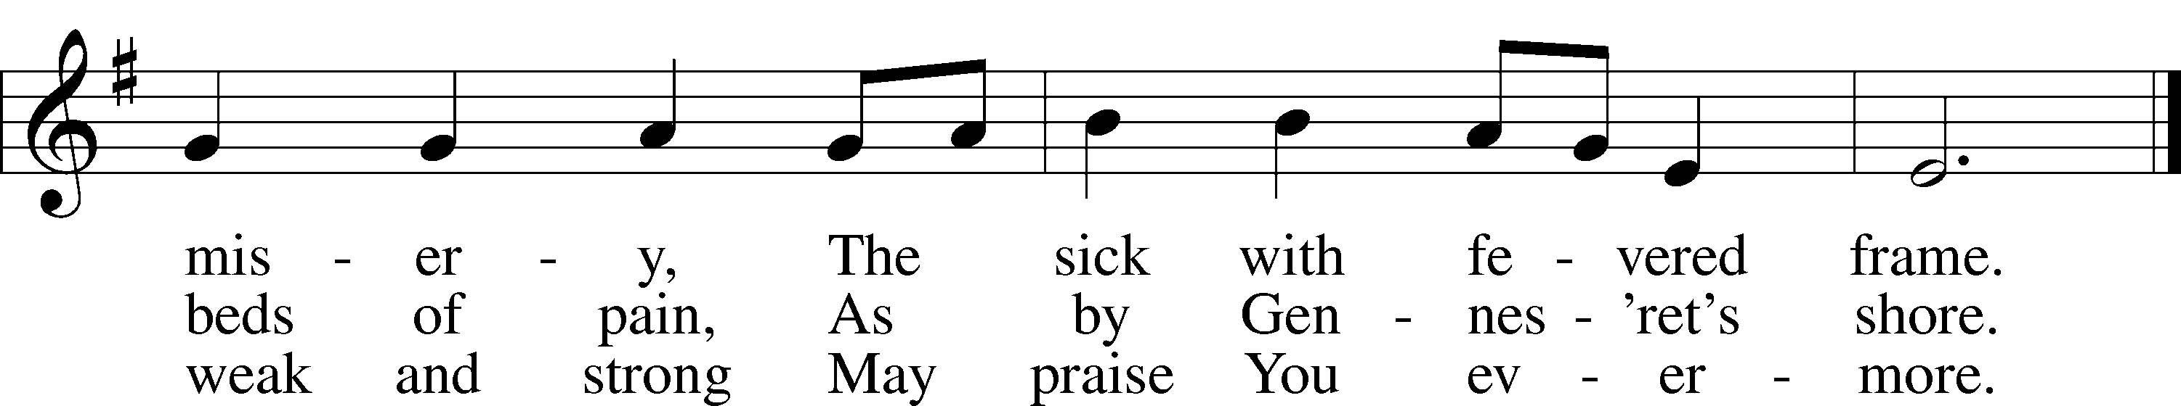
Text: Edward H. Plumptre, 1821–91, alt.
Tune: English; adapt. and harm. Ralph Vaughan Williams, 1872–1958, alt.
Text and tune: Public domain
ACKNOWLEDGMENTS
Unless otherwise indicated, Scripture quotations are from the ESV® Bible (The Holy Bible, English Standard Version®), copyright © 2001 by Crossway, a publishing ministry of Good News Publishers. Used by permission. All rights reserved.
Created by Lutheran Service Builder © 2026 Concordia Publishing House.

