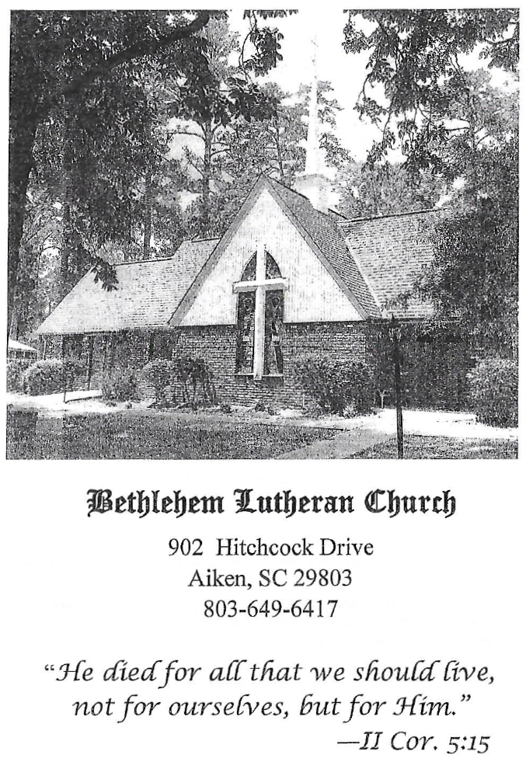

BETHLEHEM LUTHERAN CHURCH
A congregation of The Lutheran Church-Missouri Synod
902 Hitchcock Drive SW,
Aiken, South Carolina 29803
Church Phone: (803) 649-6417
blcaikensc@gmail.com

Bethlehem Lutheran welcomes our members and guests to our worship service! Unable to join us in person? Please find us on Facebook live. The service is also posted on our website; bethlehemlutheranaiken.org.

+ + + + + + + + + + + + + + +
Sixteenth Sunday after Pentecost
September 13, 2026
10:30 a.m.
+ + + + + + + + + + + + + + +

+ SERVICE OF PREPARATION +

(After the bell tolls, please observe a time of silence.)

WELCOME AND ANNOUNCEMENTS

(Stand)

815 ALL PRAISE TO THEE, FOR THOU, O KING DIVINE
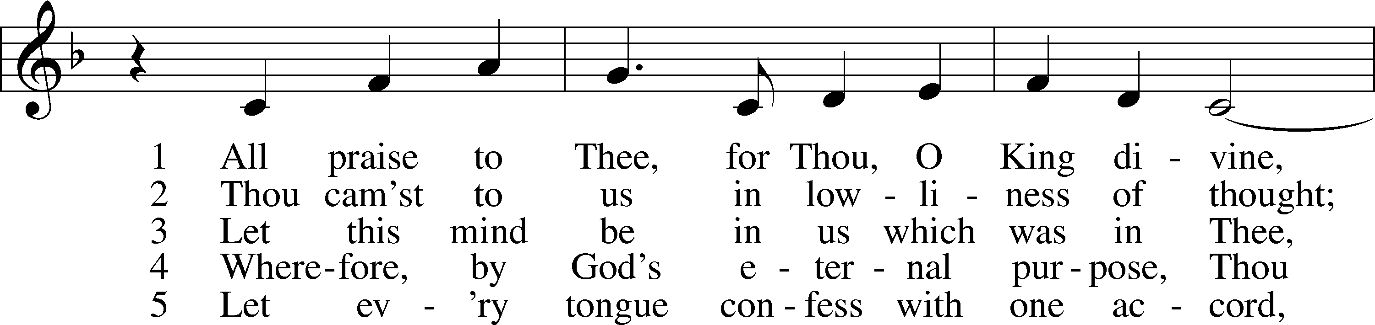
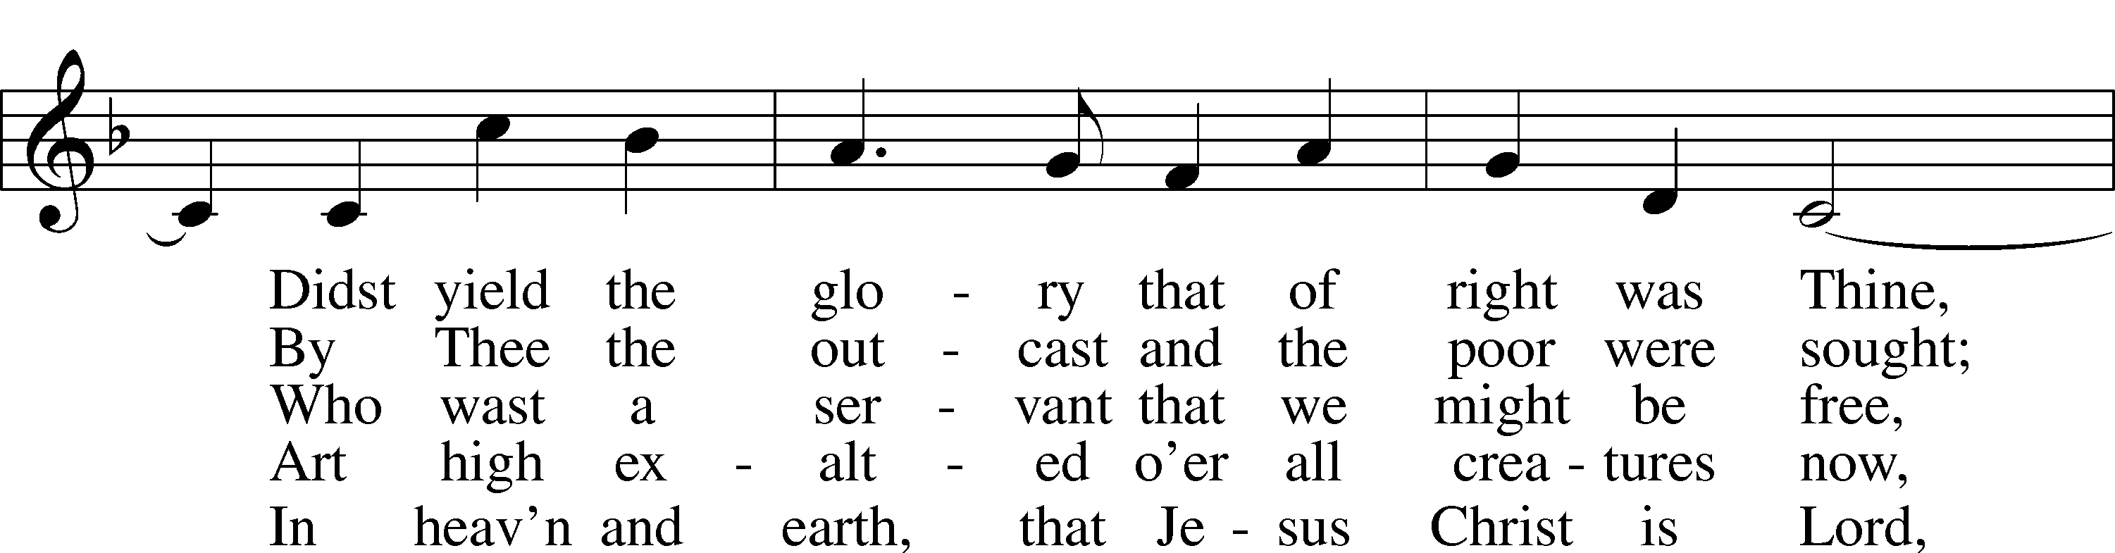
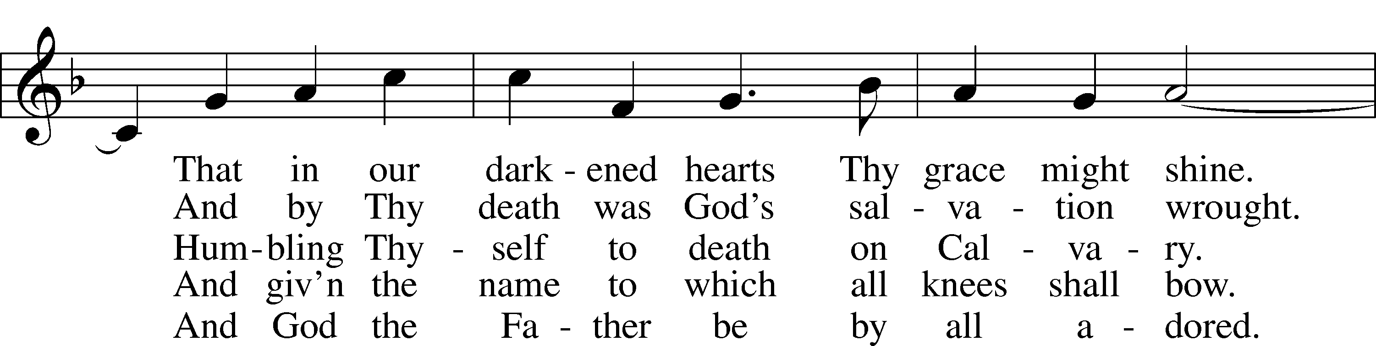
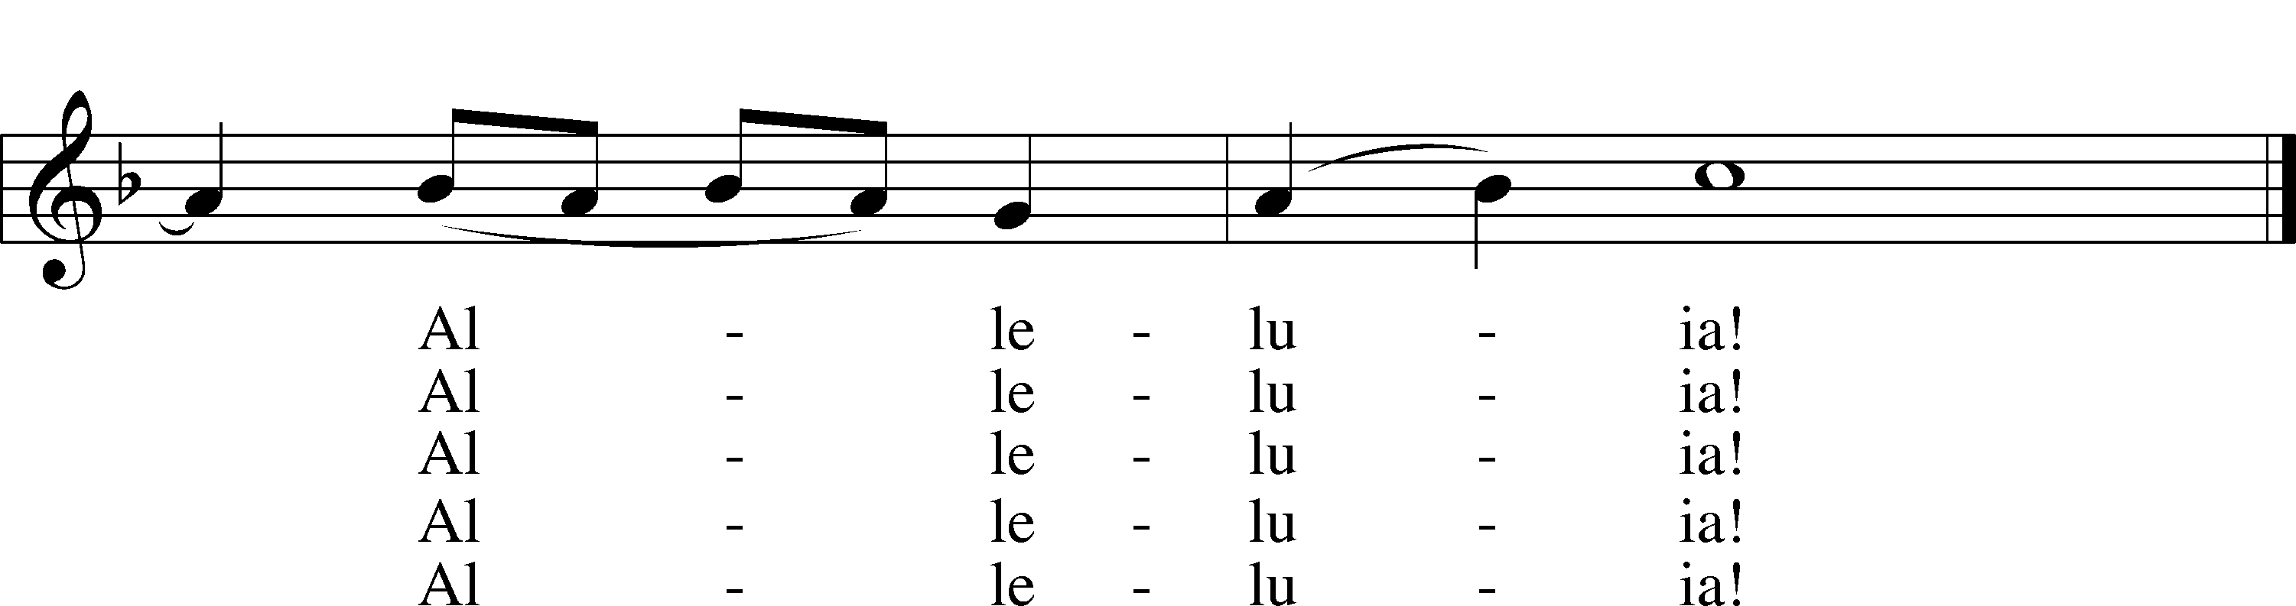
Text: F. Bland Tucker, 1895–1984
Tune: Charles V. Stanford, 1852–1924
Text: © The Church Pension Fund. Used by permission: LSB Hymn License no. 110004798
Tune: Public domain

+ CONFESSION AND ABSOLUTION +

(The sign of the cross may be made by all in remembrance of their Baptism.)

INVOCATION LSB 151
L In the name of the Father and of the T Son and of the Holy Spirit.
C Amen.

EXHORTATION LSB 151
L If we say we have no sin, we deceive ourselves, and the truth is not in us.
C But if we confess our sins, God, who is faithful and just, will forgive our sins and cleanse us from all unrighteousness.

(Silence for reflection on God’s Word and for self-examination.)

CONFESSION OF SINS LSB 151
L Let us then confess our sins to God our Father.
C Most merciful God, we confess that we are by nature sinful and unclean. We have sinned against You in thought, word, and deed, by what we have done and by what we have left undone. We have not loved You with our whole heart; we have not loved our neighbors as ourselves. We justly deserve Your present and eternal punishment. For the sake of Your Son, Jesus Christ, have mercy on us. Forgive us, renew us, and lead us, so that we may delight in Your will and walk in Your ways to the glory of Your holy name. Amen.

DECLARATION OF GRACE LSB 151
L In the mercy of almighty God, Jesus Christ was given to die for us, and for His sake God forgives us all our sins. To those who believe in Jesus Christ He gives the power to become the children of God and bestows on them the Holy Spirit. May the Lord, who has begun this good work in us, bring it to completion in the day of our Lord Jesus Christ.
C Amen.

+ SERVICE OF THE WORD +

INTROIT Psalm 143:1–2; antiphon: v. 9

Deliver me from my enemies, | O Lord!*
I have fled to you for | refuge!
Hear my prayer, O Lord; give ear to my pleas for | mercy!*
In your faithfulness answer me, in your | righteousness!
Enter not into judgment with your | servant,*
for no one living is righteous be- | fore you.
Glory be to the Father and | to the Son*
and to the Holy | Spirit;
as it was in the be- | ginning,*
is now, and will be forever. | Amen.
Deliver me from my enemies, | O Lord!*
I have fled to you for | refuge!

KYRIE LSB 152

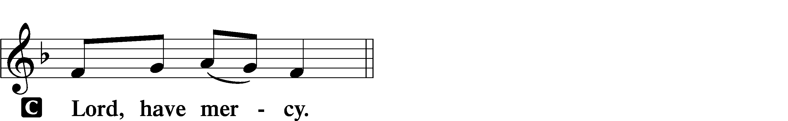

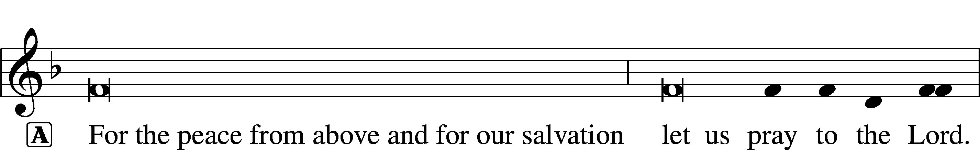
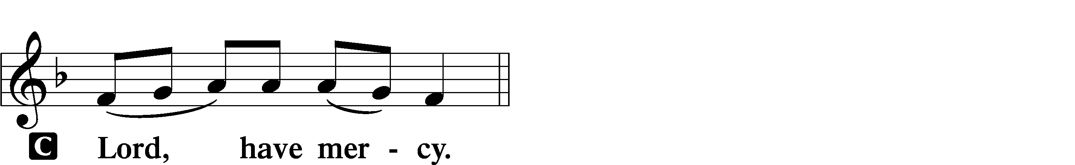

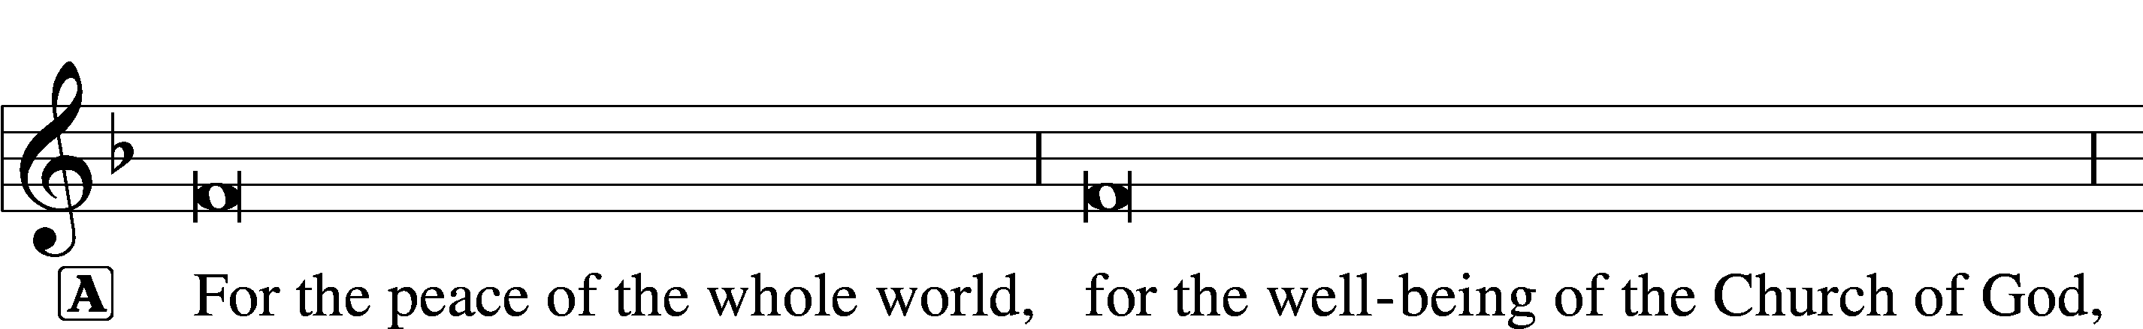
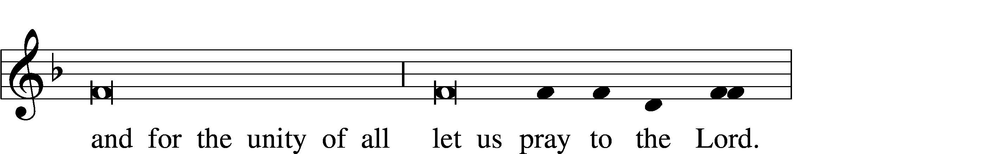
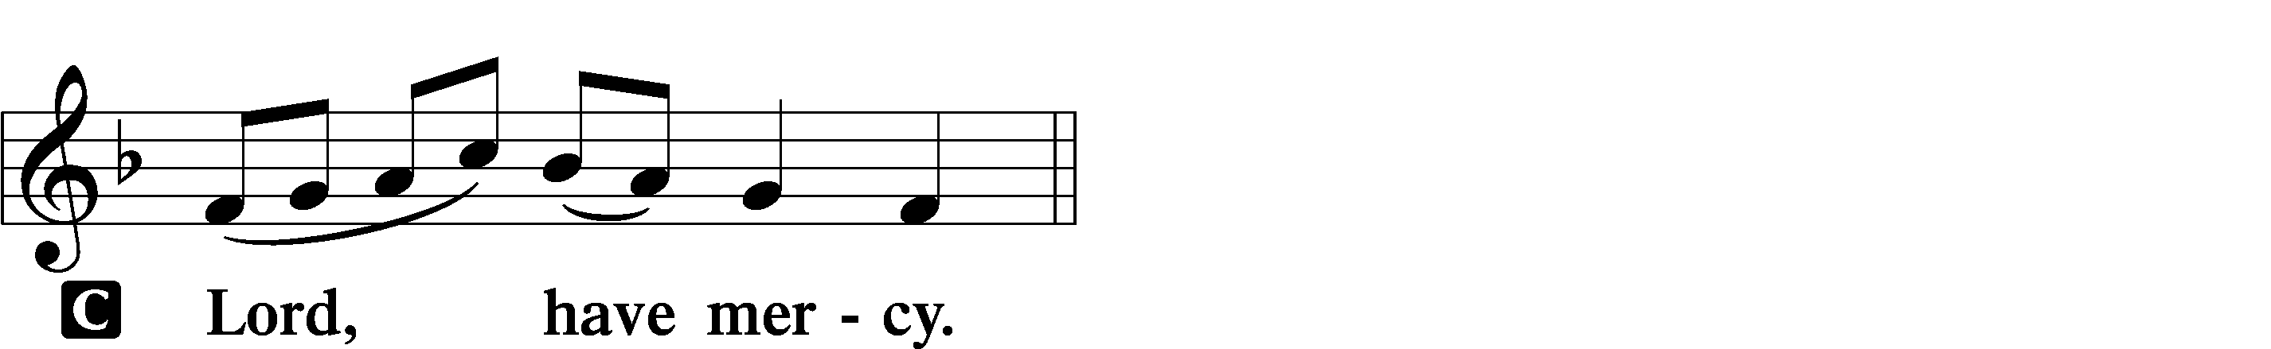

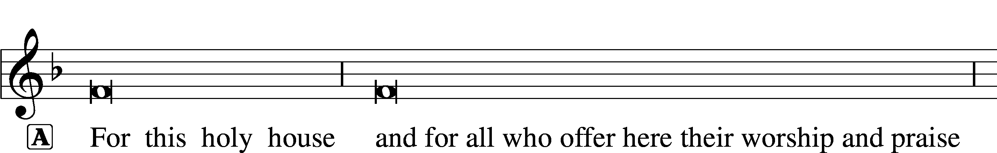

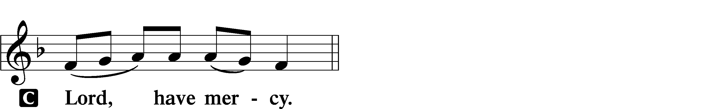




GLORIA IN EXCELSIS LSB 154
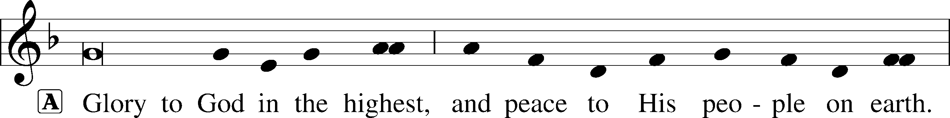
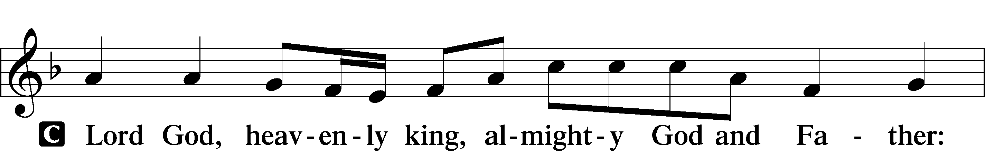
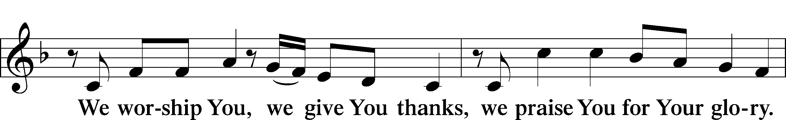
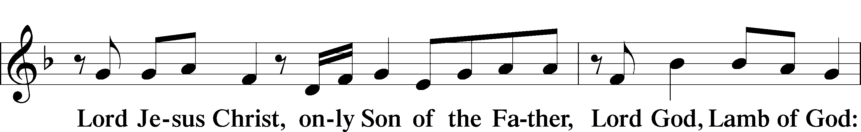
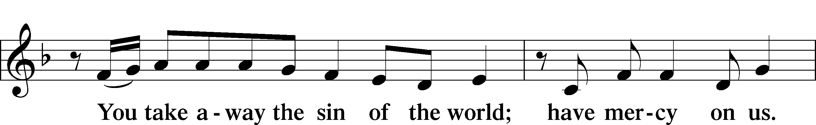
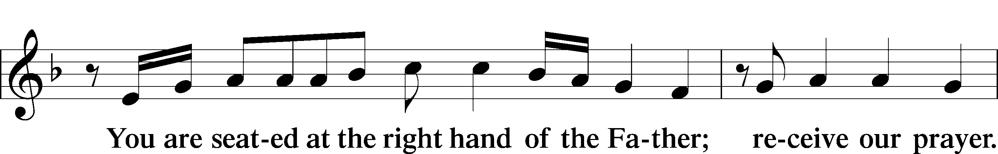
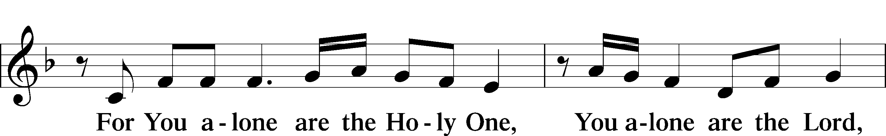
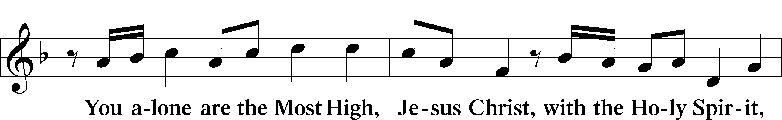
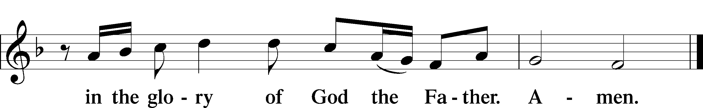

SALUTATION AND COLLECT OF THE DAY LSB 156
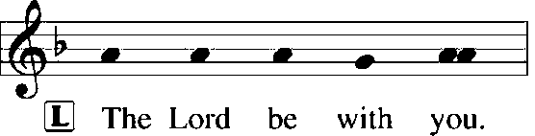
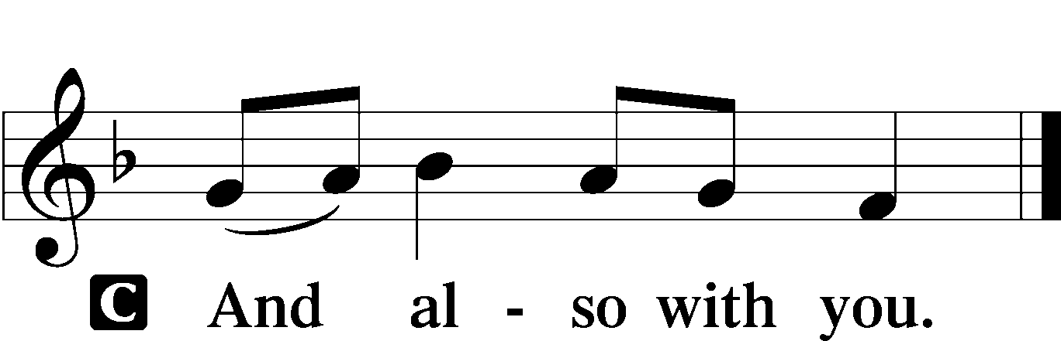

L Let us pray.
O God, our refuge and strength, the author of all godliness, hear the devout prayers of Your Church, especially in times of persecution, and grant that what we ask in faith we may obtain; through Jesus Christ, our Lord, who lives and reigns with You and the Holy Spirit, one God, now and forever.

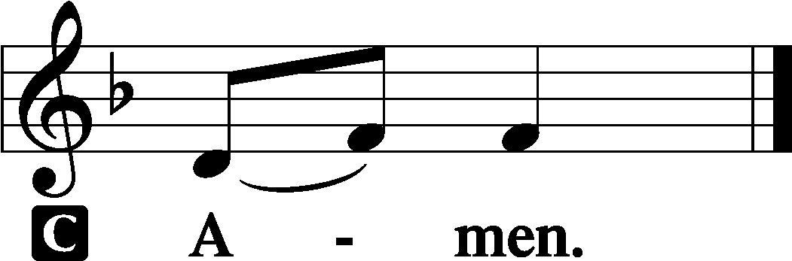

(Sit)

OLD TESTAMENT READING Genesis 50:15–21
15When Joseph’s brothers saw that their father was dead, they said, “It may be that Joseph will hate us and pay us back for all the evil that we did to him.” 16So they sent a message to Joseph, saying, “Your father gave this command before he died, 17‘Say to Joseph, Please forgive the transgression of your brothers and their sin, because they did evil to you.’ And now, please forgive the transgression of the servants of the God of your father.” Joseph wept when they spoke to him. 18His brothers also came and fell down before him and said, “Behold, we are your servants.” 19But Joseph said to them, “Do not fear, for am I in the place of God? 20As for you, you meant evil against me, but God meant it for good, to bring it about that many people should be kept alive, as they are today. 21So do not fear; I will provide for you and your little ones.” Thus he comforted them and spoke kindly to them.

L This is the Word of the Lord.
C Thanks be to God.

GRADUAL Psalm 34:9, 19, alt.
Fear the Lord, | you his saints,*
for those who fear him lack | nothing!
Many are the afflictions of the | righteous,*
but the Lord delivers him out | of them all.

EPISTLE Romans 14:1–12
1As for the one who is weak in faith, welcome him, but not to quarrel over opinions. 2One person believes he may eat anything, while the weak person eats only vegetables. 3Let not the one who eats despise the one who abstains, and let not the one who abstains pass judgment on the one who eats, for God has welcomed him. 4Who are you to pass judgment on the servant of another? It is before his own master that he stands or falls. And he will be upheld, for the Lord is able to make him stand.
5One person esteems one day as better than another, while another esteems all days alike. Each one should be fully convinced in his own mind. 6The one who observes the day, observes it in honor of the Lord. The one who eats, eats in honor of the Lord, since he gives thanks to God, while the one who abstains, abstains in honor of the Lord and gives thanks to God. 7For none of us lives to himself, and none of us dies to himself. 8If we live, we live to the Lord, and if we die, we die to the Lord. So then, whether we live or whether we die, we are the Lord’s. 9For to this end Christ died and lived again, that he might be Lord both of the dead and of the living.
10Why do you pass judgment on your brother? Or you, why do you despise your brother? For we will all stand before the judgment seat of God; 11for it is written,
“As I live, says the Lord, every knee shall bow to me,
and every tongue shall confess to God.”
12So then each of us will give an account of himself to God.

L This is the Word of the Lord.
C Thanks be to God.

(Stand)

ALLELUIA AND VERSE LSB 156
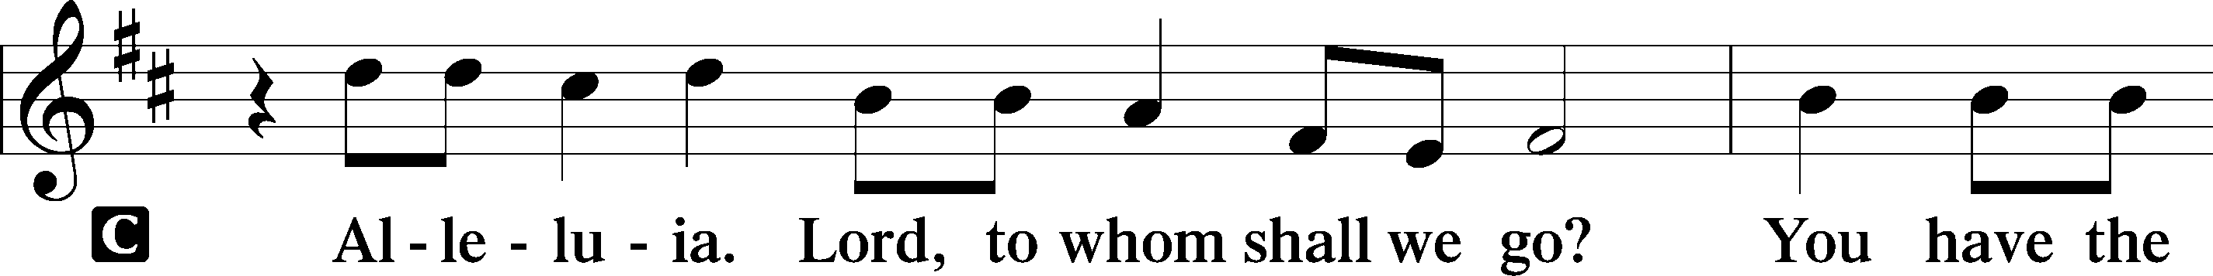
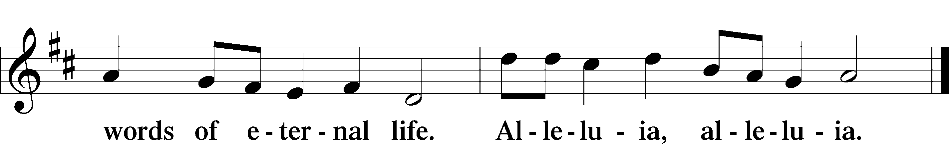

HOLY GOSPEL Matthew 18:21–35
L The Holy Gospel according to St. Matthew, the eighteenth chapter.

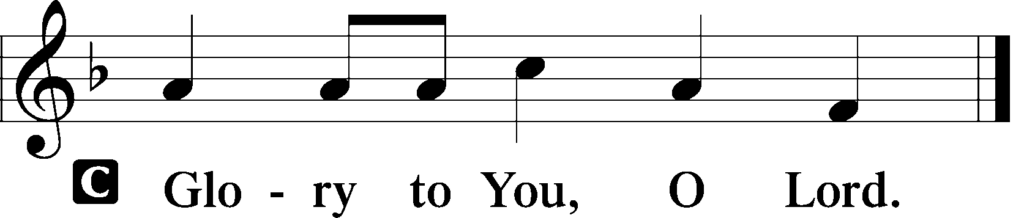

21Peter came up and said to [Jesus], “Lord, how often will my brother sin against me, and I forgive him? As many as seven times?” 22Jesus said to him, “I do not say to you seven times, but seventy times seven.
23“Therefore the kingdom of heaven may be compared to a king who wished to settle accounts with his servants. 24When he began to settle, one was brought to him who owed him ten thousand talents. 25And since he could not pay, his master ordered him to be sold, with his wife and children and all that he had, and payment to be made. 26So the servant fell on his knees, imploring him, ‘Have patience with me, and I will pay you everything.’ 27And out of pity for him, the master of that servant released him and forgave him the debt. 28But when that same servant went out, he found one of his fellow servants who owed him a hundred denarii, and seizing him, he began to choke him, saying, ‘Pay what you owe.’ 29So his fellow servant fell down and pleaded with him, ‘Have patience with me, and I will pay you.’ 30He refused and went and put him in prison until he should pay the debt. 31When his fellow servants saw what had taken place, they were greatly distressed, and they went and reported to their master all that had taken place. 32Then his master summoned him and said to him, ‘You wicked servant! I forgave you all that debt because you pleaded with me. 33And should not you have had mercy on your fellow servant, as I had mercy on you?’ 34And in anger his master delivered him to the jailers, until he should pay all his debt. 35So also my heavenly Father will do to every one of you, if you do not forgive your brother from your heart.”

L This is the Gospel of the Lord.

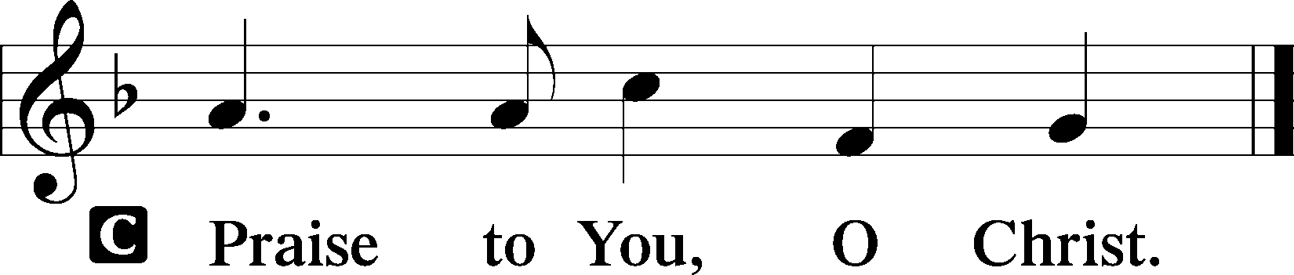

(Sit)

501 COME DOWN, O LOVE DIVINE
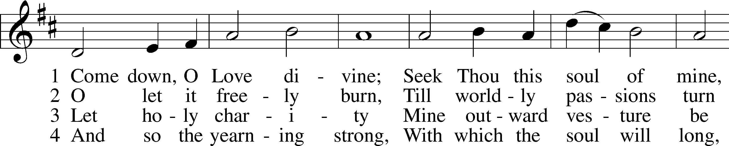
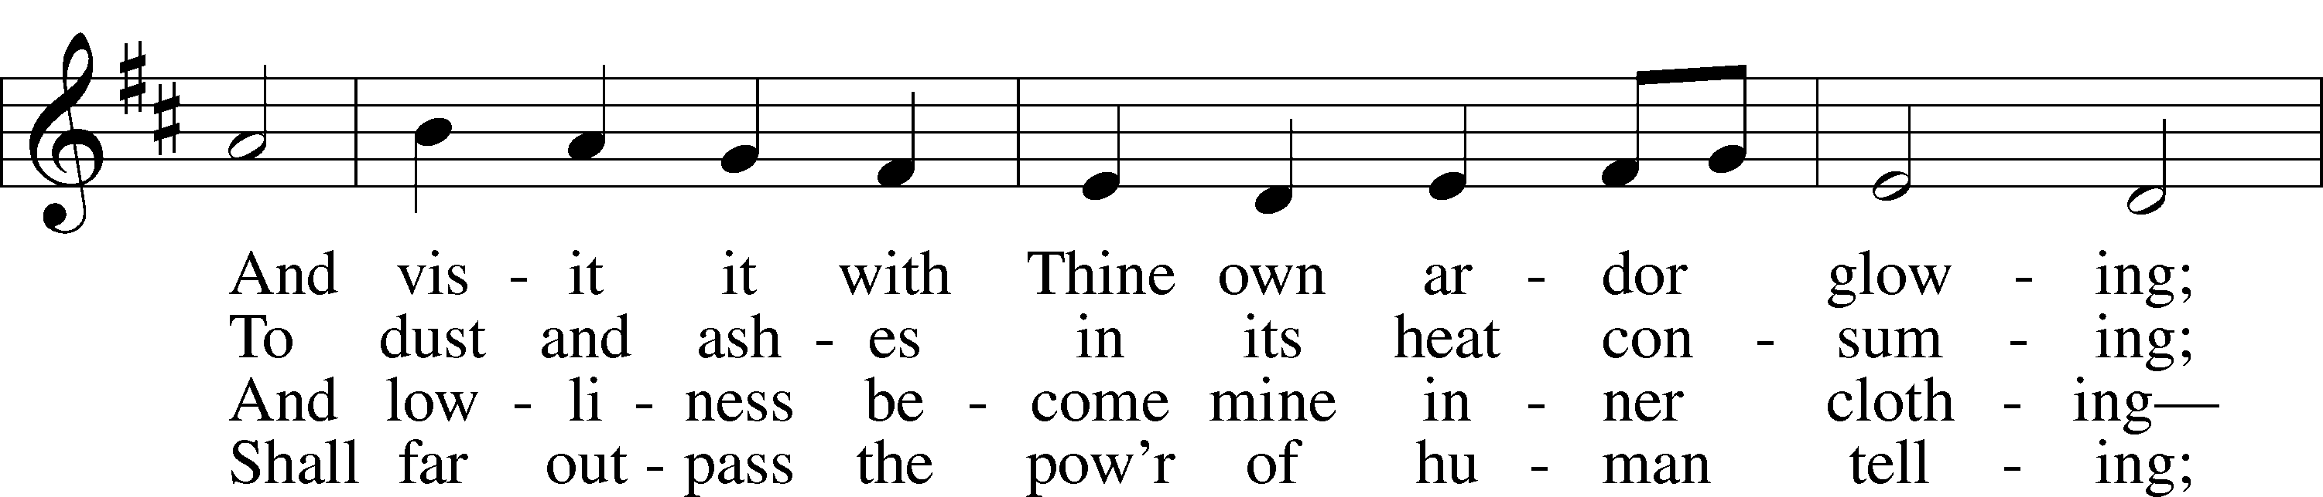
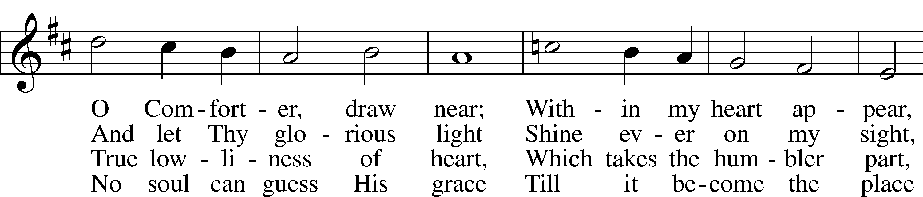
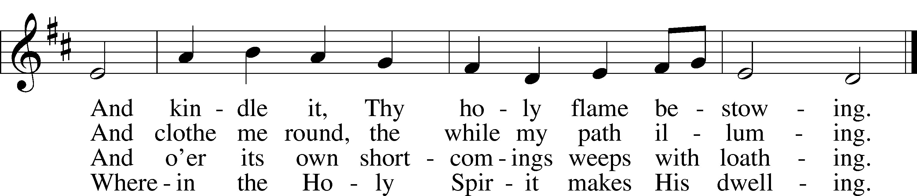
Text: Bianco da Siena, c. 1350–1434; tr. Richard F. Littledale, 1833–90
Tune: Ralph Vaughan Williams, 1872–1958
Text and tune: Public domain

SERMON

(Sermons for Elder led services are provided courtesy of the Lutheran Church - Canada (https://www.lutheranchurchcanada.ca/resources/written-sermons/), a member of the International Lutheran Council (https://ilcouncil.org/) with whom the Lutheran Church - Missouri Synod (https://www.lcms.org/) is in altar and pulpit fellowship.)

765 GOD MOVES IN A MYSTERIOUS WAY
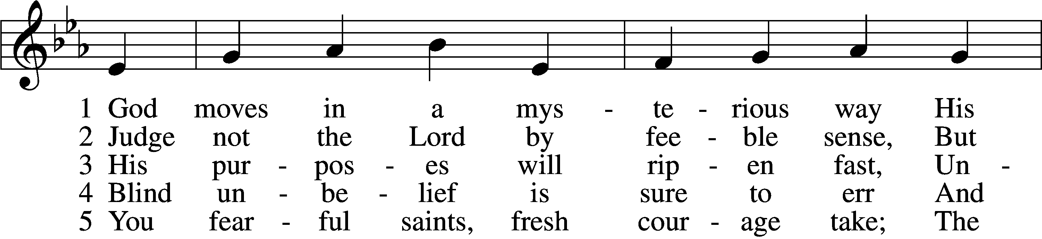
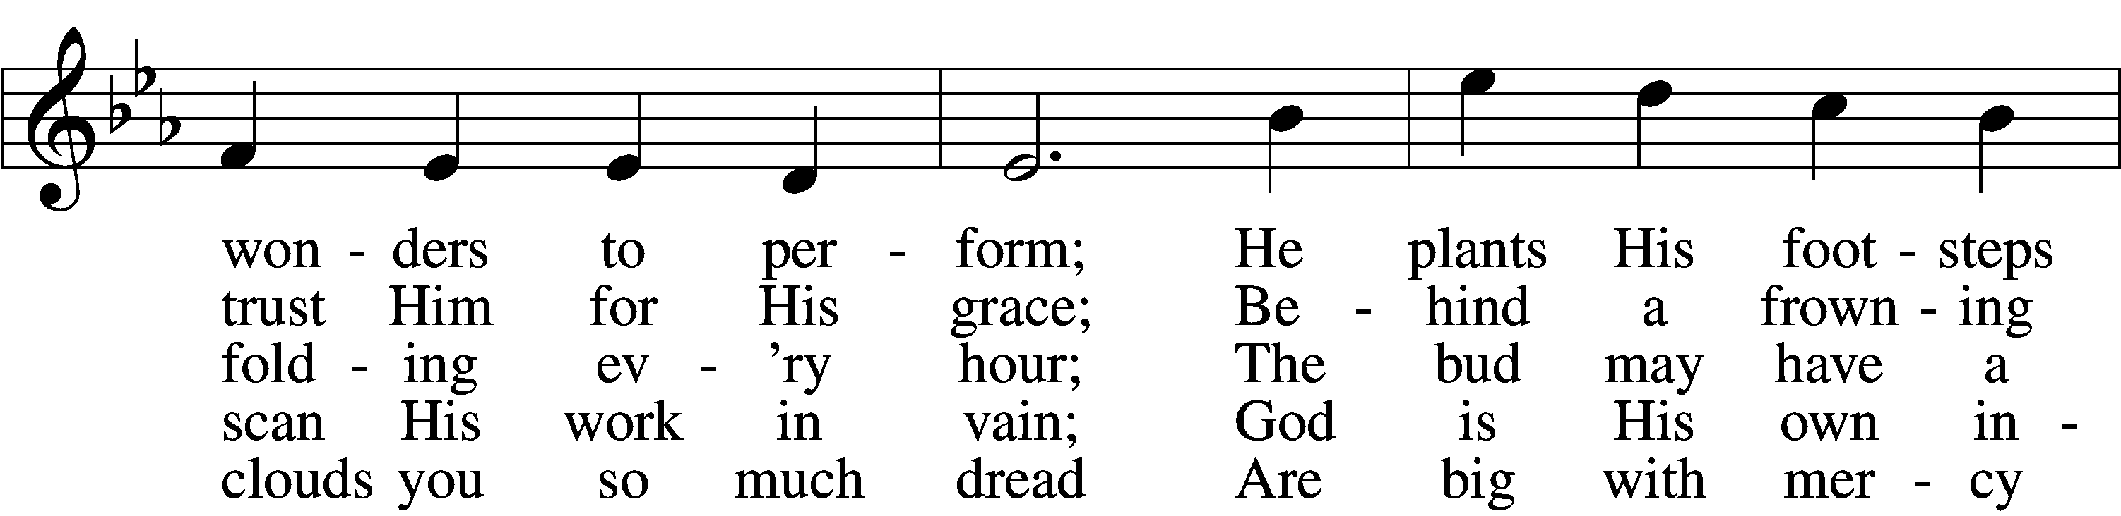
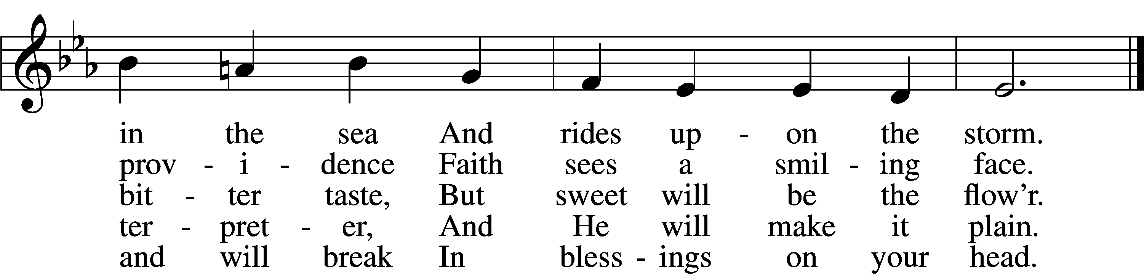
Text: William Cowper, 1731–1800, alt.
Tune: The CL Psalmes of David, 1615, Edinburgh
Text and tune: Public domain

(Stand)

APOSTLES’ CREED LSB 159
C I believe in God, the Father Almighty,
maker of heaven and earth.

And in Jesus Christ, His only Son, our Lord,
who was conceived by the Holy Spirit,
born of the virgin Mary,
suffered under Pontius Pilate,
was crucified, died and was buried.
He descended into hell.
The third day He rose again from the dead.
He ascended into heaven
and sits at the right hand of God the Father Almighty.
From thence He will come to judge the living and the dead.

I believe in the Holy Spirit,
the holy Christian Church,
the communion of saints,
the forgiveness of sins,
the resurrection of the body,
and the life T everlasting. Amen.

SHARING OF THE PEACE

(The people may greet one another in the name of the Lord, saying, “Peace be with you,” as a sign of reconciliation and of the unity of the Spirit in the bond of peace (Matt. 5:22–24; Eph. 4:1–3).)

(Sit)

PRAYER OF THE CHURCH

OFFERING

(As a part of our expression of thanksgiving to God for the treasure of His salvation to us, we offer a portion of our treasure, according to what each has determined in their heart to give. Please place offerings in the collection plate at the back of the sanctuary before or after the service. Offerings can also be sent to Bethlehem Lutheran Church via U.S. Mail. Thank you!)

(Stand)

OFFERTORY LSB 159
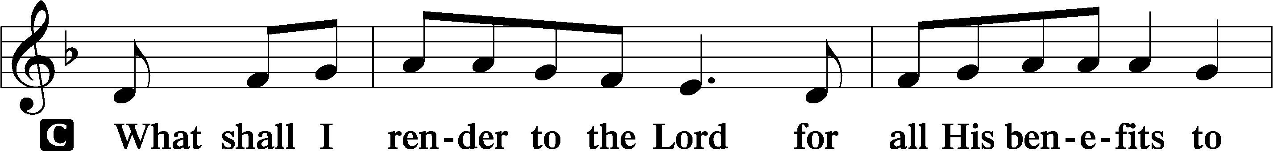
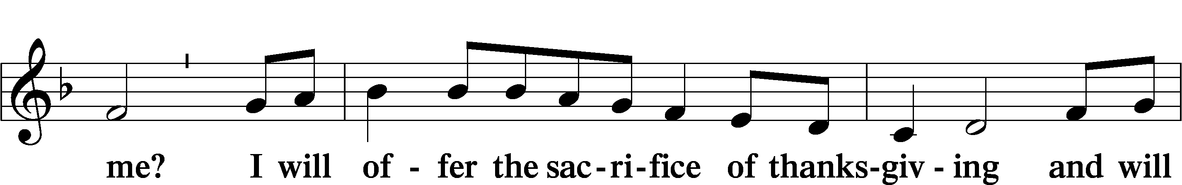
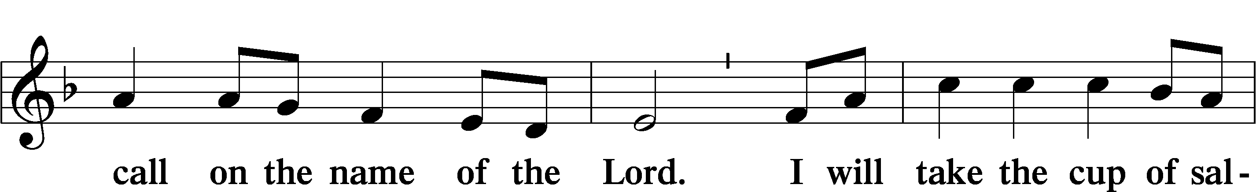
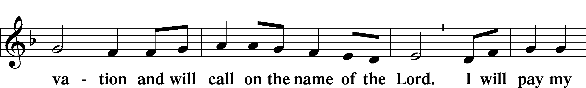
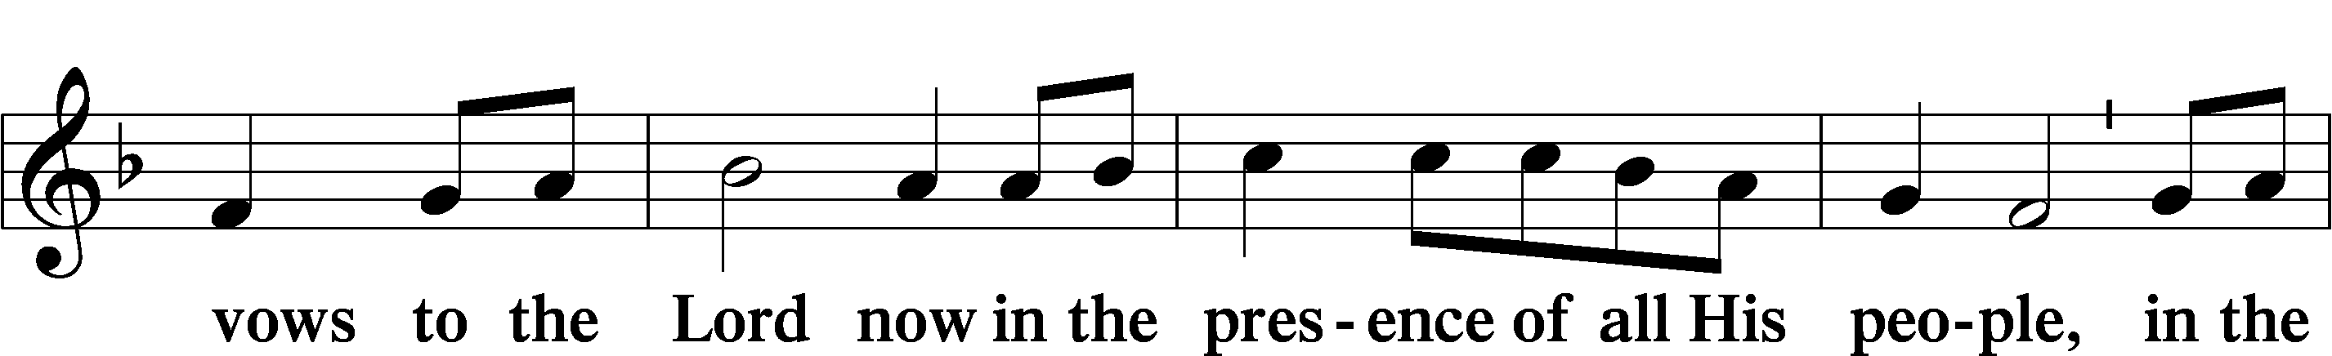
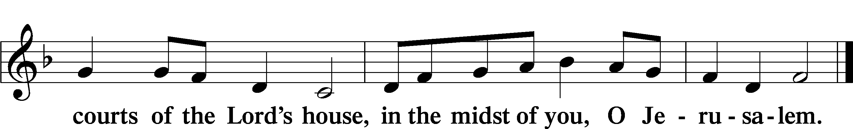

LORD’S PRAYER LSB 162
L Lord, remember us in Your kingdom and teach us to pray:
C Our Father who art in heaven,
hallowed be Thy name,
Thy kingdom come,
Thy will be done on earth
as it is in heaven;
give us this day our daily bread;
and forgive us our trespasses
as we forgive those
who trespass against us;
and lead us not into temptation,
but deliver us from evil.
For Thine is the kingdom
and the power and the glory
forever and ever. Amen.

CONCLUDING COLLECT

BENEDICTION LSB 166
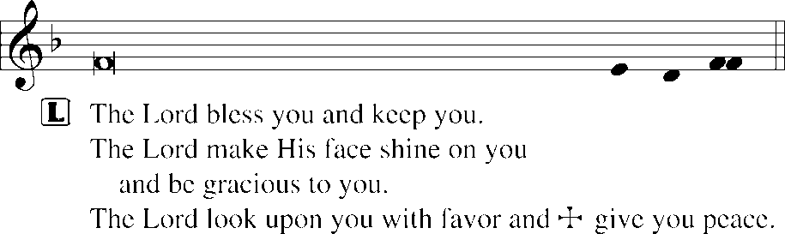


845 WHERE CHARITY AND LOVE PREVAIL
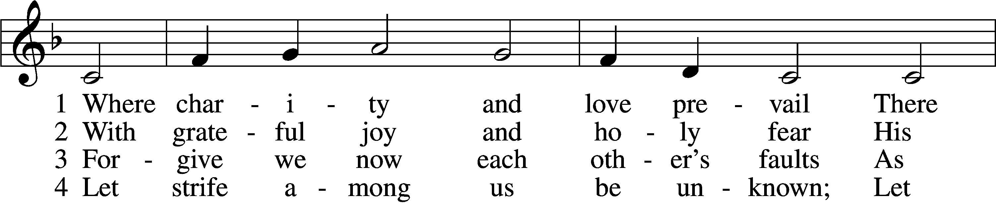
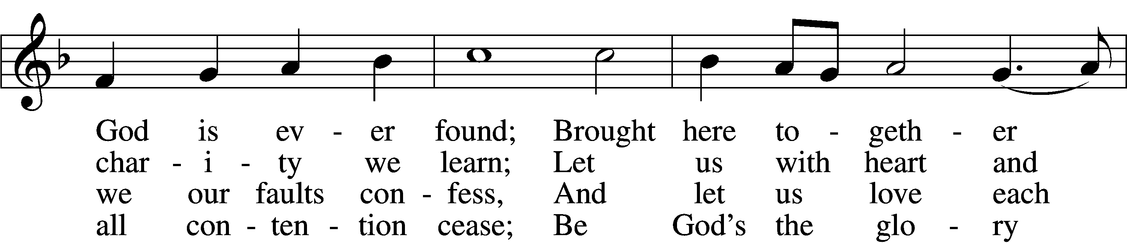
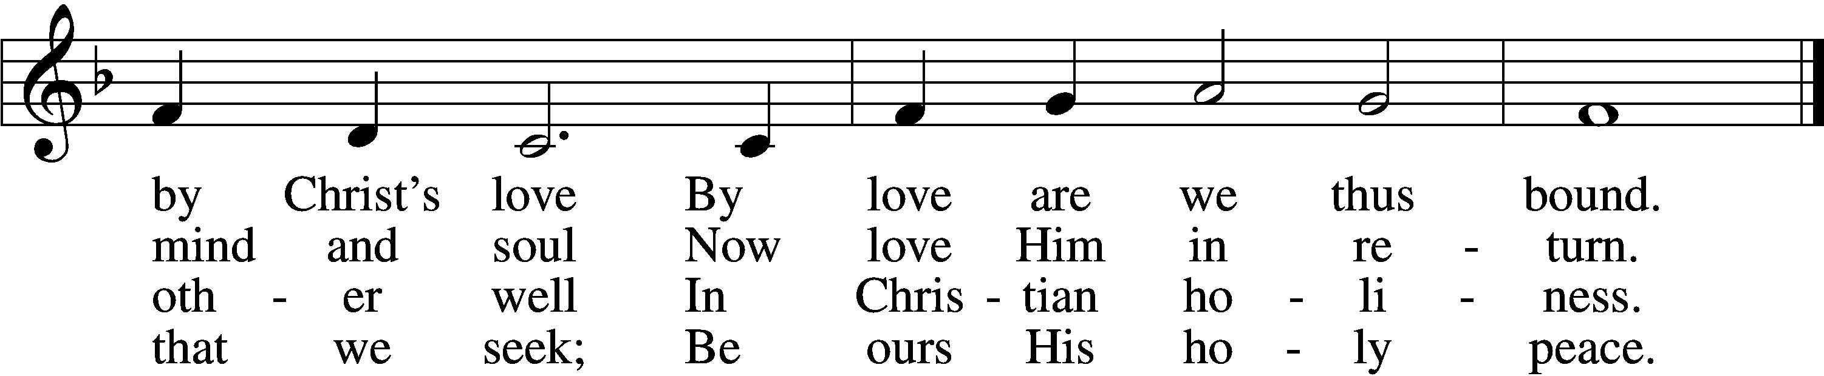

5 Let us recall that in our midst
Dwells Christ, His only Son;
As members of His body joined
We are in Him made one.

6 For love excludes no race or clan
That names the Savior’s name;
His family embraces all
Whose Father is the same.
Text: Latin, c. 9th cent.; tr. Omer E. Westendorf, 1916–97, alt.
Tune: Lucius Chapin, 1760–1842
Text: © 1960 World Library Publications. Used by permission: LSB Hymn License no. 110004798
Tune: Public domain
ACKNOWLEDGMENTS
Unless otherwise indicated, Scripture quotations are from the ESV® Bible (The Holy Bible, English Standard Version®), copyright © 2001 by Crossway, a publishing ministry of Good News Publishers. Used by permission. All rights reserved.
Created by Lutheran Service Builder © 2026 Concordia Publishing House.

