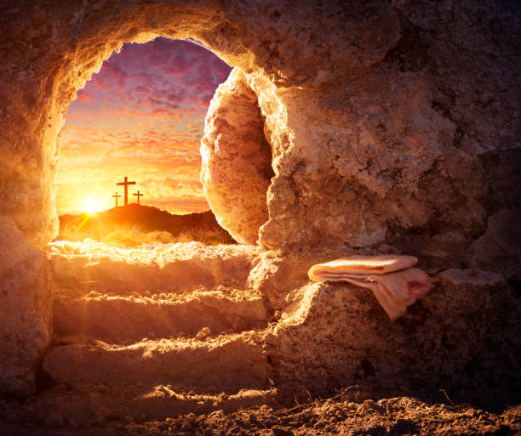

+ + + + + + + + + + + + + + +
EASTER SUNDAY
April 5TH, 2026
10:30a.m.
+ + + + + + + + + + + + + + +

BETHLEHEM LUTHERAN CHURCH
A congregation of The Lutheran Church-Missouri Synod
902 Hitchcock Drive SW,
Aiken, South Carolina 29803
Church Phone: (803) 649-6417
blcaikensc@gmail.com
Pastor: Rev. John B. Engwall
Office Hours By Appointment
Bethlehem Lutheran welcomes our members and guests to our worship service! Unable to join us in person? Please find us on Facebook live. The service is also posted on our website; bethlehemlutheranaiken.org.

Our Policy and Practice Regarding Holy Communion
Hear the words of the Apostle Paul;
Anyone who eats and drinks without recognizing the body of the Lord eats and drinks judgment on himself. -1 Cor.11:29
Therefore, visitors are asked to please refrain from partaking of the Sacrament before speaking about this with the pastor; because we care about your spiritual well-being.
Also, because communing at this altar is a public confession that you agree with the doctrines of The Lutheran Church-Missouri Synod, and reject all contrary teachings.
Persons who are not communing today are always welcome to come forward during the distribution to receive an individual blessing; please cross your arms over your chest to indicate your desire for this. Thank you!
We commune in two alternating tables. The ushers will guide you. Non-alcoholic white wine is available in the center of the individual cup tray. Please leave empty individual cups at the altar rail.

+ SERVICE OF PREPARATION +
After the bell tolls, please observe a time of silence.

WELCOME AND ANNOUNCEMENTS

(Stand)
457 JESUS CHRIST IS RISEN TODAY
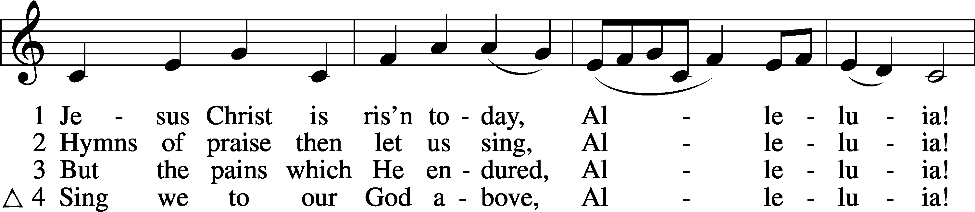
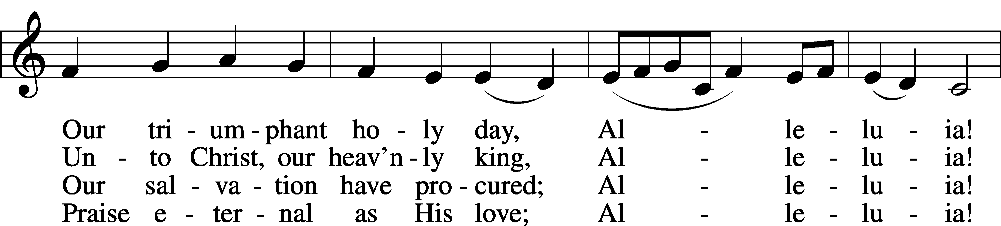
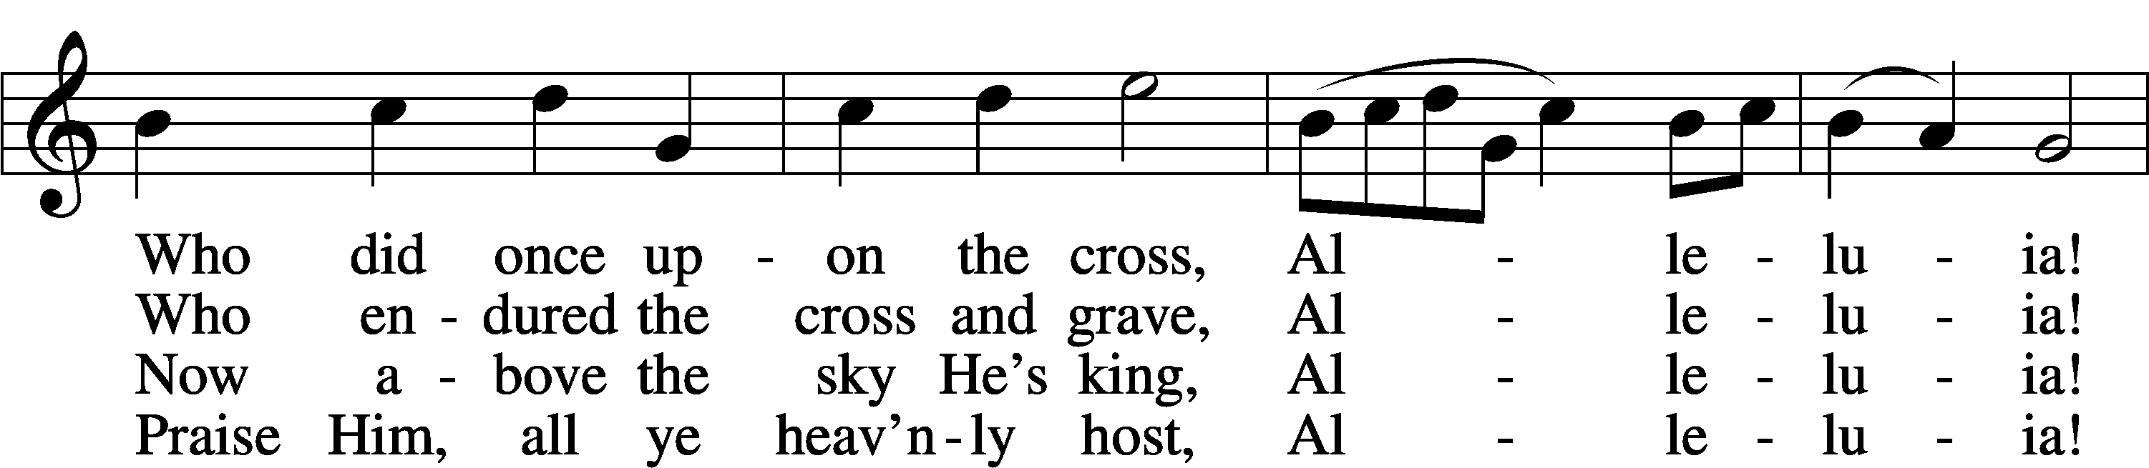
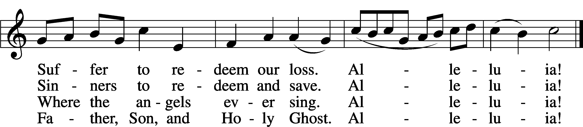
Text: tr. Lyra Davidica, 1708, London, alt.; (sts. 1–3): Latin, 14th cent.; (st. 4): Charles Wesley, 1707–88
Tune: Lyra Davidica, 1708, London
Text and tune: Public domain

+ CONFESSION AND ABSOLUTION +

(The sign of the cross may be made by all in remembrance of their Baptism.)

P In the name of the Father and of the T Son and of the Holy Spirit.
C Amen.

P Beloved in the Lord! Let us draw near with a true heart and confess our sins unto God our Father, beseeching Him in the name of our Lord Jesus Christ to grant us forgiveness.

P Our help is in the name of the Lord,
C who made heaven and earth.
P I said, I will confess my transgressions unto the Lord,
C and You forgave the iniquity of my sin.

(Silence for reflection on God’s Word and for self-examination.)

P O almighty God, merciful Father,
C I, a poor, miserable sinner, confess unto You all my sins and iniquities with which I have ever offended You and justly deserved Your temporal and eternal punishment. But I am heartily sorry for them and sincerely repent of them, and I pray You of Your boundless mercy and for the sake of the holy, innocent, bitter sufferings and death of Your beloved Son, Jesus Christ, to be gracious and merciful to me, a poor, sinful being.

P Upon this your confession, I, by virtue of my office, as a called and ordained servant of the Word, announce the grace of God unto all of you, and in the stead and by the command of my Lord Jesus Christ I forgive you all your sins in the name of the Father and of the T Son and of the Holy Spirit.
C Amen.

+ SERVICE OF THE WORD +

INTROIT Exodus 15:2a, 6, 13, 17–18; antiphon: v. 1b
I will sing to the Lord, for he has triumphed | gloriously;*
the horse and his rider he has thrown in- | to the sea.
The Lord is my strength | and my song,*
and he has become my sal- | vation.
Your right hand, O Lord, glorious | in power,*
your right hand, O Lord, shatters the | enemy.
You have led in your steadfast love the people whom you | have redeemed;*
you have guided them by your strength to your ho- | ly abode.
You will bring them in and plant them on your own | mountain,*
the place, O Lord, which you have made for | your abode,
the sanctuary, O Lord, which your hands have es- | tablished.*
The Lord will reign forever and | ever.
I will sing to the Lord, for he has triumphed | gloriously;*
the horse and his rider he has thrown in- | to the sea.

GLORIA PATRI
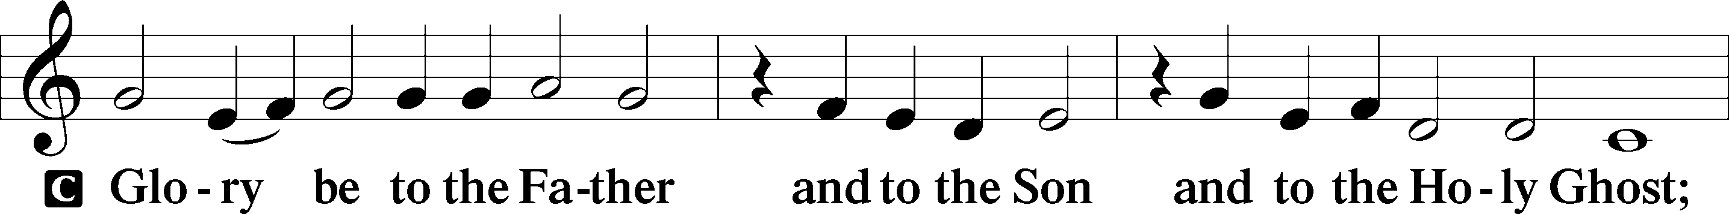
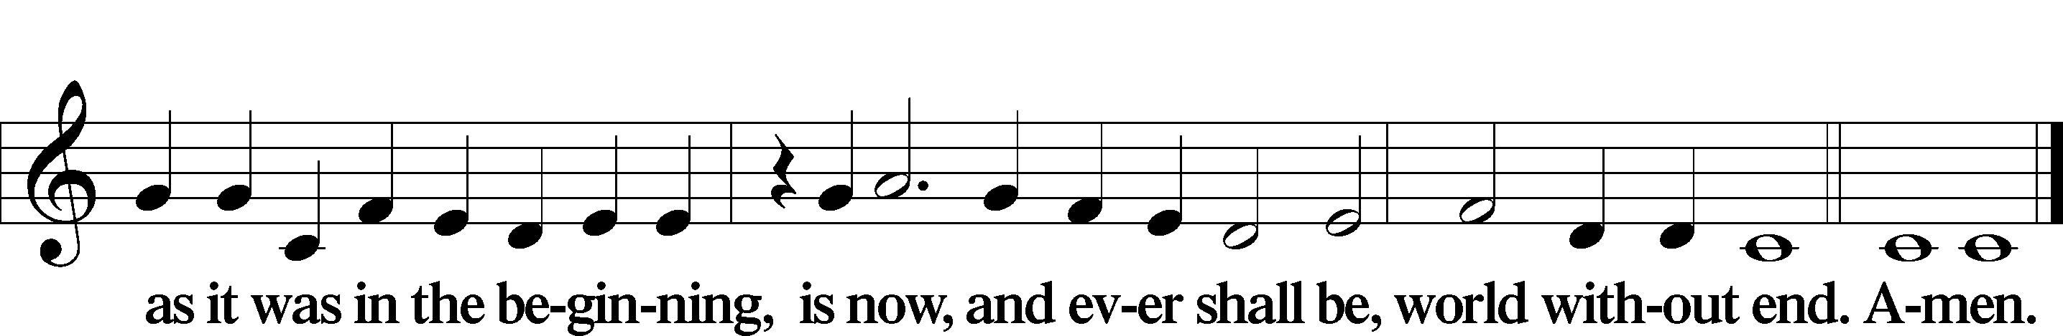

KYRIE LSB 186
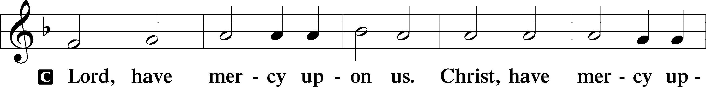
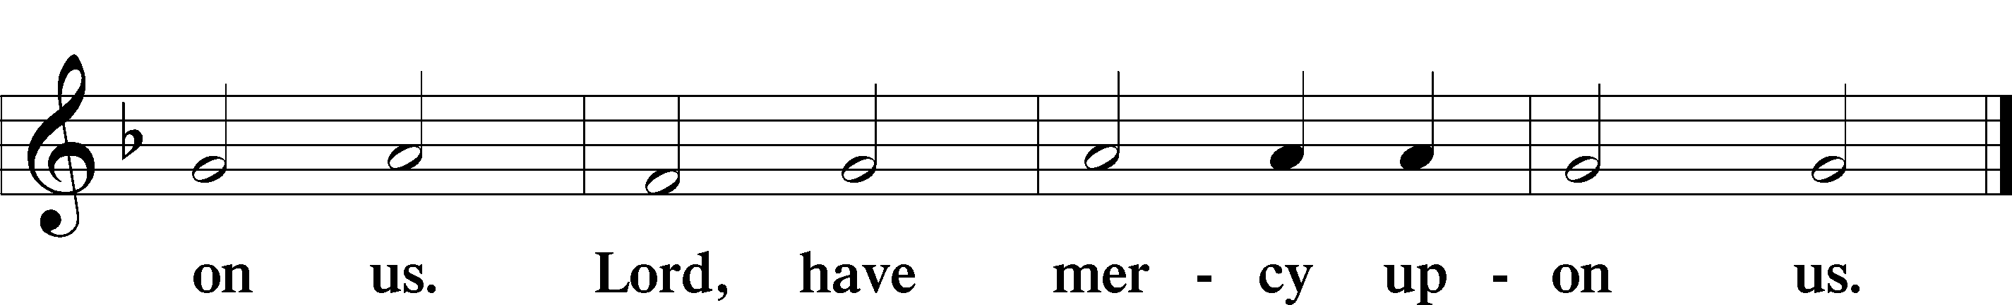

GLORIA IN EXCELSIS LSB 187
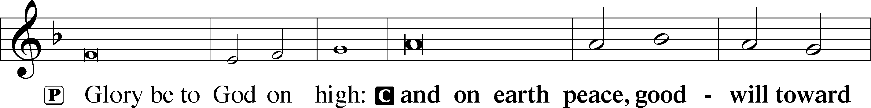
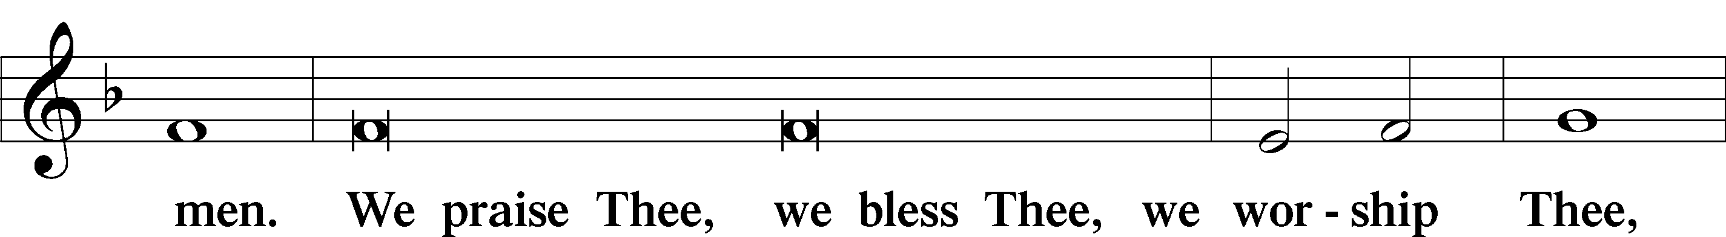
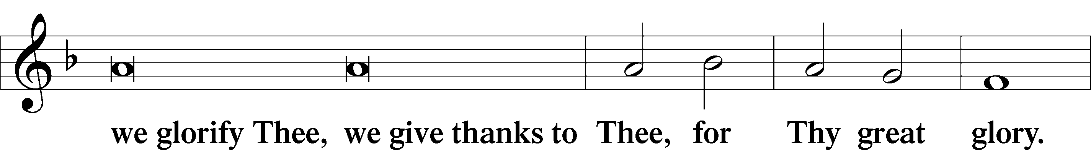
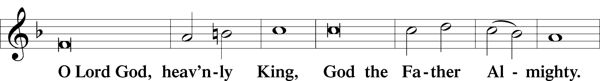
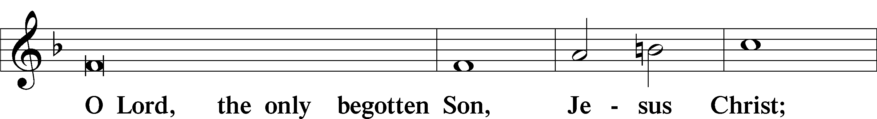
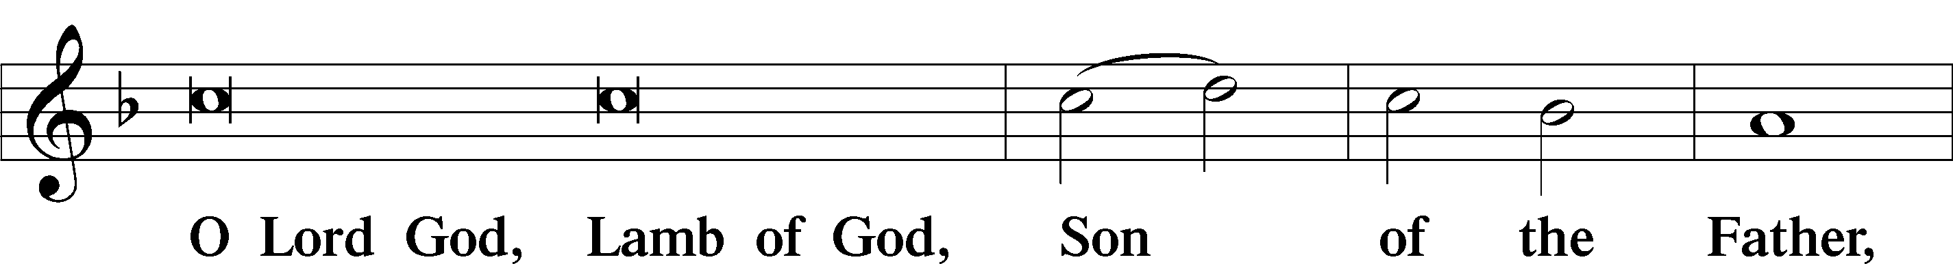
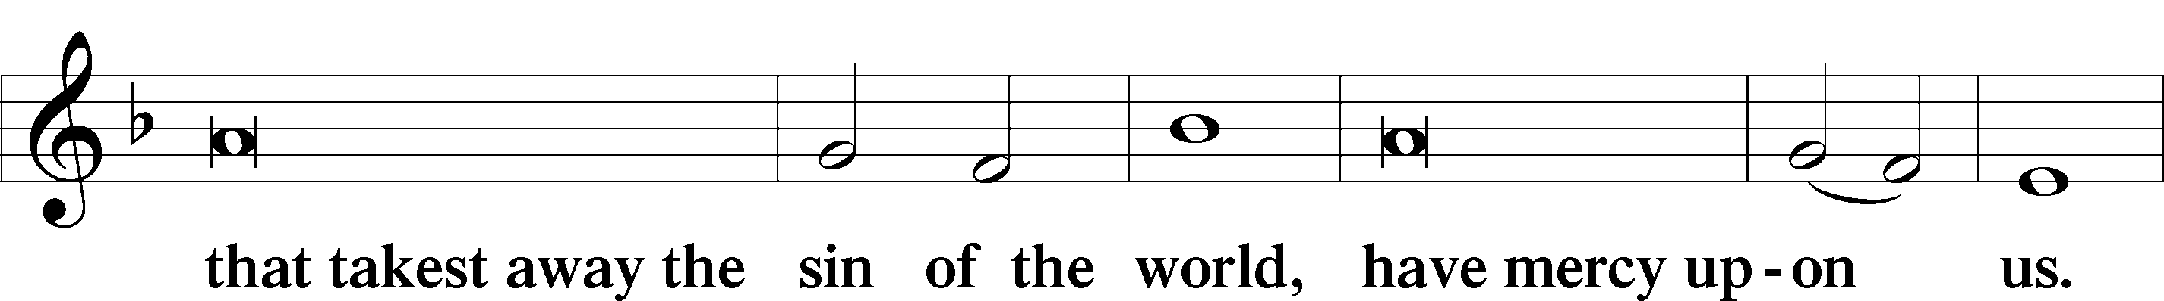
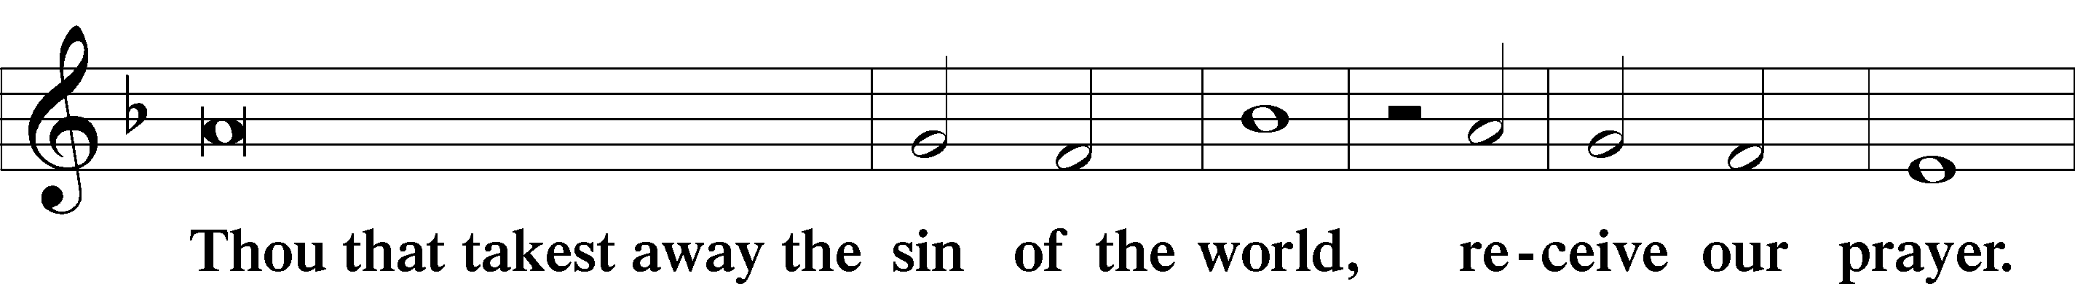
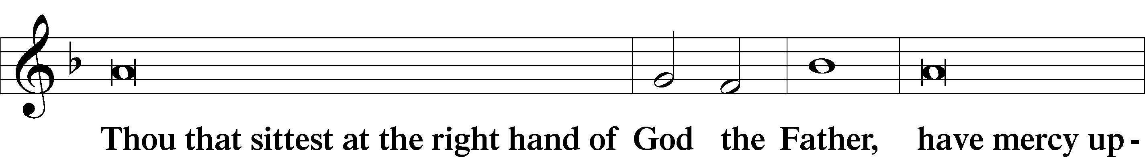
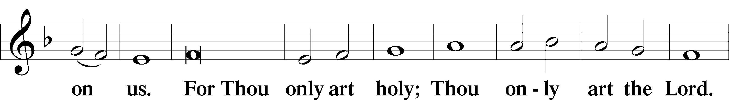

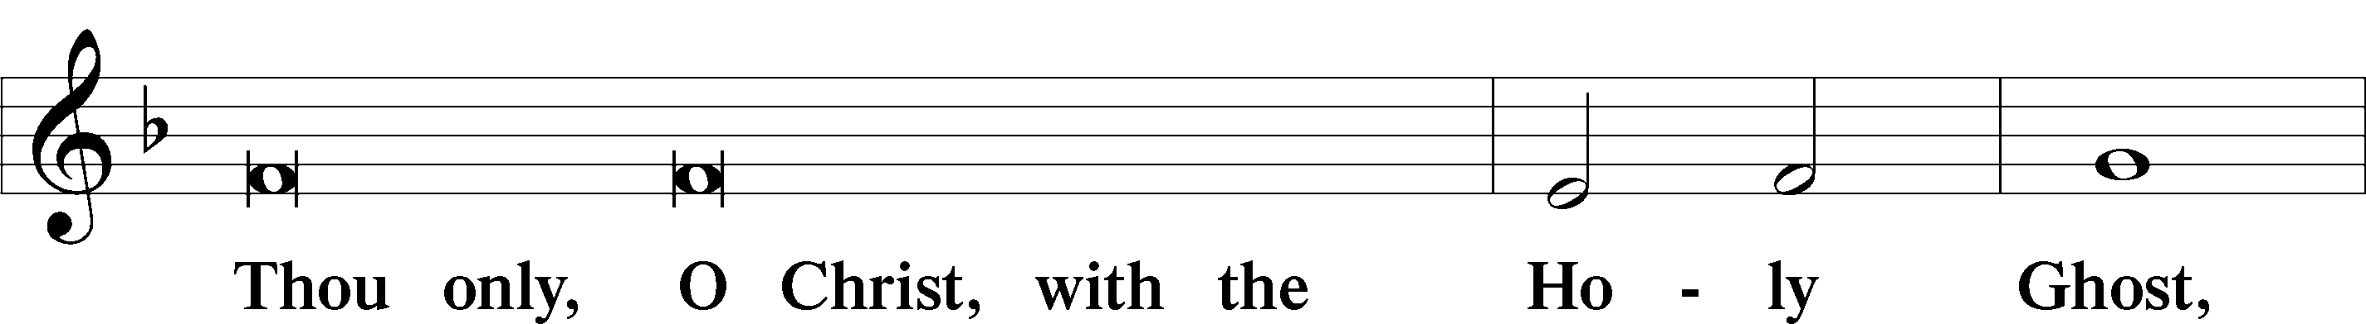
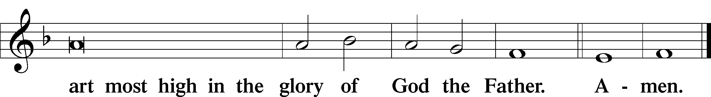

SALUTATION AND COLLECT OF THE DAY LSB 201
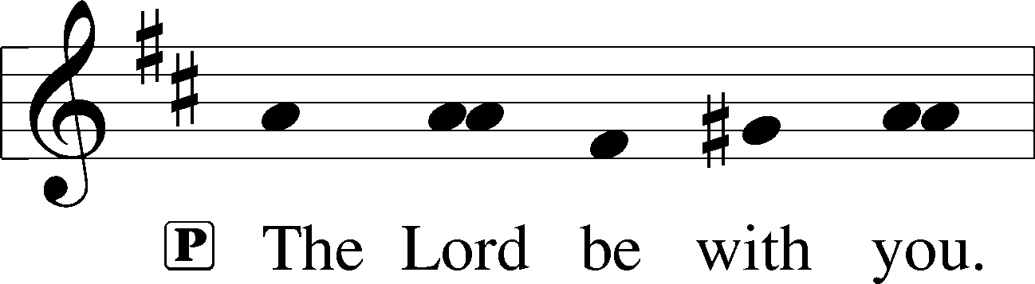

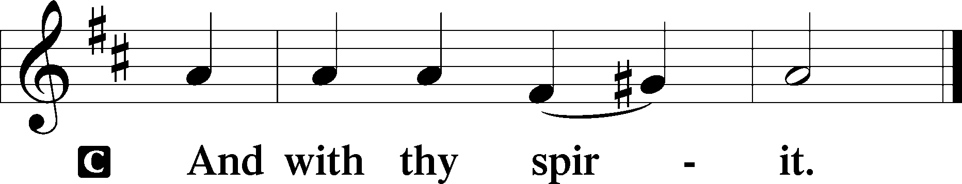

P Let us pray

Almighty God the Father, through Your only-begotten Son, Jesus Christ, You have overcome death and opened the gate of everlasting life to us. Grant that we, who celebrate with joy the day of our Lord’s resurrection, may be raised from the death of sin by Your life-giving Spirit; through Jesus Christ, our Lord, who lives and reigns with You and the Holy Spirit, one God, now and forever.
C Amen.

(Sit)

FIRST READING Acts 10:34–43
34Peter opened his mouth and said: “Truly I understand that God shows no partiality, 35but in every nation anyone who fears him and does what is right is acceptable to him. 36As for the word that he sent to Israel, preaching good news of peace through Jesus Christ (he is Lord of all), 37you yourselves know what happened throughout all Judea, beginning from Galilee after the baptism that John proclaimed: 38how God anointed Jesus of Nazareth with the Holy Spirit and with power. He went about doing good and healing all who were oppressed by the devil, for God was with him. 39And we are witnesses of all that he did both in the country of the Jews and in Jerusalem. They put him to death by hanging him on a tree, 40but God raised him on the third day and made him to appear, 41not to all the people but to us who had been chosen by God as witnesses, who ate and drank with him after he rose from the dead. 42And he commanded us to preach to the people and to testify that he is the one appointed by God to be judge of the living and the dead. 43To him all the prophets bear witness that everyone who believes in him receives forgiveness of sins through his name.”

P This is the Word of the Lord.
C Thanks be to God.

GRADUAL
C Christ has risen | from the dead.*
[God the Father] has crowned him with glory and | honor.
He has given him dominion over the works | of his hands;*
he has put all things un- | der his feet.

EPISTLE Colossians 3:1–4
1If then you have been raised with Christ, seek the things that are above, where Christ is, seated at the right hand of God. 2Set your minds on things that are above, not on things that are on earth. 3For you have died, and your life is hidden with Christ in God. 4When Christ who is your life appears, then you also will appear with him in glory.

P This is the Word of the Lord.
C Thanks be to God.

(Stand)

ALLELUIA LSB 190
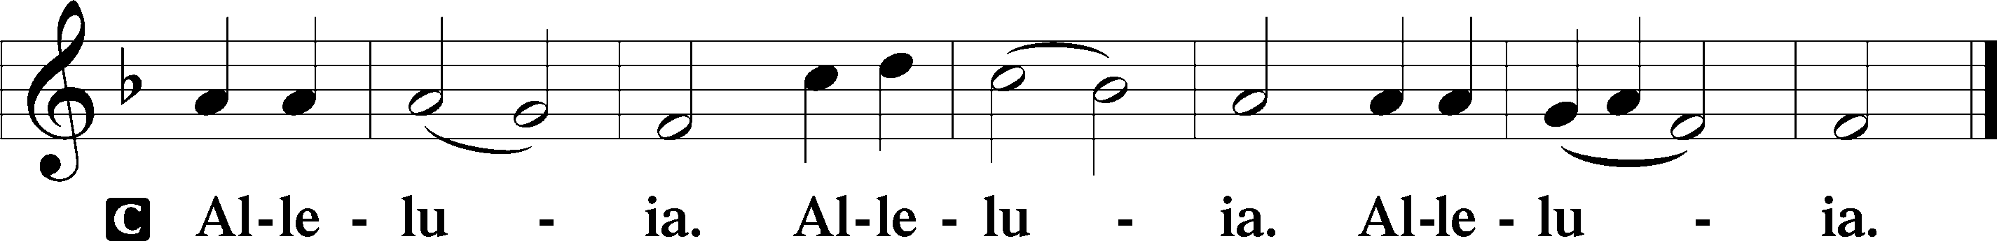

HOLY GOSPEL Matthew 28:1–10
P The Holy Gospel according to St. Matthew, the twenty-eighth chapter.

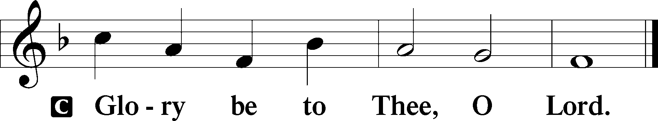

1Now after the Sabbath, toward the dawn of the first day of the week, Mary Magdalene and the other Mary went to see the tomb. 2And behold, there was a great earthquake, for an angel of the Lord descended from heaven and came and rolled back the stone and sat on it. 3His appearance was like lightning, and his clothing white as snow. 4And for fear of him the guards trembled and became like dead men. 5But the angel said to the women, “Do not be afraid, for I know that you seek Jesus who was crucified. 6He is not here, for he has risen, as he said. Come, see the place where he lay. 7Then go quickly and tell his disciples that he has risen from the dead, and behold, he is going before you to Galilee; there you will see him. See, I have told you.” 8So they departed quickly from the tomb with fear and great joy, and ran to tell his disciples. 9And behold, Jesus met them and said, “Greetings!” And they came up and took hold of his feet and worshiped him. 10Then Jesus said to them, “Do not be afraid; go and tell my brothers to go to Galilee, and there they will see me.”

P This is the Gospel of the Lord.

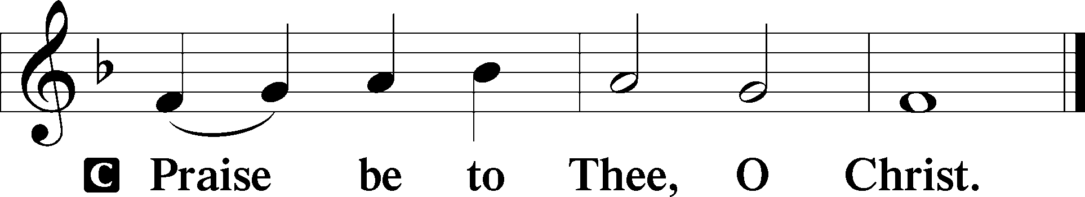

NICENE CREED
C I believe in one God,
the Father Almighty,
maker of heaven and earth
and of all things visible and invisible.

And in one Lord Jesus Christ,
the only-begotten Son of God,
begotten of His Father before all worlds,
God of God, Light of Light,
very God of very God,
begotten, not made,
being of one substance with the Father,
by whom all things were made;
who for us men and for our salvation came down from heaven
and was incarnate by the Holy Spirit of the virgin Mary
and was made man;
and was crucified also for us under Pontius Pilate.
He suffered and was buried.
And the third day He rose again according to the Scriptures
and ascended into heaven
and sits at the right hand of the Father.
And He will come again with glory to judge both the living and the dead,
whose kingdom will have no end.

And I believe in the Holy Spirit,
the Lord and giver of life,
who proceeds from the Father and the Son,
who with the Father and the Son together is worshiped and glorified,
who spoke by the prophets.
And I believe in one holy Christian and apostolic Church,
I acknowledge one Baptism for the remission of sins,
and I look for the resurrection of the dead
and the life T of the world to come. Amen.

(Sit)

465 NOW ALL THE VAULT OF HEAVEN RESOUNDS
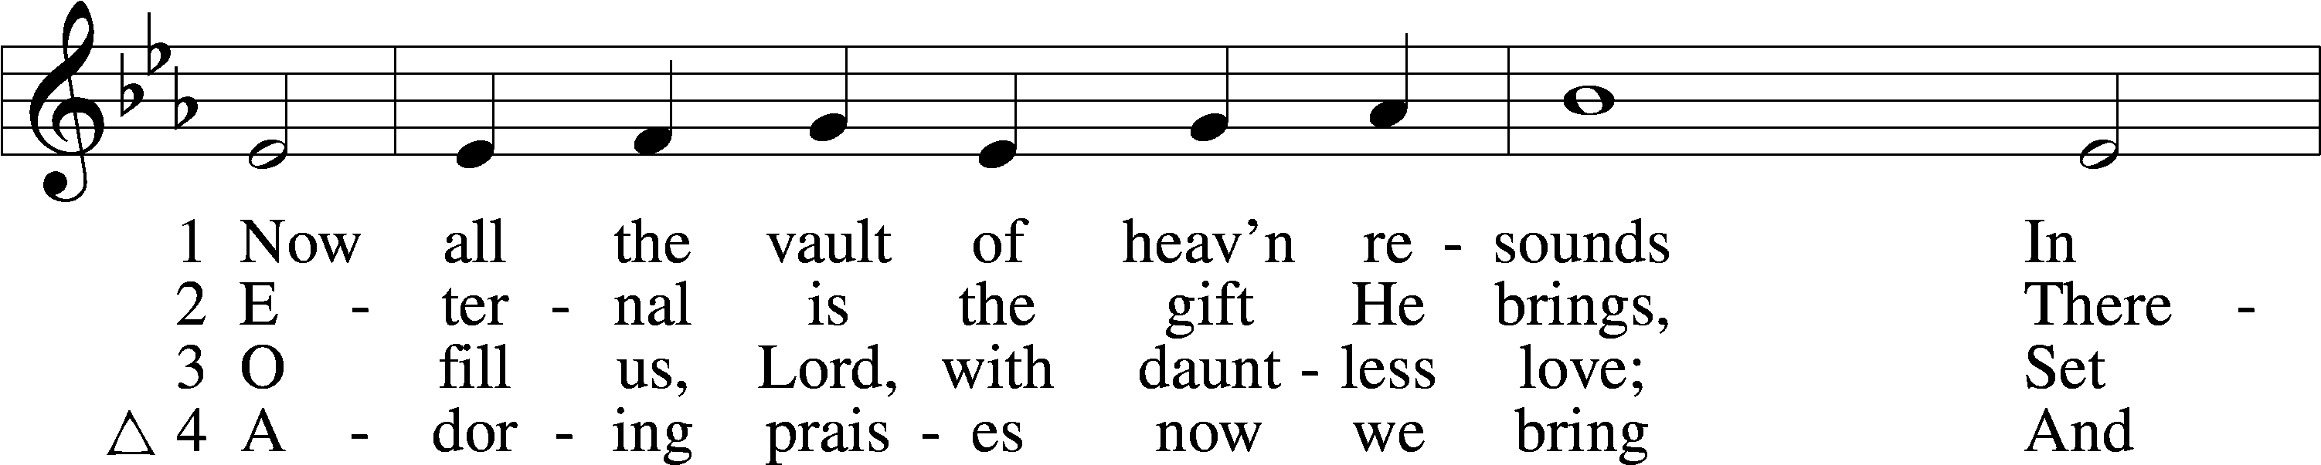
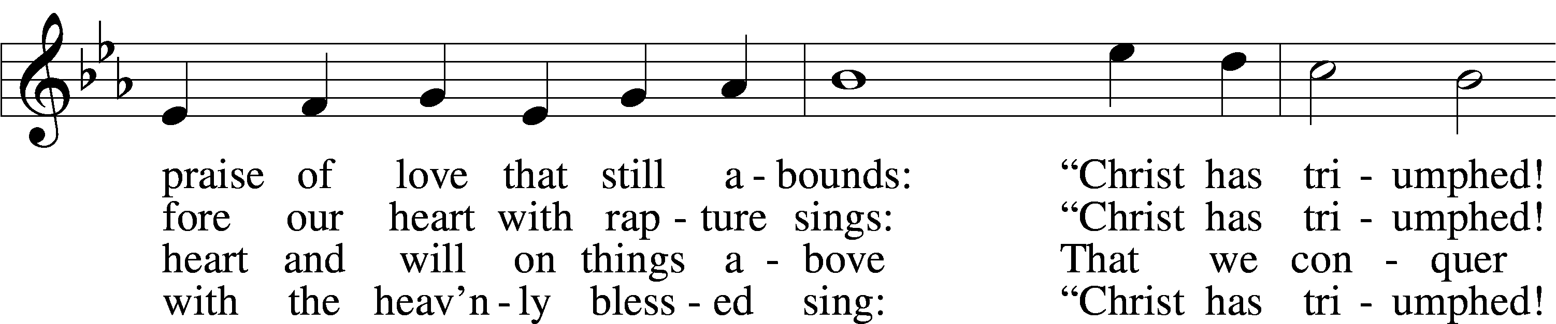
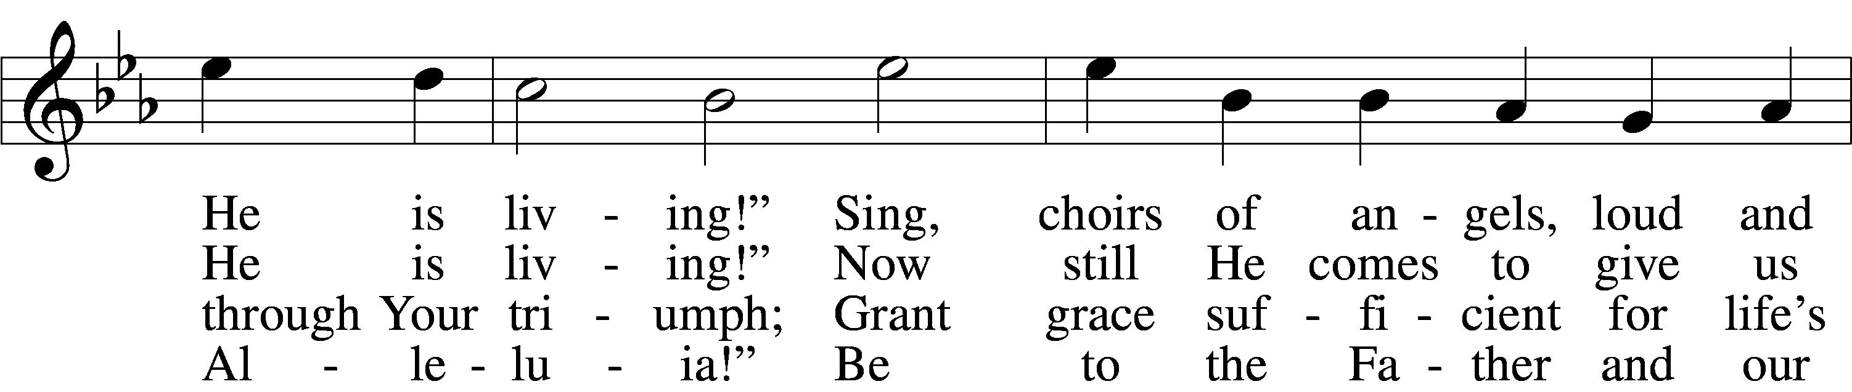
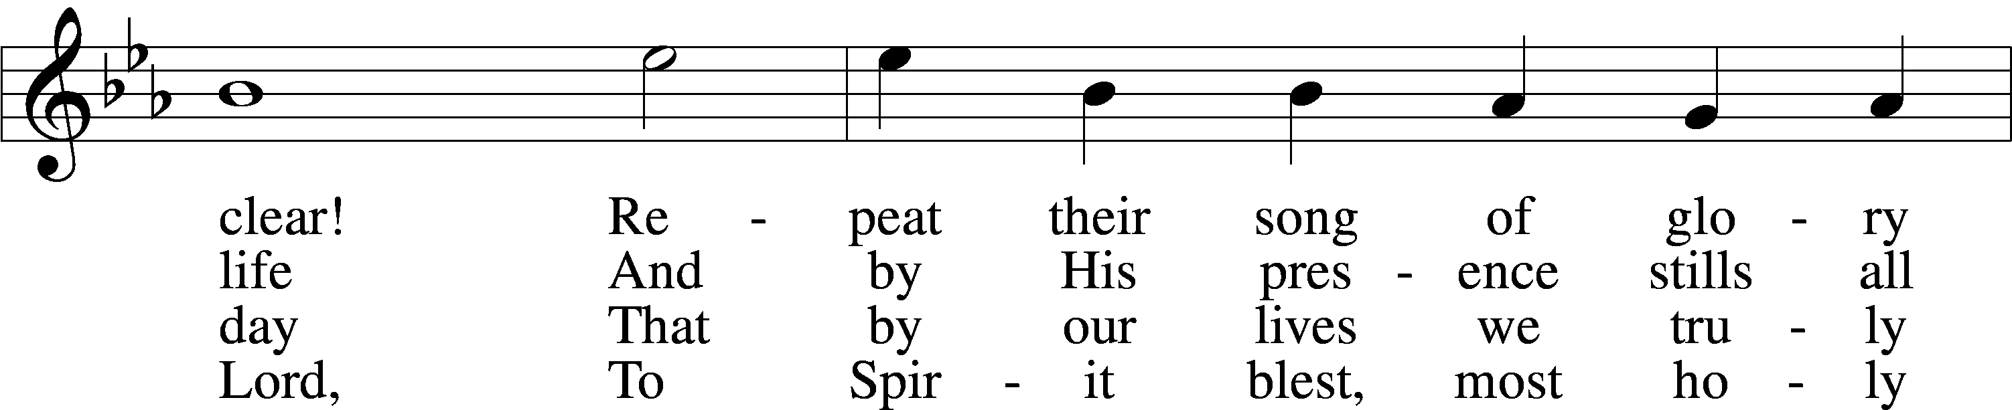
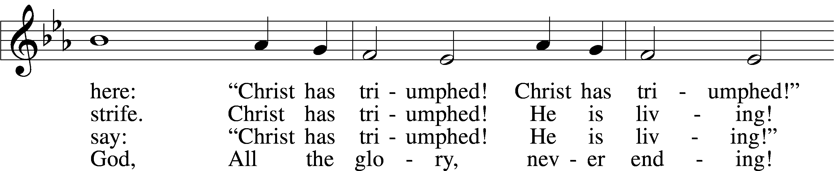
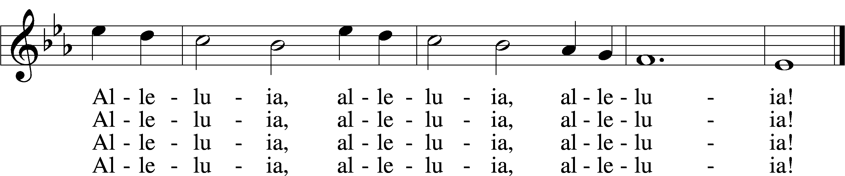
Text: Paul Z. Strodach, 1876–1947, alt.
Tune: Geistliche Kirchengesäng, 1623, Köln
Text: © 1958 Augsburg Publishing House. Used by permission: LSB Hymn License no. 110004798
Tune: Public domain

SERMON

(Stand)

OFFERTORY LSB 192
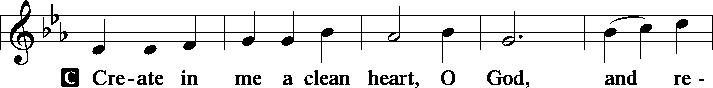
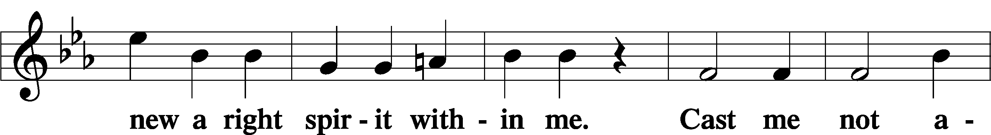
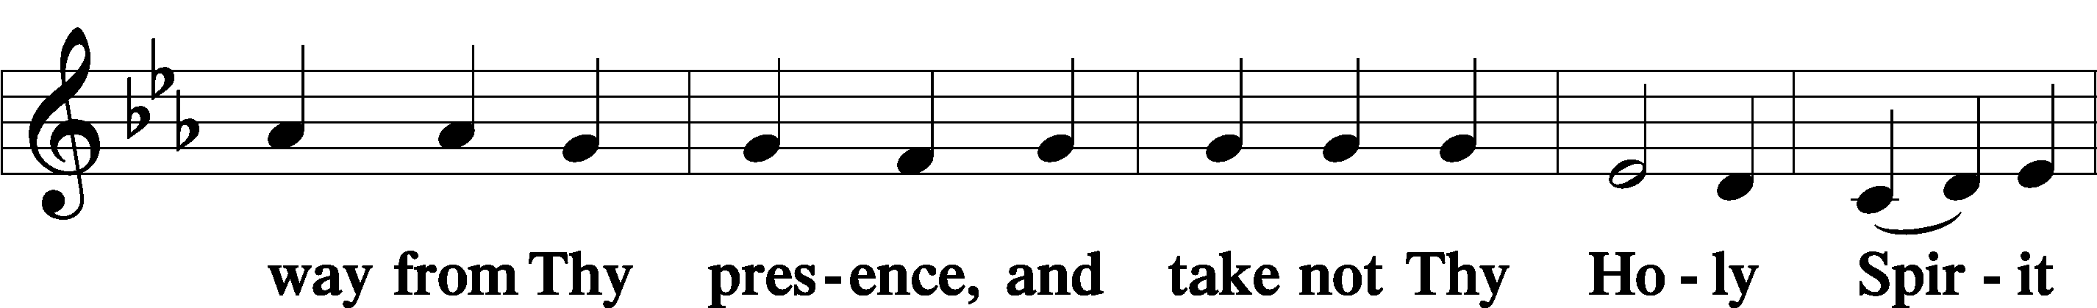
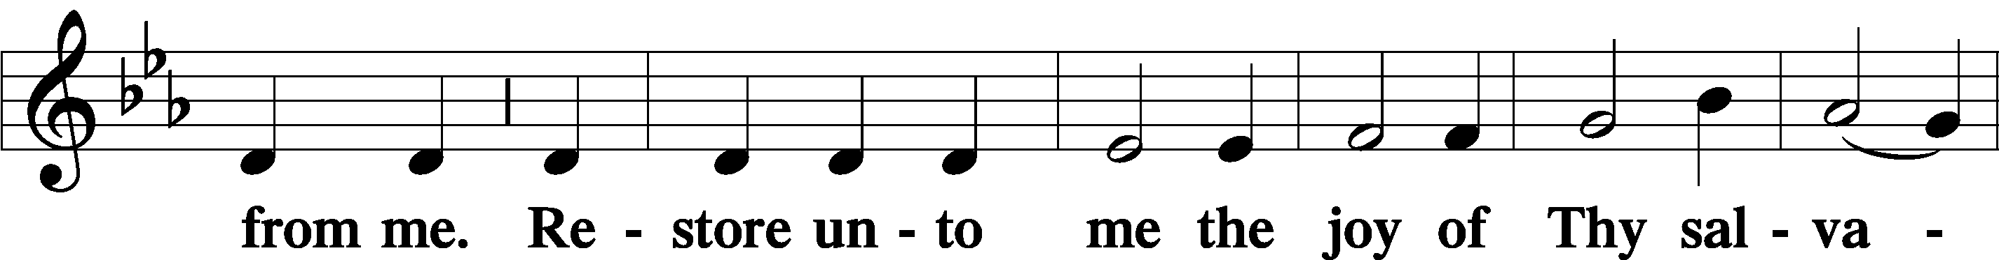
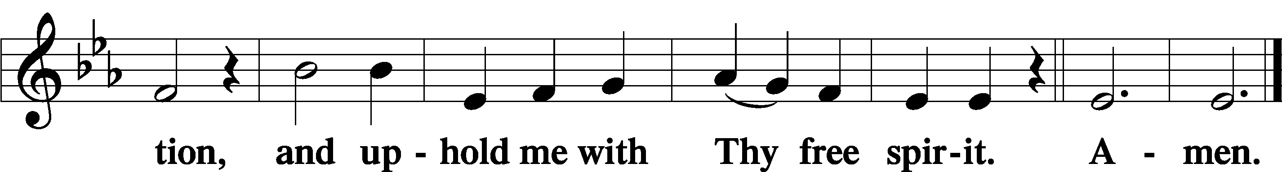

OFFERING

(Stand)

SHARING OF THE PEACE

(Sit)

PRAYER OF THE CHURCH

+ SERVICE OF THE SACRAMENT +

PREFACE LSB 194

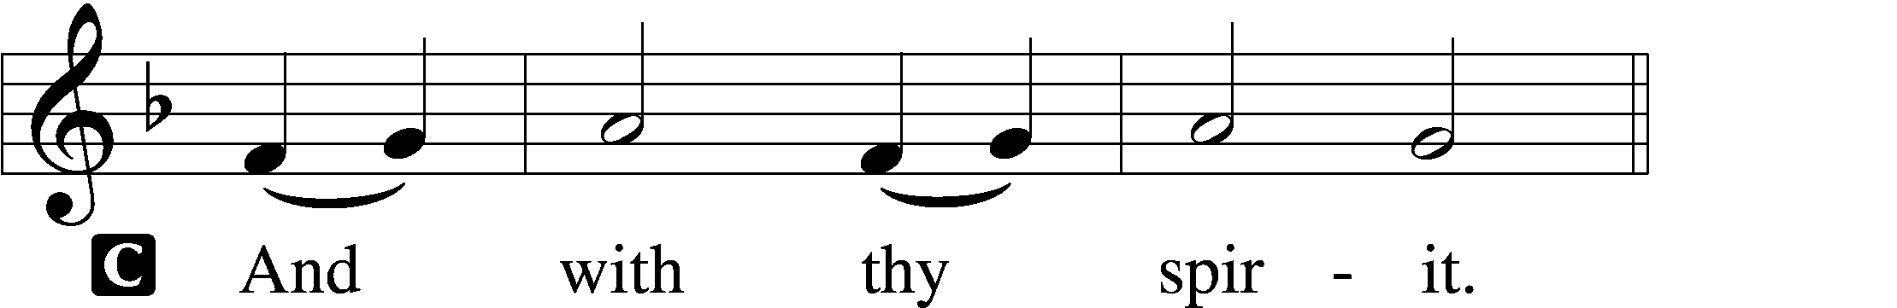


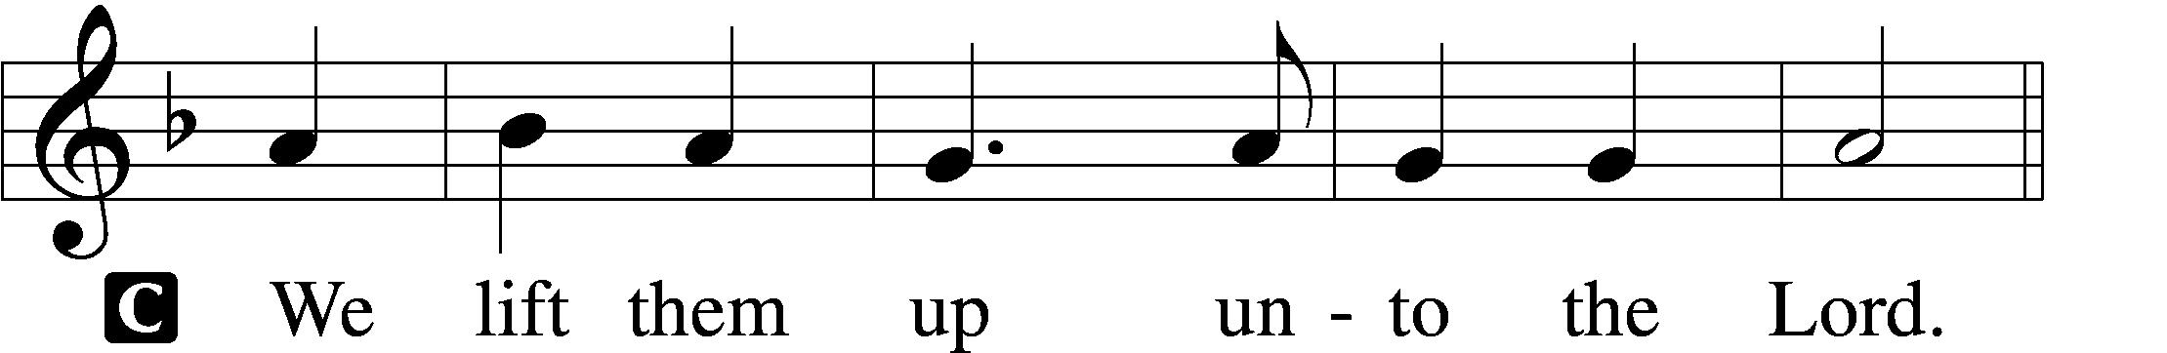

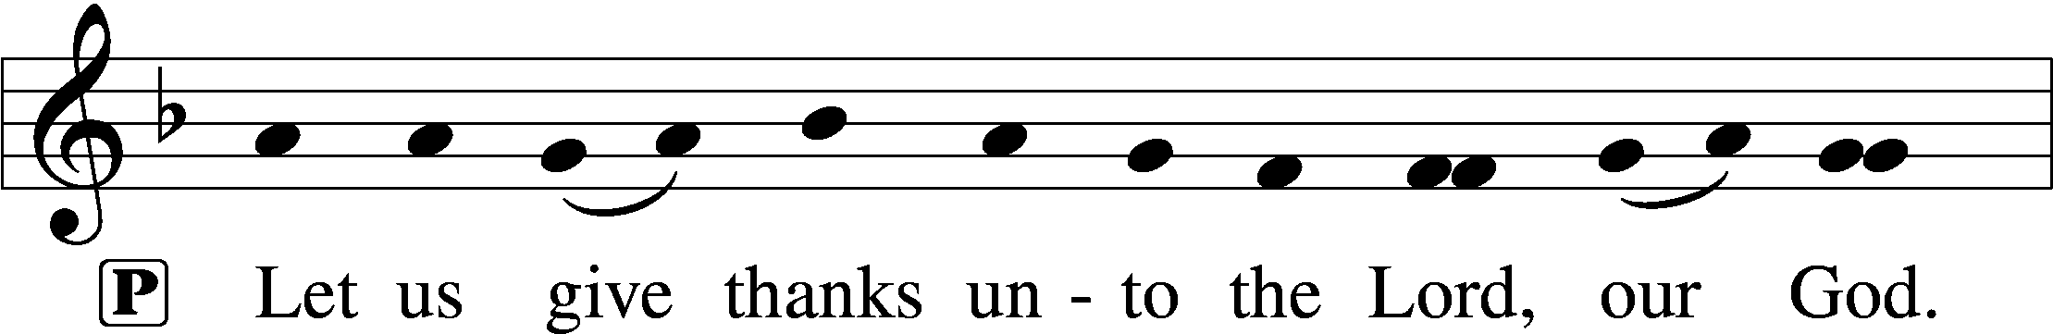
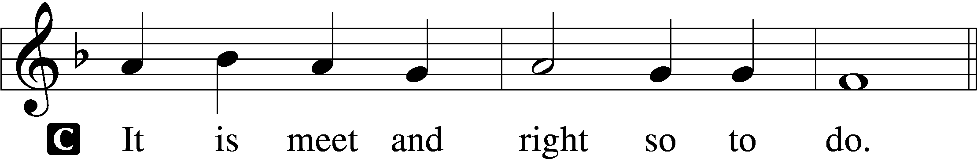

PROPER PREFACE (ABBREVIATED) LSB 194
P It is truly meet, right, and salutary . . . evermore praising You and saying:

SANCTUS LSB 195
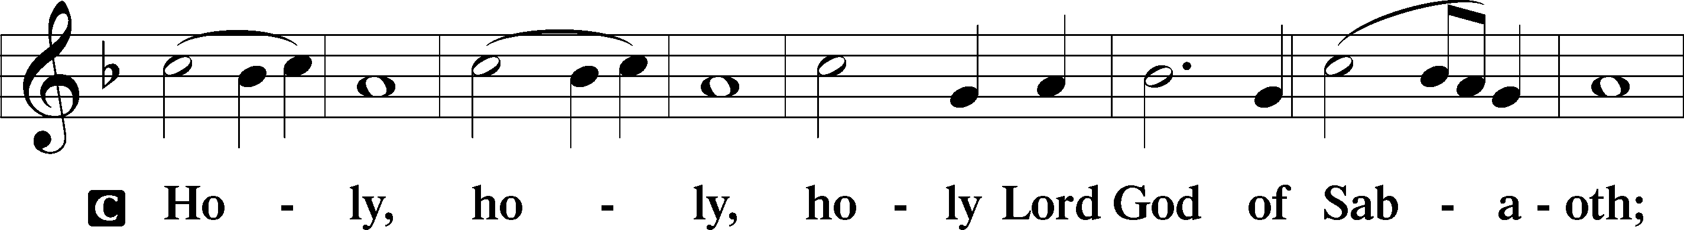
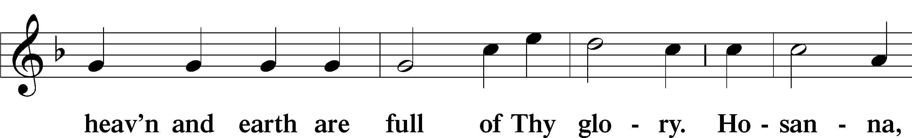
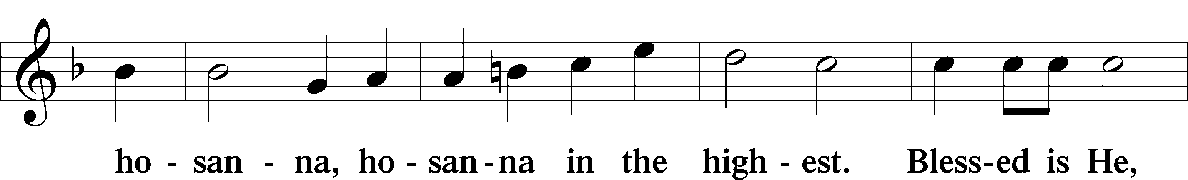
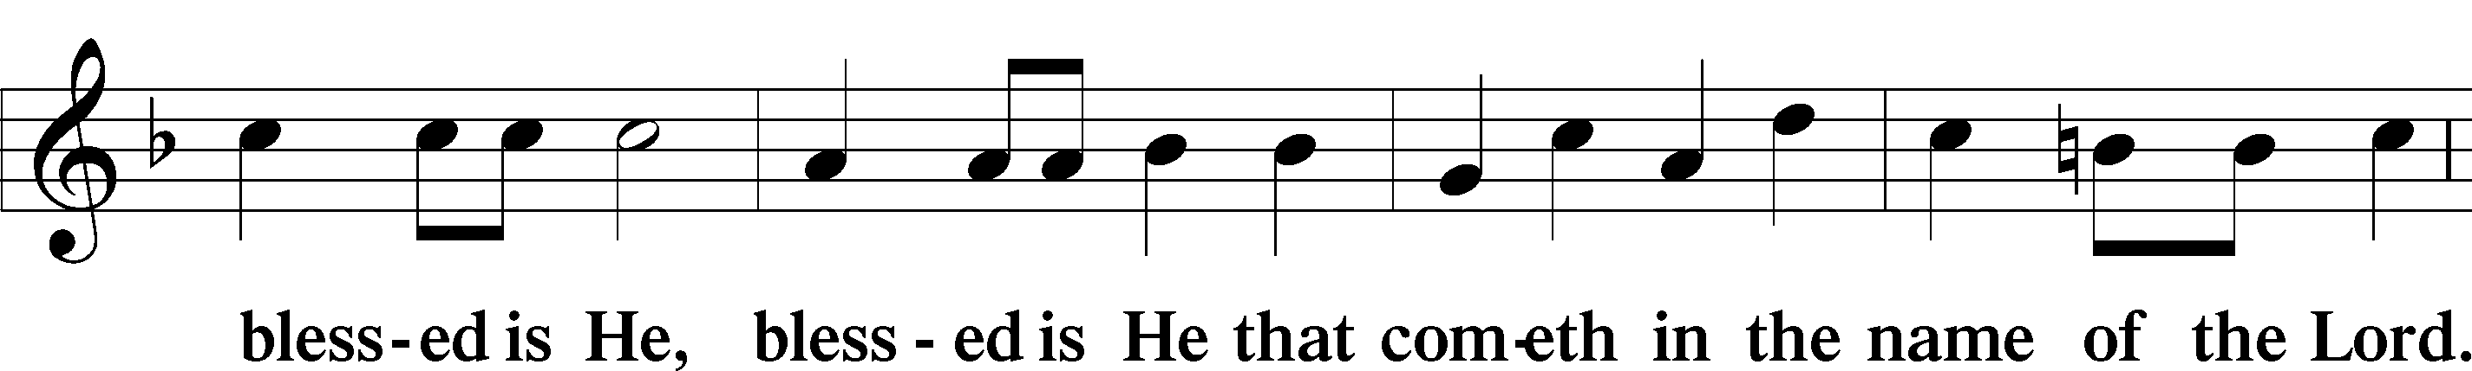
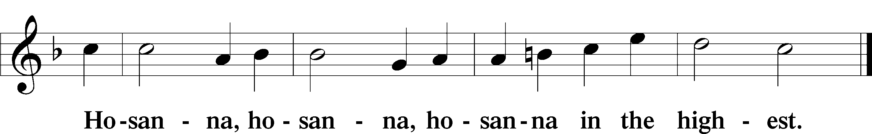

LORD’S PRAYER LSB 196
P Our Father who art in heaven,
hallowed be Thy name,
Thy kingdom come,
Thy will be done on earth as it is in heaven;
give us this day our daily bread;
and forgive us our trespasses as we forgive those who trespass against us;
and lead us not into temptation,
but deliver us from evil.
C For Thine is the kingdom and the power and the glory forever and ever. Amen.

THE WORDS OF OUR LORD LSB 197
P Our Lord Jesus Christ, on the night when He was betrayed, took bread, and when He had given thanks, He broke it and gave it to the disciples and said: “Take, eat; this is My T body, which is given for you. This do in remembrance of Me.”

In the same way also He took the cup after supper, and when He had given thanks, He gave it to them, saying: “Drink of it, all of you; this cup is the new testament in My T blood, which is shed for you for the forgiveness of sins. This do, as often as you drink it, in remembrance of Me.”

PAX DOMINI LSB 197
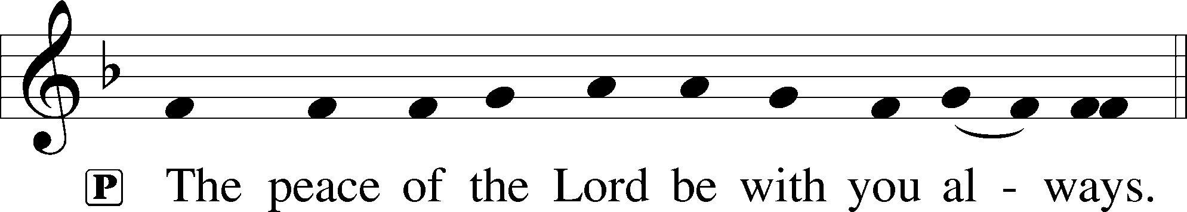

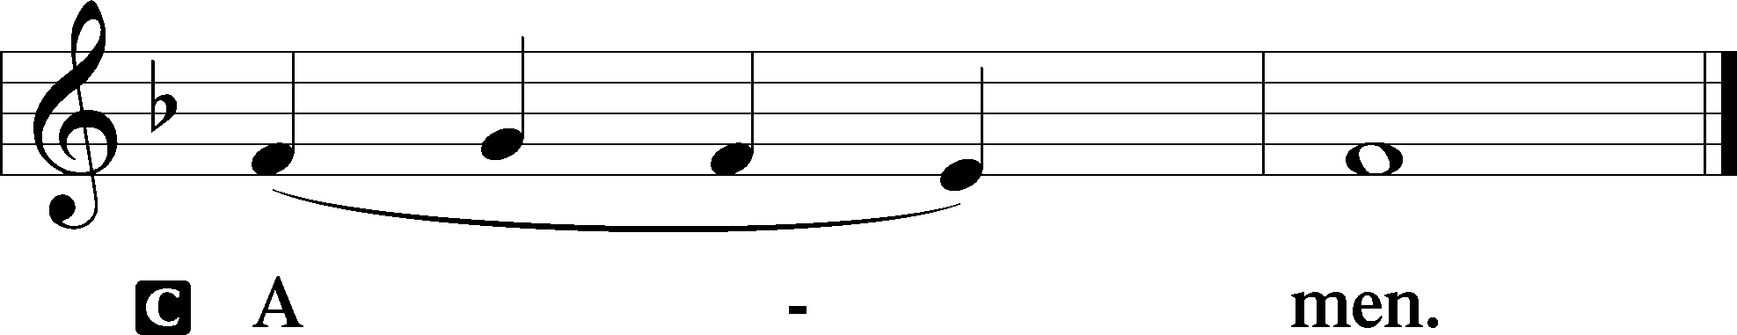

AGNUS DEI LSB 198
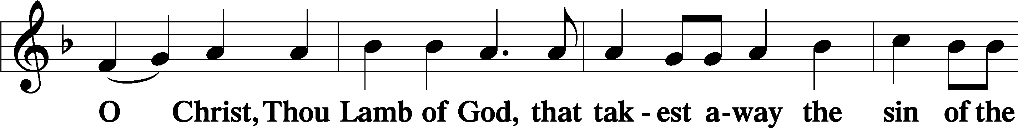
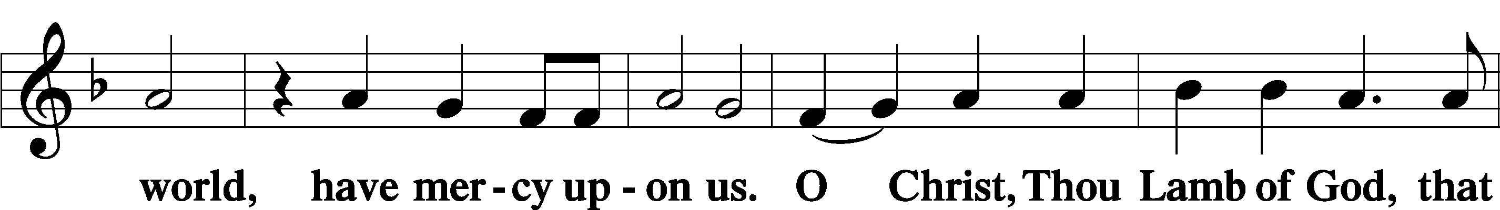
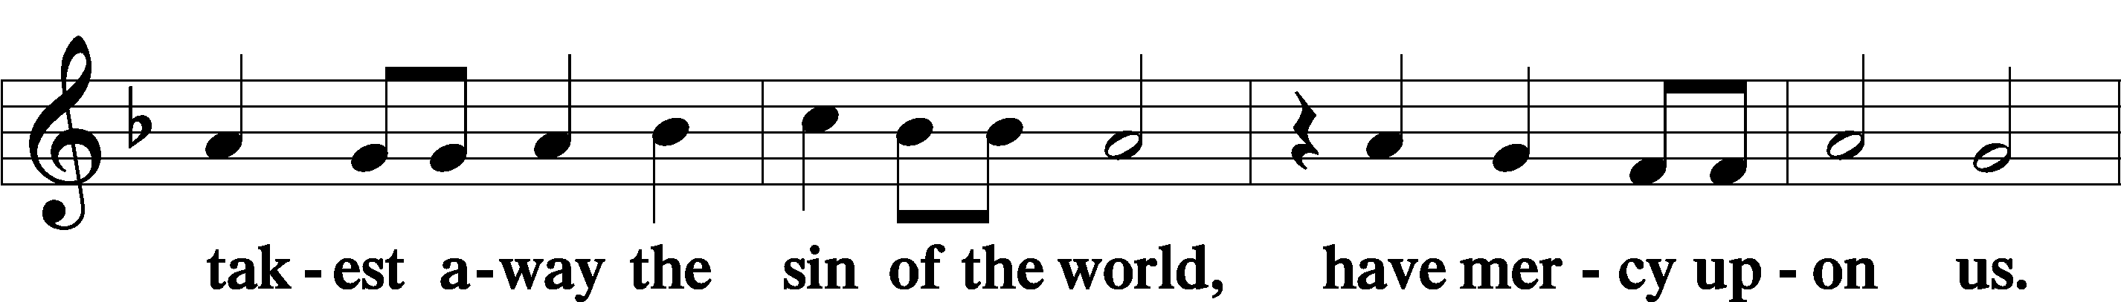
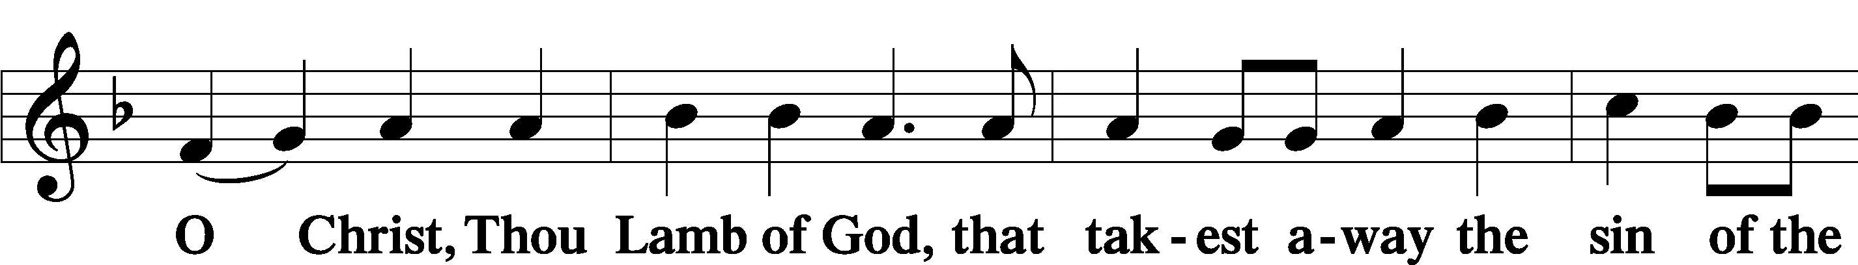
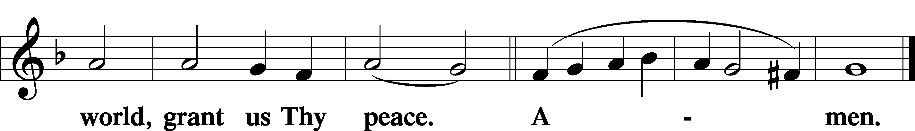

(Sit)

DISTRIBUTION

(The pastor and those who assist him receive the body and blood of Christ first and then distribute them to those who come to receive, saying:)

481 SCATTER THE DARKNESS, BREAK THE GLOOM
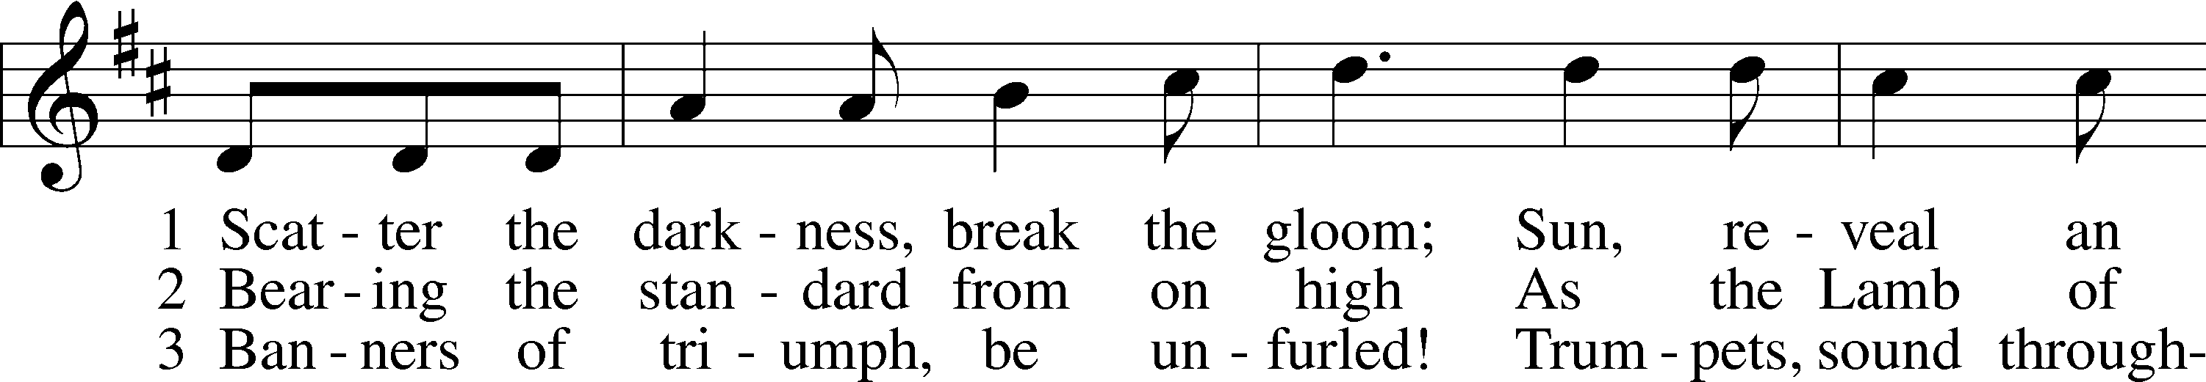
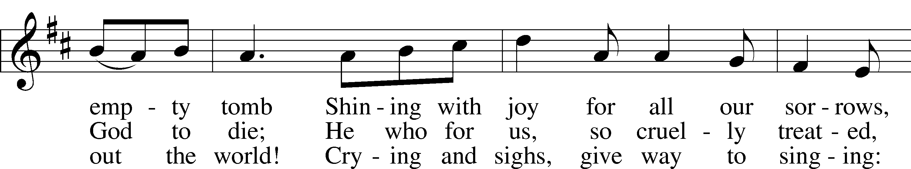
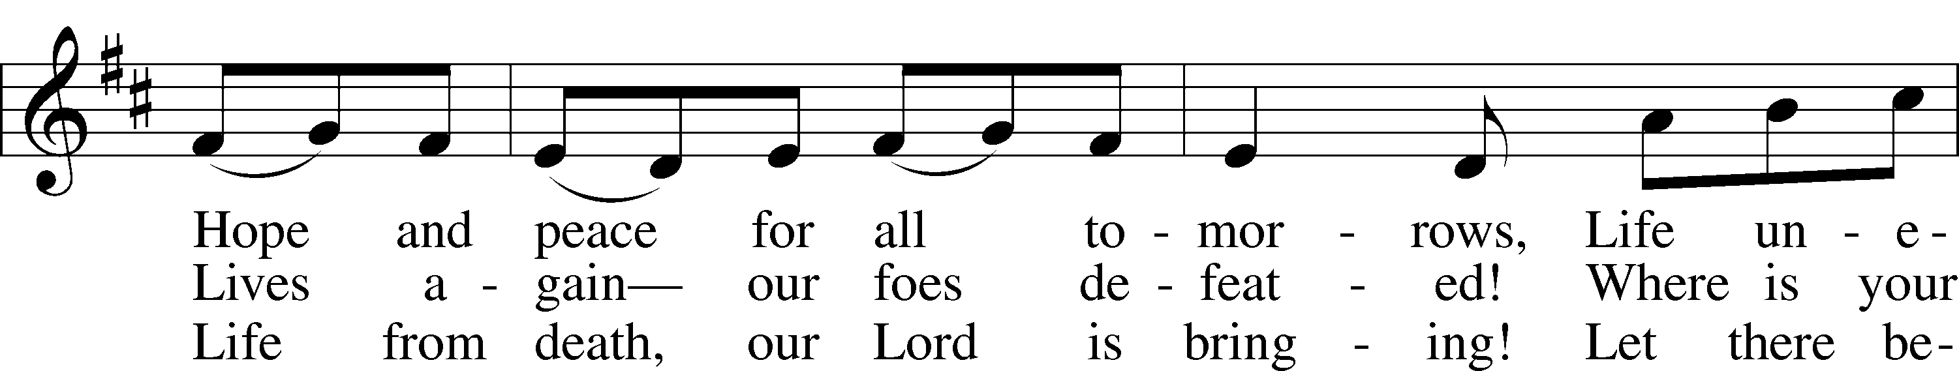
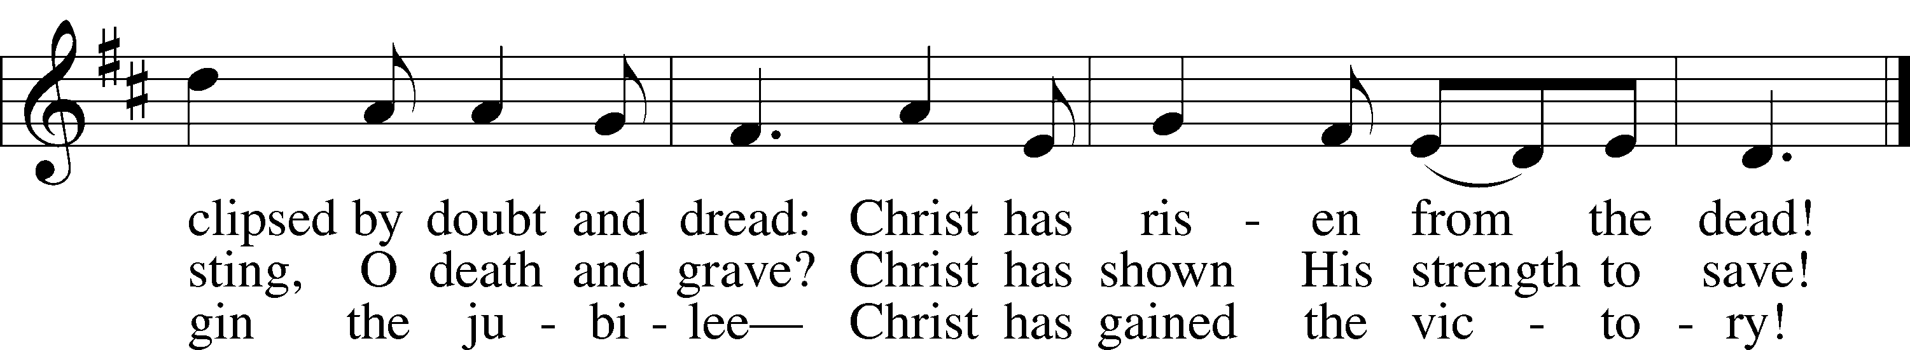
Text: Stephen P. Starke, 1955
Tune: French
Text: © 1995 Stephen P. Starke, admin. Concordia Publishing House. Used by permission: LSB Hymn License no. 110004798
Tune: Public domain

633 AT THE LAMB’S HIGH FEAST WE SING
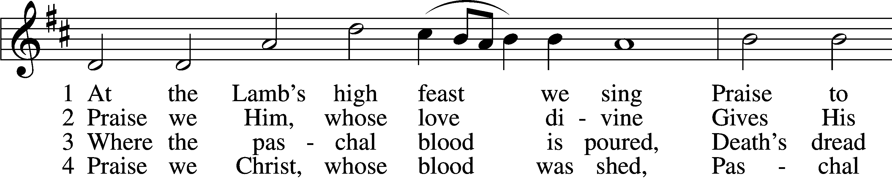
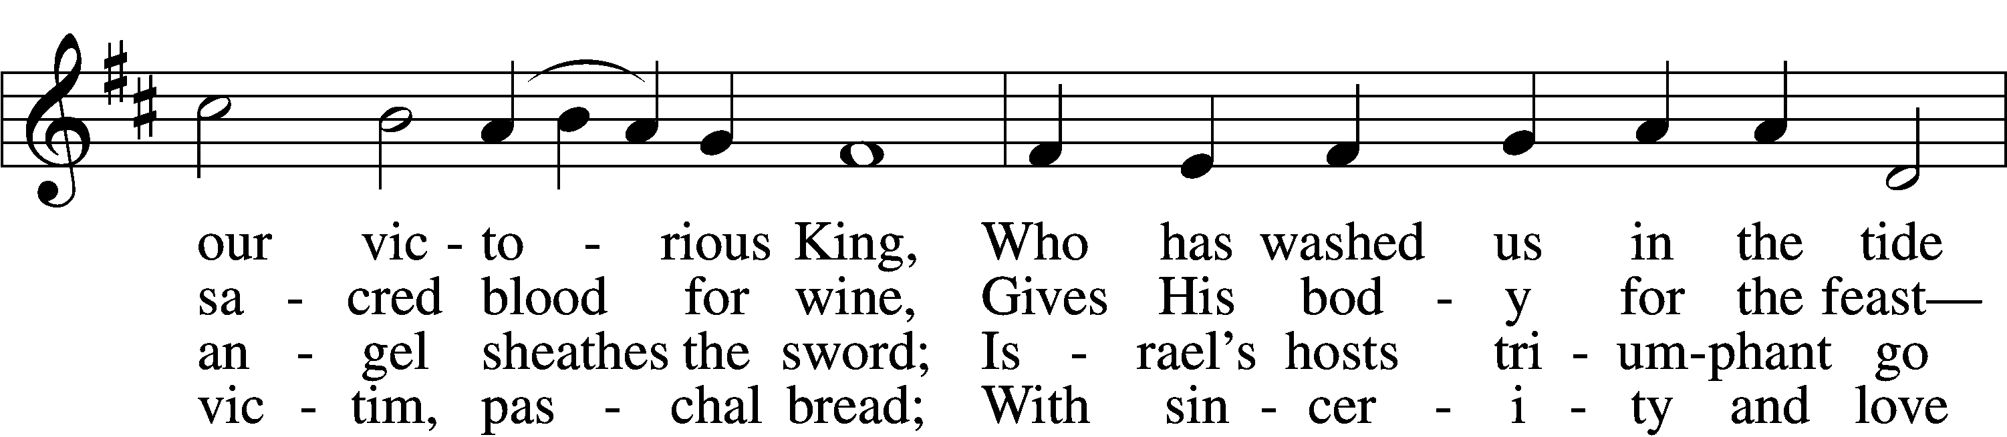
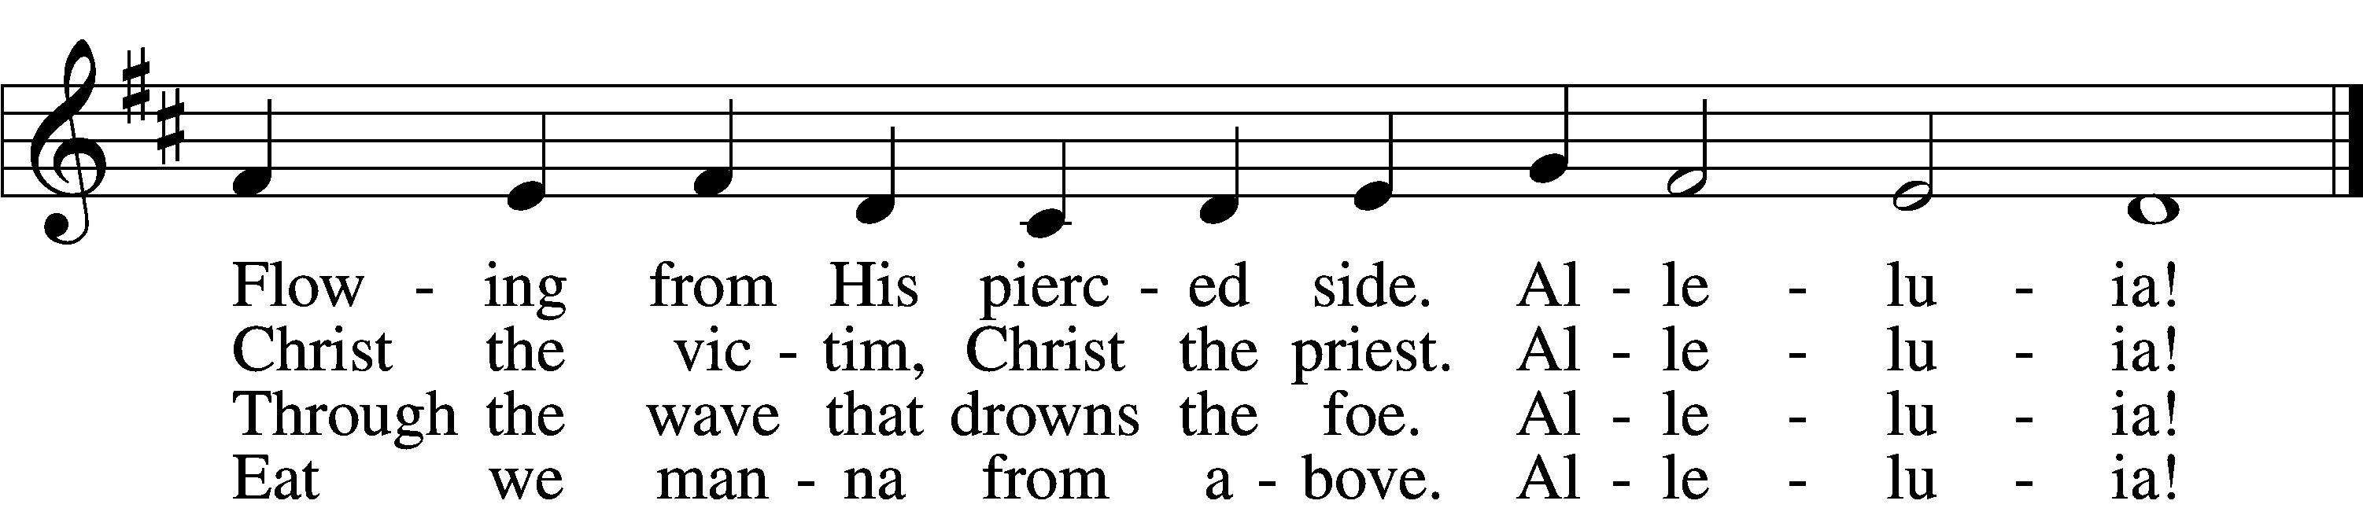

5 Mighty Victim from the sky,
Hell’s fierce pow’rs beneath You lie;
You have conquered in the fight,
You have brought us life and light.
Alleluia!

6 Now no more can death appall,
Now no more the grave enthrall;
You have opened paradise,
And Your saints in You shall rise.
Alleluia!

7 Easter triumph, Easter joy!
This alone can sin destroy;
From sin’s pow’r, Lord, set us free,
Newborn souls in You to be.
Alleluia!

D 8 Father, who the crown shall give,
Savior, by whose death we live,
Spirit, guide through all our days:
Three in One, Your name we praise.
Alleluia!
Text: Latin, c. 5th–10th cent.; tr. Robert Campbell, 1814–68, alt.
Tune: Kirchengeseng, 1566, Ivancice
Text and tune: Public domain

(Stand)

NUNC DIMITTIS LSB 199
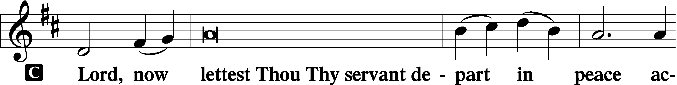

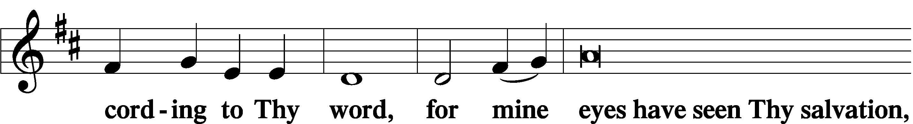

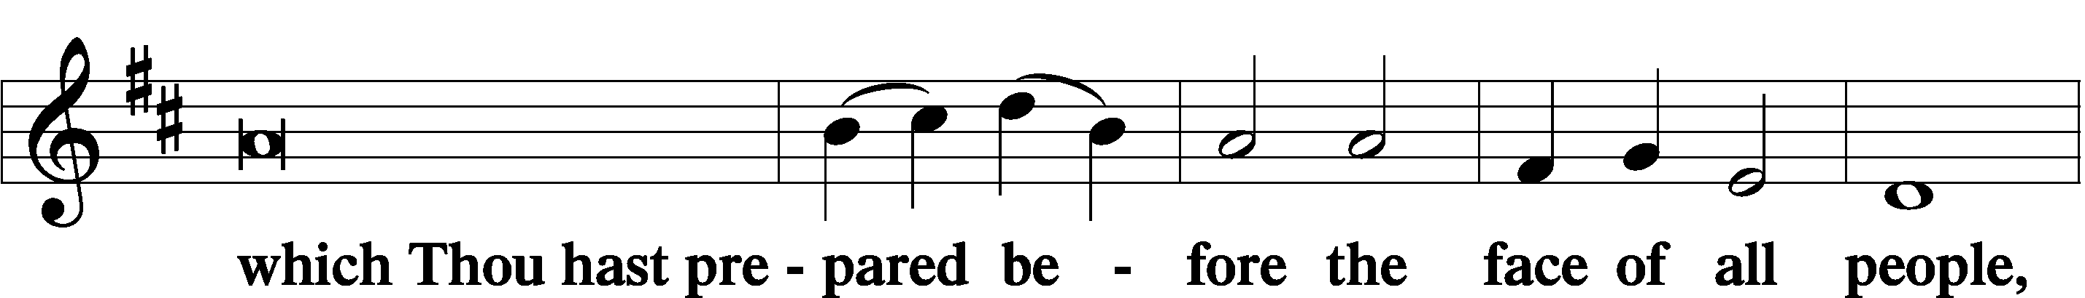

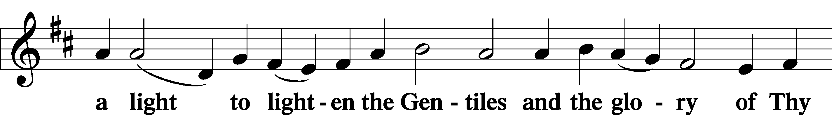

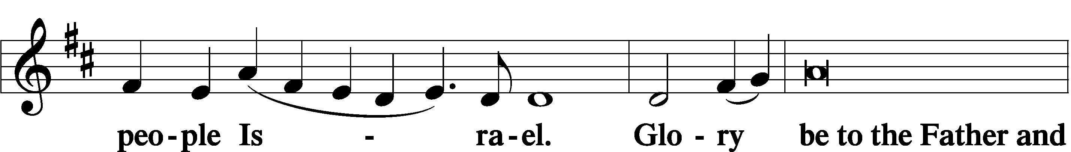

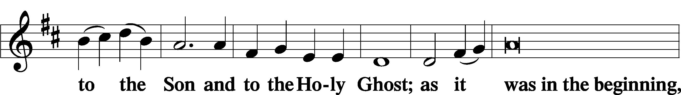

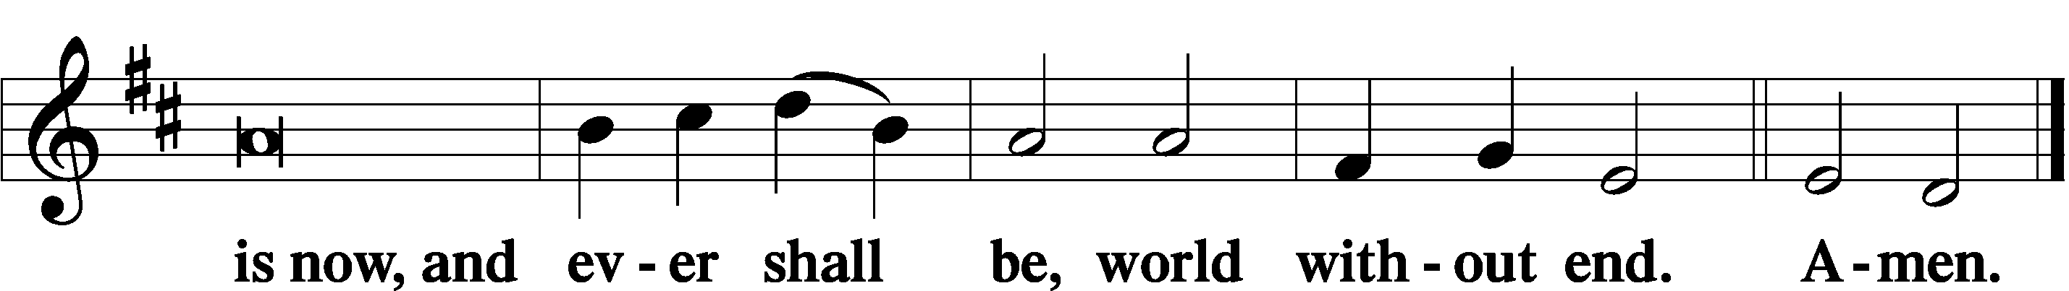

THANKSGIVING LSB 200
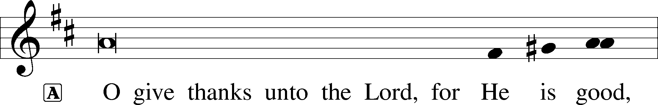

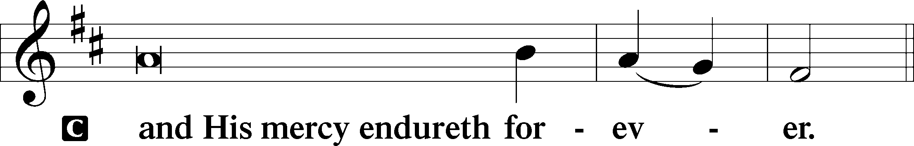

POST-COMMUNION COLLECT

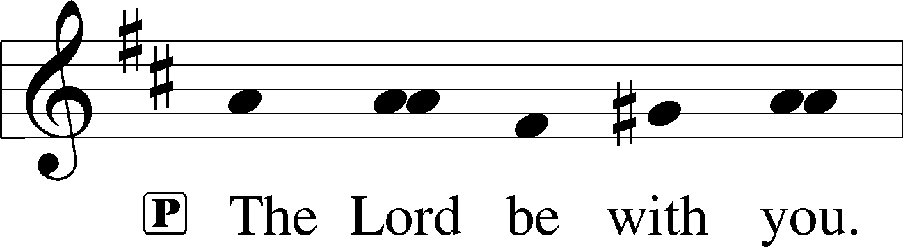

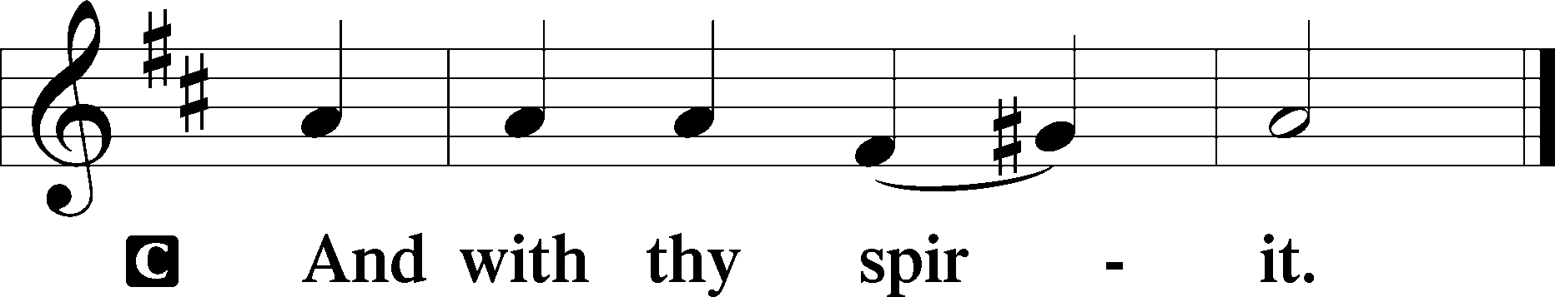

BENEDICAMUS LSB 202
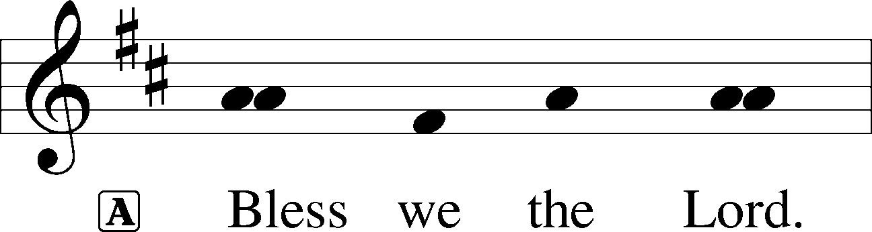

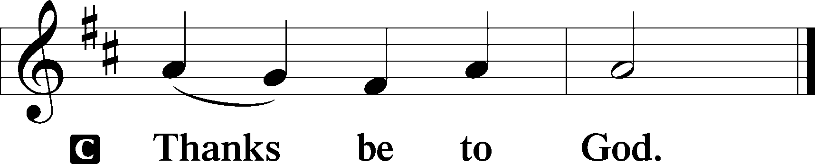

BENEDICTION LSB 202
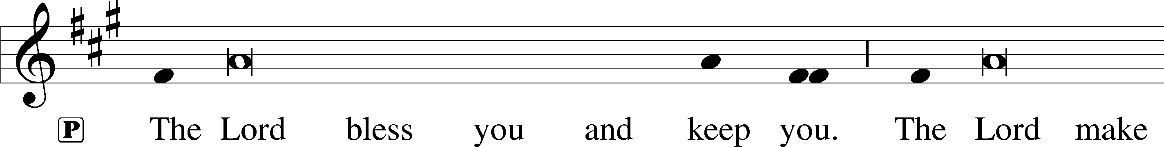
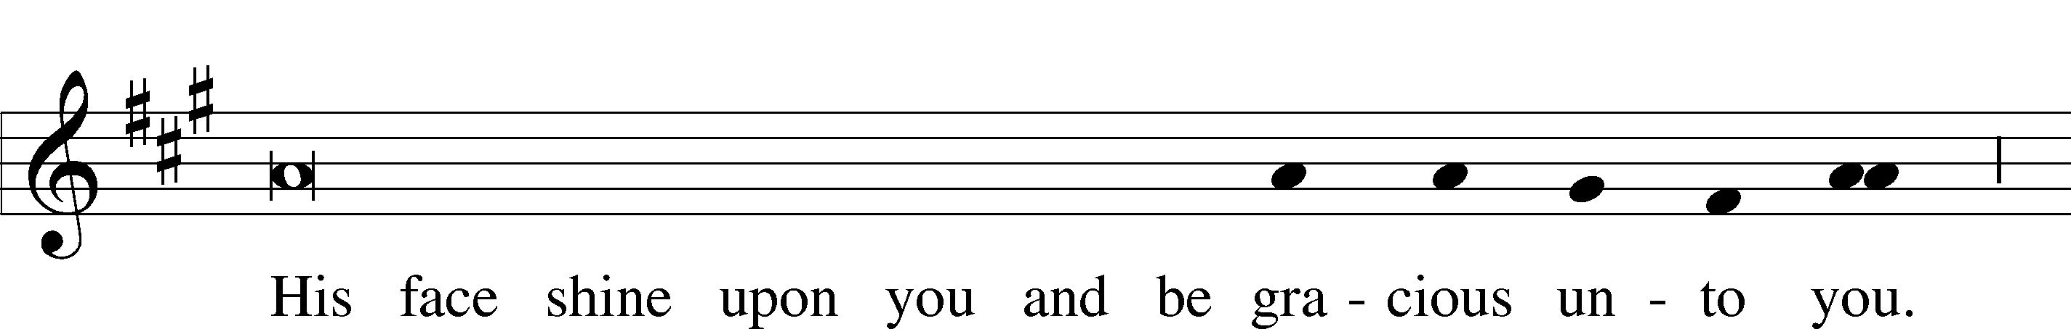
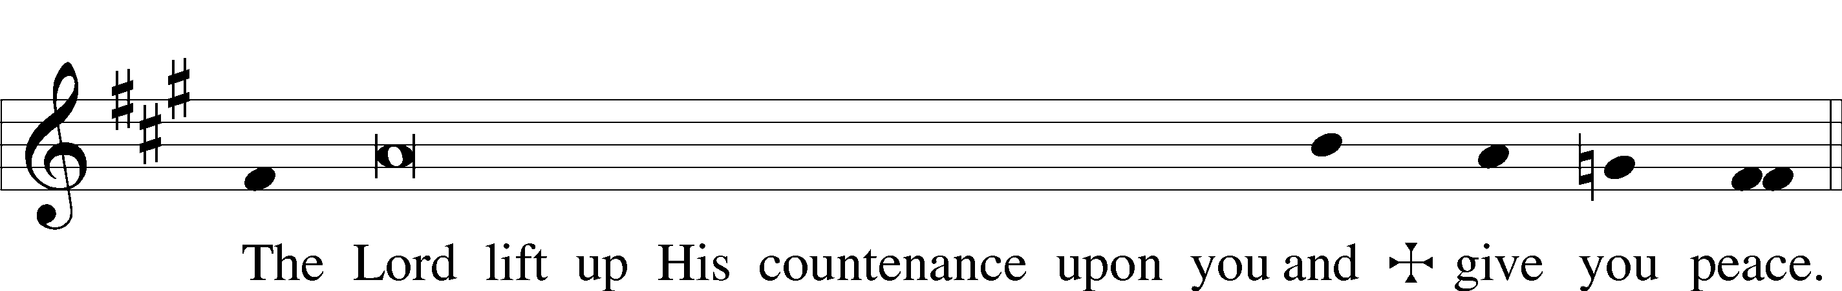

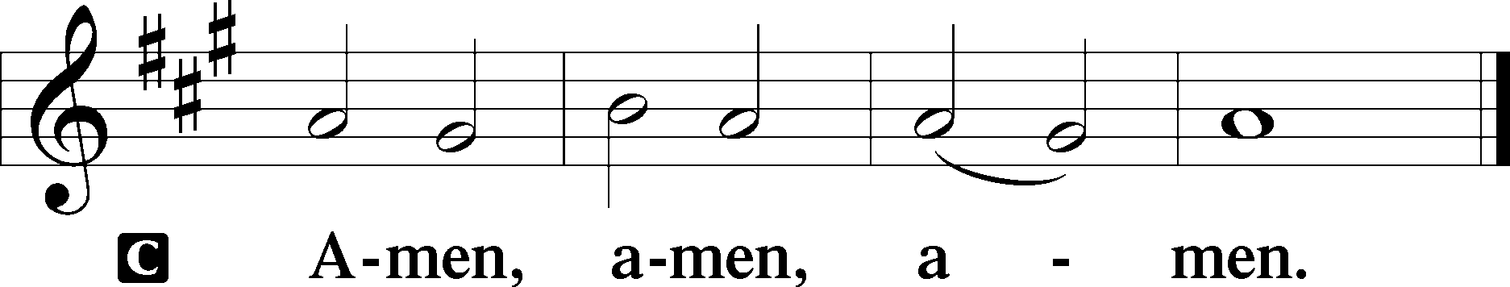

475 GOOD CHRISTIAN FRIENDS, REJOICE AND SING
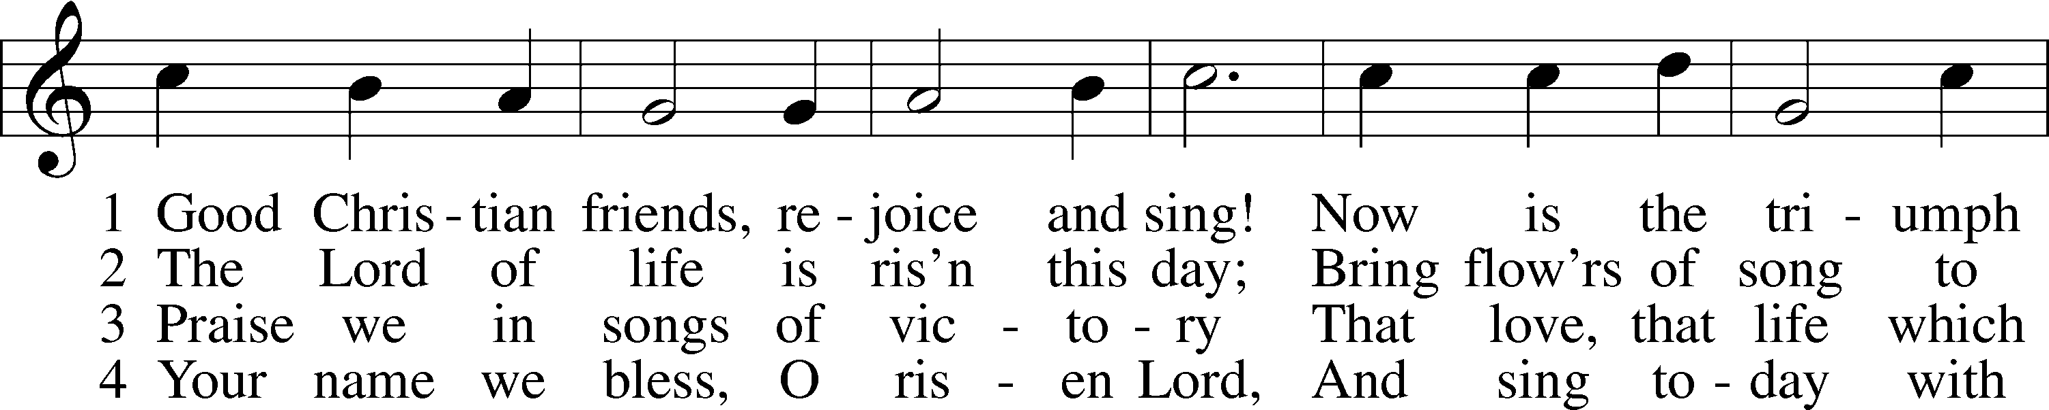
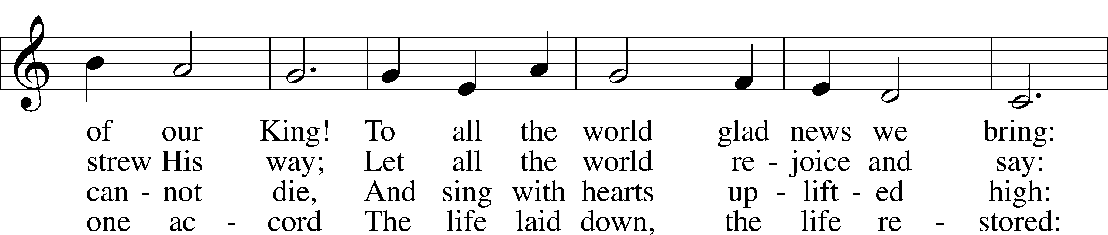
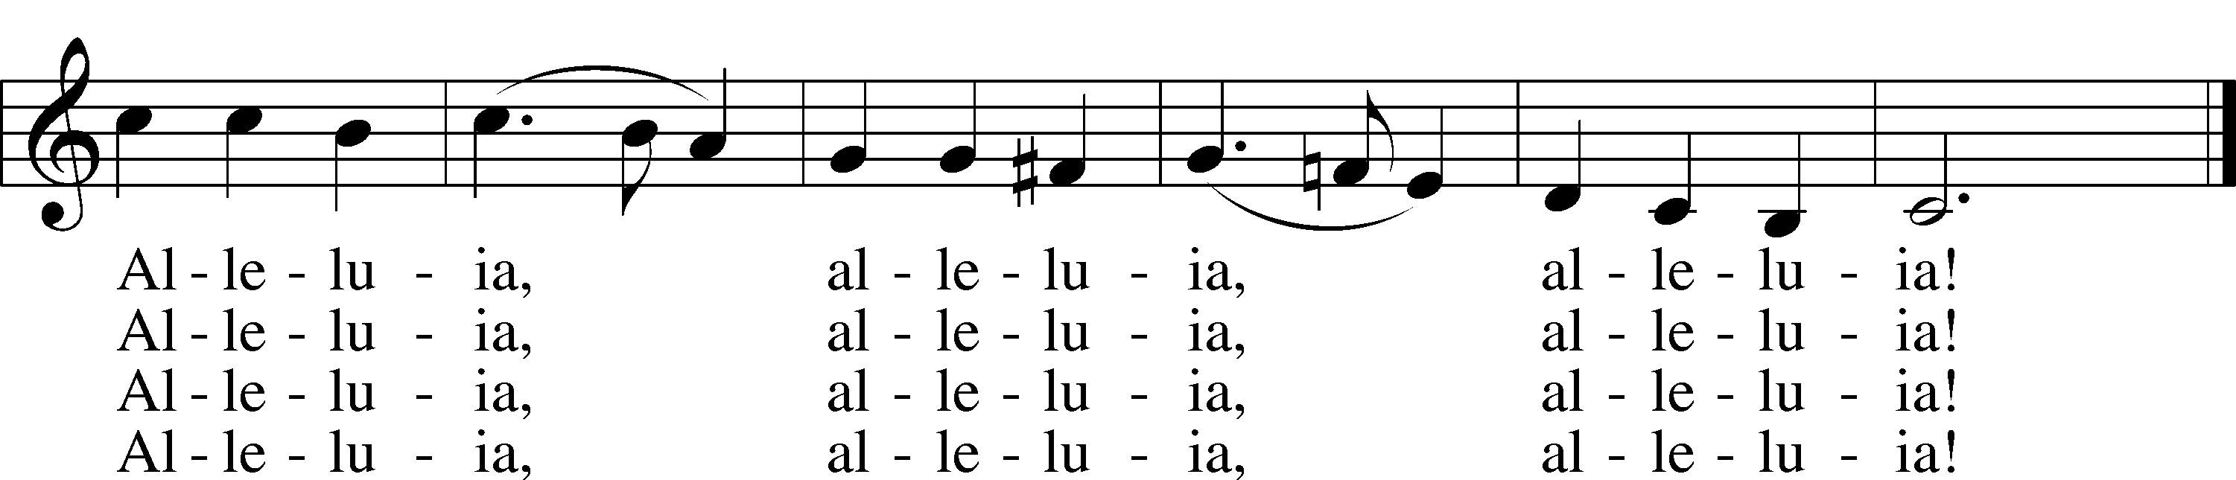
Text: Cyril A. Alington, 1872–1955, alt.
Tune: Melchior Vulpius, c. 1570–1615
Text: © 1958, renewed 1986 Hymns Ancient and Modern Ltd., admin. Hope Publishing Co. Used by permission: LSB Hymn License no. 110004798
Tune: Public domain

ACKNOWLEDGMENTS
Divine Service, Setting Three from Lutheran Service Book
Unless otherwise indicated, Scripture quotations are from the ESV® Bible (The Holy Bible, En
glish Standard Version®), copyright © 2001 by Crossway, a publishing ministry of Good News Publishers. Used by permission. All rights reserved.
Created by Lutheran Service Builder © 2026 Concordia Publishing House.

IN OUR PRAYERS:
Submitted petitions are included for two consecutive Sundays

For Those suffering afflictions of mind, body, or spirit:
Blake B., Carol R., Michele N., Dean S.,
Carl B., Joseph C. jr., Mark S., Dallas S.
All of our Shut- Ins:
Betty A., Shirley F., Mary H., Patsy L., Tommy M., Jerome M., Sharon B., Judy S.
For missionaries
Deaconess Sandra R., Rev. Jonathan A.

ANNOUNCEMENTS
Please email announcements for Sunday bulletins by 8:00 a.m. Tuesday to pastorblcaiken@gmail.com

ALTAR FLOWERS:
Flowers are donated today by Rebecca S.

ACTS DONATION FOR APRIL:
CEREAL

FELLOWSHIP COFFEE HOUR:
Every Sunday morning, during Bible Study and after the Divine Service, coffee, treats and good fellowship are waiting for you in our Fellowship Hall!
PASTOR ENGWALL’S LAST DAY AT BETHLEHEM:
Sunday, April 19th, is Pastor Engwall’s final service here.
A farewell potluck for Pastor and Teffie will be held in the Fellowship Hall after the service.
Pastor Engwall will be installed at Immanuel Lutheran Church, Sweet Springs, Missouri
at 4:00p.m. Central time (5:00p.m. Eastern time) on Sunday, May 3rd.

Attendance: Wednesday, March 25th: 34 Sunday, March 29th: 51

Offerings: Sunday: $3,814
Average weekly offering needed to make budget: $2,579

OUR VALUE STATEMENT: Bethlehem Lutheran Church exists under God’s grace to save the lost and to strengthen the saved so that they may live bold and courageous lives of Christian witness before a non-believing world.
Therefore, our purpose is:
- to glorify God in Word and deed,
- to nurture each other in Christian love,
- to reach out to others with our Savior’s Gospel of life and salvation.
(Rom 5:8, Matt. 28:18-20).

OUR VISION: By the Grace of God, Bethlehem Lutheran Church, is a loving family united in Christ, learning, living, and spreading His Word.

OUR MISSION: Learn the Word. Live the Word. Spread the Word.

2026 Easter Lilies
Bob and Eileen A. – 1 lily
Roger and Charlsie B. – 1 lily
Suzy E. – 3 lilies in memory of Sandy A. and Russell and Carole E.
Lana L. – 1 lily
Chuck and Joanne M. – 1 lily
John and Nancy M. – 1 lily for Blessings Received
Jack N. – 5 lilies in memory of Sharon
Juanita R. – 2 lilies in memory of her daughter, Shirley, and her son, John
Liz S. – 1 lily in memory of her mother, Pat C.
Angela S. – 1 lily in memory of Sam and Frances A. and Jennifer T.
Rebecca S. – 2 lilies in memory of her mother, Pat C., and her grandparents, Bigma & Papa
Kathy S. – 1 lily
Margie T. – 2 lilies in memory of Mike
Tom T. – 1 lily

