BETHLEHEM LUTHERAN CHURCH
A congregation of The Lutheran Church-Missouri Synod
902 Hitchcock Drive SW,
Aiken, South Carolina 29803
Church Phone: (803) 649-6417
blcaikensc@gmail.com

Bethlehem Lutheran welcomes our members and guests to our worship service! Unable to join us in person? Please find us on Facebook live. The service is also posted on our website; bethlehemlutheranaiken.org.

+ + + + + + + + + + + + + + +
Eighth Sunday after Pentecost
July 19, 2026
10:30 a.m.
+ + + + + + + + + + + + + + +

+ SERVICE OF PREPARATION +

(After the bell tolls, please observe a time of silence.)

WELCOME AND ANNOUNCEMENTS

(Stand)

575 MY HOPE IS BUILT ON NOTHING LESS
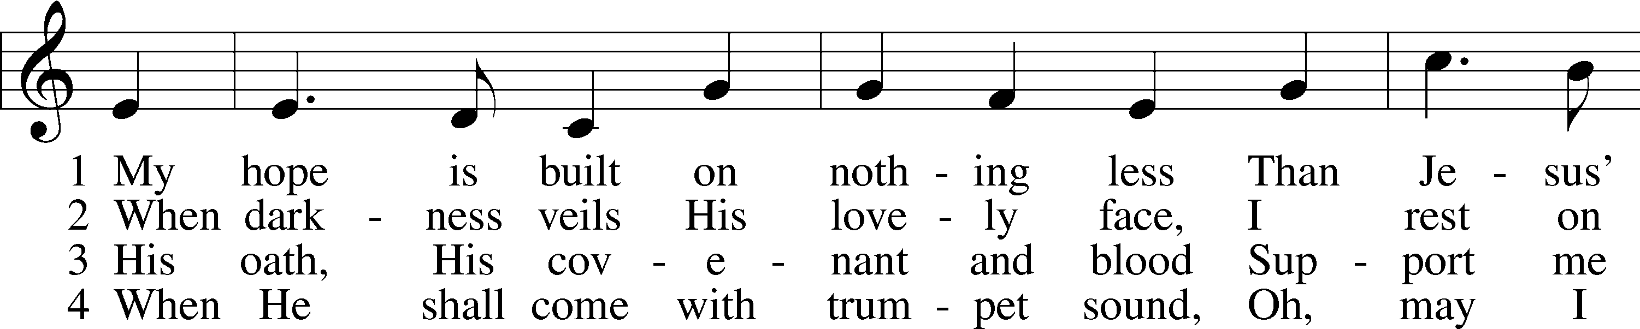
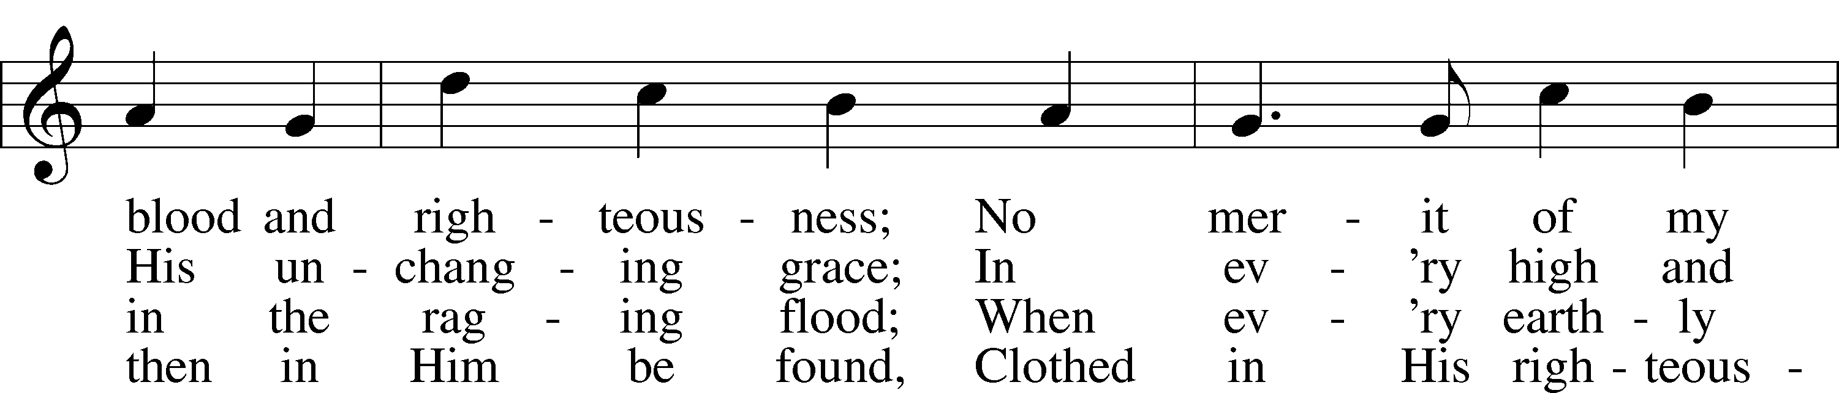
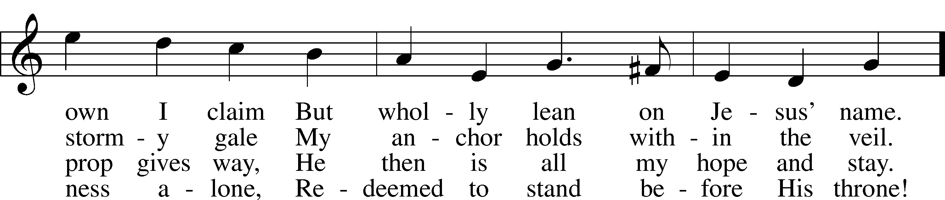
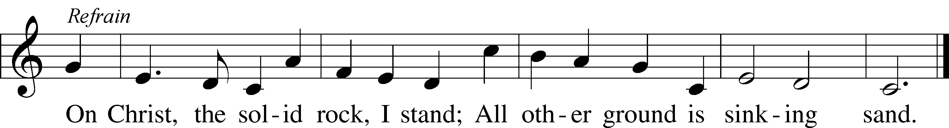
Text: Edward Mote, 1797–1874, alt.
Tune: John Stainer, 1840–1901
Text and tune: Public domain

+ CONFESSION AND ABSOLUTION +

(The sign of the cross may be made by all in remembrance of their Baptism.)

INVOCATION LSB 151
L In the name of the Father and of the T Son and of the Holy Spirit.
C Amen.

EXHORTATION LSB 151
L If we say we have no sin, we deceive ourselves, and the truth is not in us.
C But if we confess our sins, God, who is faithful and just, will forgive our sins and cleanse us from all unrighteousness.

(Silence for reflection on God’s Word and for self-examination.)

CONFESSION OF SINS LSB 151
L Let us then confess our sins to God our Father.
C Most merciful God, we confess that we are by nature sinful and unclean. We have sinned against You in thought, word, and deed, by what we have done and by what we have left undone. We have not loved You with our whole heart; we have not loved our neighbors as ourselves. We justly deserve Your present and eternal punishment. For the sake of Your Son, Jesus Christ, have mercy on us. Forgive us, renew us, and lead us, so that we may delight in Your will and walk in Your ways to the glory of Your holy name. Amen.

DECLARATION OF GRACE LSB 151
L In the mercy of almighty God, Jesus Christ was given to die for us, and for His sake God forgives us all our sins. To those who believe in Jesus Christ He gives the power to become the children of God and bestows on them the Holy Spirit. May the Lord, who has begun this good work in us, bring it to completion in the day of our Lord Jesus Christ.
C Amen.

+ SERVICE OF THE WORD +

INTROIT Psalm 86:11–15; antiphon: v. 6

Give ear, O Lord, | to my prayer;*
listen to my | plea for grace.
Teach me your way, O Lord, that I may walk | in your truth;*
unite my heart to | fear your name.
I give thanks to you, O Lord my God, with | my whole heart,*
and I will glorify your name for- | ever.
For great is your steadfast | love toward me;*
you have delivered my soul from the depths | of Sheol.
O God, insolent men have risen up against me; a band of ruthless men | seek my life,*
and they do not set you be- | fore them.
But you, O Lord, are a God merciful and | gracious,*
slow to anger and abounding in steadfast love and | faithfulness.
Glory be to the Father and | to the Son*
and to the Holy | Spirit;
as it was in the be- | ginning,*
is now, and will be forever. | Amen.
Give ear, O Lord, | to my prayer;*
listen to my | plea for grace.

KYRIE LSB 152

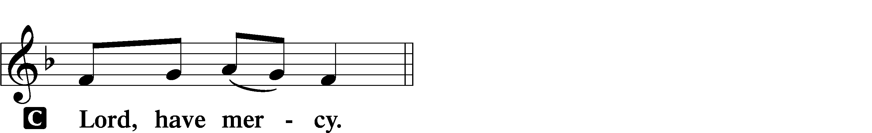

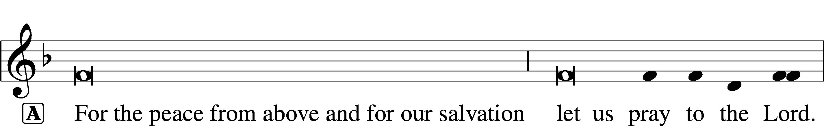

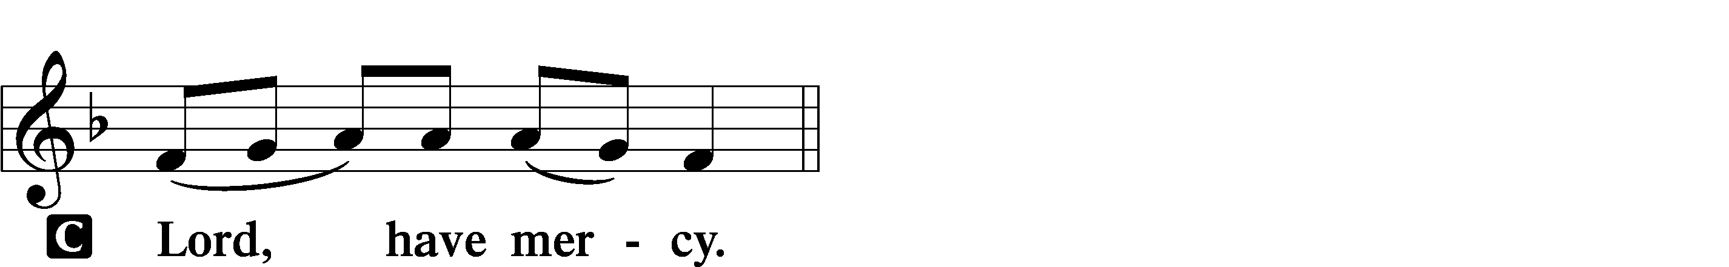

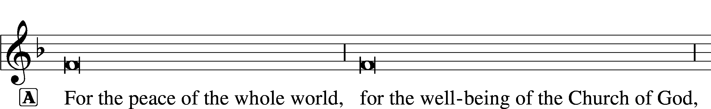
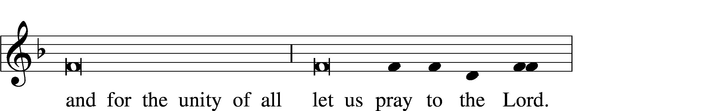
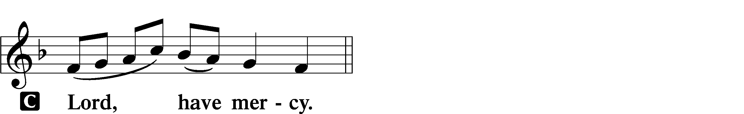

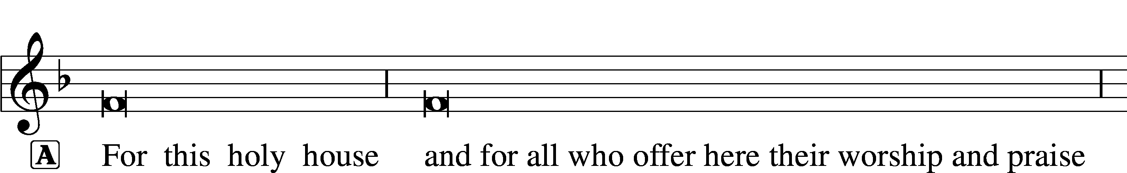

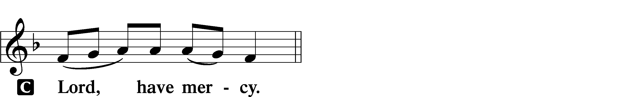

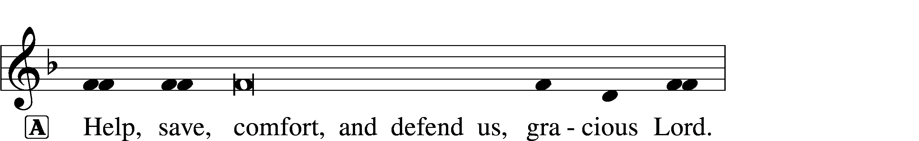


GLORIA IN EXCELSIS LSB 154
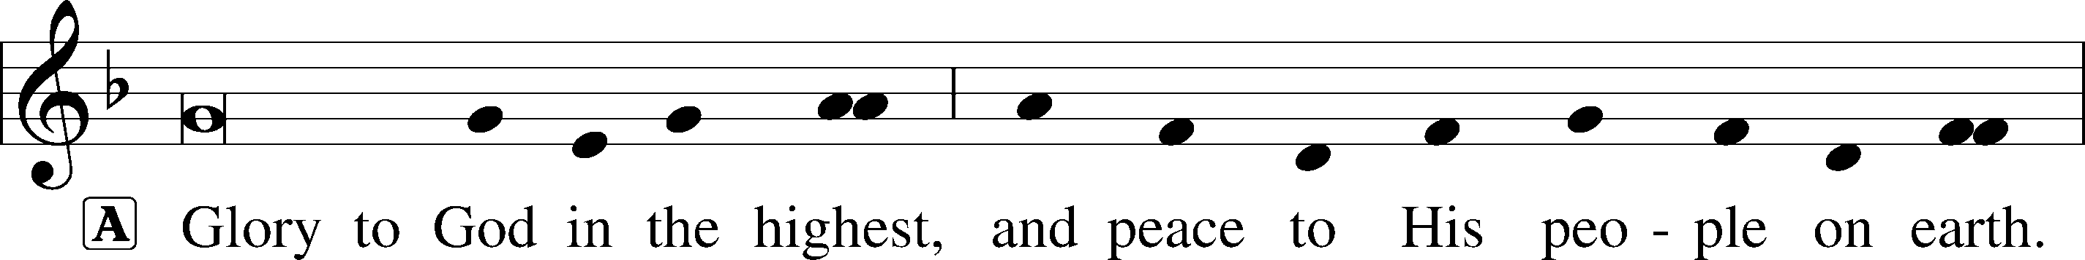
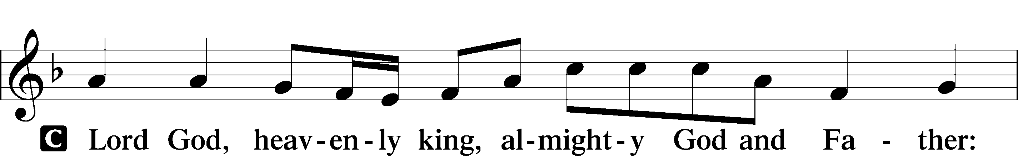
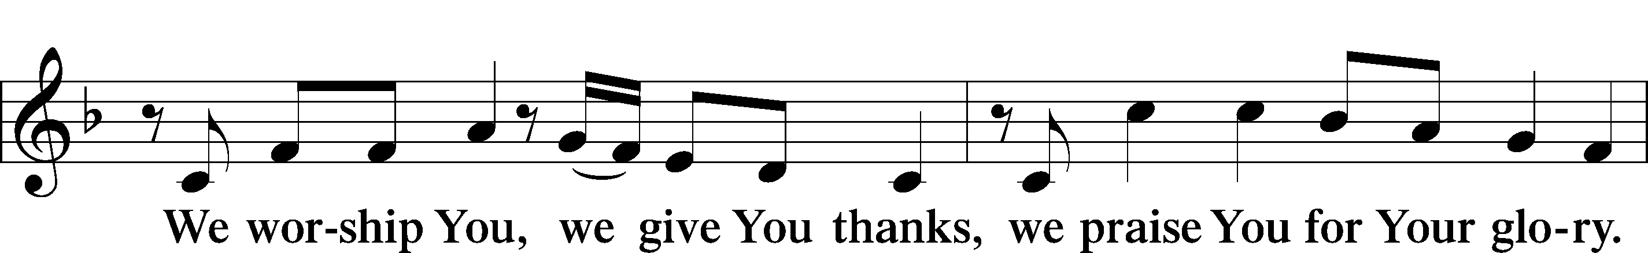
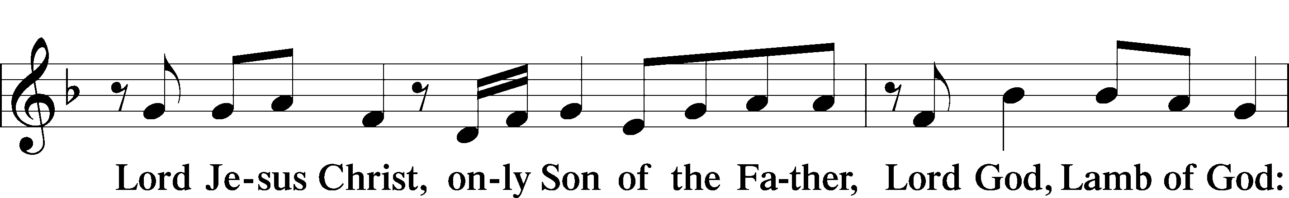
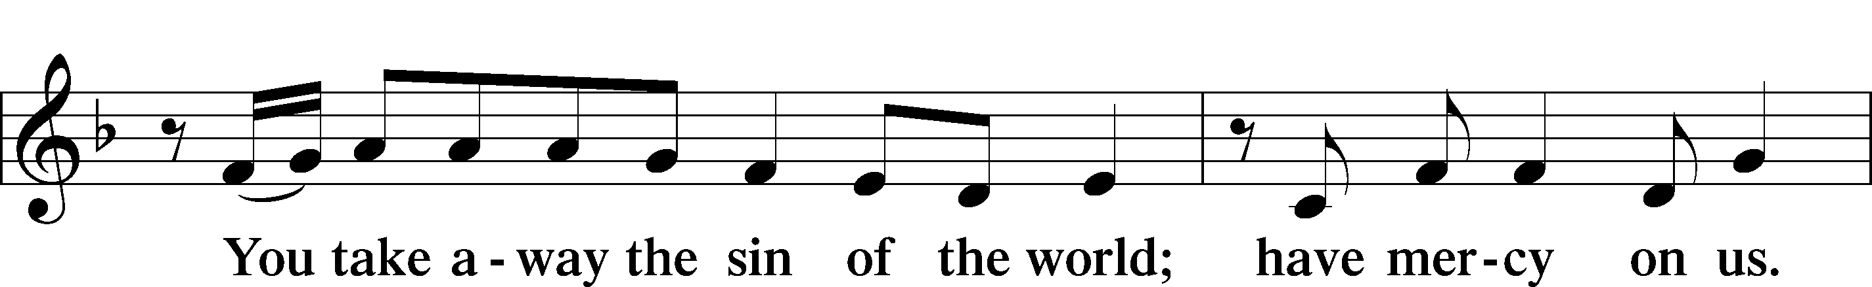
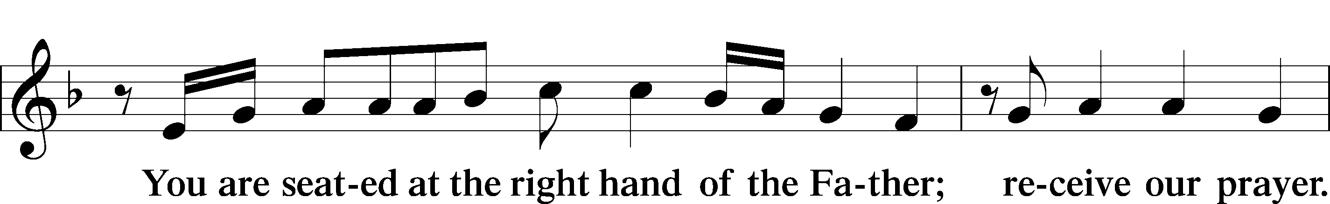
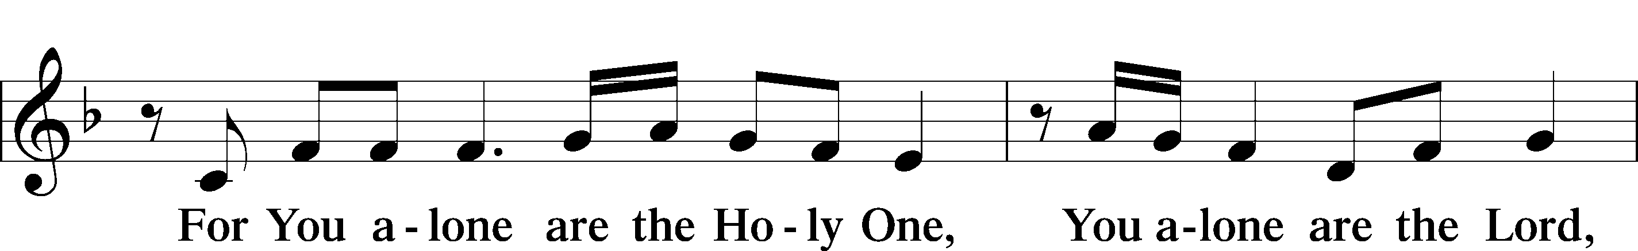
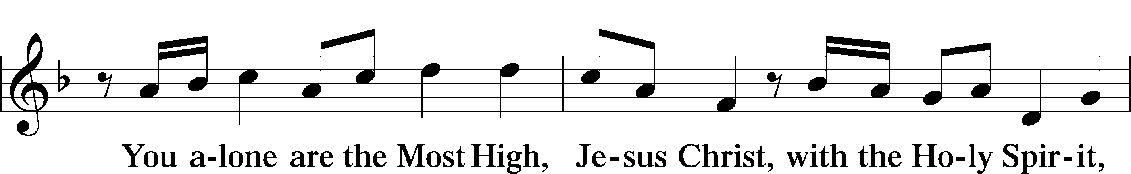
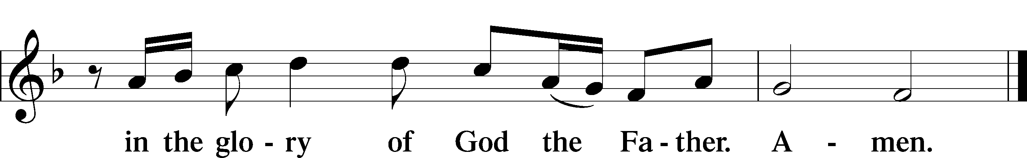

SALUTATION AND COLLECT OF THE DAY LSB 156
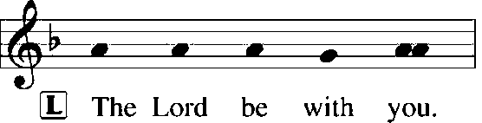
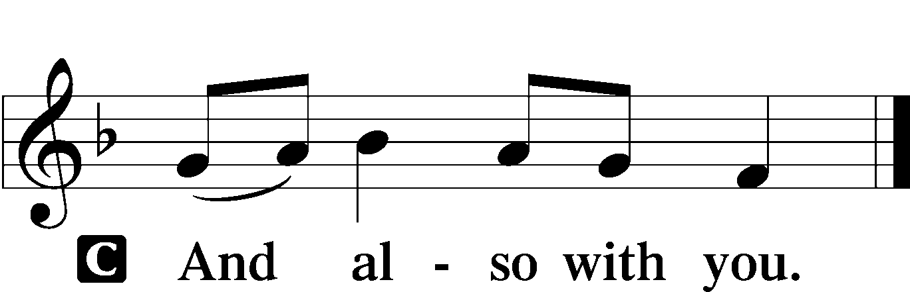

L Let us pray.
O God, so rule and govern our hearts and minds by Your Holy Spirit that, ever mindful of Your final judgment, we may be stirred up to holiness of living here and dwell with You in perfect joy hereafter; through Jesus Christ, Your Son, our Lord, who lives and reigns with You and the Holy Spirit, one God, now and forever.

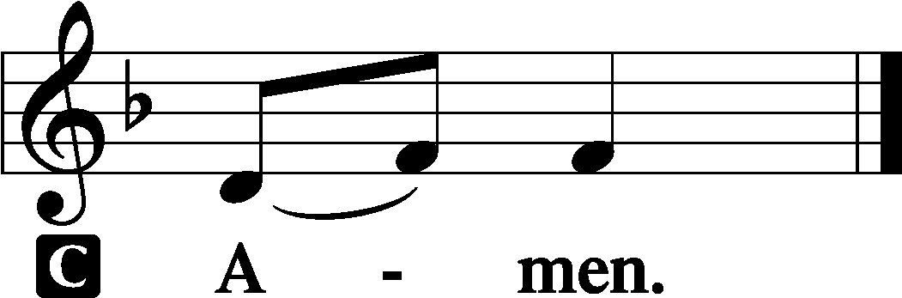

(Sit)

OLD TESTAMENT READING Isaiah 44:6–8
6Thus says the Lord, the King of Israel
and his Redeemer, the Lord of hosts:
“I am the first and I am the last;
besides me there is no god.
7Who is like me? Let him proclaim it.
Let him declare and set it before me,
since I appointed an ancient people.
Let them declare what is to come, and what will happen.
8Fear not, nor be afraid;
have I not told you from of old and declared it?
And you are my witnesses!
Is there a God besides me?
There is no Rock; I know not any.”

L This is the Word of the Lord.
C Thanks be to God.

GRADUAL Romans 11:33, 36
Oh, the depth of the riches and wisdom and knowl- | edge of God!*
How unsearchable are his judgments and how inscrutable | his ways!
For from him and through him and to him are | all things.*
To him be glory forever. | Amen.

EPISTLE Romans 8:18–27
18For I consider that the sufferings of this present time are not worth comparing with the glory that is to be revealed to us. 19For the creation waits with eager longing for the revealing of the sons of God. 20For the creation was subjected to futility, not willingly, but because of him who subjected it, in hope 21that the creation itself will be set free from its bondage to decay and obtain the freedom of the glory of the children of God. 22For we know that the whole creation has been groaning together in the pains of childbirth until now. 23And not only the creation, but we ourselves, who have the firstfruits of the Spirit, groan inwardly as we wait eagerly for adoption as sons, the redemption of our bodies. 24For in this hope we were saved. Now hope that is seen is not hope. For who hopes for what he sees? 25But if we hope for what we do not see, we wait for it with patience.
26Likewise the Spirit helps us in our weakness. For we do not know what to pray for as we ought, but the Spirit himself intercedes for us with groanings too deep for words. 27And he who searches hearts knows what is the mind of the Spirit, because the Spirit intercedes for the saints according to the will of God.

L This is the Word of the Lord.
C Thanks be to God.

(Stand)

ALLELUIA AND VERSE LSB 156
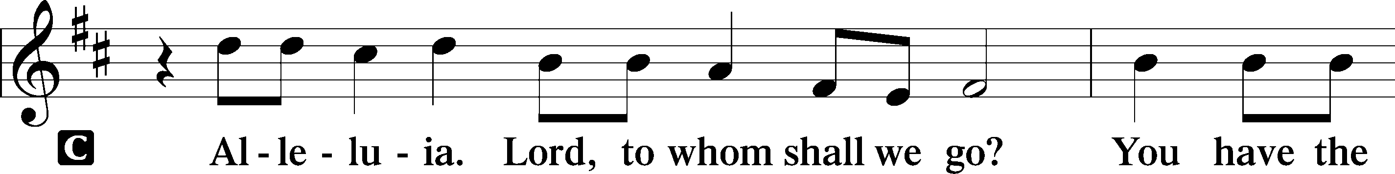
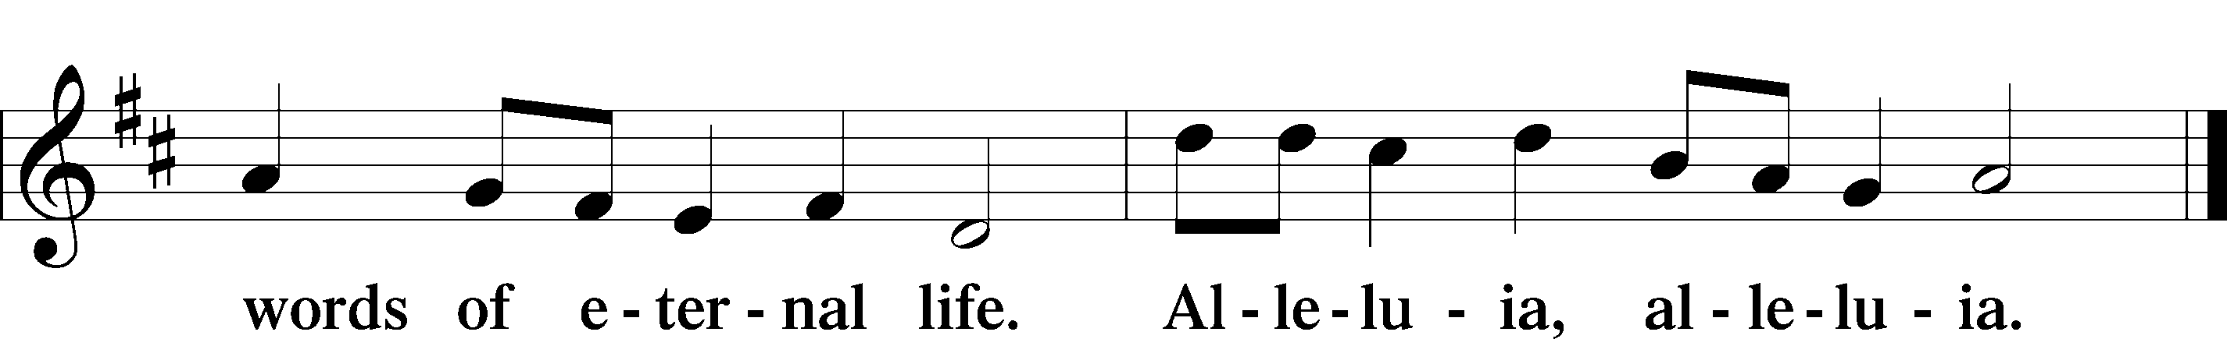

HOLY GOSPEL Matthew 13:24–30, 36–43
L The Holy Gospel according to St. Matthew, the thirteenth chapter.

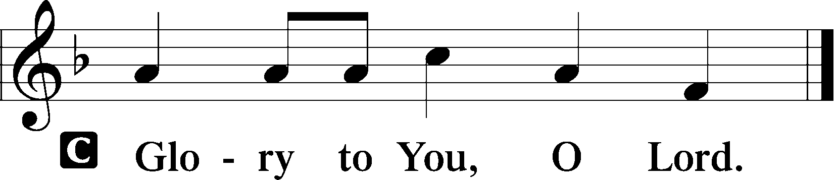

24[Jesus] put another parable before them, saying, “The kingdom of heaven may be compared to a man who sowed good seed in his field, 25but while his men were sleeping, his enemy came and sowed weeds among the wheat and went away. 26So when the plants came up and bore grain, then the weeds appeared also. 27And the servants of the master of the house came and said to him, ‘Master, did you not sow good seed in your field? How then does it have weeds?’ 28He said to them, ‘An enemy has done this.’ So the servants said to him, ‘Then do you want us to go and gather them?’ 29But he said, ‘No, lest in gathering the weeds you root up the wheat along with them. 30Let both grow together until the harvest, and at harvest time I will tell the reapers, Gather the weeds first and bind them in bundles to be burned, but gather the wheat into my barn.’” . . .
36Then he left the crowds and went into the house. And his disciples came to him, saying, “Explain to us the parable of the weeds of the field.” 37He answered, “The one who sows the good seed is the Son of Man. 38The field is the world, and the good seed is the children of the kingdom. The weeds are the sons of the evil one, 39and the enemy who sowed them is the devil. The harvest is the close of the age, and the reapers are angels. 40Just as the weeds are gathered and burned with fire, so will it be at the close of the age. 41The Son of Man will send his angels, and they will gather out of his kingdom all causes of sin and all law-breakers, 42and throw them into the fiery furnace. In that place there will be weeping and gnashing of teeth. 43Then the righteous will shine like the sun in the kingdom of their Father. He who has ears, let him hear.”

L This is the Gospel of the Lord.

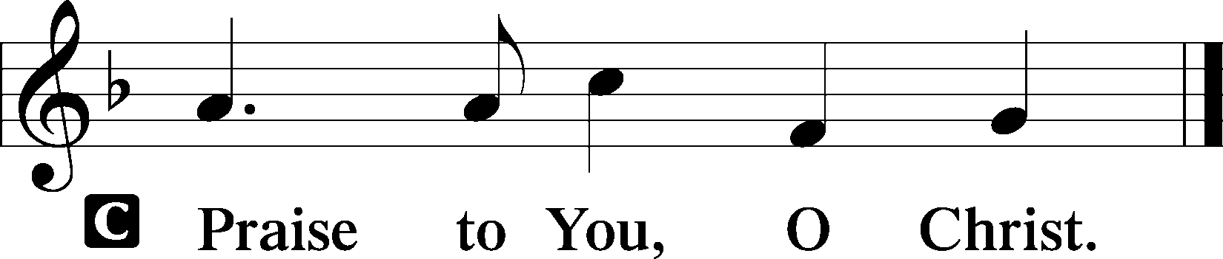

(Sit)

652 FATHER, WE THANK THEE
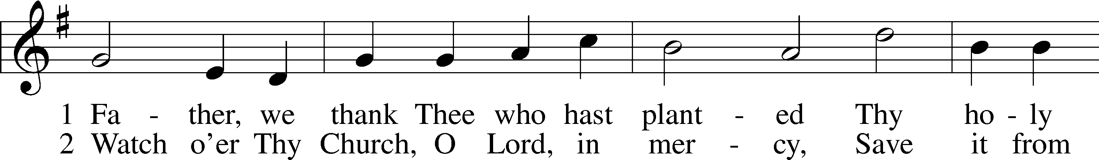
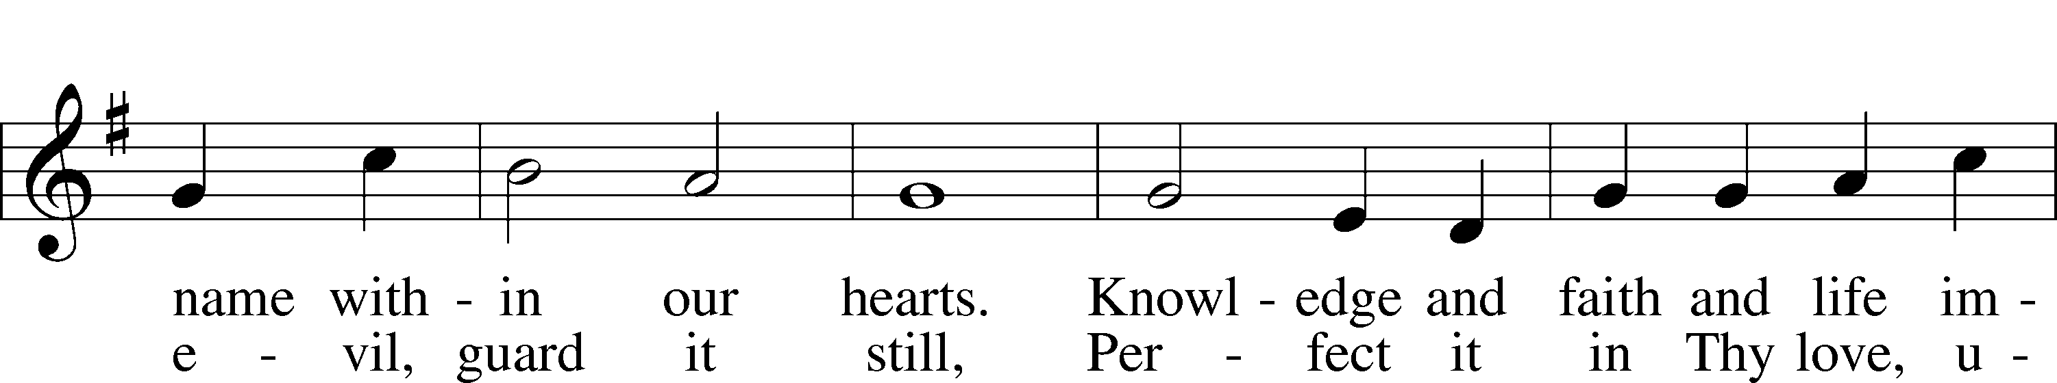
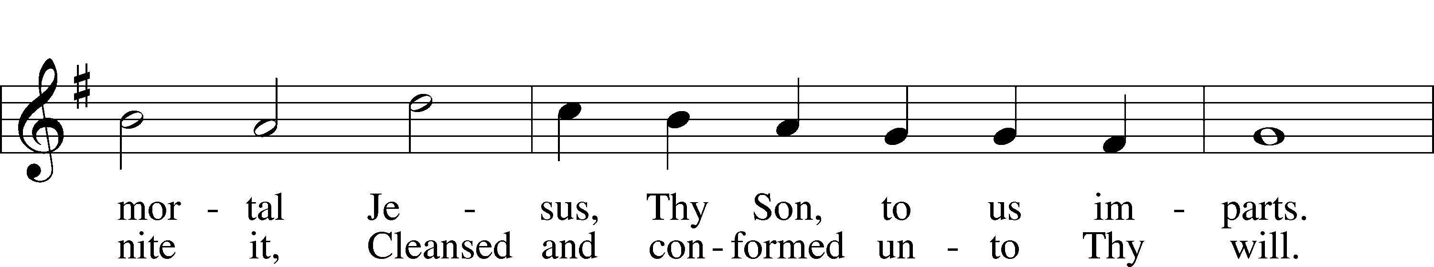
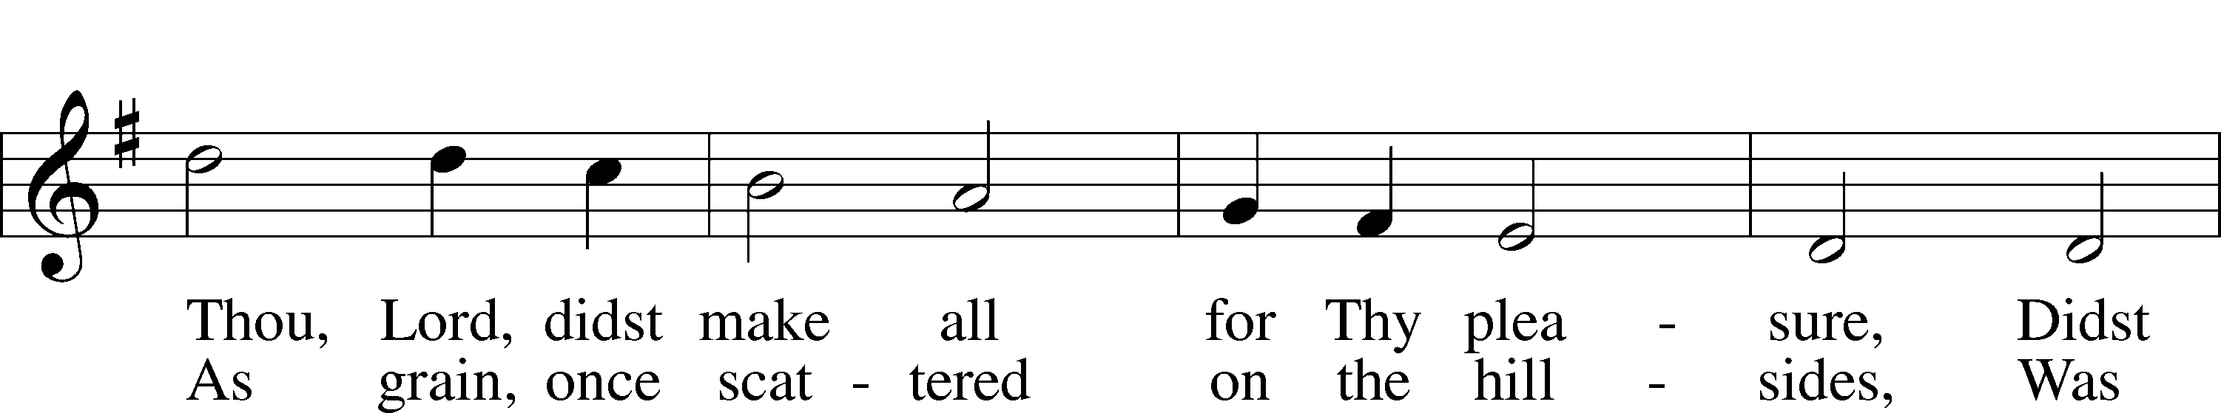
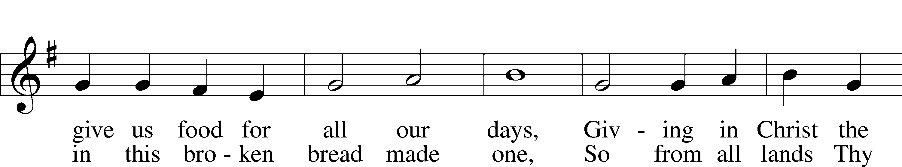
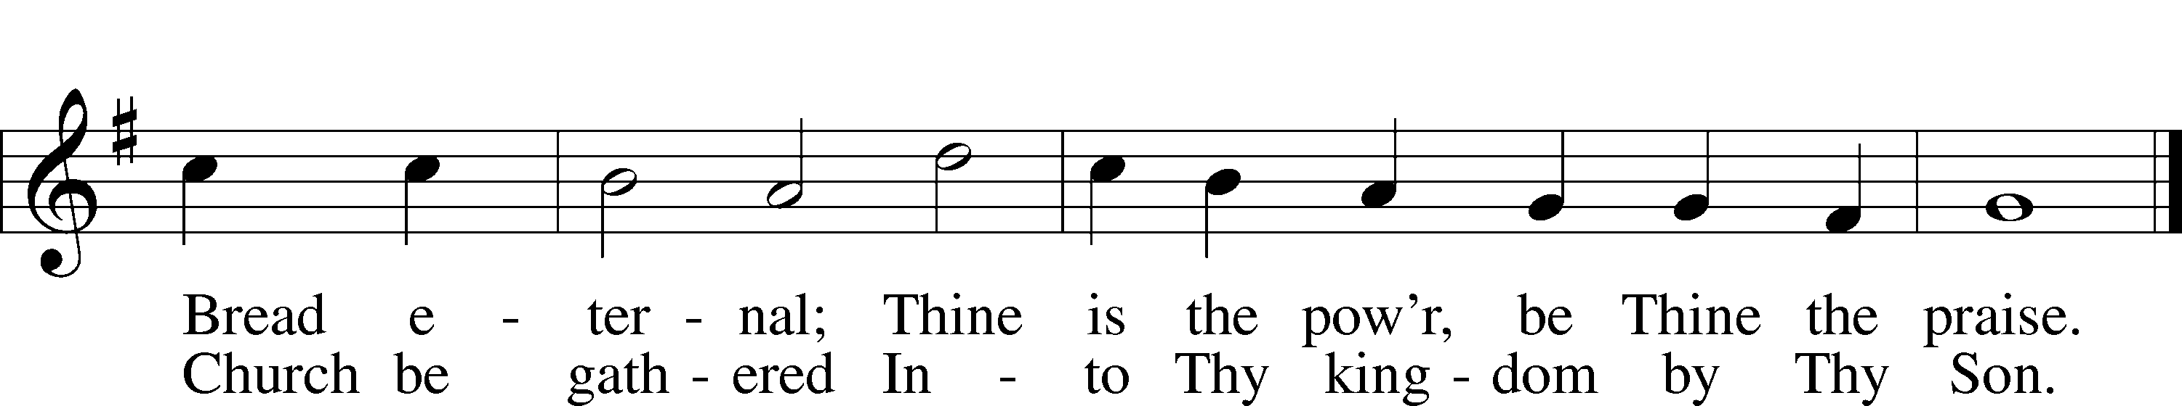
Text: Didache, 2nd cent.; tr. F. Bland Tucker, 1895–1984
Tune: attr. Louis Bourgeois, c. 1510–61
Text: © The Church Pension Fund. Used by permission: LSB Hymn License no. 110004798
Tune: Public domain

SERMON

(Sermons for Elder led services are provided courtesy of the Lutheran Church - Canada (https://www.lutheranchurchcanada.ca/resources/written-sermons/), a member of the International Lutheran Council (https://ilcouncil.org/) with whom the Lutheran Church - Missouri Synod (https://www.lcms.org/) is in altar and pulpit fellowship.)

(Stand)

NICENE CREED LSB 158
C I believe in one God,
the Father Almighty,
maker of heaven and earth
and of all things visible and invisible.

And in one Lord Jesus Christ,
the only-begotten Son of God,
begotten of His Father before all worlds,
God of God, Light of Light,
very God of very God,
begotten, not made,
being of one substance with the Father,
by whom all things were made;
who for us men and for our salvation came down from heaven
and was incarnate by the Holy Spirit of the virgin Mary
and was made man;
and was crucified also for us under Pontius Pilate.
He suffered and was buried.
And the third day He rose again according to the Scriptures
and ascended into heaven
and sits at the right hand of the Father.
And He will come again with glory to judge both the living and the dead,
whose kingdom will have no end.

And I believe in the Holy Spirit,
the Lord and giver of life,
who proceeds from the Father and the Son,
who with the Father and the Son together is worshiped and glorified,
who spoke by the prophets.
And I believe in one holy Christian and apostolic Church,
I acknowledge one Baptism for the remission of sins,
and I look for the resurrection of the dead
and the life T of the world to come. Amen.

SHARING OF THE PEACE

(The people may greet one another in the name of the Lord, saying, “Peace be with you,” as a sign of reconciliation and of the unity of the Spirit in the bond of peace (Matt. 5:22–24; Eph. 4:1–3).)

(Sit)

PRAYER OF THE CHURCH

OFFERING

(As a part of our expression of thanksgiving to God for the treasure of His salvation to us, we offer a portion of our treasure, according to what each has determined in their heart to give. Please place offerings in the collection plate at the back of the sanctuary before or after the service. Offerings can also be sent to Bethlehem Lutheran Church via U.S. Mail. Thank you!)

(Stand)

OFFERTORY LSB 159
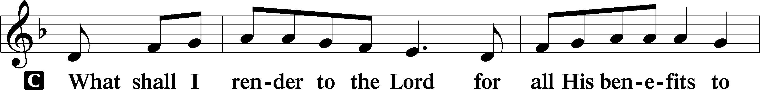
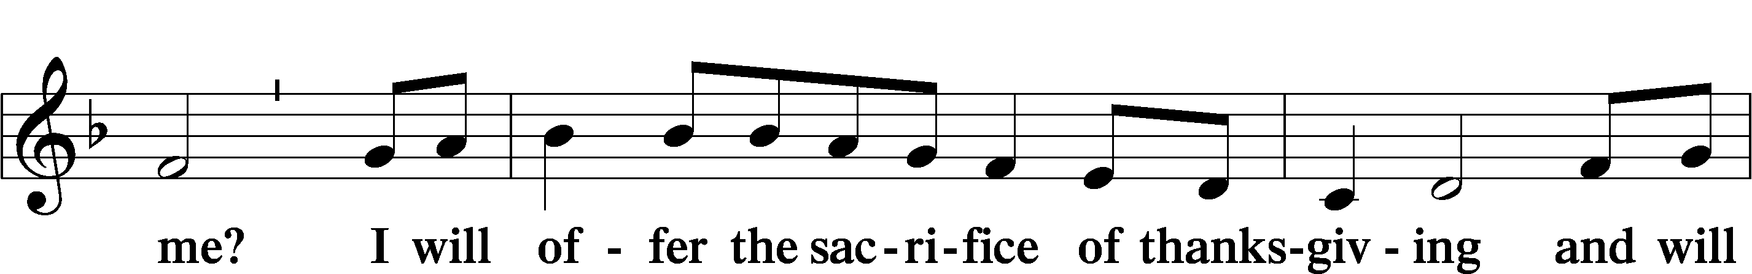
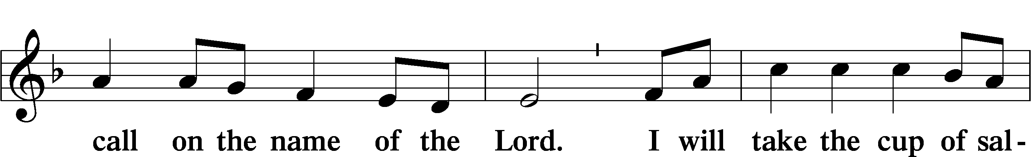
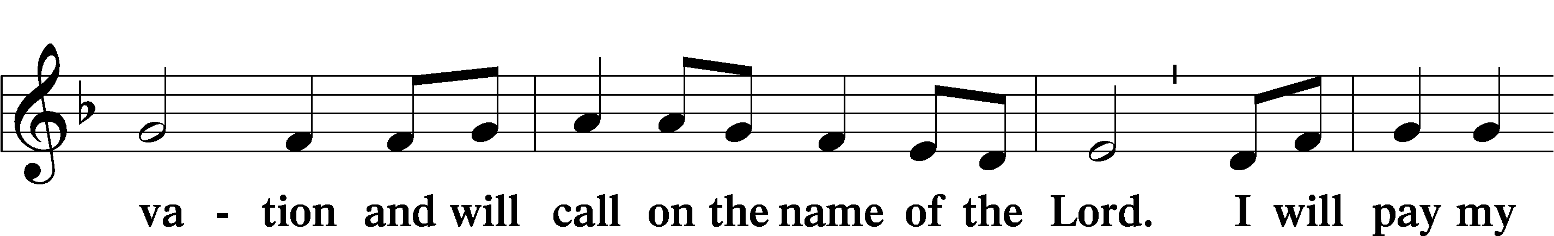
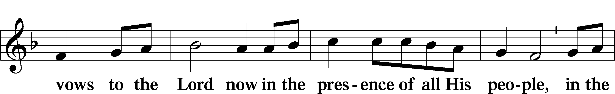
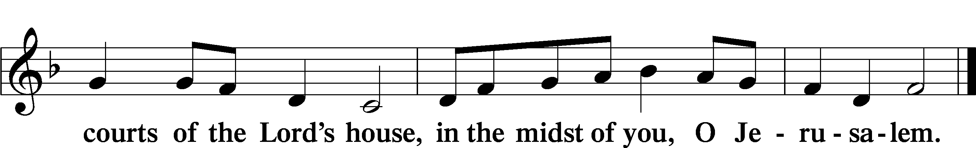

LORD’S PRAYER LSB 162
L Lord, remember us in Your kingdom and teach us to pray:
C Our Father who art in heaven,
hallowed be Thy name,
Thy kingdom come,
Thy will be done on earth
as it is in heaven;
give us this day our daily bread;
and forgive us our trespasses
as we forgive those
who trespass against us;
and lead us not into temptation,
but deliver us from evil.
For Thine is the kingdom
and the power and the glory
forever and ever. Amen.

CONCLUDING COLLECT

BENEDICTION LSB 166
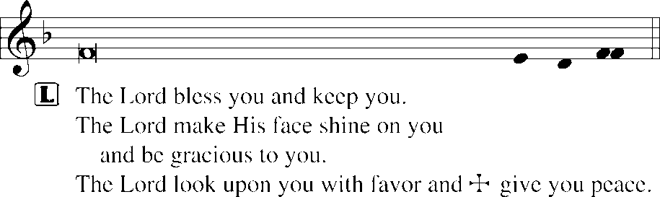


700 LOVE DIVINE, ALL LOVES EXCELLING
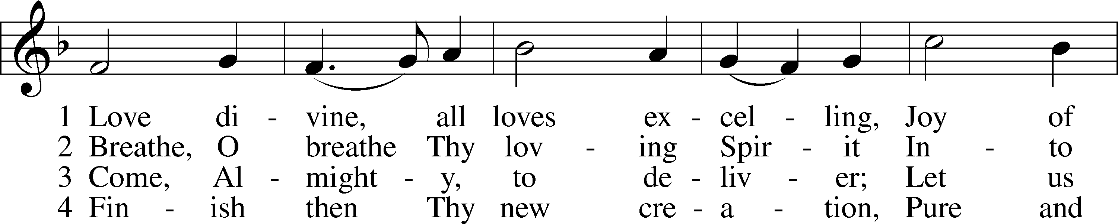
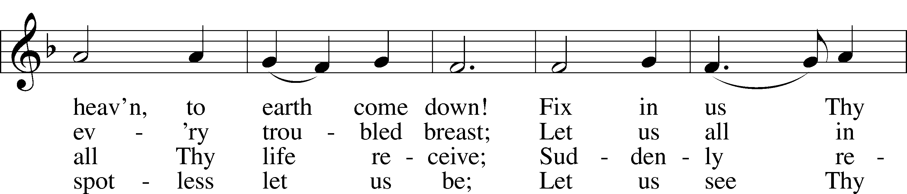
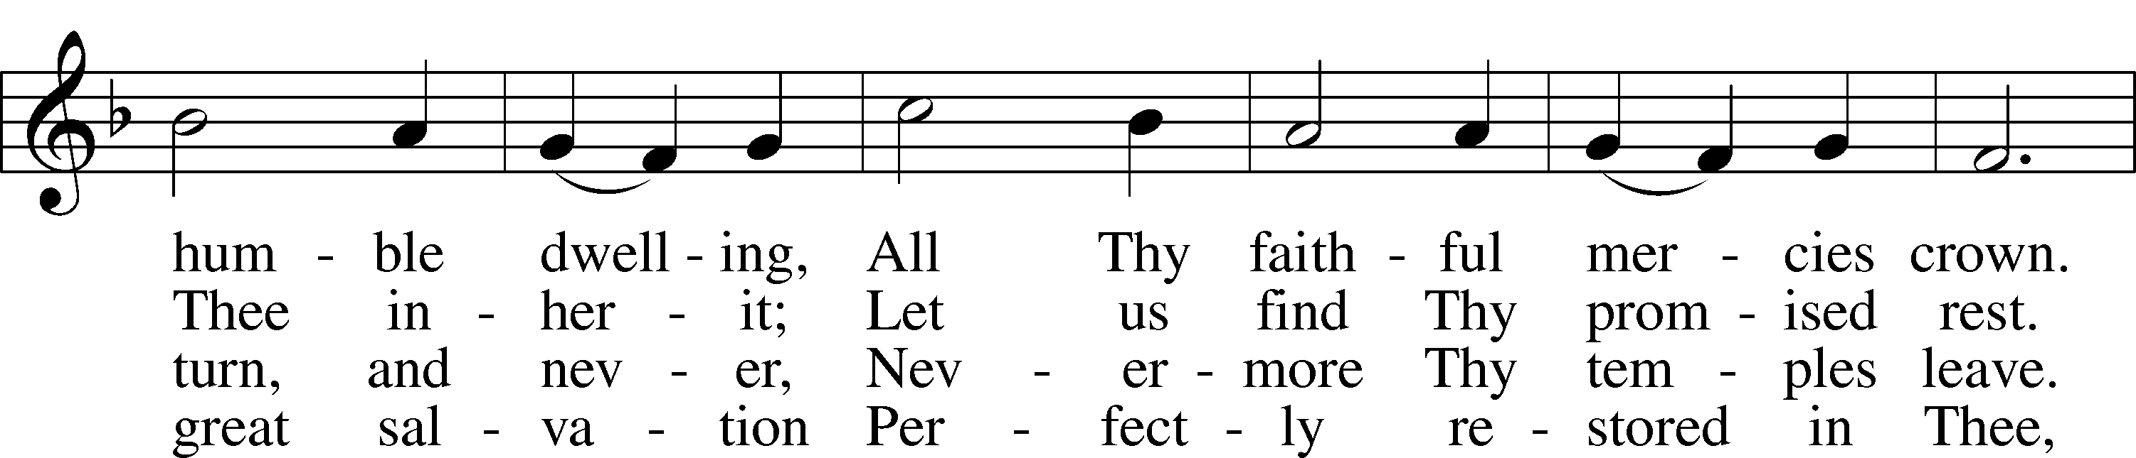
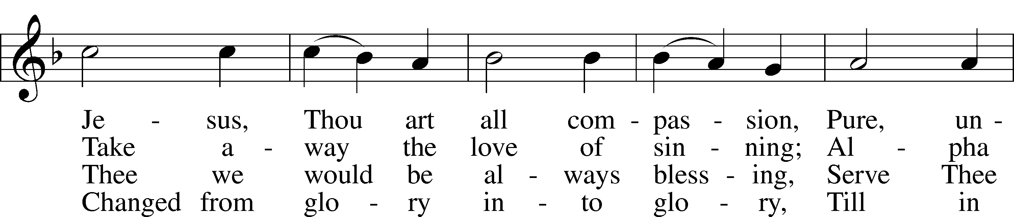
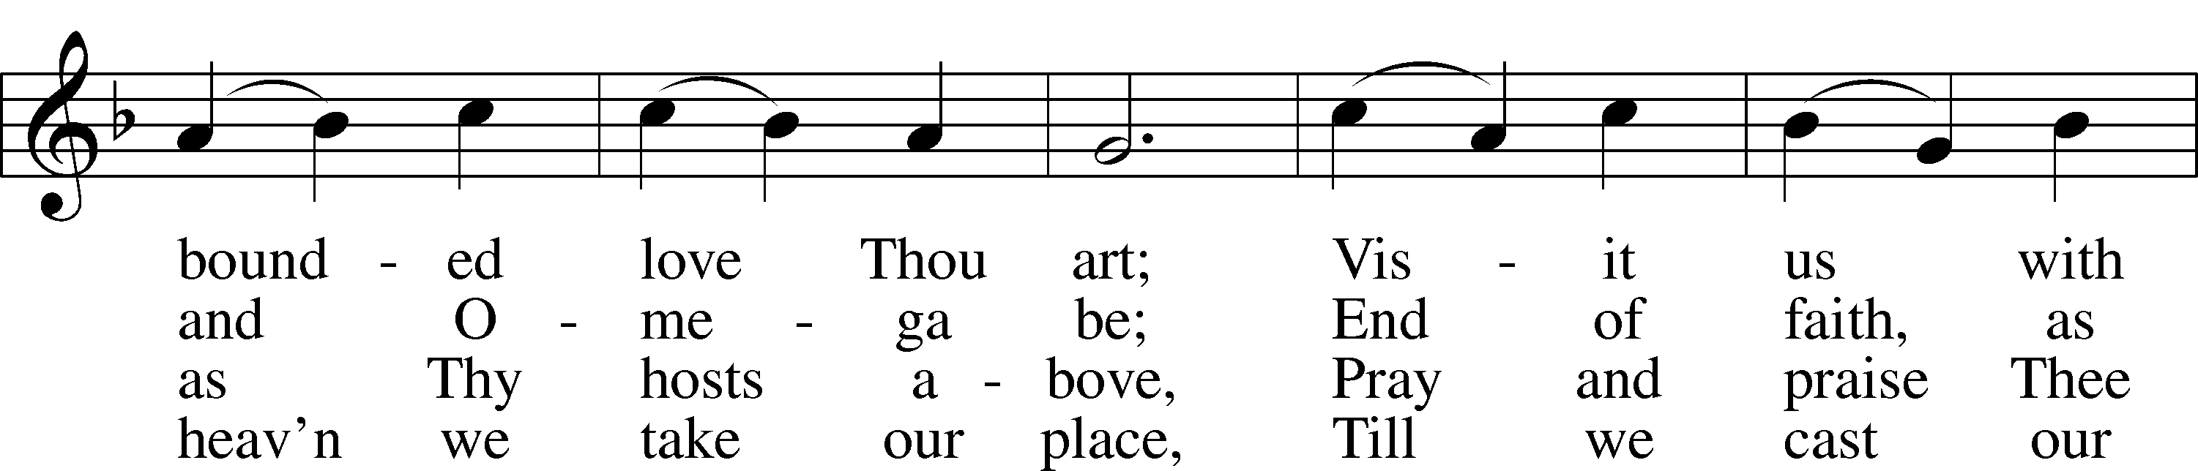
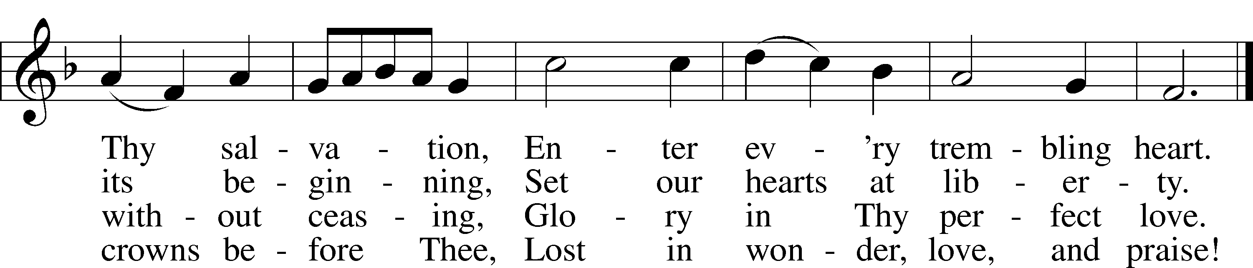
Text: Charles Wesley, 1707–88
Tune: Rowland H. Prichard, 1811–87
Text and tune: Public domain
ACKNOWLEDGMENTS
Unless otherwise indicated, Scripture quotations are from the ESV® Bible (The Holy Bible, English Standard Version®), copyright © 2001 by Crossway, a publishing ministry of Good News Publishers. Used by permission. All rights reserved.
Created by Lutheran Service Builder © 2026 Concordia Publishing House.

