BETHLEHEM LUTHERAN CHURCH
A congregation of The Lutheran Church-Missouri Synod
902 Hitchcock Drive SW,
Aiken, South Carolina 29803
Church Phone: (803) 649-6417
blcaikensc@gmail.com

Bethlehem Lutheran welcomes our members and guests to our worship service! Unable to join us in person? Please find us on Facebook live. The service is also posted on our website; bethlehemlutheranaiken.org.

+ + + + + + + + + + + + + + +
Seventh Sunday after Pentecost
July 12, 2026
10:30 a.m.
+ + + + + + + + + + + + + + +

+ SERVICE OF PREPARATION +

(After the bell tolls, please observe a time of silence.)

WELCOME AND ANNOUNCEMENTS

(Stand)

893 SING TO THE LORD OF HARVEST
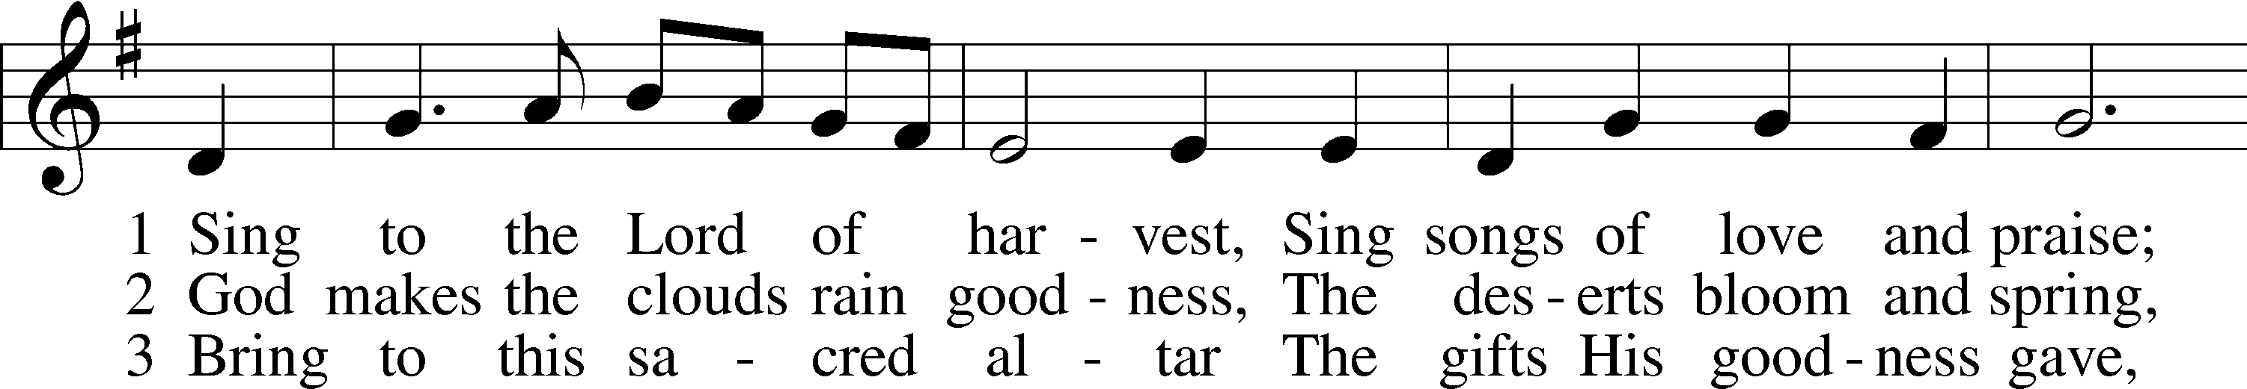
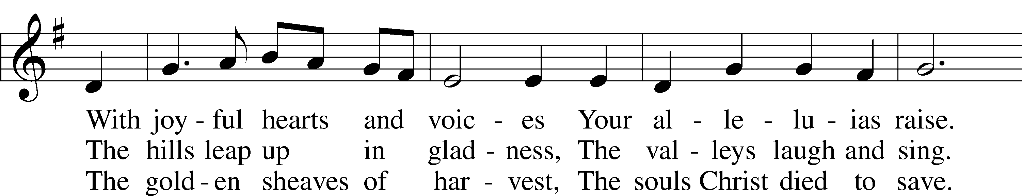
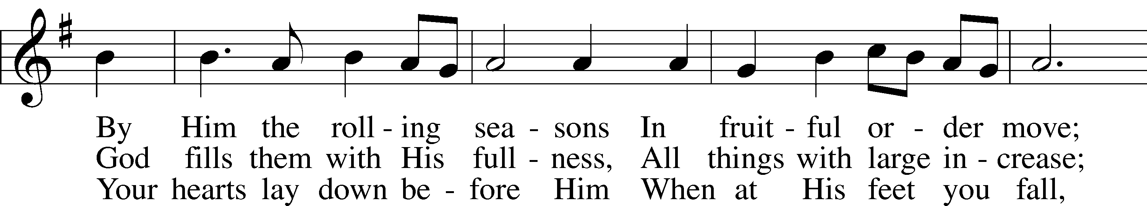
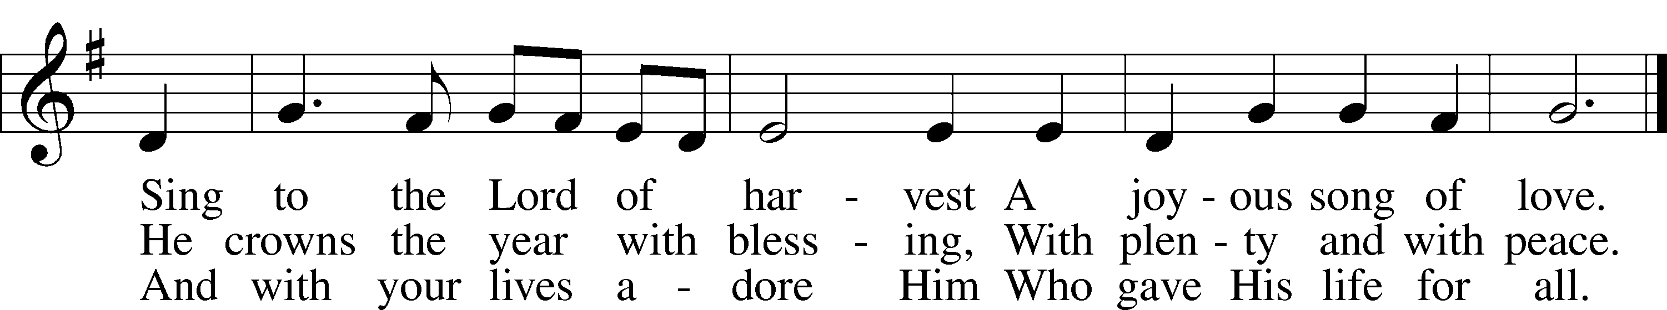
Text: John S. B. Monsell, 1811–75, alt.
Tune: Johann Steurlein, 1546–1613
Text and tune: Public domain

+ CONFESSION AND ABSOLUTION +

(The sign of the cross may be made by all in remembrance of their Baptism.)

INVOCATION LSB 151
L In the name of the Father and of the T Son and of the Holy Spirit.
C Amen.

EXHORTATION LSB 151
L If we say we have no sin, we deceive ourselves, and the truth is not in us.
C But if we confess our sins, God, who is faithful and just, will forgive our sins and cleanse us from all unrighteousness.

(Silence for reflection on God’s Word and for self-examination.)

CONFESSION OF SINS LSB 151
L Let us then confess our sins to God our Father.
C Most merciful God, we confess that we are by nature sinful and unclean. We have sinned against You in thought, word, and deed, by what we have done and by what we have left undone. We have not loved You with our whole heart; we have not loved our neighbors as ourselves. We justly deserve Your present and eternal punishment. For the sake of Your Son, Jesus Christ, have mercy on us. Forgive us, renew us, and lead us, so that we may delight in Your will and walk in Your ways to the glory of Your holy name. Amen.

DECLARATION OF GRACE LSB 151
L In the mercy of almighty God, Jesus Christ was given to die for us, and for His sake God forgives us all our sins. To those who believe in Jesus Christ He gives the power to become the children of God and bestows on them the Holy Spirit. May the Lord, who has begun this good work in us, bring it to completion in the day of our Lord Jesus Christ.
C Amen.

+ SERVICE OF THE WORD +

INTROIT Psalm 103:15–19; antiphon: v. 8

The Lord is merciful and | gracious,*
slow to anger and abounding in | steadfast love.
As for man, his days | are like grass;*
he flourishes like a flower | of the field;
for the wind passes over it, and | it is gone,*
and its place knows | it no more.
But the steadfast love of the Lord is from everlasting to everlasting on those who | fear him,*
and his righteousness to children’s | children,
to those who keep his | covenant*
and remember to do his com- | mandments.
The Lord has established his throne in the | heavens,*
and his kingdom rules | over all.
Glory be to the Father and | to the Son*
and to the Holy | Spirit;
as it was in the be- | ginning,*
is now, and will be forever. | Amen.
The Lord is merciful and | gracious,*
slow to anger and abounding in | steadfast love.

KYRIE LSB 152
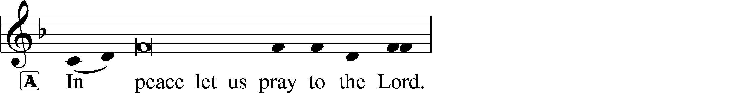
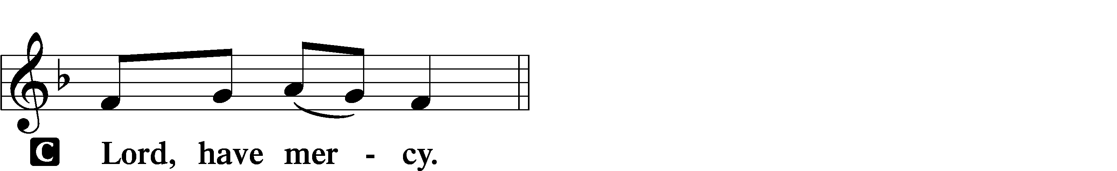

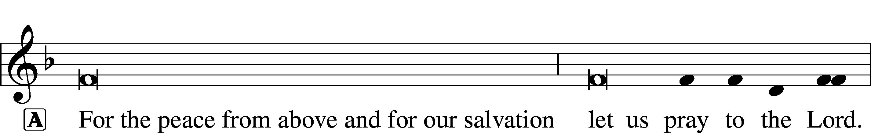

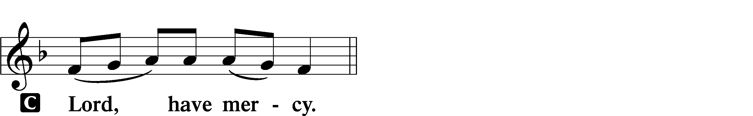

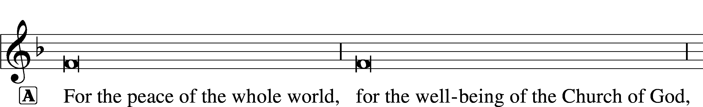
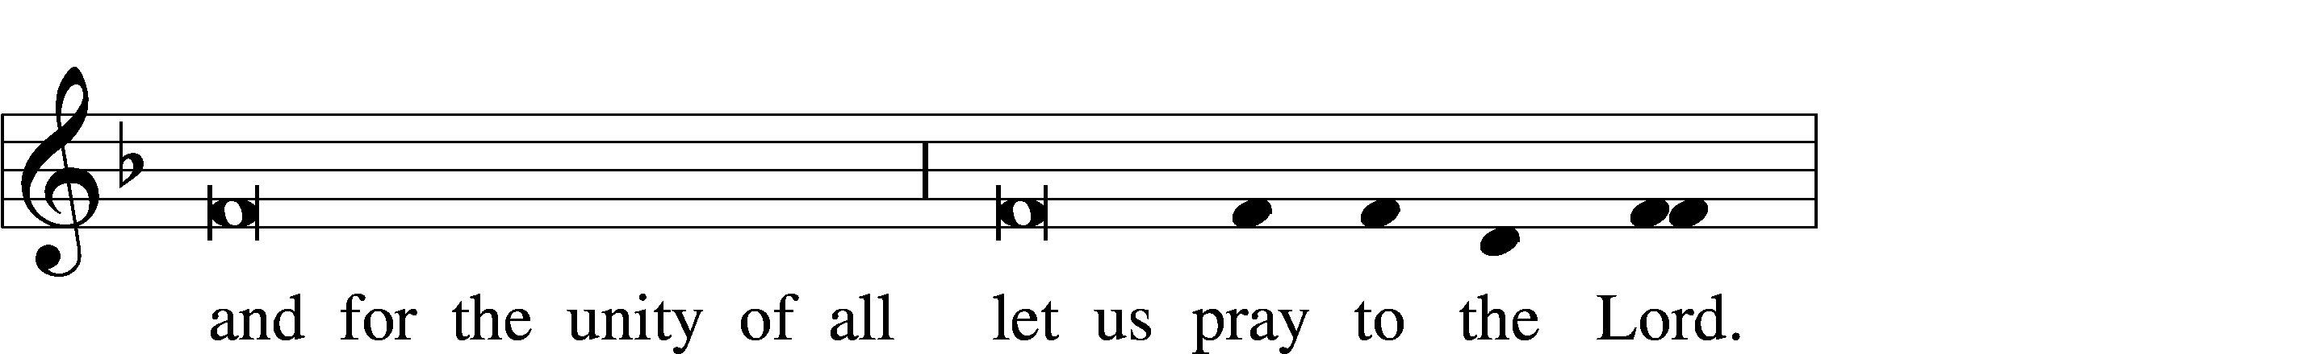
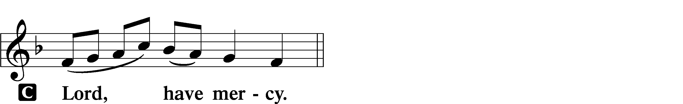

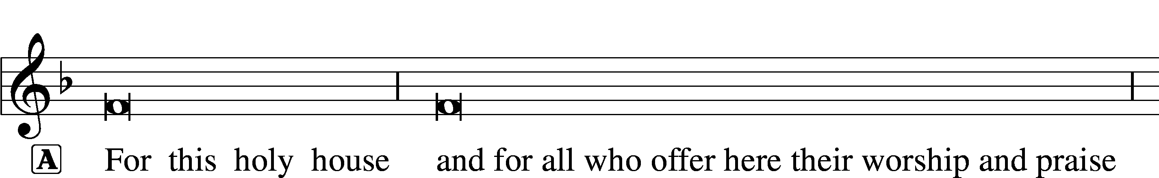
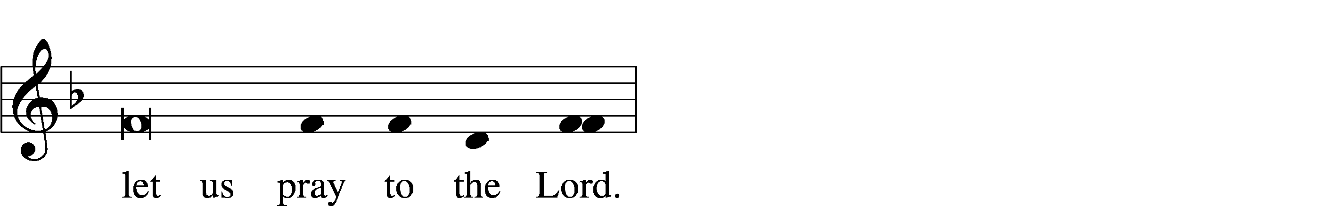
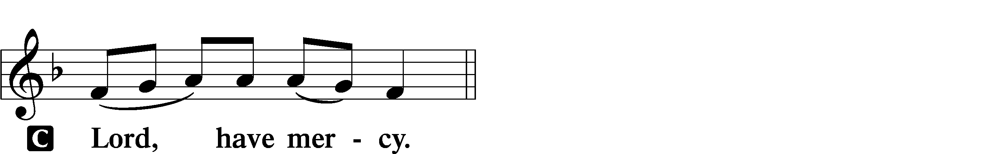

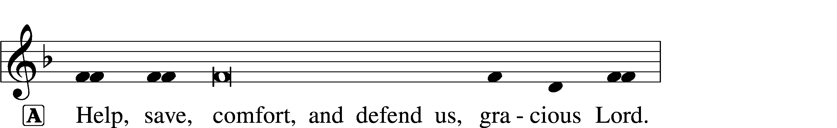
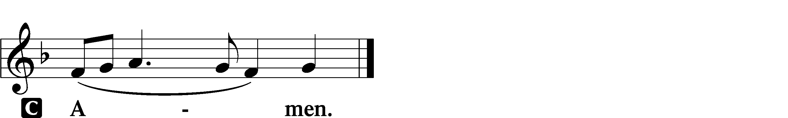

GLORIA IN EXCELSIS LSB 154
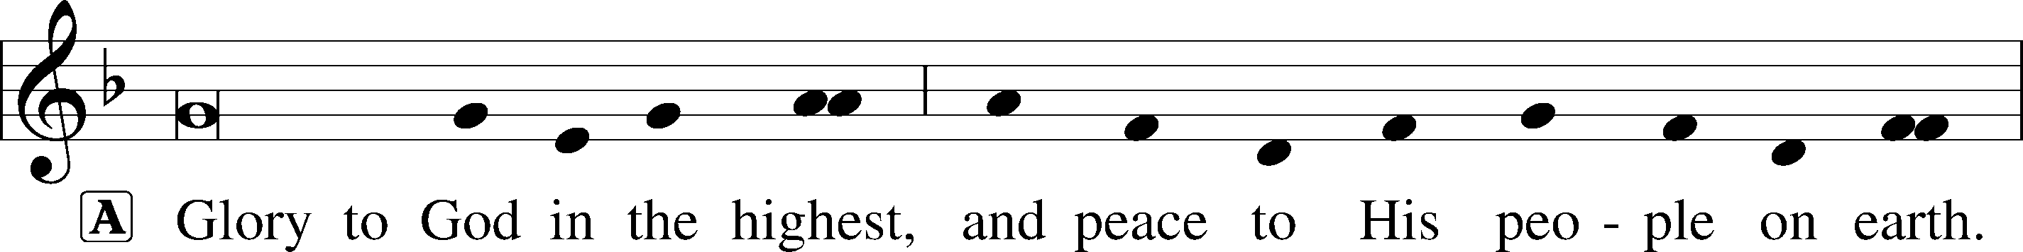
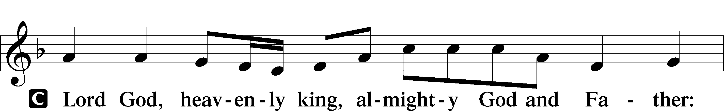
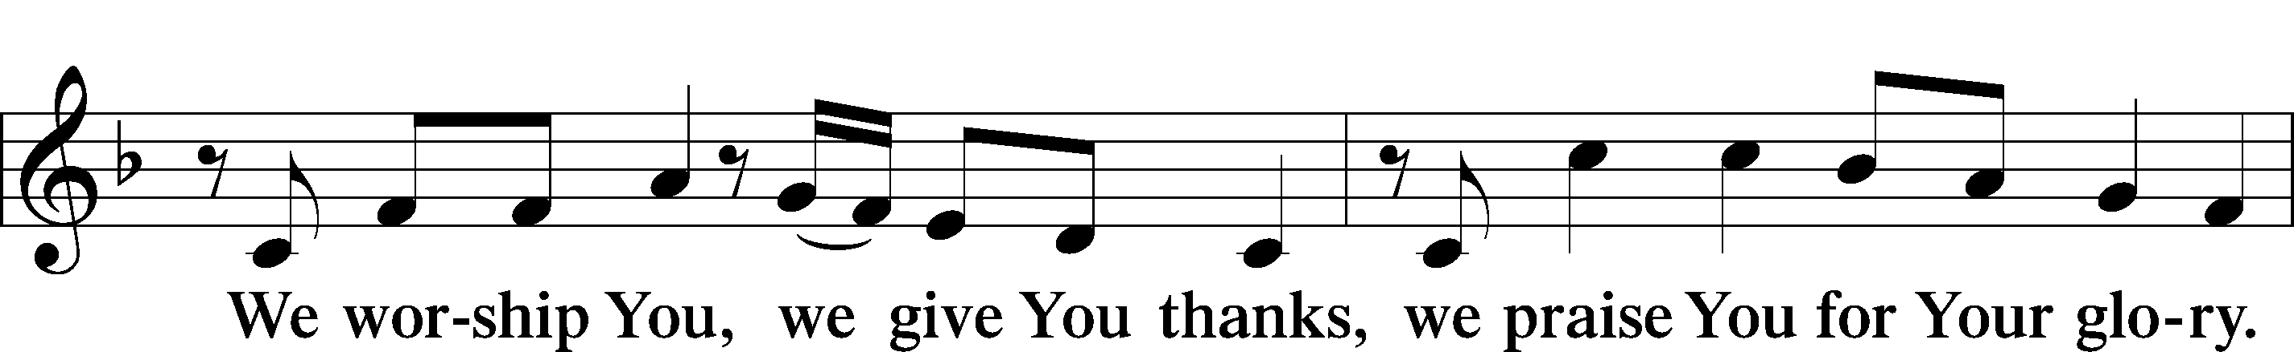
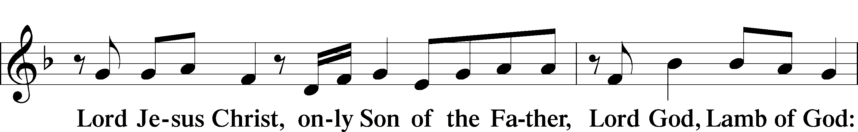
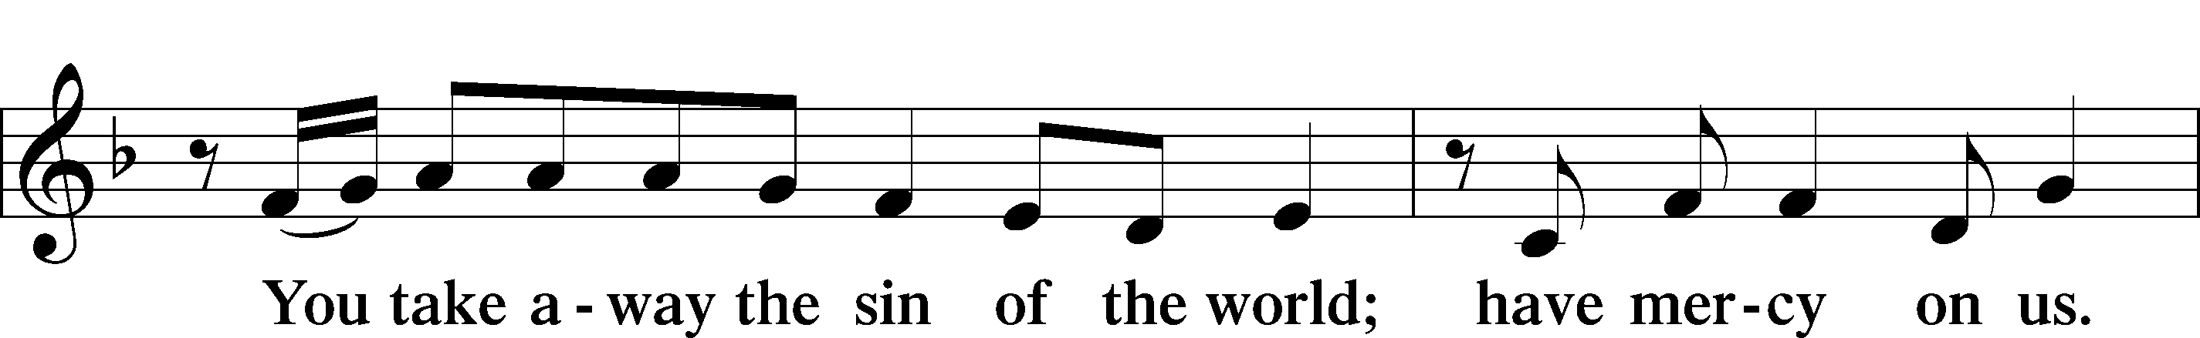
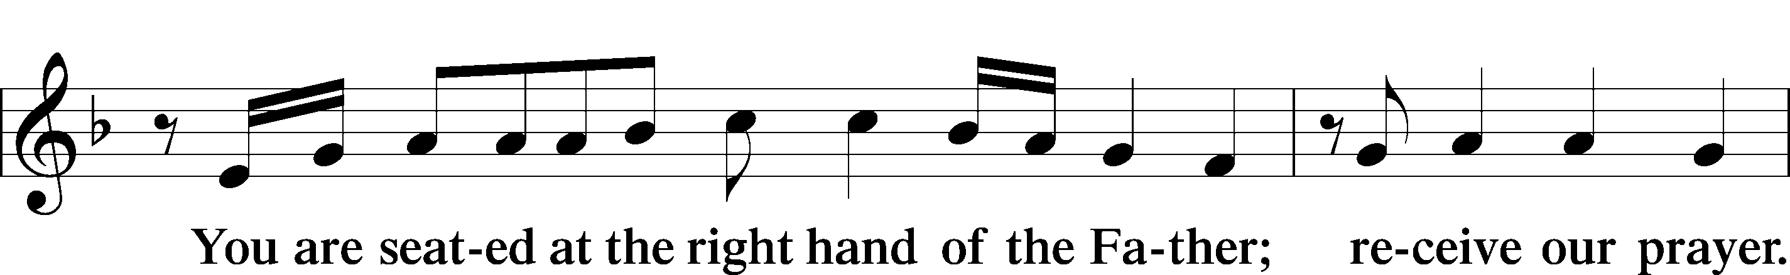
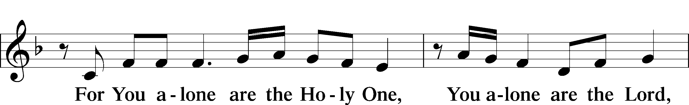
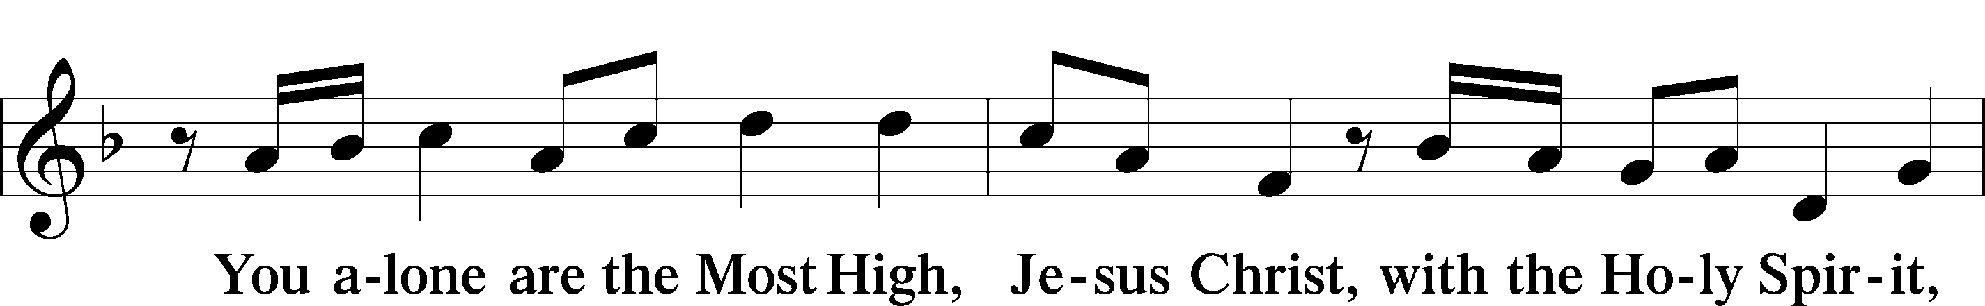
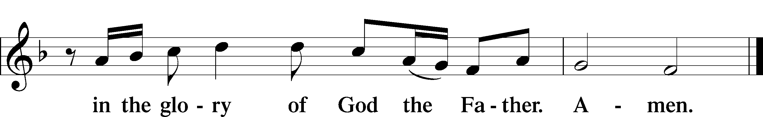

SALUTATION AND COLLECT OF THE DAY LSB 156
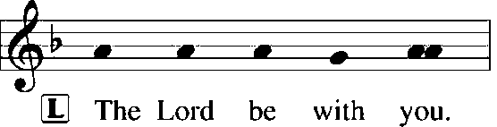
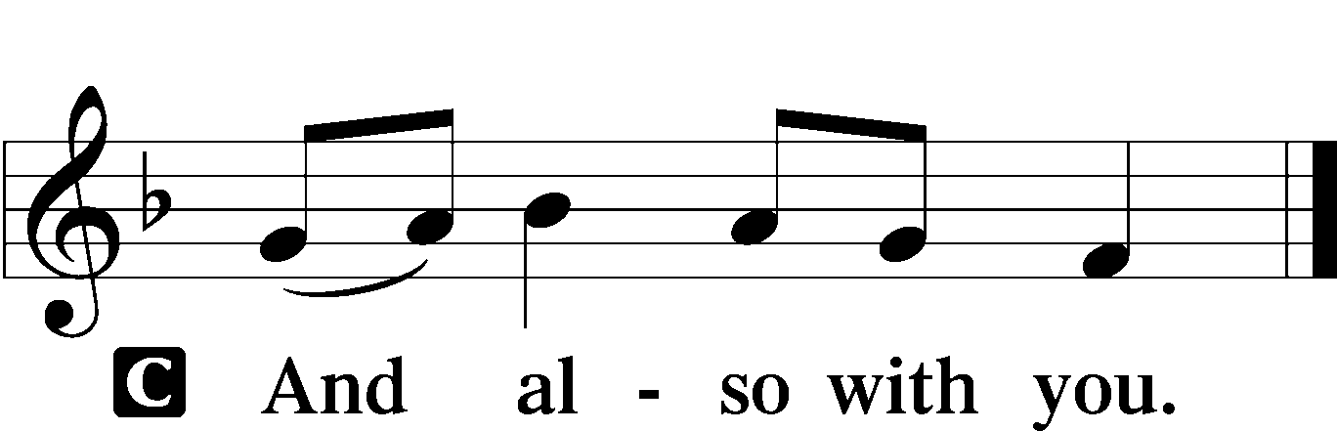

L Let us pray.
Blessed Lord, since You have caused all Holy Scriptures to be written for our learning, grant that we may so hear them, read, mark, learn, and inwardly digest them that we may embrace and ever hold fast the blessed hope of everlasting life; through Jesus Christ, Your Son, our Lord, who lives and reigns with You and the Holy Spirit, one God, now and forever.

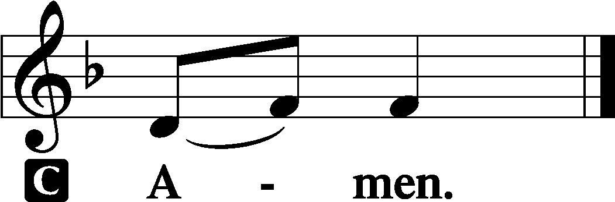

(Sit)

OLD TESTAMENT READING Isaiah 55:10–13
10“For as the rain and the snow come down from heaven
and do not return there but water the earth,
making it bring forth and sprout,
giving seed to the sower and bread to the eater,
11so shall my word be that goes out from my mouth;
it shall not return to me empty,
but it shall accomplish that which I purpose,
and shall succeed in the thing for which I sent it.
12“For you shall go out in joy
and be led forth in peace;
the mountains and the hills before you
shall break forth into singing,
and all the trees of the field shall clap their hands.
13Instead of the thorn shall come up the cypress;
instead of the brier shall come up the myrtle;
and it shall make a name for the Lord,
an everlasting sign that shall not be cut off.”

L This is the Word of the Lord.
C Thanks be to God.

GRADUAL Romans 11:33, 36
Oh, the depth of the riches and wisdom and knowl- | edge of God!*
How unsearchable are his judgments and how inscrutable | his ways!
For from him and through him and to him are | all things.*
To him be glory forever. | Amen.

EPISTLE Romans 8:12–17
12So then, brothers, we are debtors, not to the flesh, to live according to the flesh. 13For if you live according to the flesh you will die, but if by the Spirit you put to death the deeds of the body, you will live. 14For all who are led by the Spirit of God are sons of God. 15For you did not receive the spirit of slavery to fall back into fear, but you have received the Spirit of adoption as sons, by whom we cry, “Abba! Father!” 16The Spirit himself bears witness with our spirit that we are children of God, 17and if children, then heirs—heirs of God and fellow heirs with Christ, provided we suffer with him in order that we may also be glorified with him.

L This is the Word of the Lord.
C Thanks be to God.

(Stand)

ALLELUIA AND VERSE LSB 156
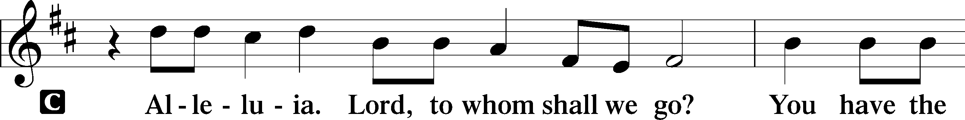
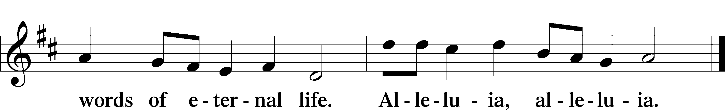

HOLY GOSPEL Matthew 13:1–9, 18–23
L The Holy Gospel according to St. Matthew, the thirteenth chapter.

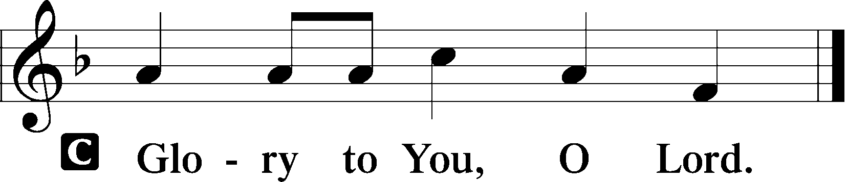

1That same day Jesus went out of the house and sat beside the sea. 2And great crowds gathered about him, so that he got into a boat and sat down. And the whole crowd stood on the beach. 3And he told them many things in parables, saying: “A sower went out to sow. 4And as he sowed, some seeds fell along the path, and the birds came and devoured them. 5Other seeds fell on rocky ground, where they did not have much soil, and immediately they sprang up, since they had no depth of soil, 6but when the sun rose they were scorched. And since they had no root, they withered away. 7Other seeds fell among thorns, and the thorns grew up and choked them. 8Other seeds fell on good soil and produced grain, some a hundredfold, some sixty, some thirty. 9He who has ears, let him hear. . . .
18“Hear then the parable of the sower: 19When anyone hears the word of the kingdom and does not understand it, the evil one comes and snatches away what has been sown in his heart. This is what was sown along the path. 20As for what was sown on rocky ground, this is the one who hears the word and immediately receives it with joy, 21yet he has no root in himself, but endures for a while, and when tribulation or persecution arises on account of the word, immediately he falls away. 22As for what was sown among thorns, this is the one who hears the word, but the cares of the world and the deceitfulness of riches choke the word, and it proves unfruitful. 23As for what was sown on good soil, this is the one who hears the word and understands it. He indeed bears fruit and yields, in one case a hundredfold, in another sixty, and in another thirty.”

L This is the Gospel of the Lord.

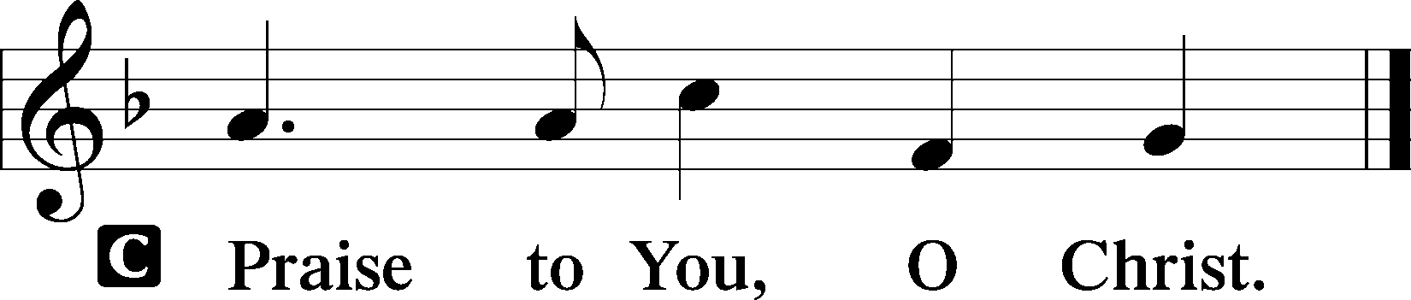

(Sit)
577 ALMIGHTY GOD, YOUR WORD IS CAST
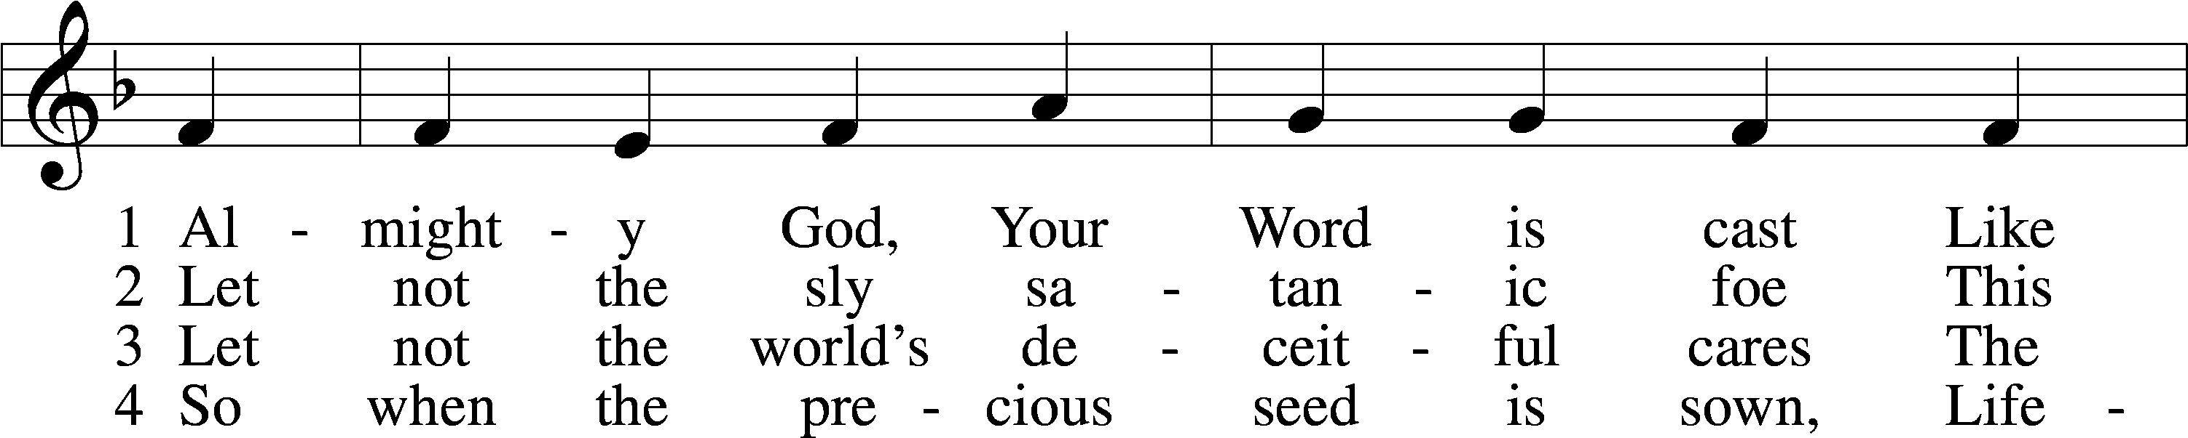
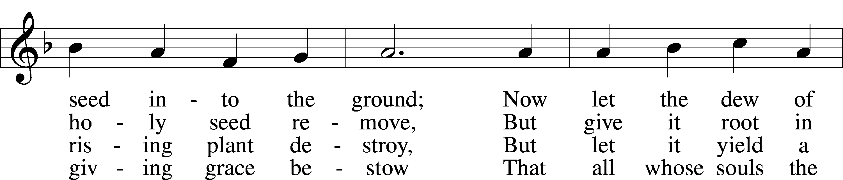
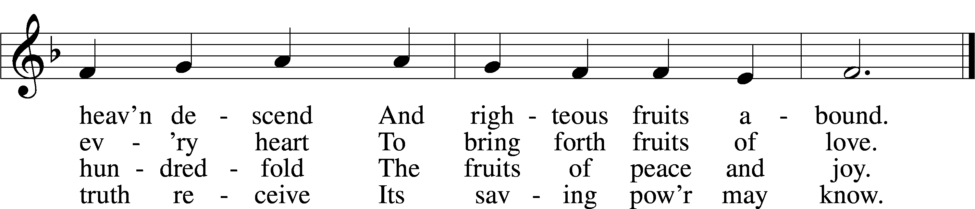
Text: John Cawood, 1775–1852, alt.
Tune: The Whole Booke of Psalmes, 1562, London
Text and tune: Public domain

SERMON

(Sermons for Elder led services are provided courtesy of the Lutheran Church - Canada (https://www.lutheranchurchcanada.ca/resources/written-sermons/), a member of the International Lutheran Council (https://ilcouncil.org/) with whom the Lutheran Church - Missouri Synod (https://www.lcms.org/) is in altar and pulpit fellowship.)

(Stand)

NICENE CREED LSB 158
C I believe in one God,
the Father Almighty,
maker of heaven and earth
and of all things visible and invisible.

And in one Lord Jesus Christ,
the only-begotten Son of God,
begotten of His Father before all worlds,
God of God, Light of Light,
very God of very God,
begotten, not made,
being of one substance with the Father,
by whom all things were made;
who for us men and for our salvation came down from heaven
and was incarnate by the Holy Spirit of the virgin Mary
and was made man;
and was crucified also for us under Pontius Pilate.
He suffered and was buried.
And the third day He rose again according to the Scriptures
and ascended into heaven
and sits at the right hand of the Father.
And He will come again with glory to judge both the living and the dead,
whose kingdom will have no end.

And I believe in the Holy Spirit,
the Lord and giver of life,
who proceeds from the Father and the Son,
who with the Father and the Son together is worshiped and glorified,
who spoke by the prophets.
And I believe in one holy Christian and apostolic Church,
I acknowledge one Baptism for the remission of sins,
and I look for the resurrection of the dead
and the life T of the world to come. Amen.

SHARING OF THE PEACE

(The people may greet one another in the name of the Lord, saying, “Peace be with you,” as a sign of reconciliation and of the unity of the Spirit in the bond of peace (Matt. 5:22–24; Eph. 4:1–3).)

(Sit)

PRAYER OF THE CHURCH

OFFERING

(As a part of our expression of thanksgiving to God for the treasure of His salvation to us, we offer a portion of our treasure, according to what each has determined in their heart to give. Please place offerings in the collection plate at the back of the sanctuary before or after the service. Offerings can also be sent to Bethlehem Lutheran Church via U.S. Mail. Thank you!)

(Stand)

OFFERTORY LSB 159
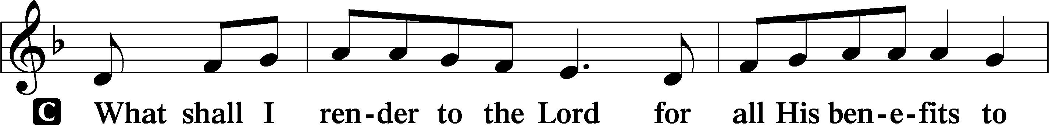
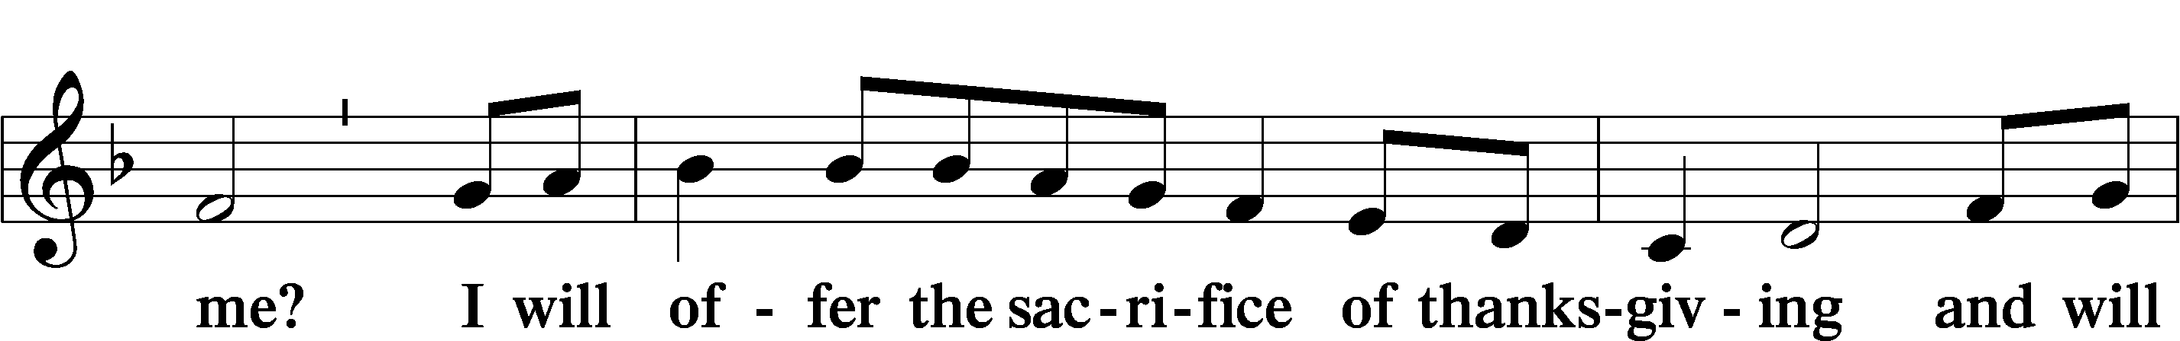
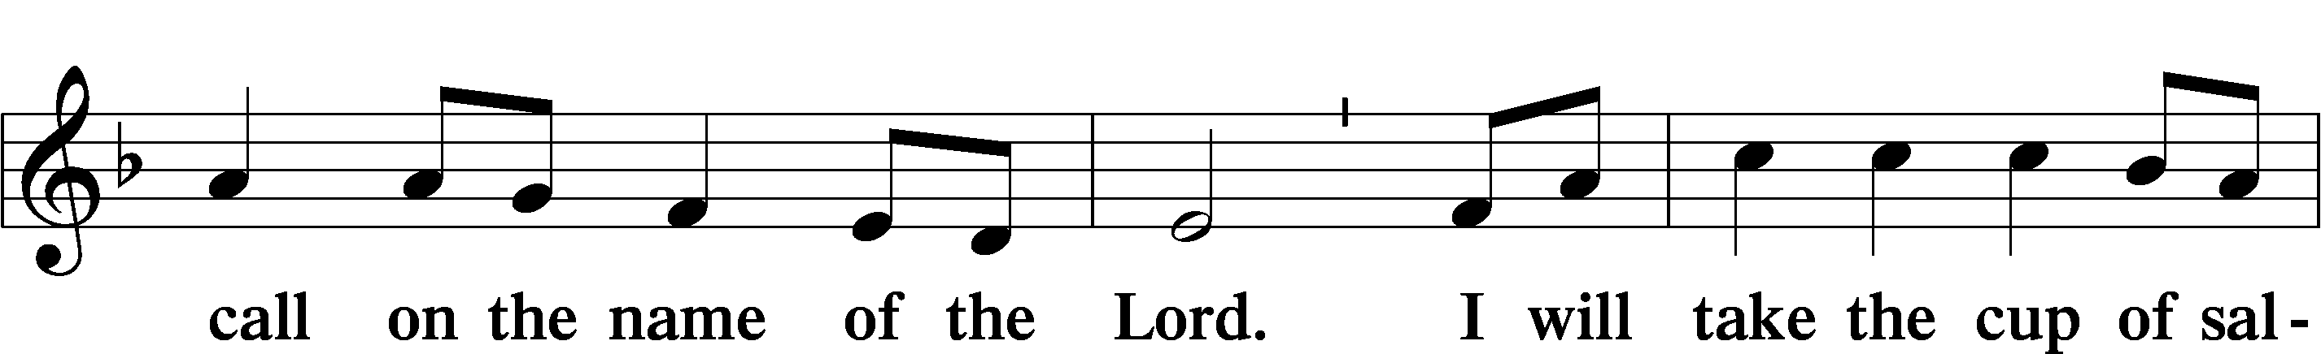
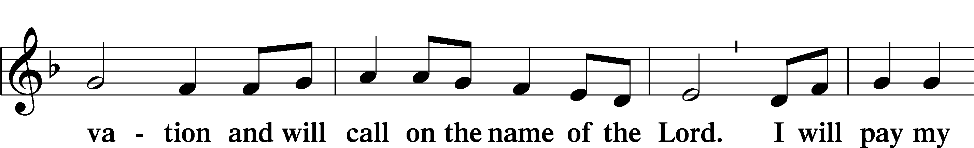
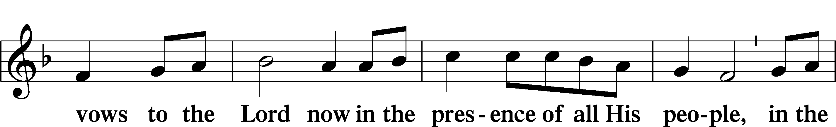
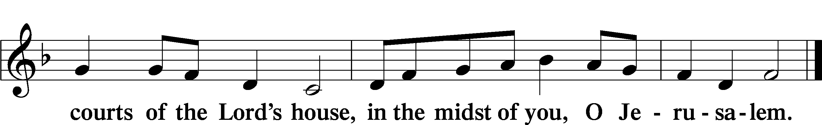

LORD’S PRAYER LSB 162
L Lord, remember us in Your kingdom and teach us to pray:
C Our Father who art in heaven,
hallowed be Thy name,
Thy kingdom come,
Thy will be done on earth
as it is in heaven;
give us this day our daily bread;
and forgive us our trespasses
as we forgive those
who trespass against us;
and lead us not into temptation,
but deliver us from evil.
For Thine is the kingdom
and the power and the glory
forever and ever. Amen.

CONCLUDING COLLECT

BENEDICTION LSB 166
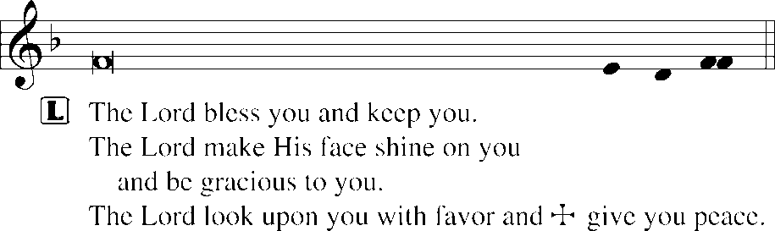
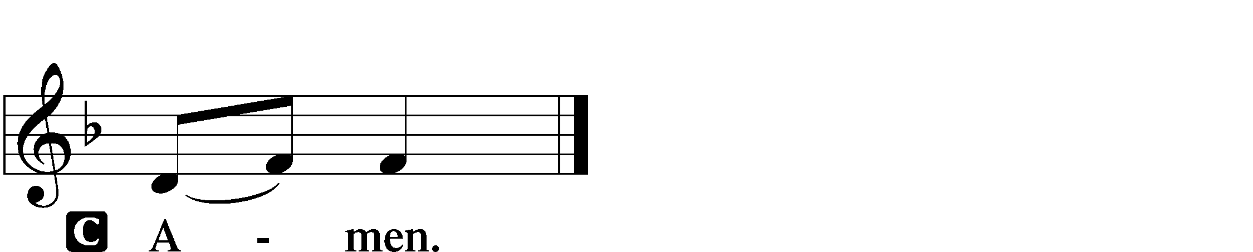

921 ON WHAT HAS NOW BEEN SOWN
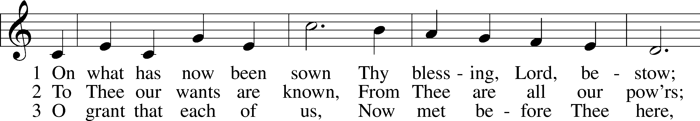
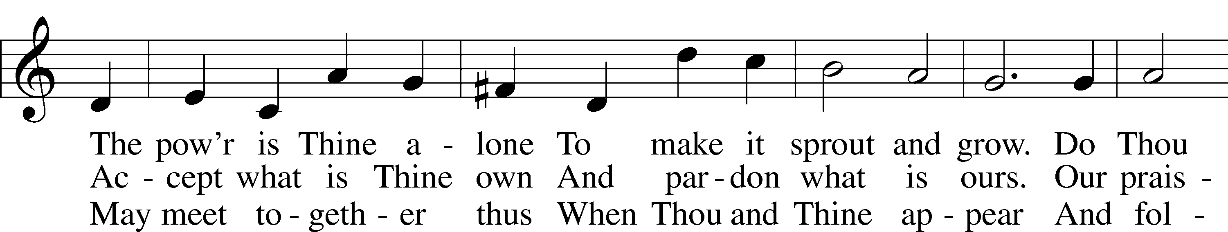
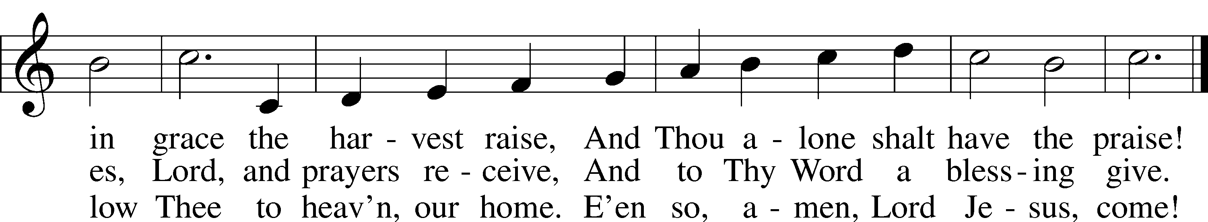
Text: John Newton, 1725–1807, alt.
Tune: John Darwall, 1731–89
Text and tune: Public domain
ACKNOWLEDGMENTS
Unless otherwise indicated, Scripture quotations are from the ESV® Bible (The Holy Bible, English Standard Version®), copyright © 2001 by Crossway, a publishing ministry of Good News Publishers. Used by permission. All rights reserved.
Created by Lutheran Service Builder © 2026 Concordia Publishing House.

