**BETHLEHEM LUTHERAN CHURCH**

***A congregation of The Lutheran Church-Missouri Synod***

902 Hitchcock Drive SW,

Aiken, South Carolina 29803

Church Phone: (803) 649-6417

blcaikensc@gmail.com

**Pastor: Rev. John B. Engwall**

**Office Hours By Appointment**

**Note:** The format of this bulletin has been modified for use in private devotion services. Unable to join us in person? Please find us on Facebook live. The service is also posted on our website; bethlehemlutheranaiken.org

**+ + + + + + + + + + + + + + +**

**The Fifteenth Sunday after Pentecost**

**September 21, 2025**

**10:30 a.m.**

**+ + + + + + + + + + + + + + +**

**Our Policy and Practice Regarding Holy Communion**

**Hear the words of the Apostle Paul;**

*Anyone who eats and drinks without recognizing the body of the Lord eats and drinks judgment on himself. -*1 Cor.11:29

**Therefore, visitors are asked to please refrain from partaking of the Sacrament before speaking about this with the pastor; because we care about your spiritual well-being.**

**Also, because communing at this altar is a public confession that you agree with the doctrines of The Lutheran Church-Missouri Synod, and reject all contrary teachings.**

Persons who are not communing today are always welcome to come forward during the distribution to receive an individual blessing; please cross your arms over your chest to indicate your desire for this. Thank you!

We commune in two alternating tables. The ushers will guide you. Non-alcoholic white wine is available in the center of the individual cup tray. Please leave empty individual cups at the altar rail.

**+ SERVICE OF PREPARATION +**

*After the bell tolls, please observe a time of silence.*

**WELCOME AND ANNOUNCEMENTS**

(Stand)

350 COME, THOU PRECIOUS RANSOM, COME

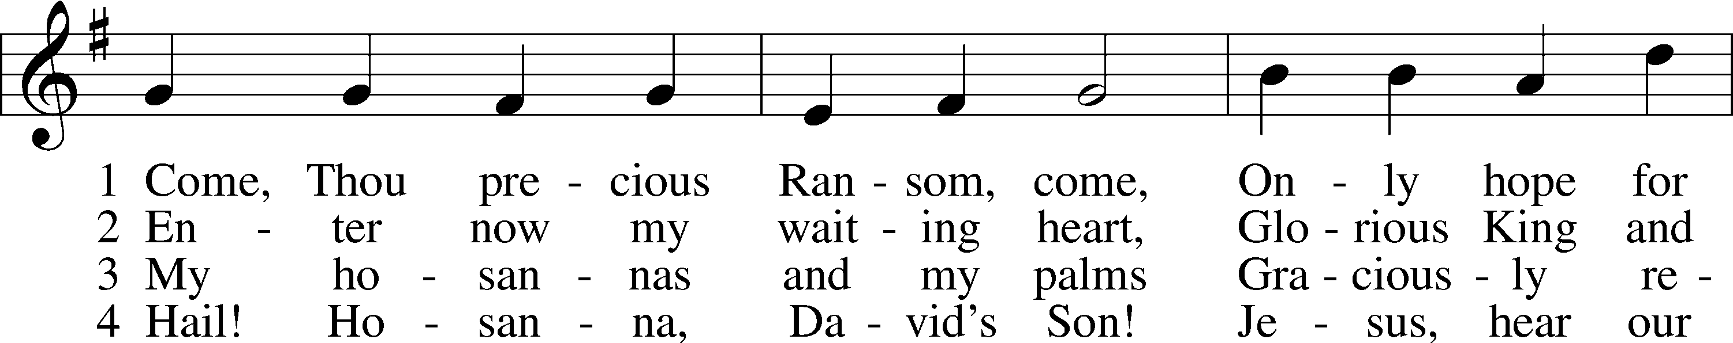

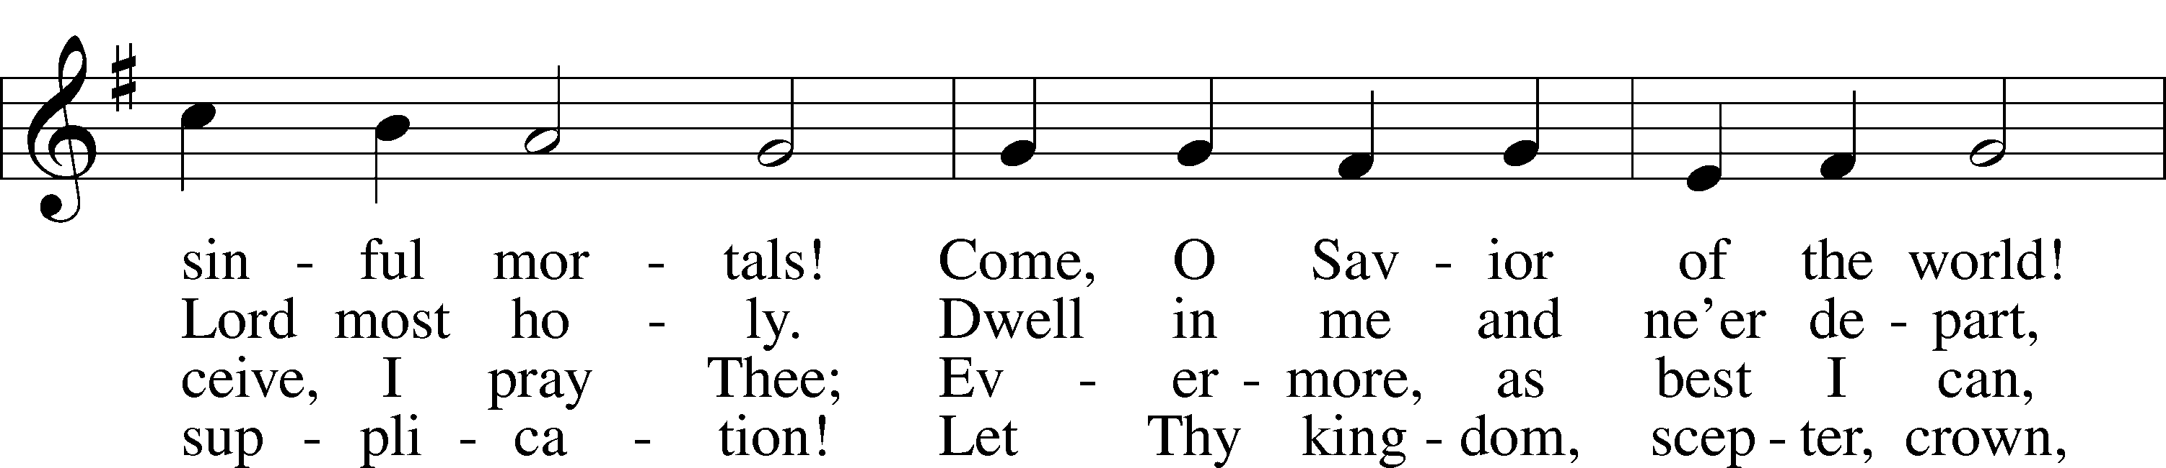

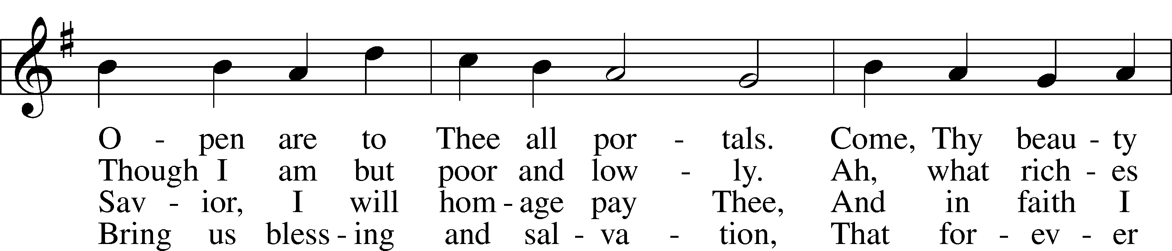

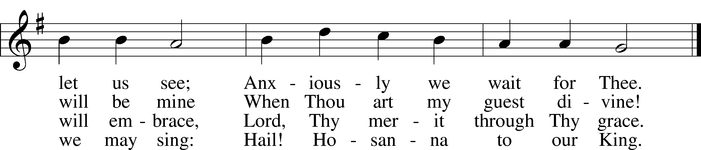

Text: Johann Gottfried Olearius, 1635–1711; tr. August Crull, 1845–1923, alt.  
Tune: Neu-verfertigtes Darmstädtisches Gesang-Buch, 1699, Darmstadt  
Text and tune: Public domain

# + CONFESSION AND ABSOLUTION +

(The sign of the cross may be made by all in remembrance of their Baptism.)

INVOCATION

L In the name of the Father and of the T Son and of the Holy Spirit.

C **Amen.**

EXHORTATION LSB 151

L If we say we have no sin, we deceive ourselves, and the truth is not in us.

C **But if we confess our sins, God, who is faithful and just, will forgive our sins and cleanse us from all unrighteousness.**

(Silence for reflection on God’s Word and for self-examination.)

CONFESSION OF SINS LSB 151

L Let us then confess our sins to God our Father.

C **Most merciful God, we confess that we are by nature sinful and unclean. We have sinned against You in thought, word, and deed, by what we have done and by what we have left undone. We have not loved You with our whole heart; we have not loved our neighbors as ourselves. We justly deserve Your present and eternal punishment. For the sake of Your Son, Jesus Christ, have mercy on us. Forgive us, renew us, and lead us, so that we may delight in Your will and walk in Your ways to the glory of Your holy name. Amen.**

DECLARATION OF GRACE

L In the mercy of almighty God, Jesus Christ was given to die for us, and for His sake God forgives us all our sins. To those who believe in Jesus Christ He gives the power to become the children of God and bestows on them the Holy Spirit. May the Lord, who has begun this good work in us, bring it to completion in the day of our Lord Jesus Christ.

C **Amen.**

# + SERVICE OF THE WORD +

INTROIT Psalm 119:137–140, 142; antiphon: v. 144

Your testimonies are righteous for- | ever;*  
 give me understanding that | I may live.  
Righteous are you, | O Lord,*  
 and right are your | just decrees.  
You have appointed your testimonies in | righteousness*  
 and in all | faithfulness.  
My zeal con- | sumes me,*  
 because my foes for- | get your words.  
Your promise is | well tried,*  
 and your servant | loves it.  
Your righteousness is righteous for- | ever,*  
 and your | law is true.  
**Glory be to the Father and | to the Son**\*  
 **and to the Holy | Spirit;**  
**as it was in the be- | ginning,**\*  
 **is now, and will be forever. | Amen.**  
Your testimonies are righteous for- | ever;*  
 give me understanding that | I may live.

KYRIE LSB 152



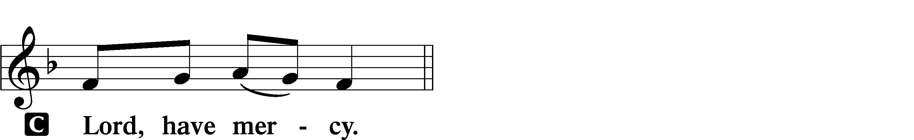

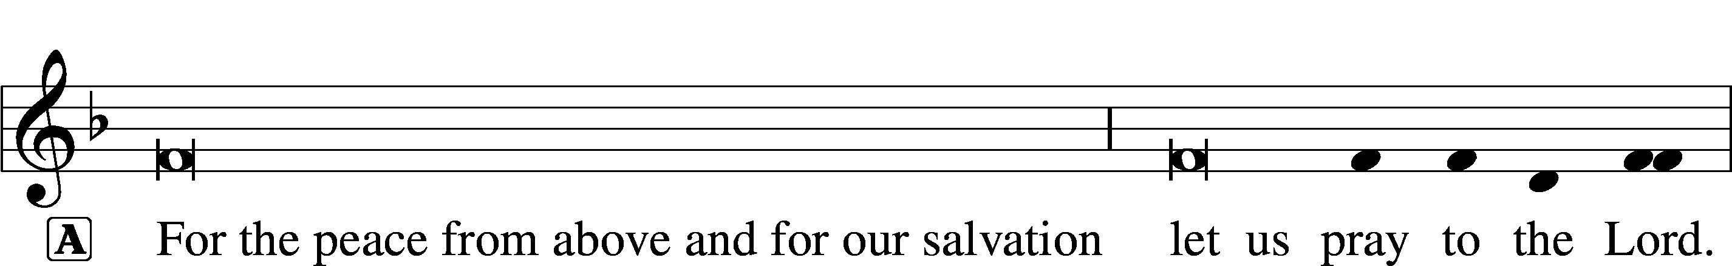

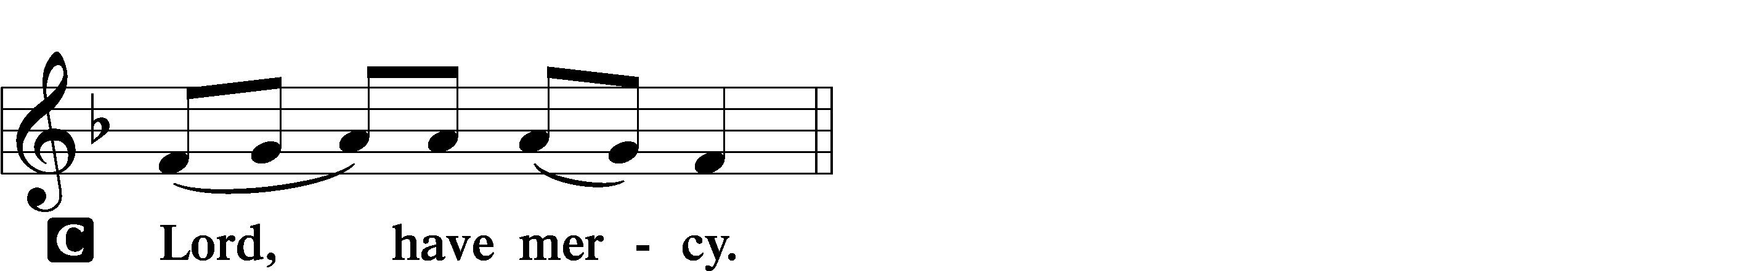

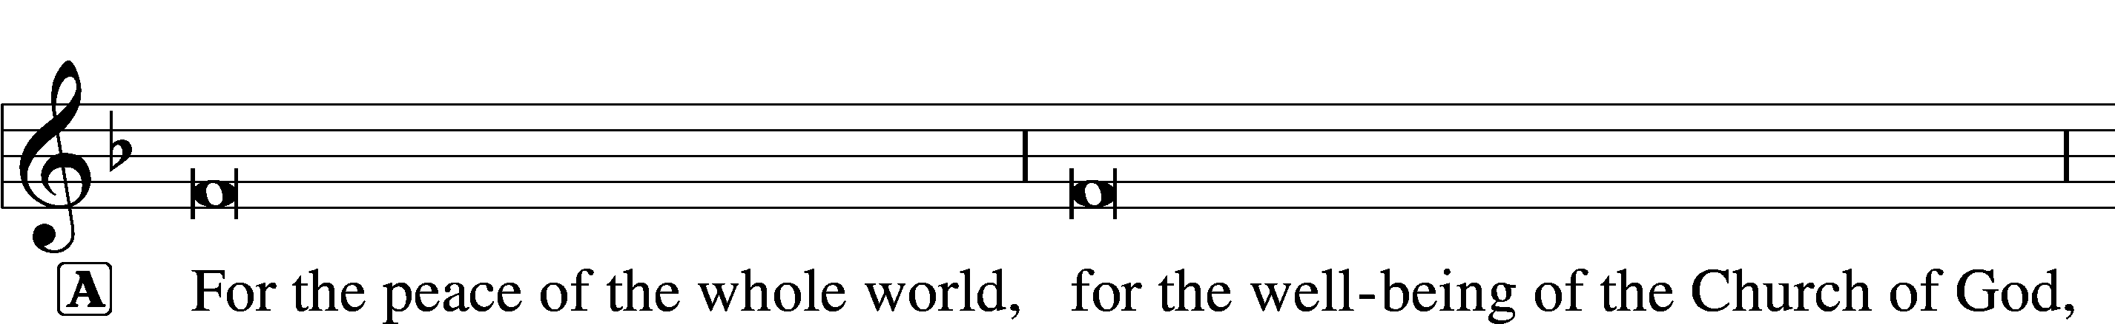

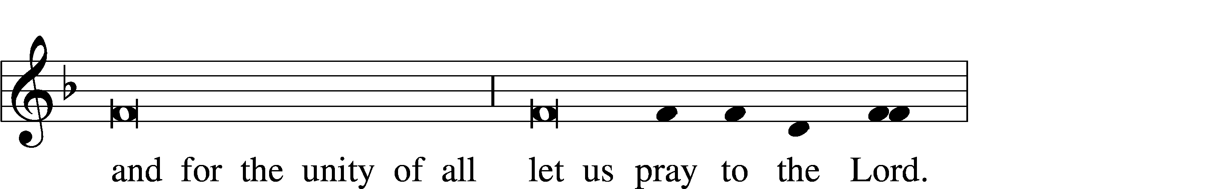

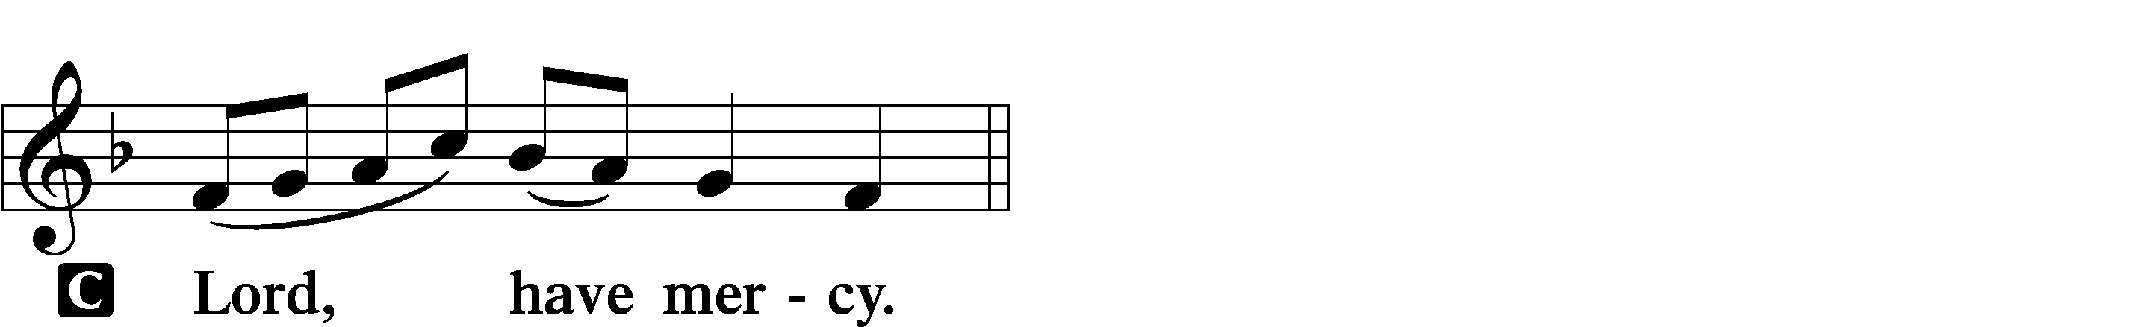

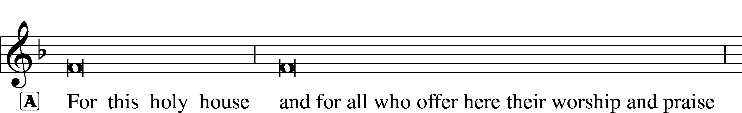



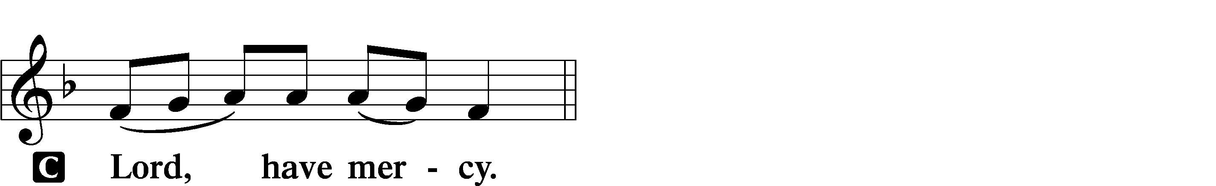





THIS IS THE FEAST LSB 155

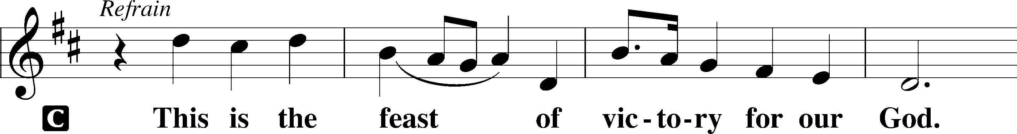

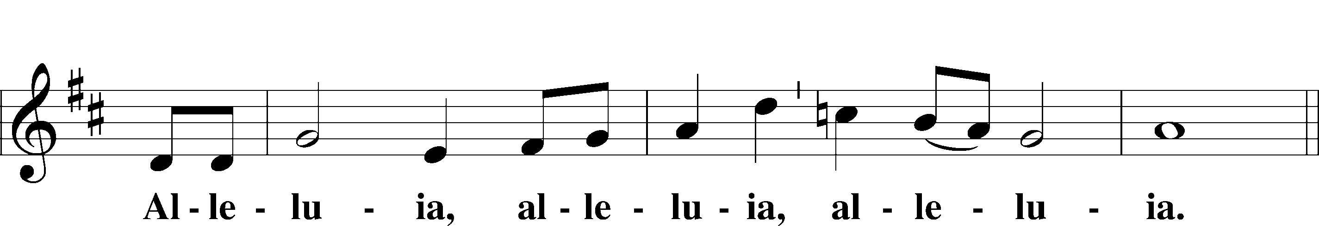

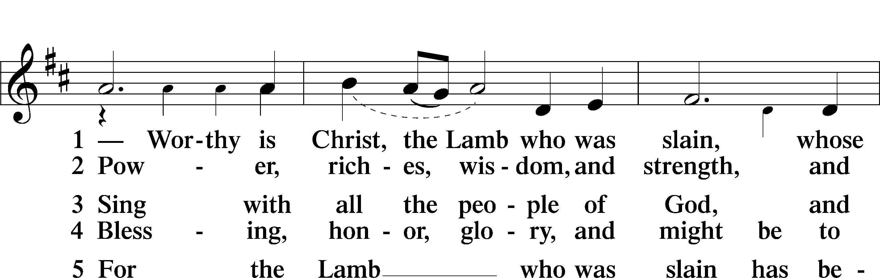

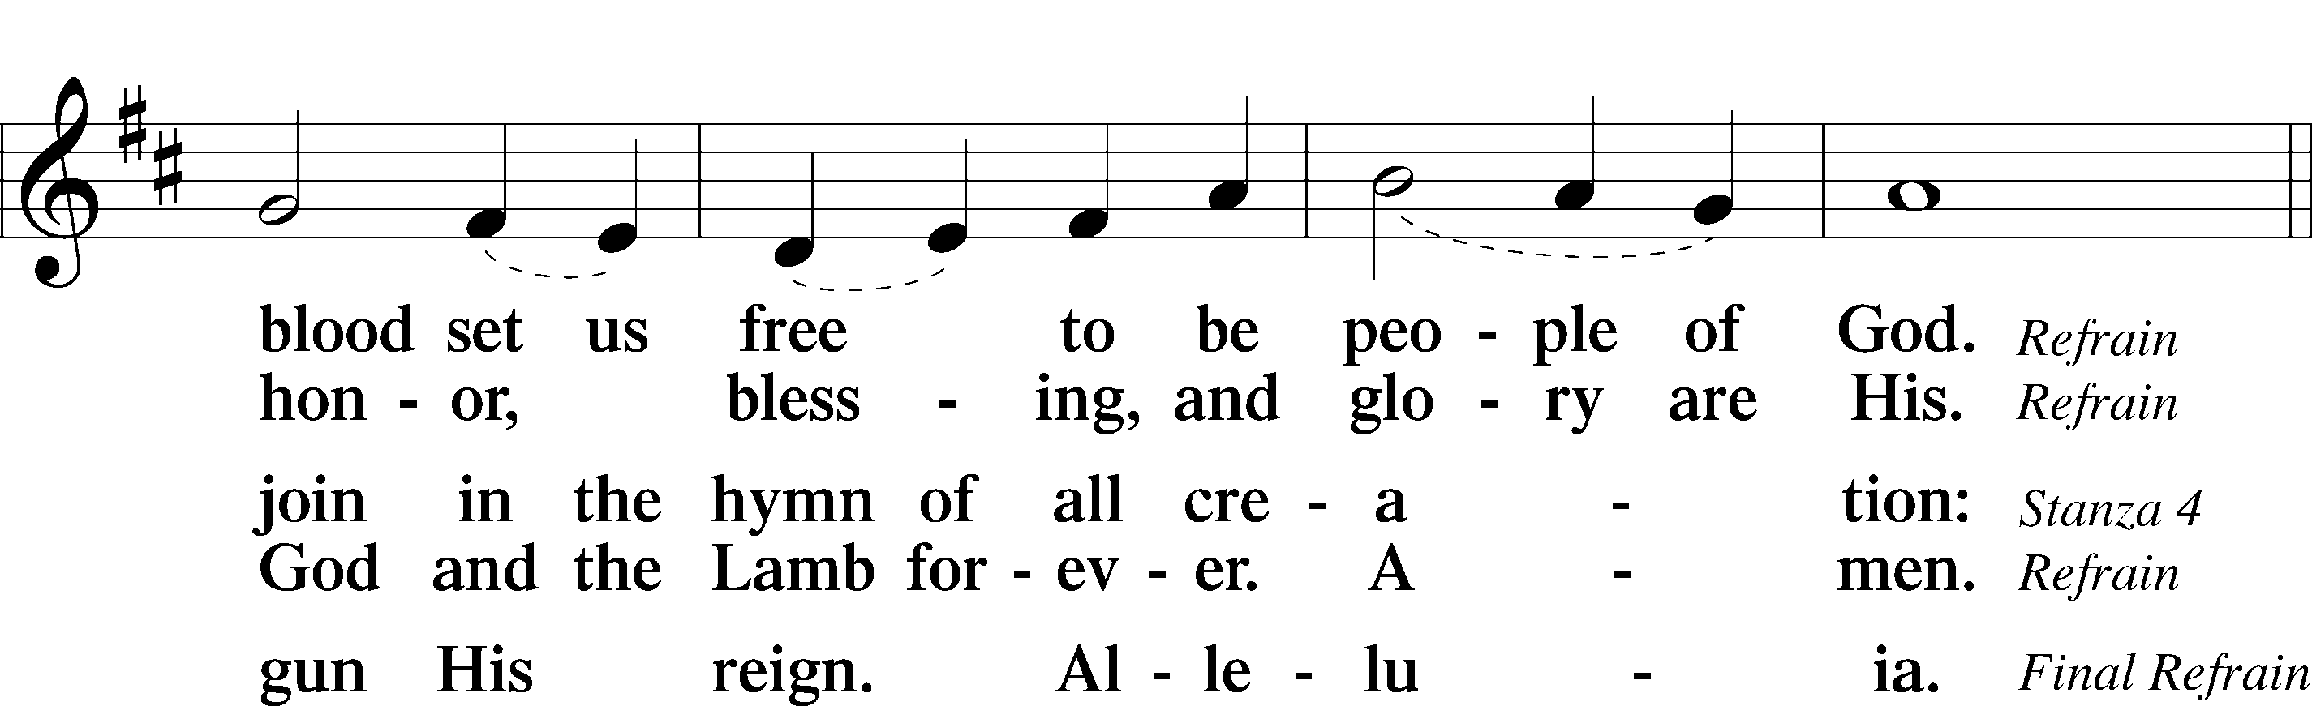

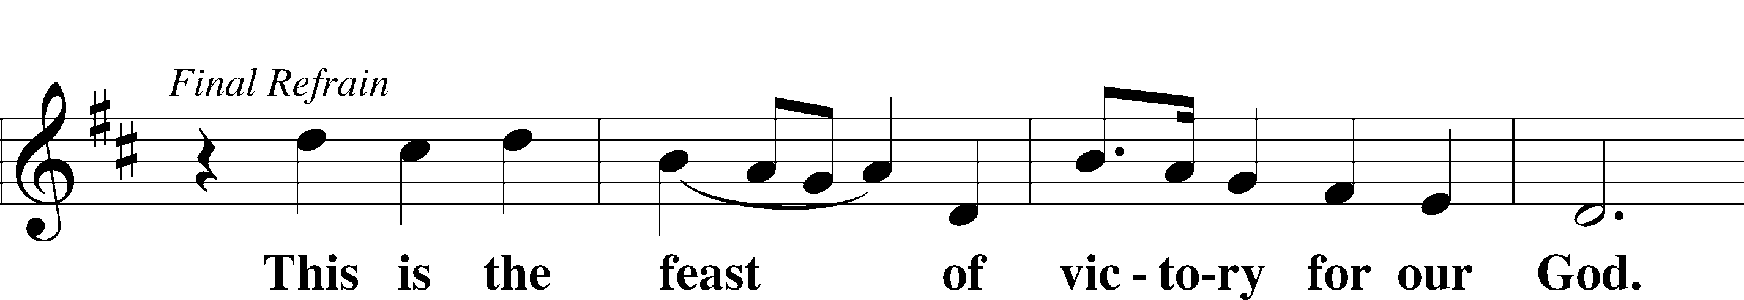

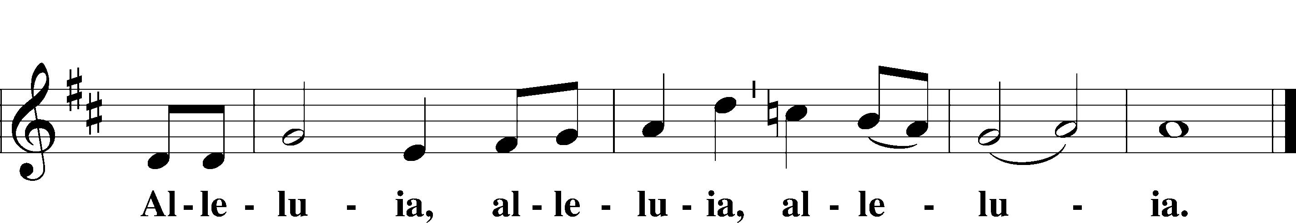

SALUTATION AND COLLECT OF THE DAY

P The Lord be with you.

C **And also with you.**

P Let us pray.

O Lord, keep Your Church in Your perpetual mercy; and because without You we cannot but fall, preserve us from all things hurtful, and lead us to all things profitable to our salvation; through Jesus Christ, Your Son, our Lord, who lives and reigns with You and the Holy Spirit, one God, now and forever.

C **Amen.**

(Sit)

CHILDRENS LESSON

OLD TESTAMENT READING Amos 8:4–7

4Hear this, you who trample on the needy  
 and bring the poor of the land to an end,  
5saying, “When will the new moon be over,  
 that we may sell grain?  
And the Sabbath,  
 that we may offer wheat for sale,  
that we may make the ephah small and the shekel great  
 and deal deceitfully with false balances,  
6that we may buy the poor for silver  
 and the needy for a pair of sandals  
 and sell the chaff of the wheat?”

7The Lord has sworn by the pride of Jacob:  
“Surely I will never forget any of their deeds.”

L This is the Word of the Lord.

C **Thanks be to God.**

GRADUAL Psalm 34:9, 19, alt.

Fear the Lord, | you his saints,*  
 for those who fear him lack | nothing!  
Many are the afflictions of the | righteous,*  
 but the Lord delivers him out | of them all.

EPISTLE 1 Timothy 2:1–15

1First of all, then, I urge that supplications, prayers, intercessions, and thanksgivings be made for all people, 2for kings and all who are in high positions, that we may lead a peaceful and quiet life, godly and dignified in every way. 3This is good, and it is pleasing in the sight of God our Savior, 4who desires all people to be saved and to come to the knowledge of the truth. 5For there is one God, and there is one mediator between God and men, the man Christ Jesus, 6who gave himself as a ransom for all, which is the testimony given at the proper time. 7For this I was appointed a preacher and an apostle (I am telling the truth, I am not lying), a teacher of the Gentiles in faith and truth.

8I desire then that in every place the men should pray, lifting holy hands without anger or quarreling; 9likewise also that women should adorn themselves in respectable apparel, with modesty and self-control, not with braided hair and gold or pearls or costly attire, 10but with what is proper for women who profess godliness—with good works. 11Let a woman learn quietly with all submissiveness. 12I do not permit a woman to teach or to exercise authority over a man; rather, she is to remain quiet. 13For Adam was formed first, then Eve; 14and Adam was not deceived, but the woman was deceived and became a transgressor. 15Yet she will be saved through childbearing—if they continue in faith and love and holiness, with self-control.

L This is the Word of the Lord.

C **Thanks be to God.**

(Stand)

ALLELUIA AND VERSE LSB 156

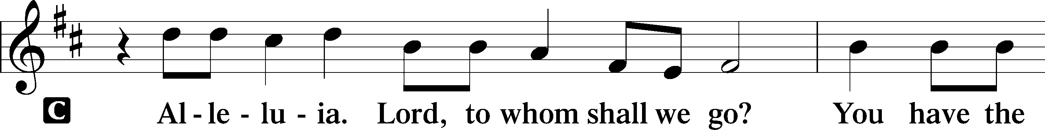

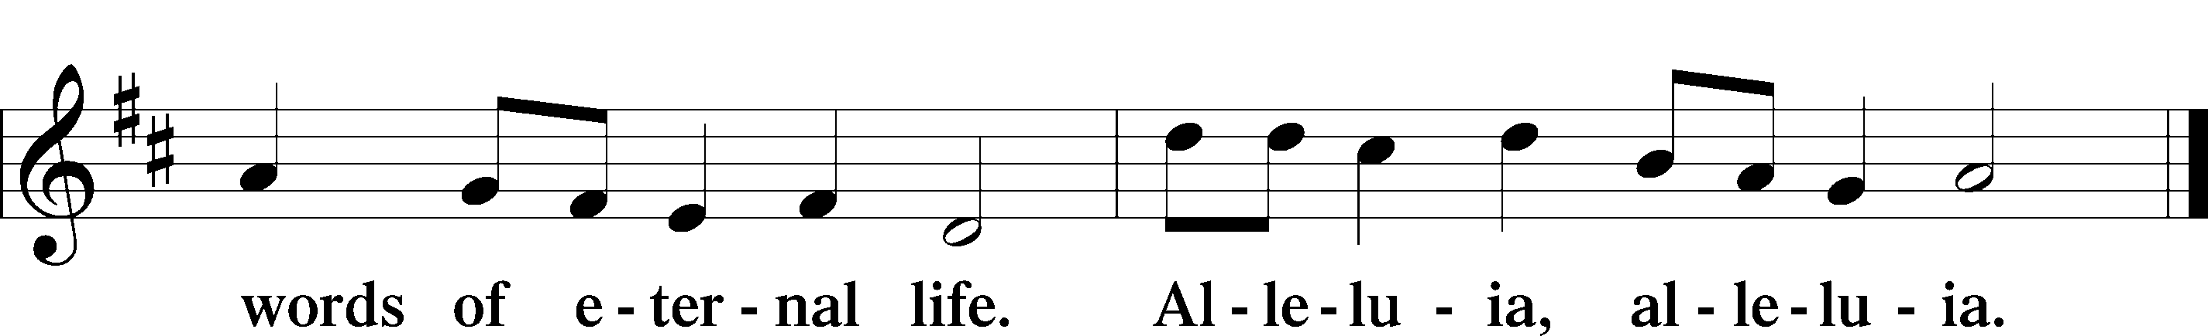

HOLY GOSPEL Luke 16:1–15

L The Holy Gospel according to St. Luke, the sixteenth chapter.

C **Glory to You, O Lord.**

1[Jesus] also said to the disciples, “There was a rich man who had a manager, and charges were brought to him that this man was wasting his possessions. 2And he called him and said to him, ‘What is this that I hear about you? Turn in the account of your management, for you can no longer be manager.’ 3And the manager said to himself, ‘What shall I do, since my master is taking the management away from me? I am not strong enough to dig, and I am ashamed to beg. 4I have decided what to do, so that when I am removed from management, people may receive me into their houses.’ 5So, summoning his master’s debtors one by one, he said to the first, ‘How much do you owe my master?’ 6He said, ‘A hundred measures of oil.’ He said to him, ‘Take your bill, and sit down quickly and write fifty.’ 7Then he said to another, ‘And how much do you owe?’ He said, ‘A hundred measures of wheat.’ He said to him, ‘Take your bill, and write eighty.’ 8The master commended the dishonest manager for his shrewdness. For the sons of this world are more shrewd in dealing with their own generation than the sons of light. 9And I tell you, make friends for yourselves by means of unrighteous wealth, so that when it fails they may receive you into the eternal dwellings.

10“One who is faithful in a very little is also faithful in much, and one who is dishonest in a very little is also dishonest in much. 11If then you have not been faithful in the unrighteous wealth, who will entrust to you the true riches? 12And if you have not been faithful in that which is another’s, who will give you that which is your own? 13No servant can serve two masters, for either he will hate the one and love the other, or he will be devoted to the one and despise the other. You cannot serve God and money.”

14The Pharisees, who were lovers of money, heard all these things, and they ridiculed him. 15And he said to them, “You are those who justify yourselves before men, but God knows your hearts. For what is exalted among men is an abomination in the sight of God.”

L This is the Gospel of the Lord.

C **Praise to You, O Christ.**

(Sit)

557 SEEK WHERE YOU MAY TO FIND A WAY

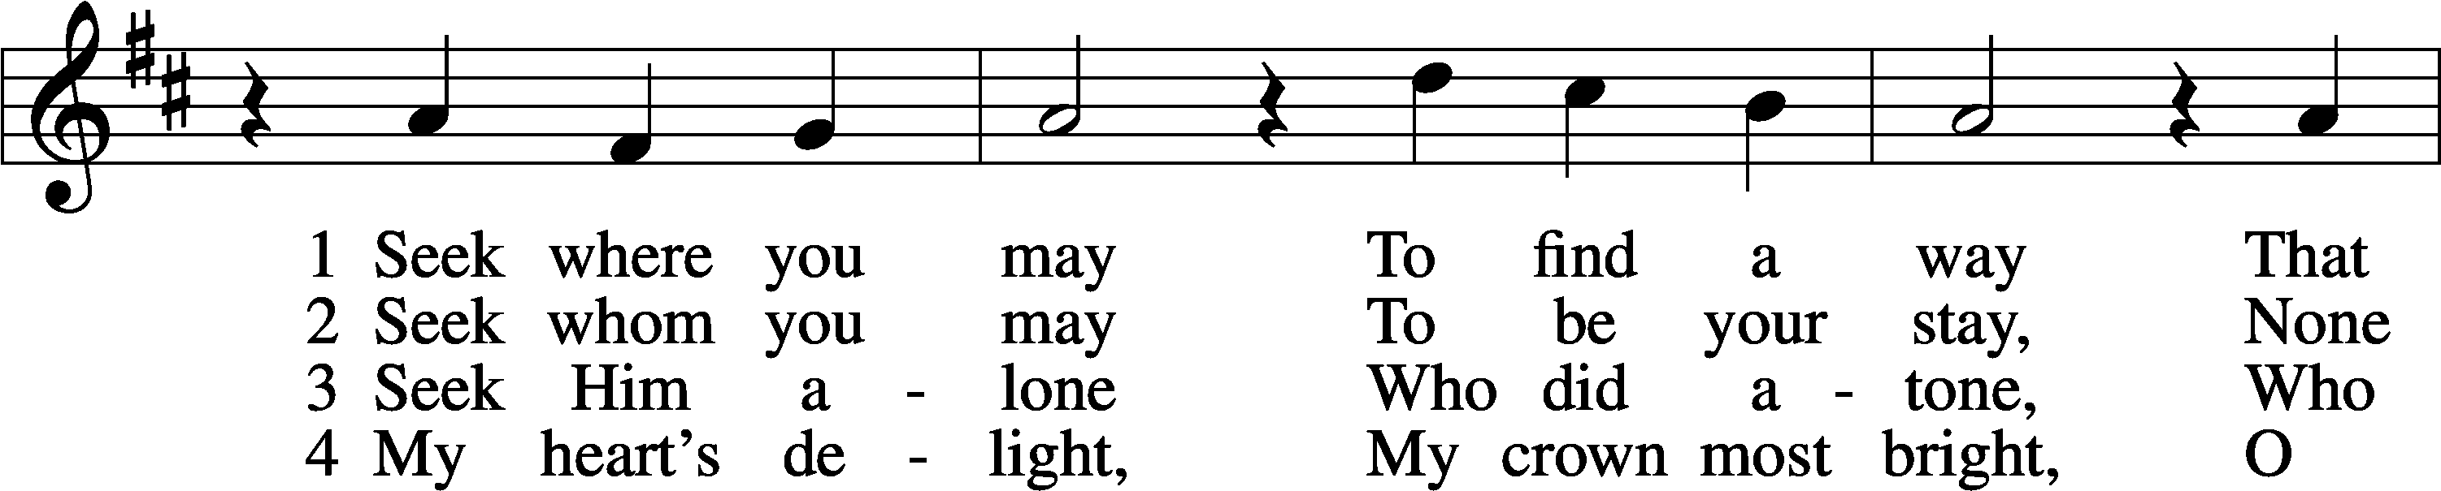

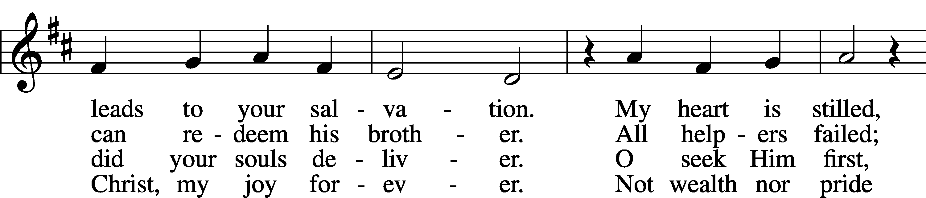

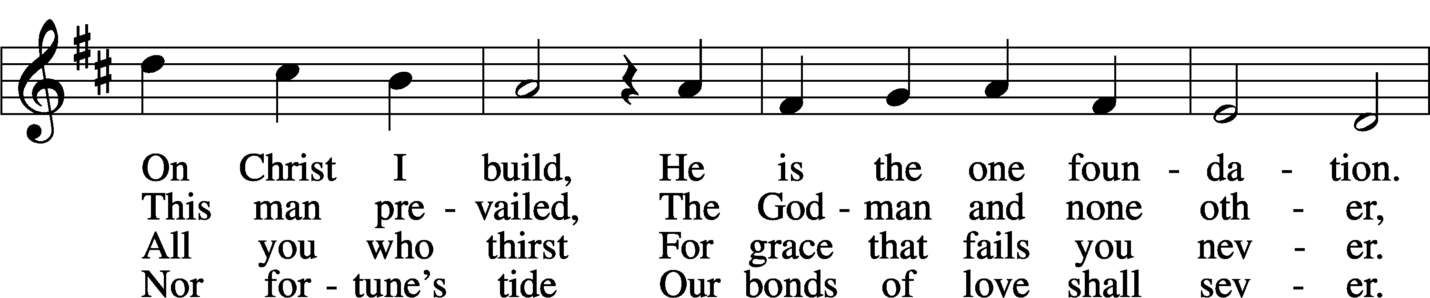

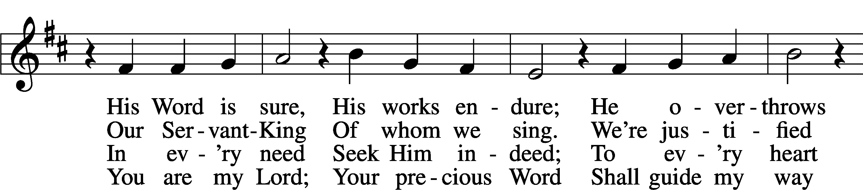

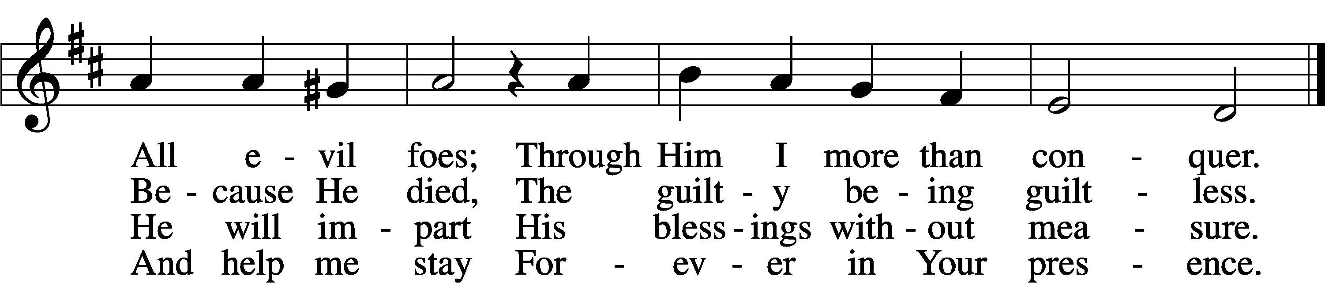

Text: Georg Weissel, 1590–1635; tr. Arthur P. Voss, 1899–1955, alt.  
Tune: Johann Stobäus, 1580–1646  
Text: © 1941 Concordia Publishing House. Used by permission: LSB Hymn License no. 110004798  
Tune: Public domain

SERMON OR MEDITATION ON THE READINGS

(Stand)

NICENE CREED

C **I believe in one God,**

**the Father Almighty,**

**maker of heaven and earth**

**and of all things visible and invisible.**

**And in one Lord Jesus Christ,**

**the only-begotten Son of God,**

**begotten of His Father before all worlds,**

**God of God, Light of Light,**

**very God of very God,**

**begotten, not made,**

**being of one substance with the Father,**

**by whom all things were made;**

**who for us men and for our salvation came down from heaven**

**and was incarnate by the Holy Spirit of the virgin Mary**

**and was made man;**

**and was crucified also for us under Pontius Pilate.**

**He suffered and was buried.**

**And the third day He rose again according to the Scriptures**

**and ascended into heaven**

**and sits at the right hand of the Father.**

**And He will come again with glory to judge both the living and the dead,**

**whose kingdom will have no end.**

**And I believe in the Holy Spirit,**

**the Lord and giver of life,**

**who proceeds from the Father and the Son,**

**who with the Father and the Son together is worshiped and glorified,**

**who spoke by the prophets.**

**And I believe in one holy Christian and apostolic Church,**

**I acknowledge one Baptism for the remission of sins,**

**and I look for the resurrection of the dead**

**and the life** T **of the world to come. Amen.**

SHARING OF THE PEACE

(Sit)

PRAYER OF THE CHURCH

OFFERING

(Stand)

OFFERTORY LSB 159

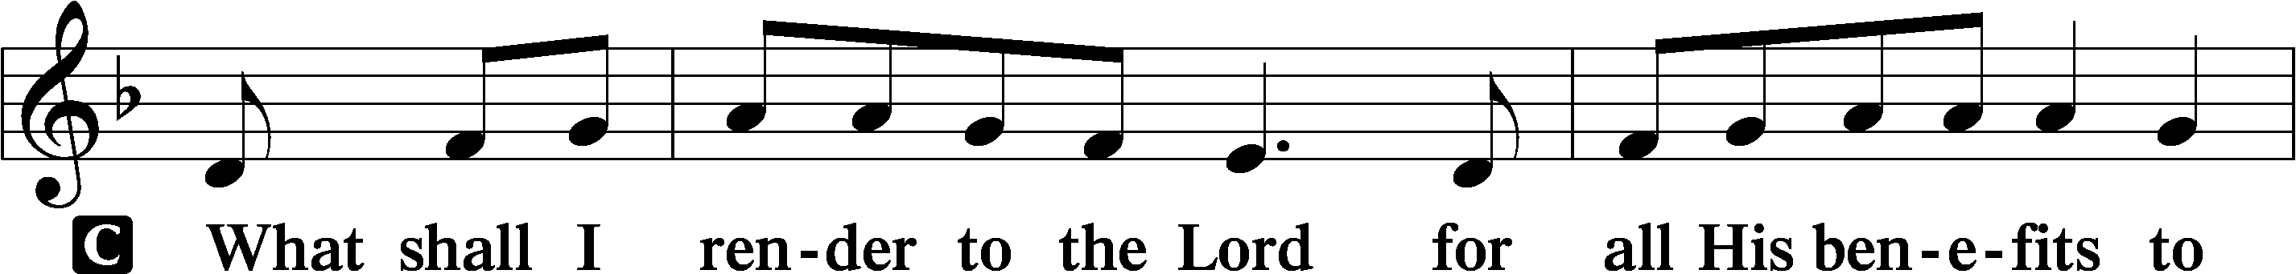

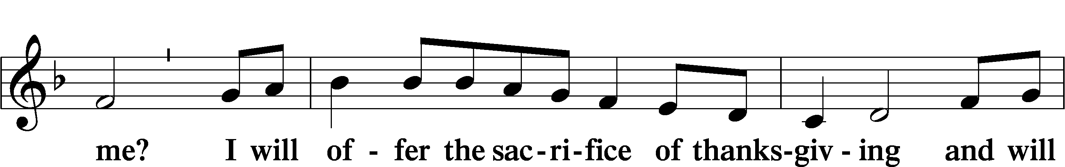

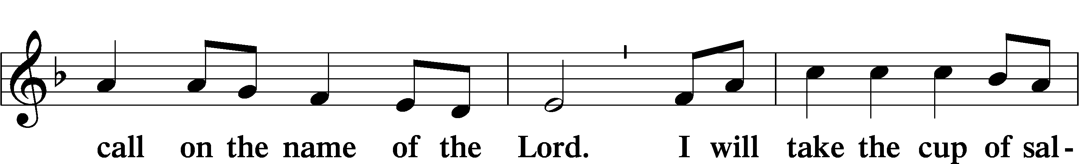

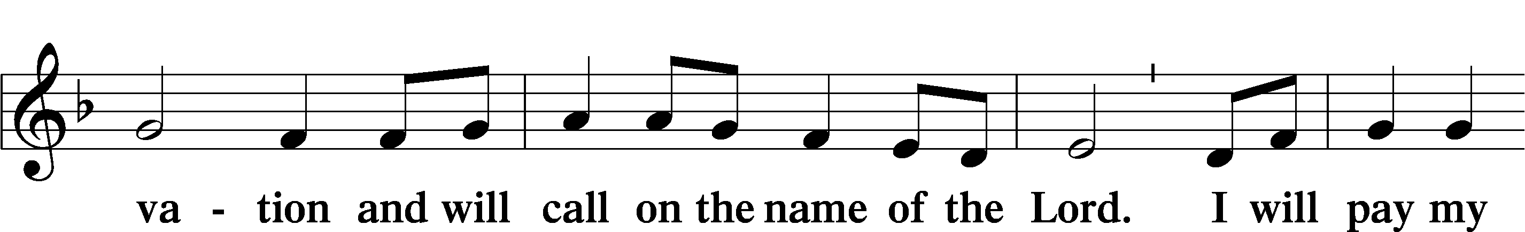

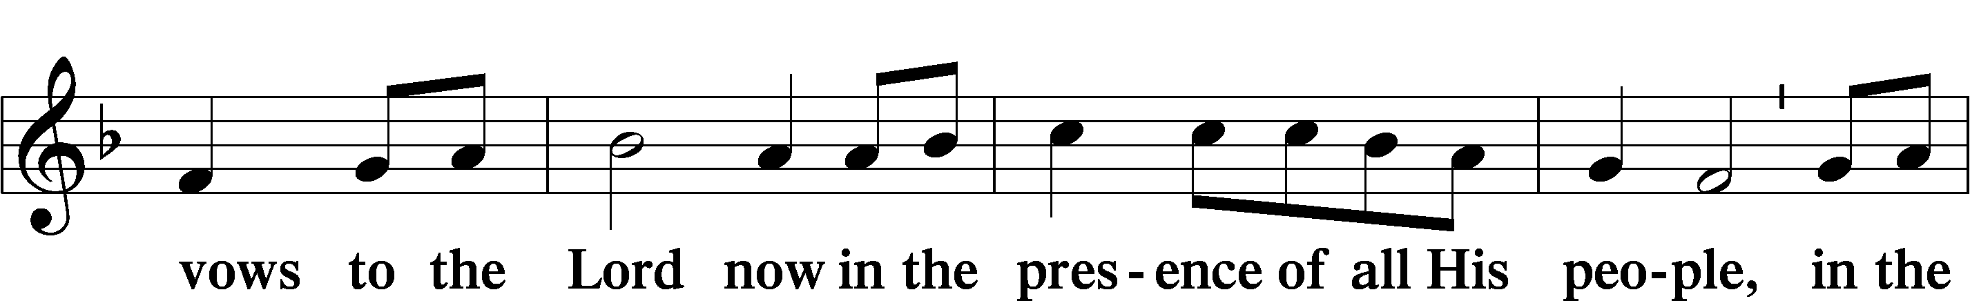

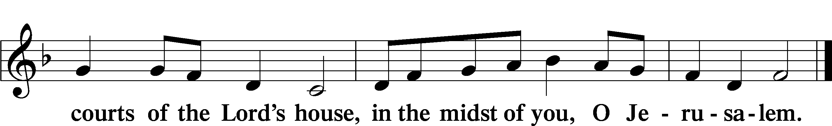

(Sit)

+ SERVICE OF THE SACRAMENT +

# Note: The Service of The Sacrament is included in the lay bulletin solely as a viewers’ guide for those watching the livestream service; *Communicant members who are unable to attend the Divine Service in person are encouraged to make arrangements with Pastor Engwall to receive the Lord’s Supper.*

PREFACE LSB 160











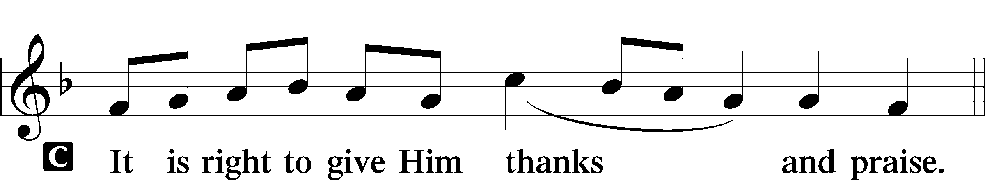

PROPER PREFACE (ABBREVIATED) LSB 161

P It is truly good, right, and salutary . . . evermore praising You and saying:

SANCTUS LSB 161

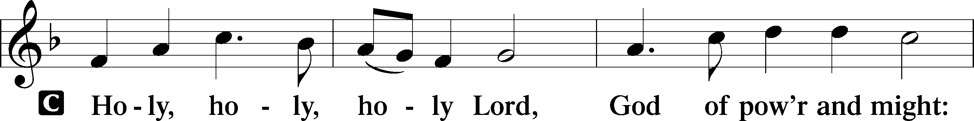

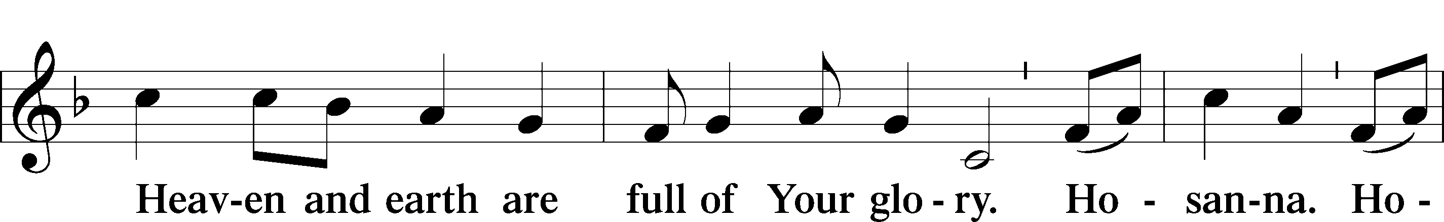

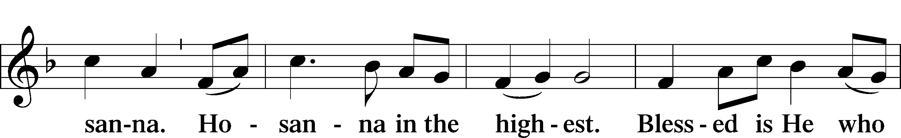

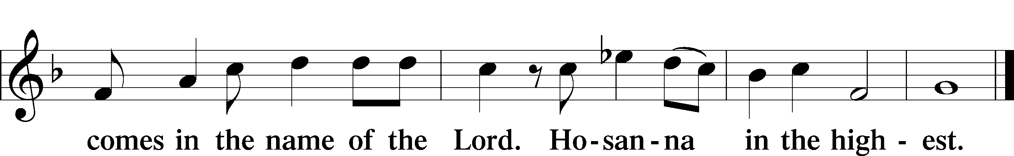

PRAYER OF THANKSGIVING LSB 161

LORD’S PRAYER

C **Our Father who art in heaven,**

**hallowed be Thy name,**

**Thy kingdom come,**

**Thy will be done on earth**

**as it is in heaven;**

**give us this day our daily bread;**

**and forgive us our trespasses**

**as we forgive those**

**who trespass against us;**

**and lead us not into temptation,**

**but deliver us from evil.**

**For Thine is the kingdom**

**and the power and the glory**

**forever and ever. Amen.**

THE WORDS OF OUR LORD

PAX DOMINI LSB 163

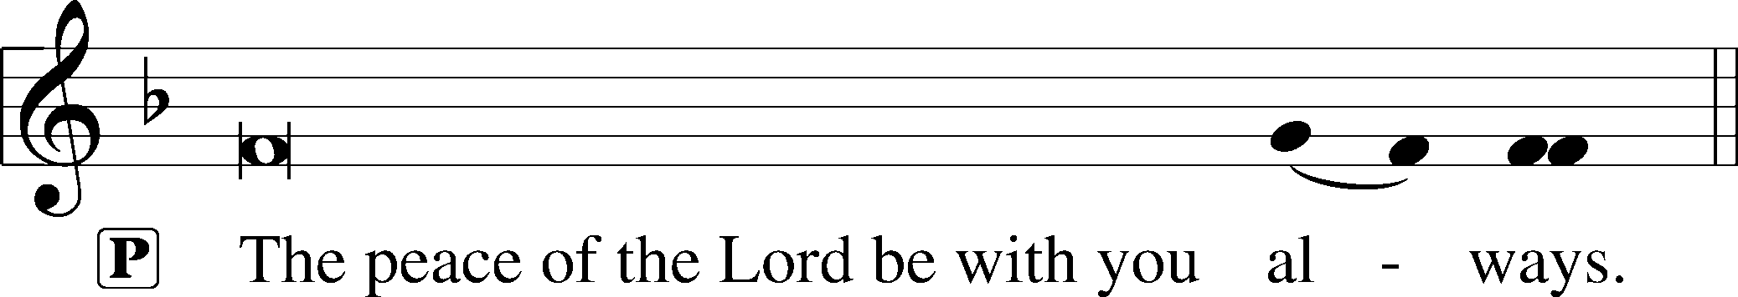



AGNUS DEI LSB 163

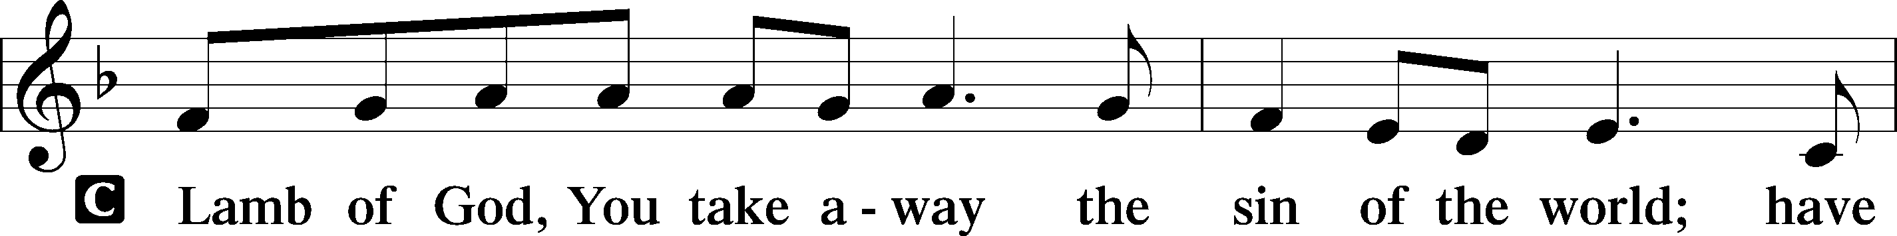

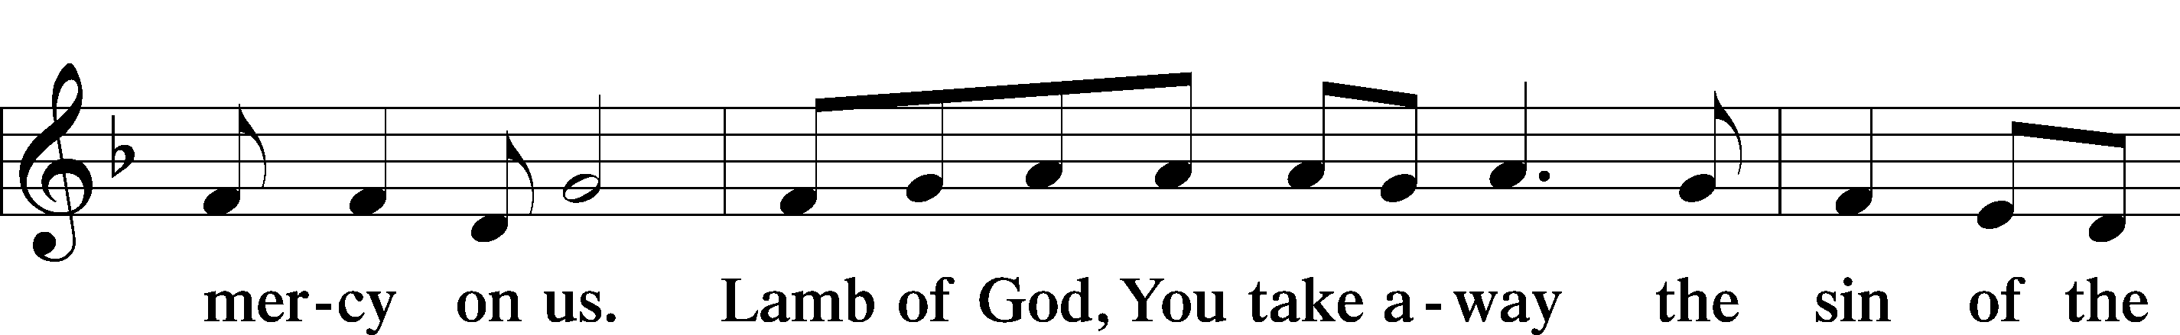

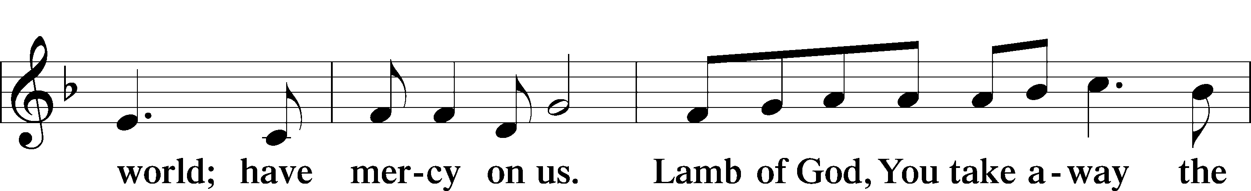

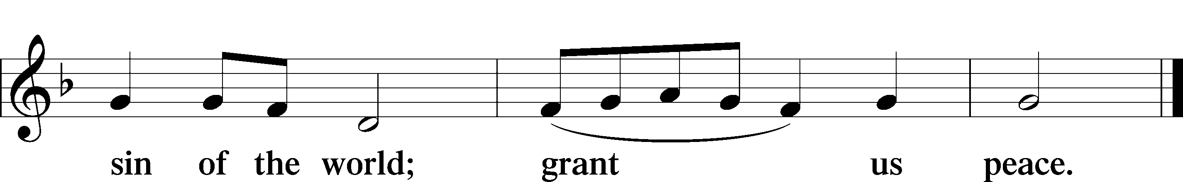

(Sit)

DISTRIBUTION

(The pastor and those who assist him receive the body and blood of Christ first and then distribute them to those who are unable to come to the altar. The ushers will then direct all other communicants to the altar..)

563 JESUS, THY BLOOD AND RIGHTEOUSNESS

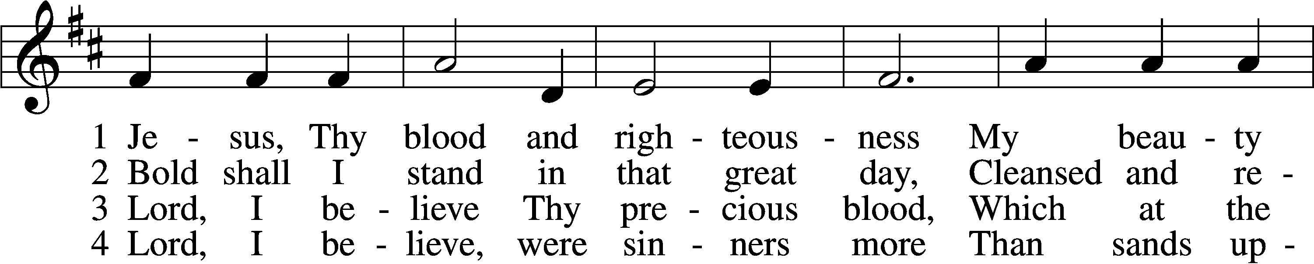

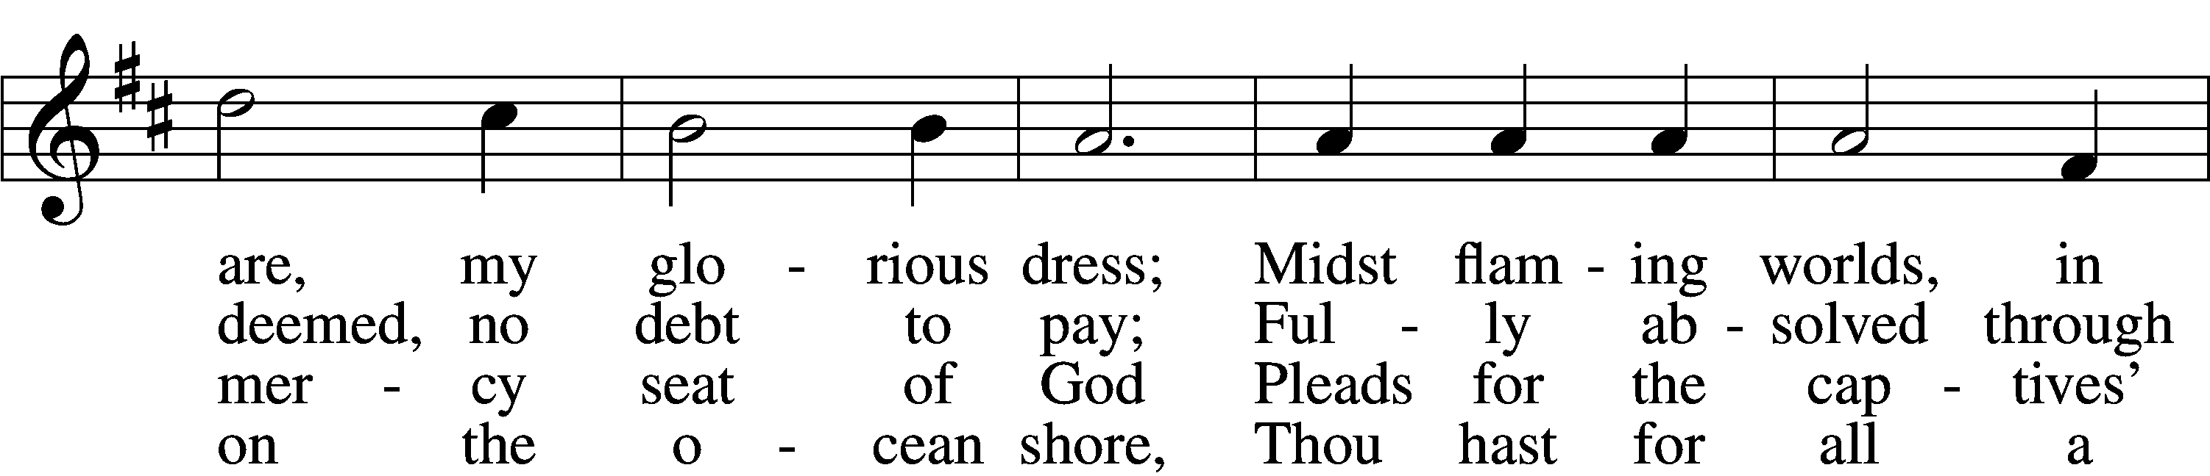

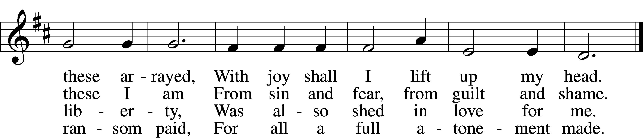

5 When from the dust of death I rise  
To claim my mansion in the skies,  
This then shall be my only plea:  
Jesus hath lived and died for me.

6 Jesus, be endless praise to Thee,  
Whose boundless mercy hath for me,  
For me, and all Thy hands have made,  
An everlasting ransom paid.

Text: Nicolaus Ludwig von Zinzendorf, 1700–60; tr. John B. Wesley, 1703–91, alt.  
Tune: George J. Elvey, 1816–93  
Text and tune: Public domain

INSTRUMENTAL

(Stand)

THANK THE LORD LSB 164

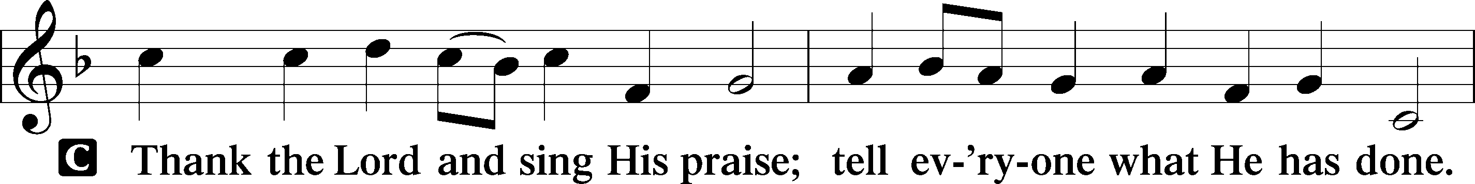

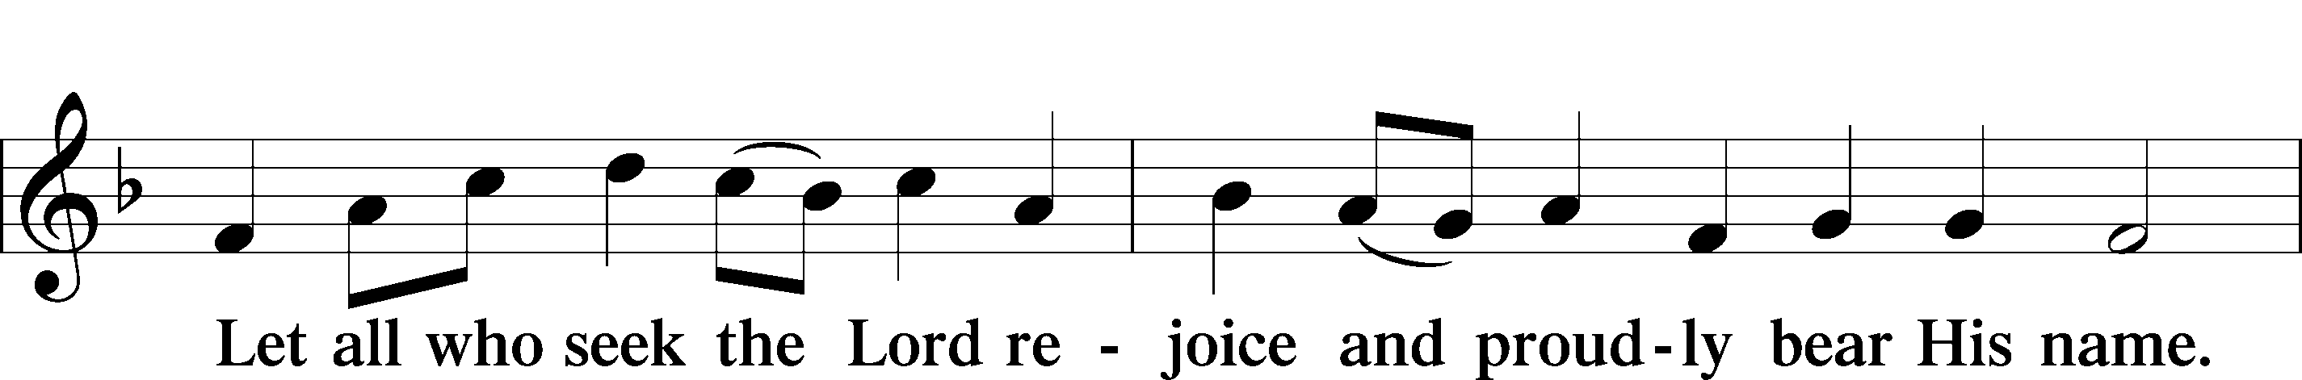

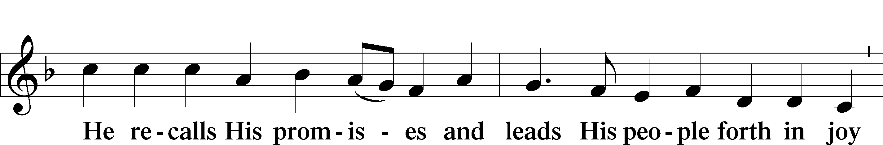

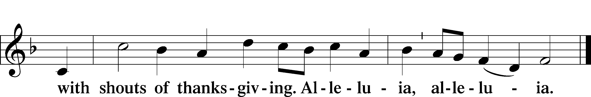

POST-COMMUNION COLLECT

__________________________________________________________

**BENEDICTION**

L: The grace of our Lord T Jesus Christ, and the love of God, and the fellowship of the Holy Spirit, be with us all.

C: **Amen.**

844 LORD OF ALL NATIONS, GRANT ME GRACE

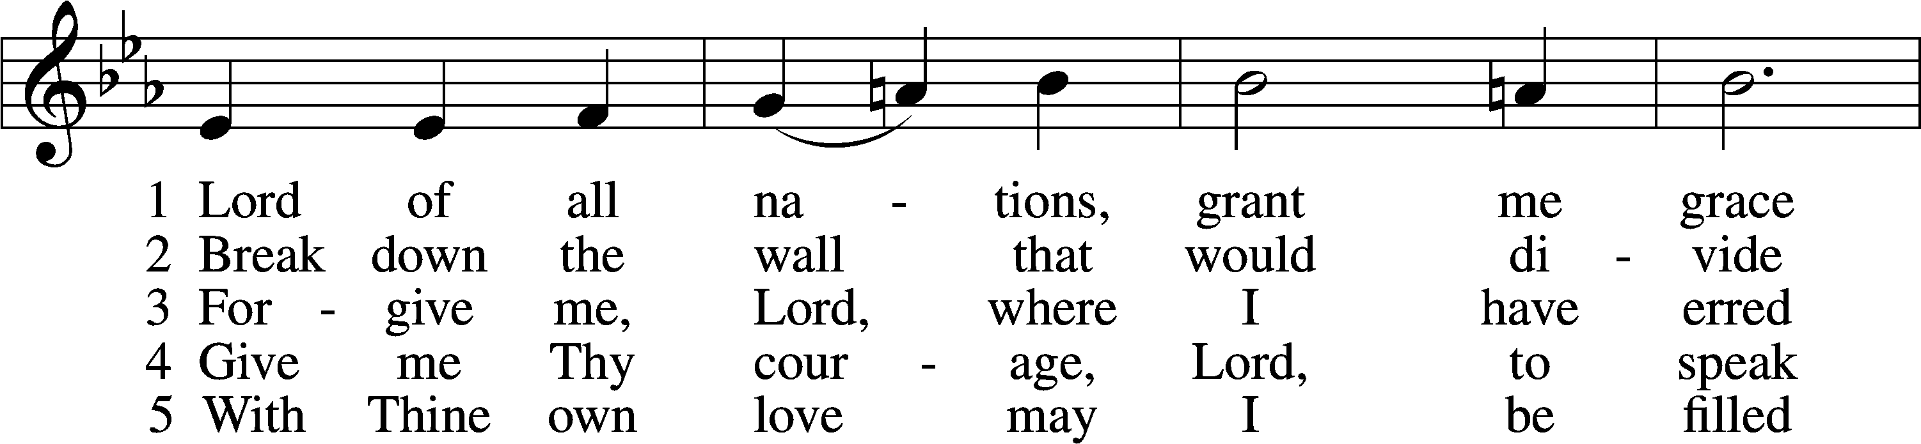

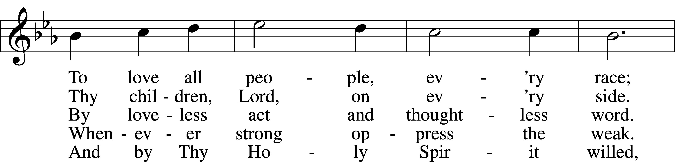

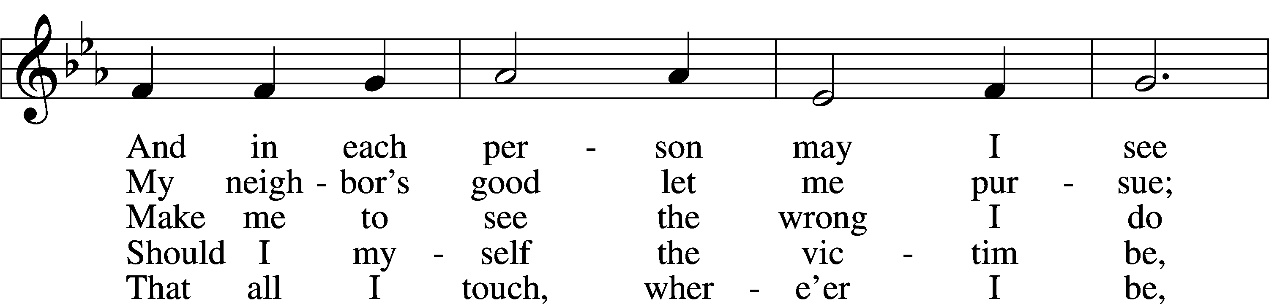

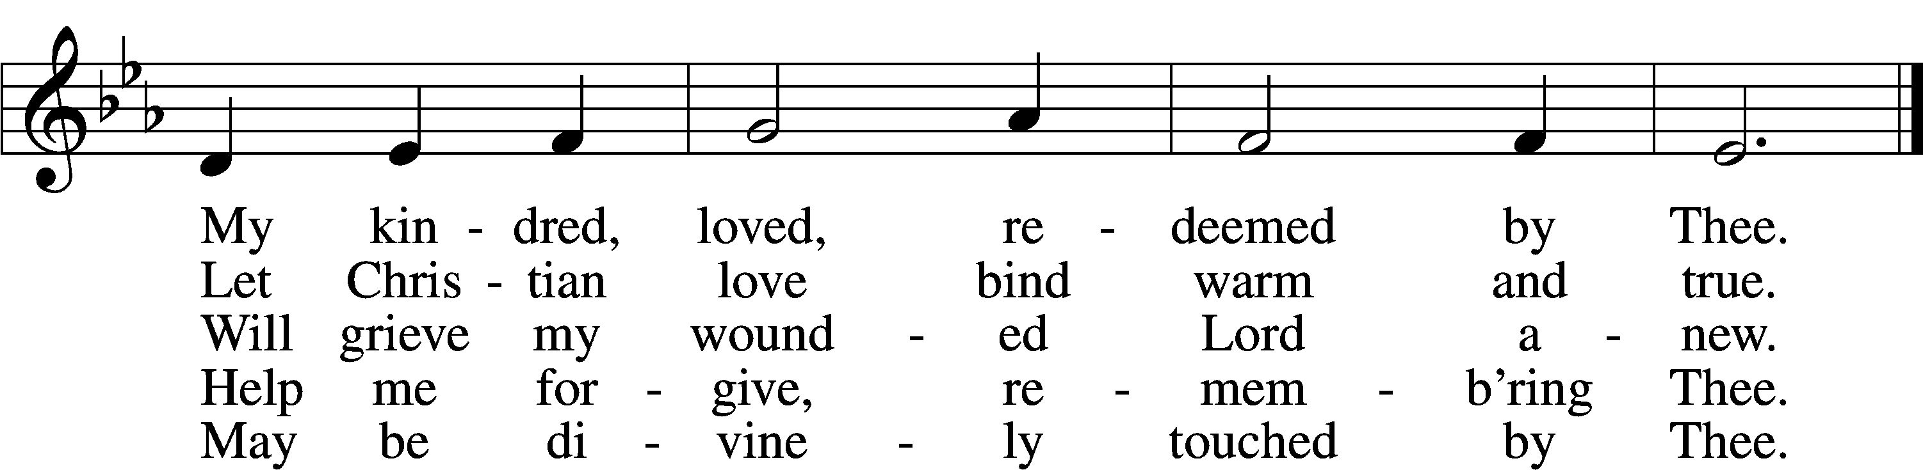

Text: Olive Wise Spannaus, 1916–2018, alt.  
Tune: Georg Joseph, 17th cent., adapt.  
Text: © 1969 Concordia Publishing House. Used by permission: LSB Hymn License no. 110004798  
Tune: Public domain

ACKNOWLEDGMENTS

Unless otherwise indicated, Scripture quotations are from the ESV® Bible (The Holy Bible, English Standard Version®), copyright © 2001 by Crossway, a publishing ministry of Good News Publishers. Used by permission. All rights reserved.

Created by Lutheran Service Builder © 2025 Concordia Publishing House.

**IN OUR PRAYERS:**



*Submitted petitions are included for two consecutive Sundays*



**For Those suffering afflictions of mind, body,or spirit:**

John M., Anne H., Jim S., Dennis S., Blake B., Carol R., Michele N., Mark K., Dean S.

**For missionaries**

Deaconess Sandra R., Rev. Jonathan A.

**All of our Shut- Ins:**

Betty A., Shirley F., Mary H., Patsy L., Herman L., Tommy, Pam and Jerome M., Sharon B.

**ANNOUNCEMENTS**

**Please email announcements for Sunday bulletins by 8:00 a.m. Tuesday to** [**pastorblcaiken@gmail.com**](mailto:pastorblcaiken@gmail.com)

**ALTAR FLOWERS:**

Today are donated by Rebecca S.

**TUESDAY AND WEDNESDAY BIBLE STUDIES:**

Due to pastor’s travel next month, this Tuesday will be our last Women’s Bible Study until October 28th, and October 1st will be our last Wednesday Bible Study until October 29th.

**LAY VOTING DELEGATE TO THE 2026 SYNOD CONVENTION;**

On Saturday, October 11th, our circuit will be electing the ordained and lay voting delegates and their alternates to represent our circuit at the 2026 Synod Convention. All parishes are to nominate a lay person for the slate of candidates.

**ACTS DONATION FOR OCTOBER:**

Canned meat; beef, chicken, salmon, tuna, etc.

**FELLOWSHIP COFFEE HOUR:**

Every Sunday morning, during Bible Study and after the Divine Service, coffee, treats and good fellowship are waiting for you in our Fellowship Hall!

**CALENDAR, NEWSLETTER, AND CHURCH DIRECTORY:**

Please provide any articles, calendar entries, announcements, photos, etc. for the *Star of Bethlehem* newsletter to Debbie C. no later than noon on the 23rd of each month. The *Star* calendar will also be used for the website. Updates to your church directory data may be provided at any time.

**Last week’s attendance:** 47

**Average weekly offering needed to make budget: $2,508**

|  |  |
| --- | --- |
| |  | | --- | |  | |
| |  | | --- | |  | |

**BE IN THE WORD!**

**SUNDAY MORNINGS AT 9 a.m.**

**Adult Bible Study**

**Sunday School for children and youth**

**TUESDAY MORNINGS AT 10:00 a.m.**

**Women’s Bible Study**

**WEDNESDAY EVENINGS AT 7 p.m.**

**Adult Bible Study**

**JUNIOR CONFIRMATION and ADULT INSTRUCTION**

**Always available by request:**

**Contact Pastor to schedule**

**OUR VALUE STATEMENT:**Bethlehem Lutheran Church exists under God’s grace to save the lost and to strengthen the saved so that they may live bold and courageous lives of Christian witness before a non-believing world.

**Therefore, our purpose is:**

**- to glorify God in Word and deed,**

**- to nurture each other in Christian love,**

**- to reach out to others with our Savior’s Gospel of life and salvation.**

**(Rom 5:8, Matt. 28:18-20).**

**OUR VISION:**By the Grace of God, Bethlehem Lutheran Church, is a loving family united in Christ, learning, living, and spreading His Word.

**OUR MISSION**: Learn the Word. Live the Word. Spread the Word.