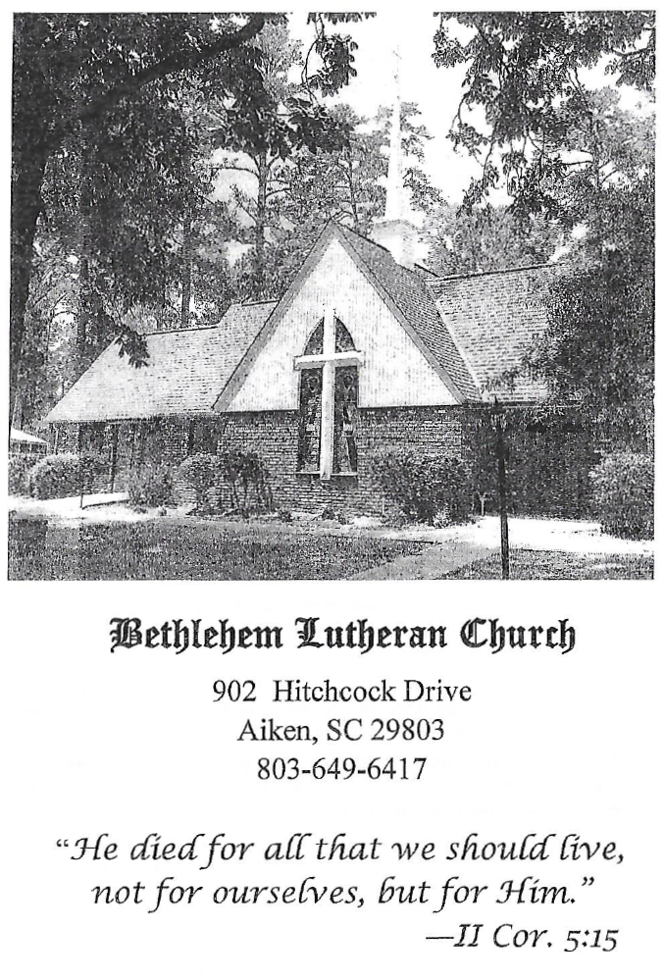

BETHLEHEM LUTHERAN CHURCH
A congregation of The Lutheran Church-Missouri Synod
902 Hitchcock Drive SW,
Aiken, South Carolina 29803
Church Phone: (803) 649-6417
blcaikensc@gmail.com

Bethlehem Lutheran welcomes our members and guests to our worship service! Unable to join us in person? Please find us on Facebook live. The service is also posted on our website; bethlehemlutheranaiken.org.

+ + + + + + + + + + + + + + +
Nineteenth Sunday after Pentecost
October 4, 2026
10:30 a.m.
+ + + + + + + + + + + + + + +

+ SERVICE OF PREPARATION +

(After the bell tolls, please observe a time of silence.)

WELCOME AND ANNOUNCEMENTS

(Stand)

426 WHEN I SURVEY THE WONDROUS CROSS
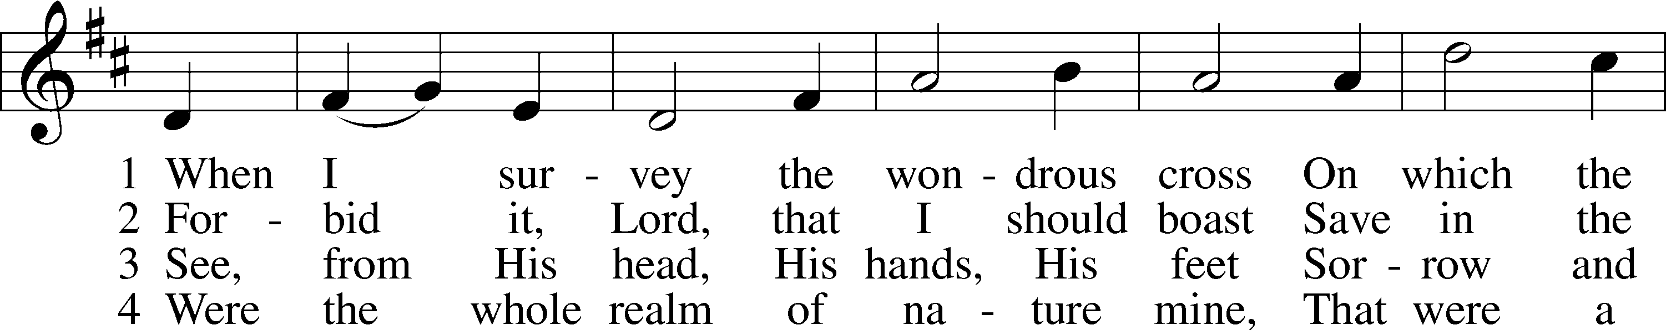
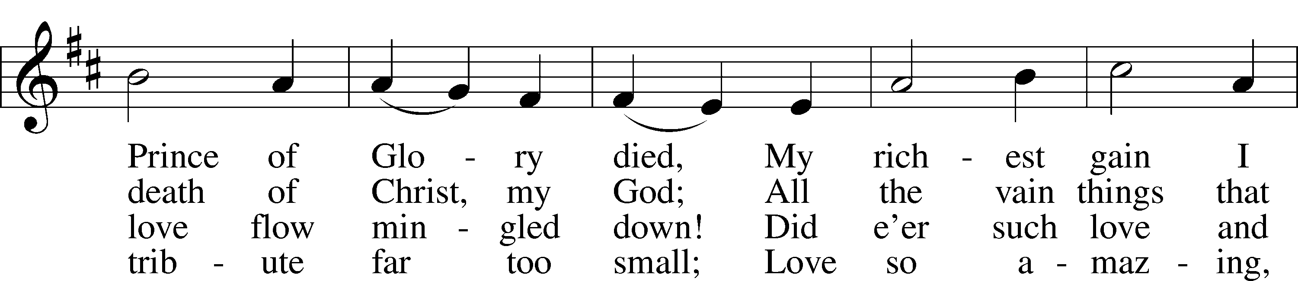
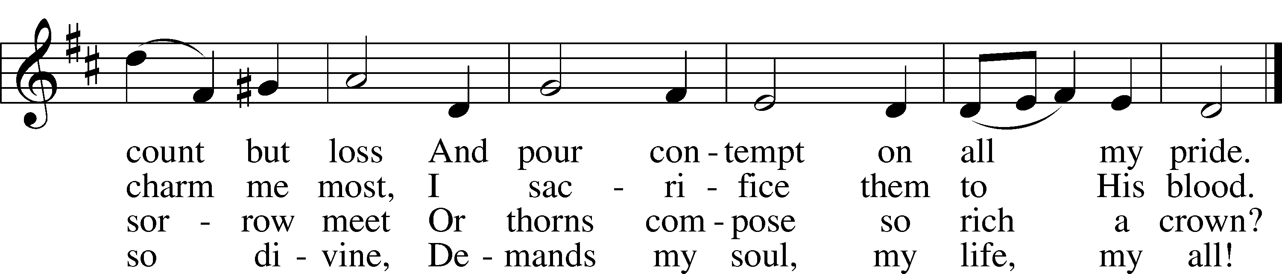
Text: Isaac Watts, 1674–1748
Tune: Second Supplement to Psalmody in Miniature, 1778, London; adapt. Edward Miller, 1731–1807
Text and tune: Public domain

+ CONFESSION AND ABSOLUTION +

(The sign of the cross may be made by all in remembrance of their Baptism.)

INVOCATION LSB 151
L In the name of the Father and of the T Son and of the Holy Spirit.
C Amen.

EXHORTATION LSB 151
L If we say we have no sin, we deceive ourselves, and the truth is not in us.
C But if we confess our sins, God, who is faithful and just, will forgive our sins and cleanse us from all unrighteousness.

(Silence for reflection on God’s Word and for self-examination.)

CONFESSION OF SINS LSB 151
L Let us then confess our sins to God our Father.
C Most merciful God, we confess that we are by nature sinful and unclean. We have sinned against You in thought, word, and deed, by what we have done and by what we have left undone. We have not loved You with our whole heart; we have not loved our neighbors as ourselves. We justly deserve Your present and eternal punishment. For the sake of Your Son, Jesus Christ, have mercy on us. Forgive us, renew us, and lead us, so that we may delight in Your will and walk in Your ways to the glory of Your holy name. Amen.

DECLARATION OF GRACE LSB 151
L In the mercy of almighty God, Jesus Christ was given to die for us, and for His sake God forgives us all our sins. To those who believe in Jesus Christ He gives the power to become the children of God and bestows on them the Holy Spirit. May the Lord, who has begun this good work in us, bring it to completion in the day of our Lord Jesus Christ.
C Amen.

+ SERVICE OF THE WORD +

INTROIT Psalm 118:22–24; antiphon: v. 1

Oh give thanks to the Lord, for | he is good;*
for his steadfast love endures for- | ever!
The stone that the builders re- | jected*
has become the | cornerstone.
This is the Lord’s | doing;*
it is marvelous | in our eyes.
This is the day that the | Lord has made;*
let us rejoice and be | glad in it.
Glory be to the Father and | to the Son*
and to the Holy | Spirit;
as it was in the be- | ginning,*
is now, and will be forever. | Amen.
Oh give thanks to the Lord, for | he is good;*
for his steadfast love endures for- | ever!

KYRIE LSB 152

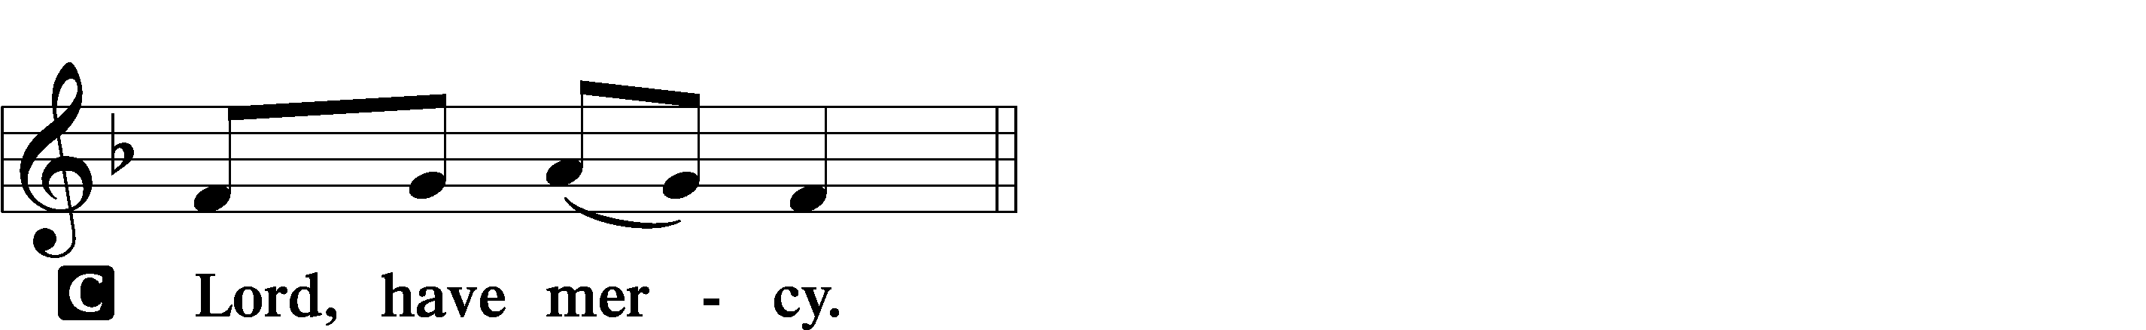

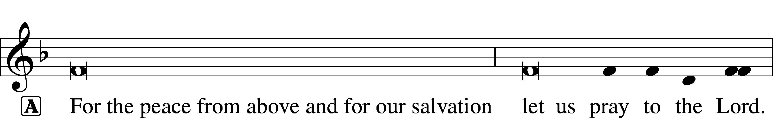
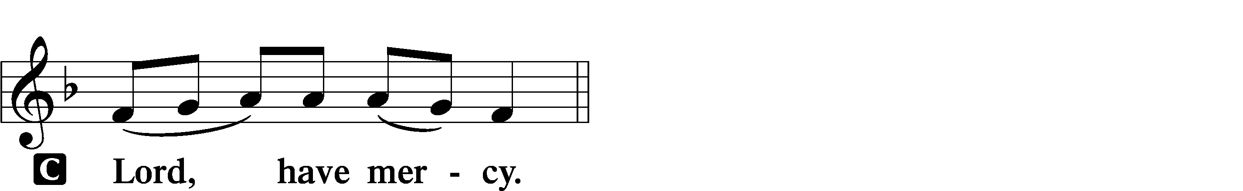

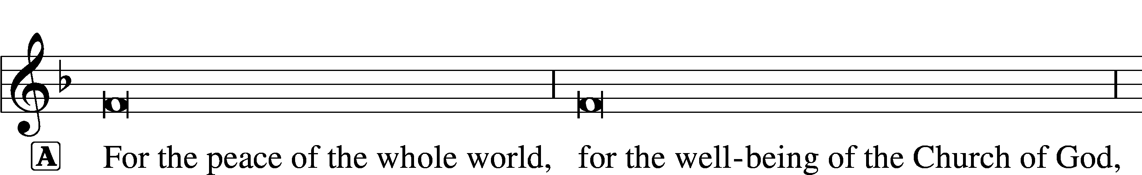
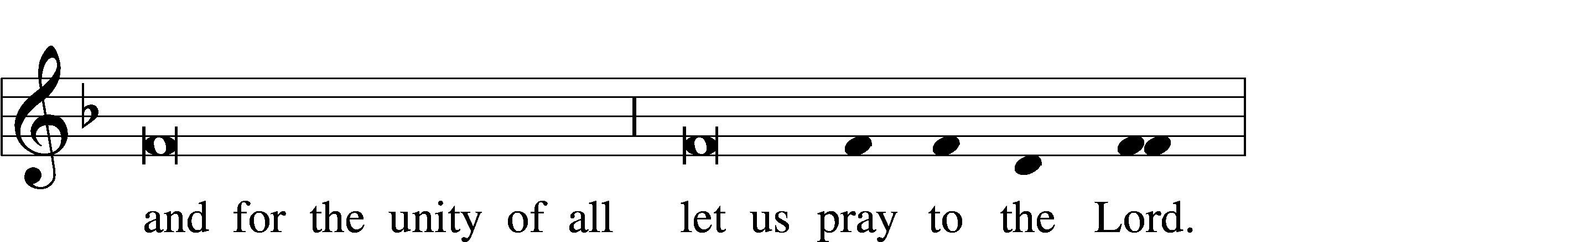
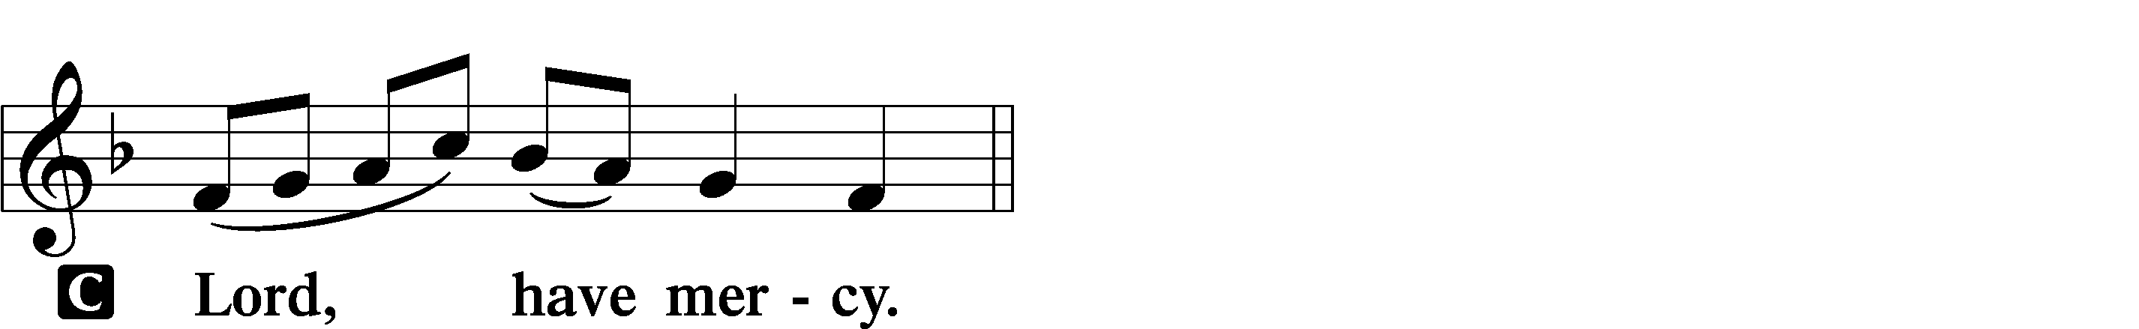

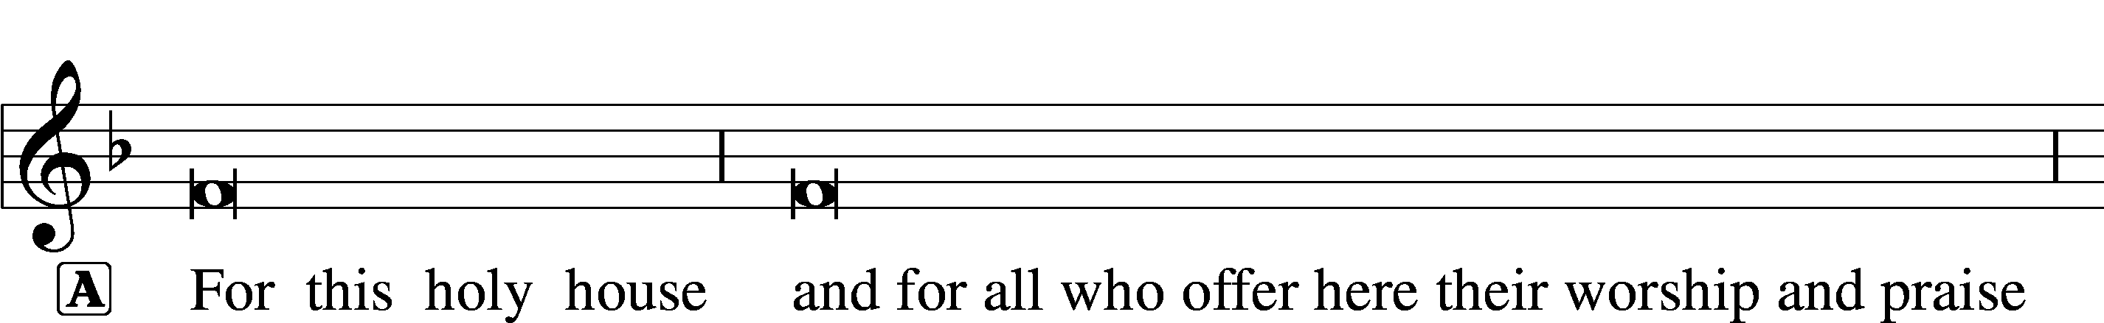

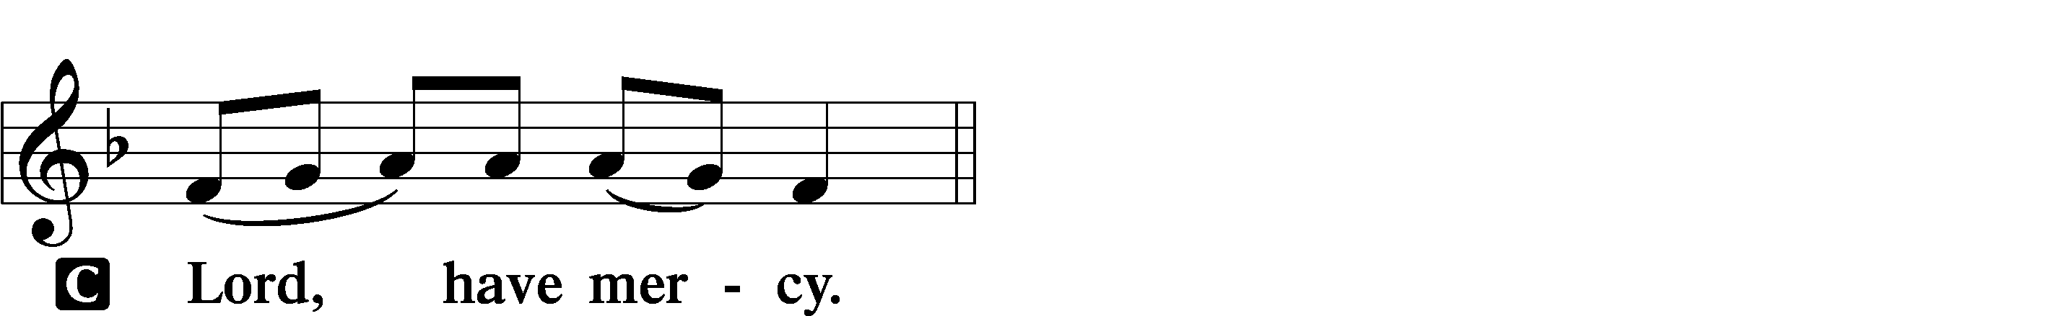

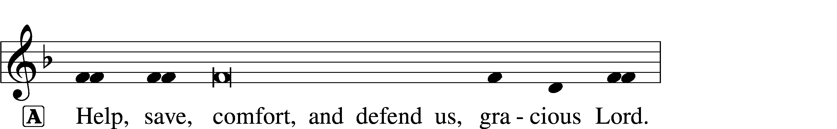


GLORIA IN EXCELSIS LSB 154
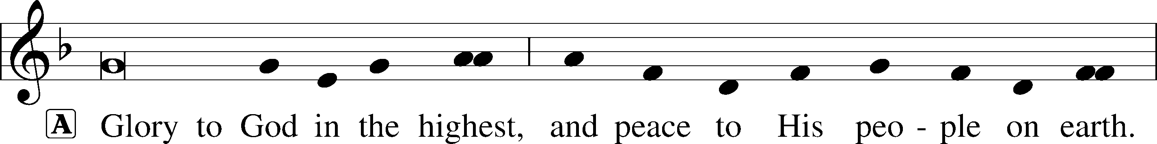
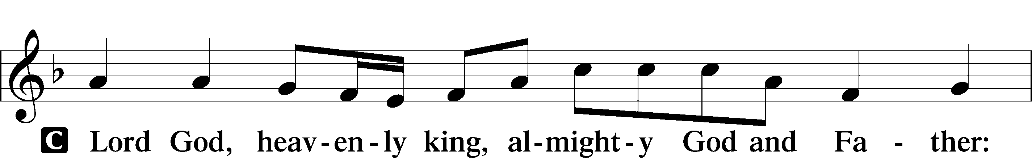
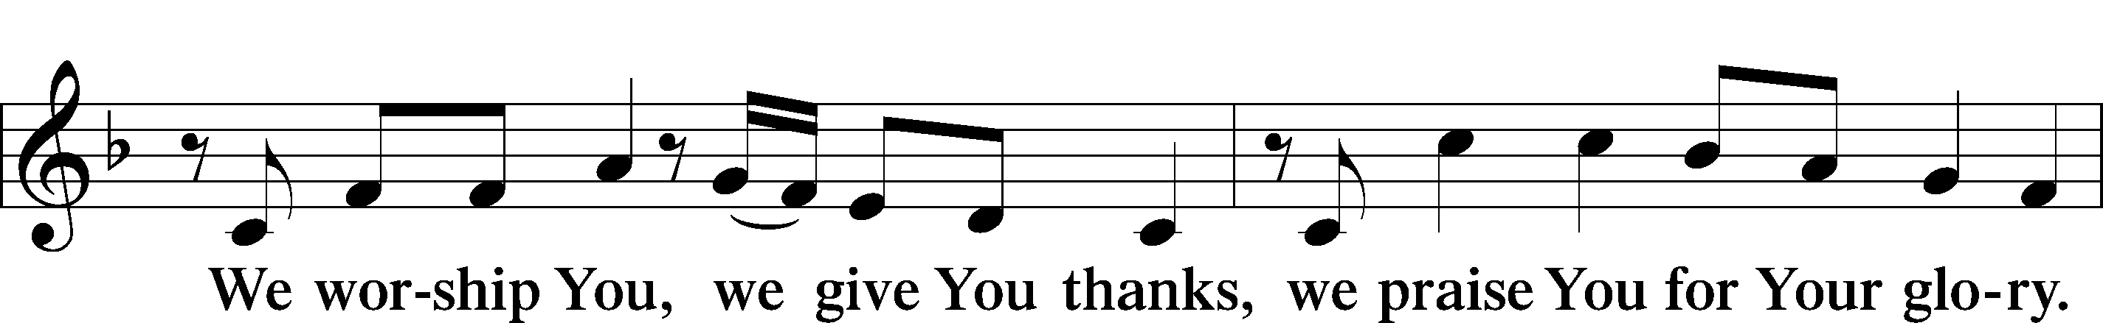
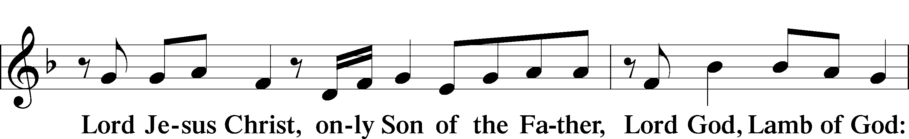
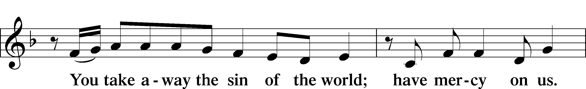
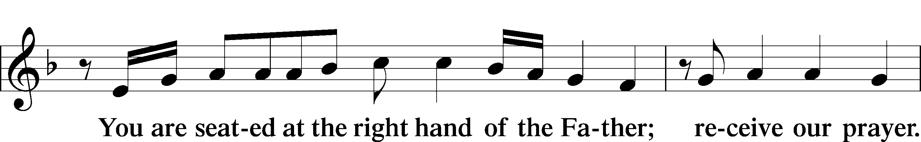
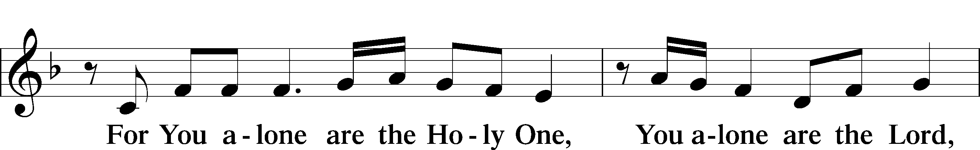
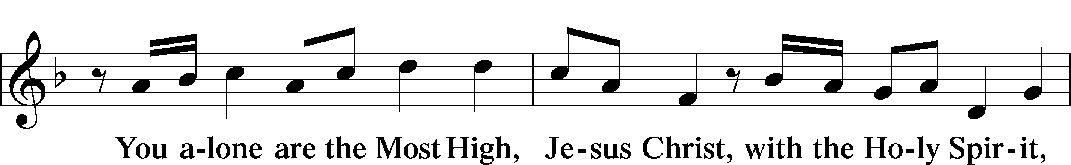
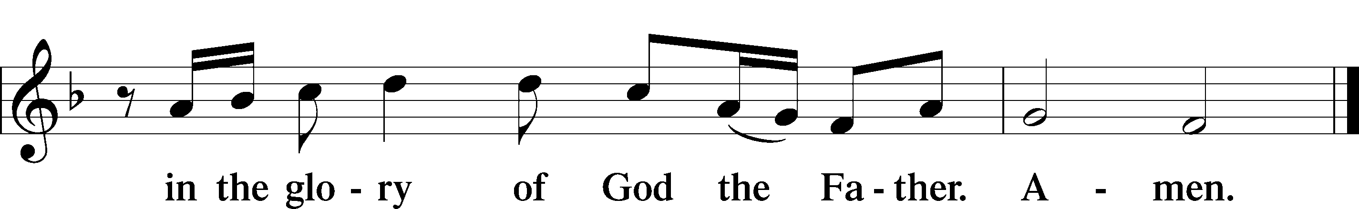

SALUTATION AND COLLECT OF THE DAY LSB 156
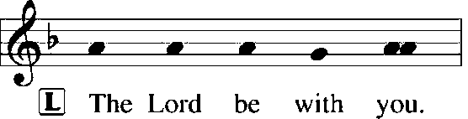
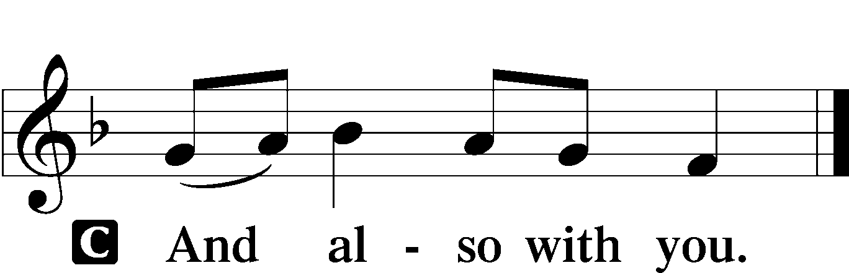

L Let us pray.
Gracious God, You gave Your Son into the hands of sinful men who killed Him. Forgive us when we reject Your unfailing love, and grant us the fullness of Your salvation; through Jesus Christ, Your Son, our Lord, who lives and reigns with You and the Holy Spirit, one God, now and forever.

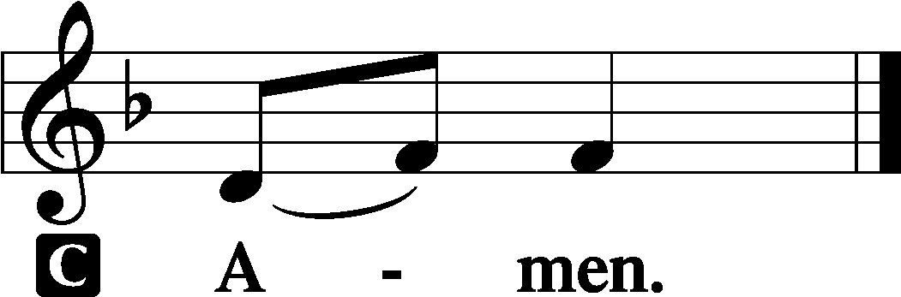

(Sit)

OLD TESTAMENT READING Isaiah 5:1–7
1Let me sing for my beloved
my love song concerning his vineyard:
My beloved had a vineyard
on a very fertile hill.
2He dug it and cleared it of stones,
and planted it with choice vines;
he built a watchtower in the midst of it,
and hewed out a wine vat in it;
and he looked for it to yield grapes,
but it yielded wild grapes.
3And now, O inhabitants of Jerusalem
and men of Judah,
judge between me and my vineyard.
4What more was there to do for my vineyard,
that I have not done in it?
When I looked for it to yield grapes,
why did it yield wild grapes?
5And now I will tell you
what I will do to my vineyard.
I will remove its hedge,
and it shall be devoured;
I will break down its wall,
and it shall be trampled down.
6I will make it a waste;
it shall not be pruned or hoed,
and briers and thorns shall grow up;
I will also command the clouds
that they rain no rain upon it.
7For the vineyard of the Lord of hosts
is the house of Israel,
and the men of Judah
are his pleasant planting;
and he looked for justice,
but behold, bloodshed;
for righteousness,
but behold, an outcry!

L This is the Word of the Lord.
C Thanks be to God.

GRADUAL Psalm 91:11; 103:1
He will command his angels con- | cerning you*
to guard you in | all your ways.
Bless the Lord, | O my soul,*
and all that is within me, bless his | holy name!

EPISTLE Philippians 3:4b–14
If anyone else thinks he has reason for confidence in the flesh, I have more: 5circumcised on the eighth day, of the people of Israel, of the tribe of Benjamin, a Hebrew of Hebrews; as to the law, a Pharisee; 6as to zeal, a persecutor of the church; as to righteousness, under the law blameless. 7But whatever gain I had, I counted as loss for the sake of Christ. 8Indeed, I count everything as loss because of the surpassing worth of knowing Christ Jesus my Lord. For his sake I have suffered the loss of all things and count them as rubbish, in order that I may gain Christ 9and be found in him, not having a righteousness of my own that comes from the law, but that which comes through faith in Christ, the righteousness from God that depends on faith— 10that I may know him and the power of his resurrection, and may share his sufferings, becoming like him in his death, 11that by any means possible I may attain the resurrection from the dead.
12Not that I have already obtained this or am already perfect, but I press on to make it my own, because Christ Jesus has made me his own. 13Brothers, I do not consider that I have made it my own. But one thing I do: forgetting what lies behind and straining forward to what lies ahead, 14I press on toward the goal for the prize of the upward call of God in Christ Jesus.

L This is the Word of the Lord.
C Thanks be to God.

(Stand)

ALLELUIA AND VERSE LSB 156
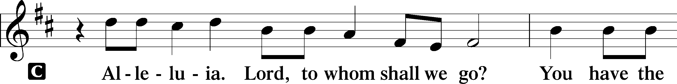
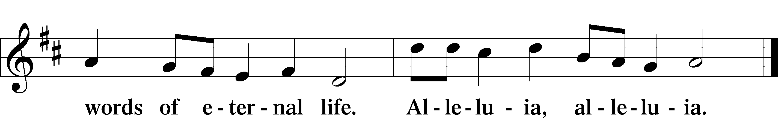

HOLY GOSPEL Matthew 21:33–46
L The Holy Gospel according to St. Matthew, the twenty-first chapter.

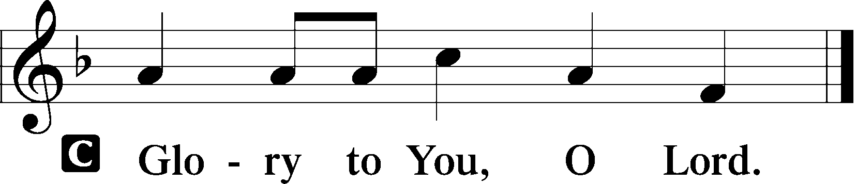

33[Jesus said:] “Hear another parable. There was a master of a house who planted a vineyard and put a fence around it and dug a winepress in it and built a tower and leased it to tenants, and went into another country. 34When the season for fruit drew near, he sent his servants to the tenants to get his fruit. 35And the tenants took his servants and beat one, killed another, and stoned another. 36Again he sent other servants, more than the first. And they did the same to them. 37Finally he sent his son to them, saying, ‘They will respect my son.’ 38But when the tenants saw the son, they said to themselves, ‘This is the heir. Come, let us kill him and have his inheritance.’ 39And they took him and threw him out of the vineyard and killed him. 40When therefore the owner of the vineyard comes, what will he do to those tenants?” 41They said to him, “He will put those wretches to a miserable death and let out the vineyard to other tenants who will give him the fruits in their seasons.”

(next page)

42Jesus said to them, “Have you never read in the Scriptures:
“‘The stone that the builders rejected
has become the cornerstone;
this was the Lord’s doing,
and it is marvelous in our eyes’?
43Therefore I tell you, the kingdom of God will be taken away from you and given to a people producing its fruits. 44And the one who falls on this stone will be broken to pieces; and when it falls on anyone, it will crush him.”
45When the chief priests and the Pharisees heard his parables, they perceived that he was speaking about them. 46And although they were seeking to arrest him, they feared the crowds, because they held him to be a prophet.

L This is the Gospel of the Lord.

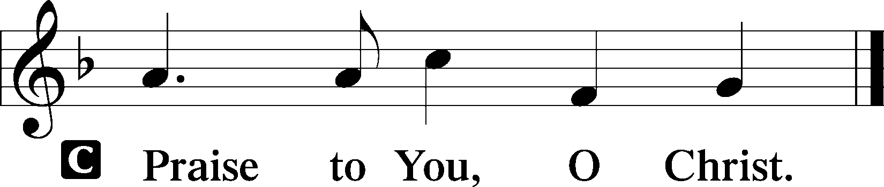

(Sit)

544 O LOVE, HOW DEEP
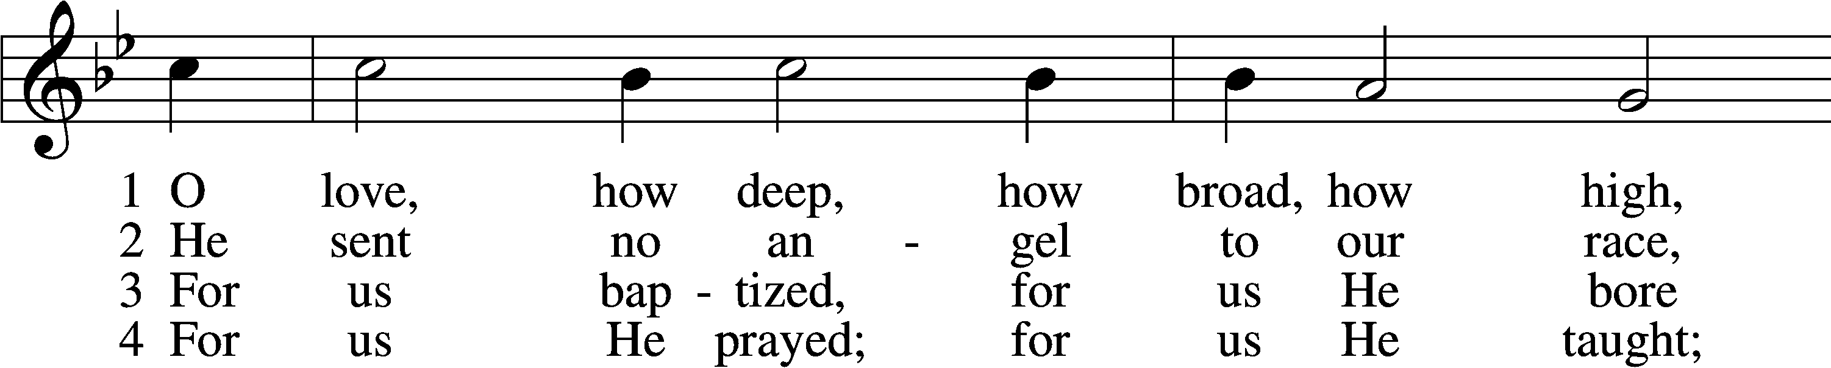
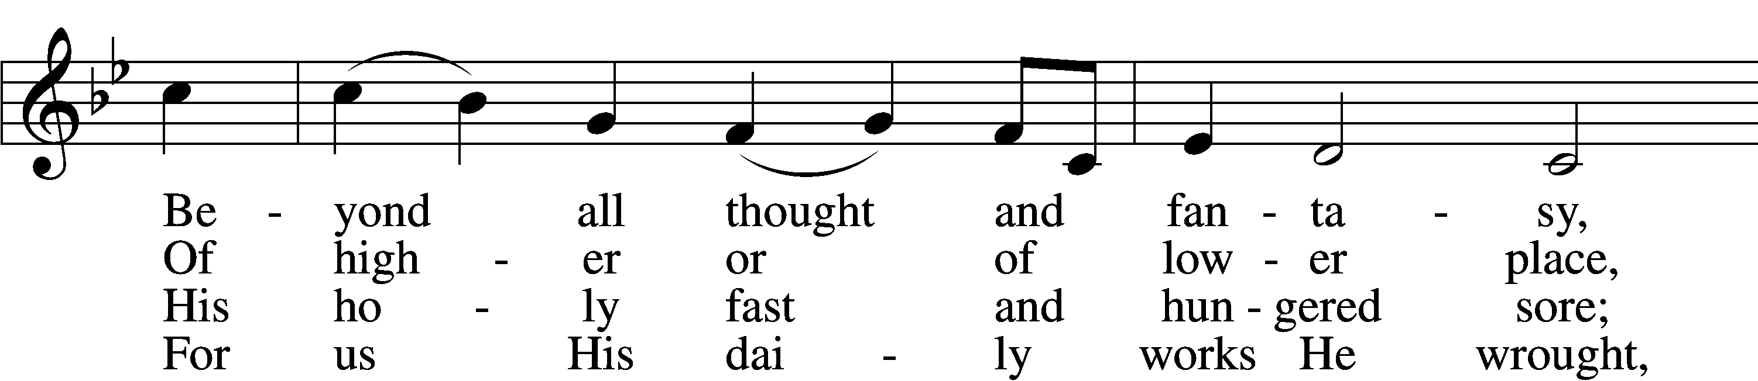
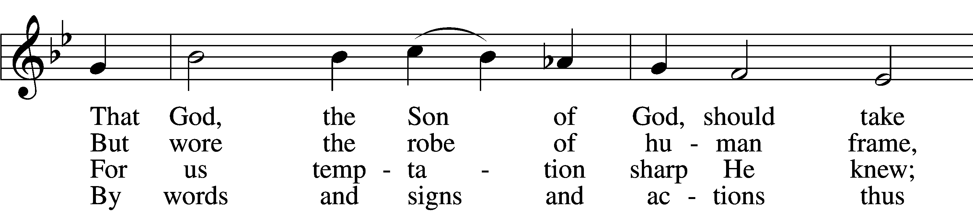
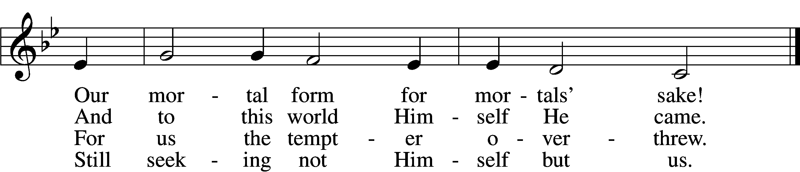

5 For us by wickedness betrayed,
For us, in crown of thorns arrayed,
He bore the shameful cross and death;
For us He gave His dying breath.

6 For us He rose from death again;
For us He went on high to reign;
For us He sent His Spirit here
To guide, to strengthen, and to cheer.

D 7 All glory to our Lord and God
For love so deep, so high, so broad;
The Trinity whom we adore
Forever and forevermore.
Text: attr. Thomas à Kempis, 1380–1471; tr. Benjamin Webb, 1819–85, alt.
Tune: English, 15th cent.
Text: Public domain

SERMON

(Sermons for Elder led services are provided courtesy of the Lutheran Church - Canada (https://www.lutheranchurchcanada.ca/resources/written-sermons/), a member of the International Lutheran Council (https://ilcouncil.org/) with whom the Lutheran Church - Missouri Synod (https://www.lcms.org/) is in altar and pulpit fellowship.)

955 LET THE VINEYARDS BE FRUITFUL
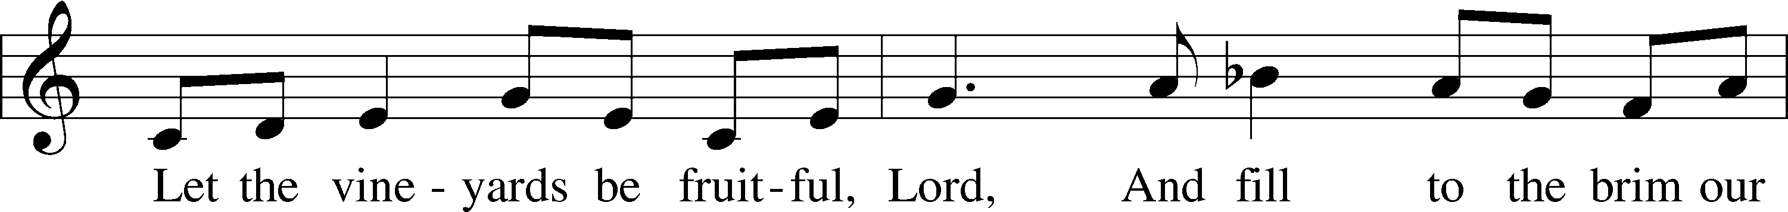
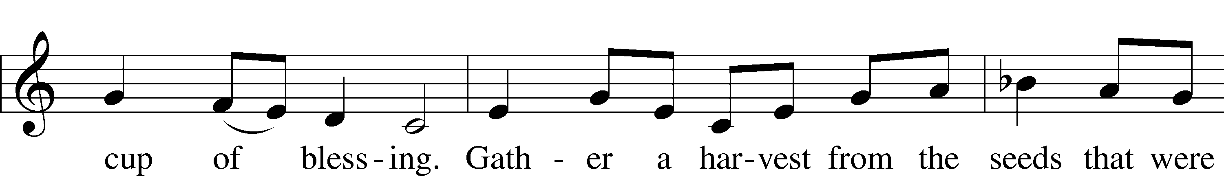
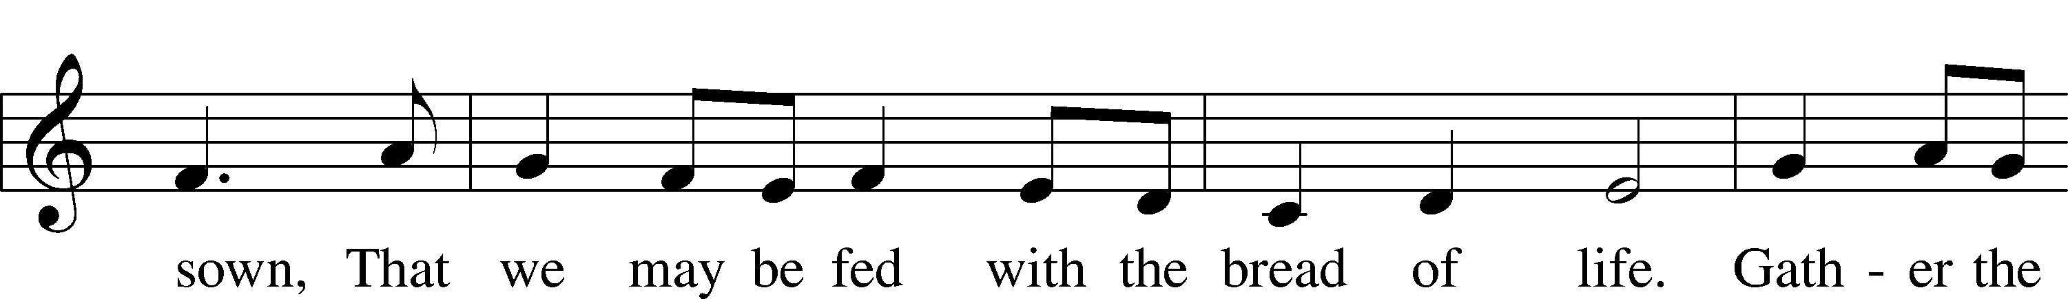
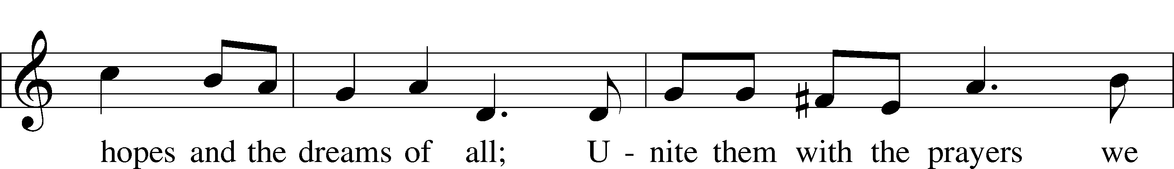
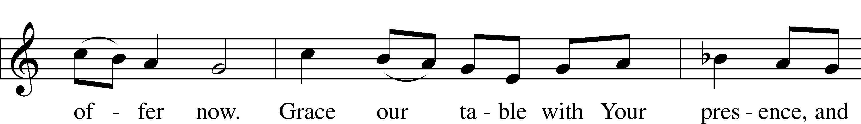
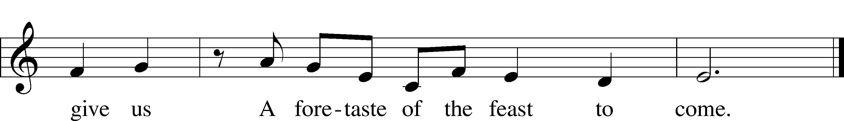
Text: John W. Arthur, 1922–80
Tune: Richard W. Hillert, 1923–2010
Text and tune: © 1978 Lutheran Book of Worship. Used by permission: LSB Hymn License no. 110004798

(Stand)

APOSTLES’ CREED LSB 159
C I believe in God, the Father Almighty,
maker of heaven and earth.

And in Jesus Christ, His only Son, our Lord,
who was conceived by the Holy Spirit,
born of the virgin Mary,
suffered under Pontius Pilate,
was crucified, died and was buried.
He descended into hell.
The third day He rose again from the dead.
He ascended into heaven
and sits at the right hand of God the Father Almighty.
From thence He will come to judge the living and the dead.

I believe in the Holy Spirit,
the holy Christian Church,
the communion of saints,
the forgiveness of sins,
the resurrection of the body,
and the life T everlasting. Amen.

SHARING OF THE PEACE

(The people may greet one another in the name of the Lord, saying, “Peace be with you,” as a sign of reconciliation and of the unity of the Spirit in the bond of peace (Matt. 5:22–24; Eph. 4:1–3).)

(Sit)

PRAYER OF THE CHURCH

OFFERING

(As a part of our expression of thanksgiving to God for the treasure of His salvation to us, we offer a portion of our treasure, according to what each has determined in their heart to give. Please place offerings in the collection plate at the back of the sanctuary before or after the service. Offerings can also be sent to Bethlehem Lutheran Church via U.S. Mail. Thank you!)

(Stand)

OFFERTORY LSB 159
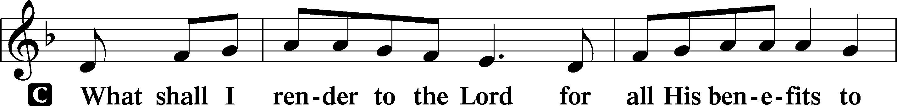
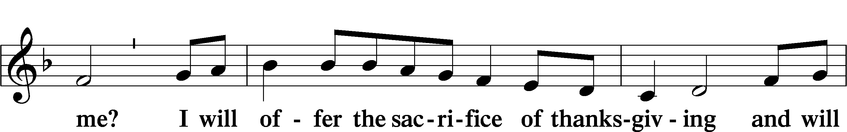
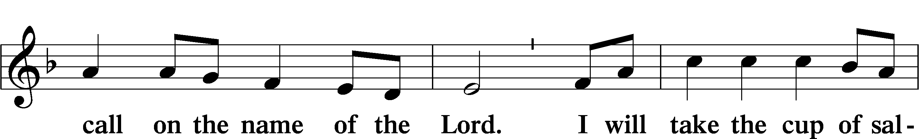
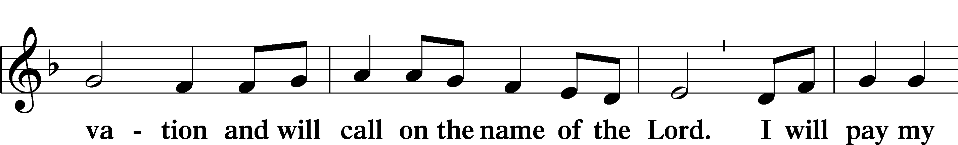
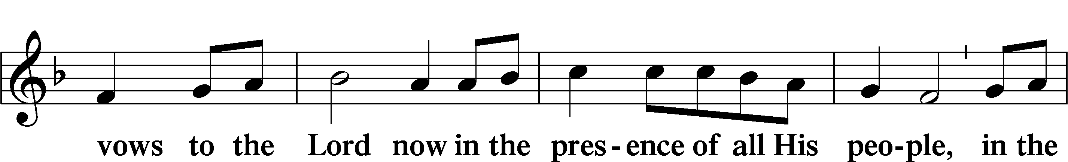
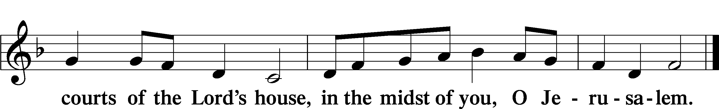

LORD’S PRAYER LSB 162
L Lord, remember us in Your kingdom and teach us to pray:
C Our Father who art in heaven,
hallowed be Thy name,
Thy kingdom come,
Thy will be done on earth
as it is in heaven;
give us this day our daily bread;
and forgive us our trespasses
as we forgive those
who trespass against us;
and lead us not into temptation,
but deliver us from evil.
For Thine is the kingdom
and the power and the glory
forever and ever. Amen.

CONCLUDING COLLECT

BENEDICTION LSB 166
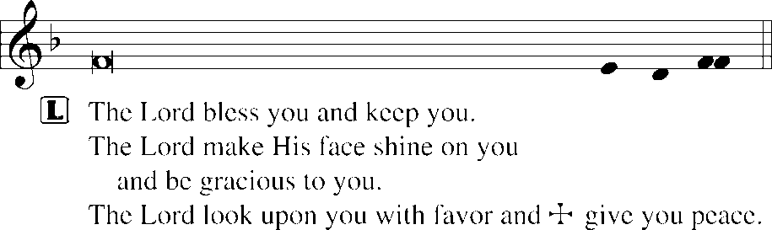


912 CHRIST IS OUR CORNERSTONE
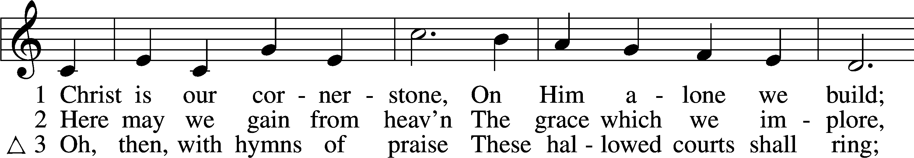
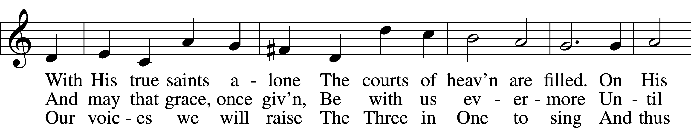
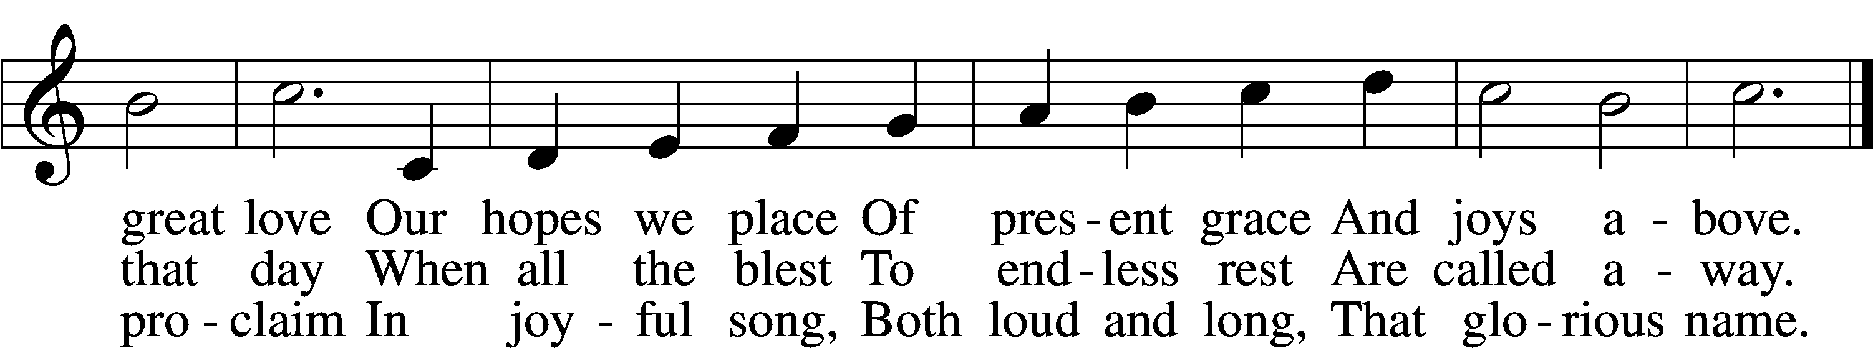
Text: Latin, c. 8th cent.; tr. John Chandler, 1806–76, alt.
Tune: John Darwall, 1731–89
Text and tune: Public domain
ACKNOWLEDGMENTS
Unless otherwise indicated, Scripture quotations are from the ESV® Bible (The Holy Bible, English Standard Version®), copyright © 2001 by Crossway, a publishing ministry of Good News Publishers. Used by permission. All rights reserved.
Created by Lutheran Service Builder © 2026 Concordia Publishing House.

