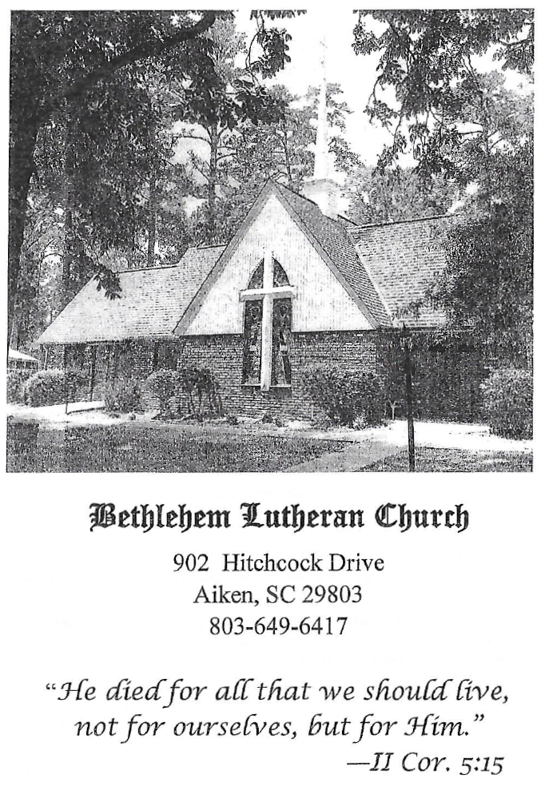

BETHLEHEM LUTHERAN CHURCH
A congregation of The Lutheran Church-Missouri Synod
902 Hitchcock Drive SW,
Aiken, South Carolina 29803
Church Phone: (803) 649-6417
blcaikensc@gmail.com

Bethlehem Lutheran welcomes our members and guests to our worship service! Unable to join us in person? Please find us on Facebook live. The service is also posted on our website; bethlehemlutheranaiken.org.

+ + + + + + + + + + + + + + +
Twelfth Sunday after Pentecost
August 16, 2026
10:30 a.m.
+ + + + + + + + + + + + + + +

+ SERVICE OF PREPARATION +

(After the bell tolls, please observe a time of silence.)

WELCOME AND ANNOUNCEMENTS

(Stand)

832 JESUS SHALL REIGN
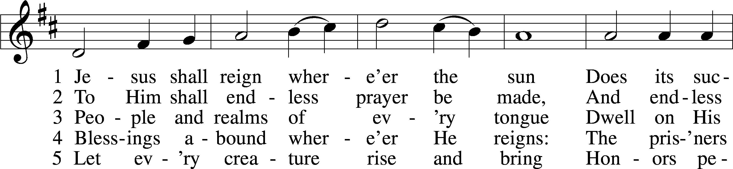
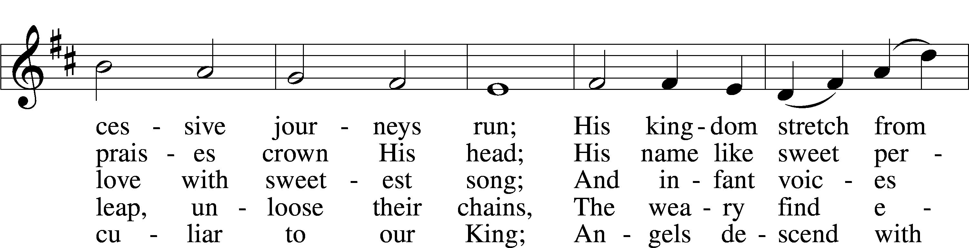
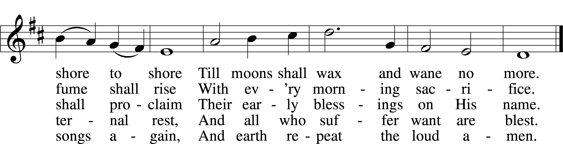
Text: Isaac Watts, 1674–1748, alt.
Tune: attr. John C. Hatton, d. 1793
Text and tune: Public domain

+ CONFESSION AND ABSOLUTION +

(The sign of the cross may be made by all in remembrance of their Baptism.)

INVOCATION LSB 151
L In the name of the Father and of the T Son and of the Holy Spirit.
C Amen.

EXHORTATION LSB 151
L If we say we have no sin, we deceive ourselves, and the truth is not in us.
C But if we confess our sins, God, who is faithful and just, will forgive our sins and cleanse us from all unrighteousness.

(Silence for reflection on God’s Word and for self-examination.)

CONFESSION OF SINS LSB 151
L Let us then confess our sins to God our Father.
C Most merciful God, we confess that we are by nature sinful and unclean. We have sinned against You in thought, word, and deed, by what we have done and by what we have left undone. We have not loved You with our whole heart; we have not loved our neighbors as ourselves. We justly deserve Your present and eternal punishment. For the sake of Your Son, Jesus Christ, have mercy on us. Forgive us, renew us, and lead us, so that we may delight in Your will and walk in Your ways to the glory of Your holy name. Amen.

DECLARATION OF GRACE LSB 151
L In the mercy of almighty God, Jesus Christ was given to die for us, and for His sake God forgives us all our sins. To those who believe in Jesus Christ He gives the power to become the children of God and bestows on them the Holy Spirit. May the Lord, who has begun this good work in us, bring it to completion in the day of our Lord Jesus Christ.
C Amen.

+ SERVICE OF THE WORD +

INTROIT Psalm 28:1–2, 6–7; antiphon: v. 8

The Lord is the strength of his | people;*
he is the saving refuge of his a- | nointed.
To you, O Lord, I call; my rock, be not | deaf to me,*
lest, if you be silent to me, I become like those who go down | to the pit.
Hear the voice of my pleas for mercy, when I cry to | you for help,*
when I lift up my hands toward your most holy sanctu- | ary.
Blessèd | be the Lord!*
For he has heard the voice of my pleas for | mercy.
The Lord is my strength and my shield; in him my heart trusts, and | I am helped;*
my heart exults, and with my song I give | thanks to him.
Glory be to the Father and | to the Son*
and to the Holy | Spirit;
as it was in the be- | ginning,*
is now, and will be forever. | Amen.
The Lord is the strength of his | people;*
he is the saving refuge of his a- | nointed.

KYRIE LSB 152
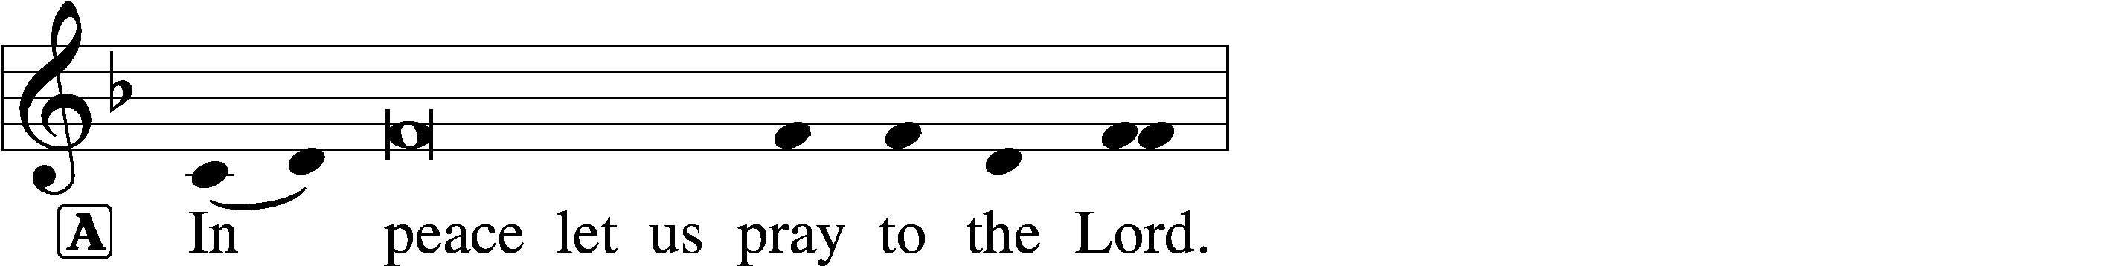
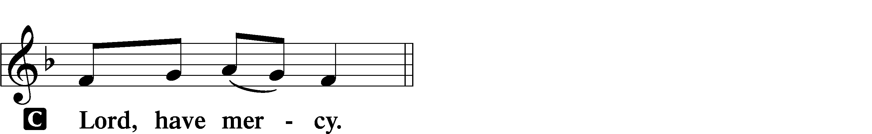

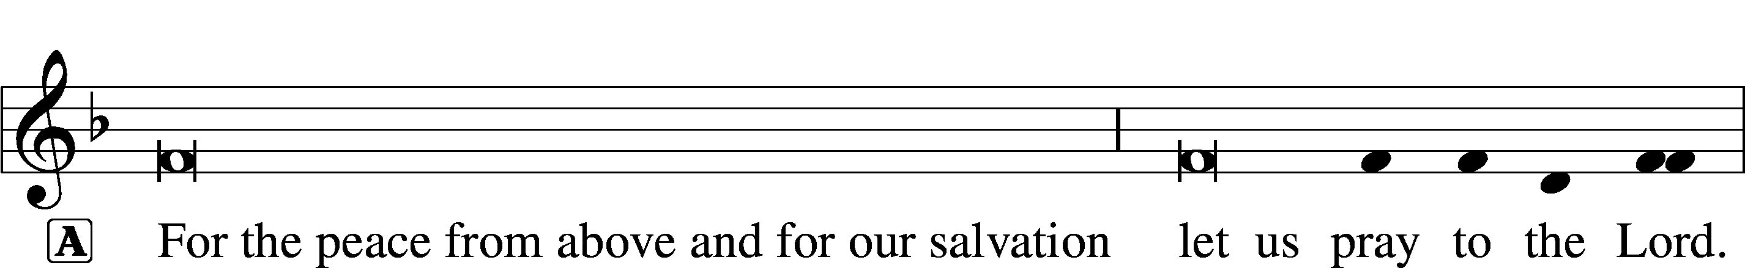

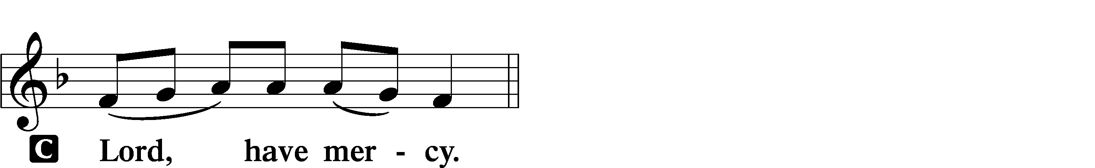

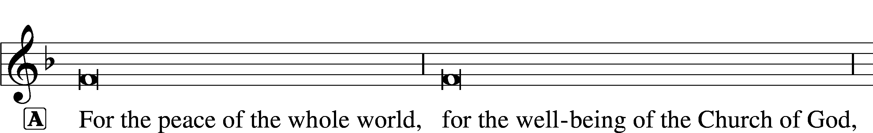
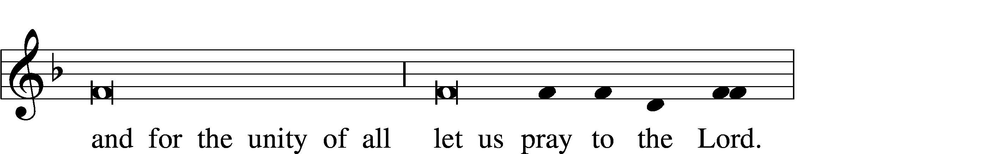
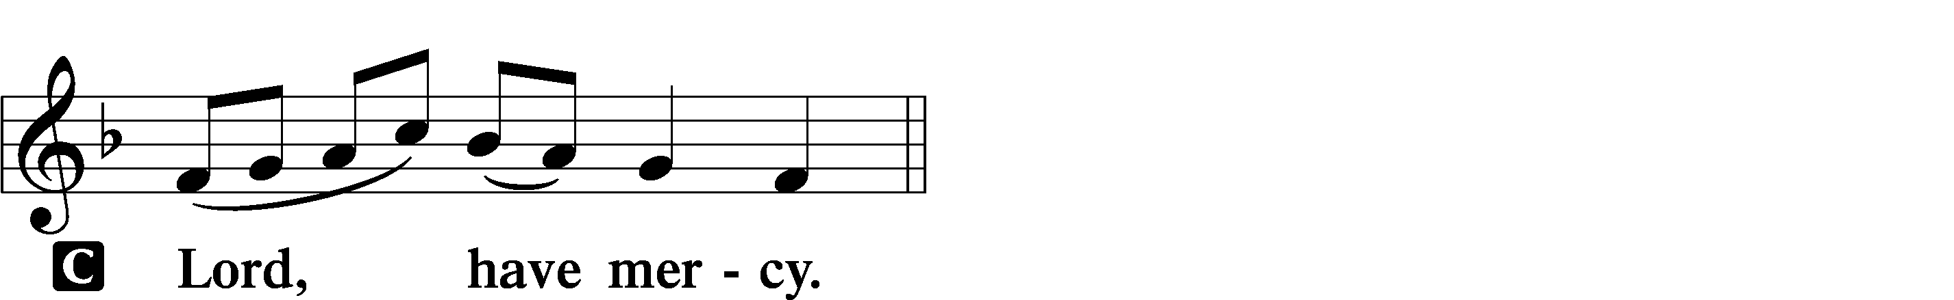

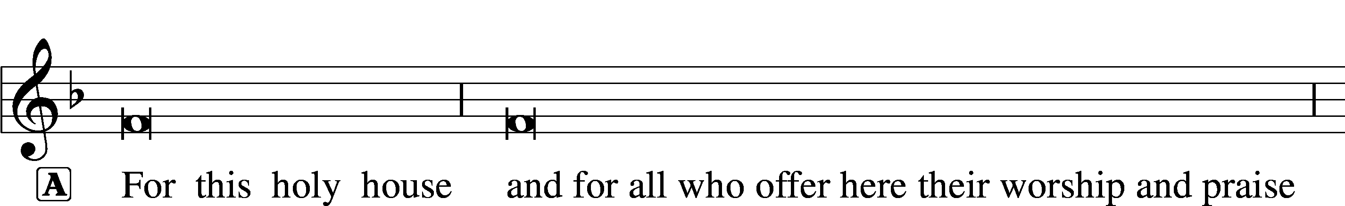
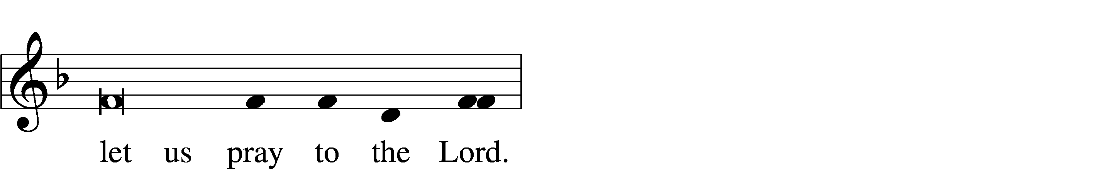
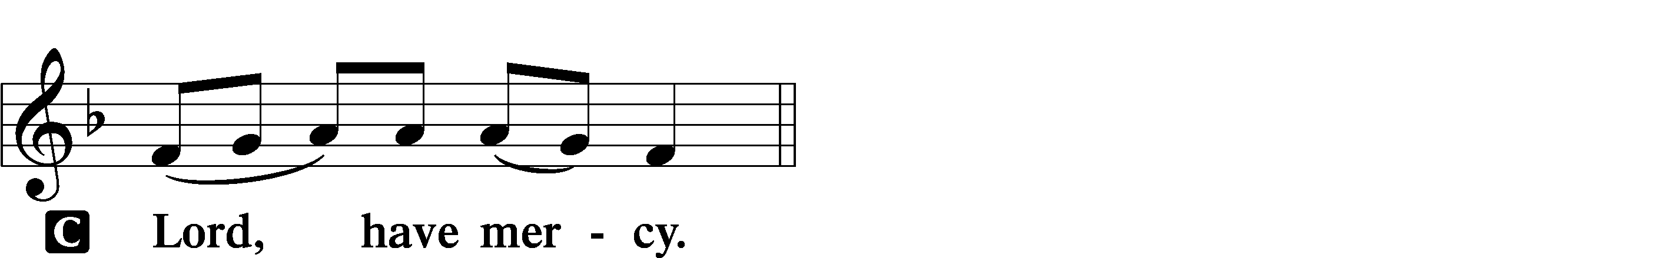

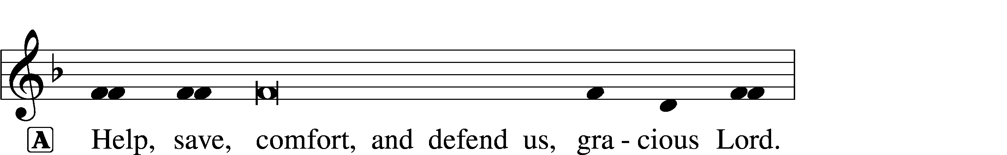


GLORIA IN EXCELSIS LSB 154
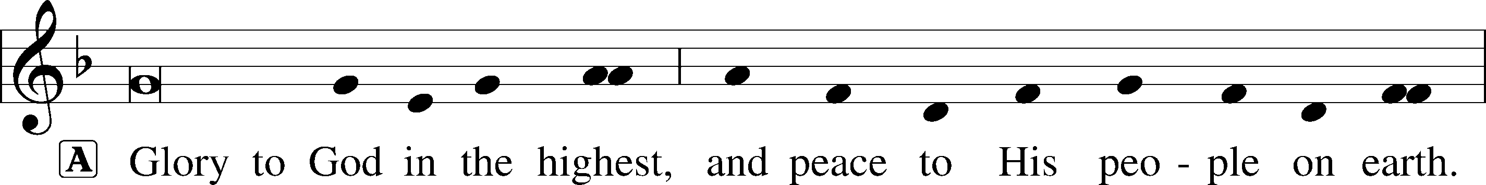
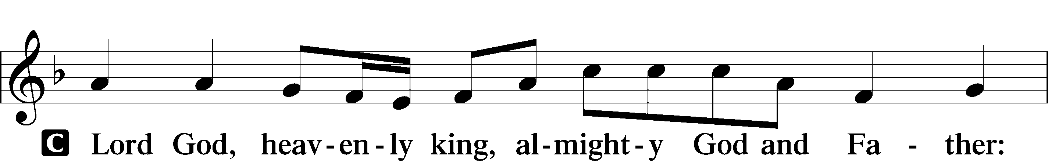
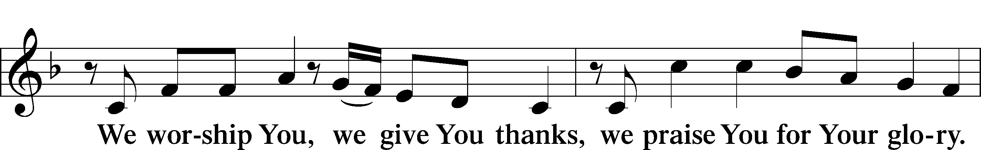
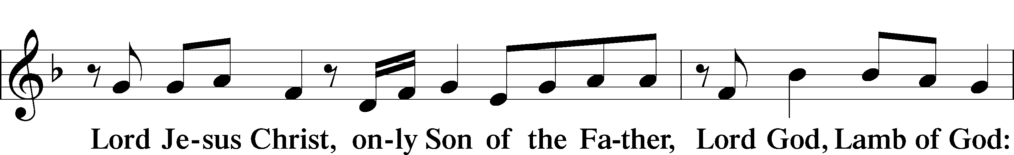
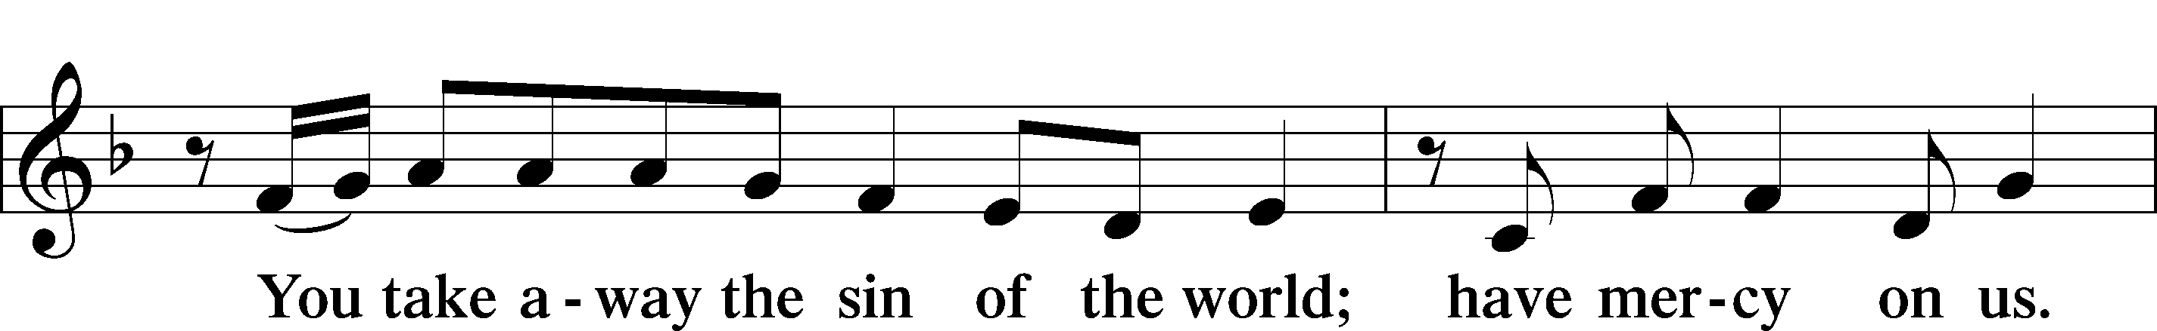
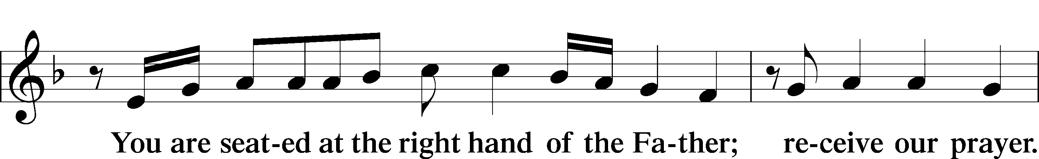
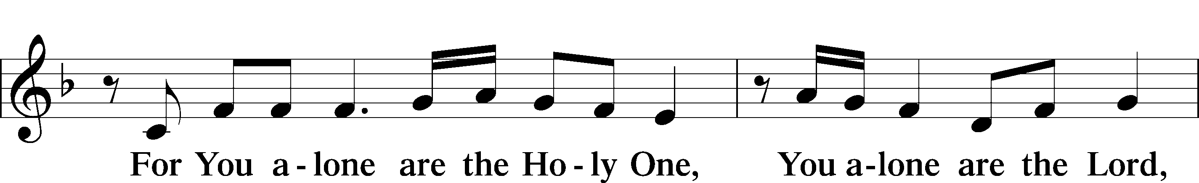
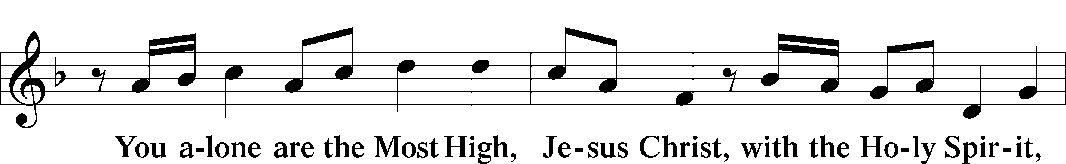
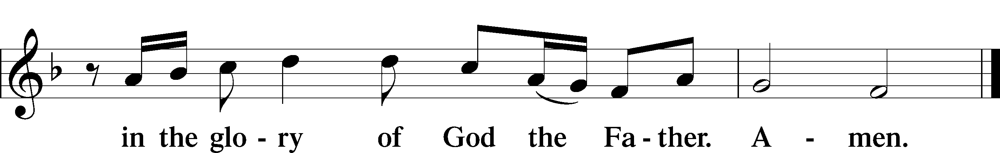

SALUTATION AND COLLECT OF THE DAY LSB 156
L The Lord be with you.
C And also with you.

L Let us pray.
Almighty and everlasting Father, You give Your children many blessings even though we are undeserving. In every trial and temptation grant us steadfast confidence in Your loving-kindness and mercy; through Jesus Christ, Your Son, our Lord, who lives and reigns with You and the Holy Spirit, one God, now and forever.
C Amen.

(Sit)

OLD TESTAMENT READING Isaiah 56:1, 6–8
1Thus says the Lord:
“Keep justice, and do righteousness,
for soon my salvation will come,
and my deliverance be revealed. . . .
6“And the foreigners who join themselves to the Lord,
to minister to him, to love the name of the Lord,
and to be his servants,
everyone who keeps the Sabbath and does not profane it,
and holds fast my covenant—
7these I will bring to my holy mountain,
and make them joyful in my house of prayer;
their burnt offerings and their sacrifices
will be accepted on my altar;
for my house shall be called a house of prayer
for all peoples.”
8The Lord God,
who gathers the outcasts of Israel, declares,
“I will gather yet others to him
besides those already gathered.”

L This is the Word of the Lord.
C Thanks be to God.

GRADUAL Psalm 34:9, 19, alt.
Fear the Lord, | you his saints,*
for those who fear him lack | nothing!
Many are the afflictions of the | righteous,*
but the Lord delivers him out | of them all.

EPISTLE Romans 11:1–2a, 13–15, 28–32
1I ask, then, has God rejected his people? By no means! For I myself am an Israelite, a descendant of Abraham, a member of the tribe of Benjamin. 2God has not rejected his people whom he foreknew. . . .
13Now I am speaking to you Gentiles. Inasmuch then as I am an apostle to the Gentiles, I magnify my ministry 14in order somehow to make my fellow Jews jealous, and thus save some of them. 15For if their rejection means the reconciliation of the world, what will their acceptance mean but life from the dead? . . .
28As regards the gospel, they are enemies of God for your sake. But as regards election, they are beloved for the sake of their forefathers. 29For the gifts and the calling of God are irrevocable. 30Just as you were at one time disobedient to God but now have received mercy because of their disobedience, 31so they too have now been disobedient in order that by the mercy shown to you they also may now receive mercy. 32For God has consigned all to disobedience, that he may have mercy on all.

L This is the Word of the Lord.
C Thanks be to God.

(Stand)

ALLELUIA AND VERSE LSB 156
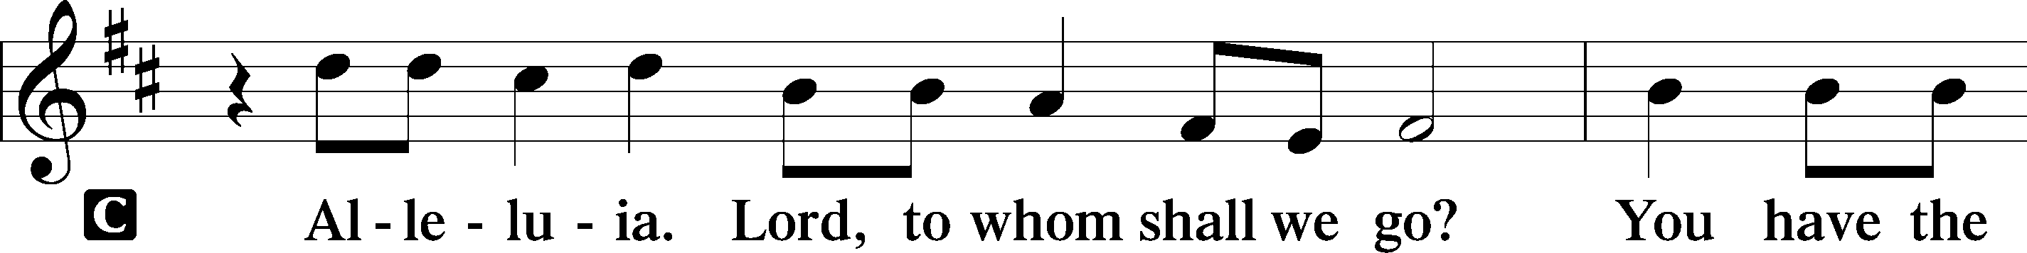
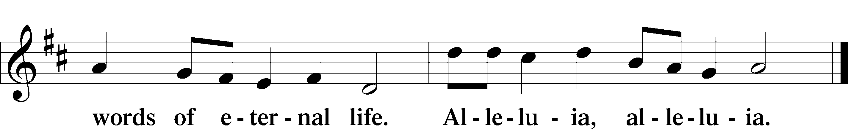

HOLY GOSPEL Matthew 15:21–28
L The Holy Gospel according to St. Matthew, the fifteenth chapter.

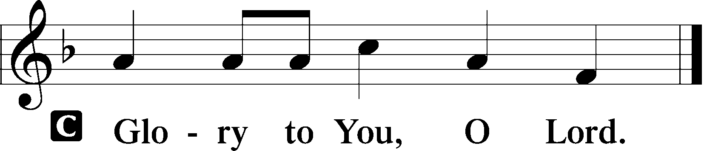

21Jesus went away from there and withdrew to the district of Tyre and Sidon. 22And behold, a Canaanite woman from that region came out and was crying, “Have mercy on me, O Lord, Son of David; my daughter is severely oppressed by a demon.” 23But he did not answer her a word. And his disciples came and begged him, saying, “Send her away, for she is crying out after us.” 24He answered, “I was sent only to the lost sheep of the house of Israel.” 25But she came and knelt before him, saying, “Lord, help me.” 26And he answered, “It is not right to take the children’s bread and throw it to the dogs.” 27She said, “Yes, Lord, yet even the dogs eat the crumbs that fall from their masters’ table.” 28Then Jesus answered her, “O woman, great is your faith! Be it done for you as you desire.” And her daughter was healed instantly.

L This is the Gospel of the Lord.

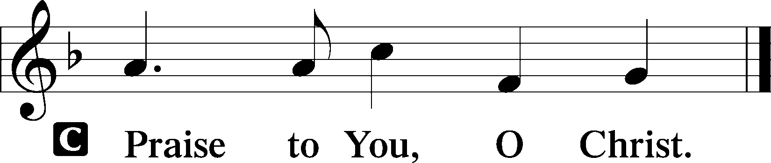

(Sit)

653 IN CHRIST THERE IS NO EAST OR WEST
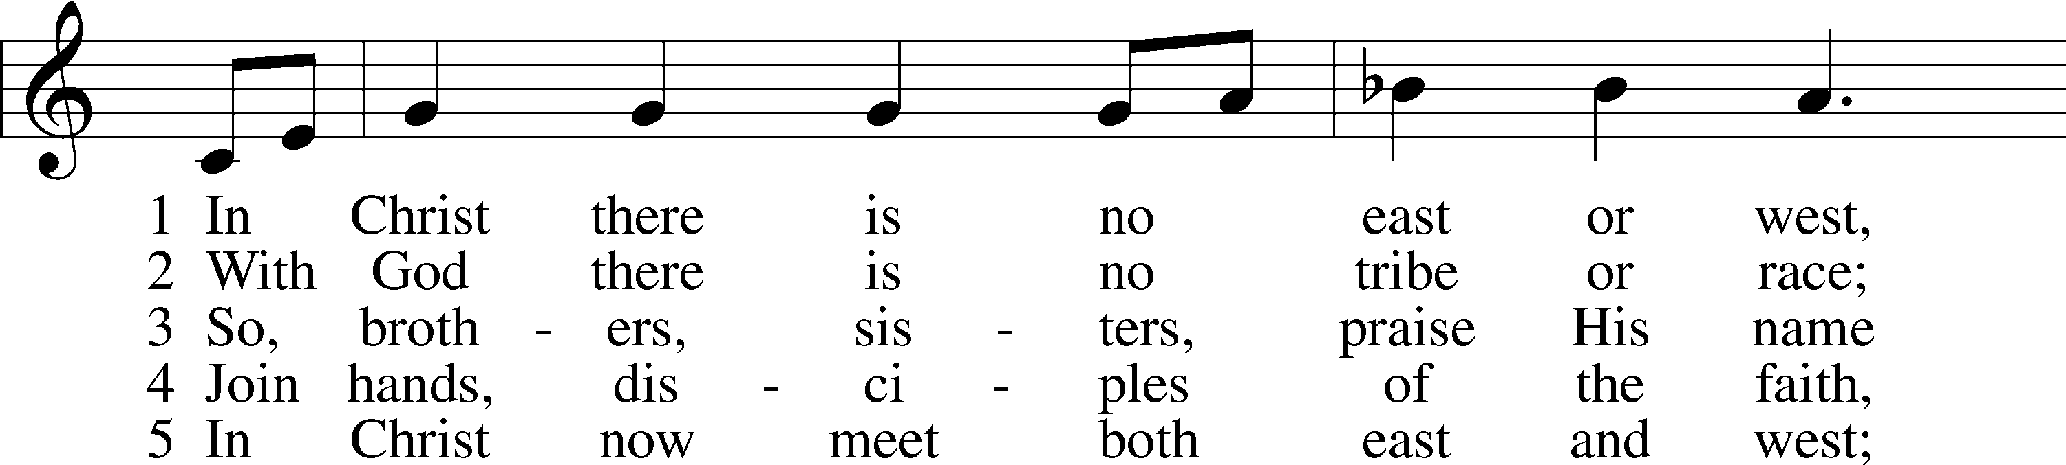
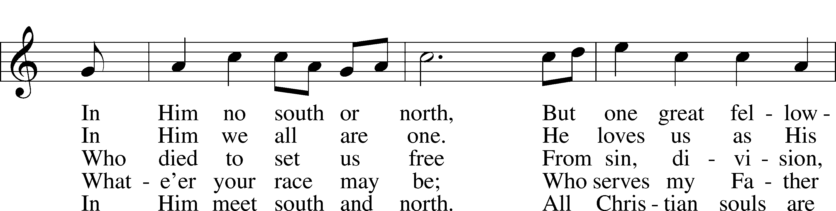
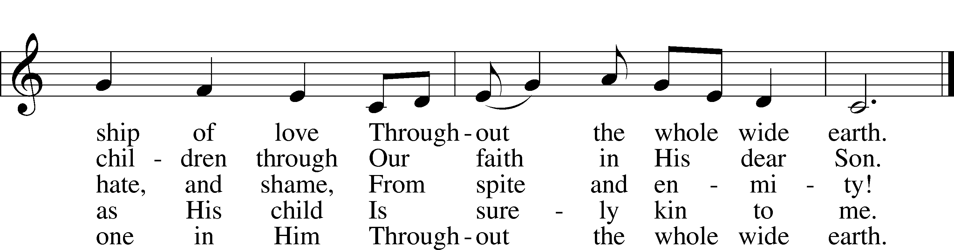
Text (sts. 1, 4–5): John Oxenham, 1852–1941, alt.; (st. 2): Mark A. Jeske, 1952; (st. 3): Michael A. Perry, 1942–96
Tune: African American spiritual; adapt. Harry T. Burleigh, 1866–1949
Text (st. 2): © 1993 Mark A. Jeske; (st. 3): © 1982 The Jubilate Group, admin. Hope Publishing Co. Used by permission: LSB Hymn License no. 110004798
Text (sts. 1, 4–5) and tune: Public domain

SERMON

(Sermons for Elder led services are provided courtesy of the Lutheran Church - Canada (https://www.lutheranchurchcanada.ca/resources/written-sermons/), a member of the International Lutheran Council (https://ilcouncil.org/) with whom the Lutheran Church - Missouri Synod (https://www.lcms.org/) is in altar and pulpit fellowship.)

(Stand)

NICENE CREED LSB 158
C I believe in one God,
the Father Almighty,
maker of heaven and earth
and of all things visible and invisible.

And in one Lord Jesus Christ,
the only-begotten Son of God,
begotten of His Father before all worlds,
God of God, Light of Light,
very God of very God,
begotten, not made,
being of one substance with the Father,
by whom all things were made;
who for us men and for our salvation came down from heaven
and was incarnate by the Holy Spirit of the virgin Mary
and was made man;
and was crucified also for us under Pontius Pilate.
He suffered and was buried.
And the third day He rose again according to the Scriptures
and ascended into heaven
and sits at the right hand of the Father.
And He will come again with glory to judge both the living and the dead,
whose kingdom will have no end.

And I believe in the Holy Spirit,
the Lord and giver of life,
who proceeds from the Father and the Son,
who with the Father and the Son together is worshiped and glorified,
who spoke by the prophets.
And I believe in one holy Christian and apostolic Church,
I acknowledge one Baptism for the remission of sins,
and I look for the resurrection of the dead
and the life T of the world to come. Amen.

SHARING OF THE PEACE

(The people may greet one another in the name of the Lord, saying, “Peace be with you,” as a sign of reconciliation and of the unity of the Spirit in the bond of peace (Matt. 5:22–24; Eph. 4:1–3).)

(Sit)

PRAYER OF THE CHURCH

OFFERING

(As a part of our expression of thanksgiving to God for the treasure of His salvation to us, we offer a portion of our treasure, according to what each has determined in their heart to give. Please place offerings in the collection plate at the back of the sanctuary before or after the service. Offerings can also be sent to Bethlehem Lutheran Church via U.S. Mail. Thank you!)

(Stand)

OFFERTORY LSB 159
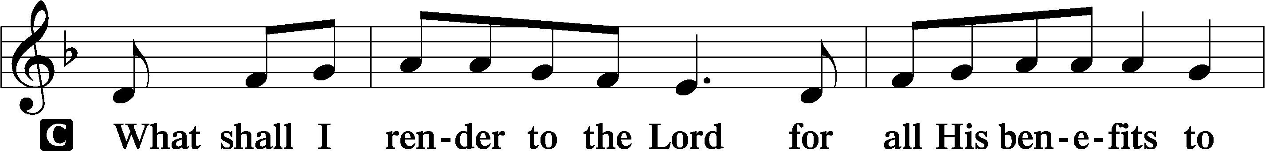
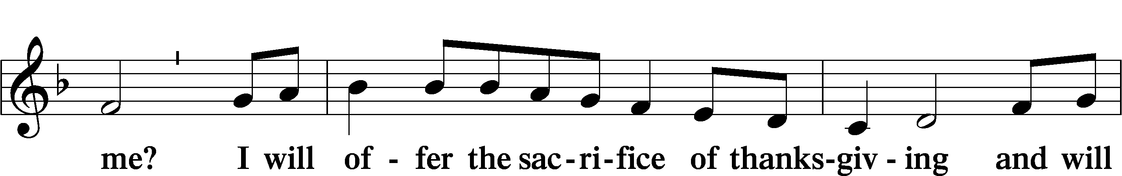
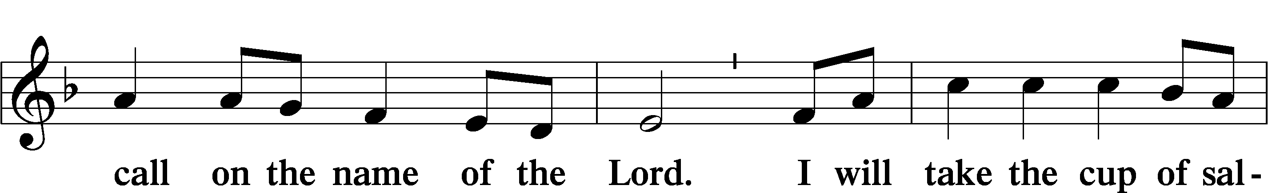
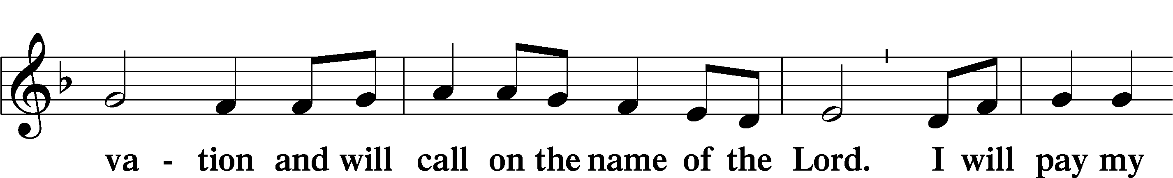
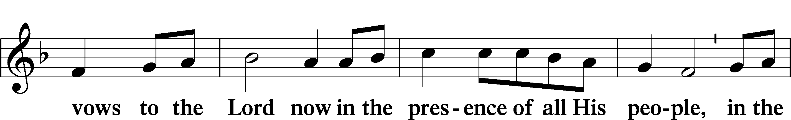
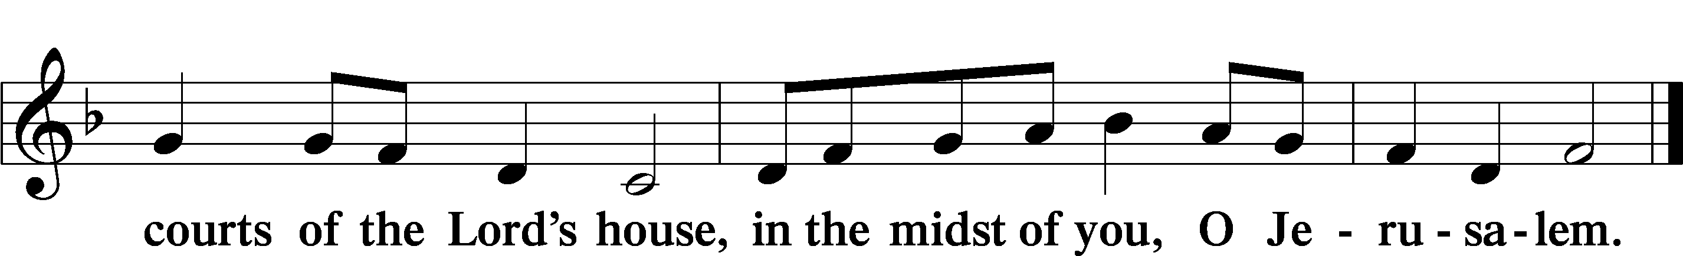

LORD’S PRAYER LSB 162
L Lord, remember us in Your kingdom and teach us to pray:
C Our Father who art in heaven,
hallowed be Thy name,
Thy kingdom come,
Thy will be done on earth
as it is in heaven;
give us this day our daily bread;
and forgive us our trespasses
as we forgive those
who trespass against us;
and lead us not into temptation,
but deliver us from evil.
For Thine is the kingdom
and the power and the glory
forever and ever. Amen.

CONCLUDING COLLECT

BENEDICTION LSB 166
L The Lord bless you and keep you.
The Lord make His face shine on you
and be gracious to you.
The Lord look upon you with favor and T give you peace.
C Amen.

941 WE PRAISE YOU AND ACKNOWLEDGE YOU, O GOD
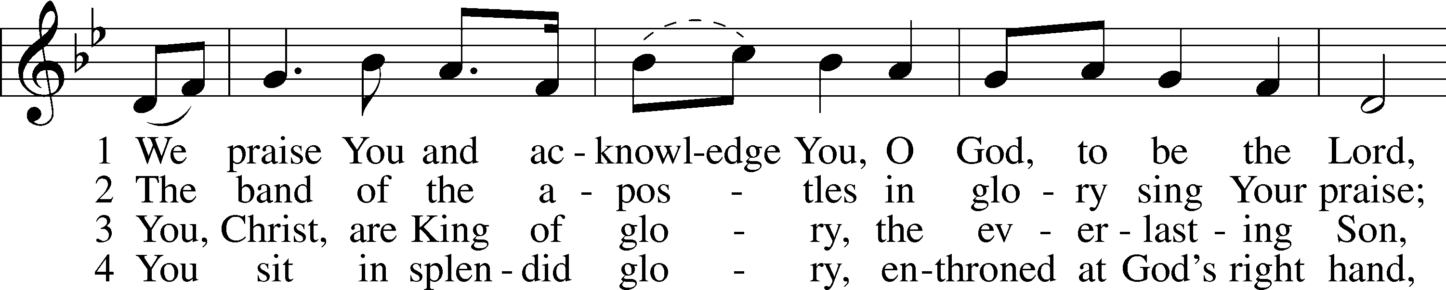
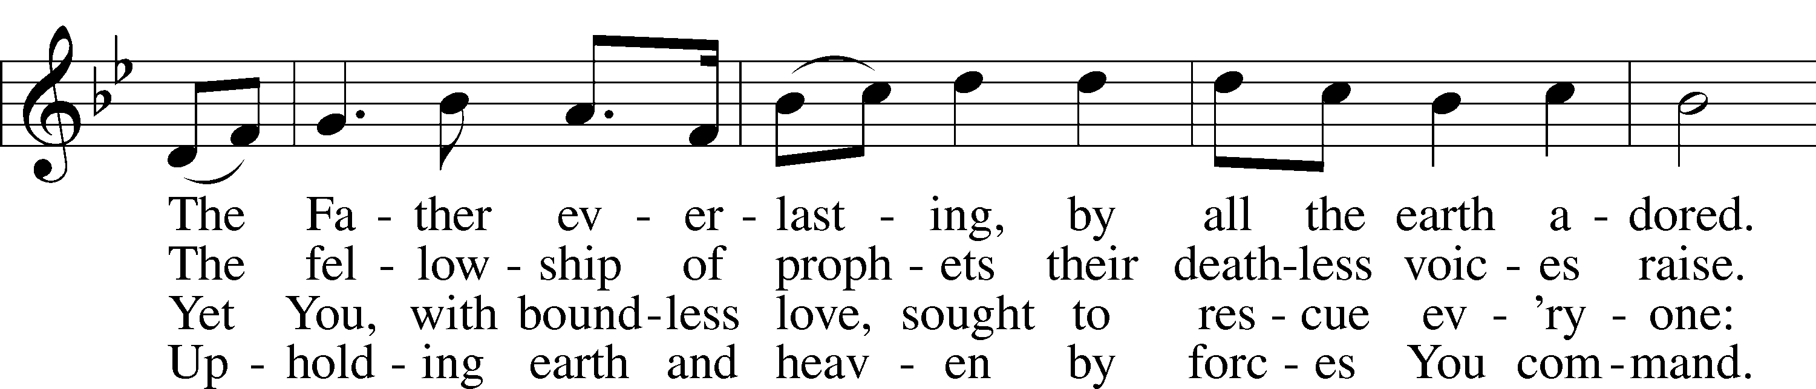
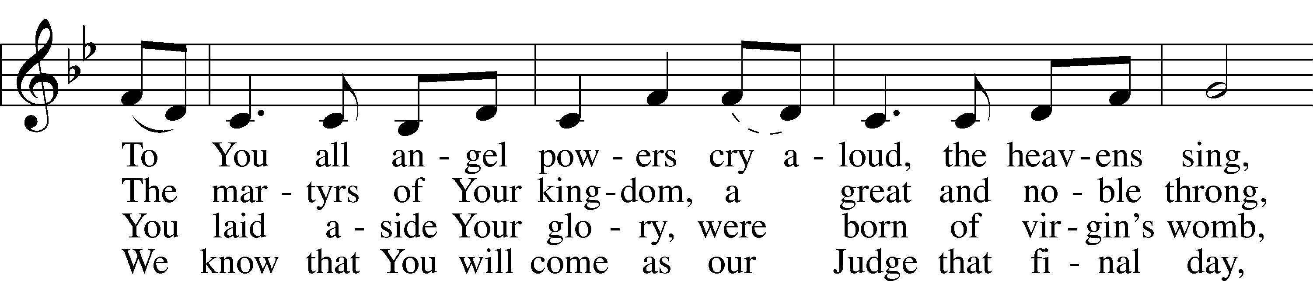
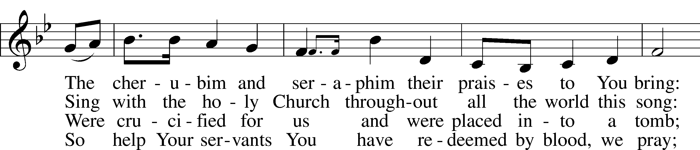
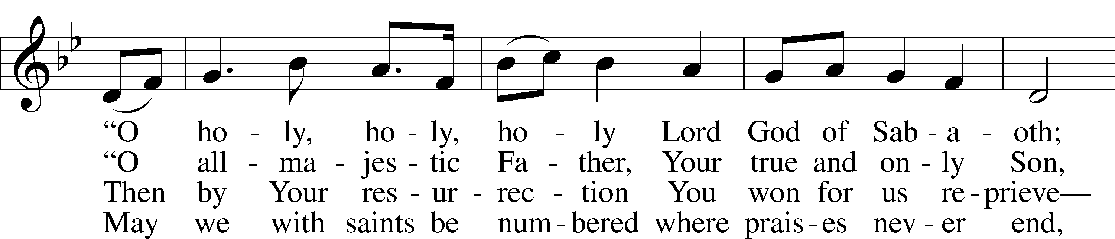
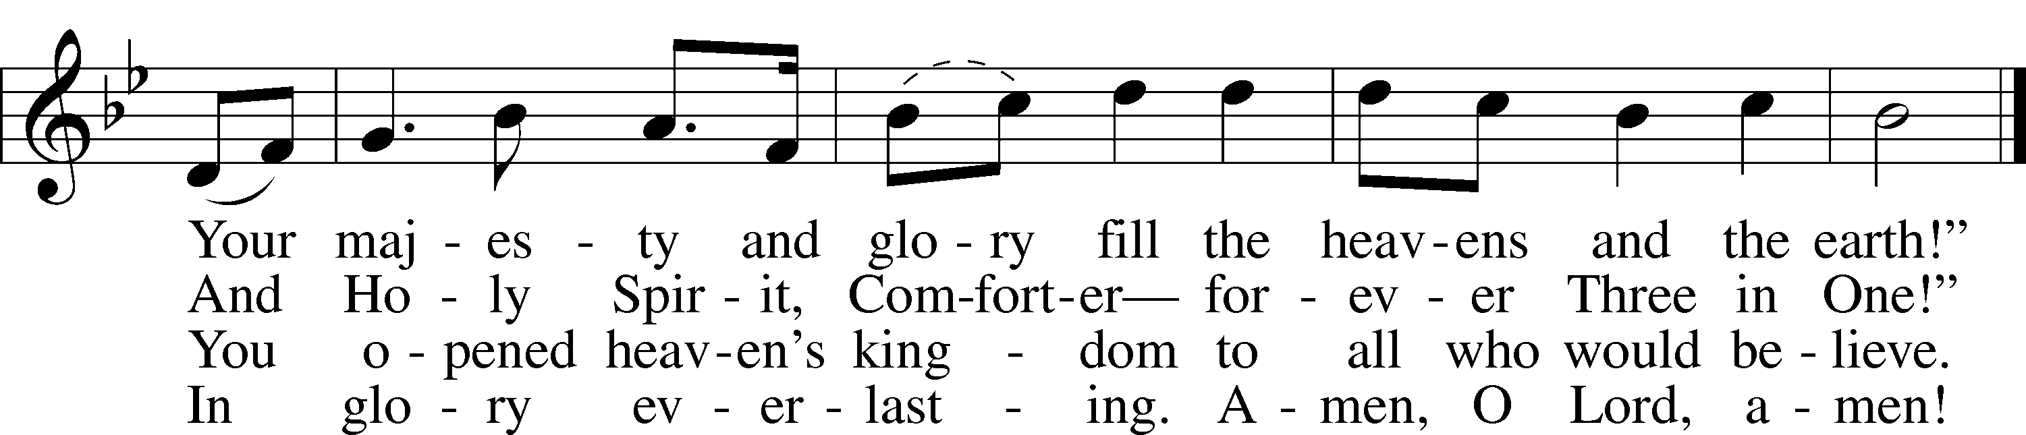
Text: Stephen P. Starke, 1955
Tune: Gustav Holst, 1874–1934, alt.
Text: © 1999 Stephen P. Starke, admin. Concordia Publishing House. Used by permission: LSB Hymn License no. 110004798
Tune: Public domain

ACKNOWLEDGMENTS
Unless otherwise indicated, Scripture quotations are from the ESV® Bible (The Holy Bible, English Standard Version®), copyright © 2001 by Crossway, a publishing ministry of Good News Publishers. Used by permission. All rights reserved.
Created by Lutheran Service Builder © 2026 Concordia Publishing House.

