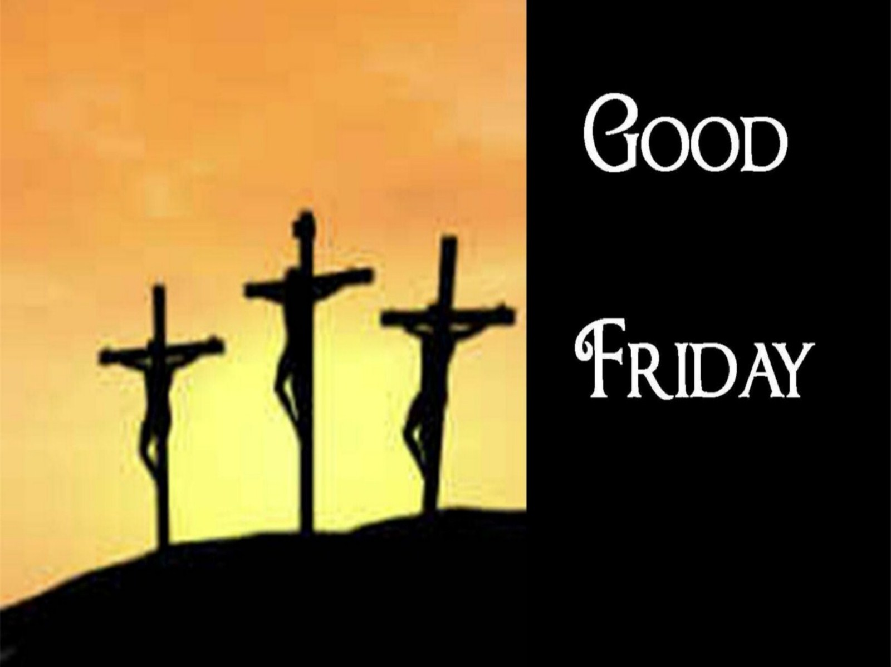

+ + + + + + + + + + + + + + +
Tenebrae Service
April 3, 2026
7:00 p.m.
+ + + + + + + + + + + + + + +

+ THE CONGREGATION ENTERS IN SILENCE +

BETHLEHEM LUTHERAN CHURCH
A congregation of The Lutheran Church-Missouri Synod
902 Hitchcock Drive SW,
Aiken, South Carolina 29803
Church Phone: (803) 649-6417
blcaikensc@gmail.com
Bethlehem Lutheran welcomes our members and guests to our worship service! Unable to join us in person? Please find us on Facebook live. The service is also posted on our website; bethlehemlutheranaiken.org.
(The congregation enters in silence.)

(Stand)

P The Lord be with you.
C And also with you.

P Let us pray.
Almighty God, graciously behold this Your family for whom our Lord Jesus Christ was willing to be betrayed and delivered into the hands of sinful men to suffer death upon the cross; through the same Jesus Christ, Your Son, our Lord, who lives and reigns with You and the Holy Spirit, one God, now and forever.
C Amen.

(Sit)

+ THE PASSION OF OUR LORD JESUS CHRIST +

THE BETRAYAL AND ARREST OF JESUS John 18:1–11
1When Jesus had spoken these words, he went out with his disciples across the Kidron Valley, where there was a garden, which he and his disciples entered. 2Now Judas, who betrayed him, also knew the place, for Jesus often met there with his disciples. 3So Judas, having procured a band of soldiers and some officers from the chief priests and the Pharisees, went there with lanterns and torches and weapons. 4Then Jesus, knowing all that would happen to him, came forward and said to them, “Whom do you seek?” 5They answered him, “Jesus of Nazareth.” Jesus said to them, “I am he.” Judas, who betrayed him, was standing with them. 6When Jesus said to them, “I am he,” they drew back and fell to the ground. 7So he asked them again, “Whom do you seek?” And they said, “Jesus of Nazareth.” 8Jesus answered, “I told you that I am he. So, if you seek me, let these men go.” 9This was to fulfill the word that he had spoken: “Of those whom you gave me I have lost not one.” 10Then Simon Peter, having a sword, drew it and struck the high priest’s servant and cut off his right ear. (The servant’s name was Malchus.) 11So Jesus said to Peter, “Put your sword into its sheath; shall I not drink the cup that the Father has given me?”

HOMILY; JOHN 18:1-11

547 THE LAMB
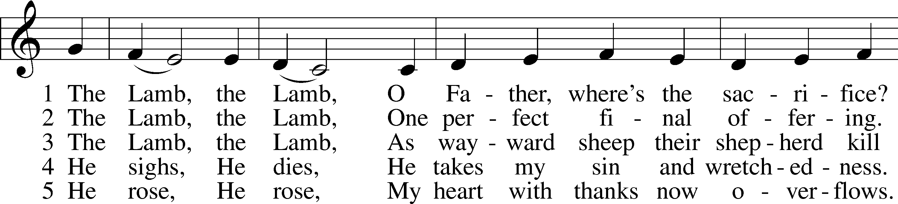
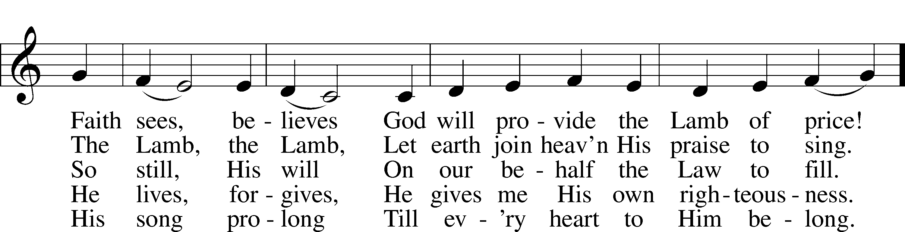
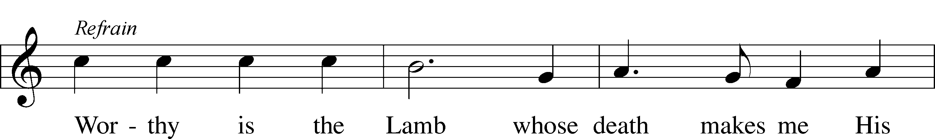
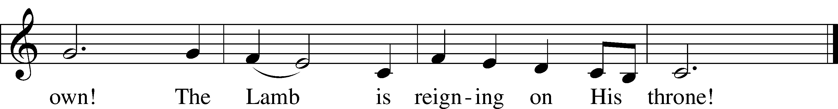
Text and tune: Gerald P. Coleman, 1953–2023
Text and tune: © 1987 and 1997 MorningStar Music Publishers. Used by permission: LSB Hymn License no. 110004798

(The first candle is extinguished)

JESUS BEFORE THE HIGH PRIEST, AND PETER'S DENIAL John 18:12–27
12So the band of soldiers and their captain and the officers of the Jews arrested Jesus and bound him. 13First they led him to Annas, for he was the father-in-law of Caiaphas, who was high priest that year. 14It was Caiaphas who had advised the Jews that it would be expedient that one man should die for the people.
15Simon Peter followed Jesus, and so did another disciple. Since that disciple was known to the high priest, he entered with Jesus into the court of the high priest, 16but Peter stood outside at the door. So the other disciple, who was known to the high priest, went out and spoke to the servant girl who kept watch at the door, and brought Peter in. 17The servant girl at the door said to Peter, “You also are not one of this man’s disciples, are you?” He said, “I am not.” 18Now the servants and officers had made a charcoal fire, because it was cold, and they were standing and warming themselves. Peter also was with them, standing and warming himself.
19The high priest then questioned Jesus about his disciples and his teaching. 20Jesus answered him, “I have spoken openly to the world. I have always taught in synagogues and in the temple, where all Jews come together. I have said nothing in secret. 21Why do you ask me? Ask those who have heard me what I said to them; they know what I said.” 22When he had said these things, one of the officers standing by struck Jesus with his hand, saying, “Is that how you answer the high priest?” 23Jesus answered him, “If what I said is wrong, bear witness about the wrong; but if what I said is right, why do you strike me?” 24Annas then sent him bound to Caiaphas the high priest.
25Now Simon Peter was standing and warming himself. So they said to him, “You also are not one of his disciples, are you?” He denied it and said, “I am not.” 26One of the servants of the high priest, a relative of the man whose ear Peter had cut off, asked, “Did I not see you in the garden with him?” 27Peter again denied it, and at once a rooster crowed.

HOMILY; JOHN 18:12-27

440 JESUS, I WILL PONDER NOW
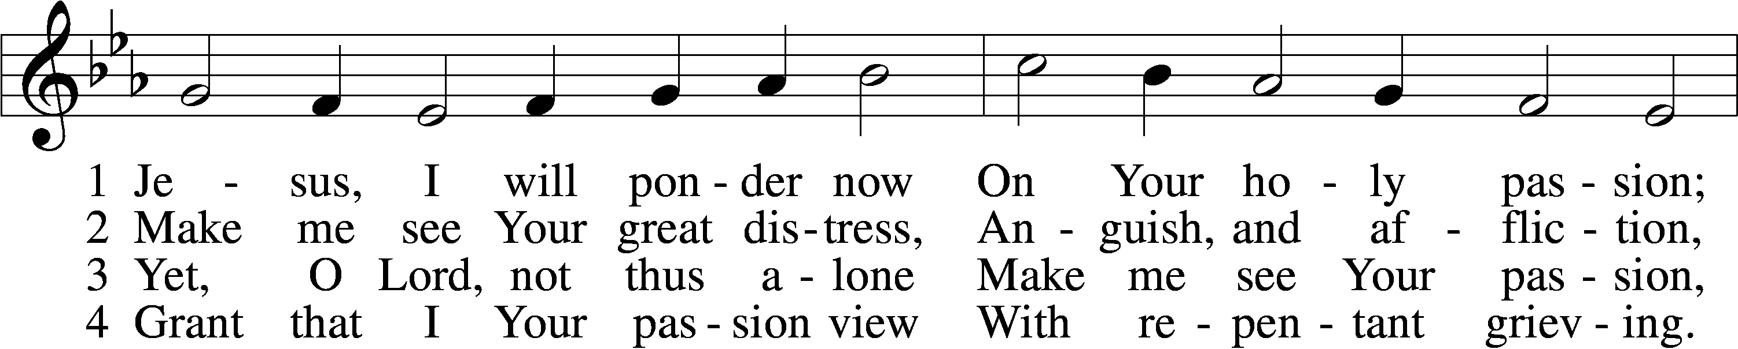
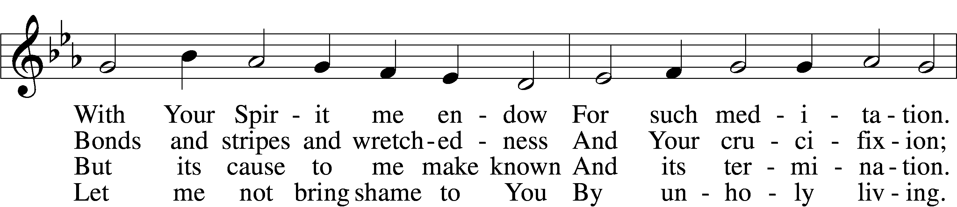
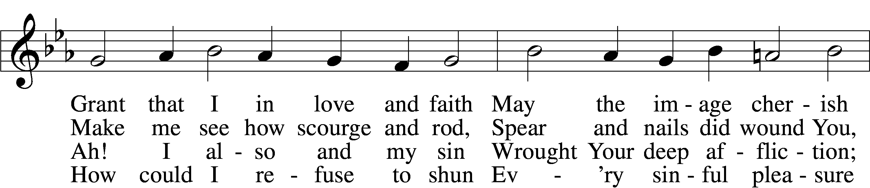
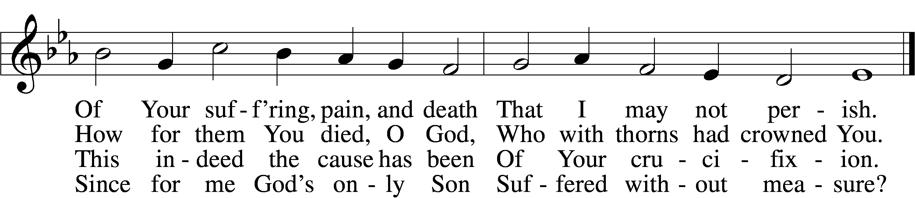

5 If my sins give me alarm
And my conscience grieve me,
Let Your cross my fear disarm;
Peace of conscience give me.
Help me see forgiveness won
By Your holy passion.
If for me He slays His Son,
God must have compassion!

6 Graciously my faith renew;
Help me bear my crosses,
Learning humbleness from You,
Peace mid pain and losses.
May I give You love for love!
Hear me, O my Savior,
That I may in heav’n above
Sing Your praise forever.
Text: Sigismund von Birken, 1626–81; tr. August Crull, 1845–1923, alt.
Tune: Melchior Vulpius, c. 1570–1615
Text and tune: Public domain

(The second candle is extinguished)

JESUS BEFORE PILATE John 18:28–40
28Then they led Jesus from the house of Caiaphas to the governor’s headquarters. It was early morning. They themselves did not enter the governor’s headquarters, so that they would not be defiled, but could eat the Passover. 29So Pilate went outside to them and said, “What accusation do you bring against this man?” 30They answered him, “If this man were not doing evil, we would not have delivered him over to you.” 31Pilate said to them, “Take him yourselves and judge him by your own law.” The Jews said to him, “It is not lawful for us to put anyone to death.” 32This was to fulfill the word that Jesus had spoken to show by what kind of death he was going to die.
33So Pilate entered his headquarters again and called Jesus and said to him, “Are you the King of the Jews?” 34Jesus answered, “Do you say this of your own accord, or did others say it to you about me?” 35Pilate answered, “Am I a Jew? Your own nation and the chief priests have delivered you over to me. What have you done?” 36Jesus answered, “My kingdom is not of this world. If my kingdom were of this world, my servants would have been fighting, that I might not be delivered over to the Jews. But my kingdom is not from the world.” 37Then Pilate said to him, “So you are a king?” Jesus answered, “You say that I am a king. For this purpose I was born and for this purpose I have come into the world—to bear witness to the truth. Everyone who is of the truth listens to my voice.” 38Pilate said to him, “What is truth?”
After he had said this, he went back outside to the Jews and told them, “I find no guilt in him. 39But you have a custom that I should release one man for you at the Passover. So do you want me to release to you the King of the Jews?” 40They cried out again, “Not this man, but Barabbas!” Now Barabbas was a robber.

HOMILY; JOHN 18:28-40

(The third candle is extinguished)

JESUS FLOGGED, MOCKED, AND SENTENCED TO DEATH
John 19:1–16
1Then Pilate took Jesus and flogged him. 2And the soldiers twisted together a crown of thorns and put it on his head and arrayed him in a purple robe. 3They came up to him, saying, “Hail, King of the Jews!” and struck him with their hands. 4Pilate went out again and said to them, “See, I am bringing him out to you that you may know that I find no guilt in him.” 5So Jesus came out, wearing the crown of thorns and the purple robe. Pilate said to them, “Behold the man!” 6When the chief priests and the officers saw him, they cried out, “Crucify him, crucify him!” Pilate said to them, “Take him yourselves and crucify him, for I find no guilt in him.” 7The Jews answered him, “We have a law, and according to that law he ought to die because he has made himself the Son of God.” 8When Pilate heard this statement, he was even more afraid. 9He entered his headquarters again and said to Jesus, “Where are you from?” But Jesus gave him no answer. 10So Pilate said to him, “You will not speak to me? Do you not know that I have authority to release you and authority to crucify you?” 11Jesus answered him, “You would have no authority over me at all unless it had been given you from above. Therefore he who delivered me over to you has the greater sin.”
12From then on Pilate sought to release him, but the Jews cried out, “If you release this man, you are not Caesar’s friend. Everyone who makes himself a king opposes Caesar.” 13So when Pilate heard these words, he brought Jesus out and sat down on the judgment seat at a place called The Stone Pavement, and in Aramaic Gabbatha. 14Now it was the day of Preparation of the Passover. It was about the sixth hour. He said to the Jews, “Behold your King!” 15They cried out, “Away with him, away with him, crucify him!” Pilate said to them, “Shall I crucify your King?” The chief priests answered, “We have no king but Caesar.” 16So he delivered him over to them to be crucified.
So they took Jesus,

HOMILY; JOHN 19:1-16

438 A LAMB GOES UNCOMPLAINING FORTH
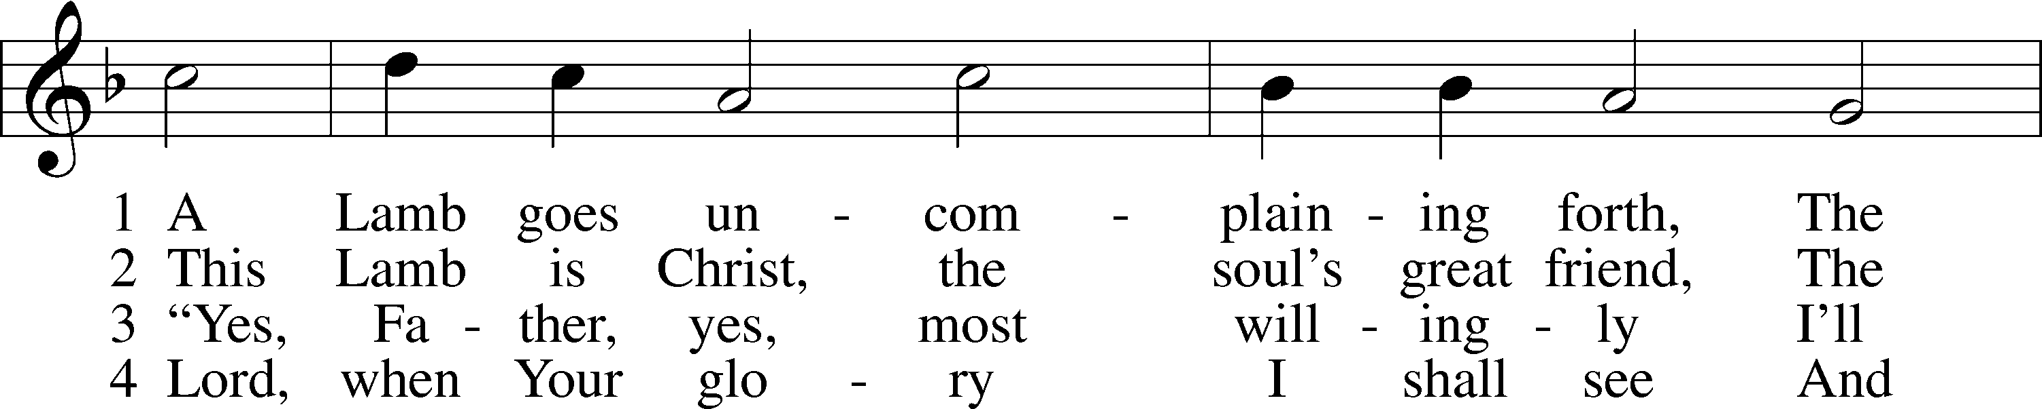
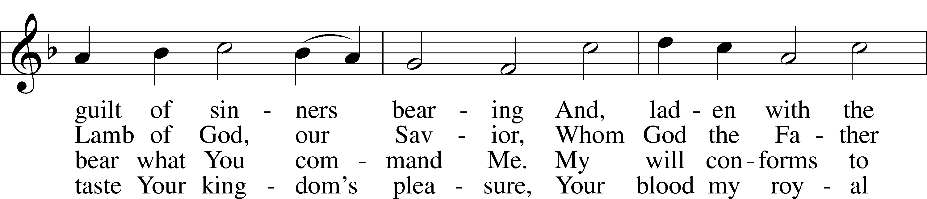
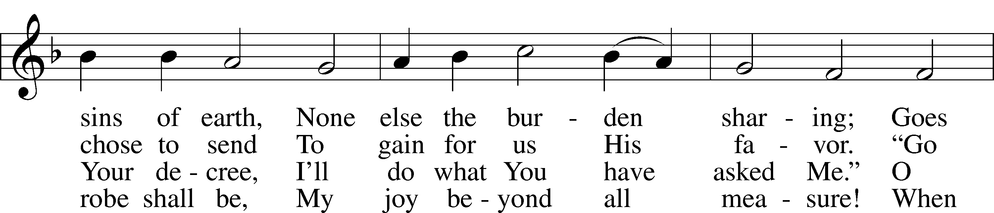
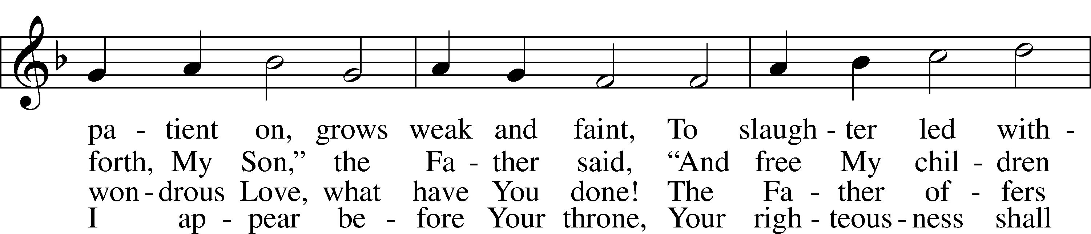
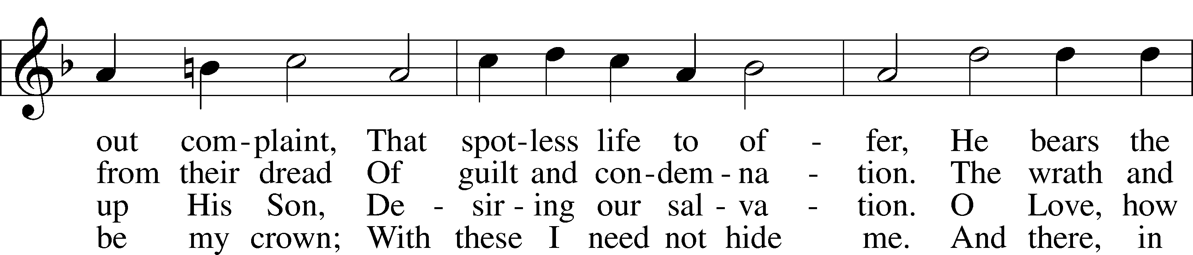
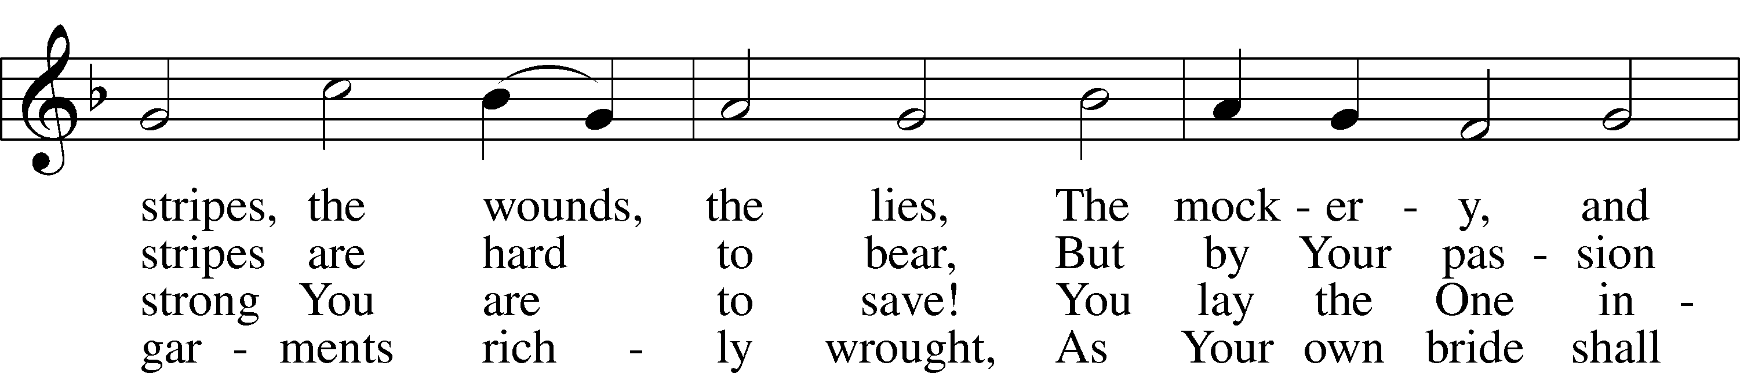
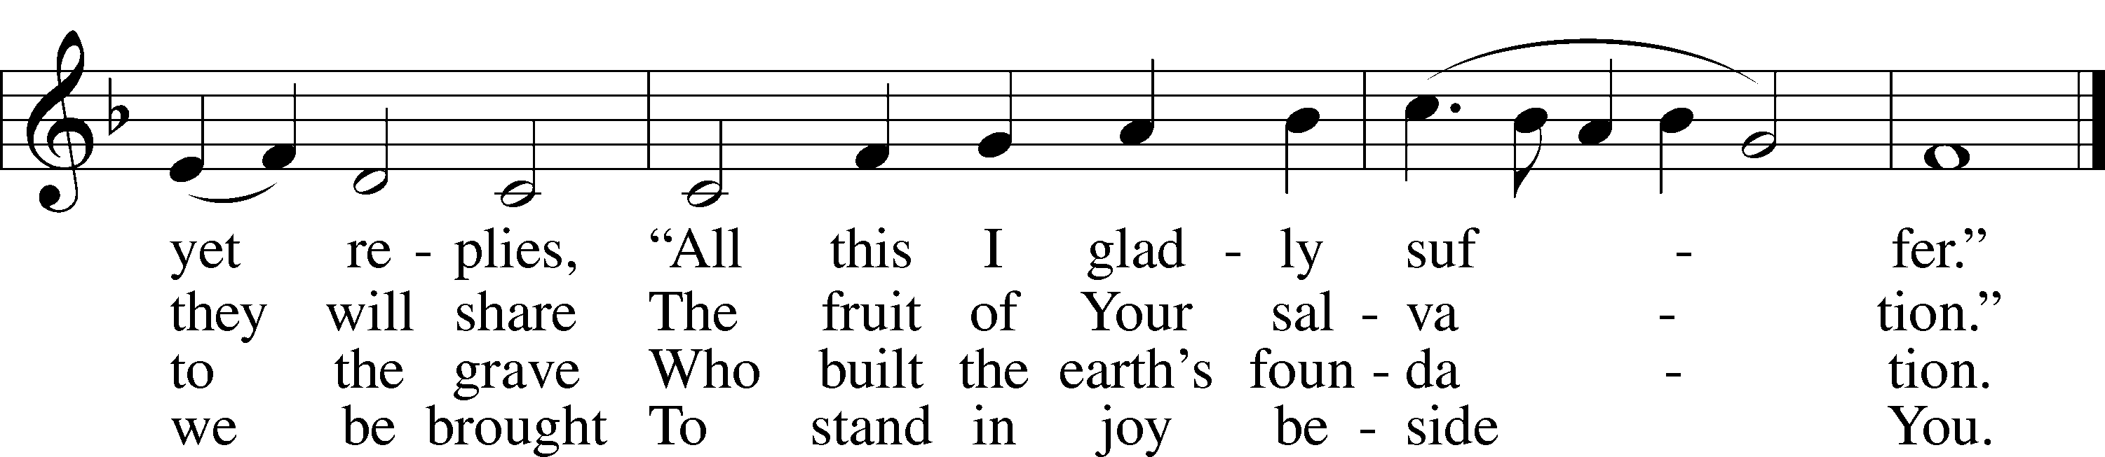
Text: Paul Gerhardt, 1607–76; tr. The Lutheran Hymnal, 1941, alt.
Tune: Wolfgang Dachstein, c. 1487–1553
Text: © 1941 Concordia Publishing House. Used by permission: LSB Hymn License no. 110004798
Tune: Public domain

(The fourth candle is extinguished)

THE CRUCIFIXION OF JESUS John 19:16–24
16So he delivered him over to them to be crucified.
So they took Jesus, 17and he went out, bearing his own cross, to the place called the place of a skull, which in Aramaic is called Golgotha. 18There they crucified him, and with him two others, one on either side, and Jesus between them. 19Pilate also wrote an inscription and put it on the cross. It read, “Jesus of Nazareth, the King of the Jews.” 20Many of the Jews read this inscription, for the place where Jesus was crucified was near the city, and it was written in Aramaic, in Latin, and in Greek. 21So the chief priests of the Jews said to Pilate, “Do not write, ‘The King of the Jews,’ but rather, ‘This man said, I am King of the Jews.’” 22Pilate answered, “What I have written I have written.”
23When the soldiers had crucified Jesus, they took his garments and divided them into four parts, one part for each soldier; also his tunic. But the tunic was seamless, woven in one piece from top to bottom, 24so they said to one another, “Let us not tear it, but cast lots for it to see whose it shall be.” This was to fulfill the Scripture which says,
“They divided my garments among them,
and for my clothing they cast lots.”
So the soldiers did these things,

HOMILY; JOHN 19:16-24

451 STRICKEN, SMITTEN, AND AFFLICTED
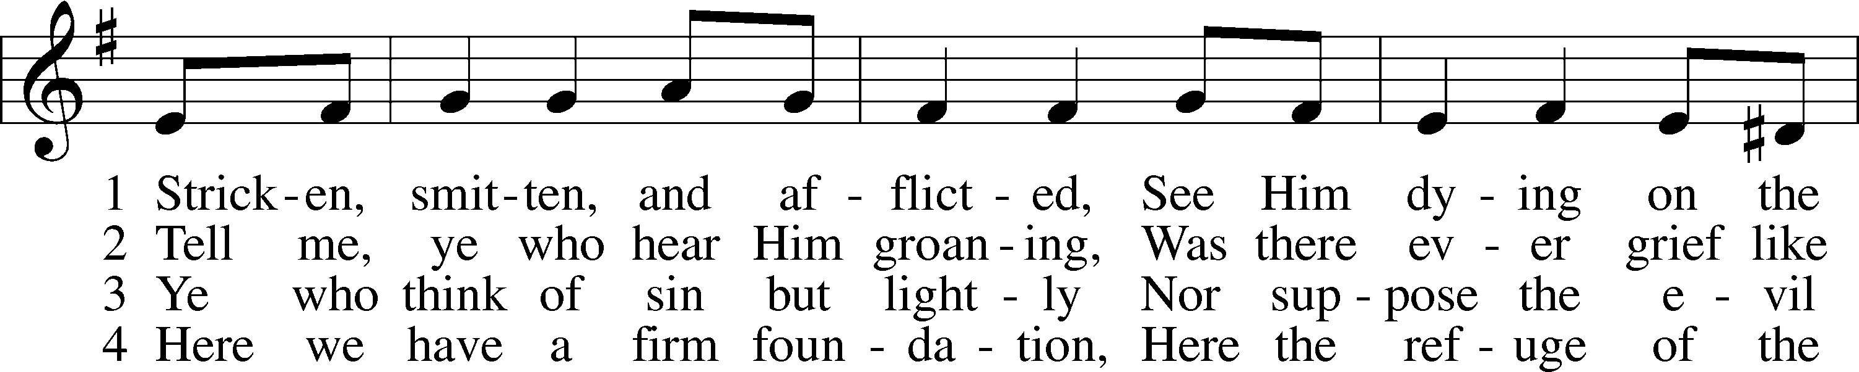
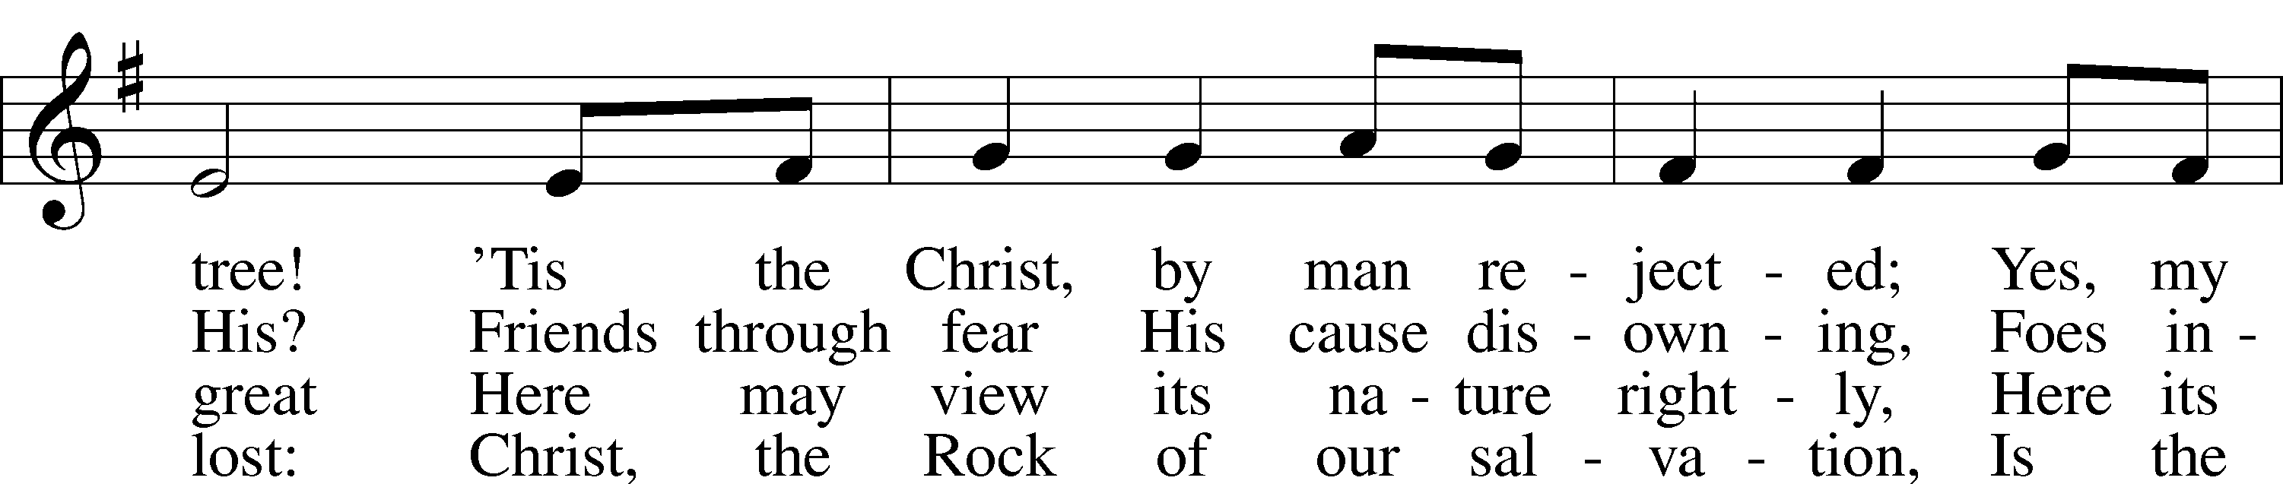
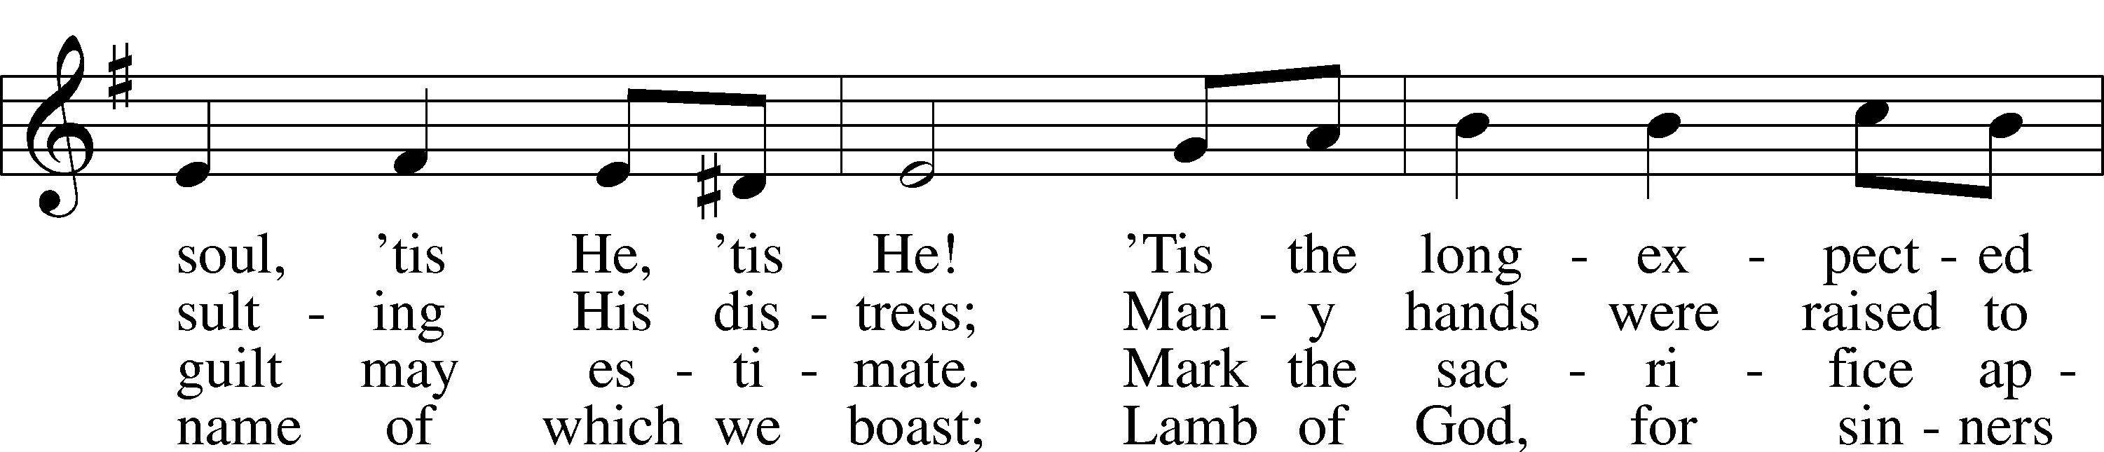
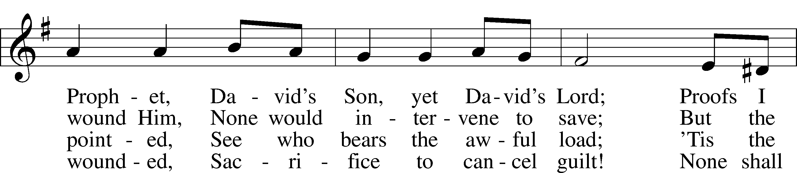
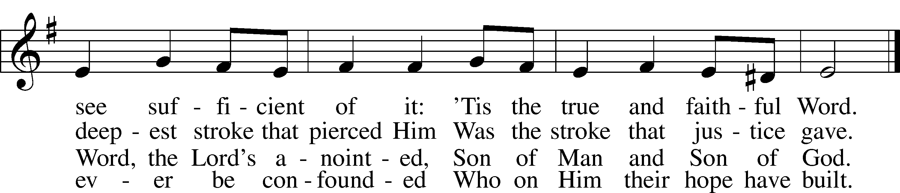
Text: Thomas Kelly, 1769–1855, alt.
Tune: Geistliche Volkslieder, 1850, Paderborn
Text and tune: Public domain

(the fifth candle is extinguished)

JESUS' DEATH John 19:25–30
25Standing by the cross of Jesus were his mother and his mother’s sister, Mary the wife of Clopas, and Mary Magdalene. 26When Jesus saw his mother and the disciple whom he loved standing nearby, he said to his mother, “Woman, behold, your son!” 27Then he said to the disciple, “Behold, your mother!” And from that hour the disciple took her to his own home.
28After this, Jesus, knowing that all was now finished, said (to fulfill the Scripture), “I thirst.” 29A jar full of sour wine stood there, so they put a sponge full of the sour wine on a hyssop branch and held it to his mouth. 30When Jesus had received the sour wine, he said, “It is finished,” and he bowed his head and gave up his spirit.
HOMILY; JOHN 19:25-30

425 WHEN I SURVEY THE WONDROUS CROSS
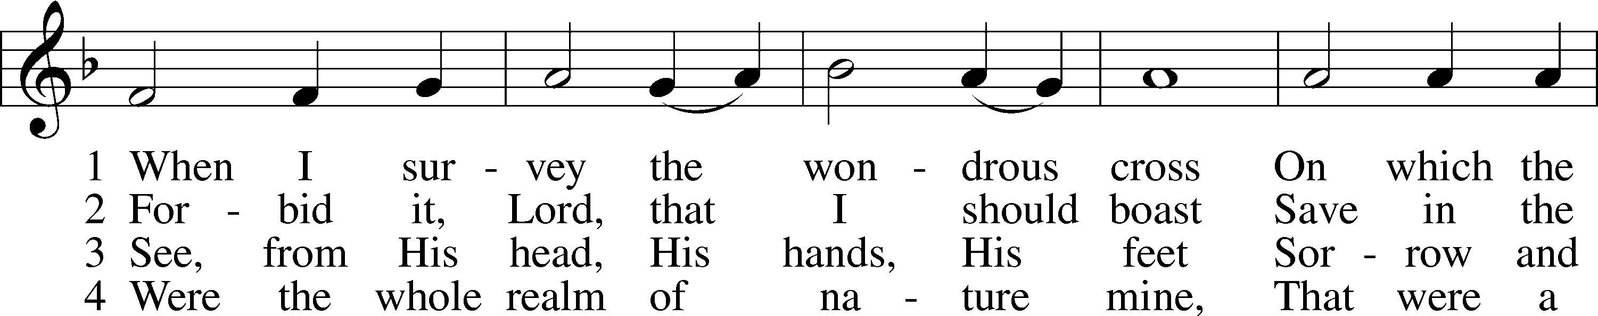
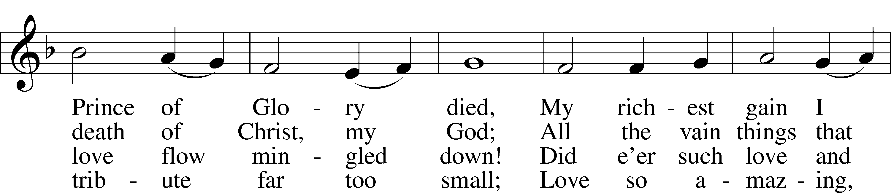
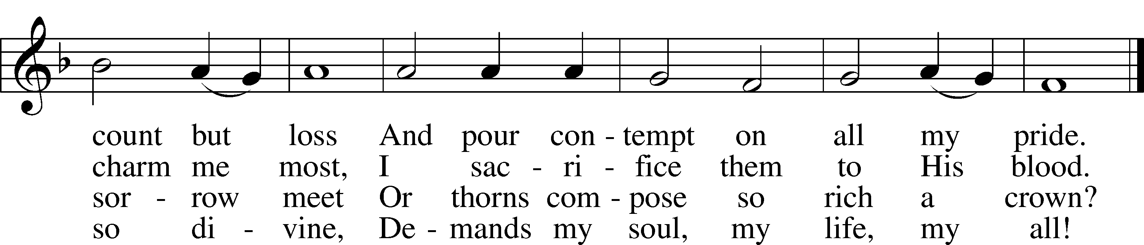
Text: Isaac Watts, 1674–1748
Tune: Lowell Mason, 1792–1872
Text and tune: Public domain

(The sixth candle is extinguished)

READING John 19:31–37
31Since it was the day of Preparation, and so that the bodies would not remain on the cross on the Sabbath (for that Sabbath was a high day), the Jews asked Pilate that their legs might be broken and that they might be taken away. 32So the soldiers came and broke the legs of the first, and of the other who had been crucified with him. 33But when they came to Jesus and saw that he was already dead, they did not break his legs. 34But one of the soldiers pierced his side with a spear, and at once there came out blood and water. 35He who saw it has borne witness—his testimony is true, and he knows that he is telling the truth—that you also may believe. 36For these things took place that the Scripture might be fulfilled: “Not one of his bones will be broken.” 37And again another Scripture says, “They will look on him whom they have pierced.”

HOMILY; JOHN 19:31-37

READING John 19:38–42
38After these things Joseph of Arimathea, who was a disciple of Jesus, but secretly for fear of the Jews, asked Pilate that he might take away the body of Jesus, and Pilate gave him permission. So he came and took away his body. 39Nicodemus also, who earlier had come to Jesus by night, came bringing a mixture of myrrh and aloes, about seventy-five pounds in weight. 40So they took the body of Jesus and bound it in linen cloths with the spices, as is the burial custom of the Jews. 41Now in the place where he was crucified there was a garden, and in the garden a new tomb in which no one had yet been laid. 42So because of the Jewish day of Preparation, since the tomb was close at hand, they laid Jesus there.

(The seventh candle is extinguished)

456 WERE YOU THERE
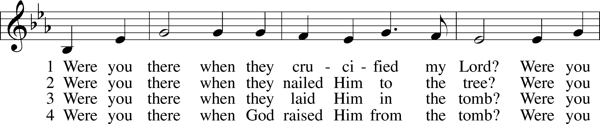
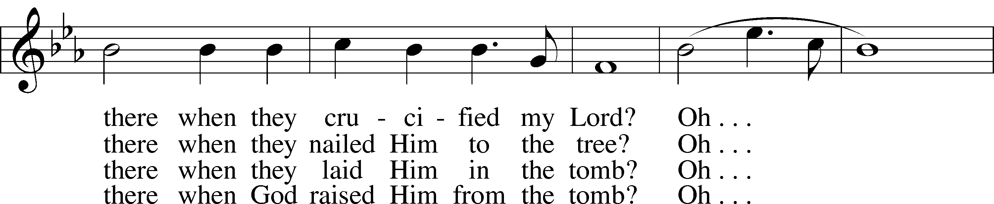
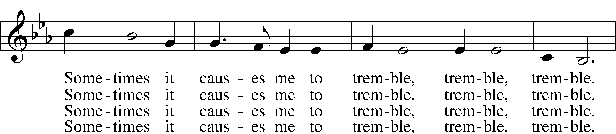
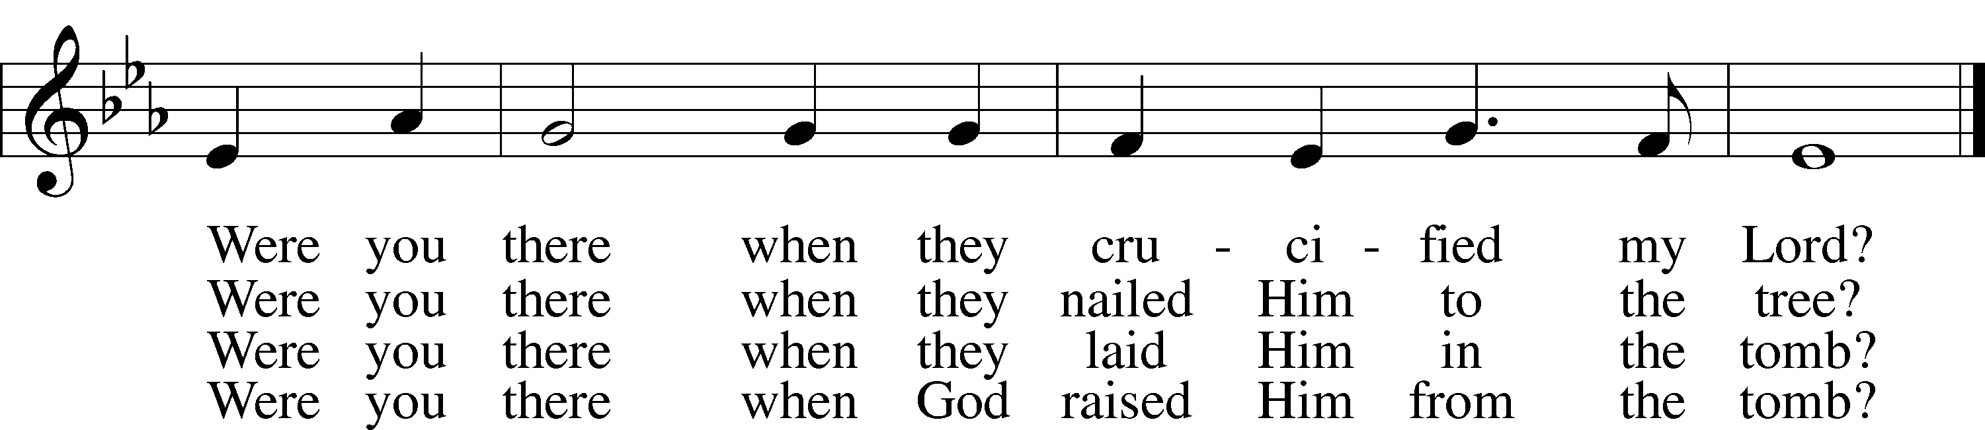
Text and tune: African American spiritual, 19th cent., alt.
Text and tune: Public domain

(the strepitus)

+ THE CONGREGATION LEAVES IN SILENCE +

(The congregation leaves in silence and minimal light.)

Good Friday, Tenebrae Vespers from Lutheran Service Book
Unless otherwise indicated, Scripture quotations are from the ESV® Bible (The Holy Bible, English Standard Version®), copyright © 2001 by Crossway, a publishing ministry of Good News Publishers. Used by permission. All rights reserved.
Created by Lutheran Service Builder © 2026 Concordia Publishing House.

