BETHLEHEM LUTHERAN CHURCH
A congregation of The Lutheran Church-Missouri Synod
902 Hitchcock Drive SW,
Aiken, South Carolina 29803
Church Phone: (803) 649-6417
blcaikensc@gmail.com

Bethlehem Lutheran welcomes our members and guests to our worship service! Unable to join us in person? Please find us on Facebook live. The service is also posted on our website; bethlehemlutheranaiken.org.

+ + + + + + + + + + + + + + +
Second Sunday after Pentecost
June 7, 2026
10:30 a.m.
+ + + + + + + + + + + + + + +

+ SERVICE OF PREPARATION +

(After the bell tolls, please observe a time of silence.)

WELCOME AND ANNOUNCEMENTS

(Stand)

464 THE STRIFE IS O’ER, THE BATTLE DONE
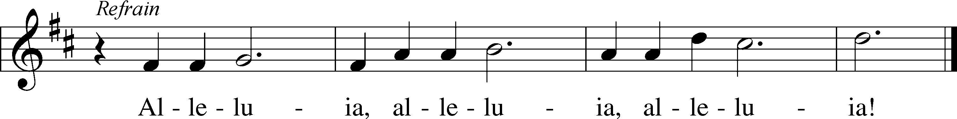
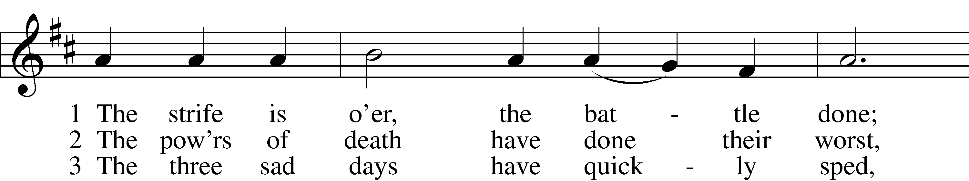
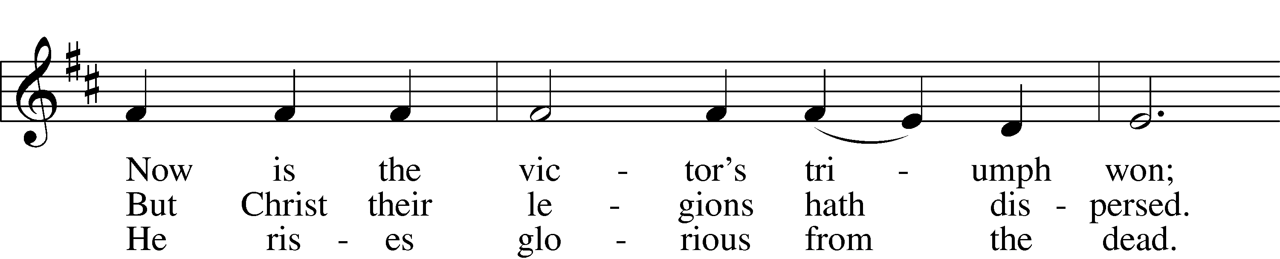
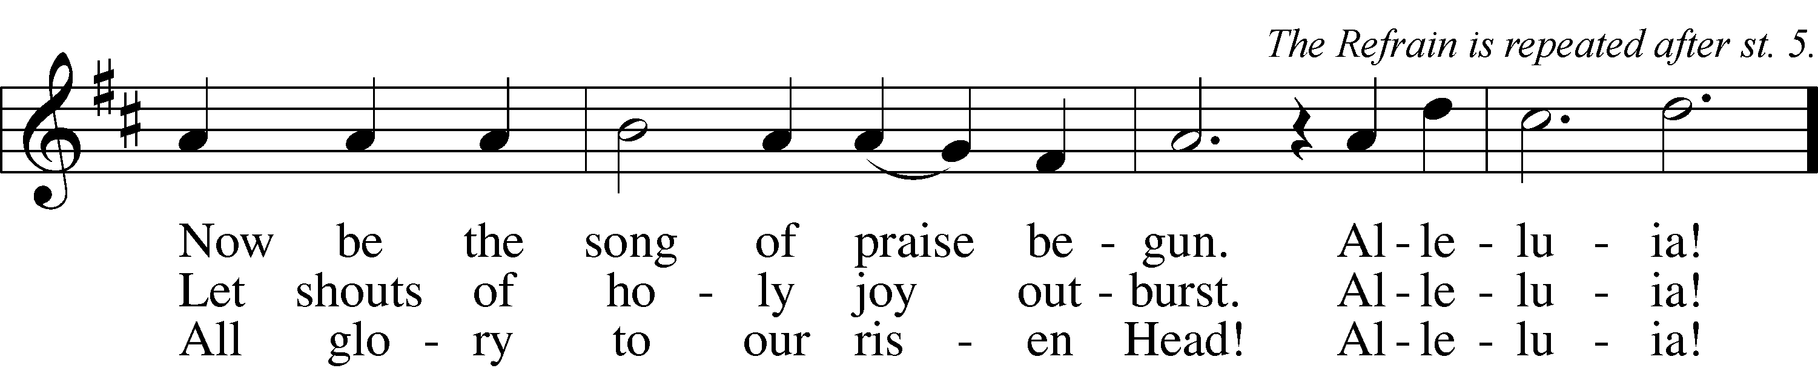

4 He broke the age-bound chains of hell;
The bars from heav’n’s high portals fell.
Let hymns of praise His triumph tell.
Alleluia!

5 Lord, by the stripes which wounded Thee,
From death’s dread sting Thy servants free
That we may live and sing to Thee.
Alleluia! Refrain
Text: Symphonia Sirenum Selectarum, 1695, Köln; tr. Francis Pott, 1832–1909, alt.
Tune: Giovanni P. da Palestrina, c. 1525–1594, adapt.
Text and tune: Public domain

+ CONFESSION AND ABSOLUTION +

(The sign of the cross may be made by all in remembrance of their Baptism.)

INVOCATION LSB 151
L In the name of the Father and of the T Son and of the Holy Spirit.
C Amen.

EXHORTATION LSB 151
L If we say we have no sin, we deceive ourselves, and the truth is not in us.
C But if we confess our sins, God, who is faithful and just, will forgive our sins and cleanse us from all unrighteousness.

(Silence for reflection on God’s Word and for self-examination.)

CONFESSION OF SINS LSB 151
L Let us then confess our sins to God our Father.
C Most merciful God, we confess that we are by nature sinful and unclean. We have sinned against You in thought, word, and deed, by what we have done and by what we have left undone. We have not loved You with our whole heart; we have not loved our neighbors as ourselves. We justly deserve Your present and eternal punishment. For the sake of Your Son, Jesus Christ, have mercy on us. Forgive us, renew us, and lead us, so that we may delight in Your will and walk in Your ways to the glory of Your holy name. Amen.

DECLARATION OF GRACE LSB 151
L In the mercy of almighty God, Jesus Christ was given to die for us, and for His sake God forgives us all our sins. To those who believe in Jesus Christ He gives the power to become the children of God and bestows on them the Holy Spirit. May the Lord, who has begun this good work in us, bring it to completion in the day of our Lord Jesus Christ.
C Amen.

+ SERVICE OF THE WORD +

INTROIT Psalm 50:7–10; antiphon: v. 1
The Mighty One, God the Lord, speaks and sum- | mons the earth*
from the rising of the sun to its | setting.
Hear, O my people, and I will speak; O Israel, I will testify a- | gainst you.*
I am | God, your God.
Not for your sacrifices do I re- | buke you;*
your burnt offerings are continually be- | fore me.
I will not accept a bull | from your house*
or goats | from your folds.
For every beast of the for- | est is mine,*
the cattle on a | thousand hills.
Glory be to the Father and | to the Son*
and to the Holy | Spirit;
as it was in the be- | ginning,*
is now, and will be forever. | Amen.
The Mighty One, God the Lord, speaks and sum- | mons the earth*
from the rising of the sun to its | setting.

KYRIE LSB 152

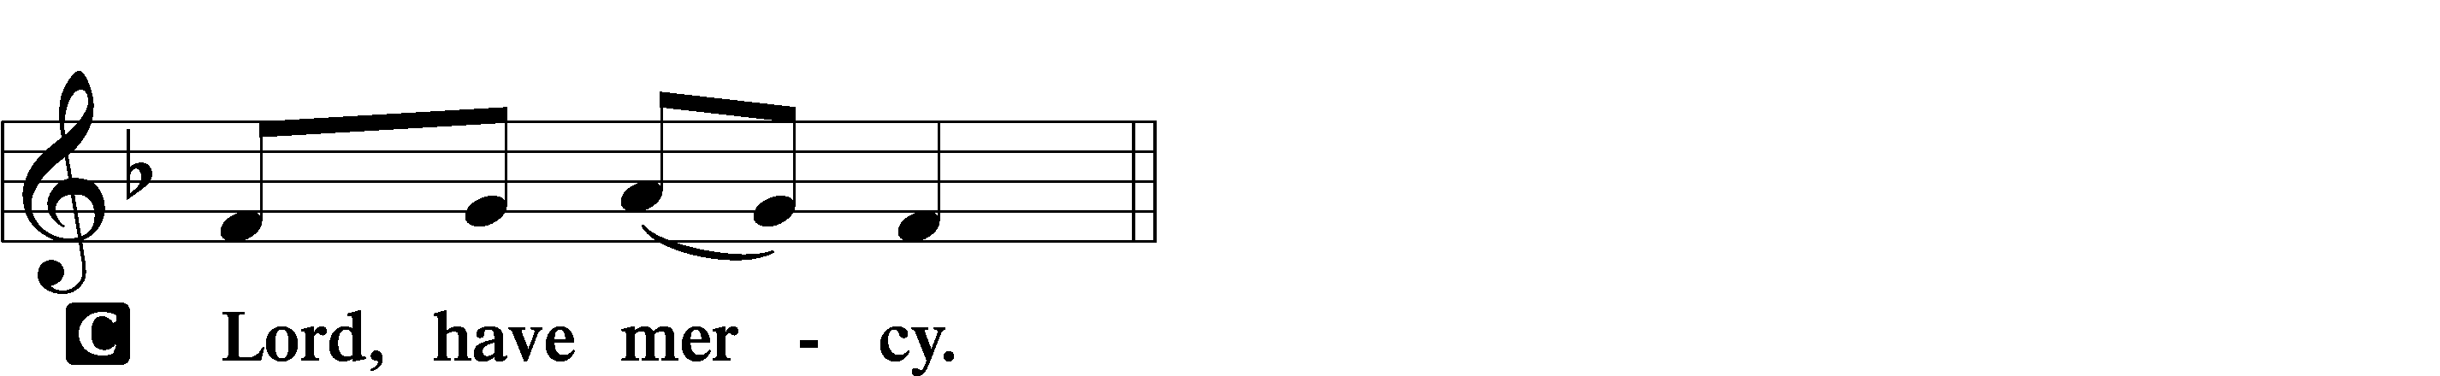

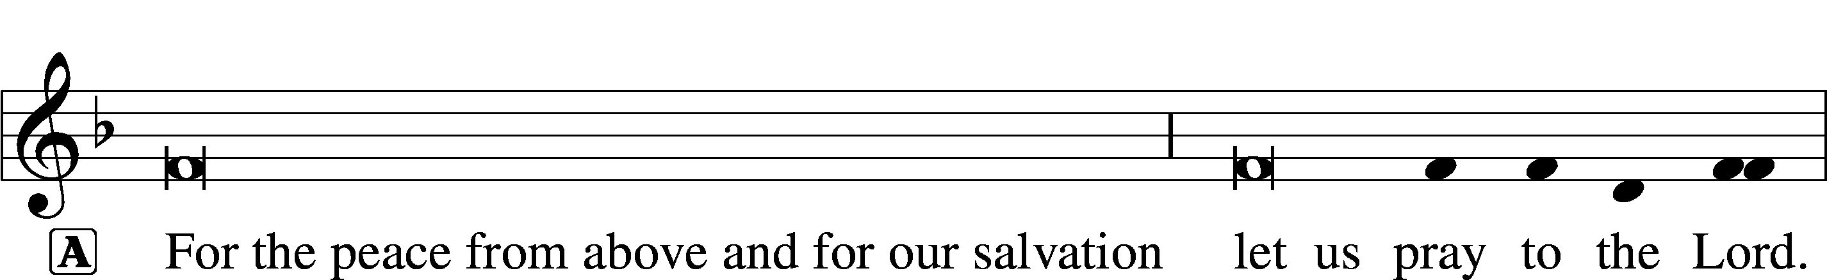
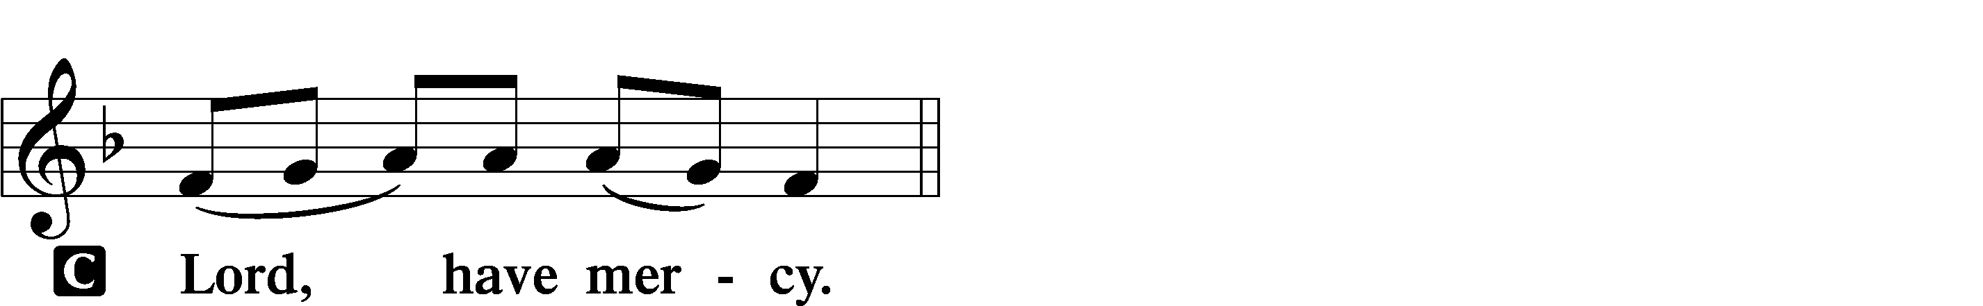

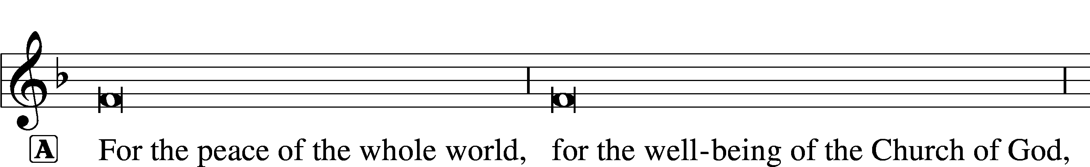
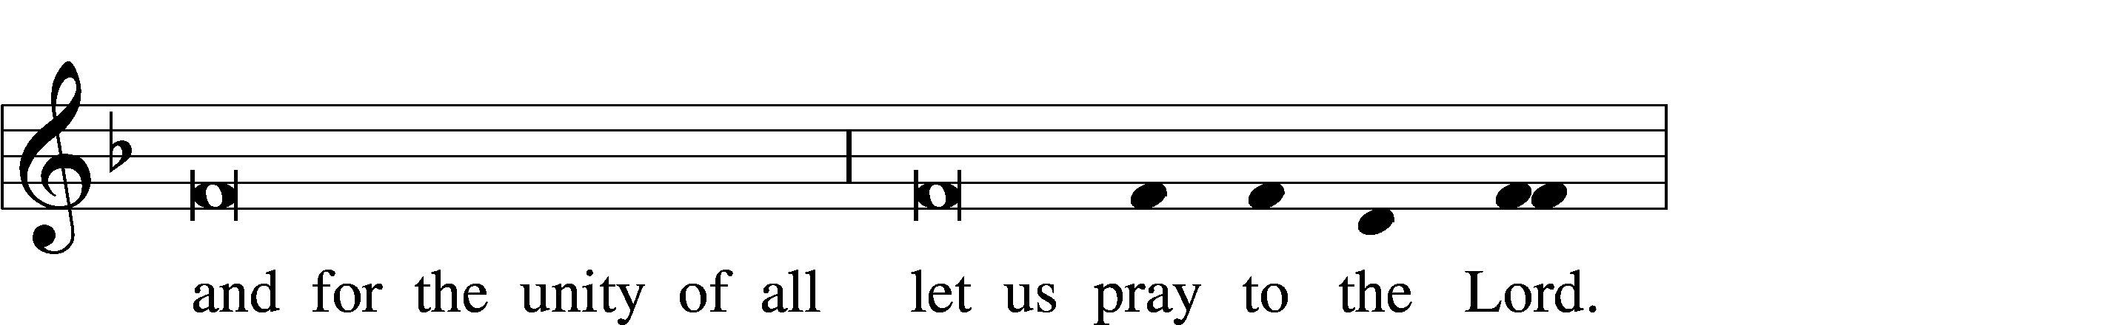
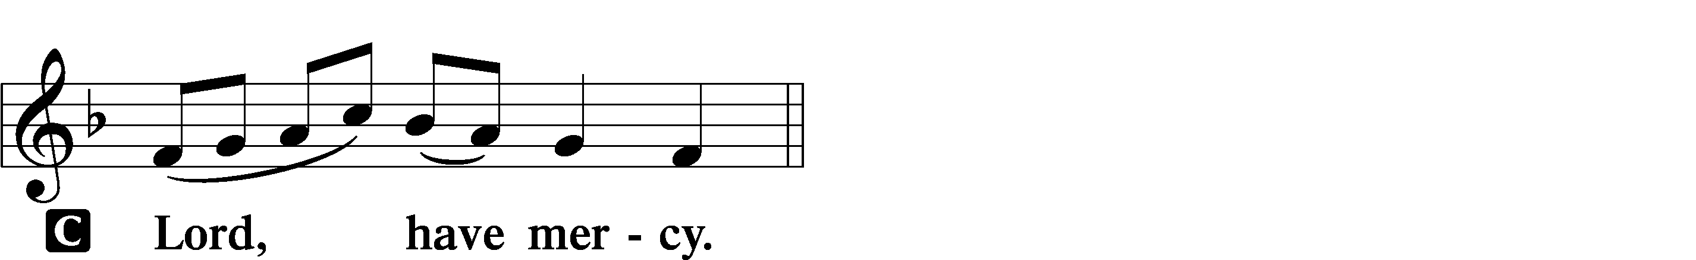

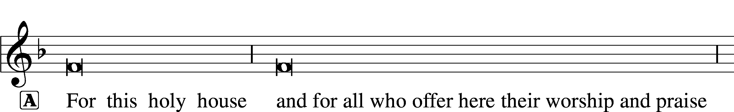
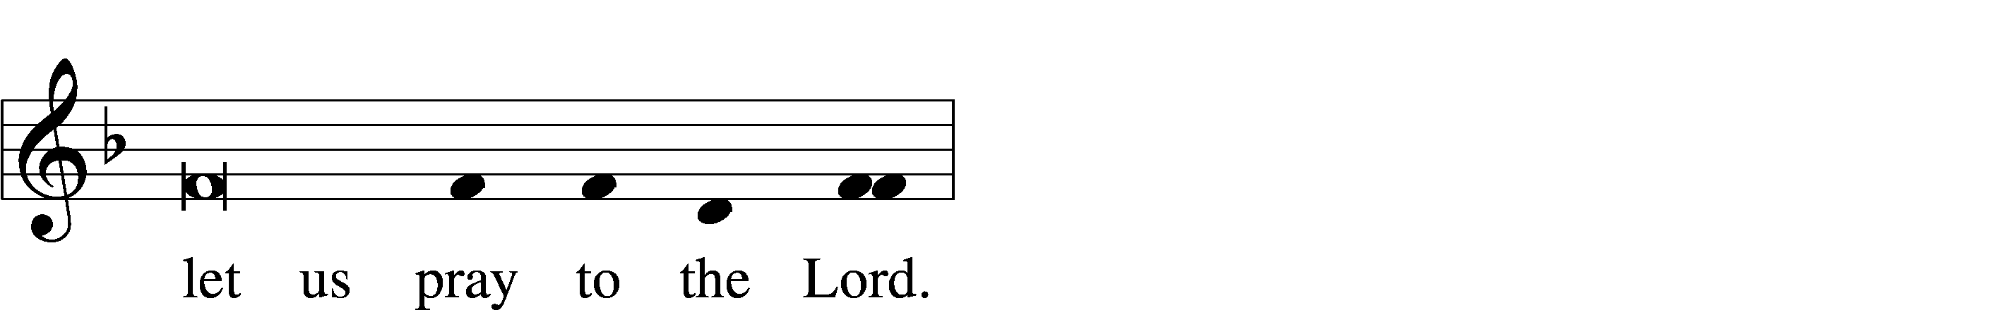
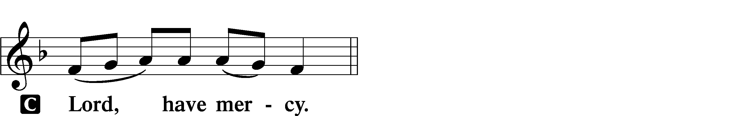

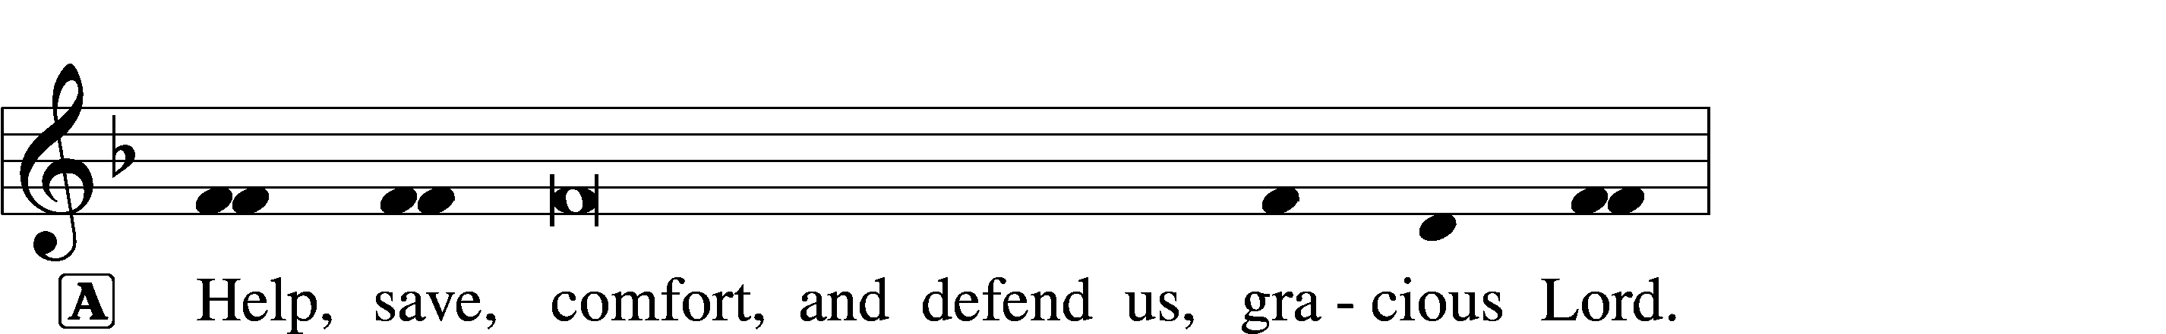


GLORIA IN EXCELSIS LSB 154
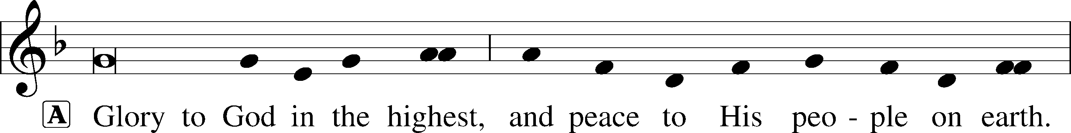
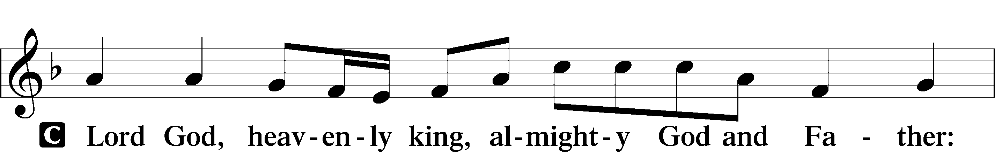
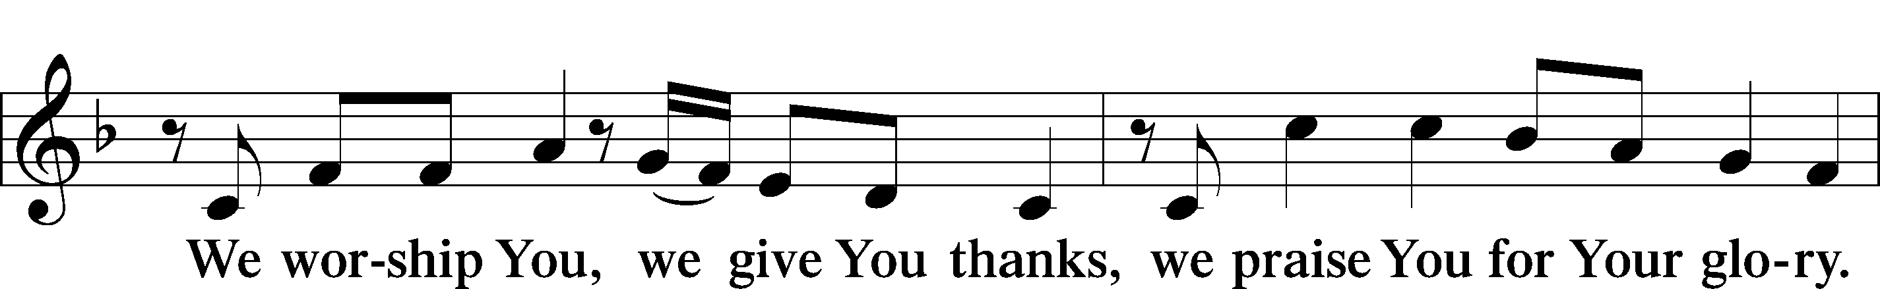
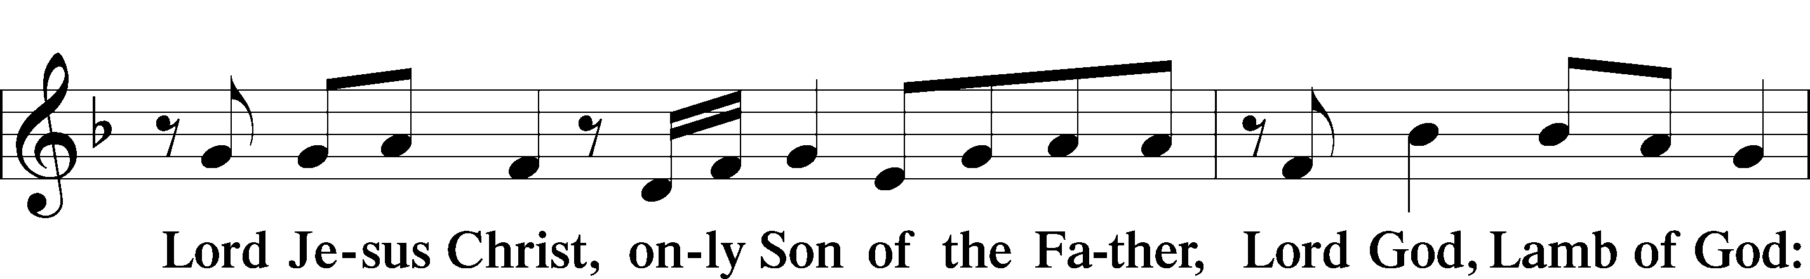
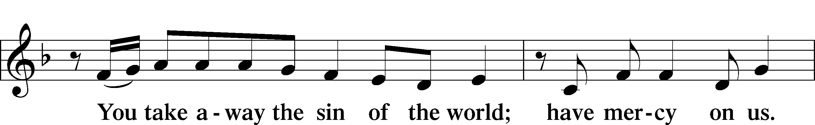
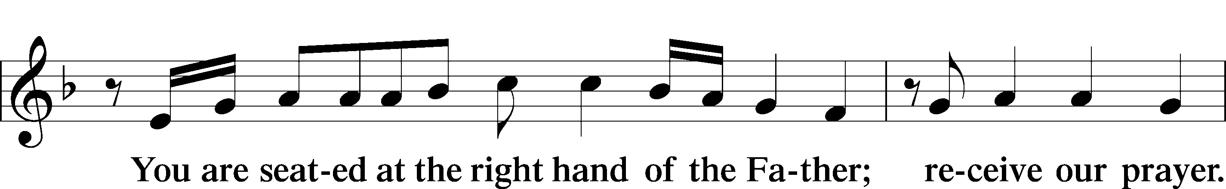
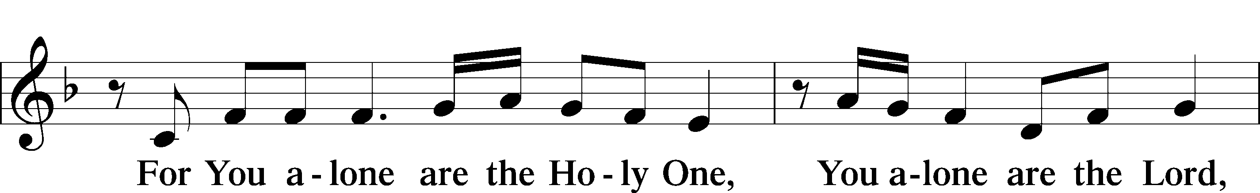
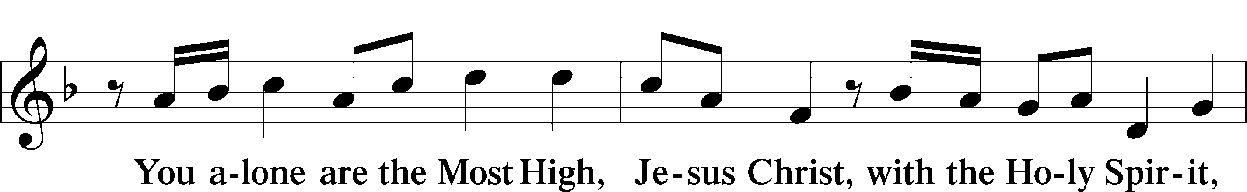
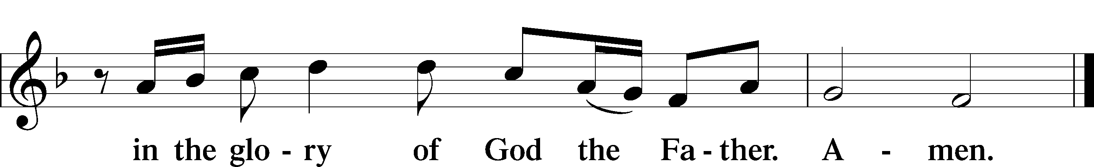

SALUTATION AND COLLECT OF THE DAY LSB 156
L The Lord be with you.
C And also with you.

L Let us pray.
Almighty and most merciful God, You sent Your Son, Jesus Christ, to seek and to save the lost. Graciously open our ears and our hearts to hear His call and to follow Him by faith that we may feast with Him forever in His kingdom; through the same Jesus Christ, our Lord, who lives and reigns with You and the Holy Spirit, one God, now and forever.
C Amen.

(Sit)

OLD TESTAMENT READING Hosea 5:15—6:6
15I will return again to my place,
until they acknowledge their guilt and seek my face,
and in their distress earnestly seek me.
1“Come, let us return to the Lord;
for he has torn us, that he may heal us;
he has struck us down, and he will bind us up.
2After two days he will revive us;
on the third day he will raise us up,
that we may live before him.
3Let us know; let us press on to know the Lord;
his going out is sure as the dawn;
he will come to us as the showers,
as the spring rains that water the earth.”
4What shall I do with you, O Ephraim?
What shall I do with you, O Judah?
Your love is like a morning cloud,
like the dew that goes early away.
5Therefore I have hewn them by the prophets;
I have slain them by the words of my mouth,
and my judgment goes forth as the light.
6For I desire steadfast love and not sacrifice,
the knowledge of God rather than burnt offerings.

L This is the Word of the Lord.
C Thanks be to God.
GRADUAL Psalm 145:3, 5b, 6b
Great is the Lord, and greatly | to be praised,*
and his greatness is un- | searchable.
On your wondrous works, I will | meditate,*
and I will declare your | greatness.

EPISTLE Romans 4:13–25
13The promise to Abraham and his offspring that he would be heir of the world did not come through the law but through the righteousness of faith. 14For if it is the adherents of the law who are to be the heirs, faith is null and the promise is void. 15For the law brings wrath, but where there is no law there is no transgression.
16That is why it depends on faith, in order that the promise may rest on grace and be guaranteed to all his offspring—not only to the adherent of the law but also to the one who shares the faith of Abraham, who is the father of us all, 17as it is written, “I have made you the father of many nations”—in the presence of the God in whom he believed, who gives life to the dead and calls into existence the things that do not exist. 18In hope he believed against hope, that he should become the father of many nations, as he had been told, “So shall your offspring be.” 19He did not weaken in faith when he considered his own body, which was as good as dead (since he was about a hundred years old), or when he considered the barrenness of Sarah’s womb. 20No distrust made him waver concerning the promise of God, but he grew strong in his faith as he gave glory to God, 21fully convinced that God was able to do what he had promised. 22That is why his faith was “counted to him as righteousness.” 23But the words “it was counted to him” were not written for his sake alone, 24but for ours also. It will be counted to us who believe in him who raised from the dead Jesus our Lord, 25who was delivered up for our trespasses and raised for our justification.

L This is the Word of the Lord.
C Thanks be to God.

(Stand)

ALLELUIA AND VERSE LSB 156
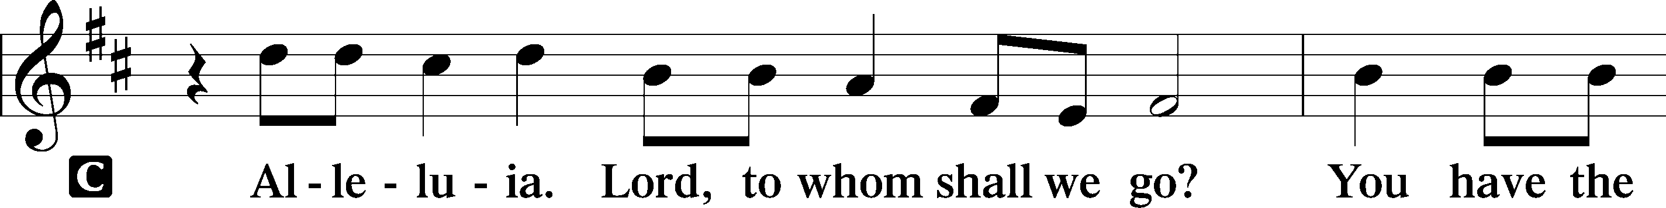
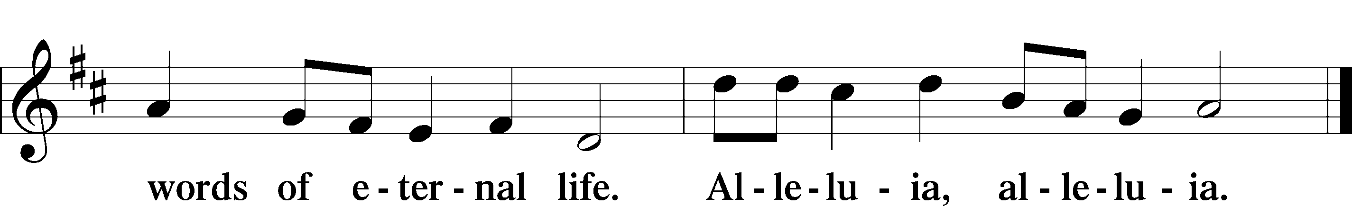

HOLY GOSPEL Matthew 9:9–13
L The Holy Gospel according to St. Matthew, the ninth chapter.

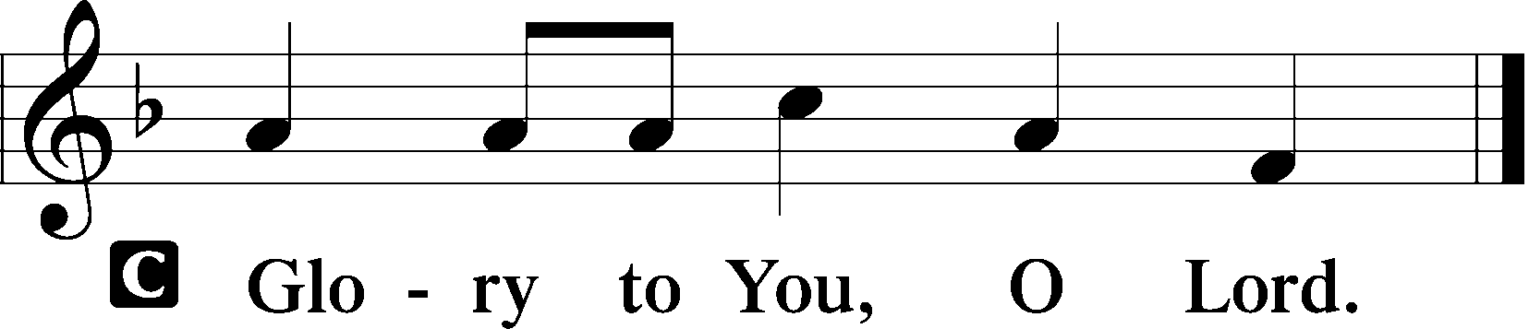

9As Jesus passed on from there, he saw a man called Matthew sitting at the tax booth, and he said to him, “Follow me.” And he rose and followed him.
10And as Jesus reclined at table in the house, behold, many tax collectors and sinners came and were reclining with Jesus and his disciples. 11And when the Pharisees saw this, they said to his disciples, “Why does your teacher eat with tax collectors and sinners?” 12But when he heard it, he said, “Those who are well have no need of a physician, but those who are sick. 13Go and learn what this means, ‘I desire mercy, and not sacrifice.’ For I came not to call the righteous, but sinners.”

L This is the Gospel of the Lord.

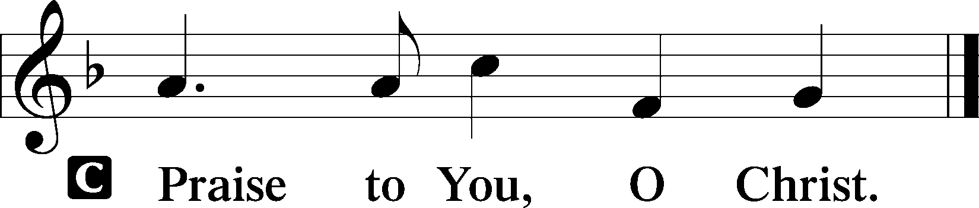

(Sit)

702 MY FAITH LOOKS UP TO THEE
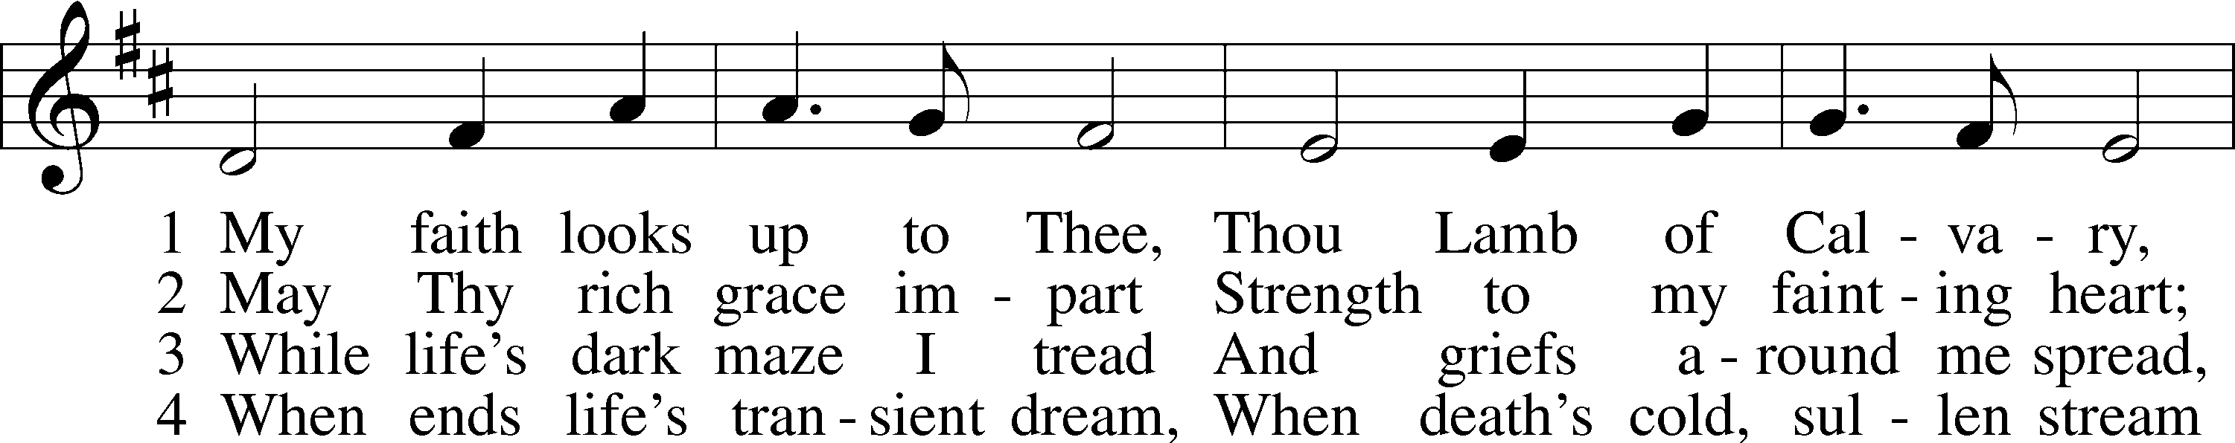
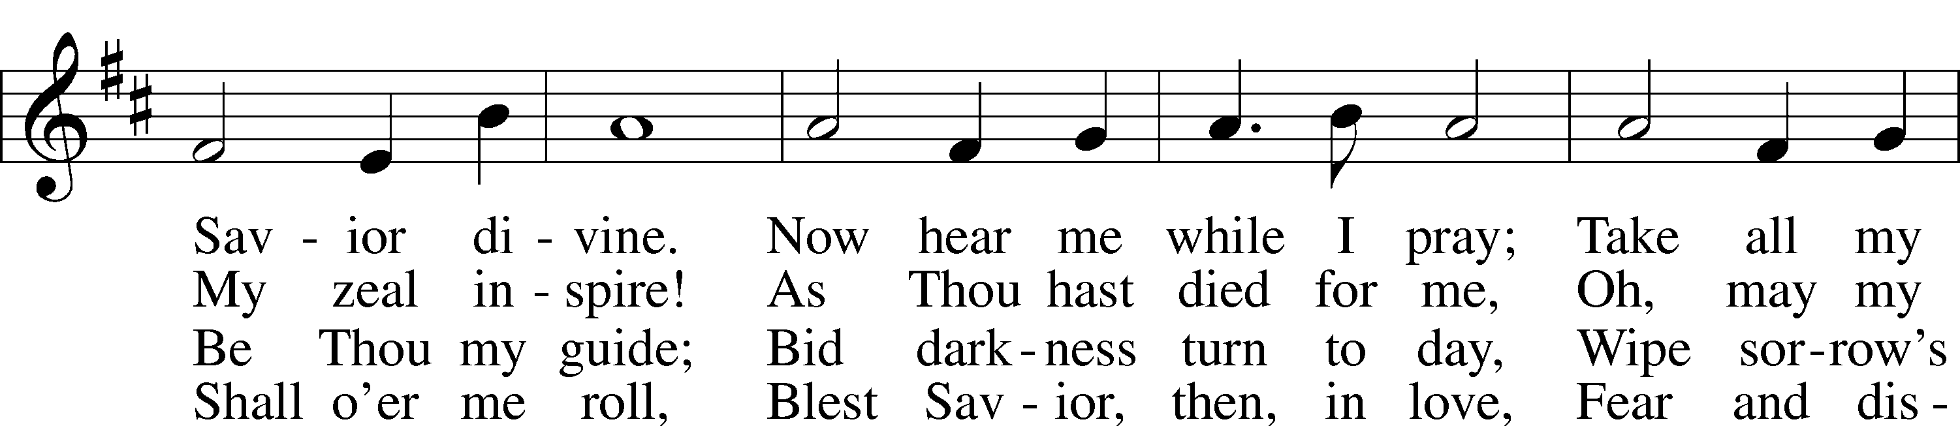
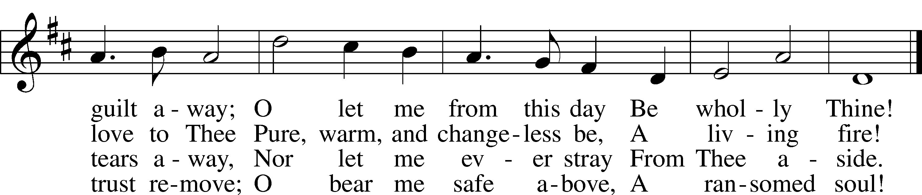
Text: Ray Palmer, 1808–87
Tune: Lowell Mason, 1792–1872
Text and tune: Public domain

SERMON

(Sermons for Elder led services are provided courtesy of the Lutheran Church - Canada (https://www.lutheranchurchcanada.ca/resources/written-sermons/), a member of the International Lutheran Council (https://ilcouncil.org/) with whom the Lutheran Church - Missouri Synod (https://www.lcms.org/) is in altar and pulpit fellowship.)

(Stand)

NICENE CREED LSB 158
C I believe in one God,
the Father Almighty,
maker of heaven and earth
and of all things visible and invisible.

And in one Lord Jesus Christ,
the only-begotten Son of God,
begotten of His Father before all worlds,
God of God, Light of Light,
very God of very God,
begotten, not made,
being of one substance with the Father,
by whom all things were made;
who for us men and for our salvation came down from heaven
and was incarnate by the Holy Spirit of the virgin Mary
and was made man;
and was crucified also for us under Pontius Pilate.
He suffered and was buried.
And the third day He rose again according to the Scriptures
and ascended into heaven
and sits at the right hand of the Father.
And He will come again with glory to judge both the living and the dead,
whose kingdom will have no end.

And I believe in the Holy Spirit,
the Lord and giver of life,
who proceeds from the Father and the Son,
who with the Father and the Son together is worshiped and glorified,
who spoke by the prophets.
And I believe in one holy Christian and apostolic Church,
I acknowledge one Baptism for the remission of sins,
and I look for the resurrection of the dead
and the life T of the world to come. Amen.

SHARING OF THE PEACE

(The people may greet one another in the name of the Lord, saying, “Peace be with you,” as a sign of reconciliation and of the unity of the Spirit in the bond of peace (Matt. 5:22–24; Eph. 4:1–3).)

(Sit)

PRAYER OF THE CHURCH

OFFERING

(As a part of our expression of thanksgiving to God for the treasure of His salvation to us, we offer a portion of our treasure, according to what each has determined in their heart to give. Please place offerings in the collection plate at the back of the sanctuary before or after the service. Offerings can also be sent to Bethlehem Lutheran Church via U.S. Mail. Thank you!)

(Stand)

OFFERTORY LSB 159
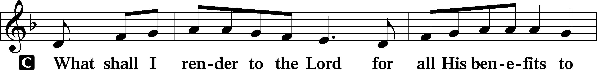
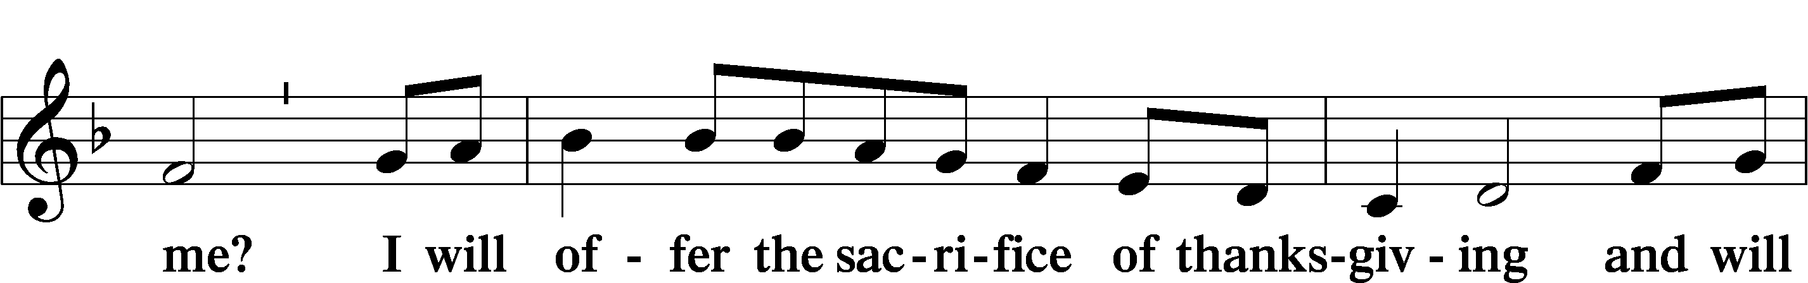
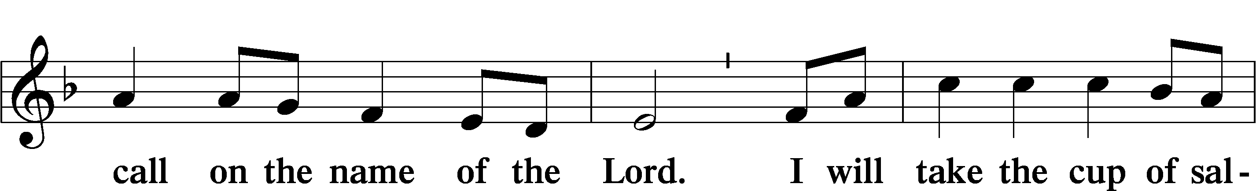
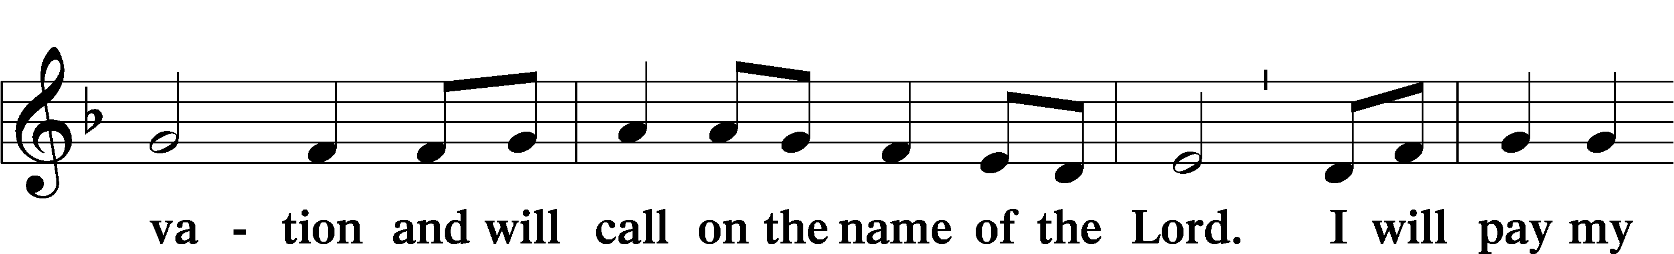
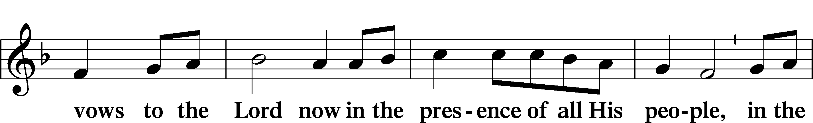
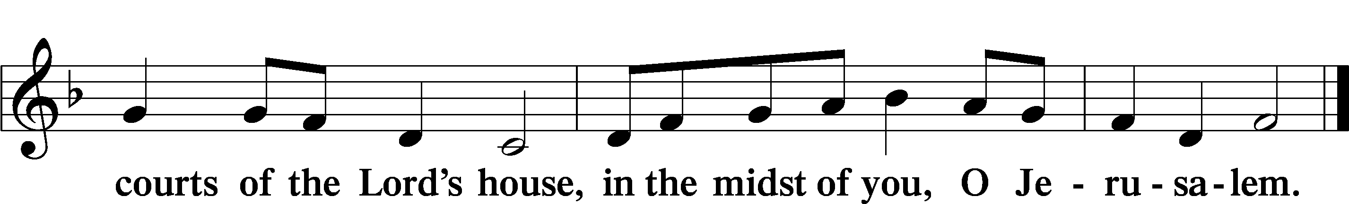

LORD’S PRAYER LSB 162
L Lord, remember us in Your kingdom and teach us to pray:
C Our Father who art in heaven,
hallowed be Thy name,
Thy kingdom come,
Thy will be done on earth
as it is in heaven;
give us this day our daily bread;
and forgive us our trespasses
as we forgive those
who trespass against us;
and lead us not into temptation,
but deliver us from evil.
For Thine is the kingdom
and the power and the glory
forever and ever. Amen.

CONCLUDING COLLECT

BENEDICTION
L The grace of our Lord T Jesus Christ and the love of God and the fellowship of the Holy Spirit be with us all.
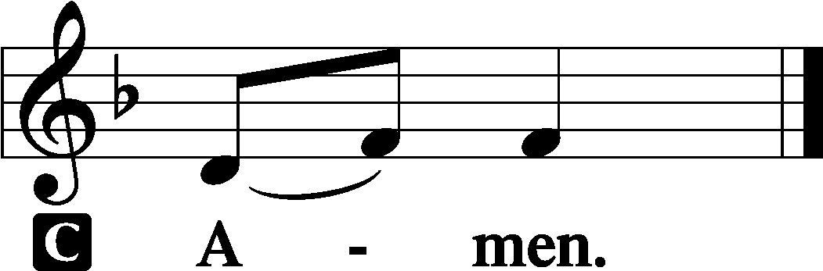

728 HOW FIRM A FOUNDATION
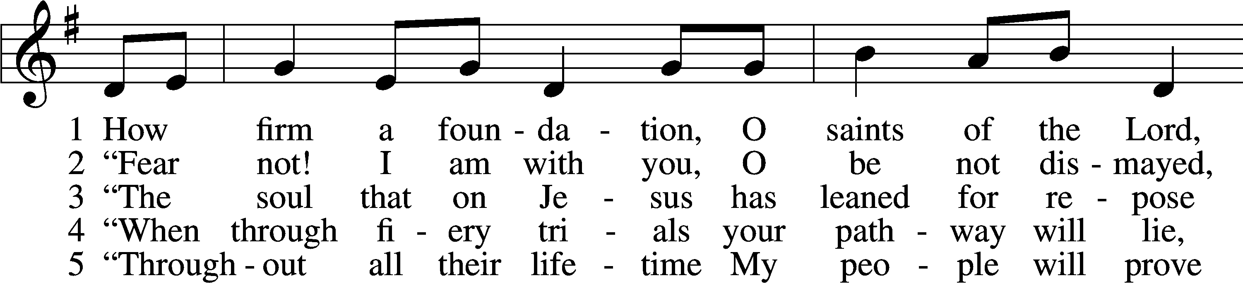
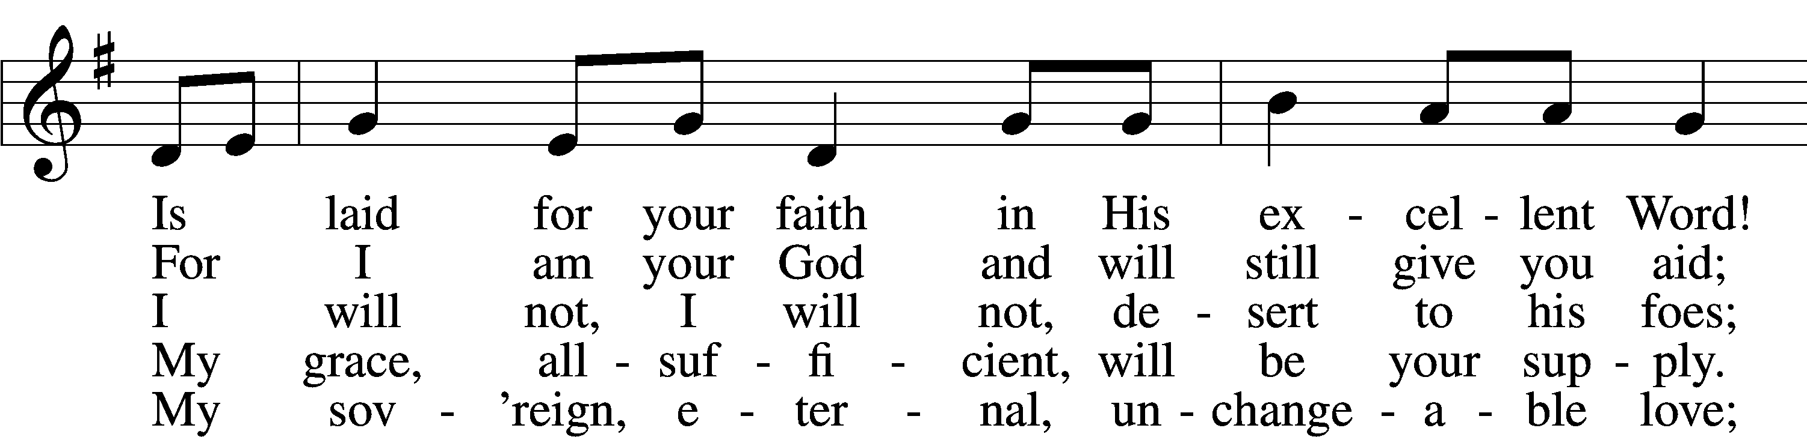
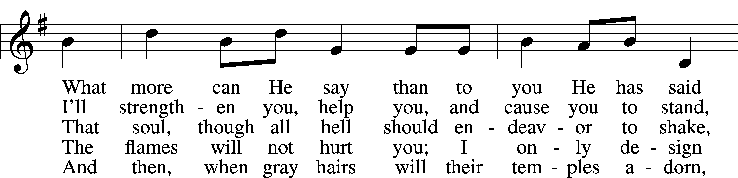
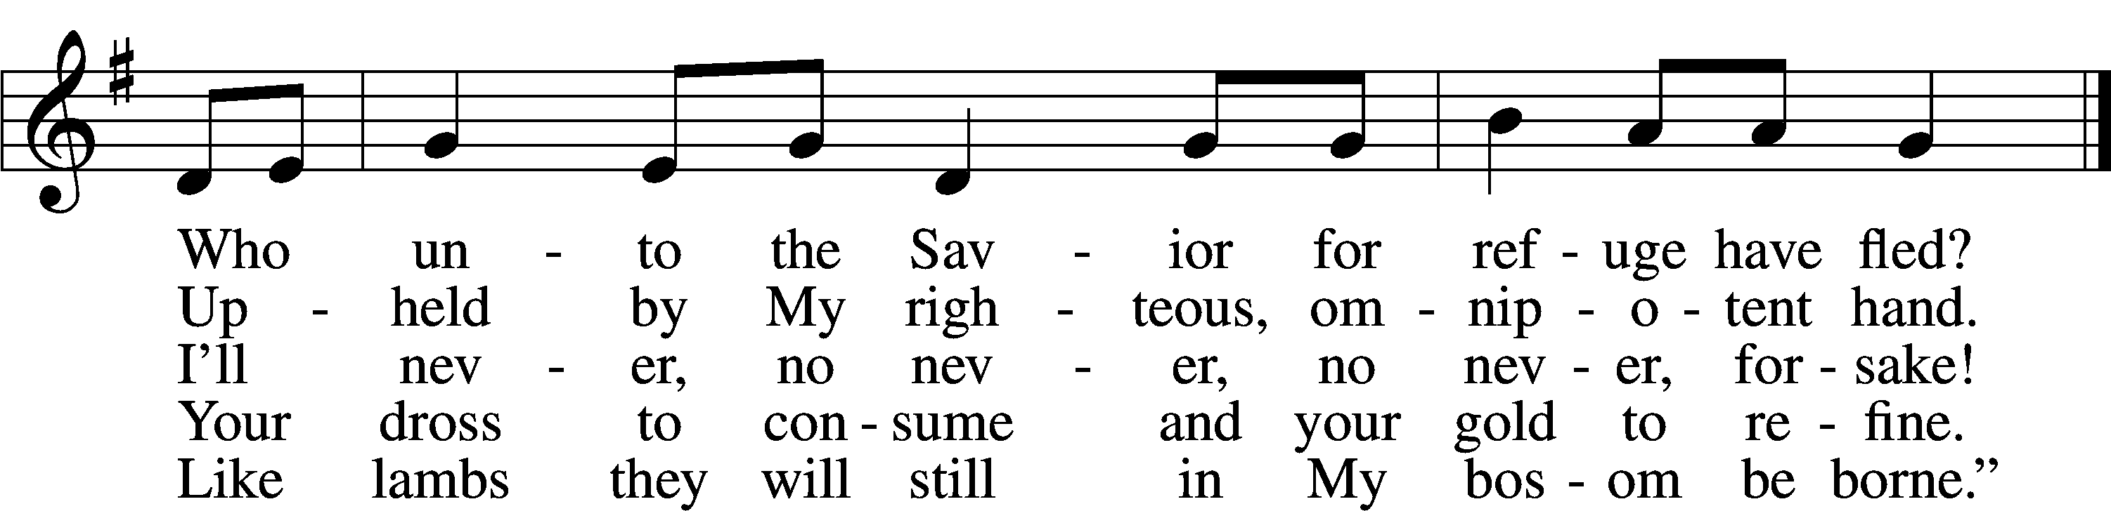
Text: A Selection of Hymns, 1787, London, alt.
Tune: Genuine Church Music, 1832, Winchester
Text and tune: Public domain
ACKNOWLEDGMENTS
Unless otherwise indicated, Scripture quotations are from the ESV® Bible (The Holy Bible, English Standard Version®), copyright © 2001 by Crossway, a publishing ministry of Good News Publishers. Used by permission. All rights reserved.
Created by Lutheran Service Builder © 2026 Concordia Publishing House.

