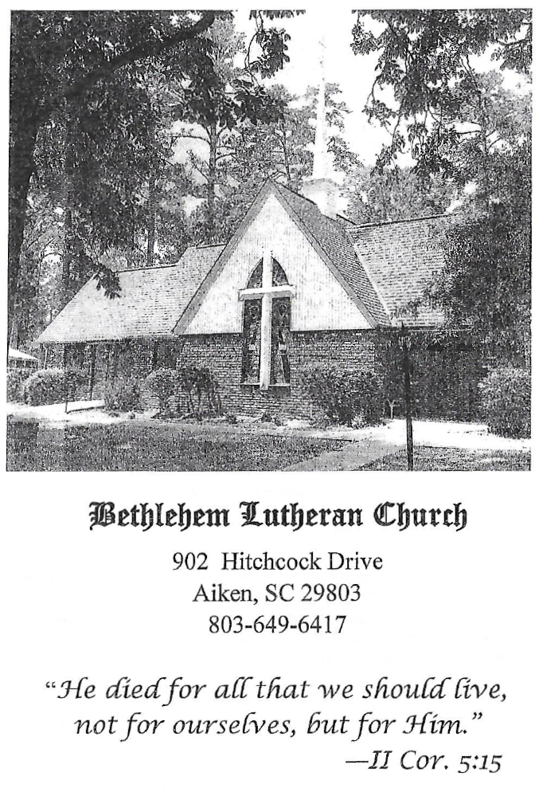

BETHLEHEM LUTHERAN CHURCH
A congregation of The Lutheran Church-Missouri Synod
902 Hitchcock Drive SW,
Aiken, South Carolina 29803
Church Phone: (803) 649-6417
blcaikensc@gmail.com

Bethlehem Lutheran welcomes our members and guests to our worship service! Unable to join us in person? Please find us on Facebook live. The service is also posted on our website; bethlehemlutheranaiken.org.

+ + + + + + + + + + + + + + +
Reformation Day (observed)
October 25, 2026
10:30 a.m.
+ + + + + + + + + + + + + + +

Our Policy and Practice Regarding Holy Communion
Hear the words of the Apostle Paul;
Anyone who eats and drinks without recognizing the body of the Lord eats and drinks judgment on himself. -1 Cor.11:29
Therefore, visitors are asked to please refrain from partaking of the Sacrament before speaking about this with the pastor; because we care about your spiritual well-being.
Also, because communing at this altar is a public confession that you agree with the doctrines of The Lutheran Church-Missouri Synod, and reject all contrary teachings.
Persons who are not communing today are always welcome to come forward during the distribution to receive an individual blessing; please cross your arms over your chest to indicate your desire for this. Thank you!
We commune in two alternating tables. The ushers will guide you. Non-alcoholic white wine is available in the center of the individual cup tray. Please leave empty individual cups at the altar rail.

+ SERVICE OF PREPARATION +

(After the bell tolls, please observe a time of silence.)

OPENING THOUGHTS
P Today is “Reformation Sunday.” This is a special day for Protestant Churches, especially Lutheran Churches. We commemorate the day when Martin Luther posted his famous 95 Theses to the church door in Wittenberg, Germany (which happened October 31, 1517). They sparked the Reformation. As the Reformation moved forward, the Lutherans were given the chance to clearly state what they believed. A special gathering was called in Augsburg, Germany and, on June 25, 1530, the Lutherans presented what is now called the Augsburg Confession. This confession, along with several other documents, were gathered and published in 1580 as the Book of Concord. This book has become the official statement of what Lutherans believe, teach, and confess. Today’s service will use many quotes from the Lutheran Confessions, especially the Augsburg Confession, as a way of affirming our unity with those who have gone before us and with those to whom the faith will be passed.

PRAYER BEFORE WORSHIP
P Almighty God, Who, through the preaching of Thy servants, the blessed Reformers, hast caused the light of the Gospel to shine forth: Grant, we beseech Thee, that, knowing its saving power, we may faithfully guard and defend it against all enemies and joyfully proclaim it, to the salvation of souls and the glory of Thy holy Name; through Jesus Christ, Thy Son, our Lord. Amen.

WELCOME AND ANNOUNCEMENTS

PRELUDE

(Stand)

578 THY STRONG WORD
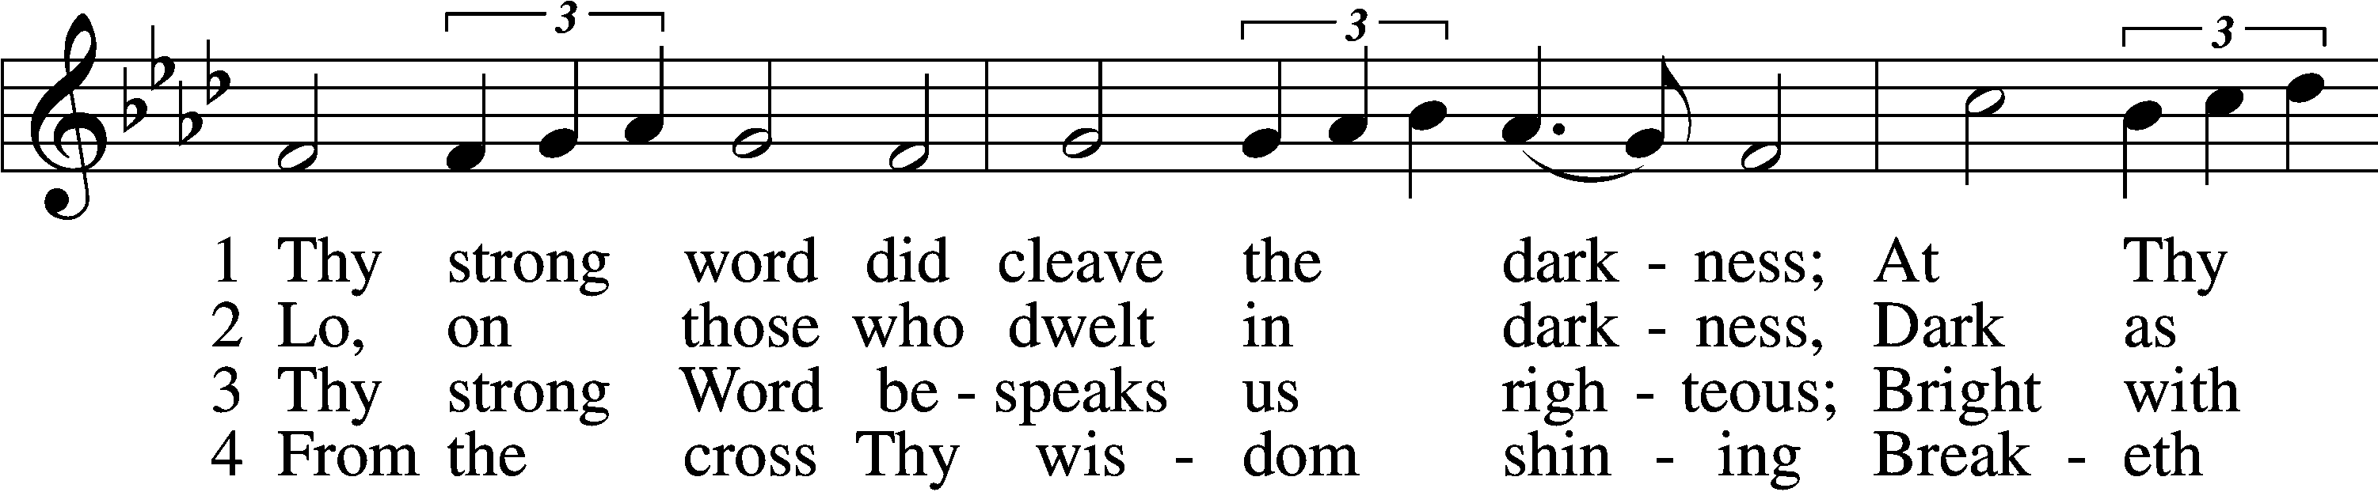
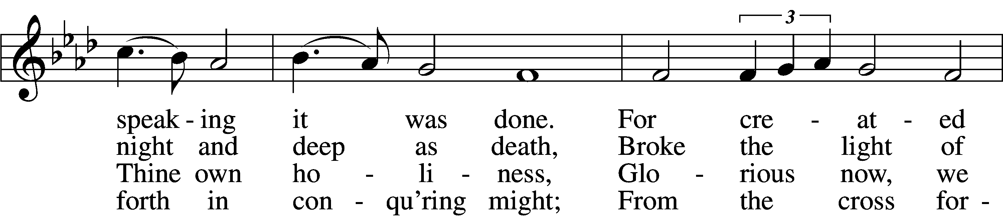
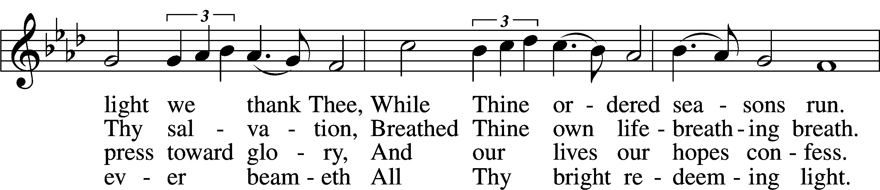
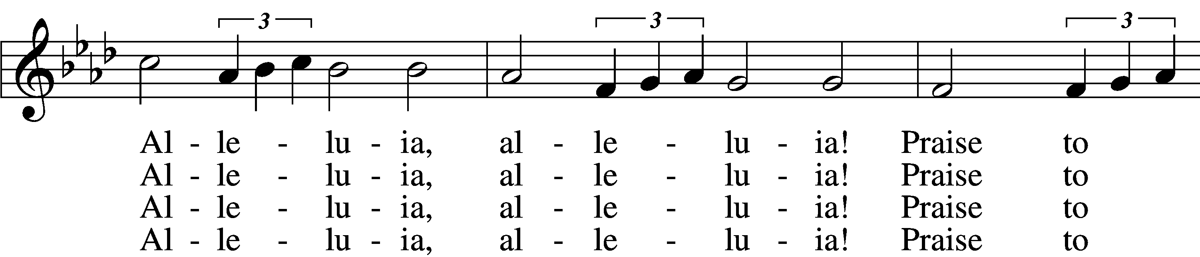
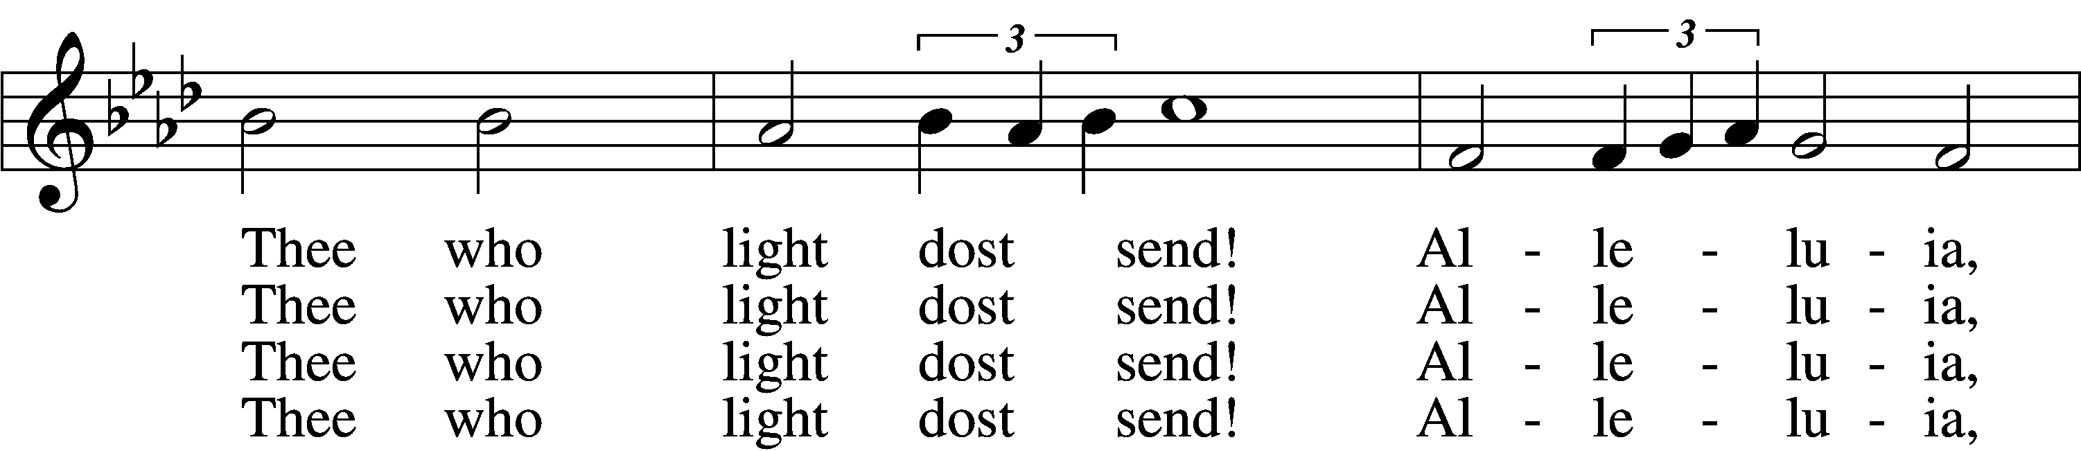
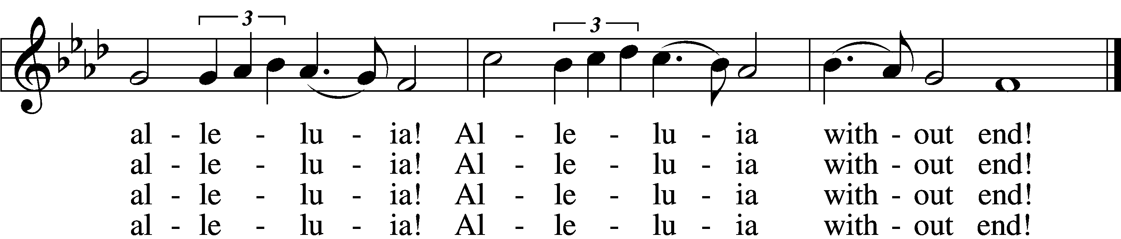

(next page)

5 Give us lips to sing Thy glory,
Tongues Thy mercy to proclaim,
Throats that shout the hope that fills us,
Mouths to speak Thy holy name.
Alleluia, alleluia!
May the light which Thou dost send
Fill our songs with alleluias,
Alleluias without end!

D 6 God the Father, light-creator,
To Thee laud and honor be.
To Thee, Light of Light begotten,
Praise be sung eternally.
Holy Spirit, light-revealer,
Glory, glory be to Thee.
Mortals, angels, now and ever
Praise the holy Trinity!
Text: Martin H. Franzmann, 1907–76
Tune: Thomas J. Williams, 1869–1944
Text: © 1969 Concordia Publishing House. Used by permission: LSB Hymn License no. 110004798
Tune: Public domain

(The sign of the cross may be made by all in remembrance of their Baptism.)

INVOCATION LSB 184
P In the name of the Father and of the T Son and of the Holy Spirit.
C Amen.

P According to the Word of God, and the Lutheran Confessions, what do we believe is the nature of the Triune God?
C Our churches teach with common consent that the decree of the Council of Nicaea about the unity of the divine essence and the three persons is true. It is to be believed without any doubt. God is one divine essence who is eternal, without a body, without parts, of infinite power, wisdom, and goodness. He is the maker and preserver of all things, visible and invisible. Yet there are three persons, the Father, the Son, and the Holy Spirit. These three persons are of the same essence and power. (Augsburg Confession, Article I:1-3)

+ CONFESSION AND ABSOLUTION +

P Whenever we celebrate the Lord’s Supper our services contain a time to confess our sins and receive absolution. What do we believe about this?
C Confession in the churches is not abolished among us. The body of the Lord is not usually given to those who have not been examined and absolved. The people are very carefully taught about faith in the Absolution. … Our people are taught that they should highly prize the Absolution as being God’s voice and pronounced by God’s command. The Power of the Keys is set forth in its beauty. They are reminded what great consolation it brings to anxious consciences and that God requires faith to believe such Absolution as a voice sounding from heaven. They are taught that such faith in Christ truly obtains and receives the forgiveness of sins. …
Our churches teach that naming every sin is not necessary and that consciences should not be burdened with worry about naming every sin. It is impossible to recount all sins, as Psalm 19:12 testifies: “Who can discern his errors?” Also Jeremiah 17:9, “The heart is deceitful above all things, and desperately sick; who can understand it?” If only sins that can be named are forgiven, consciences could never find peace. For many sins cannot be seen or remembered. The ancient writers also testify that a listing of sins is not necessary.
… because of the great benefit of Absolution, and because it is otherwise useful to the conscience, Confession is retained among us. (Augsburg Confession, Article XXV:1-4, 7-10, 13)
P We continue, then, with our confession and absolution.

EXHORTATION LSB 184
P Beloved in the Lord! Let us draw near with a true heart and confess our sins unto God our Father, beseeching Him in the name of our Lord Jesus Christ to grant us forgiveness.

P Our help is in the name of the Lord,
C who made heaven and earth.
P I said, I will confess my transgressions unto the Lord,
C and You forgave the iniquity of my sin.

(Silence for reflection on God’s Word and for self-examination.)

CONFESSION OF SINS LSB 184
P O almighty God, merciful Father,
C I, a poor, miserable sinner, confess unto You all my sins and iniquities with which I have ever offended You and justly deserved Your temporal and eternal punishment. But I am heartily sorry for them and sincerely repent of them, and I pray You of Your boundless mercy and for the sake of the holy, innocent, bitter sufferings and death of Your beloved Son, Jesus Christ, to be gracious and merciful to me, a poor, sinful being.

ABSOLUTION LSB 185
P Upon this your confession, I, by virtue of my office, as a called and ordained servant of the Word, announce the grace of God unto all of you, and in the stead and by the command of my Lord Jesus Christ I forgive you all your sins in the name of the Father and of the T Son and of the Holy Spirit.
C Amen.

+ SERVICE OF THE WORD +

P In the years leading up to the Reformation the worship services in Germany, France, England, and elsewhere in the West, were conducted in the Latin language. Why did we start using languages people could understand?
C Not only has Paul commanded that a language understood by the people be used in church (1 Corinthians 14:2, 9) but human law has also commanded it. (Augsburg Confession, Article XXIV [The Mass] 4)
P In the days of Jesus true believers didn’t celebrate Reformation Sunday, or many of the other special days we set aside and celebrate. On the other hand, there have been many special days in the past that we no longer observe. Why is this so?
C Our churches teach that ceremonies ought to be observed that may be observed without sin. Also, ceremonies and other practices that are profitable for tranquility and good order in the Church (in particular, holy days, festivals, and the like) ought to be observed.
Yet, the people are taught that consciences are not to be burdened as though observing such things was necessary for salvation. (Augsburg Confession, Article XV:1-2a)

P In our worship services we are constantly engaged in a dialogue, both sung and spoken, drawn from the Bible. Why do we place such importance on hearing the Word of God?
C We believe, teach, and confess that the only rule and norm according to which all teachings, together with all teachers, should be evaluated and judged are the prophetic and apostolic Scriptures of the Old and New Testament alone. For it is written in Psalm 119:105, “Your word is a lamp to my feet and a light to my path.” St. Paul has written, “even if we or an angel from heaven should preach to you a gospel contrary to the one we preached to you, let him be accursed.”
However, other writings by ancient or modern teachers—no matter whose name they bear—must not be regarded as equal to the Holy Scriptures. All of them are subject to the Scriptures. (Formula of Concord, Epitome, Summary 1-2)
P Then let us continue our celebration of the Reformation, in English, with the Introit for the Day, which is drawn from the Psalms:

INTROIT Psalm 34:1–2, 11, 22; antiphon: Psalm 119:46
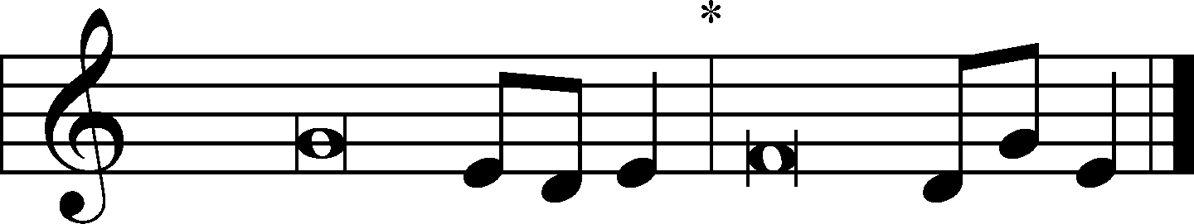
I will speak of your testimonies before kings, | [O Lord,]*
and shall not be | put to shame.
I will bless the Lord at | all times;*
his praise shall continually be | in my mouth.
My soul makes its boast | in the Lord;*
let the humble hear | and be glad.
Come, O children, lis- | ten to me;*
I will teach you the fear | of the Lord.
The Lord redeems the life of his | servants;*
none of those who take refuge in him will | be condemned.
Glory be to the Father and | to the Son*
and to the Holy | Spirit;
as it was in the be- | ginning,*
is now, and will be forever. | Amen.
I will speak of your testimonies before kings, | [O Lord,]*
and shall not be | put to shame.

KYRIE LSB 186
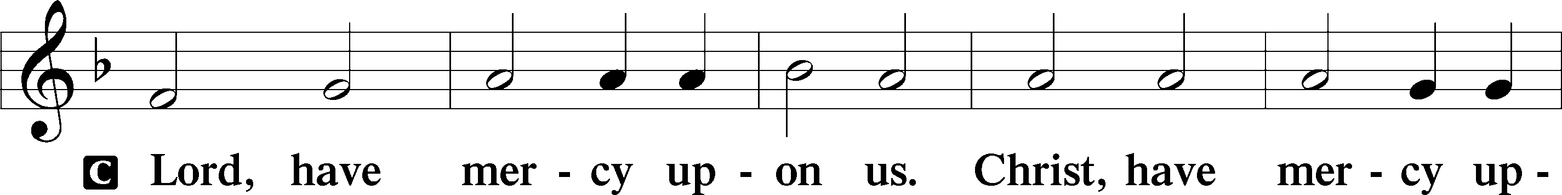
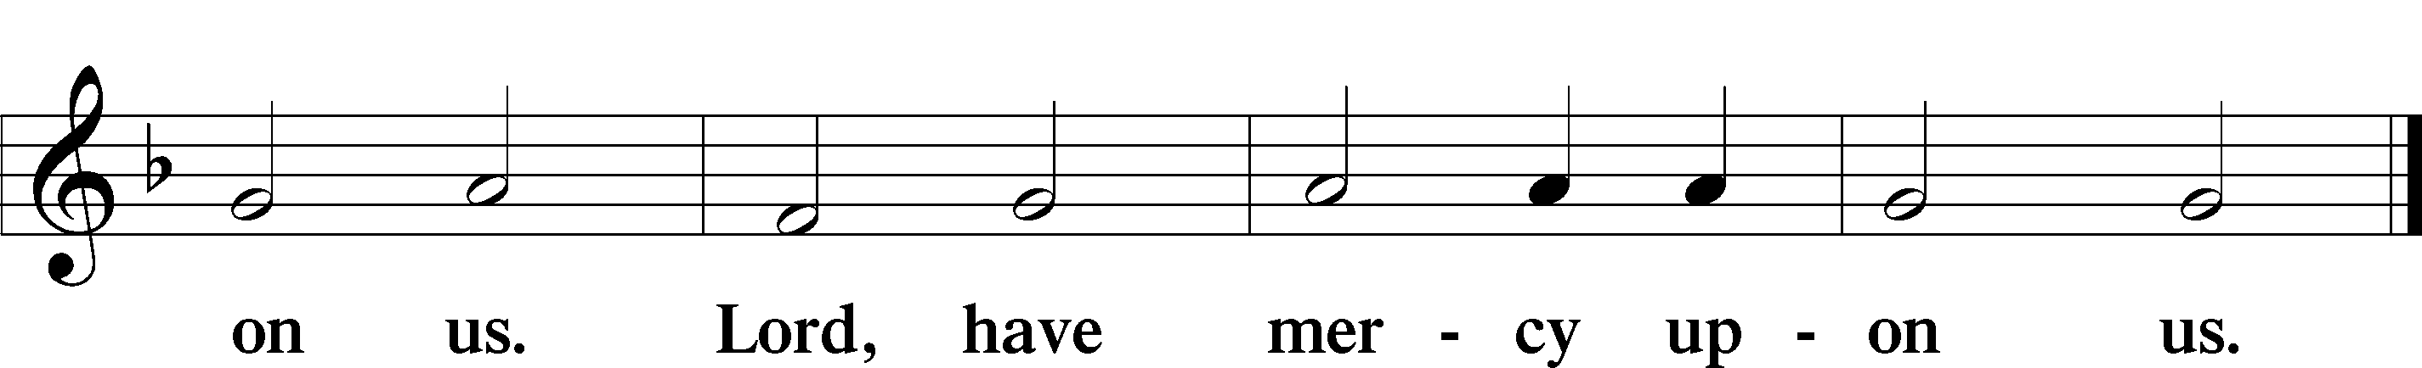

GLORIA IN EXCELSIS LSB 187
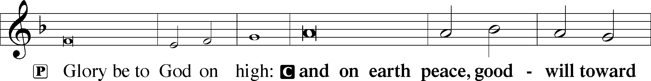
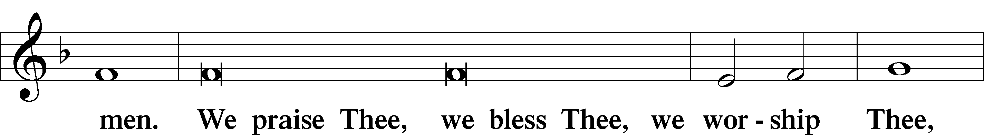
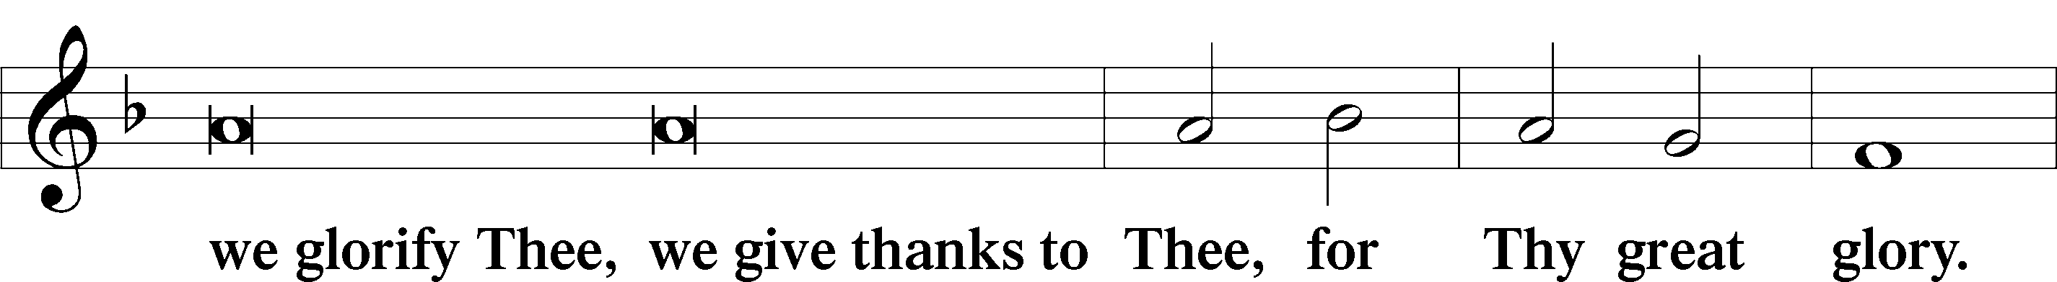
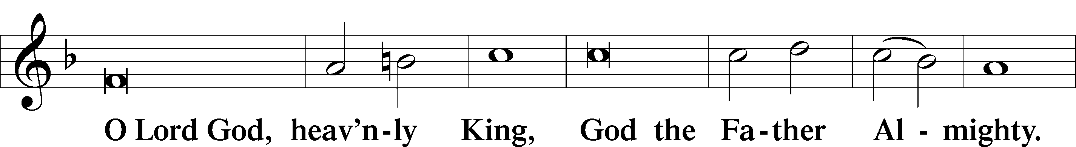
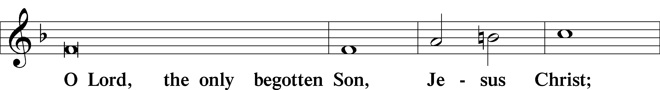
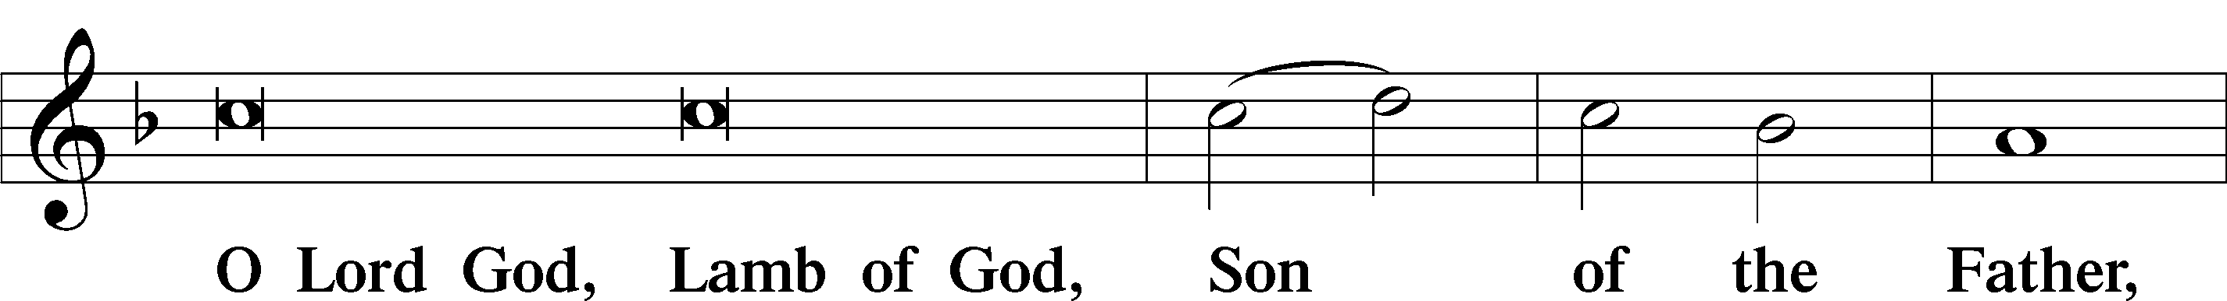
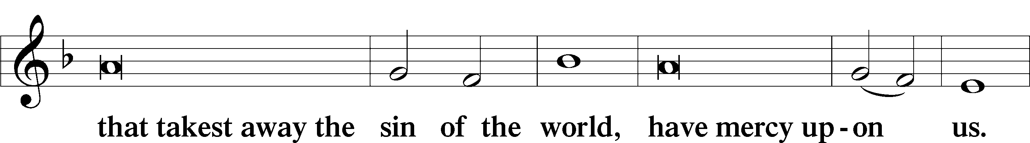
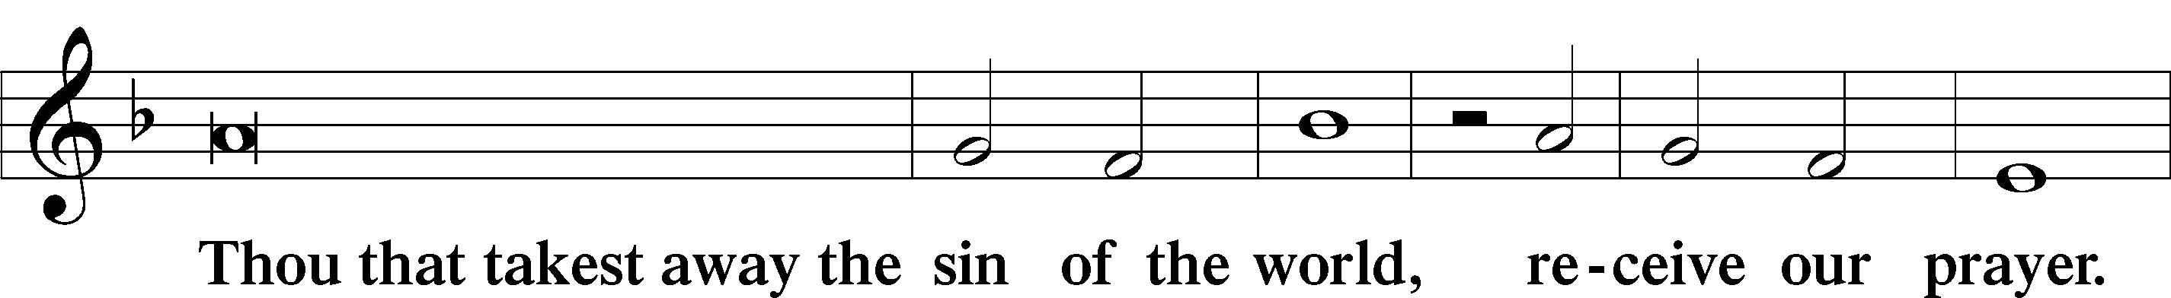

(next page)

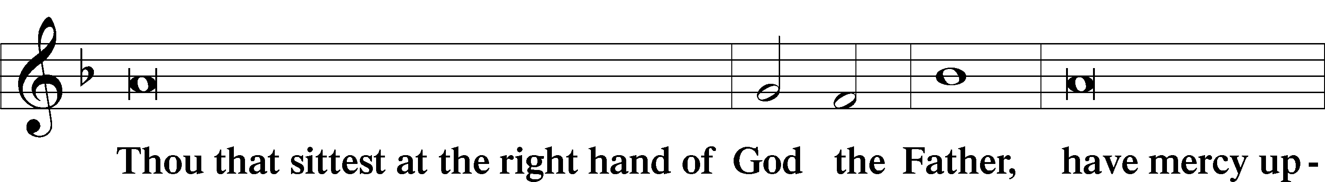
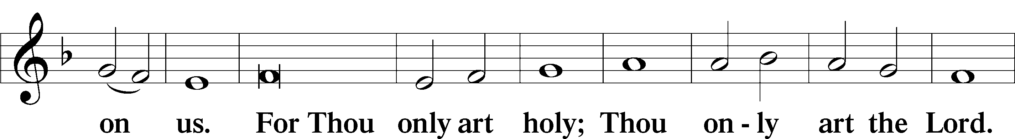
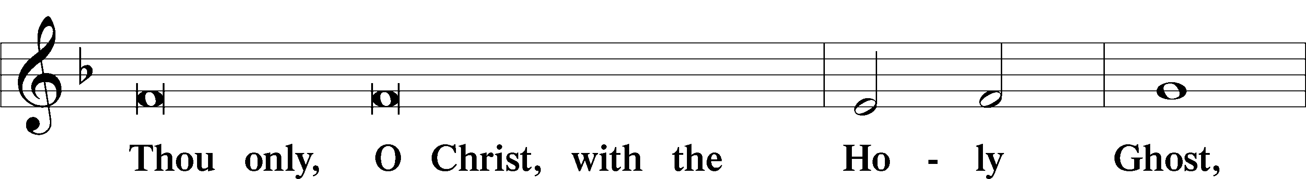
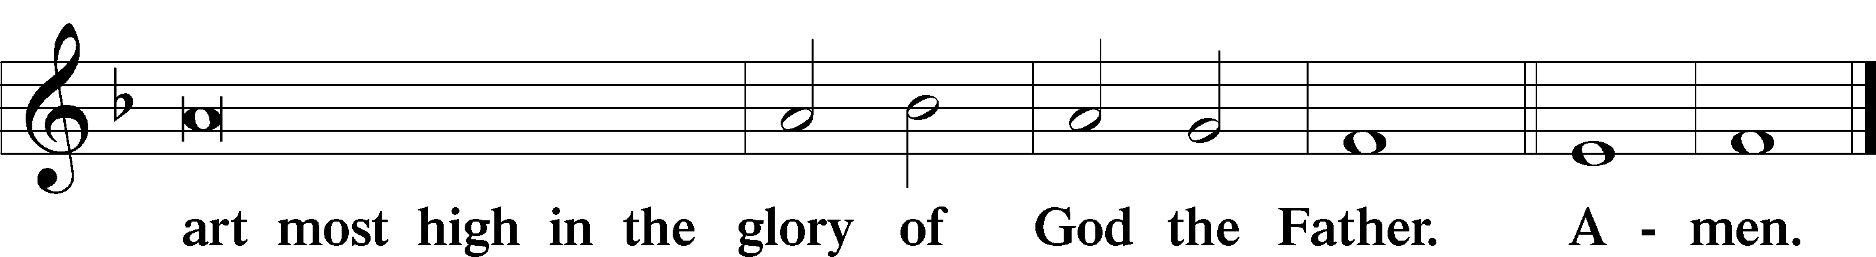

SALUTATION AND COLLECT OF THE DAY LSB 189
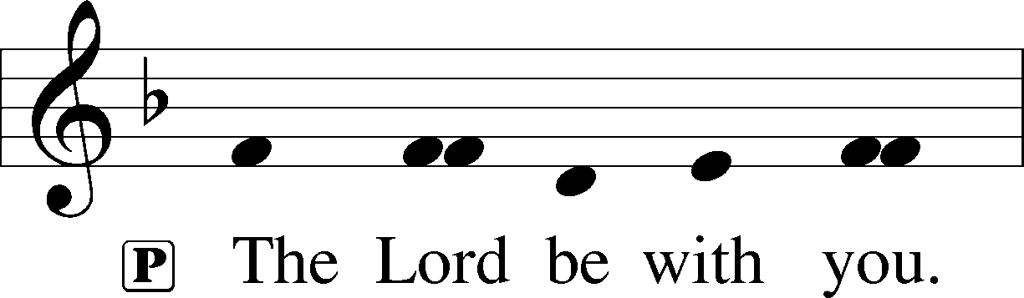
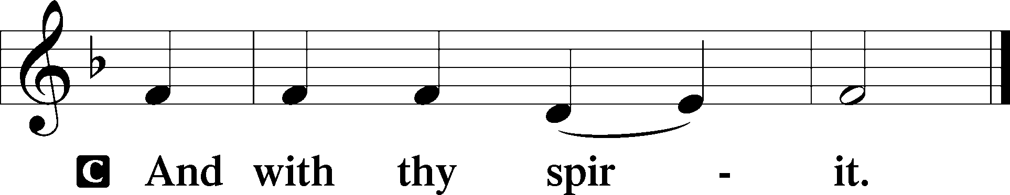

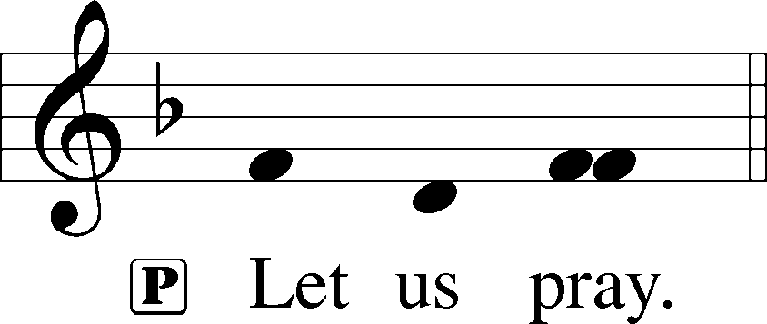

P Almighty and gracious Lord, pour out Your Holy Spirit on Your faithful people. Keep us steadfast in Your grace and truth, protect and deliver us in times of temptation, defend us against all enemies, and grant to Your Church Your saving peace; through Jesus Christ, Your Son, our Lord, who lives and reigns with You and the Holy Spirit, one God, now and forever.

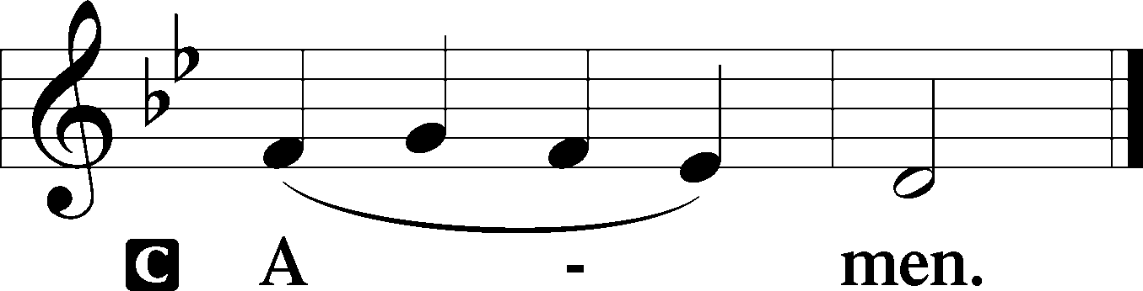

(Sit)

FIRST READING Revelation 14:6–7
6Then I saw another angel flying directly overhead, with an eternal gospel to proclaim to those who dwell on earth, to every nation and tribe and language and people. 7And he said with a loud voice, “Fear God and give him glory, because the hour of his judgment has come, and worship him who made heaven and earth, the sea and the springs of water.”

P This is the Word of the Lord.
C Thanks be to God.

GRADUAL Psalm 48:1a, 12–14a
Great is the Lord and greatly | to be praised*
in the city | of our God!
Walk about Zion, go around her, number her | towers,*
consider well her ramparts, go through her | citadels,
that you may tell the next gener- | ation*
that this is God, our God forever and | ever.

EPISTLE Romans 3:19–28
19Now we know that whatever the law says it speaks to those who are under the law, so that every mouth may be stopped, and the whole world may be held accountable to God. 20For by works of the law no human being will be justified in his sight, since through the law comes knowledge of sin.
21But now the righteousness of God has been manifested apart from the law, although the Law and the Prophets bear witness to it— 22the righteousness of God through faith in Jesus Christ for all who believe. For there is no distinction: 23for all have sinned and fall short of the glory of God, 24and are justified by his grace as a gift, through the redemption that is in Christ Jesus, 25whom God put forward as a propitiation by his blood, to be received by faith. This was to show God’s righteousness, because in his divine forbearance he had passed over former sins. 26It was to show his righteousness at the present time, so that he might be just and the justifier of the one who has faith in Jesus.
27Then what becomes of our boasting? It is excluded. By what kind of law? By a law of works? No, but by the law of faith. 28For we hold that one is justified by faith apart from works of the law.

P This is the Word of the Lord.
C Thanks be to God.

(Stand)

ALLELUIA LSB 190
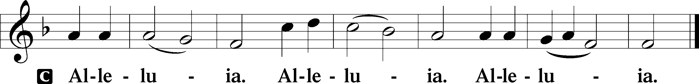

HOLY GOSPEL John 8:31–36
P The Holy Gospel according to St. John, the eighth chapter.

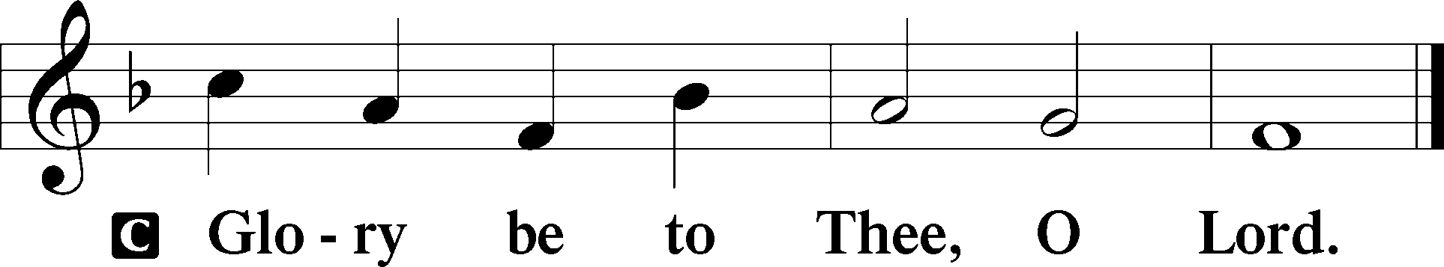

31So Jesus said to the Jews who had believed in him, “If you abide in my word, you are truly my disciples, 32and you will know the truth, and the truth will set you free.” 33They answered him, “We are offspring of Abraham and have never been enslaved to anyone. How is it that you say, ‘You will become free’?”
34Jesus answered them, “Truly, truly, I say to you, everyone who commits sin is a slave to sin. 35The slave does not remain in the house forever; the son remains forever. 36So if the Son sets you free, you will be free indeed.”

P This is the Gospel of the Lord.

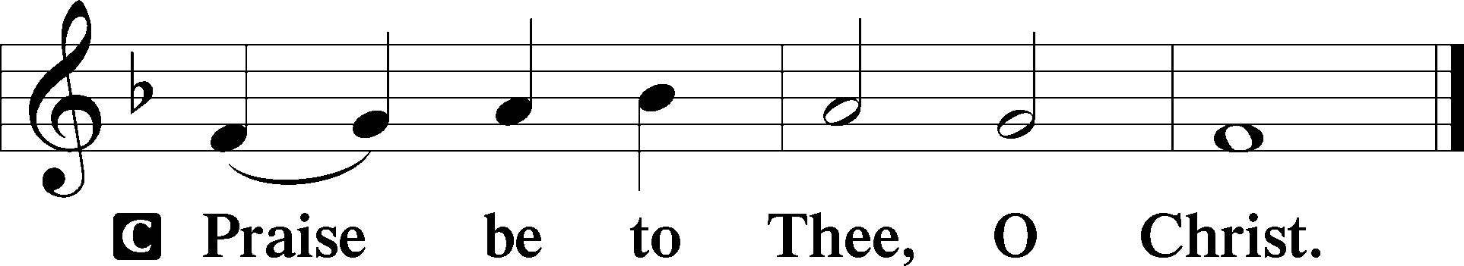

P After hearing the Word of God we confess our Christian Faith using one of the ancient creeds. But why is faith so important that we confess it so often?
C God wants to be worshiped through faith so that we receive from Him those things He promises and offers.
Faith means not only a knowledge of the history, but the kind of faith that believes in the promise. Paul plainly testifies about this when he says in Romans 4:16, “That is why it depends on faith, in order that the promise may rest on grace and be guaranteed.” He judges that the promise cannot be received unless it comes through faith. (Apology of the Augsburg Confession, Article IV: 49b-50a)
P Then let us confess our faith using the Nicene Creed.

NICENE CREED LSB 191
C I believe in one God,
the Father Almighty,
maker of heaven and earth
and of all things visible and invisible.

And in one Lord Jesus Christ,
the only-begotten Son of God,
begotten of His Father before all worlds,
God of God, Light of Light,
very God of very God,
begotten, not made,
being of one substance with the Father,
by whom all things were made;
who for us men and for our salvation came down from heaven
and was incarnate by the Holy Spirit of the virgin Mary
and was made man;
and was crucified also for us under Pontius Pilate.
He suffered and was buried.
And the third day He rose again in accordance with the Scriptures
and ascended into heaven
and sits at the right hand of the Father.
And He will come again with glory to judge both the living and the dead,
whose kingdom will have no end.

And I believe in the Holy Spirit,
the Lord and giver of life,
who proceeds from the Father and the Son,
who with the Father and the Son together is worshiped and glorified,
who spoke by the prophets.
And I believe in one holy Christian and apostolic Church,
I acknowledge one Baptism for the remission of sins,
and I look for the resurrection of the dead
and the life T of the world to come. Amen.

(Sit)

657 A MIGHTY FORTRESS IS OUR GOD sts. 1–4
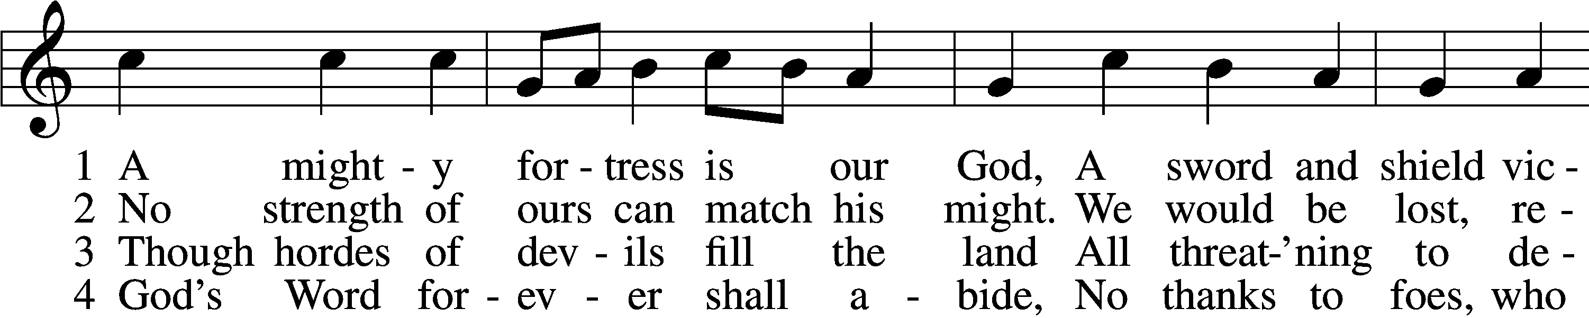
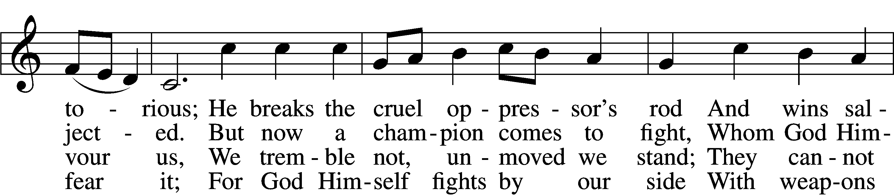
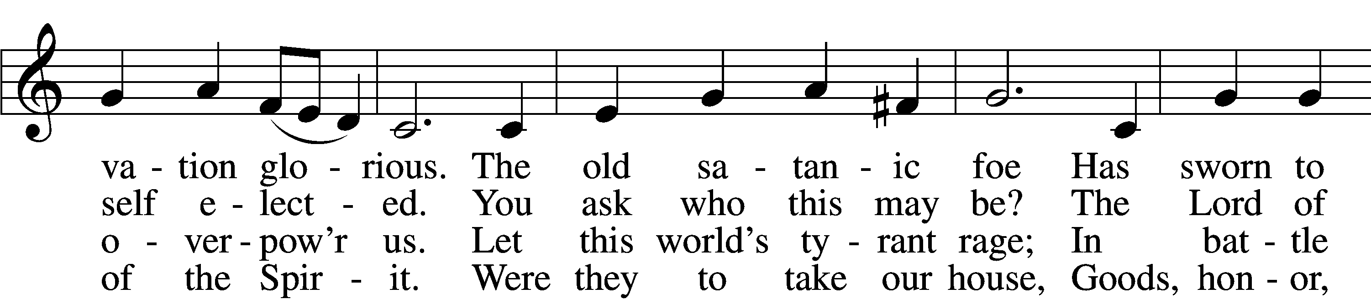
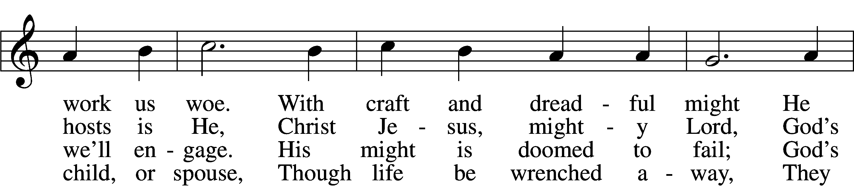
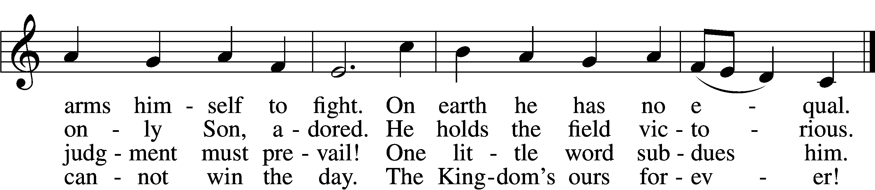
Text: tr. Lutheran Book of Worship, 1978
Text and tune: Martin Luther, 1483–1546
Text: © 1978 Lutheran Book of Worship. Used by permission: LSB Hymn License no. 110004798
Tune: Public domain

SERMON

(The table is set while the Offertory is sung.)

(Stand)

OFFERTORY LSB 192
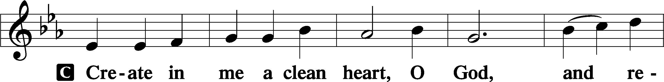
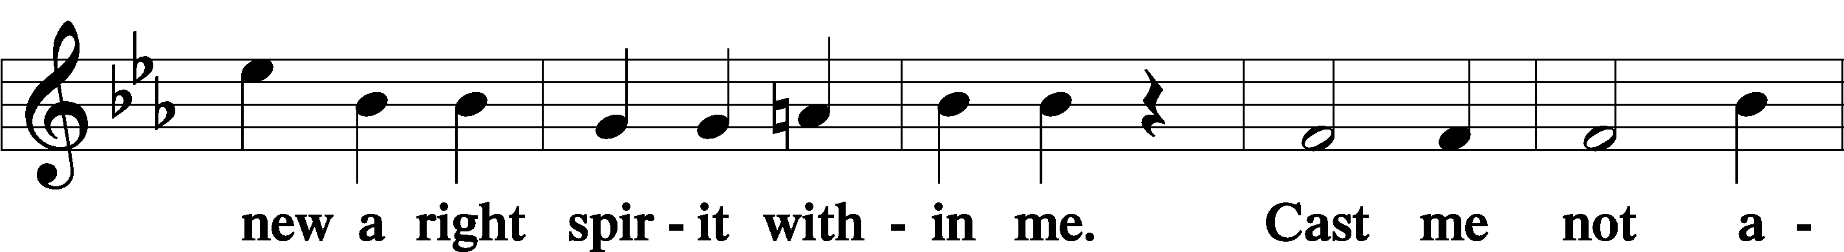
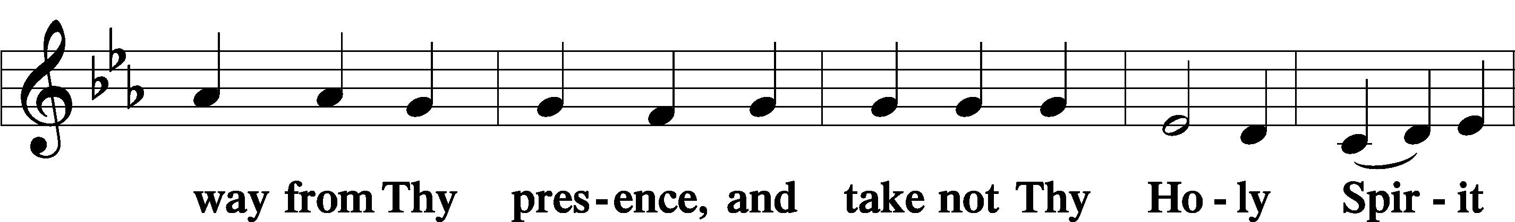
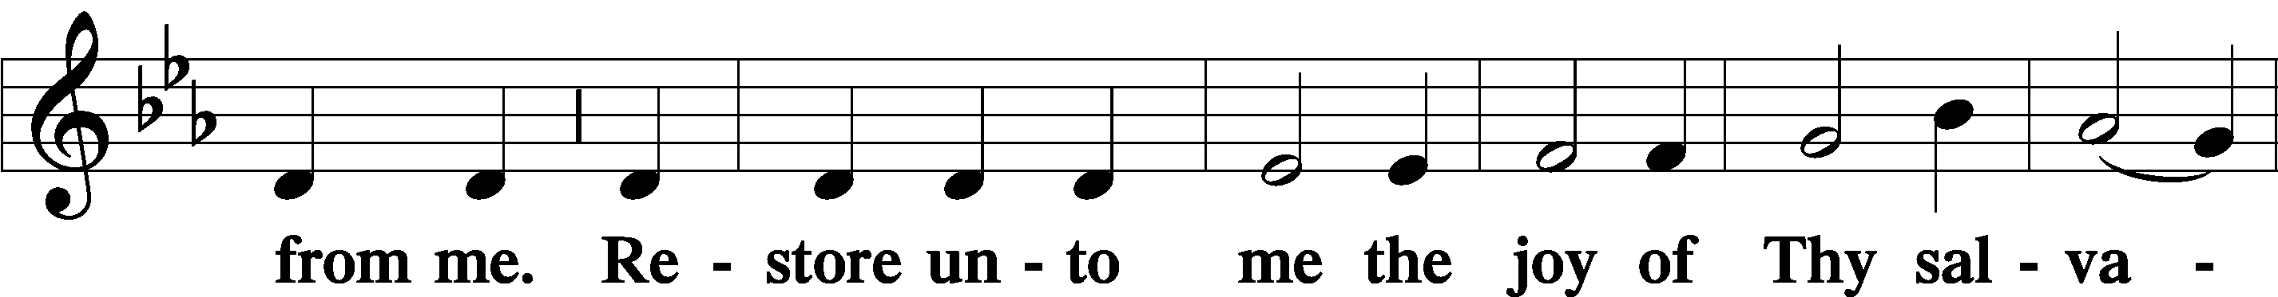
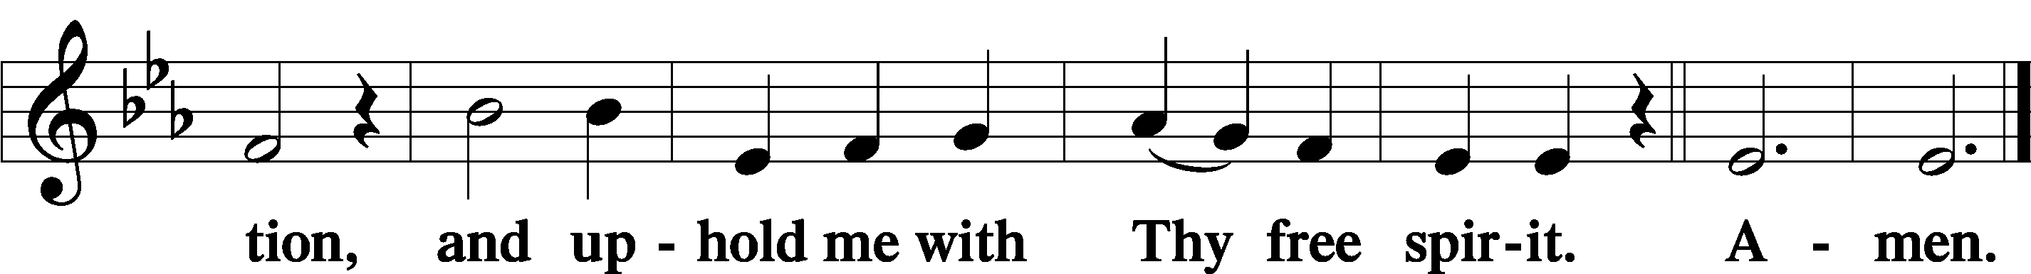

(Sit)

OFFERING

(As a part of our expression of thanksgiving to God for the treasure of His salvation to us, we offer a portion of our treasure, according to what each has determined in their heart to give. Please place offerings in the collection plate at the back of the sanctuary before or after the service. Offerings can also be sent to Bethlehem Lutheran Church via U.S. Mail. Thank you!)

P Every week we offer our prayers to the Lord. But why do we believe that God cares about our prayers?
C Jesus teaches us to pray, “Our Father who art in heaven.” By these words God would tenderly encourage us to believe that He is our true Father and that we are His true children, so that we may ask Him confidently with all assurance, as dear children ask their dear father. (Small Catechism. Part III. The Lord’s Prayer)
We also pray to God because prayer has both God’s command and very many promises. (Apology of the Augsburg Confession, Article XIII: 16)
P Let us pray for the whole Church of God in Christ Jesus and for all people according to their needs.

PRAYER OF THE CHURCH

(The pastor reads each petition. After each petition, the congregation responds "Hear our prayer." After the final petition, the congregation responds "Amen.")

COLLECT FOR THE COMMEMORATION OF DORCAS (TABITHA), LYDIA, AND PHOEBE, FAITHFUL WOMEN
P Almighty God, You stirred to compassion the hearts of Your dear servants Dorcas, Lydia, and Phoebe to uphold and sustain Your Church by their devoted and charitable deeds. Give us the same will to love You, open our eyes to see You in the least ones, and strengthen our hands to serve You in others, for the sake of Your Son, Jesus Christ, our Lord, who lives and reigns with You and the Holy Spirit, one God, now and forever.
C Amen

(Stand)

+ SERVICE OF THE SACRAMENT +

PREFACE LSB 194




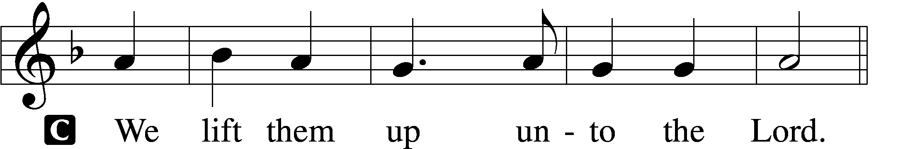

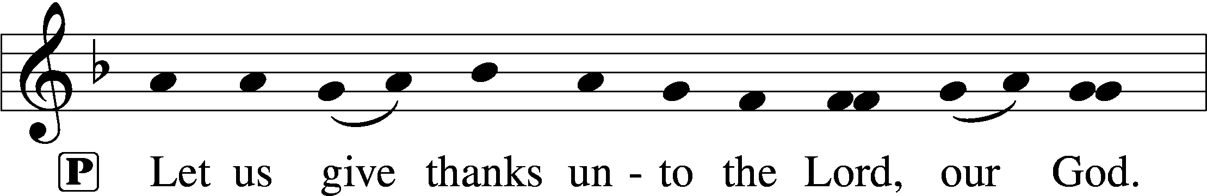
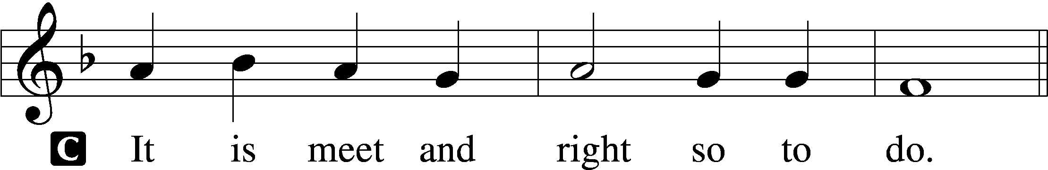

P It is truly meet, right, and salutary that we should at all times and in all places give thanks to You, O Lord, our God, king of all creation, for You have had mercy on us and given Your only-begotten Son that whoever believes in Him should not perish but have eternal life. Grant us Your Spirit, gracious Father, that we may give heed to the testament of Your Son in true faith and, above all, finally take to heart the words with which Christ gives to us His body and blood for our forgiveness. By Your grace, lead us to remember and give thanks for the boundless love which He manifested to us when, by pouring out his precious blood, He saved us from Your righteous wrath and from sin, death, and hell. Grant that we may receive the bread and wine, that is, His body and blood, as a gift, guarantee, and pledge of His salvation. Graciously receive our prayers; deliver and preserve us. To You alone, O Father, be all glory, honor and worship, with the Son and the Holy Spirit, now and forever, as we sing Your praise:

SANCTUS LSB 195
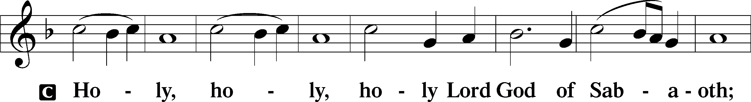
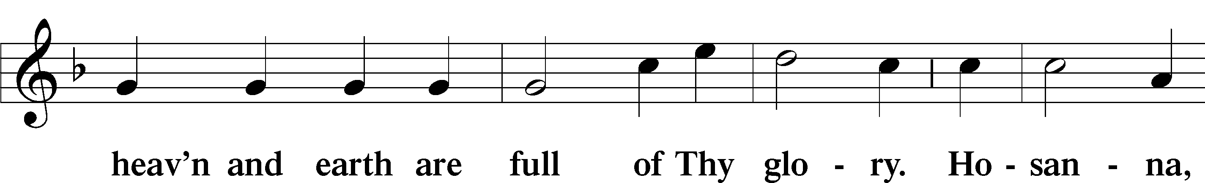
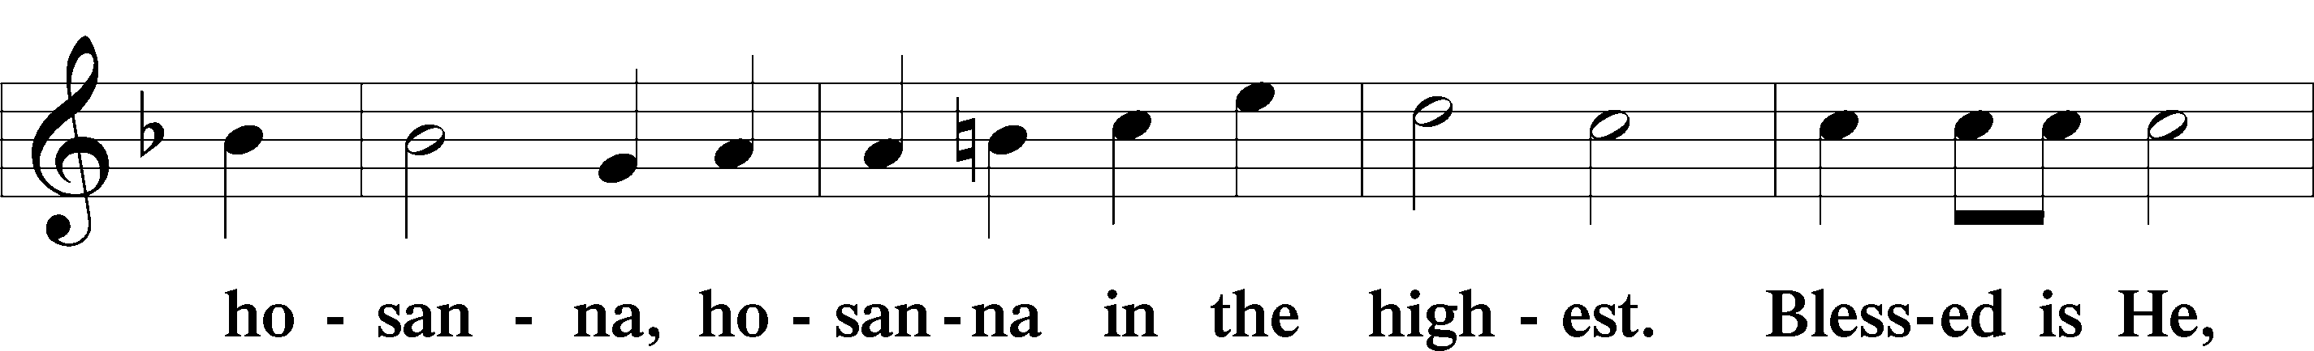
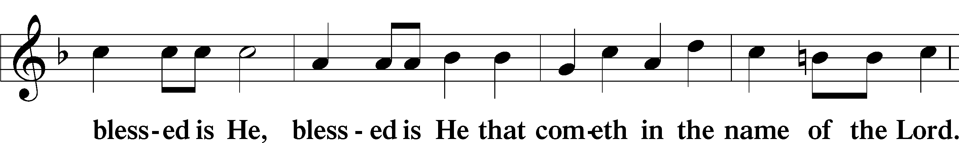
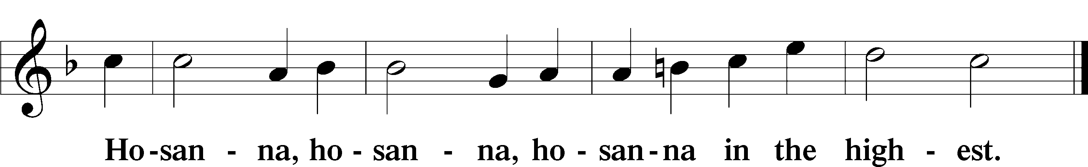

LORD’S PRAYER LSB 196
C Our Father who art in heaven,
hallowed be Thy name,
Thy kingdom come,
Thy will be done on earth as it is in heaven;
give us this day our daily bread;
and forgive us our trespasses as we forgive those who trespass against us;
and lead us not into temptation,
but deliver us from evil.
For Thine is the kingdom and the power and the glory forever and ever. Amen.

P We come to the Lord’s Supper, which we call a miracle, a Sacrament, or a mystery. What makes this meal any different from others we share?
C It is the Word, I say, that makes and sets this Sacrament apart. So it is not mere bread and wine, but is, and is called, Christ’s body and blood. For it is said, “When the Word is joined to the element or natural substance, it becomes a Sacrament.”
“This is My body and blood, given and shed for you for the forgiveness of sins.” Briefly, that is like saying, “For this reason we go to the Sacrament: there we receive such a treasure by and in which we gain forgiveness of sins.” Why so?” “Because the words stand here and give us this. …” (Large Catechism, Part V. The Sacrament of the Altar:10, 21b-22a)
P Then we hear those precious words.

THE WORDS OF OUR LORD LSB 197
P Our Lord Jesus Christ, on the night when He was betrayed, took bread, and when He had given thanks, He broke it and gave it to the disciples and said: “Take, eat; this is My T body, which is given for you. This do in remembrance of Me.”

In the same way also He took the cup after supper, and when He had given thanks, He gave it to them, saying: “Drink of it, all of you; this cup is the new testament in My T blood, which is shed for you for the forgiveness of sins. This do, as often as you drink it, in remembrance of Me.”

PAX DOMINI LSB 197
P The peace of the Lord be with you always.
C Amen.

AGNUS DEI LSB 198
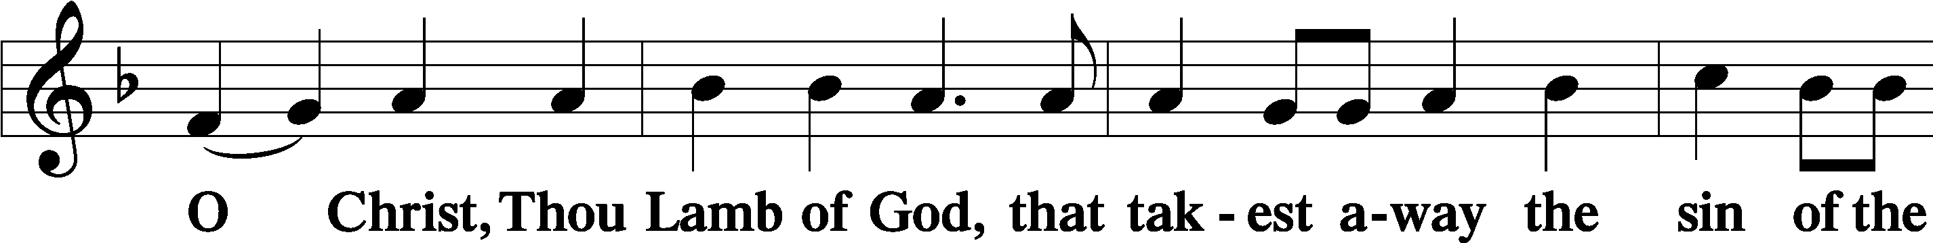
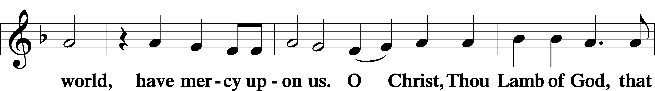
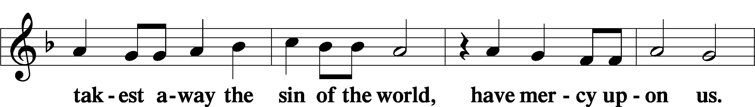
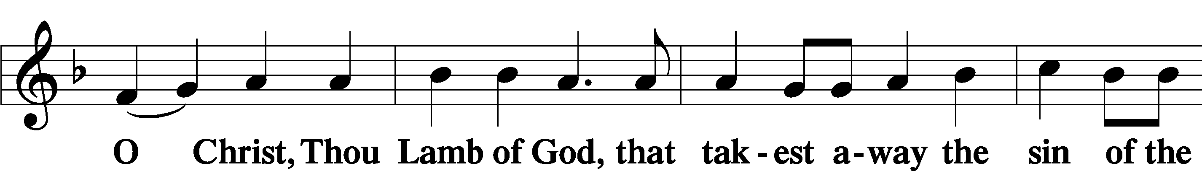
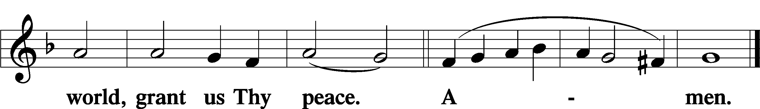

(Sit)

DISTRIBUTION

(The pastor and those assisting him are communed first, then commune those who are unable to come to the altar. The ushers will then direct all other communicants to the altar.)

655 LORD, KEEP US STEADFAST IN YOUR WORD
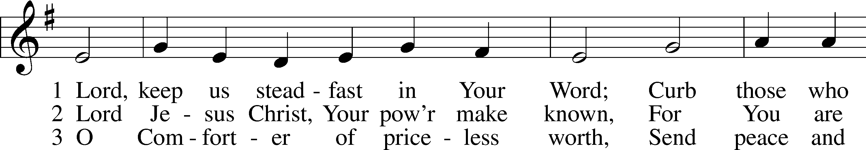
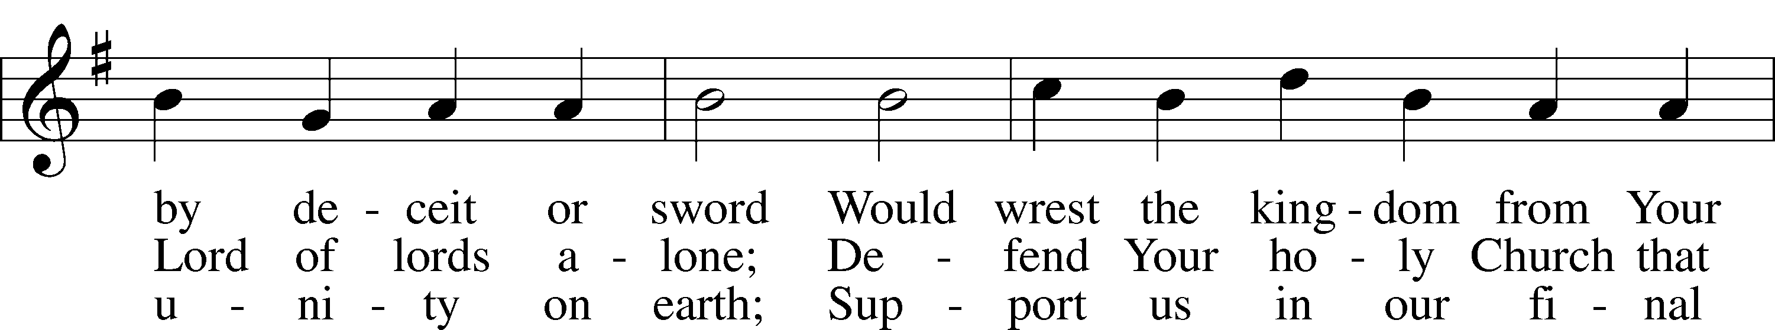
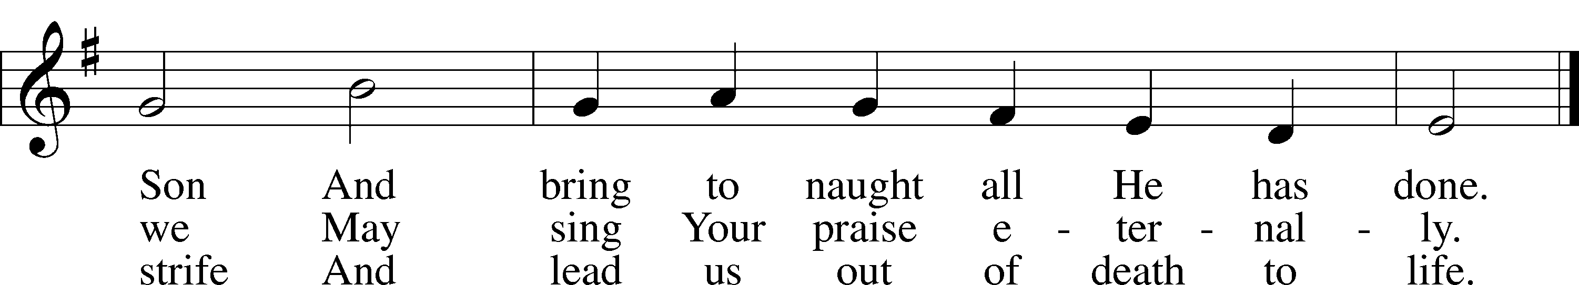
Text: Martin Luther, 1483–1546; tr. Catherine Winkworth, 1827–78, alt.
Tune: Geistliche Lieder auffs new gebessert, 1543, Wittenberg, ed. Joseph Klug
Text and tune: Public domain

INSTRUMENTAL

(Stand)

NUNC DIMITTIS LSB 199
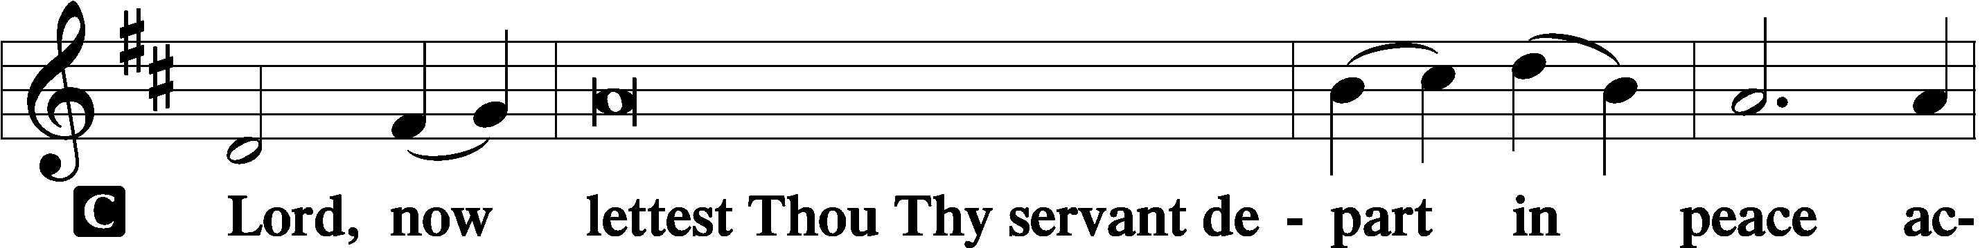

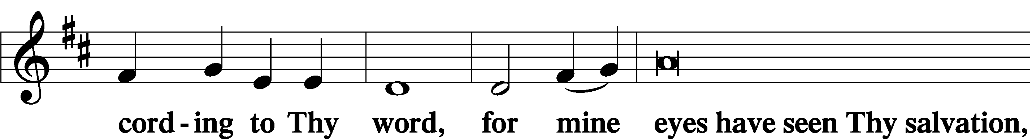

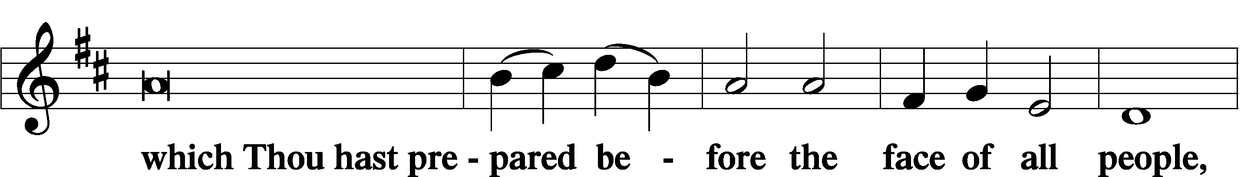

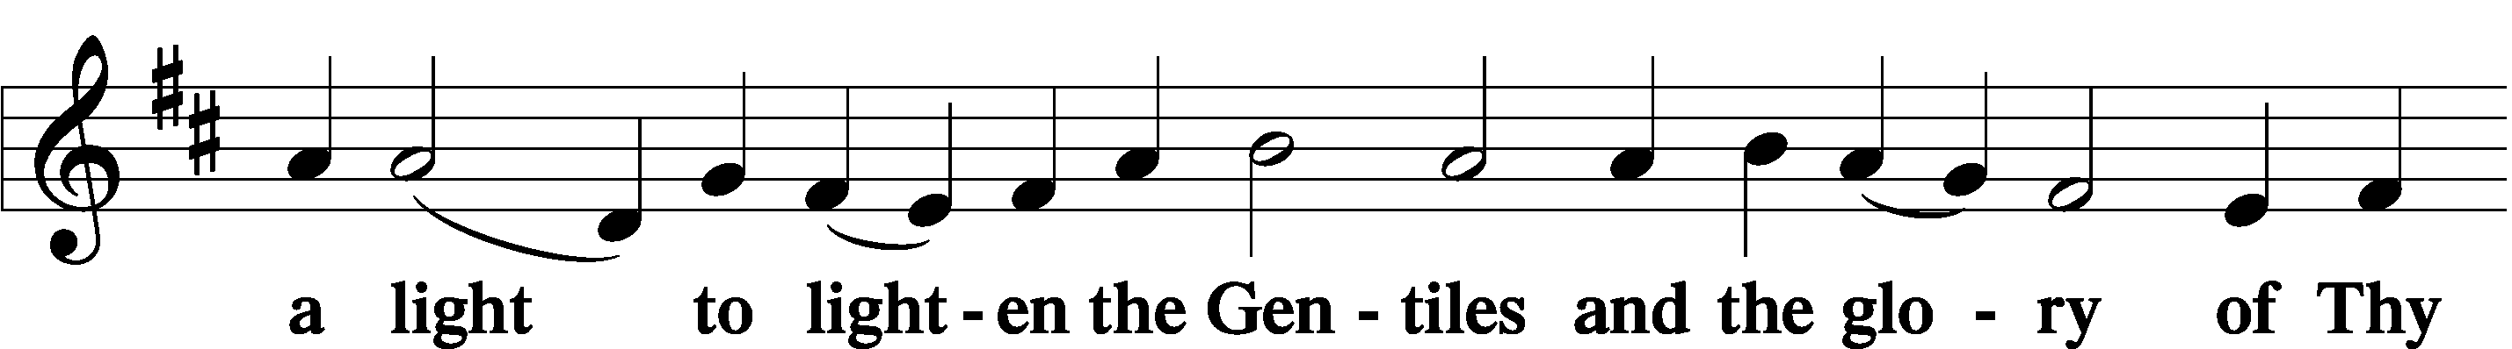

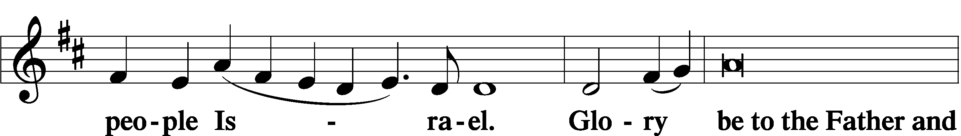

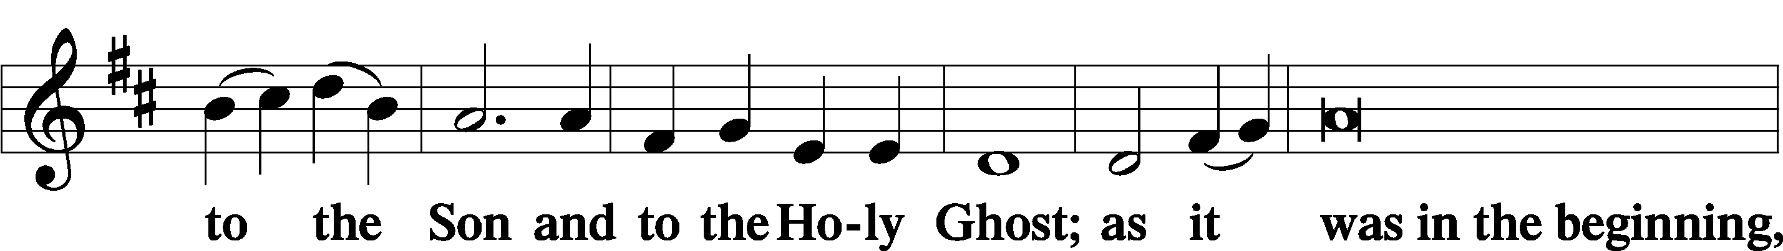

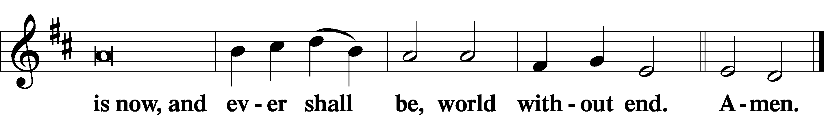

THANKSGIVING LSB 200
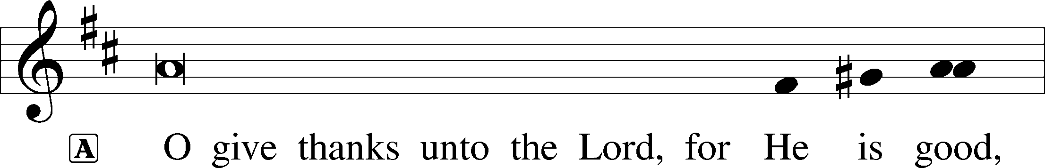

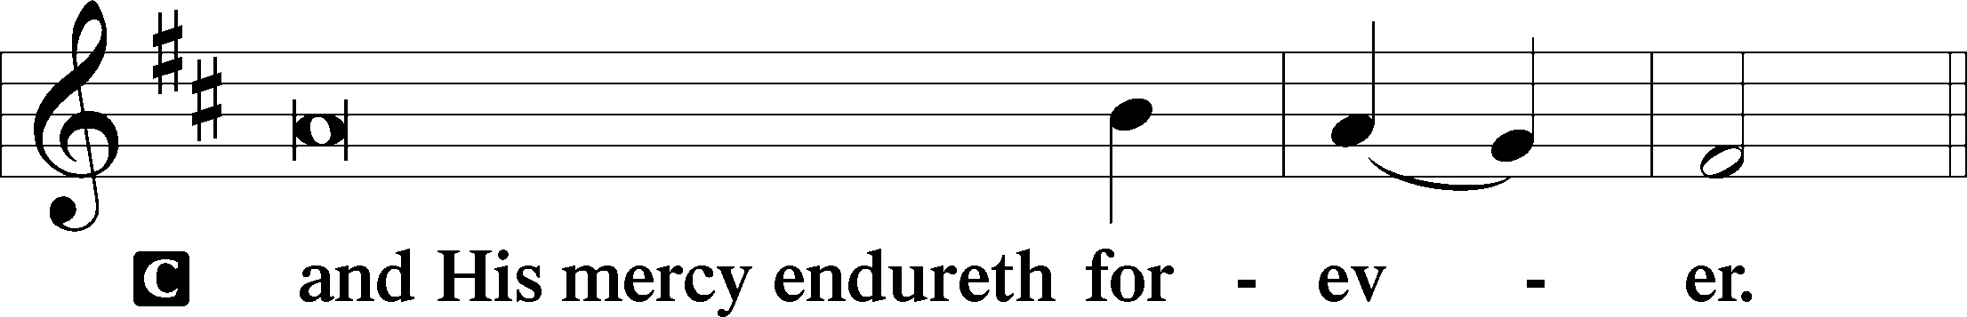

POST-COMMUNION COLLECT LSB 201
P Let us pray.
We give thanks to You, almighty God, that You have refreshed us through this salutary gift, and we implore You that of Your mercy You would strengthen us through the same in faith toward You and in fervent love toward one another; through Jesus Christ, Your Son, our Lord, who lives and reigns with You and the Holy Spirit, one God, now and forever.

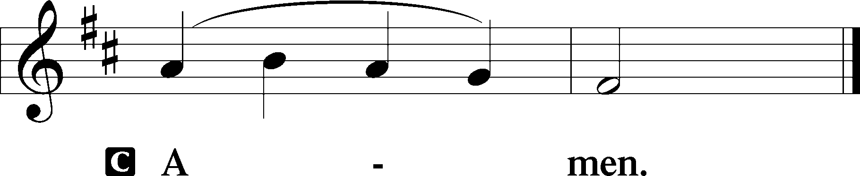

SALUTATION LSB 201
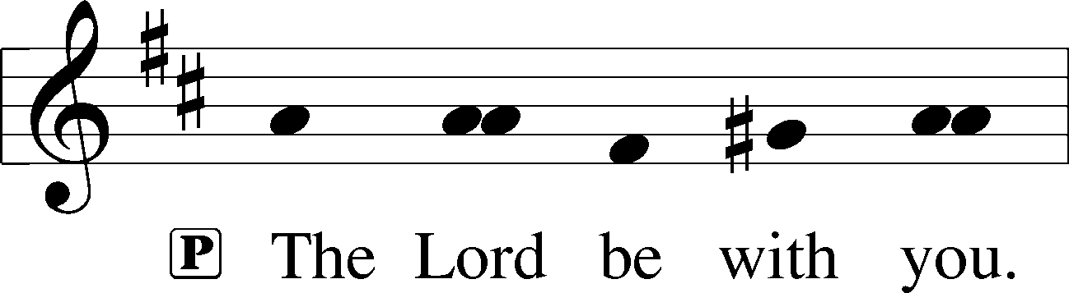

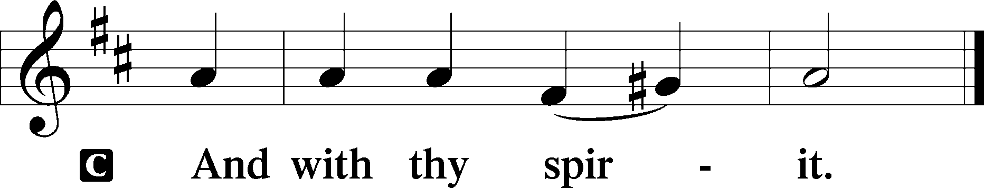

BENEDICAMUS LSB 202
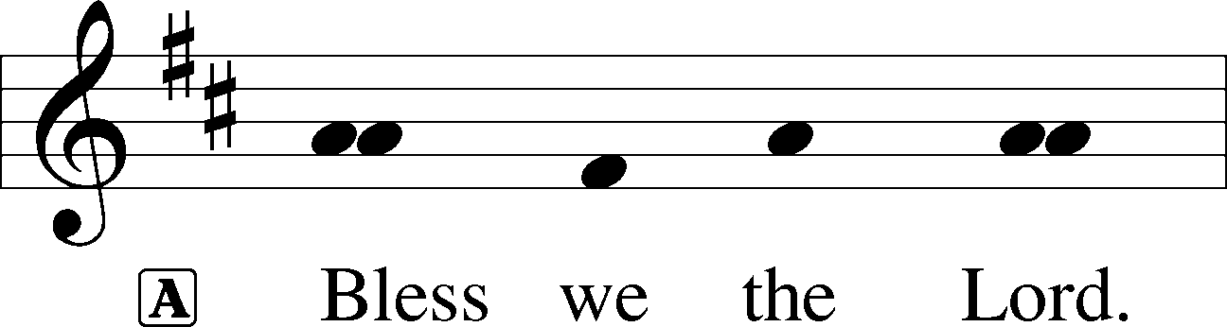

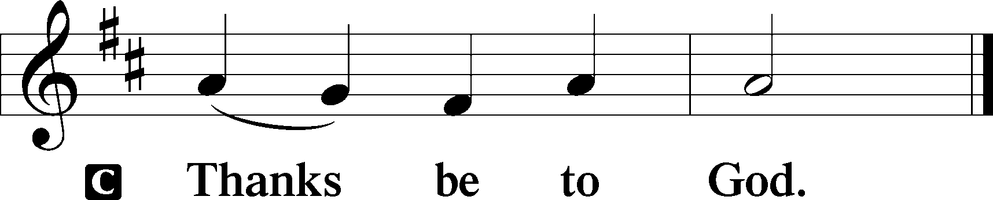

BENEDICTION LSB 202
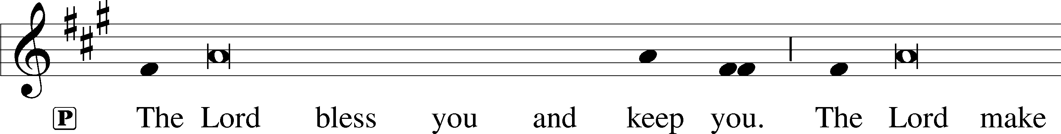
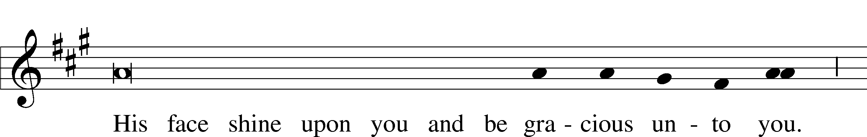
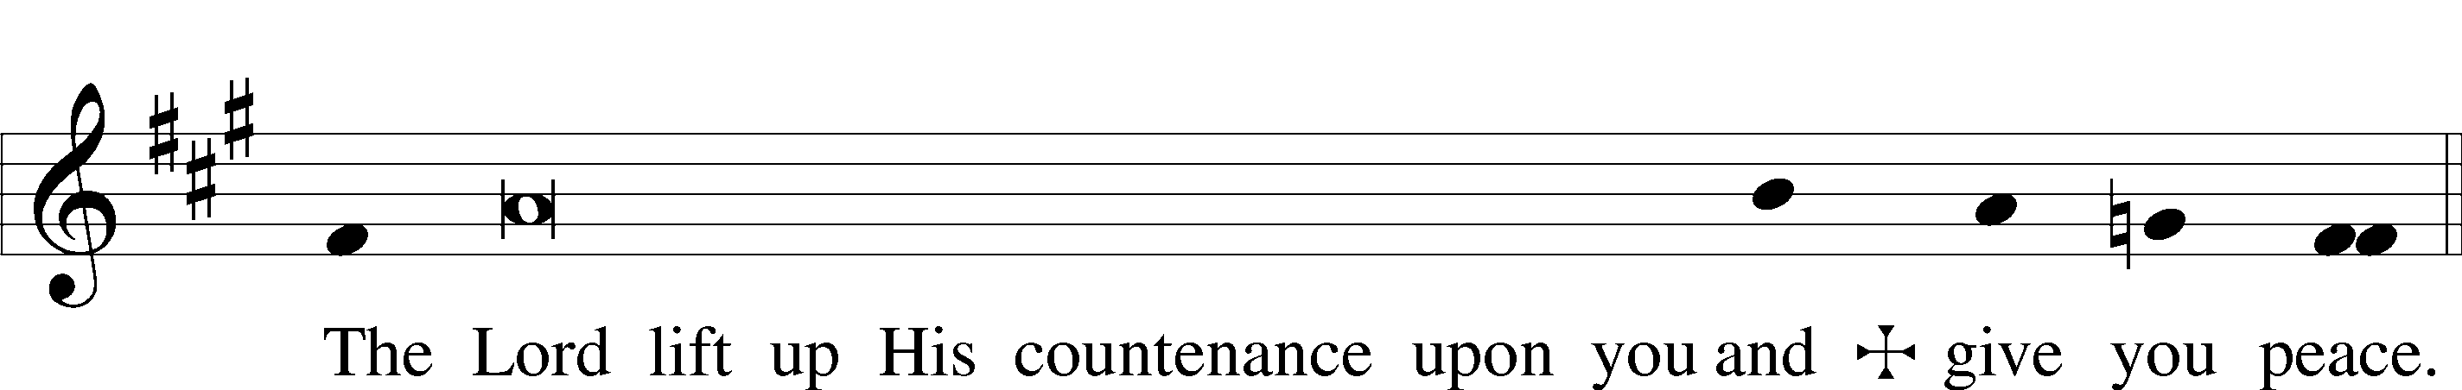

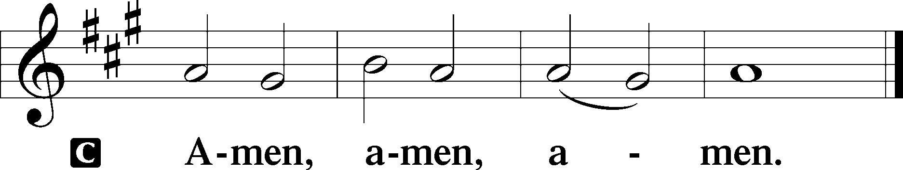

643 SENT FORTH BY GOD’S BLESSING
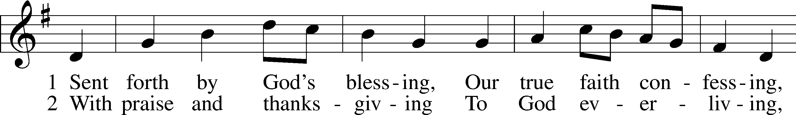
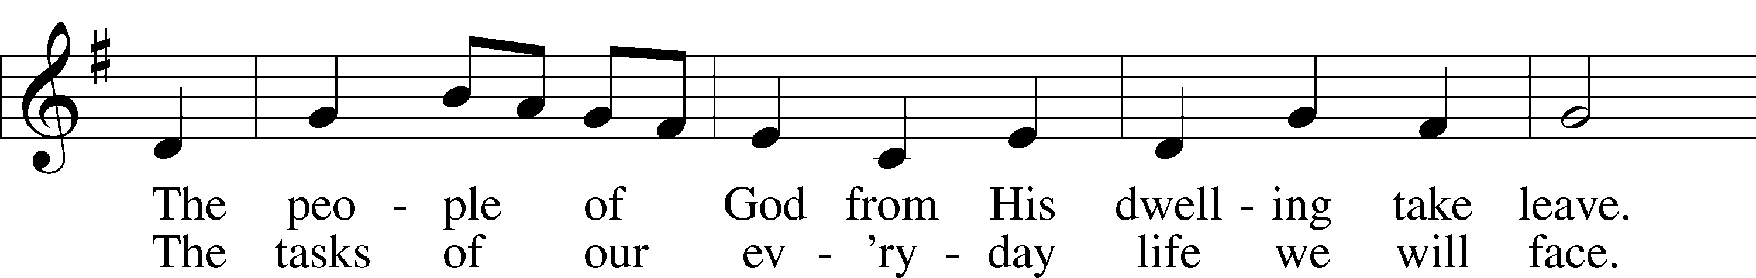
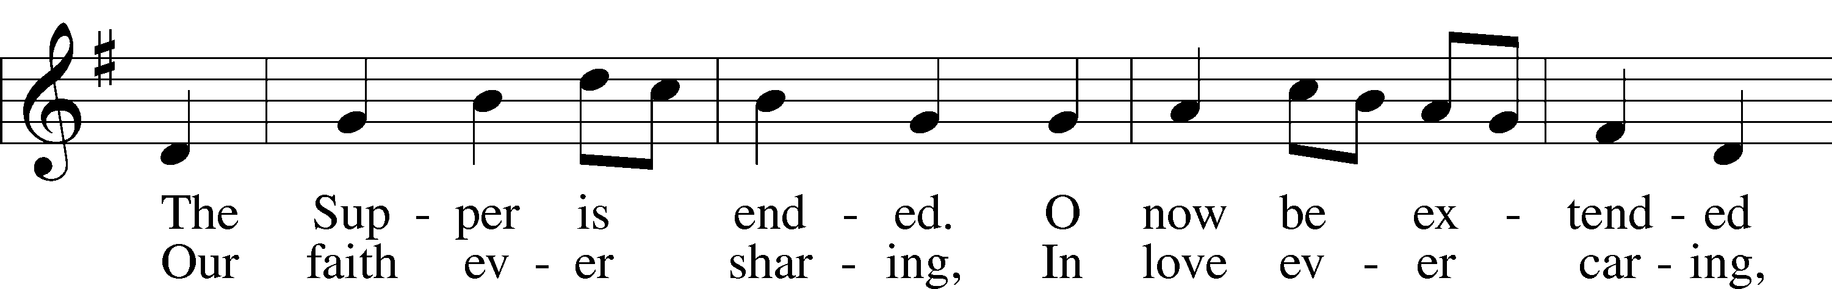
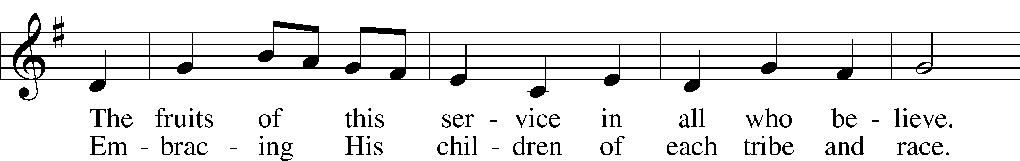
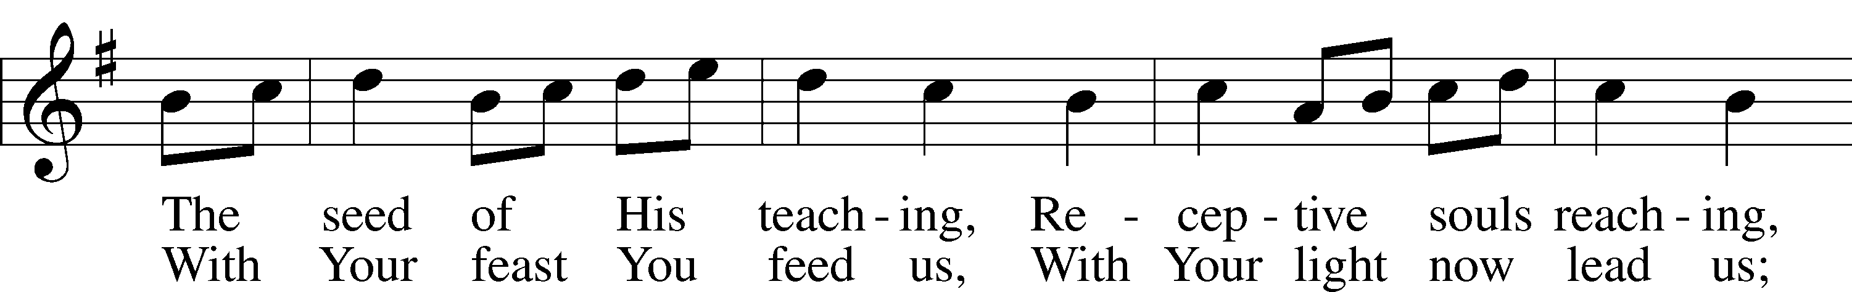
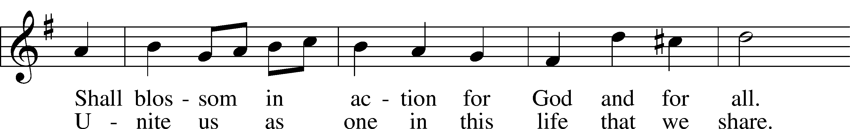
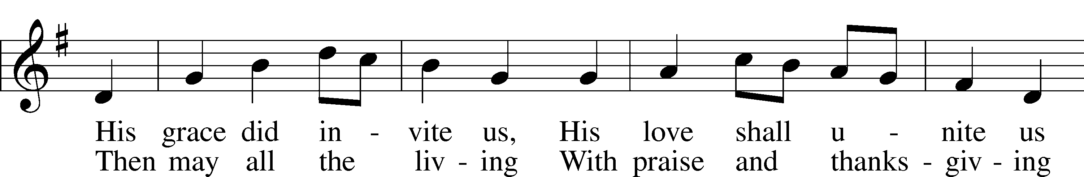
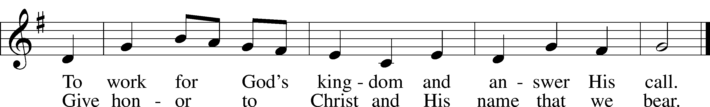
Text: Omer E. Westendorf, 1916–97, alt.
Tune: Welsh
Text: © 1964 World Library Publications. Used by permission: LSB Hymn License no. 110004798
Tune: Public domain

SILENT PRAYER

P Go in peace to serve the Lord.
C Thanks be to God!
ACKNOWLEDGMENTS
Divine Service, Setting Three from Lutheran Service Book
Unless otherwise indicated, Scripture quotations are from the ESV® Bible (The Holy Bible, English Standard Version®), copyright © 2001 by Crossway, a publishing ministry of Good News Publishers. Used by permission. All rights reserved.
Created by Lutheran Service Builder © 2026 Concordia Publishing House.

Commemoration of Dorcas (Tabitha), Lydia, and Phoebe, Faithful Women
October 25

These women were exemplary Christians who demonstrated their faith by their material support of the Church. Dorcas, or Tabitha (the name means “gazelle” and was a favorite name among both Greeks and Jews), was well-known and much loved for her acts of charity in the city of Joppa, especially for making clothes for the poor. When Dorcas died suddenly, the members of her congregation sent to the neighboring city of Lydda for the apostle Peter, who came and raised her from the dead (Acts 9:36-41). This was the first time an Apostle did such a miracle and it was a powerful witness to the Gentiles.

Lydia was a woman of Thyatira, who worked at Philippi selling a famous purple dye that was much in demand in the ancient world. (Thyatira was a Lydian city and so the name Lydia might originally have been an adjective.) Such a business required a great deal of capital, so she was probably well-to-do. She was also a “worshiper of God” at the local synagogue (Acts 16:14) and the first person converted to Christianity in Europe. When the apostle Paul encountered her in prayer among other proselyte women, his preaching of the Word brought Lydia to faith in Christ. She and her friends thus became the nucleus of the Christian community in Philippi (Acts 16:13-15, 40). After her baptism she invited Paul and his companions to stay in her house, which relieved Paul of the necessity of earning his support, as was his custom elsewhere.

Phoebe (her name means “bright” or “radiant”) was another faithful woman associated with the apostle Paul. She was a deaconess from Cenchreae (the port of Corinth) whom Paul sent to the Church in Rome with his Epistle to the Romans. The word “deaconess” might perhaps be better translated “patron” or “helper,” for Paul doesn’t mean that he is a deacon when he applies a similar word to himself (2 Corinthians 11:23; Colossians 1:23, 25). In Romans, Paul writes of Phoebe’s support for the work of the Early Church (Romans 16:1-2) and this, along with Paul calling her a deaconess, became the inspiration for the more regular order of deaconesses that was to emerge in the Church in the third and fourth centuries.

The date for remembering these ladies of faith was taken from the liturgical calendar used in Orthodox denominations, as they remember the Blessed Tabitha on October 25. We have simply expanded the commemoration to include more of the important women in the Early Church.

Collect for the Commemoration of Dorcas (Tabitha), Lydia, and Phoebe, Faithful Women: Almighty God, You stirred to compassion the hearts of Your dear servants Dorcas, Lydia, and Phoebe to uphold and sustain Your Church by their devoted and charitable deeds. Give us the same will to love You, open our eyes to see You in the least ones, and strengthen our hands to serve You in others, for the sake of Your Son, Jesus Christ, our Lord, who lives and reigns with You and the Holy Spirit, one God, now and forever. Amen.

Other things you might pray for:
- For the poor
- For foreigners in a strange land
- For deaconesses
- For all who assist in the proclamation of the word of God

