**BETHLEHEM LUTHERAN CHURCH**

***A congregation of The Lutheran Church-Missouri Synod***

902 Hitchcock Drive SW,

Aiken, South Carolina 29803

Church Phone: (803) 649-6417

blcaikensc@gmail.com

**Pastor: Rev. John B. Engwall**

**Office Hours By Appointment**

**Note:** The format of this bulletin has been modified for use in private devotion services. Unable to join us in person? Please find us on Facebook live. The service is also posted on our website: bethlehemlutheranaiken.org

**+ + + + + + + + + + + + + + +**

**The 4th Sunday after Pentecost**

**July 6, 2025**

**10:30 a.m.**

**+ + + + + + + + + + + + + + +**

**Our Policy and Practice Regarding Holy Communion**

**Hear the words of the Apostle Paul;**

*Anyone who eats and drinks without recognizing the body of the Lord eats and drinks judgment on himself. -*1 Cor.11:29

**Therefore, visitors are asked to please refrain from partaking of the Sacrament before speaking about this with the pastor; because we care about your spiritual well-being.**

**Also, because communing at this altar is a public confession that you agree with the doctrines of The Lutheran Church-Missouri Synod, and reject all contrary teachings.**

Persons who are not communing today are always welcome to come forward during the distribution to receive an individual blessing; please cross your arms over your chest to indicate your desire for this. Thank you!

We commune in two alternating tables. The ushers will guide you. Non-alcoholic white wine is available in the center of the individual cup tray. Please leave empty individual cups at the altar rail.

**+ SERVICE OF PREPARATION +**

*After the bell tolls, please observe a time of silence.*

**WELCOME AND ANNOUNCEMENTS**

Divine Service, Setting I LSB 151

(Stand)

672 JERUSALEM THE GOLDEN

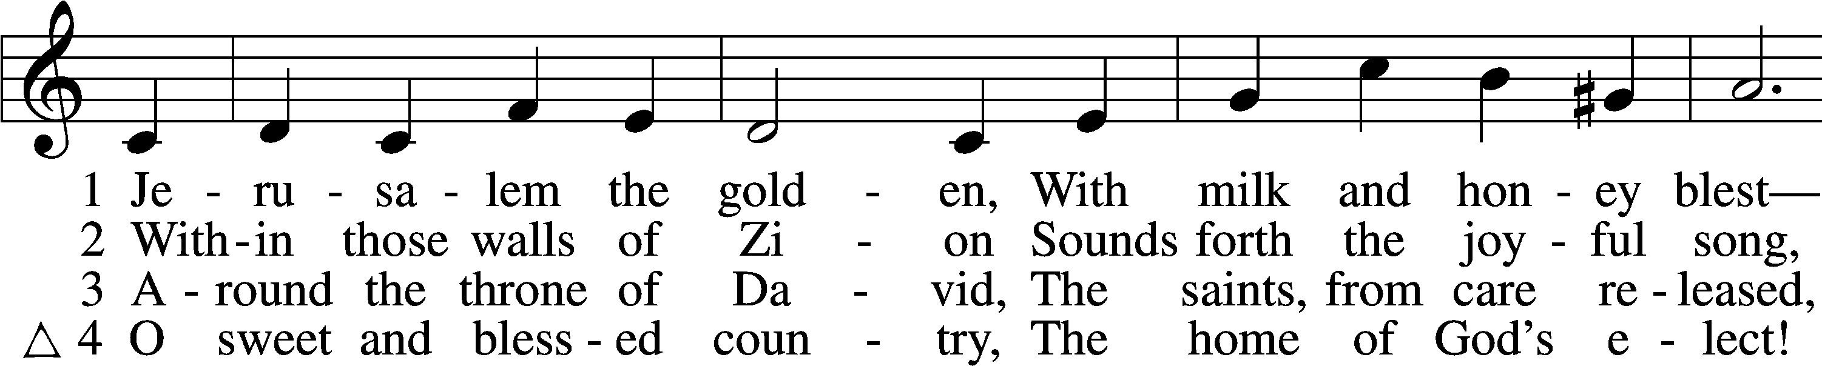

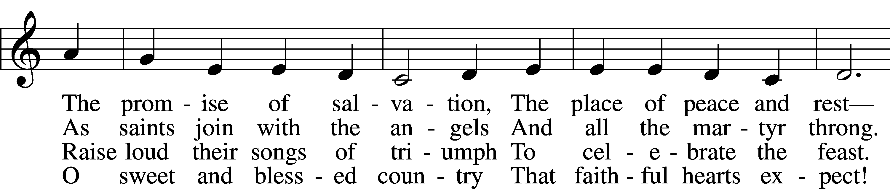

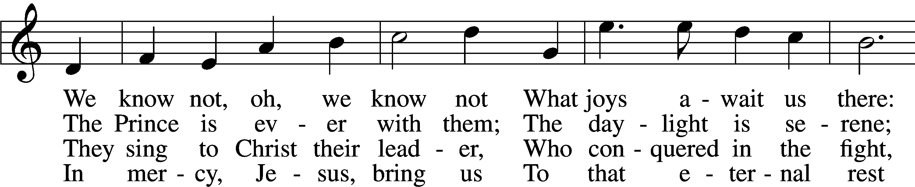

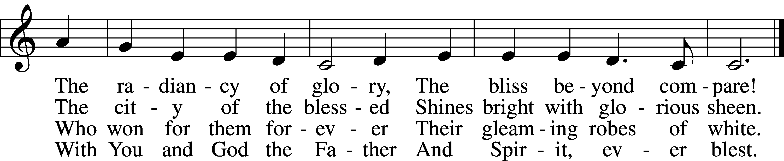

Text: Bernard of Cluny, 12th cent.; tr. John Mason Neale, 1818–66, alt.  
Tune: Alexander C. Ewing, 1830–95, alt.  
Text and tune: Public domain

# + CONFESSION AND ABSOLUTION +

(The sign of the cross may be made by all in remembrance of their Baptism.)

INVOCATION

L In the name of the Father and of the T Son and of the Holy Spirit.

C **Amen.**

EXHORTATION LSB 151

L If we say we have no sin, we deceive ourselves, and the truth is not in us.

C **But if we confess our sins, God, who is faithful and just, will forgive our sins and cleanse us from all unrighteousness.**

(Silence for reflection on God’s Word and for self-examination.)

CONFESSION OF SINS LSB 151

L Let us then confess our sins to God our Father.

C **Most merciful God, we confess that we are by nature sinful and unclean. We have sinned against You in thought, word, and deed, by what we have done and by what we have left undone. We have not loved You with our whole heart; we have not loved our neighbors as ourselves. We justly deserve Your present and eternal punishment. For the sake of Your Son, Jesus Christ, have mercy on us. Forgive us, renew us, and lead us, so that we may delight in Your will and walk in Your ways to the glory of Your holy name. Amen.**

DECLARATION OF GRACE

L In the mercy of almighty God, Jesus Christ was given to die for us, and for His sake God forgives us all our sins. To those who believe in Jesus Christ He gives the power to become the children of God and bestows on them the Holy Spirit. May the Lord, who has begun this good work in us, bring it to completion in the day of our Lord Jesus Christ.

C **Amen.**

(Stand)

# + SERVICE OF THE WORD +

INTROIT Psalm 19:2, 4–6; antiphon: v. 1

The heavens declare the glo- | ry of God,*  
 and the sky above proclaims his | handiwork.  
Day to day | pours out speech,*  
 and night to night reveals | knowledge.  
Their measuring line goes out through all the earth, and their words to the end | of the world.*  
 In them he has set a tent | for the sun,  
which comes out like a bridegroom leaving his | chamber,*  
 and, like a strong man, runs its | course with joy.  
Its rising is from the end of the heavens, and its circuit to the | end of them,*  
 and there is nothing hidden | from its heat.  
**Glory be to the Father and | to the Son**\*  
 **and to the Holy | Spirit;**  
**as it was in the be- | ginning,**\*  
 **is now, and will be forever. | Amen.**  
The heavens declare the glo- | ry of God,*  
 and the sky above proclaims his | handiwork.

KYRIE LSB 152





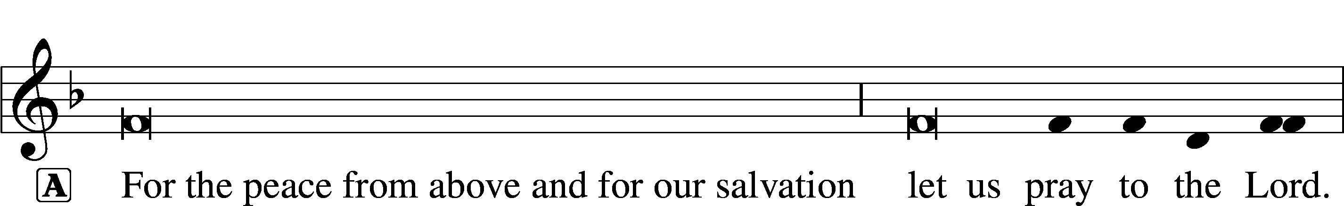



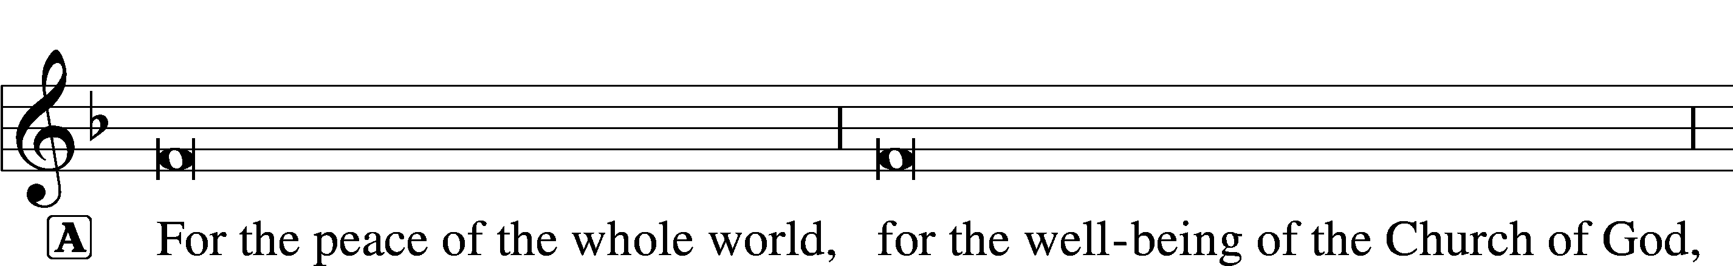





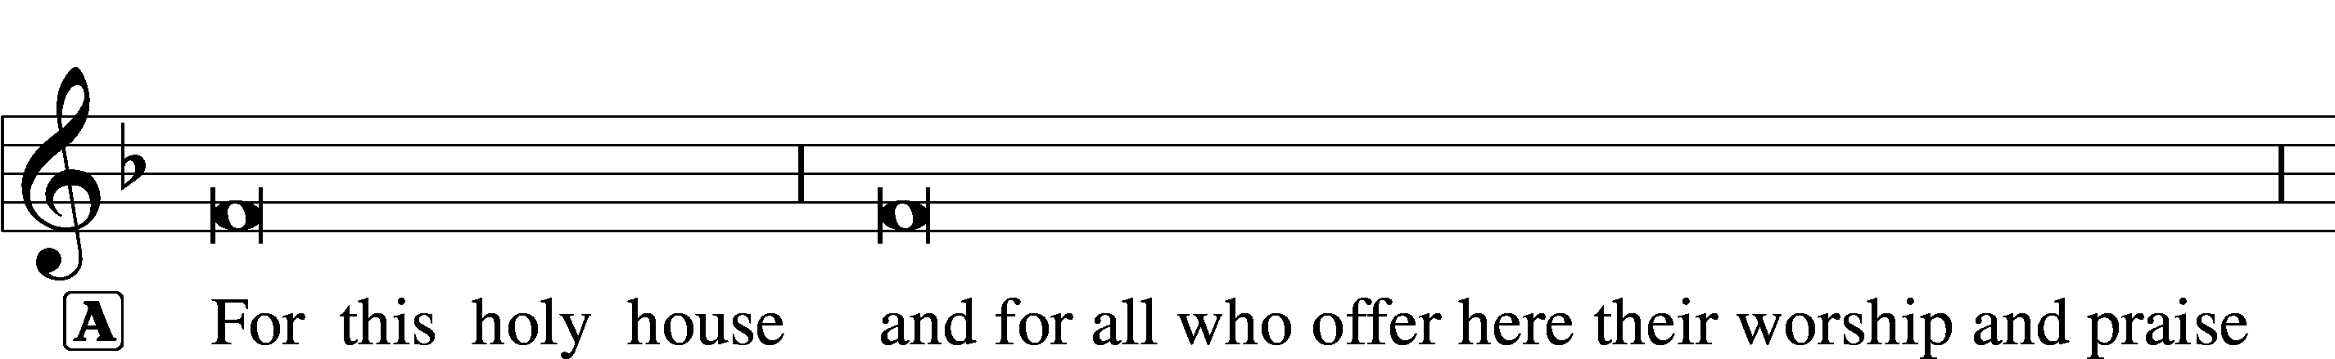









GLORIA IN EXCELSIS LSB 154

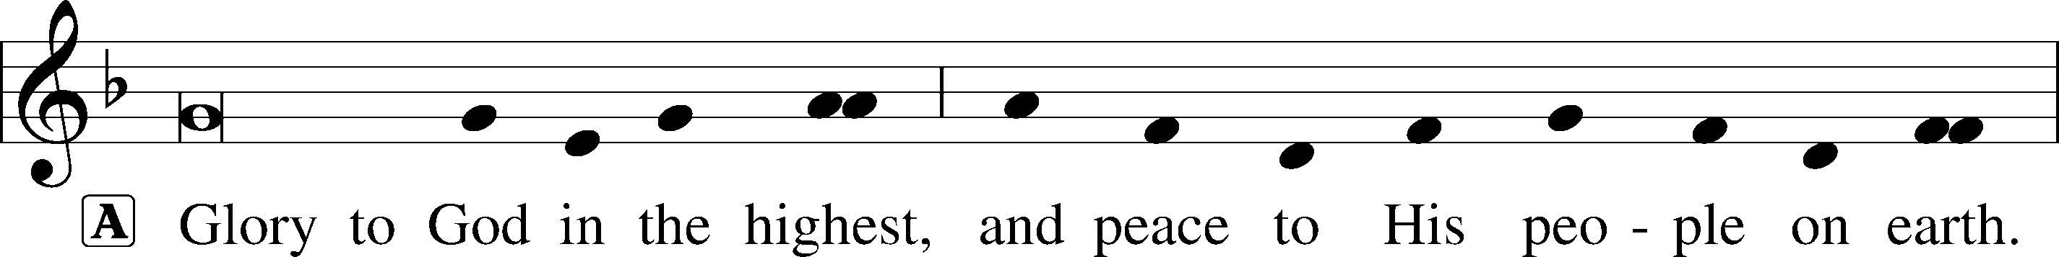

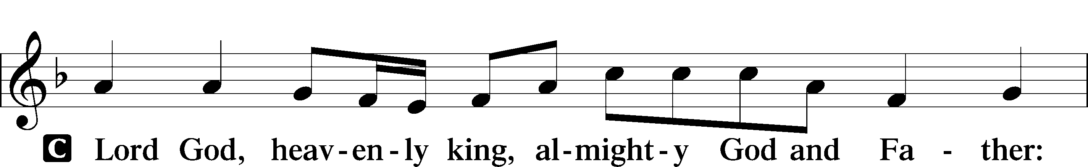

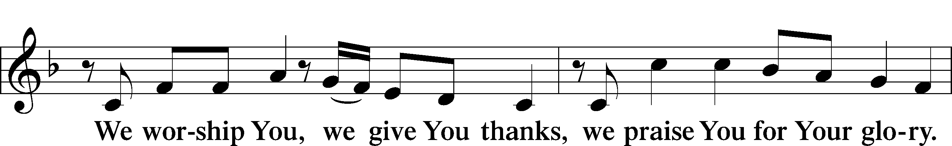

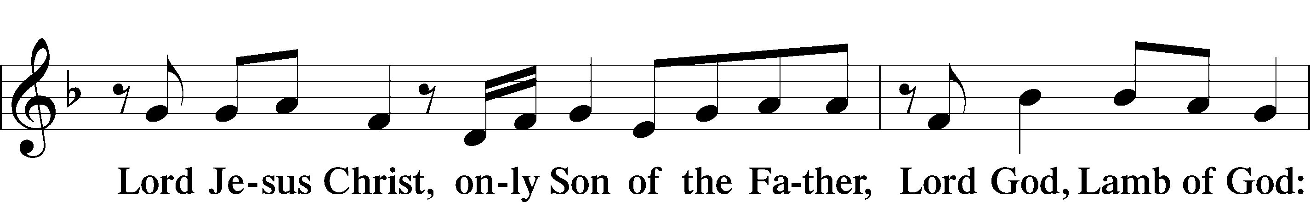

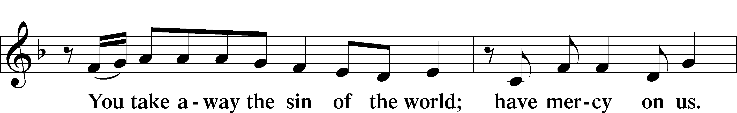

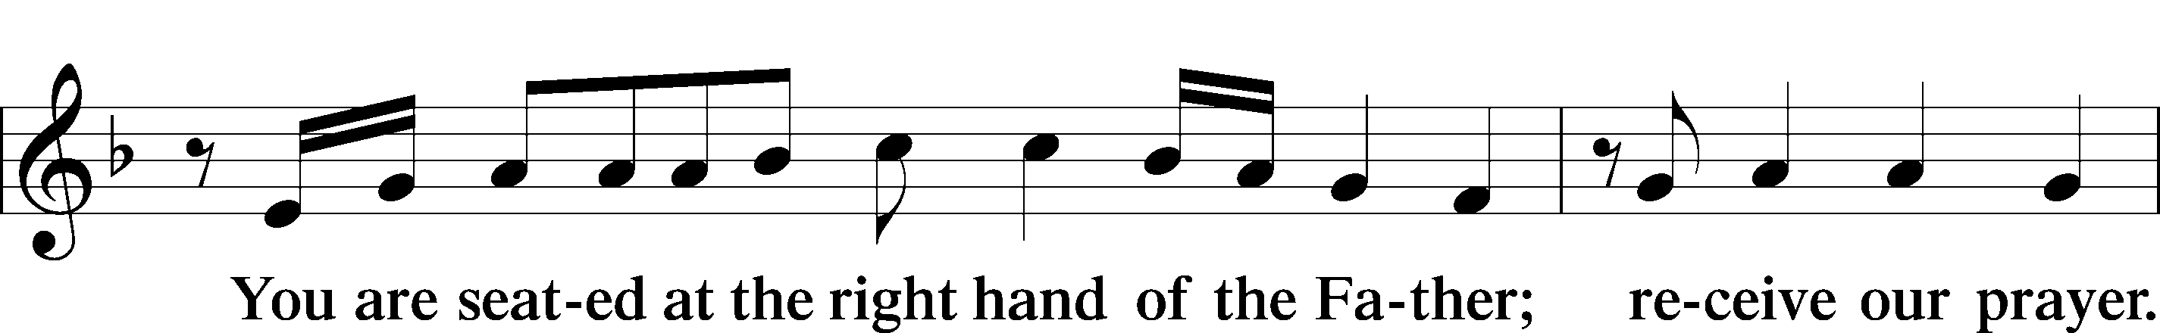

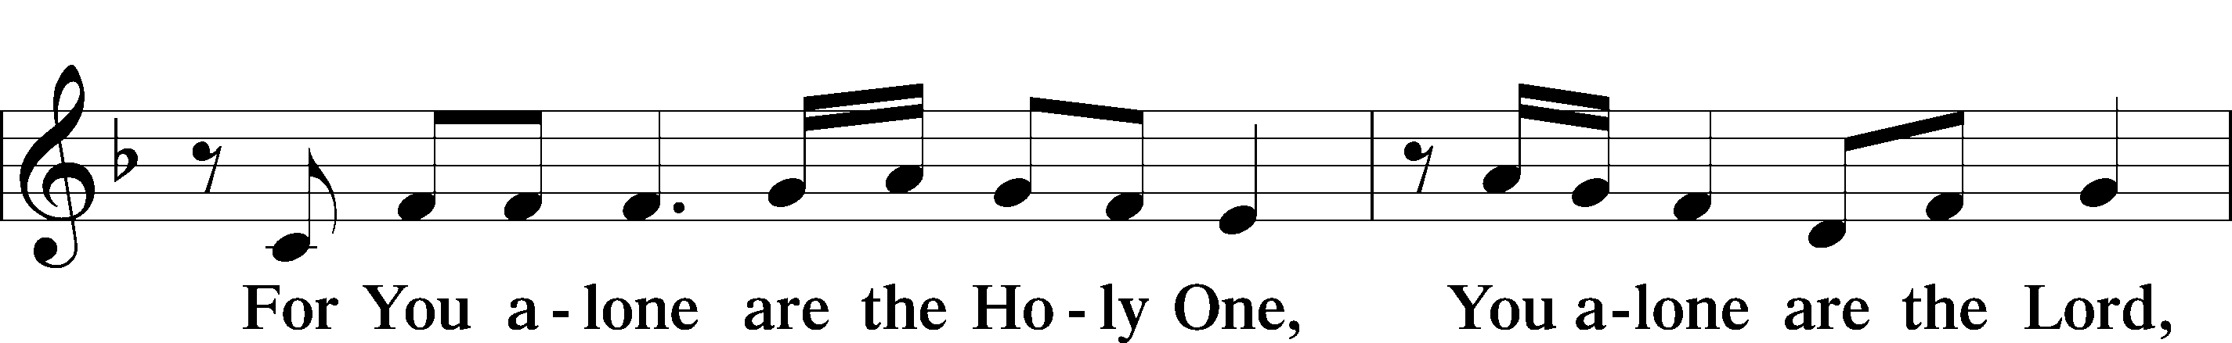

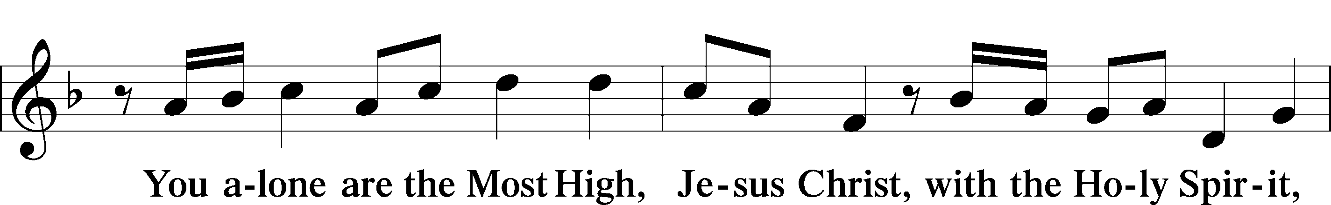

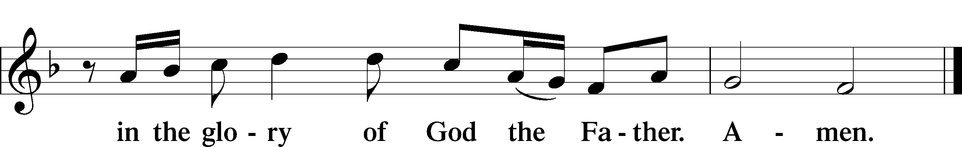

SALUTATION AND COLLECT OF THE DAY

L The Lord be with you.

C **And also with you.**

L Let us pray.

Almighty God, You have built Your Church on the foundation of the apostles and prophets with Christ Jesus Himself as the cornerstone. Continue to send Your messengers to preserve Your people in true peace that, by the preaching of Your Word, Your Church may be kept free from all harm and danger; through Jesus Christ, Your Son, our Lord, who lives and reigns with You and the Holy Spirit, one God, now and forever.

C **Amen.**

(Sit)

CHILDREN'S LESSON

OLD TESTAMENT READING Isaiah 66:10–14

10“Rejoice with Jerusalem, and be glad for her,  
 all you who love her;  
rejoice with her in joy,  
 all you who mourn over her;  
11that you may nurse and be satisfied  
 from her consoling breast;  
that you may drink deeply with delight  
 from her glorious abundance.”  
12For thus says the Lord:  
“Behold, I will extend peace to her like a river,  
 and the glory of the nations like an overflowing stream;  
and you shall nurse, you shall be carried upon her hip,  
 and bounced upon her knees.  
13As one whom his mother comforts,  
 so I will comfort you;  
 you shall be comforted in Jerusalem.  
14You shall see, and your heart shall rejoice;  
 your bones shall flourish like the grass;  
and the hand of the Lord shall be known to his servants,  
 and he shall show his indignation against his enemies.”

L This is the Word of the Lord.

C **Thanks be to God.**

PROPER Romans 10:15b, 18b; Isaiah 52:7b, alt.

How beautiful are the feet of those who preach the | good news,*  
 who publish peace and bring good news of sal- | vation.  
Their voice has gone out to | all the earth,*  
 and their words to the ends |of the world.

EPISTLE Galatians 6:1–10, 14–18

1Brothers, if anyone is caught in any transgression, you who are spiritual should restore him in a spirit of gentleness. Keep watch on yourself, lest you too be tempted. 2Bear one another’s burdens, and so fulfill the law of Christ. 3For if anyone thinks he is something, when he is nothing, he deceives himself. 4But let each one test his own work, and then his reason to boast will be in himself alone and not in his neighbor. 5For each will have to bear his own load.

6One who is taught the word must share all good things with the one who teaches. 7Do not be deceived: God is not mocked, for whatever one sows, that will he also reap. 8For the one who sows to his own flesh will from the flesh reap corruption, but the one who sows to the Spirit will from the Spirit reap eternal life. 9And let us not grow weary of doing good, for in due season we will reap, if we do not give up. 10So then, as we have opportunity, let us do good to everyone, and especially to those who are of the household of faith. . . .

14But far be it from me to boast except in the cross of our Lord Jesus Christ, by which the world has been crucified to me, and I to the world. 15For neither circumcision counts for anything, nor uncircumcision, but a new creation. 16And as for all who walk by this rule, peace and mercy be upon them, and upon the Israel of God.

17From now on let no one cause me trouble, for I bear on my body the marks of Jesus.

18The grace of our Lord Jesus Christ be with your spirit, brothers. Amen.

L This is the Word of the Lord.

C **Thanks be to God.**

(Stand)

ALLELUIA AND VERSE LSB 156

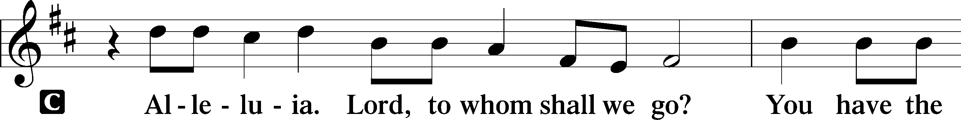

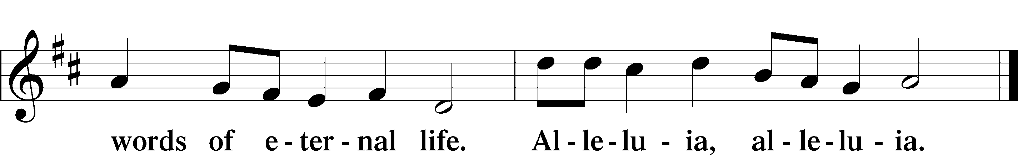

HOLY GOSPEL Luke 10:1–20

L The Holy Gospel according to St. Luke, the tenth chapter.

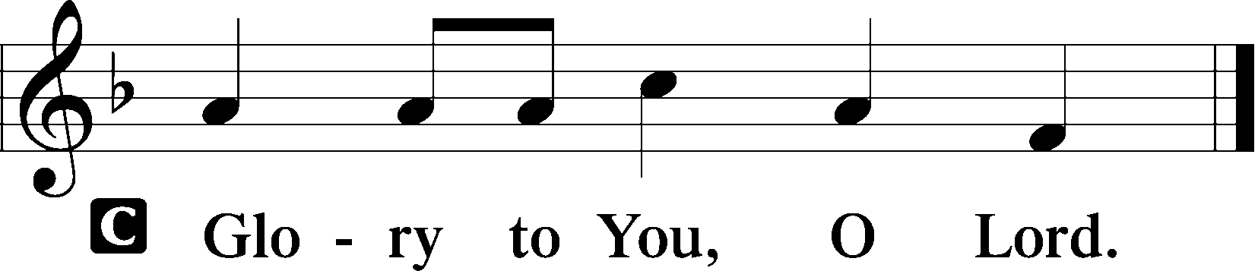

1After this the Lord appointed seventy-two others and sent them on ahead of him, two by two, into every town and place where he himself was about to go. 2And he said to them, “The harvest is plentiful, but the laborers are few. Therefore pray earnestly to the Lord of the harvest to send out laborers into his harvest. 3Go your way; behold, I am sending you out as lambs in the midst of wolves. 4Carry no moneybag, no knapsack, no sandals, and greet no one on the road. 5Whatever house you enter, first say, ‘Peace be to this house!’ 6And if a son of peace is there, your peace will rest upon him. But if not, it will return to you. 7And remain in the same house, eating and drinking what they provide, for the laborer deserves his wages. Do not go from house to house. 8Whenever you enter a town and they receive you, eat what is set before you. 9Heal the sick in it and say to them, ‘The kingdom of God has come near to you.’ 10But whenever you enter a town and they do not receive you, go into its streets and say, 11‘Even the dust of your town that clings to our feet we wipe off against you. Nevertheless know this, that the kingdom of God has come near.’ 12I tell you, it will be more bearable on that day for Sodom than for that town.

13“Woe to you, Chorazin! Woe to you, Bethsaida! For if the mighty works done in you had been done in Tyre and Sidon, they would have repented long ago, sitting in sackcloth and ashes. 14But it will be more bearable in the judgment for Tyre and Sidon than for you. 15And you, Capernaum, will you be exalted to heaven? You shall be brought down to Hades.

16“The one who hears you hears me, and the one who rejects you rejects me, and the one who rejects me rejects him who sent me.”

17The seventy-two returned with joy, saying, “Lord, even the demons are subject to us in your name!” 18And he said to them, “I saw Satan fall like lightning from heaven. 19Behold, I have given you authority to tread on serpents and scorpions, and over all the power of the enemy, and nothing shall hurt you. 20Nevertheless, do not rejoice in this, that the spirits are subject to you, but rejoice that your names are written in heaven.”

L This is the Gospel of the Lord.

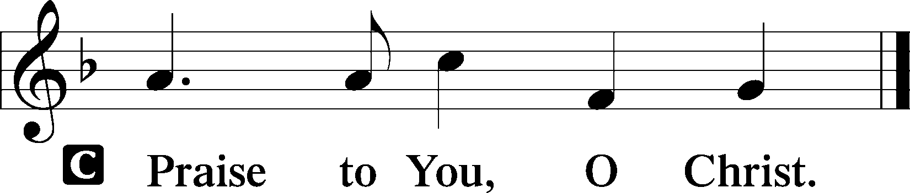

(Sit)

830 SPREAD THE REIGN OF GOD THE LORD

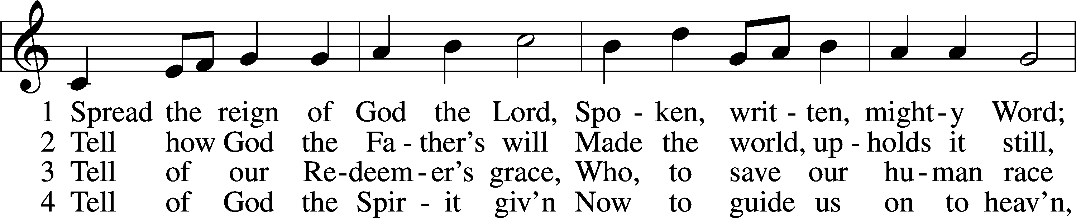

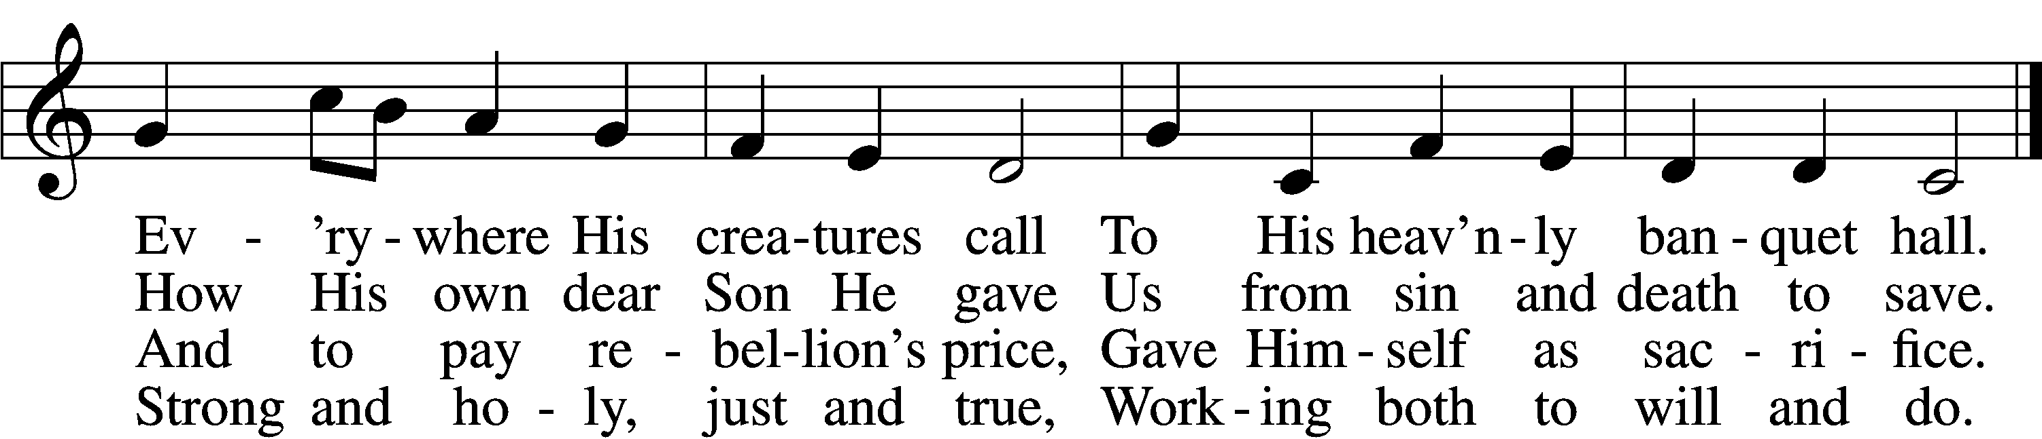

5 Enter, mighty Word, the field;  
Ripe the promise of its yield.  
But the reapers, oh, how few  
For the work there is to do!

6 Lord of harvest, great and kind,  
Rouse to action heart and mind;  
Let the gath’ring nations all  
See Your light and heed Your call.

Text: Jonathan Friedrich Bahnmaier, 1774–1841; tr. composite  
Tune: Geist-reiches Gesang-Buch, 1704, Halle, ed. Johann A. Freylinghausen, alt.  
Text and tune: Public domain

SERMON OR MEDITATION ON THE READINGS

(Stand)

APOSTLES’ CREED

C **I believe in God, the Father Almighty,**

**maker of heaven and earth.**

**And in Jesus Christ, His only Son, our Lord,**

**who was conceived by the Holy Spirit,**

**born of the virgin Mary,**

**suffered under Pontius Pilate,**

**was crucified, died and was buried.**

**He descended into hell.**

**The third day He rose again from the dead.**

**He ascended into heaven**

**and sits at the right hand of God the Father Almighty.**

**From thence He will come to judge the living and the dead.**

**I believe in the Holy Spirit,**

**the holy Christian Church,**

**the communion of saints,**

**the forgiveness of sins,**

**the resurrection of the body,**

**and the life** T **everlasting. Amen.**

SHARING OF THE PEACE

(Sit)

PRAYER OF THE CHURCH

(Stand)

OFFERING

*As a part of our expression of thanksgiving to God for the treasure of His salvation to us, we offer a portion of our treasure, according to what each has determined in their heart to give. Please place offerings in the collection plate at the back of the sanctuary before or after the service. Offerings can also be sent to Bethlehem Lutheran Church via U.S. Mail. Thank you!*

OFFERTORY LSB 159

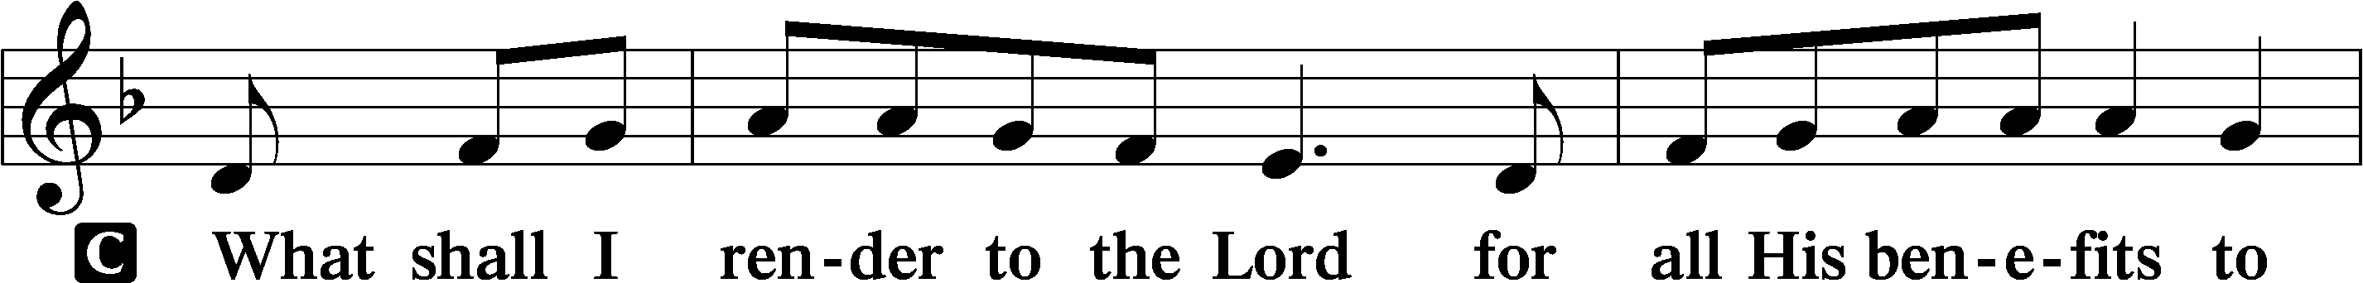

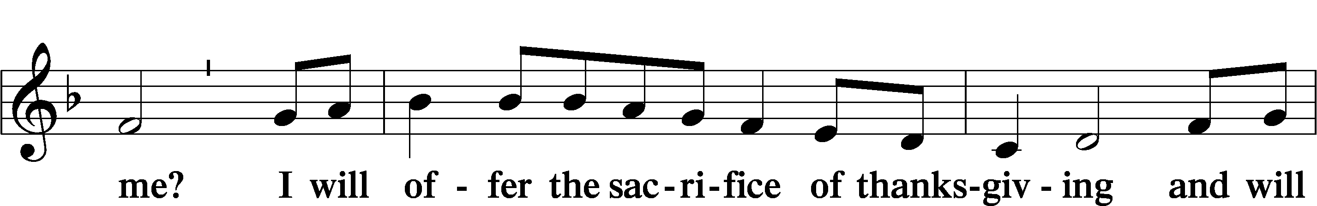

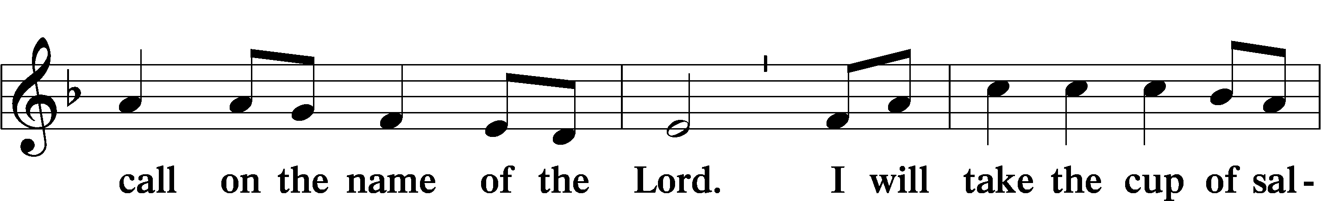

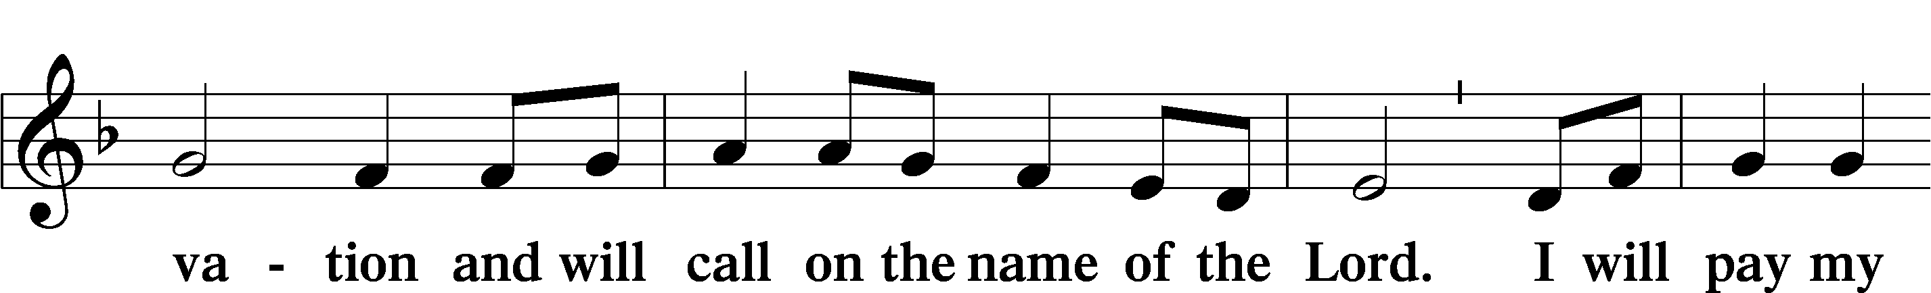

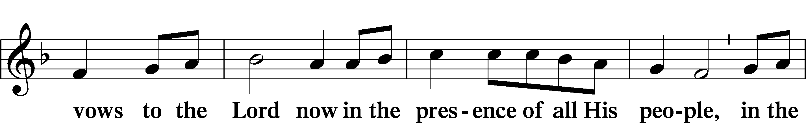

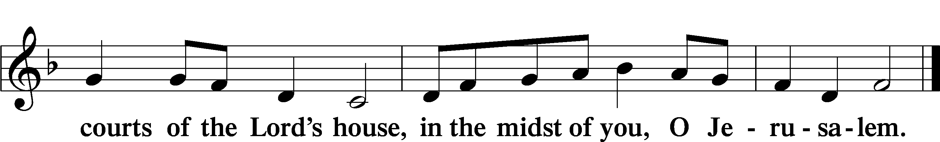

(Sit)

# Note: *Communicant members who are unable to attend the Divine Service are encouraged to make arrangements with Pastor Engwall to receive the Lord’s Supper.*

684 COME UNTO ME, YE WEARY

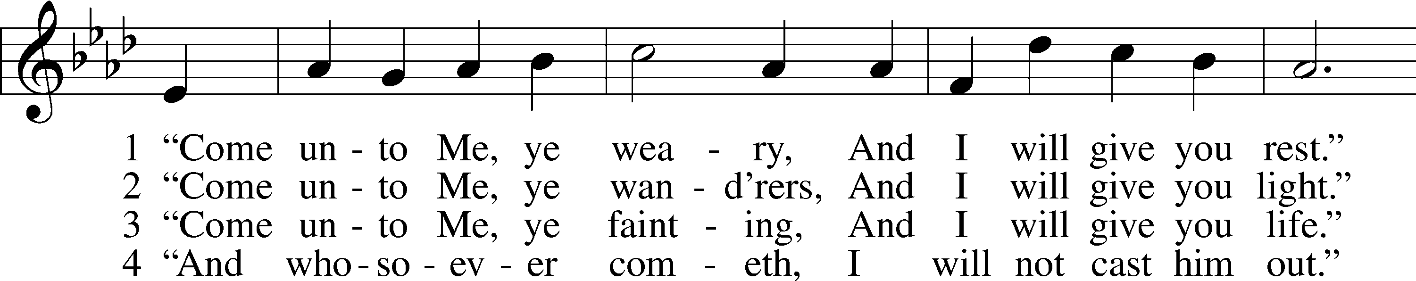

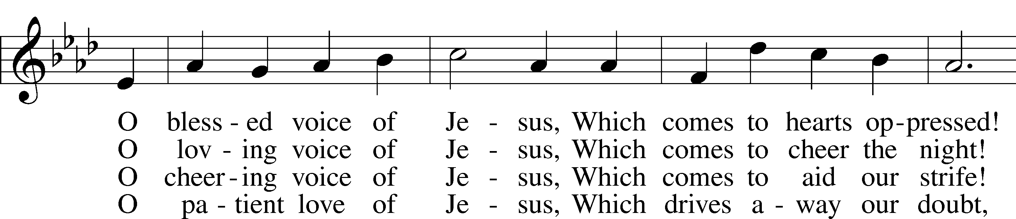

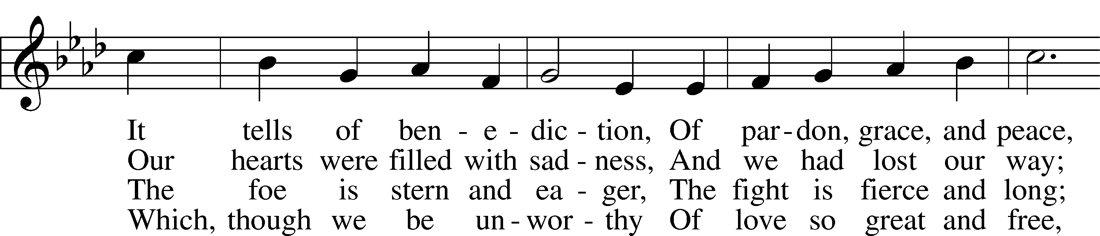

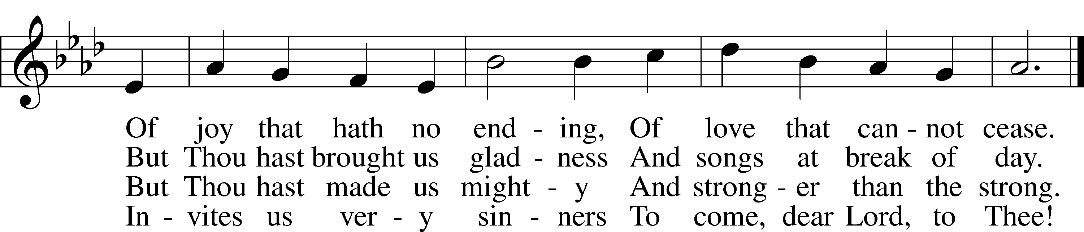

Text: William C. Dix, 1837–98, alt.  
Tune: Friedrich K. Anthes, 1812–after 1857  
Text and tune: Public domain

(Stand)

LORD’S PRAYER

C **Our Father who art in heaven,**

**hallowed be Thy name,**

**Thy kingdom come,**

**Thy will be done on earth**

**as it is in heaven;**

**give us this day our daily bread;**

**and forgive us our trespasses**

**as we forgive those**

**who trespass against us;**

**and lead us not into temptation,**

**but deliver us from evil.**

**For Thine is the kingdom**

**and the power and the glory**

**forever and ever. Amen.**

**BENEDICTION**

L: The grace of our Lord T Jesus Christ, and the love of God, and the fellowship of the Holy Spirit, be with us all.

C: **Amen.**

826 HARK, THE VOICE OF JESUS CRYING

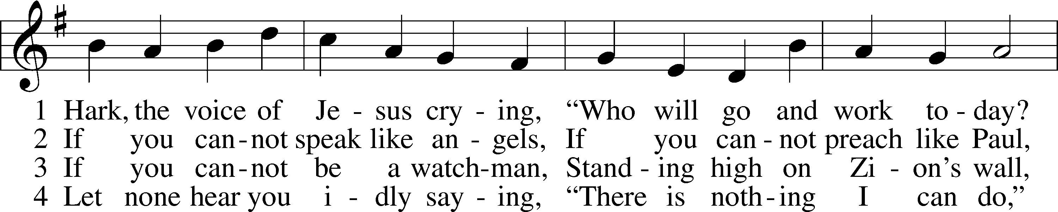

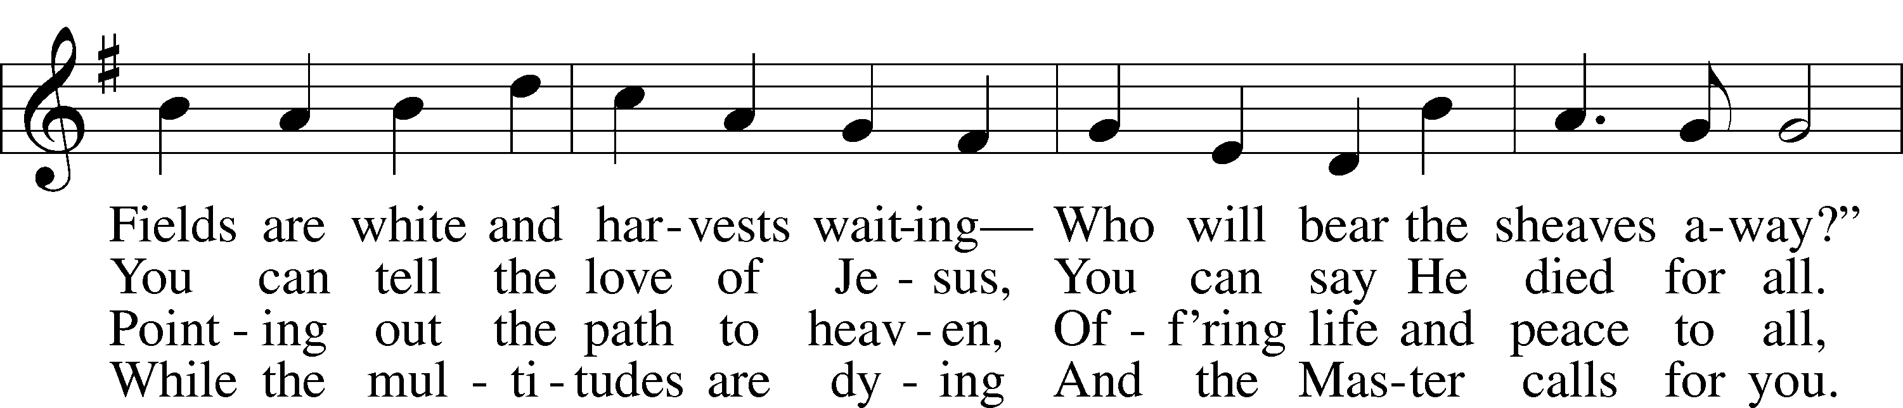

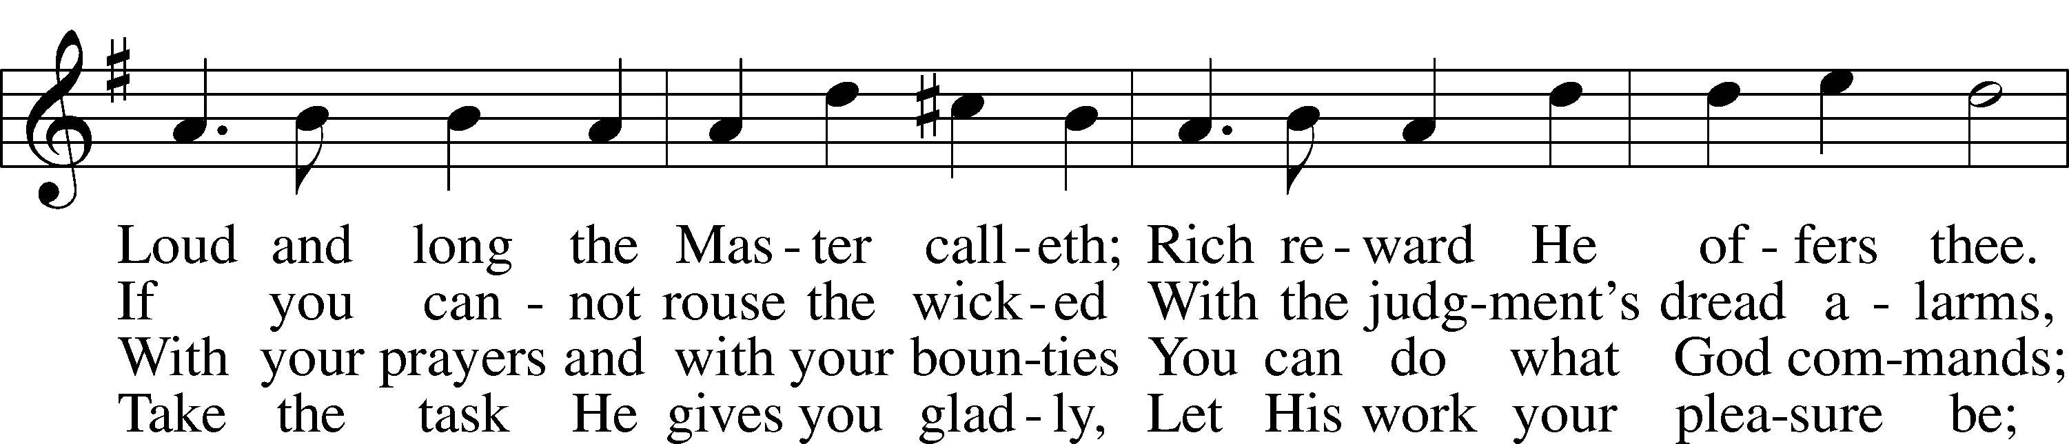

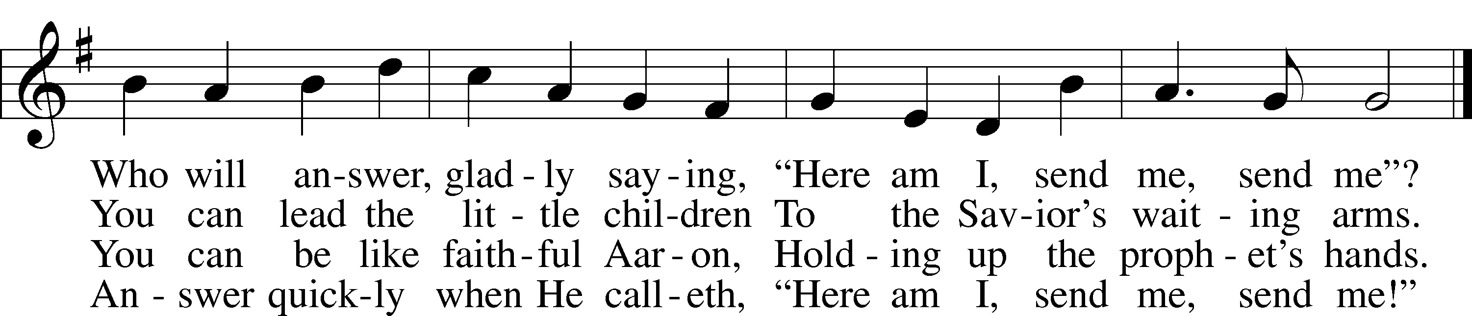

Text (sts. 1–2, 4): Daniel March, 1816–1909, alt.; (st. 3): unknown, alt.  
Tune: Joseph Barnby, 1838–96  
Text and tune: Public domain

ACKNOWLEDGMENTS

Unless otherwise indicated, Scripture quotations are from the ESV® Bible (The Holy Bible, English Standard Version®), copyright © 2001 by Crossway, a publishing ministry of Good News Publishers. Used by permission. All rights reserved.

Created by Lutheran Service Builder © 2025 Concordia Publishing House.