BETHLEHEM LUTHERAN CHURCH
A congregation of The Lutheran Church-Missouri Synod
902 Hitchcock Drive SW,
Aiken, South Carolina 29803
Church Phone: (803) 649-6417
blcaikensc@gmail.com
Pastor: Rev. John B. Engwall
Office Hours By Appointment
Note: The format of this bulletin has been modified for use in private devotion services.
Unable to join us in person? Please find us on Facebook live.
The service is also posted on our website; bethlehemlutheranaiken.org

+ + + + + + + + + + + + + + +
The Fourth Wednesday in Lent
March 18, 2026
11:00 a.m. and 7:00 p.m.
+ + + + + + + + + + + + + + +

+ SERVICE OF PREPARATION +
After the bell tolls, please observe a time of silence.

WELCOME AND ANNOUNCEMENTS

849 PRAISE THE ONE WHO BREAKS THE DARKNESS
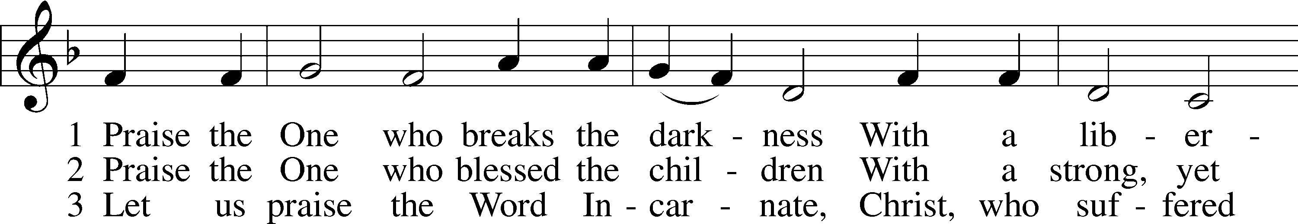
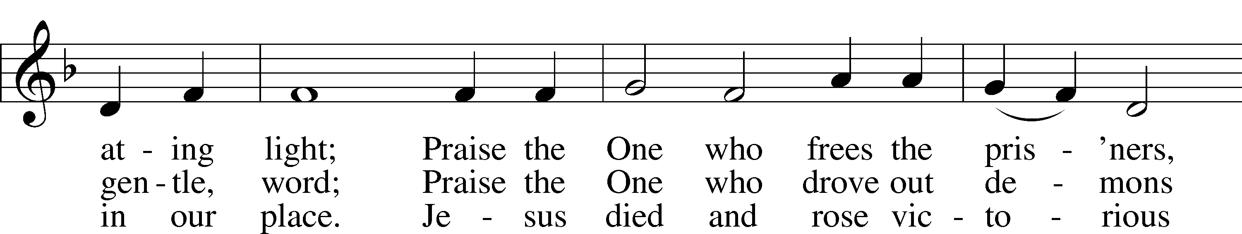
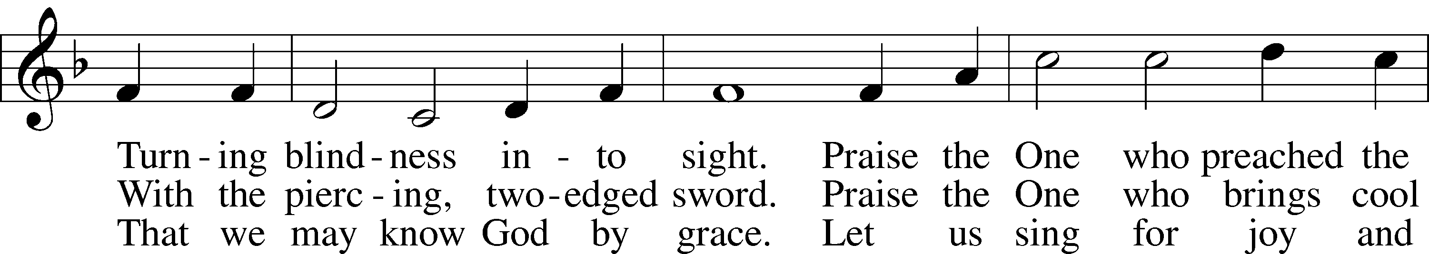
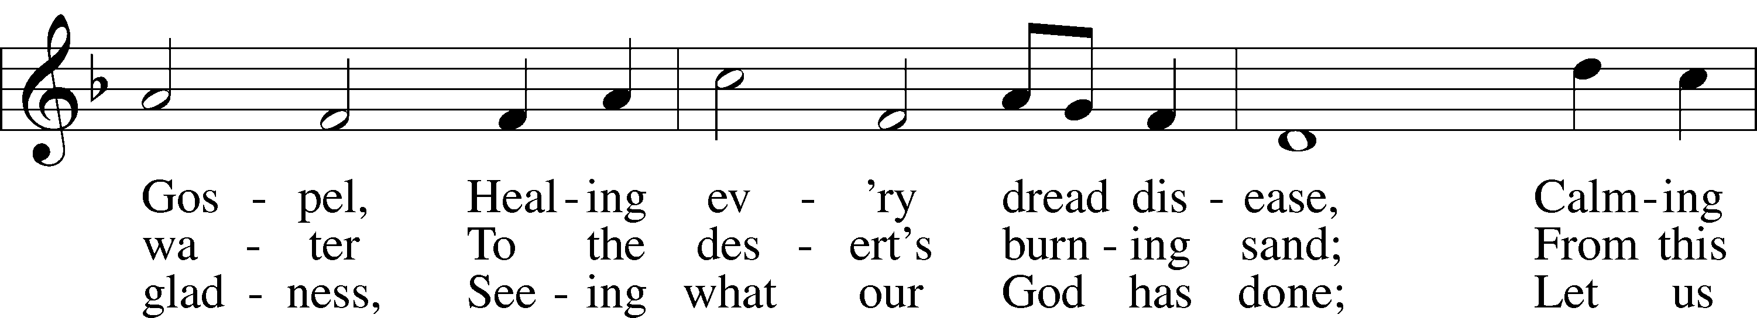
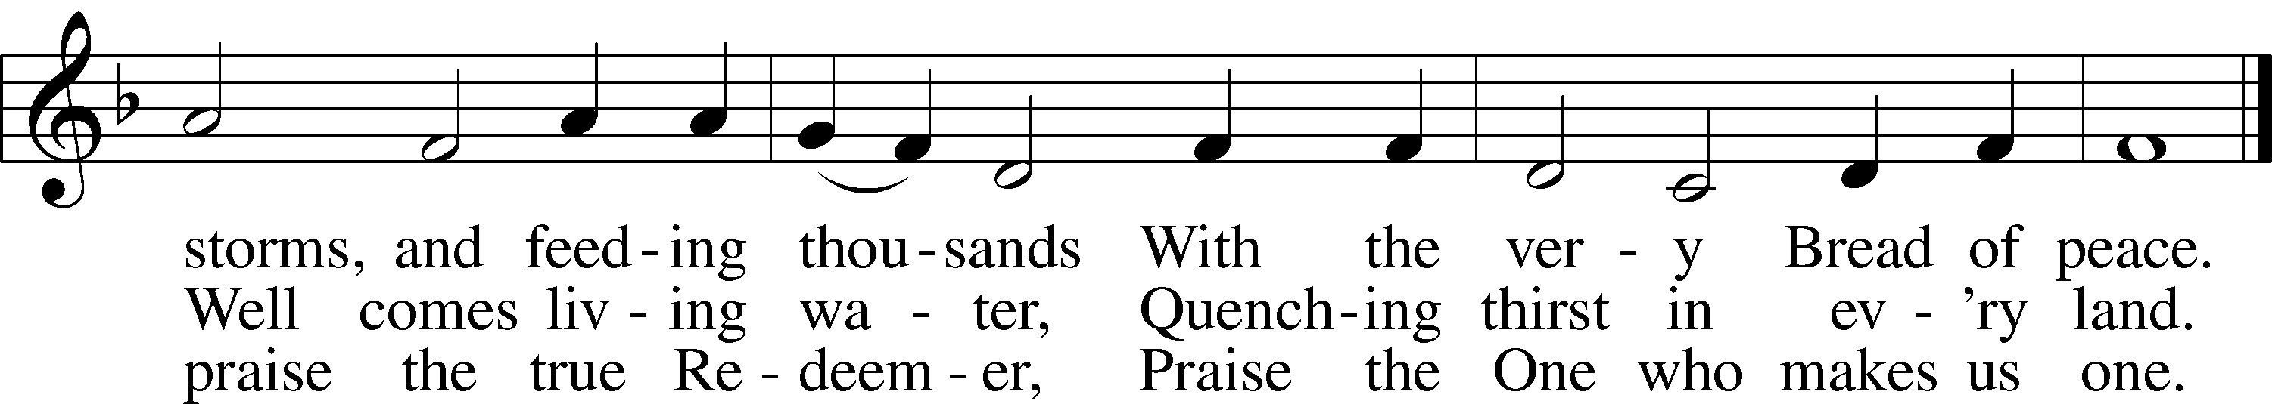
Text: Rusty Edwards, 1955
Tune: The Sacred Harp, 1844, Philadelphia
Text: © 1987 Hope Publishing Co. Used by permission: LSB Hymn License no. 110004798
Tune: Public domain

PRAYER
O God, You resist the proud and give grace to the humble. Grant us true humility after the likeness of Your only Son that we may never be arrogant and prideful and thus provoke Your wrath, but in all lowliness be made partakers of the gifts of Your grace; through Jesus Christ, our Lord.

READING Isaiah 42:14–21
14For a long time I have held my peace;
I have kept still and restrained myself;
now I will cry out like a woman in labor;
I will gasp and pant.
15I will lay waste mountains and hills,
and dry up all their vegetation;
I will turn the rivers into islands,
and dry up the pools.
16And I will lead the blind
in a way that they do not know,
in paths that they have not known
I will guide them.
I will turn the darkness before them into light,
the rough places into level ground.
These are the things I do,
and I do not forsake them.
17They are turned back and utterly put to shame,
who trust in carved idols,
who say to metal images,
“You are our gods.”
18Hear, you deaf,
and look, you blind, that you may see!
19Who is blind but my servant,
or deaf as my messenger whom I send?
Who is blind as my dedicated one,
or blind as the servant of the Lord?
20He sees many things, but does not observe them;
his ears are open, but he does not hear.
21The Lord was pleased, for his righteousness’ sake,
to magnify his law and make it glorious.

SERMON OR MEDITATION ON THE READING

APOSTLES’ CREED
C I believe in God, the Father Almighty,
maker of heaven and earth.

And in Jesus Christ, His only Son, our Lord,
who was conceived by the Holy Spirit,
born of the virgin Mary,
suffered under Pontius Pilate,
was crucified, died and was buried.
He descended into hell.
The third day He rose again from the dead.
He ascended into heaven
and sits at the right hand of God the Father Almighty.
From thence He will come to judge the living and the dead.

I believe in the Holy Spirit,
the holy Christian Church,
the communion of saints,
the forgiveness of sins,
the resurrection of the body,
and the life T everlasting. Amen.

LORD’S PRAYER
C Our Father who art in heaven,
hallowed be Thy name,
Thy kingdom come,
Thy will be done on earth
as it is in heaven;
give us this day our daily bread;
and forgive us our trespasses
as we forgive those
who trespass against us;
and lead us not into temptation,
but deliver us from evil.
For Thine is the kingdom
and the power and the glory
forever and ever. Amen.

BLESSING
L The grace of our Lord T Jesus Christ and the love of God and the communion of the Holy Spirit be with us all.
C Amen.

744 AMAZING GRACE sts. 1–5
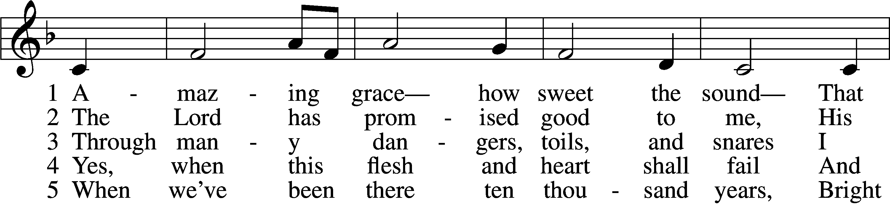
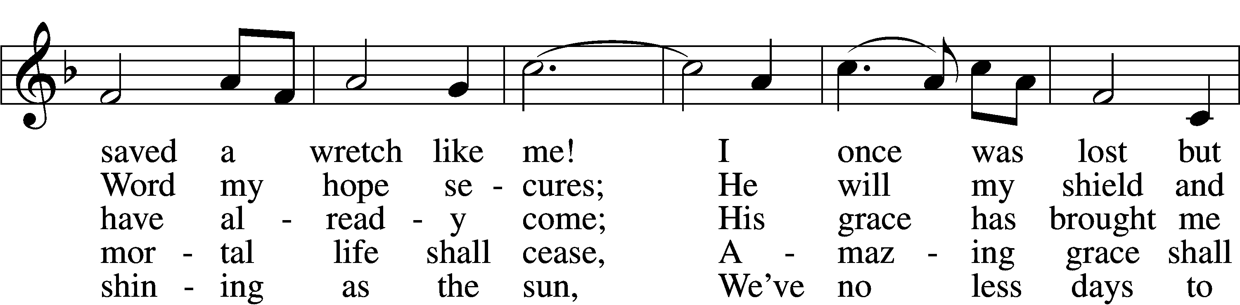
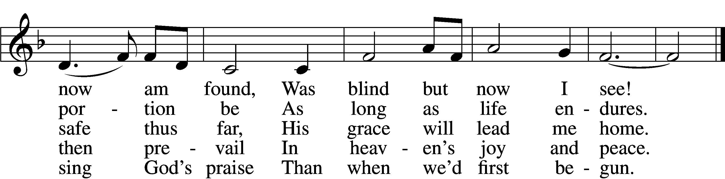
Text (sts. 1–4): John Newton, 1725–1807, alt.; (st. 5): A Collection of Sacred Ballads, 1790, Richmond
Tune: Columbian Harmony, 1829, Cincinnati
Text and tune: Public domain

Unless otherwise indicated, Scripture quotations are from the ESV® Bible (The Holy Bible, English Standard Version®), copyright © 2001 by Crossway, a publishing ministry of Good News Publishers. Used by permission. All rights reserved.
Created by Lutheran Service Builder © 2026 Concordia Publishing House.

