BETHLEHEM LUTHERAN CHURCH
A congregation of The Lutheran Church-Missouri Synod
902 Hitchcock Drive SW,
Aiken, South Carolina 29803
Church Phone: (803) 649-6417
blcaikensc@gmail.com

Bethlehem Lutheran welcomes our members and guests to our worship service! Unable to join us in person? Please find us on Facebook live. The service is also posted on our website; bethlehemlutheranaiken.org.

+ + + + + + + + + + + + + + +
Sixth Sunday after Pentecost
July 5, 2026
10:30 a.m.
+ + + + + + + + + + + + + + +

+ SERVICE OF PREPARATION +

(After the bell tolls, please observe a time of silence.)

WELCOME AND ANNOUNCEMENTS

(Stand)

733 O GOD, OUR HELP IN AGES PAST sts. 1–6
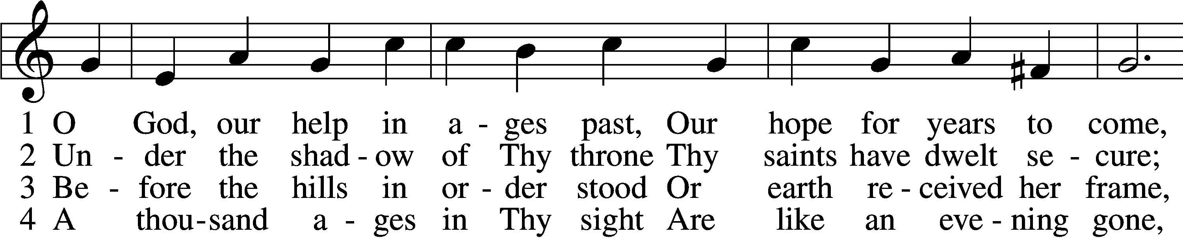
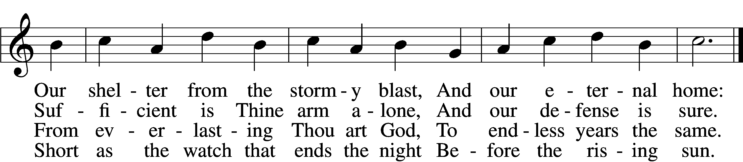

5 Time, like an ever-rolling stream,
Soon bears us all away;
We fly forgotten as a dream
Dies at the op’ning day.

6 O God, our help in ages past,
Our hope for years to come,
Be Thou our guard while troubles last
And our eternal home!
Text: Isaac Watts, 1674–1748, alt.
Tune: William Croft, 1678–1727
Text and tune: Public domain

+ CONFESSION AND ABSOLUTION +

(The sign of the cross may be made by all in remembrance of their Baptism.)

INVOCATION LSB 151
L In the name of the Father and of the T Son and of the Holy Spirit.
C Amen.

EXHORTATION LSB 151
L If we say we have no sin, we deceive ourselves, and the truth is not in us.
C But if we confess our sins, God, who is faithful and just, will forgive our sins and cleanse us from all unrighteousness.

(Silence for reflection on God’s Word and for self-examination.)

CONFESSION OF SINS LSB 151
L Let us then confess our sins to God our Father.
C Most merciful God, we confess that we are by nature sinful and unclean. We have sinned against You in thought, word, and deed, by what we have done and by what we have left undone. We have not loved You with our whole heart; we have not loved our neighbors as ourselves. We justly deserve Your present and eternal punishment. For the sake of Your Son, Jesus Christ, have mercy on us. Forgive us, renew us, and lead us, so that we may delight in Your will and walk in Your ways to the glory of Your holy name. Amen.

DECLARATION OF GRACE LSB 151
L In the mercy of almighty God, Jesus Christ was given to die for us, and for His sake God forgives us all our sins. To those who believe in Jesus Christ He gives the power to become the children of God and bestows on them the Holy Spirit. May the Lord, who has begun this good work in us, bring it to completion in the day of our Lord Jesus Christ.
C Amen.

+ SERVICE OF THE WORD +

INTROIT Psalm 91:2, 9–10; antiphon: v. 1
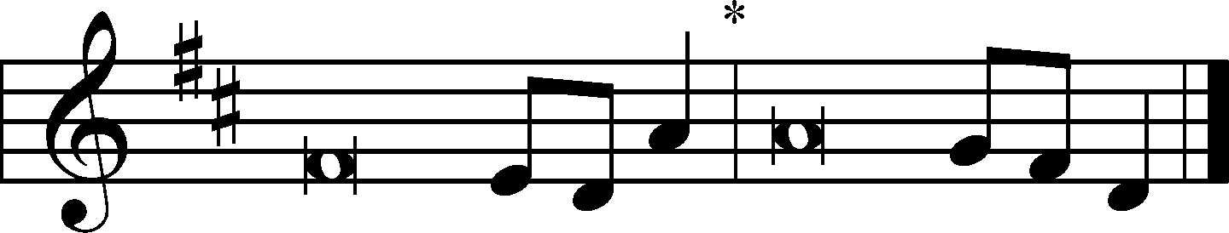
He who dwells in the shelter of the | Most High*
will abide in the shadow of the Al- | mighty.
I will say to the Lord, “My refuge and my | fortress,*
my God, in | whom I trust.”
Because you have made the Lord your | dwelling place—*
the Most High, who is my | refuge—
no evil shall be allowed to be- | fall you,*
no plague come | near your tent.
Glory be to the Father and | to the Son*
and to the Holy | Spirit;
as it was in the be- | ginning,*
is now, and will be forever. | Amen.
He who dwells in the shelter of the | Most High*
will abide in the shadow of the Al- | mighty.

KYRIE LSB 152
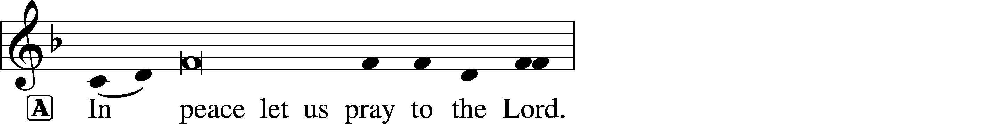
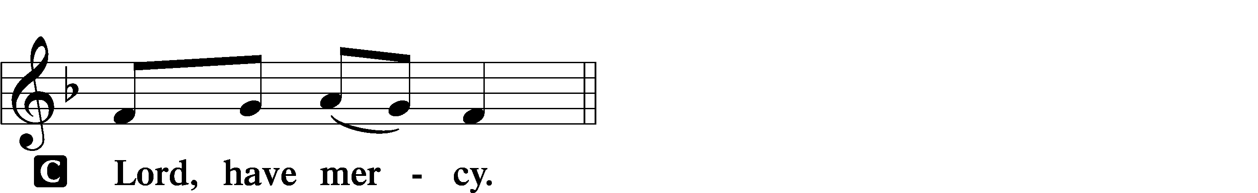

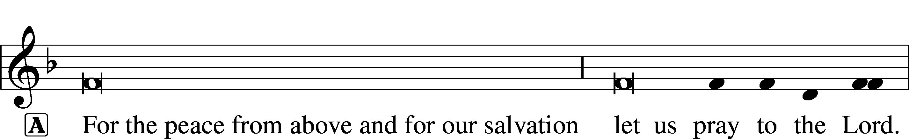
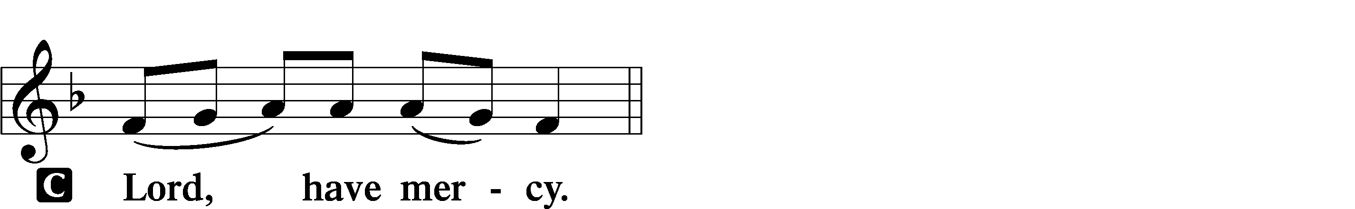

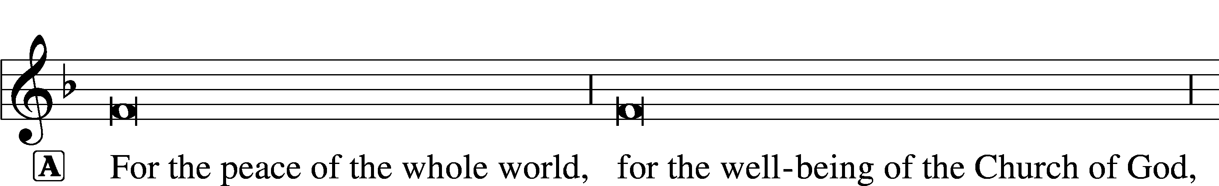
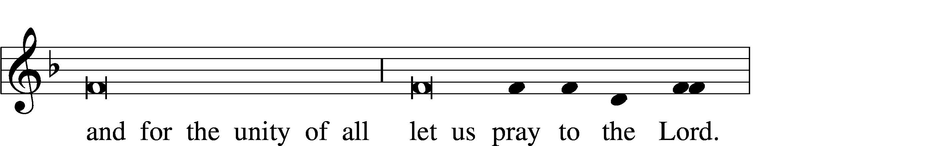
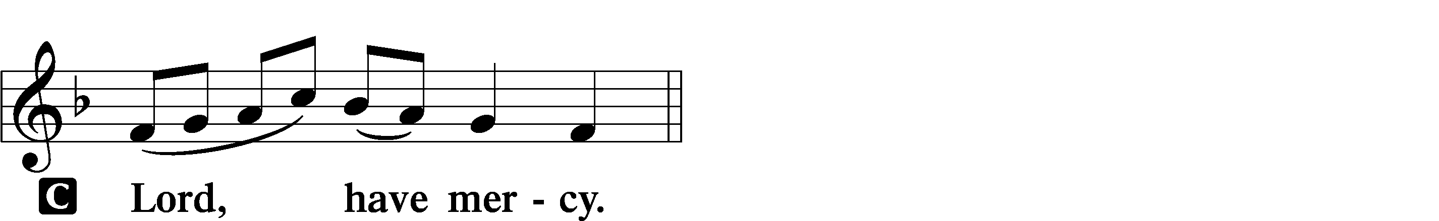

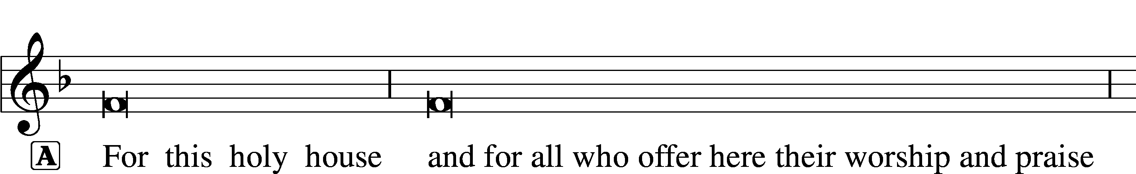
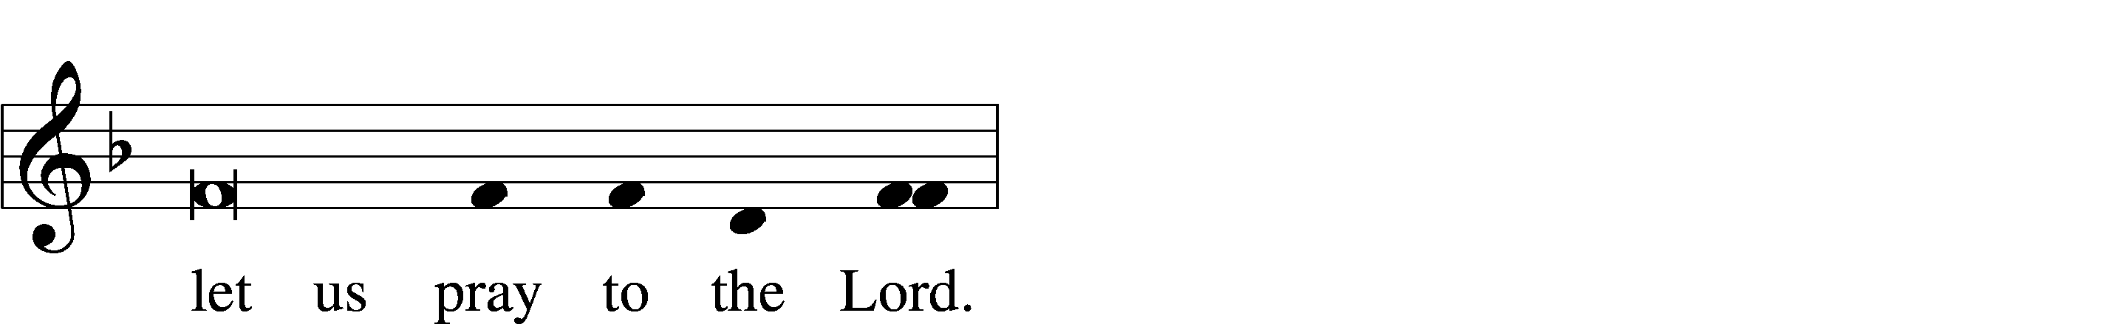
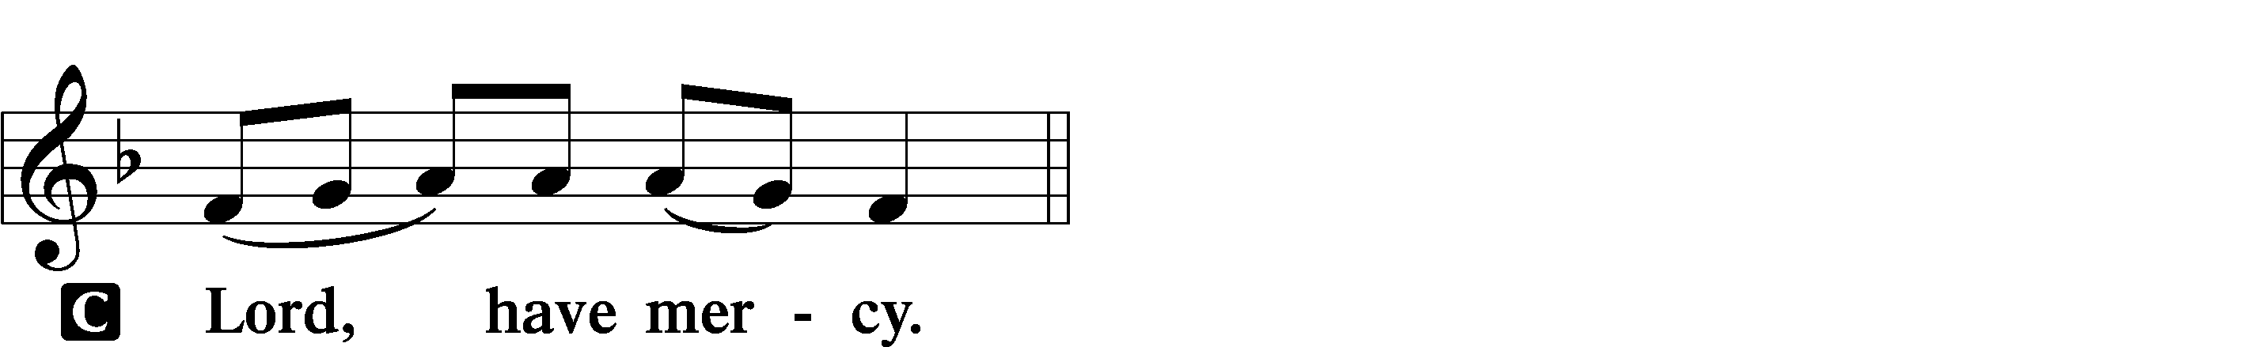

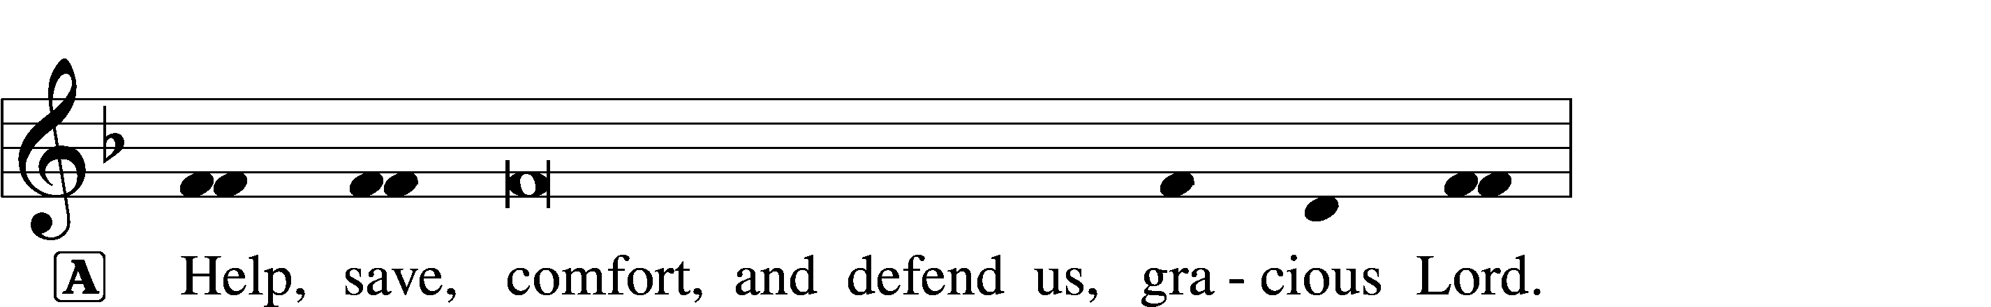
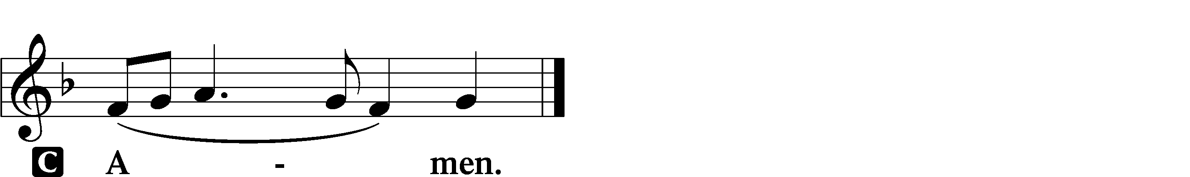

GLORIA IN EXCELSIS LSB 154
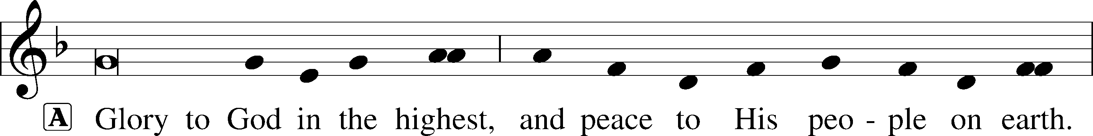
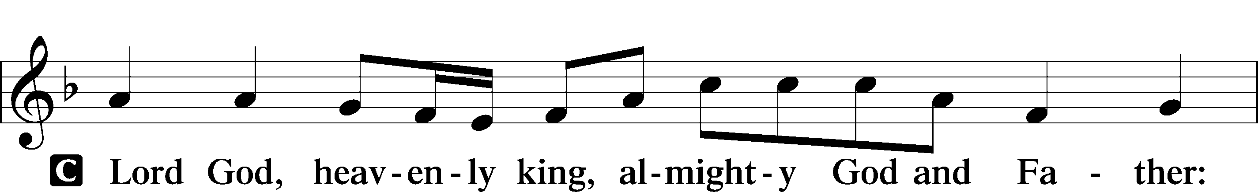
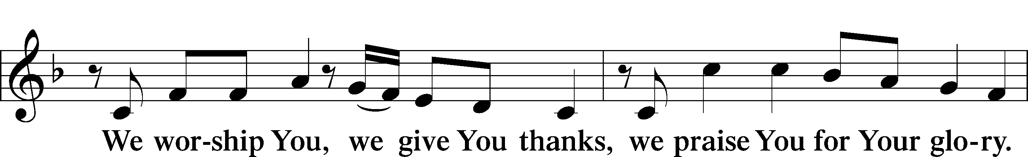
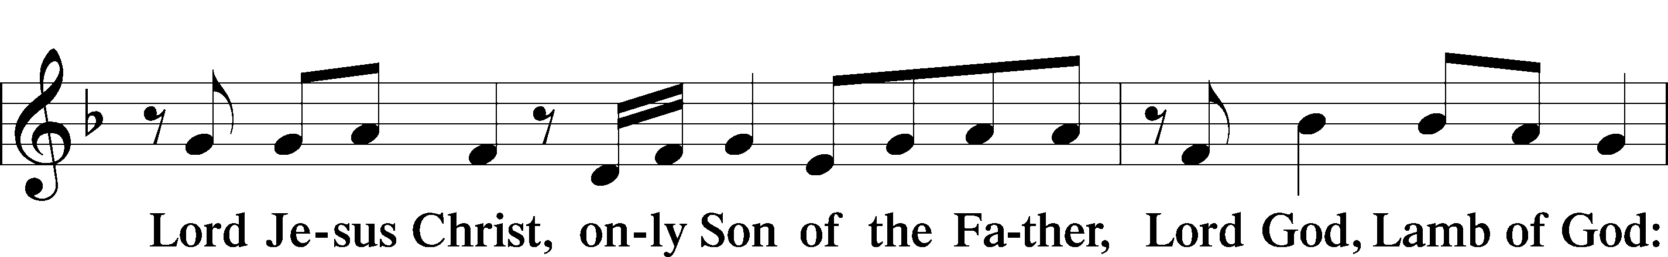
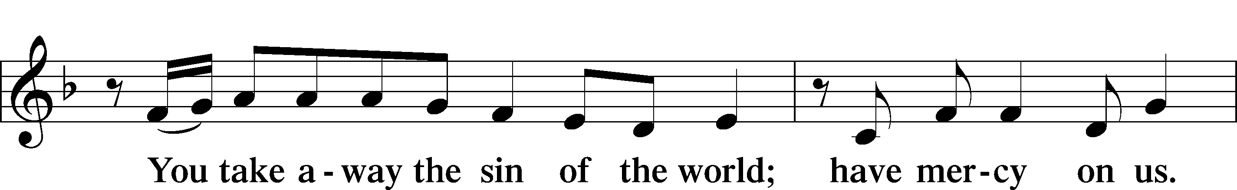
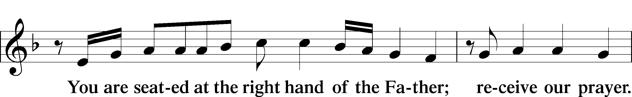
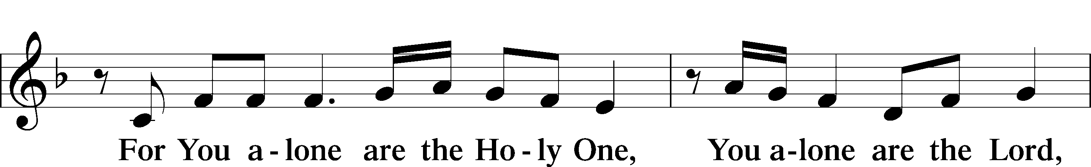
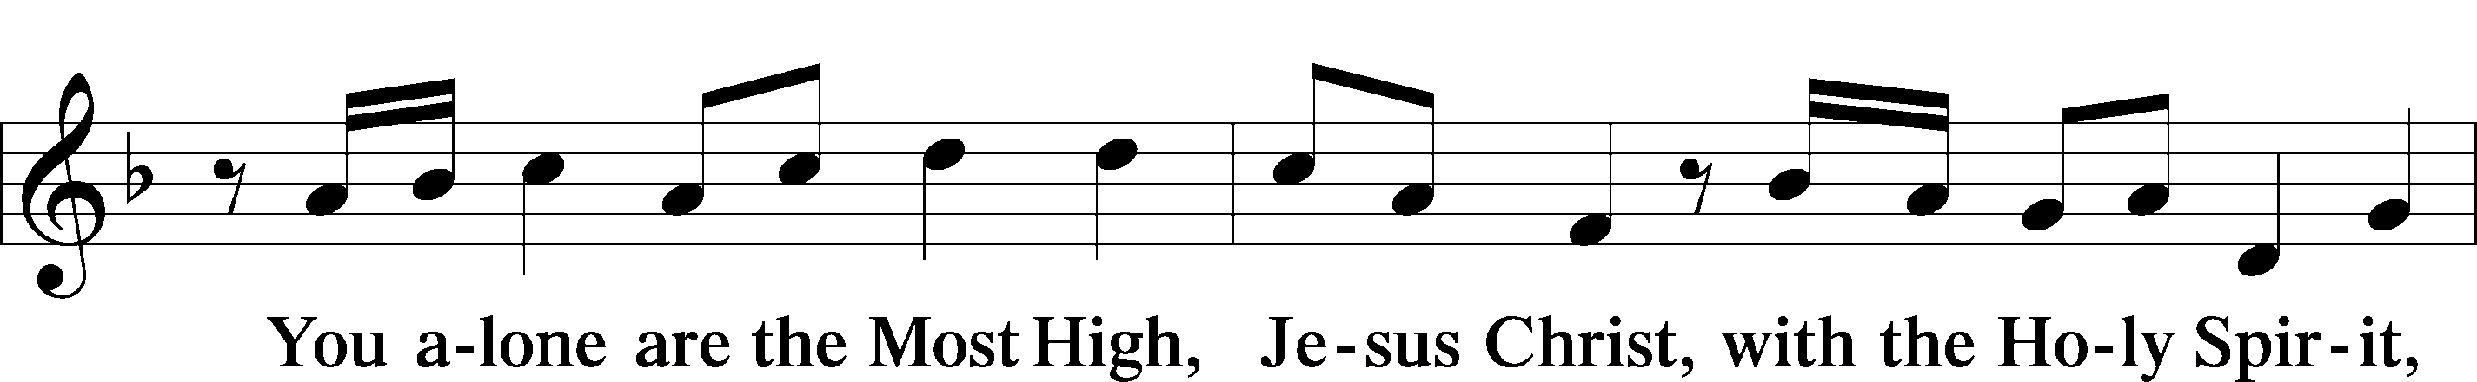
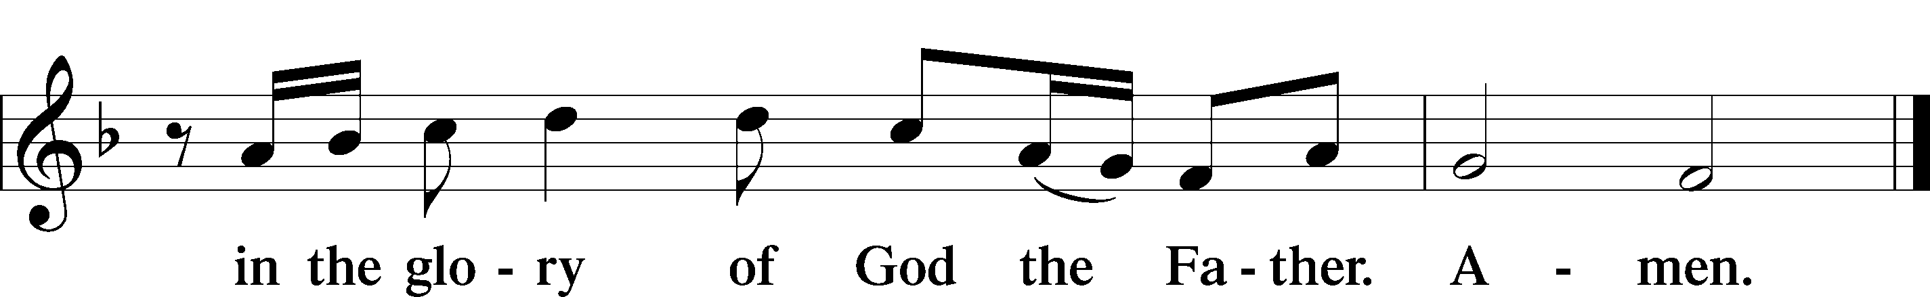

SALUTATION AND COLLECT OF THE DAY LSB 156
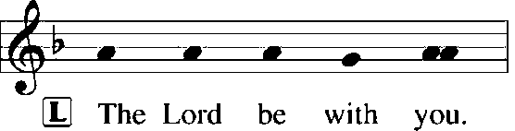
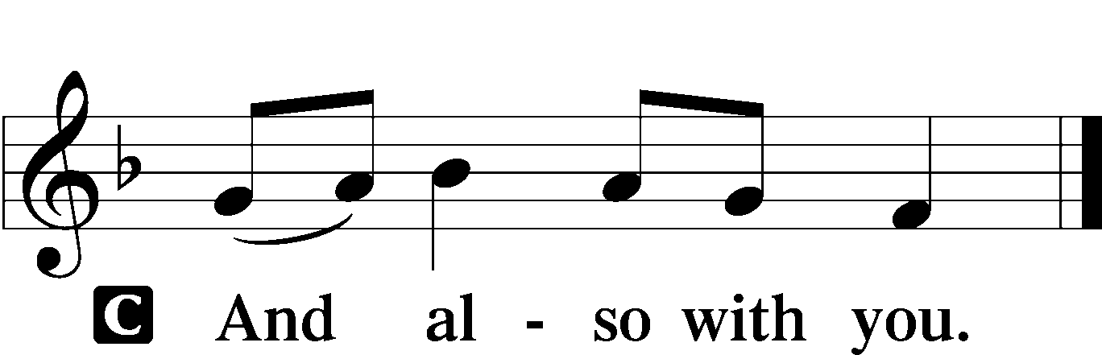

L Let us pray.
Gracious God, our heavenly Father, Your mercy attends us all our days. Be our strength and support amid the wearisome changes of this world, and at life’s end grant us Your promised rest and the full joys of Your salvation; through Jesus Christ, Your Son, our Lord, who lives and reigns with You and the Holy Spirit, one God, now and forever.

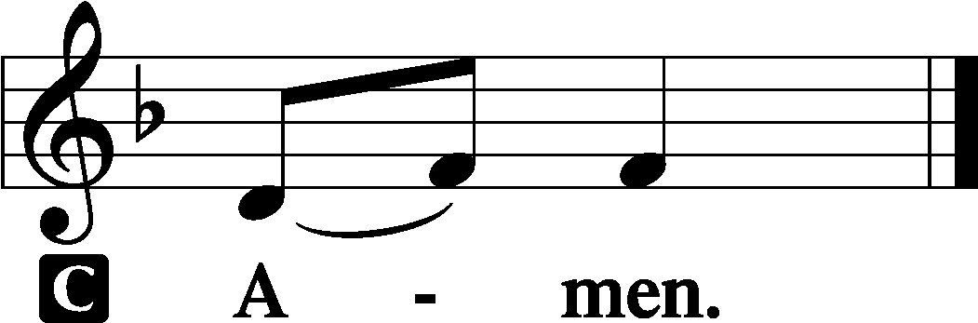

(Sit)

OLD TESTAMENT READING Zechariah 9:9–12
9Rejoice greatly, O daughter of Zion!
Shout aloud, O daughter of Jerusalem!
behold, your king is coming to you;
righteous and having salvation is he,
humble and mounted on a donkey,
on a colt, the foal of a donkey.
10I will cut off the chariot from Ephraim
and the war horse from Jerusalem;
and the battle bow shall be cut off,
and he shall speak peace to the nations;
his rule shall be from sea to sea,
and from the River to the ends of the earth.
11As for you also, because of the blood of my covenant with you,
I will set your prisoners free from the waterless pit.
12Return to your stronghold, O prisoners of hope;
today I declare that I will restore to you double.

L This is the Word of the Lord.
C Thanks be to God.

GRADUAL Romans 11:33, 36
Oh, the depth of the riches and wisdom and knowl- | edge of God!*
How unsearchable are his judgments and how inscrutable | his ways!
For from him and through him and to him are | all things.*
To him be glory forever. | Amen.

EPISTLE Romans 7:14–25a
14We know that the law is spiritual, but I am of the flesh, sold under sin. 15I do not understand my own actions. For I do not do what I want, but I do the very thing I hate. 16Now if I do what I do not want, I agree with the law, that it is good. 17So now it is no longer I who do it, but sin that dwells within me. 18For I know that nothing good dwells in me, that is, in my flesh. For I have the desire to do what is right, but not the ability to carry it out. 19For I do not do the good I want, but the evil I do not want is what I keep on doing. 20Now if I do what I do not want, it is no longer I who do it, but sin that dwells within me.
21So I find it to be a law that when I want to do right, evil lies close at hand. 22For I delight in the law of God, in my inner being, 23but I see in my members another law waging war against the law of my mind and making me captive to the law of sin that dwells in my members. 24Wretched man that I am! Who will deliver me from this body of death? 25Thanks be to God through Jesus Christ our Lord!

L This is the Word of the Lord.
C Thanks be to God.

(Stand)

ALLELUIA AND VERSE LSB 156
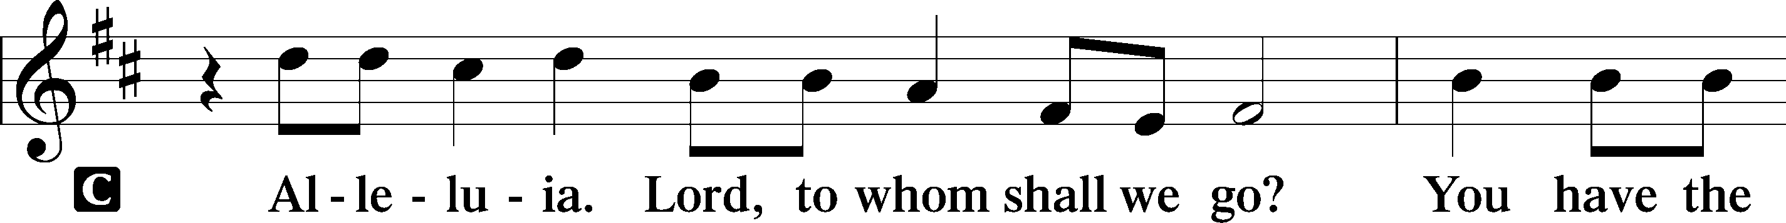
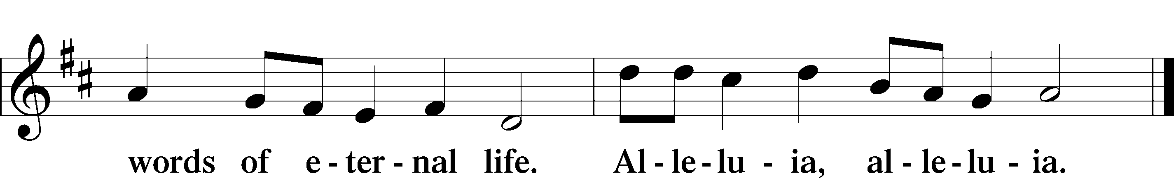

HOLY GOSPEL Matthew 11:25–30
L The Holy Gospel according to St. Matthew, the eleventh chapter.

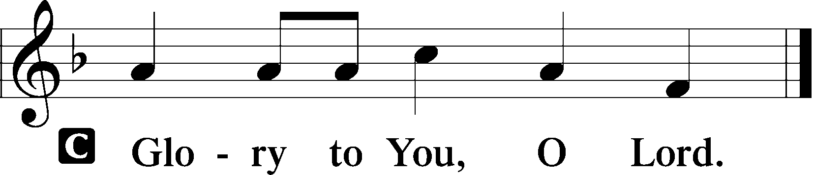

25At that time Jesus declared, “I thank you, Father, Lord of heaven and earth, that you have hidden these things from the wise and understanding and revealed them to little children; 26yes, Father, for such was your gracious will. 27All things have been handed over to me by my Father, and no one knows the Son except the Father, and no one knows the Father except the Son and anyone to whom the Son chooses to reveal him. 28Come to me, all who labor and are heavy laden, and I will give you rest. 29Take my yoke upon you, and learn from me, for I am gentle and lowly in heart, and you will find rest for your souls. 30For my yoke is easy, and my burden is light.”

L This is the Gospel of the Lord.

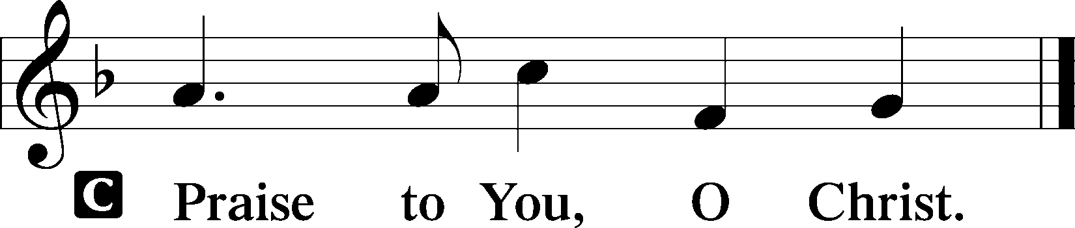

(Sit)

717 ETERNAL FATHER, STRONG TO SAVE
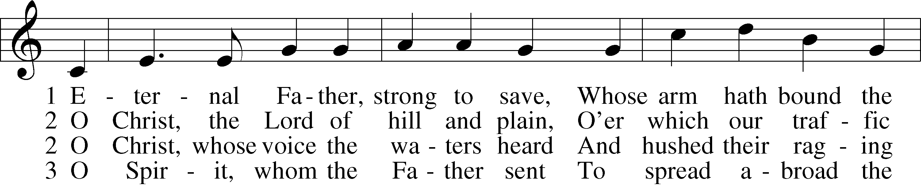
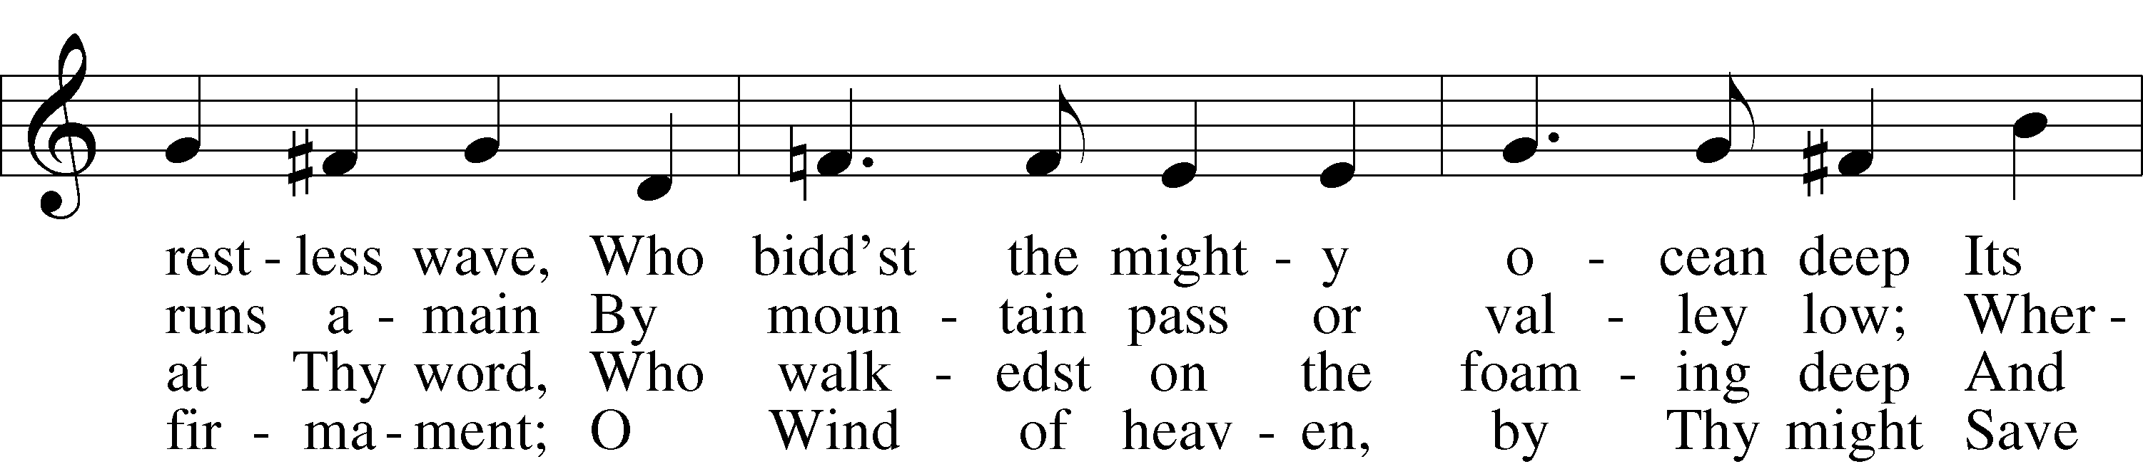
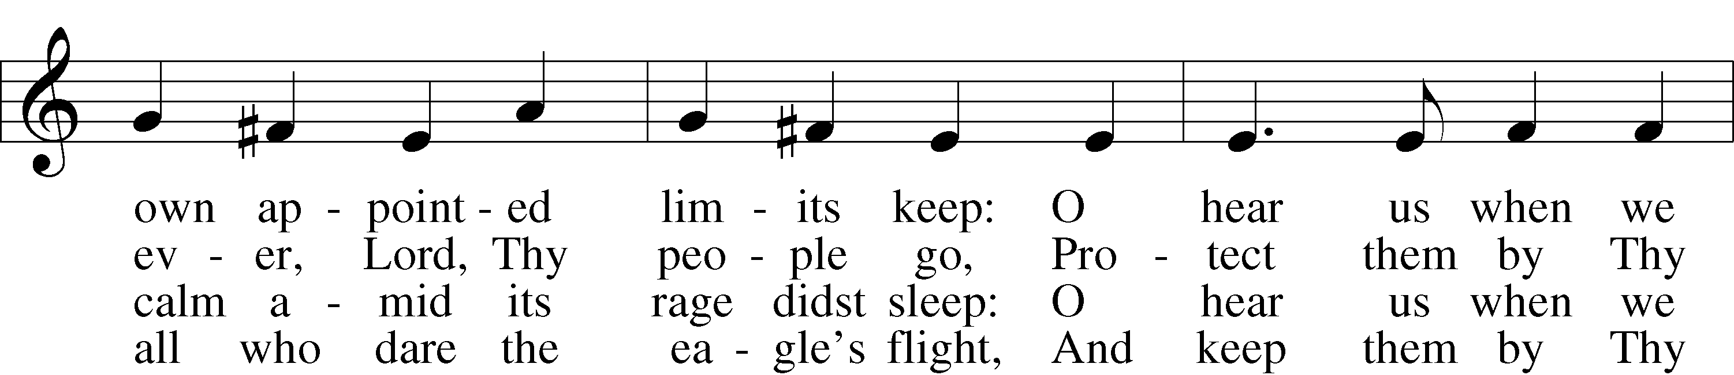
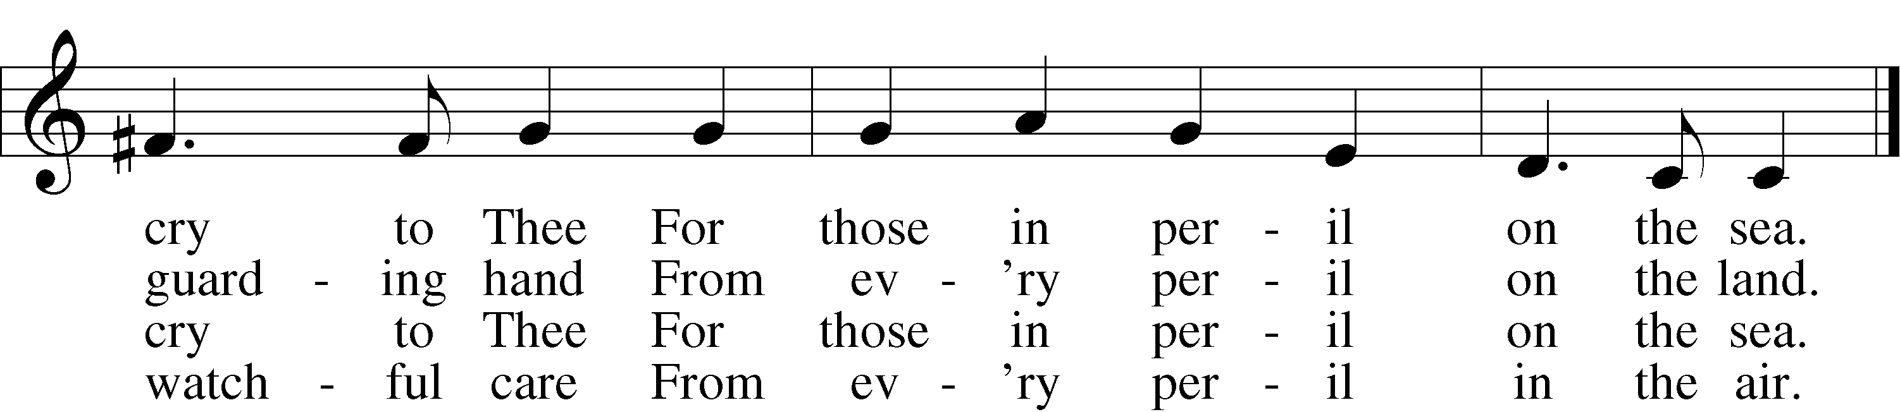

3a Most Holy Spirit, who didst brood
Upon the chaos dark and rude,
And bid its angry tumult cease,
And give, for wild confusion, peace:
O hear us when we cry to Thee
For those in peril on the sea.

4 O Trinity of love and pow’r,
Our people shield in danger’s hour;
From rock and tempest, fire and foe,
Protect them wheresoe’er they go;
Thus evermore shall rise to Thee
Glad praise from air and land and sea.
Text (sts. 1–4): William Whiting, 1825–78, alt.; (sts. 2a–3a): Robert N. Spencer, 1877–1961, alt.
Tune: John B. Dykes, 1823–76
Text (sts. 2–3): © The Church Pension Fund. Used by permission: LSB Hymn License no. 110004798
Text (sts. 1–4) and tune: Public domain

SERMON

(Sermons for Elder led services are provided courtesy of the Lutheran Church - Canada (https://www.lutheranchurchcanada.ca/resources/written-sermons/), a member of the International Lutheran Council (https://ilcouncil.org/) with whom the Lutheran Church - Missouri Synod (https://www.lcms.org/) is in altar and pulpit fellowship.)

(Stand)

965 GOD BLESS OUR NATIVE LAND
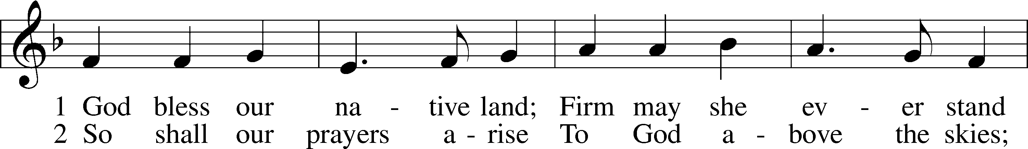
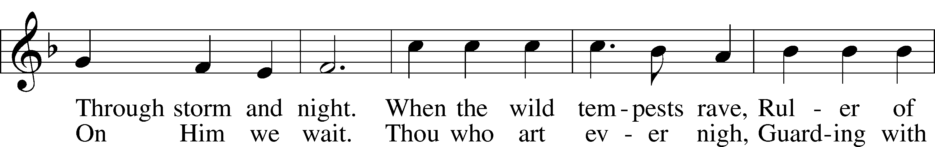
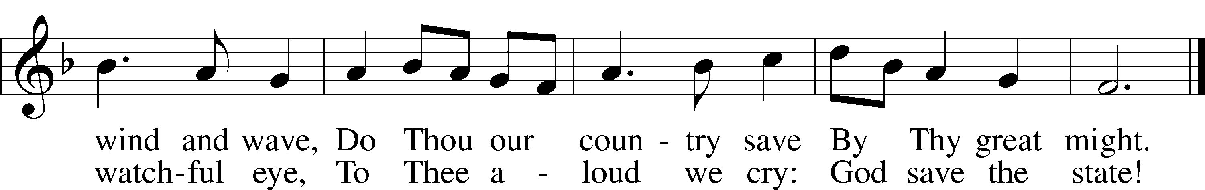
Text (st. 1): Charles T. Brooks, 1813–83, alt.; (st. 2): John S. Dwight, 1813–93, alt.
Tune: Thesaurus Musicus, c. 1740, London
Text and tune: Public domain

NICENE CREED LSB 158
C I believe in one God,
the Father Almighty,
maker of heaven and earth
and of all things visible and invisible.

And in one Lord Jesus Christ,
the only-begotten Son of God,
begotten of His Father before all worlds,
God of God, Light of Light,
very God of very God,
begotten, not made,
being of one substance with the Father,
by whom all things were made;
who for us men and for our salvation came down from heaven
and was incarnate by the Holy Spirit of the virgin Mary
and was made man;
and was crucified also for us under Pontius Pilate.
He suffered and was buried.
And the third day He rose again according to the Scriptures
and ascended into heaven
and sits at the right hand of the Father.
And He will come again with glory to judge both the living and the dead,
whose kingdom will have no end.

And I believe in the Holy Spirit,
the Lord and giver of life,
who proceeds from the Father and the Son,
who with the Father and the Son together is worshiped and glorified,
who spoke by the prophets.
And I believe in one holy Christian and apostolic Church,
I acknowledge one Baptism for the remission of sins,
and I look for the resurrection of the dead
and the life T of the world to come. Amen.

SHARING OF THE PEACE

(The people may greet one another in the name of the Lord, saying, “Peace be with you,” as a sign of reconciliation and of the unity of the Spirit in the bond of peace (Matt. 5:22–24; Eph. 4:1–3).)

(Sit)

PRAYER OF THE CHURCH

OFFERING

(As a part of our expression of thanksgiving to God for the treasure of His salvation to us, we offer a portion of our treasure, according to what each has determined in their heart to give. Please place offerings in the collection plate at the back of the sanctuary before or after the service. Offerings can also be sent to Bethlehem Lutheran Church via U.S. Mail. Thank you!)

(Stand)

OFFERTORY LSB 159
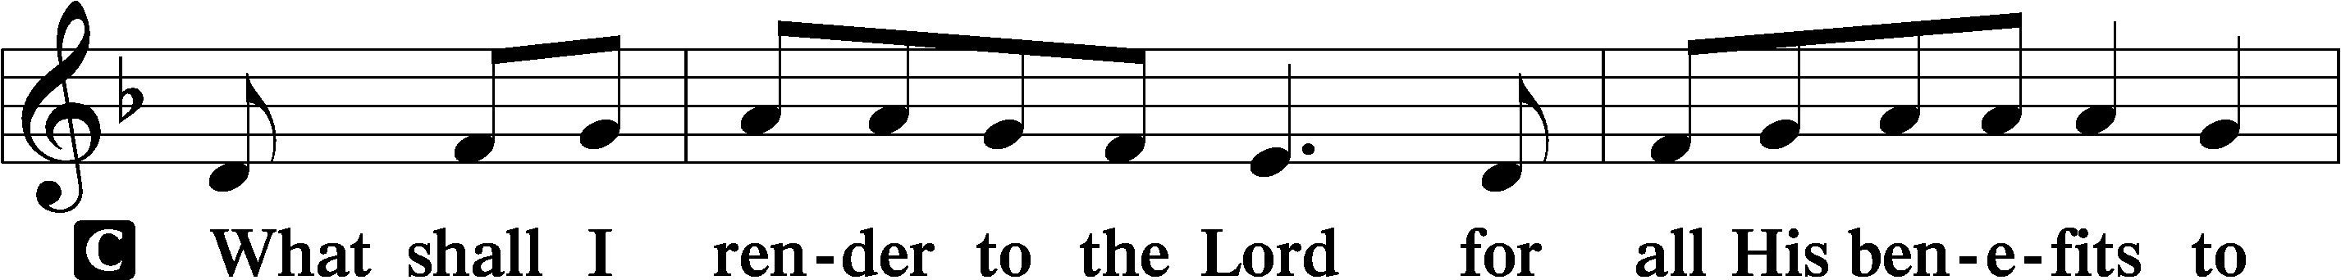
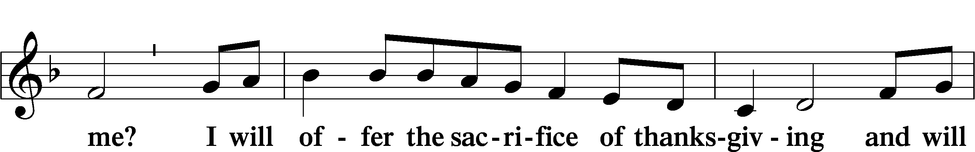
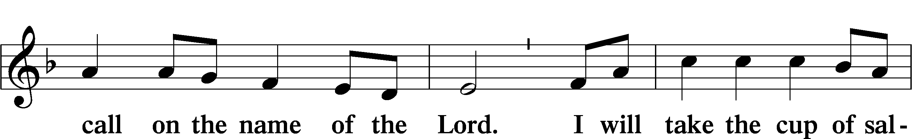
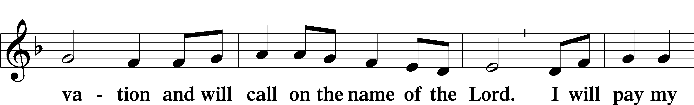
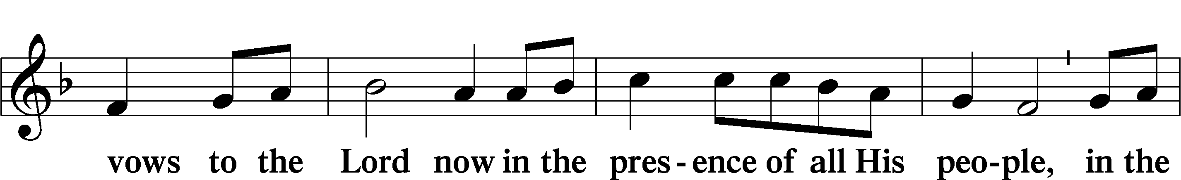
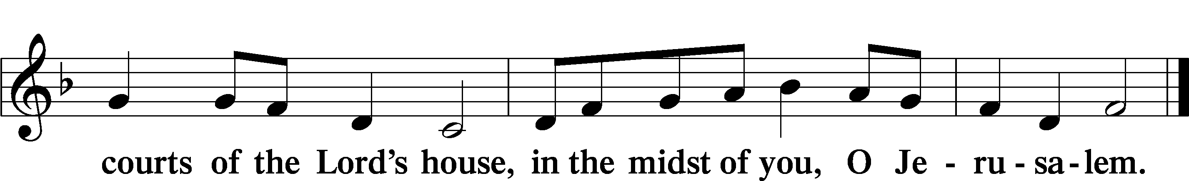

LORD’S PRAYER LSB 162
L Lord, remember us in Your kingdom and teach us to pray:
C Our Father who art in heaven,
hallowed be Thy name,
Thy kingdom come,
Thy will be done on earth
as it is in heaven;
give us this day our daily bread;
and forgive us our trespasses
as we forgive those
who trespass against us;
and lead us not into temptation,
but deliver us from evil.
For Thine is the kingdom
and the power and the glory
forever and ever. Amen.

CONCLUDING COLLECT

BENEDICTION 166
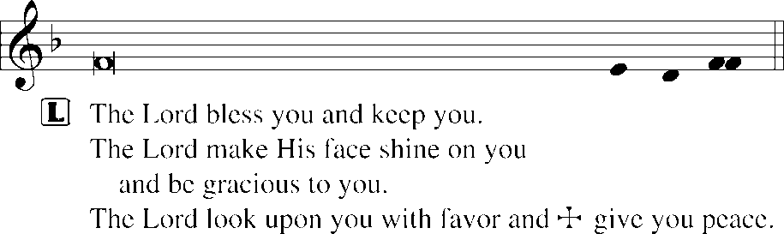
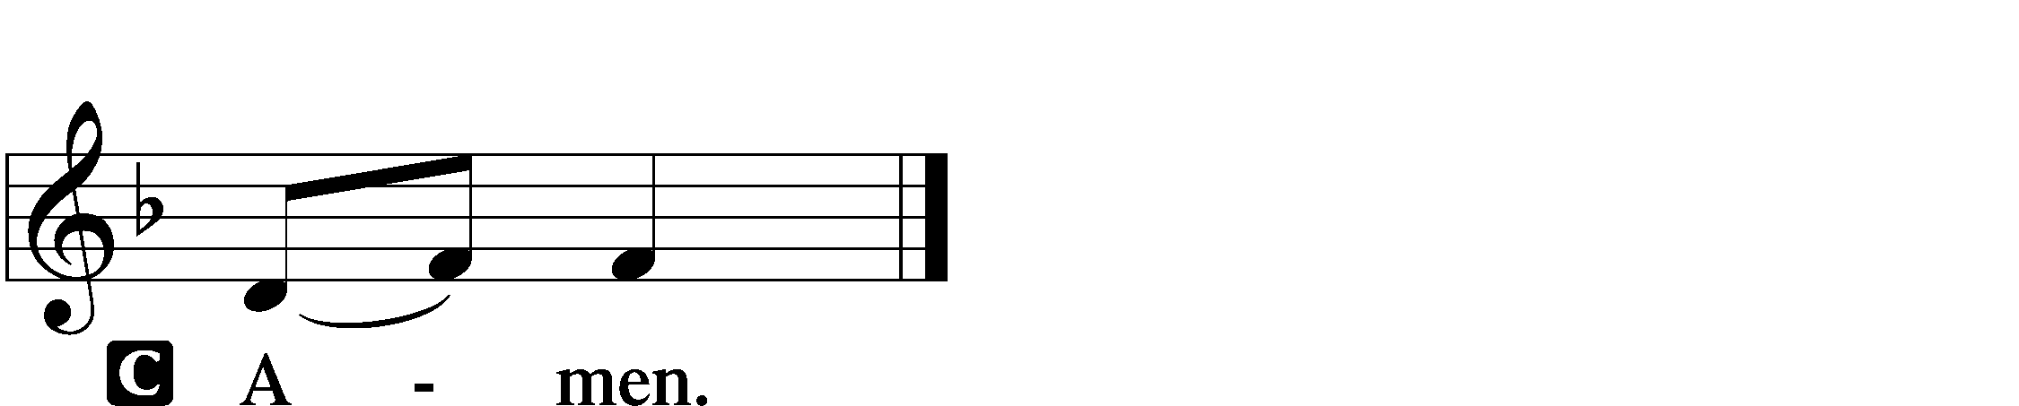

657 A MIGHTY FORTRESS IS OUR GOD sts. 1–4
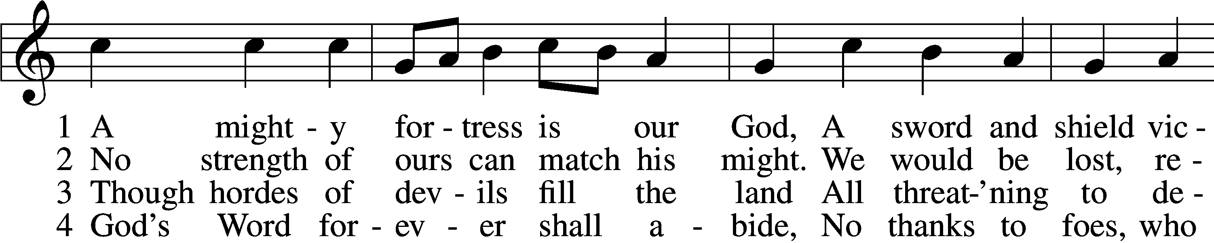
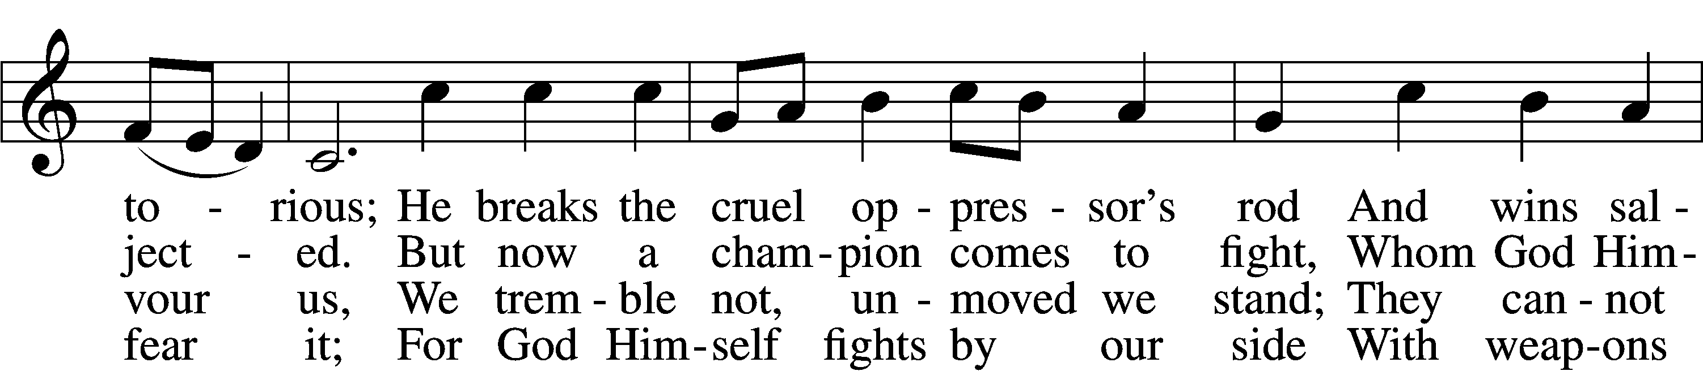
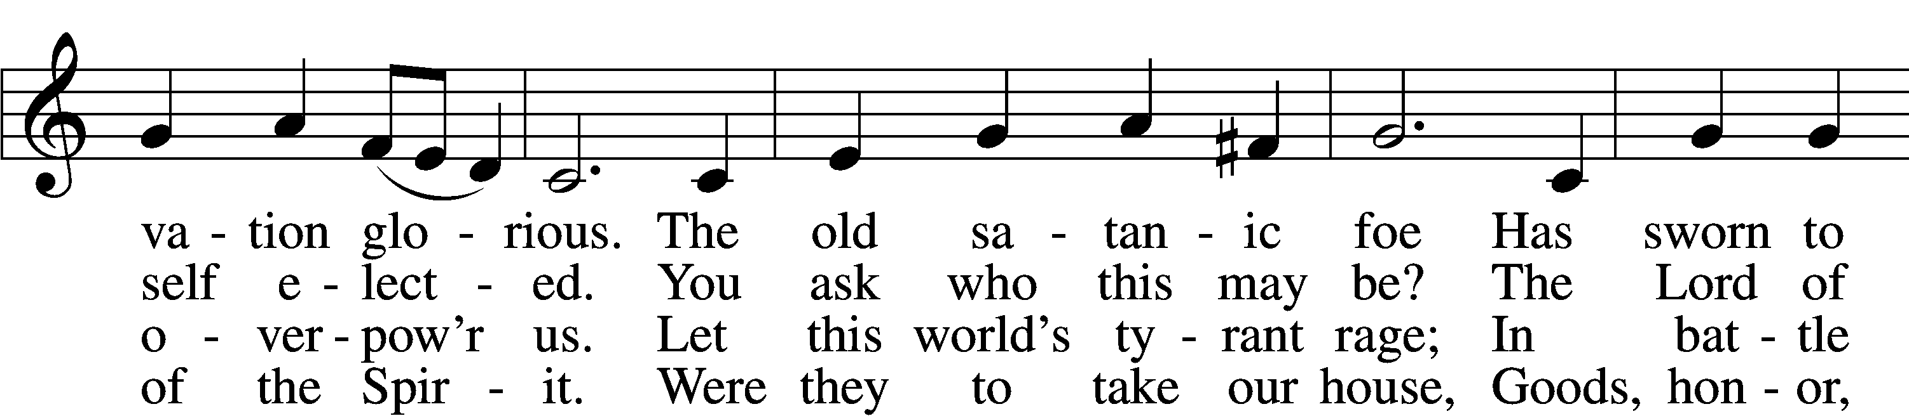
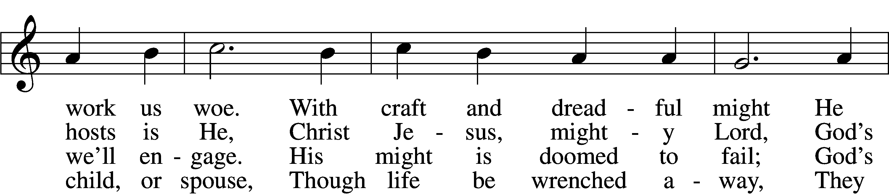
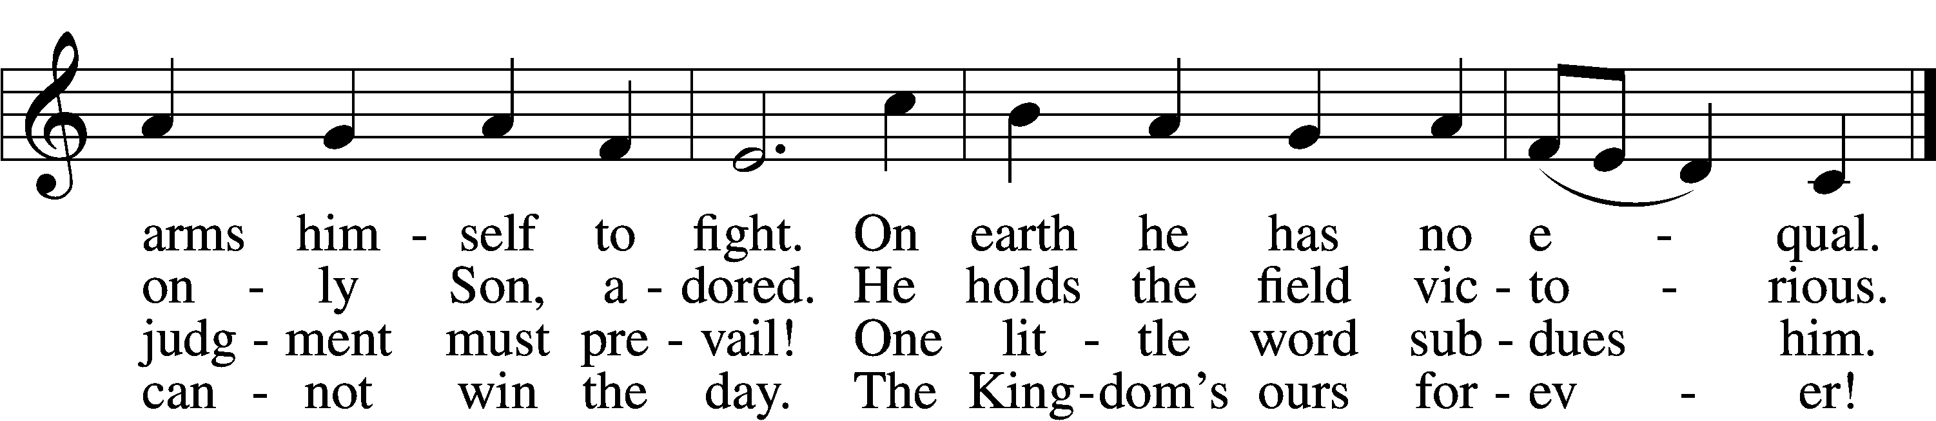
Text: tr. Lutheran Book of Worship, 1978
Text and tune: Martin Luther, 1483–1546
Text: © 1978 Lutheran Book of Worship. Used by permission: LSB Hymn License no. 110004798
Tune: Public domain
ACKNOWLEDGMENTS
Unless otherwise indicated, Scripture quotations are from the ESV® Bible (The Holy Bible, English Standard Version®), copyright © 2001 by Crossway, a publishing ministry of Good News Publishers. Used by permission. All rights reserved.
Created by Lutheran Service Builder © 2026 Concordia Publishing House.

BE IN THE WORD!
SUNDAY MORNINGS AT 9 a.m.
Adult Bible Study
MONDAY MORNINGS AT 10:00 a.m.
Women’s Bible Study
WEDNESDAY EVENINGS AT 7 p.m.
Adult Bible Study
JUNIOR CONFIRMATION and ADULT INSTRUCTION
Always available by request
Contact the church to schedule

OUR VALUE STATEMENT: Bethlehem Lutheran Church exists under God’s grace to save the lost and to strengthen the saved so that they may live bold and courageous lives of Christian witness before a non-believing world.
Therefore, our purpose is:
- to glorify God in Word and deed,
- to nurture each other in Christian love,
- to reach out to others with our Savior’s Gospel of life and salvation.
(Rom 5:8, Matt. 28:18-20).

OUR VISION: By the Grace of God, Bethlehem Lutheran Church, is a loving family united in Christ, learning, living, and spreading His Word.

OUR MISSION: Learn the Word. Live the Word. Spread the Word.

