BETHLEHEM LUTHERAN CHURCH
A congregation of The Lutheran Church-Missouri Synod
902 Hitchcock Drive SW,
Aiken, South Carolina 29803
Church Phone: (803) 649-6417
blcaikensc@gmail.com

Bethlehem Lutheran welcomes our members and guests to our worship service! Unable to join us in person? Please find us on Facebook live. The service is also posted on our website; bethlehemlutheranaiken.org.

+ + + + + + + + + + + + + + +
The Day of Pentecost
May 24, 2026
10:30 a.m.
+ + + + + + + + + + + + + + +

Our Policy and Practice Regarding Holy Communion
Hear the words of the Apostle Paul;
Anyone who eats and drinks without recognizing the body of the Lord eats and drinks judgment on himself. -1 Cor.11:29
Therefore, visitors are asked to please refrain from partaking of the Sacrament before speaking about this with the pastor; because we care about your spiritual well-being.
Also, because communing at this altar is a public confession that you agree with the doctrines of The Lutheran Church-Missouri Synod, and reject all contrary teachings.
Persons who are not communing today are always welcome to come forward during the distribution to receive an individual blessing; please cross your arms over your chest to indicate your desire for this. Thank you!
We commune in two alternating tables. The ushers will guide you. Non-alcoholic white wine is available in the center of the individual cup tray. Please leave empty individual cups at the altar rail.

+ SERVICE OF PREPARATION +

(After the bell tolls, please observe a time of silence.)

WELCOME AND ANNOUNCEMENTS

(Stand)

503 O DAY FULL OF GRACE
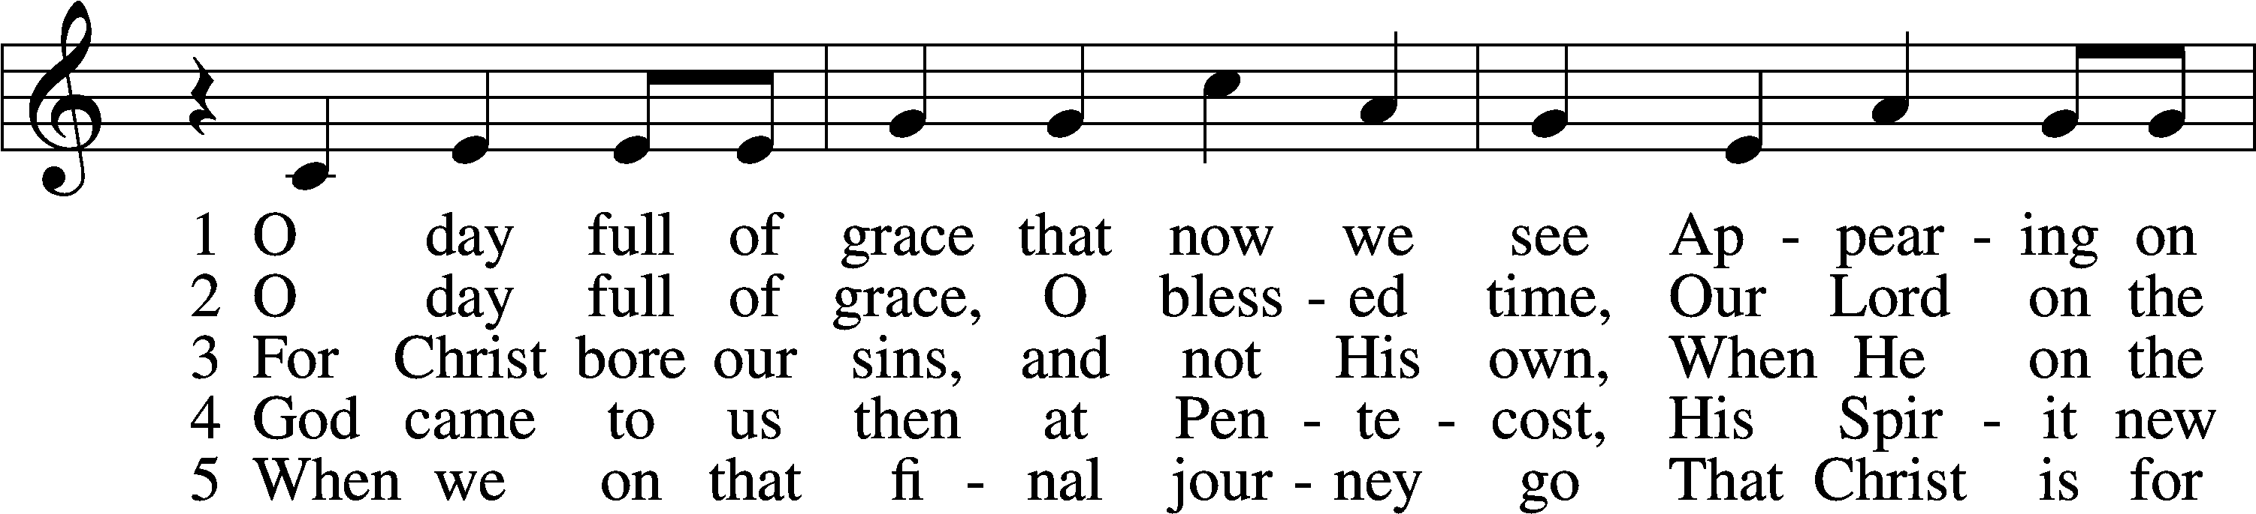
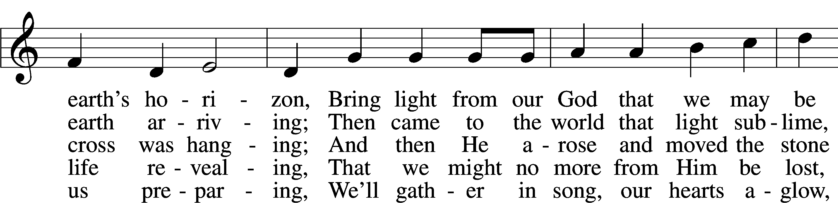
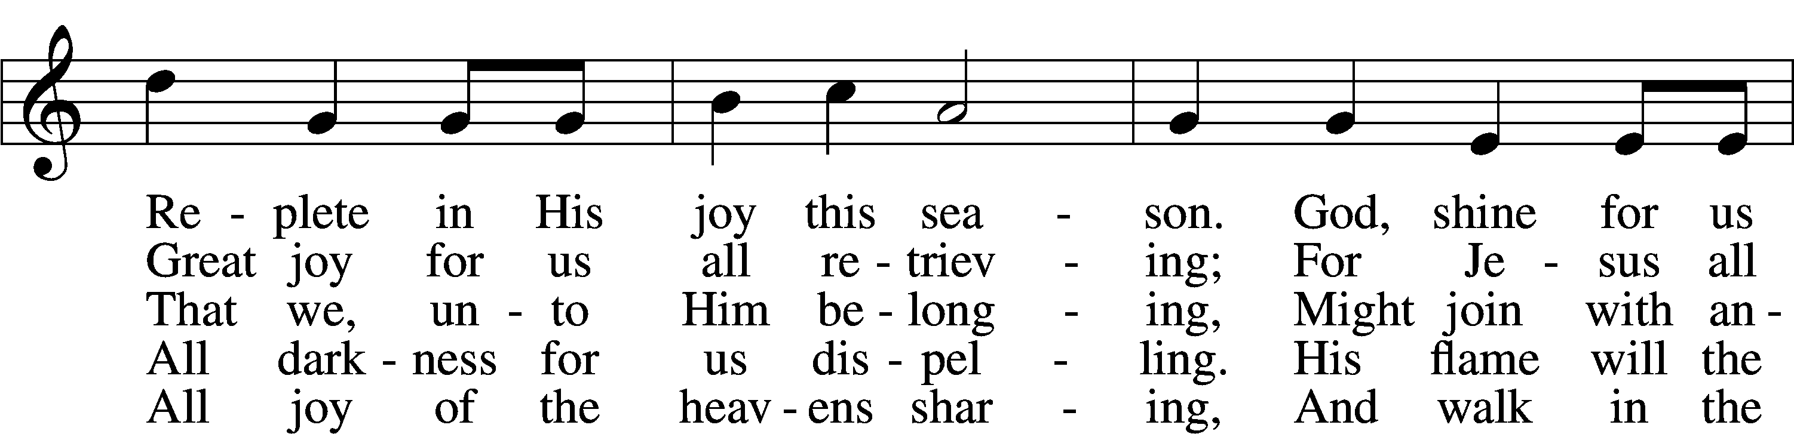
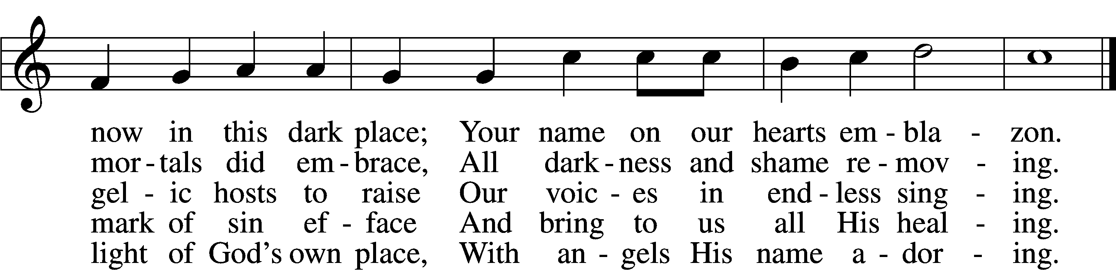
Text: Scandinavian, c. 1450; tr. Gerald Thorson, 1921–2001
Tune: Christoph E. F. Weyse, 1774–1842
Text: © 1978 Lutheran Book of Worship. Used by permission: LSB Hymn License no. 110004798
Tune: Public domain

+ CONFESSION AND ABSOLUTION +

(The sign of the cross may be made by all in remembrance of their Baptism.)

INVOCATION LSB 151
P In the name of the Father and of the T Son and of the Holy Spirit.
C Amen.

EXHORTATION LSB 151
P If we say we have no sin, we deceive ourselves, and the truth is not in us.
C But if we confess our sins, God, who is faithful and just, will forgive our sins and cleanse us from all unrighteousness.

(Silence for reflection on God’s Word and for self-examination.)

CONFESSION OF SINS LSB 151
P Let us then confess our sins to God our Father.
C Most merciful God, we confess that we are by nature sinful and unclean. We have sinned against You in thought, word, and deed, by what we have done and by what we have left undone. We have not loved You with our whole heart; we have not loved our neighbors as ourselves. We justly deserve Your present and eternal punishment. For the sake of Your Son, Jesus Christ, have mercy on us. Forgive us, renew us, and lead us, so that we may delight in Your will and walk in Your ways to the glory of Your holy name. Amen.

ABSOLUTION LSB 151
P Almighty God in His mercy has given His Son to die for you and for His sake forgives you all your sins. As a called and ordained servant of Christ, and by His authority, I therefore forgive you all your sins in the name of the Father and of the T Son and of the Holy Spirit.
C Amen.

+ SERVICE OF THE WORD +

INTROIT Psalm 104:24, 27–28, 30; antiphon: Liturgical Text
Come, Holy Spirit, fill the hearts of the | faithful,*
and kindle in them the fire of your love. Alle- | luia.
O Lord, how manifold are your works! In wisdom have you | made them all;*
the earth is full of your | creatures.
These all | look to you,*
to give them their food in due | season.
When you give it to them, they gath- | er it up;*
when you open your hand, they are filled with | good things.
When you send forth your Spirit, they are cre- | ated,*
and you renew the face | of the ground.
Glory be to the Father and | to the Son*
and to the Holy | Spirit;
as it was in the be- | ginning,*
is now, and will be forever. | Amen.
Come, Holy Spirit, fill the hearts of the | faithful,*
and kindle in them the fire of your love. Alle- | luia.

KYRIE LSB 152

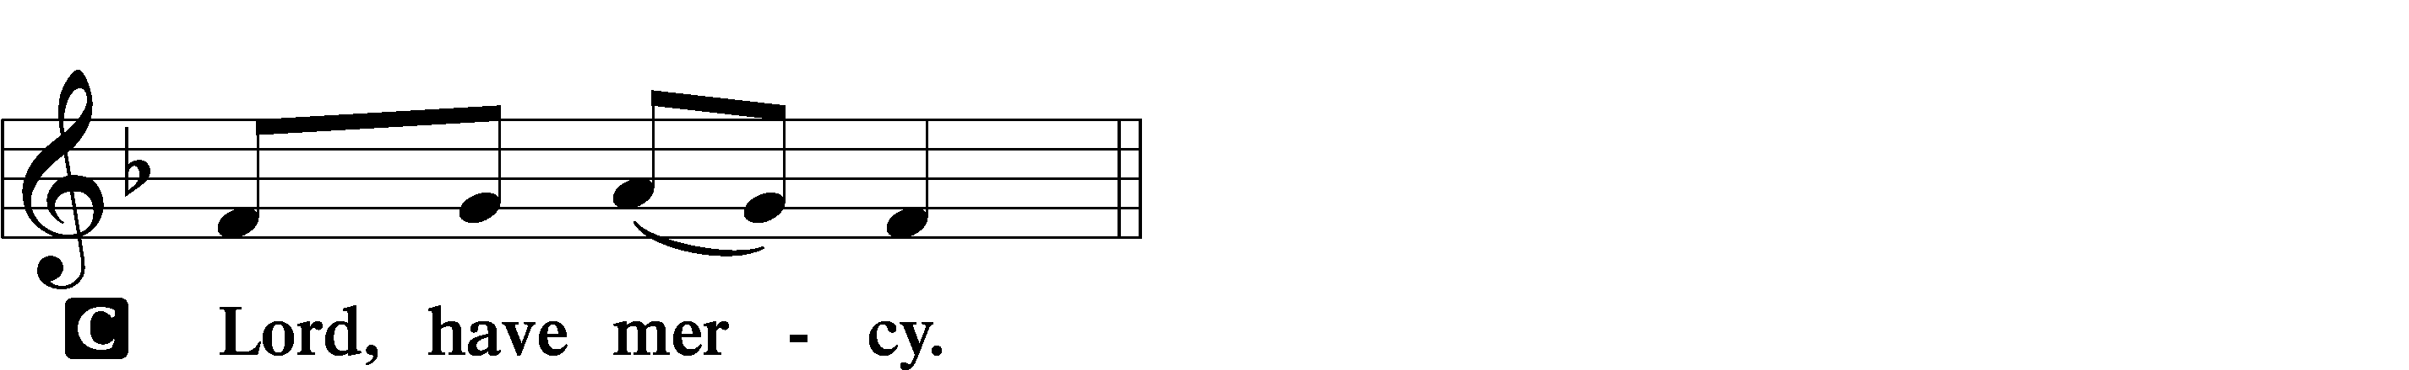

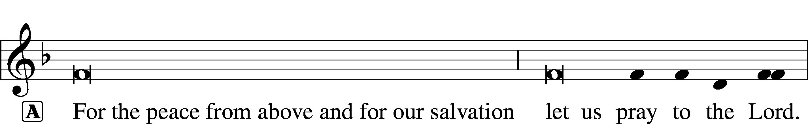
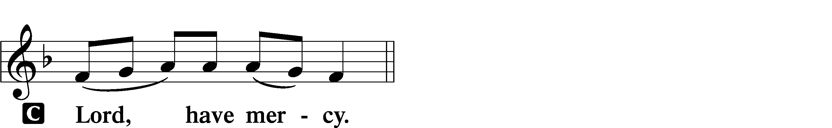

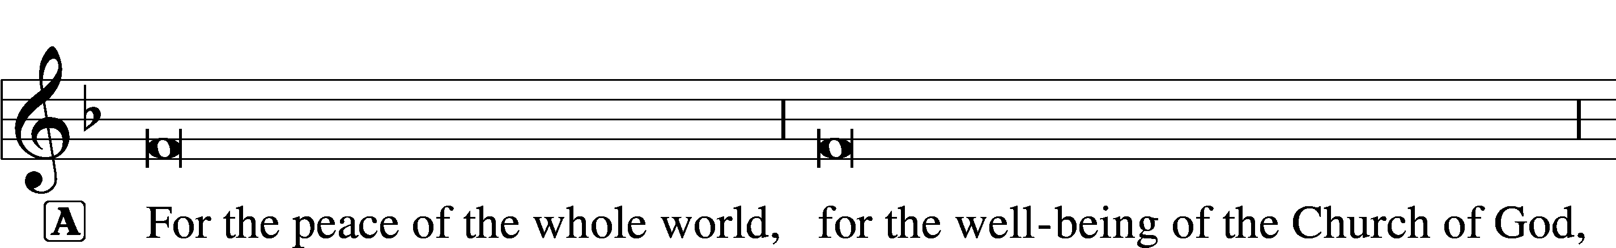
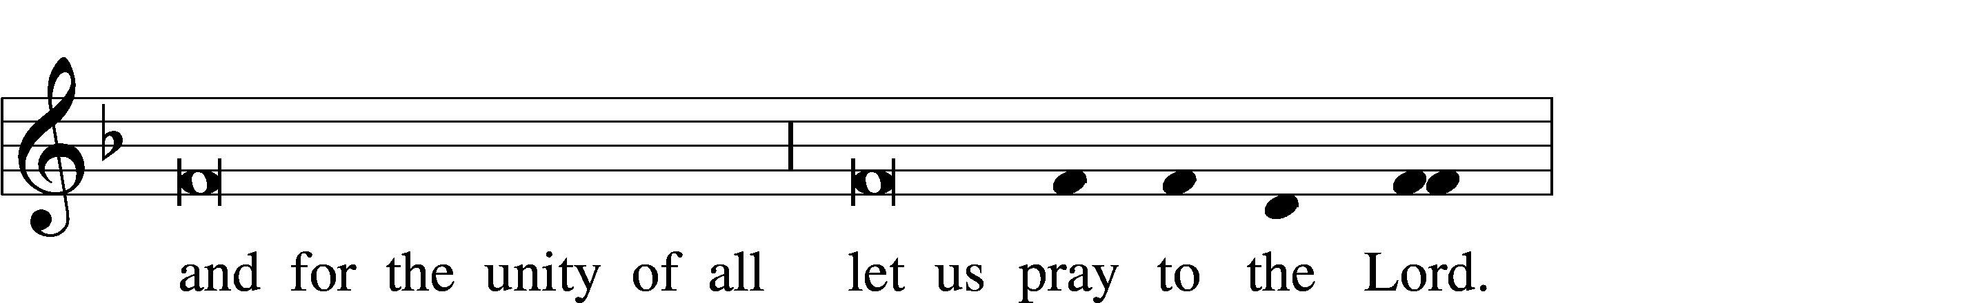
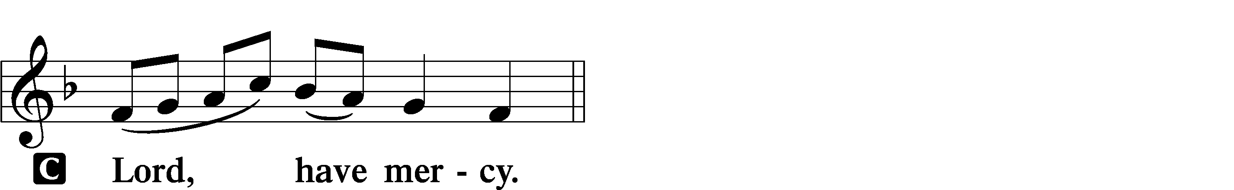

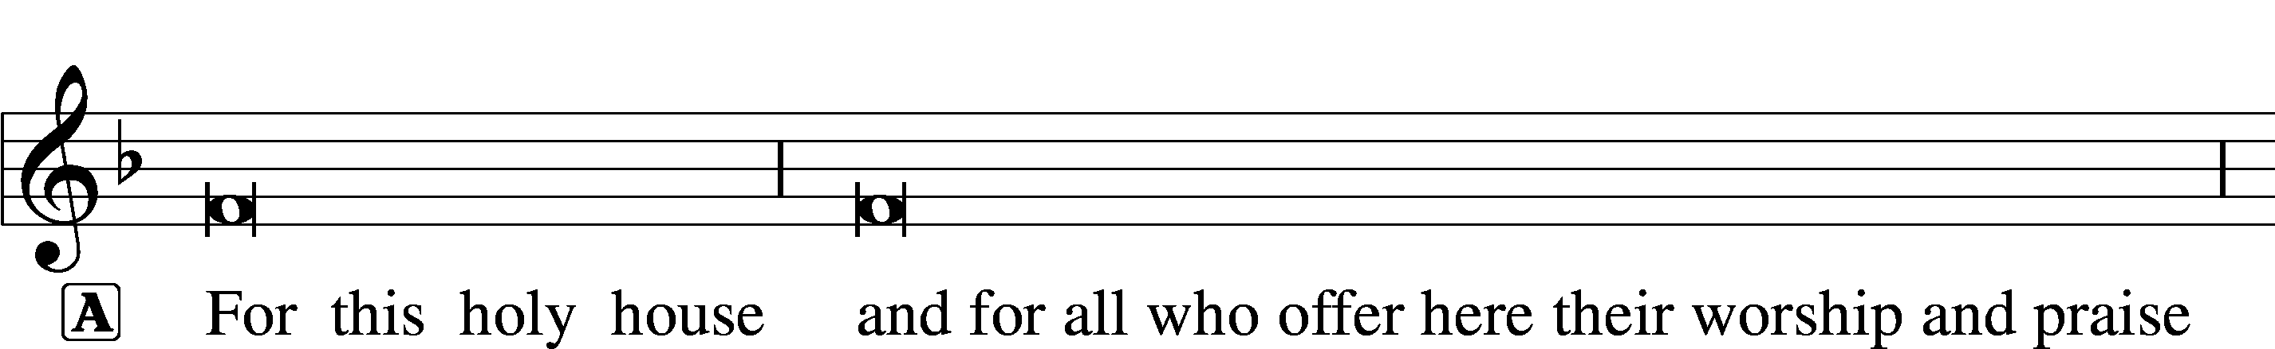

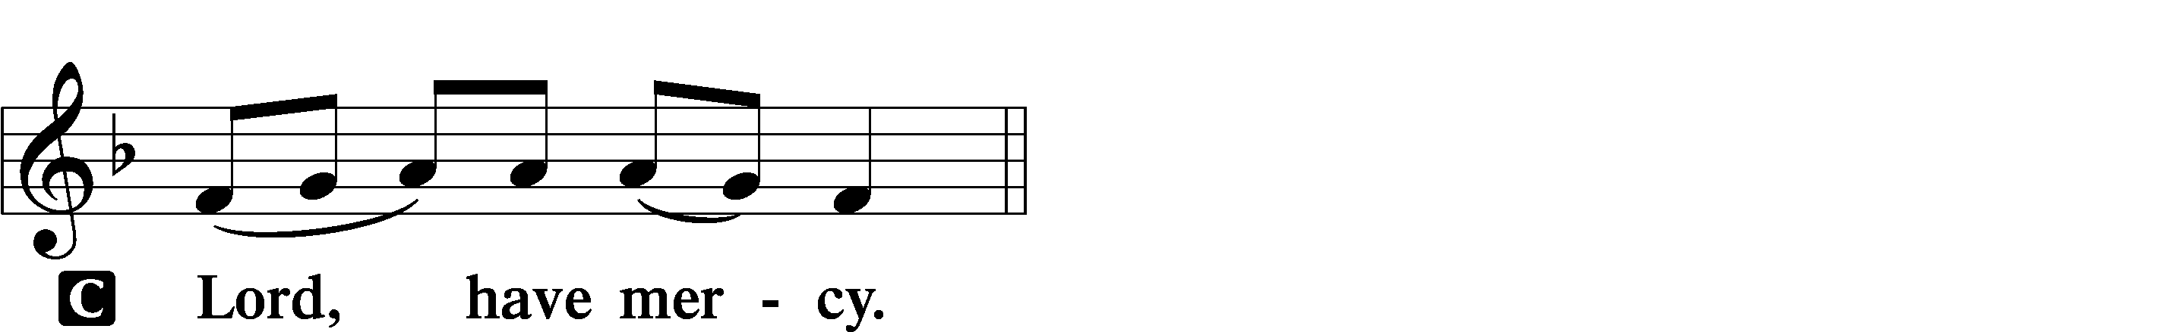

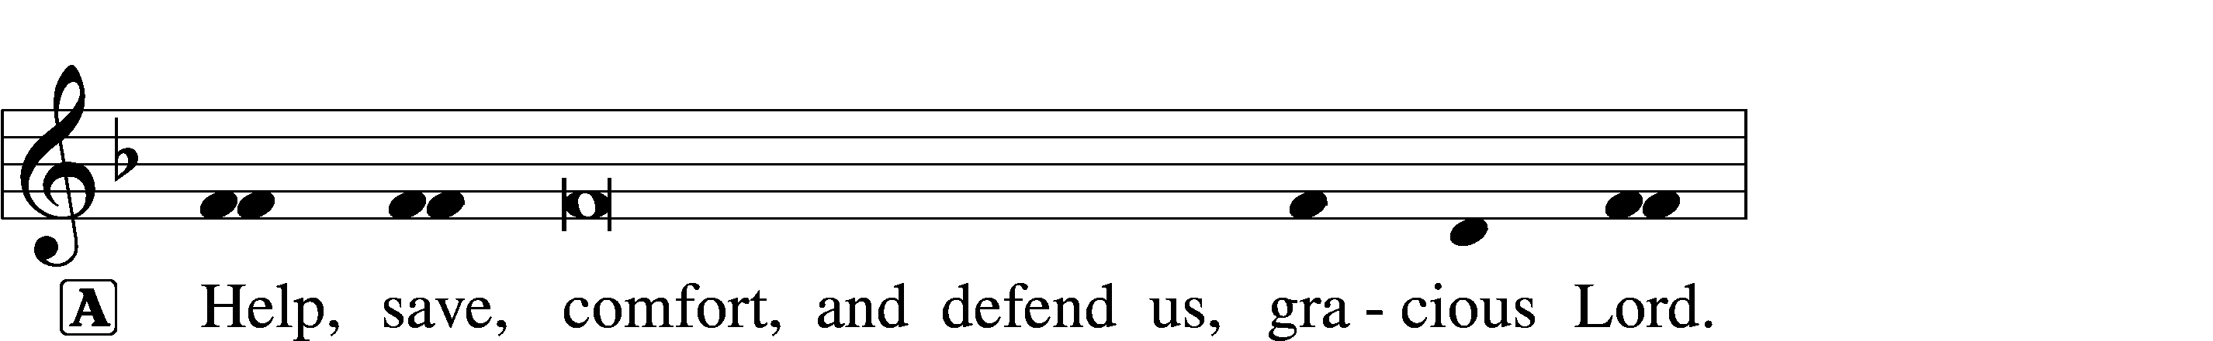


THIS IS THE FEAST LSB 155
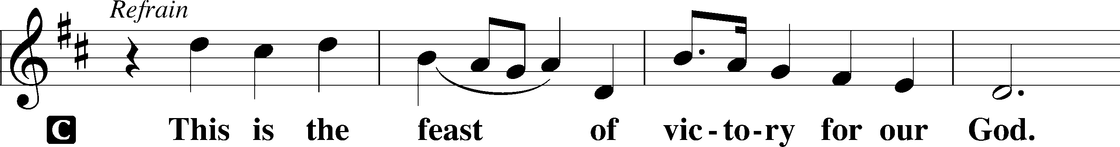
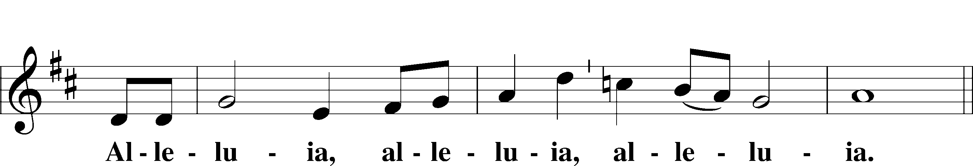
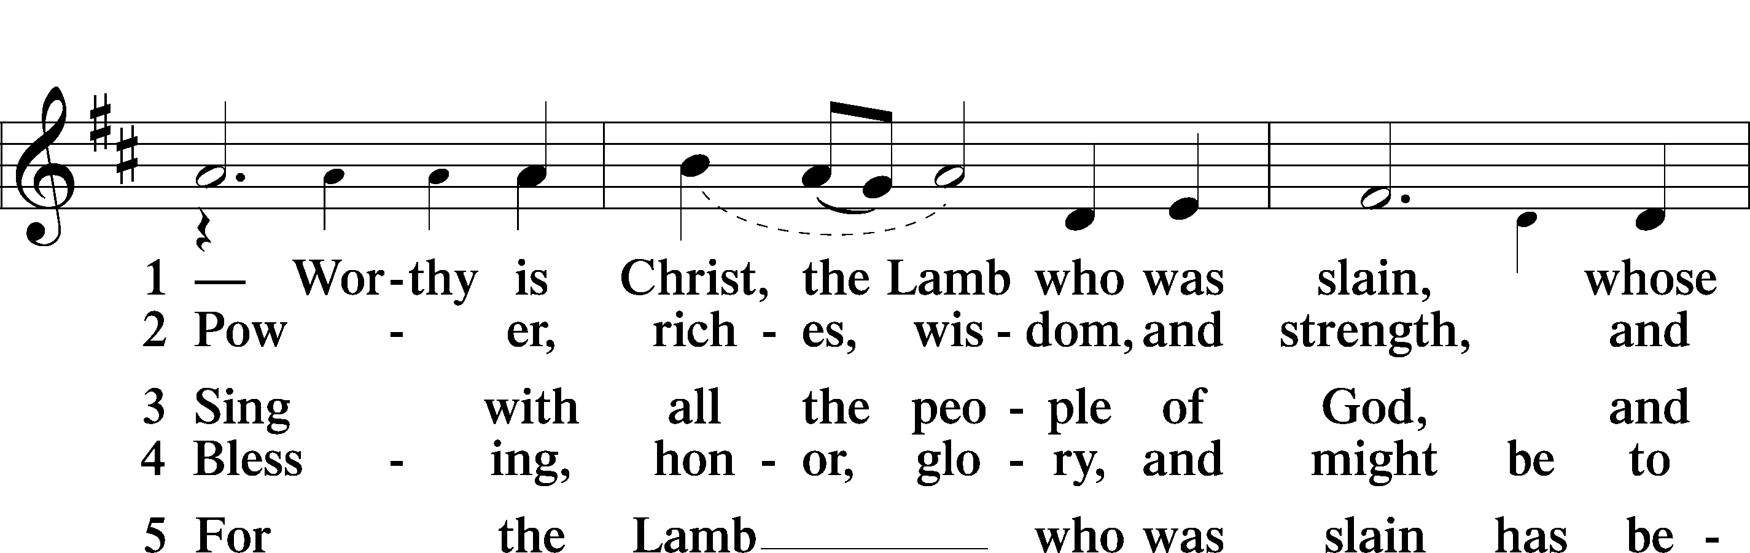
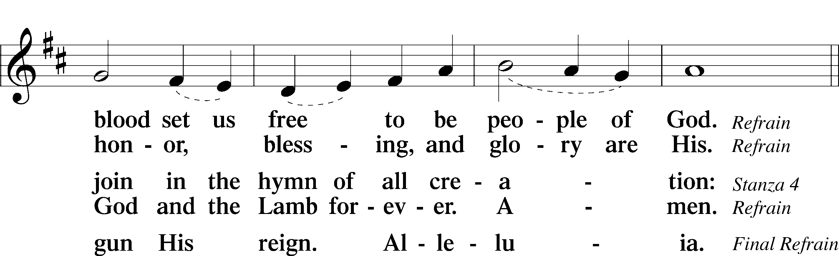
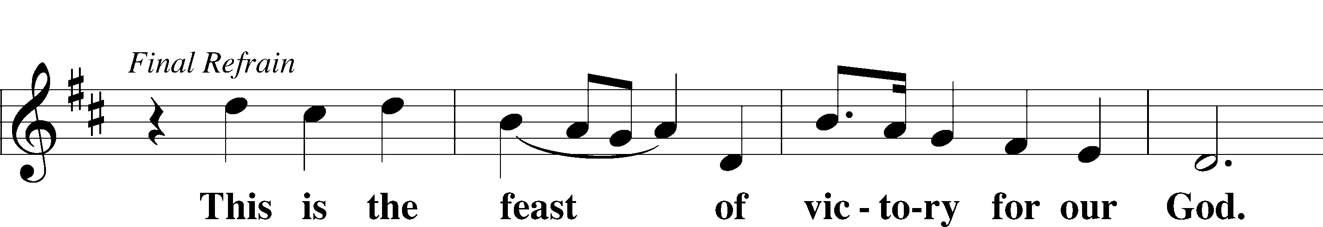
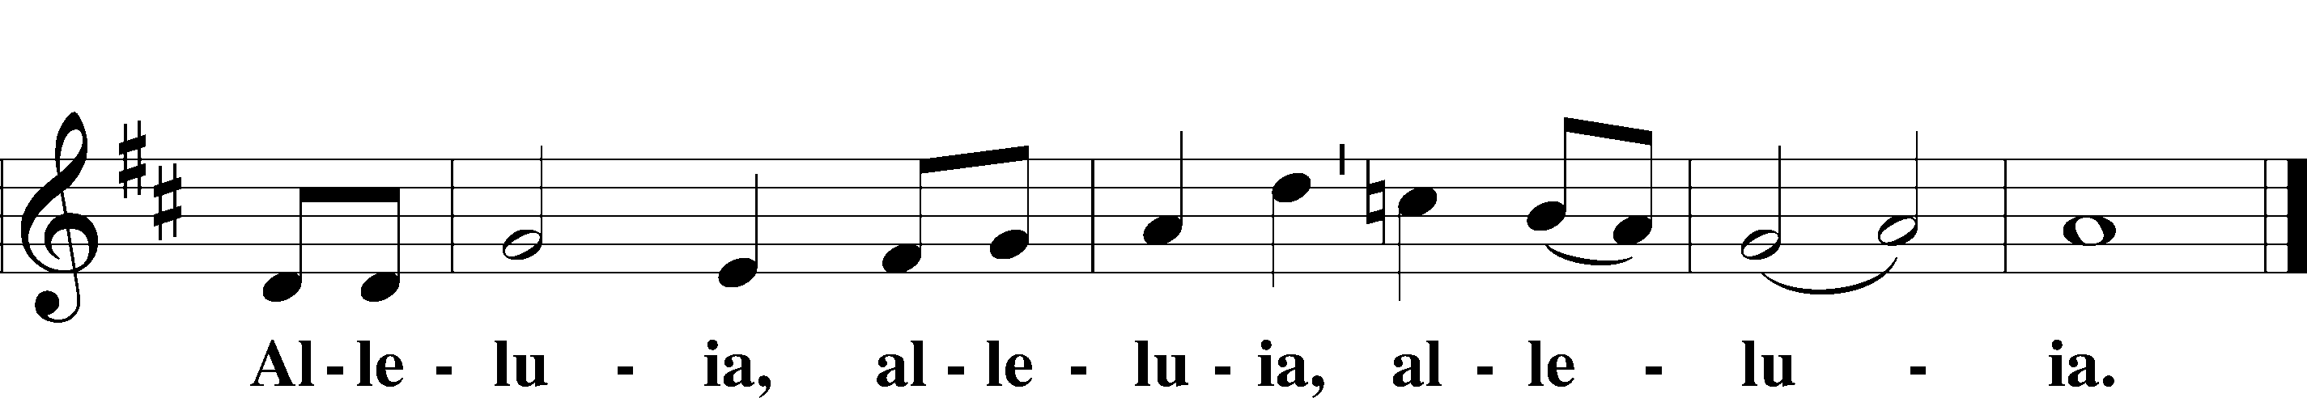

SALUTATION AND COLLECT OF THE DAY LSB 156
P The Lord be with you.
C And also with you.

P Let us pray.
O God, on this day You once taught the hearts of Your faithful people by sending them the light of Your Holy Spirit. Grant us in our day by the same Spirit to have a right understanding in all things and evermore to rejoice in His holy consolation; through Jesus Christ, Your Son, our Lord, who lives and reigns with You and the Holy Spirit, one God, now and forever.
C Amen.

(Sit)

OLD TESTAMENT READING Numbers 11:24–30
24Moses went out and told the people the words of the Lord. And he gathered seventy men of the elders of the people and placed them around the tent. 25Then the Lord came down in the cloud and spoke to him, and took some of the Spirit that was on him and put it on the seventy elders. And as soon as the Spirit rested on them, they prophesied. But they did not continue doing it.
26Now two men remained in the camp, one named Eldad, and the other named Medad, and the Spirit rested on them. They were among those registered, but they had not gone out to the tent, and so they prophesied in the camp. 27And a young man ran and told Moses, “Eldad and Medad are prophesying in the camp.” 28And Joshua the son of Nun, the assistant of Moses from his youth, said, “My lord Moses, stop them.” 29But Moses said to him, “Are you jealous for my sake? Would that all the Lord’s people were prophets, that the Lord would put his Spirit on them!” 30And Moses and the elders of Israel returned to the camp.

P This is the Word of the Lord.
C Thanks be to God.

GRADUAL Acts 2:17b; Romans 10:10
I will pour out my Spirit | on all flesh,*
and your sons and your daughters shall | prophesy.
With the heart one believes and is | justified,*
and with the mouth one confesses | and is saved.

SECOND READING Acts 2:1–21
1When the day of Pentecost arrived, they were all together in one place. 2And suddenly there came from heaven a sound like a mighty rushing wind, and it filled the entire house where they were sitting. 3And divided tongues as of fire appeared to them and rested on each one of them. 4And they were all filled with the Holy Spirit and began to speak in other tongues as the Spirit gave them utterance.
5Now there were dwelling in Jerusalem Jews, devout men from every nation under heaven. 6And at this sound the multitude came together, and they were bewildered, because each one was hearing them speak in his own language. 7And they were amazed and astonished, saying, “Are not all these who are speaking Galileans? 8And how is it that we hear, each of us in his own native language? 9Parthians and Medes and Elamites and residents of Mesopotamia, Judea and Cappadocia, Pontus and Asia, 10Phrygia and Pamphylia, Egypt and the parts of Libya belonging to Cyrene, and visitors from Rome, 11both Jews and proselytes, Cretans and Arabians—we hear them telling in our own tongues the mighty works of God.” 12And all were amazed and perplexed, saying to one another, “What does this mean?” 13But others mocking said, “They are filled with new wine.”
14But Peter, standing with the eleven, lifted up his voice and addressed them, “Men of Judea and all who dwell in Jerusalem, let this be known to you, and give ear to my words. 15For these men are not drunk, as you suppose, since it is only the third hour of the day. 16But this is what was uttered through the prophet Joel:
17“‘And in the last days it shall be, God declares,
that I will pour out my Spirit on all flesh,
and your sons and your daughters shall prophesy,
and your young men shall see visions,
and your old men shall dream dreams;
18even on my male servants and female servants
in those days I will pour out my Spirit, and they shall prophesy.
19And I will show wonders in the heavens above
and signs on the earth below,
blood, and fire, and vapor of smoke;
20the sun shall be turned to darkness
and the moon to blood,
before the day of the Lord comes, the great and magnificent day.
(next page)

21And it shall come to pass that everyone who calls upon the name of the Lord shall be saved.’”

P This is the Word of the Lord.
C Thanks be to God.

(Stand)

ALLELUIA AND VERSE LSB 156
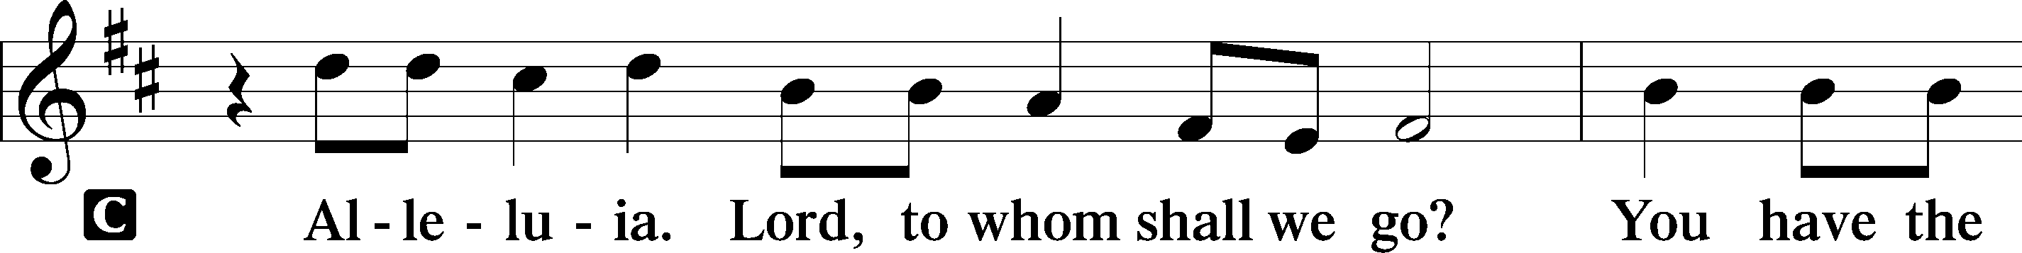
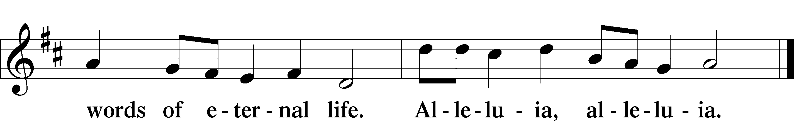

HOLY GOSPEL John 7:37–39
P The Holy Gospel according to St. John, the seventh chapter.

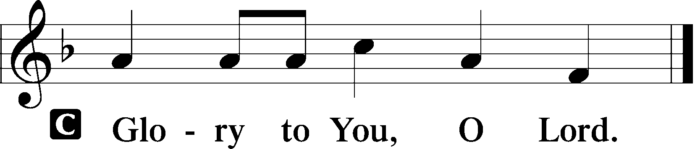

37On the last day of the feast, the great day, Jesus stood up and cried out, “If anyone thirsts, let him come to me and drink. 38Whoever believes in me, as the Scripture has said, ‘Out of his heart will flow rivers of living water.’” 39Now this he said about the Spirit, whom those who believed in him were to receive, for as yet the Spirit had not been given, because Jesus was not yet glorified.

P This is the Gospel of the Lord.

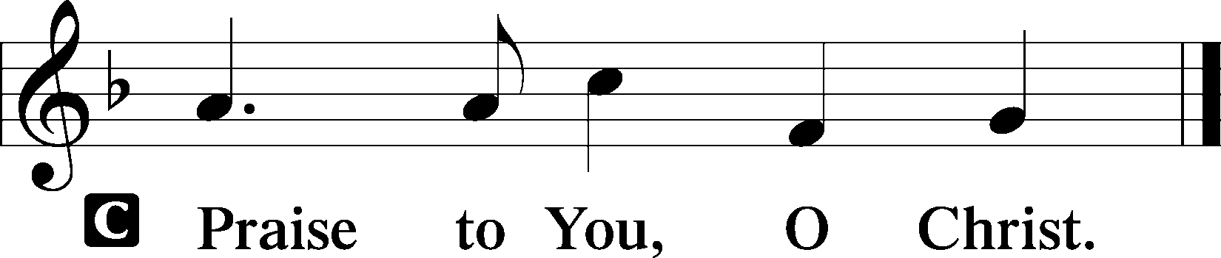

(Sit)

597 WATER, BLOOD, AND SPIRIT CRYING
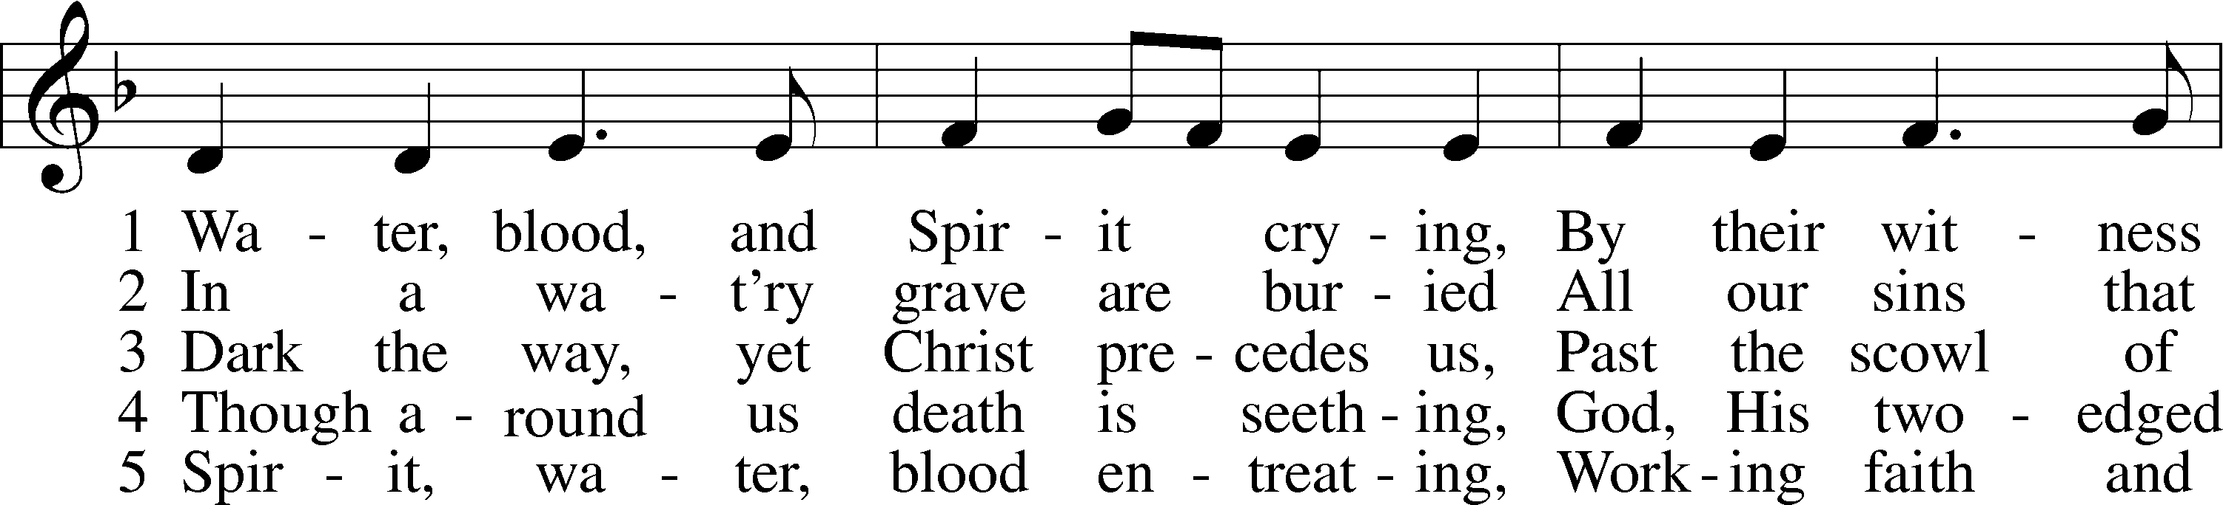
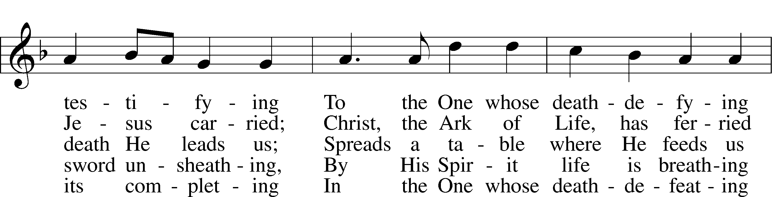
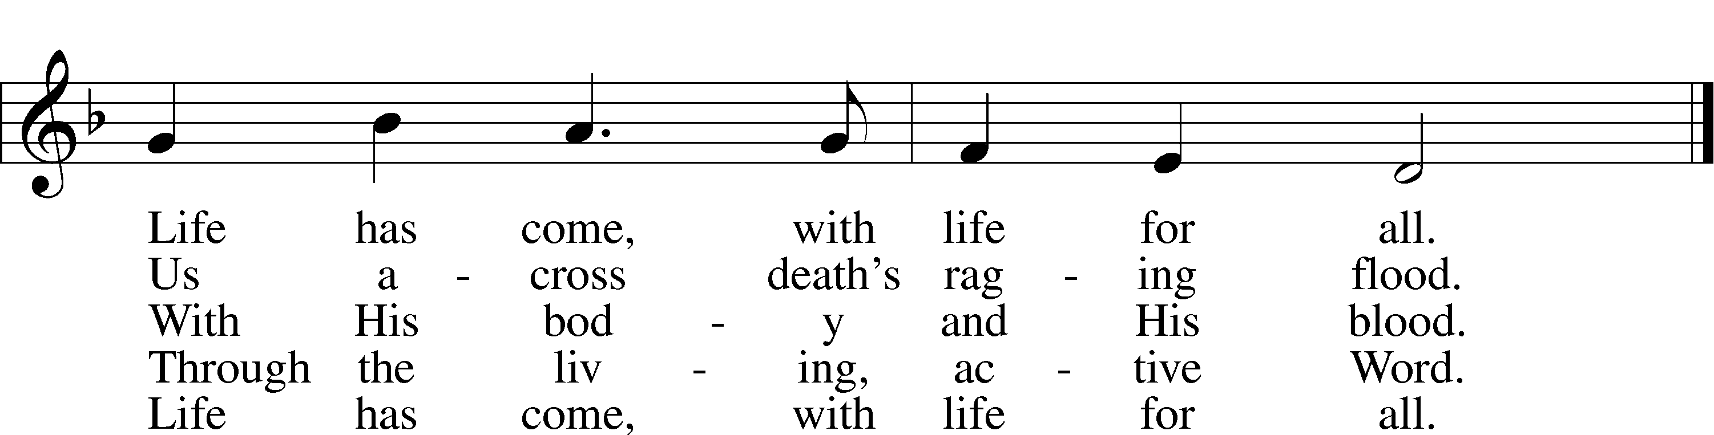
Text: Stephen P. Starke, 1955
Tune: Jeffrey N. Blersch, 1967
Text: © 1999 Stephen P. Starke, admin. Concordia Publishing House. Used by permission: LSB Hymn License no. 110004798
Tune: © 2003 Jeffrey N. Blersch. Used by permission: LSB Hymn License no. 110004798

SERMON

(Stand)

APOSTLES’ CREED LSB 159
C I believe in God, the Father Almighty,
maker of heaven and earth.

And in Jesus Christ, His only Son, our Lord,
who was conceived by the Holy Spirit,
born of the virgin Mary,
suffered under Pontius Pilate,
was crucified, died and was buried.
He descended into hell.
The third day He rose again from the dead.
He ascended into heaven
and sits at the right hand of God the Father Almighty.
From thence He will come to judge the living and the dead.

I believe in the Holy Spirit,
the holy Christian Church,
the communion of saints,
the forgiveness of sins,
the resurrection of the body,
and the life T everlasting. Amen.

SHARING OF THE PEACE

(The people may greet one another in the name of the Lord, saying, “Peace be with you,” as a sign of reconciliation and of the unity of the Spirit in the bond of peace (Matt. 5:22–24; Eph. 4:1–3).)

(Sit)

PRAYER OF THE CHURCH

OFFERING

(As a part of our expression of thanksgiving to God for the treasure of His salvation to us, we offer a portion of our treasure, according to what each has determined in their heart to give. Please place offerings in the collection plate at the back of the sanctuary before or after the service. Offerings can also be sent to Bethlehem Lutheran Church via U.S. Mail. Thank you!)

(Stand)

OFFERTORY LSB 159
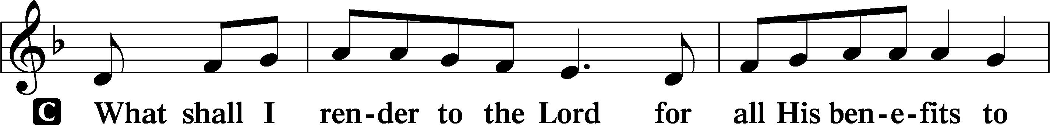
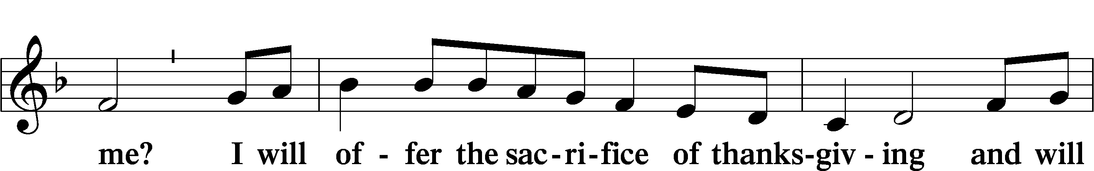
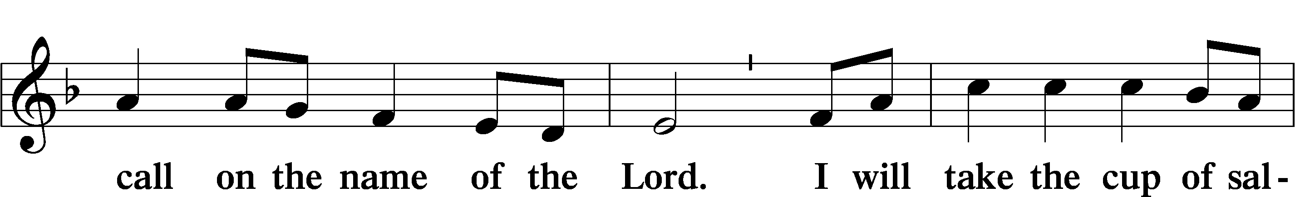
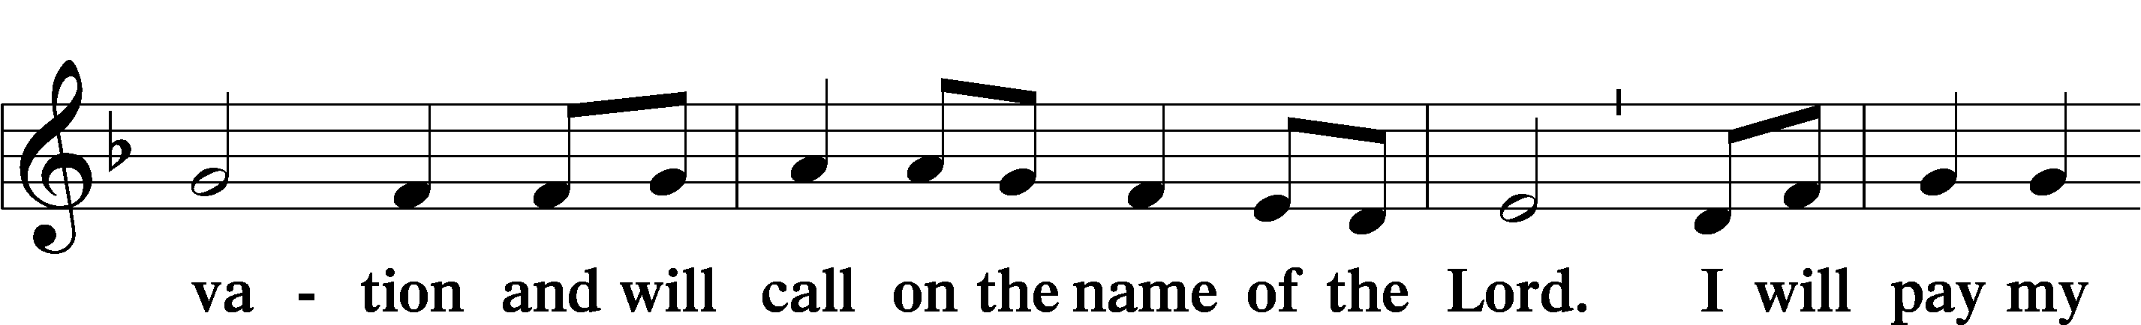
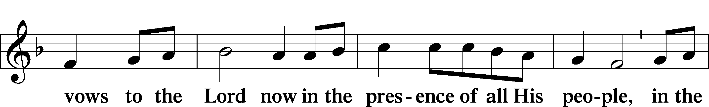
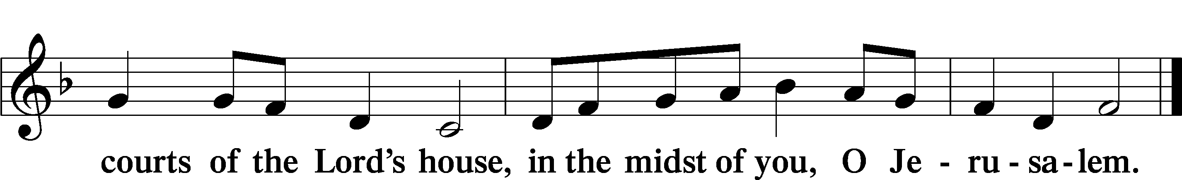

+ SERVICE OF THE SACRAMENT +

PREFACE LSB 160
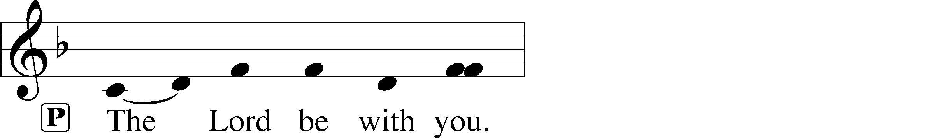
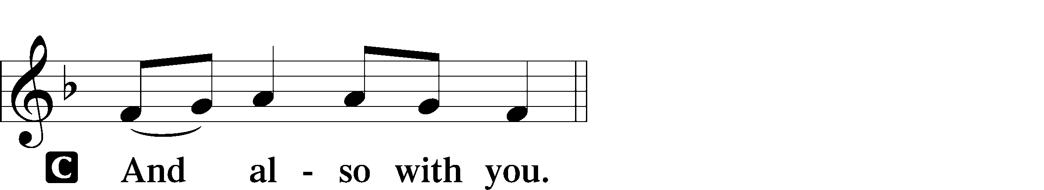
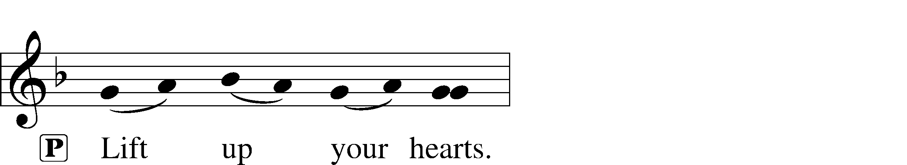

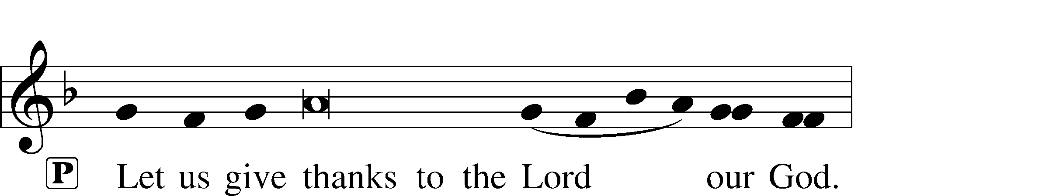
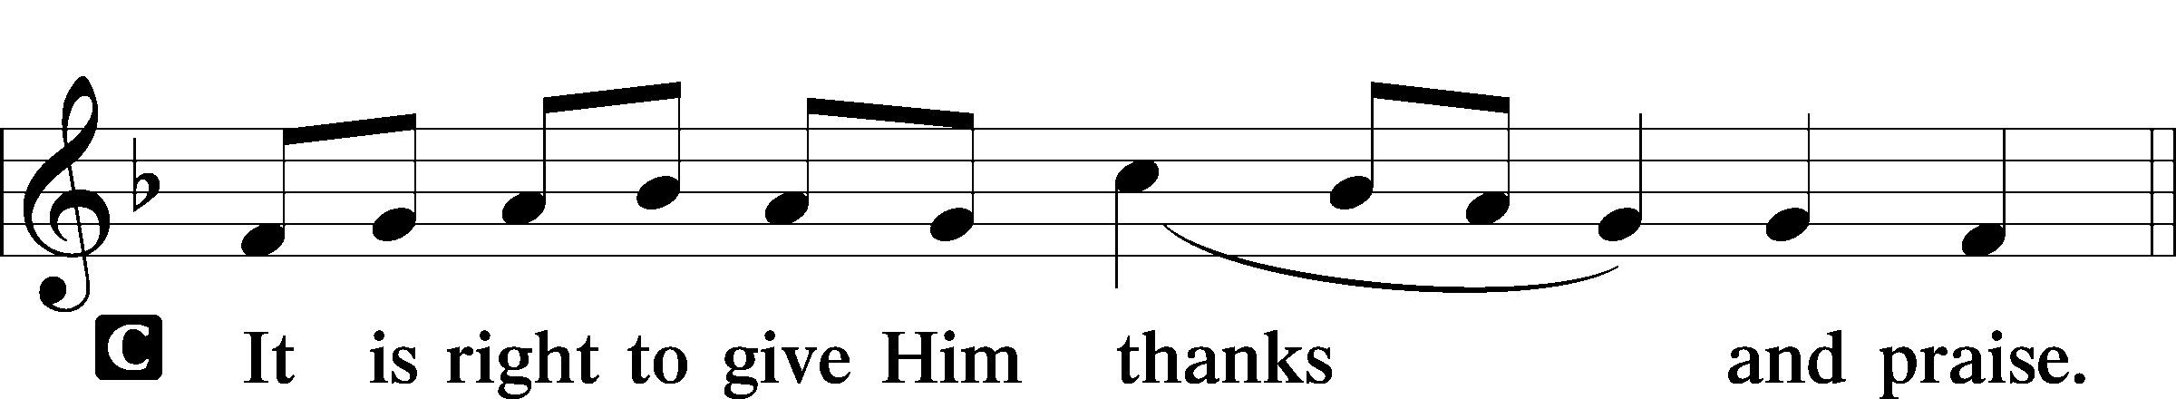

PROPER PREFACE (ABBREVIATED) LSB 161
P It is truly good, right, and salutary . . . evermore praising You and saying:

SANCTUS LSB 161
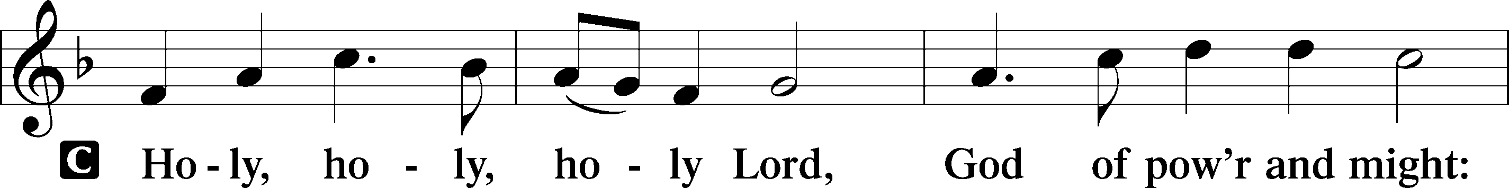
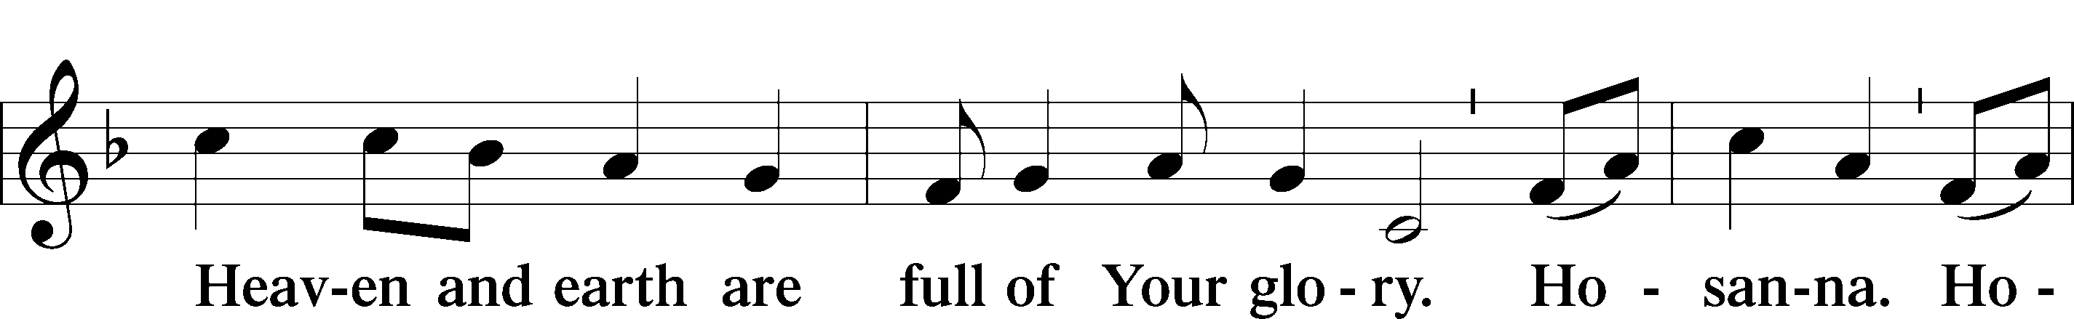
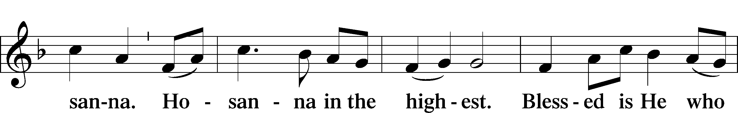
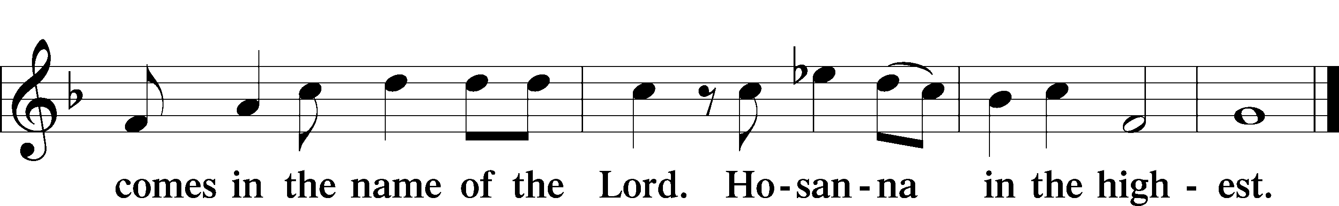

PRAYER OF THANKSGIVING LSB 161
P Blessed are You, Lord of heaven and earth...
,... with the Son and the Holy Spirit, one God, now and forever.
C Amen.

LORD’S PRAYER LSB 162
P Lord, remember us in Your kingdom and teach us to pray:
C Our Father who art in heaven,
hallowed be Thy name,
Thy kingdom come,
Thy will be done on earth
as it is in heaven;
give us this day our daily bread;
and forgive us our trespasses
as we forgive those
who trespass against us;
and lead us not into temptation,
but deliver us from evil.
For Thine is the kingdom
and the power and the glory
forever and ever. Amen.

THE WORDS OF OUR LORD LSB 162

PAX DOMINI LSB 163
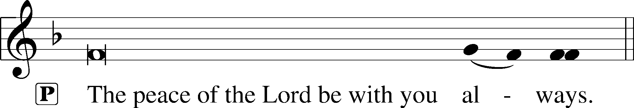


AGNUS DEI LSB 163
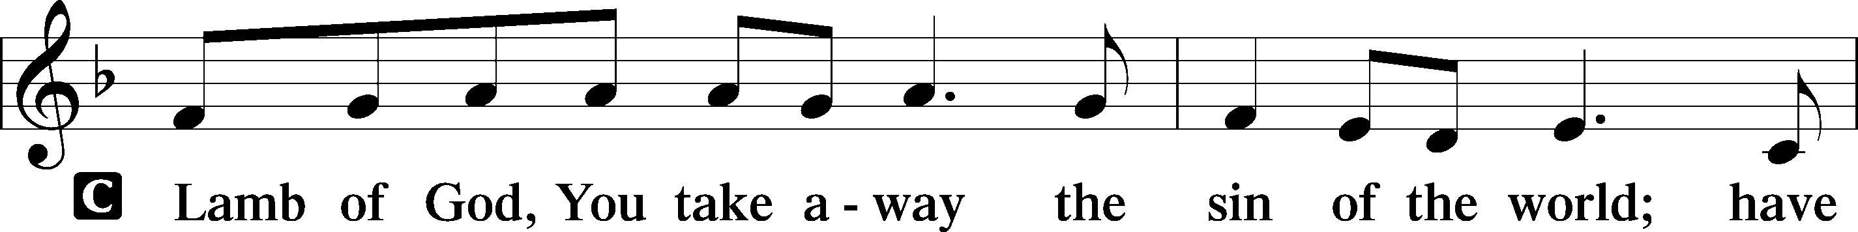
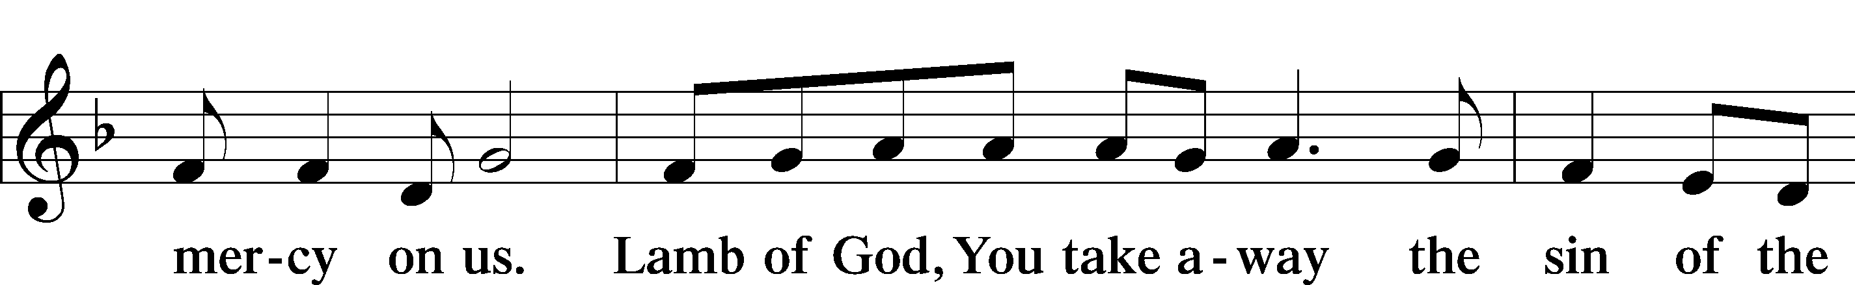
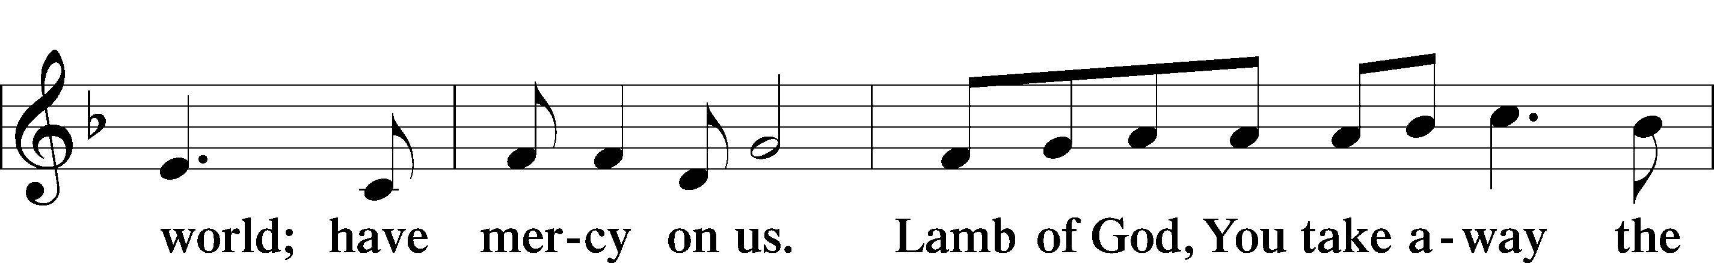
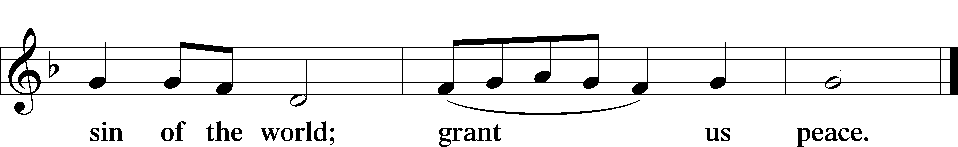

(Sit)

DISTRIBUTION

(The pastor and those who assist him receive the body and blood of Christ first and then distribute them to those who are unable to come to the altar. The ushers will then direct all other communicants to the altar.)

501 COME DOWN, O LOVE DIVINE
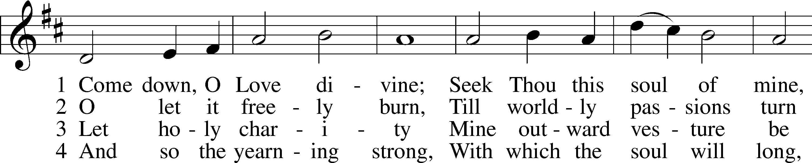
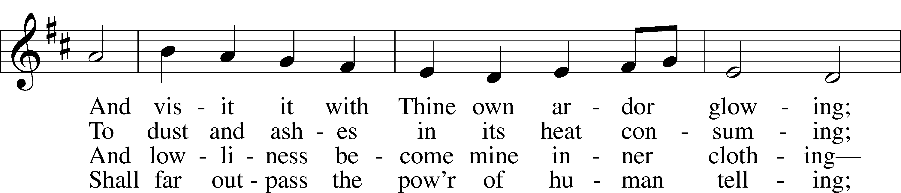
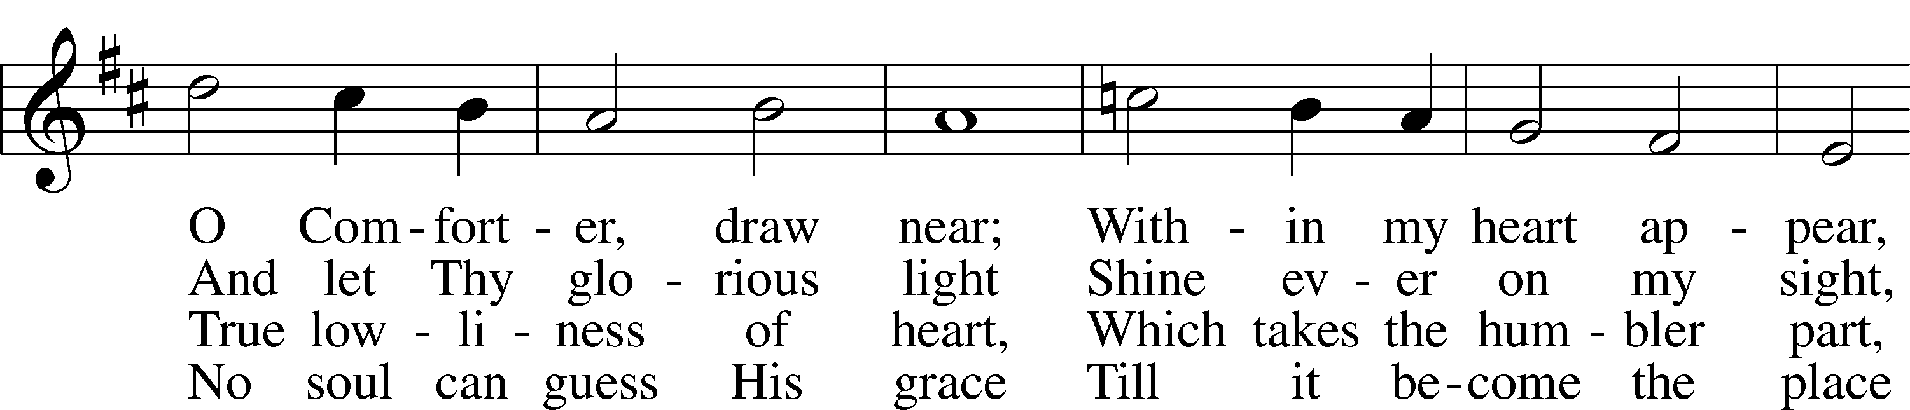
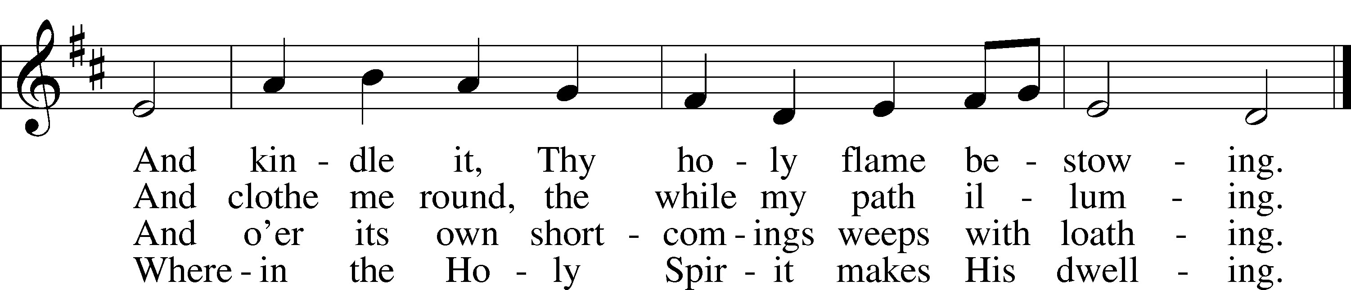
Text: Bianco da Siena, c. 1350–1434; tr. Richard F. Littledale, 1833–90
Tune: Ralph Vaughan Williams, 1872–1958
Text and tune: Public domain

INSTRUMENTAL

(Stand)

THANK THE LORD LSB 164
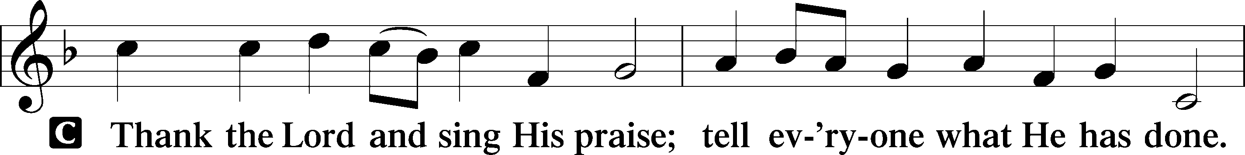
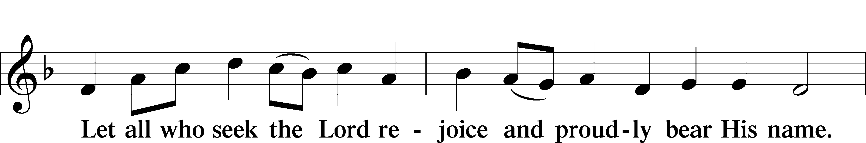
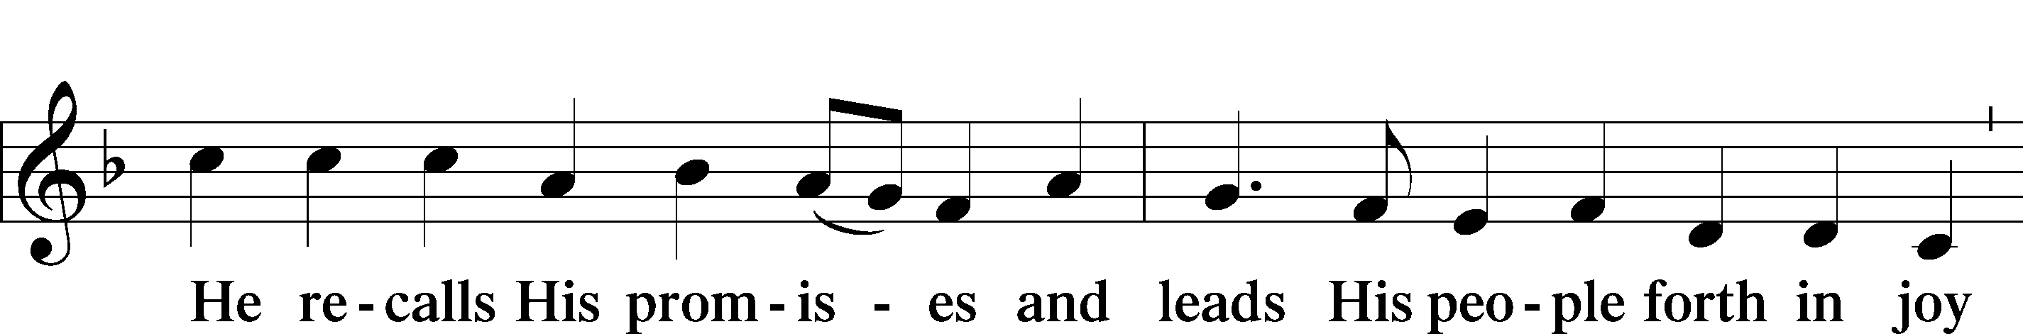
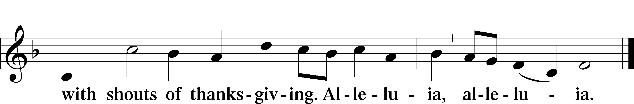

POST-COMMUNION COLLECT LSB 166
P Let us pray.
...through Jesus Christ, Your Son, our Lord, who lives and reigns with You and the Holy Spirit, one God, now and forever.
C Amen.

BENEDICTION LSB 166
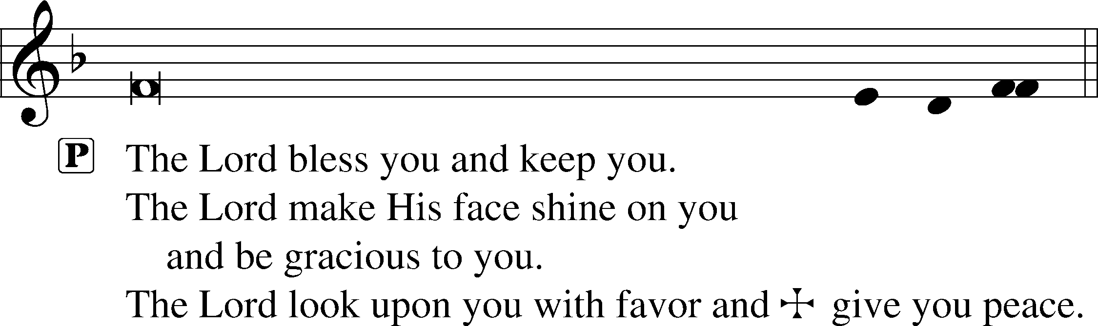


915 TODAY YOUR MERCY CALLS US
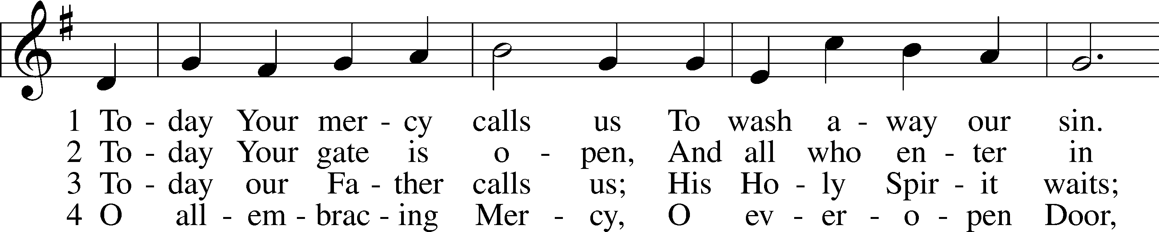
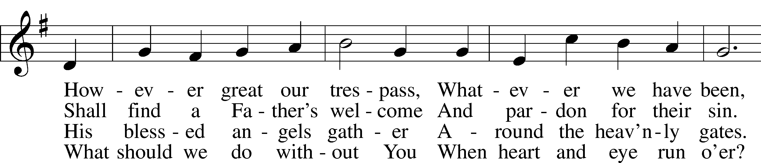
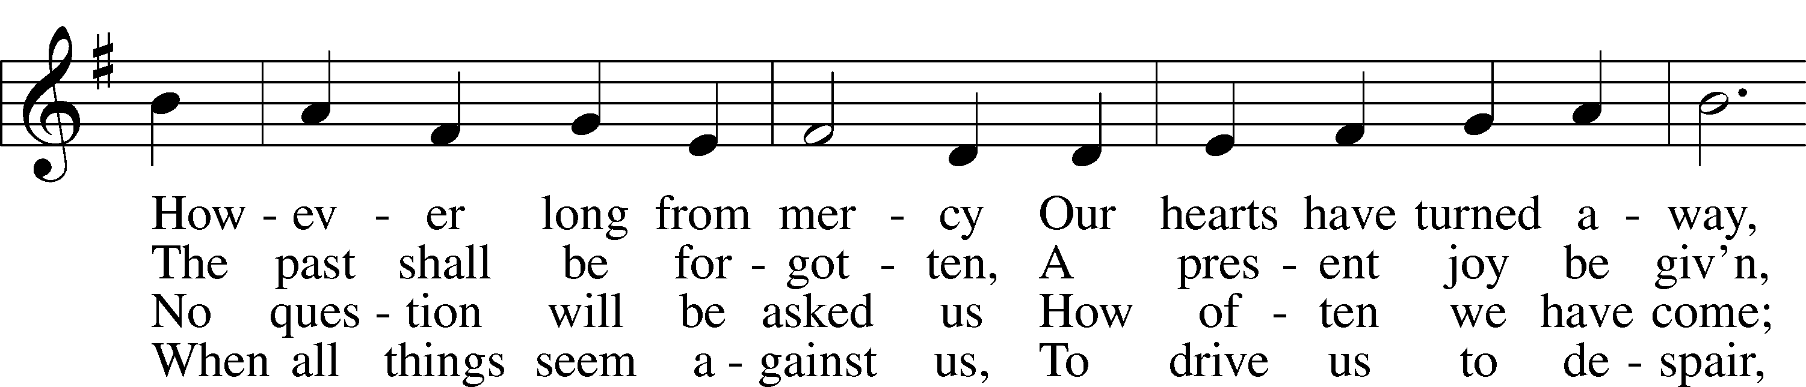
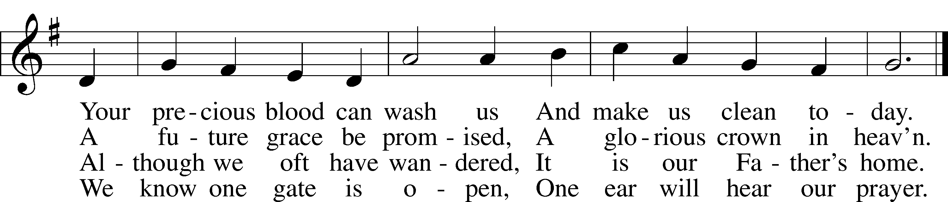
Text: Oswald Allen, 1816–78, alt.
Tune: Friedrich K. Anthes, 1812–after 1857
Text and tune: Public domain
ACKNOWLEDGMENTS
Unless otherwise indicated, Scripture quotations are from the ESV® Bible (The Holy Bible, English Standard Version®), copyright © 2001 by Crossway, a publishing ministry of Good News Publishers. Used by permission. All rights reserved.
Created by Lutheran Service Builder © 2026 Concordia Publishing House.

OUR VALUE STATEMENT: Bethlehem Lutheran Church exists under God’s grace to save the lost and to strengthen the saved so that they may live bold and courageous lives of Christian witness before a non-believing world.
Therefore, our purpose is:
- to glorify God in Word and deed,
- to nurture each other in Christian love,
- to reach out to others with our Savior’s Gospel of life and salvation.
(Rom 5:8, Matt. 28:18-20).

OUR VISION: By the Grace of God, Bethlehem Lutheran Church, is a loving family united in Christ, learning, living, and spreading His Word.

OUR MISSION: Learn the Word. Live the Word. Spread the Word.

