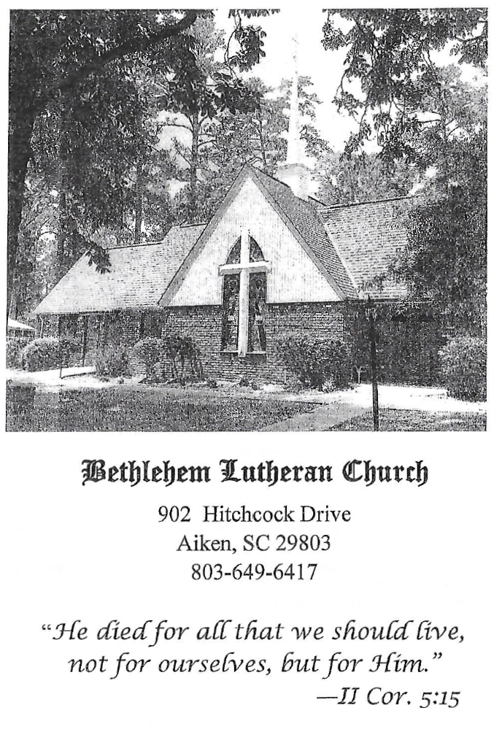

BETHLEHEM LUTHERAN CHURCH
A congregation of The Lutheran Church-Missouri Synod
902 Hitchcock Drive SW,
Aiken, South Carolina 29803
Church Phone: (803) 649-6417
blcaikensc@gmail.com

Bethlehem Lutheran welcomes our members and guests to our worship service! Unable to join us in person? Please find us on Facebook live. The service is also posted on our website; bethlehemlutheranaiken.org.

+ + + + + + + + + + + + + + +
Twentieth Sunday after Pentecost
October 11, 2026
10:30 a.m.
+ + + + + + + + + + + + + + +

+ SERVICE OF PREPARATION +

(After the bell tolls, please observe a time of silence.)

WELCOME AND ANNOUNCEMENTS

(Stand)

813 REJOICE, O PILGRIM THRONG
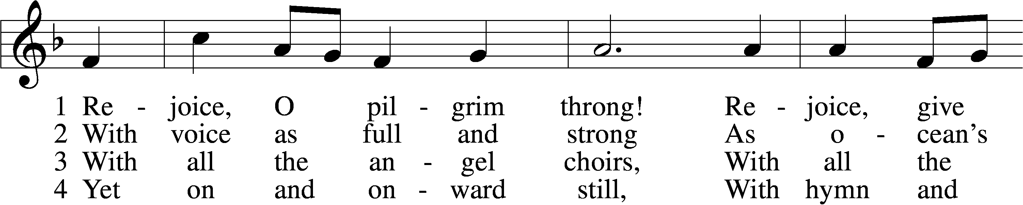
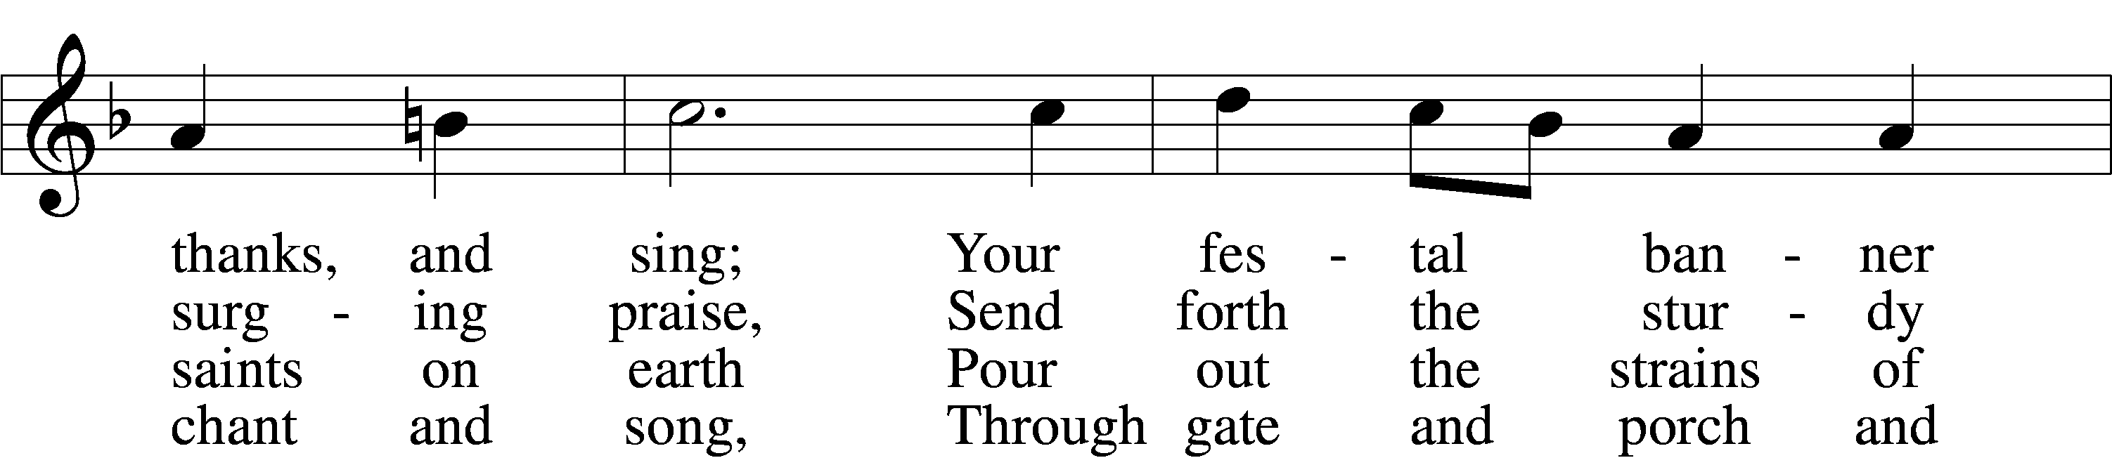
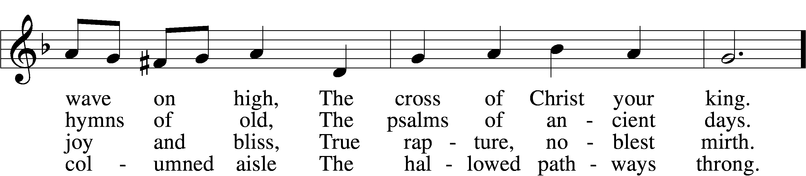
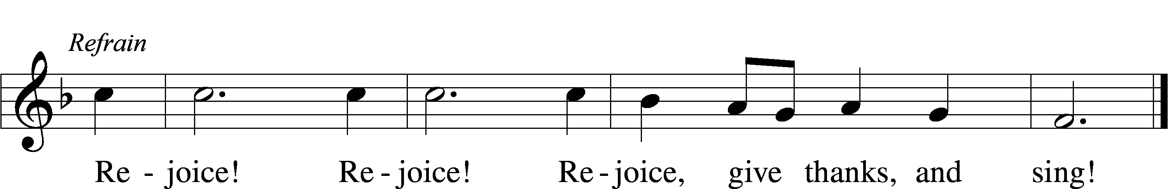

5 Still lift your standard high,
Still march in firm array,
As pilgrims through the darkness wend
Till dawns the golden day. Refrain

6 At last the march shall end;
The wearied ones shall rest;
The pilgrims find their home at last,
Jerusalem the blest. Refrain

(next page)

D 7 Praise Him who reigns on high,
The Lord whom we adore:
The Father, Son, and Holy Ghost,
One God forevermore. Refrain
Text: Edward H. Plumptre, 1821–91, alt.
Tune: Arthur H. Messiter, 1834–1916
Text and tune: Public domain

+ CONFESSION AND ABSOLUTION +

(The sign of the cross may be made by all in remembrance of their Baptism.)

INVOCATION LSB 151
L In the name of the Father and of the T Son and of the Holy Spirit.
C Amen.

EXHORTATION LSB 151
L If we say we have no sin, we deceive ourselves, and the truth is not in us.
C But if we confess our sins, God, who is faithful and just, will forgive our sins and cleanse us from all unrighteousness.

(Silence for reflection on God’s Word and for self-examination.)

CONFESSION OF SINS LSB 151
L Let us then confess our sins to God our Father.
C Most merciful God, we confess that we are by nature sinful and unclean. We have sinned against You in thought, word, and deed, by what we have done and by what we have left undone. We have not loved You with our whole heart; we have not loved our neighbors as ourselves. We justly deserve Your present and eternal punishment. For the sake of Your Son, Jesus Christ, have mercy on us. Forgive us, renew us, and lead us, so that we may delight in Your will and walk in Your ways to the glory of Your holy name. Amen.

DECLARATION OF GRACE LSB 151
L In the mercy of almighty God, Jesus Christ was given to die for us, and for His sake God forgives us all our sins. To those who believe in Jesus Christ He gives the power to become the children of God and bestows on them the Holy Spirit. May the Lord, who has begun this good work in us, bring it to completion in the day of our Lord Jesus Christ.
C Amen.

+ SERVICE OF THE WORD +

INTROIT Isaiah 61:10; antiphon: Psalm 146:2

I will praise the Lord as long | as I live;*
I will sing praises to my God while I have my | being.
I will greatly rejoice | in the Lord;*
my soul shall exult | in my God,
for he has clothed me with the garments of sal- | vation;*
he has covered me with the robe of | righteousness,
as a bridegroom decks himself like a priest with a beautiful | headdress,*
and as a bride adorns herself | with her jewels.
Glory be to the Father and | to the Son*
and to the Holy | Spirit;
as it was in the be- | ginning,*
is now, and will be forever. | Amen.
I will praise the Lord as long | as I live;*
I will sing praises to my God while I have my | being.

KYRIE LSB 152

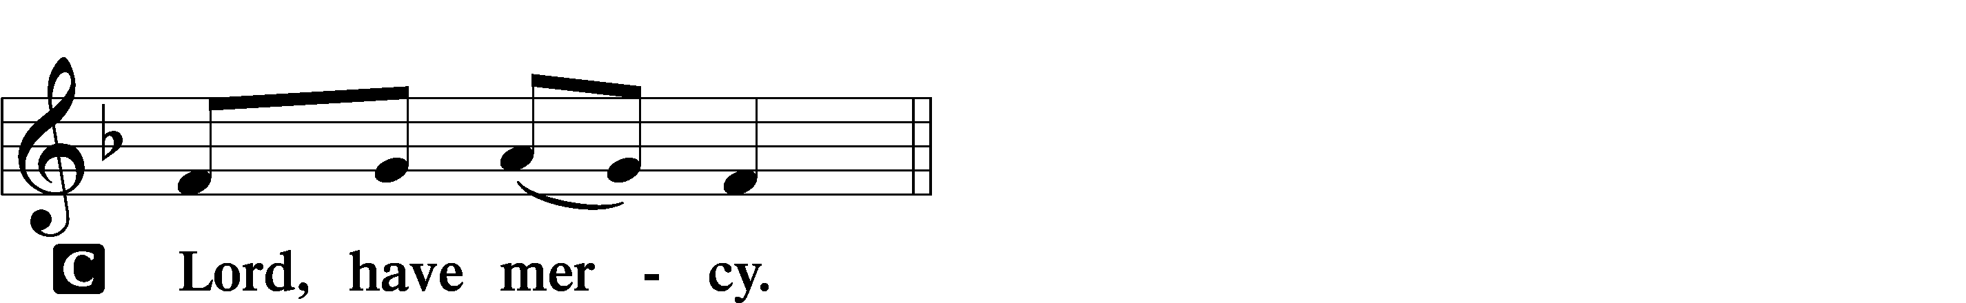

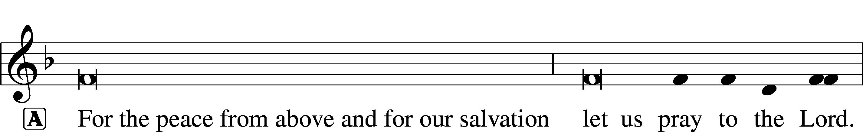


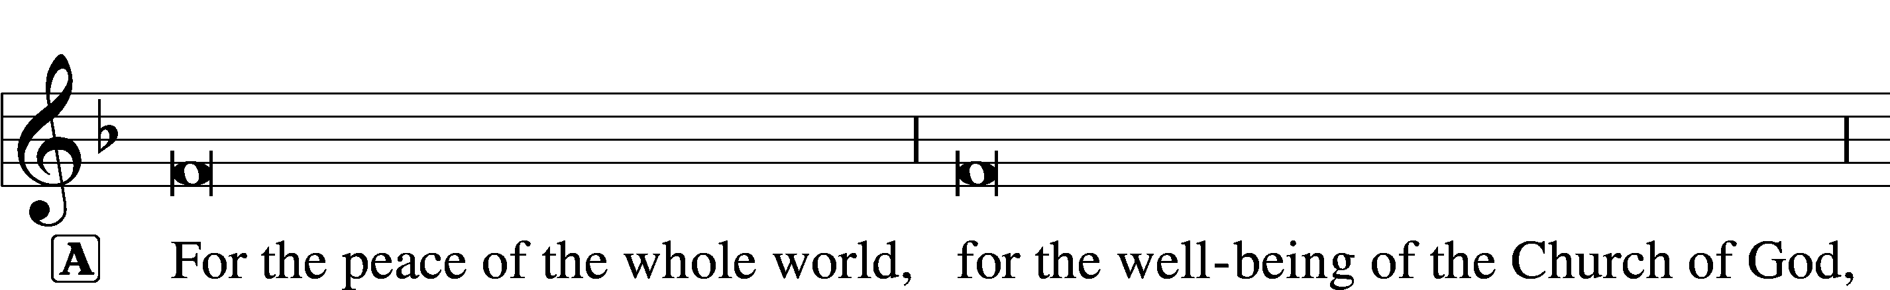
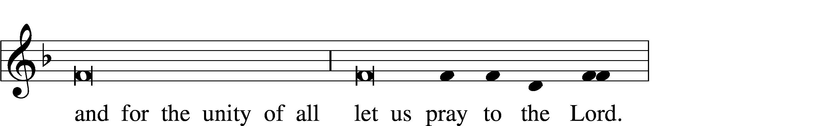


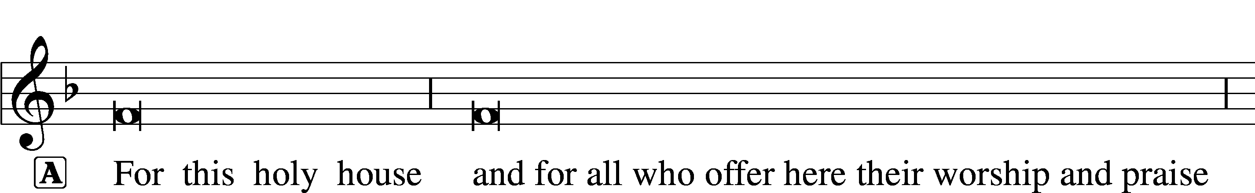

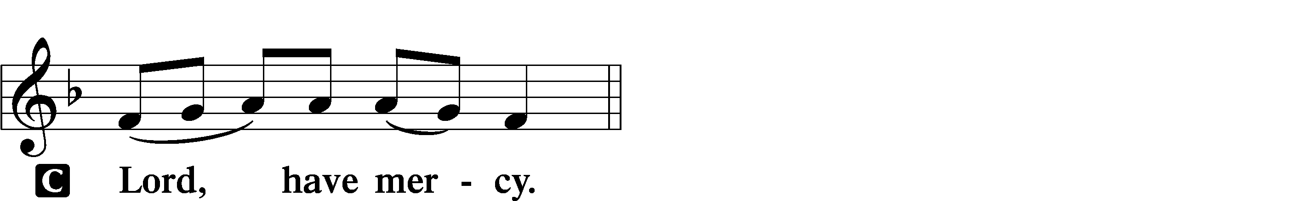




GLORIA IN EXCELSIS LSB 154
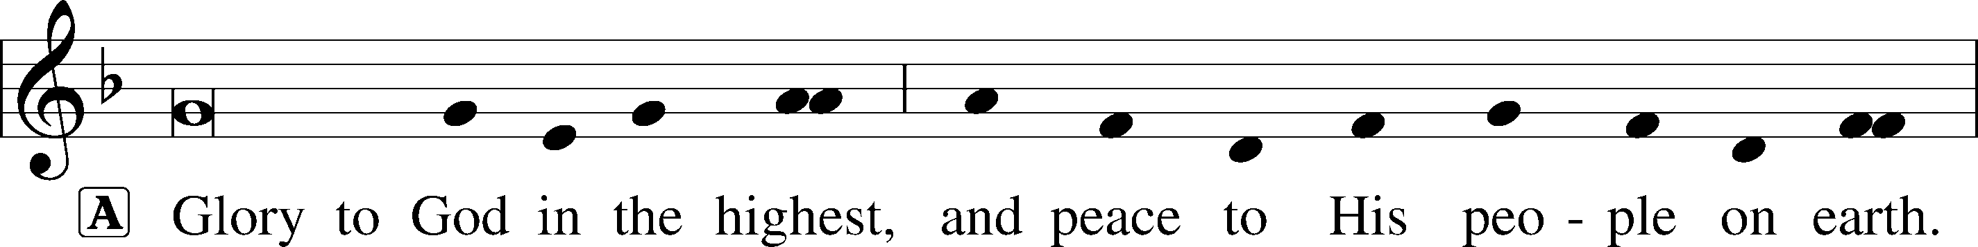
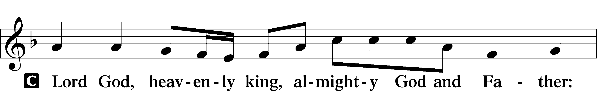
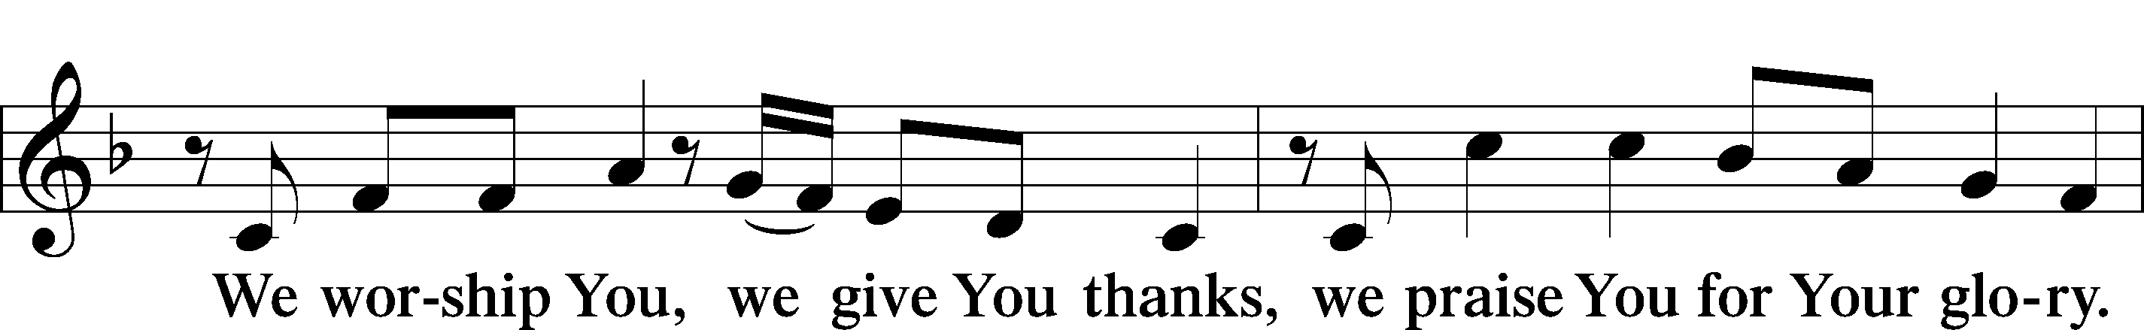
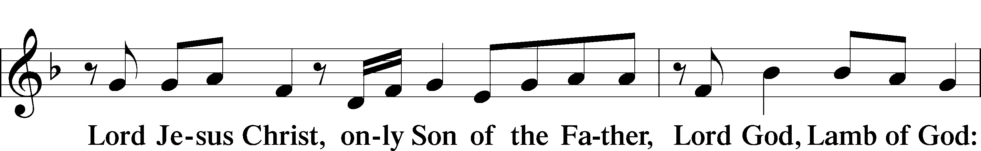
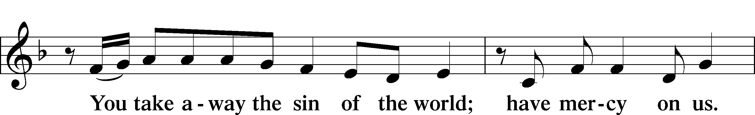
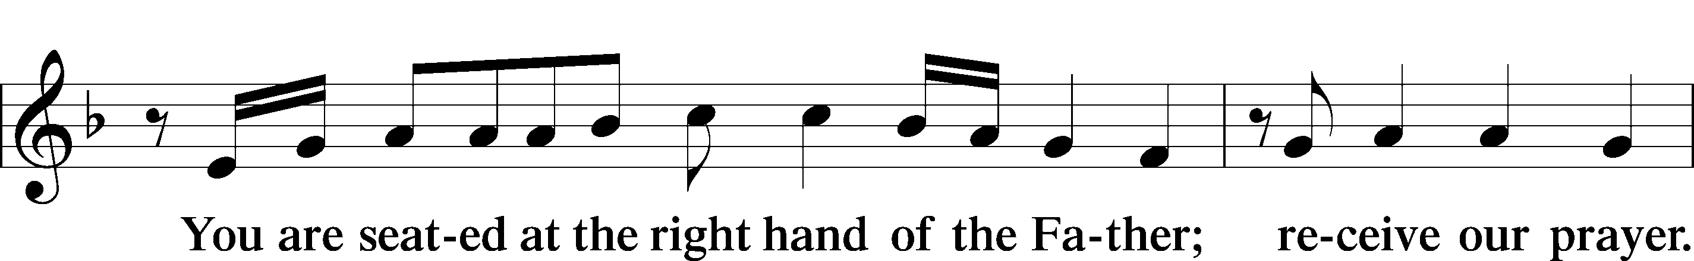
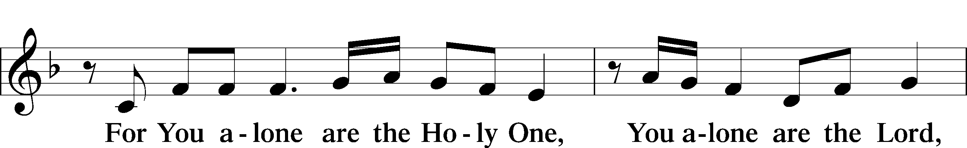
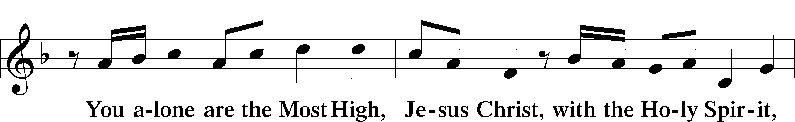
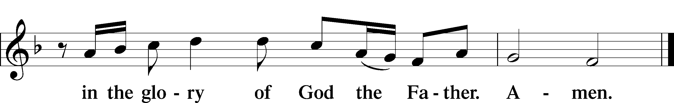

SALUTATION AND COLLECT OF THE DAY LSB 156
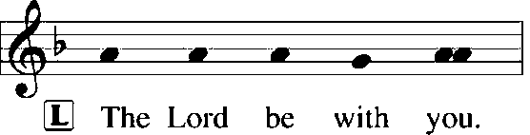
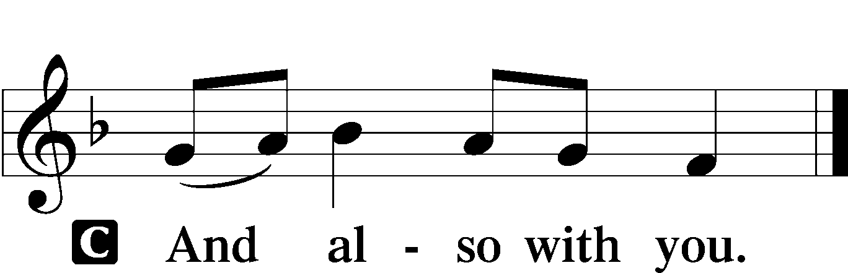

L Let us pray.
Almighty God, You invite us to trust in You for our salvation. Deal with us not in the severity of Your judgment but by the greatness of Your mercy; through Jesus Christ, Your Son, our Lord, who lives and reigns with You and the Holy Spirit, one God, now and forever.

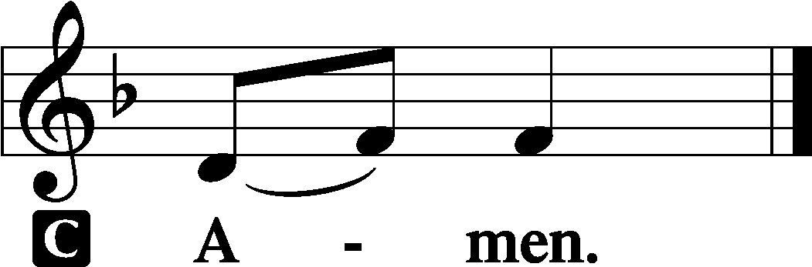

(Sit)

OLD TESTAMENT READING Isaiah 25:6–9
6On this mountain the Lord of hosts will make for all peoples
a feast of rich food, a feast of well-aged wine,
of rich food full of marrow, of aged wine well refined.
7And he will swallow up on this mountain
the covering that is cast over all peoples,
the veil that is spread over all nations.
8He will swallow up death forever;
and the Lord God will wipe away tears from all faces,
and the reproach of his people he will take away from all the earth,
for the Lord has spoken.
9It will be said on that day,
“Behold, this is our God; we have waited for him, that he might save us.
This is the Lord; we have waited for him;
let us be glad and rejoice in his salvation.”

L This is the Word of the Lord.
C Thanks be to God.

GRADUAL Psalm 91:11; 103:1
He will command his angels con- | cerning you*
to guard you in | all your ways.
Bless the Lord, | O my soul,*
and all that is within me, bless his | holy name!

EPISTLE Philippians 4:4–13
4Rejoice in the Lord always; again I will say, Rejoice. 5Let your reasonableness be known to everyone. The Lord is at hand; 6do not be anxious about anything, but in everything by prayer and supplication with thanksgiving let your requests be made known to God. 7And the peace of God, which surpasses all understanding, will guard your hearts and your minds in Christ Jesus.
8Finally, brothers, whatever is true, whatever is honorable, whatever is just, whatever is pure, whatever is lovely, whatever is commendable, if there is any excellence, if there is anything worthy of praise, think about these things. 9What you have learned and received and heard and seen in me—practice these things, and the God of peace will be with you.
10I rejoiced in the Lord greatly that now at length you have revived your concern for me. You were indeed concerned for me, but you had no opportunity. 11Not that I am speaking of being in need, for I have learned in whatever situation I am to be content. 12I know how to be brought low, and I know how to abound. In any and every circumstance, I have learned the secret of facing plenty and hunger, abundance and need. 13I can do all things through him who strengthens me.

L This is the Word of the Lord.
C Thanks be to God.

(Stand)

ALLELUIA AND VERSE LSB 156
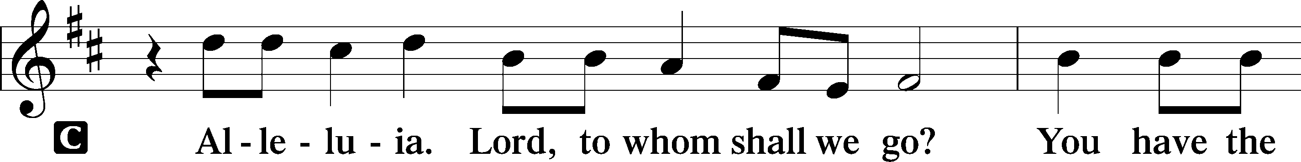
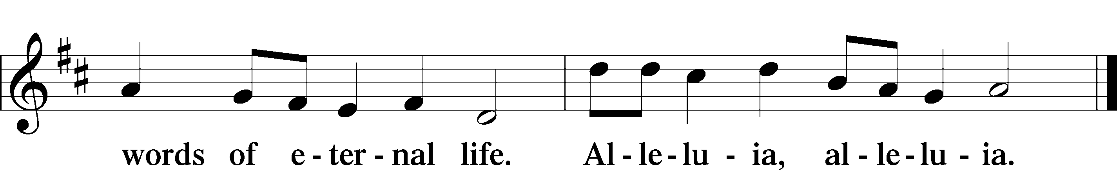

HOLY GOSPEL Matthew 22:1–14
L The Holy Gospel according to St. Matthew, the twenty-second chapter.

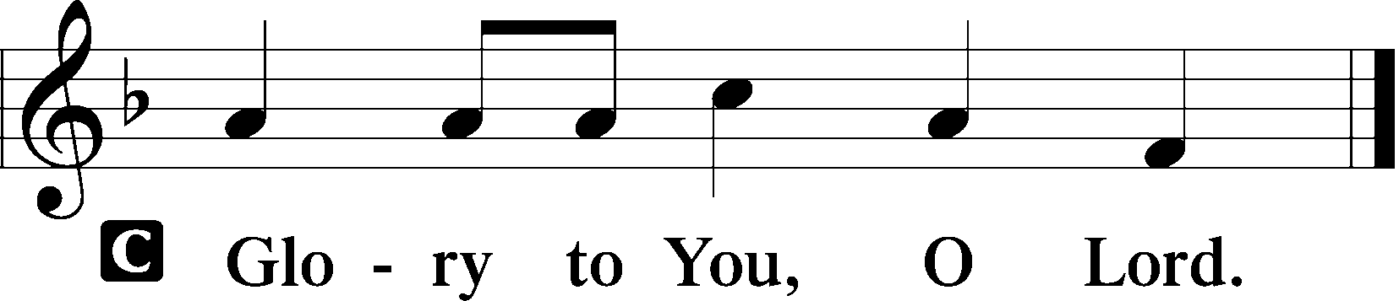

1Again Jesus spoke to them in parables, saying, 2“The kingdom of heaven may be compared to a king who gave a wedding feast for his son, 3and sent his servants to call those who were invited to the wedding feast, but they would not come. 4Again he sent other servants, saying, ‘Tell those who are invited, See, I have prepared my dinner, my oxen and my fat calves have been slaughtered, and everything is ready. Come to the wedding feast.’ 5But they paid no attention and went off, one to his farm, another to his business, 6while the rest seized his servants, treated them shamefully, and killed them. 7The king was angry, and he sent his troops and destroyed those murderers and burned their city. 8Then he said to his servants, ‘The wedding feast is ready, but those invited were not worthy. 9Go therefore to the main roads and invite to the wedding feast as many as you find.’ 10And those servants went out into the roads and gathered all whom they found, both bad and good. So the wedding hall was filled with guests.
11“But when the king came in to look at the guests, he saw there a man who had no wedding garment. 12And he said to him, ‘Friend, how did you get in here without a wedding garment?’ And he was speechless. 13Then the king said to the attendants, ‘Bind him hand and foot and cast him into the outer darkness. In that place there will be weeping and gnashing of teeth.’ 14For many are called, but few are chosen.”

L This is the Gospel of the Lord.

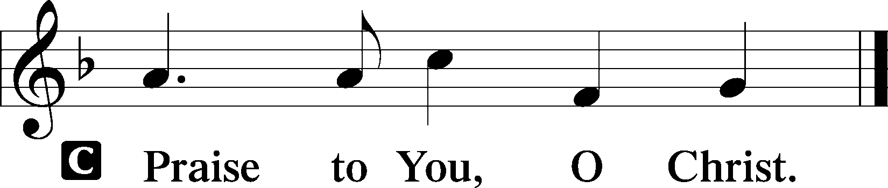

(Sit)

510 A MULTITUDE COMES FROM THE EAST AND THE WEST
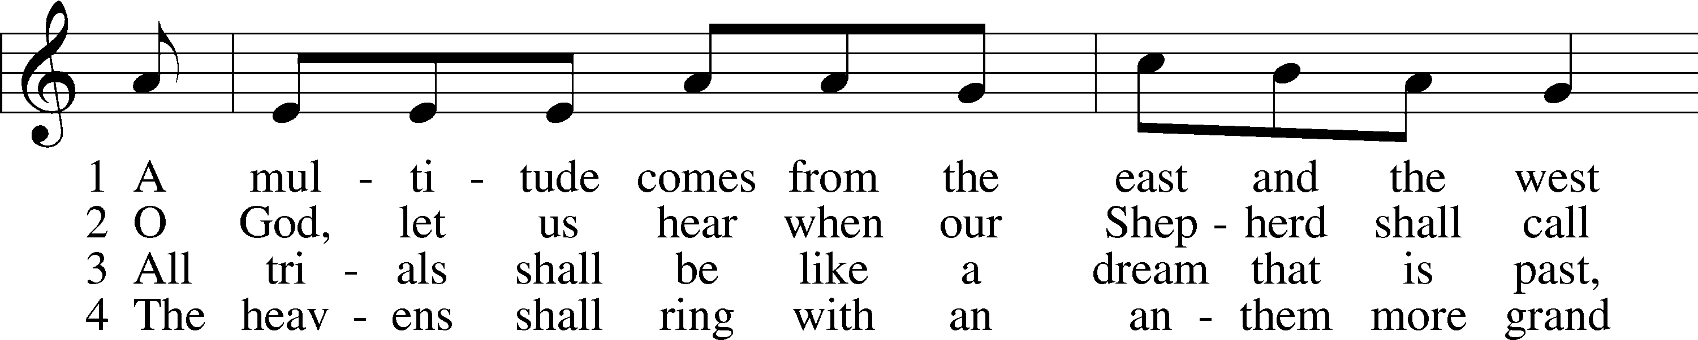
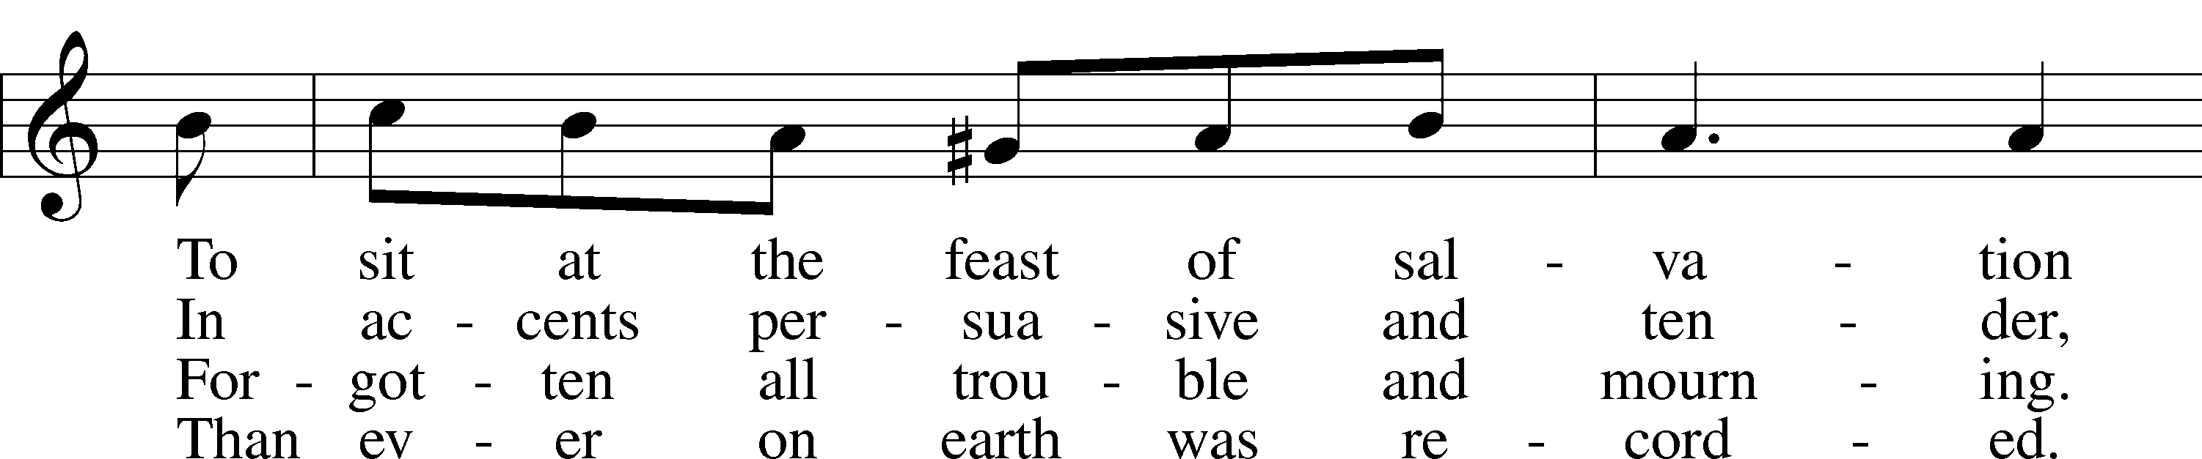
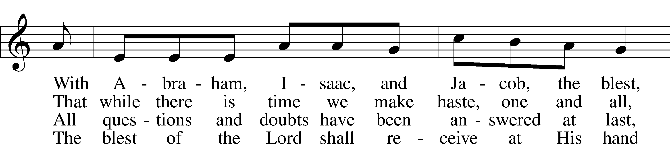
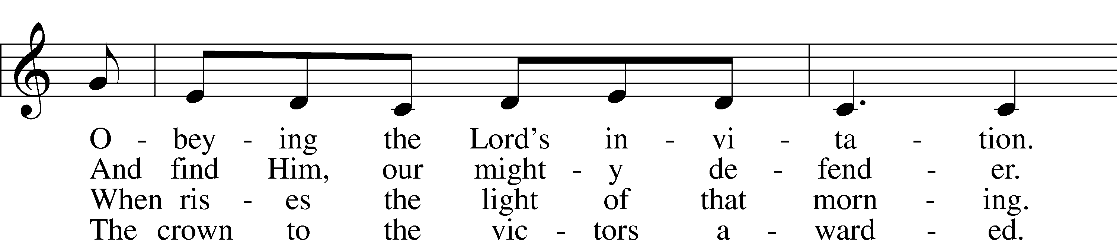
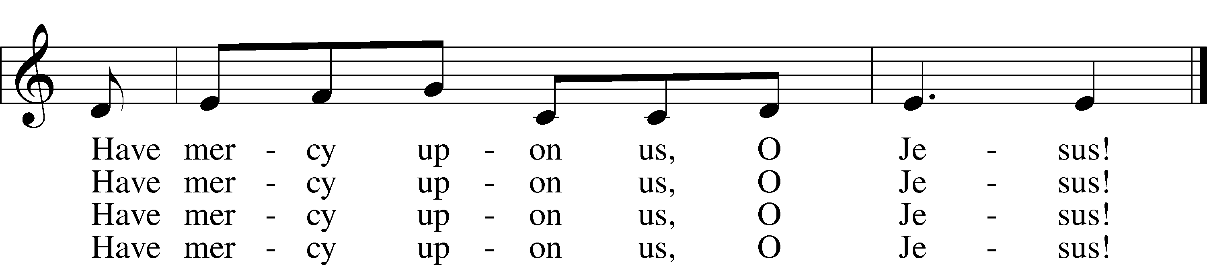
Text: Magnus Brostrup Landstad, 1802–80; tr. Peer O. Strömme, 1856–1921, adapt.
Tune: Swedish, 1694
Text and tune: Public domain

SERMON

(Sermons for Elder led services are provided courtesy of the Lutheran Church - Canada (https://www.lutheranchurchcanada.ca/resources/written-sermons/), a member of the International Lutheran Council (https://ilcouncil.org/) with whom the Lutheran Church - Missouri Synod (https://www.lcms.org/) is in altar and pulpit fellowship.)

676 BEHOLD A HOST, ARRAYED IN WHITE
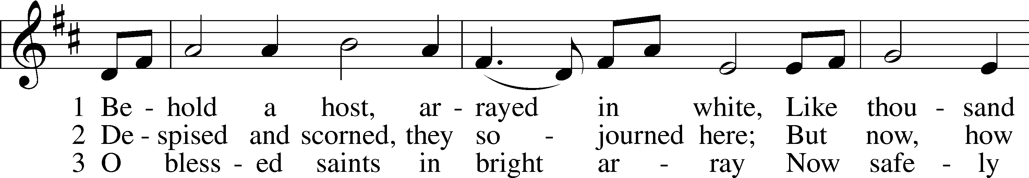
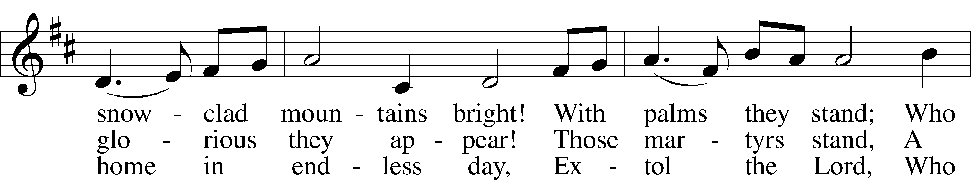
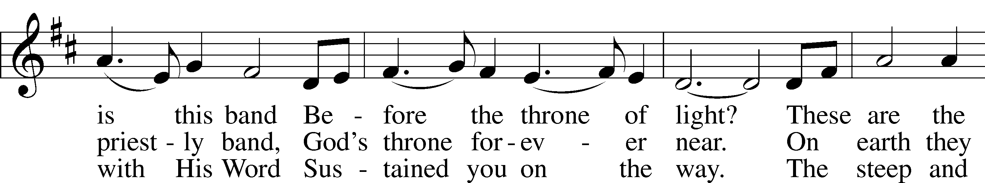
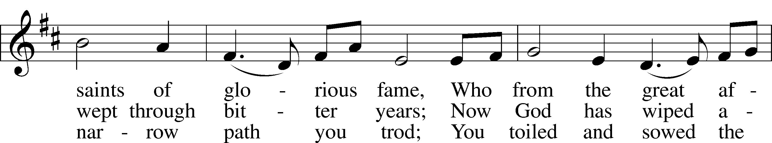
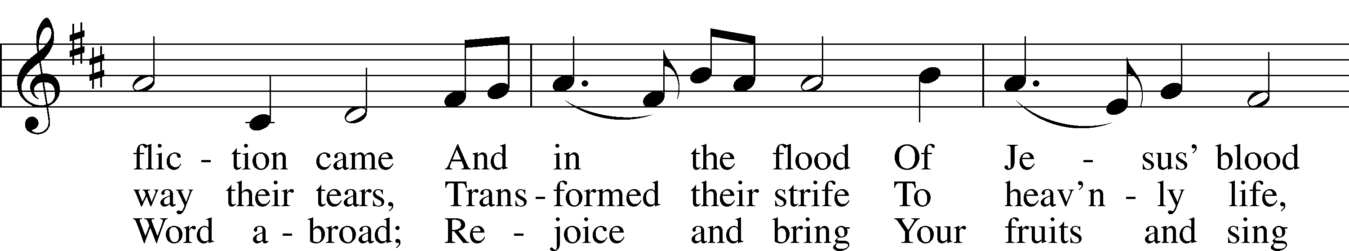
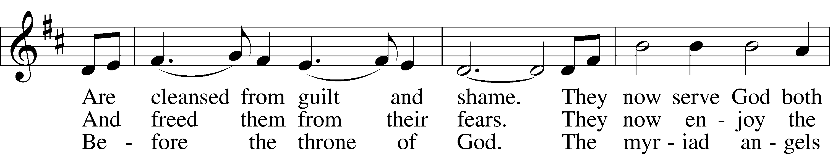
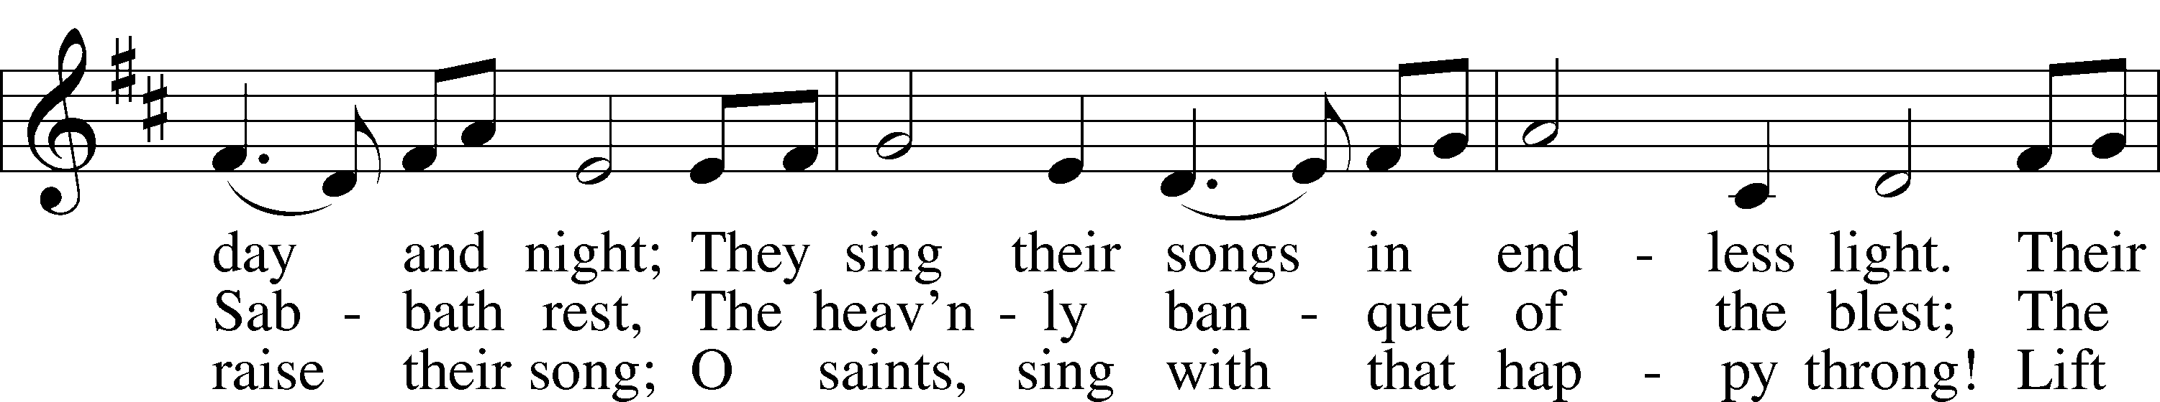
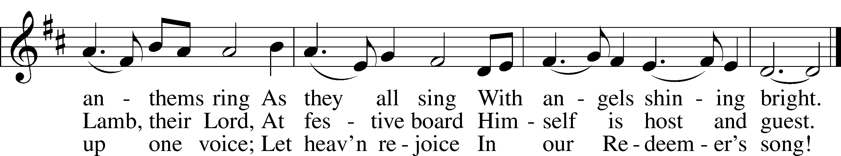
Text: Hans Adolf Brorson, 1694–1764; tr. The Lutheran Hymnal, 1941, alt.
Tune: Norwegian, 17th cent.
Text and tune: Public domain

(Stand)

APOSTLES’ CREED LSB 159
C I believe in God, the Father Almighty,
maker of heaven and earth.

And in Jesus Christ, His only Son, our Lord,
who was conceived by the Holy Spirit,
born of the virgin Mary,
suffered under Pontius Pilate,
was crucified, died and was buried.
He descended into hell.
The third day He rose again from the dead.
He ascended into heaven
and sits at the right hand of God the Father Almighty.
From thence He will come to judge the living and the dead.

I believe in the Holy Spirit,
the holy Christian Church,
the communion of saints,
the forgiveness of sins,
the resurrection of the body,
and the life T everlasting. Amen.

SHARING OF THE PEACE

(The people may greet one another in the name of the Lord, saying, “Peace be with you,” as a sign of reconciliation and of the unity of the Spirit in the bond of peace (Matt. 5:22–24; Eph. 4:1–3).)

(Sit)

PRAYER OF THE CHURCH

OFFERING

(As a part of our expression of thanksgiving to God for the treasure of His salvation to us, we offer a portion of our treasure, according to what each has determined in their heart to give. Please place offerings in the collection plate at the back of the sanctuary before or after the service. Offerings can also be sent to Bethlehem Lutheran Church via U.S. Mail. Thank you!)

(Stand)

OFFERTORY LSB 159
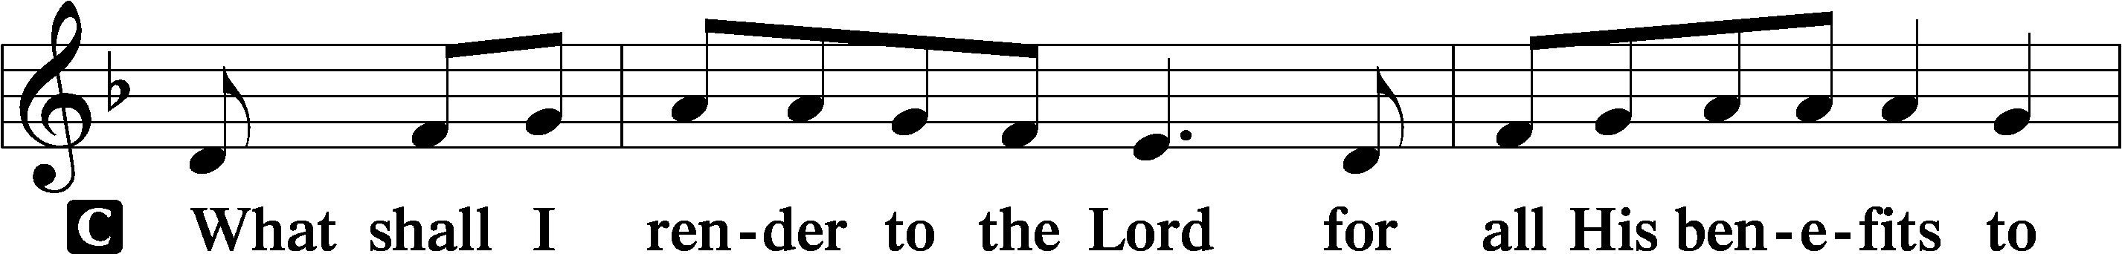
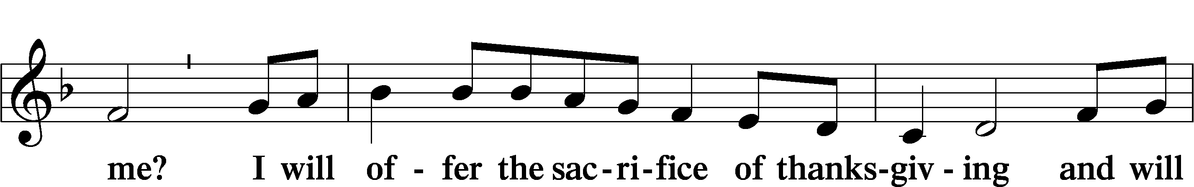
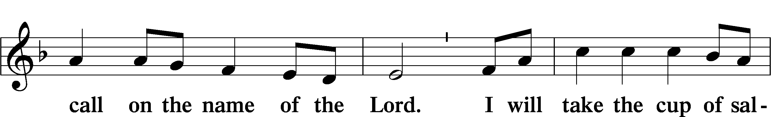
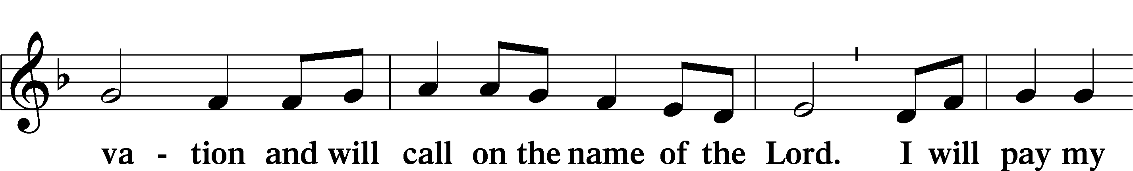
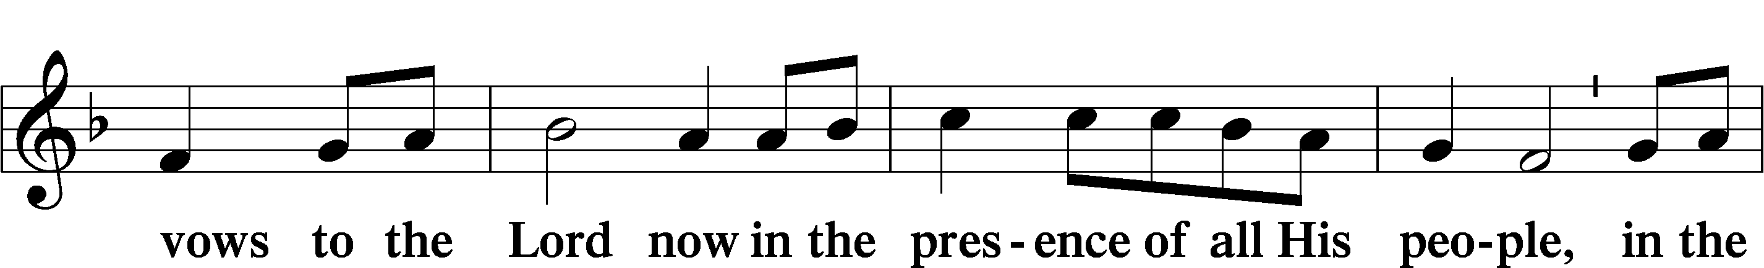
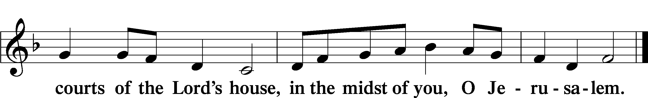

LORD’S PRAYER LSB 162
L Lord, remember us in Your kingdom and teach us to pray:
C Our Father who art in heaven,
hallowed be Thy name,
Thy kingdom come,
Thy will be done on earth
as it is in heaven;
give us this day our daily bread;
and forgive us our trespasses
as we forgive those
who trespass against us;
and lead us not into temptation,
but deliver us from evil.
For Thine is the kingdom
and the power and the glory
forever and ever. Amen.

CONCLUDING COLLECT

BENEDICTION LSB 166
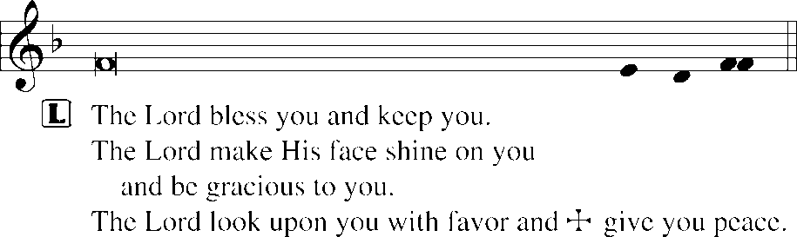


515 REJOICE, REJOICE, BELIEVERS
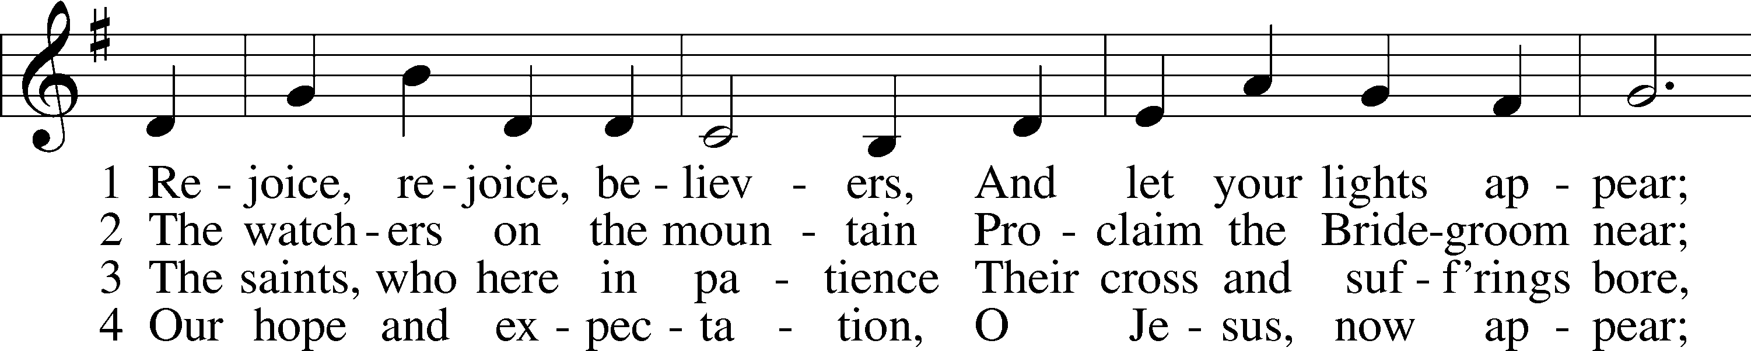
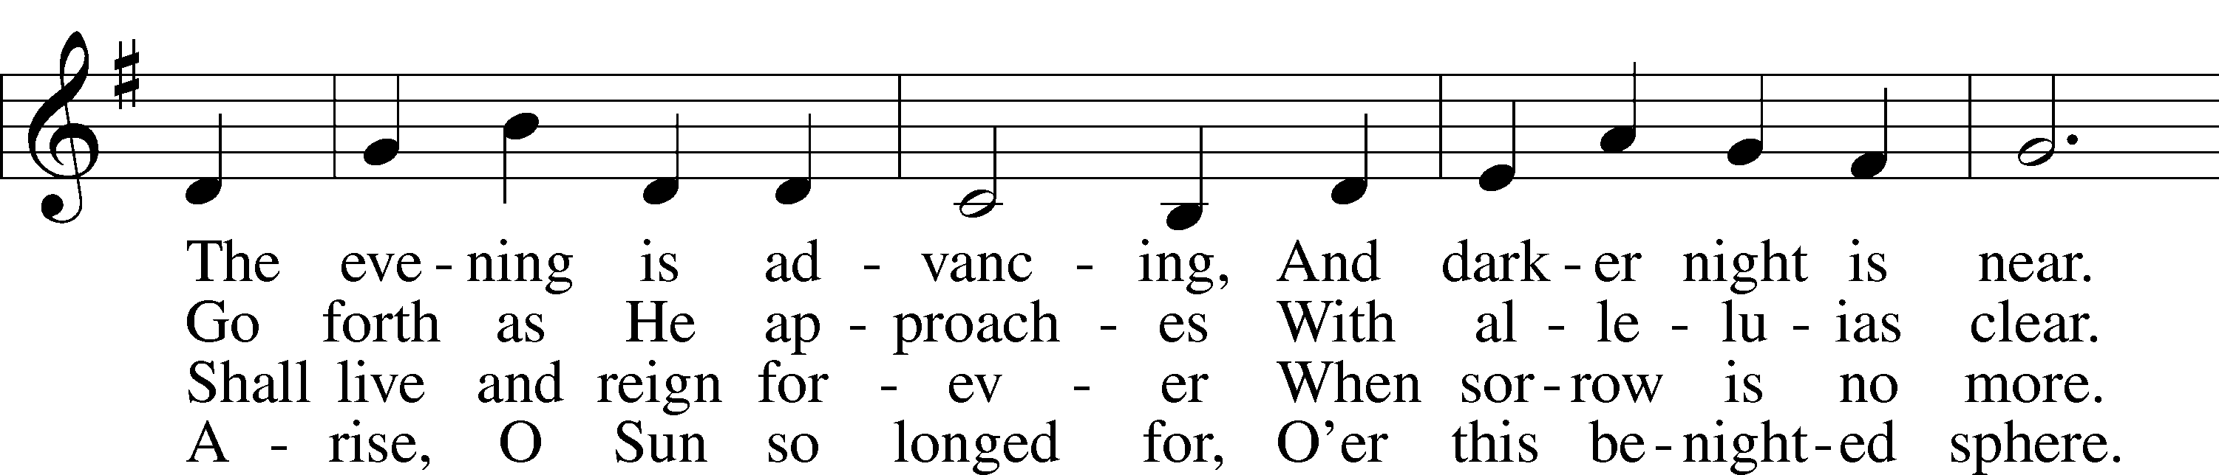
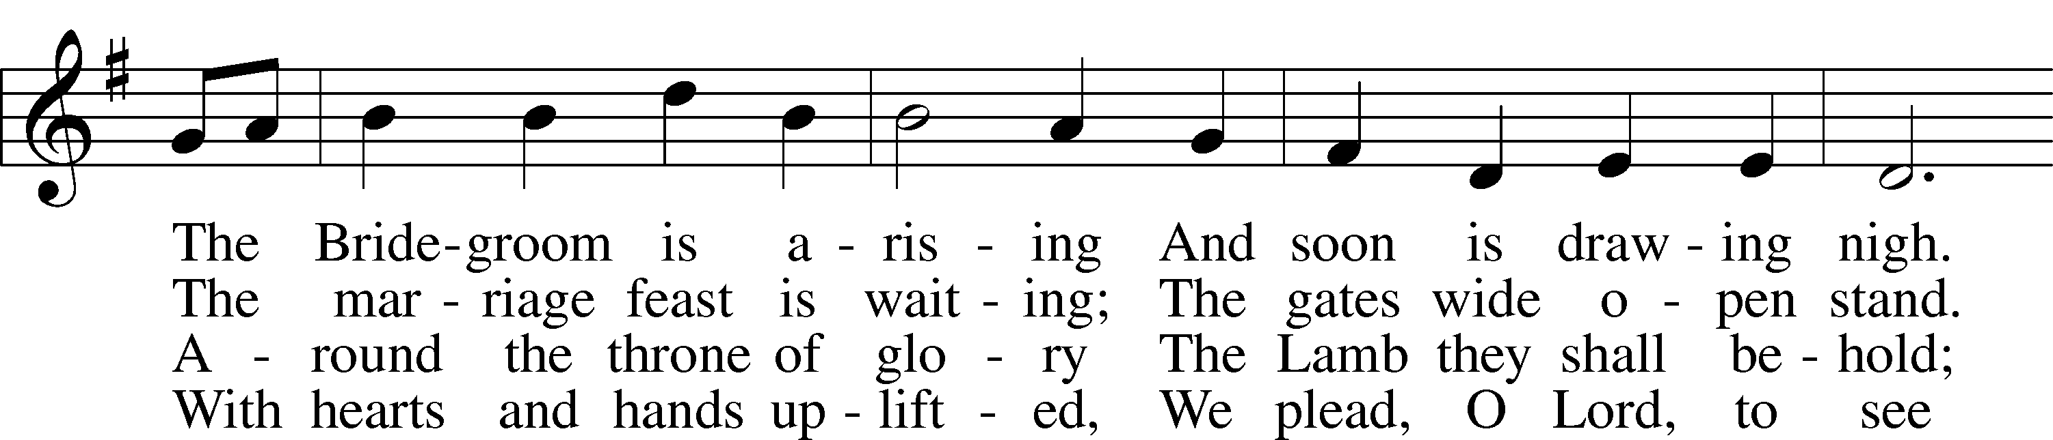
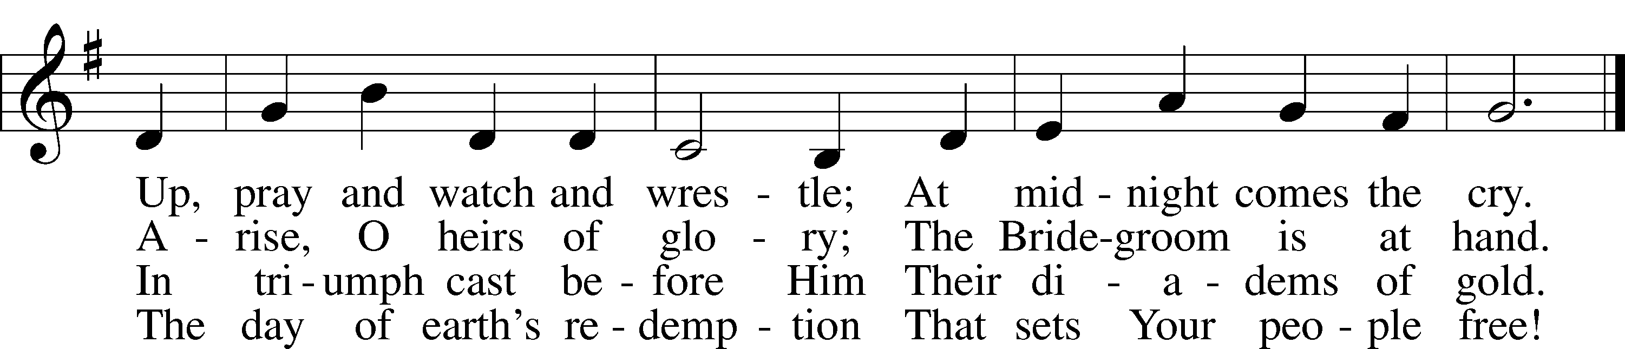
Text: Laurentius Laurenti, 1660–1722; tr. Sarah B. Findlater, 1823–1907, alt.
Tune: Swedish
Text and tune: Public domain
ACKNOWLEDGMENTS
Unless otherwise indicated, Scripture quotations are from the ESV® Bible (The Holy Bible, English Standard Version®), copyright © 2001 by Crossway, a publishing ministry of Good News Publishers. Used by permission. All rights reserved.
Created by Lutheran Service Builder © 2026 Concordia Publishing House.

