BETHLEHEM LUTHERAN CHURCH
A congregation of The Lutheran Church-Missouri Synod
902 Hitchcock Drive SW,
Aiken, South Carolina 29803
Church Phone: (803) 649-6417
blcaikensc@gmail.com

Bethlehem Lutheran welcomes our members and guests to our worship service! Unable to join us in person? Please find us on Facebook live. The service is also posted on our website; bethlehemlutheranaiken.org.

+ + + + + + + + + + + + + + +
Tenth Sunday after Pentecost
August 2, 2026
10:30 a.m.
+ + + + + + + + + + + + + + +

Our Policy and Practice Regarding Holy Communion
Hear the words of the Apostle Paul;
Anyone who eats and drinks without recognizing the body of the Lord eats and drinks judgment on himself. -1 Cor.11:29
Therefore, visitors are asked to please refrain from partaking of the Sacrament before speaking about this with the pastor; because we care about your spiritual well-being.
Also, because communing at this altar is a public confession that you agree with the doctrines of The Lutheran Church-Missouri Synod, and reject all contrary teachings.
Persons who are not communing today are always welcome to come forward during the distribution to receive an individual blessing; please cross your arms over your chest to indicate your desire for this. Thank you!
We commune in two alternating tables. The ushers will guide you. Non-alcoholic white wine is available in the center of the individual cup tray. Please leave empty individual cups at the altar rail.

+ SERVICE OF PREPARATION +

(After the bell tolls, please observe a time of silence.)

WELCOME AND ANNOUNCEMENTS

(Stand)

618 I COME, O SAVIOR, TO THY TABLE
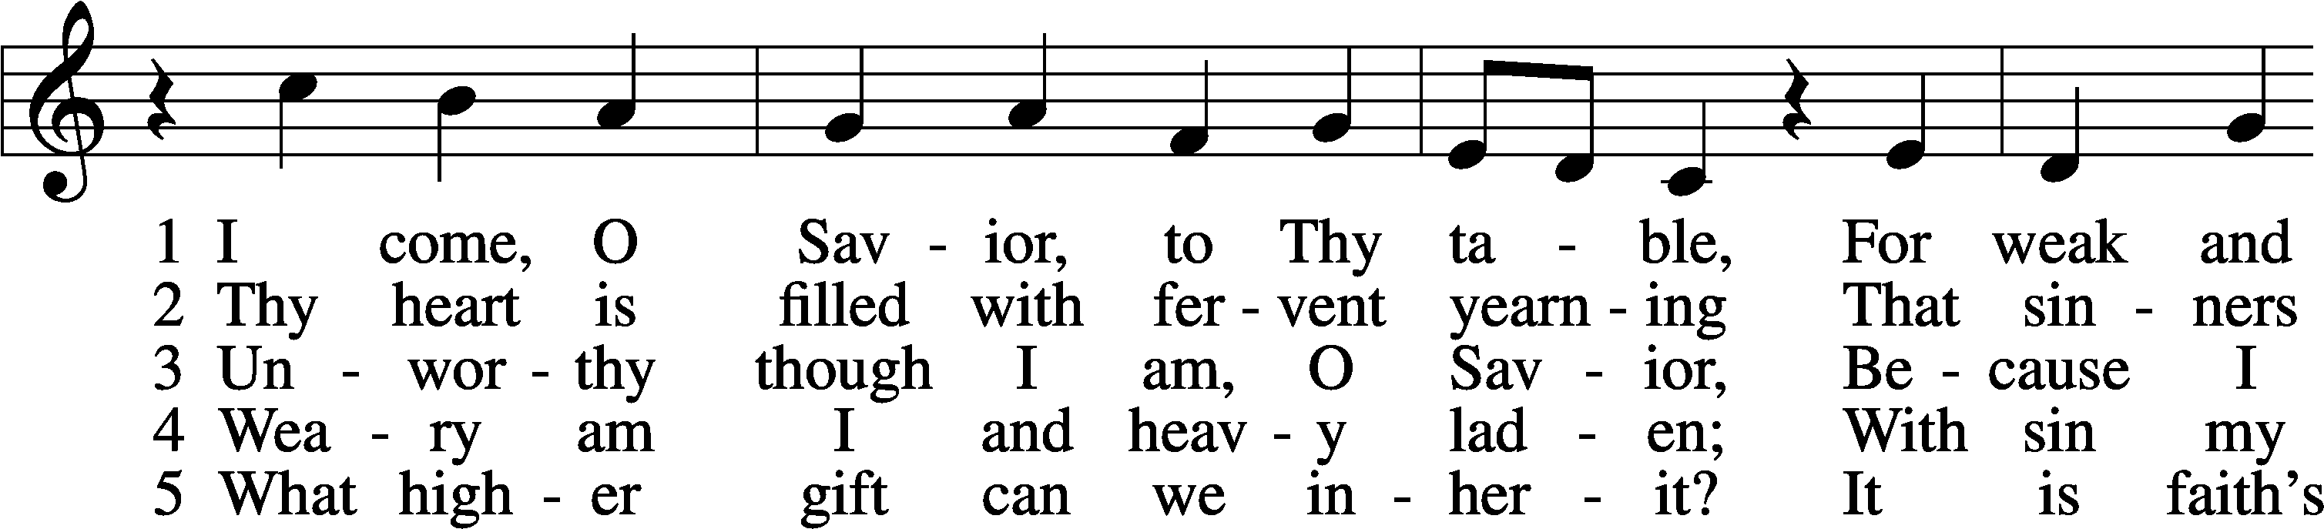
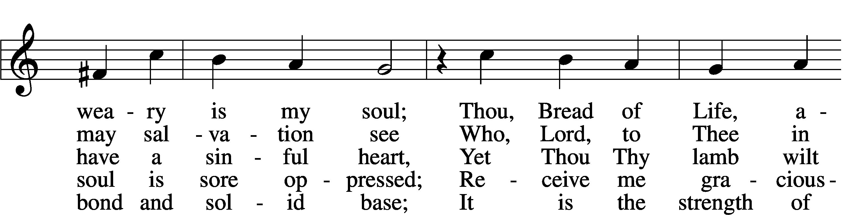
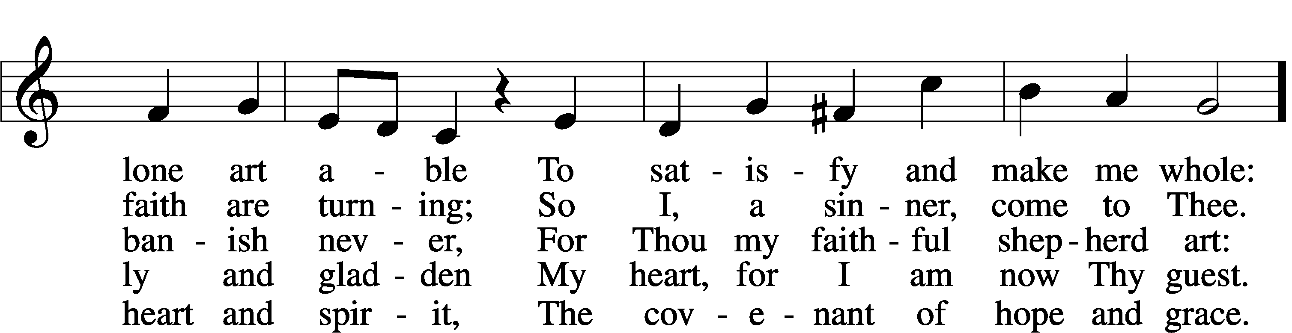
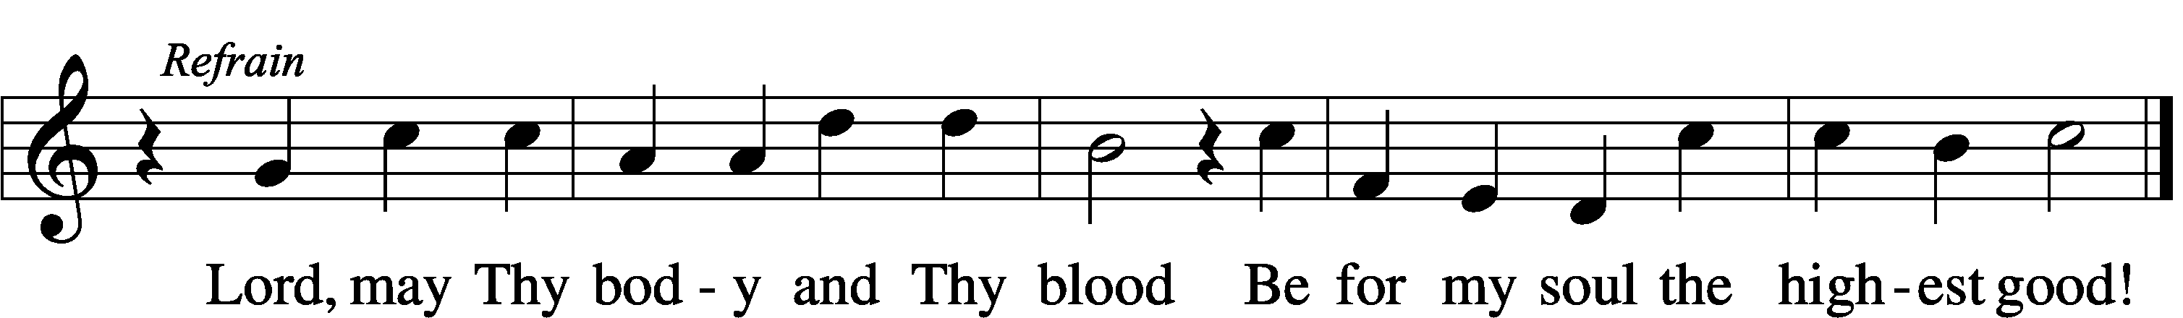
Text: Friedrich Christian Heyder, 1677–1754; tr. The Lutheran Hymnal, 1941, abr.
Tune: Emskirchner Choral-Buch, 1756, Leipzig
Text: © 1941 Concordia Publishing House. Used by permission: LSB Hymn License no. 110004798
Tune: Public domain

+ CONFESSION AND ABSOLUTION +

(The sign of the cross may be made by all in remembrance of their Baptism.)

INVOCATION LSB 151
P In the name of the Father and of the T Son and of the Holy Spirit.
C Amen.

EXHORTATION LSB 151
P If we say we have no sin, we deceive ourselves, and the truth is not in us.
C But if we confess our sins, God, who is faithful and just, will forgive our sins and cleanse us from all unrighteousness.

(Silence for reflection on God’s Word and for self-examination.)

CONFESSION OF SINS LSB 151
P Let us then confess our sins to God our Father.
C Most merciful God, we confess that we are by nature sinful and unclean. We have sinned against You in thought, word, and deed, by what we have done and by what we have left undone. We have not loved You with our whole heart; we have not loved our neighbors as ourselves. We justly deserve Your present and eternal punishment. For the sake of Your Son, Jesus Christ, have mercy on us. Forgive us, renew us, and lead us, so that we may delight in Your will and walk in Your ways to the glory of Your holy name. Amen.

ABSOLUTION LSB 151
P Almighty God in His mercy has given His Son to die for you and for His sake forgives you all your sins. As a called and ordained servant of Christ, and by His authority, I therefore forgive you all your sins in the name of the Father and of the T Son and of the Holy Spirit.
C Amen.

+ SERVICE OF THE WORD +

INTROIT Psalm 105:39–43; antiphon: v. 1
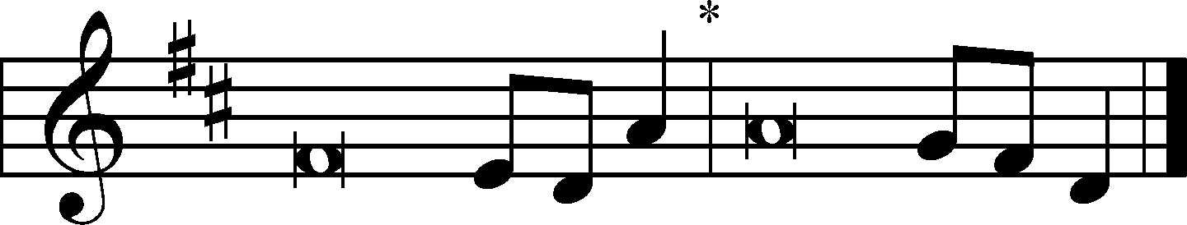
Oh give thanks to the Lord; call up- | on his name;*
make known his deeds among the | peoples!
He spread a cloud for a | covering,*
and fire to give | light by night.
They asked, and he | brought quail,*
and gave them bread from heaven in a- | bundance.
He opened the rock, and water | gushed out;*
it flowed through the desert like a | river.
For he remembered his holy | promise,*
and Abraham, his | servant.
So he brought his people | out with joy,*
his chosen ones with | singing.
Glory be to the Father and | to the Son*
and to the Holy | Spirit;
as it was in the be- | ginning,*
is now, and will be forever. | Amen.
Oh give thanks to the Lord; call up- | on his name;*
make known his deeds among the | peoples!

KYRIE LSB 152
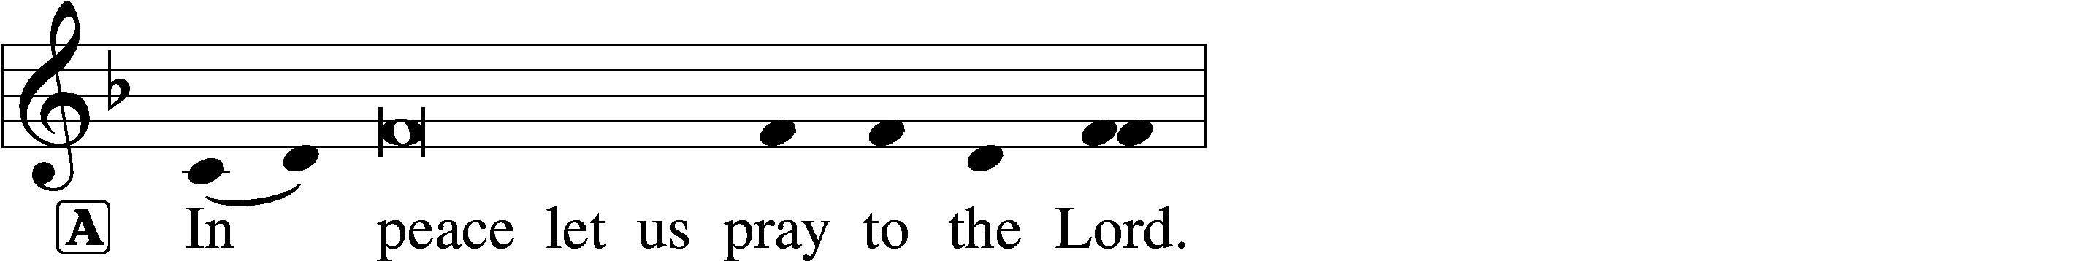
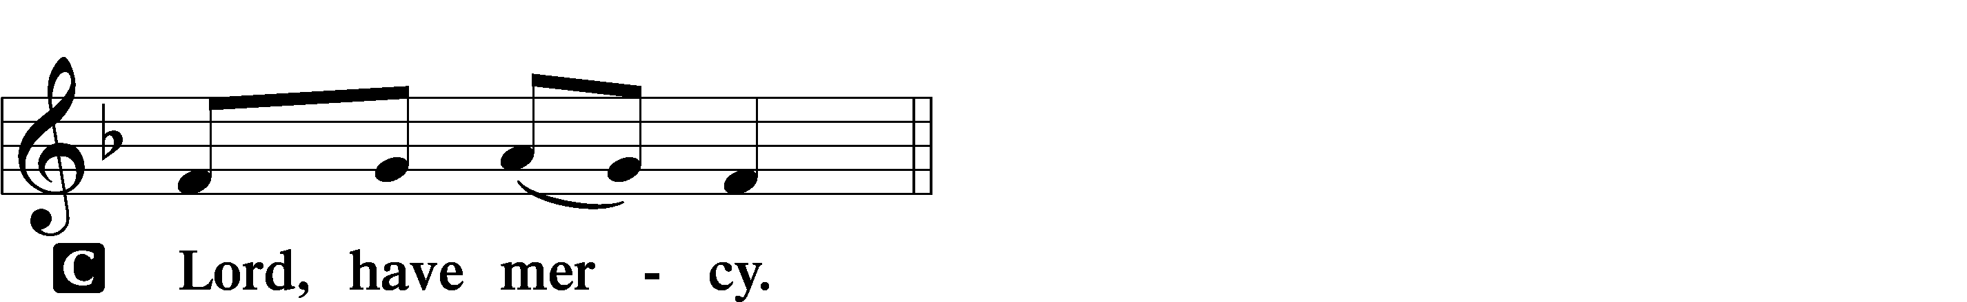

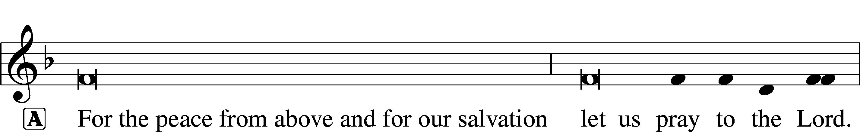

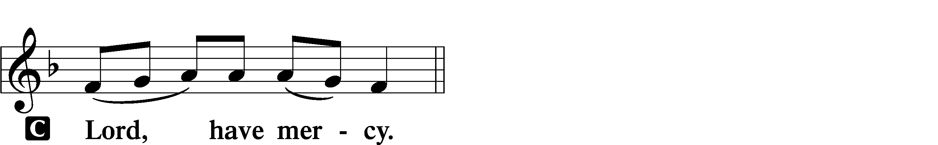

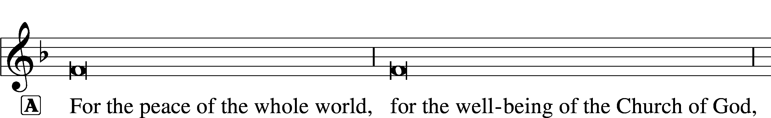
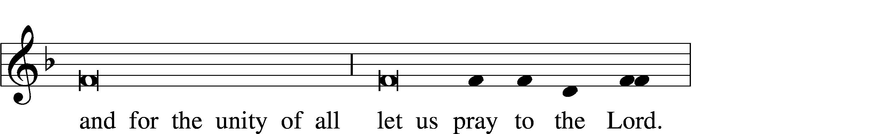
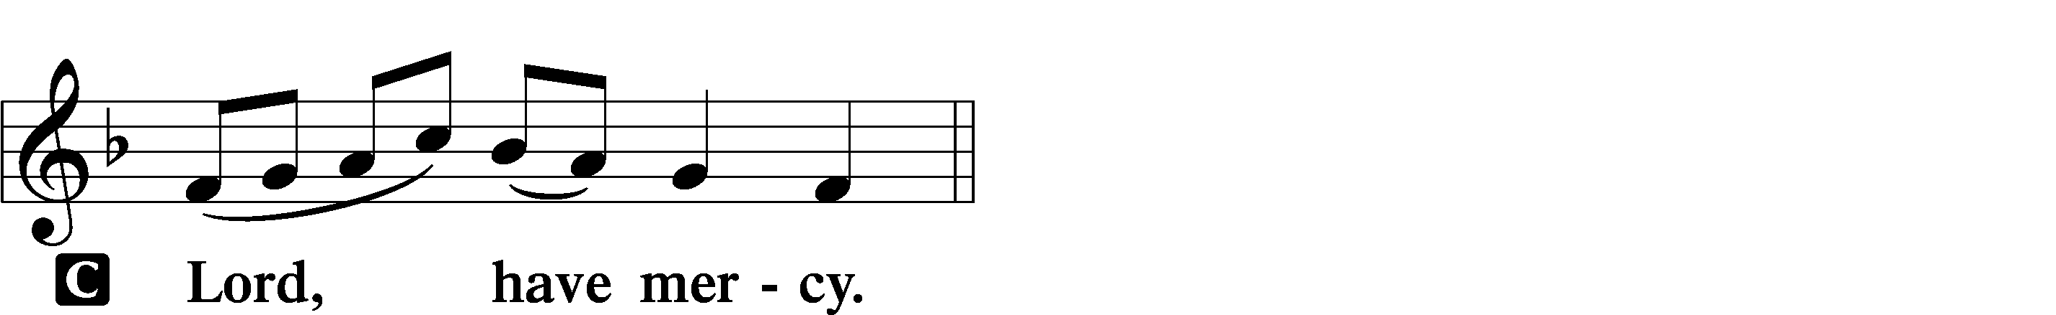

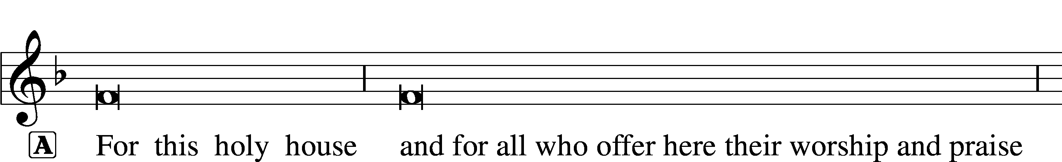
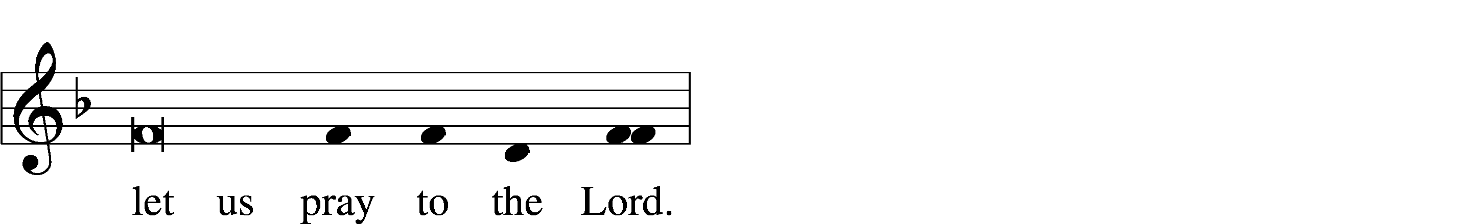
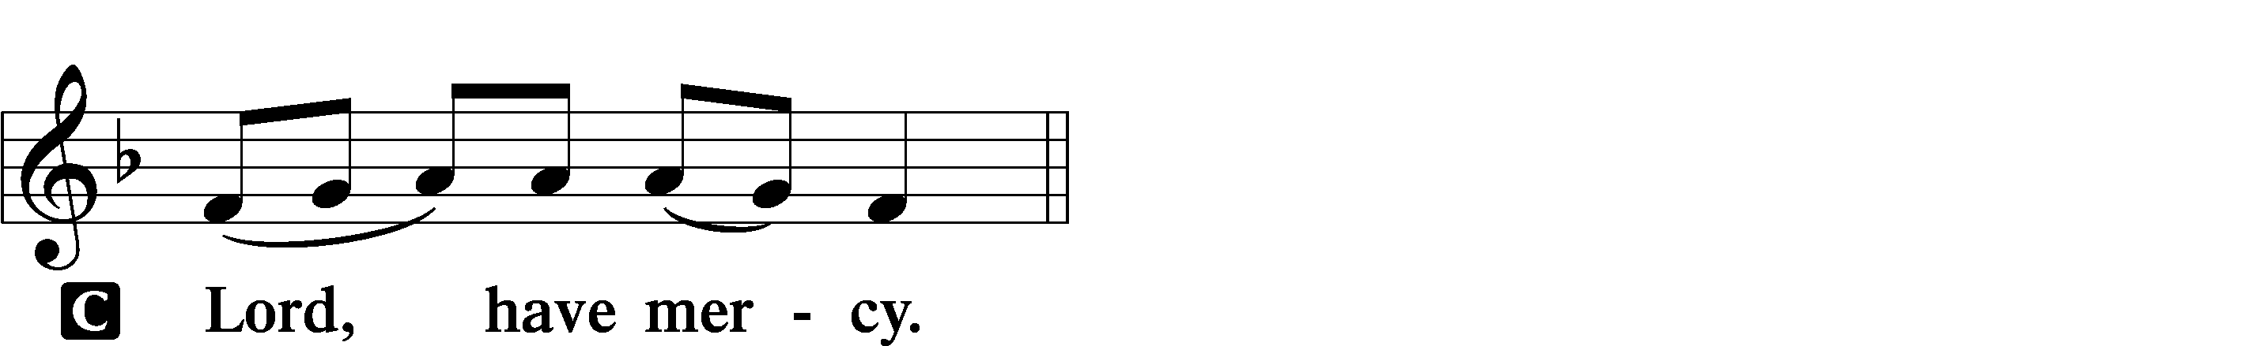

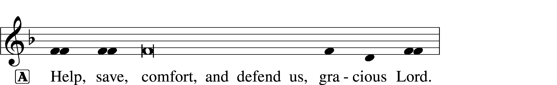


THIS IS THE FEAST LSB 155
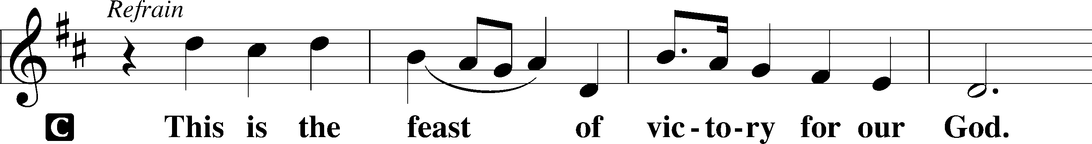
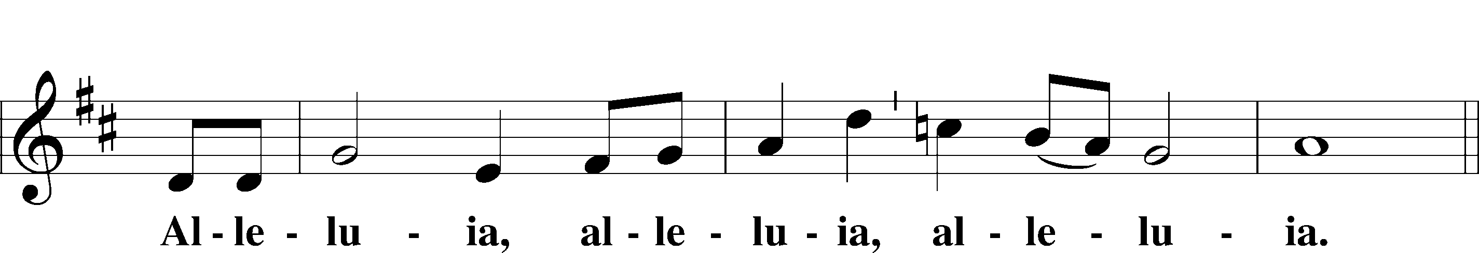
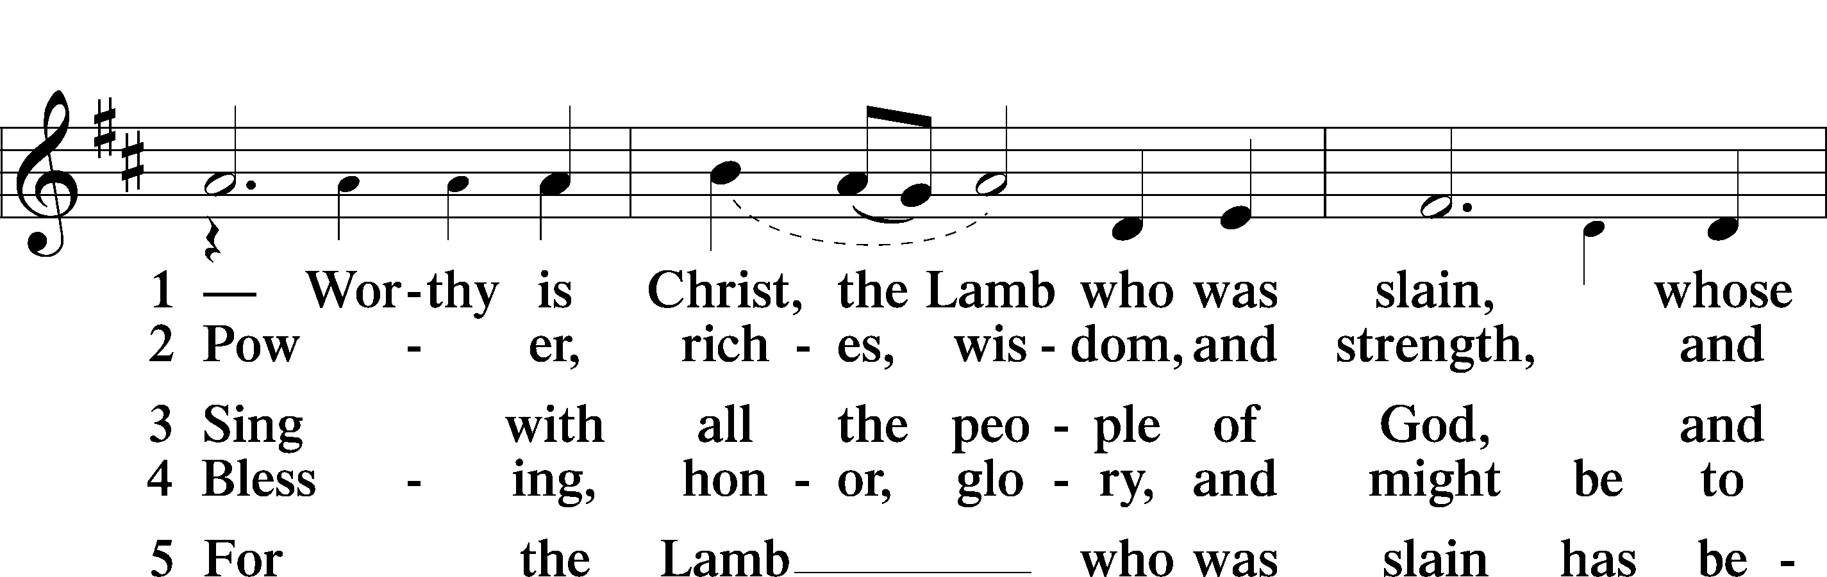
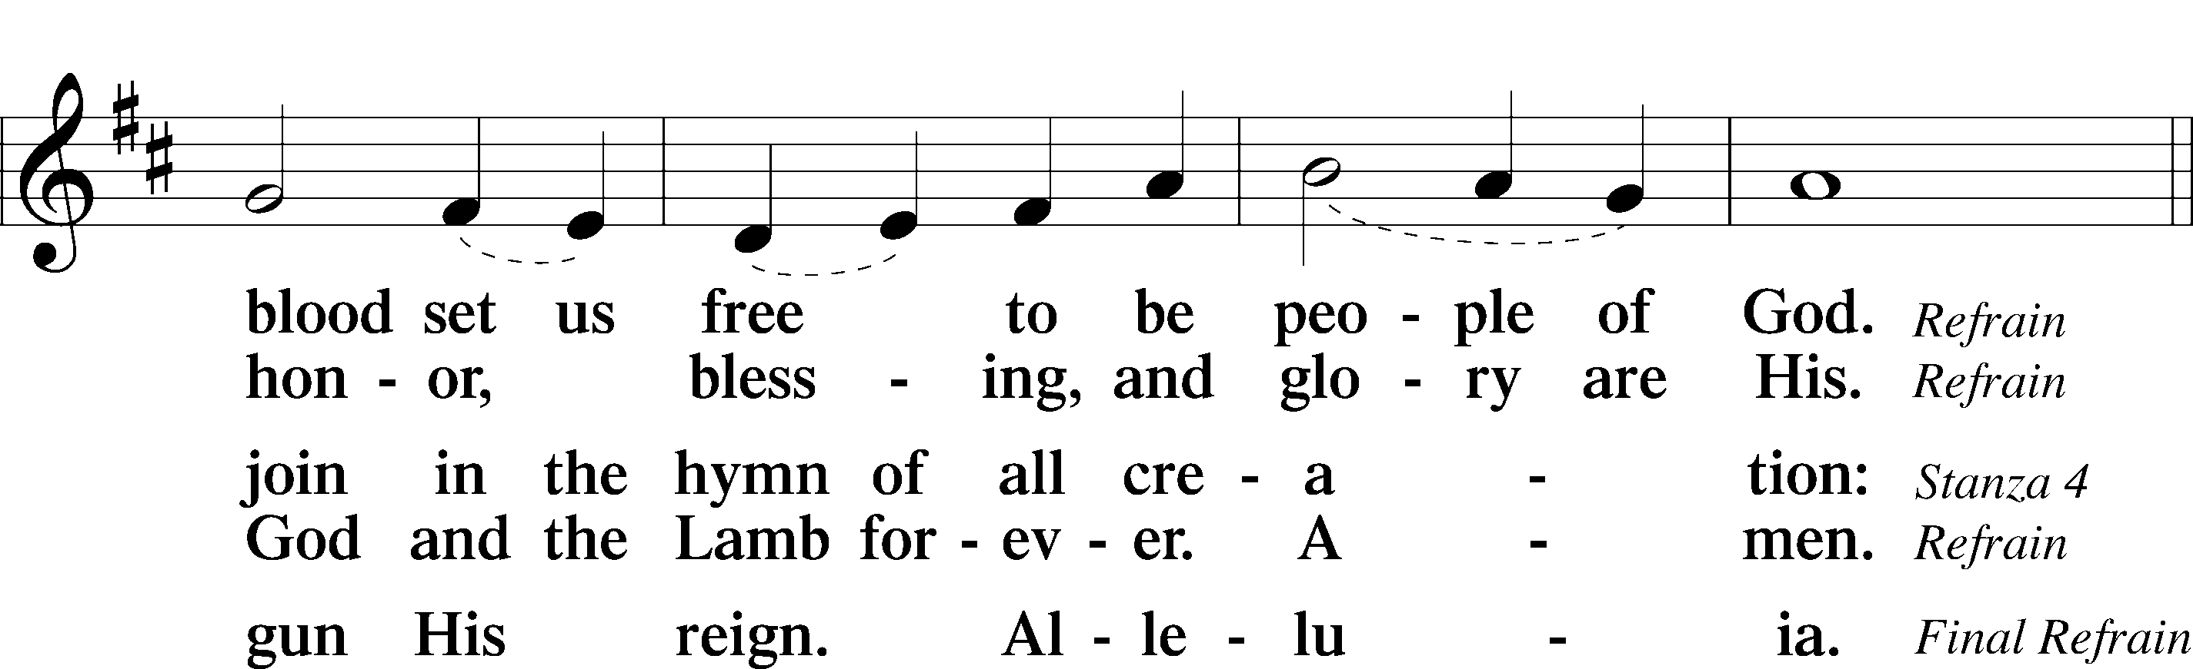
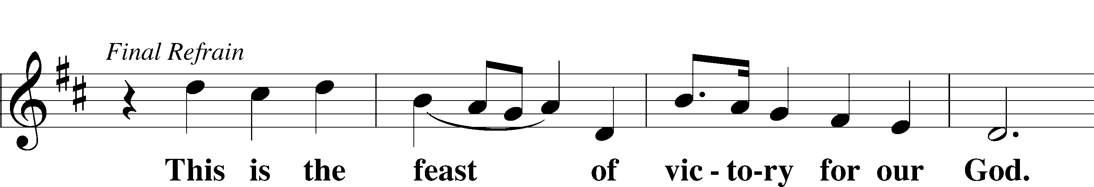
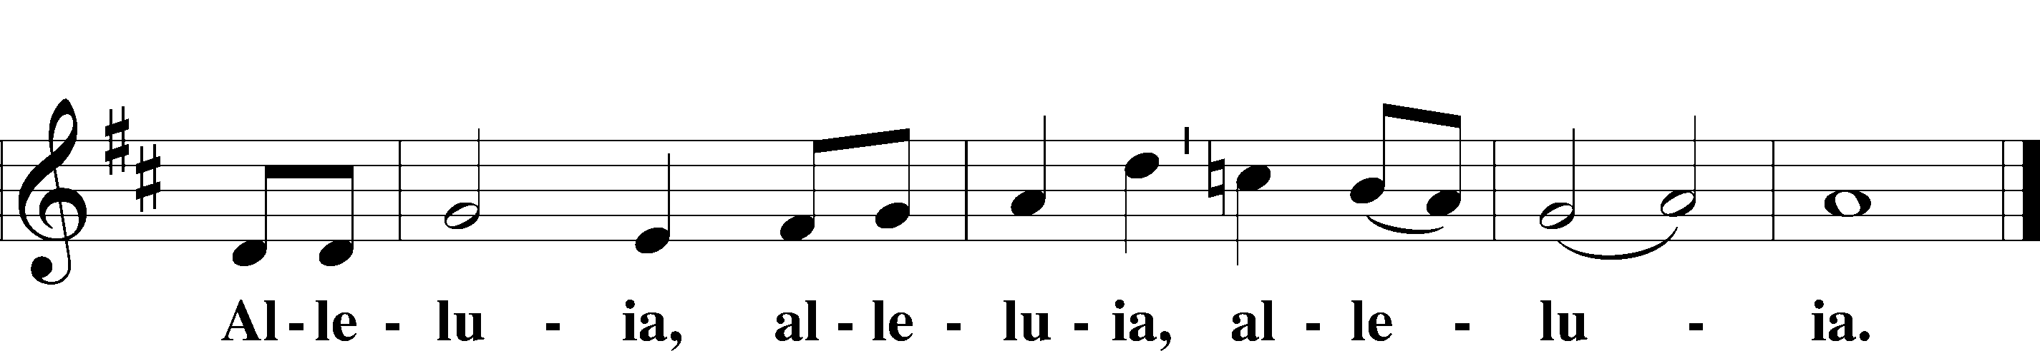

SALUTATION AND COLLECT OF THE DAY LSB 156
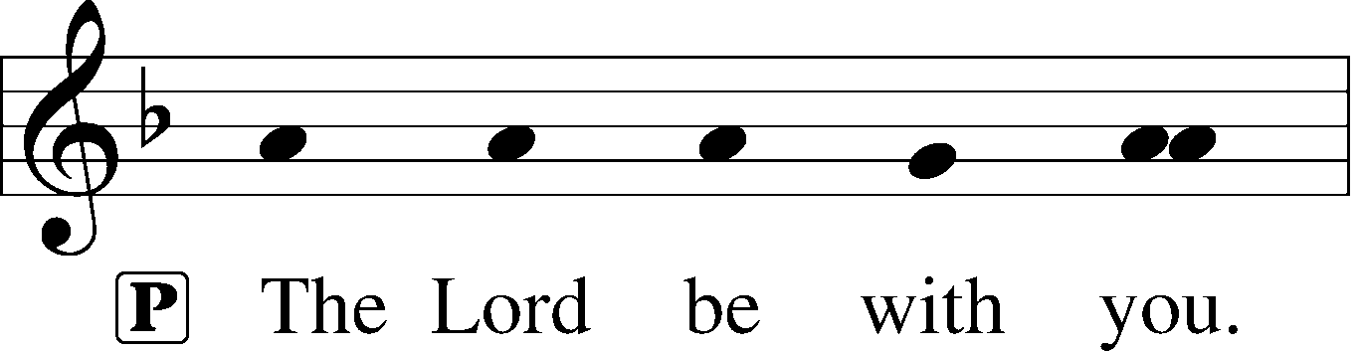
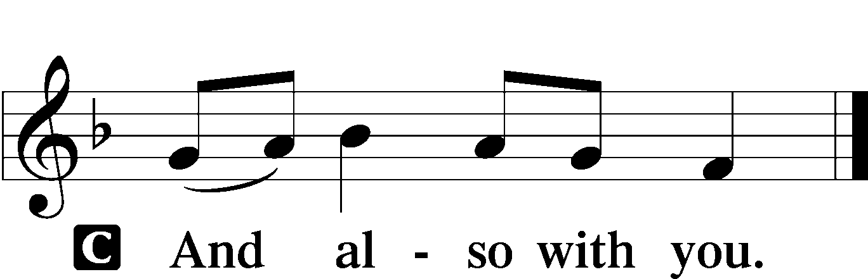

P Let us pray.
Heavenly Father, though we do not deserve Your goodness, still You provide for all our needs of body and soul. Grant us Your Holy Spirit that we may acknowledge Your gifts, give thanks for all Your benefits, and serve You in willing obedience; through Jesus Christ, Your Son, our Lord, who lives and reigns with You and the Holy Spirit, one God, now and forever.

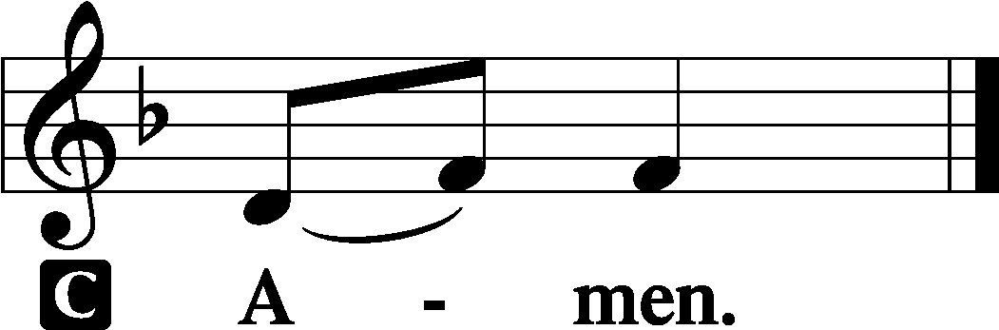

(Sit)

OLD TESTAMENT READING Isaiah 55:1–5
1“Come, everyone who thirsts,
come to the waters;
and he who has no money,
come, buy and eat!
Come, buy wine and milk
without money and without price.
2Why do you spend your money for that which is not bread,
and your labor for that which does not satisfy?
Listen diligently to me, and eat what is good,
and delight yourselves in rich food.
3Incline your ear, and come to me;
hear, that your soul may live;
and I will make with you an everlasting covenant,
my steadfast, sure love for David.
4Behold, I made him a witness to the peoples,
a leader and commander for the peoples.
5Behold, you shall call a nation that you do not know,
and a nation that did not know you shall run to you,
because of the Lord your God, and of the Holy One of Israel,
for he has glorified you.”

P This is the Word of the Lord.
C Thanks be to God.

GRADUAL Romans 11:33, 36
Oh, the depth of the riches and wisdom and knowl- | edge of God!*
How unsearchable are his judgments and how inscrutable | his ways!
For from him and through him and to him are | all things.*
To him be glory forever. | Amen.

EPISTLE Romans 9:1–13
1I am speaking the truth in Christ—I am not lying; my conscience bears me witness in the Holy Spirit— 2that I have great sorrow and unceasing anguish in my heart. 3For I could wish that I myself were accursed and cut off from Christ for the sake of my brothers, my kinsmen according to the flesh. 4They are Israelites, and to them belong the adoption, the glory, the covenants, the giving of the law, the worship, and the promises. 5To them belong the patriarchs, and from their race, according to the flesh, is the Christ who is God over all, blessed forever. Amen.
6But it is not as though the word of God has failed. For not all who are descended from Israel belong to Israel, 7and not all are children of Abraham because they are his offspring, but “Through Isaac shall your offspring be named.” 8This means that it is not the children of the flesh who are the children of God, but the children of the promise are counted as offspring. 9For this is what the promise said: “About this time next year I will return and Sarah shall have a son.” 10And not only so, but also when Rebecca had conceived children by one man, our forefather Isaac, 11though they were not yet born and had done nothing either good or bad—in order that God’s purpose of election might continue, not because of works but because of his call— 12she was told, “The older will serve the younger.” 13As it is written, “Jacob I loved, but Esau I hated.”

P This is the Word of the Lord.
C Thanks be to God.

(Stand)

ALLELUIA AND VERSE LSB 156
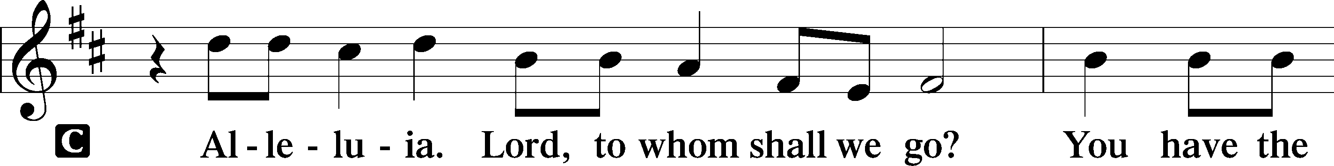
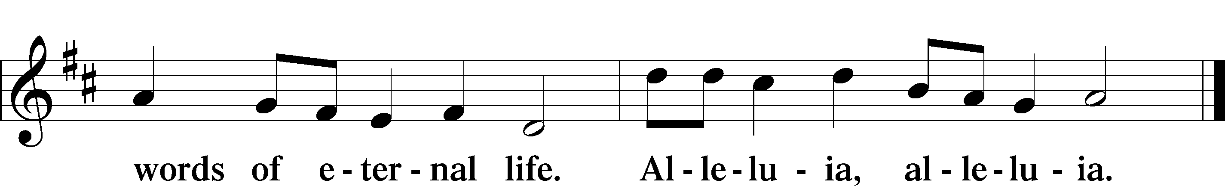

HOLY GOSPEL Matthew 14:13–21
P The Holy Gospel according to St. Matthew, the fourteenth chapter.

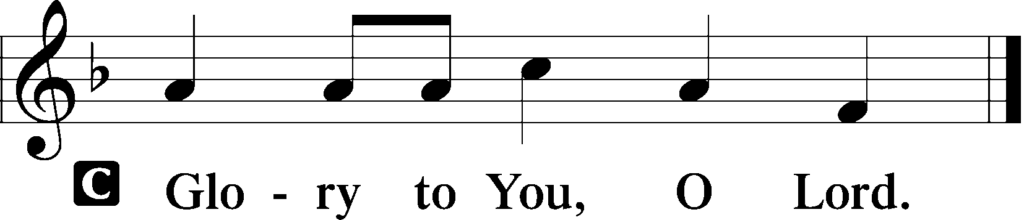

13Now when Jesus heard [about the death of John], he withdrew from there in a boat to a desolate place by himself. But when the crowds heard it, they followed him on foot from the towns. 14When he went ashore he saw a great crowd, and he had compassion on them and healed their sick. 15Now when it was evening, the disciples came to him and said, “This is a desolate place, and the day is now over; send the crowds away to go into the villages and buy food for themselves.” 16But Jesus said, “They need not go away; you give them something to eat.” 17They said to him, “We have only five loaves here and two fish.” 18And he said, “Bring them here to me.” 19Then he ordered the crowds to sit down on the grass, and taking the five loaves and the two fish, he looked up to heaven and said a blessing. Then he broke the loaves and gave them to the disciples, and the disciples gave them to the crowds. 20And they all ate and were satisfied. And they took up twelve baskets full of the broken pieces left over. 21And those who ate were about five thousand men, besides women and children.

P This is the Gospel of the Lord.

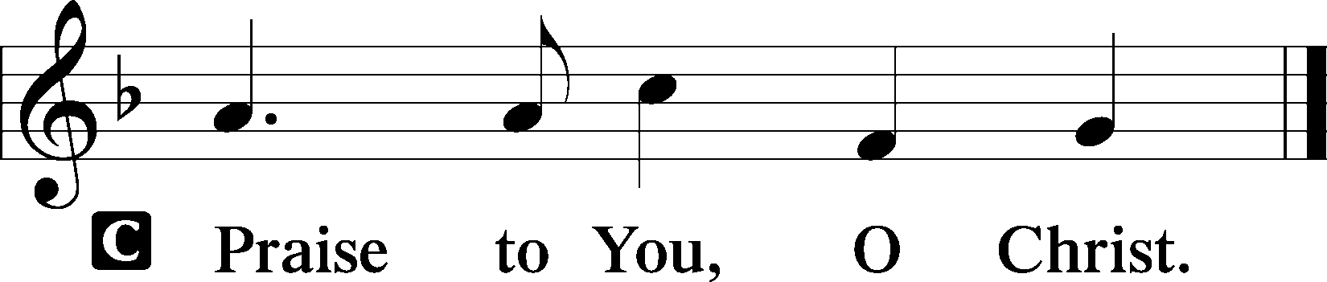

(Sit)

642 O LIVING BREAD FROM HEAVEN
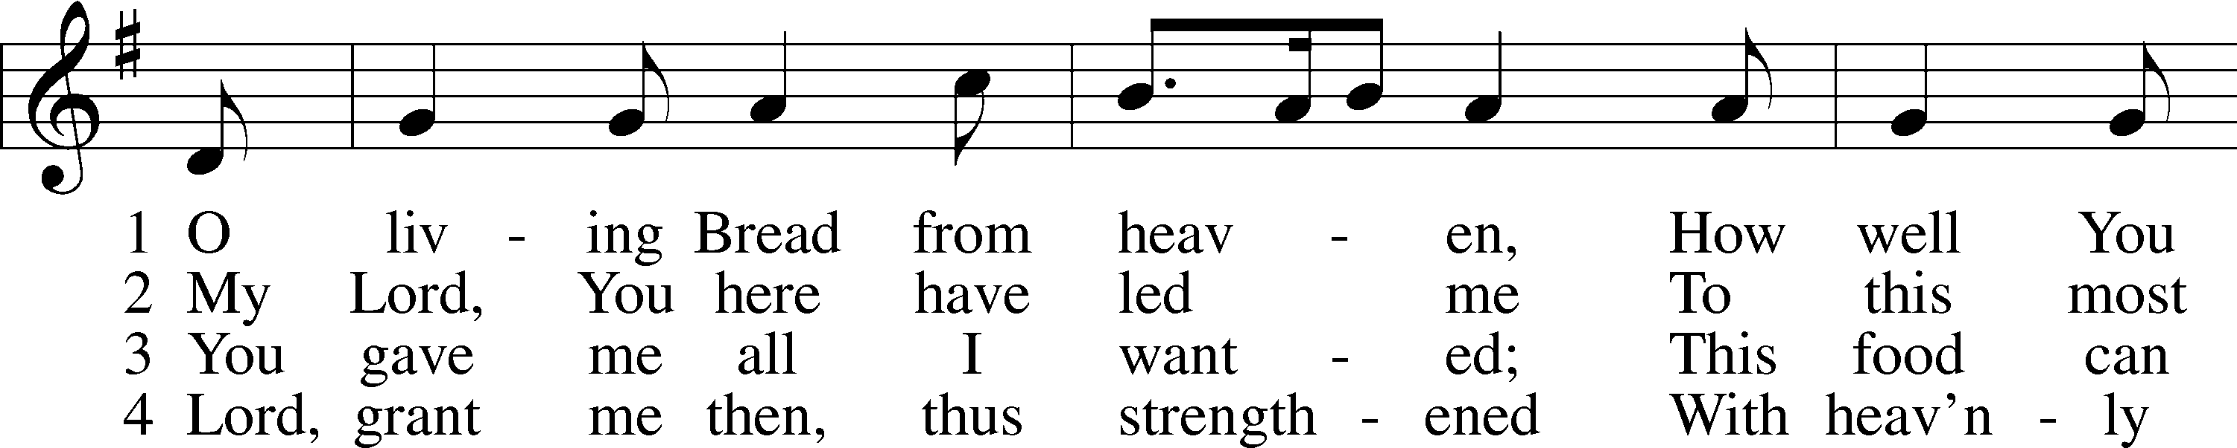
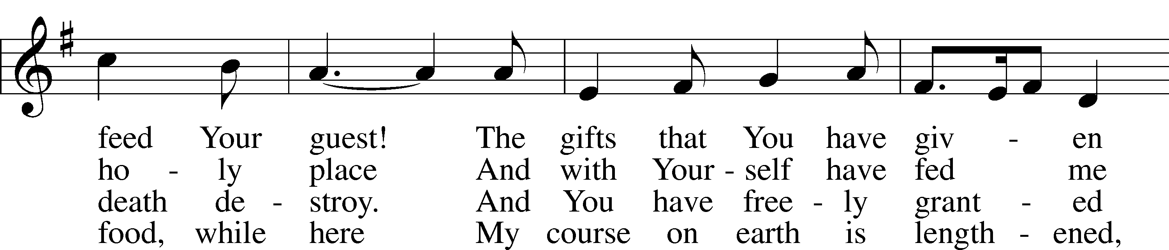
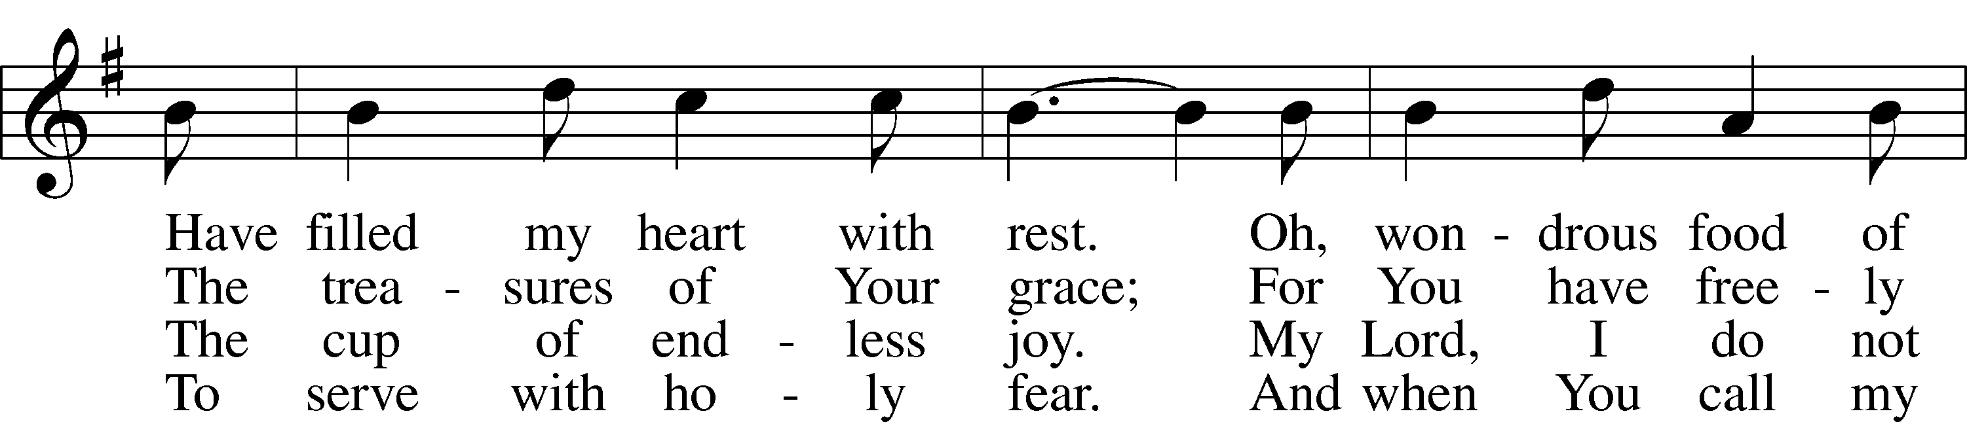
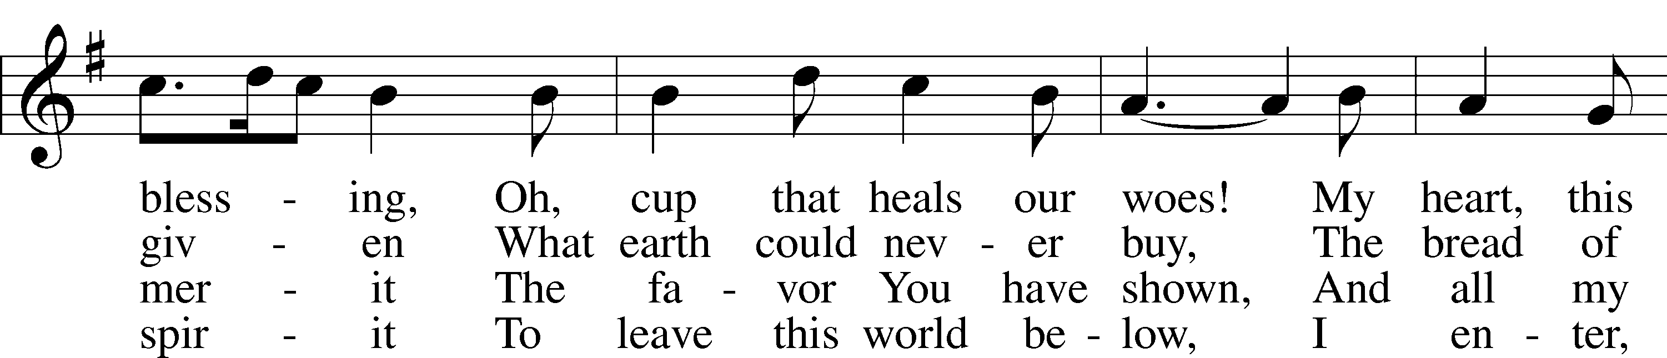
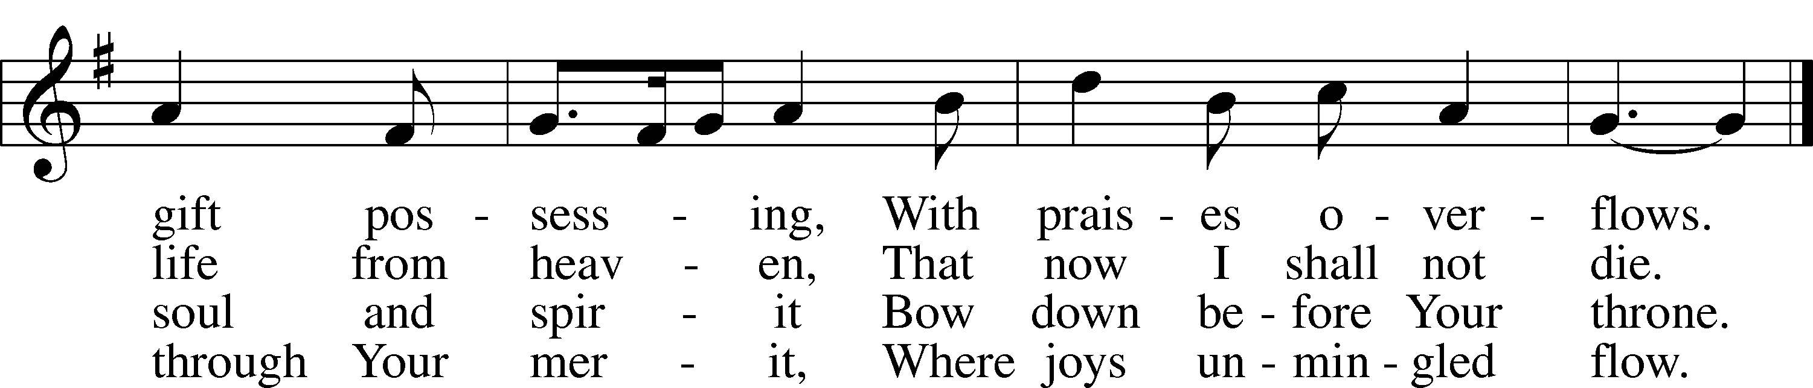
Text: Johann Rist, 1607–67; tr. Catherine Winkworth, 1827–78, alt.
Tune: Musae Sioniae, 1609, vol. 7, Wolfenbüttel, ed. Michael Praetorius
Text and tune: Public domain

SERMON

(Stand)

NICENE CREED LSB 158
C I believe in one God,
the Father Almighty,
maker of heaven and earth
and of all things visible and invisible.

And in one Lord Jesus Christ,
the only-begotten Son of God,
begotten of His Father before all worlds,
God of God, Light of Light,
very God of very God,
begotten, not made,
being of one substance with the Father,
by whom all things were made;
who for us men and for our salvation came down from heaven
and was incarnate by the Holy Spirit of the virgin Mary
and was made man;
and was crucified also for us under Pontius Pilate.
He suffered and was buried.
And the third day He rose again according to the Scriptures
and ascended into heaven
and sits at the right hand of the Father.
And He will come again with glory to judge both the living and the dead,
whose kingdom will have no end.

And I believe in the Holy Spirit,
the Lord and giver of life,
who proceeds from the Father and the Son,
who with the Father and the Son together is worshiped and glorified,
who spoke by the prophets.
And I believe in one holy Christian and apostolic Church,
I acknowledge one Baptism for the remission of sins,
and I look for the resurrection of the dead
and the life T of the world to come. Amen.

SHARING OF THE PEACE

(The people may greet one another in the name of the Lord, saying, “Peace be with you,” as a sign of reconciliation and of the unity of the Spirit in the bond of peace (Matt. 5:22–24; Eph. 4:1–3).)

(Sit)

PRAYER OF THE CHURCH

OFFERING

(As a part of our expression of thanksgiving to God for the treasure of His salvation to us, we offer a portion of our treasure, according to what each has determined in their heart to give. Please place offerings in the collection plate at the back of the sanctuary before or after the service. Offerings can also be sent to Bethlehem Lutheran Church via U.S. Mail. Thank you!)

(Stand)

OFFERTORY LSB 159
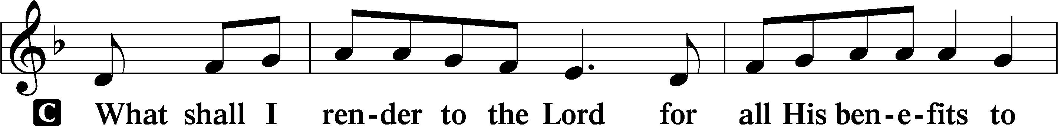
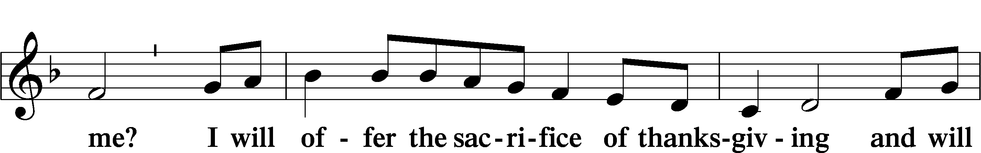
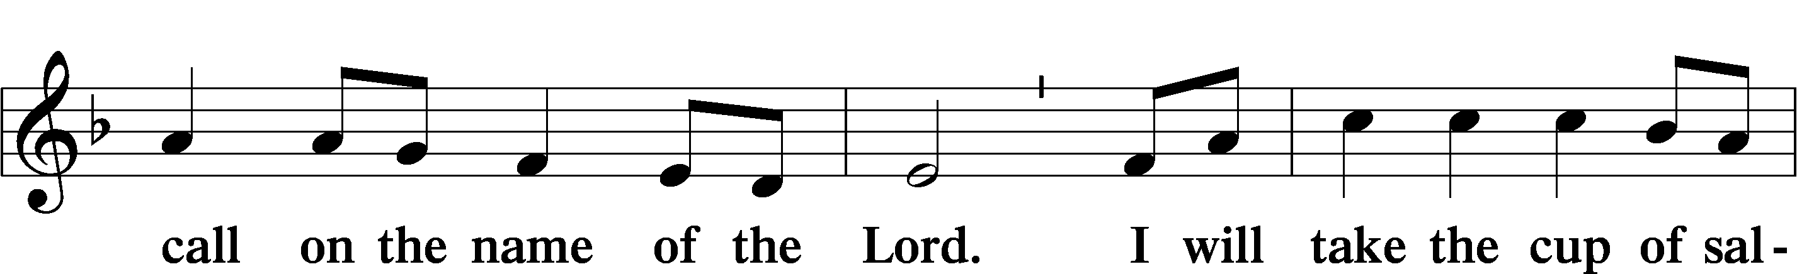
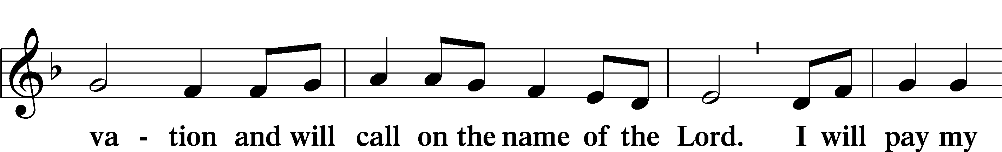
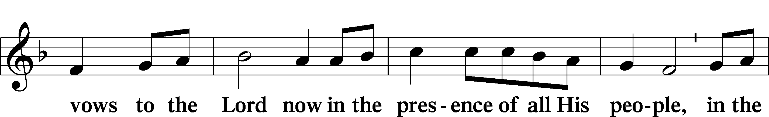
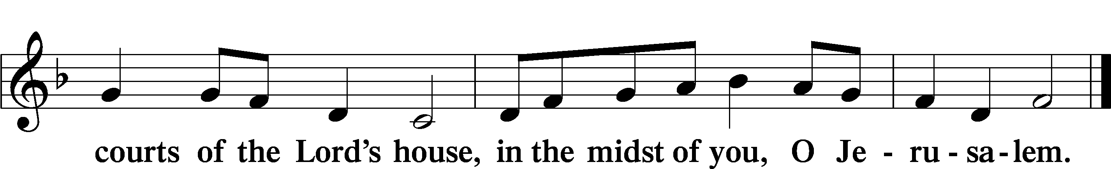

+ SERVICE OF THE SACRAMENT +

PREFACE LSB 160
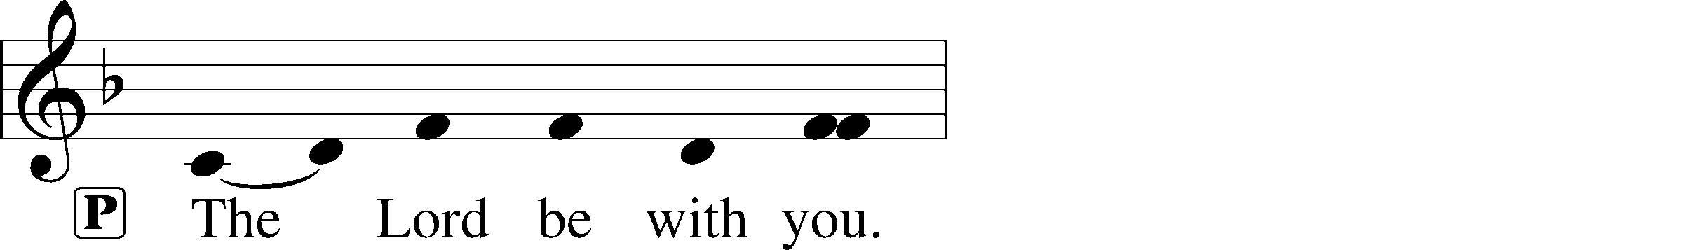
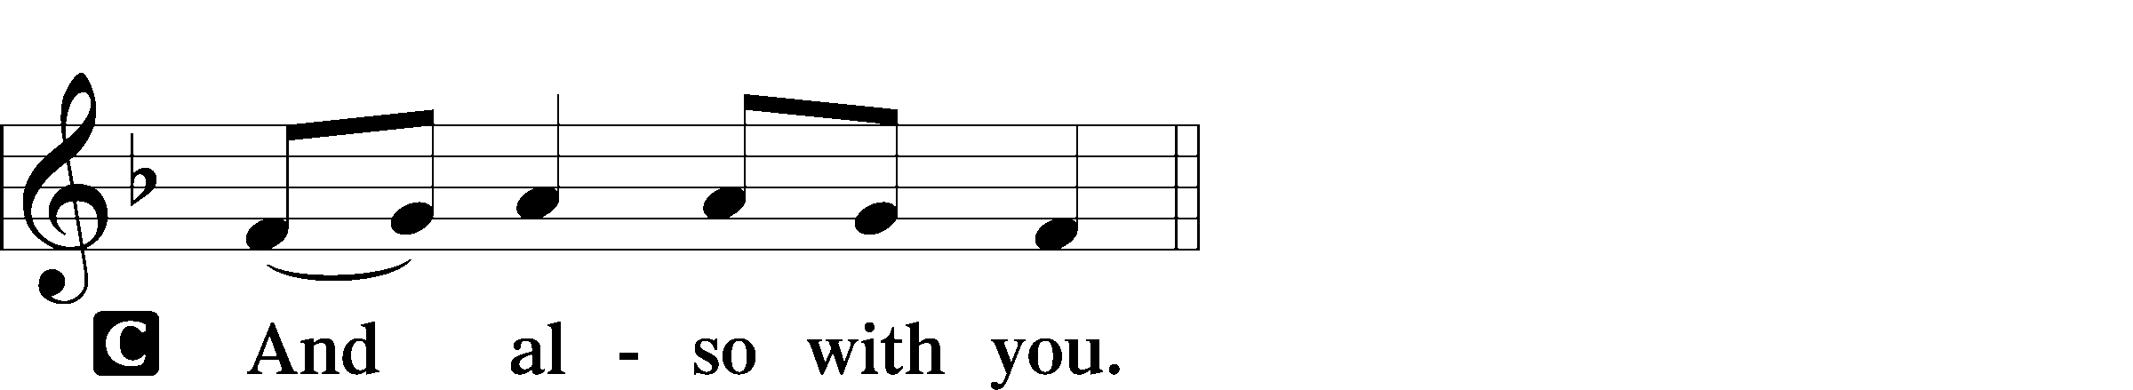
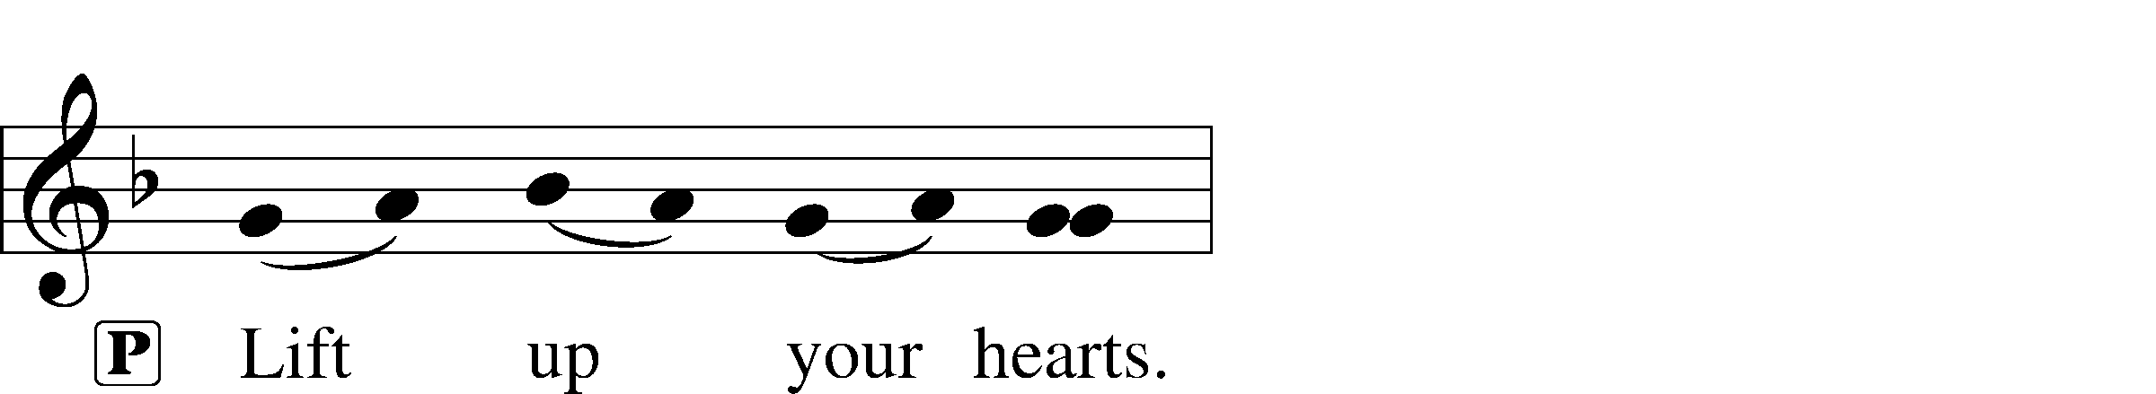

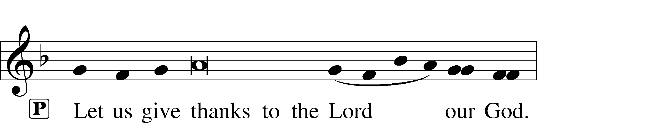
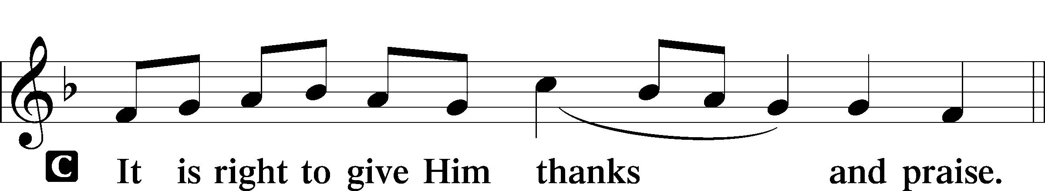

PROPER PREFACE (ABBREVIATED) LSB 161
P It is truly good, right, and salutary . . . evermore praising You and saying:

SANCTUS LSB 161
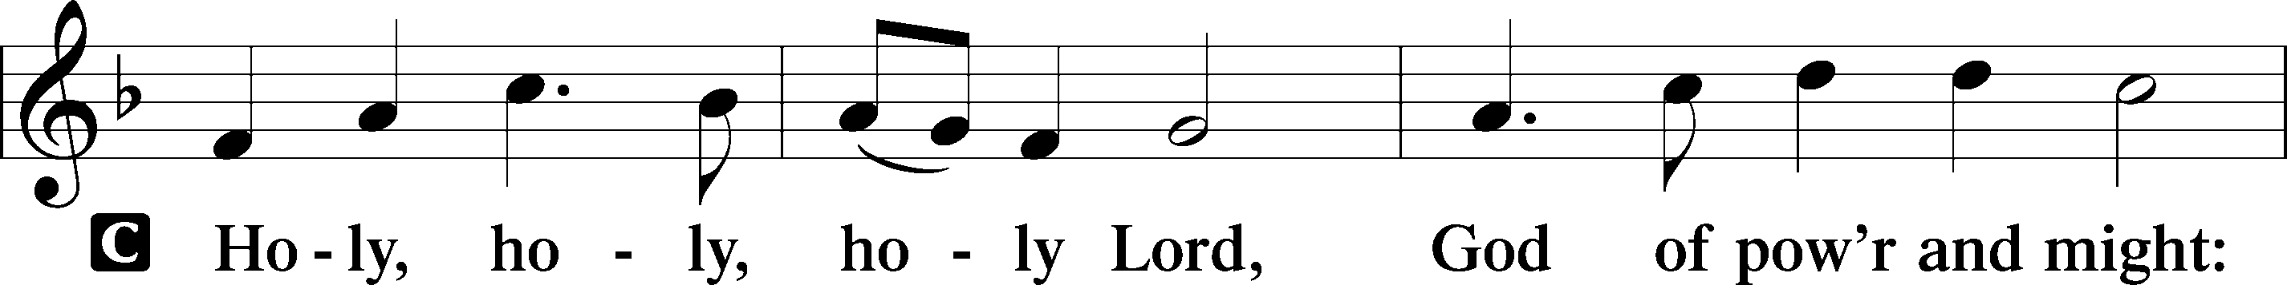
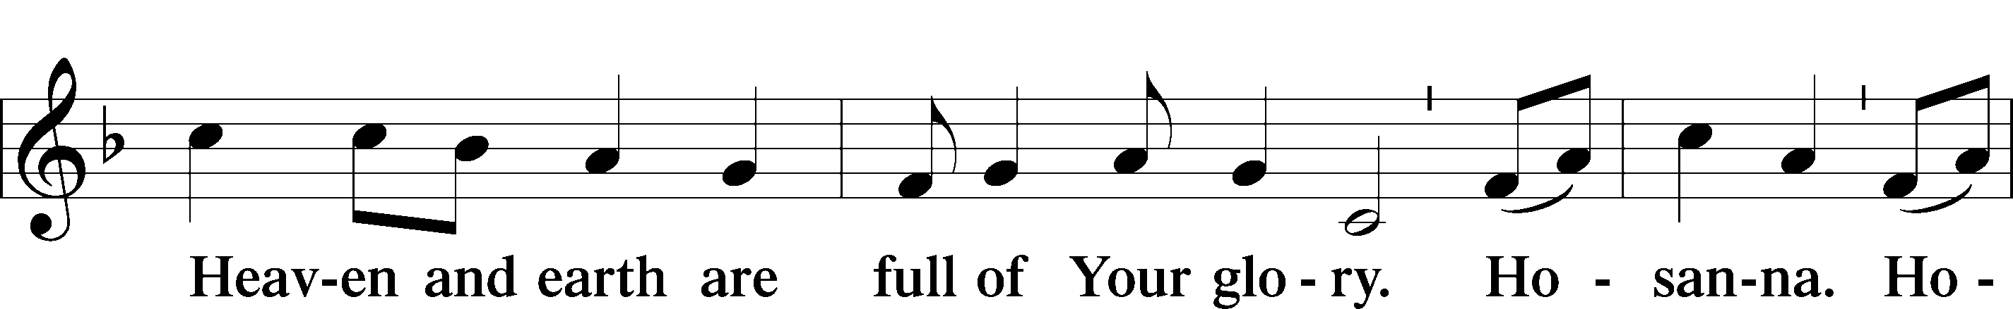
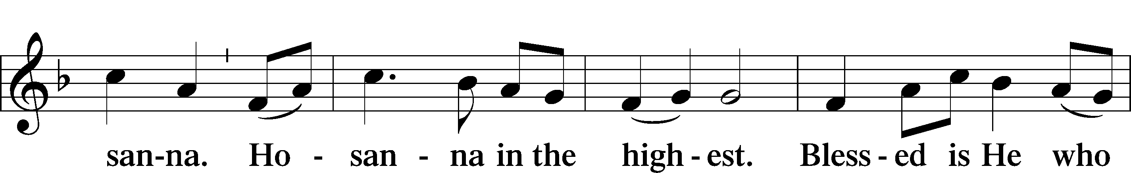
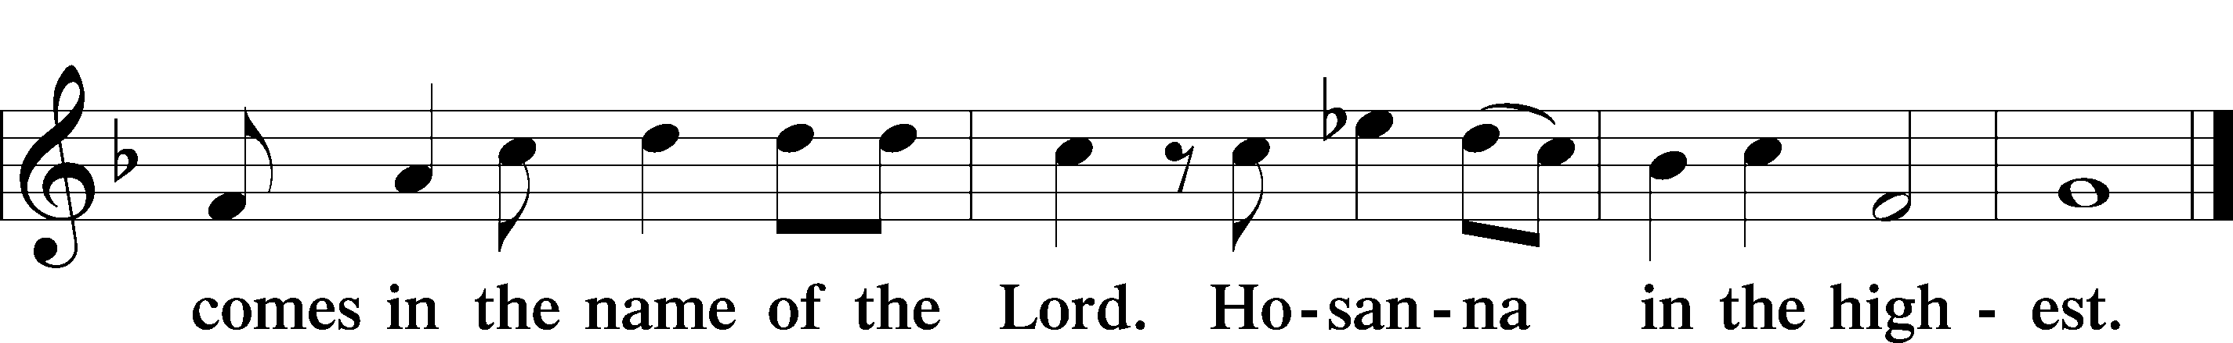

PRAYER OF THANKSGIVING LSB 161
P Blessed are You, Lord of heaven and earth...
,... with the Son and the Holy Spirit, one God, now and forever.
C Amen.

LORD’S PRAYER LSB 162
P Lord, remember us in Your kingdom and teach us to pray:
C Our Father who art in heaven,
hallowed be Thy name,
Thy kingdom come,
Thy will be done on earth
as it is in heaven;
give us this day our daily bread;
and forgive us our trespasses
as we forgive those
who trespass against us;
and lead us not into temptation,
but deliver us from evil.
For Thine is the kingdom
and the power and the glory
forever and ever. Amen.

THE WORDS OF OUR LORD LSB 162

PAX DOMINI LSB 163
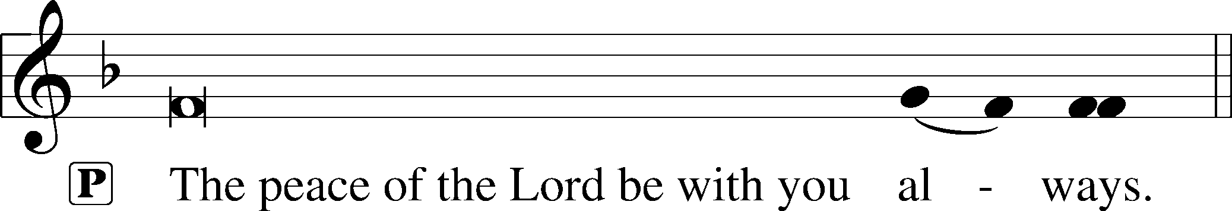


AGNUS DEI LSB 163
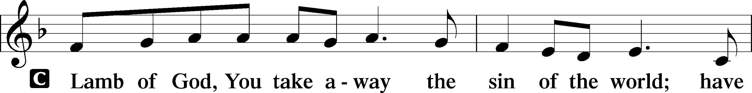
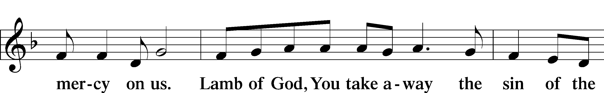
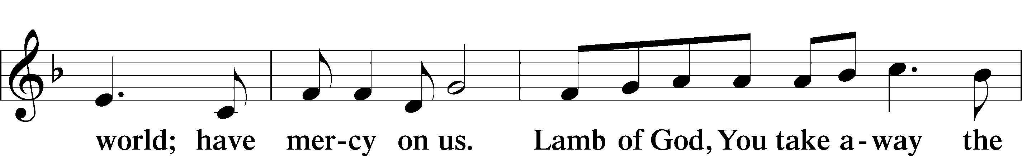
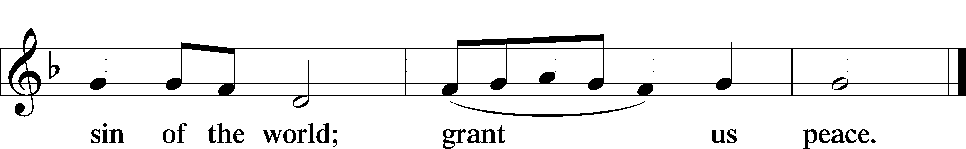

(Sit)

DISTRIBUTION

(The pastor and those assisting him are communed first, then commune those who are unable to come to the altar. The ushers will then direct all other communicants to the altar.)

699 I HEARD THE VOICE OF JESUS SAY
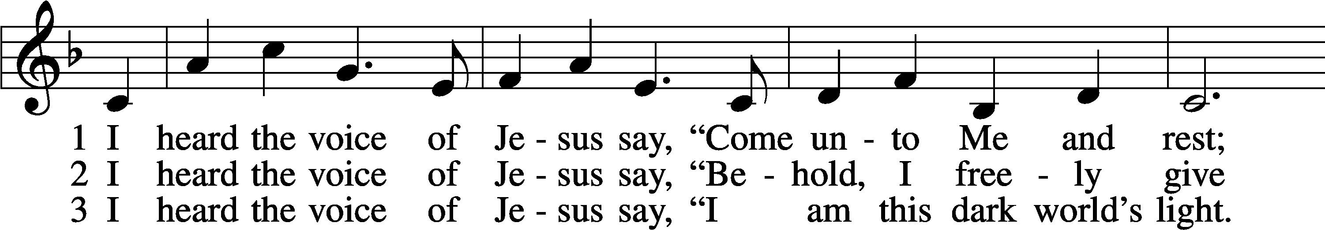
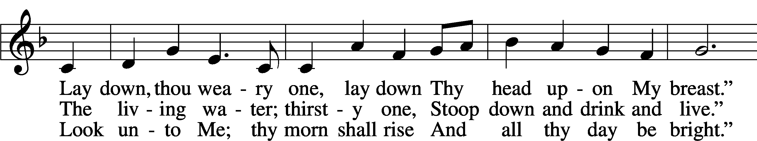
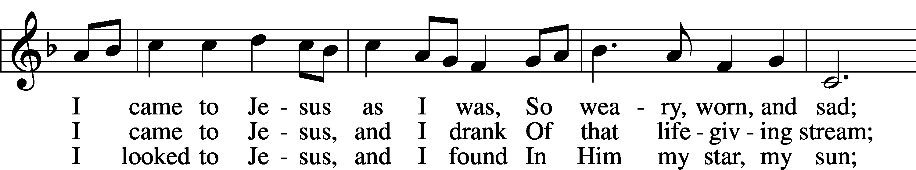
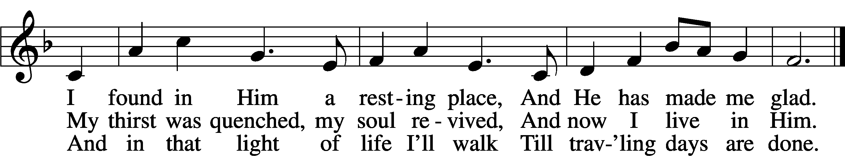
Text: Horatius Bonar, 1808–89, alt.
Tune: Amanda Husberg, 1940–2021
Text: Public domain
Tune: © 1996 Amanda Husberg. Used by permission: LSB Hymn License no. 110004798

INSTRUMENTAL

(Stand)

THANK THE LORD LSB 164
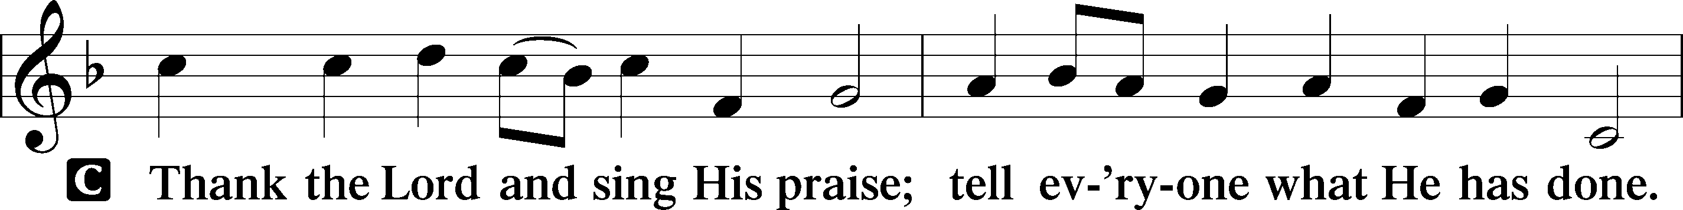
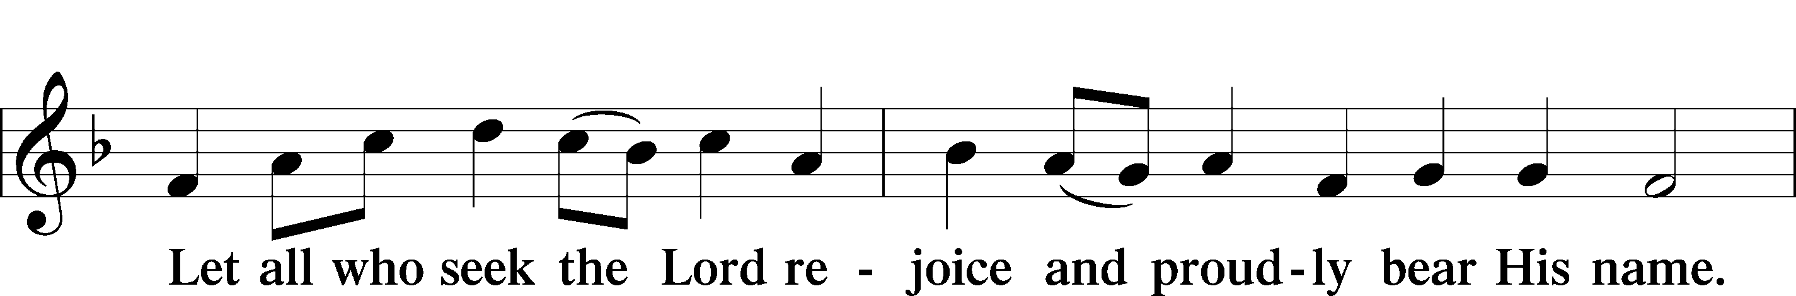
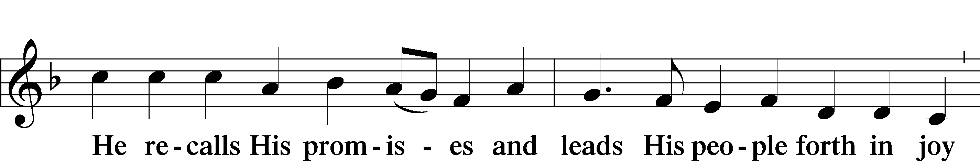
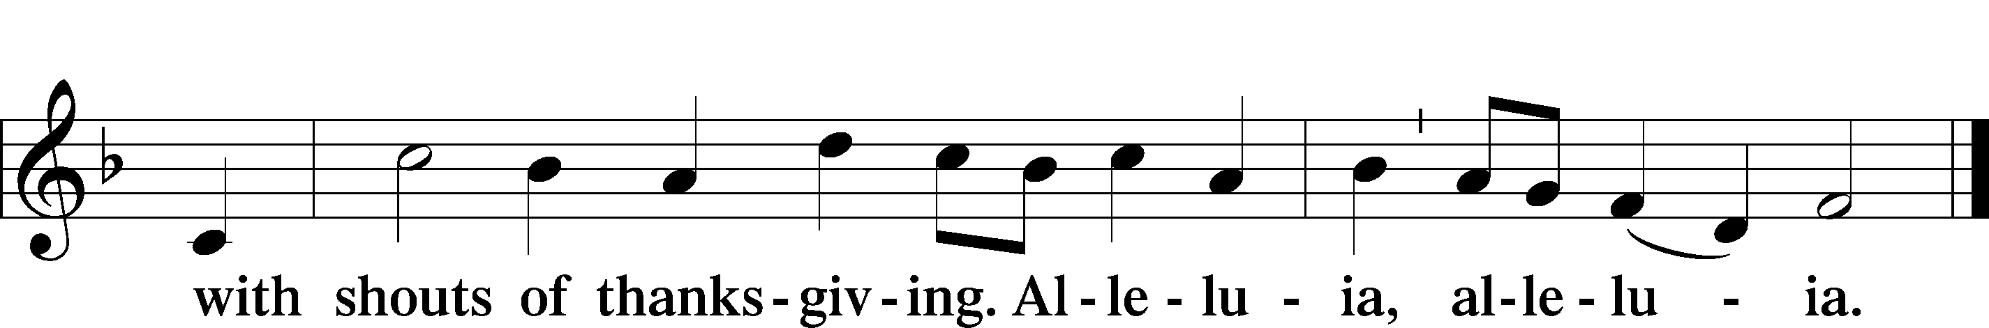

POST-COMMUNION COLLECT LSB 166
P Let us pray.
...through Jesus Christ, Your Son, our Lord, who lives and reigns with You and the Holy Spirit, one God, now and forever.
C Amen.

BENEDICTION LSB 166
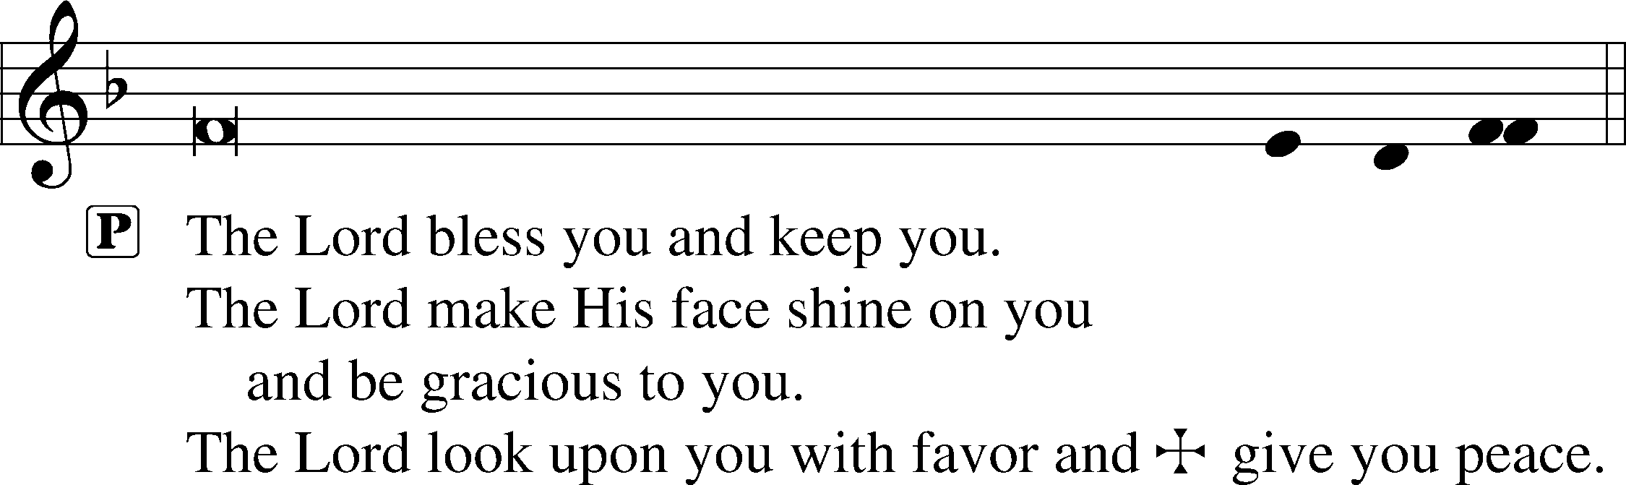
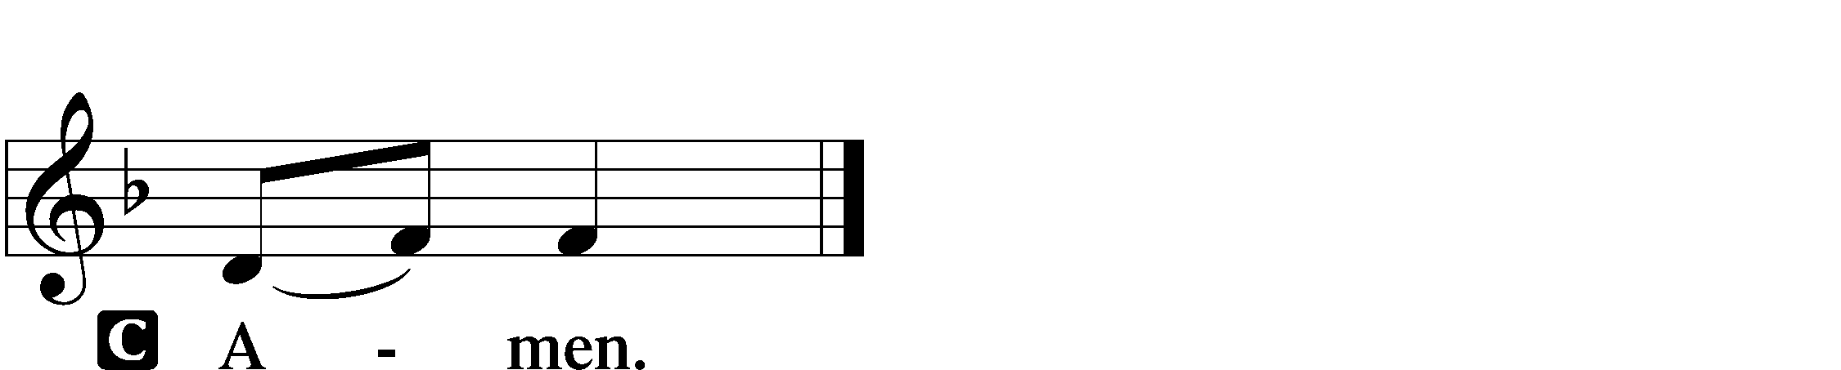

573 LORD, ’TIS NOT THAT I DID CHOOSE THEE
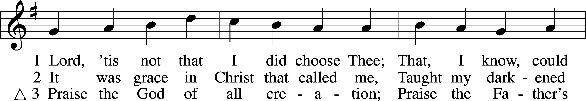
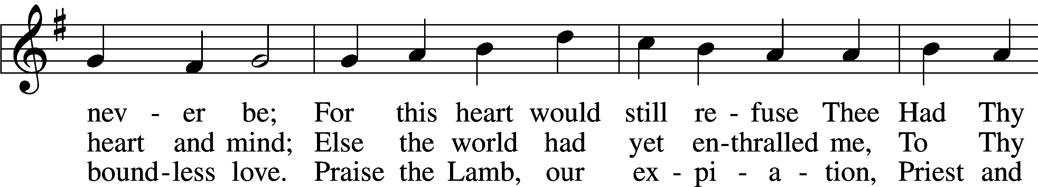
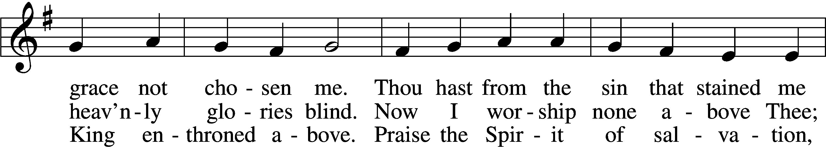
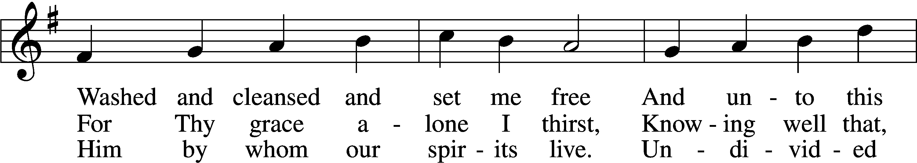
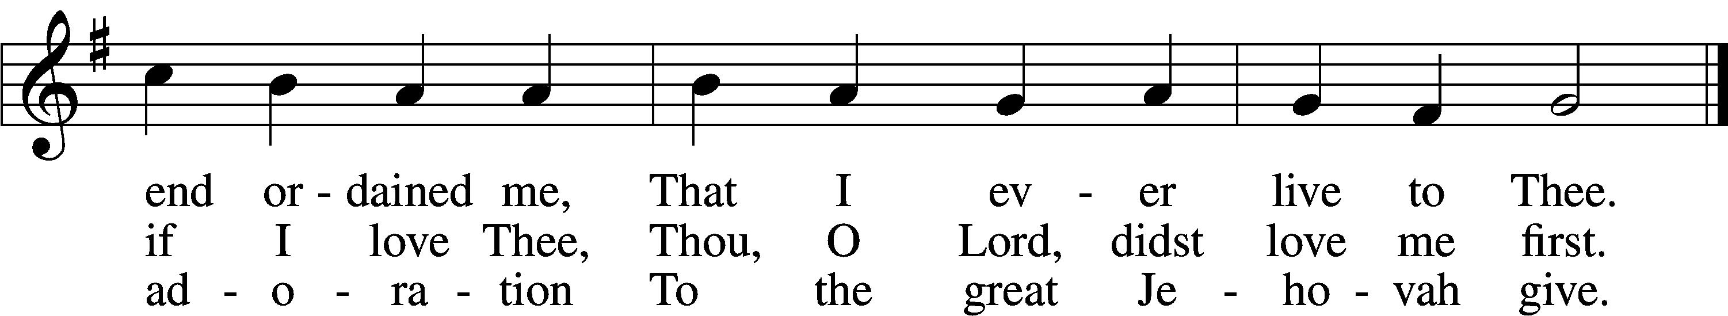
Text: Josiah Conder, 1789–1855, alt.
Tune: Erbaulicher Musicalischer Christen-Schatz, 1745, Basel
Text and tune: Public domain
ACKNOWLEDGMENTS
Unless otherwise indicated, Scripture quotations are from the ESV® Bible (The Holy Bible, English Standard Version®), copyright © 2001 by Crossway, a publishing ministry of Good News Publishers. Used by permission. All rights reserved.
Created by Lutheran Service Builder © 2026 Concordia Publishing House.

