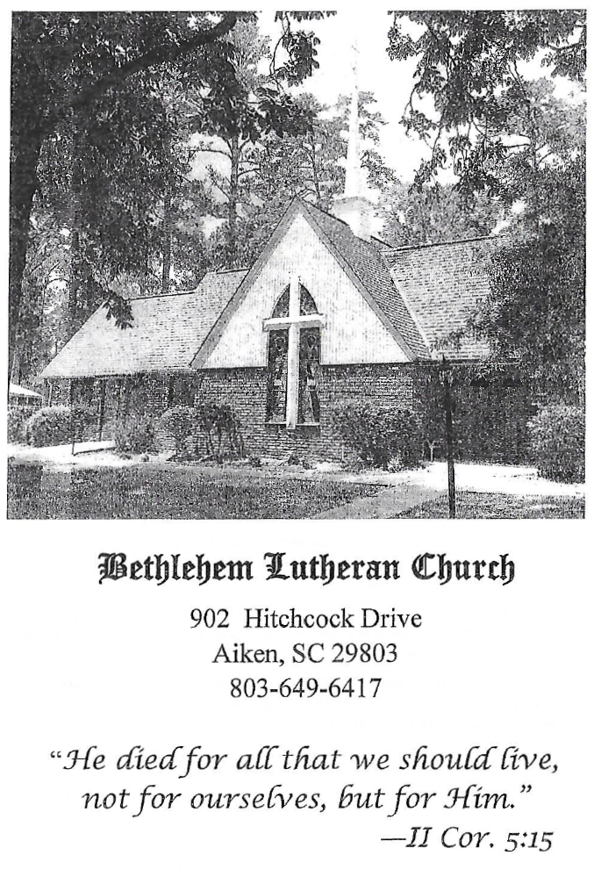

BETHLEHEM LUTHERAN CHURCH
A congregation of The Lutheran Church-Missouri Synod
902 Hitchcock Drive SW,
Aiken, South Carolina 29803
Church Phone: (803) 649-6417
blcaikensc@gmail.com

Bethlehem Lutheran welcomes our members and guests to our worship service! Unable to join us in person? Please find us on Facebook live. The service is also posted on our website; bethlehemlutheranaiken.org.

+ + + + + + + + + + + + + + +
Fifteenth Sunday after Pentecost
September 6, 2026
10:30 a.m.
+ + + + + + + + + + + + + + +

Our Policy and Practice Regarding Holy Communion
Hear the words of the Apostle Paul;
Anyone who eats and drinks without recognizing the body of the Lord eats and drinks judgment on himself. -1 Cor.11:29
Therefore, visitors are asked to please refrain from partaking of the Sacrament before speaking about this with the pastor; because we care about your spiritual well-being.
Also, because communing at this altar is a public confession that you agree with the doctrines of The Lutheran Church-Missouri Synod, and reject all contrary teachings.
Persons who are not communing today are always welcome to come forward during the distribution to receive an individual blessing; please cross your arms over your chest to indicate your desire for this. Thank you!
We commune in two alternating tables. The ushers will guide you. Non-alcoholic white wine is available in the center of the individual cup tray. Please leave empty individual cups at the altar rail.

+ SERVICE OF PREPARATION +

(After the bell tolls, please observe a time of silence.)

WELCOME AND ANNOUNCEMENTS

(Stand)

864 SHEPHERD OF TENDER YOUTH
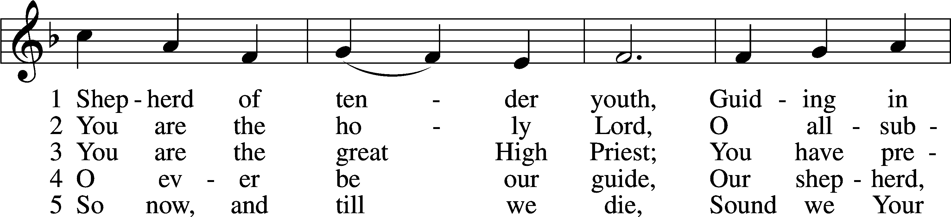
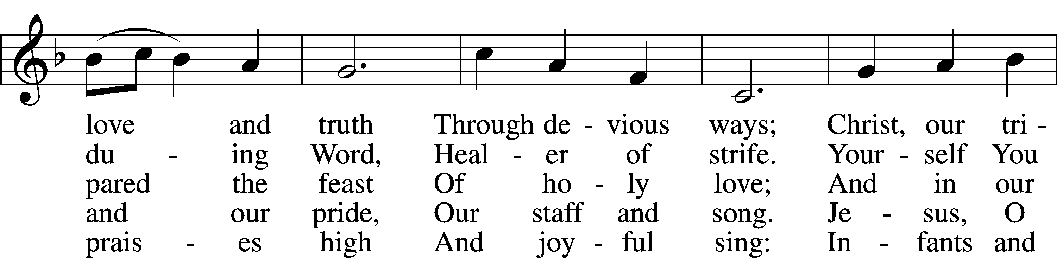
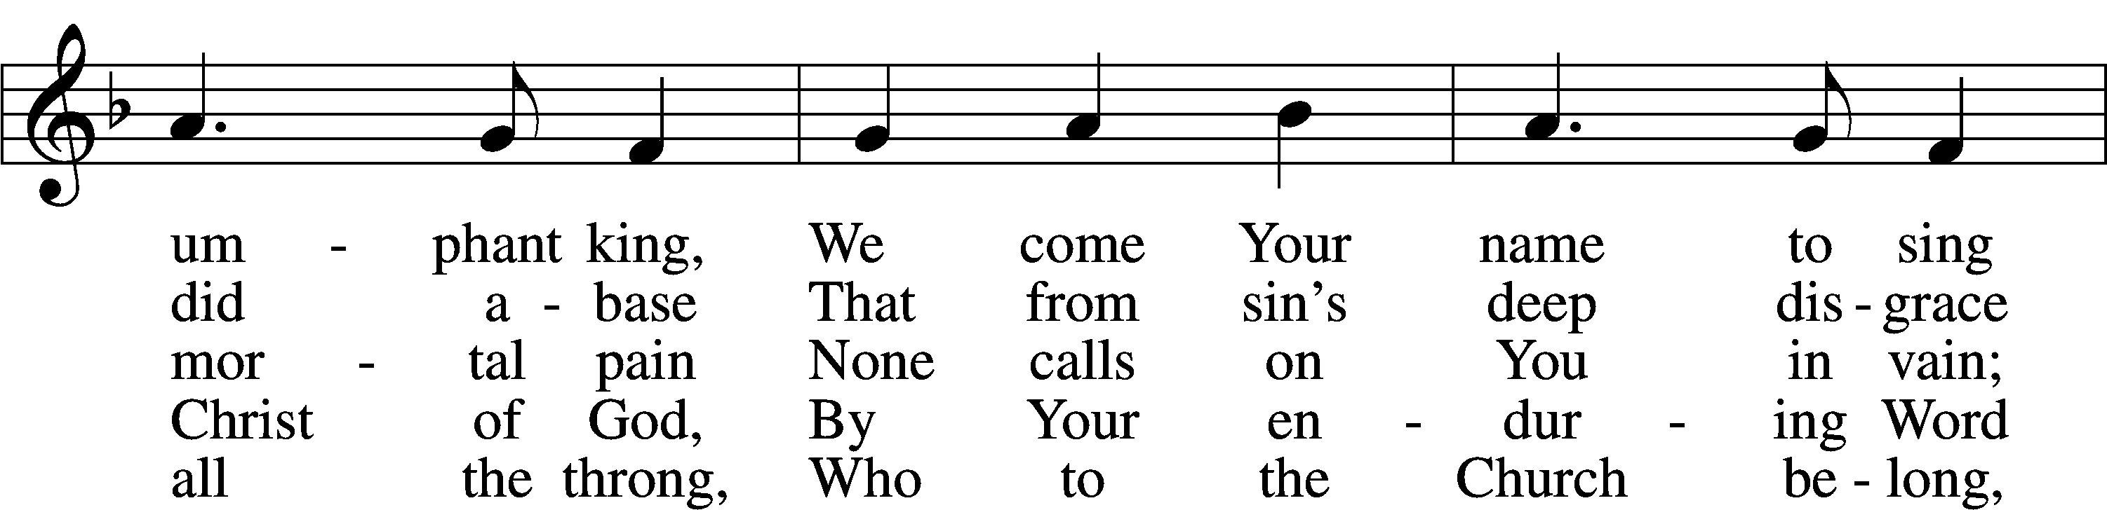
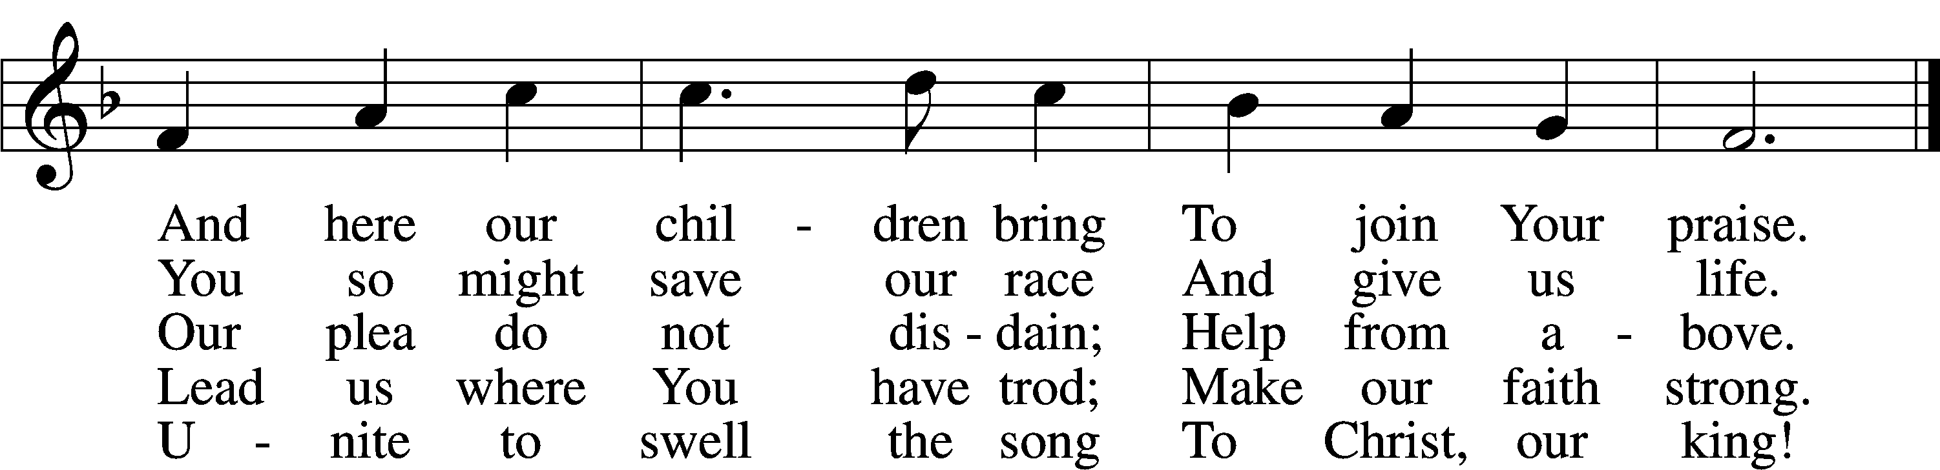
Text: attr. Clement of Alexandria, c. 170–c. 220; tr. Henry M. Dexter, 1821–90, alt.
Tune: Felice de Giardini, 1716–96
Text and tune: Public domain

+ CONFESSION AND ABSOLUTION +

(The sign of the cross may be made by all in remembrance of their Baptism.)

INVOCATION LSB 151
P In the name of the Father and of the T Son and of the Holy Spirit.
C Amen.

EXHORTATION LSB 151
P If we say we have no sin, we deceive ourselves, and the truth is not in us.
C But if we confess our sins, God, who is faithful and just, will forgive our sins and cleanse us from all unrighteousness.

(Silence for reflection on God’s Word and for self-examination.)

CONFESSION OF SINS LSB 151
P Let us then confess our sins to God our Father.
C Most merciful God, we confess that we are by nature sinful and unclean. We have sinned against You in thought, word, and deed, by what we have done and by what we have left undone. We have not loved You with our whole heart; we have not loved our neighbors as ourselves. We justly deserve Your present and eternal punishment. For the sake of Your Son, Jesus Christ, have mercy on us. Forgive us, renew us, and lead us, so that we may delight in Your will and walk in Your ways to the glory of Your holy name. Amen.

ABSOLUTION LSB 151
P Almighty God in His mercy has given His Son to die for you and for His sake forgives you all your sins. As a called and ordained servant of Christ, and by His authority, I therefore forgive you all your sins in the name of the Father and of the T Son and of the Holy Spirit.
C Amen.

+ SERVICE OF THE WORD +

PSALM Psalm 32:1–7
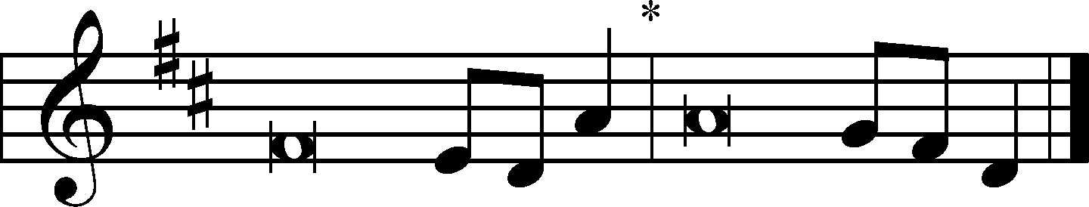
1Blessèd is the one whose transgression is for- | given,*
whose sin is | covered.
2Blessèd is the man against whom the Lord counts no in- | iquity,*
and in whose spirit there is | no deceit.
3For when I kept silent, my bones wast- | ed away*
through my groaning | all day long.
4For day and night your hand was heavy up- | on me;*
my strength was dried up as by the heat of | summer.
5I acknowledged my sin to you,
and I did not cover my in- | iquity;*
I said, “I will confess my transgressions to the Lord,”
and you forgave the iniquity | of my sin.
6Therefore let everyone who is godly
offer prayer to you at a time when you | may be found;*
surely in the rush of great waters,
they shall not | reach him.
7You are a hiding place for me;
you preserve me from | trouble;*
you surround me with shouts of de- | liverance.

KYRIE LSB 152
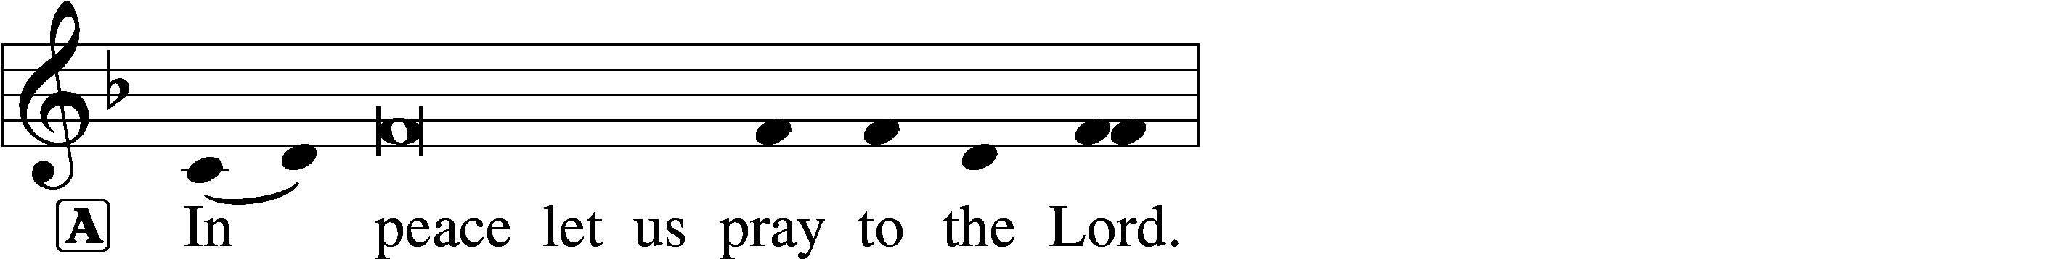
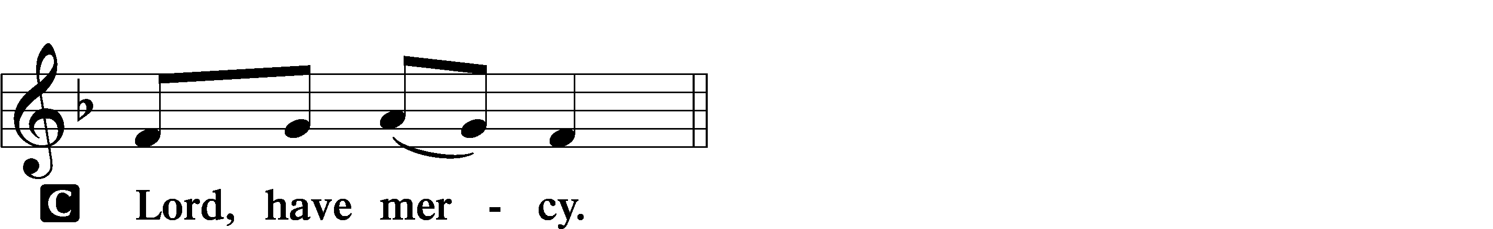

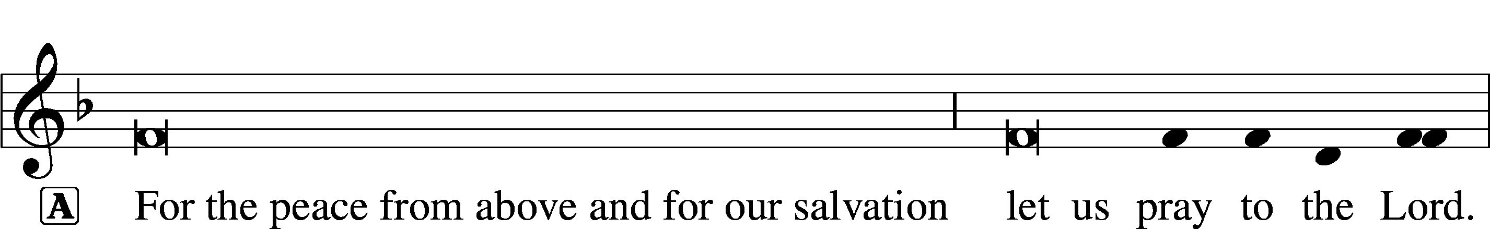

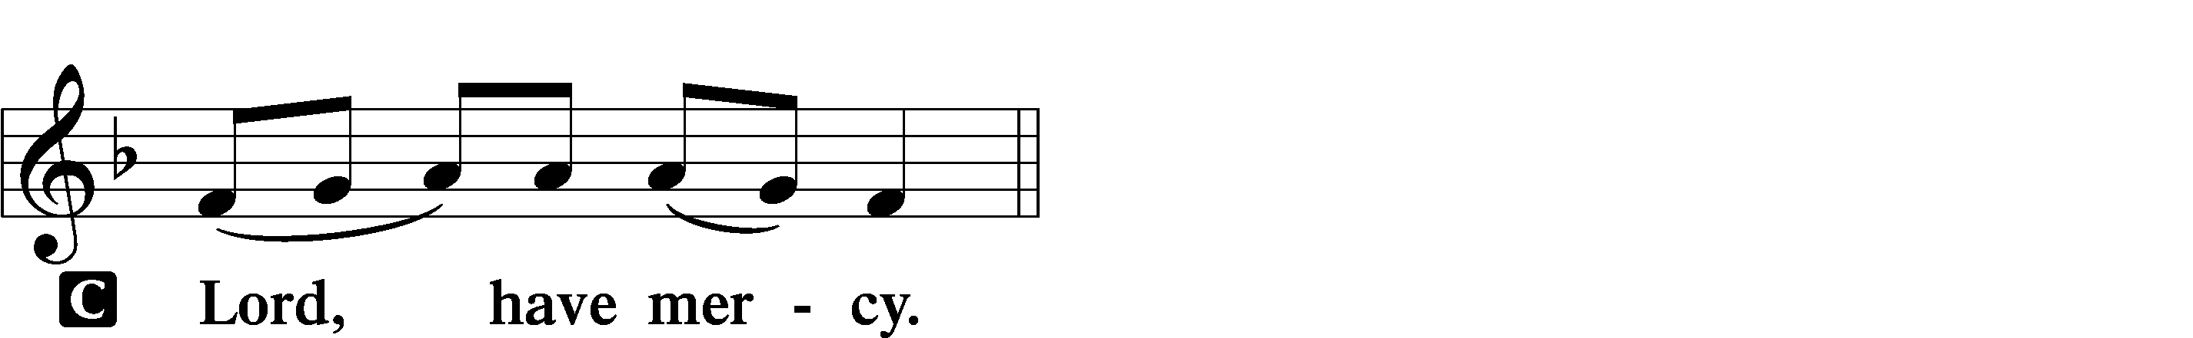

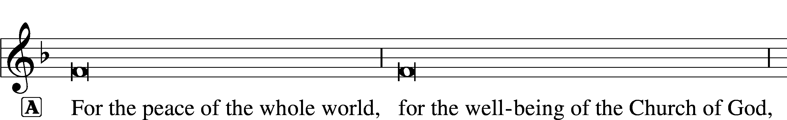
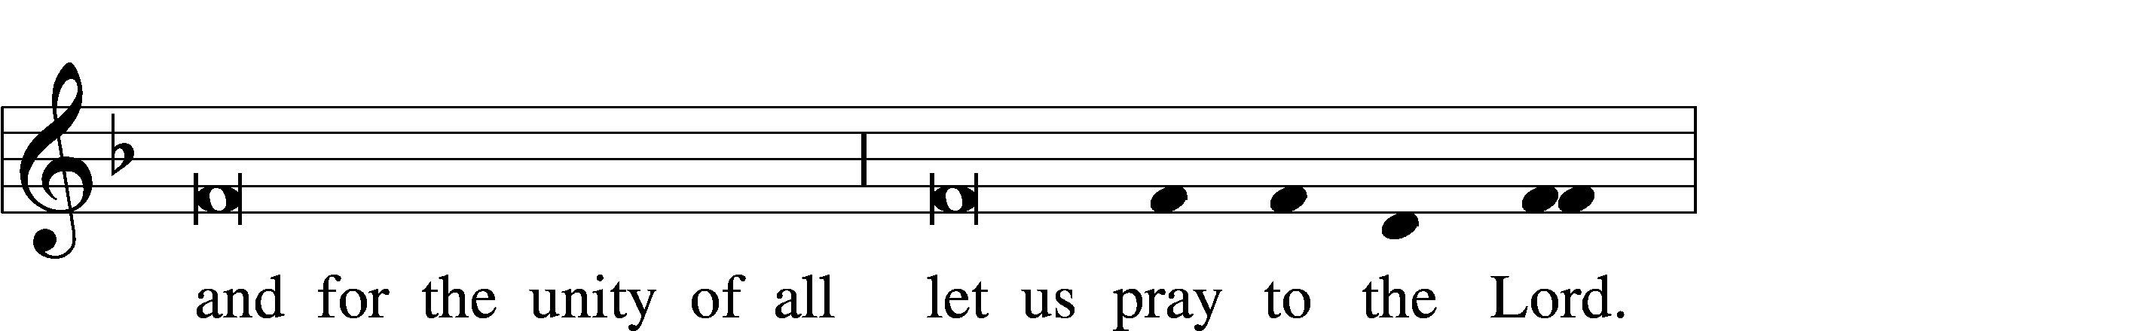
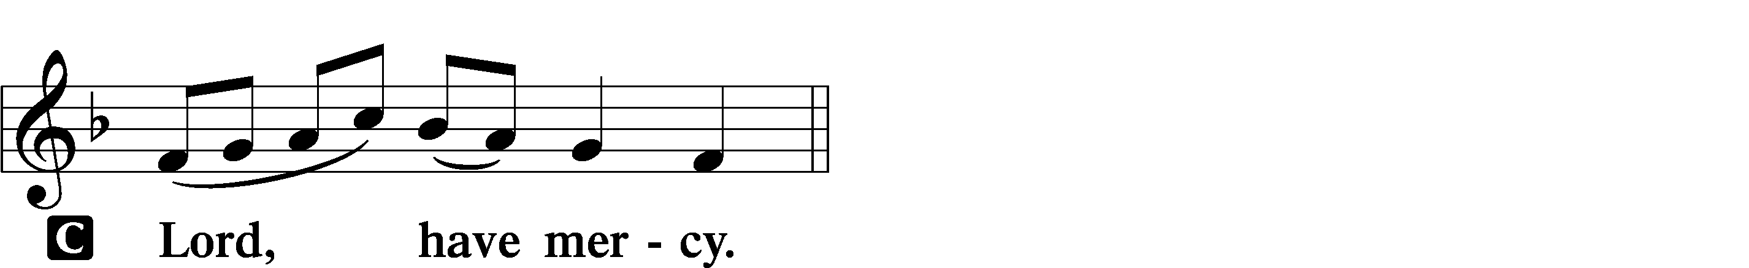

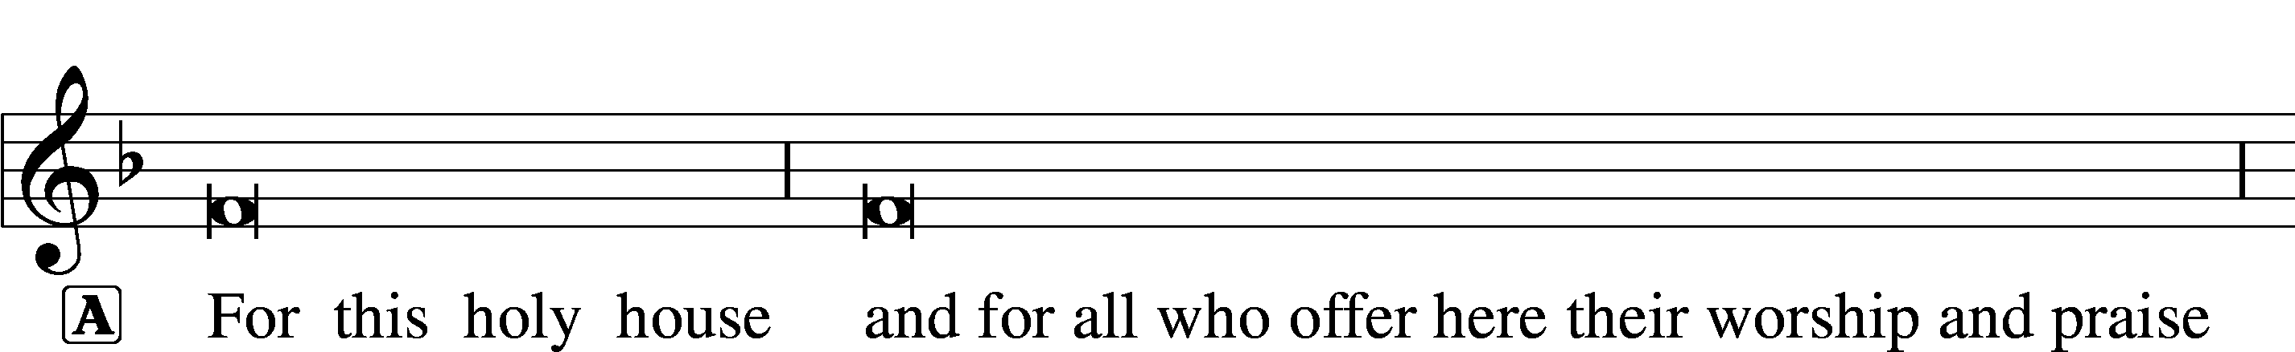
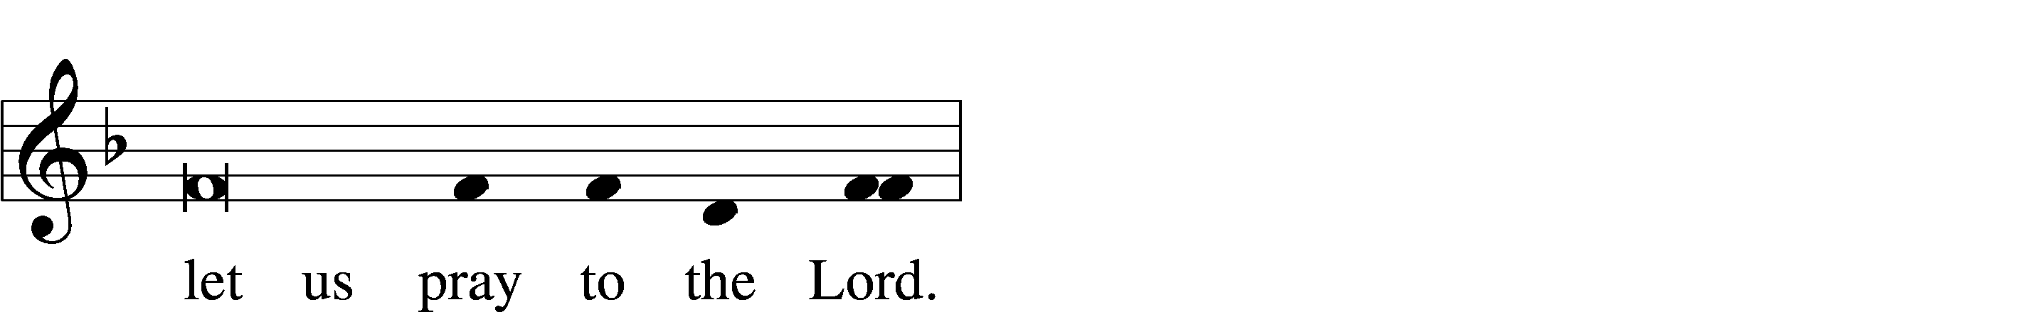
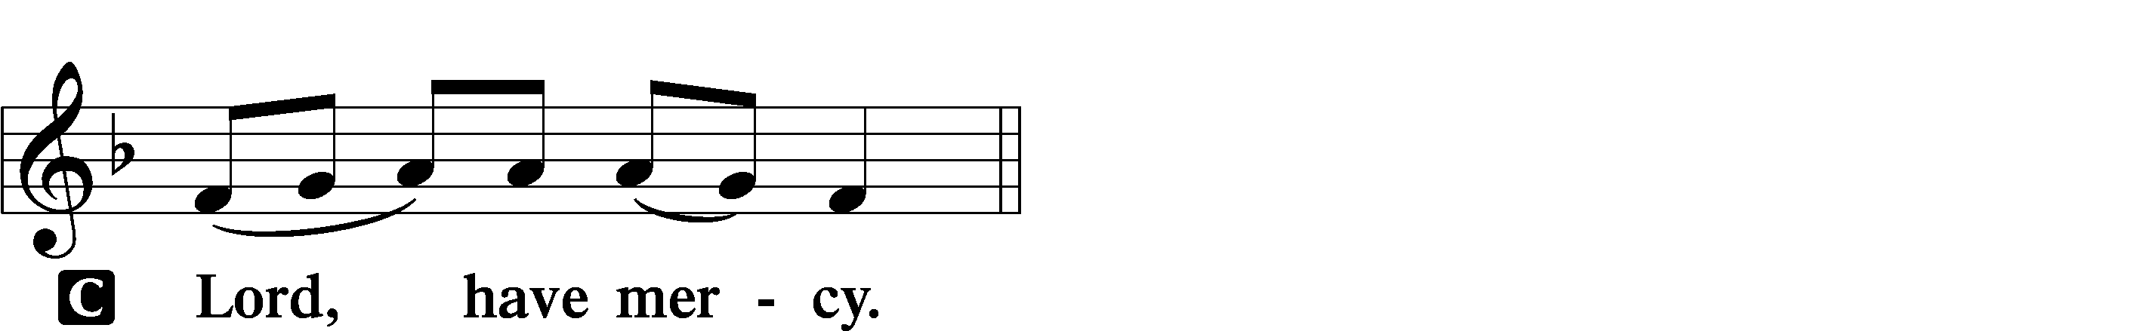

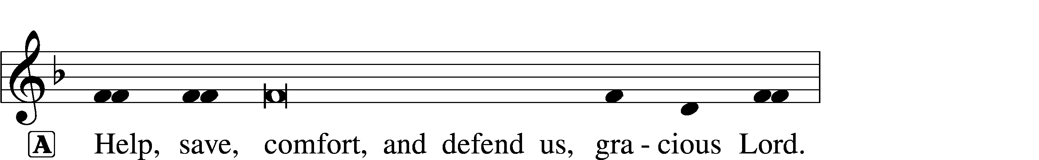


THIS IS THE FEAST LSB 155
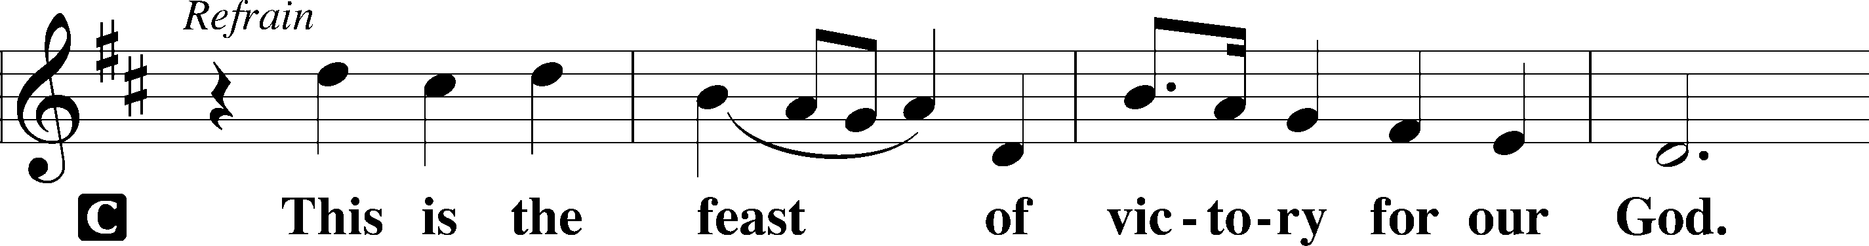
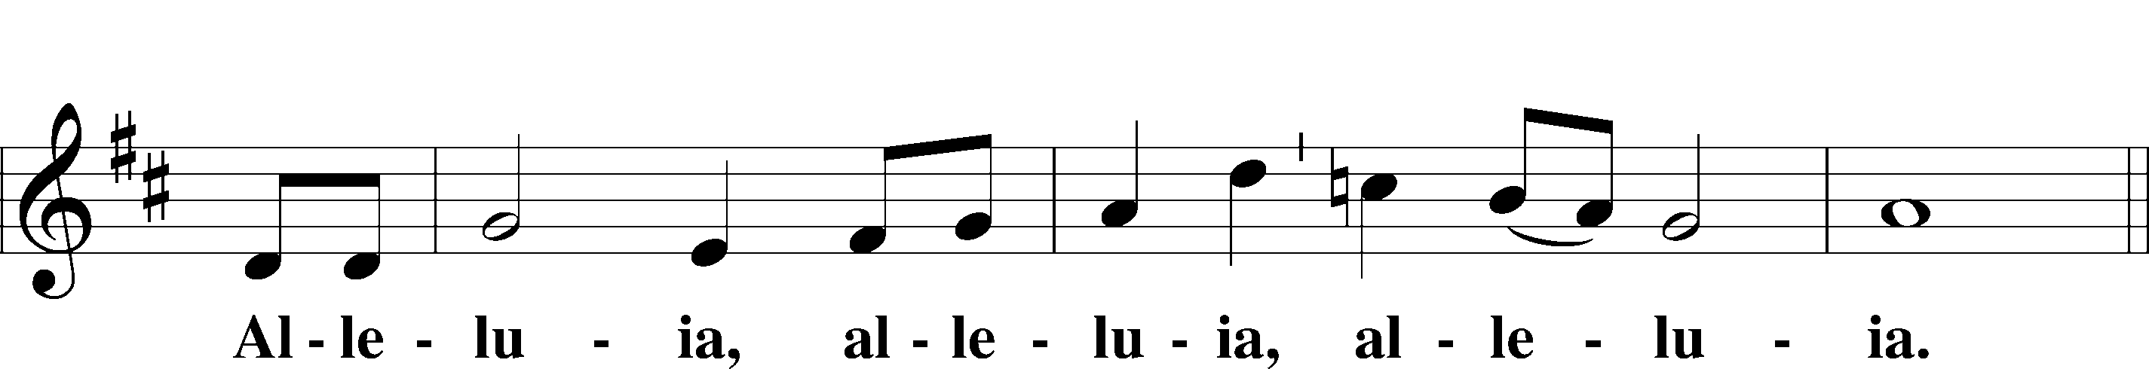
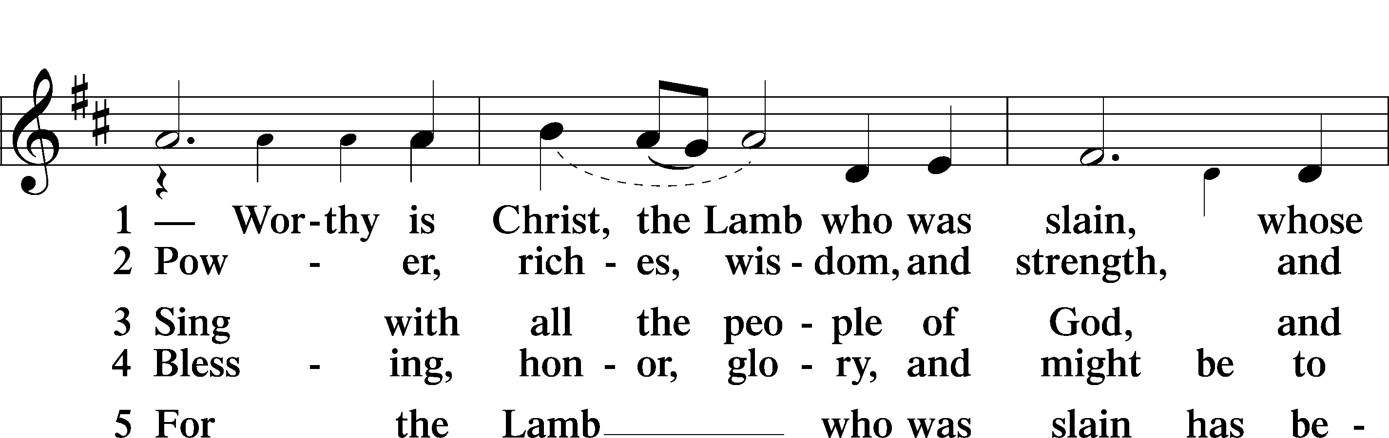
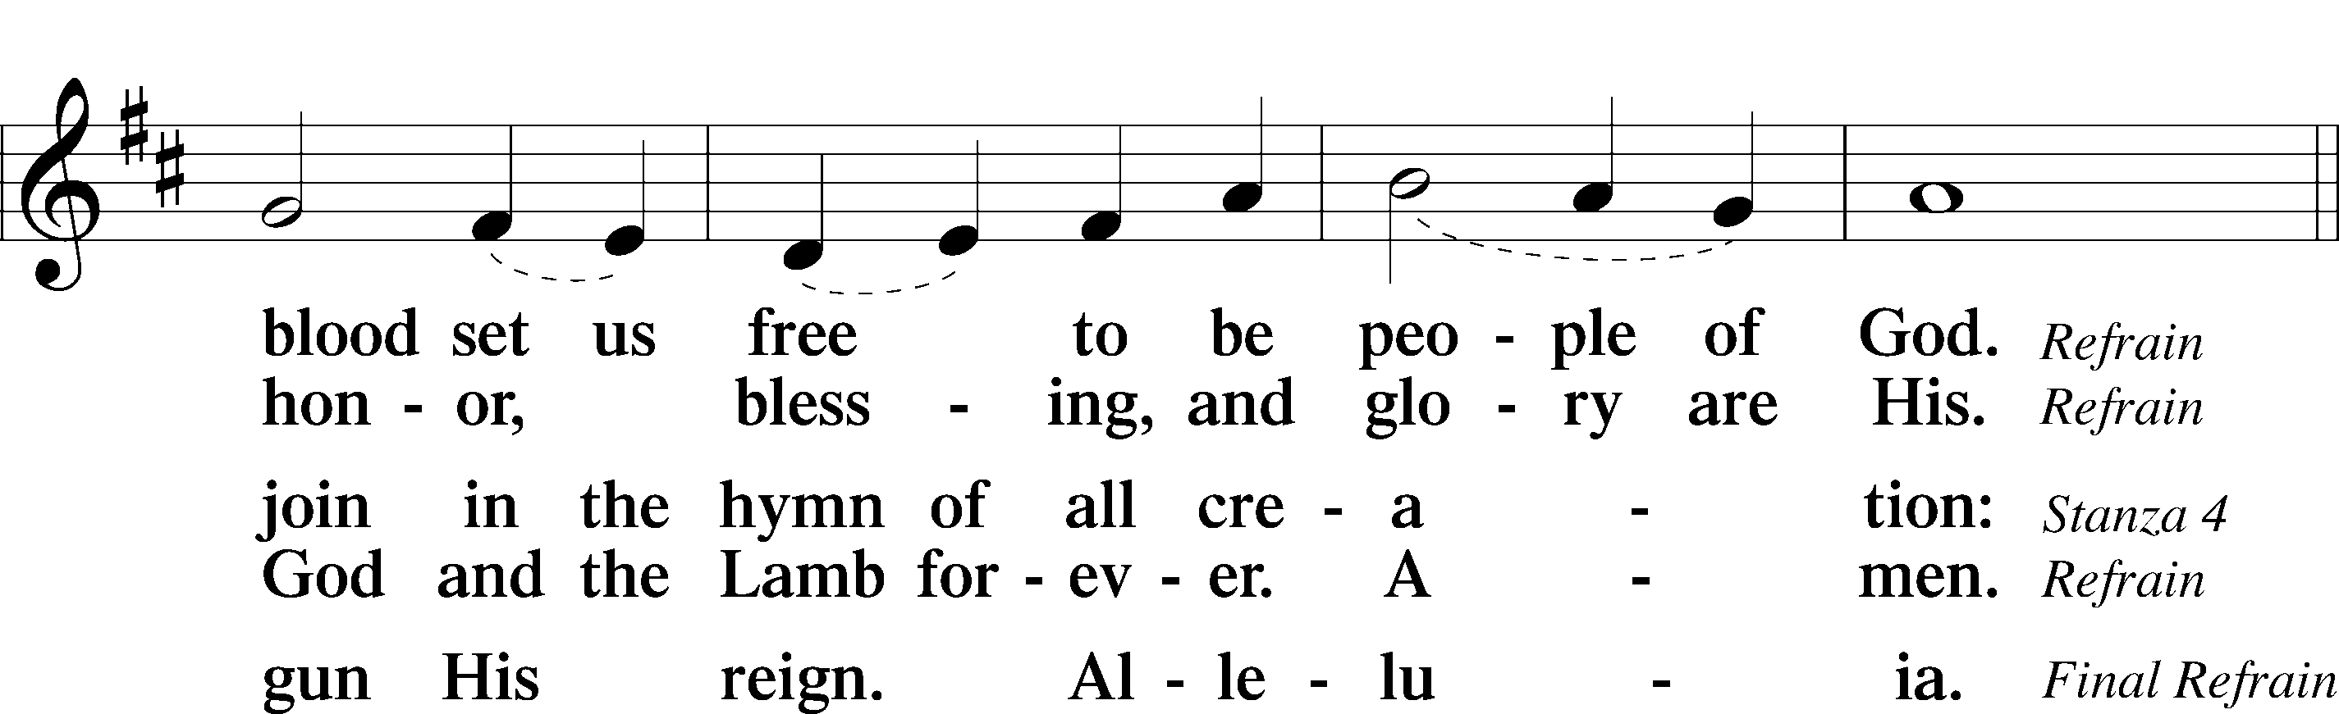
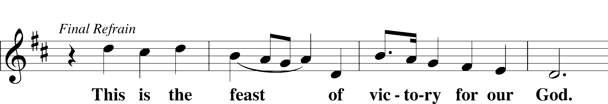
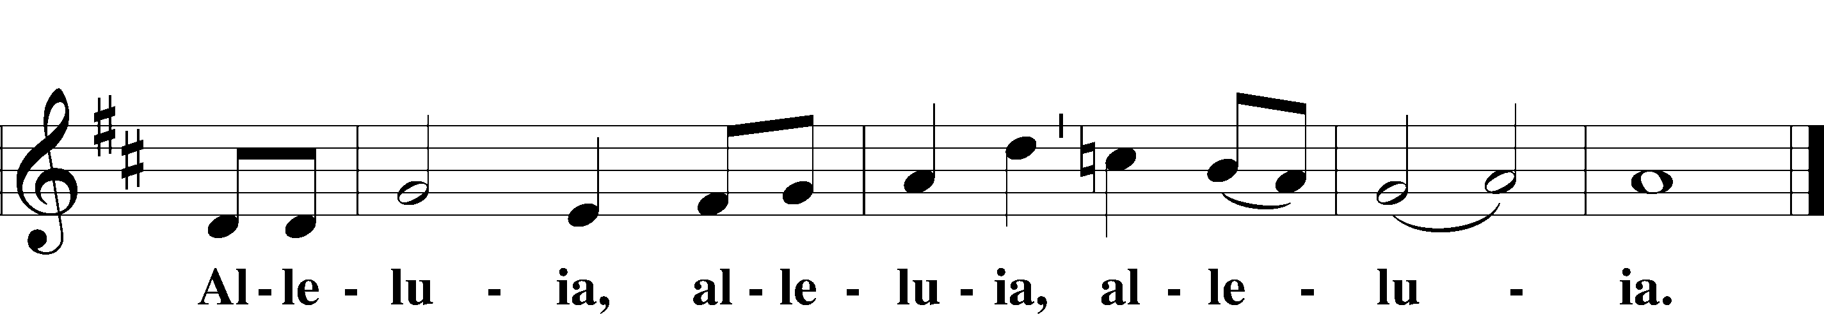

SALUTATION AND COLLECT OF THE DAY LSB 156
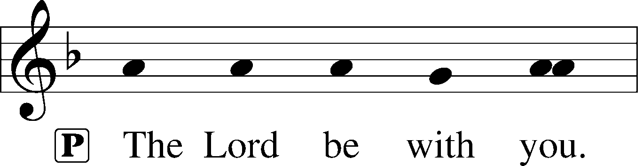
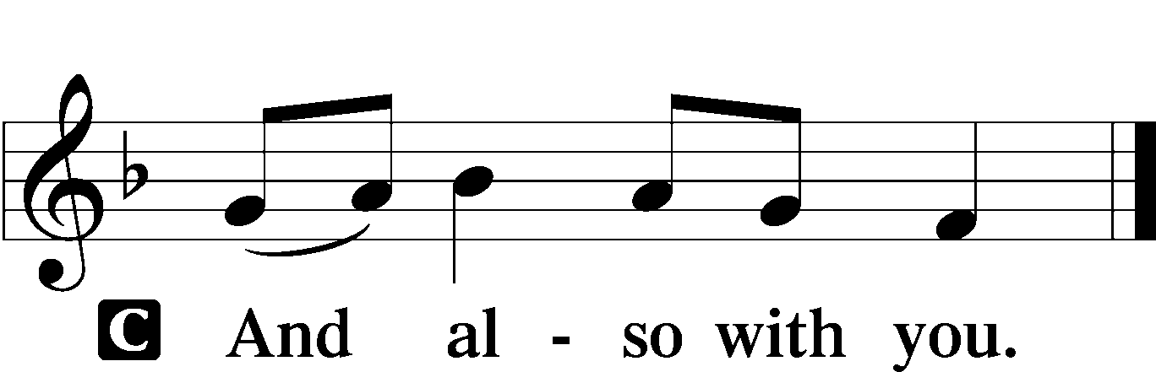

P Let us pray.
O God, from whom all good proceeds, grant to us, Your humble servants, Your holy inspiration, that we may set our minds on the things that are right and, by Your merciful guiding, accomplish them; through Jesus Christ, Your Son, our Lord, who lives and reigns with You and the Holy Spirit, one God, now and forever.

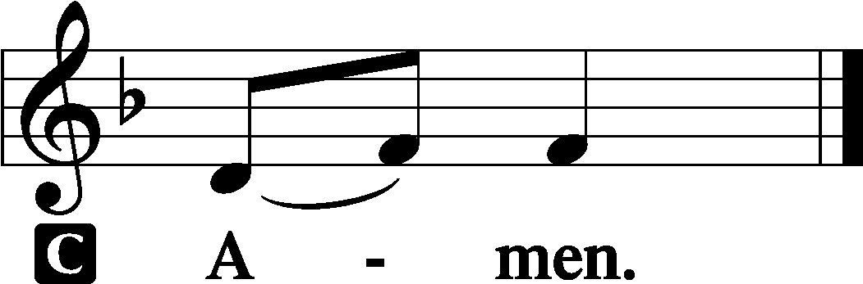

(Sit)

OLD TESTAMENT READING Ezekiel 33:7–9
7“So you, son of man, I have made a watchman for the house of Israel. Whenever you hear a word from my mouth, you shall give them warning from me. 8If I say to the wicked, O wicked one, you shall surely die, and you do not speak to warn the wicked to turn from his way, that wicked person shall die in his iniquity, but his blood I will require at your hand. 9But if you warn the wicked to turn from his way, and he does not turn from his way, that person shall die in his iniquity, but you will have delivered your soul.”

P This is the Word of the Lord.
C Thanks be to God.

GRADUAL Psalm 34:9, 19, alt.
Fear the Lord, | you his saints,*
for those who fear him lack | nothing!
Many are the afflictions of the | righteous,*
but the Lord delivers him out | of them all.

EPISTLE Romans 13:1–10
1Let every person be subject to the governing authorities. For there is no authority except from God, and those that exist have been instituted by God. 2Therefore whoever resists the authorities resists what God has appointed, and those who resist will incur judgment. 3For rulers are not a terror to good conduct, but to bad. Would you have no fear of the one who is in authority? Then do what is good, and you will receive his approval, 4for he is God’s servant for your good. But if you do wrong, be afraid, for he does not bear the sword in vain. For he is the servant of God, an avenger who carries out God’s wrath on the wrongdoer. 5Therefore one must be in subjection, not only to avoid God’s wrath but also for the sake of conscience. 6For the same reason you also pay taxes, for the authorities are ministers of God, attending to this very thing. 7Pay to all what is owed to them: taxes to whom taxes are owed, revenue to whom revenue is owed, respect to whom respect is owed, honor to whom honor is owed.
8Owe no one anything, except to love each other, for the one who loves another has fulfilled the law. 9The commandments, “You shall not commit adultery, You shall not murder, You shall not steal, You shall not covet,” and any other commandment, are summed up in this word: “You shall love your neighbor as yourself.” 10Love does no wrong to a neighbor; therefore love is the fulfilling of the law.

P This is the Word of the Lord.
C Thanks be to God.

(Stand)

ALLELUIA AND VERSE LSB 156
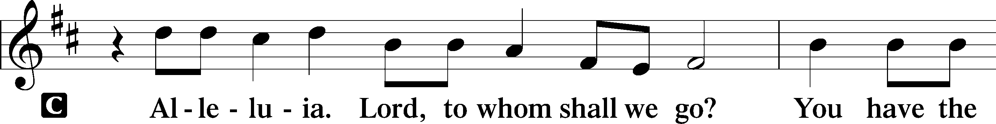
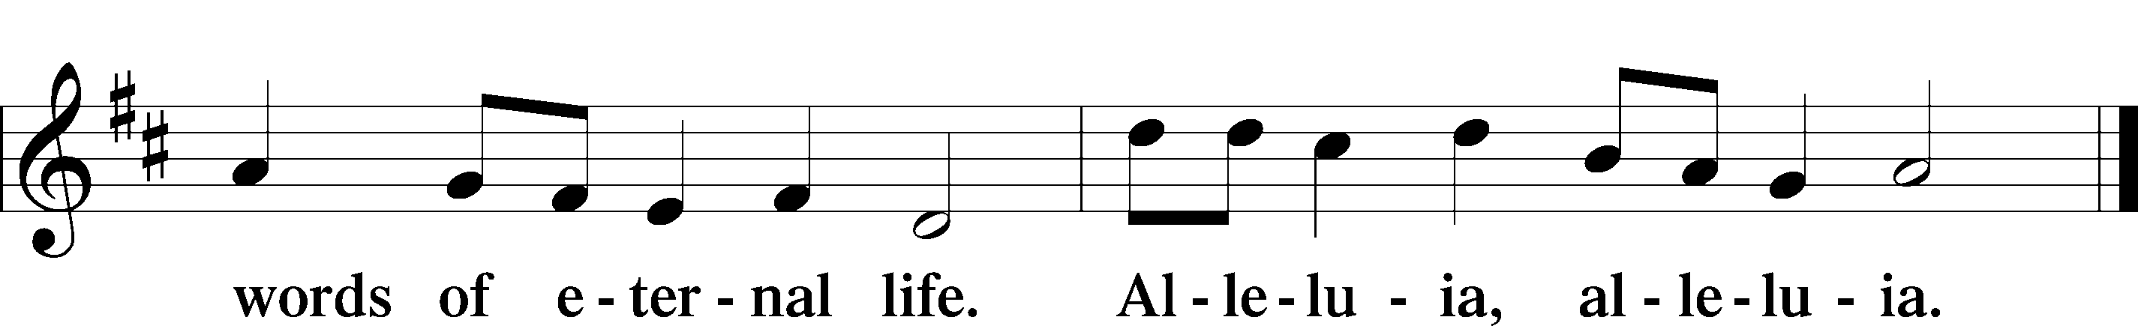

HOLY GOSPEL Matthew 18:1–20
P The Holy Gospel according to St. Matthew, the eighteenth chapter.

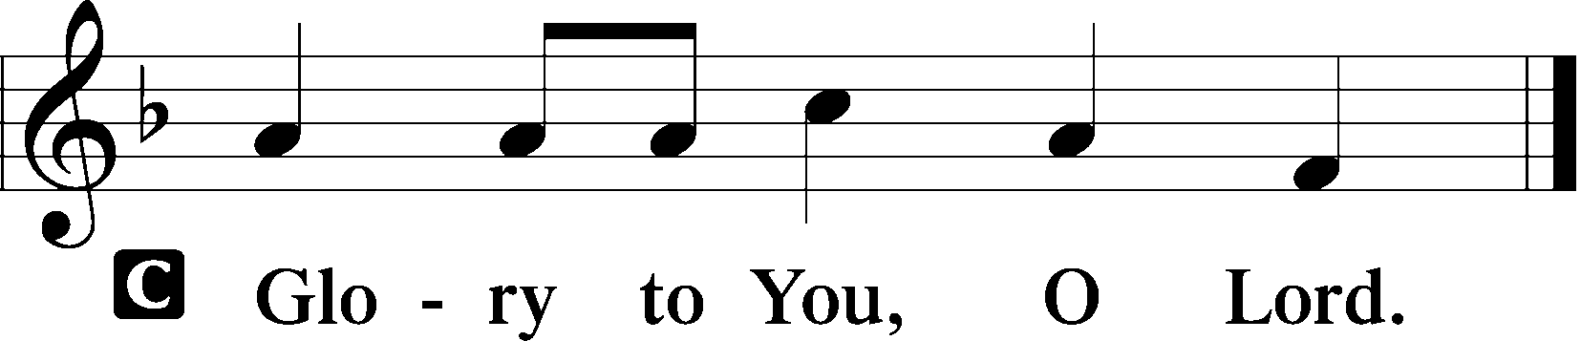

1At that time the disciples came to Jesus, saying, “Who is the greatest in the kingdom of heaven?” 2And calling to him a child, he put him in the midst of them 3and said, “Truly, I say to you, unless you turn and become like children, you will never enter the kingdom of heaven. 4Whoever humbles himself like this child is the greatest in the kingdom of heaven.
5“Whoever receives one such child in my name receives me, 6but whoever causes one of these little ones who believe in me to sin, it would be better for him to have a great millstone fastened around his neck and to be drowned in the depth of the sea.
7“Woe to the world for temptations to sin! For it is necessary that temptations come, but woe to the one by whom the temptation comes! 8And if your hand or your foot causes you to sin, cut it off and throw it away. It is better for you to enter life crippled or lame than with two hands or two feet to be thrown into the eternal fire. 9And if your eye causes you to sin, tear it out and throw it away. It is better for you to enter life with one eye than with two eyes to be thrown into the hell of fire.

(next page)

10“See that you do not despise one of these little ones. For I tell you that in heaven their angels always see the face of my Father who is in heaven. 11For the Son of Man came to save the lost. 12What do you think? If a man has a hundred sheep and one of them has gone astray, does he not leave the ninety-nine on the mountains and go in search of the one that went astray? 13And if he finds it, truly, I say to you, he rejoices over it more than over the ninety-nine that never went astray. 14So it is not the will of my Father who is in heaven that one of these little ones should perish.
15“If your brother sins against you, go and tell him his fault, between you and him alone. If he listens to you, you have gained your brother. 16But if he does not listen, take one or two others along with you, that every charge may be established by the evidence of two or three witnesses. 17If he refuses to listen to them, tell it to the church. And if he refuses to listen even to the church, let him be to you as a Gentile and a tax collector. 18Truly, I say to you, whatever you bind on earth shall be bound in heaven, and whatever you loose on earth shall be loosed in heaven. 19Again I say to you, if two of you agree on earth about anything they ask, it will be done for them by my Father in heaven. 20For where two or three are gathered in my name, there am I among them.”

P This is the Gospel of the Lord.

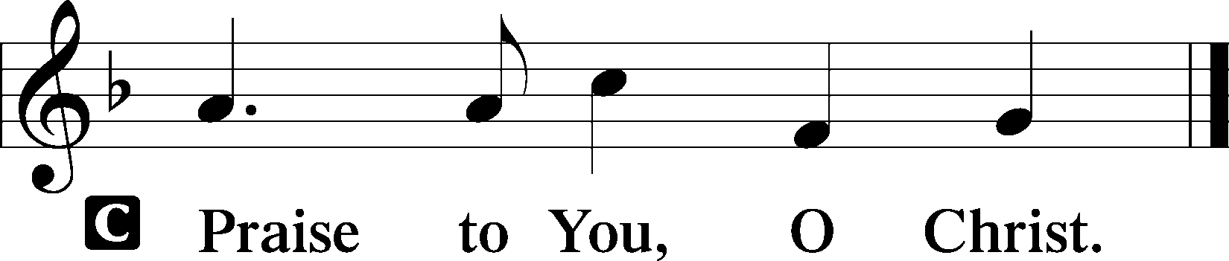

(Sit)

820 MY SOUL, NOW PRAISE YOUR MAKER
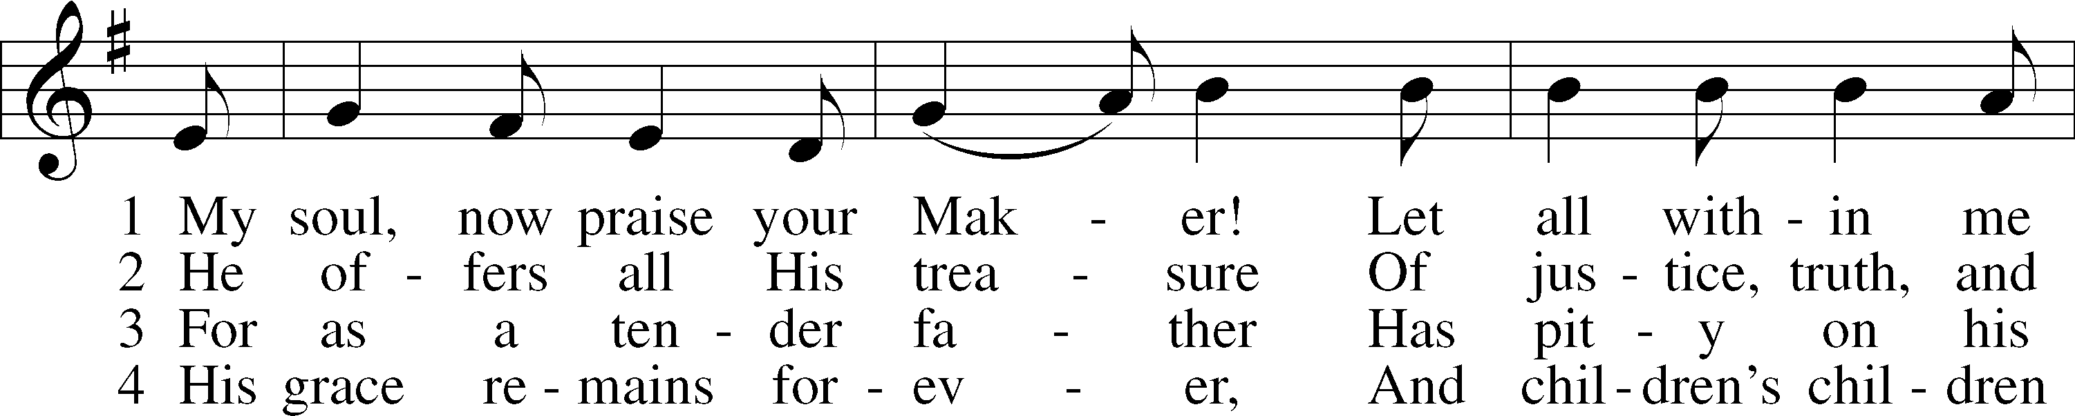
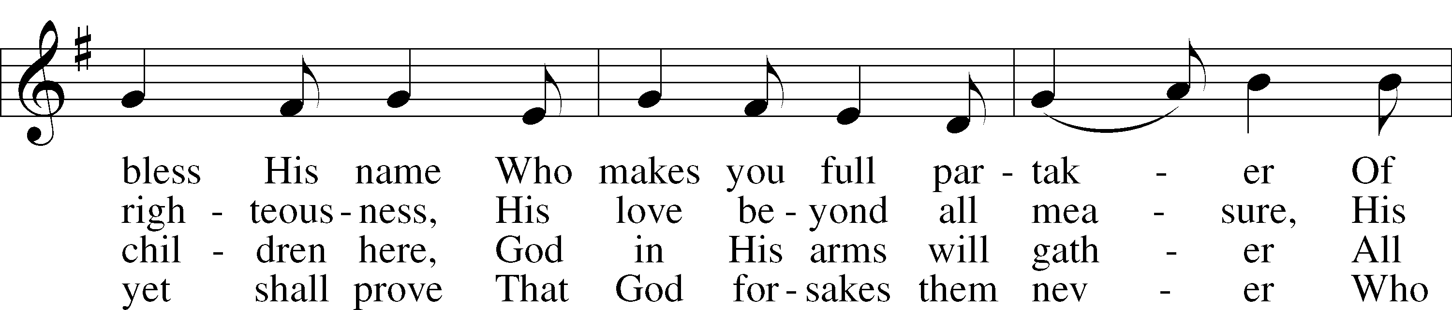
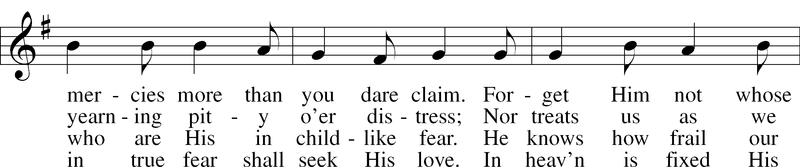
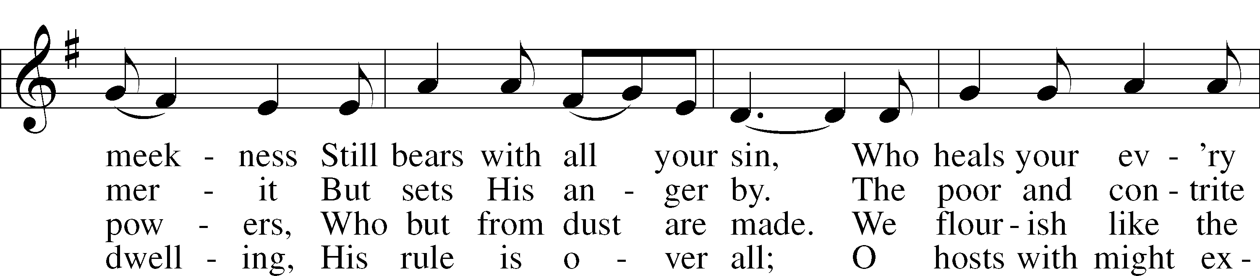
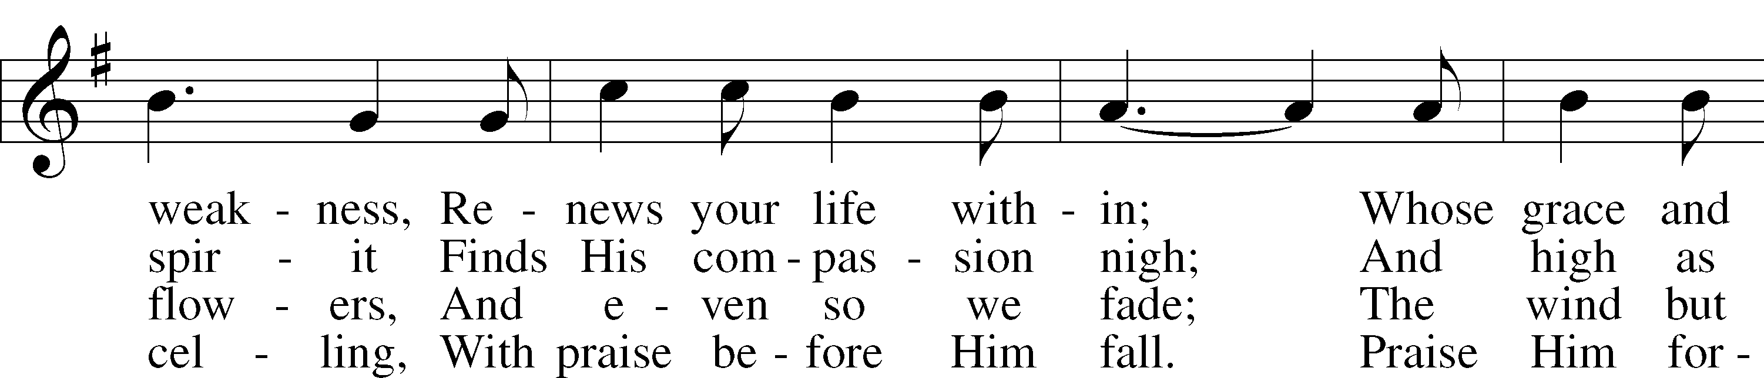
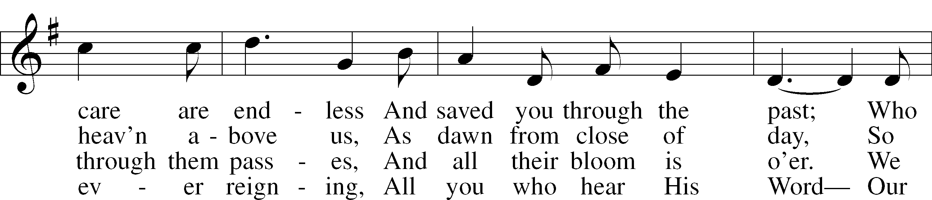
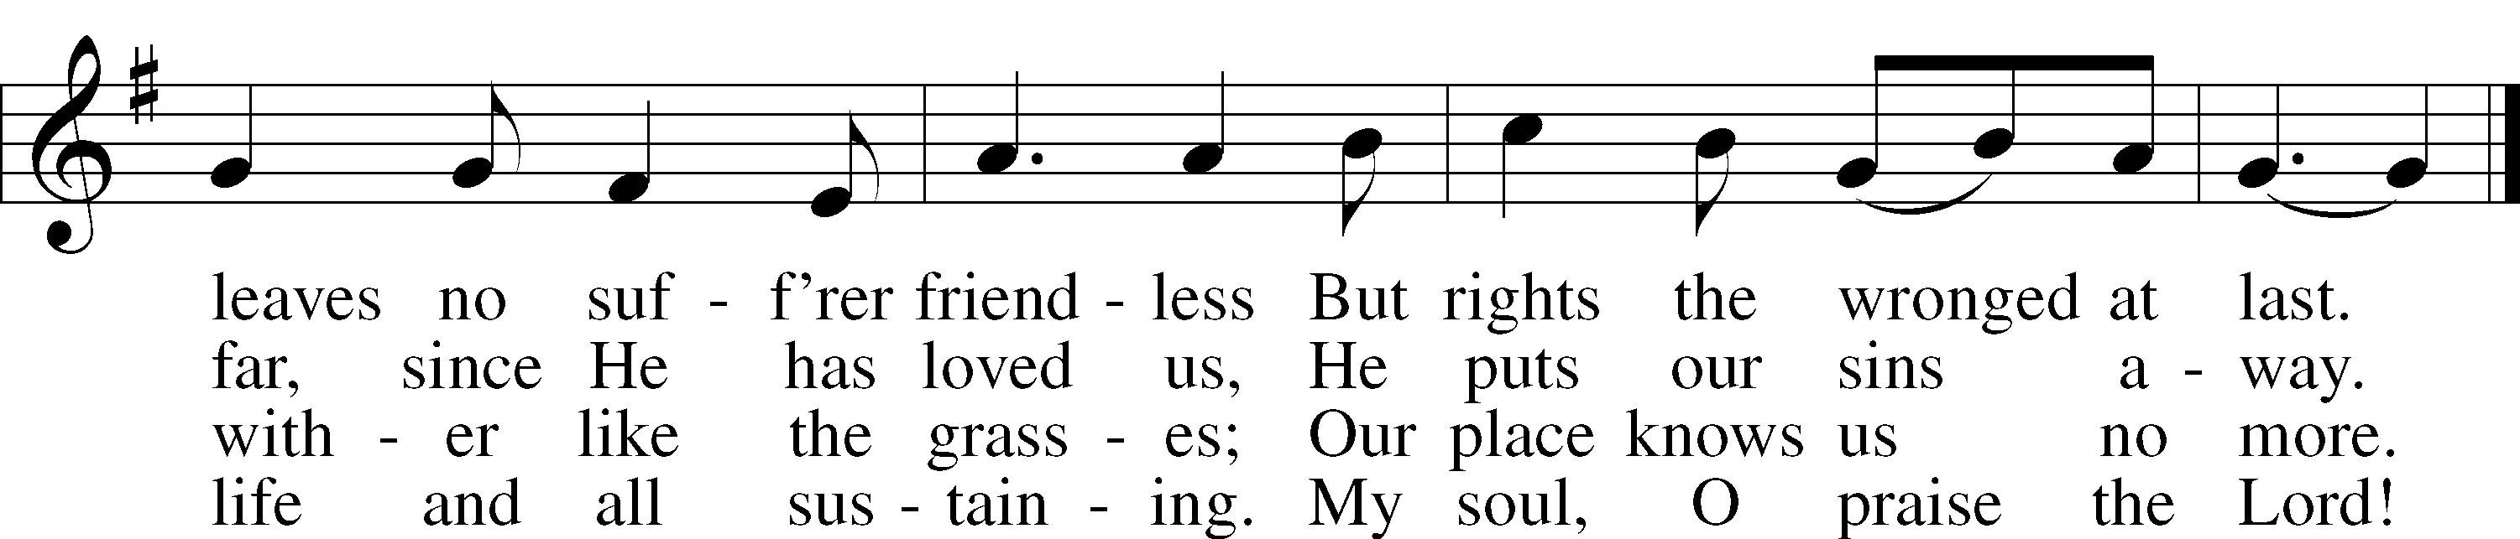
Text: Johann Gramann, 1487–1541; tr. Catherine Winkworth, 1827–78, alt.
Tune: Concentus novi, 1540, Augsburg
Text and tune: Public domain

SERMON

(Stand)

NICENE CREED LSB 158
C I believe in one God,
the Father Almighty,
maker of heaven and earth
and of all things visible and invisible.

And in one Lord Jesus Christ,
the only-begotten Son of God,
begotten of His Father before all worlds,
God of God, Light of Light,
very God of very God,
begotten, not made,
being of one substance with the Father,
by whom all things were made;
who for us men and for our salvation came down from heaven
and was incarnate by the Holy Spirit of the virgin Mary
and was made man;
and was crucified also for us under Pontius Pilate.
He suffered and was buried.
And the third day He rose again in accordance with the Scriptures
and ascended into heaven
and sits at the right hand of the Father.
And He will come again with glory to judge both the living and the dead,
whose kingdom will have no end.

And I believe in the Holy Spirit,
the Lord and giver of life,
who proceeds from the Father and the Son,
who with the Father and the Son together is worshiped and glorified,
who spoke by the prophets.
And I believe in one holy Christian and apostolic Church,
I acknowledge one Baptism for the remission of sins,
and I look for the resurrection of the dead
and the life T of the world to come. Amen.
SHARING OF THE PEACE

(The people may greet one another in the name of the Lord, saying, “Peace be with you,” as a sign of reconciliation and of the unity of the Spirit in the bond of peace (Matt. 5:22–24; Eph. 4:1–3).)

(Sit)

PRAYER OF THE CHURCH

OFFERING

(As a part of our expression of thanksgiving to God for the treasure of His salvation to us, we offer a portion of our treasure, according to what each has determined in their heart to give. Please place offerings in the collection plate at the back of the sanctuary before or after the service. Offerings can also be sent to Bethlehem Lutheran Church via U.S. Mail. Thank you!)

(Stand)

OFFERTORY LSB 159
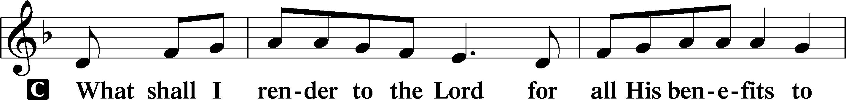
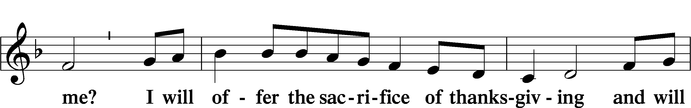
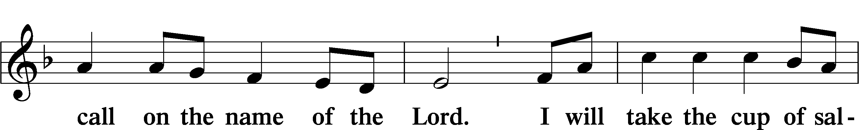
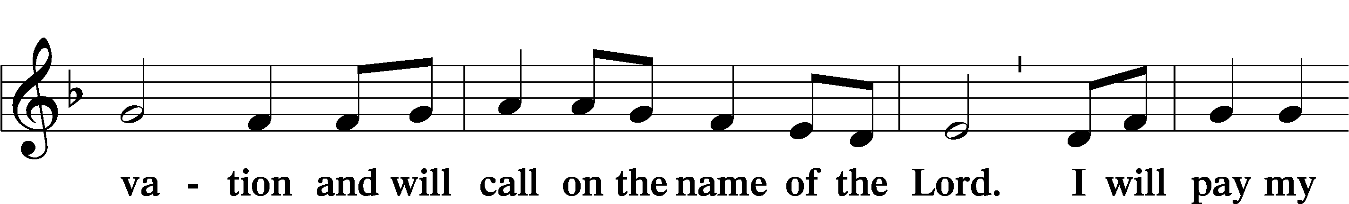
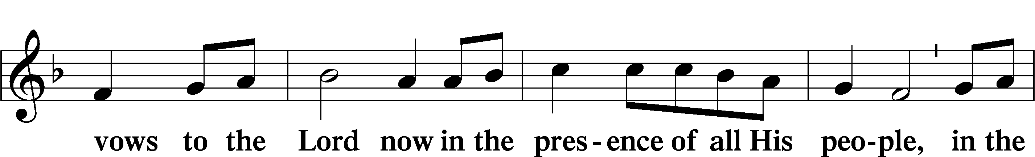
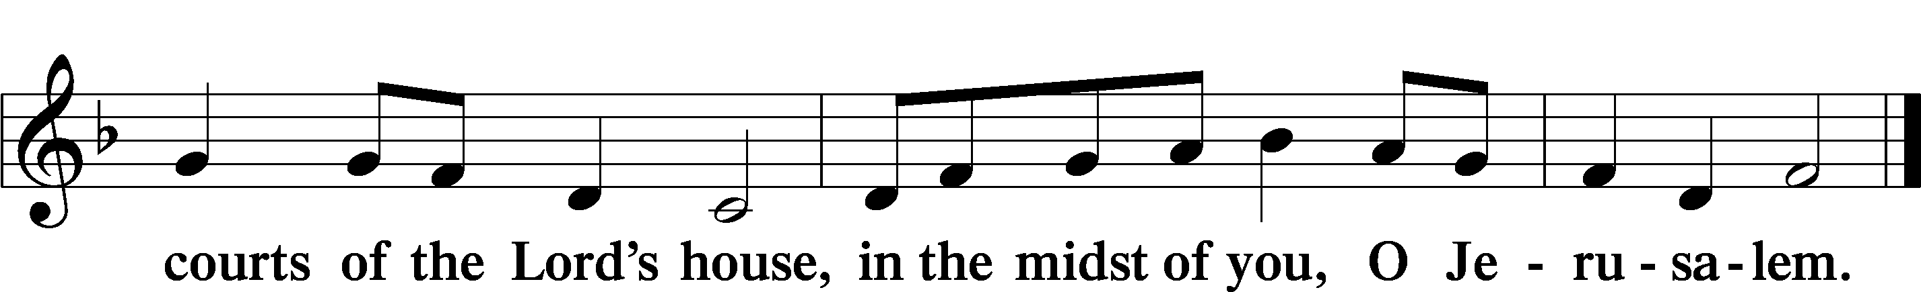

+ SERVICE OF THE SACRAMENT +

PREFACE LSB 160
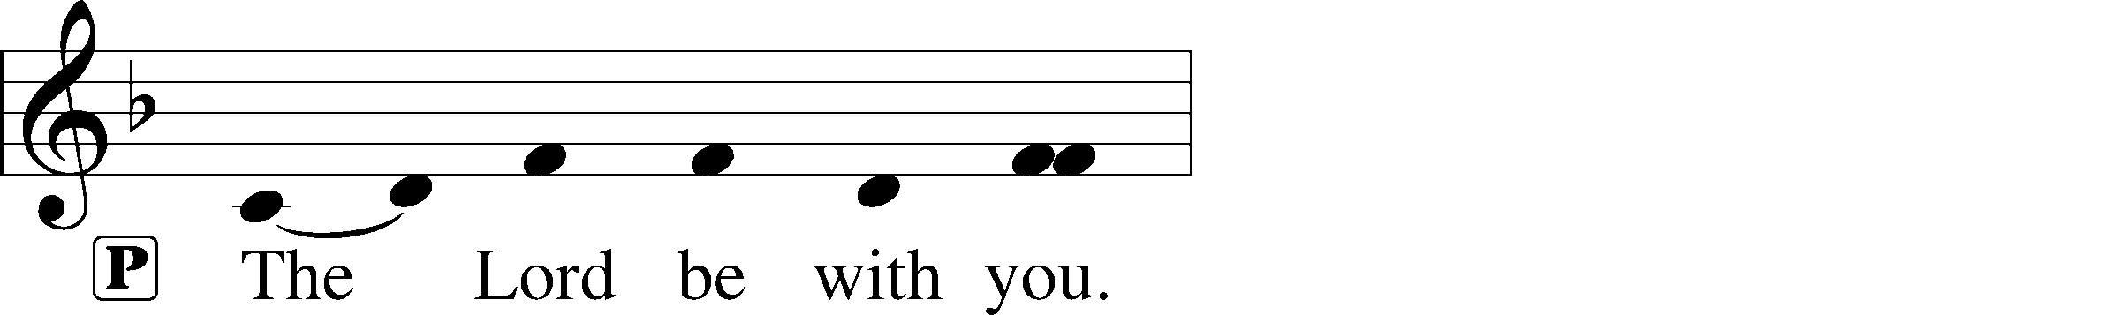
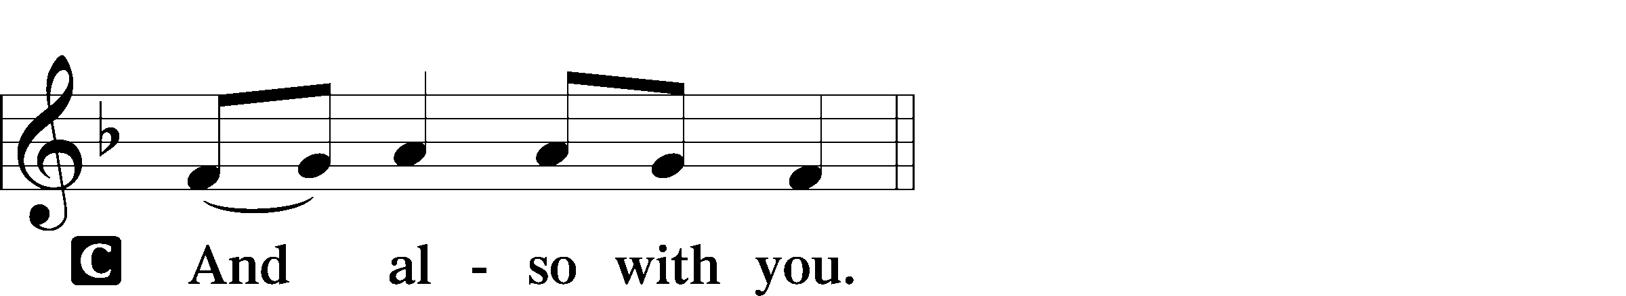
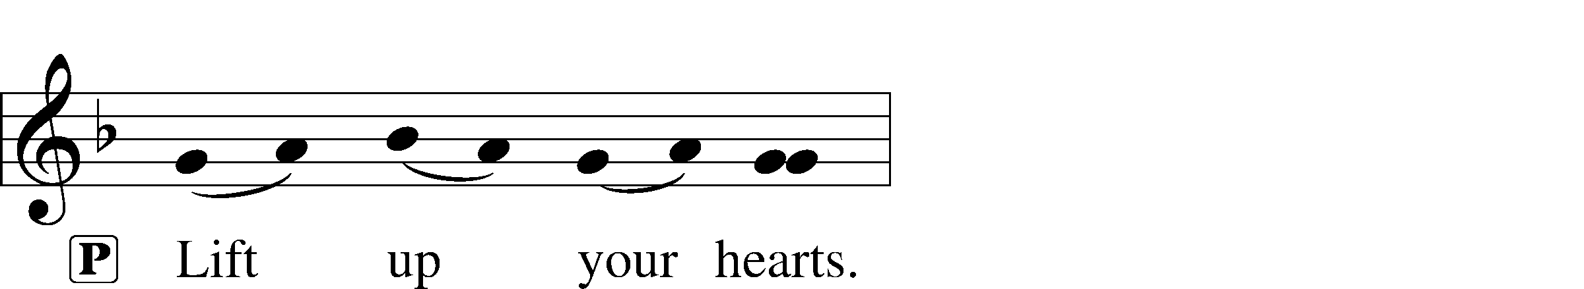

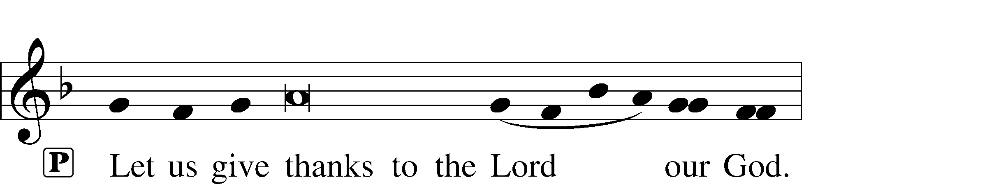
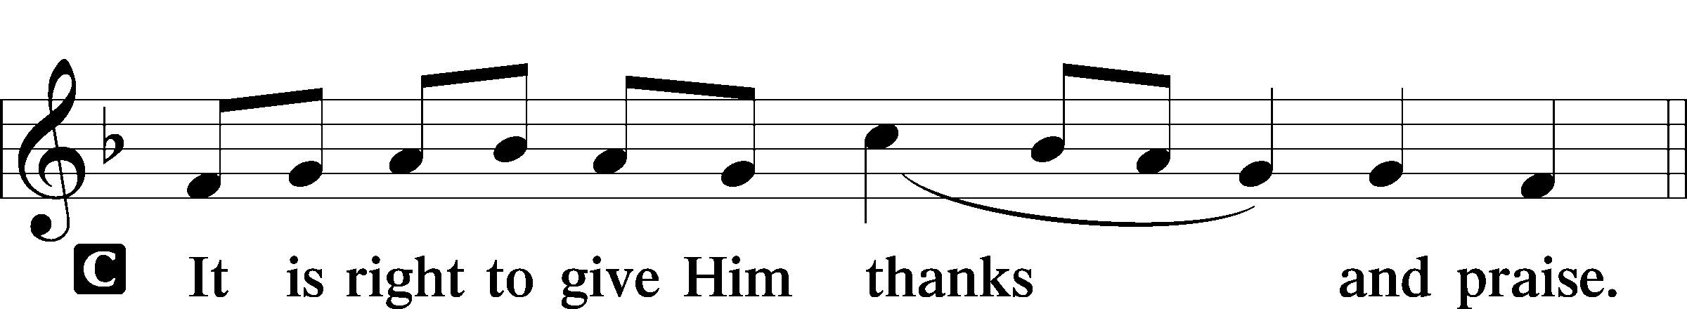

PROPER PREFACE (ABBREVIATED) LSB 161
P It is truly good, right, and salutary . . . evermore praising You and saying:

SANCTUS LSB 161
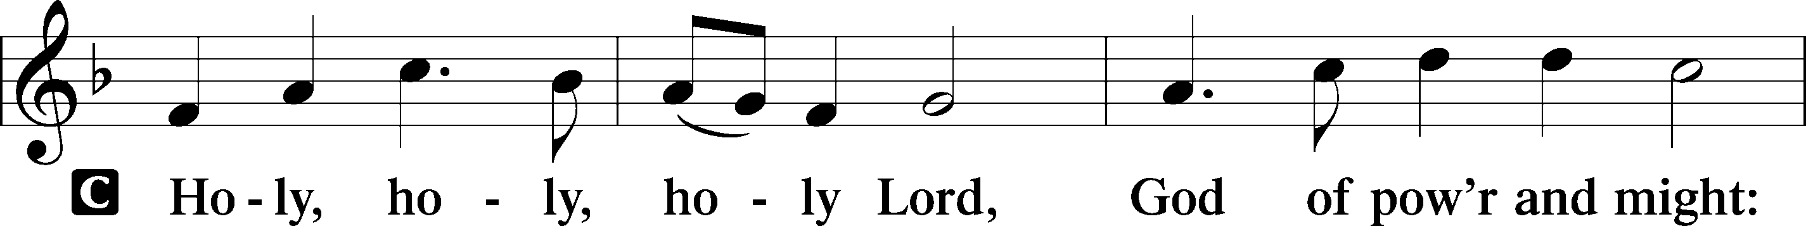
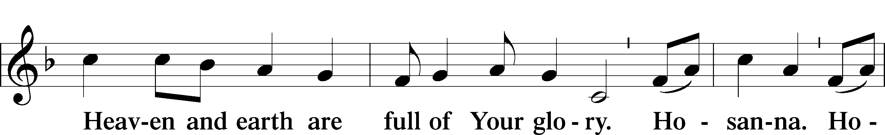
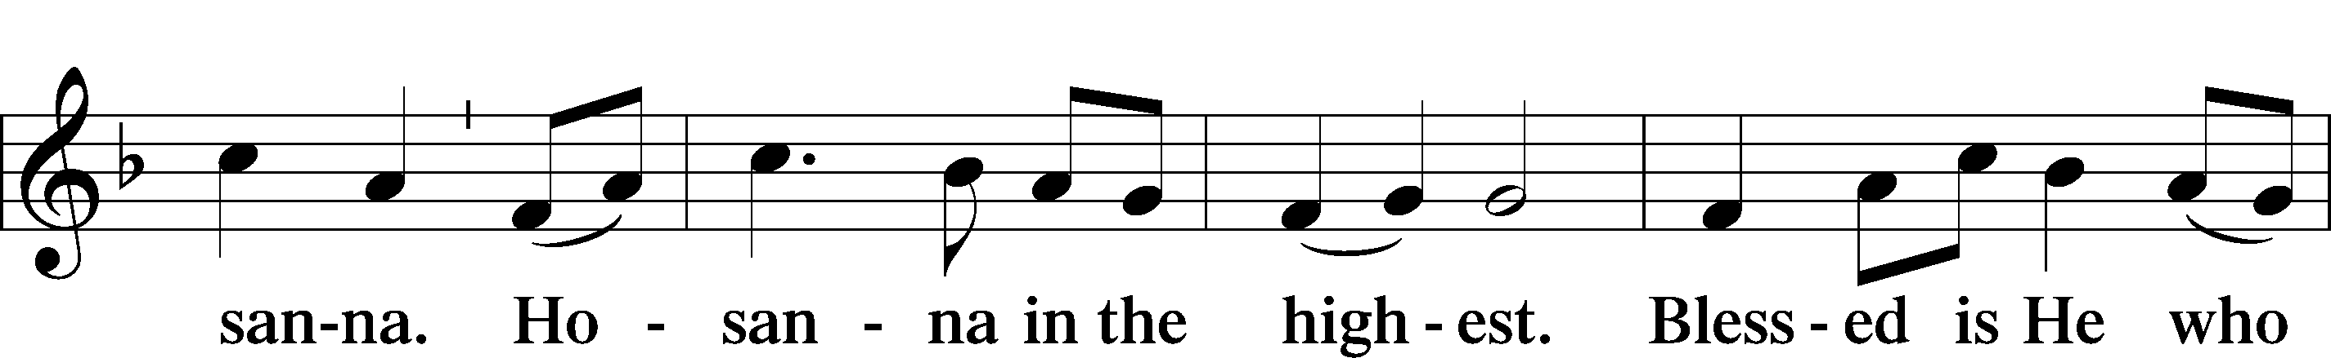
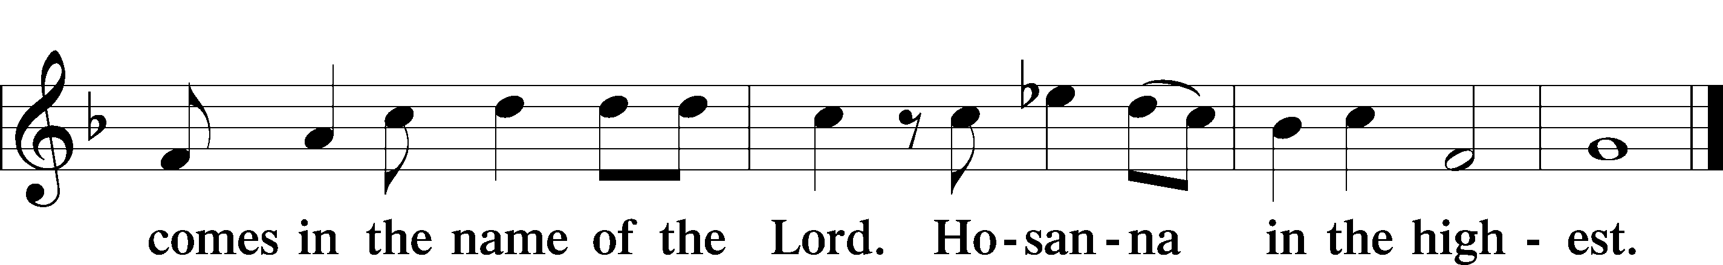

PRAYER OF THANKSGIVING LSB 161
P Blessed are You, Lord of heaven and earth...
,... with the Son and the Holy Spirit, one God, now and forever.
C Amen.

LORD’S PRAYER LSB 162
P Lord, remember us in Your kingdom and teach us to pray:
C Our Father who art in heaven,
hallowed be Thy name,
Thy kingdom come,
Thy will be done on earth
as it is in heaven;
give us this day our daily bread;
and forgive us our trespasses
as we forgive those
who trespass against us;
and lead us not into temptation,
but deliver us from evil.
For Thine is the kingdom
and the power and the glory
forever and ever. Amen.

THE WORDS OF OUR LORD LSB 162

PAX DOMINI LSB 163
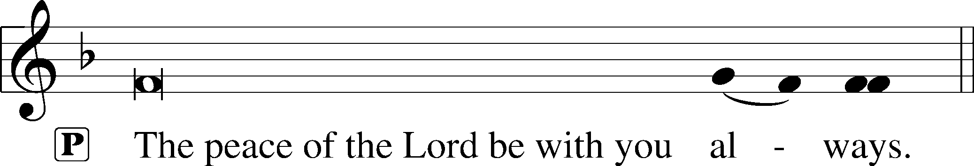


AGNUS DEI LSB 163
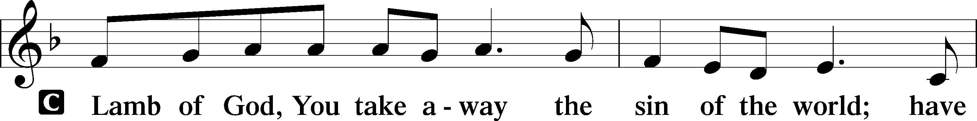
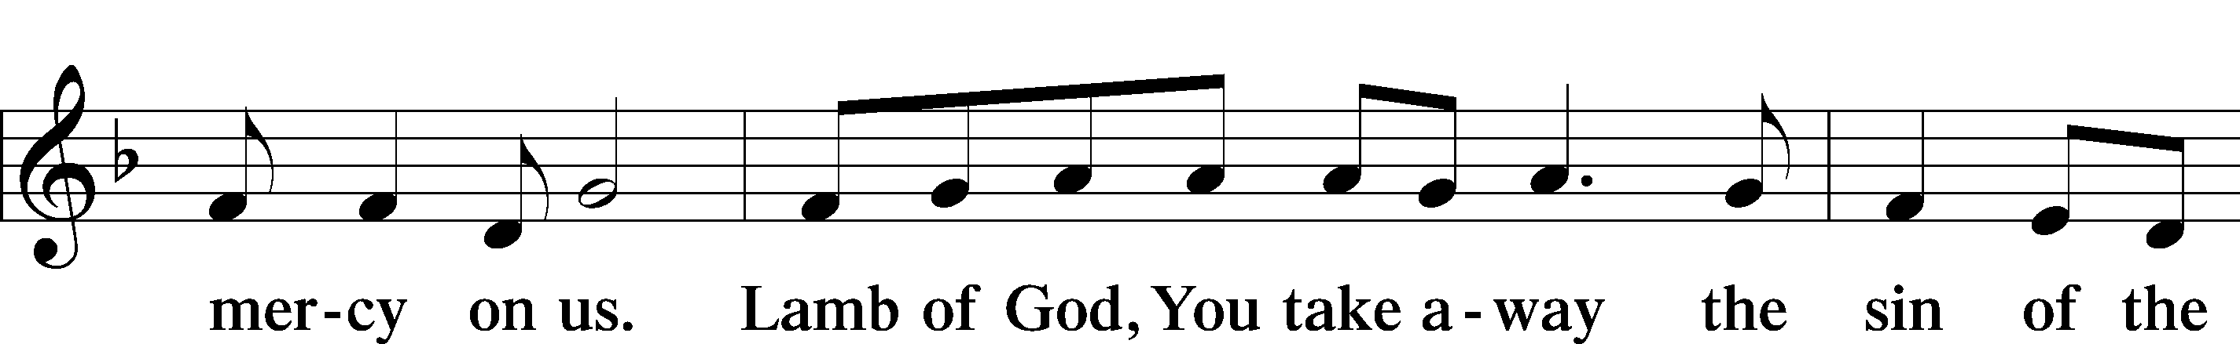
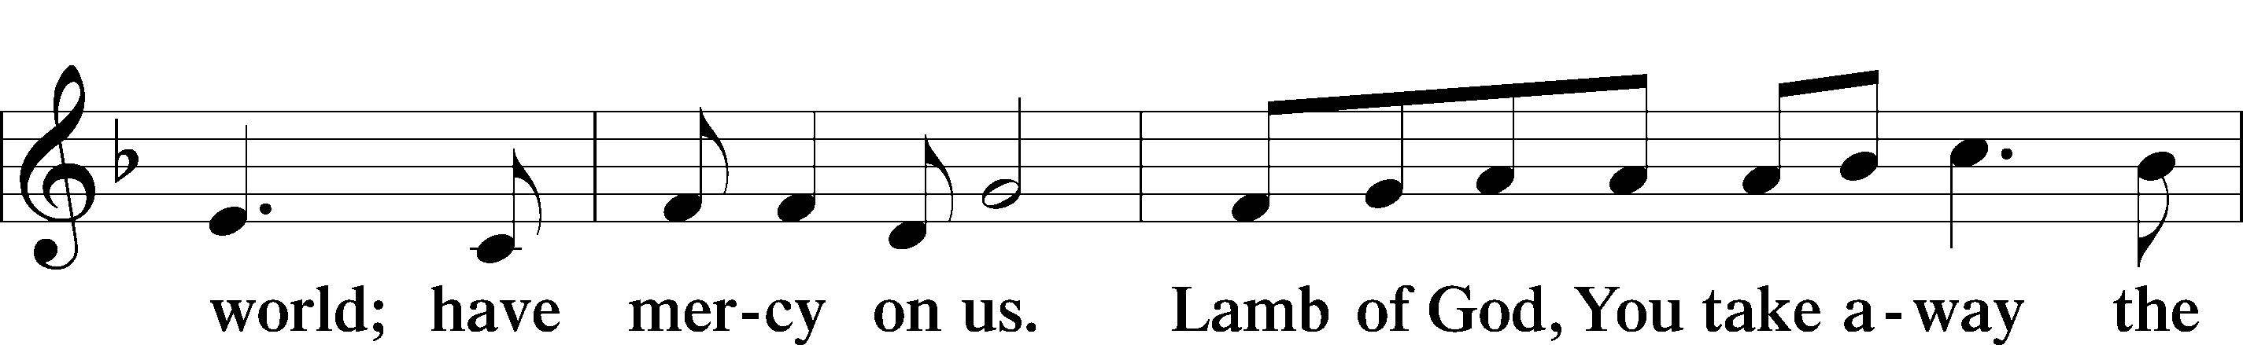
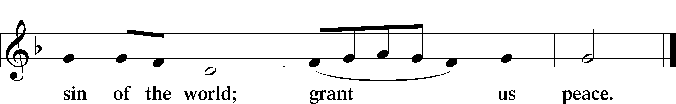

(Sit)

DISTRIBUTION

(The pastor and those assisting him are communed first, then commune those who are unable to come to the altar. The ushers will then direct all other communicants to the altar.)

725 CHILDREN OF THE HEAVENLY FATHER
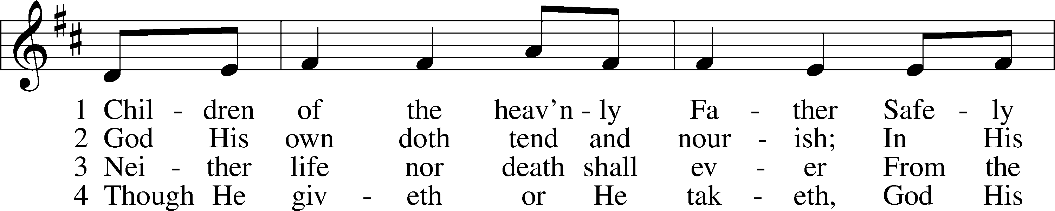
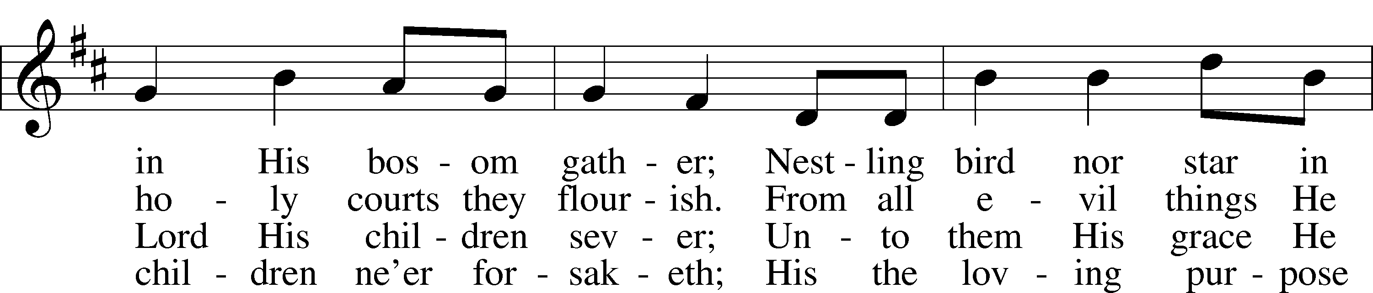
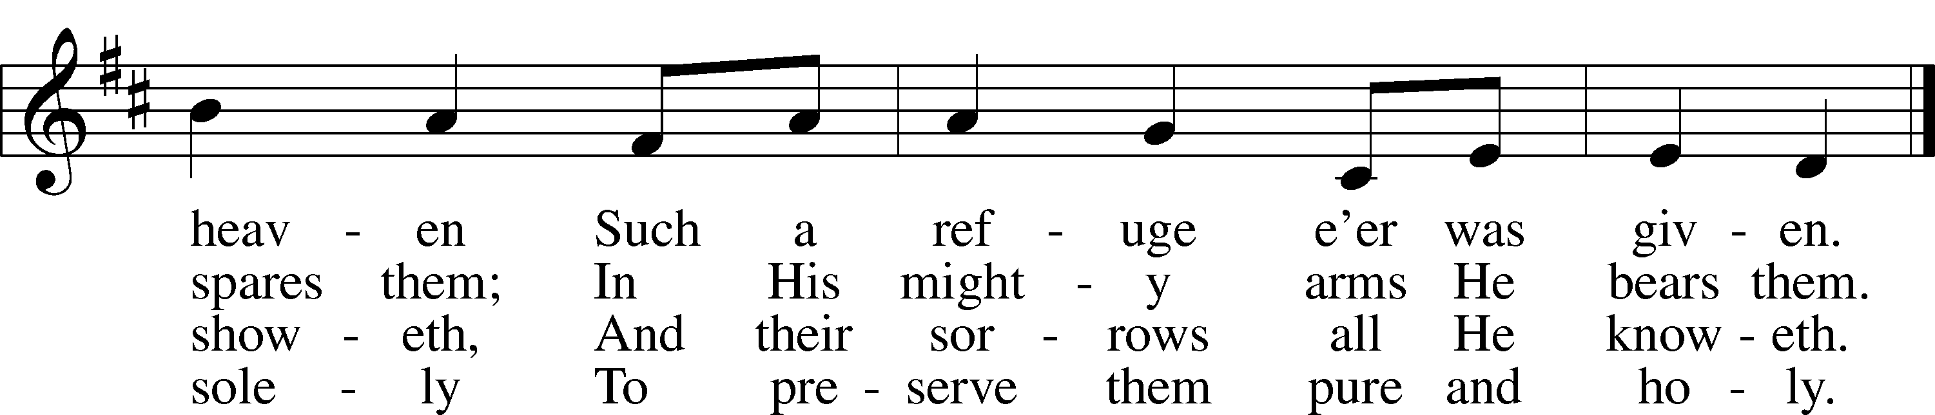
Text: Carolina Sandell Berg, 1832–1903; tr. Ernst W. Olson, 1870–1958
Tune: Lofsånger och andeliga wisor, 1873, Sweden
Text: Public domain
Tune: Public domain

INSTRUMENTAL

(Stand)

THANK THE LORD LSB 164
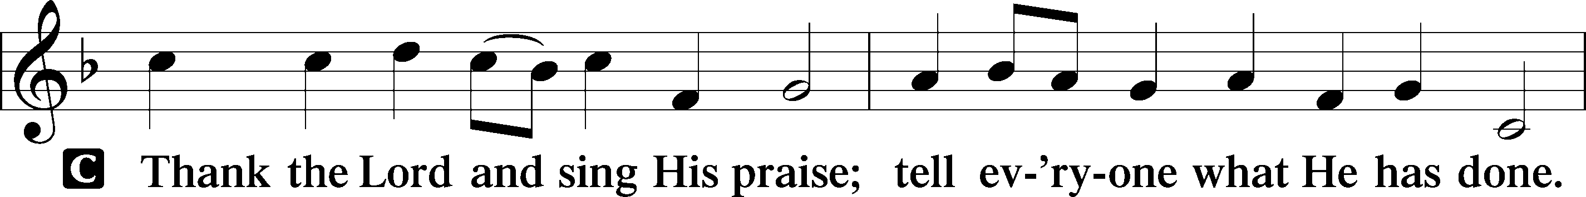
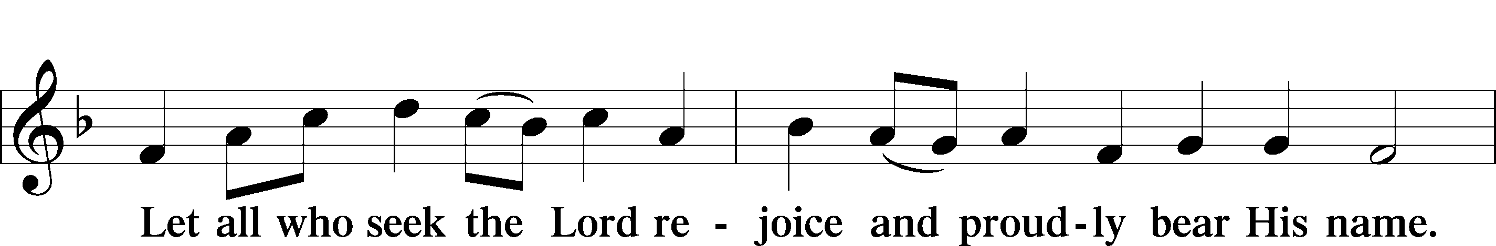
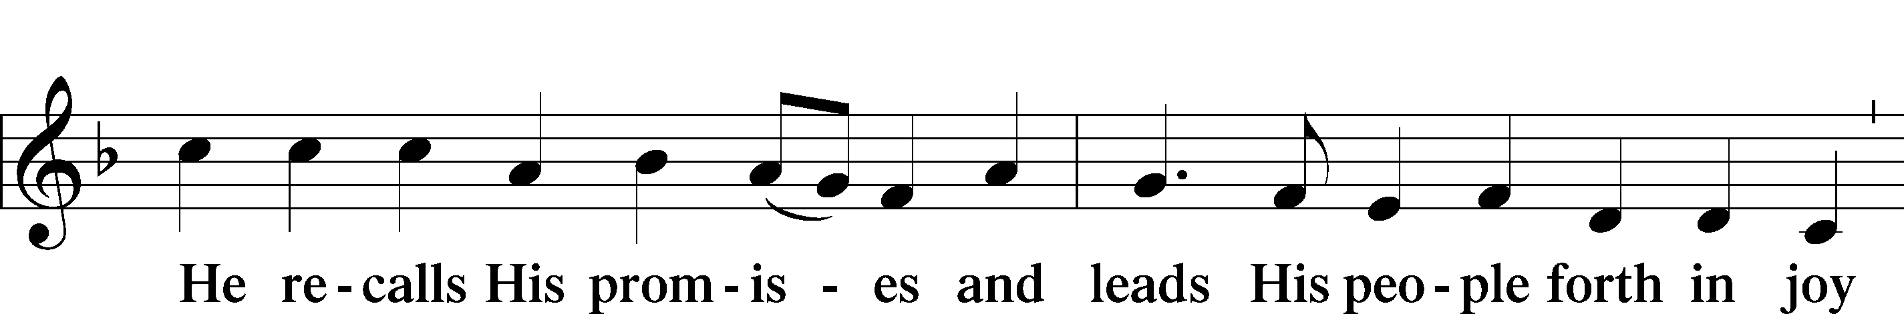
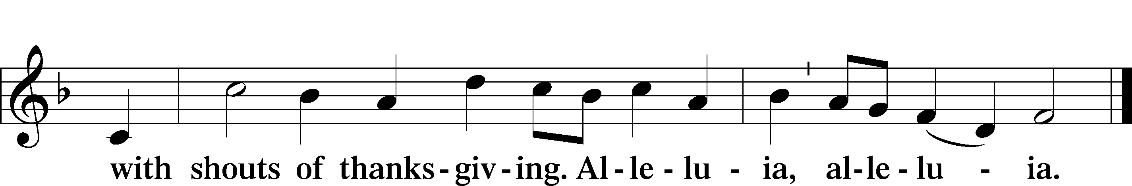

POST-COMMUNION COLLECT LSB 166
P Let us pray.
...through Jesus Christ, Your Son, our Lord, who lives and reigns with You and the Holy Spirit, one God, now and forever.
C Amen.

BENEDICTION LSB 166
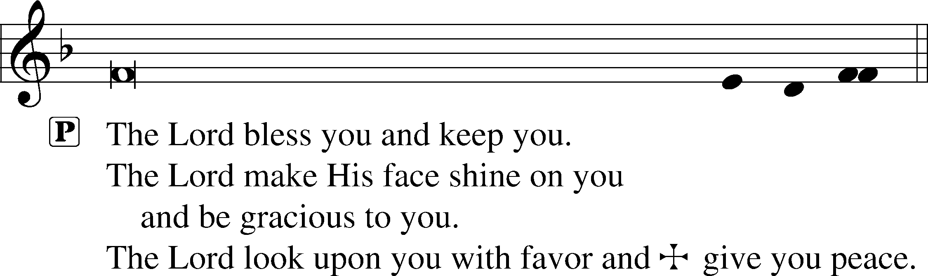
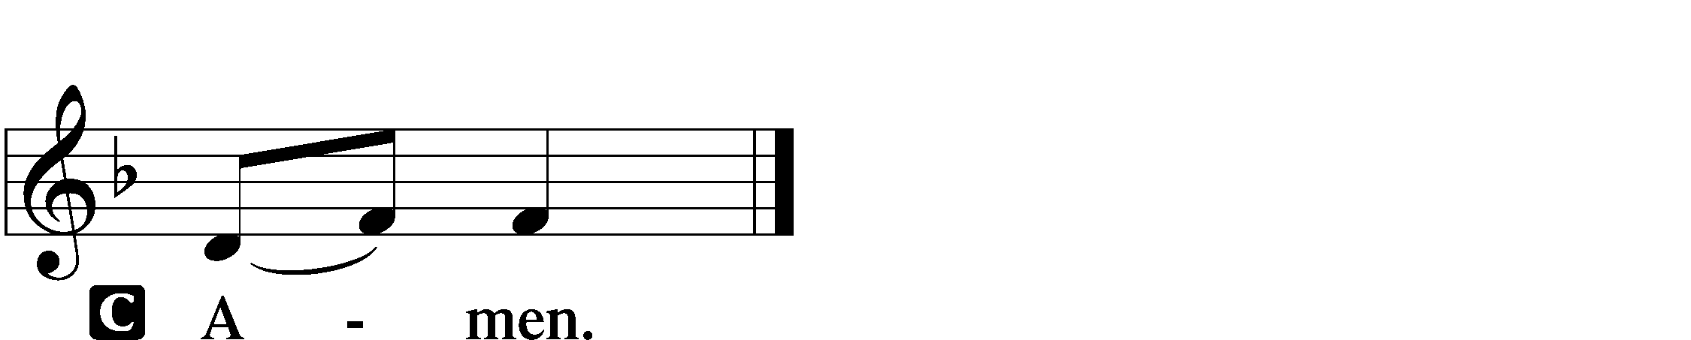

709 THE KING OF LOVE MY SHEPHERD IS
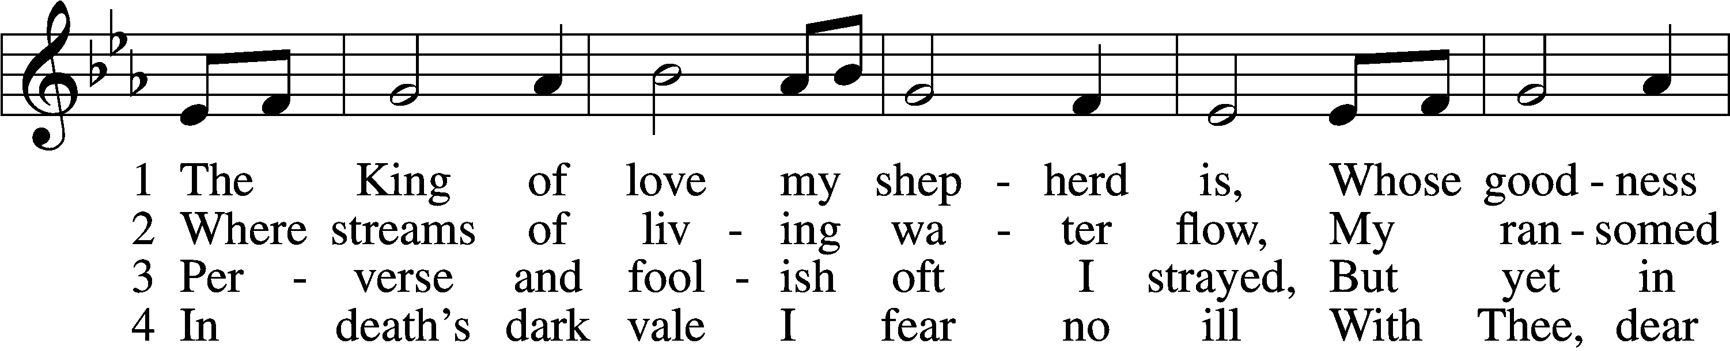
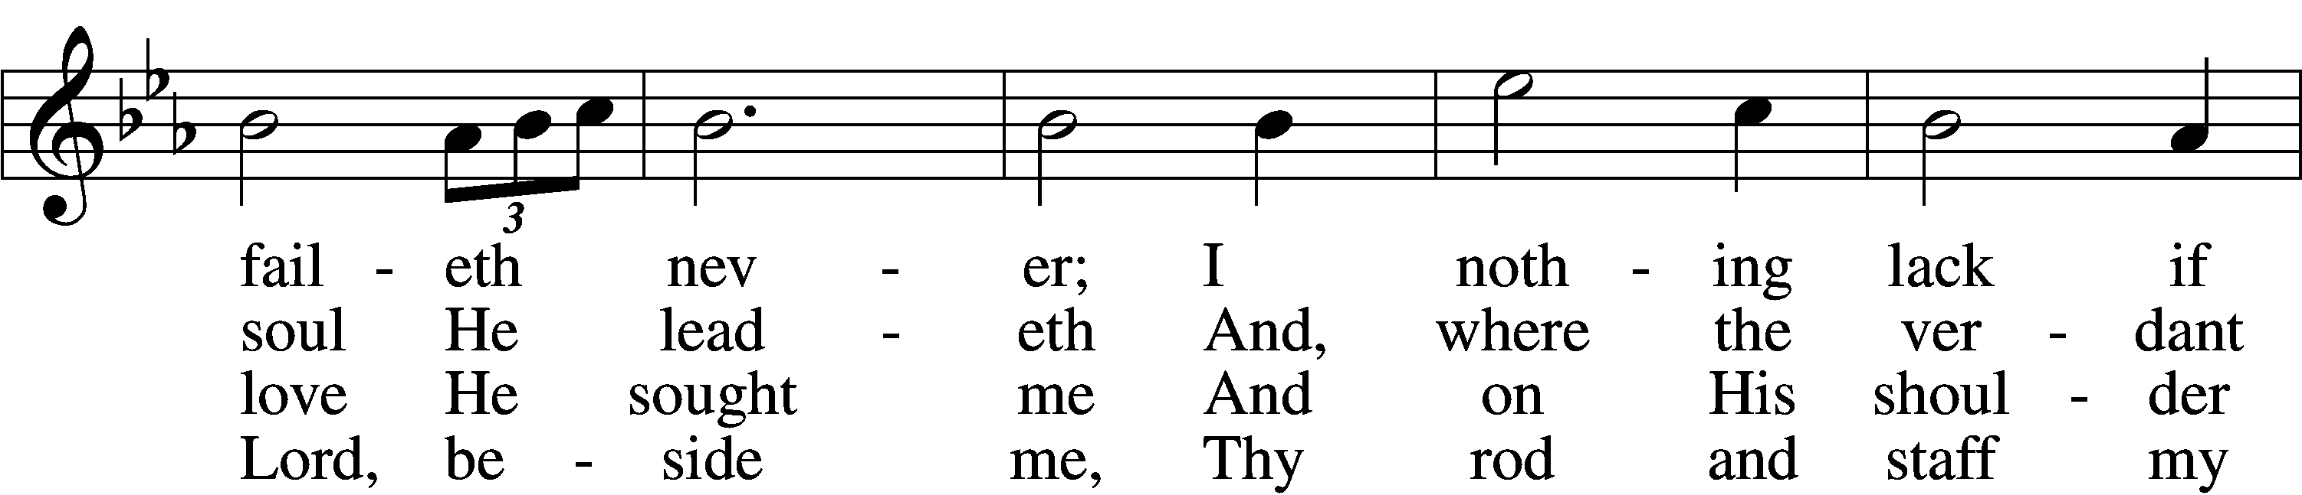
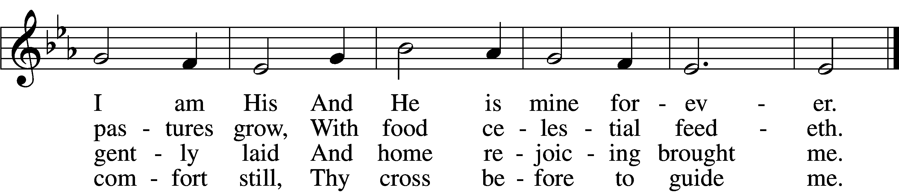

5 Thou spreadst a table in my sight;
Thine unction grace bestoweth;
And, oh, what transport of delight
From Thy pure chalice floweth!

6 And so through all the length of days
Thy goodness faileth never;
Good Shepherd, may I sing Thy praise
Within Thy house forever!
Text: Henry W. Baker, 1821–77
Tune: Irish, c. 18th cent.
Text and tune: Public domain
ACKNOWLEDGMENTS
Unless otherwise indicated, Scripture quotations are from the ESV® Bible (The Holy Bible, English Standard Version®), copyright © 2001 by Crossway, a publishing ministry of Good News Publishers. Used by permission. All rights reserved.
Created by Lutheran Service Builder © 2026 Concordia Publishing House.

