BETHLEHEM LUTHERAN CHURCH
A congregation of The Lutheran Church-Missouri Synod
902 Hitchcock Drive SW,
Aiken, South Carolina 29803
Church Phone: (803) 649-6417
blcaikensc@gmail.com
Pastor: Rev. John B. Engwall
Office Hours By Appointment
Note: The format of this bulletin has been modified for use in private devotion services.
Unable to join us in person? Please find us on Facebook live.
The service is also posted on our website; bethlehemlutheranaiken.org

+ + + + + + + + + + + + + + +
The First Sunday in Lent
February 22, 2026
10:30 a.m.
+ + + + + + + + + + + + + + +

Our Policy and Practice Regarding Holy Communion
Hear the words of the Apostle Paul;
Anyone who eats and drinks without recognizing the body of the Lord eats and drinks judgment on himself. -1 Cor.11:29
Therefore, visitors are asked to please refrain from partaking of the Sacrament before speaking about this with the pastor; because we care about your spiritual well-being.
Also, because communing at this altar is a public confession that you agree with the doctrines of The Lutheran Church-Missouri Synod, and reject all contrary teachings.
Persons who are not communing today are always welcome to come forward during the distribution to receive an individual blessing; please cross your arms over your chest to indicate your desire for this. Thank you!
We commune in two alternating tables. The ushers will guide you. Non-alcoholic white wine is available in the center of the individual cup tray. Please leave empty individual cups at the altar rail.

+ SERVICE OF PREPARATION +
After the bell tolls, please observe a time of silence.

WELCOME AND ANNOUNCEMENTS

(Stand)

569 IN ADAM WE HAVE ALL BEEN ONE
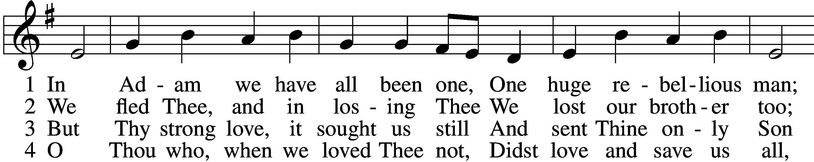
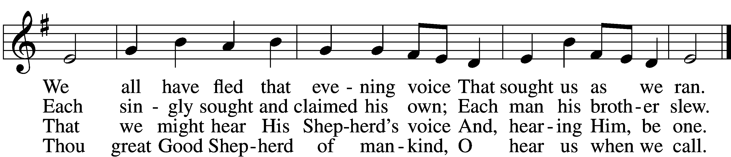

5 Send us Thy Spirit, teach us truth;
Thou Son, O set us free
From fancied wisdom, self-sought ways,
To make us one in Thee.

D 6 Then shall our song united rise
To Thine eternal throne,
Where with the Father evermore
And Spirit Thou art one.
Text: Martin H. Franzmann, 1907–76
Tune: Southern Harmony, 1835, New Haven
Text: © 1969 Concordia Publishing House. Used by permission: LSB Hymn License no. 110004798
Tune: Public domain

(The sign of the cross may be made by all in remembrance of their Baptism.)

INVOCATION
L In the name of the Father and of the T Son and of the Holy Spirit.
C Amen.

+ CONFESSION AND ABSOLUTION +

EXHORTATION LSB 184
L Beloved in the Lord! Let us draw near with a true heart and confess our sins unto God our Father, beseeching Him in the name of our Lord Jesus Christ to grant us forgiveness.

L Our help is in the name of the Lord,
C who made heaven and earth.
L I said, I will confess my transgressions unto the Lord,
C and You forgave the iniquity of my sin.

(Silence for reflection on God’s Word and for self-examination.)

CONFESSION OF SINS LSB 184
L O almighty God, merciful Father,
C I, a poor, miserable sinner, confess unto You all my sins and iniquities with which I have ever offended You and justly deserved Your temporal and eternal punishment. But I am heartily sorry for them and sincerely repent of them, and I pray You of Your boundless mercy and for the sake of the holy, innocent, bitter sufferings and death of Your beloved Son, Jesus Christ, to be gracious and merciful to me, a poor, sinful being.

DECLARATION OF GRACE
L In the mercy of almighty God, Jesus Christ was given to die for us, and for His sake God forgives us all our sins. To those who believe in Jesus Christ He gives the power to become the children of God and bestows on them the Holy Spirit. May the Lord, who has begun this good work in us, bring it to completion in the day of our Lord Jesus Christ.
C Amen.

+ SERVICE OF THE WORD +

INTROIT Psalm 91:9–13; antiphon: vv. 15–16
When he calls to me, I will answer him; I will be with him in | trouble;*
I will rescue him and | honor him.
With long life I will sat- | isfy him*
and show him my sal- | vation.
Because you have made the Lord your | dwelling place—*
the Most High, who is my | refuge—
no evil shall be allowed to be- | fall you,*
no plague come | near your tent.
For he will command his angels con- | cerning you*
to guard you in | all your ways.
On their hands they will | bear you up,*
lest you strike your foot a- | gainst a stone.
You will tread on the lion and the | adder;*
the young lion and the serpent you will trample | underfoot.
Glory be to the Father and | to the Son*
and to the Holy | Spirit;
as it was in the be- | ginning,*
is now, and will be forever. | Amen.
When he calls to me, I will answer him; I will be with him in | trouble;*
I will rescue him and | honor him.
With long life I will sat- | isfy him*
and show him my sal- | vation.

KYRIE LSB 186
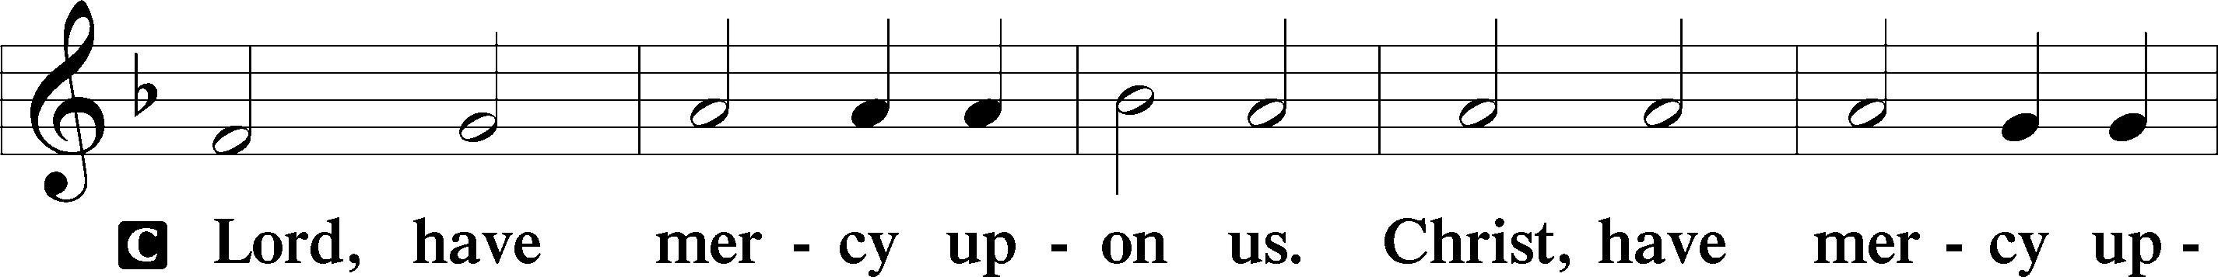
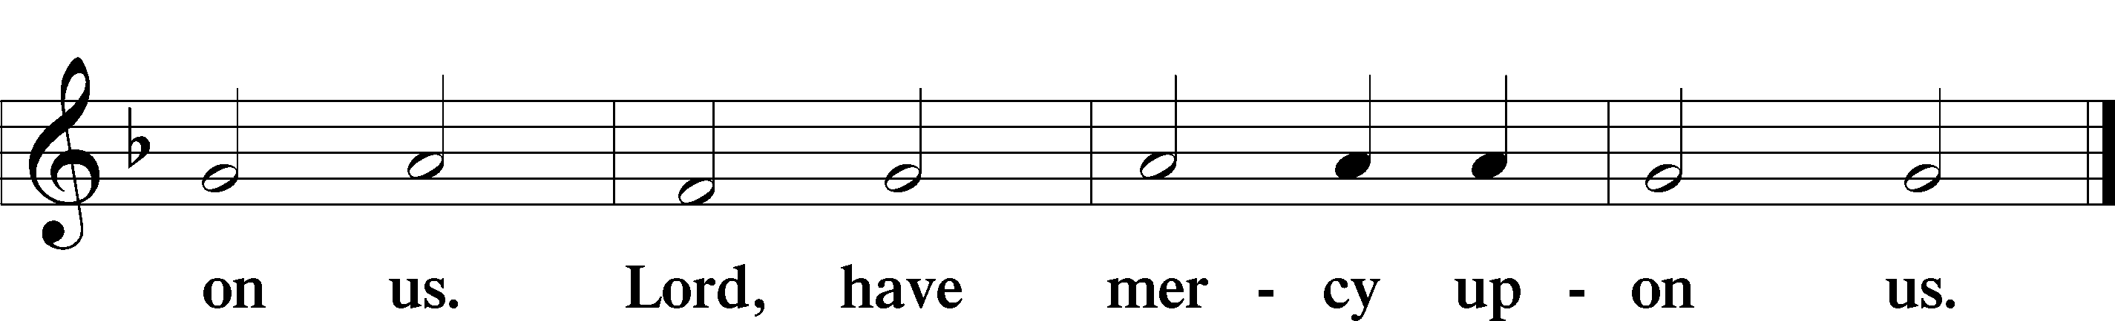

SALUTATION AND COLLECT OF THE DAY
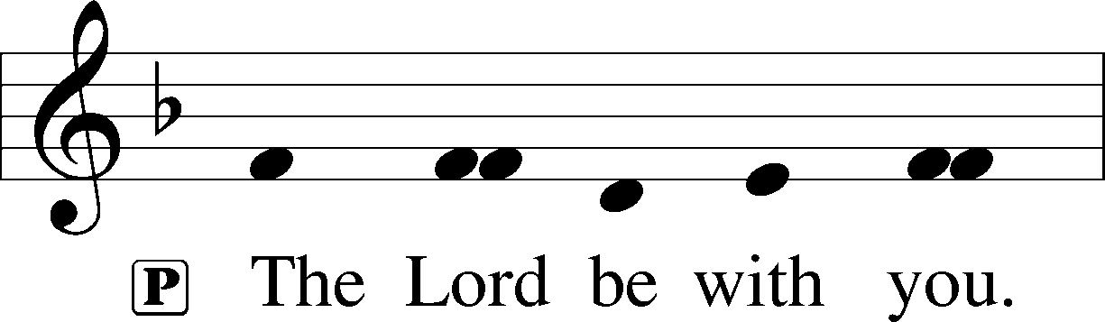
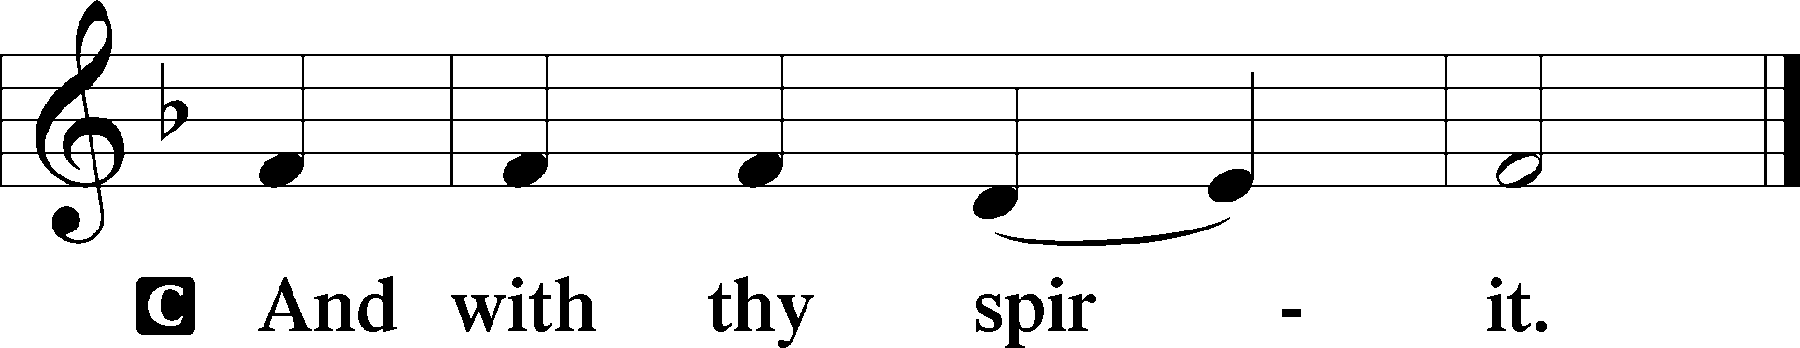

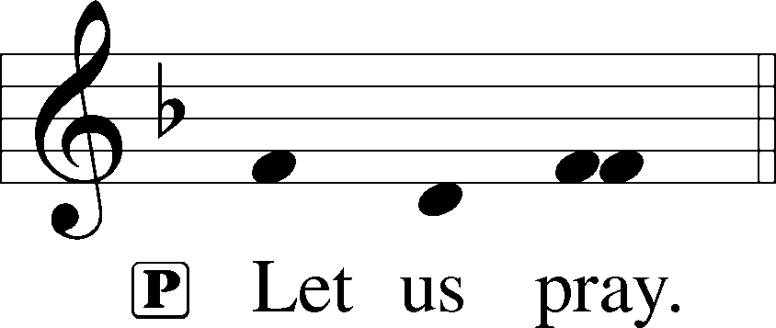

L O Lord God, You led Your ancient people through the wilderness and brought them to the promised land. Guide the people of Your Church that following our Savior we may walk through the wilderness of this world toward the glory of the world to come; through Jesus Christ, Your Son, our Lord, who lives and reigns with You and the Holy Spirit, one God, now and forever.

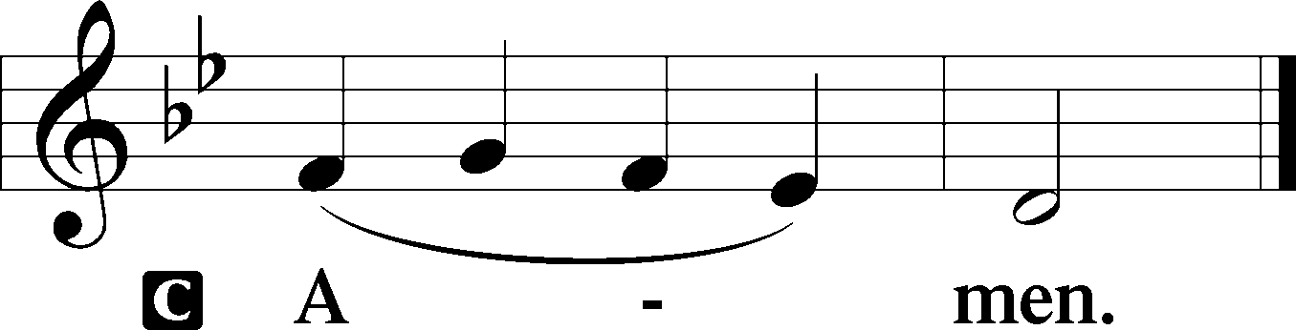

(Sit)

CHILDREN'S LESSON

OLD TESTAMENT READING Genesis 3:1–21
1Now the serpent was more crafty than any other beast of the field that the Lord God had made.
He said to the woman, “Did God actually say, ‘You shall not eat of any tree in the garden’?” 2And the woman said to the serpent, “We may eat of the fruit of the trees in the garden, 3but God said, ‘You shall not eat of the fruit of the tree that is in the midst of the garden, neither shall you touch it, lest you die.’” 4But the serpent said to the woman, “You will not surely die. 5For God knows that when you eat of it your eyes will be opened, and you will be like God, knowing good and evil.” 6So when the woman saw that the tree was good for food, and that it was a delight to the eyes, and that the tree was to be desired to make one wise, she took of its fruit and ate, and she also gave some to her husband who was with her, and he ate. 7Then the eyes of both were opened, and they knew that they were naked. And they sewed fig leaves together and made themselves loincloths.
8And they heard the sound of the Lord God walking in the garden in the cool of the day, and the man and his wife hid themselves from the presence of the Lord God among the trees of the garden. 9But the Lord God called to the man and said to him, “Where are you?” 10And he said, “I heard the sound of you in the garden, and I was afraid, because I was naked, and I hid myself.” 11He said, “Who told you that you were naked? Have you eaten of the tree of which I commanded you not to eat?” 12The man said, “The woman whom you gave to be with me, she gave me fruit of the tree, and I ate.” 13Then the Lord God said to the woman, “What is this that you have done?” The woman said, “The serpent deceived me, and I ate.”
14The Lord God said to the serpent,
“Because you have done this,
cursed are you above all livestock
and above all beasts of the field;
on your belly you shall go,
and dust you shall eat
all the days of your life.
15I will put enmity between you and the woman,
and between your offspring and her offspring;
he shall bruise your head,
and you shall bruise his heel.”
16To the woman he said,
“I will surely multiply your pain in childbearing;
in pain you shall bring forth children.
Your desire shall be for your husband,
and he shall rule over you.”
17And to Adam he said,
“Because you have listened to the voice of your wife
and have eaten of the tree
of which I commanded you,
‘You shall not eat of it,’
cursed is the ground because of you;
in pain you shall eat of it all the days of your life;
18thorns and thistles it shall bring forth for you;
and you shall eat the plants of the field.
19By the sweat of your face
you shall eat bread,
till you return to the ground,
for out of it you were taken;
for you are dust,
and to dust you shall return.”
20The man called his wife’s name Eve, because she was the mother of all living. 21And the Lord God made for Adam and for his wife garments of skins and clothed them.

L This is the Word of the Lord.
C Thanks be to God.

GRADUAL Hebrews 12:2
[O come, let us fix our eyes on] | Jesus,*
the founder and perfecter | of our faith,
who for the joy that was set before him endured the cross, despis- | ing the shame,*
and is seated at the right hand of the | throne of God.

EPISTLE Romans 5:12–19
12Therefore, just as sin came into the world through one man, and death through sin, and so death spread to all men because all sinned— 13for sin indeed was in the world before the law was given, but sin is not counted where there is no law. 14Yet death reigned from Adam to Moses, even over those whose sinning was not like the transgression of Adam, who was a type of the one who was to come.
15But the free gift is not like the trespass. For if many died through one man’s trespass, much more have the grace of God and the free gift by the grace of that one man Jesus Christ abounded for many. 16And the free gift is not like the result of that one man’s sin. For the judgment following one trespass brought condemnation, but the free gift following many trespasses brought justification. 17If, because of one man’s trespass, death reigned through that one man, much more will those who receive the abundance of grace and the free gift of righteousness reign in life through the one man Jesus Christ.
18Therefore, as one trespass led to condemnation for all men, so one act of righteousness leads to justification and life for all men. 19For as by the one man’s disobedience the many were made sinners, so by the one man’s obedience the many will be made righteous.

L This is the Word of the Lord.
C Thanks be to God.

(Stand)

HOLY GOSPEL Matthew 4:1–11
L The Holy Gospel according to St. Matthew, the fourth chapter.

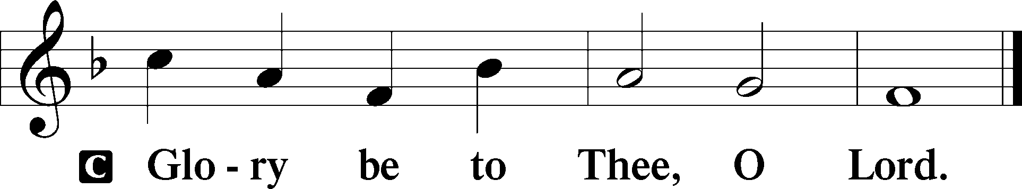

1Then Jesus was led up by the Spirit into the wilderness to be tempted by the devil. 2And after fasting forty days and forty nights, he was hungry. 3And the tempter came and said to him, “If you are the Son of God, command these stones to become loaves of bread.” 4But he answered, “It is written,
“‘Man shall not live by bread alone,
but by every word that comes from the mouth of God.’”
5Then the devil took him to the holy city and set him on the pinnacle of the temple 6and said to him, “If you are the Son of God, throw yourself down, for it is written,
“‘He will command his angels concerning you,’
and
“‘On their hands they will bear you up,
lest you strike your foot against a stone.’”
7Jesus said to him, “Again it is written, ‘You shall not put the Lord your God to the test.’” 8Again, the devil took him to a very high mountain and showed him all the kingdoms of the world and their glory. 9And he said to him, “All these I will give you, if you will fall down and worship me.” 10Then Jesus said to him, “Be gone, Satan! For it is written,
“‘You shall worship the Lord your God
and him only shall you serve.’”
11Then the devil left him, and behold, angels came and were ministering to him.

L This is the Gospel of the Lord.

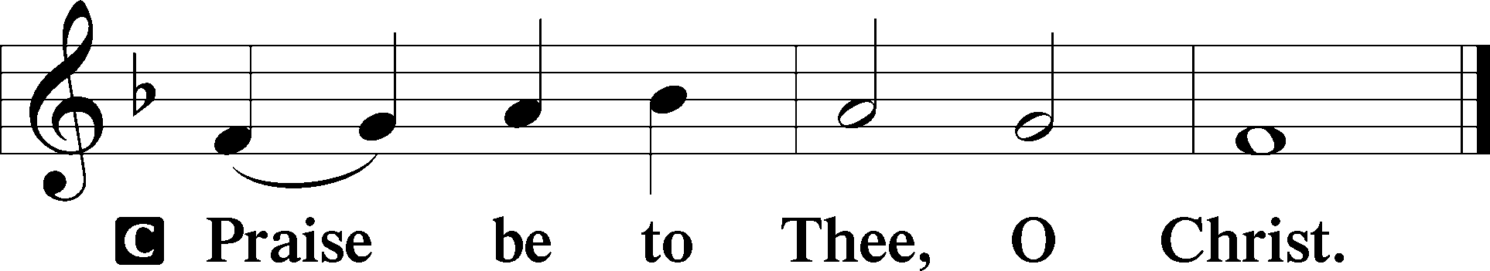

APOSTLES’ CREED
C I believe in God, the Father Almighty,
maker of heaven and earth.

And in Jesus Christ, His only Son, our Lord,
who was conceived by the Holy Spirit,
born of the virgin Mary,
suffered under Pontius Pilate,
was crucified, died and was buried.
He descended into hell.
The third day He rose again from the dead.
He ascended into heaven
and sits at the right hand of God the Father Almighty.
From thence He will come to judge the living and the dead.

I believe in the Holy Spirit,
the holy Christian Church,
the communion of saints,
the forgiveness of sins,
the resurrection of the body,
and the life T everlasting. Amen.

(Sit)

657 A MIGHTY FORTRESS IS OUR GOD sts. 1–4
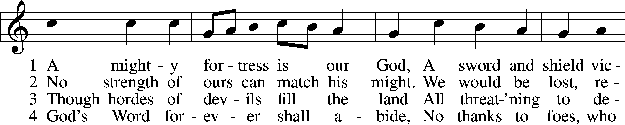
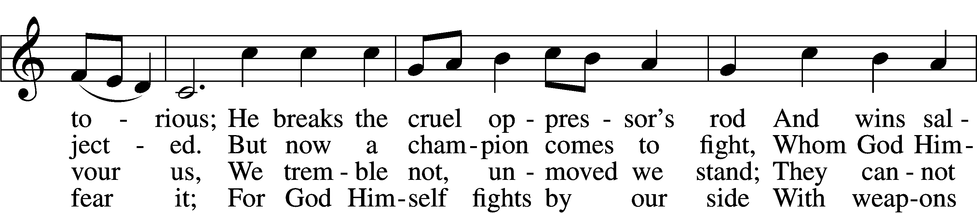
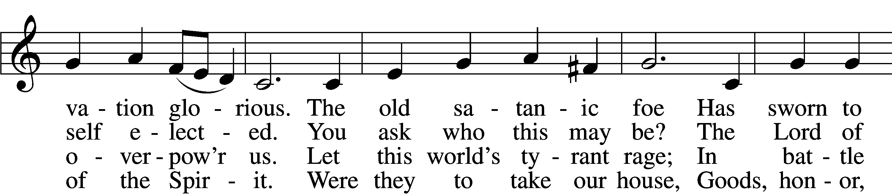
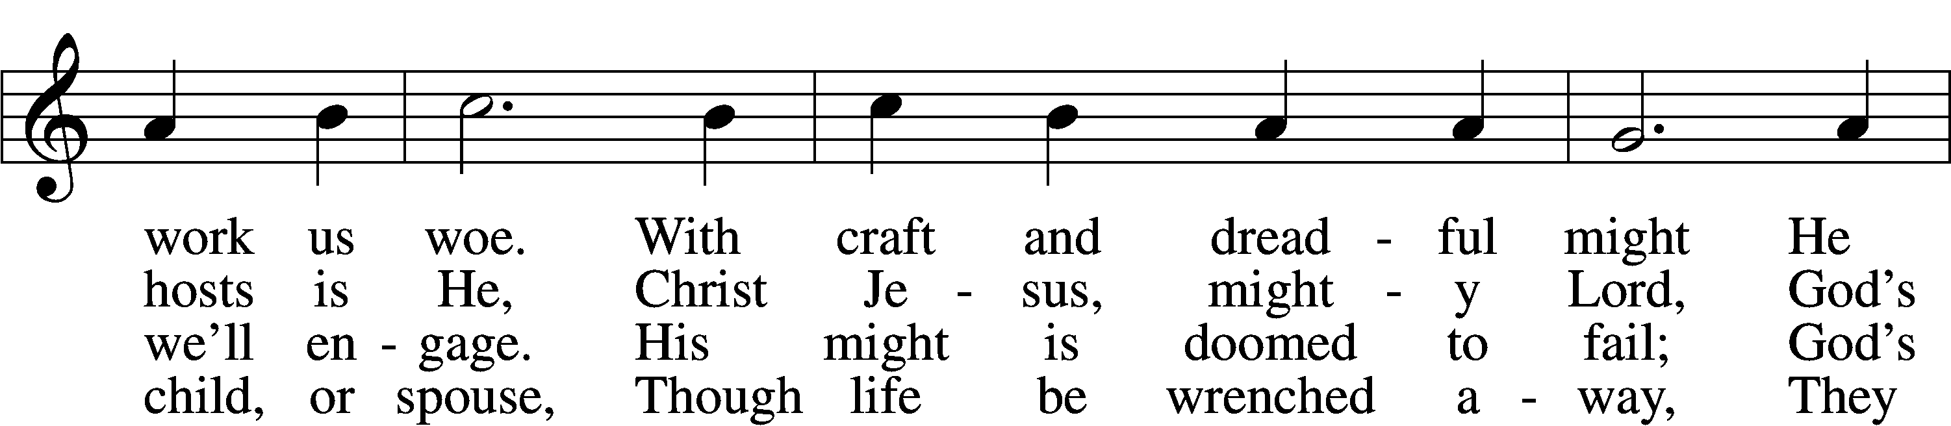
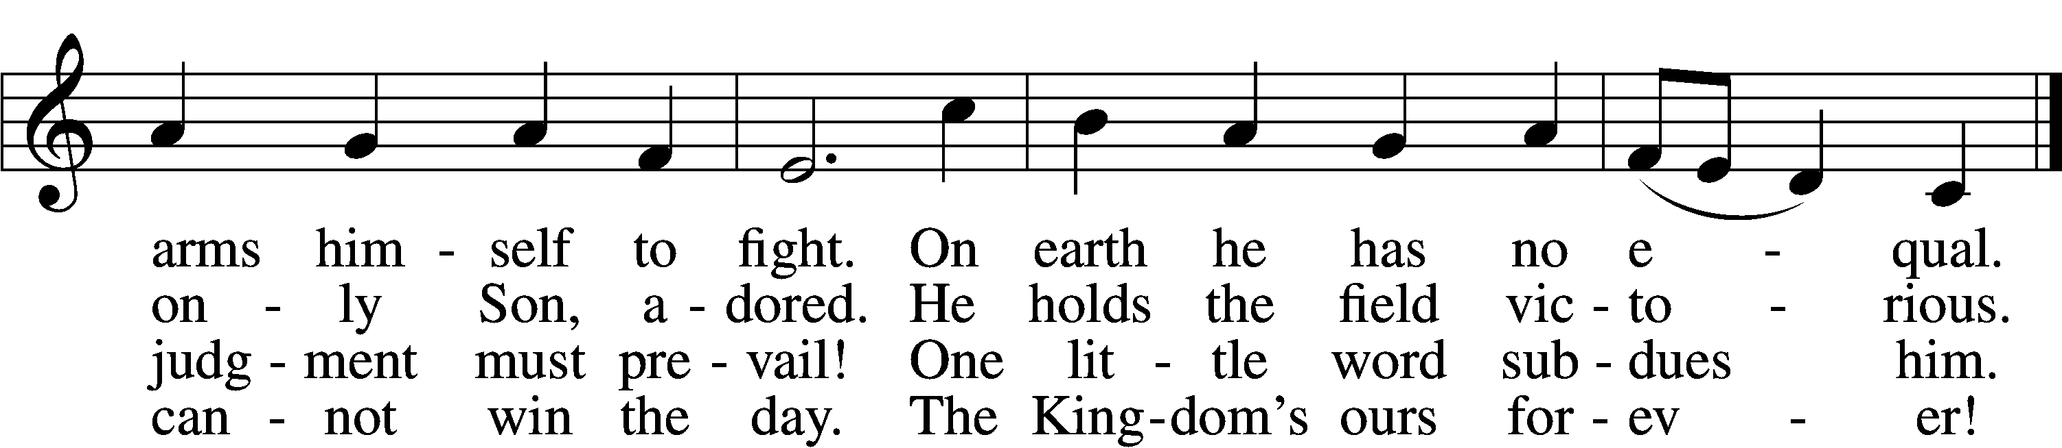
Text: tr. Lutheran Book of Worship, 1978
Text and tune: Martin Luther, 1483–1546
Text: © 1978 Lutheran Book of Worship. Used by permission: LSB Hymn License no. 110004798
Tune: Public domain

SERMON OR MEDITATION ON THE READINGS

OFFERING
As a part of our expression of thanksgiving to God for the treasure of His salvation to us, we offer a portion of our treasure, according to what each has determined in their heart to give. Please place offerings in the collection plate at the back of the sanctuary before or after the service. Offerings can also be sent to Bethlehem Lutheran Church via U.S. Mail. Thank you!

(Stand)

OFFERTORY LSB 192
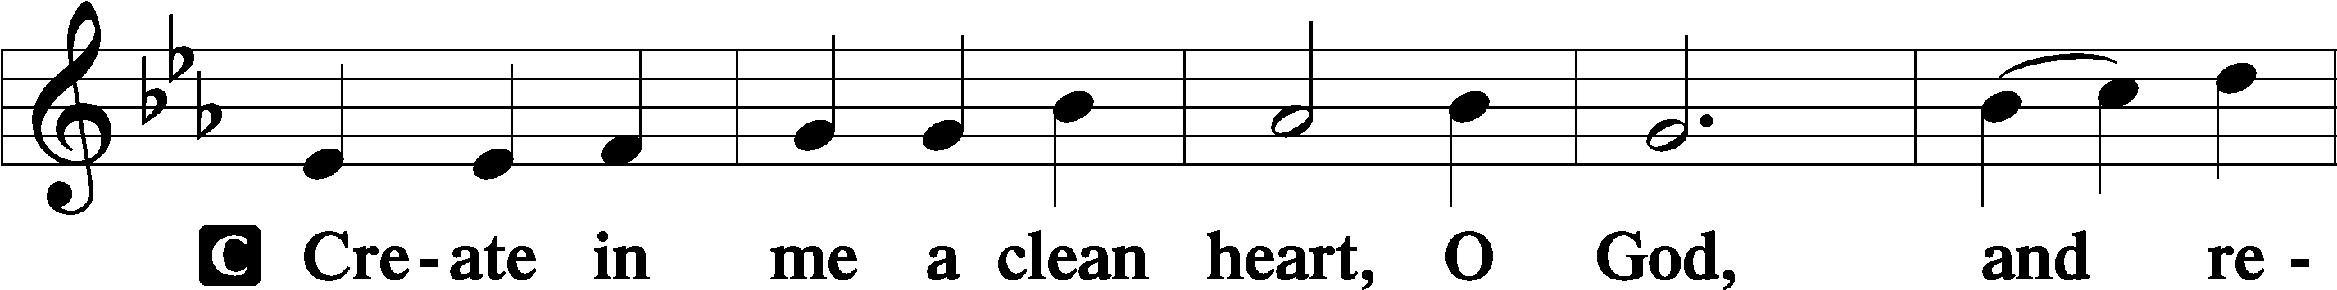
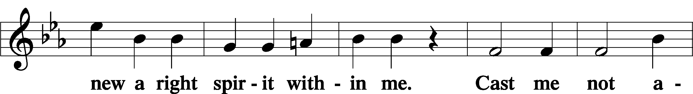
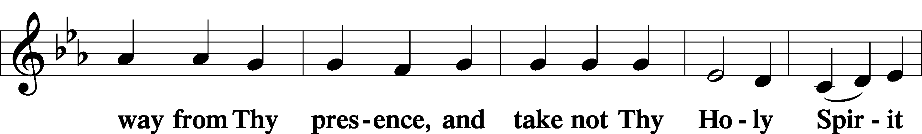
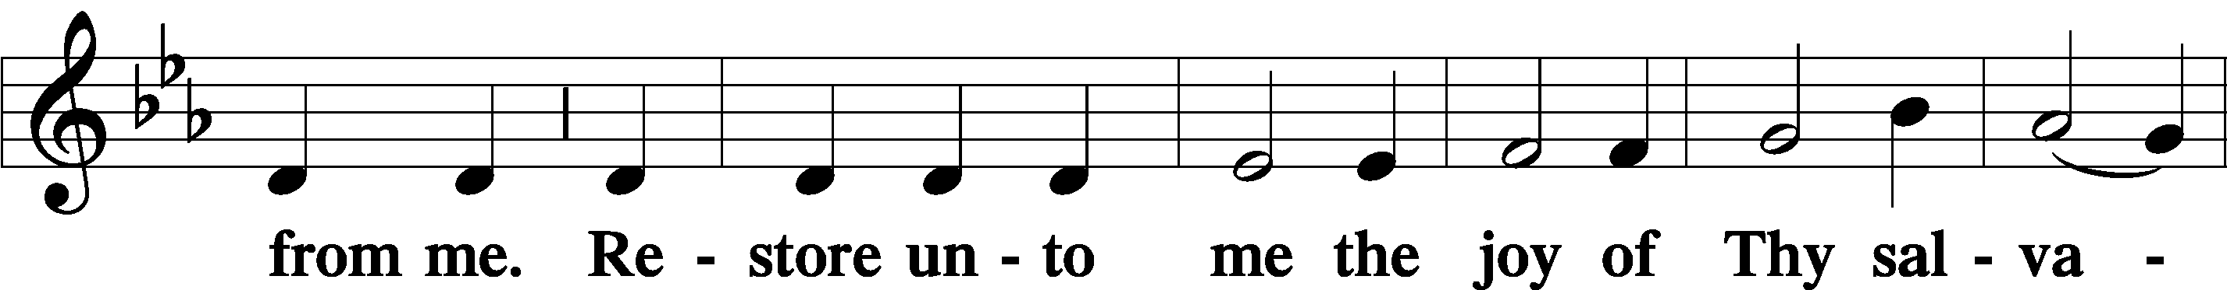
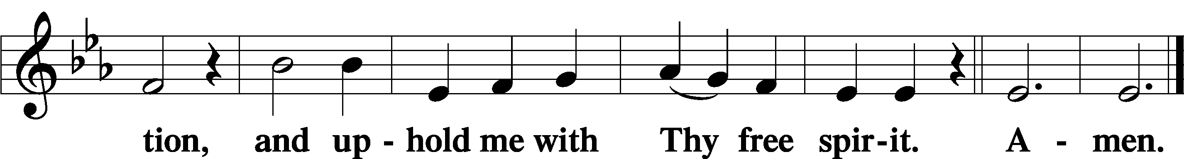

SHARING OF THE PEACE

(Sit)

PRAYER OF THE CHURCH

+ SERVICE OF THE SACRAMENT +
Note: The Service of The Sacrament is included in the lay bulletin solely as a viewers’ guide for those watching the livestream service; Communicant members who are unable to attend the Divine Service in person are encouraged to make arrangements with Pastor Engwall to receive the Lord’s Supper.

PREFACE LSB 194




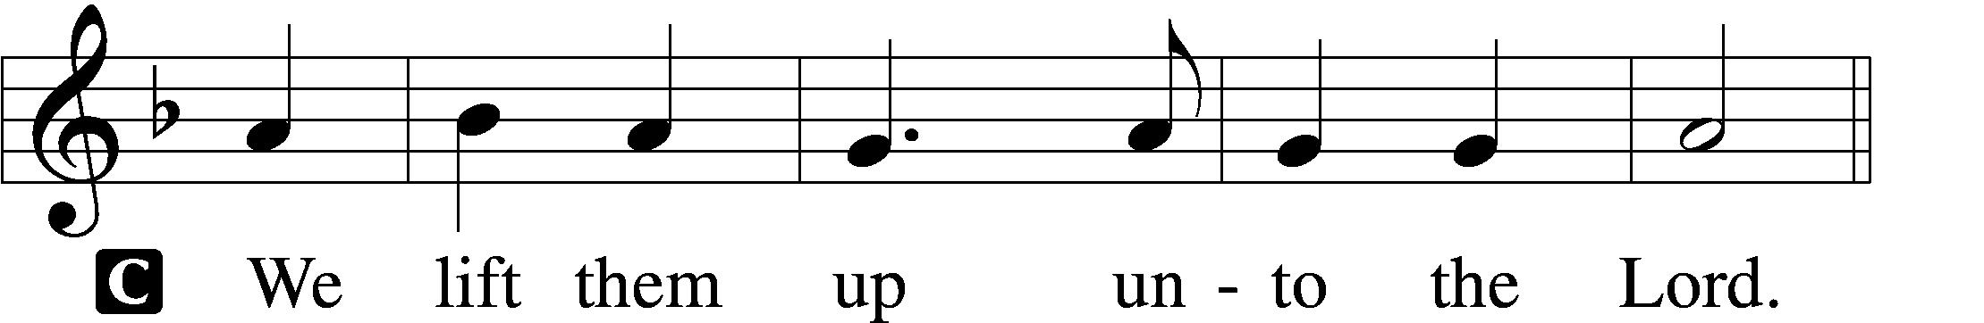

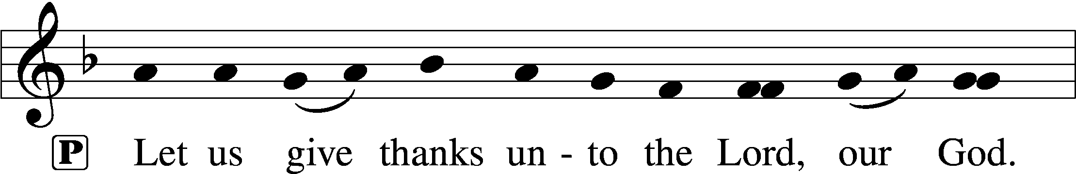
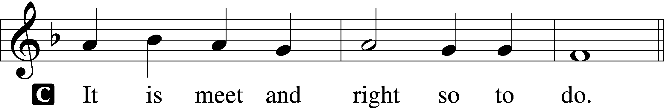

PROPER PREFACE (ABBREVIATED) LSB 194
P It is truly meet, right, and salutary . . . evermore praising You and saying:

SANCTUS LSB 195
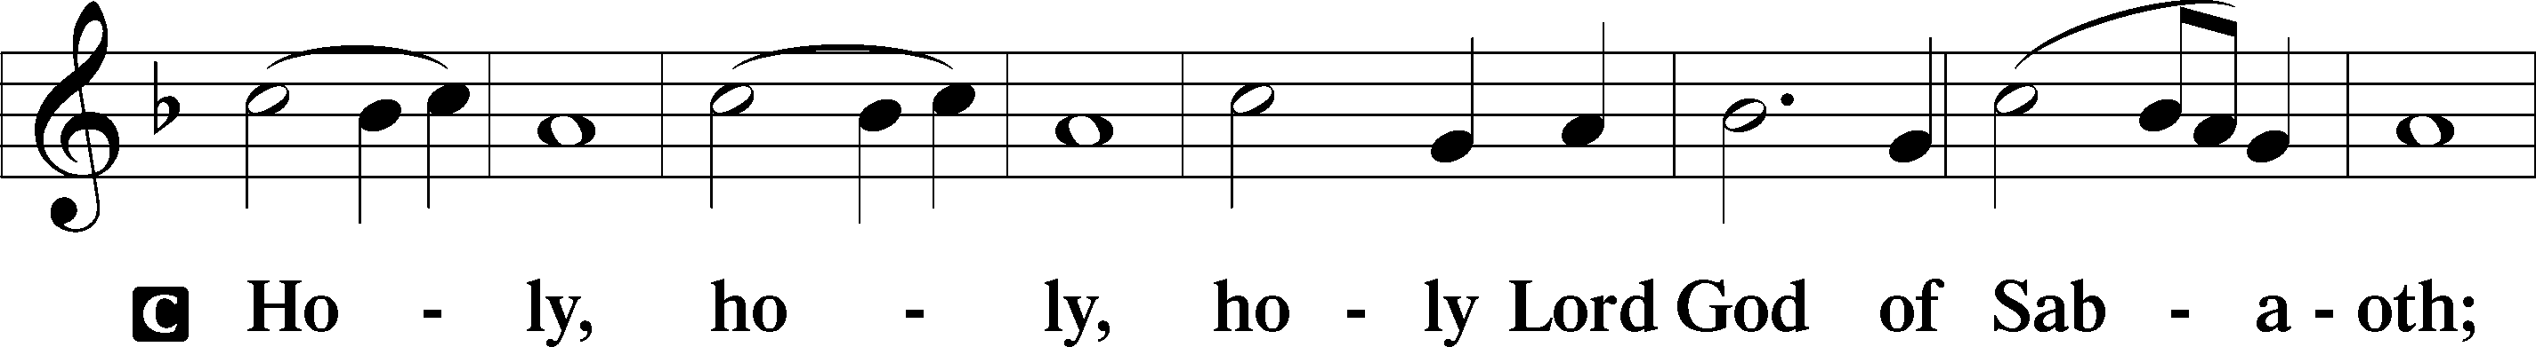
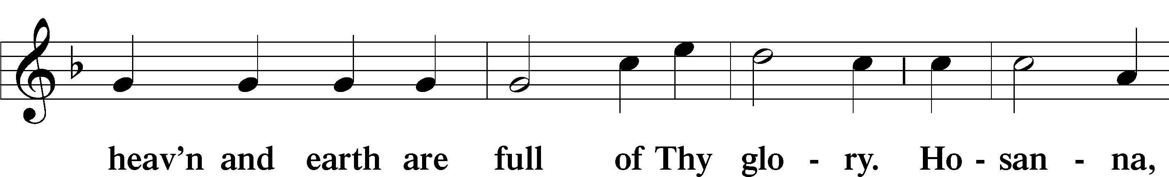
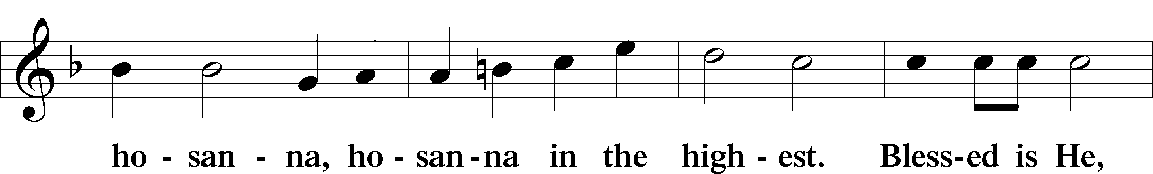
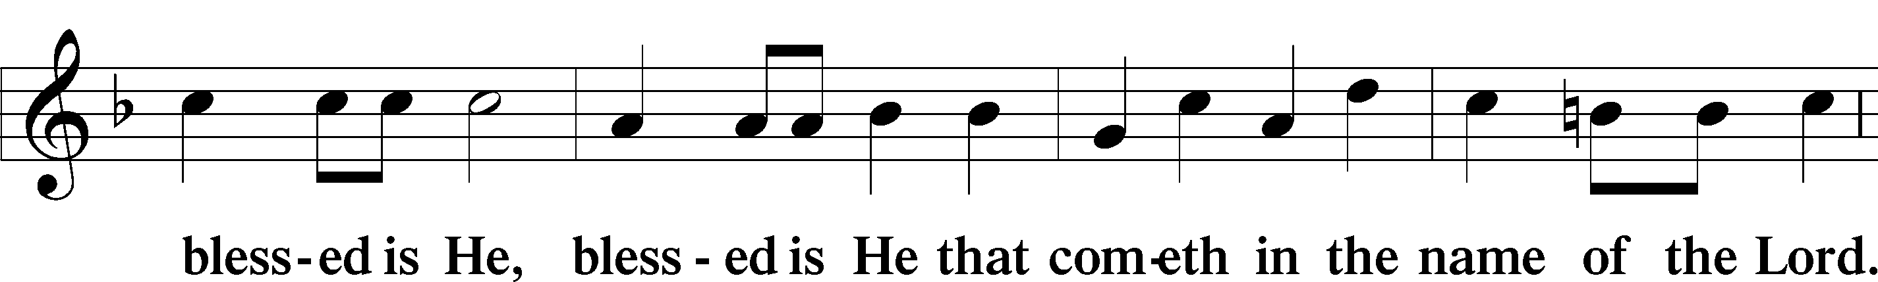
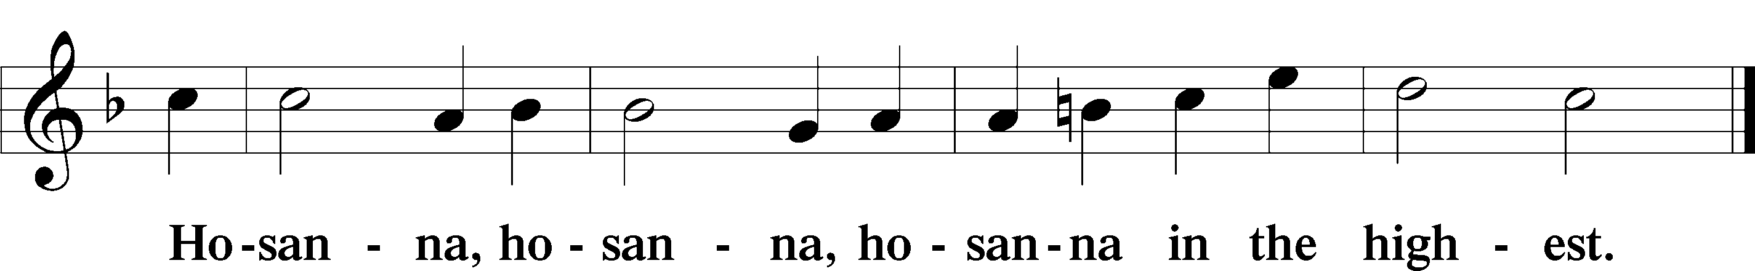

LORD’S PRAYER
C Our Father who art in heaven,
hallowed be Thy name,
Thy kingdom come,
Thy will be done on earth
as it is in heaven;
give us this day our daily bread;
and forgive us our trespasses
as we forgive those
who trespass against us;
and lead us not into temptation,
but deliver us from evil.
For Thine is the kingdom
and the power and the glory
forever and ever. Amen.

THE WORDS OF OUR LORD LSB 197

PAX DOMINI LSB 197
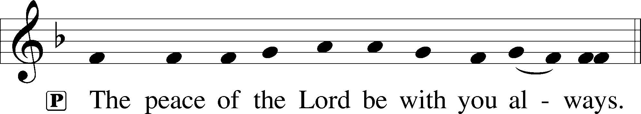

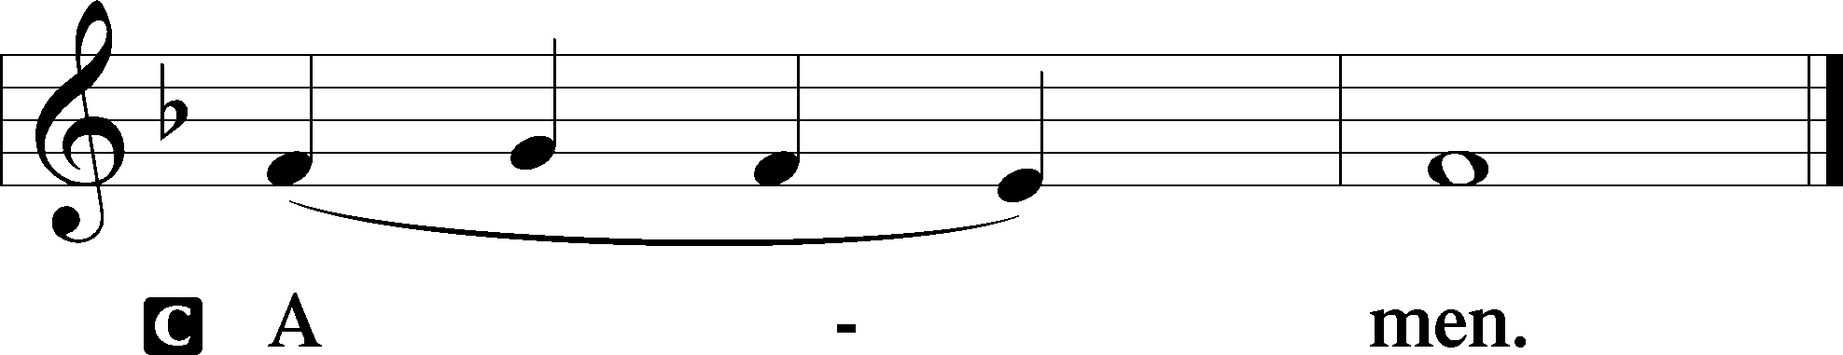

AGNUS DEI LSB 198
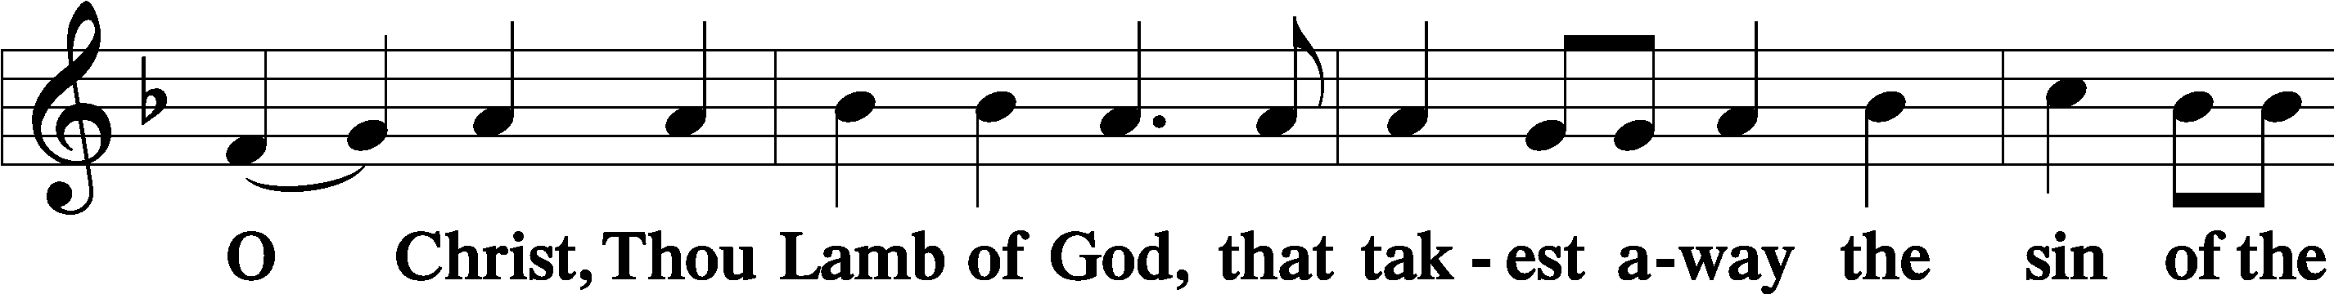
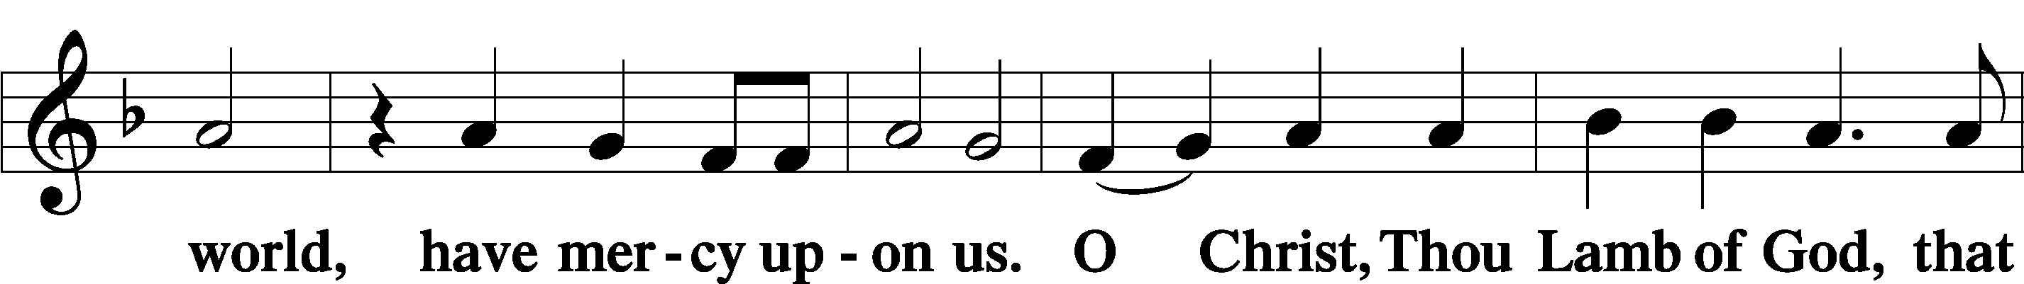
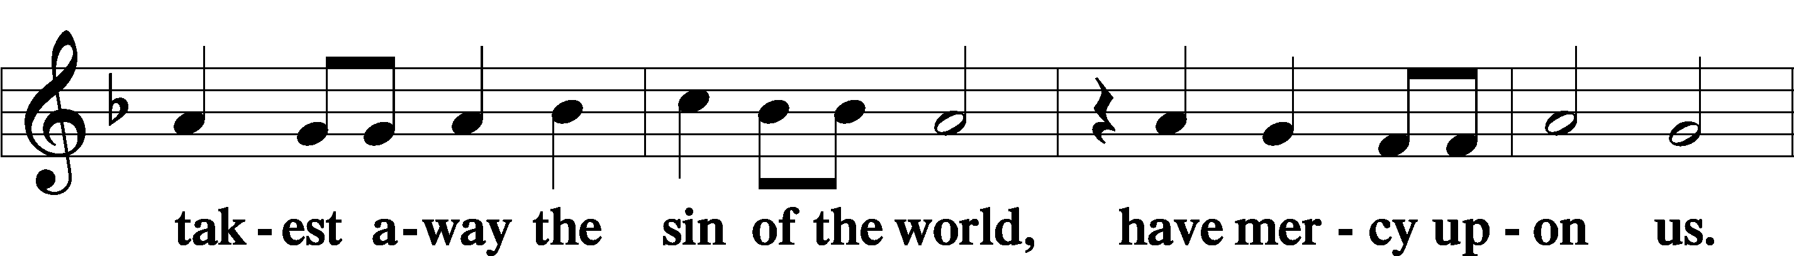
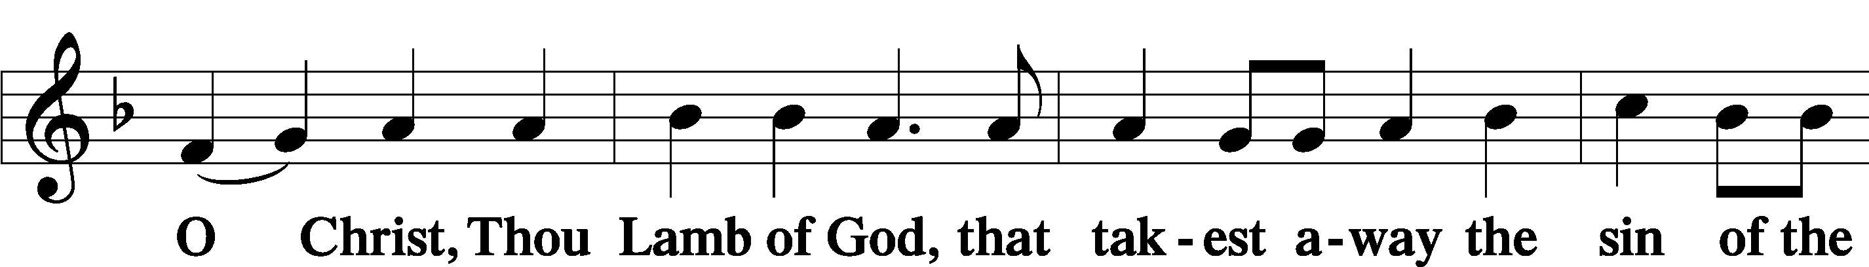
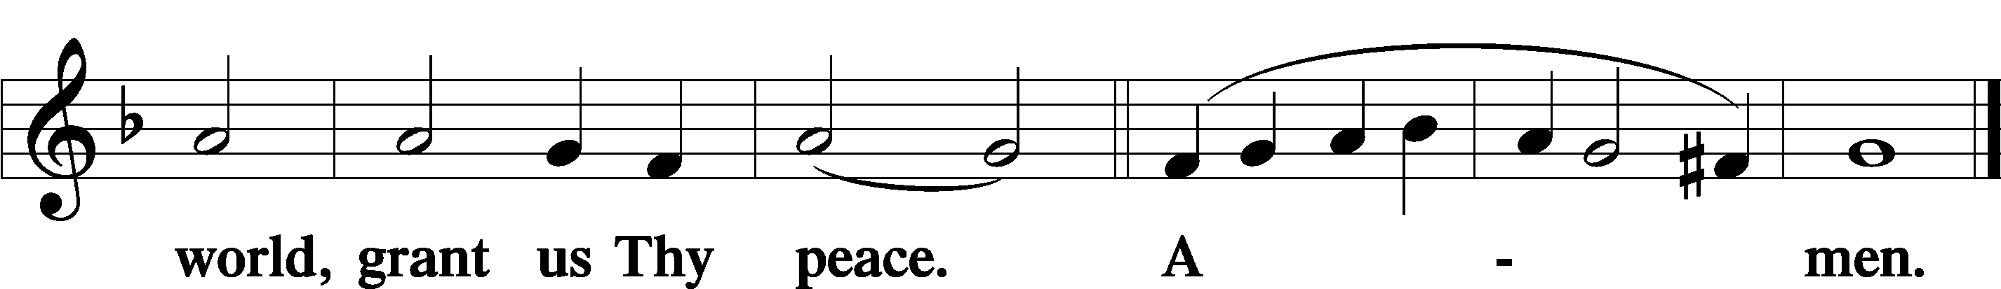

DISTRIBUTION
(The pastor and those who assist him receive the body and blood of Christ first, then commune those who are unable to come to the altar. The ushers will then direct all other communicants to the altar.)

561 THE TREE OF LIFE
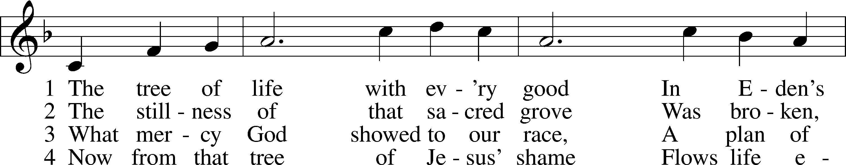
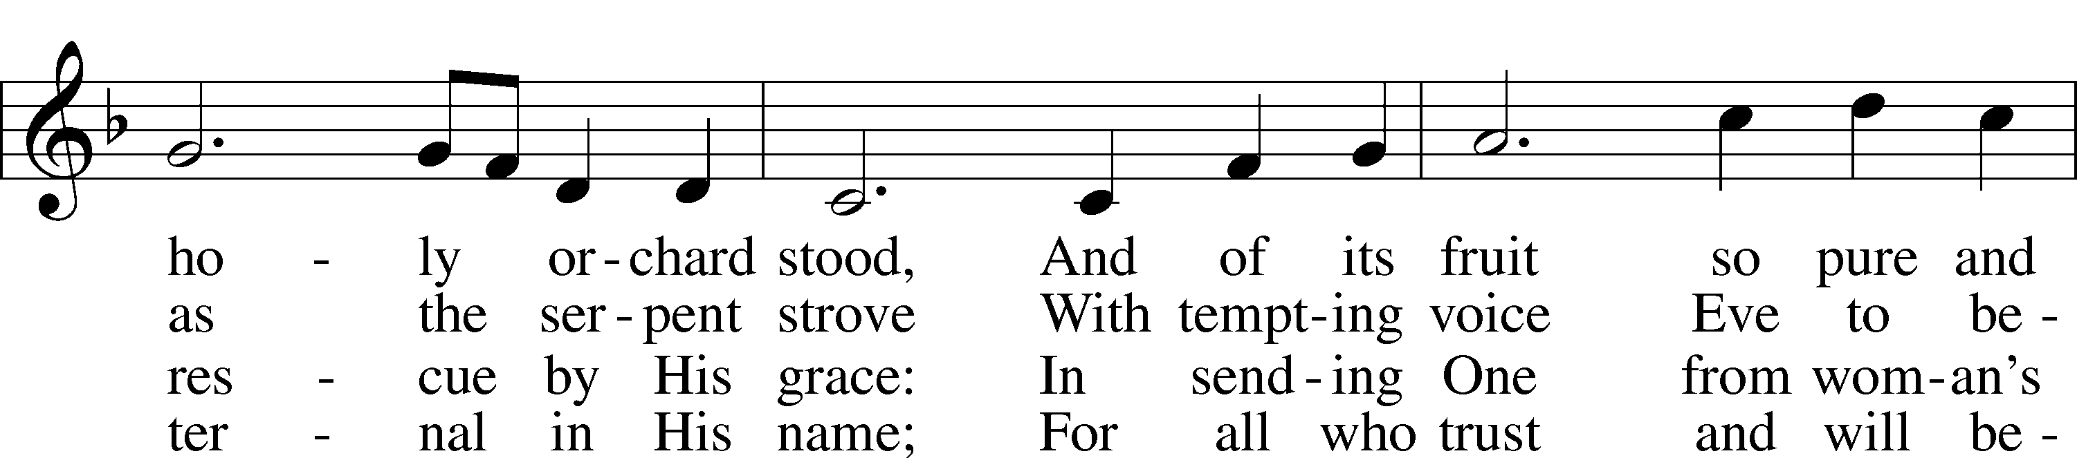
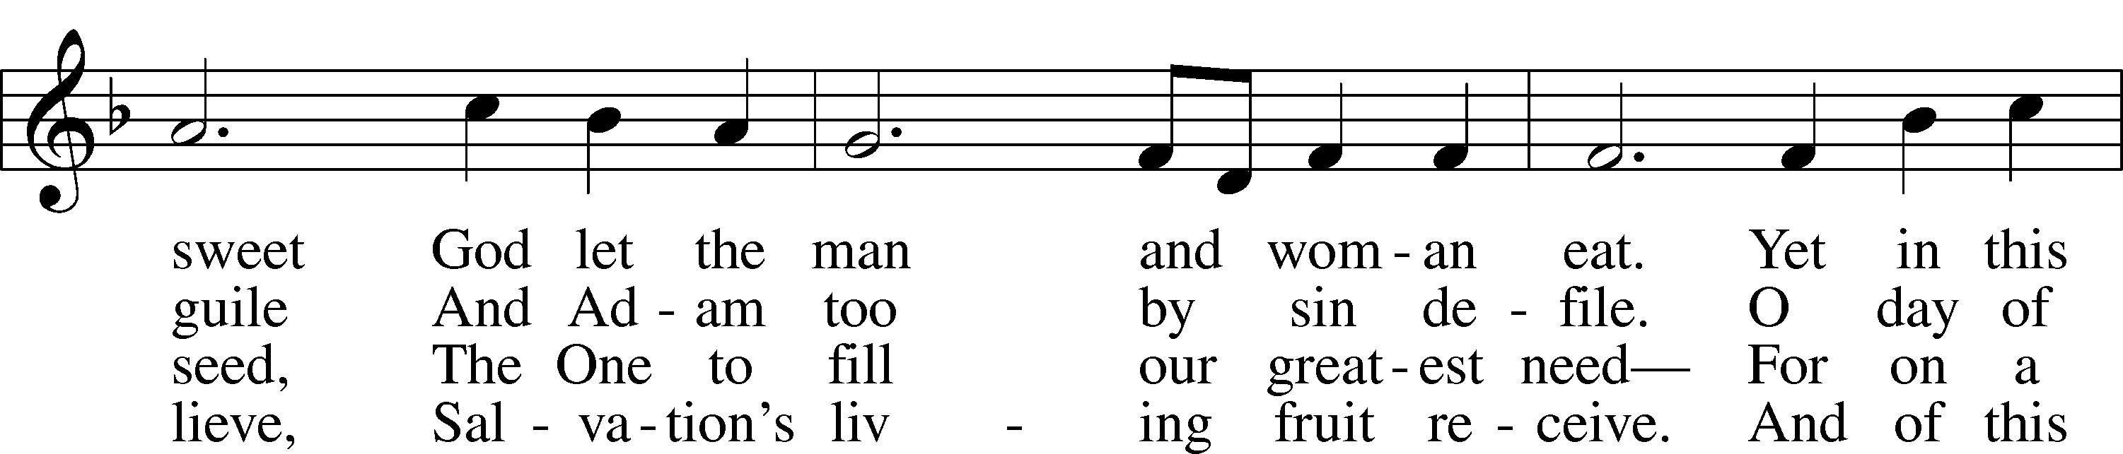
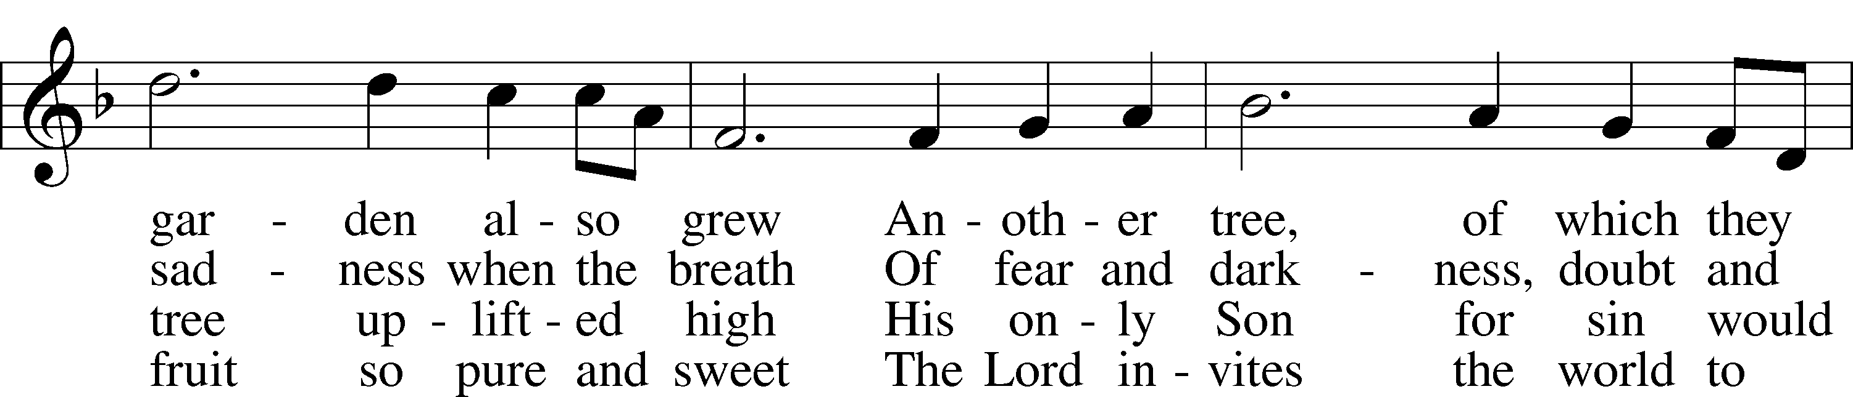
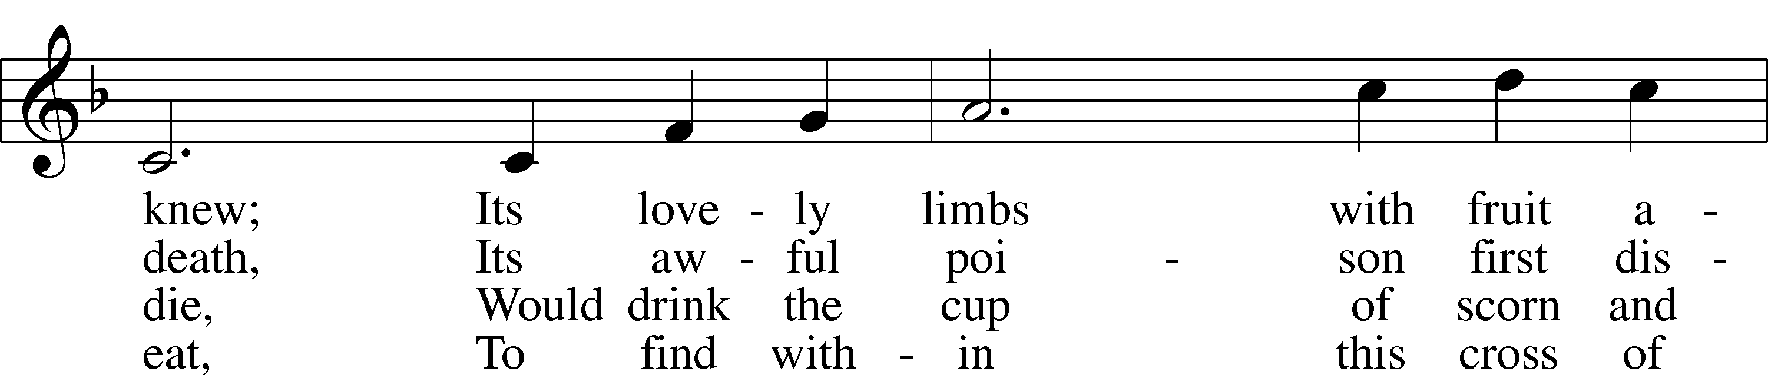
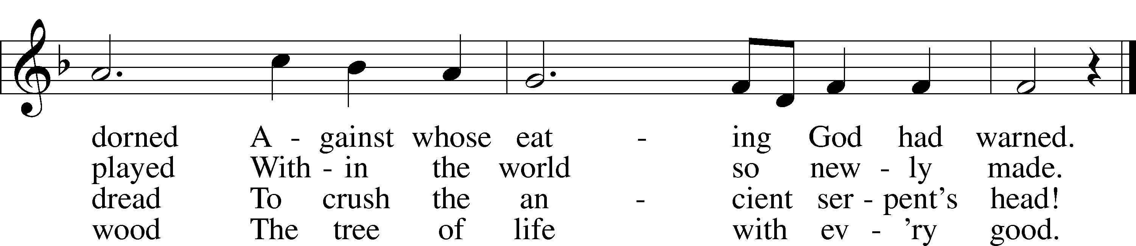
Text: Stephen P. Starke, 1955
Tune: Bruce W. Becker, 1952
Text: © 1993 Stephen P. Starke, admin. Concordia Publishing House. Used by permission: LSB Hymn License no. 110004798
Tune: © 1995 Bruce W. Becker. Used by permission: LSB Hymn License no. 110004798

INSTRUMENTAL

(Stand)

NUNC DIMITTIS LSB 199
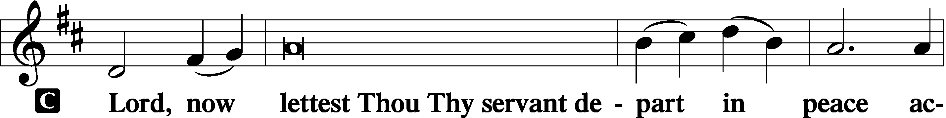

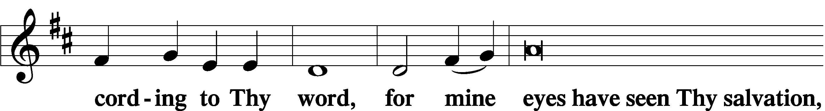

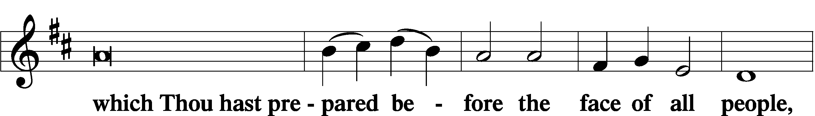

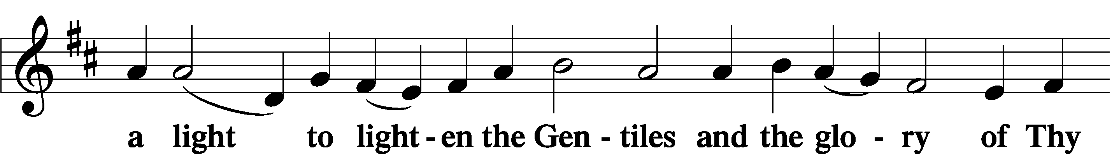

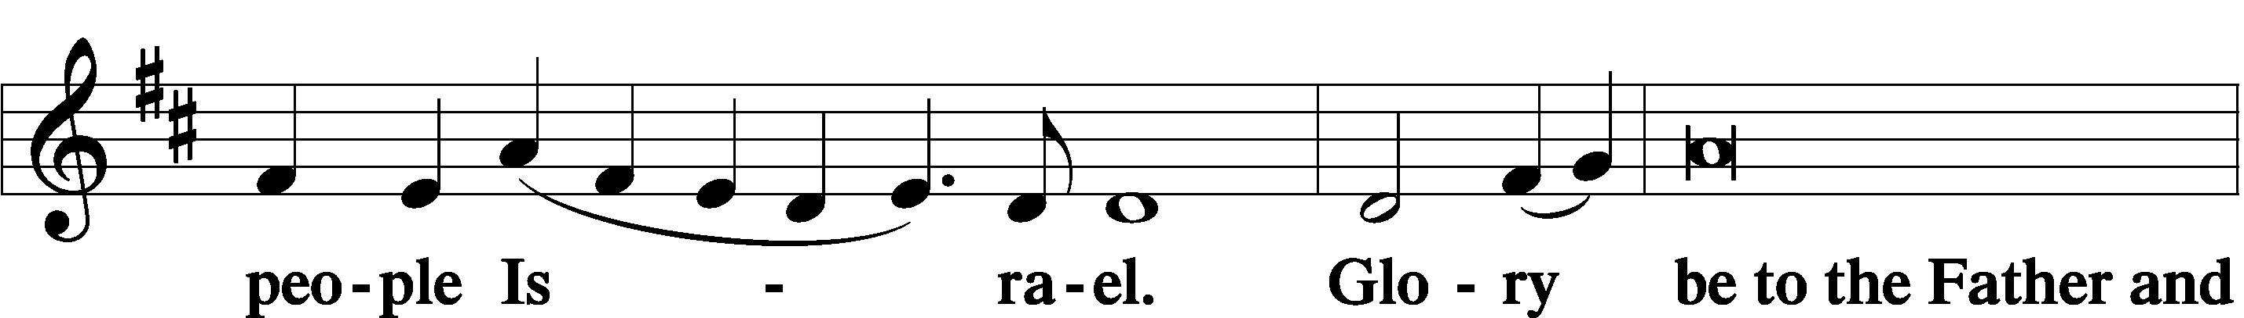

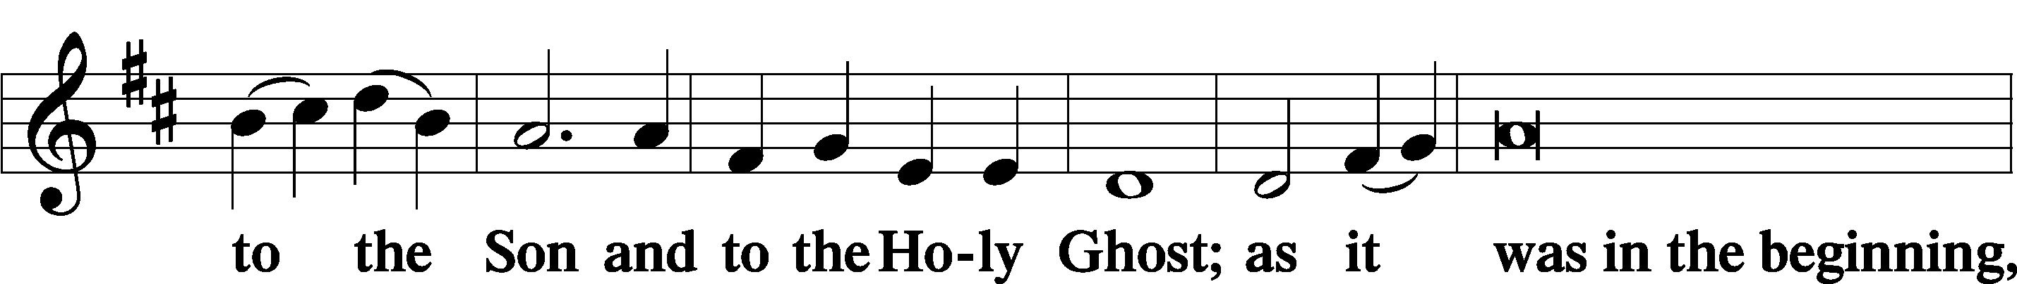

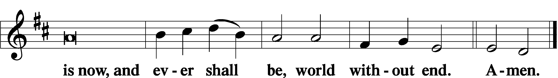

THANKSGIVING LSB 200
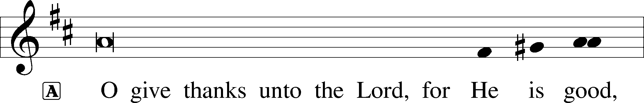

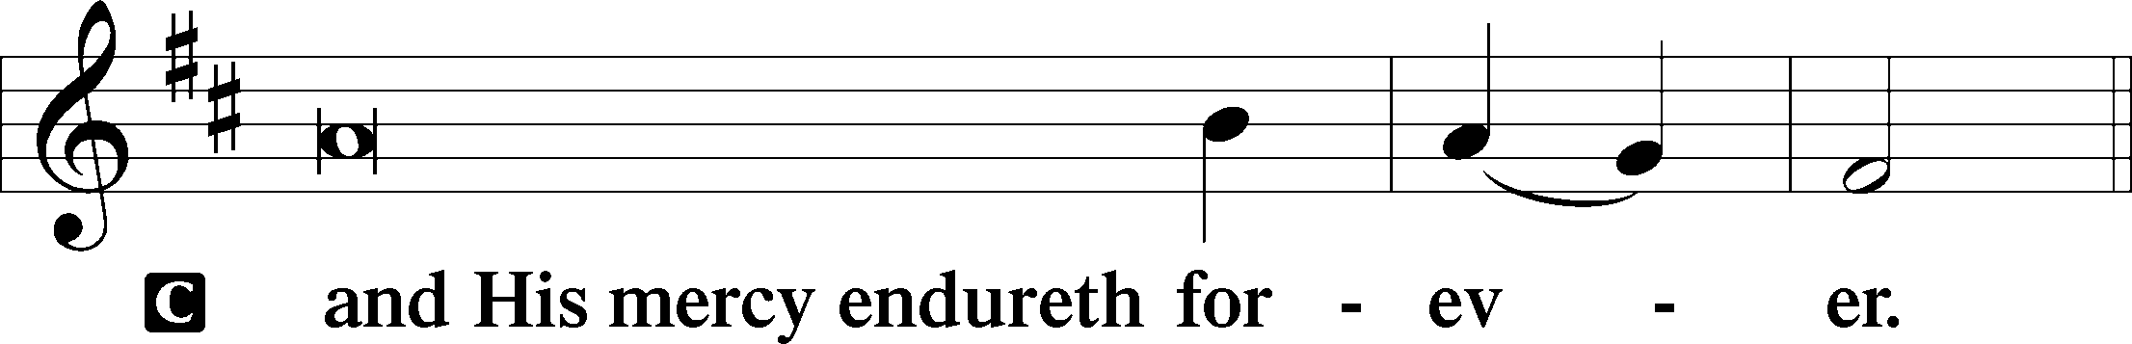
POST-COMMUNION COLLECT
P Let us pray.
We give thanks to You, almighty God, that You have refreshed us through this salutary gift, and we implore You that of Your mercy You would strengthen us through the same in faith toward You and in fervent love toward one another; through Jesus Christ, Your Son, our Lord, who lives and reigns with You and the Holy Spirit, one God, now and forever.

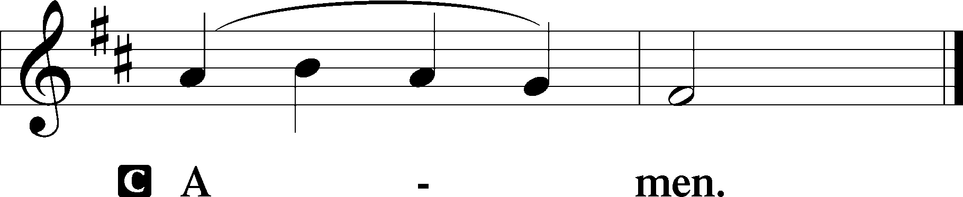

SALUTATION LSB 201
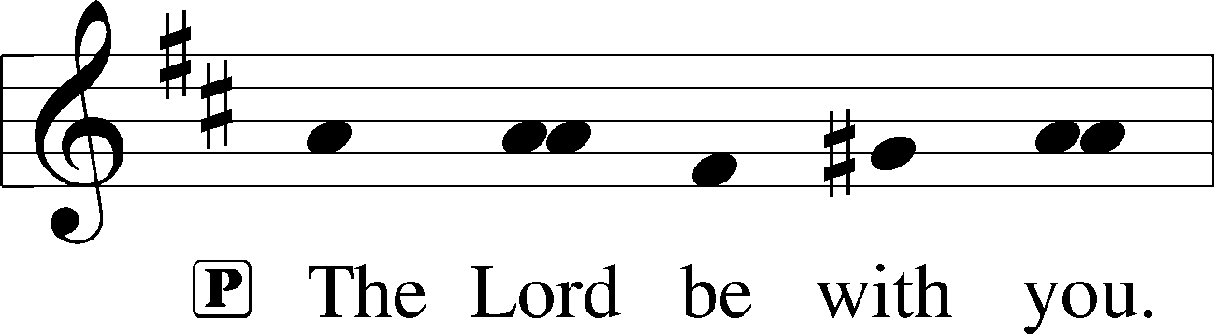

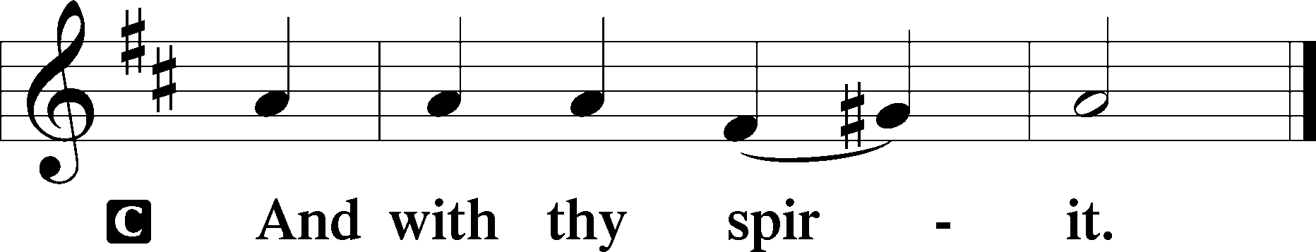

BENEDICAMUS LSB 202
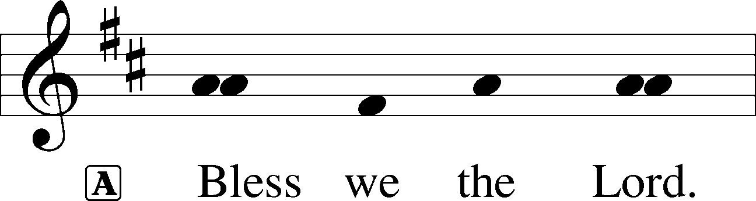

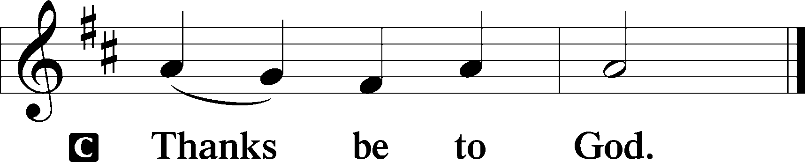

BENEDICTION
L:The grace of our Lord T Jesus Christ, and the love of God, and the fellowship of the Holy Spirit, be with us all.
C: Amen.

575 MY HOPE IS BUILT ON NOTHING LESS
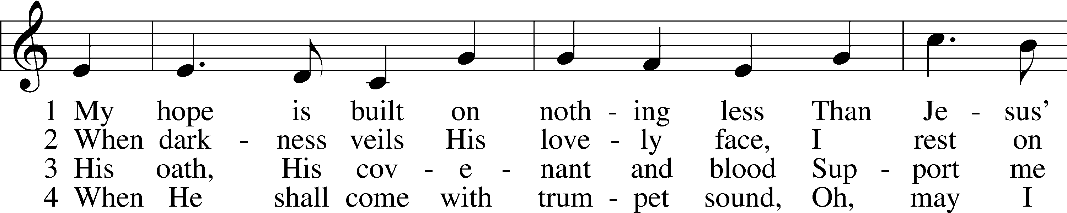
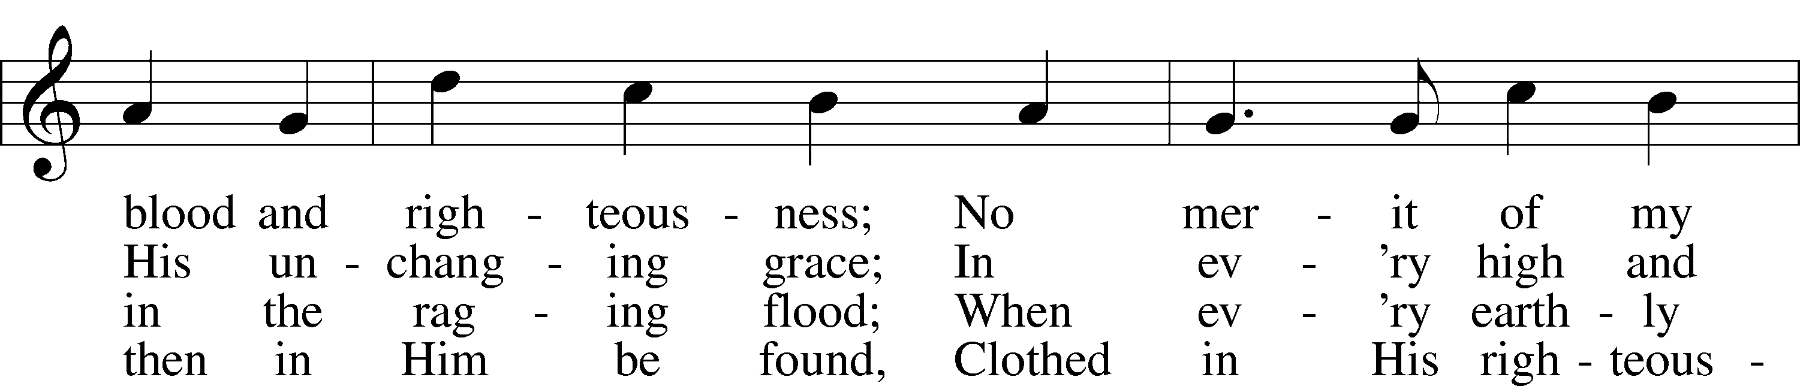
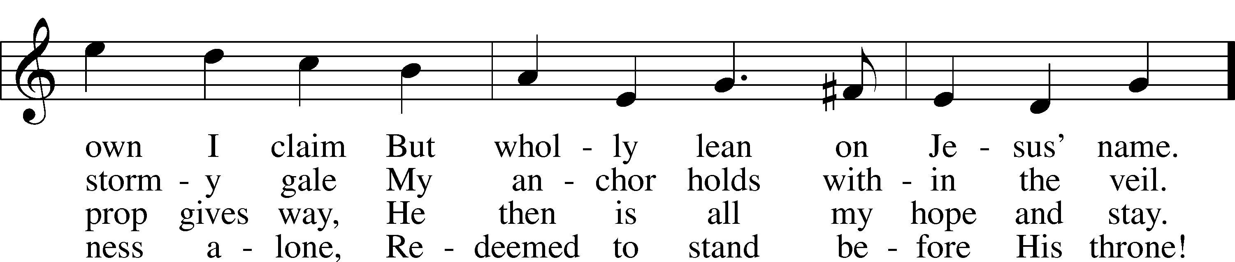
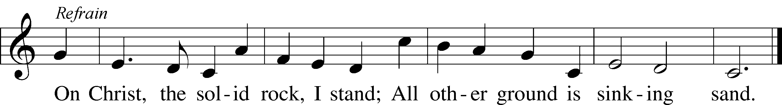
Text: Edward Mote, 1797–1874, alt.
Tune: John Stainer, 1840–1901
Text and tune: Public domain

ACKNOWLEDGMENTS
Unless otherwise indicated, Scripture quotations are from the ESV® Bible (The Holy Bible, English Standard Version®), copyright © 2001 by Crossway, a publishing ministry of Good News Publishers. Used by permission. All rights reserved.
Created by Lutheran Service Builder © 2026 Concordia Publishing House.

IN OUR PRAYERS:
Submitted petitions are included for two consecutive Sundays
For Those suffering afflictions of mind, body, or spirit:
Blake B., Carol R., Michele N., Dean S., Carl B.

All of our Shut- Ins:
Betty A., Shirley F., Mary H., Patsy L., Herman L., Tommy M., Jerome M., Sharon B., Judy S., Anne H.

For missionaries
Deaconess Sandra R., Rev. Jonathan A.

ANNOUNCEMENTS
Please email announcements for Sunday bulletins by 8:00 a.m. Tuesday to pastorblcaiken@gmail.com
ALTAR FLOWERS:
Flowers are donated today by Rebecca S.

Lent, Holy Week, and Easter Schedule of services
Lenten Wednesdays: Feb. 25th; Mar. 4th,11th,18th, 25th
-Meals at 11:30 a.m. and 6:00 p.m.; services at 11:00 a.m. and 7:00 p.m.
Palm/ Passion Sunday: March 29th
Maundy Thursday: April 2nd; 7:00 p.m. Communion service
Good Friday: April 3rd; 7:00 p.m. Tenebrae service
Easter Sunday: April 5th; 9:00 a.m. breakfast,
- 10:30 a.m. Divine Service (outside, weather permitting)

ACTS DONATION FOR FEBRUARY:
Mac & cheese

FELLOWSHIP COFFEE HOUR:
Every Sunday morning, during Bible Study and after the Divine Service, coffee, treats and good fellowship are waiting for you in our Fellowship Hall!

Attendance: 43

Average weekly offering needed to make budget: $2,865

BE IN THE WORD!
SUNDAY MORNINGS AT 9 a.m.
Adult Bible Study
Sunday School for children and youth
TUESDAY MORNINGS AT 10:00 a.m.
Women’s Bible Study
WEDNESDAY EVENINGS AT 7 p.m.
Adult Bible Study
JUNIOR CONFIRMATION and ADULT INSTRUCTION
Always available by request:
Contact Pastor to schedule

OUR VALUE STATEMENT: Bethlehem Lutheran Church exists under God’s grace to save the lost and to strengthen the saved so that they may live bold and courageous lives of Christian witness before a non-believing world.
Therefore, our purpose is:
- to glorify God in Word and deed,
- to nurture each other in Christian love,
- to reach out to others with our Savior’s Gospel of life and salvation.
(Rom 5:8, Matt. 28:18-20).

OUR VISION: By the Grace of God, Bethlehem Lutheran Church, is a loving family united in Christ, learning, living, and spreading His Word.

OUR MISSION: Learn the Word. Live the Word. Spread the Word.

