BETHLEHEM LUTHERAN CHURCH
A congregation of The Lutheran Church-Missouri Synod
902 Hitchcock Drive SW,
Aiken, South Carolina 29803
Church Phone: (803) 649-6417
blcaikensc@gmail.com
Pastor: Rev. John B. Engwall
Office Hours By Appointment
Bethlehem Lutheran welcomes our members and guests to our worship service! Unable to join us in person? Please find us on Facebook live. The service is also posted on our website; bethlehemlutheranaiken.org.

+ + + + + + + + + + + + + + +
The Nineteenth Sunday after Pentecost
October 19, 2025
10:30 a.m.
+ + + + + + + + + + + + + + +

+ SERVICE OF PREPARATION +
After the bell tolls, please observe a time of silence.

WELCOME AND ANNOUNCEMENTS

(Stand)

869 WITH THE LORD BEGIN YOUR TASK
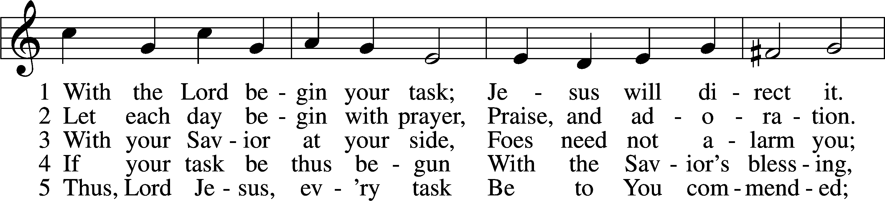
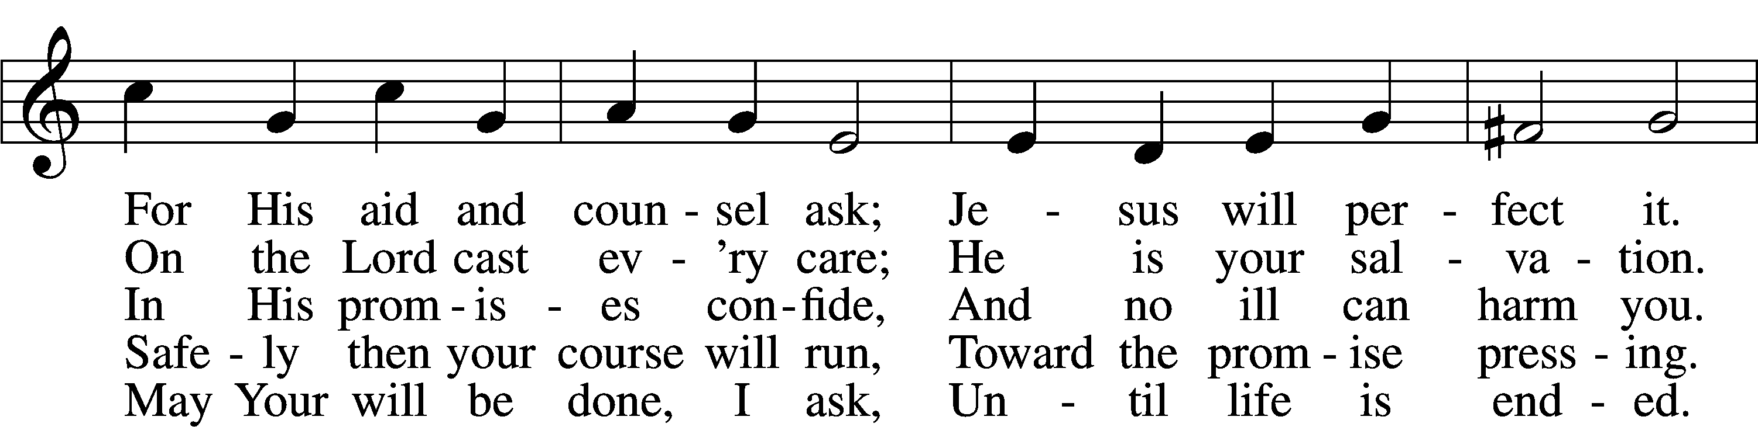
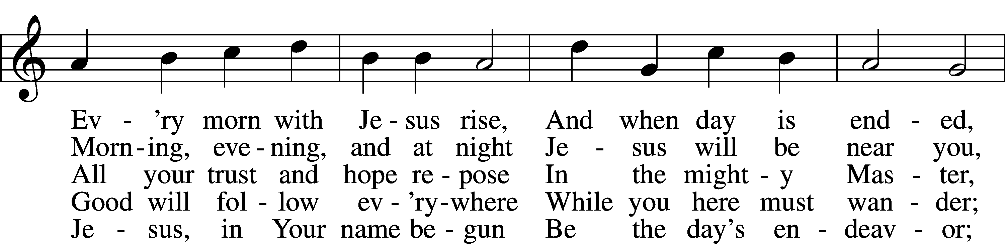
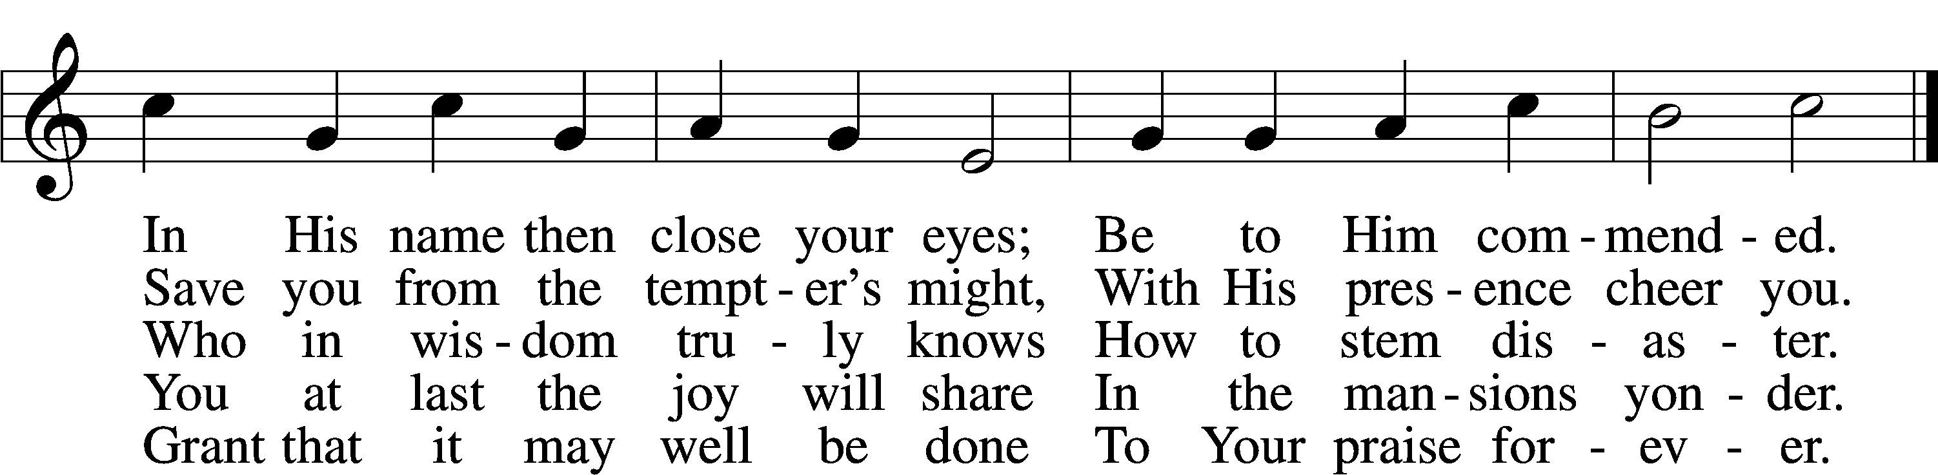
Text: Morgen- und Abend-segen, 1734, Waldenburg; tr. W. Gustave Polack, 1890–1950, alt.
Tune: Peter Frank, 1616–75
Text: © 1941 Concordia Publishing House. Used by permission: LSB Hymn License no. 110004798
Tune: Public domain

(The sign of the cross may be made by all in remembrance of their Baptism.)

INVOCATION
L In the name of the Father and of the T Son and of the Holy Spirit.
C Amen.

EXHORTATION LSB 151
L If we say we have no sin, we deceive ourselves, and the truth is not in us.
C But if we confess our sins, God, who is faithful and just, will forgive our sins and cleanse us from all unrighteousness.

(Silence for reflection on God’s Word and for self-examination.)

CONFESSION OF SINS LSB 151
L Let us then confess our sins to God our Father.
C Most merciful God, we confess that we are by nature sinful and unclean. We have sinned against You in thought, word, and deed, by what we have done and by what we have left undone. We have not loved You with our whole heart; we have not loved our neighbors as ourselves. We justly deserve Your present and eternal punishment. For the sake of Your Son, Jesus Christ, have mercy on us. Forgive us, renew us, and lead us, so that we may delight in Your will and walk in Your ways to the glory of Your holy name. Amen.

DECLARATION OF GRACE
L In the mercy of almighty God, Jesus Christ was given to die for us, and for His sake God forgives us all our sins. To those who believe in Jesus Christ He gives the power to become the children of God and bestows on them the Holy Spirit. May the Lord, who has begun this good work in us, bring it to completion in the day of our Lord Jesus Christ.
C Amen.

+ SERVICE OF THE WORD +

INTROIT Psalm 74:18–19, 21, 20a, 22a; antiphon: v. 2a
Remember your congregation, which you have pur- | chased of old,*
which you have redeemed to be the tribe of your | heritage!
Remember this, O Lord, how the en- | emy scoffs,*
and a foolish people re- | viles your name.
Do not deliver the soul of your dove to the | wild beasts;*
do not forget the life of your poor for- | ever.
Let not the downtrodden turn | back in shame;*
let the poor and needy | praise your name.
Have regard for the | covenant;*
arise, O God, de- | fend your cause.
Glory be to the Father and | to the Son*
and to the Holy | Spirit;
as it was in the be- | ginning,*
is now, and will be forever. | Amen.
Remember your congregation, which you have pur- | chased of old,*
which you have redeemed to be the tribe of your | heritage!

KYRIE LSB 152

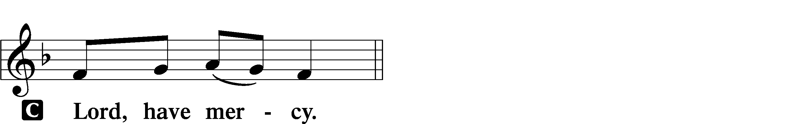

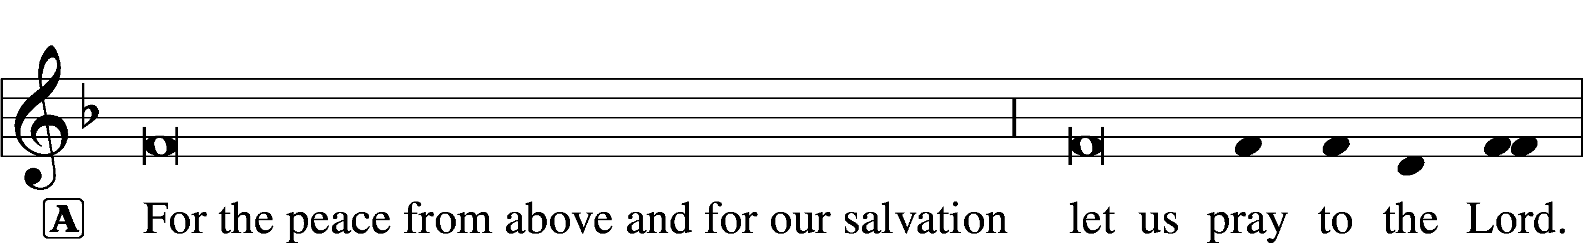
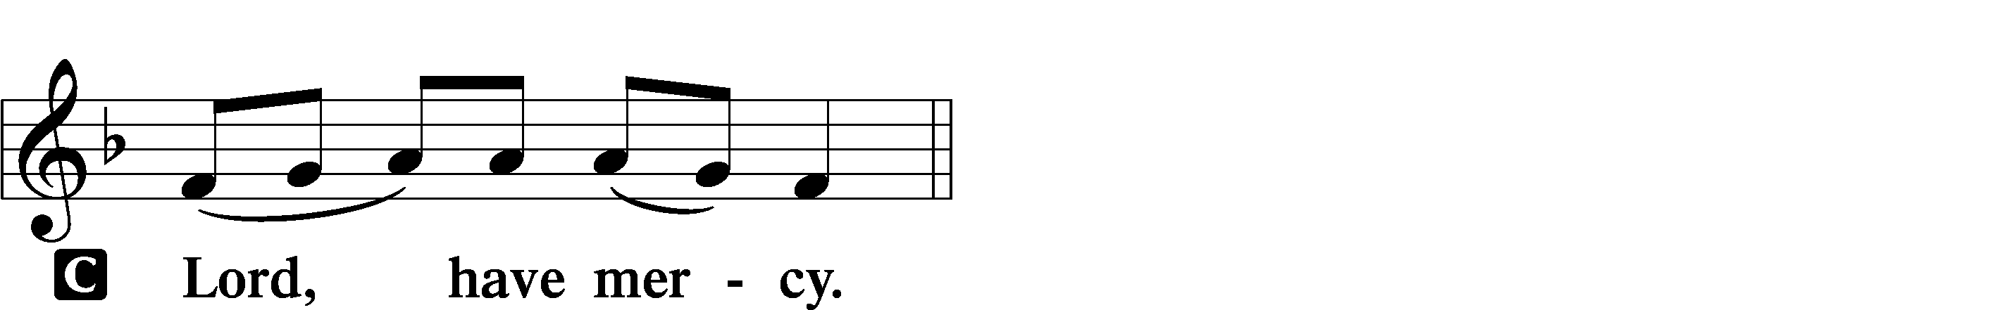

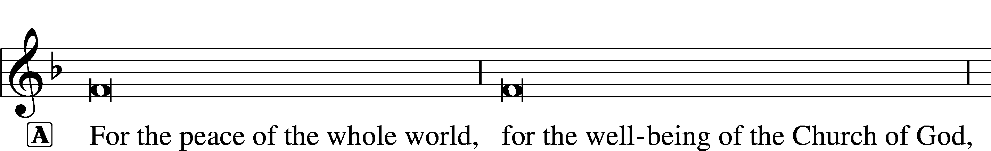
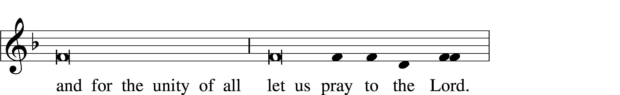
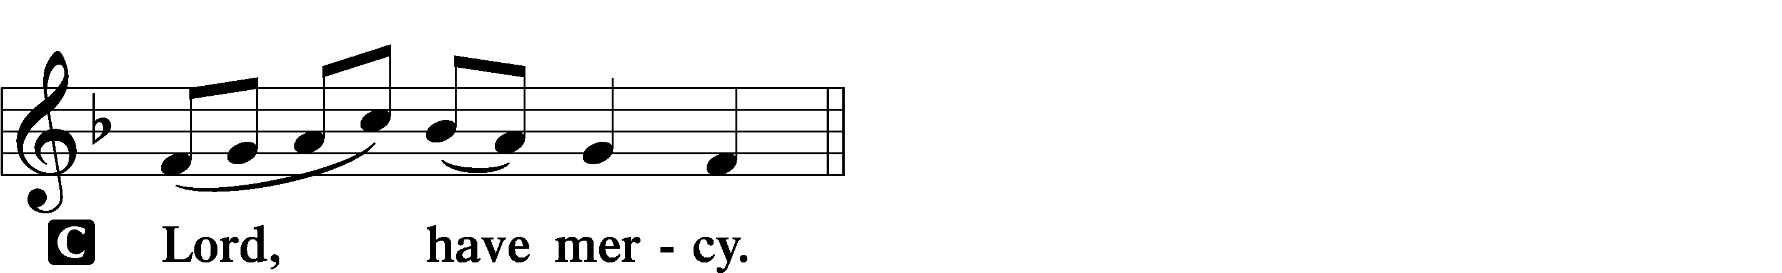

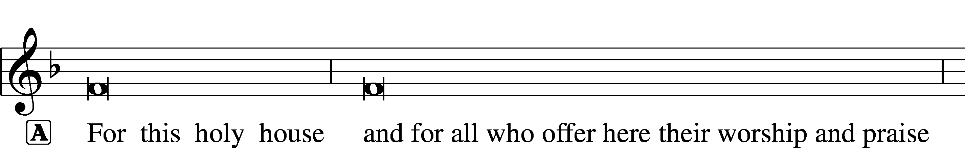

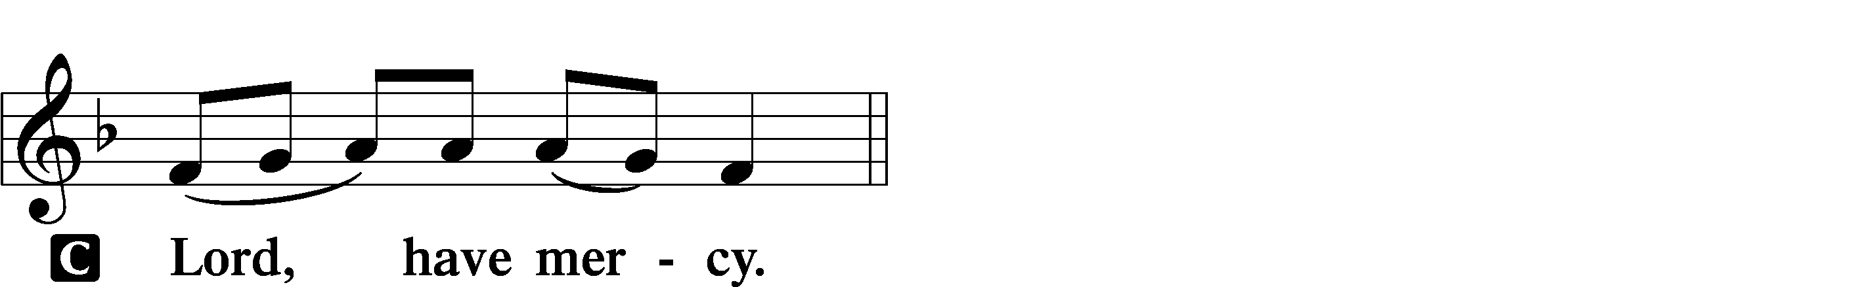

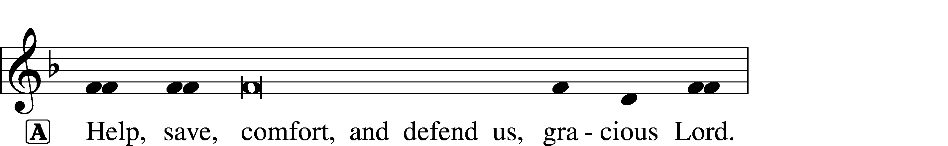


SALUTATION AND COLLECT OF THE DAY
L The Lord be with you.
C And also with you.

L Let us pray.
O Lord, almighty and everlasting God, You have commanded us to pray and have promised to hear us. Mercifully grant that Your Holy Spirit may direct and govern our hearts in all things that we may persevere with steadfast faith in the confession of Your name; through Jesus Christ, Your Son, our Lord, who lives and reigns with You and the Holy Spirit, one God, now and forever.
C Amen.

(Sit)

CHILDRENS LESSON

OLD TESTAMENT READING Genesis 32:22–30
22The same night [Jacob] arose and took his two wives, his two female servants, and his eleven children, and crossed the ford of the Jabbok. 23He took them and sent them across the stream, and everything else that he had. 24And Jacob was left alone. And a man wrestled with him until the breaking of the day. 25When the man saw that he did not prevail against Jacob, he touched his hip socket, and Jacob’s hip was put out of joint as he wrestled with him. 26Then he said, “Let me go, for the day has broken.” But Jacob said, “I will not let you go unless you bless me.” 27And he said to him, “What is your name?” And he said, “Jacob.” 28Then he said, “Your name shall no longer be called Jacob, but Israel, for you have striven with God and with men, and have prevailed.” 29Then Jacob asked him, “Please tell me your name.” But he said, “Why is it that you ask my name?” And there he blessed him. 30So Jacob called the name of the place Peniel, saying, “For I have seen God face to face, and yet my life has been delivered.”

L This is the Word of the Lord.
C Thanks be to God.

GRADUAL Psalm 91:11; 103:1
He will command his angels con- | cerning you*
to guard you in | all your ways.
Bless the Lord, | O my soul,*
and all that is within me, bless his | holy name!

EPISTLE 2 Timothy 3:14—4:5
14As for you, continue in what you have learned and have firmly believed, knowing from whom you learned it 15and how from childhood you have been acquainted with the sacred writings, which are able to make you wise for salvation through faith in Christ Jesus. 16All Scripture is breathed out by God and profitable for teaching, for reproof, for correction, and for training in righteousness, 17that the man of God may be competent, equipped for every good work.
1I charge you in the presence of God and of Christ Jesus, who is to judge the living and the dead, and by his appearing and his kingdom: 2preach the word; be ready in season and out of season; reprove, rebuke, and exhort, with complete patience and teaching. 3For the time is coming when people will not endure sound teaching, but having itching ears they will accumulate for themselves teachers to suit their own passions, 4and will turn away from listening to the truth and wander off into myths. 5As for you, always be sober-minded, endure suffering, do the work of an evangelist, fulfill your ministry.

L This is the Word of the Lord.
C Thanks be to God.

(Stand)

ALLELUIA AND VERSE LSB 156
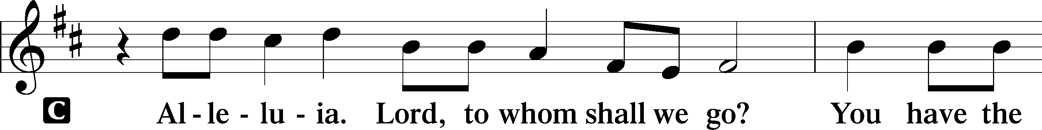
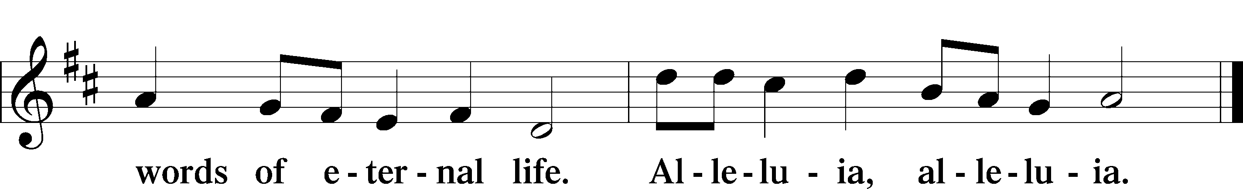

HOLY GOSPEL Luke 18:1–8
L The Holy Gospel according to St. Luke, the eighteenth chapter.
C Glory to You, O Lord.

1[Jesus] told them a parable to the effect that they ought always to pray and not lose heart. 2He said, “In a certain city there was a judge who neither feared God nor respected man. 3And there was a widow in that city who kept coming to him and saying, ‘Give me justice against my adversary.’ 4For a while he refused, but afterward he said to himself, ‘Though I neither fear God nor respect man, 5yet because this widow keeps bothering me, I will give her justice, so that she will not beat me down by her continual coming.’” 6And the Lord said, “Hear what the unrighteous judge says. 7And will not God give justice to his elect, who cry to him day and night? Will he delay long over them? 8I tell you, he will give justice to them speedily. Nevertheless, when the Son of Man comes, will he find faith on earth?”

L This is the Gospel of the Lord.
C Praise to You, O Christ.

(Sit)

772 IN HOLY CONVERSATION
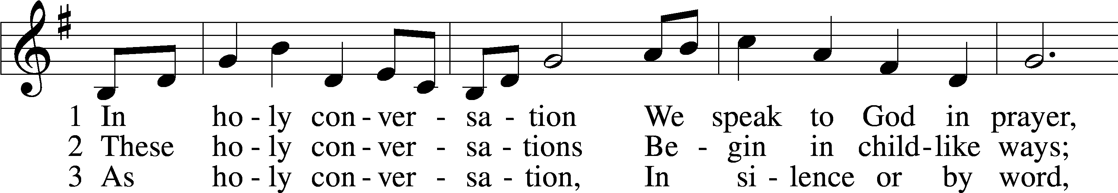
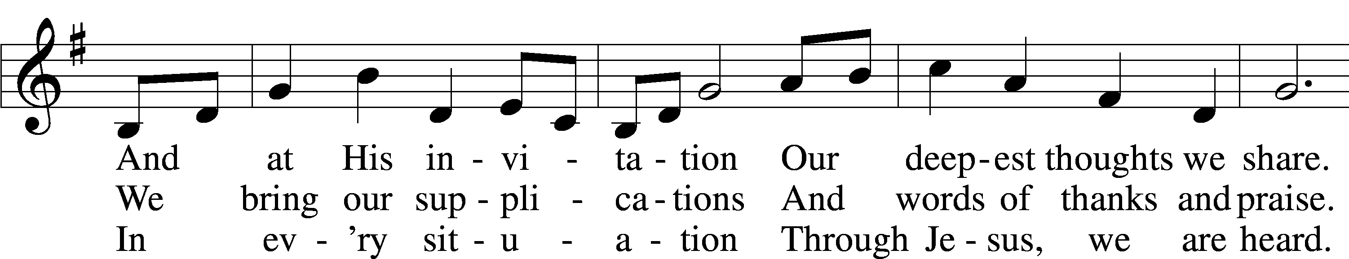
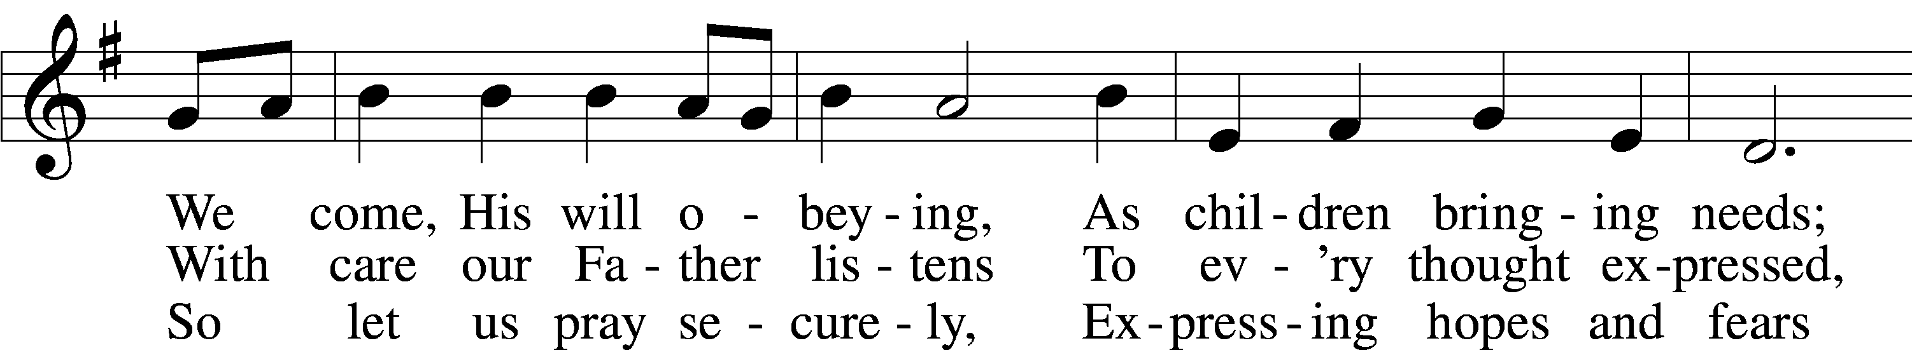
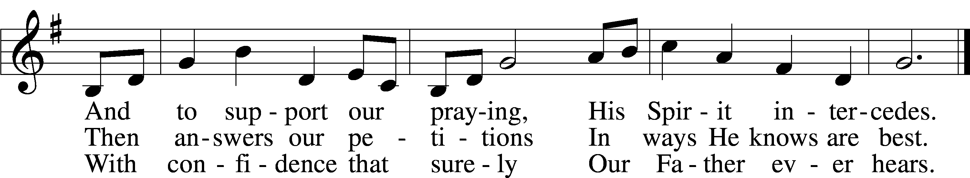
Text: Gregory J. Wismar, 1946
Tune: Swedish
Text: © 2004 Gregory J. Wismar. Used by permission: LSB Hymn License no. 110004798
Tune: Public domain

SERMON

(Stand)

APOSTLES’ CREED
C I believe in God, the Father Almighty,
maker of heaven and earth.

And in Jesus Christ, His only Son, our Lord,
who was conceived by the Holy Spirit,
born of the virgin Mary,
suffered under Pontius Pilate,
was crucified, died and was buried.
He descended into hell.
The third day He rose again from the dead.
He ascended into heaven
and sits at the right hand of God the Father Almighty.
From thence He will come to judge the living and the dead.

I believe in the Holy Spirit,
the holy Christian Church,
the communion of saints,
the forgiveness of sins,
the resurrection of the body,
and the life T everlasting. Amen.

SHARING OF THE PEACE

(Sit)

PRAYER OF THE CHURCH

OFFERING

(Stand)

OFFERTORY 159
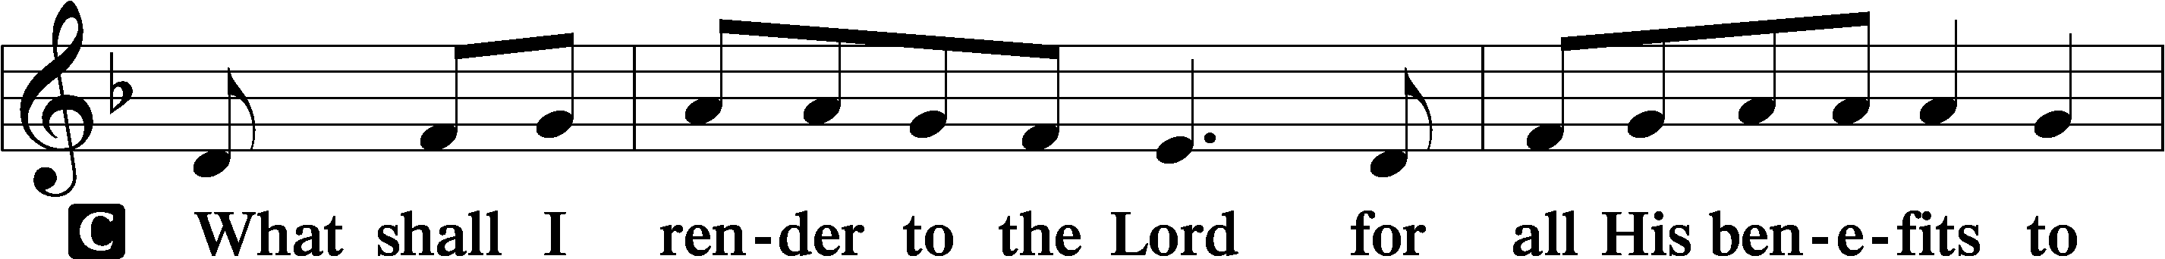
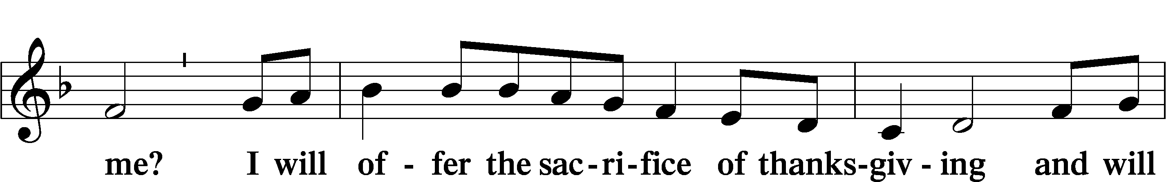
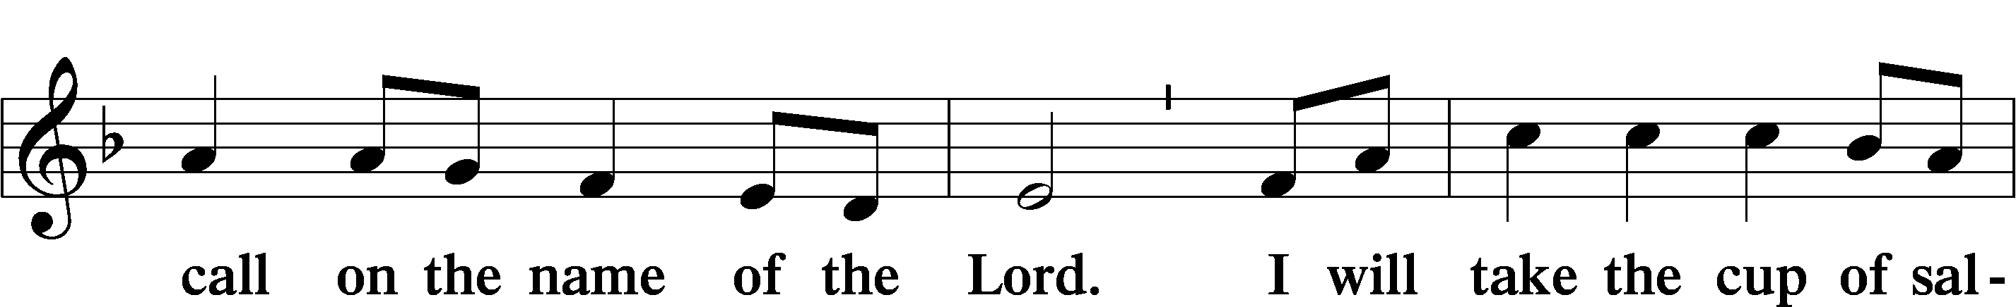
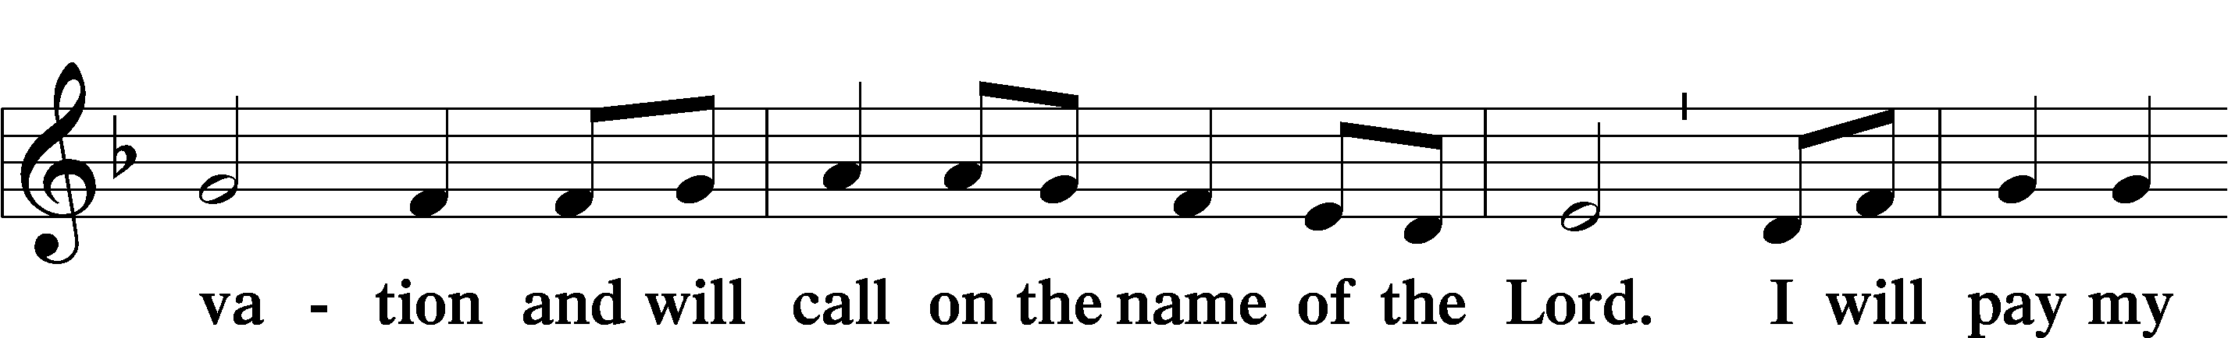
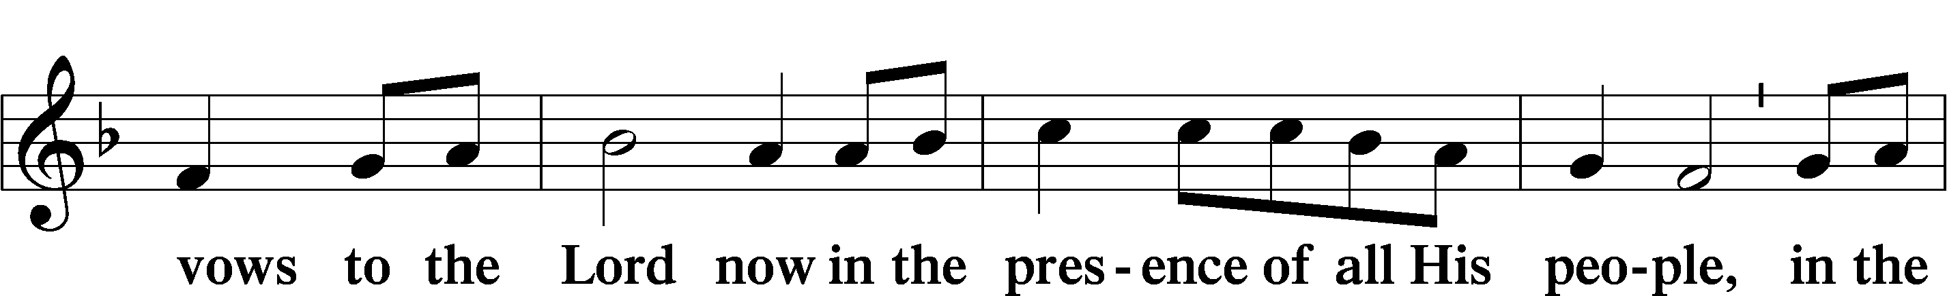
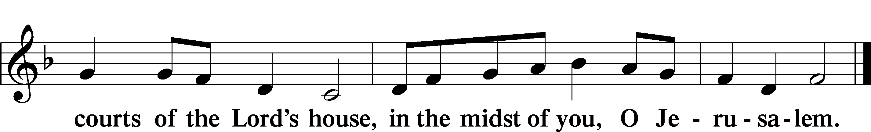

LORD’S PRAYER
C Our Father who art in heaven,
hallowed be Thy name,
Thy kingdom come,
Thy will be done on earth
as it is in heaven;
give us this day our daily bread;
and forgive us our trespasses
as we forgive those
who trespass against us;
and lead us not into temptation,
but deliver us from evil.
For Thine is the kingdom
and the power and the glory
forever and ever. Amen.

CONCLUDING COLLECT

BENEDICTION
L:The grace of our Lord T Jesus Christ, and the love of God, and the fellowship of the Holy Spirit, be with us all.
C: Amen.

828 WE ARE CALLED TO STAND TOGETHER
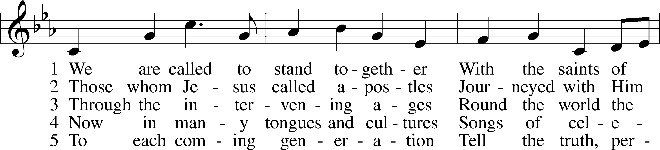
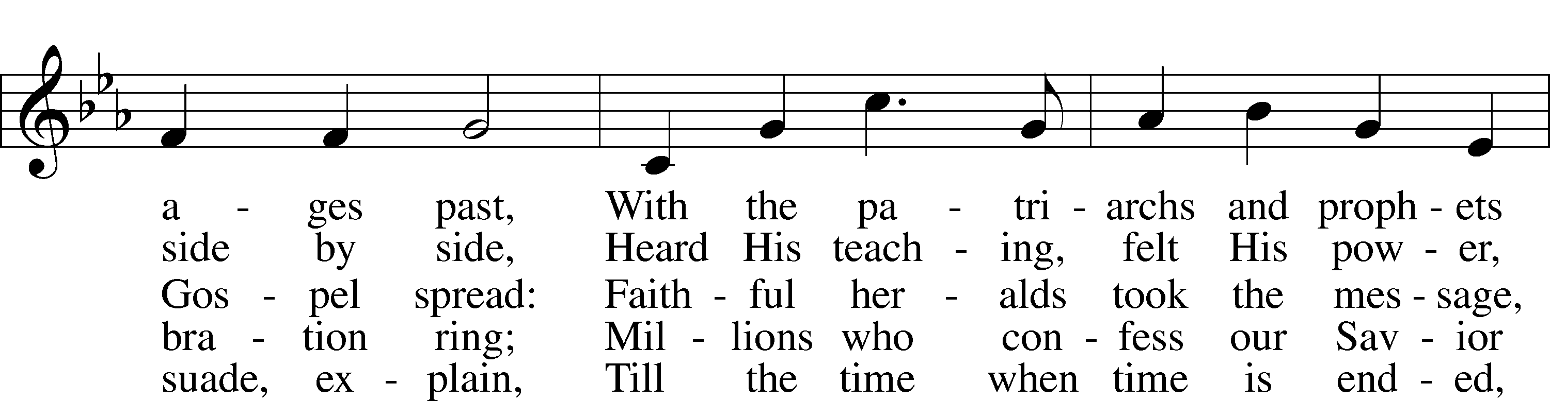
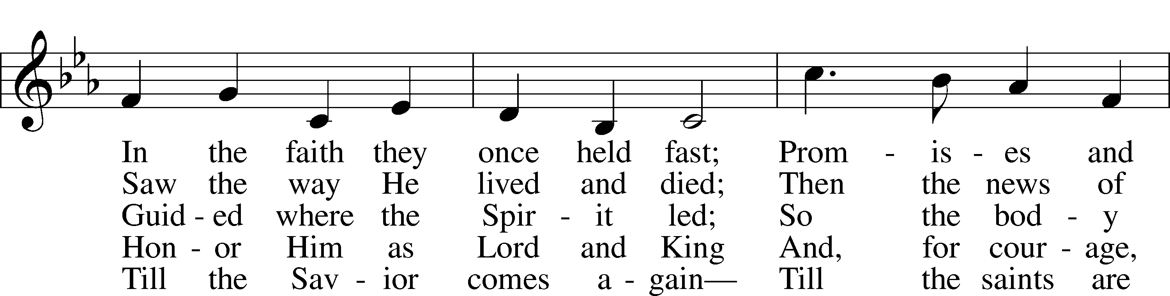
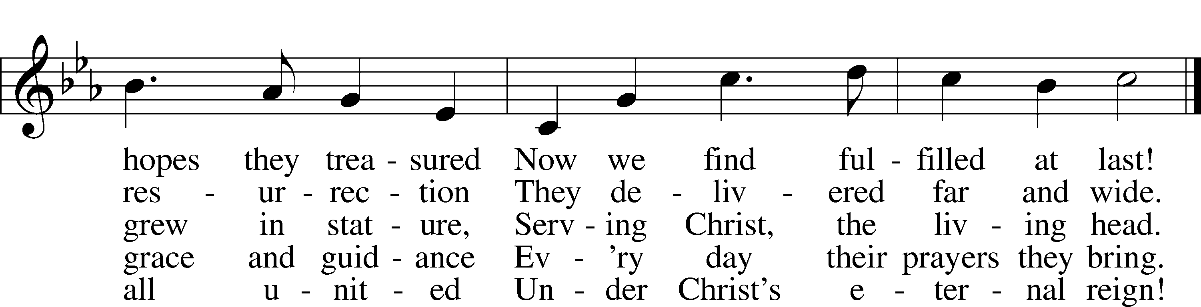
Text: Martin E. Leckebusch, 1962
Tune: Henry V. Gerike, 1948–2025
Text: © 2000 Kevin Mayhew Ltd. Used by permission: LSB Hymn License no. 110004798
Tune: © 1973 Henry V. Gerike. Used by permission: LSB Hymn License no. 110004798

ACKNOWLEDGMENTS
Unless otherwise indicated, Scripture quotations are from the ESV® Bible (The Holy Bible, English Standard Version®), copyright © 2001 by Crossway, a publishing ministry of Good News Publishers. Used by permission. All rights reserved.
Created by Lutheran Service Builder © 2025 Concordia Publishing House.

IN OUR PRAYERS:
Submitted petitions are included for two consecutive Sundays
For Those suffering afflictions of mind, body,or spirit:
John M., Anne H., Jim S., Dennis S., Blake B., Carol R., Michele N., Mark K., Dean S.
For missionaries
Deaconess Sandra R., Rev. Jonathan A.
All of our Shut- Ins:
Betty A., Shirley F., Mary H., Patsy L., Herman L., Tommy, Pam and Jerome M., Sharon B.

ANNOUNCEMENTS
Please email announcements for Sunday bulletins by 8:00 a.m. Tuesday to pastorblcaiken@gmail.com
ALTAR FLOWERS:
Today are donated by: Bob & Eileen A.

PASTOR ON THE ROAD:
Oct. 12 – Oct. 25; Vacation

REFORMATIONFEST:
Sunday, October 26th after the service. Attendees must provide their own German beverage of choice, if so desired. (bringen zein own bier)

ACTS DONATION FOR OCTOBER:
Canned meat; beef, chicken, salmon, tuna, etc.

FELLOWSHIP COFFEE HOUR:
Every Sunday morning, during Bible Study and after the Divine Service, coffee, treats and good fellowship are waiting for you in our Fellowship Hall!
CALENDAR, NEWSLETTER, AND CHURCH DIRECTORY:
Please provide any articles, calendar entries, announcements, photos, etc. for the Star of Bethlehem newsletter to Debbie C. no later than noon on the 23rd of each month. The Star calendar will also be used for the website. Updates to your church directory data may be provided at any time.

Average weekly offering needed to make budget: $2,508

BE IN THE WORD!
SUNDAY MORNINGS AT 9 a.m.
Adult Bible Study
Sunday School for children and youth
TUESDAY MORNINGS AT 10:00 a.m.
Women’s Bible Study
WEDNESDAY EVENINGS AT 7 p.m.
Adult Bible Study
JUNIOR CONFIRMATION and ADULT INSTRUCTION
Always available by request:
Contact Pastor to schedule

OUR VALUE STATEMENT: Bethlehem Lutheran Church exists under God’s grace to save the lost and to strengthen the saved so that they may live bold and courageous lives of Christian witness before a non-believing world.
Therefore, our purpose is:
- to glorify God in Word and deed,
- to nurture each other in Christian love,
- to reach out to others with our Savior’s Gospel of life and salvation.
(Rom 5:8, Matt. 28:18-20).

OUR VISION: By the Grace of God, Bethlehem Lutheran Church, is a loving family united in Christ, learning, living, and spreading His Word.

OUR MISSION: Learn the Word. Live the Word. Spread the Word.

