BETHLEHEM LUTHERAN CHURCH
A congregation of The Lutheran Church-Missouri Synod
902 Hitchcock Drive SW,
Aiken, South Carolina 29803
Church Phone: (803) 649-6417
blcaikensc@gmail.com

Bethlehem Lutheran welcomes our members and guests to our worship service! Unable to join us in person? Please find us on Facebook live. The service is also posted on our website; bethlehemlutheranaiken.org.

+ + + + + + + + + + + + + + +
Fourth Sunday after Pentecost
June 21, 2026
10:30 a.m.
+ + + + + + + + + + + + + + +

Our Policy and Practice Regarding Holy Communion
Hear the words of the Apostle Paul;
Anyone who eats and drinks without recognizing the body of the Lord eats and drinks judgment on himself. -1 Cor.11:29
Therefore, visitors are asked to please refrain from partaking of the Sacrament before speaking about this with the pastor; because we care about your spiritual well-being.
Also, because communing at this altar is a public confession that you agree with the doctrines of The Lutheran Church-Missouri Synod, and reject all contrary teachings.
Persons who are not communing today are always welcome to come forward during the distribution to receive an individual blessing; please cross your arms over your chest to indicate your desire for this. Thank you!
We commune in two alternating tables. The ushers will guide you. Non-alcoholic white wine is available in the center of the individual cup tray. Please leave empty individual cups at the altar rail.

+ SERVICE OF PREPARATION +

(After the bell tolls, please observe a time of silence.)

WELCOME AND ANNOUNCEMENTS

(Stand)

511 HERALD, SOUND THE NOTE OF JUDGMENT
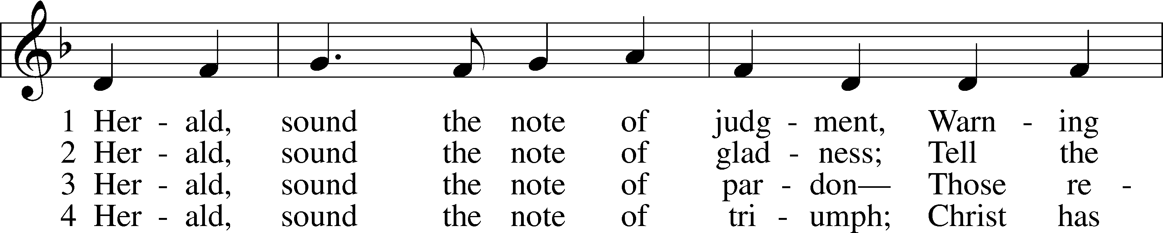
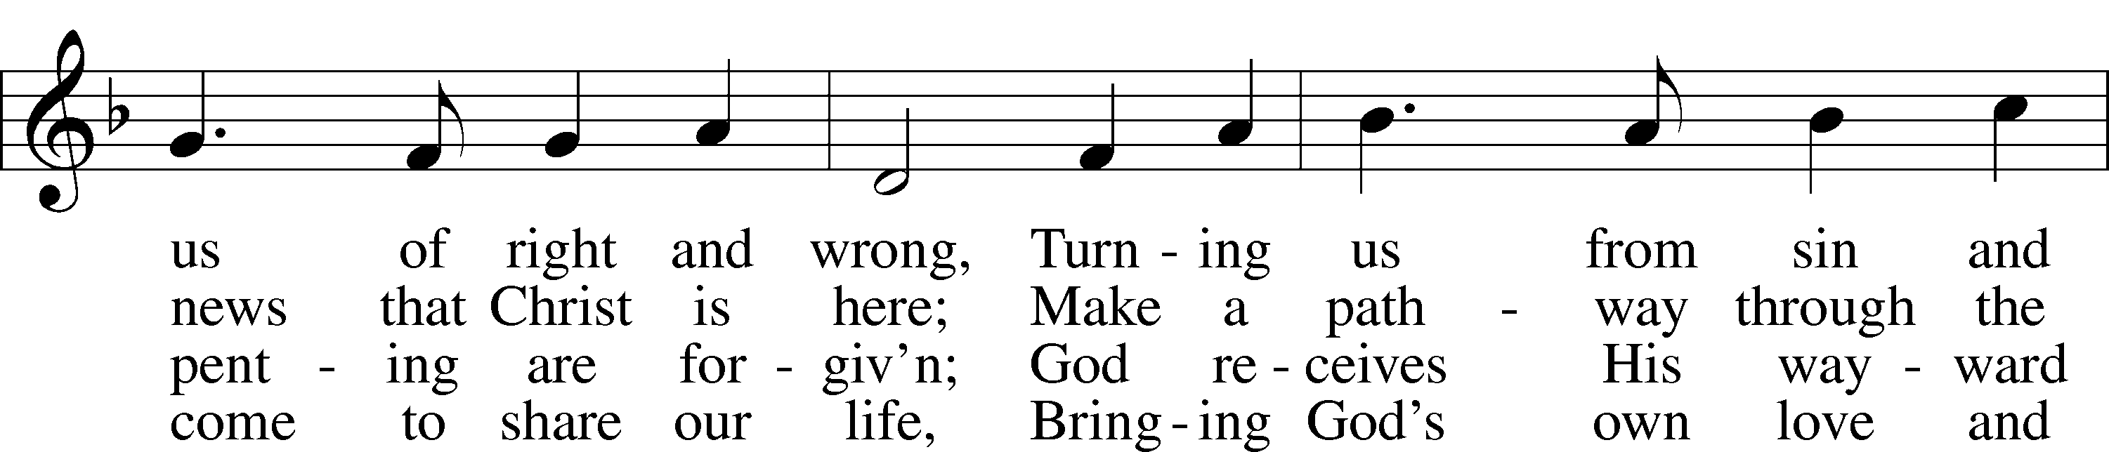
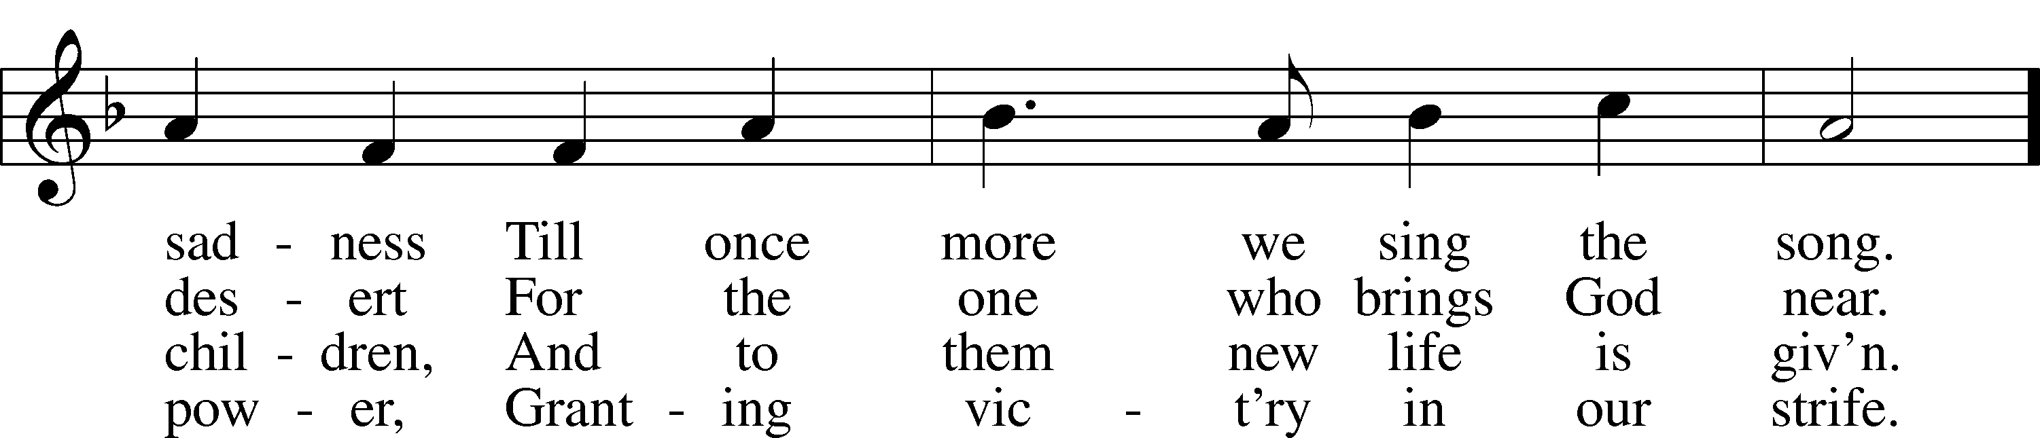
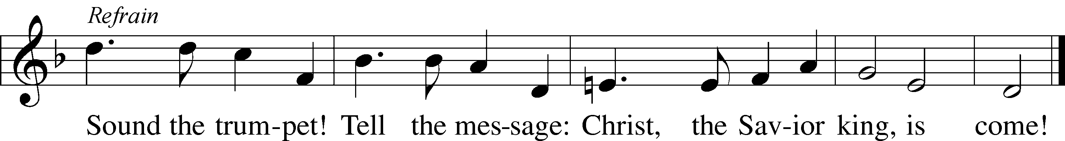
Text: Moir A. J. Waters, 1906–80
Tune: David McCarthy, 1931
Text: © 1977 Moir A. J. Waters. Used by permission: LSB Hymn License no. 110004798
Tune: © 1975 Stainer & Bell Ltd, admin. Hope Publishing Co. Used by permission: LSB Hymn License no. 110004798

+ CONFESSION AND ABSOLUTION +

(The sign of the cross may be made by all in remembrance of their Baptism.)

INVOCATION LSB 151
P In the name of the Father and of the T Son and of the Holy Spirit.
C Amen.

EXHORTATION LSB 151
P If we say we have no sin, we deceive ourselves, and the truth is not in us.
C But if we confess our sins, God, who is faithful and just, will forgive our sins and cleanse us from all unrighteousness.

(Silence for reflection on God’s Word and for self-examination.)

CONFESSION OF SINS LSB 151
P Let us then confess our sins to God our Father.
C Most merciful God, we confess that we are by nature sinful and unclean. We have sinned against You in thought, word, and deed, by what we have done and by what we have left undone. We have not loved You with our whole heart; we have not loved our neighbors as ourselves. We justly deserve Your present and eternal punishment. For the sake of Your Son, Jesus Christ, have mercy on us. Forgive us, renew us, and lead us, so that we may delight in Your will and walk in Your ways to the glory of Your holy name. Amen.

ABSOLUTION LSB 151
P Almighty God in His mercy has given His Son to die for you and for His sake forgives you all your sins. As a called and ordained servant of Christ, and by His authority, I therefore forgive you all your sins in the name of the Father and of the T Son and of the Holy Spirit.
C Amen.

+ SERVICE OF THE WORD +

INTROIT Psalm 56:3–4, 10–11; antiphon: v. 13
For you have delivered my soul from death, yes, my feet from | falling,*
that I may walk before God in the | light of life.
When I | am afraid,*
I put my | trust in you.
In God, whose word I praise, in God I trust; I shall not | be afraid.*
What can flesh | do to me?
In God, whose | word I praise,*
in the Lord, whose | word I praise,
in God I trust; I shall not | be afraid.*
What can man | do to me?
Glory be to the Father and | to the Son*
and to the Holy | Spirit;
as it was in the be- | ginning,*
is now, and will be forever. | Amen.
For you have delivered my soul from death, yes, my feet from | falling,*
that I may walk before God in the | light of life.

KYRIE LSB 152

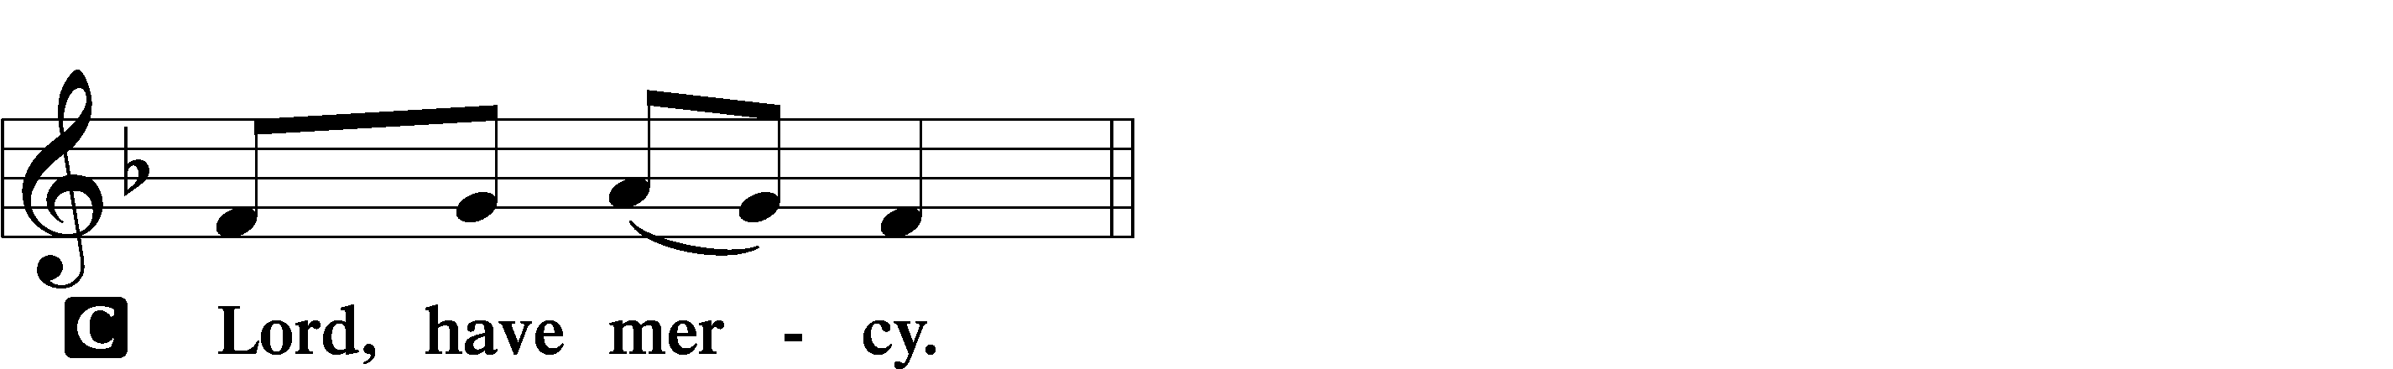

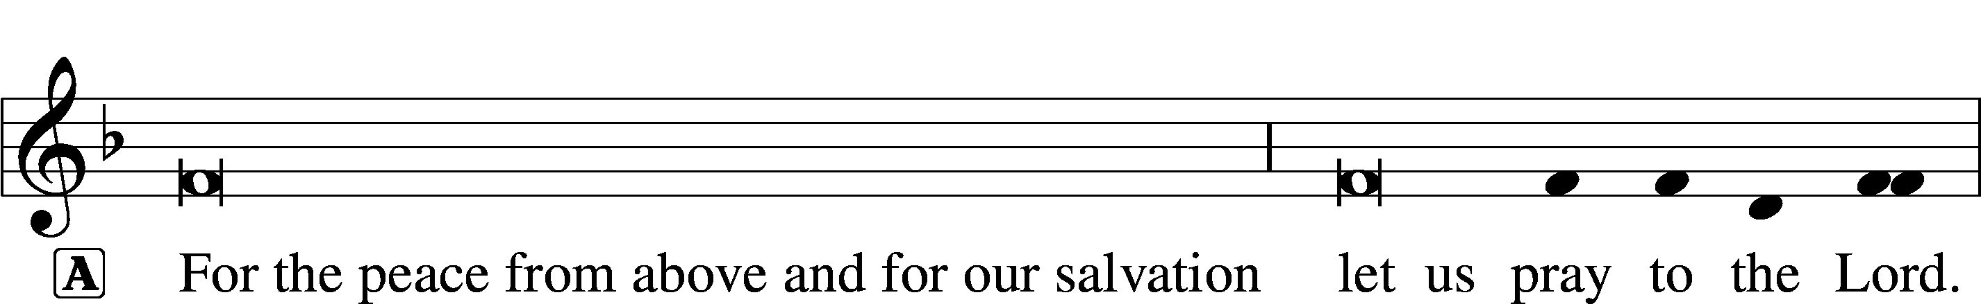
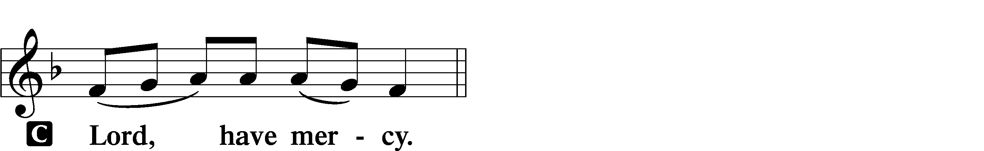

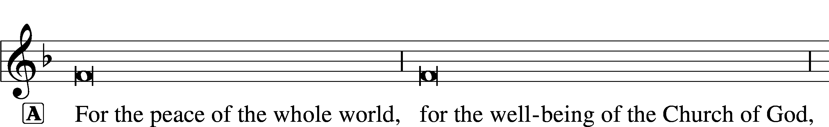
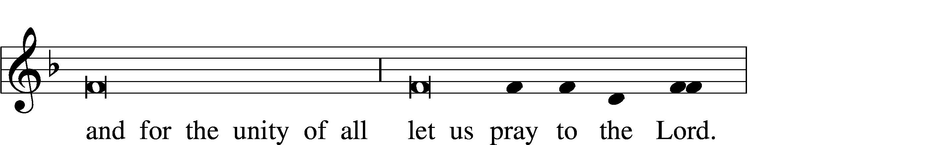
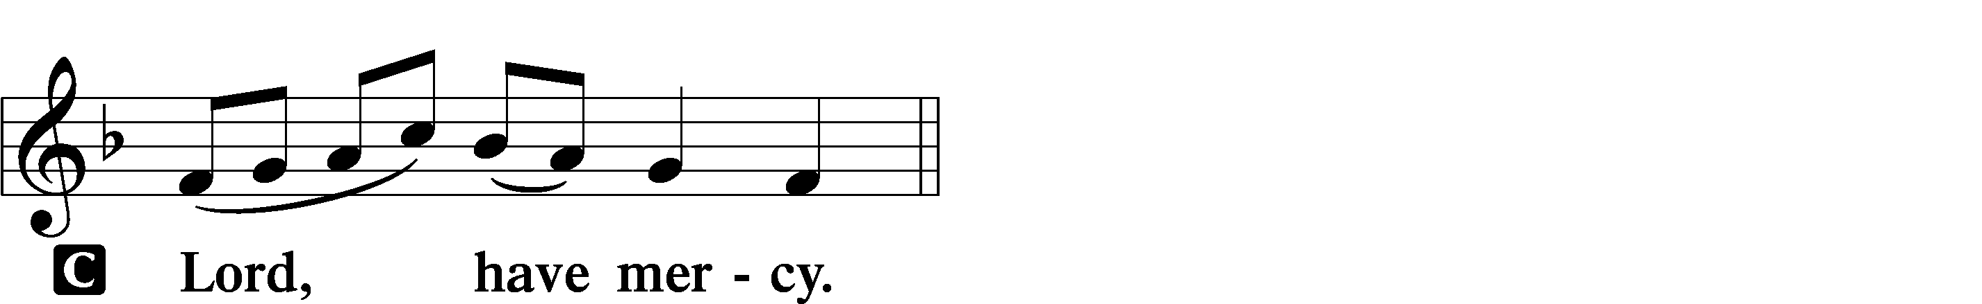

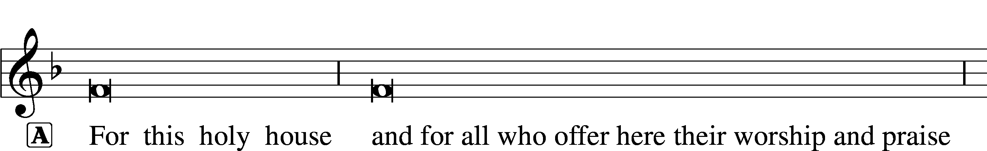
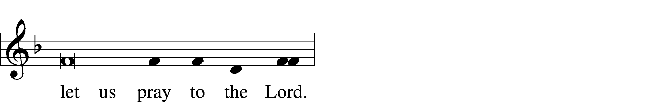
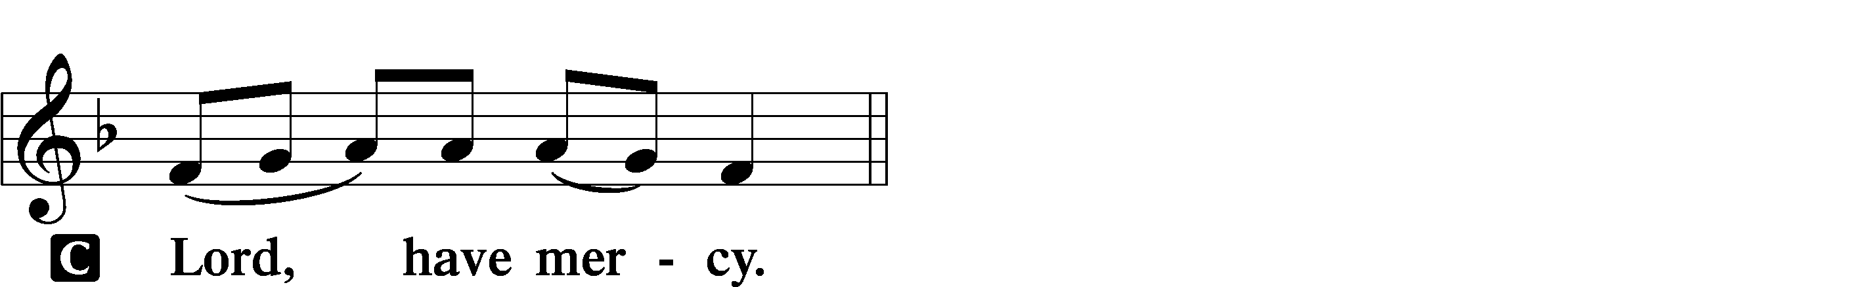

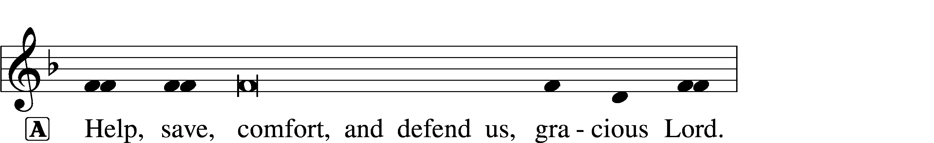


THIS IS THE FEAST LSB 155
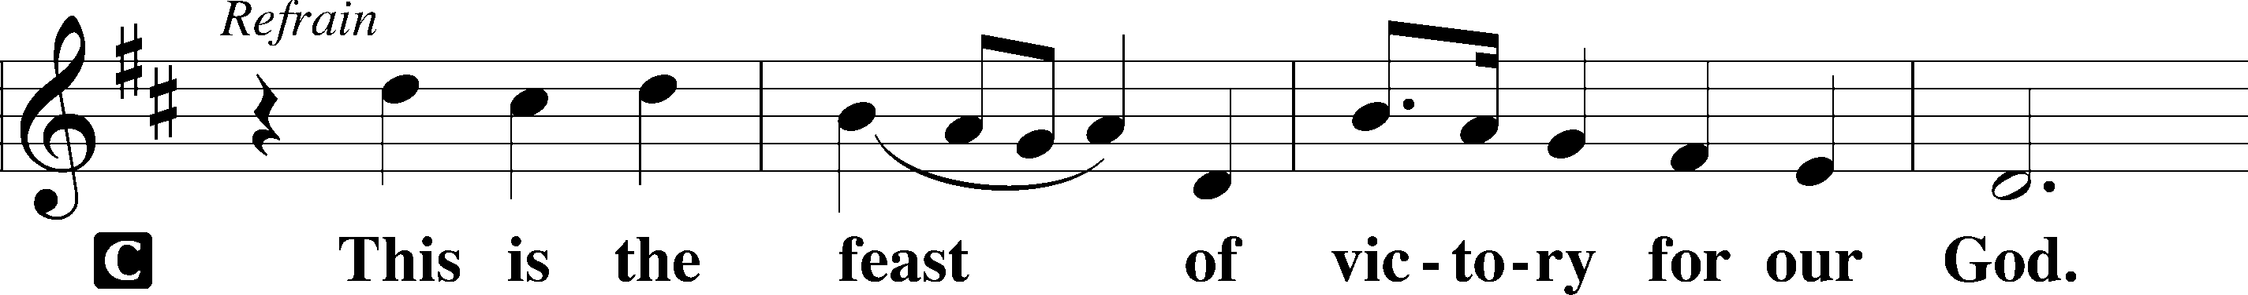
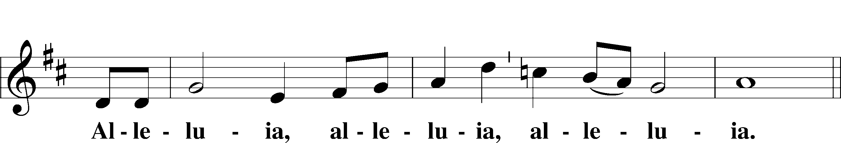
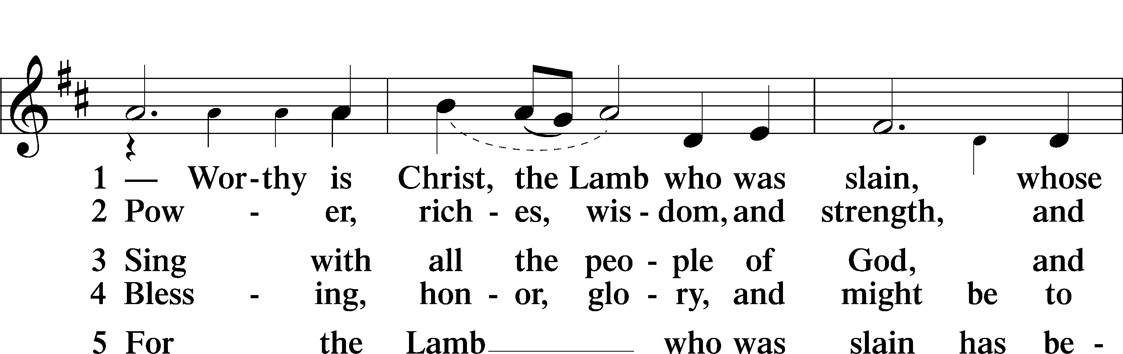
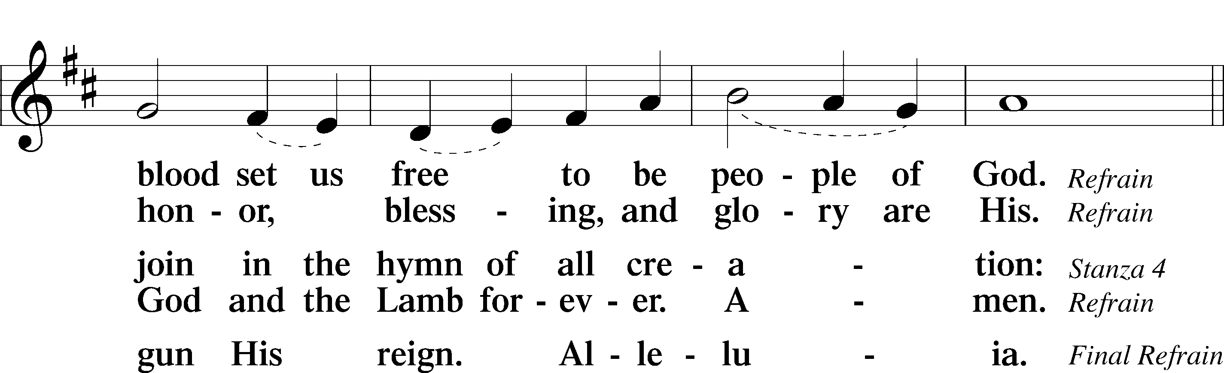
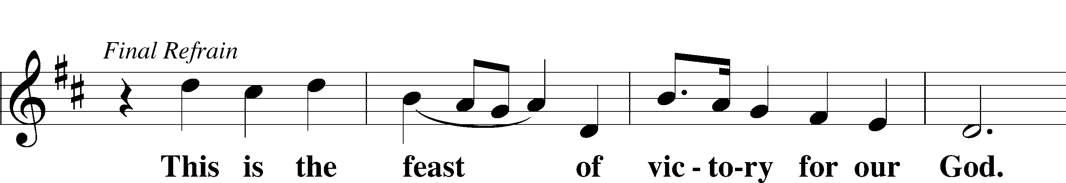
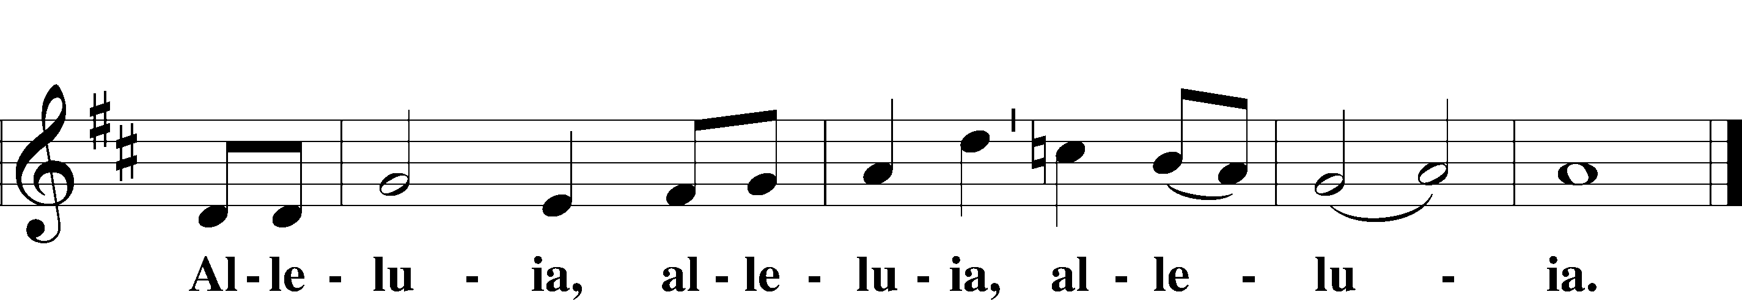

SALUTATION AND COLLECT OF THE DAY LSB 156
P The Lord be with you.
C And also with you.

P Let us pray.
O God, because Your abiding presence always goes with us, keep us aware of Your daily mercies that we may live secure and content in Your eternal love; through Jesus Christ, Your Son, our Lord, who lives and reigns with You and the Holy Spirit, one God, now and forever.
C Amen.

(Sit)

OLD TESTAMENT READING Jeremiah 20:7–13
7O Lord, you have deceived me,
and I was deceived;
you are stronger than I,
and you have prevailed.
I have become a laughingstock all the day;
everyone mocks me.
8For whenever I speak, I cry out,
I shout, “Violence and destruction!”
For the word of the Lord has become for me
a reproach and derision all day long.
9If I say, “I will not mention him,
or speak any more in his name,”
there is in my heart as it were a burning fire
shut up in my bones,
and I am weary with holding it in,
and I cannot.
10For I hear many whispering.
Terror is on every side!
“Denounce him! Let us denounce him!”
say all my close friends,
watching for my fall.
“Perhaps he will be deceived;
then we can overcome him
and take our revenge on him.”
(next page)

11But the Lord is with me as a dread warrior;
therefore my persecutors will stumble;
they will not overcome me.
They will be greatly shamed,
for they will not succeed.
Their eternal dishonor
will never be forgotten.
12O Lord of hosts, who tests the righteous,
who sees the heart and the mind,
let me see your vengeance upon them,
for to you have I committed my cause.
13Sing to the Lord;
praise the Lord!
For he has delivered the life of the needy
from the hand of evildoers.

P This is the Word of the Lord.
C Thanks be to God.

GRADUAL Psalm 145:3, 5b, 6b
Great is the Lord, and greatly | to be praised,*
and his greatness is un- | searchable.
On your wondrous works, I will | meditate,*
and I will declare your | greatness.

EPISTLE Romans 6:12–23
12Let not sin therefore reign in your mortal bodies, to make you obey their passions. 13Do not present your members to sin as instruments for unrighteousness, but present yourselves to God as those who have been brought from death to life, and your members to God as instruments for righteousness. 14For sin will have no dominion over you, since you are not under law but under grace.
15What then? Are we to sin because we are not under law but under grace? By no means! 16Do you not know that if you present yourselves to anyone as obedient slaves, you are slaves of the one whom you obey, either of sin, which leads to death, or of obedience, which leads to righteousness? 17But thanks be to God, that you who were once slaves of sin have become obedient from the heart to the standard of teaching to which you were committed, 18and, having been set free from sin, have become slaves of righteousness. 19I am speaking in human terms, because of your natural limitations. For just as you once presented your members as slaves to impurity and to lawlessness leading to more lawlessness, so now present your members as slaves to righteousness leading to sanctification.
20When you were slaves of sin, you were free in regard to righteousness. 21But what fruit were you getting at that time from the things of which you are now ashamed? The end of those things is death. 22But now that you have been set free from sin and have become slaves of God, the fruit you get leads to sanctification and its end, eternal life. 23For the wages of sin is death, but the free gift of God is eternal life in Christ Jesus our Lord.

P This is the Word of the Lord.
C Thanks be to God.

(Stand)

ALLELUIA AND VERSE LSB 156
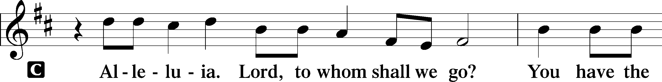
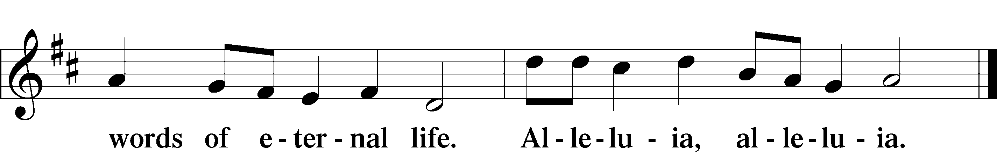

HOLY GOSPEL Matthew 10:5a, 21–33
P The Holy Gospel according to St. Matthew, the tenth chapter.

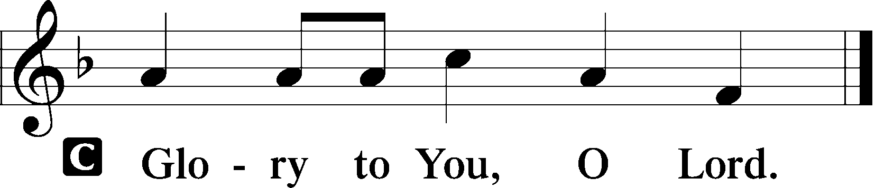

5These twelve Jesus sent out, instructing them, . . .
21“Brother will deliver brother over to death, and the father his child, and children will rise against parents and have them put to death, 22and you will be hated by all for my name’s sake. But the one who endures to the end will be saved. 23When they persecute you in one town, flee to the next, for truly, I say to you, you will not have gone through all the towns of Israel before the Son of Man comes.
24“A disciple is not above his teacher, nor a servant above his master. 25It is enough for the disciple to be like his teacher, and the servant like his master. If they have called the master of the house Beelzebul, how much more will they malign those of his household.
26“So have no fear of them, for nothing is covered that will not be revealed, or hidden that will not be known. 27What I tell you in the dark, say in the light, and what you hear whispered, proclaim on the housetops. 28And do not fear those who kill the body but cannot kill the soul. Rather fear him who can destroy both soul and body in hell. 29Are not two sparrows sold for a penny? And not one of them will fall to the ground apart from your Father. 30But even the hairs of your head are all numbered. 31Fear not, therefore; you are of more value than many sparrows. 32So everyone who acknowledges me before men, I also will acknowledge before my Father who is in heaven, 33but whoever denies me before men, I also will deny before my Father who is in heaven.”

P This is the Gospel of the Lord.

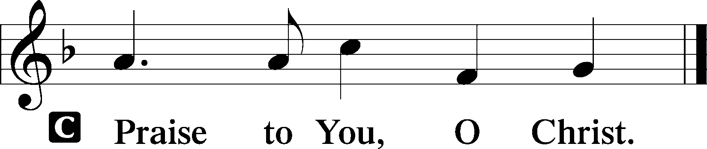

(Sit)

659 LORD OF OUR LIFE
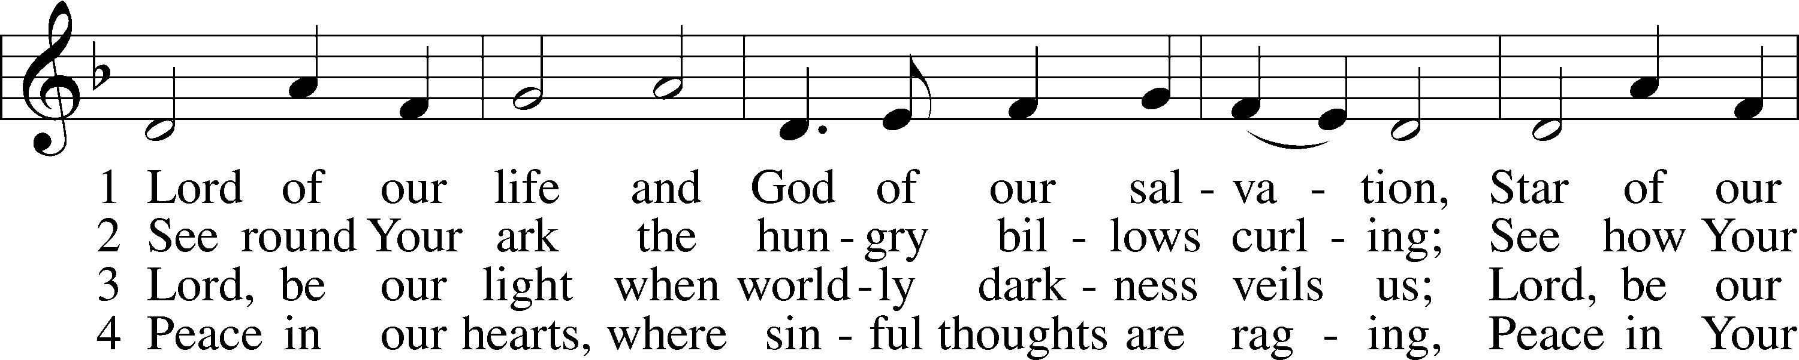
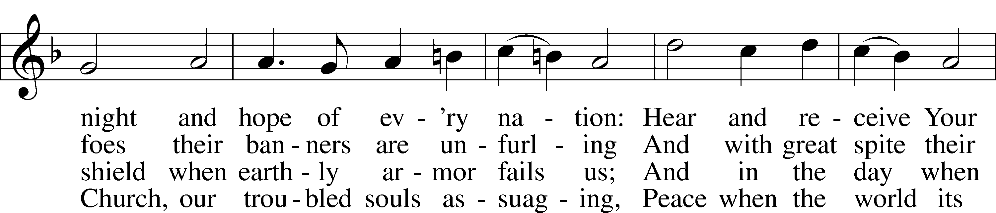
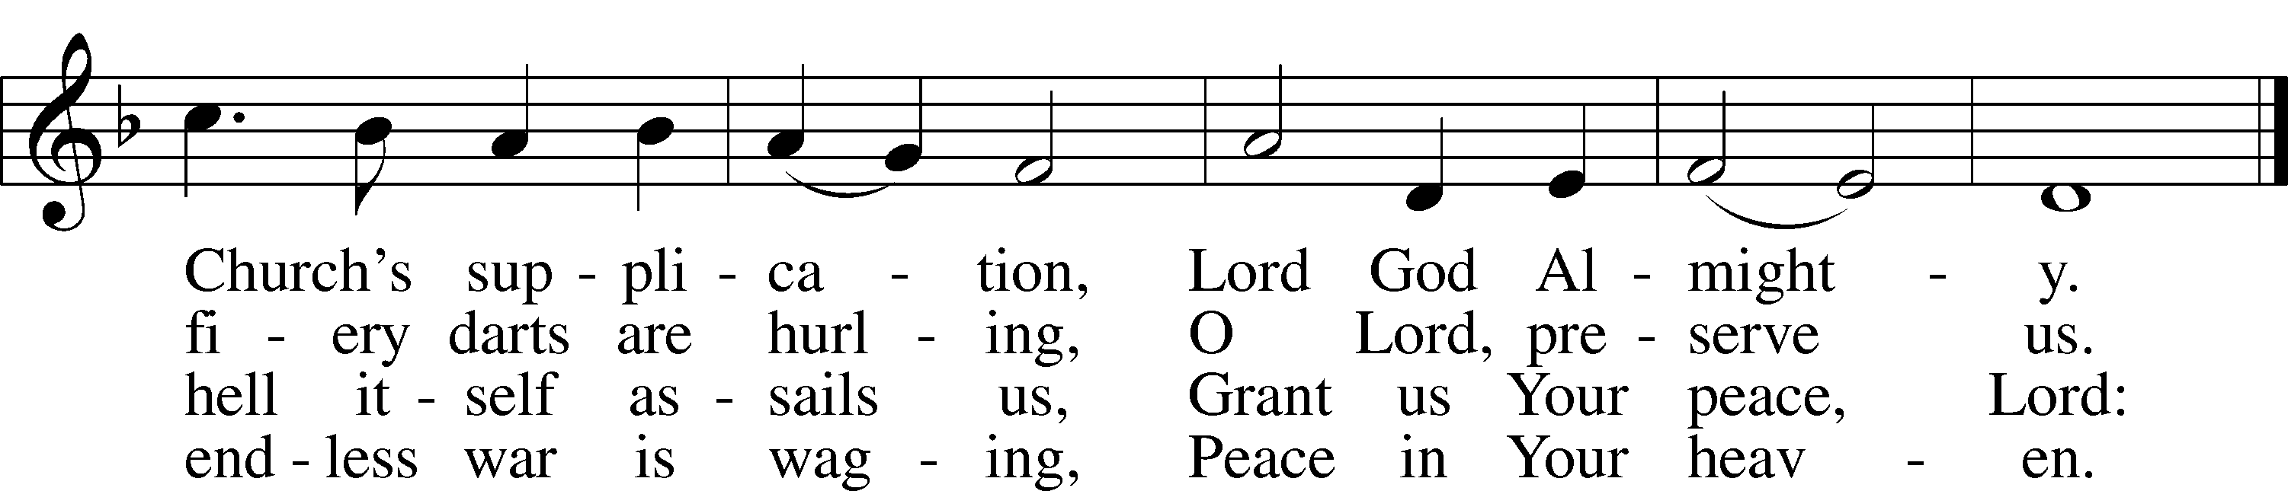
Text: Matthäus Apelles von Löwenstern, 1594–1648; tr. Philip Pusey, 1799–1855, alt.
Tune: Antiphoner, 1746, Poitiers
Text and tune: Public domain

SERMON
Title: God in a Box (God does not fit in a man/devil/world-made box)
Text: Romans 6:23

(Stand)

APOSTLES’ CREED LSB 159
C I believe in God, the Father Almighty,
maker of heaven and earth.

And in Jesus Christ, His only Son, our Lord,
who was conceived by the Holy Spirit,
born of the virgin Mary,
suffered under Pontius Pilate,
was crucified, died and was buried.
He descended into hell.
The third day He rose again from the dead.
He ascended into heaven
and sits at the right hand of God the Father Almighty.
From thence He will come to judge the living and the dead.

I believe in the Holy Spirit,
the holy Christian Church,
the communion of saints,
the forgiveness of sins,
the resurrection of the body,
and the life T everlasting. Amen.

SHARING OF THE PEACE

(The people may greet one another in the name of the Lord, saying, “Peace be with you,” as a sign of reconciliation and of the unity of the Spirit in the bond of peace (Matt. 5:22–24; Eph. 4:1–3).)

(Sit)

PRAYER OF THE CHURCH

OFFERING

(As a part of our expression of thanksgiving to God for the treasure of His salvation to us, we offer a portion of our treasure, according to what each has determined in their heart to give. Please place offerings in the collection plate at the back of the sanctuary before or after the service. Offerings can also be sent to Bethlehem Lutheran Church via U.S. Mail. Thank you!)

(Stand)

OFFERTORY LSB 159
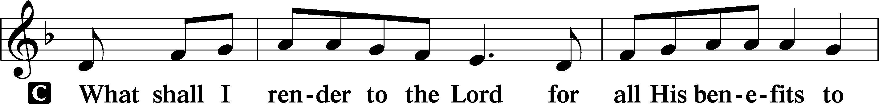
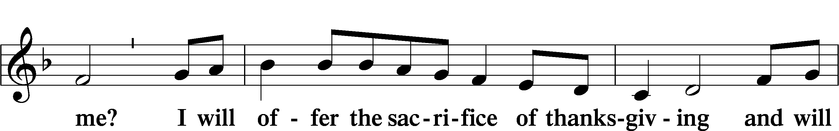
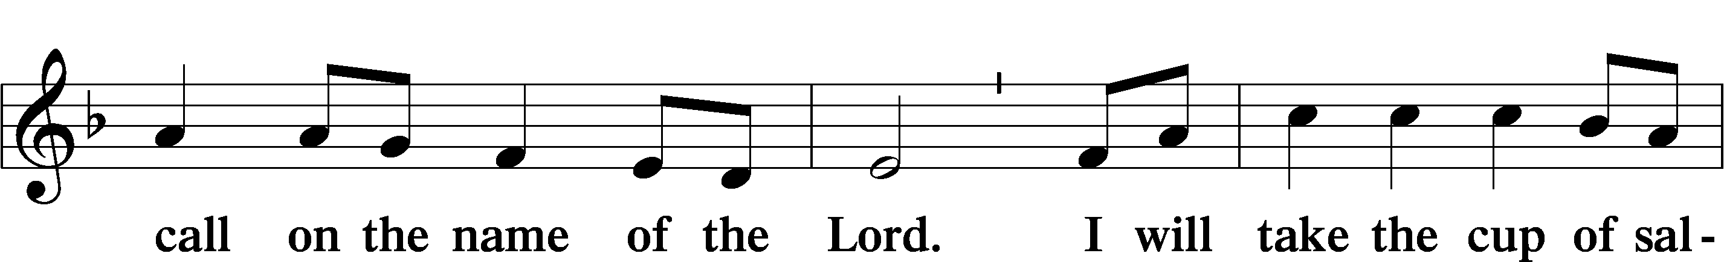
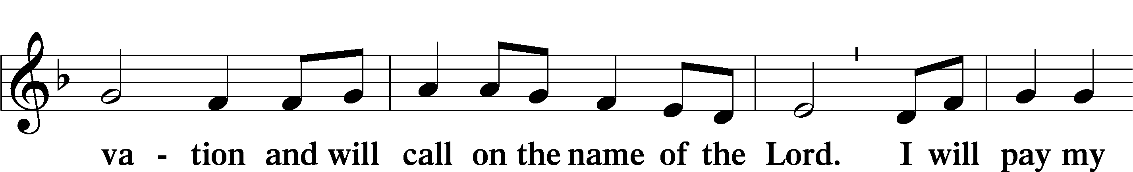
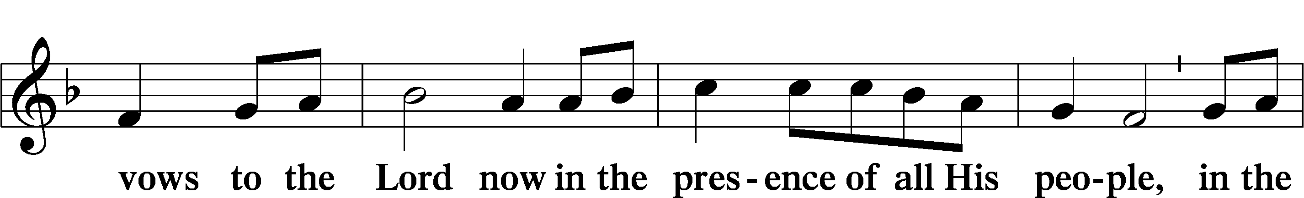
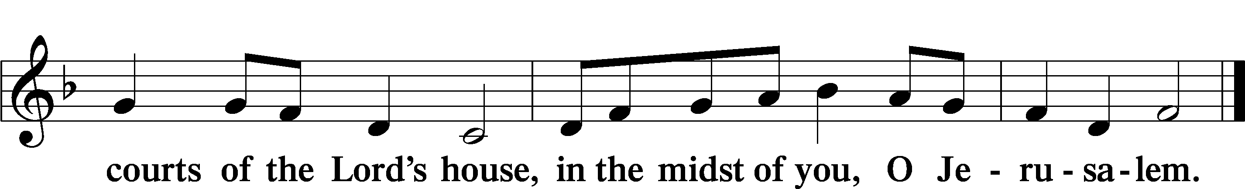

+ SERVICE OF THE SACRAMENT +

PREFACE LSB 160
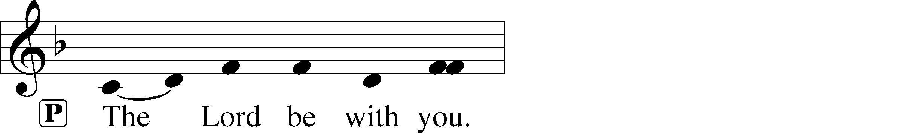
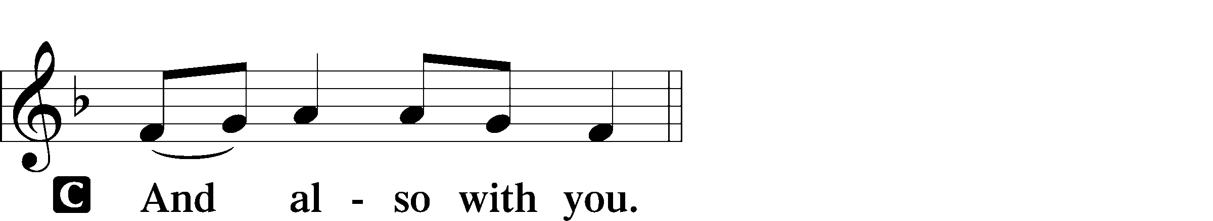
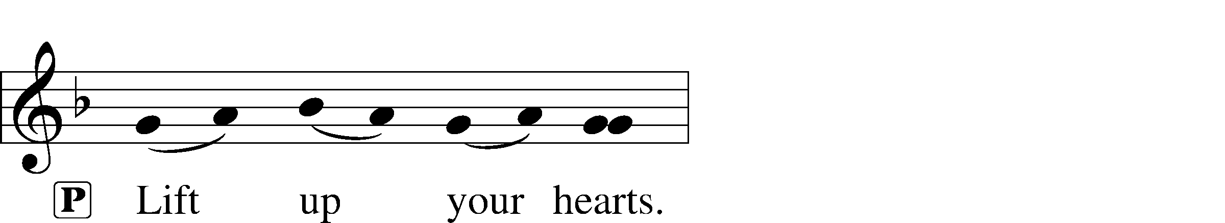

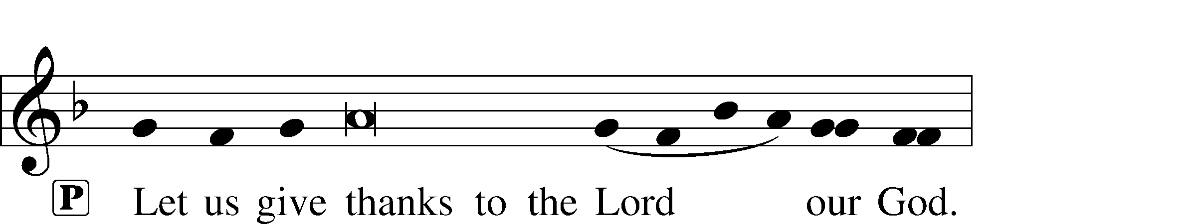
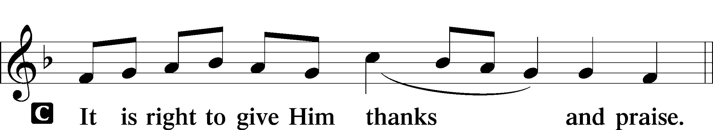

PROPER PREFACE (ABBREVIATED) LSB 161
P It is truly good, right, and salutary . . . evermore praising You and saying:

SANCTUS LSB 161
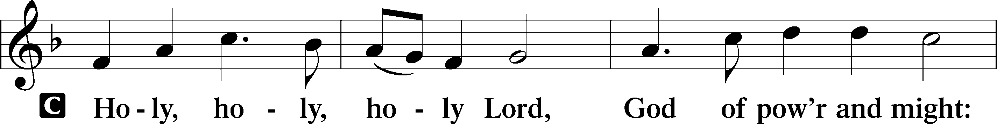
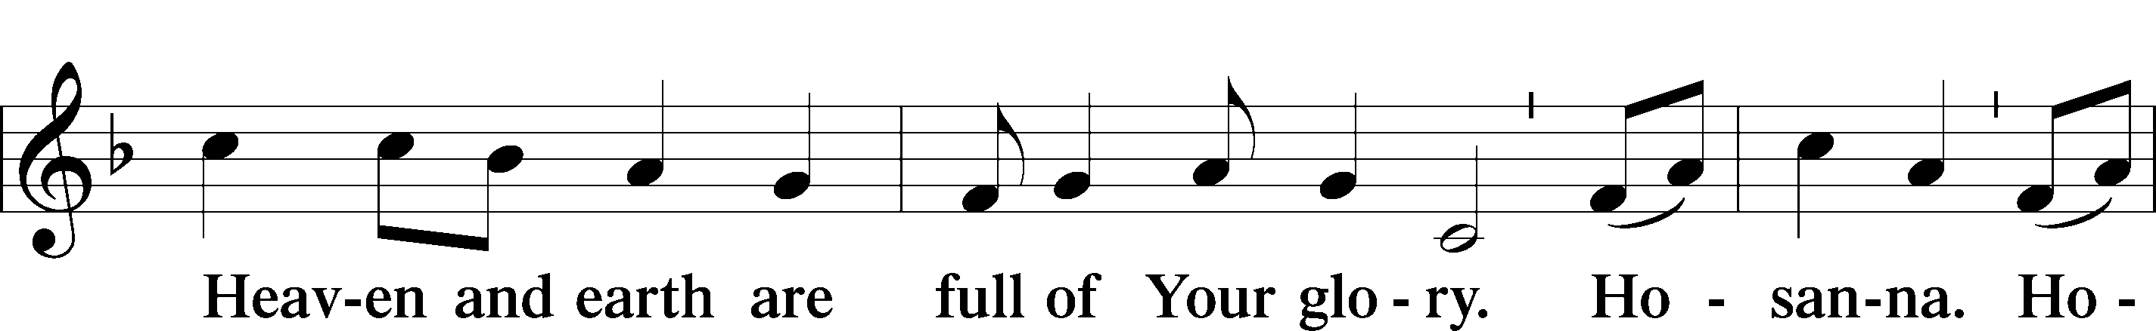
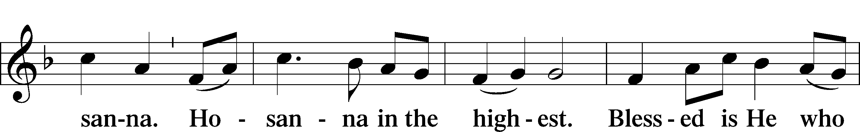
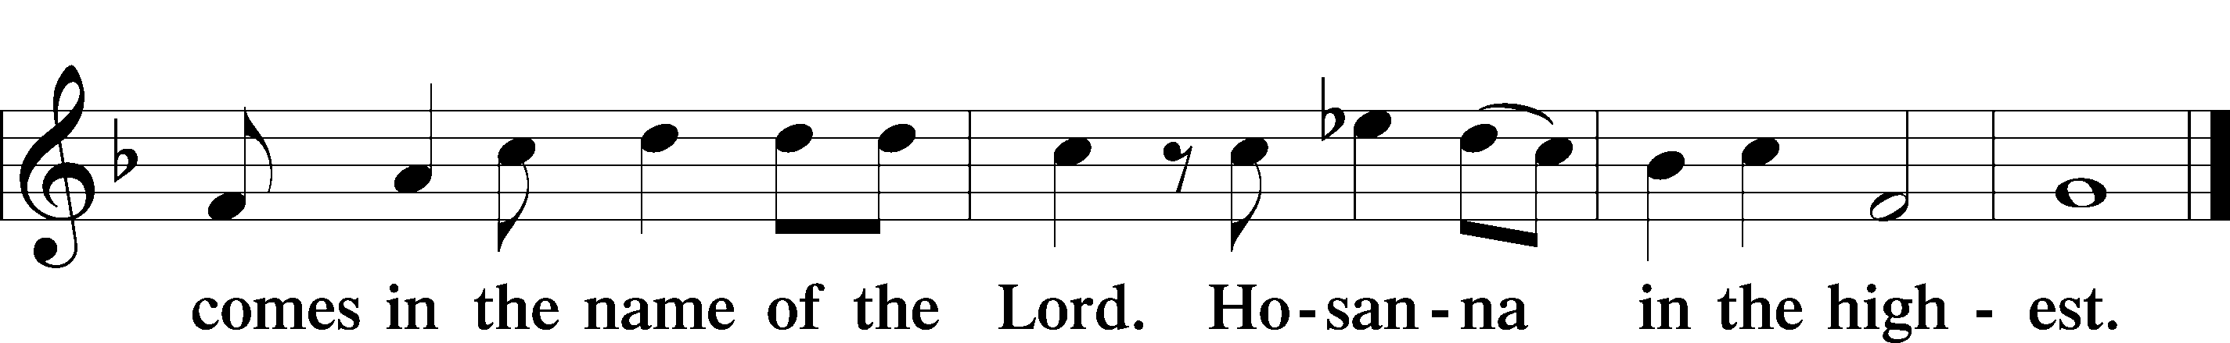

PRAYER OF THANKSGIVING LSB 161
P Blessed are You, Lord of heaven and earth...
,... with the Son and the Holy Spirit, one God, now and forever.
C Amen.

LORD’S PRAYER LSB 162
P Lord, remember us in Your kingdom and teach us to pray:
C Our Father who art in heaven,
hallowed be Thy name,
Thy kingdom come,
Thy will be done on earth
as it is in heaven;
give us this day our daily bread;
and forgive us our trespasses
as we forgive those
who trespass against us;
and lead us not into temptation,
but deliver us from evil.
For Thine is the kingdom
and the power and the glory
forever and ever. Amen.

THE WORDS OF OUR LORD LSB 162

PAX DOMINI LSB 163
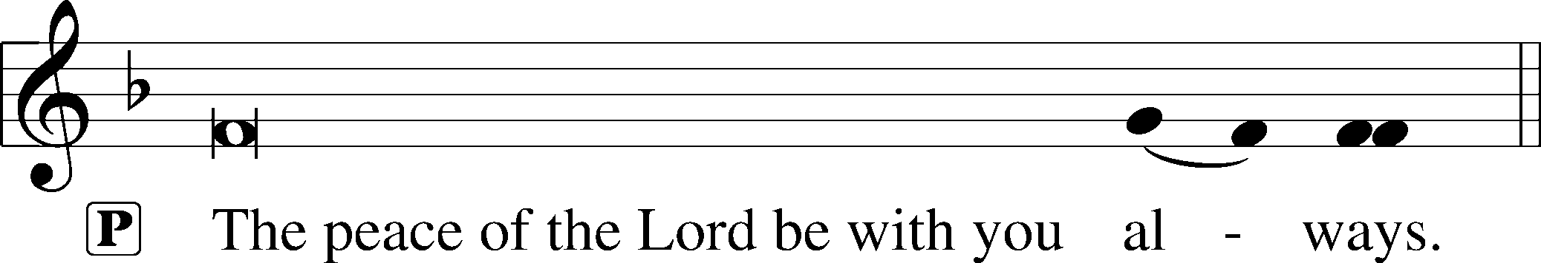


AGNUS DEI LSB 163
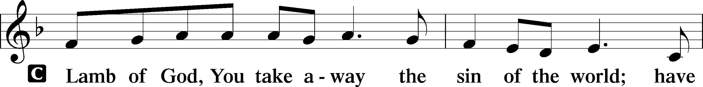
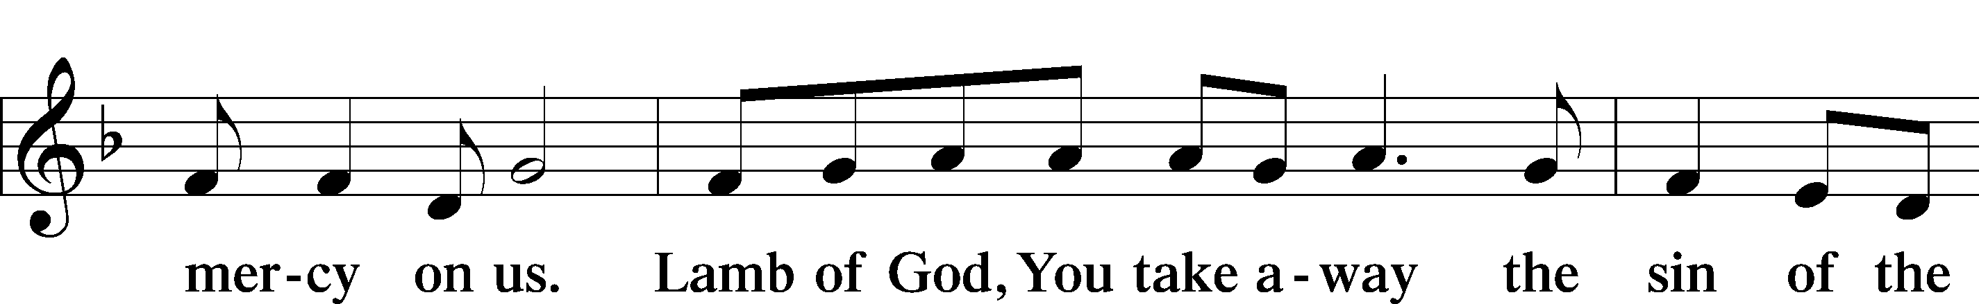
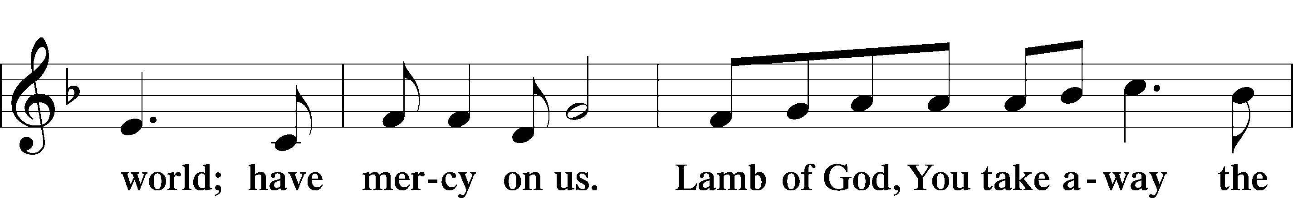
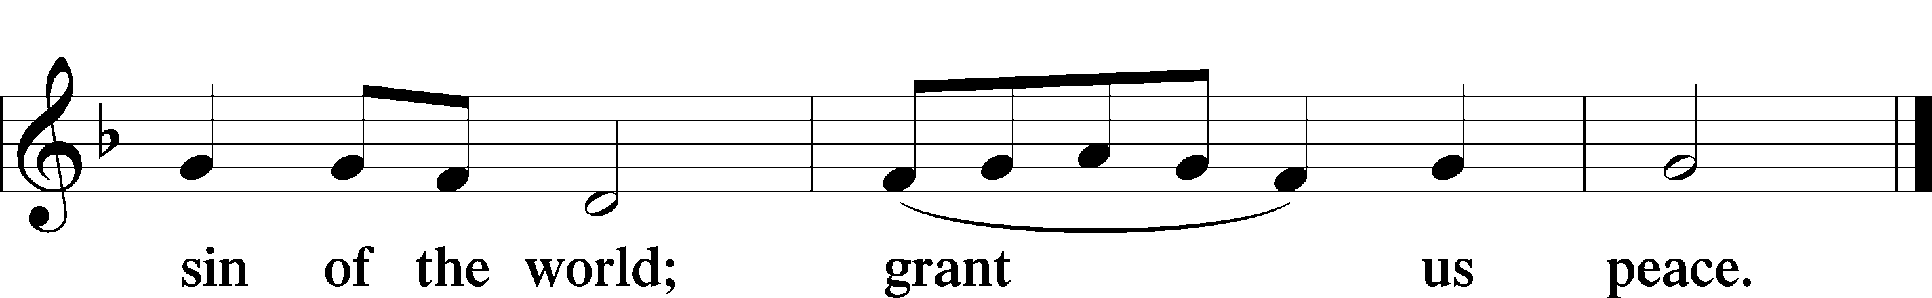

(Sit)

DISTRIBUTION

(The pastor and those assisting him are communed first, then commune those who are unable to come to the altar. The ushers will then direct all other communicants to the altar.)

691 FRUITFUL TREES, THE SPIRIT’S SOWING
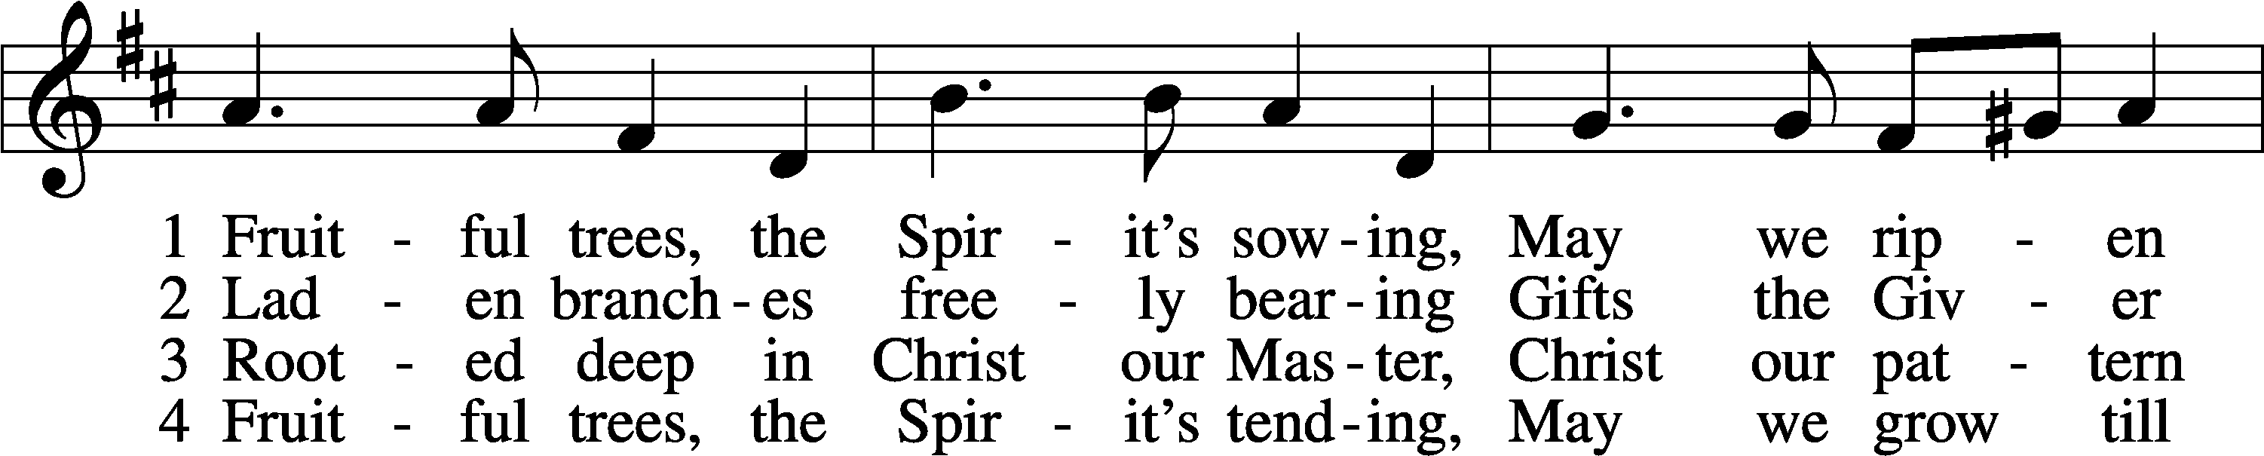
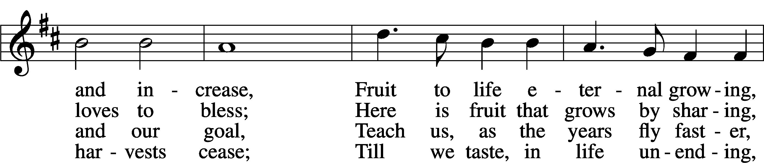
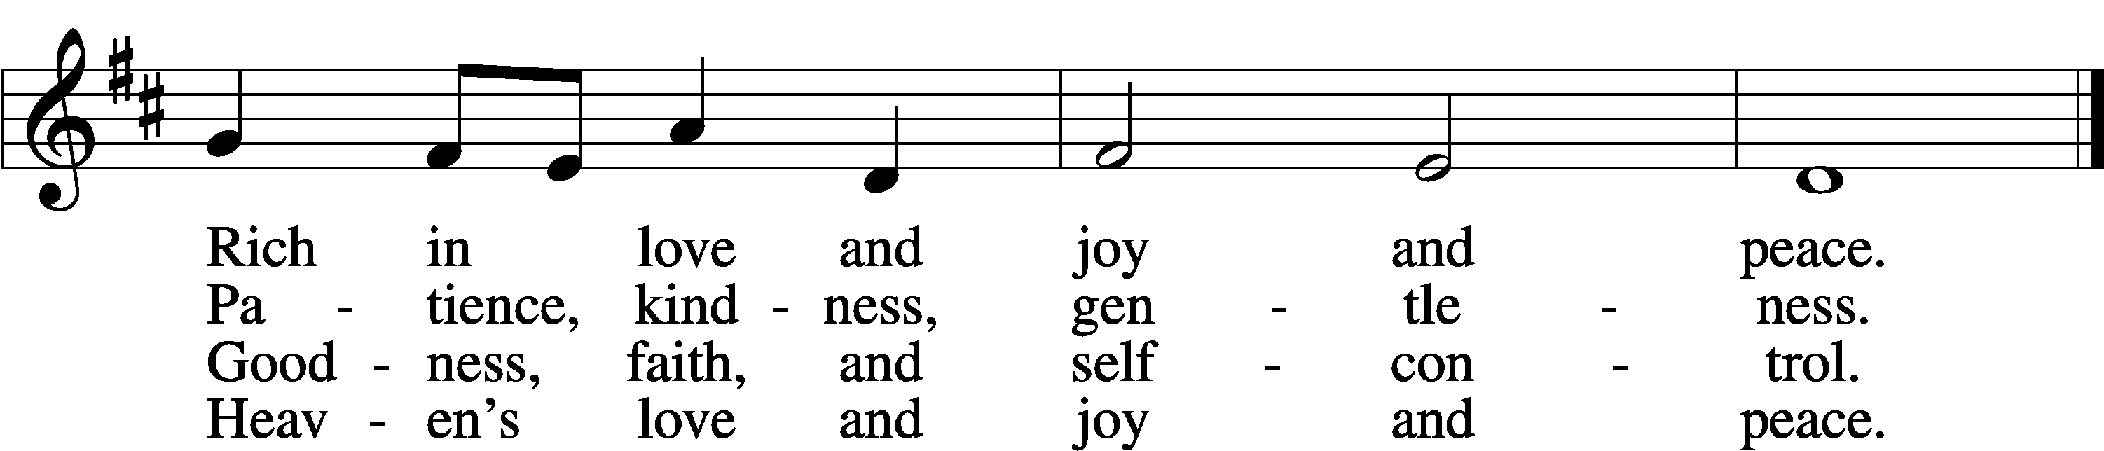
Text: Timothy Dudley-Smith, 1926–2024
Tune: Ralph C. Schultz, 1932–2024
Text: © 1984 Hope Publishing Co. Used by permission: LSB Hymn License no. 110004798
Tune: © 1980 Concordia Publishing House. Used by permission: LSB Hymn License no. 110004798

INSTRUMENTAL

(Stand)

THANK THE LORD LSB 164
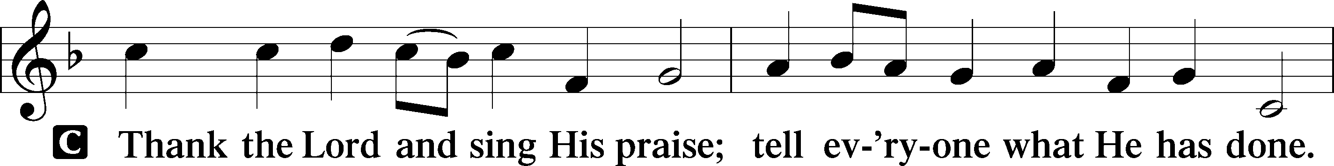
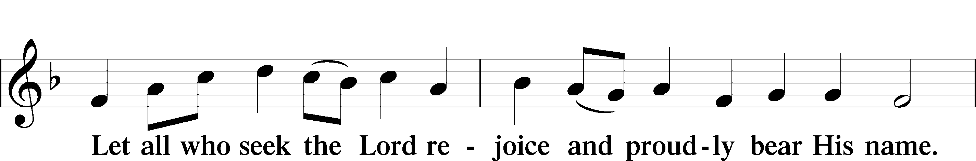
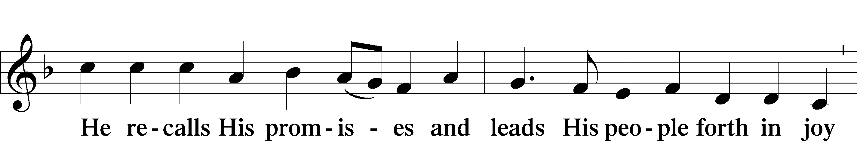
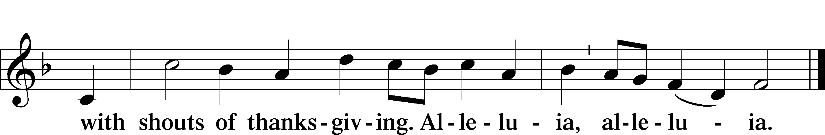

POST-COMMUNION COLLECT LSB 166
P Let us pray.
...through Jesus Christ, Your Son, our Lord, who lives and reigns with You and the Holy Spirit, one God, now and forever.
C Amen.

BENEDICTION LSB 166
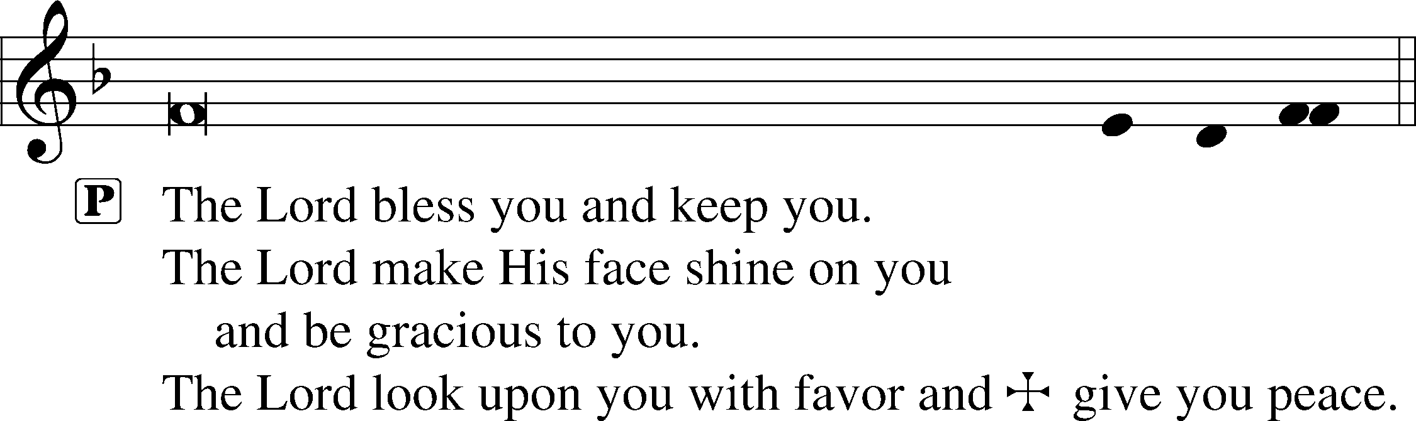


783 TAKE MY LIFE AND LET IT BE
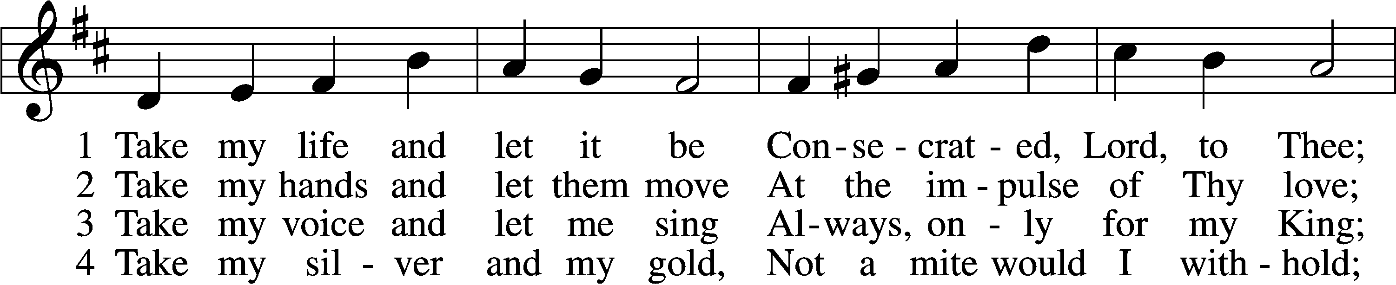
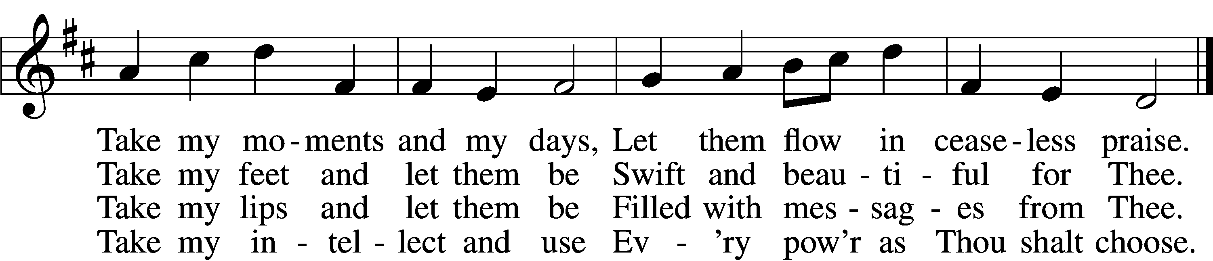

5 Take my will and make it Thine,
It shall be no longer mine;
Take my heart, it is Thine own,
It shall be Thy royal throne.

6 Take my love, my Lord, I pour
At Thy feet its treasure store;
Take myself, and I will be
Ever, only, all for Thee.
Text: Frances R. Havergal, 1836–79
Tune: William H. Havergal, 1793–1870
Text and tune: Public domain
ACKNOWLEDGMENTS
Unless otherwise indicated, Scripture quotations are from the ESV® Bible (The Holy Bible, English Standard Version®), copyright © 2001 by Crossway, a publishing ministry of Good News Publishers. Used by permission. All rights reserved.
Created by Lutheran Service Builder © 2026 Concordia Publishing House.

