BETHLEHEM LUTHERAN CHURCH
A congregation of The Lutheran Church-Missouri Synod
902 Hitchcock Drive SW,
Aiken, South Carolina 29803
Church Phone: (803) 649-6417
blcaikensc@gmail.com
Pastor: Rev. John B. Engwall
Office Hours By Appointment
Note: The format of this bulletin has been modified for use in private devotion services.
Unable to join us in person? Please find us on Facebook live.
The service is also posted on our website; bethlehemlutheranaiken.org

+ + + + + + + + + + + + + + +
SECOND SUNDAY AFTER EASTER
April 12TH, 2026
10:30a.m.
+ + + + + + + + + + + + + + +

Our Policy and Practice Regarding Holy Communion
Hear the words of the Apostle Paul;
Anyone who eats and drinks without recognizing the body of the Lord eats and drinks judgment on himself. -1 Cor.11:29
Therefore, visitors are asked to please refrain from partaking of the Sacrament before speaking about this with the pastor; because we care about your spiritual well-being.
Also, because communing at this altar is a public confession that you agree with the doctrines of The Lutheran Church-Missouri Synod, and reject all contrary teachings.
Persons who are not communing today are always welcome to come forward during the distribution to receive an individual blessing; please cross your arms over your chest to indicate your desire for this. Thank you!
We commune in two alternating tables. The ushers will guide you. Non-alcoholic white wine is available in the center of the individual cup tray. Please leave empty individual cups at the altar rail.

+ SERVICE OF PREPARATION +
After the bell tolls, please observe a time of silence.

WELCOME AND ANNOUNCEMENTS
(Stand)

564 CHRIST SITS AT GOD’S RIGHT HAND
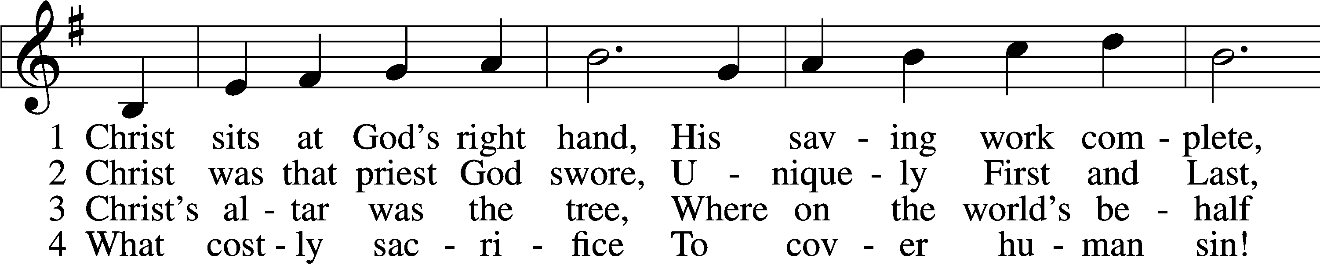
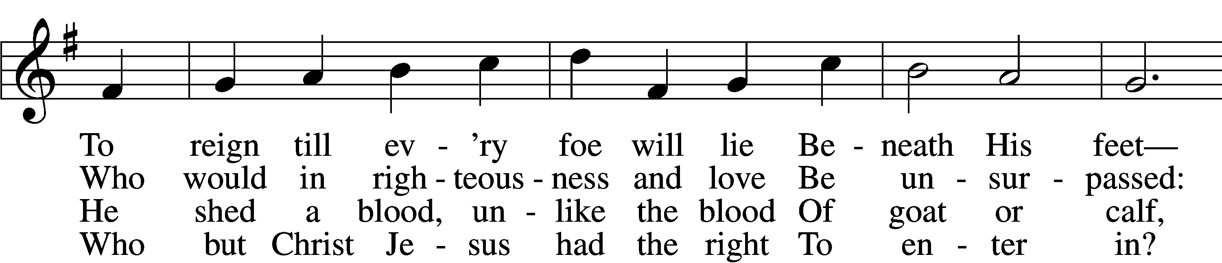
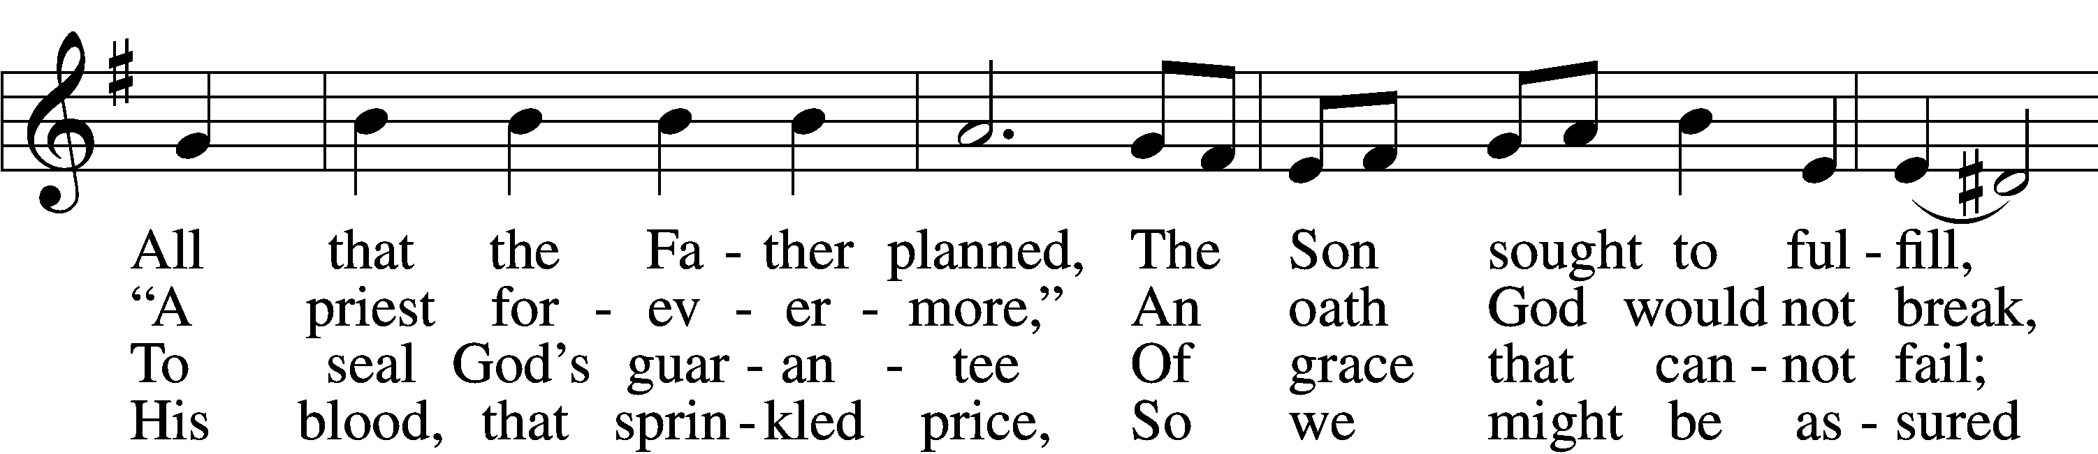
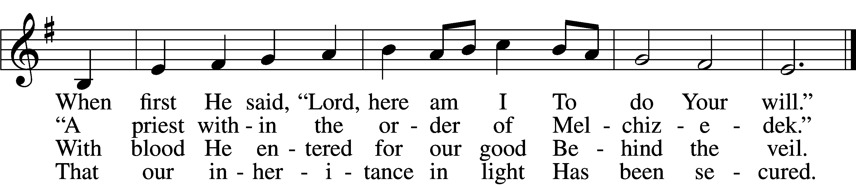

5 Then let us now draw near,
Washed in that precious flood
And enter the Most Holy Place
By Jesus’ blood.
From hearts that are sincere,
Let tongues our hope profess,
And trust anew God’s faithful grace
That we confess. (next page)

D 6 All praise to Christ we bring,
Our Lord who intercedes,
Our great High Priest enthroned above
Who knows our needs;
And to the Father sing
Our songs of thankful praise,
Who with the Spirit reigns in love
For endless days.
Text: Stephen P. Starke, 1955
Tune: Hebrew
Text: © 2002 Stephen P. Starke, admin. Concordia Publishing House. Used by permission: LSB Hymn License no. 110004798
Tune: Public domain

+ CONFESSION AND ABSOLUTION +

(The sign of the cross may be made by all in remembrance of their Baptism.)

INVOCATION
P In the name of the Father and of the T Son and of the Holy Spirit.
C Amen.

EXHORTATION LSB 151
P If we say we have no sin, we deceive ourselves, and the truth is not in us.
C But if we confess our sins, God, who is faithful and just, will forgive our sins and cleanse us from all unrighteousness.

(Silence for reflection on God’s Word and for self-examination.)

CONFESSION OF SINS LSB 151
P Let us then confess our sins to God our Father.
C Most merciful God, we confess that we are by nature sinful and unclean. We have sinned against You in thought, word, and deed, by what we have done and by what we have left undone. We have not loved You with our whole heart; we have not loved our neighbors as ourselves. We justly deserve Your present and eternal punishment. For the sake of Your Son, Jesus Christ, have mercy on us. Forgive us, renew us, and lead us, so that we may delight in Your will and walk in Your ways to the glory of Your holy name. Amen.

DECLARATION OF GRACE
L In the mercy of almighty God, Jesus Christ was given to die for us, and for His sake God forgives us all our sins. To those who believe in Jesus Christ He gives the power to become the children of God and bestows on them the Holy Spirit. May the Lord, who has begun this good work in us, bring it to completion in the day of our Lord Jesus Christ.
C Amen.
+ SERVICE OF THE WORD +

INTROIT Psalm 105:1–5, 8; antiphon: 1 Peter 2:2–3
Like newborn infants, long for the pure spiritual milk, that by it you may grow up to sal- | vation—*
if indeed you have tasted that the | Lord is good.
Oh give thanks to the Lord; call up- | on his name;*
make known his deeds among the | peoples!
Sing to him, sing prais- | es to him;*
tell of all his | wondrous works!
Glory in his | holy name;*
let the hearts of those who seek the | Lord rejoice!
Seek the Lord | and his strength;*
seek his presence con- | tinually!
Remember the wondrous works that | he has done,*
his miracles, and the judgments he | uttered.
He remembers his covenant for- | ever,*
the word that he commanded, for a thousand gener- | ations.
Glory be to the Father and | to the Son*
and to the Holy | Spirit;
as it was in the be- | ginning,*
is now, and will be forever. | Amen.
Like newborn infants, long for the pure spiritual milk, that by it you may grow up to sal- | vation—*
if indeed you have tasted that the | Lord is good.

KYRIE LSB 152



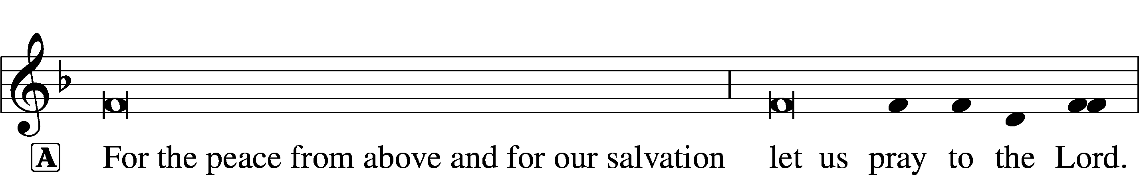

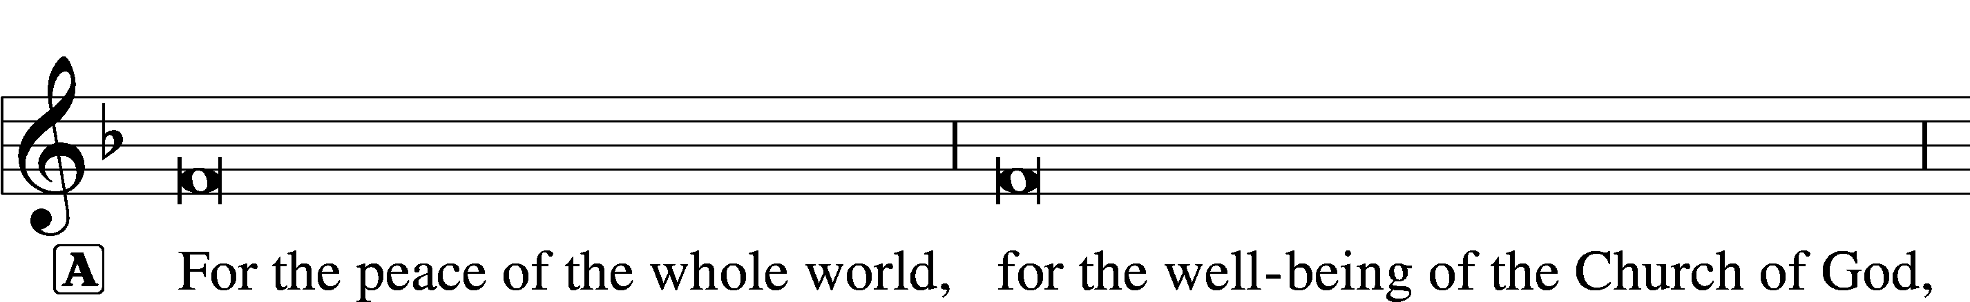


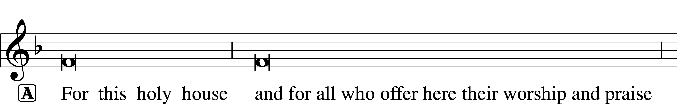






THIS IS THE FEAST LSB 155
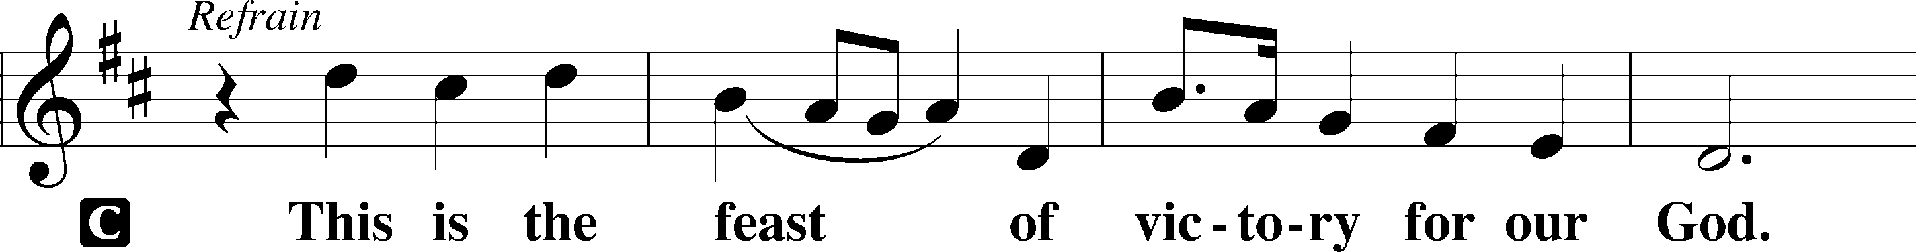
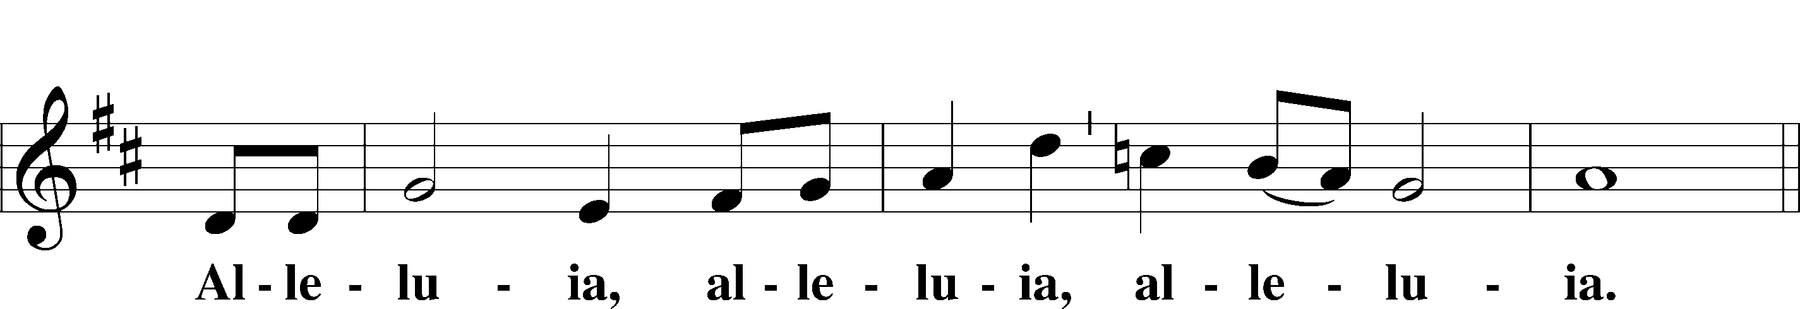
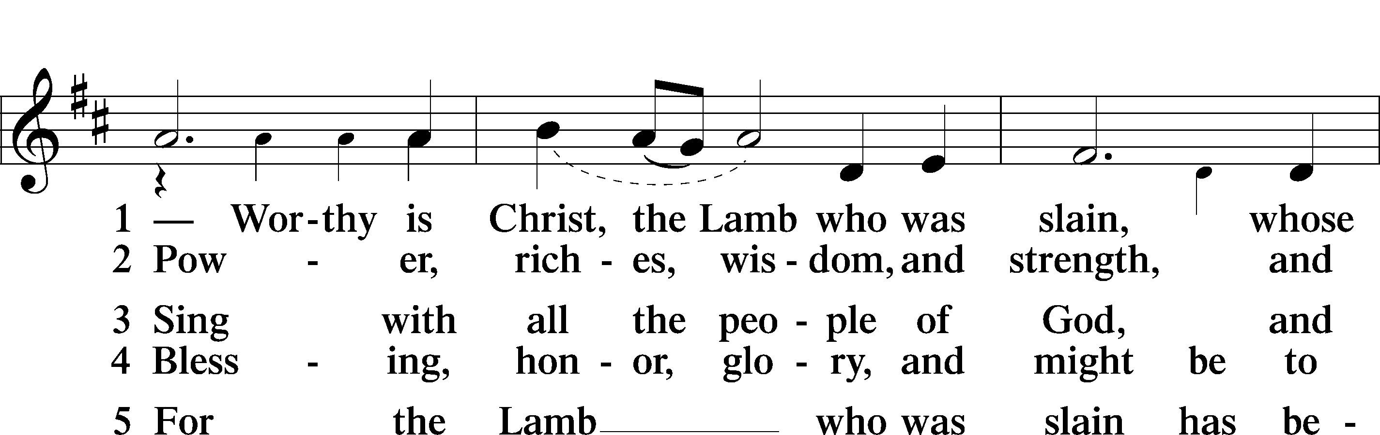
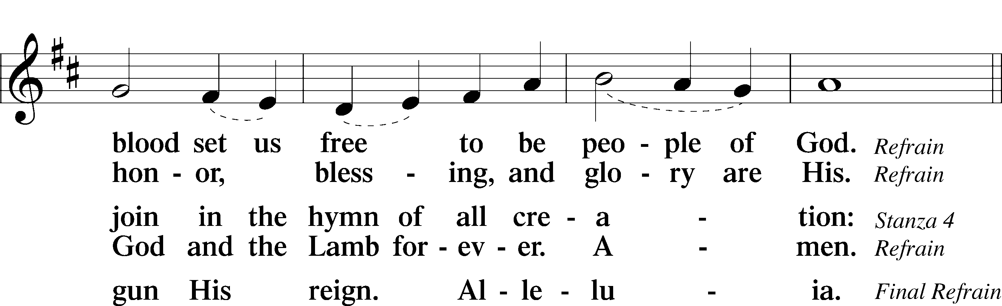
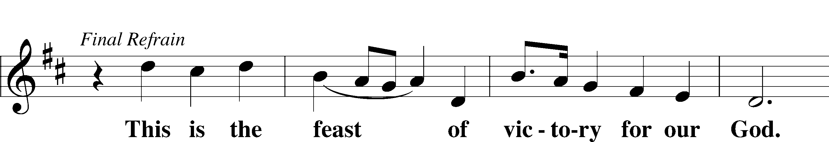
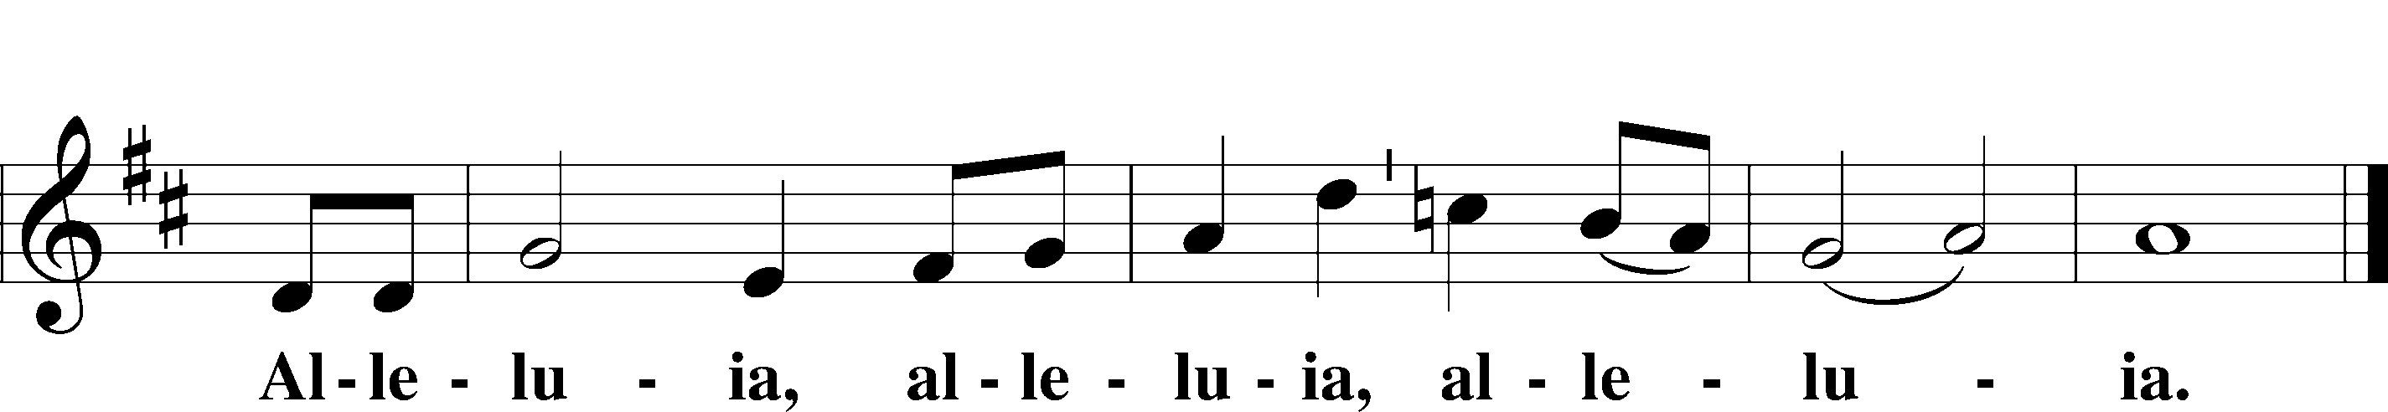

SALUTATION AND COLLECT OF THE DAY
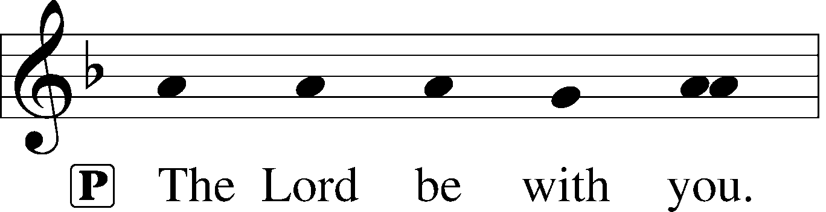
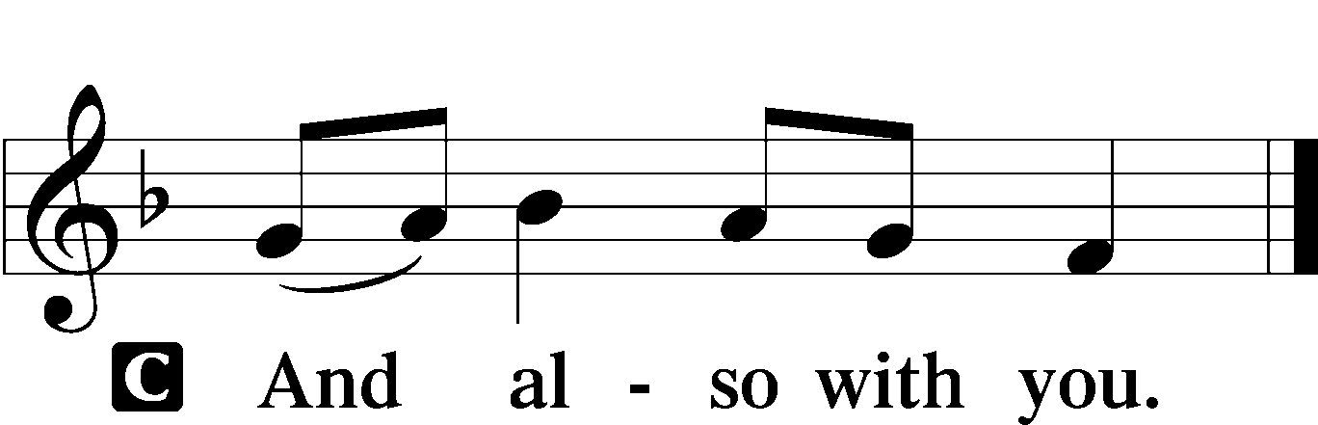

L Let us pray.
Almighty God, grant that we who have celebrated the Lord’s resurrection may by Your grace confess in our life and conversation that Jesus is Lord and God; through the same Jesus Christ, Your Son, who lives and reigns with You and the Holy Spirit, one God, now and forever.

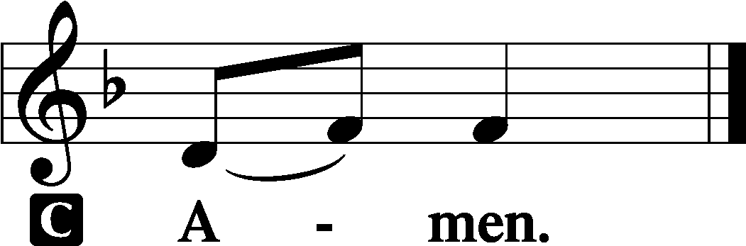

(Sit)

CHILDRENS LESSON

FIRST READING Acts 5:29–42
29But Peter and the apostles answered, “We must obey God rather than men. 30The God of our fathers raised Jesus, whom you killed by hanging him on a tree. 31God exalted him at his right hand as Leader and Savior, to give repentance to Israel and forgiveness of sins. 32And we are witnesses to these things, and so is the Holy Spirit, whom God has given to those who obey him.”
33When they heard this, they were enraged and wanted to kill them. 34But a Pharisee in the council named Gamaliel, a teacher of the law held in honor by all the people, stood up and gave orders to put the men outside for a little while. 35And he said to them, “Men of Israel, take care what you are about to do with these men. 36For before these days Theudas rose up, claiming to be somebody, and a number of men, about four hundred, joined him. He was killed, and all who followed him were dispersed and came to nothing. 37After him Judas the Galilean rose up in the days of the census and drew away some of the people after him. He too perished, and all who followed him were scattered.

38So in the present case I tell you, keep away from these men and let them alone, for if this plan or this undertaking is of man, it will fail; 39but if it is of God, you will not be able to overthrow them. You might even be found opposing God!” So they took his advice, 40and when they had called in the apostles, they beat them and charged them not to speak in the name of Jesus, and let them go. 41Then they left the presence of the council, rejoicing that they were counted worthy to suffer dishonor for the name. 42And every day, in the temple and from house to house, they did not cease teaching and preaching Jesus as the Christ.

L This is the Word of the Lord.
C Thanks be to God.

GRADUAL adapt. from Matthew 28:7; Hebrews 2:7; Psalm 8:6
Christ has risen | from the dead.*
[God the Father] has crowned him with glory and | honor.
He has given him dominion over the works | of his hands;*
he has put all things un- | der his feet.

EPISTLE 1 Peter 1:3–9
3Blessed be the God and Father of our Lord Jesus Christ! According to his great mercy, he has caused us to be born again to a living hope through the resurrection of Jesus Christ from the dead, 4to an inheritance that is imperishable, undefiled, and unfading, kept in heaven for you, 5who by God’s power are being guarded through faith for a salvation ready to be revealed in the last time. 6In this you rejoice, though now for a little while, if necessary, you have been grieved by various trials, 7so that the tested genuineness of your faith—more precious than gold that perishes though it is tested by fire—may be found to result in praise and glory and honor at the revelation of Jesus Christ. 8Though you have not seen him, you love him. Though you do not now see him, you believe in him and rejoice with joy that is inexpressible and filled with glory, 9obtaining the outcome of your faith, the salvation of your souls.

L This is the Word of the Lord.
C Thanks be to God.

(Stand)

ALLELUIA AND VERSE LSB 156
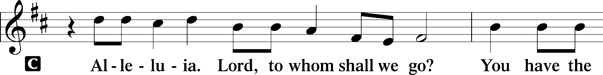
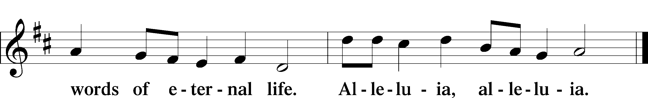

HOLY GOSPEL John 20:19–31
L The Holy Gospel according to St. John, the twentieth chapter.

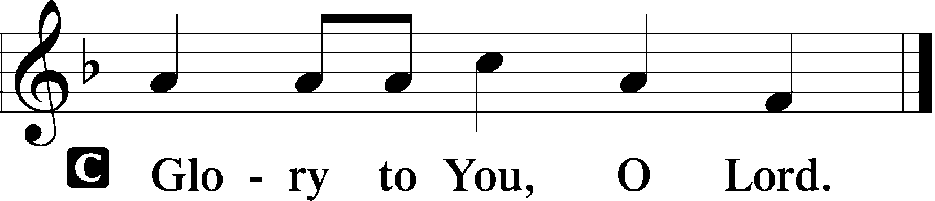

19On the evening of that day, the first day of the week, the doors being locked where the disciples were for fear of the Jews, Jesus came and stood among them and said to them, “Peace be with you.” 20When he had said this, he showed them his hands and his side. Then the disciples were glad when they saw the Lord. 21Jesus said to them again, “Peace be with you. As the Father has sent me, even so I am sending you.” 22And when he had said this, he breathed on them and said to them, “Receive the Holy Spirit. 23If you forgive the sins of anyone, they are forgiven; if you withhold forgiveness from anyone, it is withheld.”
24Now Thomas, one of the Twelve, called the Twin, was not with them when Jesus came. 25So the other disciples told him, “We have seen the Lord.” But he said to them, “Unless I see in his hands the mark of the nails, and place my finger into the mark of the nails, and place my hand into his side, I will never believe.”
26Eight days later, his disciples were inside again, and Thomas was with them. Although the doors were locked, Jesus came and stood among them and said, “Peace be with you.” 27Then he said to Thomas, “Put your finger here, and see my hands; and put out your hand, and place it in my side. Do not disbelieve, but believe.” 28Thomas answered him, “My Lord and my God!” 29Jesus said to him, “Have you believed because you have seen me? Blessed are those who have not seen and yet have believed.”
30Now Jesus did many other signs in the presence of the disciples, which are not written in this book; 31but these are written so that you may believe that Jesus is the Christ, the Son of God, and that by believing you may have life in his name.

L This is the Gospel of the Lord.
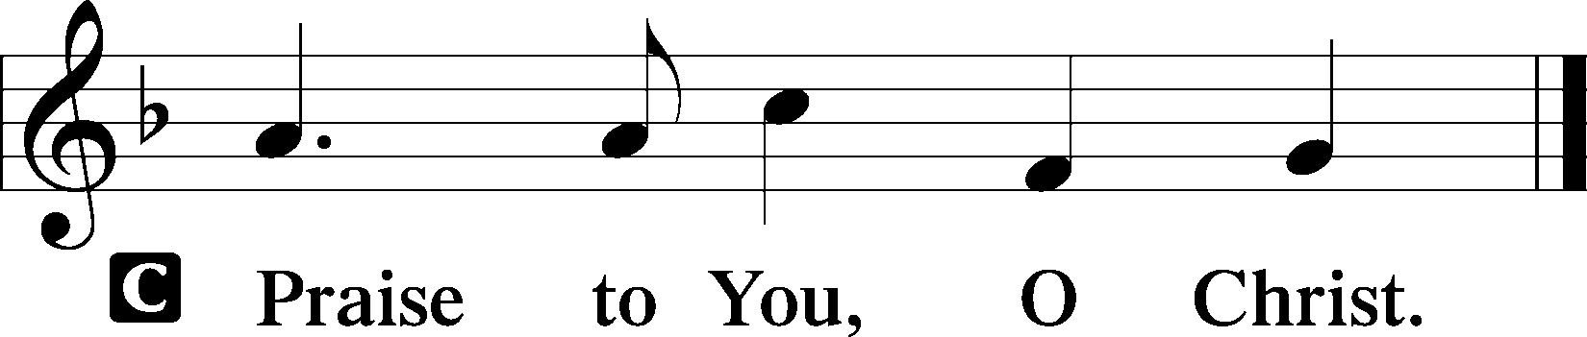

(Sit)

470 O SONS AND DAUGHTERS OF THE KING
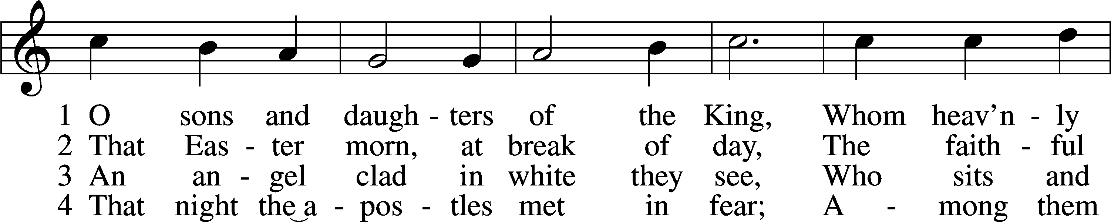
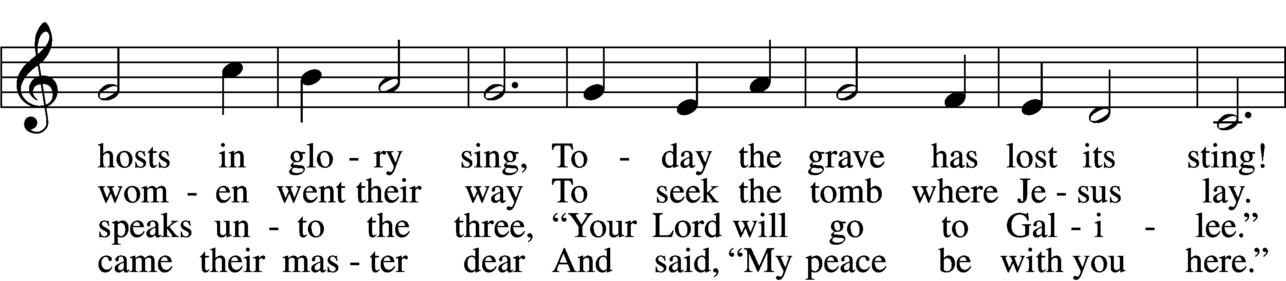
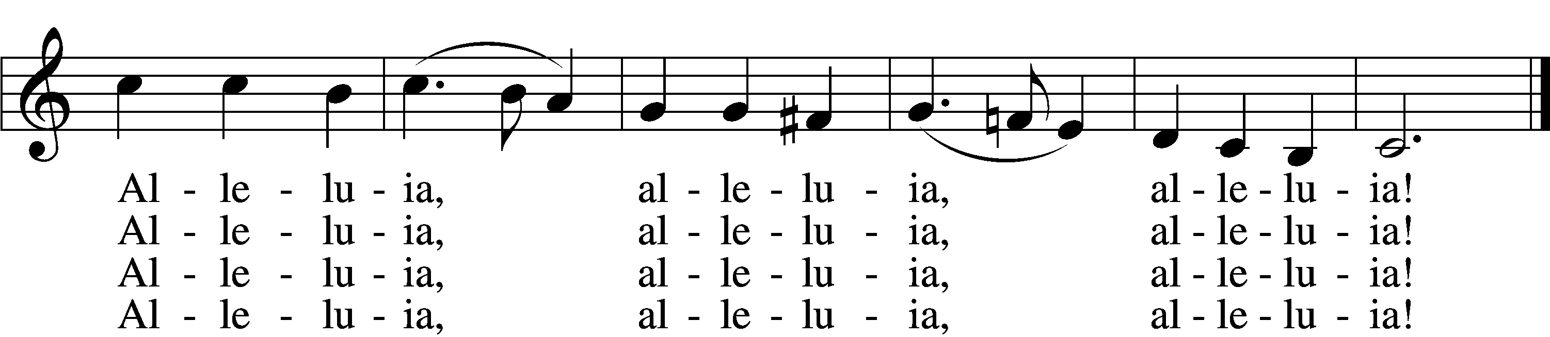

5 When Thomas first the tidings heard
That they had seen the risen Lord,
He doubted the disciples’ word.
Alleluia, alleluia, alleluia!

6 “My piercèd side, O Thomas, see,
And look upon My hands, My feet;
Not faithless but believing be.”
Alleluia, alleluia, alleluia!

7 No longer Thomas then denied;
He saw the feet, the hands, the side;
“You are my Lord and God!” he cried.
Alleluia, alleluia, alleluia!

8 How blest are they who have not seen
And yet whose faith has constant been,
For they eternal life shall win.
Alleluia, alleluia, alleluia! (next page)
9 On this most holy day of days
Be laud and jubilee and praise:
To God your hearts and voices raise.
Alleluia, alleluia, alleluia!
Text: attr. Jean Tisserand, d. 1494; tr. John Mason Neale, 1818–66, alt.
Tune: Melchior Vulpius, c. 1570–1615
Text and tune: Public domain

SERMON OR MEDITATION ON THE READINGS

(Stand)

APOSTLES’ CREED
C I believe in God, the Father Almighty,
maker of heaven and earth.

And in Jesus Christ, His only Son, our Lord,
who was conceived by the Holy Spirit,
born of the virgin Mary,
suffered under Pontius Pilate,
was crucified, died and was buried.
He descended into hell.
The third day He rose again from the dead.
He ascended into heaven
and sits at the right hand of God the Father Almighty.
From thence He will come to judge the living and the dead.

I believe in the Holy Spirit,
the holy Christian Church,
the communion of saints,
the forgiveness of sins,
the resurrection of the body,
and the life T everlasting. Amen.

SHARING OF THE PEACE

(Sit)

PRAYER OF THE CHURCH

OFFERING
As a part of our expression of thanksgiving to God for the treasure of His salvation to us, we offer a portion of our treasure, according to what each has determined in their heart to give. Please place offerings in the collection plate at the back of the sanctuary before or after the service. Offerings can also be sent to Bethlehem Lutheran Church via U.S. Mail. Thank you!

(Stand)

OFFERTORY LSB 159
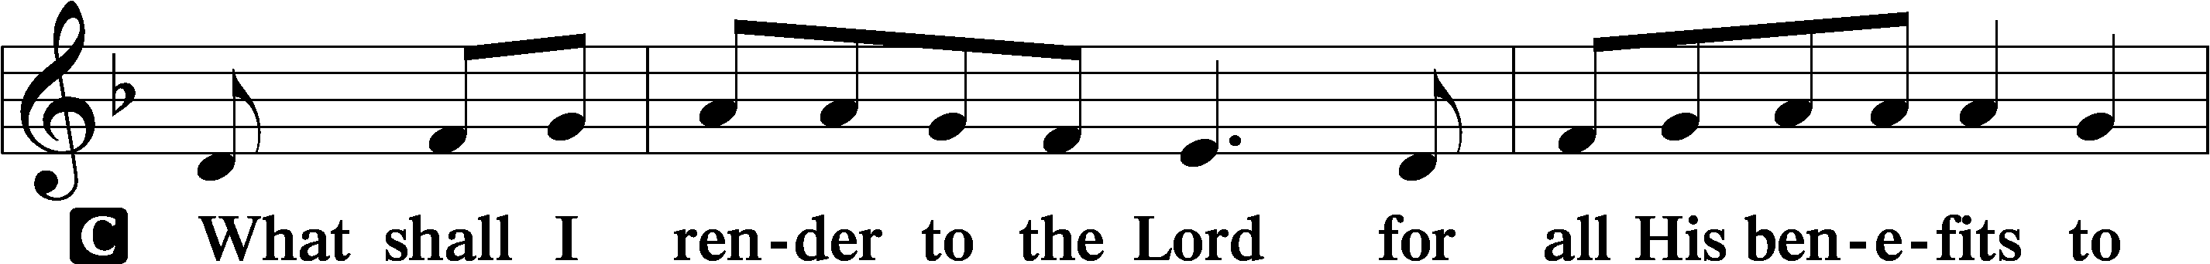
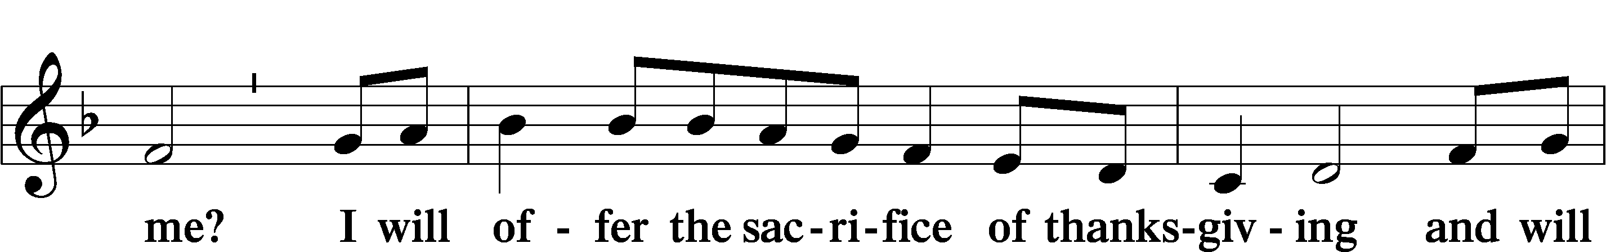
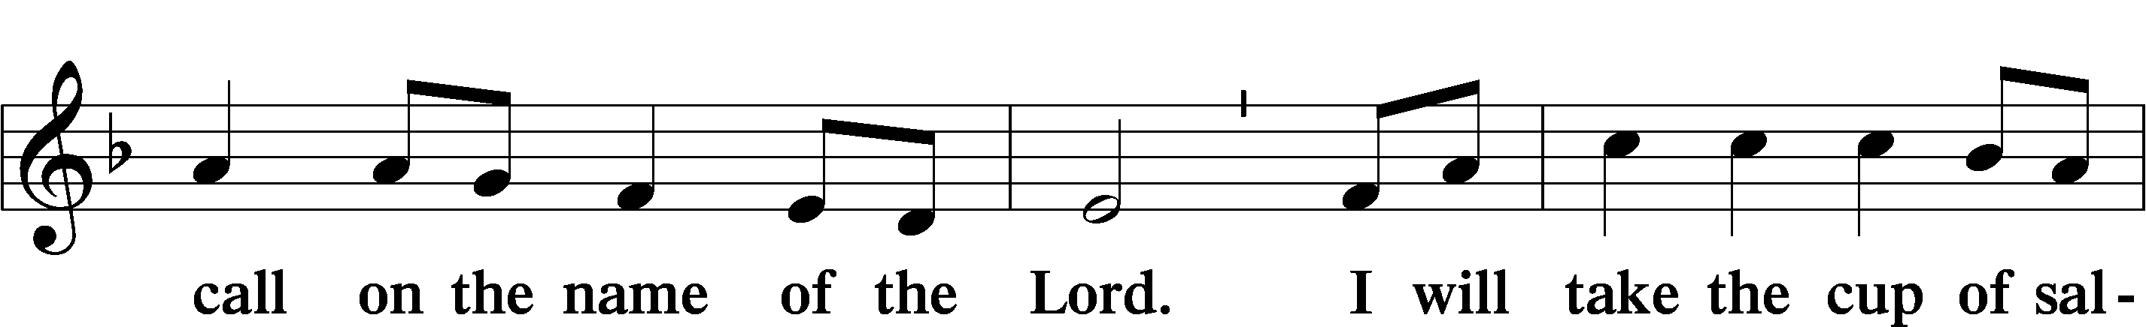
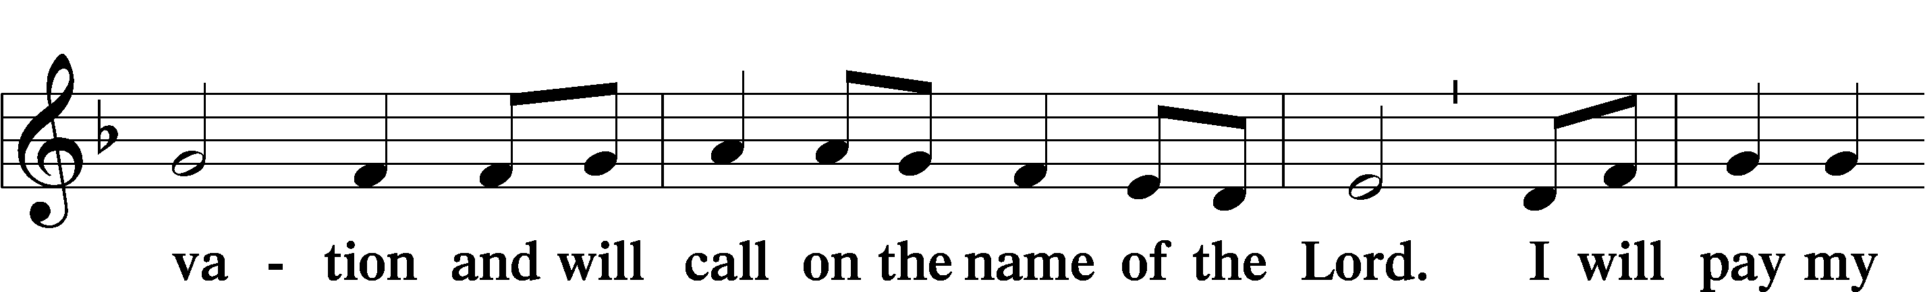
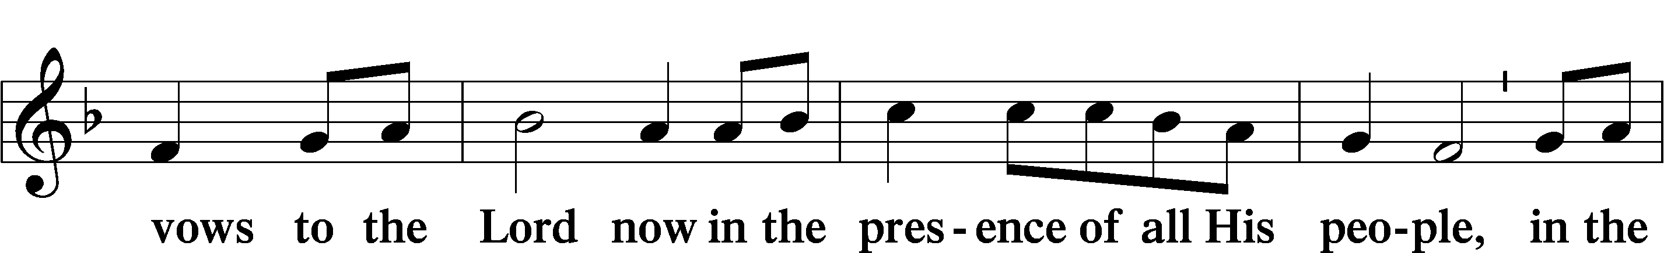
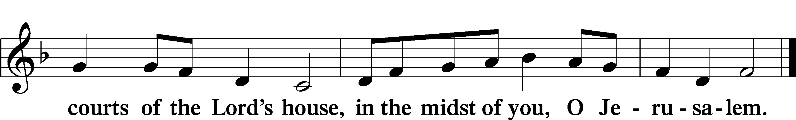

Please note: This order of worship, if being used for personal devotions, or a lay-led service, concludes at this point with the Lord’s Prayer, the Benediction, and the closing hymn.
+ SERVICE OF THE SACRAMENT +
Note: The Service of The Sacrament is included in the lay bulletin solely as a viewers’ guide for those watching the livestream service; Communicant members who are unable to attend the Divine Service in person are encouraged to contact an Elder, and make arrangements to receive the Lord’s Supper.

PREFACE LSB 160





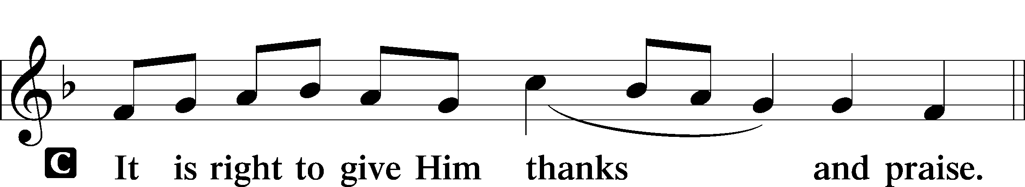

PROPER PREFACE (ABBREVIATED) LSB 161
P It is truly good, right, and salutary . . . evermore praising You and saying:

SANCTUS LSB 161
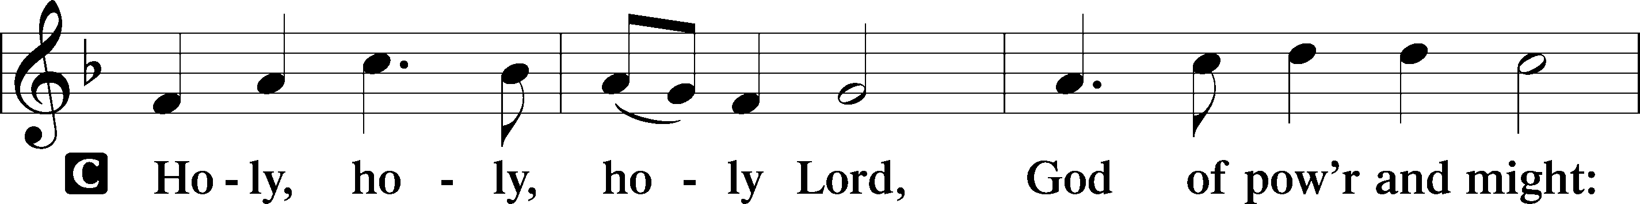
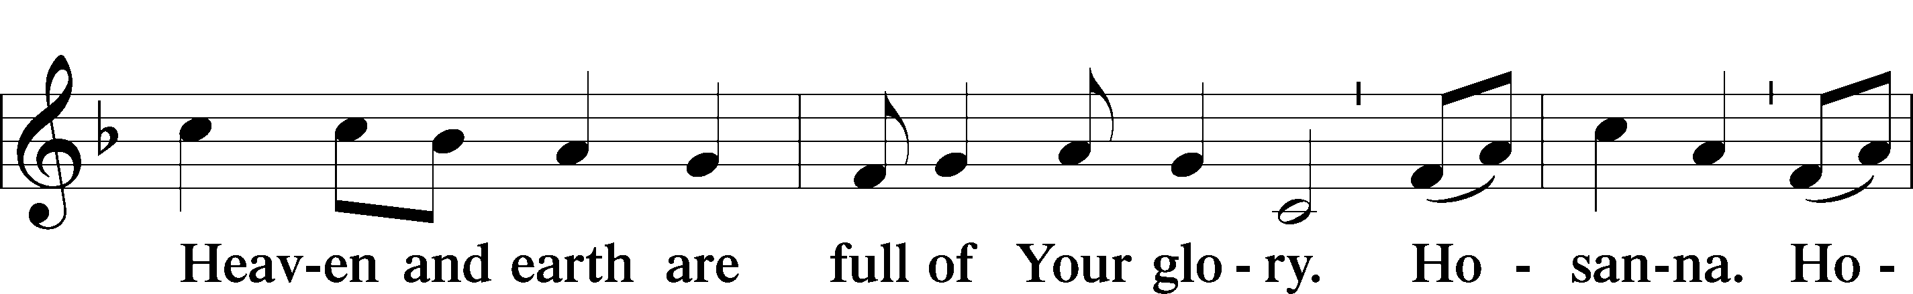
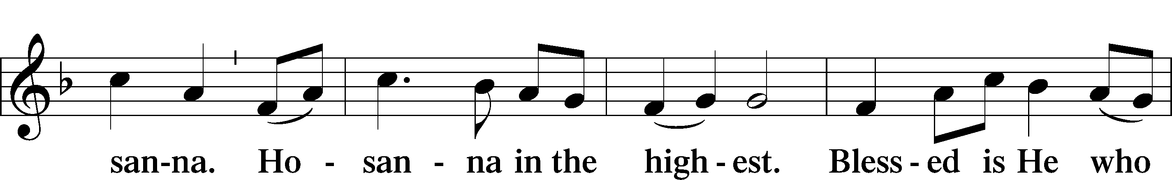
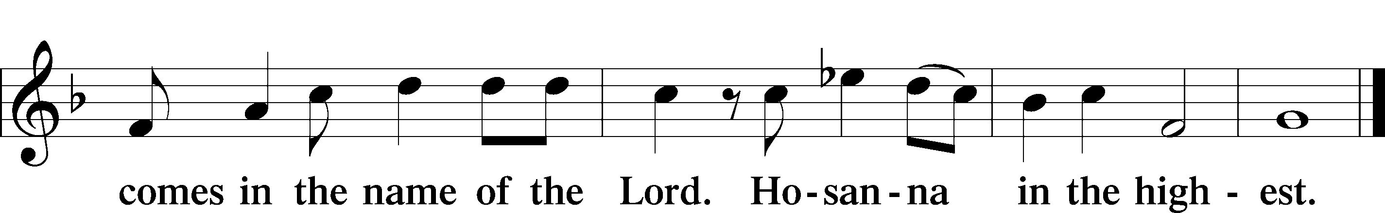

PRAYER OF THANKSGIVING LSB 161

LORD’S PRAYER 162
C Our Father who art in heaven,
hallowed be Thy name,
Thy kingdom come,
Thy will be done on earth
as it is in heaven;
give us this day our daily bread;
and forgive us our trespasses
as we forgive those
who trespass against us;
and lead us not into temptation,
but deliver us from evil.
For Thine is the kingdom
and the power and the glory
forever and ever. Amen.

THE WORDS OF OUR LORD

PAX DOMINI LSB 163
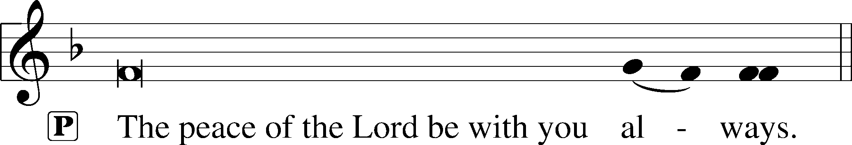


AGNUS DEI LSB 163
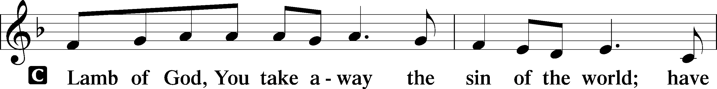
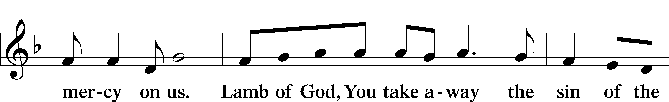
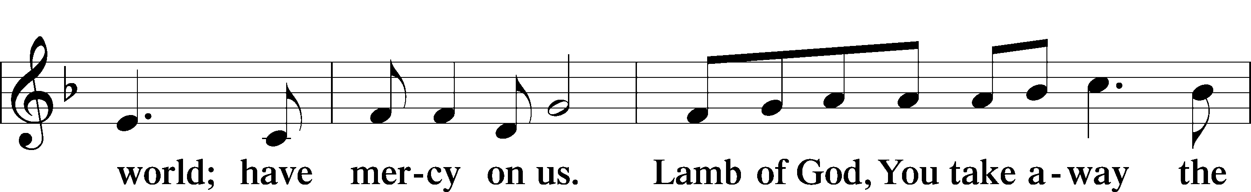
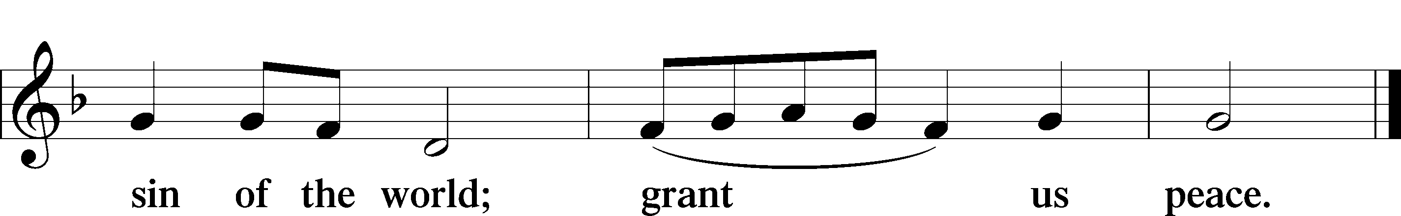

(Sit)

DISTRIBUTION
(The pastor and those who assist him receive the body and blood of Christ first and then distribute them to those who are unable to come to the altar. The ushers will then direct all other communicants to the altar.)

640 THEE WE ADORE, O HIDDEN SAVIOR
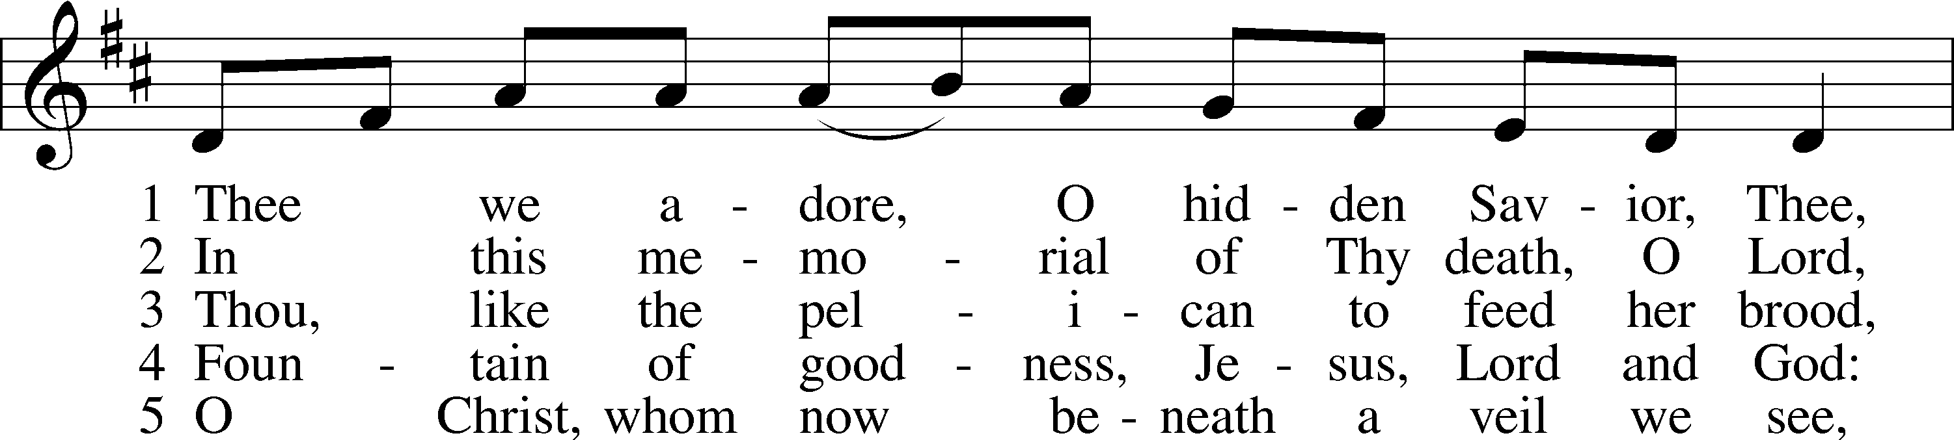
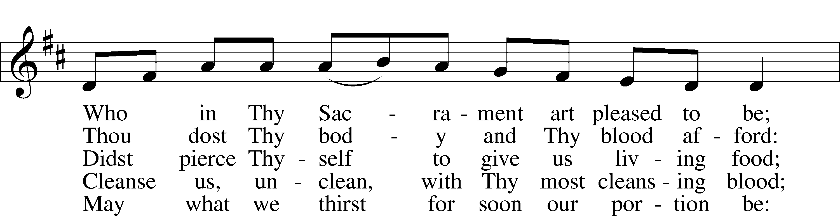
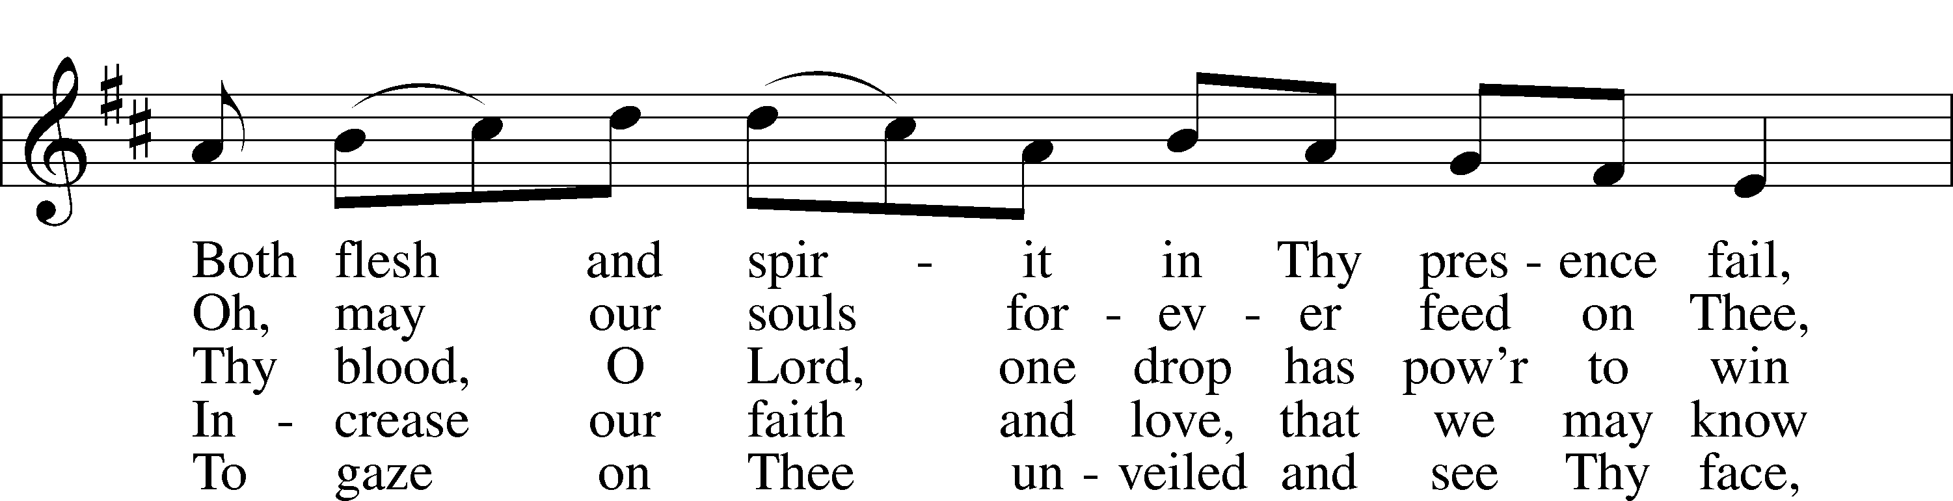
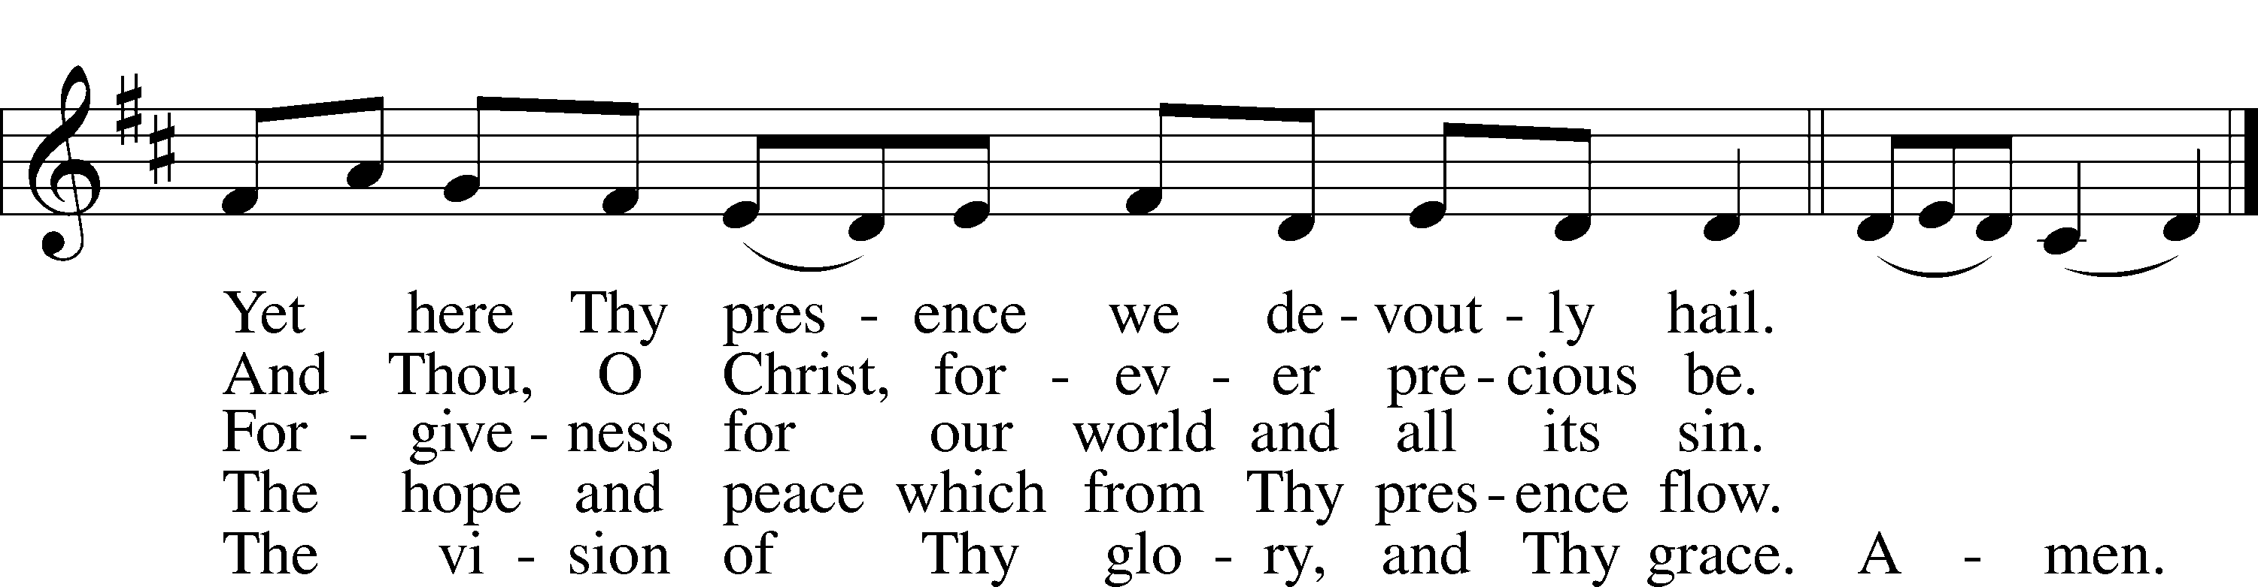
Text: Thomas Aquinas, c. 1225–1274; (sts. 1–2, 4–5): tr. James R. Woodford, 1820–85, alt.; (sts. 2–3): tr. Stephen P. Starke, 1955
Tune: Processionale, 1697, Paris, mode V
Text (sts. 2–3): © 1998 Concordia Publishing House. Used by permission: LSB Hymn License no. 110004798
Text (sts. 1, 4–5) and tune: Public domain

INSTRUMENTAL

(Stand)

THANK THE LORD LSB 164
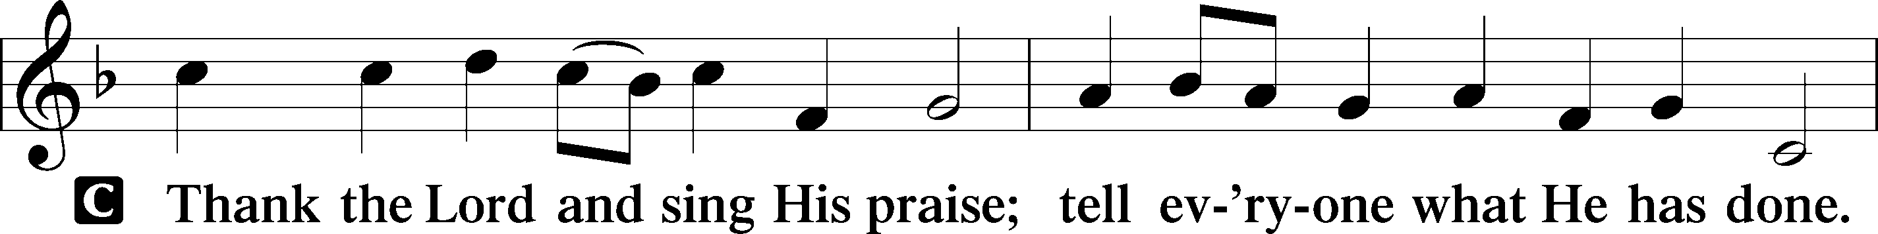
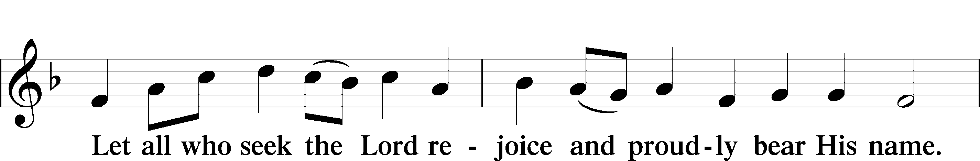
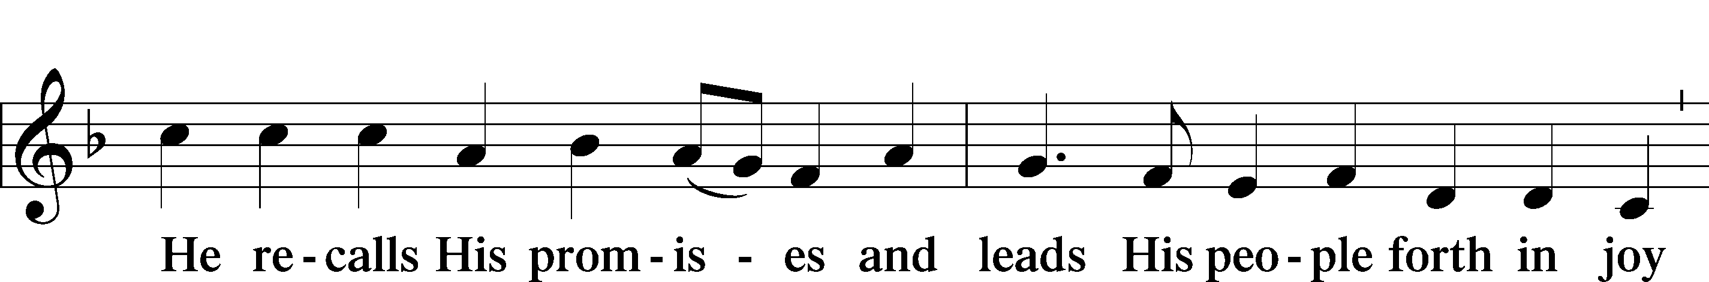
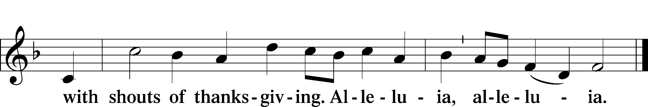

POST-COMMUNION COLLECT

BENEDICTION
L:The grace of our Lord T Jesus Christ, and the love of God, and the fellowship of the Holy Spirit, be with us all.
C: Amen.

474 ALLELUIA! JESUS IS RISEN
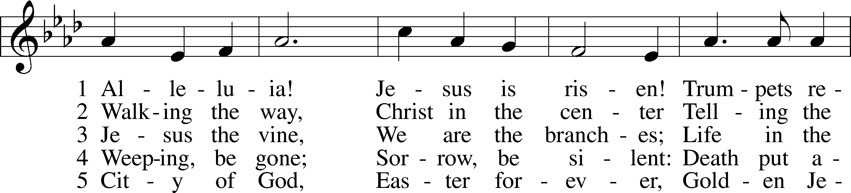
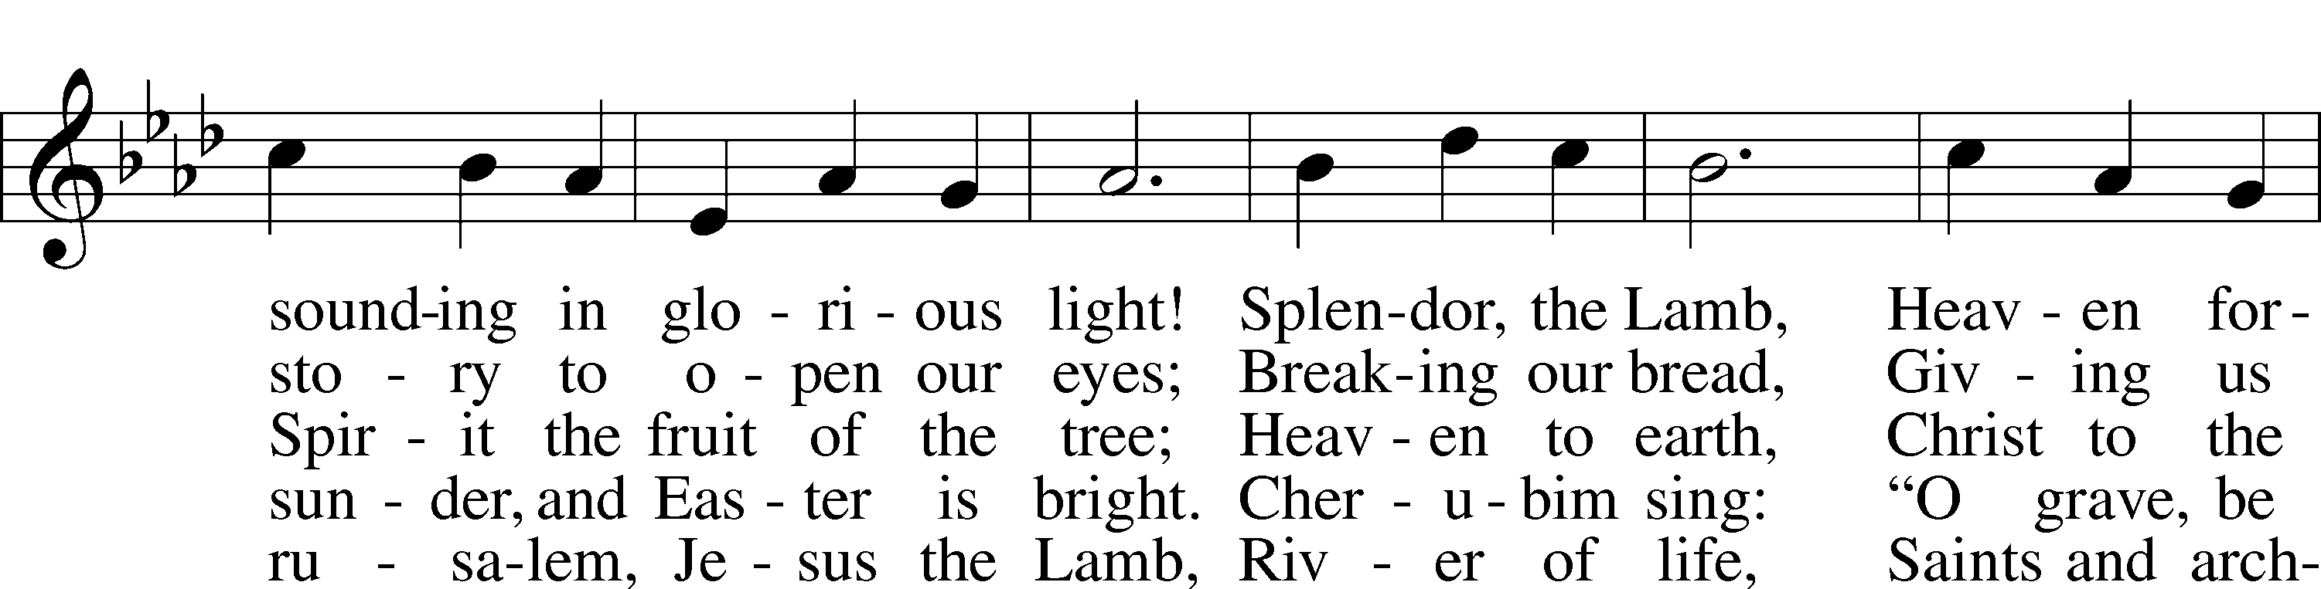
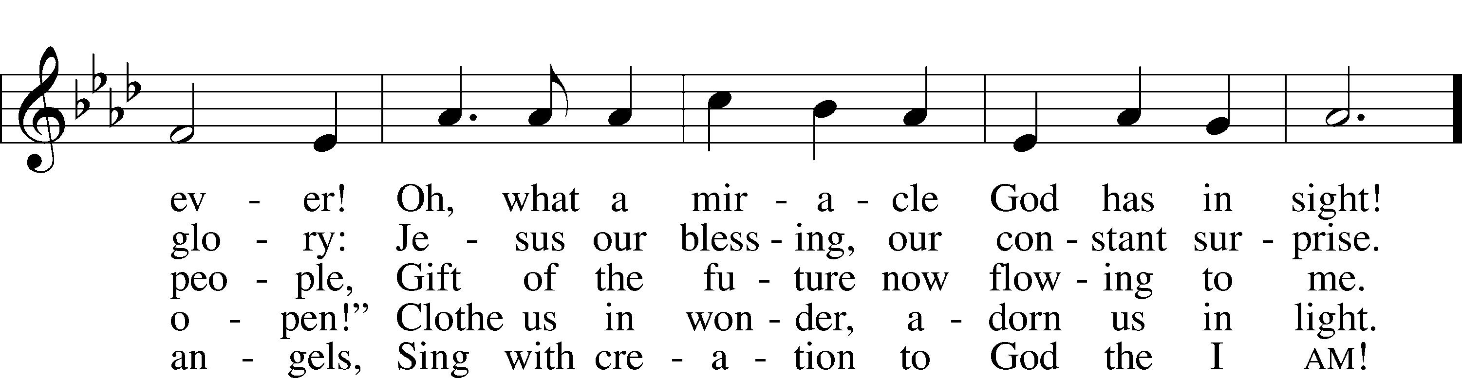
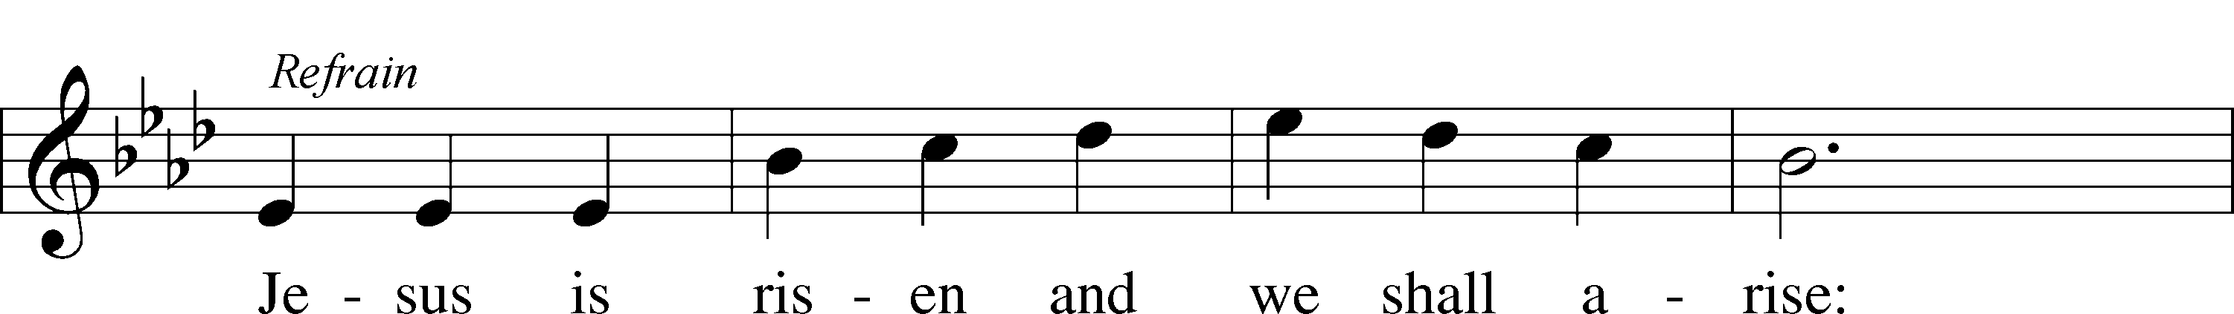
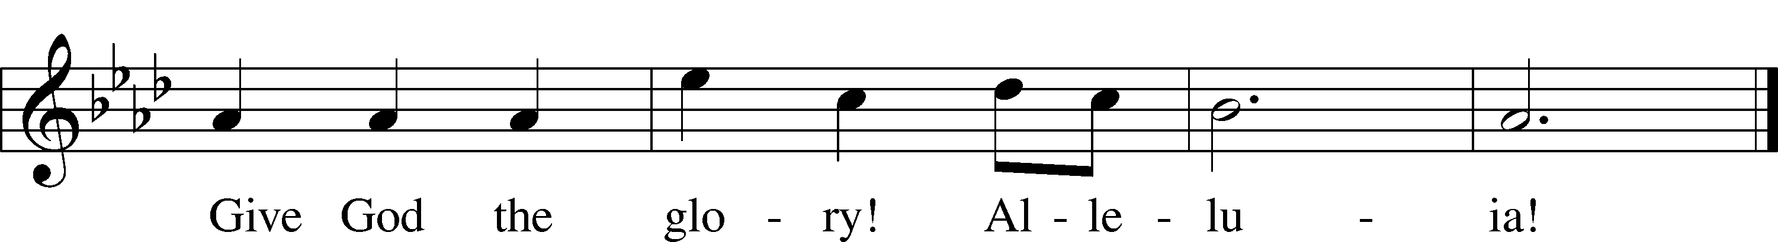
Text: Herbert F. Brokering, 1926–2009
Tune: David N. Johnson, 1922–87
Text: © 1995 Augsburg Fortress. Used by permission: LSB Hymn License no. 110004798
Tune: © 1968 Augsburg Publishing House. Used by permission: LSB Hymn License no. 110004798

ACKNOWLEDGMENTS
Unless otherwise indicated, Scripture quotations are from the ESV® Bible (The Holy Bible, English Standard Version®), copyright © 2001 by Crossway, a publishing ministry of Good News Publishers. Used by permission. All rights reserved.
Created by Lutheran Service Builder © 2026 Concordia Publishing House.

IN OUR PRAYERS:
Submitted petitions are included for two consecutive Sundays

For Those suffering afflictions of mind, body, or spirit:
Blake B., Carol R., Michele N., Dean S.,
All of our Shut- Ins:
Betty A., Shirley F., Mary H., Patsy L., Tommy M., Jerome M., Sharon B., Judy S.
For missionaries
Deaconess Sandra R., Rev. Jonathan A.

ANNOUNCEMENTS
Please email announcements for Sunday bulletins by 8:00 a.m. Tuesday to pastorblcaiken@gmail.com

ALTAR FLOWERS:
Flowers are donated today by Robert & Michelle C. in honor of Alex’s birthday

ACTS DONATION FOR APRIL:
CEREAL

FELLOWSHIP COFFEE HOUR:
Every Sunday morning, during Bible Study and after the Divine Service, coffee, treats and good fellowship are waiting for you in our Fellowship Hall!

PASTOR ENGWALL’S LAST DAY AT BETHLEHEM:
Next Sunday, April 19th, is Pastor Engwall’s final service here.
A farewell potluck for Pastor and Teffie will be held in the Fellowship Hall after the service.
Pastor Engwall will be installed at Immanuel Lutheran Church, Sweet Springs, Missouri
at 4:00p.m. Central time (5:00p.m. Eastern time) on Sunday, May 3rd.

Attendance:
Maundy Thursday, April 2nd: 26
Good Friday, April 3rd: 27
Easter Sunday, April 5th: 81

Offerings:
Maundy Thursday: $220
Good Friday: $120
Easter Sunday: $1,174
Average weekly offering needed to make budget: $2,579

OUR VALUE STATEMENT: Bethlehem Lutheran Church exists under God’s grace to save the lost and to strengthen the saved so that they may live bold and courageous lives of Christian witness before a non-believing world.
Therefore, our purpose is:
- to glorify God in Word and deed,
- to nurture each other in Christian love,
- to reach out to others with our Savior’s Gospel of life and salvation.
(Rom 5:8, Matt. 28:18-20).

OUR VISION: By the Grace of God, Bethlehem Lutheran Church, is a loving family united in Christ, learning, living, and spreading His Word.

OUR MISSION: Learn the Word. Live the Word. Spread the Word.

2026 Easter Lilies
Bob and Eileen A. – 1 lily
Roger and Charlsie B. – 1 lily
Suzy E. – 3 lilies in memory of Sandy A. and Russell and Carole E.
Lana L. – 1 lily
Chuck and Joanne M. – 1 lily
John and Nancy M. – 1 lily for Blessings Received
Jack N. – 5 lilies in memory of Sharon
Juanita R. – 2 lilies in memory of her daughter, Shirley, and her son, John
Liz S. – 1 lily in memory of her mother, Pat C.
Angela S. – 1 lily in memory of Sam and Frances A. and Jennifer T.
Rebecca S. – 2 lilies in memory of her mother, Pat C., and her grandparents, Bigma & Papa
Kathy S. – 1 lily
Margie T. – 2 lilies in memory of Mike
Tom T. – 1 lily

